Leveraging BIM for Sustainable Orphanage Design Using Locally Sourced Materials
¹Nyibanda N.G., ²Abanda F.H. and ³Florian M.Z.

^{1,2}Ecole Nationale Supérieure des Travaux Publics
B.P 510, Yaoundé
Cameroon

³Studio 127
Yaoundé
Cameroon
Abstract

In Sub-Saharan Africa, and particularly Cameroon, the demand for socially inclusive and environmentally responsible architecture is growing due to rapid urbanisation, climate pressures, and the needs of vulnerable communities. Orphanages, as critical social infrastructure, are frequently delivered through cost-driven approaches that neglect sustainability and long-term performance. While Building Information Modelling (BIM) has globally advanced design precision, cost optimisation, and environmental performance analysis, its application in Africa especially for projects using eco-friendly materials such as compressed earth blocks (CEBs) remains limited. This study employs BIM, through Autodesk Revit, to design sustainable, child-centred orphanages in Cameroon using locally sourced materials. Two functionally equivalent prototypes, one with sandcrete blocks and another with CEBs, were developed and evaluated through comparative cost estimation, embodied carbon and energy analysis, and operational performance assessment, in line with life-cycle assessment (LCA) standards and thermal comfort benchmarks. Results show that CEBs delivered lower construction costs, reduced embodied impacts, and improved thermal comfort compared to sandcrete. BIM-enabled workflows enhanced quantity take-offs, integrated early LCA, and supported evidence-based material selection. This research provides one of the first regionally validated datasets on sandcrete and CEB performance in Cameroon, while proposing a replicable digital design framework for humanitarian architecture in resource-constrained Sub-Saharan contexts.

Keywords: BIM, Compressed Earth Blocks (CEBs), LCA, Orphanage, Sandcrete blocks, Sustainability

1. Background
The design and construction of orphanages in Sub-Saharan Africa face significant challenges at the intersection of social responsibility, environmental sustainability, and economic constraints. In Cameroon, orphanages remain critical social infrastructure, yet their design and construction are often dictated by cost-minimisation strategies that prioritise speed and affordability over quality, sustainability, and cultural sensitivity. This has led to buildings that provide basic shelter but fail to promote healthy living environments for children or respond adequately to climate, resource, and cultural contexts [1] (UNEP, 2022). The reliance on conventional sandcrete blocks construction exemplifies this problem. Although widely adopted, in most building projects, sandcrete blocks carries high embodied carbon, energy demand, and cost burdens that undermine sustainability goals [2] (Awoussi et al., 2025). Furthermore, such approaches neglect the rich vernacular knowledge embedded in locally available, renewable materials such as bamboo and CEBs. These materials not only offer superior thermal comfort and lower environmental footprints but also align with cultural practices and local construction skills ([3], [4]) (van den Heuvel, 2023; Sinha & Sudarsan, 2025). However, their systematic adoption in modern institutional buildings remains limited due to perceptions of inferiority, lack of performance data, and absence of integration within formalised design and construction processes.

Globally, BIM has transformed architectural and engineering practice by enabling precise design, cost estimation, energy modelling, and life-cycle assessment ([5], [6]) (Cheng et al., 2024; Gladdys et al., 2025). Yet, in Sub-Saharan Africa, BIM adoption remains nascent, and its potential to integrate sustainable materials into evidence-based design workflows for humanitarian architecture is underexplored. By contrast, in countries such as Chile and New Zealand, BIM-enabled humanitarian housing programs have integrated local timber and prefabricated systems to accelerate delivery and improve disaster resilience [7], [8] (González et al., 2019; Smith & Thomas, 2021). These precedents highlight the untapped potential for similar approaches in Sub-Saharan Africa. This creates a critical gap while the need for environmentally responsible, socially inclusive, and cost-effective orphanage designs is urgent, the tools and data to enable informed material selection and sustainable decision-making are scarce in this regional context [9] (Abubakar et al., 2023).

Orphanages in Cameroon are predominantly designed using cost-driven approaches that rely on sandcrete blocks, resulting in unsustainable, culturally detached, and environmentally burdensome buildings. Although locally sourced materials such as CEB offer promising alternatives, their performance has not been systematically validated, nor has their integration into BIM-enabled design processes been sufficiently studied. Without such evidence, architects, policymakers, and NGOs lack the tools to design orphanages that are both socially responsive and environmentally sustainable.

The aim of this study is to use BIM to comparatively design and evaluate orphanages in Cameroon constructed with conventional sandcrete blocks and with locally sourced materials such as compressed earth blocks (CEB). The comparison will focus on environmental performance, cost-effectiveness, and cultural responsiveness, thereby providing evidence-based insights to guide architects, policymakers, and NGOs toward more sustainable and socially relevant design choices.

To achieve this aim, the study pursues the following objectives:
- To establish the state-of-the-art on the use of local materials in building construction, with a focus on sandcrete blocks and CEB, assessing their properties and applicability in sustainable architectural design.
- To comparatively investigate the cost-effectiveness and environmental impact of sandcrete blocks and CEB as building materials suitable for orphanage construction in Cameroon.
- To examine the benefits of applying BIM in the comparative design process of sustainable orphanages, particularly in relation to informed design decisions, energy modelling, and multidisciplinary coordination.
- To propose a BIM-enabled comparative design framework for orphanages in Cameroon that highlights material choices and can be adapted to similar contexts across Sub-Saharan Africa.

The remainder of the article is organised as follows. Section 2 reviews relevant literature on sustainable orphanage design, local materials, and BIM applications. Section 3 outlines the research methodology, including prototype development, evaluation criteria, and analytical frameworks. Section 4 presents the results and discussion, focusing on cost, embodied carbon, energy demand, and thermal comfort. Finally, Section 5 concludes with key findings, policy implications, and recommendations for future research.

2. Literature Review
2.1 Local Building Materials for Sustainable Construction
The use of locally sourced building materials is increasingly recognised as central to sustainable construction because it reduces transportation demands, minimises costs, and lowers environmental impact [4] (Sinha & Sudarsan, 2025). In Cameroon often described as “Africa in miniature” traditional architecture historically relied on clay, laterite, timber, bamboo, and stone [10] (Clark, 2020). Similar vernacular practices are evident across Africa, where bamboo, earth blocks, straw, and stone were long adapted to climate and culture [11] (Zoungrana et al., 2021). Recent scholarship has renewed interest in these materials due to their low embodied energy, natural thermal performance, and affordability [12], [4], [13] (Maina & Mwangi, 2022; Sinha & Sudarsan, 2025; Abanda et al., 2014a).

Five categories of materials dominate this discussion: bamboo, CEBs, timber, adobe, and stone.
- Bamboo: Fast-growing and abundant in Cameroon’s humid and montane zones, bamboo offers tensile strength comparable to steel and compressive strength rivalling concrete while maintaining a ~70% lower carbon footprint [14], [3] (Mefire, 2025; van den Heuvel, 2023). Properly treated bamboo resists pests, decay, and fire, while also sequestering significant amounts of carbon [3] (van den Heuvel, 2023). Bamboo is being used in building construction in Cameroon [15] (Abessolo, 2022).
- CEBs: Modernised from traditional adobe, CEBs are produced by compacting soil with minimal stabilisers, avoiding kiln firing, reducing energy and emissions by up to 80% compared to clay bricks [4] (Sinha & Sudarsan, 2025). With high thermal mass, low cement content (~8%), and cost-effective use of site soils, CEBs provide climate-adapted, affordable construction suitable for institutional buildings in semi-humid zones [16] (Hogue, 2023). CEB is being used in building construction in Cameroon [15], [17] (Abessolo, 2022; Ebanda et al., 2024).
- Timber/Wood: Cameroon’s forests offer hardwoods such as iroko and mahogany as well as faster-growing softwoods. Timber provides strength, insulation, and carbon sequestration but faces sustainability challenges linked to deforestation and pests [18] (WWF, 2021). Timber buildings are common in Cameroon [19] (Maeschauer et al., 2025)
- Adobe Bricks: Sun-dried earthen units are affordable, low-carbon, and insulating, though vulnerable to rainfall unless stabilised [11] (Zoungrana et al., 2021). Stabilised variants, such as compressed stabilised earth blocks, extend durability and have strong potential in arid and semi-arid regions of Cameroon. Adobe bricks are also common in Cameroon [20] (Goutsaya et al., 2021)
- Stone: Used extensively in Cameroon’s highlands and Adamawa plateau, stone provides durability, fire resistance, and high thermal mass. Locally quarried stone reduces emissions and cost, though its heavy weight and quarrying impacts constrain wider use [16] (Hogue, 2023). Stone buildings are also common in Maroua, the capital of the Far North Region Cameroon [21] (Vincelas et al., 2017)

While these materials are consistent with bioclimatic design principles and circular economy objectives, much of the existing literature remains predominantly descriptive rather than comparative. In particular, African scholarship rarely provides quantified assessments of lifecycle performance in institutional settings, limiting the ability to benchmark sandcrete against compressed earth blocks (CEBs) or engineered timber with respect to embodied carbon, thermal comfort, and cultural acceptance. The persistence of colonial-era legacies that stigmatize vernacular materials as “poor” or “temporary” further constrains their adoption [2], [22] (Awoussi et al., 2025; Fivez, 2024). Nonetheless, initiatives such as the Noomdo Orphanage in Burkina Faso and the Nyumba Mpya Modular Bamboo Orphanage in Uganda illustrate that when vernacular materials are combined with contemporary detailing and rigorous performance validation, they are capable of meeting or even surpassing modern standards. This indicates that the primary barriers lie less in technical feasibility than in perception, policy frameworks, and the lack of region-specific performance datasets.
While other vernacular or low-carbon materials such as rammed earth and hybrid timber systems also hold promise for sustainable institutional construction in Sub-Saharan Africa, they were excluded from the present comparative analysis for two main reasons. First, their adoption in Cameroon’s orphanage or similar institutional contexts remains extremely limited, with few or no regionally validated datasets on cost, embodied carbon, and operational performance to support robust BIM-based modelling. Second, both materials present context-specific constraints: rammed earth requires strict soil grading and moisture control that are difficult to guarantee in high-rainfall zones without significant stabilisation (which can offset its low-carbon advantage), while hybrid timber systems often rely on engineered products (e.g., glulam) that are not yet locally manufactured, making them cost-prohibitive and dependent on imports. Given the study’s aim to prioritise materials with proven local availability, cultural acceptance, and sufficient performance data for BIM integration sandcrete and CEB were selected as the most relevant comparators.
2.2 BIM in Sustainable Design
BIM is a digital process that centralises a building’s lifecycle data into a shared 3D environment, enabling integrated analysis of design, cost, performance, and sustainability [6] (Cheng et al., 2024). Its contribution to sustainable construction lies in its ability to minimise waste, optimise the use of resources, and support evidence-based material choices. By consolidating architectural, structural, and systems data into a single platform, BIM improves collaboration and facilitates informed decision-making at every stage of a project’s lifecycle. Key sustainable design functions discussed in [23], [24], [25], [26] Bolognesi et al. (2025), Abanda et al. (2017a;b) and Abanda and Byer (2016) include:
- Clash detection to prevent costly on-site rework and reduce material waste
- Automated quantity take-offs for precise estimation and reduced over-ordering
- Material optimisation through testing alternatives, right-sizing components, and adopting prefabrication strategies
- Green BIM integration, embedding environmental performance data into material libraries for early embodied carbon and recyclability assessments
Globally, humanitarian BIM applications have extended beyond Africa from post-tsunami modular schools in Indonesia [27] (Rahmawati et al., 2020) to adobe school retrofits in Peru [28] (Vargas-Neumann et al., 2017). However, African applications remain under-documented, creating a skewed narrative that positions BIM as an imported rather than locally adaptable technology.

When tailored to local material databases and skill ecosystems, BIM workflows have the potential to modernize and legitimize vernacular construction. In this context, the present study seeks to integrate performance data on sandcrete and compressed earth blocks (CEBs) into BIM libraries for Cameroon, thereby addressing two critical gaps: the need for robust technical validation and the challenge of cultural acceptance.
2.3 Rethinking Sustainability in African Architecture
Sustainability in African architecture cannot simply be achieved by replicating global trends; it must be grounded in local realities of material availability, labour practices, and cultural values. While international discourse often emphasise high-tech solutions and industrialised materials, many African contexts demand approaches that are both climate-responsive and socially embedded [29] (Santos et al., 2024).

One persistent challenge lies in the misconceptions surrounding local materials. Colonial legacies and modern biases continue to frame materials such as adobe, bamboo, or thatch as symbols of poverty and underdevelopment, despite their proven performance in climate adaptability and affordability [2], [22] (Awoussi et al., 2025; Fivez, 2024). Such perceptions have fostered resistance to their use in contemporary projects, especially institutional buildings like orphanages, where communities often aspire to “modern” aesthetics associated with concrete and steel. A second issue arises from the hybridisation of “local” materials. While stabilised CEBs or cement-treated adobe improve durability, they also complicate the low-energy narrative traditionally associated with vernacular construction. This tension underscores the need for contextualised sustainability metrics, ones that weigh durability gains against embodied carbon increases, and that recognise the social value of community-led construction.

By integrating BIM into this evaluative process, African architects can move beyond anecdotal advocacy for local materials toward evidence-based design decisions. This reframing positions sustainability not as a binary choice between “traditional” and “modern,” but as a spectrum where vernacular wisdom and digital precision co-produce architecture that is both culturally resonant and environmentally sound. In the context of orphanage construction, such reframing is particularly urgent: children deserve environments that are safe, thermally comfortable, and culturally grounded, without perpetuating the environmental burdens of conventional materials.

3. Research Methods
This study adopts a mixed-method comparative prototype analysis, combining qualitative field data with quantitative BIM-based performance modelling. This approach was selected to bridge the gap between contextual understanding of orphanage needs and measurable environmental and cost performance of local materials.

3.1 Data Collection
To ensure a contextually appropriate and technically robust orphanage design, this study combined both primary and secondary data sources. Data were collected to guide material selection, cost estimation, and spatial planning, with each decision aligned to technical standards, cultural realities, and international sustainability norms.

Primary data were collected through on-site observations, complemented by discussions with orphanage caregivers, administrators, architectural educators, community planners, and representatives from humanitarian organisations such as the Charity Group Association. These discussions focused on common design challenges in orphanages, vernacular construction practices, local cost structures, and the spatial needs of children. Field visits were carried out at key orphanages in Yaoundé, the capital city of Cameroon, including Saint Thérèse, Foyer École des Enfants Aveugles, and Centre d’Accueil de l’Espoir. In addition, local construction companies such as MIPROMALO [30] (Owoyemi et al., 2021) were also consulted. These engagements provided valuable insights into functional layouts, sanitation placement, classroom adjacency, sleeping arrangements, infrastructure gaps that directly affect child well-being, as well as material conditions, maintenance practices, and cost estimation frameworks that informed the design of the orphanage.

Secondary data were obtained from published literature on orphanage design and child-centered environments. For example, [31] Khanbabaei (2016) investigated the factors that foster a sense of belonging among orphaned children, proposing supportive spaces that enhance social integration and reduce insecurity and alienation, thereby improving emotional, social, and psychological well-being. Similarly, [32] Helles (2021) examined how interior spatial design can mitigate post-parental loss psychological issues, highlighting specific architectural interventions. Relevant literature on environmental psychology was also reviewed, offering theoretical grounding for design strategies aimed at reducing children’s psychological distress. Additional secondary sources included case studies, peer-reviewed articles, and books that provided insights into cost breakdowns, thermal comfort strategies, roof detailing, embodied carbon and energy data, and construction techniques associated with local materials.

Together, the primary and secondary data formed a comprehensive evidence base, guiding the development of design concepts and performance analyses for the proposed orphanage.

3.2 Project Design and Workflow Stages
Architectural Concept Development: The conceptualisation of the orphanage plan was guided by three key principles: cultural relevance, climatic responsiveness, and child-centred care. Drawing inspiration from traditional Cameroonian compound layouts, the design emphasised communal living, spatial dignity, and passive environmental comfort and other factors discuss in [31], [32] Khanbabaei (2016) and Helles (2021). Functional zones were positioned to support safety, emotional well-being, and social integration while ensuring flexibility for the application of local construction techniques. To enable material comparisons, 3D plans and models were developed for designs adapted to two construction systems: sandcrete and CEBs.

BIM Model Development: To test the influence of materials on performance, three orphanage prototypes were modelled in Autodesk Revit using identical spatial configurations:
- Model A (973.4 m²): Reinforced Concrete
- Model B (973.4 m²): CEBs (stabilised with ~8% cement)

The floor plan of the orphanage is presented in Figure 1 with the 3D models is presented in Figure 2. The different models were designed Autodesk Revit 2025.

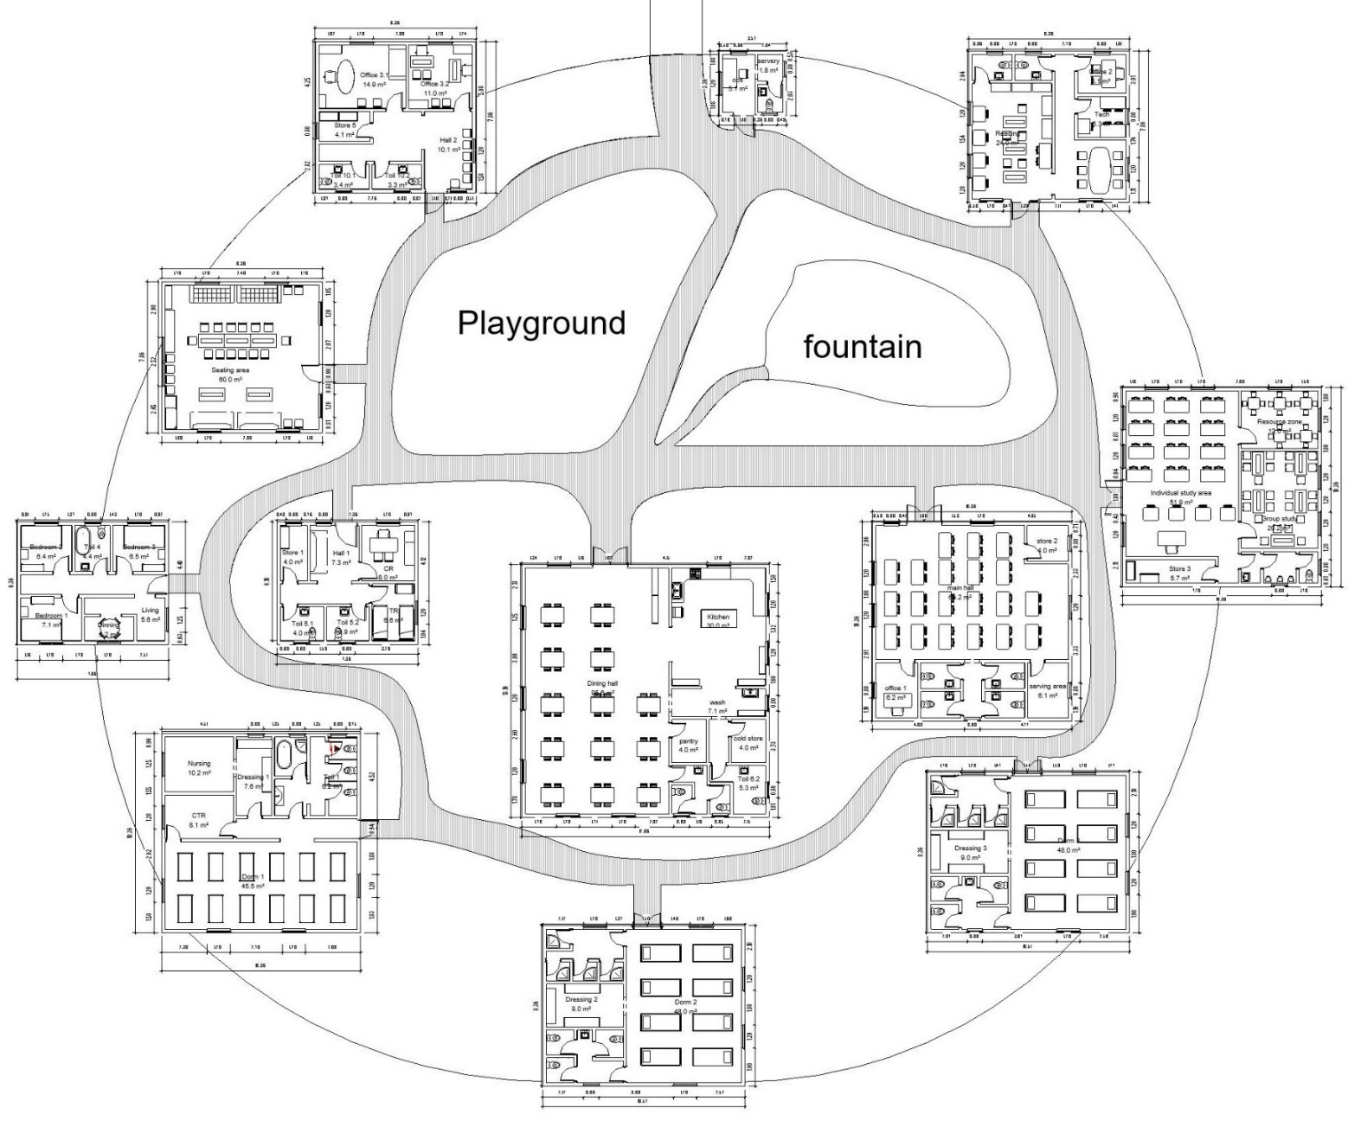
Figure 1. Floor plan of the orphanage
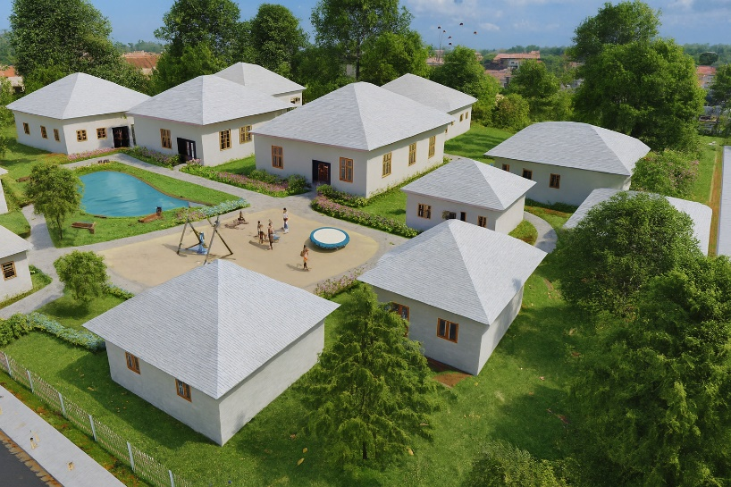 | 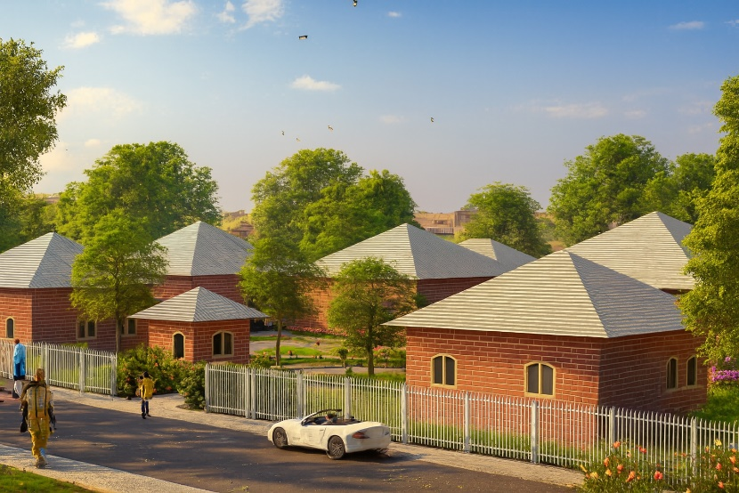
Model A: Sandcrete orphanage 3D model | Model B: Compressed Earth Blocks 3D Model
Figure 2. Sandcrete and CEB Orphanage models

Each model was developed with standardised geometry, orientation, and consistent simulation parameters to allow fair comparison. Material-specific adaptive families (e.g., CEB wall systems) were incorporated, and environmental properties such as embodied carbon and thermal mass were assigned using validated values from the literature [33] (Adier et al., 2023).
- Material Properties: Environmental datasets for sandcrete and CEB were sourced from peer-reviewed literature and cross-checked with local supplier specifications.
- Standardisation: All models were standardised for building orientation, occupancy schedules, and climate data to ensure comparability.
- Level of Detail: Models were developed to LOD 300, enabling accurate quantity take-offs and performance simulations.

3.3 Cost and Environmental Impact Computation
3.3.1 Cost Estimation
Material quantities for walls, roofs, and floors were extracted using Revit’s multicategory take-off tool and analysed in Microsoft Excel. Unit costs were assigned based on local market data and precedent studies, with adjustments made for labour and transport. Comparative cost tables were then generated to evaluate cost per square metre, total project costs, and the relative affordability of sandcrete blocks and CEB models.
In Revit 2025, a take-off was carried out and the unit costs of materials were updated. The unit cost data was sourced from various platforms, including the Mission for the Promotion of Local Materials (MIPROMALO). MIPROMALO is a Cameroonian public institution dedicated to the development and promotion of locally produced construction materials.
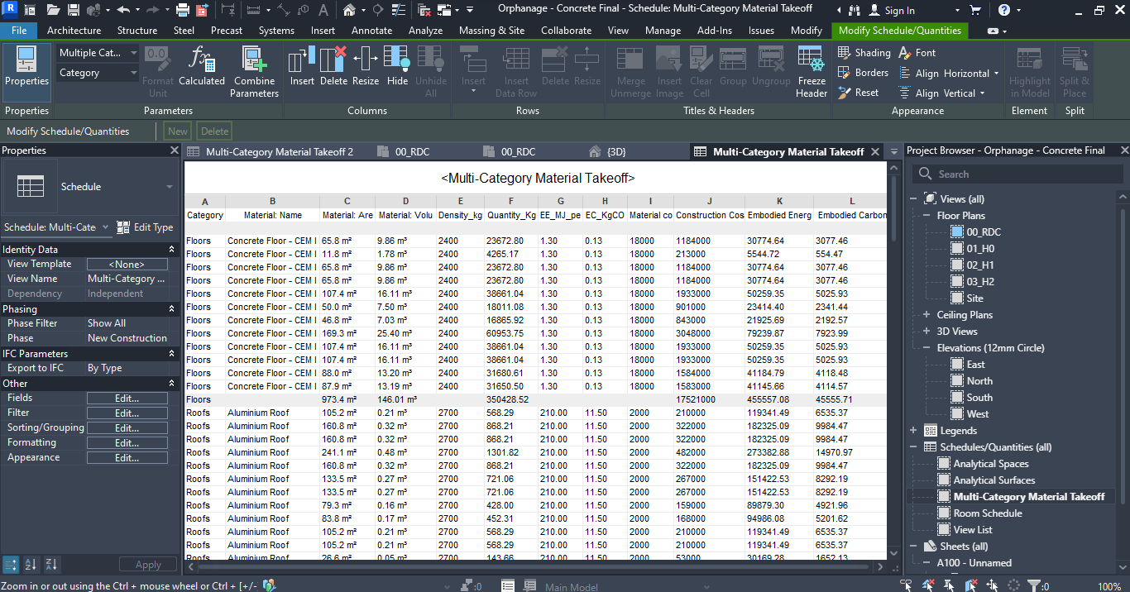
Figure 3. Multi Category Material Takeoff from Revit to Excel for Model A
Although the current focus is on cost estimation, the integrated nature of Revit has also allowed for the inclusion of embodied energy and carbon factors, which will later be used for environmental impact assessments. The data from Revit is exported to MS Excel by leveraging interoperability, where additional cost parameters such as labor costs and were incorporated to enable more flexible data manipulation. manipulation.
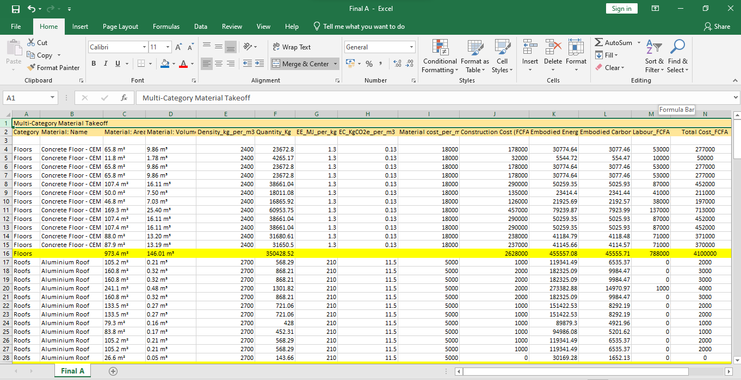
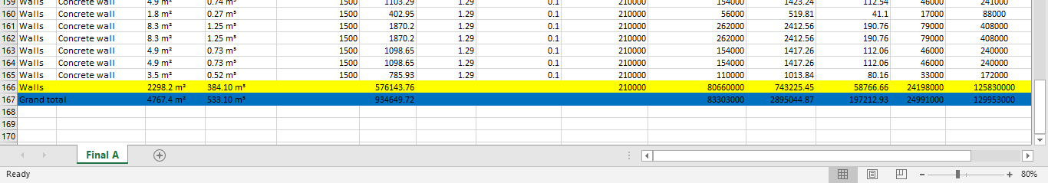
Figure 4. Grand Totals of the Different Parameters highlighted in blue
Similarly, the same approach was undertaken for Model B and the results are summarised as follows:
Table 1. Table showing Cost computations done in Excel for Models A and B
 | Model A | Model B
Material cost | 83,303,000 | 71,201,000
Labour cost | 24,991,000 | 21,361,000
Contingency cost (20% of Labour + Material cost) | 21,659,000 | 18,513,000
Grand total (FCFA) | 129,953,000 | 111,079,000
NB: 1 USD is approximately 550 FCFA
Based on Table 1, the cost of sandcrete (Model A) is 17% higher than that of CEB (Model B). Although this analysis is specific to an orphanage project in Cameroon, the result is comparable to findings from a study in Nigeria, where sandcrete affordable housing was found to be approximately 20% more expensive than CEB housing [34] (Didel, 2014).

3.3.2 Environmental Performance Analysis

A reasonable share of the total global carbon emissions stems from building material production and construction and transportation processes, which consume significant energy and release carbon to the atmosphere [35] (Marzouk and Elshaboury, 2022). While strategies to compute and reduce the operation energy and carbon of buildings is well-established, substantial and effective reduction of carbon footprint is yet to be achieved [35] ( Marzouk and Elshaboury, 2022). Thus, embodied energy and carbon has gained interest in recent years amongst construction professionals. Consequently, only embodied energy and carbon will be computed in this study as part of the environmental impact assessment for the sandcrete and CEB orphanage. Thos will be computed with the help of Revit and EMS Excel.

For the computation of embodied energy and carbon, their factors or intensities were needed for the different materials. Given these values are not available for the different materials in Cameroon, global values and values for countries with similar tropical climates were adopted. For clarity purposes, the values for the different material used are presented in Table 2.
Table 2. Embodied energy and carbon factors
 |  | Embodied energy factor (MJ/Kg) | Source/Comment | Embodied Carbon intensity (KgCO2/Kg) | Source/Comment
Model A (Sandcrete) | Concrete structural elements | 1.12 | [36] Taffese & Abegaz (2019), Buildings, 9(6), 13 | 0.095 | [36] Taffese & Abegaz (2019), Buildings, 9(6), 13
Model A (Sandcrete) | Hollow concrete blocks | 1.29 | [36] Taffese & Abegaz (2019), Buildings, 9(6), 13 | 0.102 | [36] Taffese & Abegaz (2019), Buildings, 9(6), 13
Model A (Sandcrete) | Aluzinc | 210 | [37] Bath ICE 2024 | 11.5 | [37] Bath ICE 2024
Model A (Sandcrete) | Concrete floor slab | 1.3 | [37] Bath ICE 2024 | 0.13 | [37] Bath ICE 2024
Model B (CEB) | Aluzinc | 210 | [37] Bath ICE 2024 | 11.5 | [37] Bath ICE 2024
Model B (CEB) | Concrete floor slab | 1.3 | [37] Bath ICE 2024 | 0.13 | [37] Bath ICE 2024
Model B (CEB) | CEB walls | 0.5 | [38] Zoma et al. (2025) | 0.05 | [38] Zoma et al. (2025)

To ensure regional accuracy, embodied energy and carbon factors were sourced from peer‑reviewed literature. For CEB, [38] Zoma et al. (2025) report 0.50 MJ/kg and 0.050 KgCO₂/Kg. Hollow concrete blocks were assigned 1.29 MJ/Kg and 0.102 KgCO₂/Kg from [36] Taffese et al. (2019). These values are summarised in Table 2.
Using the values in Table 2, Figures 3 and 4, and the mathematical model used in [39] Abanda et al (2014b), the embodied energy and carbon of the models have been computed and presented in Table 3.
$${EE}_{k}=\sum_{k=1}^{n}{(1+ξ_{k})∙}Q_{k}⋅ I_{k}$$

$${EC}_{k}= \sum_{k=1}^{n}{\left(1+ ξ_{k}\right)⋅ Q_{k} ⋅ I_{k}}$$

Where:
· EE_{k} and EC_{k} are embodied energy and embodied CO₂ of material type k with units MJ and KgCO₂ respectively;
·
is the waste factor(dimensionless)of material type k;
· Q_{k} is the total functional quantity of material;
· I_{k} is the embodied energy factor or embodied CO₂ factor with units MJ/functional unit and KgCO₂/functional unit of material respectively.
Because of lack of information about waste data in Cameroon, the waste factor was considered to be zero.

Table 3. Total embodied energy and carbon for the three models
Model | Embodied Energy (MJ) | MJ/m² | Embodied Carbon (KgCO₂) | KgCO2/m²
A | 2 895 044.866 | 2974.16 | 197 212.9278 | 202.60
B | 1 498 591.381 | 1539.54 | 111 491.299 | 114.54
GFA = 973.4 m²
4. Research Findings and Discussions
This section presents the findings from the BIM-based simulations and cost-benefit analyses of the two prototype orphanage designs: Sandcrete and CEB. Results are organised under three key performance indicators: environmental performance, economic performance, and BIM workflow outcomes. All values are derived from model-based simulations and verified quantity take-offs.

4.1 State-of-the-art on the use of local materials in building construction

4.2 Cost-effectiveness and Environmental impact of Sandcrete and CEB orphanage
This section presents the findings from the BIM-based simulations and cost-benefit analyses of the two prototype orphanage designs: Sandcrete (Model A) and CEB (Model B). These results are derived from model-based simulations and verified quantity take-offs. The study applied Building Information Modelling (BIM) to design sustainable, child-centred orphanages in Cameroon using locally sourced materials, specifically evaluating two functionally identical prototypes: sandcrete blocks and CEB. The evaluation included comparative cost estimation, embodied carbon, and energy analysis, guided by life-cycle assessment (LCA) standards. The overall findings indicate that CEB offered the lower construction cost and the smaller overall carbon footprint and energy demand, outperforming sandcrete blocks across sustainability indicators.

4.2.1 Cost-effectiveness of sandcrete and CEB orphanage
Based on Table 1, the cost of sandcrete (Model A) is 17% higher than that of CEB (Model B). This analysis, while specific to an orphanage project in Cameroon, is comparable to findings from a study in Nigeria, which found sandcrete affordable housing to be approximately 20% more expensive than CEB housing [34] (Didel, 2014). The cost estimation for both models involved extracting material quantities using Revit’s multicategory take-off tool and analysing them in Microsoft Excel. Unit costs were assigned based on local market data and precedent studies, with adjustments made for labour and transport costs, sourced from platforms like the Mission for the Promotion of Local Materials (MIPROMALO). The gross floor area (GFA) for both models was 973.4 m².
It is imperative to consider embodied carbon and embodied energy to further compare the orphanages constructed with sandcrete or CEB.

4.2.2 Environmental Performance
Model | Embodied Energy (MJ) | MJ/m² | Embodied Carbon (KgCO₂) | KgCO2/m²
A | 2 895 044.866 | 2974.16 | 197 212.9278 | 202.60
B | 1 498 591.381 | 1539.54 | 111 491.299 | 114.54

The environmental performance assessment highlighted notable differences between Model A (Sandcrete) and Model B (Compressed Earth Blocks, CEB). Model A exhibited significantly higher embodied energy (2974.16 MJ/m²) and embodied carbon (202.60 KgCO₂/m²), whereas Model B demonstrated considerably lower embodied energy (1539.54 MJ/m²) and embodied carbon (114.54 KgCO₂/m²). It is important to note that these values does not include finishes and services.
These findings are broadly supported by literature, indicating that earth-based construction materials often yield lower overall environmental impacts compared to conventional sandcrete or hollow cement blocks [40], [41], [42], [Adu et al., 2025; Obaje et al., 2022; Saba et al., 2018; . This is frequently attributed to the reduced need for plastering and painting in earth construction, which significantly lessens the high embodied carbon contribution from cement [40], [Adu et al., 2025 ]
However, the analysis presents nuances. For instance, individual stabilised laterite bricks can have a higher embodied carbon per kilogram than sandcrete blocks due to their cement content [40] [Adu et al., 2025]. Similarly, the embodied impacts of specific earth materials like vibration-compacted adobe bricks can vary, sometimes showing higher embodied carbon per kilogram than concrete blocks, emphasizing the influence of material composition and raw material transportation [38][Zoma et al., 2025].
Beyond direct carbon reductions, CEB construction systems offer enhanced thermal performance and energy efficiency, leading to improved indoor comfort [41], [Obaje et al., 2022] The use of interlocking blocks also significantly reduces material and labour costs due to minimal mortar requirements, accelerating construction speed compared to traditional sandcrete [41] Obaje et al., 2022].
Overall, despite variations in individual material impacts, CEB-based systems present a promising and sustainable alternative to sandcrete, offering both environmental and economic benefits for building construction [41], [42] [Obaje et al., 2022; Saba et al., 2018].

Benefits of BIM in the design process of sustainable Orphanage buildings

Building Information Modelling (BIM) has become a transformative innovation in the construction sector, enabling greater design precision, cost optimisation, and sustainability. These benefits are particularly important in Sub-Saharan Africa, where orphanage buildings must be designed to be child-centred, affordable, and environmentally responsive.
A key advantage of BIM is enhanced design precision. By centralising lifecycle data in a 3D digital environment, BIM integrates cost, performance, and sustainability assessments. Tools such as automated cost estimation, energy modelling, and life cycle assessment (LCA) provide accurate insights into the long-term performance of orphanages, ensuring that design solutions remain viable and resilient [43] ( Zhang et al., 2025).
Sustainability is central to humanitarian architecture, and BIM plays a vital role through “Green BIM” applications. These embed environmental data directly into material libraries, enabling assessments of embodied carbon and recyclability during the early design stages [44] (Basart et al., 2023). For orphanages, this allows designers to adopt eco-friendly solutions that minimise waste while ensuring healthy, child-friendly environments.
BIM also fosters collaboration among diverse stakeholders such as NGOs, architects, and local contractors. By consolidating architectural, structural, and systems data, BIM improves transparency, reduces errors, and enhances trust in decision-making [45] (Mbarga & Mpele, 2019). For orphanage projects that often depend on multiple funding and delivery partners, such collaborative tools are crucial to ensure alignment and efficiency.
Cost and resource efficiency further highlight BIM’s relevance. Clash detection prevents costly rework on-site, while automated quantity take-offs reduce material waste by ensuring precise procurement [43] (Zhang et al., 2025). For orphanage prototypes, such features are particularly useful in maximising limited budgets while still meeting quality standards.
Finally, BIM enables the validation of local and affordable materials, such as CEBs. These are often overlooked due to misconceptions, yet BIM provides robust data to demonstrate their structural and environmental performance [45] (Mbarga & Mpele, 2019). In doing so, BIM supports culturally appropriate, sustainable, and cost-effective orphanage construction.
In sum, BIM provides significant benefits for orphanage design in Sub-Saharan Africa by improving design precision, sustainability, collaboration, and cost efficiency. Its ability to validate local materials and integrate environmental analysis ensures that orphanages are not only affordable and resilient but also culturally resonant and environmentally sound.

IM-enabled design framework for sustainable orphanages in Cameroon

This study applies Building Information Modelling (BIM), using Autodesk Revit, to design sustainable, child-centred orphanages in Cameroon with locally sourced materials. It introduces a BIM-enabled comparative design framework that highlights material choices and is adaptable across Sub-Saharan Africa. By combining qualitative field data with quantitative BIM-based modelling, the framework links contextual understanding with measurable outcomes in cost and environmental performance. The first stage involves systematic data collection to guide material selection, cost estimation, and spatial planning. Primary data came from on-site observations and consultations with caregivers, administrators, educators, planners, and humanitarian organisations, focusing on design challenges, vernacular practices, costs, and children’s spatial needs. Field visits to orphanages in Yaoundé and collaboration with local firms such as MIPROMALO enriched the dataset. Secondary data, drawn from literature on orphanage design, child-centred environments, environmental psychology, and construction materials, provided insights into costs, thermal strategies, embodied carbon, and roof detailing. The second stage centres on project design and workflow. Guided by cultural relevance, climatic responsiveness, and child-centred care, the architectural concept drew inspiration from traditional Cameroonian compound layouts, emphasising communal living, safety, and spatial dignity. For material comparison, two prototypes were developed in Autodesk Revit: Model A (sandcrete) and Model B (Compressed Earth Blocks). Both shared identical spatial configurations, standardised geometry, and simulation parameters. Material-specific adaptive families were integrated, with environmental properties such as embodied carbon and thermal mass assigned from validated sources. Models were developed to Level of Detail (LOD) 300, enabling accurate take-offs and robust simulations.
The final stage focused on cost and environmental assessment. Material quantities were extracted from Revit and analysed in Excel, with local unit costs adjusted for labour and transport. Comparative cost tables were generated, while environmental performance was assessed through embodied energy and carbon indicators. In the absence of Cameroon-specific datasets, values were drawn from global databases and tropical-climate contexts. Revit’s integrated tools facilitated the embedding of these environmental factors into material assessments.
Overall, the BIM-enabled framework provides a structured, replicable approach to designing sustainable humanitarian infrastructure in Cameroon. It supports evidence-based material selection, comprehensive performance evaluation, and culturally grounded design. By integrating data-driven insights with advanced digital tools, the framework demonstrates strong potential for scalable, sustainable orphanage design across Sub-Saharan Africa.

5. Conclusions
This study effectively applied Building Information Modelling (BIM) through Autodesk Revit to design and evaluate sustainable, child-centred orphanages in Cameroon, integrating locally sourced materials. The research specifically compared two functionally identical prototypes: sandcrete blocks and Compressed Earth Blocks (CEB), assessing them against life-cycle assessment (LCA) standards for cost, embodied carbon, energy, and thermal comfort.
The findings unequivocally demonstrate CEB's superior performance across key sustainability indicators. CEB offered a significantly lower construction cost, being 17% cheaper than sandcrete blocks. Environmentally, CEB exhibited a substantially smaller overall carbon footprint and energy demand, with embodied energy of 1539.54 MJ/m² and embodied carbon of 114.54 KgCO₂/m², compared to sandcrete's 2974.16 MJ/m² and 202.60 KgCO₂/m² respectively. Furthermore, CEB outperformed sandcrete in thermal comfort and alignment with local traditions. BIM-enabled workflows were crucial, facilitating accurate quantity take-offs, early LCA integration, and evidence-based material selection. BIM's role in enhancing design precision, cost optimisation, and environmental performance analysis was central to this comparative evaluation. It supports comprehensive performance evaluation and culturally grounded design, providing a replicable digital design approach for humanitarian architecture in resource-constrained Sub-Saharan contexts. These results offer practical insights for architects, policymakers, and NGOs aiming to develop sustainable and culturally responsive infrastructure for vulnerable populations.

References

[1] UNEP. (2022, November 22). Traditional building practices offer sustainable solutions in African cities. United Nations Environment Programme. https://www.unep.org/news-and-stories/story/traditional-building-practices-offer-sustainable-solutions-african-cities
[2] Awoussi, M. Y., Domtse, E. K. A., Gake, D. K., Genovese, P. V., & Dziwonou, Y. (2025). Analysis of the sustainability elements of vernacular architecture in Northern Togo: The case of the Kara Region. Sustainability, 17(6), 2450. https://doi.org/10.3390/su17062450
[3] Van den Heuvel, R. (2023, February 6). How bamboo can help solve the world housing and climate crises. World Economic Forum. https://www.weforum.org/stories/2023/02/bamboo-construction-housing-climate
[4] Sinha, S., & Sudarsan, J. S. (2025). Building a greener future: How earth blocks are reshaping sustainability and circular economy in construction. Architecture, 5(2), 25. https://doi.org/10.3390/architecture5020025
[5] Cheng, Q., Tayeh, B. A., Abu Aisheh, Y. I., Alaloul, W. S., & Aldahdooh, Z. A. (2024). Leveraging BIM for sustainable construction: Benefits, barriers, and best practices. Sustainability, 16(17), 7654. https://doi.org/10.3390/su16177654
[6] Gladdys, M. M., Gentil, B., & Cao, P. (2025). Sustainable strategies for improving humanitarian construction through BIM and climate analysis. Sustainability, 17(4), 1556. https://doi.org/10.3390/su17041556
[7] González, P., Martínez, C., & Herrera, R. (2019). BIM for social housing in Chile: Timber prefabrication and post-disaster reconstruction. Journal of Construction Engineering and Management, 145(6), 04019032. https://doi.org/10.1061/(ASCE)CO.1943-7862.0001654
[8] Smith, J., & Thomas, G. (2021). BIM in prefabricated housing for disaster resilience: Lessons from New Zealand. Automation in Construction, 127, 103712. https://doi.org/10.1016/j.autcon.2021.103712
[9] Abubakar, M., Ibrahim, Y. M., & Bala, K. (2023). Barriers to BIM adoption in Sub-Saharan Africa: A systematic review. Journal of Construction in Developing Countries, 28(1), 1–20. https://doi.org/10.21315/jcdc2023.28.1.1
[10] Clark, J. (2020, August 27). Cameroon: Using the age-old "building from mud" construction technique for greener homes. How We Made It in Africa. https://www.howwemadeitinafrica.com/cameroon-using-the-age-old-building-from-mud-construction-technique-for-greener-homes/70791/
[11] Zoungrana, O., Bologo/Traoré, M., Messan, A., Nshimiyimana, P., & Pirotte, G. (2021). The paradox around the social representations of compressed earth block building material in Burkina Faso: The material for the poor or the luxury material? Open Journal of Social Sciences, 9(1), 50–65. https://doi.org/10.4236/jss.2021.91004
[12] Maina, J. W., & Mwangi, J. (2022). Life cycle assessment of vernacular building materials in East Africa. Sustainability, 14(15), 9234. https://doi.org/10.3390/su14159234
[13] Abanda F.H., Tah J.H.M. & Elambo G.K. (2014a) Earth-block versus sandcrete block houses: Embodied energy and CO₂ assessment. In: Pacheco-Torgal F., Lourenço P.B., Labrincha J.A., Kumar S. and Chindaprasirt P. (Editors). Eco-efficient masonry bricks and blocks: Design, properties and durability. UK: Woodhead Publishing Ltd
[14] Mefire, T. D. (2025, April 23). Unlocking bamboo's potential: A sustainable future for Cameroon and Africa. Right for Education. https://rightforeducation.org/2025/04/23/unlocking-bamboos-potential-a-sustainable-future-for-cameroon-and-africa/
[15] Abessolo, D.B. (2022). Physical, mechanical and hygroscopic behaviour of compressed earth blocks stabilized with cement and reinforced with bamboo fibres. Int. J. Eng. Res. Afr. 29–41.
[16] Hogue, P. (2023). Solutions in soil: Here's why all architects should reconsider compressed earth blocks. Architizer Journal. https://architizer.com/blog/inspiration/stories/compressed-earth-blocks-sustainable-construction/
[17] Ebanda, F.B., Mewoli, A.E., Njom, A.E. et al. Towards sustainable construction in Cameroon: impact of tropical plant fibers on the performance of compressed earth bricks. Innov. Infrastruct. Solut. 9, 476 (2024).
[18] WWF. (2021). Forest conservation and sustainable timber use in Cameroon.
[19] Maeschauer T.T.M., Hervé P.L., Paul-salomon N.-E. and Elkana P. (2025) Exergetic analysis of a wooden building envelope in a tropical region. Results in Engineering, 27,
[20] Goutsaya, J., Ntamack, G. E., Kenmeugne, B., & Charif d’Ouazzane, S. (2021). Mechanical characteristics of compressed earth blocks, compressed stabilized earth blocks and stabilized adobe bricks with cement in the town of Ngaoundere - Cameroon. Journal of Building Materials and Structures, 8(2), 139-159.
[21] Vincelas F.F.C., Ghislain T. and Robert T. (2017) Effects of the type of building materials on the thermal behavior of building in the hot dry climates: a case study of Maroua city, Cameroon. International Journal of Innovative Science, Engineering & Technology, Vol. 4 (3)
[22] Fivez, R. (2024). Resisting material binaries: Unpacking persisting dichotomies of building materials in Central Africa. Les Cahiers de la recherche architecturale urbaine et paysagère, (20). https://doi.org/10.4000/craup.15067
[23] Bolognesi, C., Bassorizzi, D., Balin, S., & Manfredi, V. (2025). An overview on LCA integration in BIM: Tools, applications, and future trends. Digital, 5(3), 31. https://doi.org/10.3390/digital5030031
[24] Abanda F.H., Kamsu-Foguem B. & Tah J.H.M. (2017a) BIM - new rules of measurement ontology for construction cost estimation. Engineering Science & Technology, 20 (2) : 443-459
[25] Abanda F.H., Oti A.H. & Tah J.H.M. (2017b) Integrating BIM and new rules of measurement for embodied energy and CO2 assessment. Journal of Building Engineering, 12 : 288-305
[26] Abanda F.H. & Byers L. (2016) An investigation of the impact of building orientation on energy consumption in a domestic building using emerging BIM. Journal of Energy, 97 : 517-527
[27] Rahmawati, D., Nugroho, A., & Prasetyo, Y. (2020). BIM for modular school reconstruction in post-tsunami Indonesia. Procedia Engineering, 212, 1120–1127. https://doi.org/10.1016/j.proeng.2018.01.144
[28] Vargas-Neumann, J., Oliveira, C., Silveira, D., Varum, H. (2018). Seismic Retrofit of Adobe Constructions. In: Costa, A., Arêde, A., Varum, H. (eds) Strengthening and Retrofitting of Existing Structures. Building Pathology and Rehabilitation, vol 9. Springer, Singapore. https://doi.org/10.1007/978-981-10-5858-5_4
[29] Santos, M.M., Ferreira, A.V., Lanzinha, J.C.G. (2024). Sustainable Vernacular Architecture to Improve Thermal Comfort in African Countries. In: Lanzinha, J.C.G., Qualharini, E.L. (eds) Proceedings of CIRMARE 2023. CIRMARE 2023. Lecture Notes in Civil Engineering, vol 444. Springer, Cham. https://doi.org/10.1007/978-3-031-48461-2_48
[30] Owoyemi, O., Adetunji, O., & Adebayo, Y. (2021). Lighting in the home and health: A systematic review. International Journal of Environmental Research and Public Health, 18(2), 609. https://doi.org/10.3390/ijerph18020609
[31] Khanbabaei A. (2016) Designing orphanage with the approach of creating sense of belonging to the environment. The Turkish Online Journal of Design, Art and Communication, pp. 944-954
[32] Helles A.S. (2021) Designing Stimulating Environment to Alleviate Orphan Children Psychological Problems. European Journal of Environment and Public Health, Vol. 5(2)
[33] Adier, M. F. V., Sevilla, M. E. P., Valerio, D. N. R., & Ongpeng, J. M. C. (2023). Bamboo as sustainable building materials: A systematic review of properties, treatment methods, and standards. Buildings, 13(10), 2449. https://doi.org/10.3390/buildings13102449
[34] Didel M. J., Matawal D.S. and Ojo E.B. (2014) Comparative cost analysis of compressed stabilised blocks and sandcrete blocks in affordable housing delivery in Nigeria. Proceedings of international housing summit on achieving affordable housing in Nigeria, Abuja, 2 – 4 June, 2014.
[35] Marzouk M. and Elshaboury N. (2022) Science mapping analysis of embodied energy in the construction industry. Energy Reports, 8, pp. 1362-1376.
[36] Taffese, W. Z., & Abegaz, K. A. (2019). Embodied Energy and CO₂ Emissions of Widely Used Building Materials: The Ethiopian Context. Buildings, 9(6), 136.
[37] Bath ICE (2024) Embodied Carbon - The ICE Database. https://circularecology.com/embodied-carbon-footprint-database.html
[38] Zoma, F., Zongo, N., Malbila, E., Toguyeni, D.Y.K., 2025. Assessment of the embodied energy and carbon footprint of vibration-compacted adobe brick. Journal of Building Engineering 111, 113145.
[39] Abanda F.H., Nkeng G.E., Tah J.H.M., Ohandja E.N.F. & Manjia M.B. (2014b) Embodied energy and CO₂ analyses of mud-brick and cement-block houses. AIMS Energy Journal, 2 (1): 18-40
[40] Adu, T.F., Zebilila, M.D.H., Adzakey, P., Sarkodie, W.O., Mustapha, Z., 2025. Life cycle embodied carbon evaluation of a two-bedroom house construction in Ghana: A comparison between stabilized laterite and sancrete building. Heliyon 11, e42212.
[41] Obaje, J.A., Ciroma, F.B., Obaje, S.A., 2022. Suitability Analysis of Compressed Earth Bricks (CEB) for Sustainable Housing Delivery in Guinea Savannah Zone of Northern Nigeria.
[42] Saba, L.A., Ahmad, M.H., Abdul Majid, R.B., 2018. Quantifying the Embodied Carbon of a Low Energy Alternative Method of Construction (AMC) House in Nigeria. Chemical Engineering Transactions 63, 643–648.
[43] Zhang, C., Dong, W., Shen, W., & Du, Y. (2025). Influencing Factors of BIM Application Benefits in Construction Projects Based on SEM. Buildings, 15(1875). https://doi.org/10.3390/buildings15111875
[44] Basart, J.M., Martínez, A., & Calvet, T. (2023). Sustainability Potential of BIM for Building Energy Efficiency. Buildings, 15(431). https://doi.org/10.3390/buildings15020431
[45] Mbarga, R.O. & Mpele, M. (2019). BIM Review in AEC Industry and Lessons for Sub-Saharan Africa: Case of Cameroon. International Journal of Civil Engineering and Technology, 10(5), 930–942.

