Development Of Heateye: A Smart Application

ABSTRACT
In the Philippines, household appliances are often used for extended periods, which may lead to overheating, electrical hazards, and, eventually, fire-related incidents. Existing temperature monitoring systems typically offer only basic alert mechanisms, limiting their effectiveness in preventing accidents and ensuring appliance safety. This study focuses on the development of HeatEye, an Arduino-based heat detector device integrated with a mobile application capable of real-time temperature monitoring and remote appliance control. The system uses an Arduino Uno, an LM35 temperature sensor, an HC-05 Bluetooth module, and a relay module to detect abnormal heat levels and automatically respond when the temperature exceeds the programmed threshold. The mobile application provides live temperature updates, overheating notifications, ON/OFF remote operation, timer automation, and historical temperature logs with graphical visualization.

INTRODUCTION

In the Philippines, the continuous advancement and widespread use of electrical appliances have greatly improved the quality of daily living. However, it has also raised safety concerns, particularly regarding overheating and equipment malfunctions. In many households, appliances are frequently operated for extended periods without proper monitoring, leading to excessive heat buildup that often goes unnoticed. This condition poses a significant risk, as overheating is a contributing factor to electrical hazards and fire-related incidents. In a setting where electrical devices are widely used, the need for a more efficient and responsive safety mechanism has become increasingly evident. Current temperature detection systems offer some level of protection, but many rely on basic alert features that need user input. These systems often alert users only after a critical point, potentially delaying the necessary actions and reducing their effectiveness in preventing danger. Additionally, the absence of real-time monitoring and accessibility limits users from consistently checking appliance conditions, especially when they are not physically present. These constraints underscore the necessity for a more comprehensive approach that integrates detection, monitoring, and immediate response.
In response to these concerns, this study focuses on developing an enhanced heat detection and monitoring system that integrates automation and application-based control. The proposed system enables continuous temperature monitoring and provides real-time feedback through a connected mobile application, allowing users to remotely monitor their appliances and receive timely notifications when abnormal heat levels are detected. By integrating monitoring and accessibility into a single platform, the system supports a more proactive approach to safety, reducing reliance on delayed responses and manual intervention.
Through this approach, the study aims to improve the overall management of overheating risks in household appliances by promoting early detection and immediate response. The system is designed not only to enhance user awareness but also to provide a more reliable and efficient way to prevent potential
hazards associated with excessive heat. While the scope of this research is limited to the development and evaluation of the proposed system, it demonstrates the potential of combining real-time monitoring, automation, and user-centered application design in addressing a common yet critical safety concern. Ultimately, the study seeks to contribute to reducing appliance-related risks and to support the creation of safer household environments.
LITERATURE REVIEW
This section provides the related underlying principle applied to the study. It also discussed the relevant literature and prior studies with the equivalent applications of key concepts to the study. These concepts and studies serve as the research foundation and academic basis for the development of the proposed study.
In the Philippines, electrical fires remain a major safety concern in residential areas due to the continued and improper use of household appliances. According to the Bureau of Fire Protection (n.d.), overheating electrical devices, overloaded circuits, and unattended appliances are among the leading causes of residential fires. This highlights the need for improved monitoring and preventive technologies that enable early detection and immediate response to overheating. The HeatEye system addresses this issue by integrating automated heat detection with real-time mobile monitoring and appliance control. Several local studies have explored the application of Arduino-based monitoring systems for household safety and automation. A study conducted by students from Liceo de Cagayan University developed an Arduino-based heat detector prototype capable of detecting high temperatures and automatically shutting down appliances using a relay module. Their study demonstrated that integrating temperature sensors with automation mechanisms can improve appliance safety and reduce overheating risks. However, the system primarily relied on local hardware indicators, such as buzzers and LEDs, limiting accessibility and remote monitoring. The present study extends this concept by integrating a mobile application with real-time monitoring, notifications, timer automation, and data logging features (Liceo de Cagayan University, n.d.).
Local research on smart home technologies also emphasized the importance of wireless communication systems for improving user convenience and safety. Studies using Bluetooth-enabled automation systems with HC-05 modules demonstrated that mobile applications can effectively transmit commands and monitor appliance status in real time. These systems improved accessibility by allowing users to operate devices remotely without direct physical interaction. Similar to these studies, HeatEye utilizes Bluetooth communication to establish wireless connectivity between the Arduino prototype and the mobile application for real-time monitoring and appliance control (Kumar & Kumar, 2018).
Foreign studies have widely explored the use of Internet of Things (IoT) and embedded systems in temperature monitoring and fire prevention. According to Khalid et al. (2020), integrating sensors, wireless communication, and automated response mechanisms significantly improves the efficiency of detecting overheating conditions and preventing appliance-related hazards. Arduino microcontrollers are commonly used in these systems because of their low cost, flexibility, and compatibility with a wide range of sensors and communication modules. Studies involving the LM35 temperature sensor highlighted its reliability and accuracy in real-time temperature monitoring applications. Texas Instruments confirms that the LM35 provides a linear voltage output proportional to temperature, making it suitable for automation systems that require accurate thermal monitoring. In many smart safety systems, sensors are connected to microcontrollers such as Arduinos to trigger alarms, activate cooling systems, or trigger automatic shutdown functions when dangerous temperature levels are detected. Foreign literature also supports the effectiveness of relay modules in automation and appliance protection systems. Electronics Hub explains that relay modules enable low-voltage microcontrollers like the Arduino to control higher-voltage appliances safely. This principle is widely applied in automated temperature control systems where appliances are automatically turned off once a threshold temperature is reached. The HeatEye system applies this same concept by using a relay module to disconnect power from the appliance during overheating.
Additionally, studies on mobile-based smart monitoring systems emphasized the growing role of smartphone applications in improving accessibility and user interaction. Mobile applications integrated with embedded systems provide users with real-time notifications, graphical data visualization, historical logs, and remote-control functions. These features enhance user awareness and promote proactive responses to potential hazards. Similar to these foreign studies, the HeatEye application was designed to provide live temperature updates, overheating alerts, historical temperature logs, timer automation, and remote ON/OFF control of appliances through a user-friendly interface (Juwariyah et al., 2021).

Arduino-Based Overheat Detectors for Fire Prevention
The development of Arduino-based overheat detection systems as a fire prevention strategy has been documented in several previous studies. One such study conducted by De La Salle University researchers (2022) introduced ODET: An Arduino-based Overheat Detector for Household Appliances, addressing the increasing incidence of electrical fires in residential settings. The study highlighted that overheated appliances are a significant contributor to fire-related incidents in the Philippines, underscoring the need for low-cost preventive measures. The prototype used an Arduino Uno, a LM35 temperature sensor, a relay module, and a buzzer to detect abnormal heat levels and automatically disconnect power to the appliance when unsafe temperatures were reached (De La Salle University, 2022). The ODET system demonstrated that Arduino-based configurations can effectively monitor temperature and respond to overheating conditions with reliable performance. However, its functionality was limited to local alerts through buzzers and onboard indicators, restricting its effectiveness when users were not physically present near the device. This limitation reduced its practicality in real-world household environments where remote monitoring is often necessary. Similarly, related studies on Arduino-based temperature control systems found that such prototypes typically achieved acceptable accuracy in detecting temperature changes but still relied heavily on manual supervision. Some versions of these systems reported average error rates below 2%, indicating strong measurement reliability of the LM35 sensor when properly calibrated (Juwariyah et al., 2021). However, variations in sensor placement and threshold configuration significantly affected detection consistency.
Furthermore, Juwariyah et al. (2021) emphasized the importance of integrating Internet of Things (IoT) capabilities into fire detection systems. Their study demonstrated that combining Arduino-based hardware with mobile applications significantly improves real-time monitoring and emergency response by enabling notifications and data logging. In comparison, while ODET and similar Arduino-based systems effectively demonstrate automated overheating protection, they lack advanced user interaction features such as mobile control, real-time remote monitoring, and data logging visualization. These limitations suggest that traditional Arduino-based detectors are primarily reactive rather than proactive. The HeatEye system addresses this gap by integrating mobile app functionality, Bluetooth communication, and real-time data visualization, creating a more comprehensive, user-centered approach to appliance safety and fire prevention.
METHODOLOGY
This research leveraged the Arduino-based heat detector prototype developed by the STEM students of the Liceo de Cagayan University. The researchers enhanced the existing prototype by integrating a compatible mobile software application. To systematically design and construct the integrated software, the study adopted the modified research and development (R&D) method designed by Borg and Gall. The testing focused on evaluating the functionality and accuracy of the software application, as well as the hardware's response time when executing the application's commands.
Hardware Architecture
The study's main focus was on integrating a mobile software application that has control and monitoring capabilities (HeatEYE) with the Arduino-based temperature-controlled prototype device intended for household appliances. As a proof-of-concept for the project, the researchers used a specific device for testing and development: a Clip Fan.
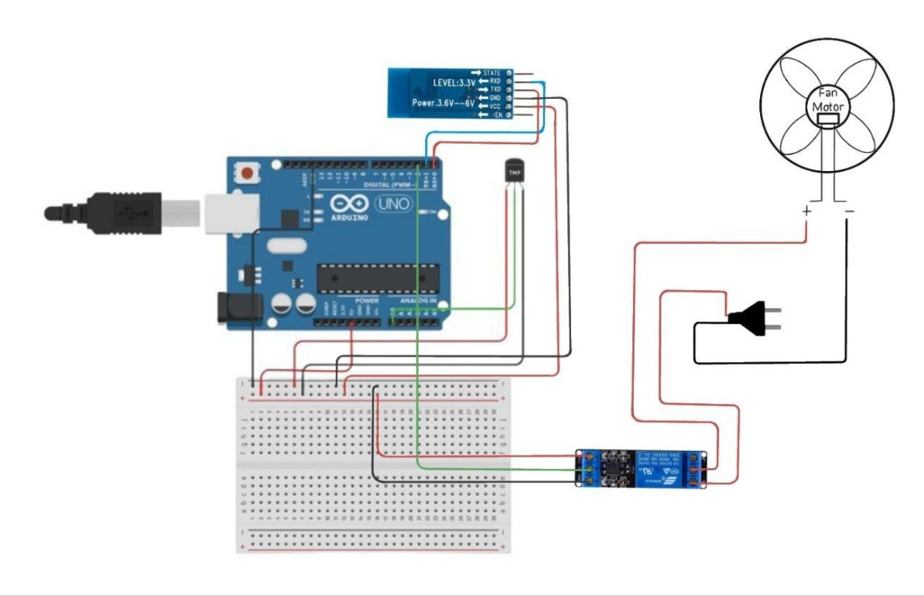
The researchers constructed a diagram of the enhanced prototype to illustrate the wiring connections between its components. As shown in Figure 1, the improved prototype featured the main components of an Arduino Uno, an LM35 temperature sensor, an HC-05 Bluetooth Module, and a 1-Channel
Figure 1. Diagram of the enhanced Arduino-based heat detector temperature control prototype

(SRD-05VDC-SL-C) Relay Module. Other components used in the prototype included a DC fan motor and a breadboard with jumper wires for circuit connections.

Hardware Components
- Arduino UNO
The Arduino served as the system's main controller. It was responsible for processing temperature data from the LM35 temperature sensor and controlling the appliance's operational state via the relay module.

- LM35 Temperature Sensor
The LM35 temperature sensor was used to detect and measure the appliance's temperature. The sensor sent the measured temperature as an analog signal to the Arduino for data processing and monitoring.
- HC-05 Bluetooth Module
HC-05 is a low-cost Bluetooth module with a communication range of up to 10 meters in an open space. This module was utilized in the prototype to establish a wireless connection between the prototype device and the HeatEye mobile application. Through this module, users can remotely monitor the appliance's temperature readings and status, and control its operation via a smartphone.
- SRD-05VDC-SL-C Relay Module
The SRD-05VDC-SL-C Relay Module was used in the prototype as an operational electrical switch, allowing the Arduino Uno to control the power supplied to the appliances. In the conducted research, the relay module used the Arduino's low-voltage output signal to safely control the fan's higher power requirements, enabling efficient switching between the Arduino and the fan.

Diagram Explanation
Figure 1 illustrates the wiring connections and the flow of the enhanced Arduino-based temperature-controlled prototype. The Arduino is connected to the LM35 temperature sensor, the HC-05 Bluetooth module, and the relay module to establish communication and control within the system.

The LM35 temperature sensor continuously measures temperature and outputs an analog signal to the Arduino Uno via the analog input pin. The Arduino Uno processes the transmitted signals and compares temperature readings with the programmed threshold value. If the detected temperature exceeds the threshold, the Arduino deactivates the relay module, causing the fan's power supply to be cut off and the fan to shut down. On the other hand, if the temperature falls below the threshold value, the Arduino will activate the relay module, allowing current to flow to the fan motor, which will automatically switch the fan ON to provide cooling. The fan motor is connected to an external power supply through the relay terminals, ensuring a stable operation within the hardware system.

Arduino Coding
The Arduino source code was developed in the Arduino IDE using C++. As shown in Figure 2, the Arduino was programmed to read the temperature data from the LM35 sensor, control the relay temperature to switch the fan operational states based on the predefined thresholds (warm at 50°C, overheat at 65°C), and implement a safety procedure that keeps the fan off for 5 seconds after the overheating events to ensure a safety cooldown period for the appliance. The Arduino was also programmed to handle Bluetooth remote commands (ON/OFF/AUTO) from the developed mobile application, ensuring that it overrides automatic control only when safe and transmits temperature data along with the appliance status to the application every second.

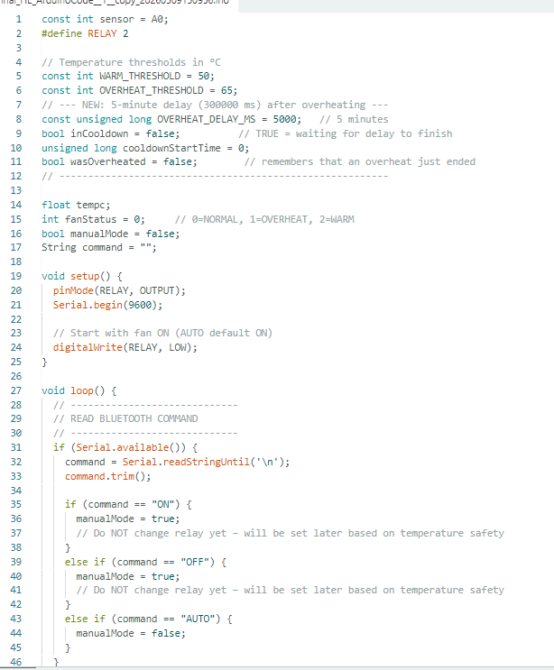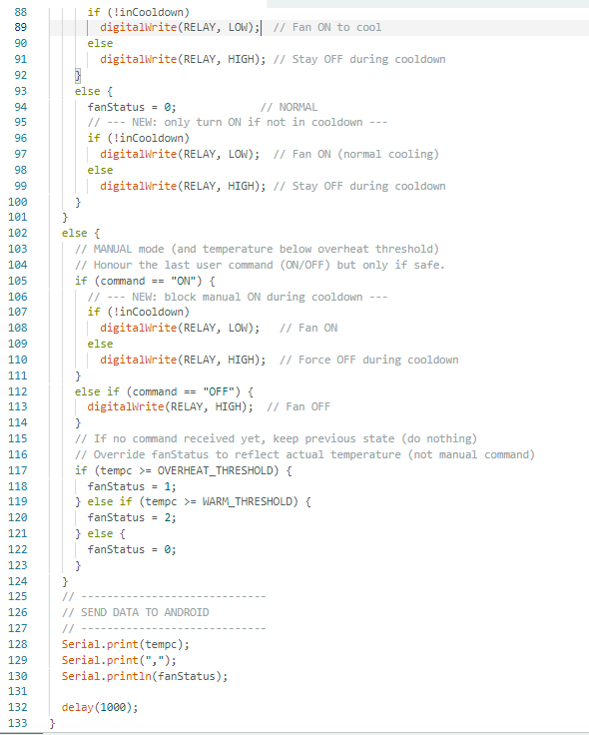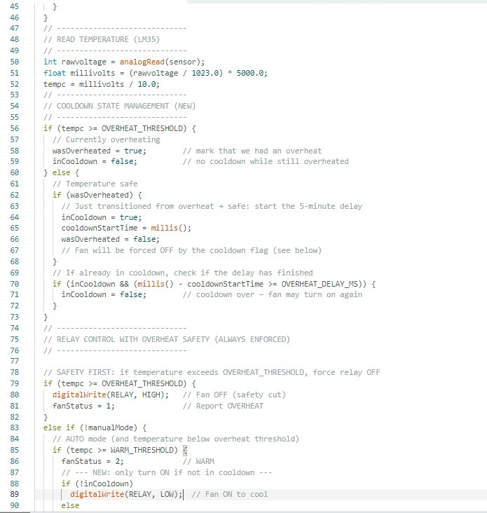
Figure 2. Arduino Code

  - Software Procedural Design
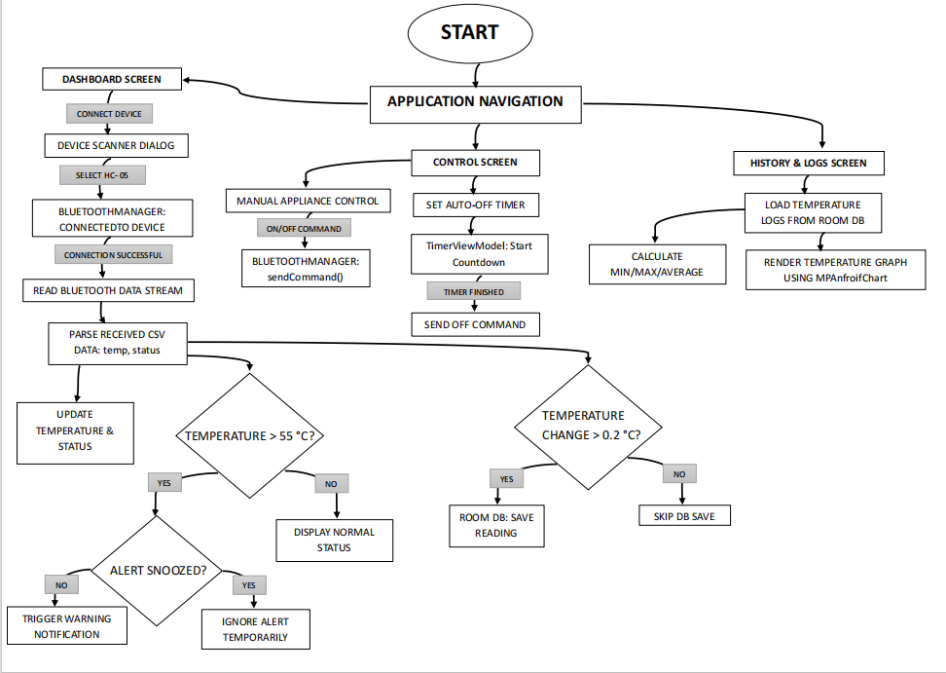
Figure 3. Flowchart of the HeatEye mobile application

Figure 3 illustrates the logical flow of the HeatEye mobile application. The application begins on the Dashboard Screen, where the user's device connects to the prototype via the HC-05 Bluetooth module. The BluetoothManager manages device connectivity, and once the connection is established, the application continuously receives temperature data from the LM35 sensor and updates the temperature display interface in real time, enabling users to monitor the temperature and status of the appliances continuously. The application also includes a Control Screen, where users can remotely control the appliance's operational states and configure an automatic shutdown timer. The automatic shutdown timer allows the user to select a countdown of 15, 30, or 60 minutes; alternatively, the user can select a customized countdown. The TimerViewModel automatically sends an OFF command to the Arduino when the timer finishes, triggering the appliance's automatic switch-off. In addition, the application stores all temperature readings locally using a Room Database. The collected data is displayed on the History & Logs screen as a visualized, timestamped line graph, historical logs of all recorded temperature readings, and the minimum, maximum, and average recorded temperatures.

Navigation between the Dashboard, Control, and History & Logs screens is managed through the application’s bottom navigation interface or via AppNavigation.
.
Software Features
    - Bluetooth Connectivity
The application implements a wireless serial connection with the Arduino-based heat detector prototype via an HC-05 Bluetooth Module, enabling real-time data transmission and control commands without physical interaction.

    - ON/OFF Remote Operation
Users can remotely control the appliance's ON/OFF functions through the application control panel. The command is sent to the Arduino via the HC-05 Bluetooth module, which then triggers the SRD-05VDC-SL-C Relay module to control the appliance's operational state.

    - Overheating Notification & Alert
When the temperature exceeds 65 °C, the application triggers an overheating notification accompanied by an alert sound. The BluetoothForegroundService manages the notification service's persistence in the device's background.

    - Real-time Temperature Monitor
The application consistently displays the live temperature readings streamed from the LM35 sensor. The temperature data is received from the Arduino via Bluetooth. The temperature is categorized into three levels: Normal (≤49 °C), Warm (50–64 °C), and Overheating (≥65 °C). Each level displays a status update along with its designated color. Green indicates the Normal status, yellow the Warm status, and red, accompanied by a push notification and an audible alert, the Overheating status. This color‑coded system for temperature updates enables intuitive real‑time monitoring of the appliance's thermal levels.

    - Temperature Data Graphing and Logs
All temperature readings are stored locally via a Room Database. The application utilizes this to construct a time-stamped line graph and historical logs, enabling users to review past temperature trends and alert events.

    - Timer Automation Control
Users can set a countdown for when the prototype automatically deactivates the appliances at the timer's expiration. The interface allows the user to either select from the preset durations of 15, 30, and 60 minutes or customize timer durations. The TimerViewModel manages the timer logic and command execution.

    - Emergency Hotline
The application includes a directory of emergency hotlines that redirects the user to the system dialer with a pre-configured number.

Testing Method
    - Functionality Test
The researchers tested the functionality of the HeatEye application by executing each core feature 10 times and tracking the number of times each successfully executed the expected action. If the feature performed as intended in at least 9 out of 10 trials, the application was considered functional, and the researchers must consider revisiting the application's programming code to identify problems.

    - Accuracy Test
The accuracy of the HeatEye application's temperature readings was tested by comparing the temperature displayed in the mobile application with the readings shown in the Arduino IDE Serial Monitor. The researchers cross-referenced the temperature readings between the application and the serial monitor to determine the consistency and accuracy of the transmitted temperature data.
    - Response Time Test
The response time of the enhanced prototype was measured by executing ON/OFF commands from the mobile application and recording the corresponding responses from the enhanced Arduino-based prototype device. The researchers observed and measured the time interval between pressing the control commands in the HeatEYE application Control screen and the actual activation or deactivation of the fan. The observation and information gathered from this test were analyzed to determine the responsiveness of the Bluetooth communication and hardware execution process.

RESULTS & DISCUSSION
This chapter discusses the results and data gathered from the employed testing procedure. It presents the development procedure for the enhanced Arduino-based Heat detector prototype with an integrated software application, "HeatEYE".

Hardware Setup and Performance
The development of the enhanced prototype involved analyzing and selecting the essential components from the original Arduino-based heat detector prototype device. The researchers made several improvements and changes from the original prototype to enhance the hardware's efficiency and incorporate the proposed HeatEye mobile application software into the prototype device. Key improvements included removing several hardware components from the original prototype, such as the push buttons, buzzer, LEDs, resistors, and LCD. The researchers made this decision after identifying that the functions of the following components can be effectively executed within the mobile application. Another improvement made to the prototype was the integration of the HC-05 Bluetooth Module. These are conducted to ensure a wireless connection between the mobile application and the Arduino-based heat detector prototype.

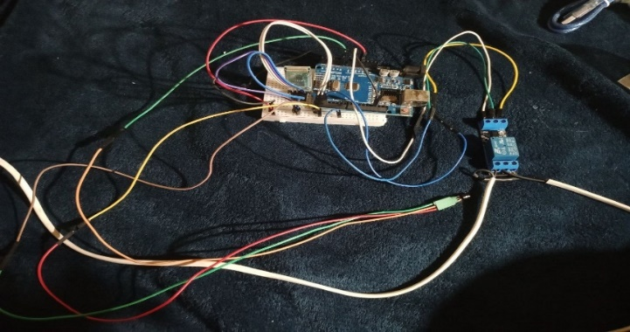
Figure 4. Arduino-Based Heat Detector Prototype Design

As shown in Figure 4, the enhanced prototype now consisted of four (4) main components: the Arduino Uno, which served as the prototype's main controller, an LM35 sensor for the temperature detection, an HC-05 Bluetooth module for the device's wireless communication, and a relay module for the appliance operational switching. From the conducted performance testing, as shown in Figure 5, it was confirmed that this enhanced setup was operating as planned. Examples are the successful execution of the automatic overheating shutdown after detecting that the temperature exceeded the programmed threshold, and the effective execution of remote commands from the HeatEYE application by successfully actuating the relay.
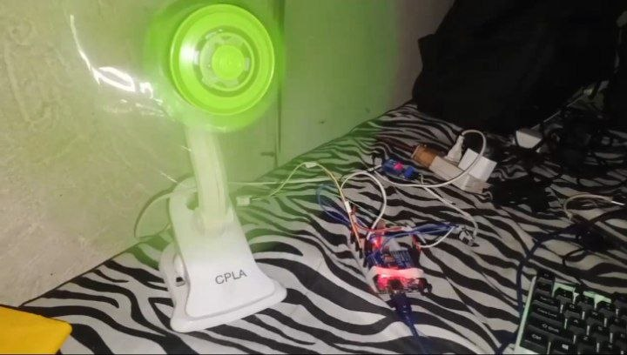
Figure 5. Prototype testing

Design and Development of HeatEYE Application UI & Logic
The HeatEye mobile application was developed in Android Studio using Kotlin as the primary programming language for the application's user interface and functionality.

The software application was programmed to continuously display LM35 temperature readings, control the appliance's operational state, store readings locally in a Room database, visualize a timestamped line graph and historical logs of recorded temperature readings, and contact the emergency hotline through the device dialer application. The HeatEYE application was designed to be simple and minimalistic, with three main navigation buttons for easy navigation and understanding, improving accessibility and giving the application a user-friendly interface.

    - Dashboard Screen
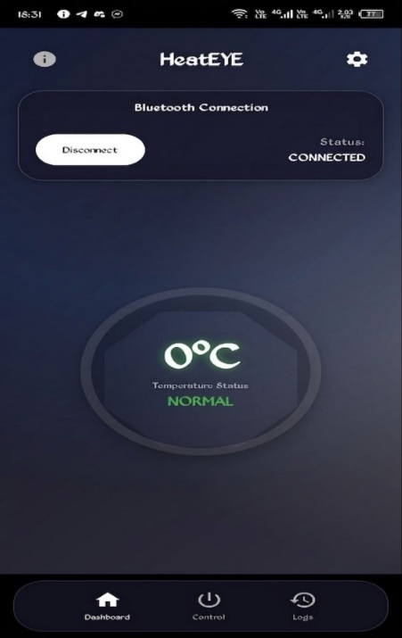
Figure 6. Dashboard Screen of the HeatEye mobile application

As shown in Figure 6, the dashboard displayed the application's Bluetooth connectivity and a live temperature readout.

    - Control Screen
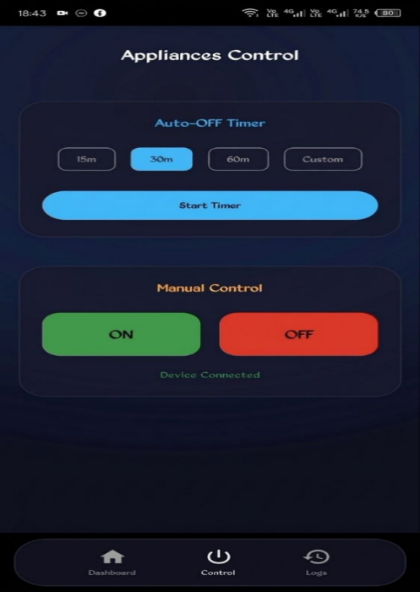
Figure 7. HeatEye application Control Screen

Figure 7 depicts the Control screen of the application, which features the automated controls for the appliance's operational state and the auto-off timer.

    - History & Logs Screen
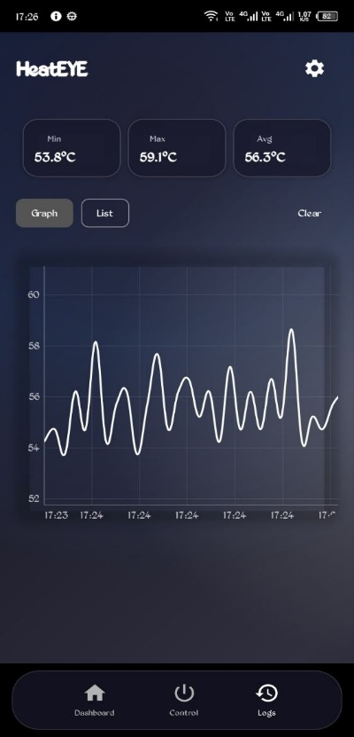
Figure 8. HeatEye’s History & Logs Screen: Graphical Representation and List

The application line graph and historical logs for all recorded temperature data were featured in the History & Logs Screen, as illustrated in Figure 8.

    - Settings Screen

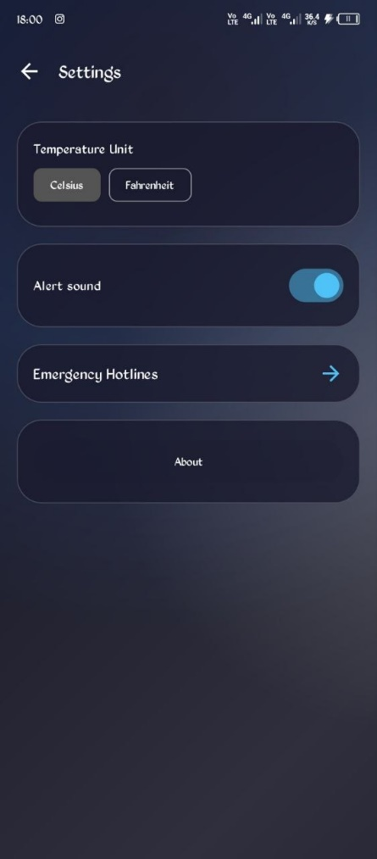
Figure 9. Settings Screen of the mobile application

The application Setting Screen contained two HeatEye application software features. One is the Temperature Unit, which allows the user to switch the temperature unit from Celsius to Fahrenheit, as illustrated in Figure 9. Moreover, the second, as shown in Figure 10, was the Emergency Screen, which allows the user to contact an Emergency Hotline via a preconfigured number in the device's dialer.
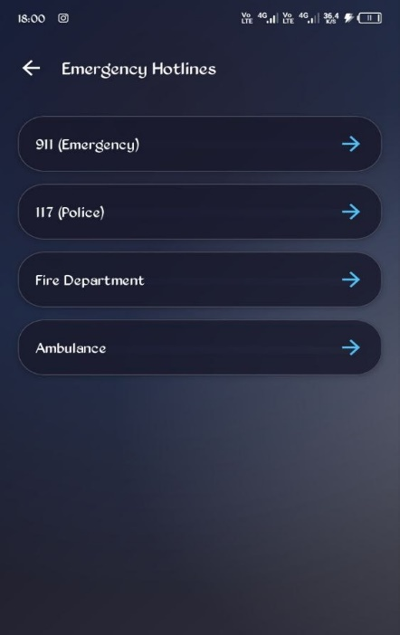
Figure 10. HeatEye’s Emergency Hotline Feature
Functionality Test
As described in the Methodology, the app functionality was tested by executing each core feature ten times. See Table 1 for the results of the functionality test.

Application Core Features | Expected Outcome | Results
Bluetooth connection or disconnection | The device successfully pairs and reliably connects with the enhanced prototype | 10/10
Remote appliance ON/OFF control | The fan or appliances automatically switch ON/OFF after issuing the command from the application | 10/10
Auto-Off timer (15, 30, 60 min or custom) | The fan or appliances automatically turn off after the set duration | 9/10
Real temperature display and live updates | The dashboard screen shows changing temperature and the temperature status every second. | 10/10
Overheating notification (≥65°C) | A pop-up notification and audible alert were triggered | 10/10
Data logging and graph generation | Display a timestamped and accurate line-graphed log with continuous updates | 10/10
Emergency hotline redirection | A device dialer with a pre-configured hotline number is opened | 10/10
Conversion of temperature Unit | Accurately converting the Celsius temperature to Fahrenheit | 10/10
Table 1. Summary of the Functionality Test Results

As shown in Table 1, all 8 features passed the functionality test, achieving a success rate of a 90% (9/10). The Auto-off timer feature failed once due to a programming issue, which caused the timer to drop off when moved to a different screen. To fix this problem, the researchers created the TimerViewModel. They fixed the programming issue, ensuring that the auto-off timer would continue its countdown even when moving to a different screen. Other than the Auto-off timer feature, no other failures were observed. The following results confirm that the HeatEYE mobile application reliably and efficiently performs its intended functions during standard operation.
Accuracy Test
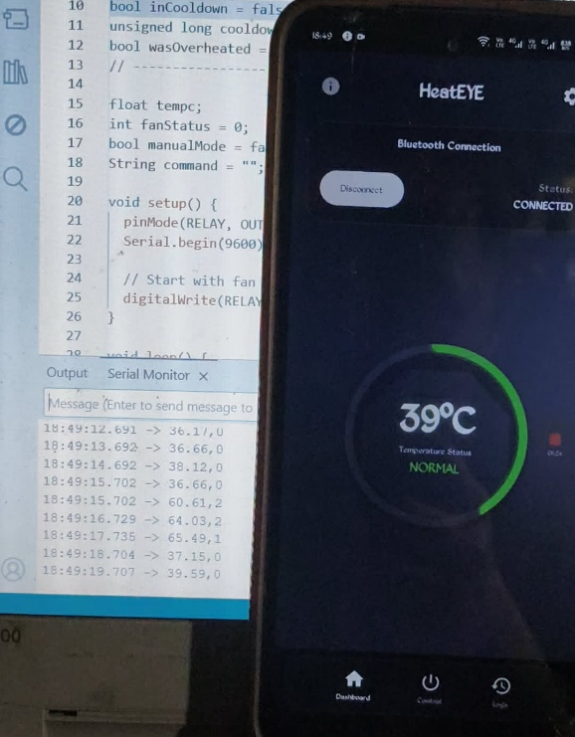
Figure 11. Accuracy Test: Comparing the application temperature display to the readings in the serial monitor

The accuracy of the mobile application's temperature display was tested as described in the Testing Method. Evidence from Figure 11 shows a corresponding temperature display between the mobile software application and the Arduino IDE Serial monitor, indicating that the application accurately aligns with the prototype's detected temperature.

Response Time Test
In accordance with the Testing Method for Response time stated in the methodology, the researchers observed the execution of the ON/OFF command through the developed application and the corresponding response from the enhanced prototype device. After multiple trials, the researchers observed and confirmed that the prototype has a 2-3 second delay before executing the command from the application.

CONCLUSION

The developed heat detection and temperature monitoring system demonstrated its intended purpose of monitoring appliance temperature and responding effectively to abnormal heat conditions. Based on the evaluation and testing conducted, the system demonstrated the ability to detect temperature changes and provide reliable monitoring during operation accurately. The integration of real-time monitoring and automated response improved the system’s ability to manage overheating, making it more efficient in supporting appliance safety and reducing the potential risks associated with excessive heat.
The results from the testing phase also indicated that the system consistently detected high-temperature conditions and provided timely notifications through the connected mobile application. The inclusion of application-based monitoring improved accessibility and allowed users to observe appliance conditions more conveniently, even without direct physical supervision. Through this approach, the study promoted a more proactive approach to handling overheating situations, compared to conventional systems that mainly rely on manual monitoring and delayed responses.
Furthermore, the study's findings confirmed that the researchers' objectives were successfully achieved. The developed system combined temperature detection, monitoring, and user accessibility into a single platform that supports safer appliance usage. Although the research focused solely on the development and evaluation of the proposed system, the results highlighted its potential as a practical tool for improving household safety and minimizing risks from overheated appliances. The study also highlights the potential for future improvements and the wider application of the system to develop more advanced safety and monitoring technologies.
LIMITATIONS AND FUTURE IMPROVEMENTS
This section discusses the essential considerations and identified limitations from the conducted study. Despite the successful development of the HeatEye system, the researchers have identified several constraints that may affect its future development. The identified limitations include the limited range of the chosen wireless components, which prevent a true smart heat monitor and controller. The lack of a fail-safe mechanism when the connection drops or the application closes prevents users from continuing to receive overheating notifications and from executing remote commands. The limitations of the appliances that can be connected to the prototype are also identified, as the prototype has only one (1) sensor and can detect and monitor only one appliance. To address these constraints and further improve the system's efficiency, functionality, and applicability, the researchers suggest the following for future research and development. The first suggested improvement is to use Wi-Fi connectivity, such as ESP32 or ESP8266, to achieve a wider range and eliminate range constraints. The second improvement suggested is to establish a fail-safe mechanism that notifies users even if the application drops its connection. Finally, the researchers suggest expanding the system to support multiple temperature sensors, enabling a wider range of appliances to be simultaneously monitored and controlled.

ACKNOWLEDGEMENT
The researchers would like to extend their heartfelt gratitude to Engr. Jose C. Felipe Jr., PCpE, for the guidance, technical assistance, patience, and valuable feedback provided throughout the development of this study. His continuous support and expertise greatly contributed to the improvement, direction, and successful completion of this research. The researchers deeply appreciate the time and effort he dedicated to helping refine this study.
The researchers also sincerely acknowledge all individuals who contributed their knowledge, ideas, and assistance during the development of this project. Their help and support were greatly appreciated and played an important role in completing this study.

REFERENCES

- AlQahtani, A. A. S., Sulaiman, M., Alshayeb, T., & Alamleh, H. (2025). From inception to innovation: A comprehensive review and bibliometric analysis of IoT-enabled fire safety systems. Safety, 11(2), 41. https://doi.org/10.3390/safety11020041
- Arafat, M. Y., Hossain, M. S., & Rahman, M. M. (2020). Smart fire detection system using IoT technology. International Journal of Advanced Computer Science and Applications, 11(5), 570–576.
- Banzi, M., & Shiloh, M. (2022). Getting started with Arduino (4th ed.). Maker Media.
- Bhoyar, K., & Sahare, P. (2019). Home automation using Bluetooth and Arduino. International Journal of Innovative Technology and Exploring Engineering, 8(6), 1200–1204.
- Casinillo, R. M. L., So, A. L. A., Mandaya, M. V., Dabalos, S. A. J., Enriquez, M. C. S., & Cane, J. F. (2024). Development of Arduino-based high heat detector temperature control prototype for household appliances. IAES International Journal of Robotics and Automation (IJRA), 13(2), 140–159. https://ijra.iaescore.com/index.php/IJRA/article/view/20620
- Chauhan, S., & Singh, R. (2021). Smart appliance monitoring system using embedded technology. International Journal of Engineering Research & Technology, 10(7), 332–336.
- Components101. (n.d.). HC-05 Bluetooth module. https://components101.com/wireless/hc-05-bluetooth-module
- Components101. (n.d.). LM35 temperature sensor pinout and features. https://components101.com/sensors/lm35-temperature-sensor
- Components101. (n.d.). Relay module pinout and working. https://components101.com/switches/5v-single-channel-relay-module-pinout-features-applications-working-datasheet
- Danaryani, S., Agustina, V., & Syamsudin, F. B. H. (2019). Fire detection based on IoT through fiber to the home (FTTH). Jurnal Poli-Teknologi, 17(2). https://doi.org/10.32722/pt.v17i2.1316
- De La Salle University. (2022). ODET: An Arduino-based overheat detector for household appliances. https://animorepository.dlsu.edu.ph/conf_shsrescon/2022/paper_csr/5/
- Electronics Hub. (n.d.). Relay module working principle. https://www.electronicshub.org/relay-module/
- Firdaus, Tjandi, Y., & Pratama, A. (2023). Design of a fire detection system using fire and smoke sensors based on Arduino microcontroller. Jurnal Media Elektrik, 21(2). https://doi.org/10.59562/metrik.v21i2.2211
- Ghosh, A., & Das, R. (2020). Android-based home automation system using Bluetooth. International Journal of Scientific Research in Computer Science Engineering and Information Technology, 6(3), 269–274.
- Hasan, M. R., Islam, S., & Rahman, A. (2022). Design and implementation of smart home safety system using IoT. Heliyon, 8(6), e09650. https://doi.org/10.1016/j.heliyon.2022.e09650
- Ifani, A. Z., Fajar, M. I. N., & Badila, A. A. (2026). IoT-based early fire detection system uses MQ-2 smoke sensor and DS18B20 temperature sensor. Infact: International Journal of Computers, 10(1), 22–29. https://doi.org/10.61179/infact.v10i01.763
- Islam, M. T., Rahman, M. A., & Hasan, M. K. (2021). IoT-based intelligent fire detection and alarm system. International Journal of Electrical and Computer Engineering, 11(2), 1452–1460.
- Juwariyah, T., Prayitno, S., Krisnawati, L., & Sulasminingsih, S. (2021). Design of IoT-based home fire detection system equipped with a data logger. IOP Conference Series: Materials Science and Engineering, 1125, 012079. https://doi.org/10.1088/1757-899X/1125/1/012079
- Kaur, A., & Kaur, P. (2019). Smart home automation using IoT and Android application. International Journal of Computer Applications, 178(7), 1–5.
- Khalaf, O. I., Abdulsahib, G. M., & Zghair, N. A. K. (2019). IoT fire detection system using sensor with Arduino. Revista AUS, 26(1), 26–30.
- Khalid, A., et al. (2020). IoT-based fire detection and temperature monitoring system. Procedia Computer Science, 170, 1171–1176. https://www.sciencedirect.com/science/article/pii/S1877050920312087
- Kumar, N., & Kumar, P. (2018). Smart home automation system using Bluetooth technology and Arduino. ResearchGate. https://www.researchgate.net/publication/328073462_Smart_Home_Automation_System_Using_Bluetooth_Technology_and_Arduino

- Kumar, S., & Kumar, V. (2020). Automatic temperature monitoring and controlling system using Arduino. International Journal of Engineering Applied Sciences and Technology, 5(4), 334–338.
- Li, S., Xu, L. D., & Zhao, S. (2015). The Internet of Things: A survey. Information Systems Frontiers, 17(2), 243–259. https://doi.org/10.1007/s10796-014-9492-7
- Malik, S., & Ahmad, N. (2021). Development of a low-cost smart fire alarm system using Arduino. International Journal of Advanced Research in Computer and Communication Engineering, 10(5), 45–50.
- Microsoft. (n.d.). Bluetooth overview. https://learn.microsoft.com/en-us/windows/uwp/devices-sensors/bluetooth
- Mishra, P., & Sharma, R. (2022). IoT-enabled smart monitoring system for household appliances. Materials Today: Proceedings, 56, 2150–2155. https://doi.org/10.1016/j.matpr.2021.11.420
- National Fire Protection Association. (2023). Electrical fires. https://www.nfpa.org/
- Perilla, F. S., Villanueva, G. R., & Cacanindin, N. M. (2018). Fire safety and alert system using Arduino sensors with IoT integration. Proceedings of the 7th International Conference on Software and Computer Applications, 199–203. https://doi.org/10.1145/3185089.3185121
- Prasad, K. N., & Rao, B. P. (2021). Real-time temperature monitoring system using wireless sensor network. International Journal of Scientific & Technology Research, 10(2), 80–84.
- Rajput, P., & Yadav, S. (2020). Smart home automation and security system using Arduino and Android application. International Research Journal of Engineering and Technology, 7(6), 4210–4215.
- Saeed, F., Paul, A., Rehman, A., Hong, W. H., & Seo, H. (2018). IoT-based intelligent modeling of smart home environment for fire prevention and safety. Journal of Sensor and Actuator Networks, 7(1), 11. https://doi.org/10.3390/jsan7010011
- Sarhan, Q. I. (2020). Systematic survey on smart home safety and security systems using the Arduino platform. IEEE Access, 8, 128362–128384. https://doi.org/10.1109/ACCESS.2020.3008610
- Sharma, A., & Gupta, R. (2021). Embedded systems for home automation and safety monitoring. International Journal of Recent Technology and Engineering, 10(1), 55–60.
- Singh, H., & Verma, A. (2020). Wireless sensor-based temperature monitoring system for smart homes. International Journal of Innovative Research in Technology, 7(2), 112–118.
- Suklabaidya, S., & Das, I. (2021). IoT as a platform: For smart home analysis and monitoring of fire parameters. In Advanced Computing and Intelligent Technologies (pp. 329–338). Springer. https://doi.org/10.1007/978-981-16-2164-2_27
- Texas Instruments. (n.d.). LM35 precision centigrade temperature sensors datasheet. https://www.ti.com/product/LM35
- Texas Instruments. (n.d.). LM35 temperature sensor technical documentation. https://www.ti.com/lit/ds/symlink/lm35.pdf
- Vernekar, H. G. (2023). Detection of fire and its control using Arduino and Proteus. Journal of Electronics and Informatics, 5(1), 54–62. https://doi.org/10.36548/jei.2023.1.004
- World Health Organization. (2022). Burns and household fire injuries. https://www.who.int/news-room/fact-sheets/detail/burns
- Yerpude, S., & Singhal, T. K. (2018). Smart home system using Internet of Things. International Journal of Advanced Research in Computer Science, 9(1), 181–184.
- Kliuba, M., & Likhouzova, T. (2023). Software tools for creating interfaces for interaction with Arduino via Bluetooth. Adaptive Systems of Automatic Control, 2(43), 3–11.
- Roque, G., & Padilla, V. S. (2020). LPWAN based IoT surveillance system for outdoor fire detection. IEEE Access, 8, 114900–114909.
- Paglinawan, C. C., Bacabac, M. L. C., & Garcia, T. J. D. (2022). Electrical fault detection and analysis Arduino-based preventive device for household appliances. 2022 IEEE Region 10 Symposium (TENSYMP), 1–6.
- Emets, S. V., Polischouk, I. N., & Kudayarov, V. N. (2020). Processing calibration results for measuring transducers with an integrated sensor. Journal of Physics: Conference Series, 1582(1), 012026.
- Rathore, R. V., Dixit, S., & Arvindhan, A. (2024). Home automation using Bluetooth HC-05 and ATmega328. Journal of Engineering Research and Applications, 14(5), 28-34.

