Lightweight Dual-View Feature Fusion for Hand-Object Interaction Recognition
Houda Skhoun
School of Artificial Intelligence
Nanjing University of Information Science and Technology (NUIST)
Nanjing, China
houda.skhoun@gmail.com

Abstract
Wrist-worn hand-object interaction (HOI) recog- nition is a critical capability for wearable rehabil- itation systems, assistive technologies,augmented reality and human-computer interaction applica- tions. Compared with fixed external cameras, wrist-worn wearable devices provide user-centered observations that are more suitable for contin- uous real-world interaction monitoring. How- ever, many existing wrist-worn HOI recognition systems still face important challenges, includ- ing incomplete interaction representation caused by single-view observations, viewpoint ambiguity, self-occlusion and the high computational com- plexity of recent deep learning approaches. To address these limitations, this paper proposes a lightweight dual-view framework for hand-object interaction recognition using synchronized palm- view and back-view RGB images acquired from a wrist-worn dual-camera device. The proposed framework employs a shared MobileNetV2 back- bone combined with multi-level feature extraction to jointly capture fine-grained spatial details and high-level semantic representations. To effectively integrate complementary information from differ- ent network depths, a view-specific adaptive fusion mechanism is introduced to dynamically balance intermediate and deep feature representations for each visual stream. The fused dual-view represen- tation is subsequently used for interaction classifi- cation. Experimental evaluation under the Leave- One-Participant-Out (LOPO) cross-subject pro- tocol demonstrates that the proposed framework achieves a mean accuracy of 82.36% and a mean F1-score of 81.65% while maintaining low compu- tational complexity suitable for real-time wearable applications. Ablation studies further confirm the effectiveness of the proposed multi-level feature extraction and adaptive fusion strategy. The pro- posed approach provides an effective balance be- tween recognition performance and computational
efficiency for lightweight wearable HOI recognition systems.
Keywords: Hand-object interaction recogni- tion; Dual-view learning; Adaptive feature fusion; Lightweight deep learning; Wrist-worn systems

Introduction
Wrist-worn hand-object interaction (HOI) recog- nition has emerged as an important capabil- ity for wearable rehabilitation systems, assistive technologies, augmented reality (AR/VR), and human-robot collaboration [1–3]. Accurate recog- nition of object manipulation enables intelligent systems to better understand user intention and provide adaptive responses during real-world in- teraction scenarios. Recent advances in deep learning have significantly improved visual recog- nition performance by enabling automatic extrac- tion of hierarchical feature representations directly from image data, overcoming many limitations as- sociated with traditional handcrafted feature ap- proaches [4–8].
Among existing acquisition settings, wrist-worn wearable systems have attracted increasing atten- tion due to their portability, non-intrusive design and suitability for continuous real-world interac- tion monitoring. Compared with fixed external cameras, wrist-worn devices provide observations that remain closely aligned with the user’s hand movements during object manipulation while re- ducing dependency on environmental setup and camera placement. Their compact and wearable nature makes them particularly suitable for assis- tive technologies, rehabilitation systems and real- time human-computer interaction applications.
Existing hand-object interaction recognition methods have explored various sensing configu- rations, including external cameras, egocentric wearable cameras, RGB-D systems and multi- modal sensing approaches [9–13]. Despite recent

progress, robust HOI recognition remains chal- lenging in wrist-worn settings due to several fac- tors. First, many approaches rely on single-view observations, which may fail to capture complete interaction information, including fine-grained fin- ger articulation, object contact regions and global hand posture. Second, viewpoint variation, illu- mination changes and inter-subject differences in hand shape and manipulation style further de- grade recognition performance [2, 14]. Finally, many recent methods depend on computation- ally expensive architectures or temporal modeling strategies, limiting their suitability for lightweight real-time wearable applications.
To address these limitations, this paper pro- poses a lightweight dual-view framework for hand- object interaction recognition using synchronized palm-view and back-view observations acquired from a wrist-worn dual-camera device. The proposed acquisition setup provides complemen- tary visual information from two synchronized viewpoints, where the palm-view stream cap- tures detailed finger articulation and object con- tact regions, while the back-view stream provides global hand posture and movement configura- tion. By combining both visual streams, the pro- posed framework improves robustness against self- occlusion and viewpoint ambiguity during fine- grained interaction analysis.
Based on this acquisition setting, a lightweight multi-level deep learning framework is devel- oped using a shared MobileNetV2 backbone com- bined with adaptive feature fusion. Intermedi- ate and high-level feature representations are ex- tracted from different network depths to cap- ture complementary spatial and semantic infor- mation. An adaptive gating mechanism is then employed to dynamically balance the contribution of multi-level features for each visual stream be- fore dual-view fusion and interaction classification. The proposed framework is designed to main- tain low computational complexity while achieving strong recognition performance suitable for wear- able real-time applications.
The proposed framework is evaluated using a subject-independent Leave-One-Participant-Out (LOPO) protocol on a dual-view hand-object in- teraction dataset collected using the proposed wrist-worn acquisition system. Experimental re- sults demonstrate that the proposed framework achieves strong recognition performance while maintaining low computational cost under cross- subject evaluation conditions.
The main contributions of this paper are sum- marized as follows:
- A lightweight dual-view framework is pro-
posed for hand-object interaction recognition using synchronized palm-view and back-view observations acquired from a wrist-worn dual- camera device.
- A multi-level feature extraction strategy is de- veloped to integrate intermediate and deep representations for fine-grained interaction analysis.
- An adaptive view-specific fusion mechanism is proposed to dynamically combine comple- mentary multi-level representations from the two visual streams.
- Extensive experiments under the LOPO cross-subject evaluation protocol demon- strate the effectiveness, robustness and com- putational efficiency of the proposed frame- work for wearable real-time HOI recognition.

Related Work

Hand-Object Interaction Recognition
Hand-object interaction (HOI) recognition has at- tracted significant attention in computer vision due to its applications in human-computer interac- tion, rehabilitation systems, robotics and wearable intelligent devices [1–3]. Compared with isolated hand gesture recognition, HOI recognition is more challenging because interaction understanding de- pends on both hand configuration and object- related contextual information. In practical sce- narios, severe occlusions, viewpoint variations, il- lumination changes and inter-subject differences further complicate robust recognition [2, 14].
Early HOI recognition methods mainly relied on handcrafted features and conventional machine learning techniques. Traditional approaches fo- cused on hand segmentation object tracking, and geometric modeling using RGB or RGB-D in- puts [15–18]. Other works incorporated contex- tual information such as grasp type and object attributes to better characterize manipulation ac- tions [11, 19]. Although these methods estab- lished important foundations for interaction anal- ysis, their dependence on handcrafted representa- tions and multi-stage processing pipelines limited their generalization capability in unconstrained environments.
Recent advances in deep learning have signifi- cantly improved HOI recognition by enabling end- to-end learning of discriminative visual represen- tations [4–6]. CNN-based approaches have been

widely adopted for egocentric interaction under- standing, object localization and hand-object re- lationship modeling [3,20,21]. In addition, several studies proposed multitask frameworks integrat- ing hand pose estimation, object detection and in- teraction recognition within unified architectures [12, 22, 23]. Temporal modeling techniques based on recurrent networks, 3D convolutional networks and ConvLSTM architectures further improved dynamic interaction analysis [9, 24–29]. Multi- modal approaches combining RGB, depth and skeleton information have also been explored to improve robustness under challenging conditions [10, 30, 31].
Despite these advances, many existing HOI recognition methods rely on large annotated datasets, temporal video modeling or computa- tionally expensive architectures, which may limit their applicability in lightweight wearable systems and real-time environments [3, 12, 23]. Further- more, single-view observations often provide in- complete interaction representations under occlu- sion and viewpoint variation, motivating the ex- ploration of multi-view learning strategies.

Multi-View Learning and Fea- ture Fusion
Multi-view learning has been widely investigated to improve recognition robustness under viewpoint variation and partial occlusion [10]. By combining complementary observations from multiple view- points, multi-view systems can capture more com- plete spatial information and reduce ambiguity during visual recognition tasks. Previous stud- ies demonstrated that multi-view observations im- prove gesture and action recognition performance by exploiting complementary visual cues across different perspectives [33–35].
To integrate information from multiple view- points, several fusion strategies have been pro- posed. Early fusion combines visual information before feature extraction, enabling the network to directly learn correlations between views [36, 37]. Feature-level fusion merges intermediate represen- tations extracted independently from each view- point while preserving discriminative characteris- tics from individual views [38, 39]. Late fusion combines predictions generated from separate vi- sual streams [36, 40]. More recent approaches em- ploy attention-based or adaptive fusion mecha- nisms to dynamically emphasize the most informa- tive representations according to the input char- acteristics [41–43]. These methods demonstrated improved robustness in recognition tasks affected by viewpoint ambiguity and occlusion.

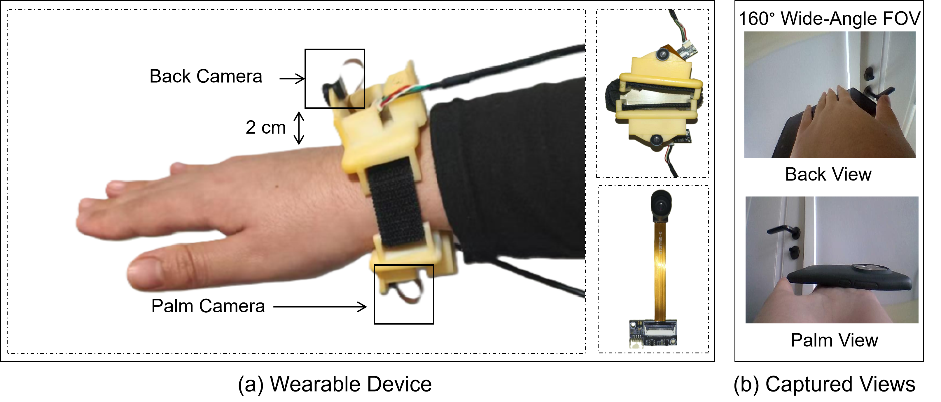
Figure 1: (a) Custom-designed wearable dual-camera device showing the positioning of the back and palm cameras at approximately 2 cm from the wrist. (b) Examples of captured images from the two viewpoints, illustrating the back view and palm view with a 160° wide-angle
field of view.

However, many existing multi-view approaches rely on computationally intensive architectures or dense temporal processing. In addition, several methods primarily focus on global representations without explicitly exploiting complementary infor- mation from different feature levels.

Multi-Level Feature Learning
Multi-level feature learning has become an impor- tant component of modern deep visual recognition systems. CNNs naturally learn hierarchical repre- sentations, where shallow and intermediate layers capture local spatial patterns, while deeper layers encode high-level semantic information. Residual learning and feature pyramid strategies demon- strated that combining features from multiple net- work depths improves robustness in complex vi- sual recognition tasks [44, 45].
For HOI recognition, multi-level feature integra- tion is particularly important because subtle vari- ations in finger articulation, grasp configuration and object contact regions often determine the in- teraction category. However, many existing ap- proaches mainly rely on deep semantic representa- tions while ignoring intermediate spatial features that may contain important fine-grained interac- tion cues. Moreover, several methods continue to depend on single-view observations or computa- tionally expensive temporal architectures, limiting their suitability for lightweight wearable applica- tions and real-time deployment.
Another important challenge concerns subject- independent generalization. Variations in hand shape, manipulation style and interaction exe- cution across users can significantly affect vi- sual appearance and reduce recognition robust- ness. Consequently, there remains a need for ef- ficient HOI recognition frameworks capable of in-

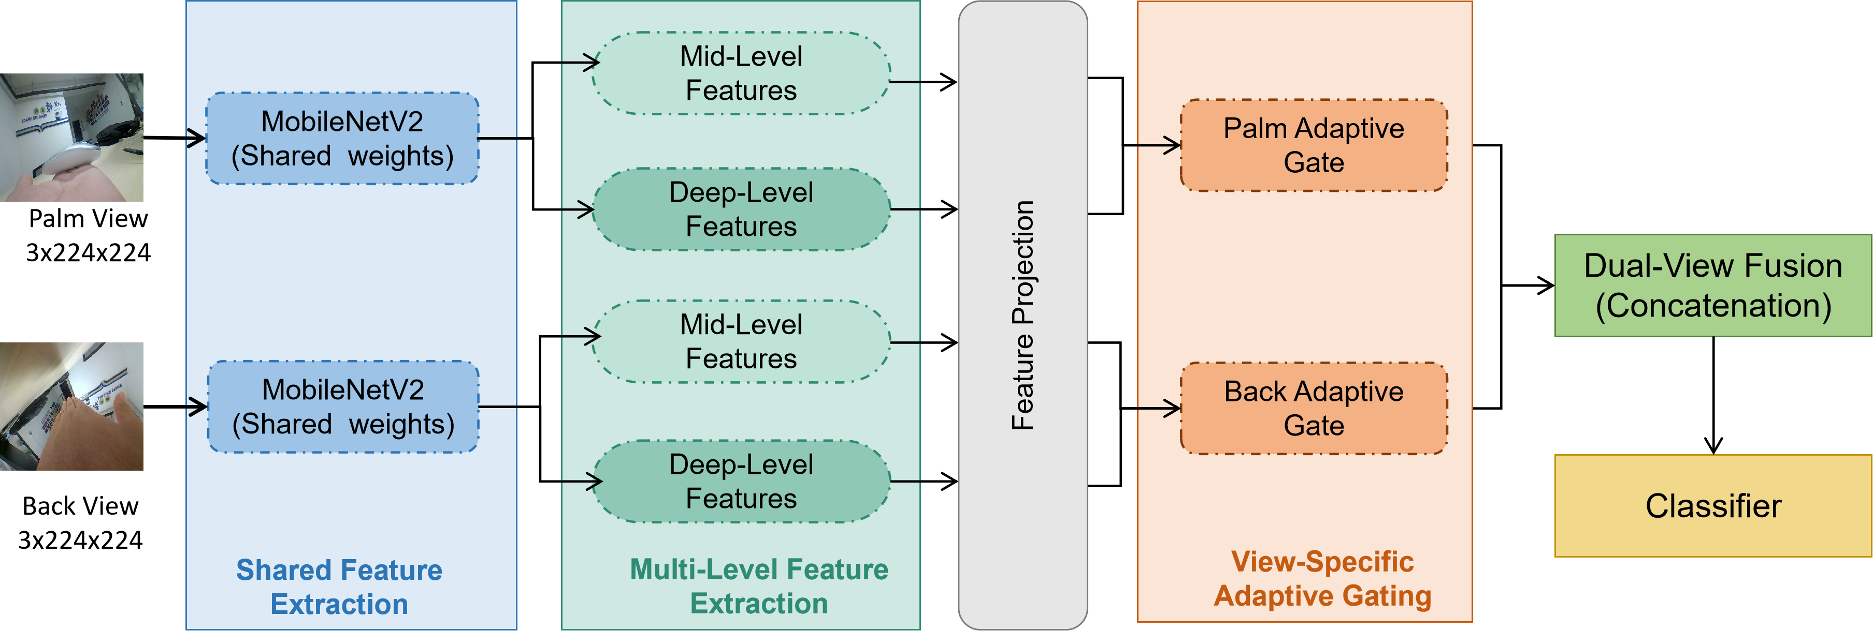
Figure 2: Overview of the proposed dual-view multi-level feature fusion framework for hand object interaction recognition. The framework integrates dual-view inputs, multi-level feature extraction, adaptive gating fusion and final classification

tegrating complementary multi-view information while maintaining low computational complexity and strong cross-subject generalization capability.
To address these limitations, this work proposes a lightweight dual-view multi-level feature fusion framework for hand-object interaction recognition using synchronized palm-view and back-view ob- servations. The proposed framework combines multi-level feature extraction with adaptive view- specific fusion to effectively exploit complemen- tary visual information while maintaining compu- tational efficiency suitable for wearable real-time applications.

Methodology

Data Acquisition
The proposed framework employs a lightweight wrist-worn dual-camera device designed to cap- ture complementary visual information during hand-object interactions. As illustrated in Figure 1, two synchronized wide-angle RGB cameras with an approximate 160◦ field of view are mounted on a wearable wrist support to simultaneously acquire palm-view and back-view observations of the same interaction instance. The back-view camera cap- tures global hand posture and interaction context, whereas the palm-view camera provides detailed information related to finger articulation, contact regions and manipulated objects. The cameras are positioned approximately 2 cm from the wrist sur- face to maximize viewpoint complementarity while maintaining a compact wearable configuration.
Let I^{p} and I^{b} denote the palm-view and back- view RGB inputs, respectively. Each synchro- nized image pair represents the same interaction captured from complementary viewpoints. This
dual-view representation enables the framework to exploit both fine-grained local interaction cues and global contextual information while reduc- ing ambiguities caused by self-occlusion and view- point variation. For compatibility with the Mo- bileNetV2 backbone, all input images are resized to 224×224 pixels. During training, data augmen- tation techniques including random resized crop- ping, color jittering, affine transformations, Gaus- sian blurring and random grayscale conversion are applied to improve robustness and reduce overfit- ting. Since the two images form a synchronized pair, identical augmentation parameters are ap- plied to both views to preserve spatial correspon- dence. The processed images are finally normal- ized using ImageNet mean and standard deviation values before being passed to the network.

Network Overview
The proposed framework performs hand-object in- teraction (HOI) recognition using synchronized palm-view and back-view observations. As il- lustrated in Figure 2, the framework consists of dual visual streams, multi-level feature extrac- tion, adaptive feature fusion and a lightweight classification module. Let I^{p} ∈ R^{3×H×W} and I^{b}
∈ R^{3×H×W} denote the palm-view and back-view
RGB inputs, respectively. Both visual streams are
processed using a shared MobileNetV2 backbone Φ(·) to extract hierarchical feature representations F^{p} and F^{b}. To preserve both local spatial de- tails and high-level semantic information, multi- level features are extracted from intermediate and deep network layers. An adaptive gating module then generates compact view-specific representa- tions v^{palm} and v^{back} for the palm-view and back- view streams, respectively. The resulting repre-
sentations are subsequently fused to generate the

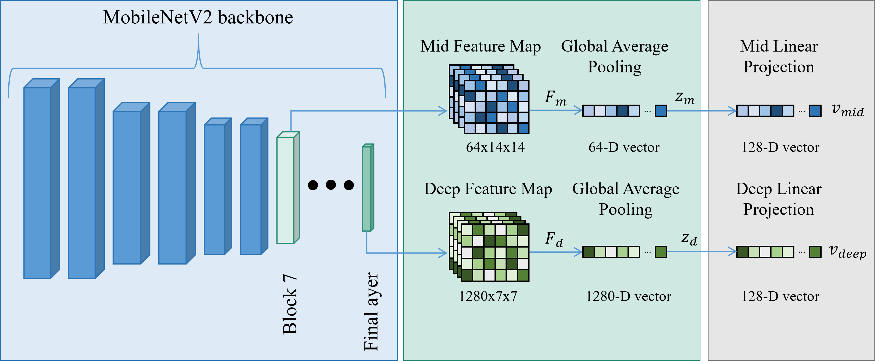
Figure 3: Multi-level feature extraction and token generation from the MobileNetV2 backbone

final interaction representation v, which is passed to the classification module for HOI prediction. The proposed framework effectively exploits com- plementary multi-view information while main- taining computational efficiency adapted to wear- able real-time applications.

Multi-Level Feature Extraction
To obtain discriminative yet efficient visual repre- sentations, the proposed framework employs Mo- bileNetV2 as a shared lightweight backbone for both palm-view and back-view streams. Mo- bileNetV2 is selected due to its favorable trade- off between recognition performance and computa- tional efficiency, making it compatible with wear- able real-time applications.
Given the synchronized inputs I^{p} and I^{b}, the shared backbone Φ(·) extracts hierarchical feature representations for each visual stream:
F^{p} = Φ(I_{p}), F^{b} = Φ(I_{b}) (1)
Instead of relying only on the final deep repre- sentation, the proposed framework extracts fea- tures from multiple network depths to preserve both local spatial details and high-level semantic information. As illustrated in Figure 3, interme- diate feature maps capture fine-grained interac- tion patterns related to finger articulation, object boundaries and contact regions, whereas deeper feature maps encode higher-level interaction se- mantics. For each visual stream, the backbone produces an intermediate feature map F_{m} and a deep feature map F_{d}. Global average pooling is then applied to obtain compact feature vectors:
z_{m} = GAP(F_{m}), z_{d} = GAP(F_{d}) (2)
Since the extracted representations have different dimensions, lightweight linear projection layers are used to map them into a unified embedding space:
v_{mid} = W_{m}z_{m} + b_{m}, v_{deep} = W_{d}z_{d} + b_{d} (3)
where W_{m} and W_{d} denote learnable projection matrices and b_{m} and b_{d} are bias terms. The projected representations v_{mid} and v_{deep} are subsequently used as inputs to the adaptive fusion module.

Adaptive Feature Fusion
The discriminative importance of intermediate and deep feature representations may vary de- pending on the interaction type, viewpoint con- ditions and object appearance. To dynamically balance the contribution of different representa- tion levels, the proposed framework employs an adaptive gating module for each visual stream, as illustrated in Figure 4. Given the projected inter- mediate and deep representations v_{mid} and v_{deep}, adaptive gating weights are computed as:
ω = MLP([v_{mid}; v_{deep}]) (4)
where [;] denotes feature concatenation and ω = [ω_{mid}; ω_{deep}] represents the learned fusion weights associated with the intermediate and deep rep- resentations, respectively. To obtain normalized adaptive weights, a softmax operation is applied:
[α_{mid}, α_{deep}] = Softmax(ω) (5)
The final view-specific representation v^{view} is then computed as a weighted combination of the two feature levels:
vview = αmid ⊙ vmid + αdeep ⊙ vdeep (6)

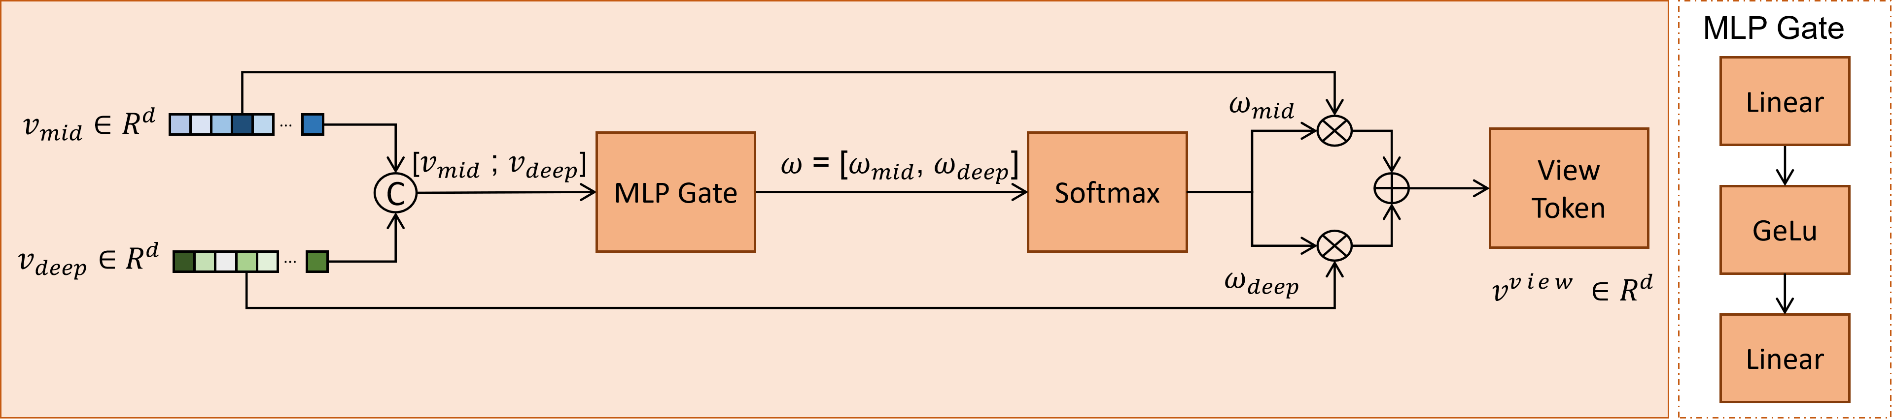
Figure 4: View-specific adaptive gating mechanism for combining mid-level and deep-level feature representations

where ⊙ denotes element-wise multiplication. This adaptive formulation enables the framework to dynamically emphasize either fine-grained spa- tial information or high-level semantic represen- tations according to the characteristics of the in-
teraction. After adaptive fusion, the palm-view and back-view representations are concatenated to generate the final interaction representation:
v = [v^{palm}; v^{back}] (7)
By adaptively balancing multi-level representa- tions for each visual stream, the proposed fu- sion strategy effectively exploits complementary information from both viewpoints while maintain- ing low computational complexity appropriate for lightweight wearable applications.

Classification
The fused representation v is passed to a lightweight classification module composed of two fully connected layers with GELU activation and dropout regularization. The classifier transforms the fused representation into the final hand-object interaction prediction scores. The network is trained end-to-end using the cross-entropy loss function. The resulting output scores correspond to the predicted hand-object interaction cate- gories.

Experiments and Results

Experimental Setup

Dataset Description
The experiments are conducted on a dual-view hand-object interaction dataset collected using the proposed wrist-worn acquisition system. Each in- teraction instance consists of synchronized palm- view and back-view RGB image pairs captured simultaneously from complementary viewpoints. Example interaction samples from the proposed dataset are illustrated in Figure 5. The dataset
contains 13 hand-object interaction categories in- volving four commonly manipulated objects: pen, mouse, book and phone. The interaction types include grasp, hold, pinch and support actions. Data were collected from 10 participants under varying hand configurations and interaction styles to ensure cross-subject diversity. Overall, the dataset contains 26,894 synchronized interaction samples with a near-uniform class distribution, as summarized in Table 1. The diversity of sub- jects, viewpoints and interaction patterns provides a challenging evaluation scenario for cross-subject hand-object interaction recognition under varying occlusion and viewpoint conditions.
Table 1: Class-wise distribution of interaction samples in the proposed dual-view hand object interaction dataset

Class ID | Interaction | #Samples
C01 | Grasp Pen | 2092
C02 | Hold Book | 2052
C03 | Hold Mouse | 2059
C04 | Hold Pen | 2059
C05 | Hold Phone | 2051
C06 | Pinch Book | 2071
C07 | Pinch Mouse | 2095
C08 | Pinch Pen | 2077
C09 | Pinch Phone | 2060
C10 | Support Book | 2052
C11 | Support Mouse | 2059
C12 | Support Pen | 2110
C13 | Support Phone | 2057
Total | — | 26,894

Evaluation Protocol
To evaluate the cross-subject generalization capa- bility of the proposed framework, a Leave-One- Participant-Out (LOPO) cross-validation protocol is adopted. The dataset contains interaction sam- ples collected from 10 participants. In each eval- uation fold, the samples from one participant are

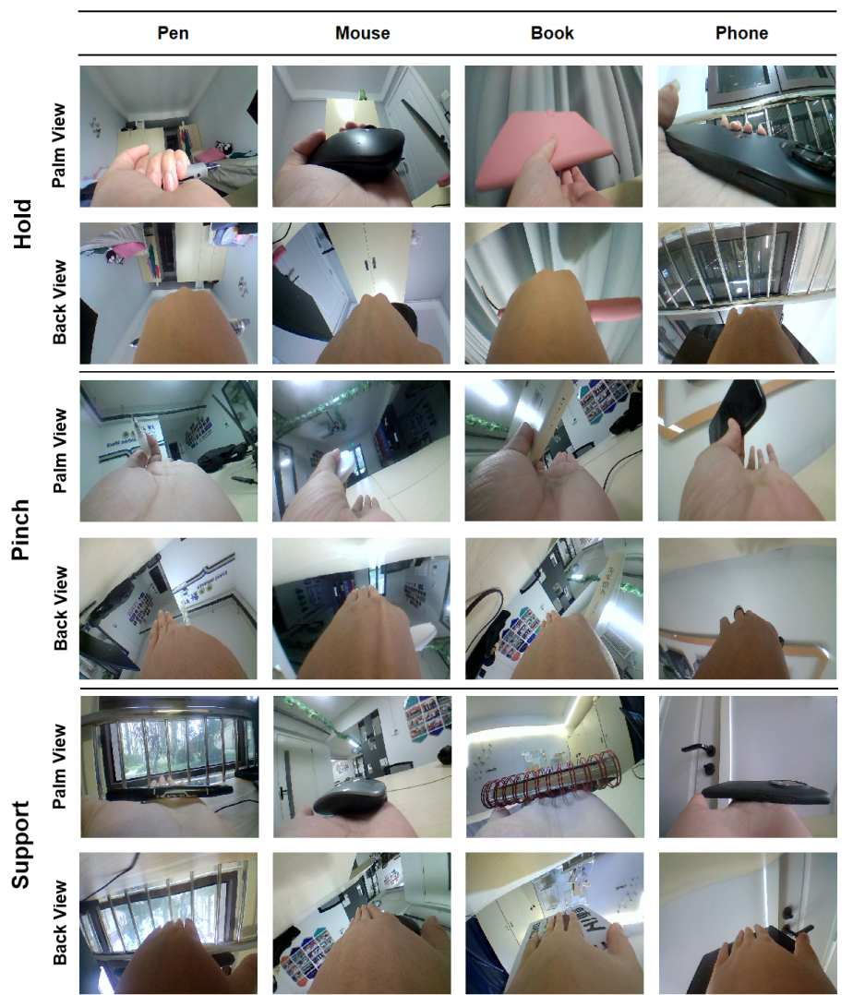
Figure 5: Each interaction instance is represented by synchronized palm and back views, highlighting complementary visual information for different grasp types and manipulated objects

used for testing, while the remaining participants are used for training. This process is repeated across all participants and the final performance is reported as the average across the 10 folds. The LOPO protocol ensures strict subject-independent evaluation by testing the model on unseen users, providing a reliable assessment of the framework under varying hand shapes, interaction styles and manipulation patterns.

Implementation Details

The proposed framework is implemented using the PyTorch deep learning library and trained us- ing GPU acceleration. The network is trained for 20 epochs with a batch size of 32 using the AdamW optimizer. The initial learning rate is set to 3 × 10⁻⁵, with a weight decay of 5 × 10⁻⁵. A co- sine annealing learning rate scheduler is employed to gradually reduce the learning rate during train- ing. Cross-entropy loss with label smoothing 0.1
is adopted to improve generalization.
During training, synchronized data augmenta-

Table 2: Cross-subject performance of the proposed method under the Leave-One-Participant-Out (LOPO) protocol

Fold | Acc (%) | F1 (%) | Precision (%) | Recall (%)
1 | 89.95 | 90.57 | 89.89 | 89.94
2 | 87.26 | 89.04 | 87.38 | 87.00
3 | 71.50 | 81.31 | 72.02 | 70.63
4 | 76.49 | 81.91 | 76.75 | 76.71
5 | 91.28 | 92.57 | 91.57 | 91.06
6 | 86.73 | 89.21 | 86.73 | 86.32
7 | 63.09 | 77.65 | 63.65 | 59.42
8 | 86.99 | 88.63 | 86.71 | 86.20
9 | 84.63 | 88.86 | 84.85 | 83.61
10 | 85.68 | 88.58 | 85.77 | 85.58
Mean±std | 82.36 ± 8.61 | 86.83 ± 4.55 | 82.53 ± 8.43 | 81.65 ± 9.42

tion is applied to both visual streams. The im- ages are normalized using the ImageNet mean and standard deviation values. For evaluation, images are resized to 224×224, normalized using Ima- geNet statistics and tested without augmentation. Experiments are conducted under the Leave-One- Participant-Out (LOPO) cross-validation proto- col, where each participant is used once as the test subject while the remaining participants are used for training.

Evaluation Metrics
The performance of the proposed framework is evaluated using accuracy, macro-averaged preci- sion, recall and F1-score. Accuracy measures the overall proportion of correctly classified interac- tion samples, while precision, recall and F1-score provide a more comprehensive evaluation of the recognition performance across all interaction cat- egories. The macro-average strategy computes each metric independently for every class and then averages the results, ensuring equal contribution from all categories regardless of sample frequency. This evaluation protocol provides a balanced as- sessment of the framework under the cross-subject LOPO setting. In addition, confusion matrix anal- ysis is performed to investigate class-wise recogni- tion behavior and identify common misclassifica- tion patterns between visually similar hand-object interaction categories.

Quantitative Results

LOPO Cross-Subject Performance
To evaluate the cross-subject generalization ca- pability of the proposed framework, experiments
are conducted using the Leave-One-Participant- Out (LOPO) evaluation protocol described in the previous section. The model is trained using data from nine participants and evaluated on the re- maining unseen participant across all 10 folds.
The quantitative results are summarized in Table 2. The proposed framework achieves a mean accuracy of 82.36% and a mean F1-score of 81.65%, demonstrating strong recognition perfor- mance under the subject-independent evaluation setting. The framework also achieves high preci- sion and recall values, indicating stable classifica- tion performance across different interaction cate- gories and participants.
The results demonstrate that the proposed dual-view framework effectively captures comple- mentary interaction information from the palm and back views while maintaining robustness to variations in hand appearance, manipulation style and viewpoint conditions. Despite the challenging cross-subject evaluation setting, the framework maintains consistent recognition per- formance across most participants, highlighting the effectiveness of the proposed multi-level fea- ture extraction and adaptive fusion strategy.

Comparison with Baseline Methods
To evaluate the effectiveness of the proposed framework, comparisons are conducted with several widely used lightweight convolutional neural network architectures, including Mo- bileNetV2, MobileNetV3, ShuffleNetV2, Ghost- Net, EfficientNet-B0, MobileViT, SqueezeNet and MnasNet. All models are evaluated under the same LOPO cross-subject protocol using identi- cal training settings and preprocessing strategies

Table 3: Performance comparison between the proposed method and baseline convolutional neural network architectures in terms of mean accuracy (mAcc), mean F1-score (mF1), mean precision, mean recall and test loss under the LOPO cross-subject evaluation protocol

Method | mAcc (%) | mF1 (%) | mPrec (%) | mRec (%) | Loss
MobileNetV2 | 80.60 ± 10.60 | 79.58 ± 11.80 | 85.62 ± 6.16 | 80.82 ± 10.43 | 1.03 ± 0.27
MobileNetV3-Small | 68.74 ± 12.27 | 66.73 ± 13.46 | 74.71 ± 9.06 | 68.99 ± 12.26 | 1.33 ± 0.28
MobileNetV3-Large | 76.33 ± 11.75 | 75.06 ± 12.69 | 82.63 ± 8.14 | 76.57 ± 11.54 | 1.17 ± 0.32
ShuffleNetV2 | 75.04 ± 12.63 | 73.57 ± 14.11 | 79.58 ± 11.30 | 75.24 ± 12.43 | 1.16 ± 0.32
GhostNet | 73.88 ± 16.95 | 71.99 ± 18.83 | 78.72 ± 13.32 | 74.21 ± 16.81 | 1.22 ± 0.44
EfficientNet-B0 | 77.75 ± 13.18 | 76.18 ± 14.72 | 83.08 ± 9.35 | 77.97 ± 13.05 | 1.11 ± 0.35
MobileViT | 77.07 ± 12.29 | 75.73 ± 14.12 | 82.81 ± 6.61 | 77.40 ± 12.12 | 1.14 ± 0.34
SqueezeNet | 75.35 ± 14.72 | 73.86 ± 16.24 | 78.93 ± 12.50 | 75.67 ± 14.57 | 1.20 ± 0.37
MnasNet | 77.69 ± 10.77 | 76.83 ± 11.80 | 83.33 ± 7.31 | 77.94 ± 10.74 | 1.17 ± 0.26
Proposed Method | 82.36 ± 8.61 | 81.65 ± 9.42 | 86.83 ± 4.55 | 82.53 ± 8.43 | 1.01 ± 0.27

to ensure a fair comparison.
Since the proposed framework operates on syn- chronized dual-view inputs, all baseline architec- tures are adapted to the same two-view setting.
Table 4: Computational complexity and efficiency comparison of the evaluated models in terms of parameters, FLOPs and inference latency

Feature representations extracted from the palm-

view and back-view streams are combined using feature concatenation before classification.
The quantitative comparison results are sum- marized in Table 3. The proposed framework achieves the best overall performance among the evaluated lightweight architectures, obtaining a mean accuracy of 82.36%, a mean F1-score of 81.65% and a mean precision of 86.83%. In comparison, MobileNetV2 achieves 80.60% accu- racy, while EfficientNet-B0 and MobileViT achieve 77.75% and 77.07%, respectively. The proposed framework also achieves the lowest test loss among most evaluated methods.
These results demonstrate that the proposed multi-level feature extraction and adaptive fu- sion strategy effectively improve recognition per- formance under the cross-subject evaluation set- ting. Despite its lightweight design, the proposed framework achieves superior recognition perfor- mance.

Computational Complexity Analysis
To evaluate the efficiency of the proposed frame- work, a computational complexity comparison is conducted using the number of parameters, FLOPs and inference latency. The results are summarized in Table 4. The proposed frame- work requires only 2.53M parameters and 0.65 GFLOPs, remaining comparable to lightweight architectures such as MobileNetV2 and Mnas- Net while being substantially less complex than EfficientNet-B0 and MobileViT. The framework achieves an average inference latency of 16.94
Method Params FLOPs Latency

MobileNetV2 | 2.88 | 0.65 | 16.19 ± 2.00
MobileNetV3-Small | 1.23 | 0.12 | 15.21 ± 0.90
MobileNetV3-Large | 3.47 | 0.47 | 19.24 ± 3.20
ShuffleNetV2 | 1.78 | 0.30 | 23.91 ± 1.74
GhostNet | 4.56 | 0.31 | 32.51 ± 1.89
EfficientNet-B0 | 4.67 | 0.77 | 32.06 ± 2.09
MobileViT | 5.27 | 2.84 | 29.55 ± 3.73
SqueezeNet | 0.99 | 0.53 | 6.16 ± 0.40
MnasNet | 3.76 | 0.67 | 15.45 ± 0.65
Proposed | 2.53 | 0.65 | 16.94 ± 1.30

ms, supporting real-time execution for wearable hand-object interaction recognition. Although SqueezeNet achieves lower latency due to its com- pact architecture, its recognition performance is significantly lower. In contrast, models such as GhostNet and EfficientNet-B0 exhibit higher computational cost and inference latency with- out providing superior recognition performance. These results indicate that the proposed frame- work provides an effective trade-off between recog- nition accuracy and computational efficiency for lightweight dual-view HOI recognition.

Ablation Study
To evaluate the contribution of the different com- ponents of the proposed framework, an ablation study is conducted under the LOPO cross-subject evaluation protocol. The study investigates the impact of multi-level feature extraction and dif-

Table 5: Ablation study evaluating the impact of multi-level feature extraction and fusion strategies on cross-subject recognition performance under the LOPO protocol

Variant | mAccuracy (%) | mF1-score (%) | Params (M) | Latency (ms)
Deep only | 79.64 | 78.87 | 2.46 | 16.95 ± 1.99
Mid+Deep+Concat | 80.36 | 79.92 | 2.50 | 17.58 ± 2.44
Mid+Deep+Sum | 81.63 | 80.89 | 2.47 | 17.31 ± 2.59
Mid+Deep+Shared Gate | 79.82 | 78.93 | 2.50 | 16.30 ± 1.46
Mid+Deep+Separate Gate(Proposed) | 82.36 | 81.65 | 2.53 | 16.94 ± 1.30

ferent feature fusion strategies while maintaining the same backbone architecture and training con- figuration across all variants.
The quantitative results are summarized in Ta- ble 5. Using only deep features achieves a mean accuracy of 79.64% and an F1-score of 78.87%, in- dicating that high-level semantic representations alone are insufficient to fully capture fine-grained interaction patterns. Incorporating both inter- mediate and deep features improves recognition performance, with concatenation and summation strategies achieving 80.36% and 81.63% accuracy, respectively.
The shared adaptive gating mechanism achieves 79.82% accuracy, suggesting that a single gat- ing function is insufficient to model the distinct characteristics of the palm-view and back-view streams. In contrast, the proposed separate gating mechanism achieves the best overall performance with 82.36% accuracy and an F1-score of 81.65%, while maintaining low computational complexity and real-time inference latency.
These results demonstrate that the proposed view-specific adaptive fusion strategy enables more effective integration of complementary multi- level representations for dual-view hand-object in- teraction recognition.

Qualitative Analysis

Confusion Matrix Analysis
To further investigate the classification behavior of the proposed framework, the aggregated confu- sion matrix obtained from the 10-fold LOPO eval- uation is presented in Figure 6. Most predictions are strongly concentrated along the main diago- nal, indicating effective recognition performance across the majority of interaction categories.
Several categories exhibit particularly high recognition accuracy. For example, support mouse (1924), support phone (1968) and support book (1866) achieve a large number of correct predic- tions. Similarly, strong recognition performance is observed for hold mouse (1818), hold pen (1787) and hold phone (1746). These interactions are

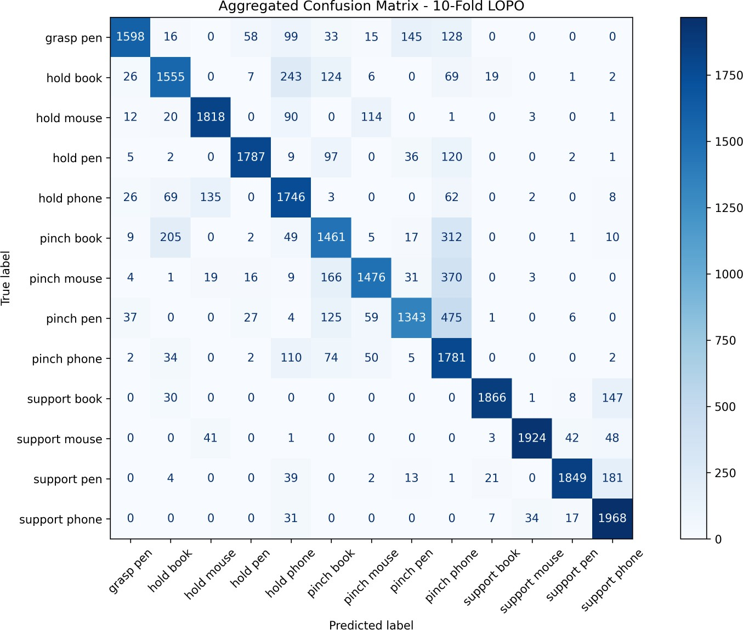
Figure 6: Aggregated confusion matrix obtained from the 10-fold Leave-One-Participant-Out (LOPO) evaluation, illustrating the classification performance of the proposed method across the 13 hand object interaction categories, with correct predictions concentrated along the main diagonal

generally characterized by more stable hand con- figurations and clearer object visibility. Despite the overall strong performance, several informa- tive misclassification patterns are observed. In particular, confusion occurs among visually sim- ilar pinch-related interactions, especially between pinch pen and pinch phone (475 samples), as well as between pinch mouse and pinch phone (370 samples). Additional confusion is observed be- tween hold and pinch interactions involving the same object category, such as pinch book misclas- sified as hold book (205 samples). These patterns reflect the fine-grained nature of the task and the difficulty of distinguishing subtle differences in fin- ger articulation and object appearance under par- tial occlusion.
Overall, the confusion matrix demonstrates that the proposed framework effectively distinguishes most interaction categories while maintaining ro- bustness under cross-subject and multi-view eval-

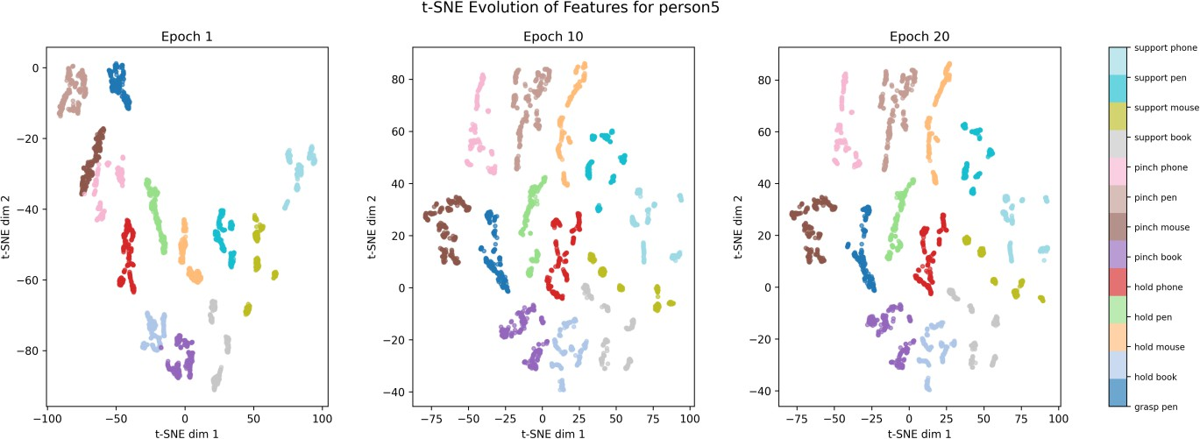
Figure 7: t-SNE visualization of the learned feature representations at different training stages: Epoch 1, Epoch 10 and Epoch 20 for a representative subject under the LOPO evaluation protocol

uation conditions.

Feature Representation Analysis
To further analyze the learned feature represen- tations, a t-SNE visualization is conducted using feature embeddings extracted from the proposed model at different training stages under the LOPO evaluation protocol. The visualization includes samples from all 13 interaction categories and is illustrated in Figure 7.
At Epoch 1, the feature representations already exhibit an initial level of class separation, indi- cating that the framework quickly captures mean- ingful interaction patterns from the dual-view in- puts. However, several clusters remain relatively dispersed with partial overlap between visually similar interaction categories.
As training progresses, the feature distribu- tions become progressively more structured and compact. At Epoch 10, clearer separation be- tween interaction categories is observed, indicat- ing improved discriminative representation learn- ing. By Epoch 20, the feature embeddings form well-defined and compact clusters with reduced inter-class overlap, demonstrating that the pro- posed framework learns semantically meaningful representations for fine-grained hand-object inter- action recognition.

Scalability Across Backbone Architectures
To further investigate the scalability of the pro- posed framework, additional experiments are con- ducted by replacing the lightweight MobileNetV2 backbone with the higher-capacity ConvNeXtV2- Tiny architecture while preserving the proposed
multi-level feature extraction and adaptive fu- sion strategy. In addition, the standalone ConvNeXtV2-Tiny backbone is evaluated under the same LOPO protocol to analyze the contribu- tion of the proposed framework beyond the back- bone architecture itself.
The results are summarized in Table 6. The standalone ConvNeXtV2-Tiny backbone achieves a mean accuracy of 86.95% and a mean F1-score of 86.25%, demonstrating strong capability for fine-grained hand-object interaction recognition. When integrated into the proposed framework, the performance further improves to 87.84% mean ac- curacy and 86.98% mean F1-score, highlighting the effectiveness of the proposed multi-level fea- ture extraction and adaptive fusion strategy in exploiting complementary dual-view information. Compared with the lightweight MobileNetV2- based configuration, the ConvNeXtV2-Tiny-based framework achieves higher recognition perfor- mance, but with increased computational com- plexity, as the number of parameters rises from
2.53M to 28.07M. These results demonstrate that the proposed framework is flexible and scalable across different backbone architectures, enabling adaptation to various computational and perfor- mance requirements.

Conclusion
This paper presented a lightweight dual-view framework for hand-object interaction recognition using synchronized palm-view and back-view ob- servations acquired from a wrist-worn device. The proposed approach combines multi-level feature extraction and adaptive feature fusion to effec- tively capture both fine-grained interaction details and high-level semantic information from comple-

Table 6: Performance comparison of the standalone ConvNeXtV2-Tiny backbone and the proposed dual-view framework with different backbone architectures under the LOPO protocol

Configuration | mAcc (%) | mF1 (%) | Params (M)
ConvNeXtV2-Tiny | 86.95 | 86.25 | 28.26
Proposed (MobileNetV2 backbone) | 82.36 | 81.65 | 2.53
Proposed (ConvNeXtV2 backbone) | 87.84 | 86.98 | 28.07

mentary viewpoints.
To improve representation learning, the frame- work integrates intermediate and deep features extracted from a shared MobileNetV2 backbone and employs a view-specific adaptive gating mech- anism to dynamically balance their contribu- tions. Experimental results under the Leave-One- Participant-Out (LOPO) cross-subject evaluation protocol demonstrate that the proposed frame- work achieves strong recognition performance while maintaining low computational complexity suitable for real-time wearable applications.
The ablation study confirms the effectiveness of the proposed multi-level fusion strategy and the importance of the separate adaptive gating mech- anism for palm-view and back-view streams. Ad- ditional experiments further demonstrate the scal- ability of the framework across different backbone architectures.
Overall, the proposed framework provides an ef- fective and computationally efficient solution for dual-view hand-object interaction recognition and shows strong potential for future wearable intel- ligent systems, human-computer interaction and assistive technology applications.

References
- Ohn-Bar E, Trivedi M M. Hand gesture recognition in real time for automotive in- terfaces[J]. IEEE Transactions on Intelligent Transportation Systems, 2014, 15(6): 2368–
2377.
- Cheng H, Yang L, Liu Z. Survey on 3D hand gesture recognition[J]. IEEE Transactions on Circuits and Systems for Video Technology, 2015, 26(9): 1659–1673.
- Fan H, Zhuo T, Yu X, et al. Understanding atomic hand-object interaction with human intention[J]. IEEE Transactions on Circuits and Systems for Video Technology, 2021, 32(1): 275–285.
- Chung H Y, Chung Y L, Tsai W F. An effi- cient hand gesture recognition system based
on deep CNN[C]// IEEE International Con- ference on Industrial Technology. IEEE, 2019: 853–858.
- Lin H I, Hsu M H, Chen W K. Human hand gesture recognition using a convolution neu- ral network[C]// IEEE International Confer- ence on Automation Science and Engineer- ing. IEEE, 2014: 1038–1043.
- Li G, Tang H, Sun Y, et al. Hand gesture recognition based on convolution neural net- work[J]. Cluster Computing, 2019, 22(S2): 2719–2729.
- Ozcan T, Basturk A. Transfer learning-based convolutional neural networks with heuristic optimization[J]. Neural Computing and Ap- plications, 2019, 31(12): 8955–8970.
- Sahoo J P, Prakash A J, Pl-awiak P, et al. Real-time hand gesture recognition using fine-tuned convolutional neural network[J]. Sensors, 2022, 22(3): 706.
- Tran D S, Ho N H, Yang H J, et al. Real-time hand gesture spotting and recognition using RGB-D camera and 3D convolutional neu- ral network[J]. Applied Sciences, 2020, 10(2):
722.
- Mahmud H, Morshed M M, Hasan M K. A deep learning-based multimodal depth-aware dynamic hand gesture recognition[EB/OL]. arXiv:2107.02543, 2021.
- Ishihara T, Kitani K M, Ma W C, et al. Recognizing hand-object interactions in wear- able camera videos[C]// IEEE International Conference on Image Processing. IEEE, 2015: 1349–1353.
- Tekin B, Bogo F, Pollefeys M. Unified egocen- tric recognition of 3D hand-object poses[C]// IEEE Conference on Computer Vision and Pattern Recognition. IEEE, 2019: 4511–4520.
- Garcia-Hernando G, Yuan S, Baek S, et al. First-person hand action benchmark with RGB-D videos and 3D hand pose annota- tions[C]// IEEE Conference on Computer

Vision and Pattern Recognition. IEEE, 2018: 409–419.
- Ahmad A, Migniot C, Dipanda A. Track- ing hands in interaction with objects: A review[C]// International Conference on Signal-Image Technology and Internet-Based Systems. IEEE, 2017: 360–369.
- Romero J, Kjellstr¨om H, Kragic D. Hands in action: Real-time 3D reconstruction of hands[C]// IEEE International Conference on Robotics and Automation. IEEE, 2010: 458–463.
- Hamer H, Schindler K, Koller-Meier E, et al. Tracking a hand manipulating an object[C]// IEEE International Conference on Computer Vision. IEEE, 2009: 1475–1482.
- Kang B, Tan K H, Jiang N, et al. Hand seg- mentation for hand-object interaction from depth map[C]// IEEE Global Conference on Signal and Information Processing. IEEE, 2017: 259–263.
- Sridhar S, Mueller F, Zollh¨ofer M, et al. Real- time joint tracking of a hand manipulating an object[C]// European Conference on Com- puter Vision. Springer, 2016: 294–310.
- Cai M, Kitani K M, Sato Y. Understanding hand-object manipulation with grasp types and object attributes[C]// Robotics: Science and Systems. 2016.
- Bertasius G, Park H S, Yu S X, et al. First person action-object detection with egonet[EB/OL]. arXiv:1603.04908, 2016.
- Schroder M, Ritter H. Hand-object interac- tion detection with fully convolutional net- works[C]// IEEE Conference on Computer Vision and Pattern Recognition Workshops. IEEE, 2017: 18–25.
- Yan W, Gao Y, Liu Q. Human-object inter- action recognition using multitask neural net- work[C]// International Symposium on Au- tonomous Systems. IEEE, 2019: 323–328.
- Kwon T, Tekin B, Stu¨hmer J, et al. H2O: Two hands manipulating objects for inter- action recognition[C]// IEEE International Conference on Computer Vision. IEEE, 2021: 10138–10148.
- K¨opu¨klu¨ O, Gunduz A, Kose N, et al. Real- time hand gesture detection and classifica- tion using convolutional neural networks[C]//
IEEE International Conference on Automatic Face and Gesture Recognition. IEEE, 2019: 1–8.
- Mujahid A, Awan M J, Yasin A, et al. Real- time hand gesture recognition based on deep learning YOLOv3 model[J]. Applied Sciences, 2021, 11(9): 4164.
- Lai K, Yanushkevich S N. CNN+RNN depth and skeleton based dynamic hand gesture recognition[C]// International Conference on Pattern Recognition. IEEE, 2018: 3451–3456.
- Pigou L, Van Den Oord A, Dieleman S, et al. Beyond temporal pooling: Recurrence and temporal convolutions for gesture recog- nition[J]. International Journal of Computer Vision, 2018, 126(2): 430–439.
- Molchanov P, Gupta S, Kim K, et al. Hand gesture recognition with 3D convolutional neural networks[C]// IEEE Conference on Computer Vision and Pattern Recognition Workshops. IEEE, 2015: 1–7.
- Zhang L, Zhu G, Shen P, et al. Learning spa- tiotemporal features using 3DCNN and Con- vLSTM for gesture recognition[C]// IEEE International Conference on Computer Vi- sion Workshops. IEEE, 2017: 3120–3128.
- Gao Q, Chen Y, Ju Z, et al. Dynamic hand gesture recognition based on 3D hand pose estimation[J]. IEEE Sensors Journal, 2021, 22(18): 17421–17430.
- Miah A S M, Hasan M A M, Shin J. Dynamic hand gesture recognition using graph neural networks[J]. IEEE Access, 2023, 11: 4703–
4716.
- Sun S. A survey of multi-view machine learn- ing[J]. Neural Computing and Applications, 2013, 23(7): 2031–2038.
- Shukla D, Erkent O¨ , Piater J. A multi-view hand gesture RGB-D dataset for human- robot interaction scenarios[C]// IEEE Inter- national Symposium on Robot and Human In- teractive Communication. IEEE, 2016: 1084–
1091.
- Wang L, Ding Z, Tao Z, et al. Generative multi-view human action recognition[C]// IEEE International Conference on Computer Vision. IEEE, 2019: 6212–6221.
- Zhang Z, Wang C, Xiao B, et al. Cross-view action recognition using contextual maximum

margin clustering[J]. IEEE Transactions on Circuits and Systems for Video Technology, 2014, 24(10): 1663–1668.
- Arnold E, Dianati M, De Temple R, et al. Cooperative perception for 3D object detec- tion in driving scenarios[J]. IEEE Transac- tions on Intelligent Transportation Systems, 2020, 23(3): 1852–1864.
- Teepe T, Wolters P, Gilg J, et al. EarlyBird: Early fusion for multi-view tracking in bird’s- eye view[C]// IEEE/CVF Winter Conference on Applications of Computer Vision. IEEE, 2024: 102–111.
- Gao Y, Maggs M. Feature-level fusion in per- sonal identification[C]// IEEE Computer So- ciety Conference on Computer Vision and Pattern Recognition. IEEE, 2005: 468–473.
- Fadadu S, Pandey S, Hegde D, et al. Multi-view fusion of sensor data for im- proved perception in autonomous driv- ing[C]// IEEE/CVF Winter Conference on Applications of Computer Vision. IEEE, 2022: 2349–2357.
- Seeland M, M¨ader P. Multi-view classification with convolutional neural networks[J]. PLoS One, 2021, 16(1): e0245230.
- Cheng J, Yin W, Wang K, et al. Adaptive fu- sion of single-view and multi-view depth for autonomous driving[C]// IEEE/CVF Con- ference on Computer Vision and Pattern Recognition. IEEE, 2024: 10138–10147.
- Zheng D, Zheng X, Yang L T, et al. Multi-view feature fusion network for cam- ouflaged object detection[C]// IEEE/CVF Winter Conference on Applications of Com- puter Vision. IEEE, 2023: 6232–6242.
- Ezati A, Dezyani M, Rana R, et al. A lightweight attention-based deep network via multi-scale feature fusion for multi- view facial expression recognition[EB/OL]. arXiv:2403.14318, 2024.
- He K, Zhang X, Ren S, et al. Deep resid- ual learning for image recognition[C]// IEEE Conference on Computer Vision and Pattern Recognition. IEEE, 2016: 770–778.
- Lin T Y, Doll´ar P, Girshick R, et al. Feature pyramid networks for object detection[C]// IEEE Conference on Computer Vision and Pattern Recognition. IEEE, 2017: 2117–2125.

