DR.Rais Abdul Hamid
Khan¹, B.Vardhini², V.HimaBindhu³, karthik reddy⁴,vamshi⁵.
¹Professor,SOCSE,Sandip University,Nashik.
² ³ ⁴ ⁵ B.TECH Scholar,School of Computer Science and Engineering,Sandip University,Nashik,India.

Abstract
Social justice and diversity are important for building fair and equal institutions in society. Social justice means providing equal rights, opportunities, and respect to every individual without discrimination. Diversity refers to the presence of people from different backgrounds, cultures, religions, genders, and economic conditions. Institutions such as schools, colleges, workplaces, and government organizations must promote these values to create a balanced and inclusive environment.
When institutions follow social justice and support diversity, they reduce inequality and give equal opportunities to all individuals. This helps marginalized groups grow and participate in education, employment, and decision-making. Diversity also improves understanding among people and brings new ideas and innovation. Therefore, promoting social justice and diversity helps in building a peaceful and progressive society.

Social justice and diversity

- Introduction
- Social justice and diversity are essential values in modern society. Social justice focuses on fairness and equal treatment of all individuals. It ensures that everyone receives equal opportunities in education, employment, and social life. Diversity refers to differences among people such as culture, language, gender, religion, and economic status. Respecting these differences helps create harmony in society.
- Institutions play a major role in shaping people’s lives. Schools, colleges, offices, and government bodies influence opportunities and development. If institutions promote fairness and equality, society becomes more balanced. Inclusive policies and practices help reduce discrimination and provide equal chances for growth.
- Diversity in institutions brings different perspectives and experiences. When people from various backgrounds work together, they share ideas and learn from each other. This improves creativity, innovation, and decision-making. Therefore, social justice and diversity together help in building strong and inclusive institutions.
- Concept of social justice
- Social justice means creating a society where everyone is treated fairly and equally. It ensures that all individuals get equal rights and opportunities regardless of their background. Social justice aims to reduce inequality and support weaker sections of society.
- It also focuses on providing basic human rights such as education, healthcare, employment, and freedom. Governments and institutions play an important role in maintaining social justice through laws and policies. Reservation systems, welfare programs, and anti-discrimination laws help in protecting marginalized groups.
- Social justice strengthens democracy and promotes unity in society. It helps people live with dignity and respect.
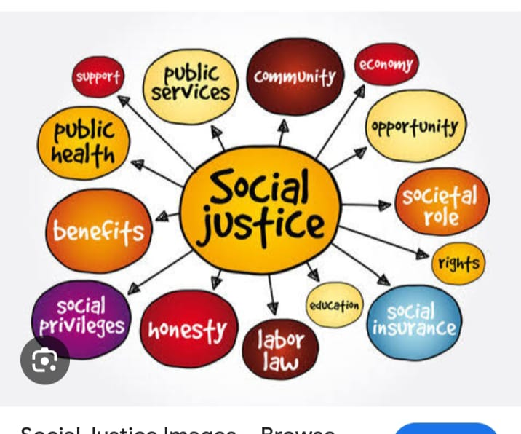

- Concept of diversity
- Diversity refers to the presence of differences among individuals in society. These differences may be related to culture, religion, language, gender, age, or economic background. Diversity makes society rich and vibrant.
- Respecting diversity helps people understand each other better. It reduces conflicts and promotes harmony. When people from different backgrounds interact, they learn new ideas and perspectives. Diversity also encourages creativity and innovation in institutions and workplaces.
- Therefore, accepting diversity is necessary for social development and progress.

- Examples of Social Diversity

- India: Multiple religions, languages, cultures, and castes coexist, making it a global example of social diversity.

- United States: A country of immigrants from different ethnicities and cultural backgrounds.

- South Africa: Diverse racial and cultural communities live together, promoting multicultural policies.

- 

- 

- 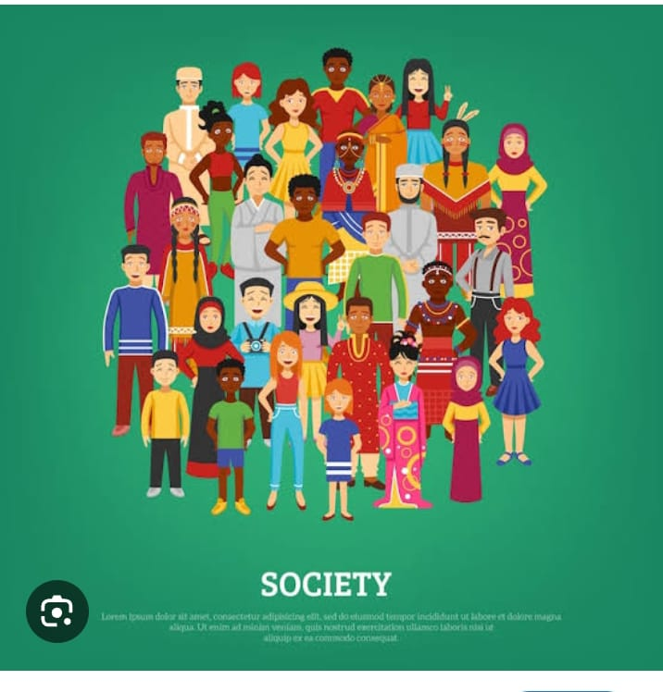

- Importance of social justice and diversity
- Provides equal opportunities for all individuals
- Protects human rights and dignity
- Reduces poverty and inequality
- Promotes peace and social harmony
- Strengthens democracy
- Empowers weaker sections of society

- Importance of Diversity
- Encourages respect for different cultures and beliefs
- Improves creativity and innovation
- Builds strong and united communities
- Increases cultural awareness
- Enhances learning and understanding
- Creates inclusive environments
- Prepares people for global society

- Why Social Justice and Diversity Together Matter
- Social justice ensures fairness
- Diversity ensures representation
- Together, they create an inclusive, peaceful, and progressive society

- Inclusive Policies and Practices

- Meaning

Inclusive policies are rules and regulations that ensure equality and fairness for all individuals. These policies prevent discrimination and provide equal opportunities in education and employment.
Examples:
- Reservation policies for disadvantaged groups
- Right to Education Act
- Gender equality policies
- Anti-harassment rules in workplaces
- Facilities for persons with disabilities

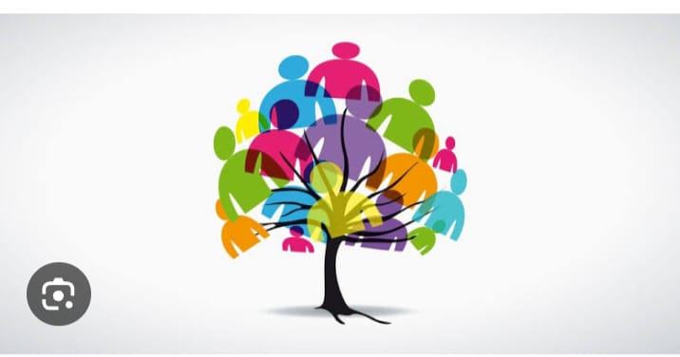

- Inclusive Practices
- Definition
Inclusive practices are the actions taken to implement inclusive policies in daily life. These practices help create a welcoming and supportive environment for everyone.
Examples:
- Using different teaching methods for different students
- Providing support for disabled persons
- Encouraging participation from all backgrounds
- Promoting teamwork and respect among students and employees



- CONCLUSION
- Social justice and diversity are necessary for building fair and inclusive institutions. When institutions provide equal opportunities and respect differences, society becomes more balanced and peaceful. Diversity brings new ideas and improves understanding among people. Social justice ensures that everyone gets equal rights and dignity.
- By promoting these values, institutions can reduce inequality and support overall development. A society that respects social justice and diversity will always move toward progress and harmony.

- REFERENCE
- Rawls, J. (1971). A Theory of Justice. Harvard University Press.
- Sen, A. (2009). The Idea of Justice. Harvard University Press.
- Banks, J. A. (2015). Cultural Diversity and Education: Foundations, Curriculum, and Teaching. Pearson Education.
- UNESCO (2017). A Guide for Ensuring Inclusion and Equity in Education. UNESCO Publishing.
- United Nations (2015). Transforming Our World: The 2030 Agenda for Sustainable Development. UN Publications.
- Bell, L. A. (2016). Teaching for Diversity and Social Justice. Routledge.
- Bourdieu, P. (1986). The Forms of Capital. In Handbook of Theory and Research for the Sociology of Education.
- OECD (2018). Equity in Education: Breaking Down Barriers to Social Mobility. OECD Publishing.
- Nussbaum, M. C. (2011). Creating Capabilities: The Human Development Approach. Harvard University Press.
- Government of India (2014). National Policy for Social Justice and Empowerment. Ministry of Social Justice and Empowerment.

