Using First-Party Data for Pharma Marketing: A Compliance-First Approach

Abstract
The pharmaceutical industry is undergoing a fundamental transformation in data strategy, driven by tightening privacy regulations, the deprecation of third-party cookies, and increasing expectations for ethical data use. First-party data information collected directly from healthcare professionals (HCPs) and patients has emerged as a cornerstone of compliant and effective pharma marketing. This review explores the role of Customer Relationship Management (CRM) systems and Customer Data Platforms (CDPs) in enabling compliant data collection, consent management, and ethical audience targeting. It further examines regulatory frameworks such as HIPAA and GDPR, and discusses how pharma companies can build trust-driven engagement models. A compliance-first approach not only mitigates legal risks but also enhances personalization, engagement, and long-term brand credibility.

Introduction
Pharmaceutical marketing has historically relied on third-party data sources to understand and target audiences. However, increasing regulatory scrutiny and the decline of third-party cookies have shifted the paradigm toward first-party data strategies. First-party data refers to information collected directly from users through interactions such as CRM systems, websites, and digital engagement platforms.
In pharma, this includes HCP engagement data, prescription behavior insights, digital interactions, and consented patient information. Unlike third-party data, first-party data is owned, controlled, and inherently more reliable, enabling organizations to develop differentiated and compliant marketing strategies.
This review examines how pharma organizations can operationalize first-party data through CRM/CDP ecosystems while maintaining compliance with evolving regulatory frameworks.

The Shift Toward First-Party Data in Pharma Marketing
The transition to first-party data is largely driven by regulatory changes and technological disruptions. The decline of third-party cookies and stricter privacy laws have made traditional tracking methods less viable.
First-party data offers several advantages:
- Higher accuracy and relevance due to direct collection
- Built-in compliance mechanisms through consent-driven capture
- Enhanced personalization based on real engagement signals
- Additionally, first-party data enables pharma companies to capture nuanced insights into HCP behavior, including how they respond to specific messaging and engagement strategies. This level of granularity is critical for effective targeting and engagement.

CRM Strategy: Capturing and Structuring First-Party Data
CRM systems form the backbone of first-party data collection in pharma. Modern pharma CRM platforms are evolving from activity-tracking tools to insight-generation engines.
Key components of an effective CRM strategy include:
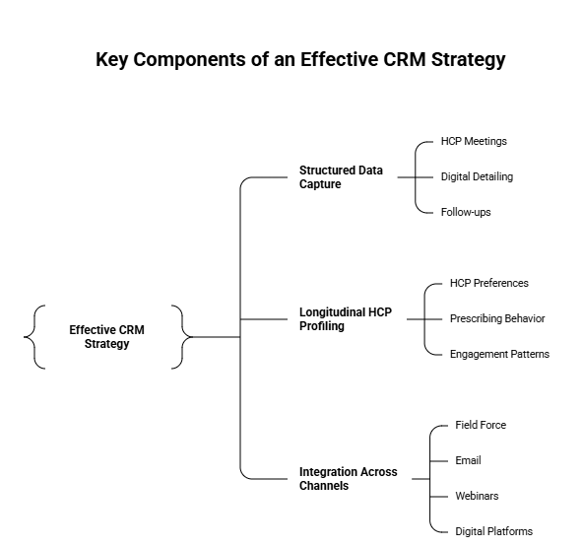
1. Structured Data Capture
Capturing insights at the point of interaction such as HCP meetings, digital detailing, and follow-ups is essential. Structured data enables consistent analysis and actionable insights.
2. Longitudinal HCP Profiling
CRM systems should build dynamic profiles that evolve over time, reflecting changes in HCP preferences, prescribing behavior, and engagement patterns.
3. Integration Across Channels
Pharma engagement is omnichannel, spanning field force, email, webinars, and digital platforms. CRM systems must unify these interactions to create a holistic view of the customer.
Without structured and consistent data capture, CRM systems risk becoming repositories of fragmented and unusable data, limiting their strategic value.

CDP Strategy: Data Unification and Activation
While CRM systems capture interaction data, Customer Data Platforms (CDPs) unify and activate it. A CDP aggregates data from multiple sources - clinical systems, digital platforms, and CRM into a single, compliant profile.
In healthcare, CDPs play a critical role in:
- Unifying fragmented patient and HCP data
- Managing consent and preferences
- Enabling personalized, compliant communication
CDPs also support advanced analytics and segmentation, allowing pharma marketers to deliver targeted content while adhering to privacy regulations. Importantly, CDPs incorporate security features such as encryption, audit logs, and access controls to protect sensitive health information.

Consent Management and Data Governance
Consent management is central to a compliance-first approach. Regulations such as GDPR and HIPAA require explicit, informed consent for data collection and usage.
Key principles of effective consent management include:
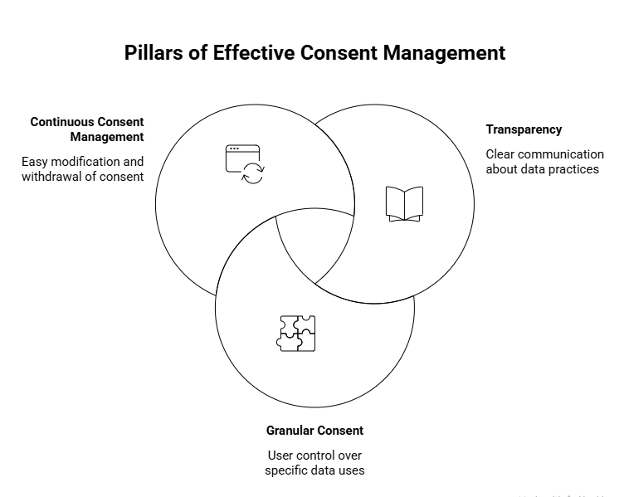
1. Transparency
Organizations must clearly communicate how data will be collected, used, and shared. Transparency builds trust and ensures regulatory compliance.
2. Granular Consent
Users should have control over specific data uses, such as marketing communications, analytics, and third-party sharing.
3. Continuous Consent Management
Consent is not a one-time event. Systems must allow users to modify or withdraw consent easily.
Failure to implement robust consent mechanisms can lead to legal penalties and reputational damage. Moreover, poorly managed data can pose significant risks, including breaches of patient privacy and loss of trust.

Regulatory Considerations in Pharma Data Strategy
Pharma marketing operates within a complex regulatory landscape, including:
- HIPAA (Health Insurance Portability and Accountability Act)
- GDPR (General Data Protection Regulation)
- CCPA (California Consumer Privacy Act)
These regulations impose strict requirements on data collection, storage, and usage. For example, HIPAA mandates safeguards for protected health information (PHI), including encryption, access controls, and audit trails.
Compliance is not merely a legal obligation but a strategic imperative. Organizations that embed compliance into their data strategy can avoid penalties while enhancing trust and credibility.

Ethical Audience Targeting in Pharma Marketing
Ethical considerations are increasingly important in pharma marketing. Beyond compliance, organizations must ensure that data is used responsibly and transparently.
Key principles include:
- Respect for patient and HCP privacy
- Avoidance of manipulative targeting practices
- Alignment with clinical and patient outcomes
First-party data enables ethical targeting by ensuring that data is collected with consent and used in a contextually relevant manner. This reduces the risk of inappropriate or intrusive marketing practices.
Furthermore, ethical data use enhances brand reputation and fosters long-term relationships with stakeholders.

The Role of Digital Platforms like HiDoc
Platforms such as HiDoc exemplify the application of first-party data strategies in pharma marketing. HiDoc facilitates direct engagement with verified HCPs, enabling the collection of high-quality, consented first-party data through interactions such as content consumption, webinars, and clinical updates.
By integrating CRM-like capabilities and analytics, HiDoc allows pharma companies to understand HCP preferences, tailor educational content, and measure engagement outcomes. Importantly, such platforms operate within compliance frameworks, ensuring that data collection and usage align with regulatory requirements.
This approach not only improves targeting accuracy but also enhances the educational value delivered to HCPs, aligning marketing efforts with clinical relevance.

Challenges and Future Directions
Despite its advantages, implementing a first-party data strategy presents challenges:
- Data silos and integration issues
- High infrastructure and implementation costs
- Complex regulatory requirements
- Need for cultural and organizational change
Future trends include the integration of artificial intelligence for predictive analytics, the use of data clean rooms for secure data sharing, and the development of privacy-enhancing technologies.
Pharma organizations must also invest in data governance frameworks and cross-functional collaboration to fully realize the potential of first-party data.

Conclusion
The shift toward first-party data represents a paradigm change in pharma marketing. A compliance-first approach, supported by robust CRM and CDP strategies, enables organizations to navigate regulatory complexities while delivering personalized and ethical engagement.
By prioritizing consent management, data governance, and ethical targeting, pharma companies can build trust, enhance engagement, and achieve sustainable competitive advantage. Platforms like HiDoc further demonstrate how first-party data can be leveraged effectively within compliant ecosystems.
Ultimately, the future of pharma marketing lies in balancing innovation with responsibility ensuring that data-driven strategies are both effective and ethical.

References
- Crawford, C. (2026). Pharma CRM data: Why first-party HCP data is the real competitive advantage. Retrieved from https://inceptioncrm.com/pharma-crm-data-why-first-party-hcp-data-is-the-real-competitive-advantage/
- Boston Consulting Group. (2020). Responsible marketing with first-party data. Retrieved from https://www.bcg.com/publications/2020/responsible-marketing-with-first-party-data
- CDP.com. (2026). CDP for healthcare: HIPAA-compliant patient data unification. Retrieved from https://cdp.com/articles/cdp-for-healthcare/
- Plainert, N. (2025). First-party data transforming EHR marketing effectiveness. Retrieved from https://healthpoint.com/data-and-information/first-party-data-transforming-ehr-marketing-effectiveness/
- Pacheco, D. (2025). Post-cookie reality check: Pharma data strategy for a privacy-first web. Retrieved from https://www.pharma-mkting.com/advertising/post-cookie-reality-check-pharma-data-strategy/
- McKinsey & Company. (2021). A customer-centric approach to marketing in a privacy-first world. Retrieved from https://www.mckinsey.com
- Cuddy, J. (2025). AI, data privacy, and compliance in pharma marketing. Retrieved from https://www.pulsepoint.com/blog/ai-data-privacy-pharma-marketing
- Faridoon, A., & Kechadi, M. T. (2024). Healthcare data governance, privacy, and security: A conceptual framework. arXiv.
- HiDoc. (2026). Digital platform for healthcare professional engagement and first-party data capture. Retrieved from https://www.hidoc.co

