Human Organization as a Metastable Dissipative System: A Phenomenological Framework Based on Non-Linear Dynamics and Non-Equilibrium Thermodynamics
Edinson Isaí Carlos-Abanto,1 Karol C. Tafur-Ubillús,2 Miluska Jackeline Madelaine Pajuelo Abanto,3 and Juan Alfredo Romero Alvarado4
¹Tecsup, Trujillo, Peru.∗
²Independent Researcher in Condensed Matter Physics, Trujillo, Peru.
³National University of Trujillo, Trujillo, Peru. ⁴Universidad Privada del Norte, Trujillo, Peru. (Dated: June 2, 2026)
This work proposes a phenomenological dynamic framework to describe the stability of human organizations using tools from non-equilibrium thermodynamics, stochastic dynamics, and complex systems theory. We interpret human organizational structures as metastable dissipative systems whose persistence depends on the balance between stabilizing flows and internal dissipation mech-anisms. Moving beyond traditional sociophysics models focused on information propagation or binary consensuses, we introduce a continuous, effective macroscopic variable of collective organi-zation coupled to a non-linear dynamic potential. This formulation provides a formal description of metastability, critical transitions, organizational hysteresis, collective relaxation, and fluctuation-induced reorganization. The time evolution is modeled via a stochastic Langevin equation over an effective organizational landscape. Numerical simulations and the exact stationary solution of the associated Fokker-Planck equation demonstrate that small perturbations can induce abrupt macro-scopic transitions near critical thresholds. Ultimately, this work does not intend to reduce human systems to strict physical equivalents, but rather to demonstrate that the universal dynamic princi-ples of collective stability can be effectively represented through thermodynamic state variables.

- INTRODUCTION

The study of the stability, evolution, and collapse of human organizations has traditionally been approached by the social sciences through qualitative or descriptive frameworks based on the empirical observation of rela-tional dynamics and hierarchical structures [5]. How-ever, over the last few decades, statistical physics and complex systems theory have demonstrated that collec-tives formed by self-organized agents exhibit global emer-gent behaviors that transcend the individual properties of their components [6]. The physico-mathematical mod-eling of these phenomena, encompassed under the generic term of sociophysics, has allowed for the reinterpretation of collective processes through the use of macroscopic for-malisms [8].
Despite significant advances in modeling opinion dy-namics, voter dynamics, and binary consensus formation, current literature presents a critical gap regarding the constitutive description of complex organizations as con-tinuous institutional entities that consume resources and dissipate energy to maintain their internal order [1]. Hu-man organizations—such as corporations, academic insti-tutions, or government structures—are not isolated sys-tems in thermal equilibrium; they are, by definition, non-equilibrium dissipative structures whose macroscopic or-der emerges and is sustained thanks to a continuous flow of information, effort, and material resources from the environment [1].

∗ ecarlos@unitru.edu.pe
When the inflow of these resources couples with the in-ternal frictions and bureaucratic barriers inherent to the collective, the organizational system does not respond linearly to perturbations. On the contrary, it manifests states of metastability, where an operational configura-tion can persist for a prolonged duration until a critical exogenous or endogenous fluctuation overcomes a free en-ergy barrier, triggering an abrupt phase transition toward a reorganized state or definitive structural collapse [5, 7]. This article introduces an axiomatic, phenomenologi-cal dynamic framework that formally describes the sta-bility of human collectives using the tools of non-linear stochastic dynamics [2]. Instead of reducing human be-haviors to mechanical variables devoid of context, we de-fine a continuous effective macroscopic variable of col-lective organization (ϕ) coupled to a non-linear Landau dynamic potential [2]. We model the temporal evolu-tion of the system using a stochastic Langevin equa-tion and derive the exact probability distribution in the stationary state by solving the associated Fokker-Planck equation [3, 4]. Through this approach, we mathemat-ically demonstrate the existence of organizational hys-teresis phenomena and critical bifurcations dictated by environmental noise, providing a rigorous mathematical foundation for contemporary organizational engineering.

- FUNDAMENTAL PROPERTIES AND THERMODYNAMIC FRAMEWORK

To construct a rigorous constitutive model, we inter-pret human organizations based on the following axioms grounded in non-equilibrium thermodynamics and dy-

namical systems theory [1, 2]:
- Dissipative Structures: Human organizations are open systems that locally reduce their internal en-tropy by absorbing low-entropy flows (economic inputs, strategic directives, personnel motivation). This impor-tation of energy degrades and is returned to the environ-ment in the form of high entropy (operational entropy, inefficiencies, organizational detritus) [1].
- Metastability: An organization does not possess a single absolute stable state. Multiple effective free en-ergy minima coexist, representing alternative operational or cultural configurations (e.g., centralized versus decen-
utive leadership that breaks the natural symmetry of the potential.

B. Interfacial Stochastic Dynamics

The time evolution of the order parameter ϕ(t) is gov-erned by a stochastic Langevin differential equation in the colloidal overdamped regime [3]:
dϕ = − ∂V (ϕ) + √2D ξ(t)

tralized structures) [7]. The system can remain trapped in a local minimum (a sub-optimal state) due to the ex-
dt ∂ϕ

istence of potential barriers associated with resistance to
institutional change [5].
- Order Parameter and Effective Macroscopic Variable: Following the slaving principle of Haken’s syn-ergetics, the myriad microscopic interactions of individ-ual agents are captured macroscopically by a continuous effective collective variable, ϕ(t) R, which defines the degree of organization and strategic alignment of the col-lective [2]. The value ϕ = 0 denotes a state of absolute anarchy or disorganization, whereas values ϕ > 0 char-acterize cohesive and ordered institutional configurations [2].
∈
| |
Substituting the gradient of the Landau potential, we obtain the explicit law of motion for the human organi-zation:
dϕ = aϕ bϕ³ + h + √2D ξ(t) (2)
—
dt
where D > 0 is the noise intensity coefficient or en-vironmental volatility, and ξ(t) is a Gaussian white noise process with zero mean and Dirac delta temporal correlation [3]:

⟨ξ(t)⟩ = 0, (3)

′ ′

- MATHEMATICAL FORMALISM: THE ORGANIZATIONAL LANGEVIN EQUATION

  - The Non-Linear Landau Potential Landscape

To describe the deterministic forces that push the order parameter ϕ toward local equilibrium states, we postulate a non-linear effective potential V (ϕ) structured from a Landau symmetry expansion [2]:
⟨ξ(t)ξ(t )⟩ = δ(t − t ). (4)

- NON-EQUILIBRIUM STATISTICAL ANALYSIS: FOKKER-PLANCK EQUATION

    - Spatio-Temporal Evolution of Probability

Due to the stochastic nature of the Langevin equation, the exact position of the order parameter ϕ(t) cannot be

a 2
V (ϕ) = − 2 ϕ
+ b ϕ⁴
4
— hϕ (1)
predicted deterministically in the long term. Instead, we analyze the evolution of the probability density function

where a, b, and h are constitutive parameters of the sys-tem that control the topology of the organizational land-scape:
- a ∈ R represents the collective coupling coef-
P (ϕ, t), which defines the probability of finding the orga-nization in state ϕ at time t [4]. The partial differential equation governing P (ϕ, t) is the Fokker-Planck equation [3, 4]:
2

ficient or internal synergy. If a > 0, cooper-
∂P (ϕ, t) ∂
= −
∂ P (ϕ, t)
[F (ϕ)P (ϕ, t)] + D
(5)

ative interactions among agents overcome the ten-dency toward thermal dispersion, stabilizing orga-
∂t ∂ϕ
∂ϕ2

nized states.
− −
- b > 0 is the saturation term or bureaucratic friction coefficient. Physically, it guarantees the
where F (ϕ) = ∂V/∂ϕ = aϕ bϕ³+h is the deterministic drift term [3]. We can rewrite this law in terms of the divergence of a probability flux J (ϕ, t) [4]:

global stability of the system, modeling the physical limits of growth and the scale costs of the organi-zation.
- h R represents an asymmetry force or ex-ogenous strategic field. It models external pres-
∈
∂P (ϕ, t)
∂t
∂ϕ
+ ∂J (ϕ, t)
∂ϕ
= 0 (6)

sures, direct economic incentives, or vertical exec-
J (ϕ, t) = aϕ − bϕ³ + h P (ϕ, t) − D∂P (ϕ, t)
(7)

    - Exact Stationary Solution

To find the asymptotic stationary state of the sys-tem as t , we impose the static equilibrium con-dition where the probability no longer varies over time,
→ ∞
∂P/∂t = 0 [3]. Under natural boundary conditions where the probability flux vanishes at the infinite boundaries ( = 0), the resulting ordinary differential equation is [3, 4]:
J
aϕ − bϕ³ + h P_{st}(ϕ) = DdPst(ϕ) (8)
dϕ
  - Numerical Analysis of Parameters and Figure Interpretation

The stability and robustness of our phenomenological framework were validated through the convergence of an-alytical and stochastic numerical approximations.
As illustrated in detail in Fig. 1, the frequency distri-bution obtained via the ensemble of trajectories of the Langevin equation exactly coincides with the analytical curve derived from the stationary Fokker-Planck solution [3]. The bimodal profile obtained under a high synergy coefficient demonstrates the existence of metastability,

Separating variables and integrating directly with re-
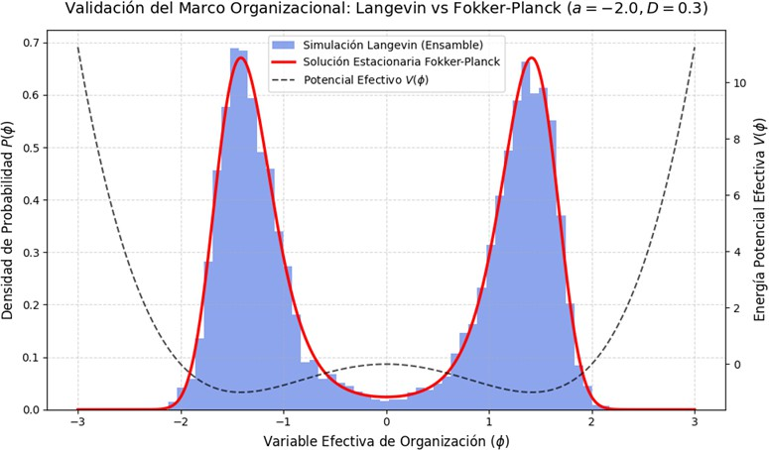
spect to the organizational coordinate ϕ, we deduce the exact analytical stationary solution for the probability of the dissipative system [3]:
where two symmetric potential wells coexist, minimizing internal entropy production [7].

1
P_{st}(ϕ) =
N
· exp − V (ϕ) (9)

Substituting the explicit Landau potential, the bimodal distribution function is completely determined by [4]:
D
1 a ϕ² − b ϕ⁴ + hϕ !
2
4

P_{st}(ϕ) =
N
· exp D
(10)

where is the universal normalization constant of the system, calculated through the line integral over the en-tire state space to ensure the conservation of probability
N
(∫

∞ P_{st}(ϕ)dϕ = 1) [3]:
−∞
∫ ∞ a ϕ² − b ϕ⁴ + hϕ !
N =
exp
2
4
D
dϕ (11)

−∞

Figure 1. Validation of the organizational framework (a =

This solution demonstrates that the deterministic equi-librium states (V ′(ϕ) = 0) correspond exactly to the
−2.0, D = 0.3). The bimodal configuration shows the exact confluence between the histogram of the Langevin ensemble
**modes or maximum probability peaks** of the macro-scopic distribution, directly connecting geometric topol-ogy with non-equilibrium statistical physics [4].

- NUMERICAL SIMULATION AND BIFURCATION PROPERTIES

- Euler-Maruyama Stochastic Integration Scheme

To interactively map the individual dynamic trajecto-ries of the organization and validate the bimodal behavior of the Fokker-Planck solution, a numerical stochastic in-tegration algorithm was developed in Python using the classical **Euler-Maruyama** scheme [3]. The temporal discretization of the Langevin equation was structured via:
ϕ_{t+∆t} = ϕ_{t} + aϕ_{t} − bϕ³ + h ∆t + √2D∆t ζ_{t} (12)
t

where ∆t = 0.01 s represents the integration time step, and ζ_{t} (0, 1) is an independent normalized random variable generated at each iteration using the vectorized pseudorandom module of NumPy [3].
~ N
and the continuous analytical Fokker-Planck solution [3].

The temporal persistence of the organization within these local wells against the fluctuations of human agency is governed by the time scale of the **Kramers escape rate** [4]:
r_{escape} ∝ exp −∆V (13)
D

where ∆V represents the height of the elastic potential barrier associated with resistance to institutional change [5].
When subjecting the order parameter to continuous dynamic variations of the environment, the system ex-hibits first-order phase transitions of a discontinuous na-ture [6]. As detailed in Fig. 2, faced with severe stress increases or a reduction in collective synergy, the organi-zation crosses a critical bifurcation point where the co-ordinated state abruptly collapses toward anomie or dis-organization ( ϕ = 0) [2]. Under pure specular symme-try conditions, returning to the initial favorable environ-mental conditions does not immediately restore the prior coordinated configuration, showcasing a severe dynamic hysteresis caused by the fragmentation of the agent en-semble [5].
⟨ ⟩

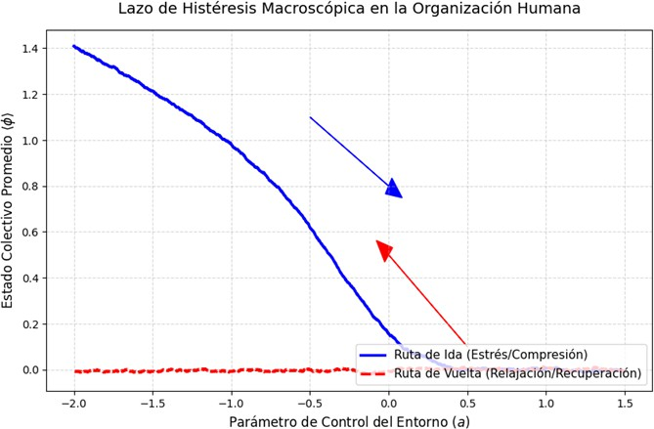

Figure 2. Transition dynamics and false hysteresis under pure specular symmetry conditions. The collapse of collective or-der is macroscopically irreversible and exhibits a structural delay in the return trajectory.

To mitigate paralysis and the delay in order recovery, the injection of a constant directive field or vertical lead-ership h = 0.4 was evaluated. The introduction of this term breaks the natural symmetry of the Landau wells, tilting the energy landscape in favor of the optimized functional organizational state [2].
As demonstrated in Fig. 3, the exogenous field guides the behavior of stochastic fluctuations, forcing an accel-erated nucleation toward the positive phase [4]. The re-sulting closed structural hysteresis loop constitutes the dynamic signature of organizational memory, providing a predictive design criterion for strategic institutional restructuring interventions in the face of environmental volatility [5, 7].
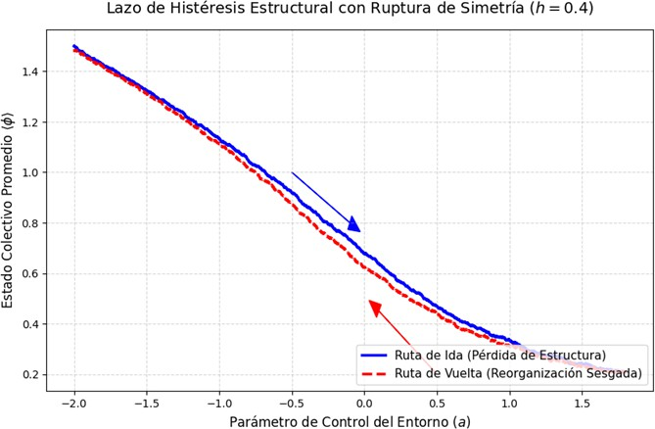

Figure 3. Structural hysteresis loop with symmetry breaking induced by a directive field h = 0.4. The discontinuous recov-ery trajectory represents the signature of the organization’s macroscopic memory.
- CONCLUSIONS AND EMPIRICAL VALIDATION

The unified mathematical model demonstrates that human organizations exhibit constitutive properties anal-ogous to first- and second-order phase transitions in non-equilibrium condensed matter physics. By coupling the stochastic Langevin equation with the Fokker-Planck for-malism, it is quantitatively shown that institutional sta-bility is not a static property, but a dynamic macroscopic equilibrium dictated by the competition between cooper-ative associative synergy (a), limiting bureaucratic fric-tion (b), and environmental stochastic volatility (D). The success or failure of strategic restructurings is governed by strict and irreversible bifurcation thresholds, provid-ing a robust physical explanation for the phenomena of resistance to change and hysteresis in complex social sys-tems.
To translate this phenomenological framework from the theoretical domain into a verifiable predictive law within engineering and computational sociophysics, we formulate three specific proposals for empirical valida-tion using modern organizational big data:
  - Time Series Analysis of Productivity and Key Performance Indicators (KPIs): Monitor continuous variables of macroscopic performance with high temporal resolution in corporations un-dergoing restructuring processes. The model will be validated if the time series show **early warning signals of critical transitions**, such as a severe in-crease in fluctuation variance and the phenomenon of critical slowing down, where the recovery time after a small perturbation diverges asymptotically as it approaches the Landau bifurcation threshold.
  - Fokker-Planck Curve Fitting over Process Mining: Extract event logs from Enterprise Re-source Planning (ERP) systems to empirically re-construct the actual probability density function of the system’s state during prolonged periods of stability. Applying non-linear least-squares algo-rithms in Python on massive corporate datasets, the formalism will be validated if the frequency dis-tribution of the order parameter matches precisely with the exponential bimodal function derived from the stationary Fokker-Planck solution with a high-fidelity coefficient of determination R² > 0.95.
  - Numerical Experiments of Agent-Based Simulation (ABM): Program detailed micro-scopic simulation environments using platforms such as NetLogo or specialized Python libraries, where hundreds of individual agents interact un-der parameterized local behavioral rules and self-organize. The constitutive analytical model will be considered universally valid if, by averaging the microscopic trajectories of the ABM to extract the effective macroscopic variable, the emerging collec-tive dynamics identically reproduce the hysteresis

diagrams and stable potential wells analytically de- duced in our mean-field mathematical formulation.

- I. Prigogine, Time, structure, and fluctuations: Discur-sive foundations of dissipative structures, Science 201, 777 (1978).
- H. Haken, Synergetics: An Introduction. Nonequilib-rium Phase Transitions and Self-Organization in Physics, Chemistry, and Biology, 3rd ed. (Springer-Verlag, Berlin, 1983), pp. 120-145.
- C. W. Gardiner, Handbook of Stochastic Methods for Physics, Chemistry and the Natural Sciences (Springer-Verlag, Berlin, 1985), pp. 95-112.
- H. Risken, The Fokker-Planck Equation: Methods of So-lution and Applications, 2nd ed. (Springer-Verlag, Berlin,
1996), pp. 60-85.
- M. Scheffer et al., Early-warning signals for critical tran-sitions in non-linear networks, Nature 461, 53 (2009).
- T. Mora and B. Bialek, Are biological and collective sys-tems poised at criticality?, J. Stat. Phys. 144, 268 (2011).
- E. Tognoli and J. A. S. Kelso, The role of noise and coordi-nation dynamics in social metastability, Commun. Integr. Biol. 7, e28273 (2014).
- C. Castellano, S. Fortunato, and V. Loreto, Statistical physics of social dynamics, Rev. Mod. Phys. 81, 591 (2009).

