DESIGN AND PERFORMANCE EVALUATION OF A MECHANICAL DUSTER-BASED SOLAR PANEL CLEANING SYSTEM FOR DUST REMOVAL

ABSTRACT
Dust accumulation on photovoltaic (PV) solar panels significantly reduces electricity generation efficiency and shortens panel lifespan. This study presents the design and performance evaluation of a mechanical duster-based solar panel cleaning system aimed at restoring panel efficiency through effective dust removal. The system detects obstruction via a voltage drop on the voltmeter, upon which the cleaning mechanism is manually activated by switching ON the electrical control circuit, which consists of relays, a DC motor, a battery, and a switch. A pulley-belt mechanism positioned within an aluminum track attached to the sides of the solar panel drives the duster in a to-and-fro motion across the panel surface, while a secondary pulley connects the DC motor to the internal pulley assembly. Testing was conducted under four conditions — dusty and clean panels, each with and without tilt — to evaluate the effect of cleaning and panel orientation on performance. Results showed that the clean panel with tilt achieved the highest maximum power output of 14.96 W and an efficiency of 20.78%, compared to 8.14 W and 10.60% for the dusty panel without tilt, representing a 96% improvement. The constructed cleaner effectively removed fine dust particles within 1–2 minutes of operation, outperforming other conventional cleaning methods. These findings confirm that the integration of mechanical cleaning systems in PV installations can substantially improve energy output and panel durability.
Keywords: Photovoltaic panel, dust removal, mechanical duster, solar panel cleaning, PV efficiency, pulley-belt mechanism, I-V curve

1. INTRODUCTION
Solar energy is one of the fastest-growing renewable energy sources globally, with photovoltaic (PV) technology playing a central role in the transition away from fossil fuels. However, a critical and often underestimated challenge facing PV systems in real-world deployment is the accumulation of dust and particulate matter on panel surfaces, which significantly reduces energy output and long-term system reliability.
Photovoltaic Panel is one which generates electricity solar radiation, photovoltaic panel consist of semiconductors with the help of which solar radiations are converted into direct currently [1]. There are different variables that impact the efficiency of (PV) panels including dust accumulation which can severely decrease power efficiency and service life through solar radiation reduction [2]. Renewable energies are playing an increasingly important role in our quest for a sustainable energy. Among these clean energy sources, solar power stands out for its immense potential and positive impact on the environment [3-4]. Photovoltaic solar panels, which covert sunlight into electricity, has become an essential component of our energy infrastructure, offering a promising alternative to traditional energy sources[5]. A cleaning device has been improved to clean solar panels using the concept of ionic wind to effectively remove accumulated sand dust [6]. Global energy demands increasing, the shift to renewable energy is crucial for addressing environmental and economic limitations [7]. Environmental variables including air temperature, relative humidity, wind speed, incident solar radiation, and shading other factors including tilt angle, module temperature and dust accumulation [8]. Natural dust accumulation on photovoltaic (PV) panels from outdoor environment mostly in northern part of Nigeria can obscure the solar radiation from reaching the solar photovoltaic panel therefore decreases the power output and the efficiency of the panels [9]. The use of solar PV panels is increasing in the present days due to the ever increasing energy demands, cost of energy and non-availability of continuous power supply in the energy system [10].
This study addresses this gap by presenting the design, construction, and performance evaluation of a mechanical duster-based solar panel cleaning system. The system utilizes a DC motor-driven pulley-belt mechanism to sweep a PVC foam duster across the panel surface in a controlled to-and-fro motion, powered by a relay-controlled electrical circuit.

2. MATERIALS AND METHODS
2.1 Materials and Component Specifications
The components used in the design and construction of the mechanical duster-based solar panel cleaning system are listed in Table 1.

Table 1: Components and Specifications
No | Component | Specification
1. | Solar Panel | 20W, 32 cm × 40 cm
2. | Solar Charge Controller | Rated voltage: 12/24V; Rated current: 20A
3. | Omron Timer Relay | 12V DC
4. | Switching Relay | 12V DC
5. | Battery | 12V, 5Ah deep cycle
6. | DC Motor | 12V, 200 rpm, 0.5–1A
7. | Aluminum Track | Structural housing for pulley system
8. | Belt & Pulley Wheel | Transmission of motor motion
9. | Cleaner Duster | PVC + soft foam; rollers, bolts, nuts
10. | Voltmeter | Dust presence indicator

2.2 OVERVIEW OF THE CLEANING MECHANISM
The cleaning system operates on an electro-mechanical principle, consisting of two integrated subsystems: the locomotive unit and the electrical control circuit (ECC). The overall system follows a sequential flow from the switch through the battery, timer relay, switching relay, DC motor, and pulley system to the cleaner duster.
Each component performs a distinct function. The switch serves as the make-and-break device that initiates system operation. The battery stores chemical energy to power the system. The timer relay specifies the duration of forward and backward movement, while the switching relay enables directional change of the duster. The DC motor converts electrical energy into mechanical energy, and the pulley system translates rotational motion into linear to-and-fro movement of the cleaner duster, which physically removes accumulated dust from the solar panel surface.

2.3 EXPERIMENTAL METHOD
2.3.1 The Locomotive Unit
The locomotive unit comprises the DC electric motor, a belt-and-pulley system, aluminum tracks, and the cleaner duster. The duster was fabricated from PVC plastic with soft foam bonded to its underside using strong adhesive, enabling effective contact with the panel surface during cleaning. It was designed to traverse the panel surface in a forward-and-backward motion for a set period until the panel was fully cleaned.
To achieve the required to-and-fro motion, sets of pulleys were mounted inside aluminum tracks attached to both sides of the solar panel. The duster was fixed to the pulley belt running within the aluminum track, and movement of the belt drives the duster across the panel. The aluminum tracks provided structural alignment and prevented sagging during operation. Two opposing pulleys were connected by an iron rod, allowing simultaneous drive by a single DC motor via a secondary pulley. The motor-connected pulley acts as the driver, while the track pulleys serve as the driven elements. The system is activated by the ON switch and halted by the OFF switch.

2.3.2 The Electrical Control Circuit (ECC)
The ECC governs system operation by managing how stored or direct electrical energy drives the locomotive unit for a specified time period. The circuit comprises a 12V 5Ah deep-cycle battery, an electric switch, an Omron timer relay, and a switching relay. The timer relay was configured to define the duration of both forward and backward movement immediately upon switch activation. The relay operates on an 8-pin configuration: pins 2 and 7 serve as power supply points, with pin 2 connected to the battery negative and pin 7 connected via the switch to the battery positive. Pin 8 is looped to pin 7, and pin 6 was exclusively used to trigger the switching relay, generating the alternating bidirectional voltage required for to-and-fro motor operation.

2.3.3 Controller Connections
The solar charge controller was connected between the solar panel and the battery at three points: (i) panel output (0–18V) connected from the panel's positive and negative terminals to the corresponding controller terminals; (ii) the 12V battery charging terminal; and (iii) the load or panel charging indicator terminal.

2.3.4 Looping of the Timer and Switching Relay
Pin 6 of the timer relay was connected to pin 2 of the switching relay, and pin 2 of the timer relay was connected to pin 10 of the switching relay. The switching relay was connected to the DC motor, with pin 1 to the motor negative terminal and pin 6 to the battery negative. Pin 6 of the switching relay was additionally connected to the motor negative, and pin 1 to the motor negative to complete the reverse-voltage circuit. Following assembly, full system inspection and functional testing were conducted. The voltmeter serves as the dust-presence indicator; a voltage drop signals dust accumulation, upon which the mechanism is manually activated via the switch to restore the panel to its rated output.

2.4 PERFORMANCE TESTING
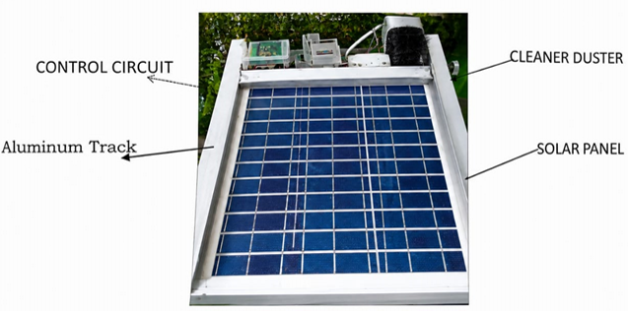
Performance was evaluated by recording I-V (current-voltage) characteristics across varying load resistances (10 Ω to 80 Ω) and measuring maximum power output and efficiency under four test conditions: (i) dusty panel without tilt, (ii) clean panel without tilt, (iii) dusty panel with tilt, and (iv) clean panel with tilt. Efficiency was calculated as the ratio of measured maximum power output to the rated panel input.
Fig. 1: Prototype of Solar Panel Cleaner

3. RESULTS AND DISCUSSION
3.1 Visual Assessment of Cleaning Effectiveness
Visual inspection confirmed that the mechanical duster effectively removed surface dust within 1–2 minutes of operation. Before-and-after photographs (Fig. 1) clearly showed a significant reduction in dust coverage following a single cleaning cycle, demonstrating the system's practical effectiveness for rapid panel restoration.

3.2 I-V Characteristics
The I-V curve test results, recorded across load resistances from 10 Ω to 80 Ω, are presented in Table 2.
Table 2: PV Panel I-V Test Results
Parameter | 10 Ω | 20 Ω | 30 Ω | 40 Ω | 50 Ω | 60 Ω | 70 Ω | 80 Ω
Vload (V) | 5.1 | 7.3 | 9.2 | 11.2 | 13.4 | 15.0 | 16.8 | 17.5
Iload (A) | 0.33 | 0.32 | 0.32 | 0.33 | 0.33 | 0.32 | 0.25 | 0.23

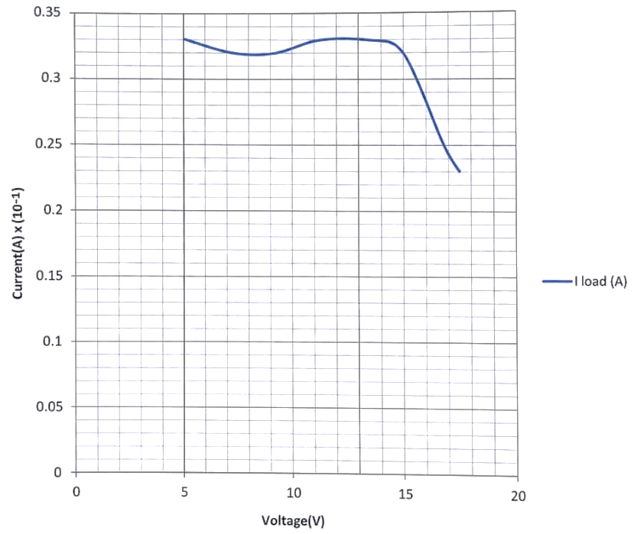

Fig. 2: I-V Curve
The I-V curve (Fig. 2) exhibits typical PV panel behavior — a relatively stable short-circuit current across low-to-mid voltage range, followed by a rapid decline near the open-circuit voltage. This characteristic confirms the electrical integrity of the test panel and the reliability of measurements.

3.3 EFFICIENCY UNDER DIFFERENT CONDITIONS
Table 3 presents the maximum power output and efficiency values recorded under each of the four test conditions.
Table 3: Efficiency of PV Panel Under Different Conditions
Parameter | Dusty Panel  (No Tilt) | Clean Panel  (No Tilt) | Dusty Panel  (With Tilt) | Clean Panel  (With Tilt)
Pmax (W) | 8.14 | 13.37 | 13.06 | 14.96
Efficiency (%) | 10.60 | 16.69 | 17.00 | 20.78

The results reveal four key findings:
Effect of Cleaning Alone: Cleaning the panel without altering its tilt increased efficiency from 10.60% to 16.69%, representing a gain of 6.09 percentage points - a 57.5% relative improvement. This directly demonstrates the adverse impact of dust accumulation on PV output.
Effect of Tilt Alone: Tilting the panel without cleaning improved efficiency from 10.60% to 17.00%, indicating that panel orientation significantly influences solar irradiance capture and is a critical factor in system optimization.
Combined Effect of Cleaning and Tilt: The highest efficiency of 20.78% was achieved with a clean panel at optimal tilt, corresponding to a maximum power output of 14.96 W. This represents a 96% relative improvement over the worst-case baseline (dusty, no tilt), confirming the complementary benefit of combining cleaning with tilt optimization.
Cleaning Speed and Particle Removal: The mechanical duster achieved visible and effective dust removal in under 2 minutes of operation, demonstrating superior performance over conventional manual cleaning methods in terms of speed and fine-particle removal.
These findings are consistent with literature reports documenting significant efficiency losses from soiling in PV systems, and reinforce the value of integrating automated or semi-automated cleaning mechanisms into solar energy installations, particularly in arid and dust-prone environments.

4. CONCLUSION
This study successfully demonstrated the design and performance evaluation of a mechanical duster-based solar panel cleaning system. The system employs a DC motor-driven pulley-belt mechanism within an aluminum track to sweep a PVC foam duster across the panel surface in a controlled to-and-fro motion, powered and timed by an electrical control circuit comprising a timer relay, switching relay, battery, and voltmeter indicator.
Efficiency measurements confirmed that the clean, tilted panel achieved the highest performance at 20.78% efficiency and 14.96 W maximum power output — nearly double the 10.60% and 8.14 W recorded for the dusty, untilted baseline condition. The cleaning operation was completed within 1–2 minutes, establishing the system as a rapid and practical solution for dust removal in PV maintenance.
These results strongly support the integration of mechanical cleaning systems in solar PV installations, especially in regions characterized by high dust concentrations. The system's simplicity, low operational cost, and demonstrated effectiveness make it a viable solution for both small-scale and commercial PV applications.

References
1. Megha Jasmin Benny (2024). Solar PV Cleaning Method: A Comparative Study. International Journal of Research in engineering, Science & Management, Volume 7.
2. Heba AL-Zaben, and Zainb AL-Manaseer (2025). An Overview of dust cleaning methods for solar photovoltaic system: Jordan Case Study. MATEC web of Conferences 411, 01007.https://doi.org/10.105/mateconf/202541101 007.
3. M. Abid, M. Kumar, V. Raj, and M. Dhas, “Environmental Impacts of the Solar Photovoltaic Systems in the Context of Globalization,” Ecol. Eng. Envir. Techn., vol. 24, no. 2, pp. 231–240, Mar. 2023, doi: https://doi.org/10.12912/27197050/157168.
4. S. Mousavi and S. S. Mousavi, “Sol. Ener. conversion technologies: principles and advancements,” Elsevier eBooks, pp. 29–76, Jan. 2022, doi: https://doi.org/10.1016/b978-0-323-89866-9.00005-5.
5. K. Sadigova, F. Aliyev, and M. Firuzi, “Leading Aspects of Transition from the Traditional Energy to Renew. Ener. Sources After the COVID-19 Pandemic,” Springer proceedings in business and economics, pp. 343–359, Jan. 2023, doi: https://doi.org/10.1007/978-3-031-28131-0_24.
6. Zeid Bendaoudi, Abdelhadi Namoune, Nezha Kadous, Yassine Bellebna, Khelife Yanallah and Amar Tilmatine (2024). An Improved Electrostatic Cleaning System for Dust Removal from Photovoltaic Panels. Journal of Engineering Science and Technology Review 17(1) (2024) 109-115.
7. A. Al-Habaibeh, B. A.-h. Moh'd, H. Massoud, O. B. Nweke, M. Al Takrouri, and B. E. Badr, "Solar energy in Jordan:
8. Investigating challenges and opportunities of using domestic solar energy systems," World Development Sustainability, vol. 3, p. 100077, 2023.
9. Orumgbe Chukwuekum and Okuma Silas Oseme. Solar Cell Cleaning and efficiency performance analysis on dust particles accumulation on solar panel in Nigeria. A Case study of Northern Nigeria. Journal of sustainable energy and environment 11 (2020) 135 – 141.
10. Mallikarjun G. Hudedmani, Gita Joshi, Umayal R M, Ashwini Revanka A Comparative Study of Dust Cleaning Methods for the Solar PV Panels. Advanced Journal of Graduate Research, Volume 1, Issue 1, pp. 24-29, January 2017.

