Comparative Investigation of the I–V Characteristics of Photovoltaic Modules under varying Environmental Conditions

Abstract
This study presents a comparative investigation of the current–voltage (I–V) characteristics and performance of monocrystalline and polycrystalline photovoltaic (PV) modules under varying environmental conditions across selected locations in Nigeria. The research aimed to comparatively investigate the current–voltage (I–V) characteristics and performance of monocrystalline and polycrystalline photovoltaic (PV) modules under varying environmental conditions in selected locations. The experimental investigation was carried out using monocrystalline and polycrystalline solar panels, a solar power meter for irradiance measurements, thermo-hygrometer for temperature and relative humidity measurements, an anemometer for wind speed determination, and an MPPT solar meter for measuring electrical parameters including voltage, current, output power. Measurements were conducted under outdoor environmental conditions at regular intervals during daylight hours. The performance of the PV modules was analysed using the I–V characteristics, open-circuit voltage, short-circuit current, output current behaviour, and power response under varying climatic conditions. The results obtained from the I–V curves revealed considerable variations in photovoltaic performance across the investigated locations. In most locations, the monocrystalline module exhibited superior electrical performance compared to the polycrystalline module due to its higher crystal purity and lower recombination losses. The monocrystalline modules recorded higher current outputs ranging approximately from 2.8 A to 3.5 A with voltage values between 17 V and 18.5 V under peak irradiance conditions. Polycrystalline modules showed slightly lower current outputs ranging between 2.3 A and 3.0 A within similar voltage ranges. Locations characterized by high solar irradiance and moderate atmospheric conditions demonstrated better photovoltaic performance with smoother and more stable I–V characteristics while locations with lower solar irradiance showed comparatively lower output currents and reduced module efficiency because of atmospheric attenuation and cloud cover effects. Elevated panel temperatures observed in some locations caused slight reductions in voltage output due to thermal effects on semiconductor junction behaviour. Comparative analysis further indicated that environmental conditions significantly influenced module performance. Higher irradiance enhanced charge carrier generation and increased photocurrent, while excessive temperature reduced voltage performance according to the photovoltaic diode equation. Overall, the monocrystalline PV modules demonstrated better operational stability, higher efficiency, and improved electrical response under varying environmental conditions compared to the polycrystalline modules. The study concludes that photovoltaic performance in Nigeria strongly depends on local climatic conditions and semiconductor material properties, with monocrystalline modules providing better performance suitability for outdoor solar energy applications in tropical environments.

keywords
Photovoltaic Performance, Monocrystalline Module, Polycrystalline Module, I–V Characteristics, Solar Irradiance
I. Introduction
The increasing global demand for sustainable, reliable, and environmentally friendly energy sources has intensified research and development in renewable energy technologies, particularly solar energy systems. Fossil fuel depletion, rising greenhouse gas emissions, climate change, and increasing energy insecurity have necessitated the search for alternative energy resources capable of meeting growing energy demands without causing severe environmental degradation. Among the available renewable energy technologies, photovoltaic (PV) systems have emerged as one of the most promising and rapidly expanding technologies for direct electricity generation from solar radiation (Ebhota and Jen 2020).
Photovoltaic technology converts solar energy directly into electrical energy through the photovoltaic effect occurring in semiconductor materials (Siva et al., 2022). Unlike conventional energy conversion systems, photovoltaic systems operate silently, require minimal maintenance, produce no harmful emissions during operation, and are suitable for both grid-connected and stand-alone applications. The abundance of solar energy in tropical countries such as Nigeria makes photovoltaic technology particularly attractive for rural electrification, industrial development, communication systems, water pumping, and domestic energy supply (Chanchangi et al., 2023)
Nigeria lies within a high solar radiation belt and receives abundant sunshine throughout the year, with average daily solar radiation ranging between 3.5 and 7.0 kWh/m²/day depending on geographical location and seasonal conditions. Despite this enormous solar potential, electricity generation in Nigeria remains inadequate, unstable, and insufficient for industrial, commercial, and domestic needs. Consequently, there has been increasing adoption of photovoltaic systems across various regions of the country. However, the performance of photovoltaic modules is not uniform across different geographical locations due to variations in environmental and climatic conditions such as solar irradiance, ambient temperature, panel temperature, relative humidity, cloud cover, atmospheric dust, and wind speed (Oyom and Sampson 2026).)
The operation of photovoltaic modules is fundamentally governed by the principles of solid-state physics, particularly semiconductor theory and electronic transport phenomena in crystalline materials. A photovoltaic cell is essentially a semiconductor p–n junction device that converts incident photon energy into electrical energy through the generation and separation of electron-hole pairs. Silicon remains the most widely used semiconductor material for photovoltaic applications because of its suitable band-gap energy, high abundance, and relatively stable electronic properties (Chaudhary et al., 2023).
In solid-state physics, the electronic behaviour of materials is explained using energy band theory (Chaudhary et al., 2023). In semiconductors, electrons occupy two major energy bands: the valence band and the conduction band, separated by a forbidden energy gap known as the band-gap energy $\left(E_{g}\right)$. For silicon photovoltaic cells, the band-gap energy is approximately 1.1 eV. When photons with energy greater than or equal to the band-gap energy strike the semiconductor surface, electrons absorb sufficient energy to transition from the valence band to the conduction band, thereby creating free electrons and holes (Woods-Robinson et al., 2020):
$hν≥E_{g}$ 1.1 where;
h = Plank’s constant
v = frequency of incident radiation
This process generates an electron–hole pair, which is the fundamental mechanism of current generation in PV cells.
The generated electron-hole pairs are separated by the built-in electric field existing across the depletion region of the p–n junction, producing a flow of electric current through an external circuit. The efficiency of this process depends strongly on semiconductor properties such as carrier mobility, carrier lifetime, recombination mechanisms, impurity concentration, crystal defects, and temperature-dependent electronic behavior (Lutz et al., 2018).
The electrical behavior of photovoltaic cells can be described using the solar cell diode equation (Cibira 2018):
$I=I_{ph}-I_{0}\left(e^{\frac{qV}{nkT}} − 1\right)$ 1.2
where;
I_{ph} = photocurrent,
I₀ = saturated current,
V = voltage,
n = ideality factor.
q = electronic charge,
k = Boltzmann constant,
T = absolute temperature.
This equation shows that photovoltaic performance is strongly affected by environmental conditions. Solar irradiance primarily determines photocurrent generation, while temperature significantly affects the reverse saturation current and open-circuit voltage. Increased operating temperature enhances thermal excitation within the semiconductor lattice, increases intrinsic carrier concentration, and promotes carrier recombination (Ahmed et al., 2021). Consequently, elevated panel temperature reduces conversion efficiency and power output.
The intrinsic carrier concentration of a semiconductor varies with temperature according to:
$n_{i}∝T^{3/2}e^{-\frac{E_{g}}{2kT}}$ 1.3This relationship indicates that increasing temperature increases intrinsic carrier concentration and recombination losses, thereby reducing photovoltaic efficiency. This temperature dependence is particularly important in tropical regions such as South-South and South-East Nigeria, where elevated ambient temperatures and intense solar radiation significantly affect PV module behaviour (Okafor et al., 2024).
Environmental conditions also influence photovoltaic performance through atmospheric effects. Relative humidity, cloud cover, and atmospheric aerosols reduce the amount of solar radiation reaching the PV surface by absorption and scattering processes (Ettah et al., 2012). Coastal regions such as Calabar, Eket, and Uyo are characterized by high humidity and frequent cloud cover, which reduce effective solar irradiance and overall module performance. Inland regions such as Obubra, Ogoja, and Obanlikwu typically experience higher solar irradiance but also higher operating temperatures, resulting in increased thermal losses. Midland regions such as Abakaliki, Ezza South, Abomege, and Ikot Ekpene often exhibit relatively balanced environmental conditions favorable for stable PV operation.
The current-voltage (I–V) characteristics of photovoltaic modules provide important information about their operational behavior and electrical performance (Dang et al., 2023). Parameters such as short-circuit current $\left(I_{sc}\right)$, open-circuit voltage $\left(V_{oc}\right)$, fill factor $\left(FF\right)$, maximum power point $\left(MPP\right)$, and conversion efficiency are commonly used to evaluate photovoltaic systems. The fill factor is expressed as:
$FF=\frac{V_{mp}I_{mp}}{V_{oc}I_{sc}}$ 1.4while the conversion efficiency is given by:
η = $\frac{Pout}{G . A}$ X 100% 1.5
Where;
P_{out} = Output power (W)
G = Solar irradiance (W/m²)
A = Panel area (m²),
Understanding how these parameters vary under different environmental conditions is essential for photovoltaic system optimization, performance prediction, and long-term reliability assessment.
Several studies have investigated photovoltaic performance in different climatic regions worldwide. Previous studies generally reported that high solar irradiance improves photocurrent generation, while elevated temperatures reduce voltage output and efficiency (Bao et al., 2025). Humidity and cloud cover have also been shown to reduce solar radiation intensity and photovoltaic output (Oyom et al., 2023). However, most existing studies focus on isolated locations or specific climatic conditions, with limited comparative investigations covering multiple climatic zones within Nigeria.
Therefore, this study seeks to experimentally evaluate the performance of photovoltaic modules across ten selected locations in South-South and South-East Nigeria, namely Abakaliki, Abomege, Calabar, Eket, Ezza South, Ikot Ekpene, Obanlikwu, Obubra, Ogoja, and Uyo. The study aims to establish the influence of environmental parameters on photovoltaic performance using solid-state physics principles and semiconductor theory as the fundamental scientific basis.
The findings of this research provide important scientific and engineering information for photovoltaic system design, deployment, optimization, and renewable energy policy development in Nigeria. The study will also contribute to the understanding of photovoltaic behaviour under tropical environmental conditions and provide baseline data for future photovoltaic and semiconductor energy research.

II. FORMATION OF THE P–N JUNCTION
A solar cell is formed by creating a p–n junction through doping:
- p-type semiconductor: excess holes
- n-type semiconductor: excess electrons
When these materials are joined, diffusion of charge carriers occurs, leading to the formation of a depletion region and an internal electric field (Yue et al., 2022).
The built-in potential $V_{bi}$of the junction is given by:
$V_{bi}=\frac{kT}{q}ln⁡\left(\frac{N_{A}N_{D}}{n_{i}^{2}}\right)$ 1.6
where;
k = Boltzmann constant,
T = temperature (K),
q = electron charge,
N_{A}, N_{D} = doping concentrations,
n_{i} = intrinsic carrier concentration.
This electric field is responsible for separating photogenerated charge carriers, thereby producing current.
One of the earliest notable studies in southern Nigeria was carried out by (Ettah et al., 2012) on the effect of relative humidity on solar panel efficiency in Calabar, Nigeria. The study reported that low relative humidity values between 69% and 75% favored increased current generation and improved photovoltaic efficiency. The authors observed that increased atmospheric moisture reduced the amount of incident solar radiation reaching the photovoltaic surface, thereby reducing output power and efficiency.
According to (Omer 2017), Nigeria possesses significant solar energy potential due to its geographical location within the tropical region, receiving average daily solar radiation ranging from 3.5 kWh/m²/day in the coastal south to over 7.0 kWh/m²/day in the northern region. Consequently, several researchers have investigated the influence of environmental and climatic conditions on photovoltaic (PV) module performance across different parts of the country.
Ettah, et al., (2015) conducted a comparative study on the effects of relative humidity on solar electricity generation in Uyo and Port Harcourt. Their results revealed that Uyo, which recorded relatively lower humidity values, generated higher photocurrent and power efficiency compared to Port Harcourt where humidity values exceeded 80%. The study further established that photovoltaic efficiency and photocurrent generation are inversely proportional to relative humidity.
Another important contribution by (Ettah et al., 2009) investigated the effect of solar panel temperature on power output efficiency in Calabar, Nigeria. The study experimentally confirmed that increased panel temperature reduced photovoltaic efficiency due to increased carrier recombination and enhanced reverse saturation current within the semiconductor junction. This finding agrees with semiconductor band-gap theory and the solar cell diode equation.
Njok and Ogbulezie (2018) investigated the performance of photovoltaics installed close to Calabar River. Their work examined the effects of temperature and relative humidity on photovoltaic output current, voltage, power, and efficiency. The study showed that voltage remained relatively stable between relative humidity values of 65% and 75%, while efficiency increased with temperature up to approximately 47°C before declining due to thermal losses.
Okono et al., (2022) performed a statistical analysis and distribution study of global solar radiation and ambient temperature over Southern Nigeria using meteorological and satellite data. Their work analyzed seventeen locations within the southern ecological zones and reported that inland regions generally recorded higher solar irradiance values compared to coastal locations due to reduced atmospheric attenuation and cloud cover.
Several studies in northern Nigeria have also demonstrated the influence of environmental parameters on photovoltaic performance. Research conducted in Dutsin-Ma, Katsina State, revealed that photovoltaic power output increases with increasing solar irradiance and moderate temperature conditions but decreases significantly under high humidity conditions. The authors observed that maximum panel performance occurred at temperatures between 42°C and 45°C with humidity values below 40%.
In semi-arid regions of northern Nigeria, (Ettah et al., 2021) conducted performance analysis of monocrystalline and polycrystalline solar panels and found that monocrystalline modules consistently generated higher output power under intense solar irradiance conditions.
Collectively, Nigerian photovoltaic studies demonstrate that solar irradiance is the dominant parameter controlling photocurrent generation, while temperature and humidity strongly affect voltage output, fill factor, efficiency, and overall photovoltaic stability. Coastal regions generally experience reduced photovoltaic efficiency due to high humidity and cloud cover, whereas inland regions possess higher solar energy potential but experience thermal losses associated with elevated panel temperatures.
Although numerous studies have investigated photovoltaic performance in isolated Nigerian locations, limited comparative studies exist involving multiple climatic zones within South-South and South-East Nigeria using identical experimental conditions and both monocrystalline and polycrystalline modules. Therefore, the present study contributes to the existing body of knowledge by experimentally comparing photovoltaic performance across inland, midland, and coastal regions using solid-state physics principles and field measurements. Other investigations include:
Yakubu et al., (2022) investigated the performance of a bifacial solar PV system in Nigeria under various climatic regions according to them bifacial PV modules are known to be location-dependent. The In-Plane solar radiation received by tilted monofacial and bifacial PV modules was calculated and compared using an analytical model. In all climatic regions, the bifacial PV system receives more in-plane solar irradiance. The systems were simulated on PVsyst to determine the energy yield, and their results show that under natural ground (vegetation and sand) of the various regions and optimization of the tilt angle, the bifacial PV system yielded more energy than the monofacial system. The bifacial gain varies depending on location, and system parameters must be optimized to improve the bifacial energy gain.
III. MATERIALS AND METHOD
Materials used in this research are; Thermo-hygrometer SM206 solar power meter, GM816 anemometer, digital stop watch, UNI-T solar MPPT meter, two Commercial PV Modules (80watt) with same technical specification as follows: Maximum power = 80W output tolerance = ±5%, Maximum current (Imp) = 4.58A, Maximum voltage (Vmp) = 17.5V, Short circuit current (Isc) = 4.85A, Short circuit voltage (Voc) = 21.55V, Surface area of panel = 0.61m². These technical specifications were given by the manufacturer at a standard test condition of solar radiation, 1000w/m² and temperature of 25⁰C.
This study adopted an experimental field measurement approach to comparatively investigate the current–voltage (I–V) characteristics and performance of monocrystalline and polycrystalline photovoltaic (PV) modules under varying environmental conditions. The experiment was conducted under natural outdoor atmospheric conditions in selected locations in Nigeria in order to evaluate the influence of solar irradiance, ambient temperature, relative humidity, and wind speed on the electrical performance of photovoltaic modules. The thermo-hygrometer was used for measuring ambient temperature and relative humidity, an anemometer for measuring wind speed, and a digital MPPT solar meter for measuring electrical parameters such as voltage, current, and output power.
The commercial PV modules were mounted on adjustable support structures and oriented southward at an optimum tilt angle corresponding to the geographical latitude of the study locations to ensure maximum exposure to solar radiation. Measurements were conducted simultaneously on both photovoltaic modules between 6:00 am and 6:00 pm at regular time intervals under varying environmental conditions. At each measurement interval, solar irradiance, ambient temperature, relative humidity, wind speed, output voltage, output current, and output power were recorded. The measured data were used to evaluate the electrical behaviour and operational performance of the modules using current–voltage (I–V) characteristics, open-circuit voltage, short-circuit current, fill factor, efficiency, and performance ratio.
The operation of the photovoltaic modules was explained using semiconductor and solid-state physics principles. The photovoltaic effect occurring within the semiconductor p–n junction generated electron-hole pairs when incident photon energy satisfied the condition:
$$hν≥E_{g}$$
The electrical performance of the modules was further analysed using the solar cell diode equation:
$$I=I_{ph}-I_{0}\left(e^{\frac{qV}{nkT}} − 1\right)$$
The collected data were analysed graphically and comparatively by plotting I–V curves for both monocrystalline and polycrystalline modules under different environmental conditions. Comparative analysis of voltage response, current output, power generation, and efficiency was carried out to determine the influence of environmental parameters on photovoltaic performance and to identify the module type with superior operational characteristics under tropical outdoor conditions.

IV. RESULTS AND DISCUSSION
TABLE 1: AVERAGE MEASURED AND COMPUTED PARAMETERS
LOCATIONS | SOLAR  RADIATION (WM⁻² ) | VOLTAGE  (V) |  | CURRENT  (A) |  | OUTPUT  POWER  (W) |  | EFFICIENCY  (%) |  | RELATIVE  HUMIDITY  (%) | PANEL  TEMP. (0C) |  | AMBIENT  TEMP.  (⁰C) | WIND  SPEED  M/S | FILL FACTOR  (%) |  | PERFORMANCE RATIO  (%)
 |  | MONO | POLY | MONO | POLY | MONO | POLY | MONO | POLY | RELATIVE  HUMIDITY  (%) | MONO | POLY |  |  | MONO | POLY | MONO | POLY
ABAKALIKI | 511.2 | 15.1 | 13.0 | 1.4 | 1.2 | 21.1 | 15.6 | 31.9 | 27.2 | 66.0 | 28.3 | 29.1 | 26.9 | 1.0 | 18.7 | 13.8 | 51.6 | 38.1
EZZA SOUTH | 473.0 | 15.3 | 12.2 | 1.3 | 1.2 | 19.9 | 14.6 | 31.0 | 27.0 | 68.6 | 27.8 | 28.2 | 27.1 | 0.5 | 17.6 | 12.9 | 52.6 | 38.6
ABOMEGE | 463.8 | 15.2 | 12.0 | 1.3 | 1.1 | 19.8 | 13.2 | 30.4 | 28.3 | 65.8 | 27.2 | 28.5 | 26.4 | 1.0 | 17.5 | 11.7 | 53.4 | 35.6
OBUBRA | 589.3 | 15.6 | 13.0 | 1.7 | 1.2 | 28.7 | 20.3 | 36.0 | 25.0 | 59.1 | 32.4 | 33.0 | 30.8 | 1.1 | 25.4 | 18.0 | 60.9 | 43.1
OGOJA | 565.9 | 15.9 | 14.6 | 1.8 | 1.6 | 30.4 | 23.4 | 38.0 | 37.0 | 58.4 | 32.8 | 34.4 | 31.2 | 0.6 | 26.9 | 20.7 | 67.1 | 51.7
OBANLIKU | 548.8 | 15.4 | 13.7 | 1.7 | 1.4 | 26.2 | 19.2 | 35.5 | 32.0 | 62.0 | 31.4 | 32.0 | 30.1 | 1.0 | 23.2 | 17.0 | 59.7 | 43.7
IKOT EKPENE | 595.0 | 15.6 | 12.4 | 1.7 | 1.4 | 26.5 | 17.4 | 40.0 | 31.0 | 60.0 | 30.3 | 30.7 | 29.6 | 0.3 | 23.5 | 15.4 | 55.7 | 36.6
EKET | 324.9 | 15.7 | 10.3 | 1.1 | 0.8 | 17.3 | 8.2 | 23.0 | 18.0 | 73.4 | 22.1 | 23.5 | 23.6 | 1.5 | 15.3 | 7.3 | 66.6 | 31.5
UYO | 522.7 | 15.8 | 14.0 | 1.4 | 1.2 | 22.1 | 16.8 | 28.0 | 23.0 | 71.5 | 26.0 | 27.8 | 24.8 | 0.4 | 19.6 | 14.9 | 52.9 | 40.2
CALABAR | 511.5 | 16.6 | 15.0 | 1.3 | 1.1 | 21.6 | 16.5 | 26.0 | 21.0 | 69.4 | 25.1 | 26.2 | 24.5 | 1.0 | 19.1 | 14.6 | 52.8 | 40.3

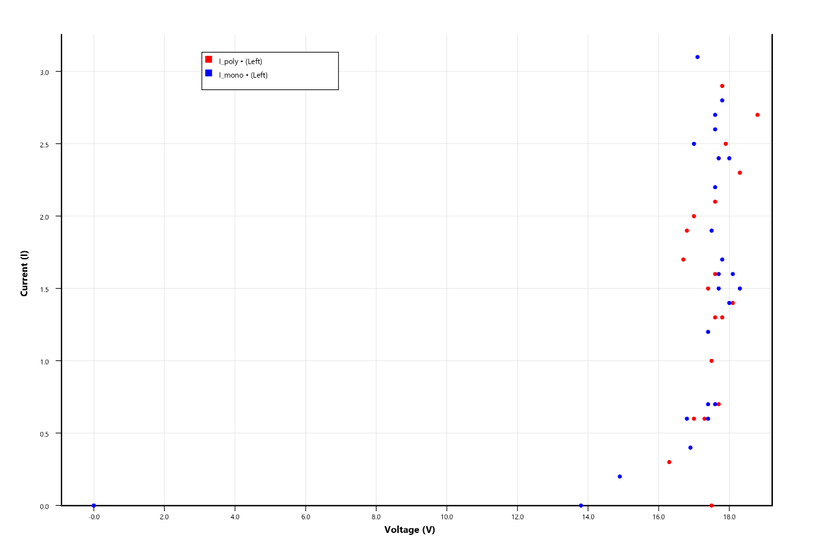
Figure 1.1: IV Curve
Location: Abakaliki

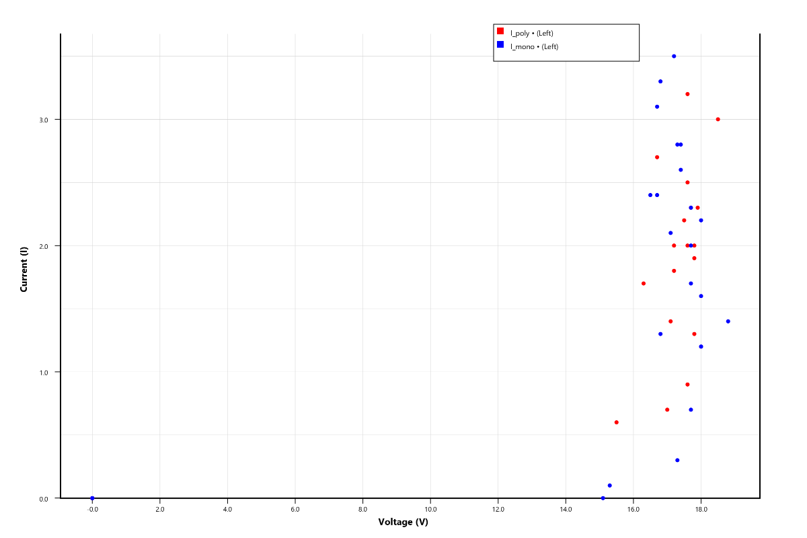
Figure 1.2: IV Curve
Location: Abomege

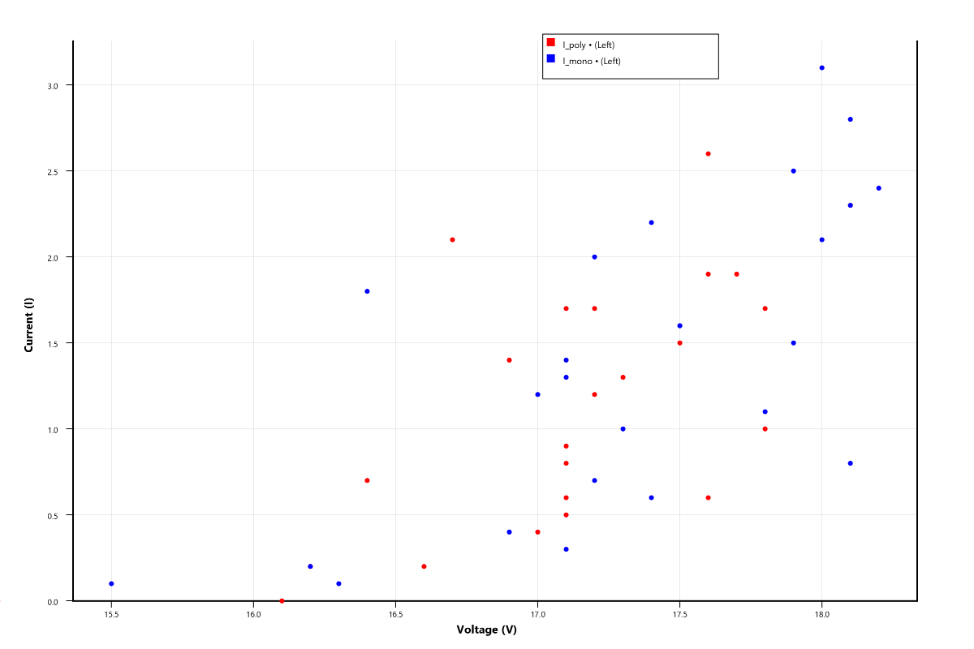
Figure 1.3: IV Curve
Location: Calabar

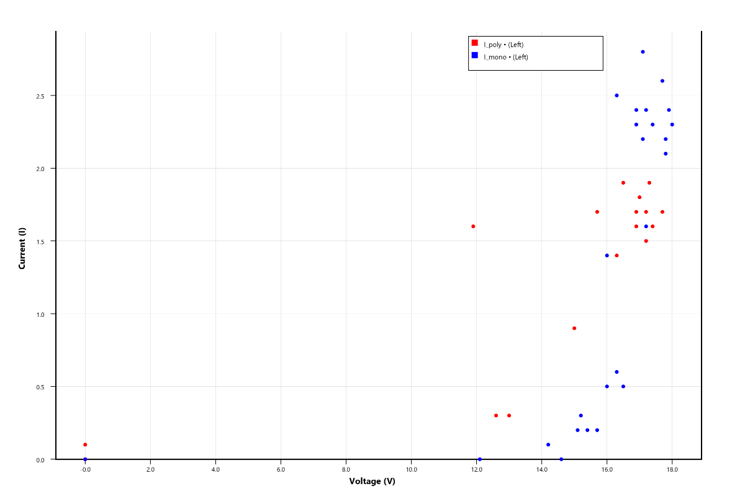
Figure 1.4: IV Curve
Location: Eket

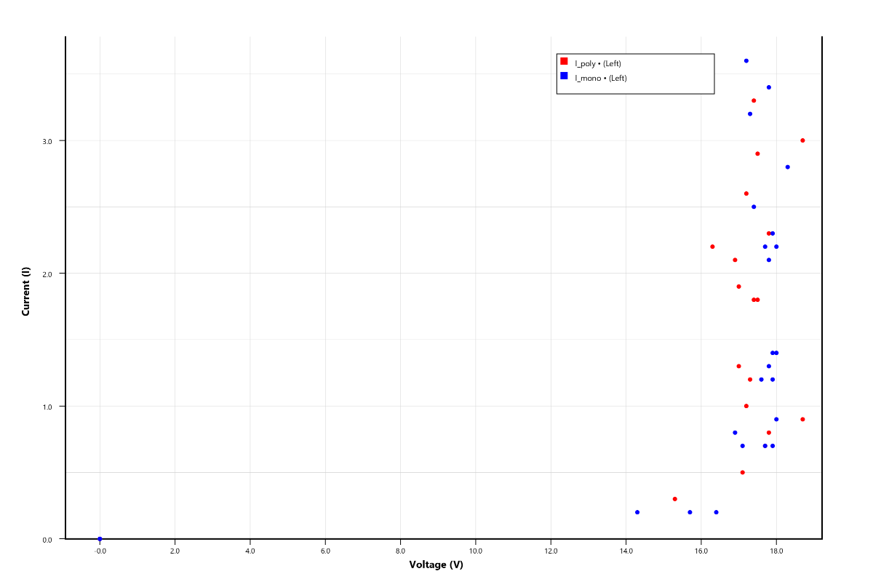
Figure 1.5: IV Curve
Location: Ezza south

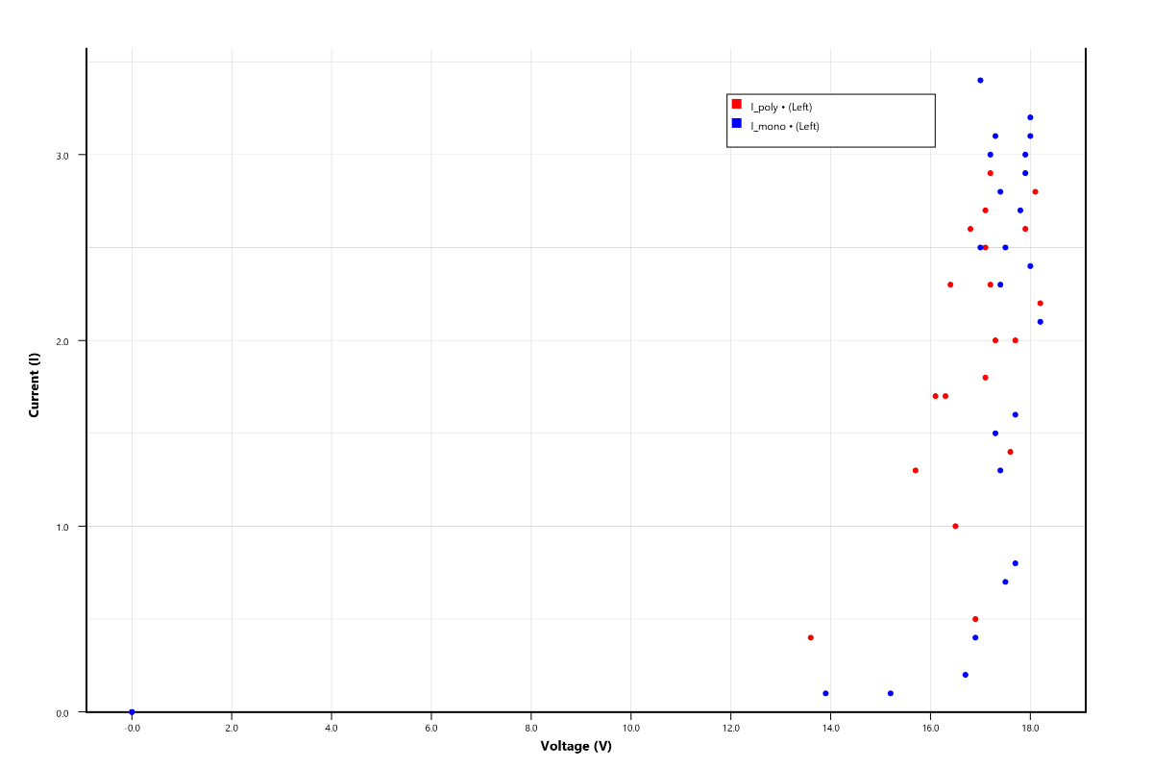
Figure 1.6: IV Curve
Location: Ikot Ekpene

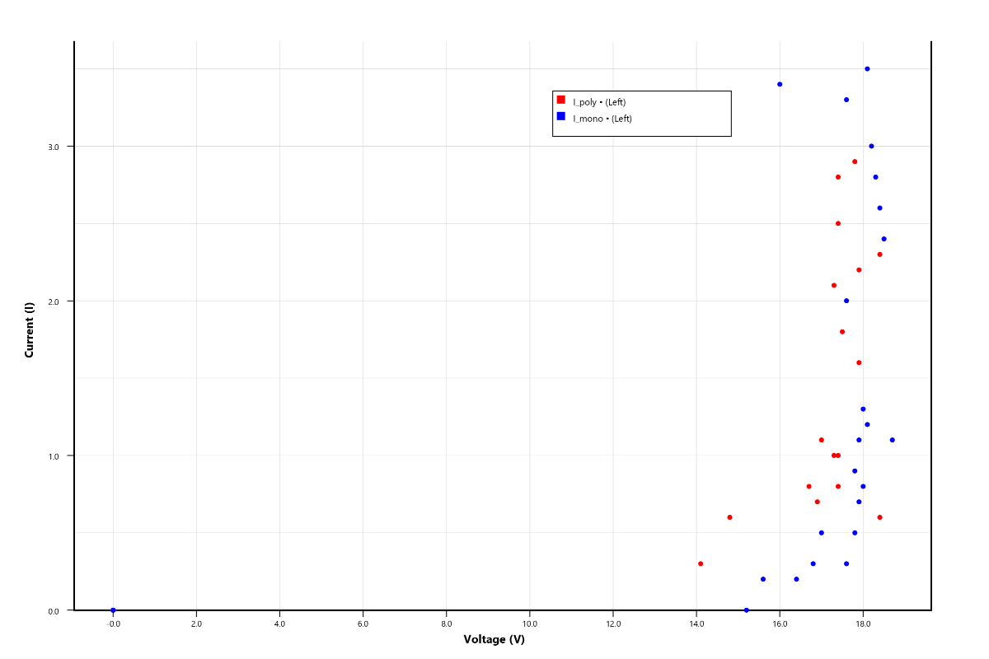
Figure 1.7: IV Curve
Location: Obanlikwu

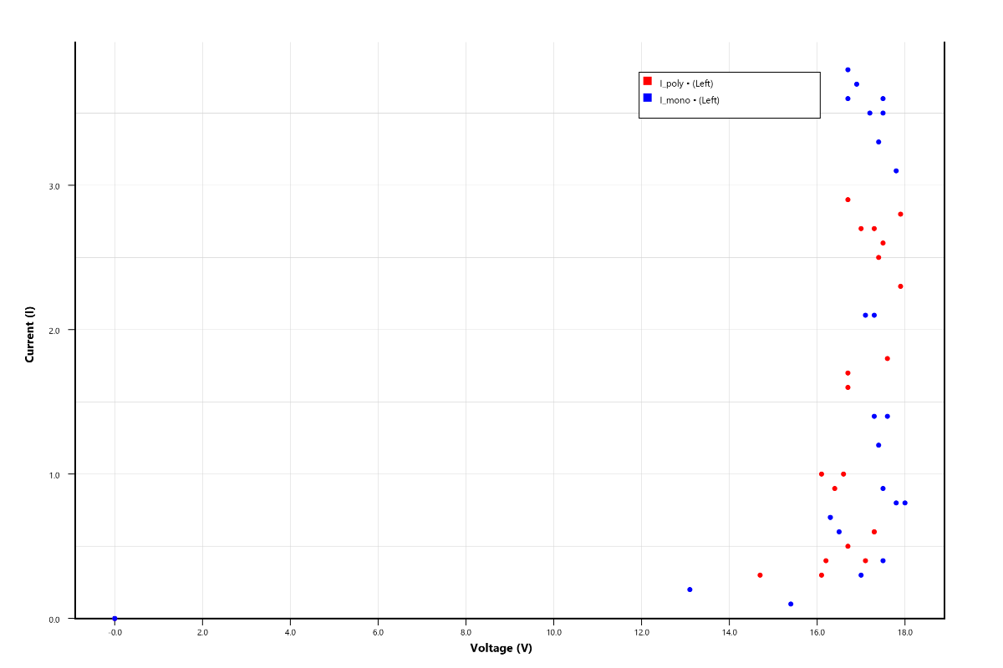
Figure 1.8: IV Curve
Location: Obubra

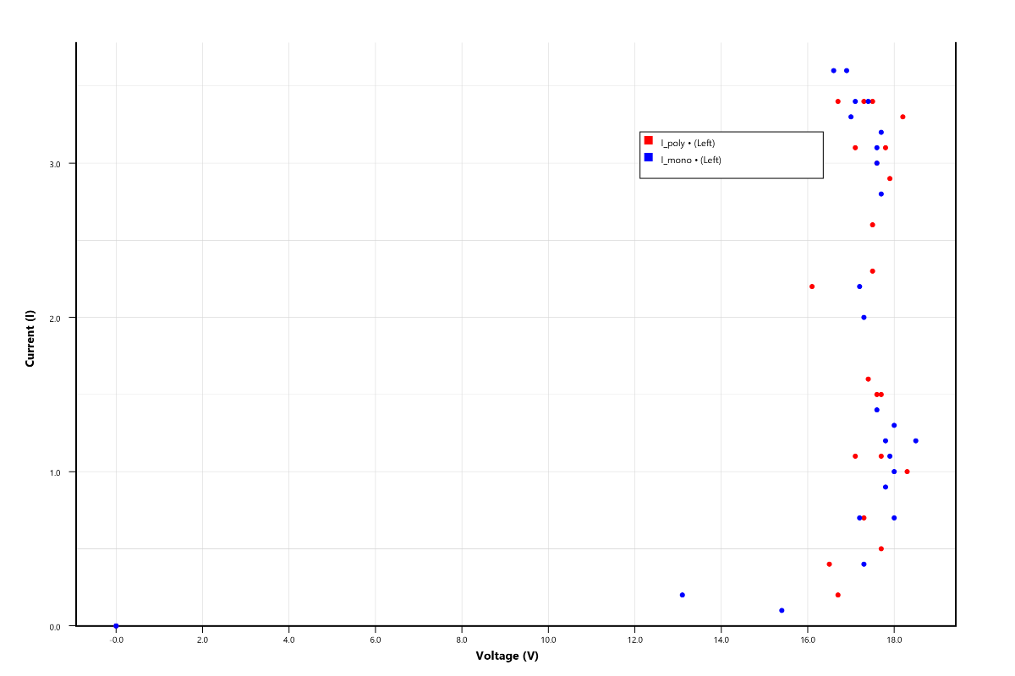
Figure 1.9: IV Curve
Location: Ogoja

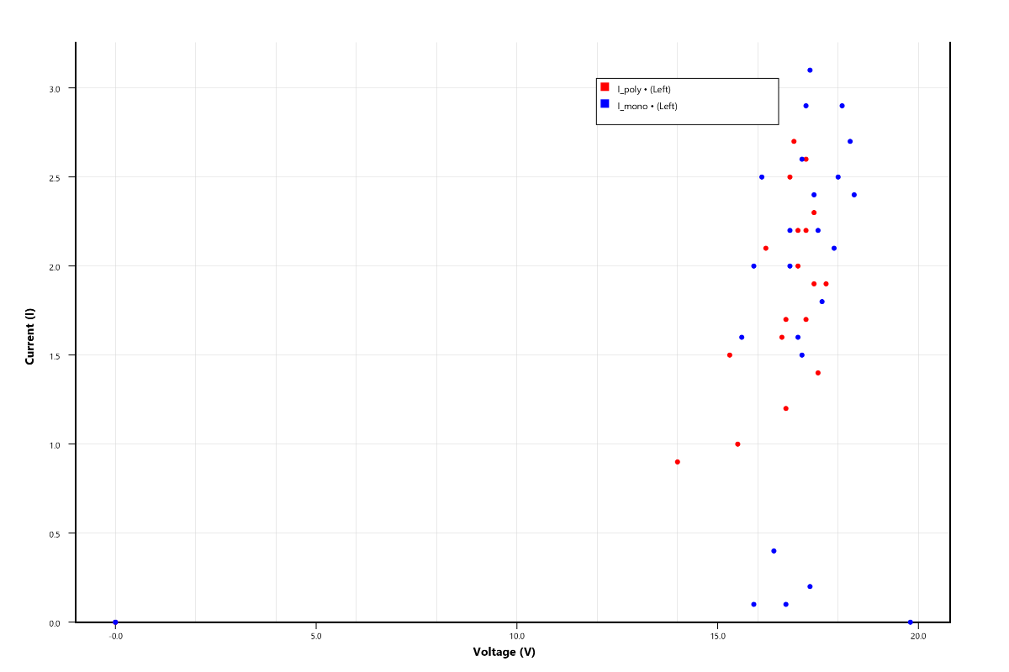
Figure 1.10: IV Curve
Location: Uyo

Figures 1.1–1.10 above represents the current–voltage (I–V) characteristics of monocrystalline (I_mono) and polycrystalline (I_poly) photovoltaic modules across ten locations: Abakaliki, Abomege, Calabar, Eket, Ezza South, Ikot Ekpene, Obanlikwu, Obubra, Ogoja, and Uyo. These curves are fundamental for evaluating electrical performance, power output, and operating efficiency of PV systems under varying environmental conditions.
Across all locations, the I–V curves exhibit the typical PV behavior i.e. Current remains relatively high and stable at low voltages, then gradually decreases as voltage increases. The region near the “knee” of the curve represents the maximum power point (MPP). Monocrystalline modules generally show slightly higher current values than polycrystalline modules at similar voltages.
This behavior aligns with standard photovoltaic theory (Villalva et al., 2009).
From the graph above the highest current outputs (≈2.5–3.5 A) are observed in Ogoja, Obubra, Ikot Ekpene, and Obanlikwu. Moderate current levels occur in Ezza South, Abomege, and Abakaliki. While lower current outputs are evident in Calabar, Eket and Uyo.
This trend reflects earlier observations where higher solar radiation leads to higher photocurrent generation, confirming that current is directly proportional to irradiance.
The voltage across all locations remains relatively consistent (≈17–19 V), with minor variations due to temperature differences. Slightly lower Voltage values are observed in high-temperature locations (e.g., Obubra, Ogoja), due to the negative temperature coefficient of voltage.
Coastal regions (Calabar, Eket, Uyo) show slightly higher Voc stability, likely due to lower operating temperatures.
However, voltage variations are less pronounced compared to current variations, indicating that irradiance affects current more strongly than voltage.
Well-defined curves with sharp knees are observed in Ogoja, Obanlikwu, Obubra, and Ikot Ekpene, indicating high fill factor, efficient power extraction, minimal losses. Flattened or scattered curves are seen in Calabar, Eket, and Uyo, suggesting reduced irradiance, higher humidity effects, Increased performance variability. Moderate curve quality is observed in Abakaliki, Abomege, and Ezza South.
Monocrystalline modules consistently produce slightly higher current values, more clustered and stable I–V points. While polycrystalline modules show similar trends but with slightly lower current output. In some locations they exhibit more spread indicating that monocrystalline modules have a marginally higher efficiency, although the difference is not significant compared to environmental influences.
The above I–V analysis confirms that: Photocurrent is strongly dependent on solar radiation, voltage is slightly affected by temperature, humidity indirectly reduces performance by lowering irradiance, module type has a minor effect compared to environmental conditions.
Conclusively, all locations exhibit standard PV I–V characteristics, Inland locations show higher current output and better curve quality, Coastal locations exhibit reduced and less stable performance, Monocrystalline modules slightly outperform polycrystalline modules, Irradiance is the dominant factor influencing PV electrical output.

V. CONCLUSION
This study presented a comparative investigation of the current–voltage (I–V) characteristics and performance of monocrystalline and polycrystalline photovoltaic (PV) modules under varying environmental conditions across selected climatic regions in Nigeria. The results demonstrate that the electrical performance of both PV technologies is strongly influenced by variations in solar irradiance, panel temperature, ambient temperature, relative humidity, and wind speed. While increased solar irradiance enhanced current generation and output power, elevated panel temperatures reduced the operating voltage and overall conversion efficiency, confirming the sensitivity of photovoltaic systems to environmental variability.
A key finding of this study is the consistently superior performance of the monocrystalline module over the polycrystalline module across the investigated locations. The monocrystalline module exhibited higher output power, conversion efficiency, fill factor, and performance ratio under comparable operating conditions, indicating greater resilience to environmental fluctuations. In addition, clear spatial variations in module performance were observed among the study locations, highlighting the influence of regional climatic characteristics on photovoltaic energy yield and emphasizing the need for location-specific system evaluation and technology selection.
The principal scientific contribution of this work lies in the comprehensive field-based comparison of photovoltaic module performance across multiple environmental zones using measured I–V characteristics and derived performance indices under real operating conditions. Unlike studies conducted under controlled laboratory environments or limited geographical coverage, this investigation provides practical evidence of how climatic variability influences photovoltaic performance in tropical regions. The findings establish a valuable dataset for validating photovoltaic performance models, optimizing system design, and improving technology selection for diverse environmental conditions.
Overall, this study demonstrates that incorporating local climatic characteristics into photovoltaic system planning can significantly improve energy yield, system reliability, and long-term operational efficiency. The results provide useful guidance for researchers, engineers, policymakers, and investors seeking to accelerate the deployment of efficient and sustainable solar energy technologies in Nigeria and regions with similar tropical climates.

REFERENCES
Ahmed, I., Shi, L., Pasanen, H., Vivo, P., Maity, P., Hatamvand, M., & Zhan, Y. (2021). There is plenty of room at the top: generation of hot charge carriers and their applications in perovskite and other semiconductor-based optoelectronic devices. Light: Science & Applications, 10(1), 174.
Bao, Q., Qian, W., Ma, G., Qiu, X., Zhang, H., Zhou, H., & Chen, M. (2025). Influence of the change direction of total solar irradiance at the inclined surface on power generation performance of photovoltaic power station: A focus on output power and photoelectric conversion efficiency. Energy, 324, 135975.
Chanchangi, Y. N., Adu, F., Ghosh, A., Sundaram, S., & Mallick, T. K. (2023). Nigeria's energy review: Focusing on solar energy potential and penetration. Environment, Development and Sustainability, 25(7), 5755-5796.
Chaudhary, O. S., Denaï, M., Refaat, S. S., & Pissanidis, G. (2023). Technology and applications of wide bandgap semiconductor materials: current state and future trends. Energies, 16(18), 6689.
Cibira, G. (2018). Relations among photovoltaic cell electrical parameters. Applied Surface Science, 461, 102-107.
Dang, D. N., Le Viet, T., Takano, H., & Duc, T. N. (2023). Estimating parameters of photovoltaic modules based on current–voltage characteristics at operating conditions. Energy Reports, 9, 18-26.
Ebhota, W. S., & Jen, T. C. (2020). Fossil fuels environmental challenges and the role of solar photovoltaic technology advances in fast tracking hybrid renewable energy system. International Journal of Precision Engineering and Manufacturing-Green Technology, 7(1), 97-117.
Ettah, E. B., Eno, E. E., & Udoimuk, A. B. (2009). The effects of Solar panel temperature on the power output efficiency in Calabar, Nigeria. Journal of Radiography and Radiation Sciences, 23(1), 16-22.
Ettah, E. B., Udoimuk, A. B., Obiefuna, J. N., & Opara, F. E. (2012). The effect of relative humidity on the efficiency of solar panels in Calabar, Nigeria. Universal Journal of Management and social sciences, 2(3), 8-11.
Ettah, E., Ekah, U., Oyom, E., & Akonjom, N. (2021). Performance analysis of monocrystalline and polycrystalline solar panels in a Semi-Arid region. International Journal of Engineering Science Invention, 10(7), 10-14.
Ettah, E., Ushie, P., Obiefuna, J., & Nwachukwu, N. (2015). Comparative study of the effects of relative humidity on solar electricity generation in UYO and Port-Harcourt, Nigeria. International Journal of Mathematics and Physical Sciences Research, 3(2), 66-70.
Lutz, J., Schlangenotto, H., Scheuermann, U., & De Doncker, R. (2018). Semiconductor properties. In Semiconductor Power Devices: Physics, Characteristics, Reliability (pp. 21-99). Cham: Springer International Publishing.
Njok, A. O., & Ogbulezie, J. C. (2018). Investigation of the performance of photovoltaics installed close to river. arXiv preprint arXiv:1808.06694.
Okafor, C. C., Ajaero, C. C., Madu, C. N., Nzekwe, C. A., Otunomo, F. A., & Nixon, N. N. (2024). Climate change mitigation and adaptation in Nigeria: A review. Sustainability, 16(16), 7048.
Okono, M. A., Agbo, E. P., Ekah, B. J., Ekah, U. J., Ettah, E. B., & Edet, C. O. (2022). Statistical analysis and distribution of global solar radiation and temperature over southern Nigeria. Journal of the Nigerian Society of Physical Sciences, 588-588.
Omer, A. (2017). Solar Energy for Buildings: Clean Energies Utilisation and Development. Available at SSRN 2933628.
Oyom, E. B., Ettah, E. B., & Akonjom, N. A. (2023). Impact of dust particles on the output power of photovoltaic modules in Calabar, Cross River State. Science World Journal, 18(3), 380-385.
Oyom, E., & Sampson, N. S. A. (2026). Diurnal Variation of Solar Radiation, Ambient Temperature, Panel Temperature and Relative Humidity across some selected locations in Nigeria. International Journal of Research and Scientific Innovation (IJRSI), 13(4).
Siva Ramkumar, M., Felshiya Rajakumari, R., Kannan, N., Premkumar, R., Mohanasundaram, S., Purushotham, S., ... & Rajan, K. (2022). Semiconductor materials for solar PV technology and challenges towards electrical engineering. Advances in Materials Science and Engineering, 2022(1), 7272489.
Sunday, E. A., Musa, H., Ibrahim, M., & Ezekiel, D. (2026). THERMODYNAMIC AND PERFORMANCE ANALYSIS OF BOX-TYPE SOLAR COOKERS: A REVIEW (2015–2025). International Journal of Renewable Energy and Environment, 4(1), 243-261.
Villalva, M. G., Gazoli, J. R., & Ruppert Filho, E. (2009). Comprehensive approach to modeling and simulation of photovoltaic arrays. IEEE Transactions on power electronics, 24(5), 1198-1208.
Woods-Robinson, R., Han, Y., Zhang, H., Ablekim, T., Khan, I., Persson, K. A., & Zakutayev, A. (2020). Wide band gap chalcogenide semiconductors. Chemical reviews, 120(9), 4007-4055.
Yakubu, R. O., Mensah, L. D., Quansah, D. A., Adaramola, M. S., & Hammed, Y. (2022). Performance evaluation of bifacial solar PV modules under different climatic regions in Nigeria. In E3S Web of Conferences (Vol. 354, p. 02006). EDP Sciences.
Yue, X., Fan, J., & Xiang, Q. (2022). Internal electric field on steering charge migration: modulations, determinations and energy‐related applications. Advanced Functional Materials, 32(12), 2110258.

