Enhancing Energy Efficiency: Performance Analysis of a Smart Lighting System for University Lecture Rooms

ABSTRACT
With the growing emphasis on sustainability and the need to reduce greenhouse gas emissions, efficient energy management in lighting systems has become increasingly critical. This study proposes an intelligent classroom lighting system that integrates Passive Infrared (PIR) and Light Dependent Resistor (LDR) sensors with a mobile application for real-time monitoring and class scheduling. The system dynamically controls lighting based on occupancy and luminance levels, even when schedules are predefined, while the mobile application provides remote access to energy usage data, including total consumption and lighting duration. Experimental results show that the system operates reliably under varying conditions and yields significant energy savings. Overall, the proposed solution enhances user accessibility, reduces unnecessary energy usage, and demonstrates strong potential as a sustainable energy management tool for educational environments.

Keywords: Energy; LDR; Scheduling; Monitoring; PIR

INTRODUCTION
An intelligent network-based lighting control system harnesses the power of central computing devices to streamline communication between system inputs and outputs. Lighting alone accounts for 20%-60% of a building's electricity usage. Manually turning lights on and off requires constant reminders, especially when leaving a room. To tackle this inefficiency, a lighting control system based on the Internet of Things (IoT) was developed, enabling seamless remote control and monitoring of lights (Ayub et al., 2025; Ahmad et al., 2019; Alif et al., 2020; Bae et al., 2021). In educational institutions, lecture rooms frequently experience random activation and deactivation of lights, irrespective of attendance or natural light availability. This erratic behavior leads to significant electricity wastage and underscores the nation's insufficient focus on energy conservation. The high electricity demand exacerbates the release of carbon dioxide and other greenhouse gases, contributing to global warming and increasing the frequency of flash floods (Elshafie et al., 2023; Khan et al., 2024; Blume et al., 2021).

A substantial body of research has examined multiple strategies to improve energy efficiency in building environments, particularly through sensor-based automation. To incorporate smartphone-based control mechanisms, Lai X et al. (2020) explored a system integrating a light-dependent resistor (LDR) sensor for daylight sensing alongside passive infrared (PIR) sensors for occupancy detection. The findings demonstrated that dynamic control based on both human presence and ambient illumination can significantly reduce unnecessary lighting use, thereby lowering operational costs. Meanwhile, Berde PA & Bhavani RG (2015) conducted an evaluation of lighting retrofits and found that replacing conventional fluorescent tubes with LED equivalents can reduce energy consumption by an average of 48.47%. This retrofit strategy is one of the most widely adopted approaches due to its relatively low implementation cost and immediate energy-saving benefits.

In the context of higher education institutions, Mansur et al. (2021) examined the performance of smart lighting systems in promoting sustainable campus operations. The study emphasized that, beyond energy savings, user comfort is a critical metric of system effectiveness. Smart lighting improves visual comfort by adjusting illumination levels according to task demands. However, the researchers noted that deploying such systems requires substantial upfront investment and ongoing maintenance support. Complexities associated with integrating modern control systems into existing campus infrastructure also pose considerable challenges. Similarly, C.Te et al. (2022) investigated an IoT-based smart lighting system designed for office environments. The results showed that user-adaptive lighting enhances energy efficiency and convenience. Yet, issues related to system connectivity, data privacy, and interoperability may limit widespread adoption.

Urban applications have also been explored, with Sikder et al. (2018) highlighting the effectiveness of adaptive lighting solutions that respond to environmental conditions and human activity. While these systems improve public safety and reduce energy consumption, The scalability remains a concern in large metropolitan areas. High deployment costs, the need for robust cybersecurity protections, and ongoing maintenance requirements present major obstacles to citywide implementation. Sensor-based control strategies have been extensively reviewed by Wagiman et al. (2019), who identified occupancy and daylight-responsive techniques as the most efficient. The comprehensive analysis indicated that building characteristics and occupancy patterns significantly influence the performance of sensing-based solutions. Hybrid systems combining multiple sensing modalities demonstrated energy savings of up to 95% in commercial buildings. In another study, Abdullah et al. (2019) proposed a street lighting control system based on adaptive dimming, which successfully reduced monthly energy consumption by up to 40%.

Various simulation-based and experimental research efforts have further expanded understanding of lighting optimization. Verma & Jain (2018) evaluated dimming and switching daylight control methods in hotels using software simulations, observing potential energy savings between 30% and 40%. Bannamas & Jirapong (2015) introduced an intelligent lighting control system featuring six operating modes for both residential and commercial applications; The findings showed that switching and dimming controls may yield average energy reductions of up to 68%. In office settings, Kaneko et al. (2013) proposed a system that synchronizes lighting intensity with access control data. By adjusting illumination based on occupant presence on a particular floor, the system achieved energy savings of approximately 25%.

Other studies have emphasized environmental and architectural influences on lighting efficiency. Ul Haq et al. (2014) noted that variables such as daylight availability, building orientation, occupant comfort, and task characteristics significantly affect the success of energy-efficiency measures. Meanwhile, Zakaria et al. (2019) introduced an enhanced Energy Efficiency Index (EEI) calculation method that incorporates occupancy density—demonstrating that occupant number and distribution heavily influence energy consumption in university buildings. Bulan et al. (2019) expanded this discourse by exploring microcontroller-based air conditioning control, which yielded an average daily energy savings of 32%.

Beyond indoor lighting, energy-saving measures in outdoor environments have also been examined. Gorgulu et al. (2020) studied garden, pathway, and roadway lighting and found that combining retrofitted luminaires with dimming controls saved 762 MWh annually. Neardey et al. (2020) proposed energy-saving measures for 24-hour service buildings and demonstrated that adjusting operational timing and integrating daylight-responsive dimming could reduce energy use by 17% and 49%, respectively.

Lighting technology comparisons have similarly offered important insights. Ayan et al. (2020) evaluated different lamp types and found smart LED bulbs to be the most energy-efficient when used with dimming and remote-control features. Research at Sharm El-Sheikh Airport by Shafei et al. (2019) confirmed that LED lighting reduces energy loads by 57%, while a fuzzy logic control system further lowers monthly energy use by approximately 25%. Lee et al. (2020) discussed the future integration of smart lighting into smart grid systems, emphasizing potential contributions to peak load reduction and grid stability alongside concerns regarding algorithmic complexity and user acceptance. Finally, IoT applications have been explored for smart buildings more broadly. Masnur & Syahirun (2024) proposed a web-server-based load control system, though challenges related to internet reliability and security were identified. Kumar et al. (2021) highlighted interoperability issues in IoT lighting implementations, while Montalbo & Enriquez (2020) demonstrated the benefits and challenges of deploying smart lighting in university classrooms.

Given these findings, the lighting system in educational facilities must be modernized to support both energy conservation and improved learning environments. With increasing awareness of sustainability, the development of a Smart Lighting System that integrates multiple sensors, centralized control, and real-time monitoring is essential. The proposed system in this study aims to optimize lighting usage through occupancy detection, daylight sensing, automated scheduling, and performance analytics. By minimizing unnecessary energy consumption and providing detailed operational insights, this innovation is expected to significantly enhance energy management practices within educational settings and contribute to long-term sustainability goals.

METHODOLOGY
A Smart Lighting System consists of hardware and software components, as illustrated in Figures 1 and 2.

Hardware Development
The ESP32 WROOM, compatible with Wi-Fi and Bluetooth, is the project's central processor depicted in the block diagram in Figure 1. Before connecting to the microcontroller, the power supply (Adapter 12V 2A) will be connected to the buck converter, which will step down the voltage while simultaneously stepping up the currents. This will occur on the path from the power supply to the voltage regulator. Arduino Uno is connected to a CT Clamp AC Current Sensor, an Alternating Current (AC) measuring device. PIR sensor, LDR sensor, Push Button, and Arduino Uno are all connected to ESP 32 WROOM to serve as inputs to the microcontroller. On the other hand, i2C LCD and Relay serve as outputs to turn on the LED lamp.
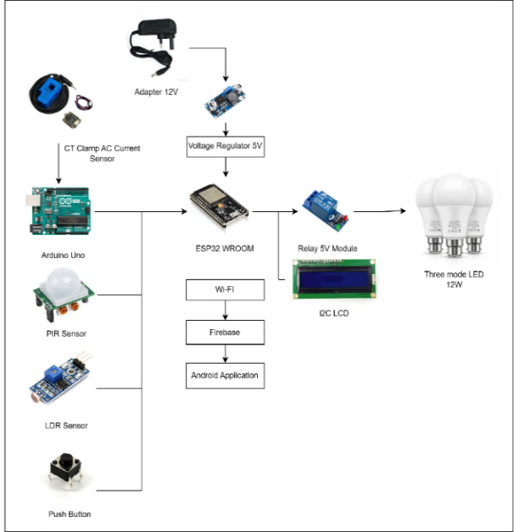
Figure 1 Hardware block diagram

Software Development
The system can schedule four sets of dates simultaneously, as can be seen in Figure 2. Firebase received the login registers and previous data on energy consumption for transmission as a cloud service. The data can be checked in Firebase and Blynk Applications. The MIT App Inventor platform allows for monitoring real-time data energy consumption.
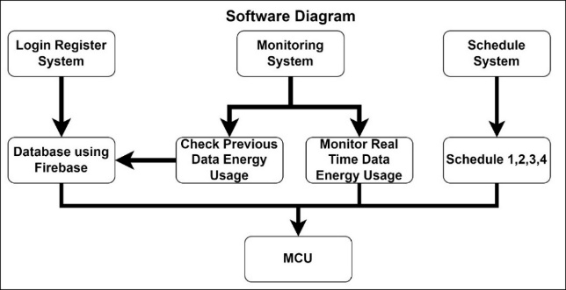
Figure 2 Software block diagram
The interface of mobile applications, Blynk and Firebase served as a bridge between the user and the software, allowing the user to enter commands or data and receive feedback or results from the software. Figure 3 (a) shows the application's login and register menu. Users must enter The username and password to create a database that can be retrieved. Figure 3 (b) shows the home screen after signing in. The screen displays a menu bar for power monitoring and scheduling tasks. Figure 3 (c) displays input fields. Once the user selects a predetermined schedule, the user can enter data. Data, including power used, price, current, and power, will appear when the user clicks power monitoring. Figure 3 (d) illustrates price and power usage are based on total usage, while current and power are based on real-time usage.

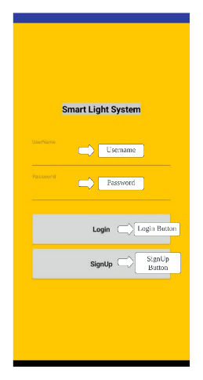 | 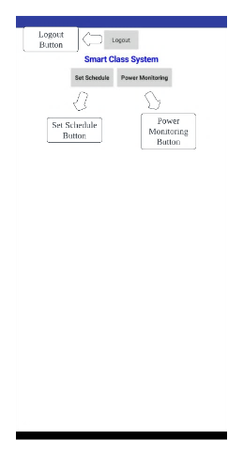
(a) | (b)
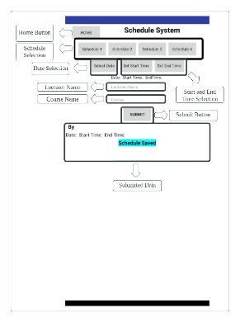 | 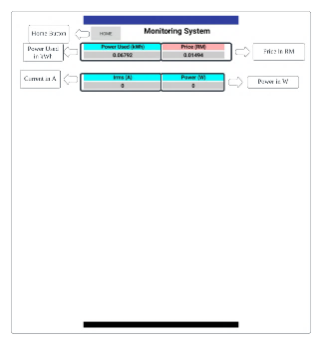
(c) | (d)
Figure 3 Interface for (a) login register, (b) home screen, (c) schedule system, (d) monitoring system

Figure 4 shows Blynk's interface. This interface showed power used, cost, current, power, LDR raw, PIR state, class lamp state, and LDR reading. A week, day, six hours, last hour, and latest can be analysed.

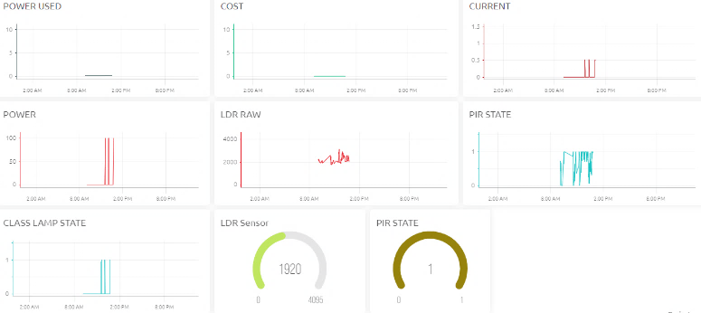
Figure 4 Blynk Interface

Prototype of Smart Lighting System
The Smart Lighting System prototype integrates PIR and LDR sensors with automated controls to optimize energy efficiency, adjusting brightness based on occupancy and ambient light while enabling remote monitoring via a mobile application. Figure 5 shows the complete prototype of this project.
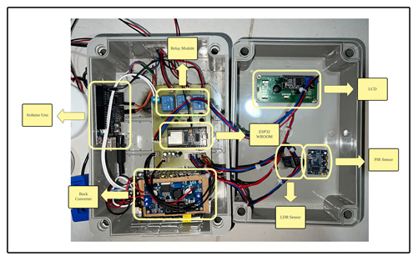
Relay Module
Arduino Uno
Buck Converter
LCD
ESP32 WROOM
PIR Sensor
LDR
Sensor

Figure 5 Overall prototype embedded system

Energy Parameters
Two energy estimation parameters are used for investigation: (i) Energy Consumption Ratio of the Smart Scenario in comparison to the Base Scenario (ECR_{SB}), (ii) Energy Consumption Ratio of the Manually Controlled Scenario in comparison to the Base Scenario (ECR_{MB}). ECR_{SB} and ECR_{MB} are the energy consumption ratios for a specific strategy to the energy consumption in the smart and manually controlled scenarios, respectively. The parameters given act as a comparison between two systems which are manually controlled and smart scenarios that refer to the base scenarios. The parameters are used as a benchmark to identify the most efficient system in terms of energy consumption and energy saving.

ECR_{SB} = E_{S}/E_{B} × 100 | (1)
ECR_{MB} = E_{M}/E_{B} × 100 | (2)
E_{B} represents the energy used in the basic scenario, E_{M} represents the energy consumed in the manually controlled scenario, and E_{S} represents the energy expended in the smart scenario in kWh.

P = Current × 220 | (3)
E = E + (0.000277778 × P/1000) | (4)
Price = Price per kWh × E | (5)

RESULTS AND DISCUSSIONS
The smart lighting system has been utilised in practice at Bilik Tutorial 1 FTKEK as shown in Figure 6. The three different possibilities are outlined in detail in Table 1. The observation was carried out concurrently for all three scenarios: the base case, the manually controlled case, and the smart. From 6:00 pm until 10:00 pm, the light bulb is assumed to be permanently in the ON position in the base scenario. The light bulb has no automatic or manual control mechanism, so it is always in the ON position. In the scenario where the light bulb is controlled manually, the ON and OFF states are switched as necessary. Utilizing a Smart Lighting System makes the light bulb's operation automated and adaptive to the environment. This can lead to energy savings, increased convenience, and improved lighting conditions compared to the base and manually control scenarios.

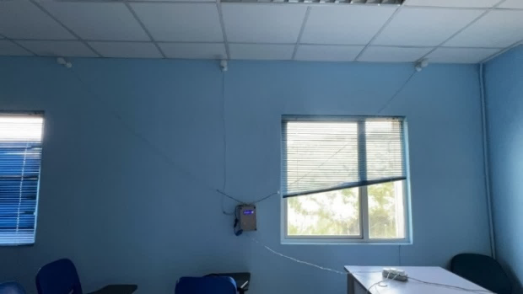
Figure 6 Embedded system at tutorial room 1 FTKEK
Table 1 Explanation of the three scenarios

Description | Base Scenario | Manually Controlled Scenario | Smart Scenario
Bulb operation state | ON and OFF | ON and OFF | ON, DIM and OFF
Environment of Scenario | The light bulb is always ON in the evening and at night. | The light bulb is manually turned to ON when needed and OFF when not. | Motion sensing and illuminance value determine whether the light is ON, DIM, or OFF.
Control of Light bulbs | Centralized control | Decentralized control | Both Centralized and Decentralized control

Energy Consumption in Three Scenarios
The analysis presented in Figure 7 highlights distinct variations in energy consumption across the three scenarios: Base, Manually Controlled, and Smart. The Base scenario, which employs a 12W LED light bulb without any control mechanisms, recorded the highest energy consumption at 0.39192 kWh per use and 143.051 kWh annually. This finding underscores the inefficiency of uncontrolled lighting, resulting in substantial energy wastage. In comparison, the Manually Controlled scenario demonstrated a significant reduction in energy consumption, with 0.19596 kWh per use and 71.5254 kWh annually. While manual control offers improvements over the Base scenario, it remains dependent on user intervention, limiting its overall efficiency. The Smart scenario, utilizing PIR and LDR sensors for automated control, achieved the lowest energy consumption at 0.18906 kWh per use and 69.0069 kWh annually. This demonstrates the effectiveness of intelligent automation in optimizing energy use by dynamically adjusting lighting based on occupancy and ambient light conditions. The results confirm that the Smart scenario minimizes energy waste and enhances operational efficiency, making it the most energy-efficient option. The findings emphasize the advantages of adopting smart lighting systems for substantial energy savings and improved sustainability in practical applications.

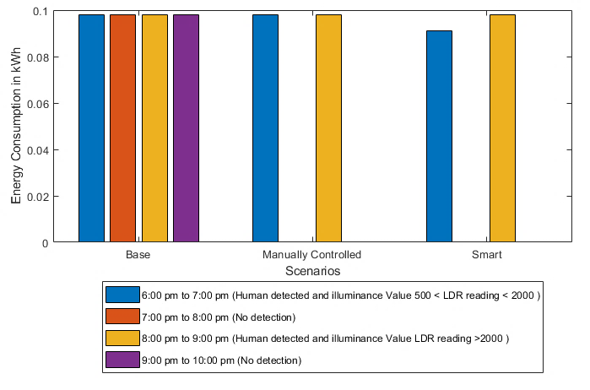
Figure 7 Energy consumption of 12W LED light bulb in three scenarios

Energy Saving Parameters
Figure 8 illustrates the energy consumption trends for three lighting scenarios—Base, Manually Controlled, and Smart—using a 12W LED light bulb. The graph indicates that the Base scenario has the highest energy consumption due to continuous operation without optimization. The Manually Controlled scenario shows a moderate reduction in energy usage, as user intervention allows lights to be switched off when not needed. However, the Smart scenario demonstrates the lowest energy consumption, leveraging dimmable lighting and sensor-based adjustments to optimize illumination based on real-time ambient conditions. This automation ensures sufficient lighting while minimizing excess energy, making the system highly efficient. Integrating smart controls significantly enhances energy savings by reducing power consumption without compromising functionality. These findings highlight the advantages of smart lighting technology, particularly in applications requiring continuous yet efficient illumination. Adopting such systems can contribute to long-term sustainability, lower operational costs, and improved energy management in both residential and commercial settings.

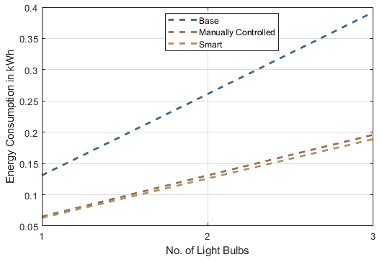
Figure 8 Energy consumption in kWh vs. number of light bulbs for 12W LED light bulbs

Figure 9 presents the energy consumption ratio (ECR) for two scenarios, ECR_{SB} and ECR_{MB}, as 12W LED light bulbs increase from one to three. The graph indicates that both ECR_{SB} and ECR_{MB} maintain a consistent energy consumption ratio of approximately 50%, regardless of the number of bulbs. This stability suggests that the energy consumption ratio remains unaffected by scaling, implying that increasing the number of light bulbs does not alter the proportional energy consumption for each scenario. The observed linearity in the ECR trends indicates that external factors, such as lighting control strategies, likely influence overall energy efficiency more significantly than the number of bulbs alone. This finding highlights a potential limitation in scalability for applications requiring adaptive energy consumption ratio adjustments, as the ratio remains constant despite an increase in lighting units. However, this consistency may suggest that the lighting system operates efficiently within predefined parameters, ensuring uniform energy distribution across different bulb quantities.

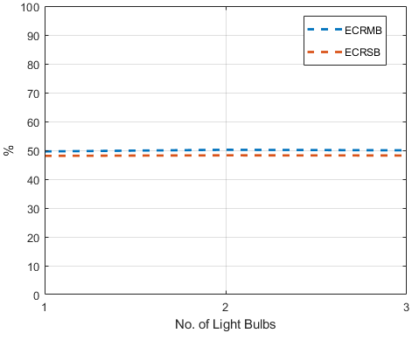
Figure 9 Energy consumption ratio vs. number of light bulbs of ECR_{SB} and ECR_{MB} of 12W LED light bulbs.

Energy Saving Graphical Analysis
Figure 10 presents the energy-saving percentage (ES) for ES_{SB} and ES_{MB} scenarios concerning the number of 12W LED light bulbs. The graph demonstrates a linear increase in energy savings as bulbs increase, suggesting that smart and manually controlled lighting systems consistently improve energy efficiency. The positive slope indicates that energy savings scale proportionally with the number of bulbs, reinforcing the effectiveness of these lighting control methods in reducing overall power consumption.

The slight difference between the ES_{SB} and ES_{MB} values suggests that the smart lighting system (ES_{SB}) achieves marginally higher energy savings than the manually controlled system (ES_{MB}). This discrepancy may be attributed to the ability of smart systems to dynamically adjust brightness based on environmental factors such as ambient light levels and occupancy, optimizing energy usage more effectively than manual controls. The increasing trend in energy savings also implies that implementing energy-efficient lighting strategies in larger-scale applications, such as commercial or industrial environments with multiple light sources, can significantly reduce electricity consumption and operational costs.

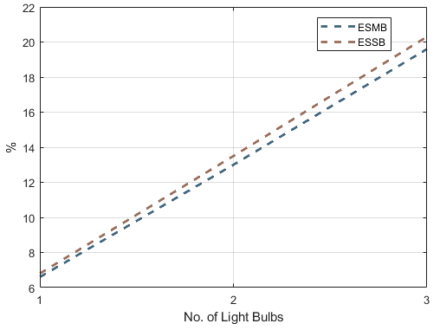
Figure 10 Energy saving ratio vs. number of light bulbs for ES_{SB} and ES_{MB}

CONCLUSION

This study evaluates the Smart Lighting System, highlighting its role in enhancing energy efficiency and automation. By integrating PIR and LDR sensors, the system achieved a 51.81% reduction in energy consumption compared to manual lighting, demonstrating its effectiveness in optimizing energy use. Mobile applications such as MIT App Inventor, Blynk, and Firebase also enable real-time monitoring, remote control, and automated scheduling, providing users with greater convenience and reducing unnecessary energy waste. Users can track power consumption and adjust settings efficiently, leading to further savings. Beyond cost reduction, the system supports environmental sustainability by lowering electricity demand and reducing carbon emissions. In conclusion, the Smart Lighting System offers a scalable, practical solution for modern lighting management. Future advancements, such as AI-driven automation, could further improve its performance and adaptability.

ACKNOWLEDGEMENT

The authors would like to thank Centre for Research and Innovation Management (CRIM), Universiti Teknikal Malaysia Melaka (UTeM) for sponsoring this work.

REFERENCES

- Ayub, M. H., Mohd.Sari, K. A., & Tong, B., “Investigation of Energy and Cost Potential in an Office Building Using IoT Lighting System,” Progress in Engineering Application and Technology, 6(2), 63-73, 2025.
- Ahmad, A., Zainal, A., & CIDB Malaysia, “The impact of energy-efficient technologies on office building performance,” Journal of Building Performance, 10(2), 1-15, 2019.
- Alif Hilmi Shahron, A., & Wee, L, “Energy efficiency in Malaysian office buildings: A review of current practices and future directions,” Energy Reports, 6, 1-12, 2020.
- Bae, J., Kim, H., & Lee, S, “Challenges and opportunities for IoT integration in building management systems,” Sustainable Cities and Society, 64, 102-110, 2021.
- Elshafie, M., & Elshafie, A, “IoT-enabled smart lighting systems: Enhancing energy efficiency in commercial buildings,” International Journal of Smart Buildings, 5(1), 22-34, 2023.
- Khan, M., & Khan, N, “Transforming building management through IoT: A case study approach,” Journal of Building Technology, 12(3), 100-115, 2024.
- Blume, C, “The rise of ESG investing: Trends and implications for corporate governance,” Corporate Governance Review, 29(4), 45-58, 2021.
- Lai X, Dai M, Rameezdeen R, “Energy saving based lighting system optimization and smart control solutions for rail transportation: evidence from China,” Results in Engineering. 2020.
- Berde PA, Bhavani RG, “Investigation for reducing energy consumption for a university campus in Dubai using automation,” In recent advances in intelligent computational systems IEEE, pp. 358-63, 2015.
- T. M. N. T. Mansur, R. Ali, N. H. Baharudin, and K. Ananda-Rao, “Performance analysis of smart lighting control system for sustainable campus operation,” International Journal of Advanced Technology and Engineering Exploration, 8(74), 54-63, 2021.
- C. Te. Lee, L. B. Chen, H. M. Chu, and C. J. Hsieh, “Design and implementation of a leader-follower smart office lighting control system based on IoT Technology,” IEEE Access,10, 28066 – 28079, 2022.
- A. K. Sikder, A. Acar, H. Aksu, A. S. Uluagac, K. Akkaya, and M. Conti, “IoT-enabled smart lighting systems for smart cities,” IEEE 8th Annual Computing and Communication Workshop and Conference, (CCWC), pp. 639-645, 2018.
- Wagiman KR, Abdullah MN, Hassan MY, Radzi NH, “A review on sensing-based strategies of interior lighting control system and The performance in commercial buildings,” Indonesian Journal of Electrical Engineering and Computer Science, 16(1), 208-15, 2019.
- Abdullah A, Yusoff SH, Zaini SA, Midi NS, Mohamad SY., “Energy efficient smart street light for smart city using sensors and controller,” Bulletin of Electrical Engineering and Informatics, 8(2),558-68, 2019.
- Verma N, Jain A, “Optimized automatic lighting control in a hotel building for energy efficiency,” In international conference on power energy, environment and intelligent control, pp. 168-72, 2018.
- Bannamas S, Jirapong P, “An intelligent lighting energy management system for commercial and residential buildings,” In innovative smart grid technologies-Asia (ISGT ASIA), pp. 1-6, 2015.
- Kaneko Y, Matsushita M, Kitagami S, Kiyohara R, “An energy-saving office lighting control system linked to employee's entry/exist,” In global conference on consumer electronics, pp. 440-4, 2013.
- Ul Haq MA, Hassan MY, Abdullah H, Rahman HA, Abdullah MP, Hussin F, “A review on lighting control technologies in commercial buildings, The performance and affecting factors,” Renewable and Sustainable Energy Reviews, 33, 268-79, 2014.
- Zakaria NA, Hassan M Y, Abdullah H, Abdullah M P, Hussin F, Hussin S M, “Energy efficiency index by considering number of occupants: a study on the lecture rooms in a university building,” Indonesian Journal of Electrical Engineering and Computer Science, 15; (3):1154-60, 2019.
- Bulan LA, Maderazo LR, Asi PB, “Design and development of microcontroller-based air conditioning units controller as input to energy conservation for university of Batangas,” International Journal of Advanced Trends in Computer Science and Engineering, 8(4):1020-5, 2019.
- Gorgulu S, Kocabey S, “An energy saving potential analysis of lighting retrofit scenarios in outdoor lighting systems: a case study for a university campus,” Journal of Cleaner Production, 2020.
- Neardey M, Aminudin E, Chung LP, Zin RM, Zakaria R, Wahid CC, “Simulation on lighting energy consumption based on building information modelling for energy efficiency at highway rest and service areas Malaysia,” IOP conference series: materials science and engineering, pp.1-10, IOP Publishing, 2020.
- Ayan O, Turkay B, “IoT-based energy efficiency in smart homes by smart lighting solutions,” In international symposium on electrical apparatus & technologies, pp. 1-5, 2020.
- Shafei M, Tawfik M, Khalil D, “Improving energy efficiency in egyptian airports: a case study of sharmelshiekh airport,” In international middle east power systems conference, pp. 289-94, 2019
- C. K. Lee, H. Liu, D. Fuhs, A. Kores, and E. Waffenschmidt, “Smart Lighting Systems as a Demand Response Solution for Future Smart Grids,” IEEE J Emerg Sel Top Power Electron, 8(3): 2362 – 2370, 2020.
- Masnur Masnur and Syahirun Alam, “Web Server Based Electrical Control System Analysis for Smart Buildings,” Advance Sustainable Science, Engineering and Technology, vol. 6, no. 4, p. 02404022, Oct. 2024, https://doi.org/10.26877/asset.v6i4.1120.
- P. Kumar, P. Rai, and D. H. B. Yadav, “Smart lighting and switching using Internet of Things,” In Proceedings of the Confluence 2021: 11th International Conference on Cloud Computing, Data Science and Engineering, pp. 536-539, 2021.
- F. J. Montalbo and E. Enriquez, “An IoT Smart Lighting System for University Classrooms,” International Symposium on Educational Technology, ISET 2020, pp. 3-7, 2020.

