MANUSCRIPT FOR

EVUALUATION OF HEAVY METALS POLLUTION IN UMUDEMOCHE -AKWA RIVER, ETCHE LGA RIVERS STATE

ABSTRACT
This​research work tested the levels of heavy metal contamination in Umudemoche-Akwa River located in Etche Local Government Area of Rivers State. The main focus was on the spatial and monthly variations of selected heavy metals and hydrocarbon-related contaminants. Samples of water were taken from five sampling points along the river between February and May, and were analyzed for lead, cadmium, mercury, chromium, iron, total petroleum hydrocarbon, and polycyclic aromatic hydrocarbon. Results revealed that among the heavy metals studied, iron had the highest concentration with monthly values fluctuating from 1.84 ± 0.45 mg/L in April to 3.86 ± 0.77 mg/L in May. Lead fluctuated between 0.13 ± 0.04 mg/L in April and 0.42 ± 0.10 mg/L in May, with cadmium, mercury, and chromium showing measurable levels during the sampling months as well. On the basis of location alone, Station 3 reported the highest average concentrations of lead, cadmium, mercury, chromium, iron, TPH, and PAH, suggesting that this part of the river may be more exposed to pollution sources than the other stations. The statistical data showed that monthly differences in lead, cadmium, mercury, chromium, iron, and PAH were significant, whereas TPH exhibited no significant difference in variation between the months. Variations of iron and TPH were significant among the sampling stations, while lead, cadmium, mercury, chromium, and PAH were not spatially significantly different. High levels measured, especially for iron, lead, chromium and TPH, are indications that Umudemoche-Akwa River is undergoing pollution stress. This may be as a result of domestic waste discharge, agricultural runoff, surface runoff, petroleum-related residues, and other human activities around the river. The study, therefore, points to the requirement for regular monitoring, pollution control, and public education to safeguard the river and lessen the risks to the ecology and human health.
Keywords: Heavy metals, Umudemoche-Akwa River, water pollution, Etche LGA, Rivers State, lead, iron, cadmium, hydrocarbon ‍‌contamination.

INTRODUCTION
Water ‍‌ is an essential resource of nature that is vitally required by humans not only for survival purposes but also for activities such as farming, household use, fishing and maintaining the ecosystem. Often times people living in rural, semi-urban areas rely heavily on surface-water bodies such as rivers, streams, and creeks for their daily needs like washing, irrigation, fishing, small-scale processing, and sometimes drinking especially if the water has undergone little or no treatment. However, the quality of many freshwaters is under threat mainly because of pollution caused by natural processes and human activities. Heavy metals are one of the major pollutants in water bodies that without a doubt make them toxic since not only are they poisonous, and persistent, they are also non-biodegradable and have the ability to get accumulated in water, sediments, aquatic organisms, and ultimately the human food chain.
Lead, cadmium, chromium, arsenic, nickel, mercury, copper, zinc, manganese, and iron are among the heavy metals that make their way into rivers through soil erosion, rock weathering, agricultural runoff, industrial waste discharge, waste dumping, oil-related activities, sand mining, and domestic wastewater.
Heavy metals have been part of soils, rocks, and sediments for a long time but the concentrations of these metals in aquatic systems have been raised drastically due to human activities. It has been found by Bawa-Allah et al. that heavy metal pollution of surface freshwaters has become an issue of the environment all over the world. Actually, human activities are responsible for the steady increase in heavy metal concentrations in many surface-water systems. They have found through meta-analysis that in many cases Nigerian surface freshwaters contain heavy metal concentrations of cadmium, chromium, manganese, nickel, and lead which are above the recommended limits for drinking water, thereby posing potential ecological and public health risks (Anyanwu et al., 2023). This is very important as heavy metals are persistent in the environment in that they cannot be easily broken down by the natural processes. Once these metals find their way into water bodies, they can be found in dissolved form, they can be attached to suspended particles that later on get deposited as sediments or they can be taken up by aquatic organisms. By means of bioaccumulation and biomagnification, these metals can be transported from water and sediments into fish, crops irrigated with contaminated water, livestock, and humans.
Health hazards caused by heavy metals differ from one metal to another and even within the same metal, they greatly depend on the concentration, exposure pathway, the age of the exposed population, and the exposure time. Lead toxicity gives rise to problems related to the nervous system, the delayed development of children, kidney damage, and blood disorders. The kidneys, bones, and respiratory system are the targets of cadmium, while arsenic has been connected with skin lesions, cardiovascular disease, and cancer risks after prolonged exposure. Hexavalent chromium is a well-known poison that may also induce liver, kidney, and respiratory problems. The nervous system is the main target of mercury toxicity, while nickel at high concentrations may cause allergic reactions and other systemic effects. Therefore, the internationally and nationally accepted water quality standards set limits on the concentrations of these metals in water intended for drinking and domestic use. WHO Guidelines for Drinking-water Quality provide a risk-management framework for protecting public health right from catchment to consumer and have remained the major reference for assessing chemical contaminants in water (Bawa-Allah, 2023). In Nigeria, the Nigerian Standard for Drinking Water Quality also provides the local benchmark values for assessing water safety for human ‍‌consumption.
Heavy ‍‌ metal pollution is a serious problem in the Niger Delta region of Nigeria because it is a very active area for oil and gas activities, urban development, farming, local businesses, waste disposal, and has a dense network of rivers and creeks. Rivers State, being one of the main states in the Niger Delta, is home to many communities that depend on surface waters for their livelihoods. Research has indicated that the aquatic environments in the Niger Delta are highly susceptible to contamination by petroleum hydrocarbons, nutrients, and heavy metals. Anyanwu et al., (2023) found that the waters of the Niger Delta, especially rivers and lagoons, are highly contaminated with total petroleum hydrocarbons and heavy metals and oil exploitation, port activities, sewage discharge, and industrial discharge were identified as the major sources of pollution. Besides, studies conducted on the issues of oil spill and heavy metals in the Niger Delta have indicated that inhabitants of the area are vulnerable to the toxic effects of heavy metals because of huge amounts of oil spill and related environmental pollution in the region. These discoveries point out that heavy metal assessment in local water bodies is not only an environmental issue but is also a matter of public health necessity. Edori et al., 2023
Etche Local Government Area of Rivers State is famous for its agricultural activities and has plenty of rivers and streams that the inhabitants depend on for their livelihood. One of those water bodies is the Umudemoche-Akwa River, whose water quality requires scientific assessment in the light of the large-scale evidence of heavy-metal contamination in Rivers State and the Niger Delta. There are some researches done on nearby or associated water systems but the local-level evaluation is still a necessity because pollution levels vary from one river to another depending on land use, geology, hydrology, human activities, season, and waste-disposal practices. For instance, Edori, Ucheaga, and Timothy analyzed heavy metals in the surface water of the Oge-Etche River in Etche, Rivers State and found measurable concentrations of iron, lead, copper, chromium, cadmium, nickel, and arsenic. They concluded that the heavy metals they investigated had contaminated the river to a high degree and the river might not be suitable for domestic use. This result supports the rationale for investigating other rivers in the same local government area, including Umudemoche-Akwa River. WHO, 2026
Surface water heavy metal contamination is a major environmental and public health threat because metals are toxic, persistent, and non-biodegradable. Unlike many organic pollutants that can naturally break down over time, heavy metals such as lead, cadmium, chromium, arsenic, nickel, mercury, copper, zinc, iron, and manganese can stay in aquatic environments for long periods. They can be found in water, sediments, aquatic plants, fish, and other organisms, thus entering the food chain and posing health risks to humans and animals. The World Health Organization recognizes chemical contaminants in drinking water as significant risks that must be managed to safeguard public health and its drinking-water guidelines serve as a key international standard for evaluating water safety for human ‍‌consumption.
Various‍‌ research works have evidenced the large-scale contamination of Nigerian freshwater bodies by heavy metal pollution. Bawa-Allah, Saliu, and Otitoloju in their heavy metal pollution meta-analysis of Nigerian surface freshwaters and sediments noted that heavy metal pollution is a prevalent environmental issue nationwide. Their work highlighted that freshwater bodies' contamination doesn't only threaten nature but also human health, especially when there is reliance on rivers and streams for domestic, agricultural, and fishing operations. Considering that many rural dwellers rely on the rivers that surround them for their everyday needs sometimes without treatment or adequate monitoring, this revelation really matters to the current work.
The assessment of heavy metal contamination in Umudemoche-Akwa River is a relevant and important issue because rivers may become not only contaminated but also the channels for the spread of pollutants in the environment. It is possible that heavy metals entering into a river at one location be carried downstream, become part of the sediments, be taken in by aquatic life or be reintroduced into the water during flood events and seasonal changes. Apart from exposure to agricultural runoffs, especially from farmlands using fertilizers and pesticides, other sources in rural settings could include open dumping of solid wastes, washing of vehicles and equipment, discharge of domestic wastewater, soil erosion, sand mining, and natural weathering of mineral-rich rocks. Water which looks visually clean may still have dissolved heavy metals at levels above the safe limits. Hence, visual check alone cannot serve as a basis to ascertain if a river is fit for domestic, agricultural, or ecological usage.
Hence, the paper examined heavy metals pollution in Umudemoche-Akwa River, Etche Local Government Area, Rivers State. This assessment serves as a good basis for carrying out the protection and the development of the river and provide insights for intervention actions when human and aquatic life risks are identified.
MATERIALS‍‌ AND METHODS
Clean, acid-washed polyethylene bottles were used to collect water samples. Initially, each bottle was rinsed with distilled water and then, to ensure the sample was representative, the bottle was rinsed with the river water. The samples were taken at a depth of 20-30 cm to avoid any floating materials or surface films. The bottle, after being opened underwater, was filled cautiously and, to prevent contamination, was immediately corked. All the sample bottles were well labeled indicating station number, date, time of collection, and sample code.
In order to store the samples for heavy metal testing, a few drops of concentrated nitric acid was added to each water sample so that the pH is lowered to below 2. This was a precaution to prevent metal precipitation, adsorption to the bottle surface, and any microbial changing before the lab analysis. The samples were placed in the ice chest and taken to the lab for the analysis. Sample handling, preservation, and analysis were carried out according to the water analysis procedures that are recognized and standard water examination methods.
Heavy metals were determined in the water samples after digestion in the lab. A predetermined volume of each sample was put in a digestion flask. A stick of concentrated nitric acid was put into it, and the mixture was gently heated on a hot plate till the volume went down and the sample got clear. The digested sample, after cooling, was simply filtered into a clean volumetric flask and was added to the volume with distilled water.
Several metals concentrations were determined by using the Atomic Absorption Spectrophotometer. For calibration of the instrument, standard solutions were used, which had known concentrations of each metal. Blank samples were also used to eliminate the possibility of contamination through reagents or laboratory materials. After each sample has been aspirated into the instrument, the amount of each metal was recorded as milligram per litre. When the concentration increased the calibration range, the samples were diluted and retested.
Statistical tools like mean, standard deviation, minimum, maximum values, etc. were used to analyze data from laboratory testing. The average concentration of heavy metals at the different stations was checked against the limits set by The World Health Organization and the Nigerian Standard for Drinking Water Quality. The contamination level was also evaluated by checking heavy metal concentrations found in the samples against the permissible limits.
Extra precaution was taken not to disturb the river environment unnecessarily during sampling. Waste materials that was generated should be disposed of properly and in keeping with laboratory safety procedures. ​‍​‌‍​‍‌​‍​‌‍​‍‌

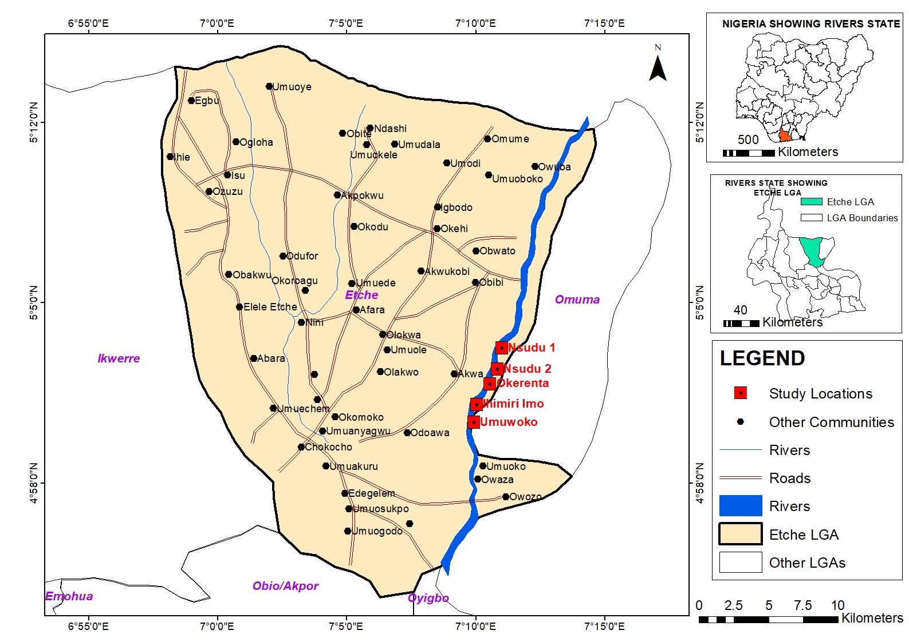
Fig 1: Map of Umudemoche-akwa river showing sample locations.

RESULTS
Table‍‌ 1a details the spatial changes among five sampling points (Stations 1-5), including average ± standard deviation figures for each element. It suggested that iron overall has the largest concentration of heavy metals with lead and chromium next in line, whereas cadmium and mercury levels are fairly low comparatively. Besides, TPH and PAH are detected at all stations with Station 3 normally showing the highest pollutant levels for various parameters. The Sig. (significance) column points out that several parameters e.g., iron and TPH notably differ across the locations (p < 0.05 or p = 0.000), whereas lead, cadmium, mercury, chromium, and PAH lack substantial spatial ‍‌variation.
Table 1a: Heavy metals monthly variations
Heavy metals | February | March | April | May | Sig.
Lead | 0.16 ± 0.05ª | 0.28± 0.07^{b} | 0.13 ± 0.04ª | 0.42 ± 0.10^{d} | 0.00
Cadmium | 0.02 ± 0.01ª | 0.03± 0.01^{b} | 0.02 ± 0.00ª | 0.04± 0.01^{c} | 0.00
Mercury | 0.01 ± 0.00ª | 0.01± 0.00^{b} | 0.01 ± 0.00ª | 0.02± 0.01^{c} | 0.00
Chromium | 0.13 ± 0.05ª | 0.22± 0.06^{b} | 0.10 ± 0.03ª | 0.28± 0.09^{b} | 0.01
Iron | 2.12 ± 0.64ª | 3.04± 0.61^{b} | 1.84 ± 0.45ª | 3.86± 0.77^{b} | 0.00
TPH | 2.27 ± 0.90ª | 1.91 ± 0.76ª | 1.30± 0.51^{ab} | 1.20± 0.66^{ab} | 0.99
PAH | 0.08 ± 0.03ª | 0.07 ± 0.02ª | 0.04± 0.02^{b} | 0.04± 0.02^{b} | 0.03

Note: Values are expressed as Means ± SD

Means with similar superscripts indicates a statistically significant difference between the means while different superscripts indicate a statistically insignificant difference between the means.

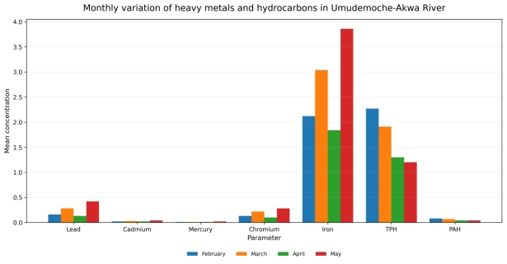

Fig 2: Monthly variation of heavy metals and hydrocarbons in Umudemoche-Akwa River.

Table‌ 1b illustrates monthly changes (February through May). It reveals that pollution levels in the environment are not constant and change through time. Most heavy metals show a pattern of rising levels till May, especially iron, lead, and chromium, which have the highest levels in May. Besides, exposure to cadmium, mercury, and PAH increases a little bit over time but these substances are found in much lower quantities. TPH is characterized by a more random fluctuation and is hardly significant looking at the whole period, whereas the majority of heavy metals show substantial differences on a monthly basis (p less than 0.05). PAH variations were not that pronounced in comparison to the ‍‌metals.
Table 1b: Heavy Metals Variation Across Sampling Stations in Umudemoche-Akwa River
Heavy Metals | Station 1 | Station 2 | Station 3 | Station 4 | Station 5 | Sig.
Lead | 0.173 ± 0.106 | 0.245 ± 0.135 | 0.333 ± 0.169 | 0.278 ± 0.143 | 0.205 ± 0.100 | 0.608
Cadmium | 0.020 ± 0.012 | 0.029 ± 0.015 | 0.039 ± 0.019 | 0.030 ± 0.011 | 0.023 ± 0.008 | 0.952
Mercury | 0.009 ± 0.007 | 0.013 ± 0.009 | 0.015 ± 0.009 | 0.012 ± 0.006 | 0.009 ± 0.004 | 0.983
Chromium | 0.123 ± 0.078 | 0.190 ± 0.095 | 0.260 ± 0.126 | 0.205 ± 0.083 | 0.143 ± 0.050 | 0.659
Iron | 1.950 ± 0.957ª | 2.825 ± 1.234^{b} | 3.425 ± 0.974^{c} | 3.025 ± 0.900^{d} | 2.350 ± 0.592 | 0.000
TPH | 0.813 ± 0.342ª | 1.825 ± 0.450^{b} | 2.350 ± 1.091^{c} | 2.050 ± 0.661^{d} | 1.315 ± 0.372 | 0.000
PAH | 0.033 ± 0.011 | 0.053 ± 0.021 | 0.084 ± 0.024 | 0.068 ± 0.020 | 0.046 ± 0.014 | 0.871

Note: Values are expressed as Means ± SD

Means with similar superscripts indicates a statistically significant difference between the means while different superscripts indicate a statistically insignificant difference between the means

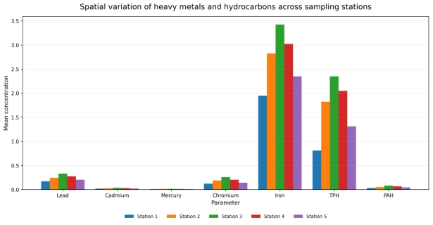

Fig 3: Spatial variation of heavy metals and hydrocarbons across sampling stations in Umudemoche-Akwa River.

DISCUSSION AND CONCLUSION
The ‍‌ analysis of Umudemoche-Akwa River samples reveals that the water contains detectable levels of lead, cadmium, mercury, chromium, and iron alongside total petroleum hydrocarbons and polycyclic aromatic hydrocarbons. Although the latter two are not heavy metals, their presence here portrays a more comprehensive scenario of chemical contamination in the river. The treatment that follows takes it for granted that concentrations are given in mg/l as it is a commonly used unit for water quality assessment and for comparison with drinking water standards.
The Nigerian Standard for Drinking Water Quality specifies the maximum allowable levels for several inorganic components, including lead at 0.01 mg/L, cadmium at 0.003 mg/L, chromium at 0.05 mg/L, iron at 0.3 mg/L and mercury at 0.001 mg/L. It also states 0.007 mg/L as the maximum permitted level for polycyclic aromatic hydrocarbons in drinking water (Standards Organisation of Nigeria, 2015). These limits are quite handy for interpreting the pollution levels of the river; however, it is a known fact that river water normally requires treatment before domestic use.
The results from the different locations indicate that most of these metals occurred in metal concentrations that exceeded acceptable drinking water standards. For lead, the results ranged from 0.173 ± 0.106 mg/L at Station 1 to 0.333 ± 0.169 mg/L at Station 3. Interestingly, the highest mean lead value was at Station 3; however, the probability value of 0.608 reveals that this lead level variation among stations was not statistically significant. This means that lead pollution seems to have broadly impacted the river rather than being confined to one point. Lead concentrations measured are very high compared to the Nigerian allowable limit of 0.01 mg/L, which suggests that the usage of the river for drinking or domestic purposes without treatment may pose a health risk. Given that lead exposure can harm infants' mental faculties and can also damage both central and peripheral nervous systems, attention to lead at these levels is warranted (Standards Organisation of Nigeria, 2015).
Cadmium exhibited a comparable trend. Its average level increased from 0.020 ± 0.012 mg/L at Station 1 to 0.039 mg/L at Station 3, and then dropped to 0.023 ± 0.008 mg/L at Station 5. The p-value of 0.952 indicates that the differences between the stations were not statistically significant. While the statistical analysis indicates moderate homogeneity in the distribution of cadmium across the river, the real issue lies in the fact that all the values recorded were above the permitted limit of 0.003 mg/L. Thus, river pollution through cadmium has been confirmed, and the negative impact of kidney damage by cadmium leads to further concern. The widespread incidence suggested by the river samples probably arises from a combination of sources such as the spreading of farm produce, the erosion of soils contaminated with heavy metals, household waste, small-scale human activities conducted close to the river, and the transport of polluted sediments within the ‍‌river.
Merury ‍‌ was found in all the stations with the lowest concentration of 0.009 ± 0.007 mg/L at Station 1 and Station 5 and highest concentration at Station 3 (0.015 ± 0.009 mg/L). The p-value of 0.983 means that there was no major spatial difference. This means that the pollution with mercury is not confined at a single station. The levels were still far above the Nigerian standard of 0.001 mg/L. Since mercury can cause damage to the kidney and central nervous system, the finding raises a significant environmental and public-health problem, particularly if the river is a source of fish or if the locals turn the river water to domestic use. Station 1 had chromium concentration of 0.123 ± 0.078 mg/L while Station 3 had 0.260 ± 0.126 mg/L) and the p-value was 0.659. The chromium concentrations were still higher than the Nigerian limit of 0.05 mg/L at all stations. Thus, the data prove that Umudemoche-Akwa River is chemically stressed by metal pollution.
Among the metals tested for, iron concentration was the highest. Mean levels went up from 1.950 ± 0.957 mg/L at Station 1 to 3.425 ± 0.974 mg/L at Station 3 and then down to 2.350 ± 0.592 mg/L at Station 5. The iron was unlike lead, cadmium, mercury and chromium in the sense that it exhibited a statistically significant variation among stations with a p-value of 0.000. The highest point at Station 3 points to the fact that either this segment of the river is being fed more iron or is characterized by environmental parameters that enable iron mobilisation. Soil erosion, surface runoff, sediment disturbance, waste discharges and natural weathering of iron-bearing materials are just some of the factors that could be responsible. The levels we found are far more above the Nigerian limit of 0.3 mg/L. Even though iron has been more linked with problems like increased colour, taste, and staining than its toxicity over a short period, at such high concentrations, it will definitely dampen water acceptability and may mean that there are bigger geochemical or anthropogenic pollution problems the area is facing.
The hydrocarbons data provide more evidence of chemical contamination. There was a significant variation in total petroleum hydrocarbon (TPH) levels at different stations with Station 1 recording the smallest value and Station 3 the highest. Such a distribution indicates that the mid-stream part of the river either receives larger hydrocarbon inputs or it is a zone where the petroleum related contaminants accumulate. The concentrations of polycyclic aromatic hydrocarbons ranged from 0.033 ± 0.011 mg/L at Station 1 to 0.084 ± 0.024 mg/L at Station 3, however, the p-value of 0.871 signifies that there was no major spatial difference between stations. PAHs level here cross the Nigerian threshold of 0.007 mg/L for drinking water. This is significant as the Nigerian standard considers PAHs as potentially carcinogenic organic components (Standards Organisation of Nigeria, 2015). The combination of metals and hydrocarbons would indicate that the pollution may have multiple sources such as waste disposal, runoff from roads and settlements, washing activities, petroleum residues, combustion products and other local human ‍‌activities.
The monthly analysis shows that the levels of most metals were altered remarkably from February to May. Lead was found to have increased from 0.16 ± 0.05 mg/L in February to 0.28 ± 0.07 mg/L in March, but then slightly decreased to 0.13 ± 0.04 mg/L in April before rising sharply to 0.42 ± 0.10 mg/L in May. The significance of the monthly variation is underscored by the p-value of 0.000. Cadmium levels increased from 0.02 ± 0.01 mg/L in February to 0.04 ± 0.01 mg/L in May while mercury was noticed to have gone up from about 0.01 mg/L between February and April to 0.02 ± 0.01 mg/L in May. Chromium broadly followed the same pattern as the rest of the metals, reaching its highest concentration in May at 0.28 ± 0.09 mg/L. Iron also reached its maximum in May, registering an average of 3.86 ± 0.77 mg/L, after dropping in April.
All of these findings point to May accounting for the highest levels of most of the metals. This trend could indicate that there was increased runoff and washing of the contaminated soil into the river, sediment disturbance, greater inflow from land and changes in the river occasion the month of sampling. The monthly changes in hydrocarbons are unlike those in metals. Total petroleum hydrocarbon sampling values were seen to have gone down from 2.27 ± 0.90 mg/L in February to 1.20 ± 0.66 mg/L in May. The p-value of 0.99 indicates that these changes were not at a statistically significant level, though the mean values trend downwards.This could be the effect of high variability in the samples, limited sample size or uneven distribution of hydrocarbon contaminants in the river.
Polycyclic aromatic hydrocarbons have also decreased from 0.08 ± 0.03 mg/L in February to 0.04 ± 0.02 mg/L in April and May, with a p-value of 0.03. This demonstrates the presence of statistically significant monthly fluctuations.Dilution, sedimentation, microbial degradation, volatilization of lighter fractions or decrease in hydrocarbon input during later sampling months are some of the possible reasons for the reduction in PAH. The fact that PAH values still remain above the recommended limit even in areas where there is a monthly downward trend is a clear indication of pollution.
The findings reveal that the Umudemoche-Akwa River is being contaminated by heavy metals and hydrocarbon-related compounds. Station 3 is the most heavily impacted sampling point as it recorded the highest values for lead, cadmium, mercury, chromium, iron, total petroleum hydrocarbons and polycyclic aromatic hydrocarbons. This means that the middle stretch of the river is probably the one that receives direct or accumulated pollutant inputs most regularly. On the other hand, the non-significant spatial variation for lead, cadmium, mercury, chromium and PAH implies that pollution is not limited to Station 3 only.
The river is polluted generally across the five stations. Significantly, the monthly variation for most metals, brings to the fore the notion that seasonal and hydrological factors have an impact on the movement and concentration of the pollutants. The rise in metals in May is a particularly important point as it may signify increased mobilisation of metal-laden particles from surrounding lands and ‍‌sediments.

In conclusion, The levels of lead, cadmium, mercury, chromium and iron exceed the recommended limits, which indicates that the untreated river water is not safe for drinking and other sensitive domestic uses. Another cause for concern is the finding of PAH exceeding the allowable limit, as it reveals the pollution of the river by organic chemicals in addition to metals. As a result, the findings are in line with the call for continuous monitoring, determination of the sources of pollution, raising public health awareness and educating people about the risks of directly consuming untreated river water. Besides, sediment and fish samples should constitute further investigation, since metals and PAHs are capable of accumulating in both sediments and aquatic organisms. This kind of supplementary analysis would provide a more comprehensive assessment of the ecological risk and a conceivable human exposure via fish consumption. ​‍​‌‍​‍‌​‍​‌‍​‍‌

REFERENCES
Anyanwu, I. N., et al. (2023). Pollution of the Niger Delta with total petroleum hydrocarbons, heavy metals and nutrients in relation to seasonal dynamics. Scientific Reports.
Bawa-Allah, K. A., Saliu, J. K., & Otitoloju, A. A. (2023). Assessment of heavy metal pollution in Nigerian surface freshwaters and sediment: A meta-analysis using ecological and human health risk indices. Journal of Contaminant Hydrology, 256, 104199.
Chinedu, E., & Chukwuemeka, C. K. (2018). Oil spillage and heavy metals toxicity risk in the Niger Delta, Nigeria.
Edori, E. S., Ucheaga, C., & Timothy, M. N. (2023). Levels of heavy metals in surface water of Oge-Etche River, Etche, Rivers State, Nigeria. Research Journal of Pure Science and Technology, 6(1), 53–65.
Nigerian Industrial Standard. (2015). Nigerian Standard for Drinking Water Quality, NIS 554:2015. Standards Organisation of Nigeria.
World Health Organization. (2026). Guidelines for drinking-water quality: Fourth edition incorporating the first, second and third addenda. World Health Organization.

Standards Organisation of Nigeria. (2015). Nigerian Standard for Drinking Water Quality, NIS 554:2015. Standards Organisation of Nigeria.
World Health Organization. (2026). Guidelines for Drinking-water Quality: Fourth Edition Incorporating the First, Second and Third Addenda. World Health Organization.

