Perceptions of Teacher-Educators on Gamification in Education among Generation Alpha

Abstract

Generation Alpha (2010 to 2024), also known as digital and AI natives, the ones who have chatbots on their fingertips and use gadgets frequently and digitally aware due to deep immersion in technology, strong sense of independence and global awareness, very much known for their adaptability, social consciousness and entrepreneurial spirit, diverse and inclusive, health and wellness conscious and family oriented, and so on. With the advent of the COVID-19 pandemic, a need for shifting the traditional method of transacting curriculum to online learning arose, which required attention from all pre-service teachers, in-service teachers, and teacher educators. Generation Alpha responds to gamified learning in a positive way in various fields. Few studies reflect the Perceptions of Teachers-Educators on Gamification in Education among Gen Alpha. So, to fill this gap, the researcher conducted Descriptive research. The sample consisted of 80 teachers-educators randomly selected from the university in South-West Delhi. The responses from 80 teachers educators was collected through likert scale to gauge the perceptions of teacher-educators on gamification in education. The present paper attempts to explore the opportunities and obstacles that teacher-educators face while implementing gamification in education among Generation Alpha. Data was analyzed using frequency and percentage analysis. The findings suggest that gamification in education can be a very powerful tool if handled with caution. Educational implications were listed at the end, followed by a conclusion.

Keywords: Gamification in Education, Generation Alpha, NEP 2020, NCFSE 2023

Introduction
Generation Alpha—children born from 2010 onward—experienced the formative years of their education during the COVID-19 pandemic, which significantly shaped their learning environments, developmental experiences, and technological habits. Extended school closures and shifts to remote learning accelerated their exposure to digital platforms, making them the most technologically immersed generation to date. While this transition enhanced their digital literacy and familiarity with online tools, it also highlighted disparities in access, parental support, and learning conditions.
The pandemic disrupted traditional socialization patterns, limiting face-to-face interaction and collaborative learning opportunities that are critical in early childhood development. Many learners exhibited challenges related to attention, routine formation, and emotional regulation due to prolonged screen time and reduced classroom structure. Teachers also reported noticeable gaps in foundational skills, particularly in literacy, numeracy, and socio-emotional competencies.
At the same time, the pandemic prompted rapid innovation in pedagogical approaches. Educators increasingly adopted flexible, technology-enhanced, and student-centered methods, including gamified learning, multimodal instruction, and differentiated support to address varied learning needs. As a result, Generation Alpha’s educational experience is now characterized by a blended learning paradigm where digital and face-to-face modalities coexist.
Overall, COVID-19 has had a lasting impact on Generation Alpha by reshaping their learning habits, accelerating digital integration, and altering the expectations placed on teachers and schools to support holistic, adaptable, and technologically mediated learning environments.
Impact of gamification on Generation Alpha and their teaching-learning process

Gamification can be defined as the use of gaming elements in non-gaming contexts. (Deterding, 2012). Generation Alpha, having grown up in a highly digital and interactive environment, responds strongly to learning experiences that mirror the immediacy, engagement, and interactivity of the technologies they use daily. Gamification aligns naturally with their learning preferences by integrating game-like elements such as challenges, rewards, feedback, and progress tracking into instructional design. These features enhance motivation, sustain attention, and support active participation—areas in which Generation Alpha typically thrives.
Gamified learning also caters to their need for autonomy and personalized experiences, enabling differentiated pathways that can adapt to individual skill levels and learning speeds. The interactive and visually rich nature of gamified tasks supports multimodal learning, making abstract concepts more concrete and accessible. Furthermore, collaborative game-based activities promote social interaction and teamwork, addressing the growing need for socio-emotional learning in digitally immersed children.
For educators, gamification provides new pedagogical tools to capture and maintain learners’ interest while offering real-time data to guide instruction and assessment. However, it also requires thoughtful design to ensure that game elements enhance, rather than distract from, learning objectives.
Overall, gamification has a significant positive impact on Generation Alpha by aligning with their digital habits, motivating learning through interactive engagement, and supporting flexible, individualized, and socially connected learning environments.
Policy regarding technology integration in the curriculum at the university level, with the use of gamification as stated in NEP 2020

The National Education Policy (NEP) 2020 places strong emphasis on transforming higher education through the systematic integration of digital technologies. At the university level, the policy promotes technology-enhanced pedagogies, flexible learning environments, and innovative instructional approaches designed to improve engagement, accessibility, and learning outcomes. NEP 2020 specifically encourages the use of digital tools such as online platforms, educational software, virtual labs, and interactive learning systems to support both teaching and assessment.
Within this broader framework, gamification aligns well with NEP 2020’s call for student-centered, experiential, and competency-based learning. The policy advocates for pedagogical approaches that foster active learning, creativity, collaboration, and problem-solving—outcomes that gamified environments are well positioned to support. Features such as interactive challenges, immediate feedback, and adaptive learning pathways reinforce the policy’s emphasis on personalized and participatory learning experiences.
NEP 2020 also highlights the need for professional development that equips educators with the technological and pedagogical skills required for innovative teaching. This indirectly supports the adoption of gamification by encouraging universities to build faculty capacity for designing and implementing technology-mediated learning strategies.
Overall, NEP 2020 provides a policy context that is favorable to the integration of gamification in higher education by promoting digital innovation, learner engagement, and flexible instructional design as core components of modern curricula.
Policy regarding technology integration in the curriculum at the university level, with the use of gamification as stated in NCFSE 2023

NCFSE 2023, though focused on school education, offers principles that are highly relevant for university curriculum design, particularly in the integration of technology and gamified learning. Its emphasis on interactive digital resources, competency-based progression, and experiential pedagogies encourages higher education institutions to adopt gamified simulations, adaptive learning pathways, and collaborative digital tasks to enhance engagement and deep learning. The framework also reinforces the need for faculty development in digital pedagogy and responsible, inclusive technology use. Consequently, universities can align with national policy directions by embedding gamification within technology-rich, learner-centred instructional models.

Theoretical frameworks:

This study is informed by a combination of motivational, constructivist, and technology-integration theories that collectively explain the educational value of gamification. Central to the framework is Self-Determination Theory (Deci & Ryan, 2000), which posits that motivation is enhanced when learners’ needs for autonomy, competence, and relatedness are supported. Gamification aligns with these principles by offering choice-based pathways, progressive challenges with immediate feedback, and opportunities for social interaction, thereby fostering intrinsic motivation.
Constructivist perspectives (Piaget, 1973; Vygotsky, 1978) further illuminate gamification’s impact by emphasizing learning as an active, participatory process shaped through exploration, collaboration, and problem-solving. Game-based activities mirror these conditions by engaging learners in interactive tasks, iterative experimentation, and knowledge construction within meaningful contexts. Insights from formative assessment theory (Black & Wiliam, 1998) and cognitive engagement theory also help explain positive perceptions of gamified assessments, where real-time feedback and performance tracking support deeper cognitive processing.
Technology adoption frameworks complement these pedagogical perspectives. The Technology Acceptance Model (Davis, 1989) and the TPACK model (Mishra & Koehler, 2006) highlight the importance of perceived usefulness, ease of use, and the integration of technological, pedagogical, and content knowledge in shaping educators’ willingness to adopt gamification. Similarly, Rogers’ Diffusion of Innovations Theory (2003) provides a lens for understanding institutional influences on adoption. Finally, Social Cognitive Theory (Bandura, 1997) underscores the role of teacher self-efficacy—particularly confidence in designing gamified learning experiences.
Together, these theoretical perspectives offer a coherent explanation for the study’s findings: gamification is perceived positively because it supports motivation, promotes active and collaborative learning, enhances assessment opportunities, and aligns with contemporary expectations for technology-supported pedagogy, while also revealing barriers related to workload, resource availability, and teacher preparedness.
Review of related literature:

Author name | Year | Research Design | Data collection | Findings
Fernando, P. A., and Premadasa, H. K. S. | 2024 | Systematic mapping design | Literature reviews from various databases | - Adaptive gamification strategies best suit the behavioral attributes of Generation Alpha students.  - Focus is on the important role of educational technology in developing pedagogical, technical, and human resources to meet the unique educational needs of Generation Alpha students, who have matured in a digital age was observed.  - Generation Alpha is highly dependent on mobile devices and gaming, hence mobile and gamified learning will become an essential part of their educational cycle.
Leiss et al., | 2025 | Online survey | Questionnaire | - Teachers’ attitude toward gamification, their perceived subjective norm, and self-efficacy regarding the execution of gamification are important factor with the goal to use gamification in class.
Núñez-Pacheco et al., | 2023 | Descriptive interdisciplinary quantitative design | Questionnaire | - University educators who were involved in this study have a positive perception of information technologies and gamified strategies, regardless of their academic qualification or area of expertise.
Bose et al., | 2024 | Descriptive research | Questionnaire | - Gamiﬁcation can be a useful tool for teaching-learning and can enhance students motivation and convert learning into an enjoyable process.  - Gamified learning have a positive impact on students learning.  - Gamification still has some barriers to application, especially among age groups above 50.
Sáez-López et al., | 2022 | Mixed methods research approach | Questionnaire | - Teachers had a positive attitude towards gamification, good knowledge of managing tools such as Genially, Kahoot and Google Classroom.  - With the appropriate resources, class planning and teacher training, game-based learning and gamification can increase student motivation and commitment, and foster passion for beneficial, pedagogical interactive processes.
Höfrová et al., | 2024 | Systematic literature reviews | PRISMA | - Generational differences show how children of this generation are different from previous generations.  - The use of technology by Generation Alpha has shown a decline in opportunities for socio-emotional development and increase in mental health problems.
R. Jukić and T. Škojo, | 2021 | Qualitative analysis | Semi-structured interviews | - A partial agreement, alongwith disagreement in the perception related to the education of Generation Alpha students by pedagogues and ICT experts.  - Using an interdisciplinary approach, a systematically plan of the educational system should be framed and adapted for Generation Alpha students.
Christopoulos, A. and Mystakidis, S. | 2023 | Systematic review | Literature reviews of gamification frameworks | - Some may observe that gamified elements are motivating, while others may view them as a potential distraction.  - Conversely, educators’ willingness to use gamification is influenced by their perceptions of its efficacy, ease of use, and the resources required for its application.  - Some view it as a effective tool for enhancing student engagement, while others may hesitate due to concerns about resource allocation and effectiveness.
Prashetha, S.R., and Devika, S. | 2023 | Qualitative method | Normative survey method | - The majority of prospective teachers have positive perception of gamification in learning but some of them feels that gamification was difficult to implement in the classroom.
Wu, M.L., Zhou, Y., and Li, L. | 2023 | Qualitative method | Survey | - The gamified course positively influenced pre-service teachers’ confidence in using technology in education, intention to adopt gamification, and motivation to explore more emerging technologies for teaching.
Kuo-Wei, L. | 2023 | Mixed methods research | Survey and questionnaire | - Students view that gamification could increase their motivation, attitudes, and interest in learning and stimulate creativity, collaboration, and communication skills.  - Out of the six teaching methods, it was observed that Mandala thinking was the most effective teaching method for achieving the creativity, collaboration, and communication skills.
Bandara, N., Chathurika, R., and Katukurunda, K. | 2024 | Descriptive analysis | Systematic reviews | - Advanced technologies like Artificial Intelligence, Virtual Reality, and Augmented Reality reshape the educational scenario with the AI-driven adaptive learning systems tailors content for personal educational needs, enhancing academic performance by increasing student engagement.  - Through VR and AR technologies, immersive learning experiences are provided, converting the abstract concepts into interactive and tangibles.
De Los Santos, J.N., and Escote, M.J.V. | 2025 | Qualitative phenomenological research design | In-Depth Interview (IDI) | - Alpha generation students adored collaborative learning.
Negrín-Medina et al., | 2022 | Qualitative study | Interviews | - Teachers stated that one of the main difficulties they faced was related to the evolution of students as a result of technology, both in the school and social context.

Aims and objectives:

The present paper attempts to explore the opportunities and obstacles that teacher-educators face while implementing gamification in education among Generation Alpha.

Objectives
- To gauge the perceptions of teacher-educators on gamification in education.
- To explore the challenges faced by teacher-educators in implementing gamification in education.
- To explore the opportunities that teacher-educators experienced while implementing gamification in education.

Research Design:

The researcher, by undertaking the present study, aims to explore the opportunities and obstacles that teacher-educators face while implementing gamification in education among Generation Alpha. For this, the researcher undertook Descriptive research. The sample consisted of 80 teacher educators randomly selected from the university in South-West Delhi. The data was collected using the Likert scale with regard to the perceptions of teacher-educators on gamification in education. Data was analyzed using frequency and percentage analysis.

Findings and interpretation of results:

- To gauge the perceptions and analyze the opportunities that teacher-educators experienced while implementing gamification in education.

Findings: 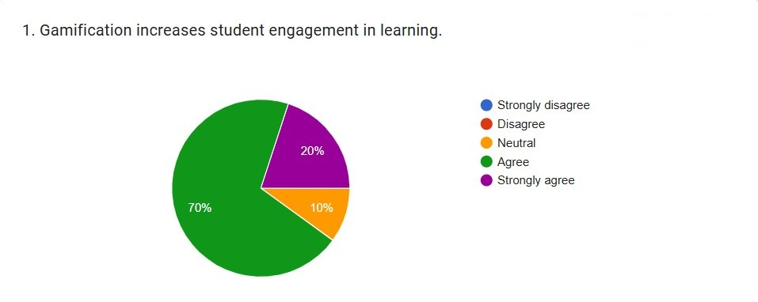

Interpretation: The majority of participants (70%) marked Agree, indicating that most respondents perceive gamification as a beneficial tool for enhancing student engagement. An additional 20% chose Strongly Agree, further reinforcing the overwhelmingly positive sentiment. Combined, these figures demonstrate that 90% of respondents believe gamification positively impacts student engagement.
A smaller portion of participants (10%) marked Neutral, suggesting that a minority are uncertain or have mixed views regarding the effectiveness of gamification. Notably, no respondents marked Disagree or Strongly Disagree, indicating a complete absence of negative perceptions.
Overall, the results suggest that participants overwhelmingly perceive gamification as a beneficial strategy for increasing student engagement.
Findings: 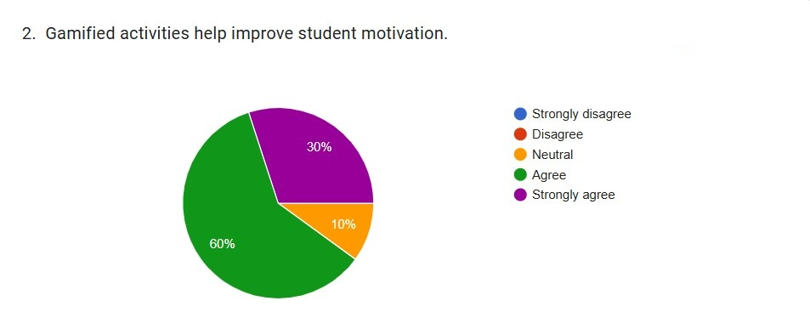

Interpretation: A majority of respondents (60%) marked Agree, indicating that more than half of the participants believe gamified activities play a meaningful role in enhancing student motivation. Additionally, 30% chose Strongly Agree, demonstrating a substantial level of conviction in the effectiveness of gamification as a motivational tool. Together, these two categories account for 90% of all responses, showing overwhelming support for the motivational impact of gamified approaches in educational contexts.
A smaller segment (10%) marked Neutral, suggesting that a limited proportion of participants feel uncertain or ambivalent about the motivational influence of gamified activities. Importantly, none of the respondents marked Disagree or Strongly Disagree, indicating a complete absence of negative perceptions related to gamification’s motivational role.
Overall, the results reveal a highly positive response pattern, reinforcing the notion that gamification contributes to improved student motivation. These findings align with previous empirical and theoretical work emphasizing the importance of game-based elements—such as rewards, challenges, and feedback—in supporting student motivation and fostering active engagement.
Findings: 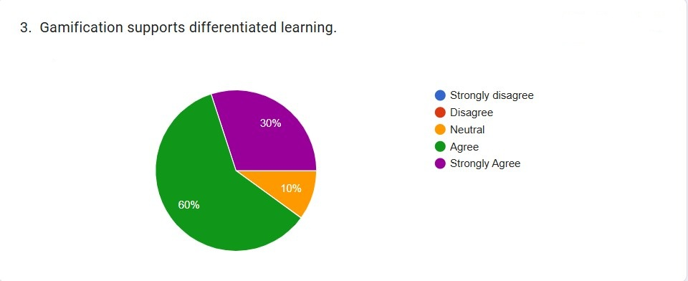

Interpretation: A significant majority of participants agreed that gamification supports differentiated learning. Specifically, 60% marked Agree, indicating strong recognition of gamification as an effective instructional strategy for addressing varied learning styles, abilities, and preferences. Additionally, 30% of respondents chose Strongly Agree, further reinforcing this positive perception. Together, these two categories account for 90% of all responses, representing a substantial consensus.
In contrast, only 10% of respondents reported a Neutral position. Notably, no participants marked Disagree or Strongly Disagree, suggesting an absence of negative perceptions regarding the use of gamification for differentiated learning.
Overall, the results suggest that gamification is widely viewed as beneficial in fostering differentiated learning environments. This strong positive endorsement indicates that educators and learners perceive gamified instructional approaches as capable of addressing diverse learning needs and enhancing engagement.
Findings: 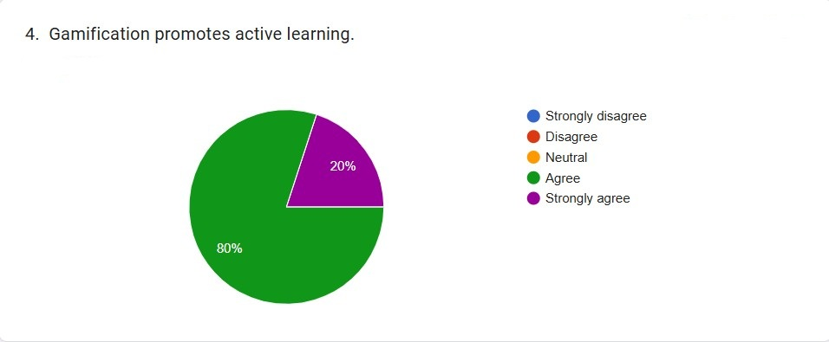

Interpretation: A substantial 80% of respondents marked Agree, indicating that the majority believe gamification effectively fosters active engagement in the learning process. Additionally, 20% of respondents chose Strongly Agree, reinforcing the notion that gamification is widely perceived as a mechanism that encourages learners to participate actively, interact with content, and assume a more involved role in their learning.
Notably, no participants marked Neutral, Disagree, or Strongly Disagree. The absence of neutral or negative responses suggests that participants do not view gamification as passive or ineffective. Instead, they overwhelmingly associate it with increased learner engagement and participation.
Overall, the data demonstrate a unanimous positive perception of gamification as a tool that promotes active learning. This strong endorsement highlights the perceived value of gamified learning environments in stimulating interaction, encouraging problem-solving, and motivating learners to take initiative throughout their learning experiences.
Findings: 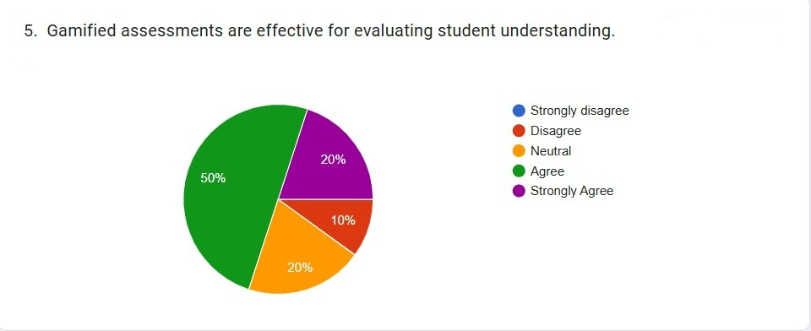

Interpretation: The results indicate a predominantly positive perception, with 50% of participants selecting Agree. This suggests that half of the respondents believe gamified assessment methods—such as quizzes with game elements, point-based evaluation, or interactive assessment platforms—are effective in measuring learners’ comprehension.
Additionally, 20% of respondents Strongly Agreed, reinforcing the notion that a considerable portion of participants perceive gamified assessments as reliable tools for capturing student learning and understanding. Another 20% of participants marked Neutral, indicating that while they do not reject the idea, they remain uncertain about the degree of effectiveness, possibly due to varying familiarity or experience with gamified assessment tools.
In contrast, only 10% of respondents expressed Disagree, and no participants marked Strongly Disagree. This small percentage suggests limited skepticism about the validity or accuracy of gamified assessments in evaluating learning outcomes.
Overall, the data reveal a strong positive inclination toward gamified assessment approaches. The combined 70% agreement rates (Agree + Strongly Agree) suggest that gamified assessments are generally perceived as beneficial for evaluating student understanding, while the small proportion of disagreement indicates only minor reservations among participants.
Findings: 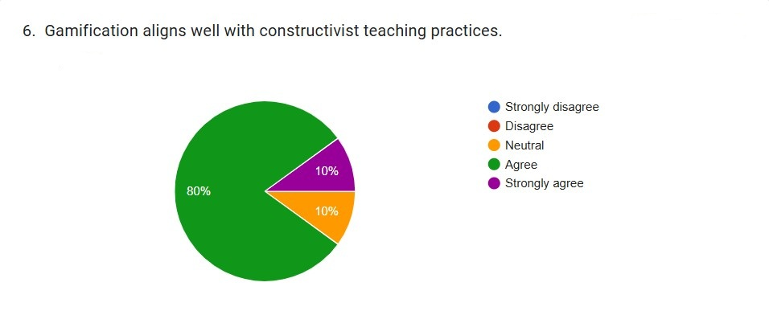

Interpretation: The results for Item 6, “Gamification aligns well with constructivist teaching practices,” reveal a strong positive perception among respondents. As shown in the pie chart, 80% of participants indicated Agree, while 10% responded Neutral, and another 10% reported Strongly Agree. Notably, no respondents marked Disagree or Strongly Disagree, suggesting an overwhelmingly favorable consensus.
These findings indicate that the vast majority of respondents perceive gamification as compatible with principles of constructivism, such as active engagement, learner-centered environments, and knowledge co-construction.
Findings: 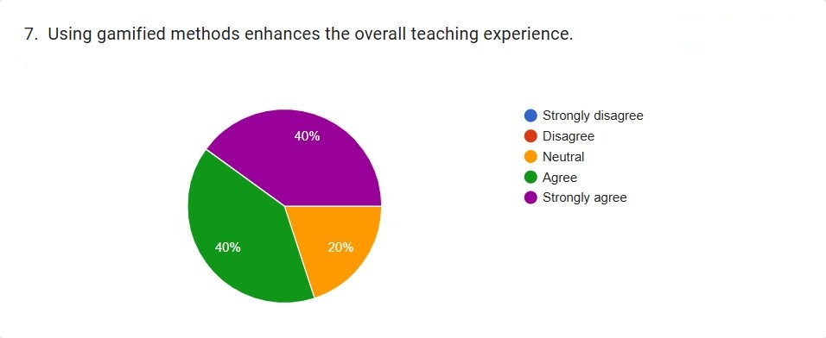

Interpretation: The results for Item 7, “Using gamified methods enhances the overall teaching experience,” show predominantly positive perceptions among participants. According to the pie chart, 40% of respondents marked Agree, while another 40% marked Strongly Agree. A smaller portion, 20%, reported Neutral, and notably, no respondents indicated Disagree or Strongly Disagree.
Overall, these results demonstrate a high level of endorsement for gamified instructional approaches, with 80% of participants expressing positive agreement regarding their contribution to enhancing teaching experiences.
Findings: 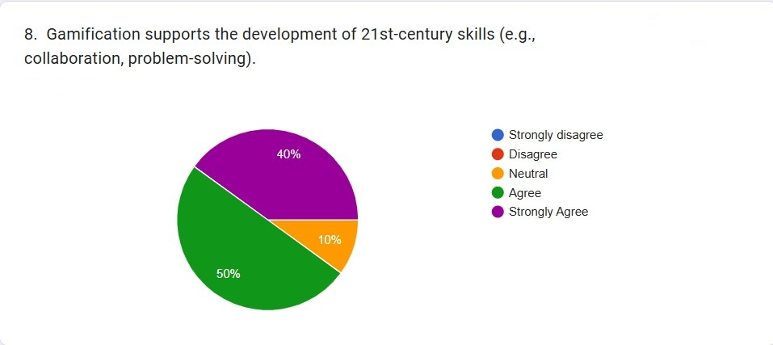

Interpretation: The results for Item 8, “Gamification supports the development of 21st-century skills (e.g., collaboration, problem-solving),” reveal strong endorsement from respondents. As illustrated in the pie chart, 50% of participants marked Agree, while 40% marked Strongly Agree. A smaller proportion, 10%, chose Neutral. Importantly, no respondents marked Disagree or Strongly Disagree.
These results indicate that 90% of respondents view gamification as an effective means of cultivating 21st-century skills, such as collaboration, creativity, communication, and problem-solving.
Findings: 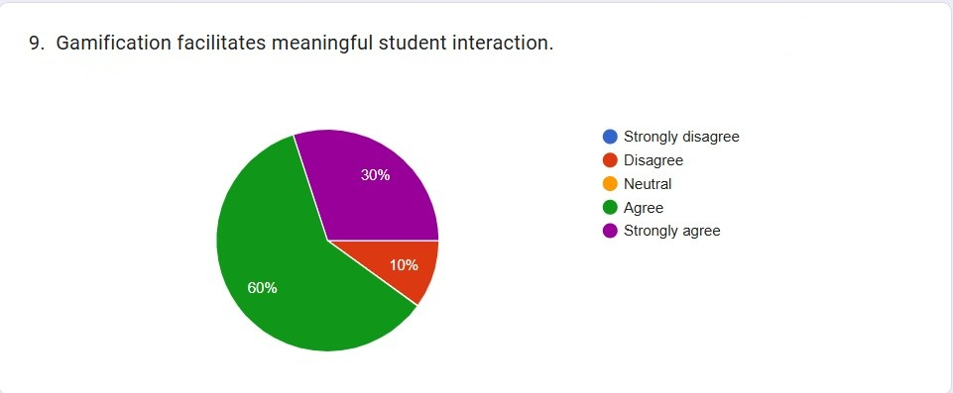

Interpretation: The largest portion of respondents—60%—agreed that gamification supports meaningful student interaction. This indicates that a majority perceives gamified activities as effective in encouraging engagement, collaboration, or communication among learners. Additionally, 30% of participants strongly agreed, further reinforcing this positive perception. Altogether, 90% of respondents expressed affirmative views, suggesting a high level of confidence in the interactive benefits of gamification.
Only 10% of respondents reported being neutral, which implies minimal uncertainty within the sample. Notably, there were no responses for either disagree or strongly disagree. This absence of negative perceptions suggests that none of the participants viewed gamification as detrimental to student interaction.
Findings: 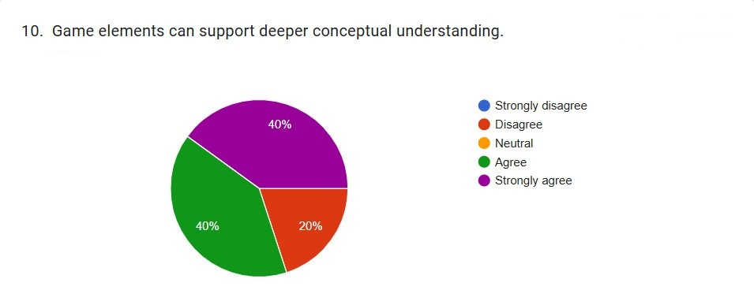

Interpretation: A combined 80% of participants expressed agreement, with 40% agreeing and another 40% strongly agreeing that game elements can enhance conceptual understanding. This suggests that a substantial majority of respondents view gamified elements—such as challenges, rewards, simulations, and interactive tasks—as effective tools for facilitating deeper comprehension of academic content.
Meanwhile, 20% of respondents marked disagree, indicating some level of skepticism or uncertainty regarding the cognitive impact of game elements. Notably, there were no neutral, strongly disagree, or undecided responses, suggesting that participants had clear opinions on the matter.
The dominance of positive responses implies that learners perceive gamification not only as engaging but also as cognitively meaningful. This supports the notion that game-based mechanisms can help students internalize concepts by providing experiential learning, immediate feedback, and active problem-solving contexts.
Overall, the data reflect strong confidence in the ability of game elements to promote deeper conceptual understanding, reinforcing their potential value in instructional design.
- To explore the challenges faced by teacher-educators in implementing gamification in education.

Findings: 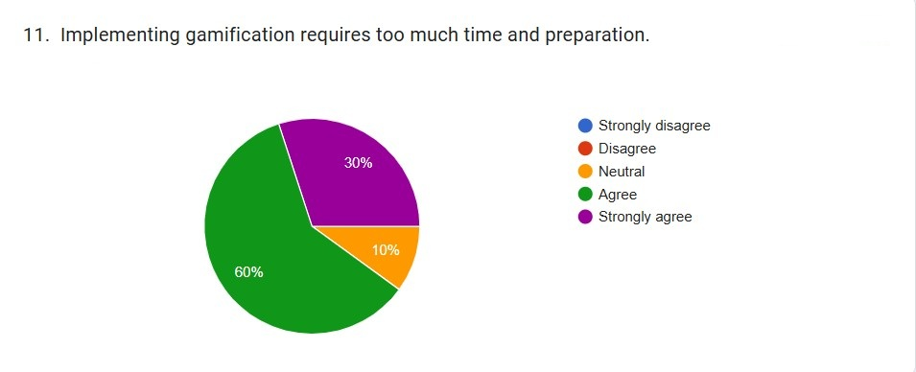

Interpretation: A majority of participants—60%—agreed that implementing gamification requires substantial time and preparation. An additional 30% strongly agreed, bringing the total proportion of respondents expressing concern to 90%. This overwhelming agreement highlights a prevalent perception that gamification, while potentially beneficial, poses significant practical challenges for educators in terms of planning, design, and execution.
Meanwhile, 10% of respondents marked neutral, indicating a small proportion who neither agreed nor disagreed with the statement. Notably, no respondents marked disagree or strongly disagree, suggesting the absence of a belief that gamification is easy or quick to implement.
These results indicate that although gamification may be viewed positively in other aspects of instruction, educators or participants recognize the substantial preparation, design complexity, and resource investment required. The unanimous lack of disagreement reinforces the view that time demand is a consistent barrier to the effective integration of gamification in educational contexts.
Findings: 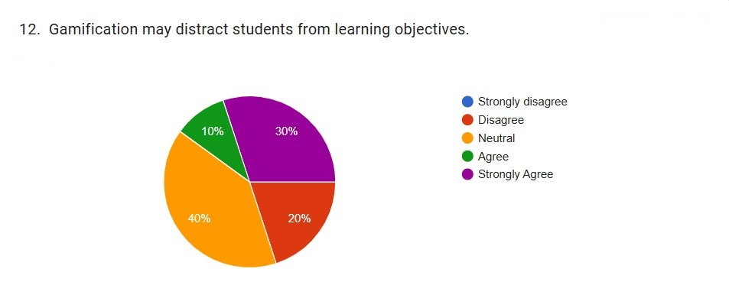

Interpretation: The results for Item 12 indicate varied perceptions regarding whether gamification distracts students from learning objectives. As shown in the pie chart, 40% of the respondents marked Neutral, suggesting uncertainty or situational dependence in their views. Meanwhile, 30% strongly agreed with the statement, and an additional 10% agreed, indicating that 40% of participants expressed some level of concern that gamification may shift students’ attention away from instructional goals. Conversely, 20% of respondents disagreed, and none marked strongly disagree, demonstrating that while some participants reject the idea that gamification is distracting, this group is comparatively smaller.
Overall, the distribution reveals that although a significant proportion of respondents perceive potential distractibility in gamified learning environments, many remain neutral, suggesting that these concerns may depend on factors such as implementation quality, classroom management, or the type of gamification used.
The findings highlight a nuanced view of gamification’s potential risks. The large neutral proportion (40%) suggests that many educators are uncertain about how much distraction gamification actually introduces. This may reflect inconsistent personal experiences, limited exposure to gamified instruction, or recognition that gamification’s effects vary across student groups and instructional contexts.
However, the combined 40% agreement (strong + moderate) signals a substantial concern among respondents that gamification could redirect students’ focus from learning objectives to game mechanics, competition, or rewards. This aligns with existing caution in the literature. Researchers such as Hanus and Fox (2015) have noted that poorly designed gamification can lead students to prioritize points or badges over conceptual understanding. Similarly, Dichev and Dicheva (2017) argue that misalignment between game elements and instructional goals can produce surface-level engagement rather than deep learning.
The small proportion who disagreed (20%) reflects a minority who see gamification as inherently supportive rather than distracting. This viewpoint is consistent with studies highlighting effective, well-integrated gamification practices that reinforce learning objectives rather than detract from them (Kapp, 2012; Zainuddin & Chu, 2020).
Taken together, these results suggest that while gamification can be engaging, careful design is essential to ensure that game mechanics support—not overshadow—core learning outcomes.
Findings: 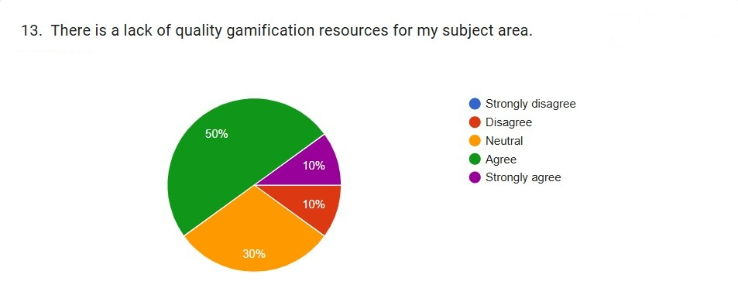

Interpretation: The responses to Item 13 indicate that a majority of participants perceive a shortage of high-quality gamification resources in their subject area. As shown in the pie chart, 50% of respondents agreed with the statement, while an additional 10% strongly agreed, resulting in 60% who believe there is a lack of adequate gamification resources. Meanwhile, 30% of participants marked “Neutral,” highlighting uncertainty or mixed experiences regarding available resources. Only 10% disagreed, and no respondents strongly disagreed.
These results suggest that most educators perceive material scarcity as a significant barrier to implementing effective gamification strategies in their teaching.
The data illustrate a broad consensus among respondents that accessible, high-quality gamification resources remain insufficient. With 60% indicating agreement or strong agreement, educators appear to face challenges in locating or adapting gamified teaching tools that align with their curriculum needs. The high proportion of neutral responses (30%) further suggests variability in access, subject-specific availability, or familiarity with existing gamification platforms.
These findings align with concerns in the literature. Dichev and Dicheva (2017) argue that while gamification has gained traction, the availability of well-designed educational resources remains inconsistent, particularly across diverse subject fields. Many tools lack pedagogical grounding, offer limited customization, or prioritize entertainment over learning objectives. Similarly, Kim and Lee (2020) note that the uneven distribution of gamified materials across disciplines contributes to inconsistent adoption among educators.
The scarcity of resources may also stem from a lack of institutional support, insufficient training, or limited developer focus on niche subject areas, as highlighted by Zainuddin and Chu (2020). These barriers can impede educators’ ability to integrate well-structured gamification practices that promote deep learning rather than superficial engagement.
Furthermore, the small percentage of respondents who disagreed (10%) may reflect those working in subjects with more abundant digital materials—such as STEM, language learning apps, or business simulations—where gamification tools are more readily available.
Overall, the perception of limited high-quality gamification resources underscores a significant structural challenge in scaling gamification practices across educational contexts. This finding suggests a need for institutional investment, professional development, and collaboration between educators and developers to create subject-aligned, pedagogically sound gamification materials.
Findings: 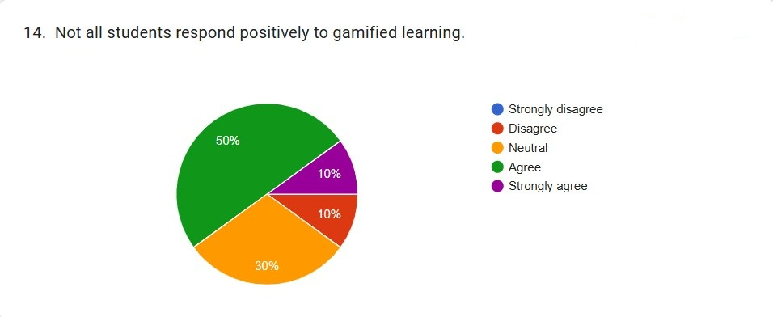

Interpretation: The data presented above illustrates teachers’ perceptions regarding whether “Not all students respond positively to gamified learning.” The distribution shows a clear trend: 50% of respondents agreed, 30% remained neutral, 10% disagreed, and 10% strongly agreed. Notably, no respondents marked “strongly disagree.”
Overall, a combined 60% of participants (agree + strongly agree) indicated that some students indeed fail to respond positively to gamification approaches. The significant neutral proportion (30%) suggests a level of uncertainty or variability in teachers’ experiences, potentially reflecting differences across grade levels, subjects, or the specific gamified strategies used.
Findings: 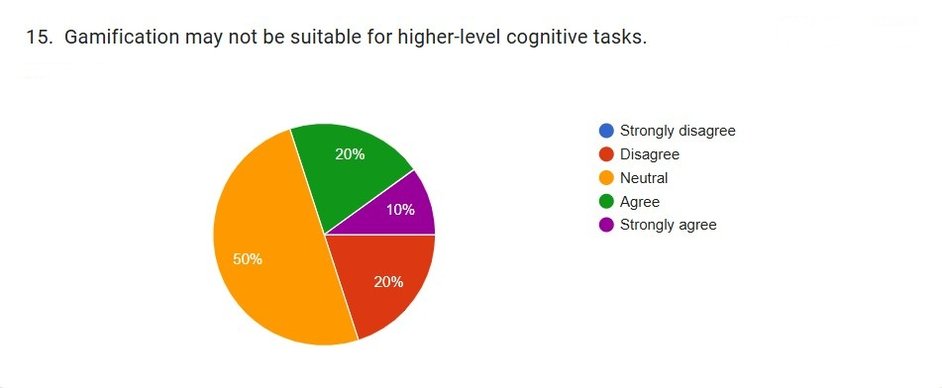

Interpretation: The distribution of responses indicates a varied perception among participants regarding the suitability of gamification for higher-order thinking tasks. Half of the respondents (50%) marked neutral, suggesting uncertainty or mixed experiences with applying gamification to complex cognitive activities. An additional 20% agreed, and 10% strongly agreed, indicating that 30% of participants perceive potential limitations in using gamification for higher-level cognition. Conversely, 20% disagreed, and no respondents marked strongly disagree, showing that a minority actively oppose the statement.
Overall, the results suggest that while some educators view gamification as potentially constraining for advanced learning tasks, many remain undecided, and a smaller proportion believe it remains appropriate even for cognitively demanding activities.
Findings: 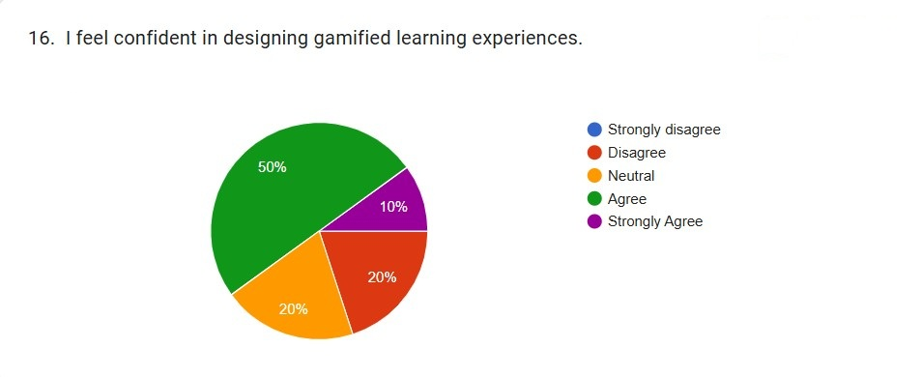

Interpretation: The results for Item 16 indicate generally positive educator self-efficacy regarding the design of gamified learning activities. Half of the respondents (50%) agreed with the statement, reflecting substantial confidence in their ability to develop gamified instructional strategies. Additionally, 10% strongly agreed, bringing the total level of confidence to 60%.
Meanwhile, 20% of participants marked neutral, suggesting moderate uncertainty or variable experiences with designing gamified tasks. Another 20% disagreed, indicating that a portion of educators lack confidence in this area. Notably, no respondents marked strongly disagree, implying that while some educators feel uncertain, extreme lack of confidence is uncommon.
These results demonstrate that most educators perceive themselves as capable of designing gamified learning experiences, though a meaningful minority remain unsure or lack confidence.
Findings: 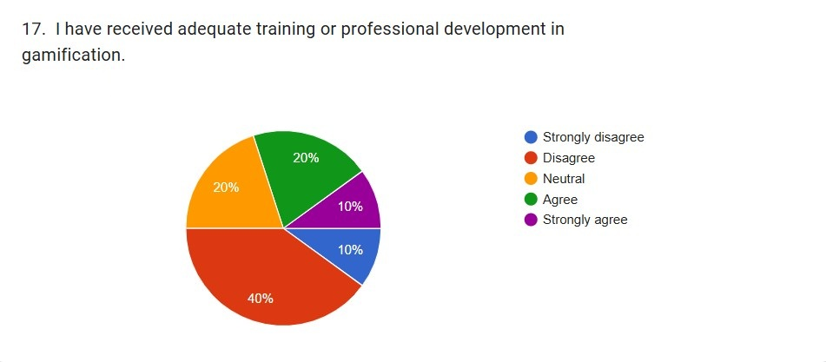

Interpretation: The responses to Item 17, which assessed educators’ perceptions of whether they have received adequate training or professional development in gamification, reveal a substantial lack of formal preparation. As illustrated in the pie chart, 40% of participants disagreed with the statement, indicating that they have not received sufficient training. Additionally, 10% strongly disagreed, meaning that half of all respondents (50%) explicitly reported inadequate training experiences.
A further 20% of participants marked neutral, suggesting indecision or inconsistency in the availability or quality of training opportunities. Only 20% agreed, and a limited 10% strongly agreed, resulting in just 30% of participants who felt they have received adequate professional development.
These results indicate that although a minority of educators feel adequately supported, a much larger proportion lacks the training necessary to confidently implement or design gamified learning experiences.
Findings: 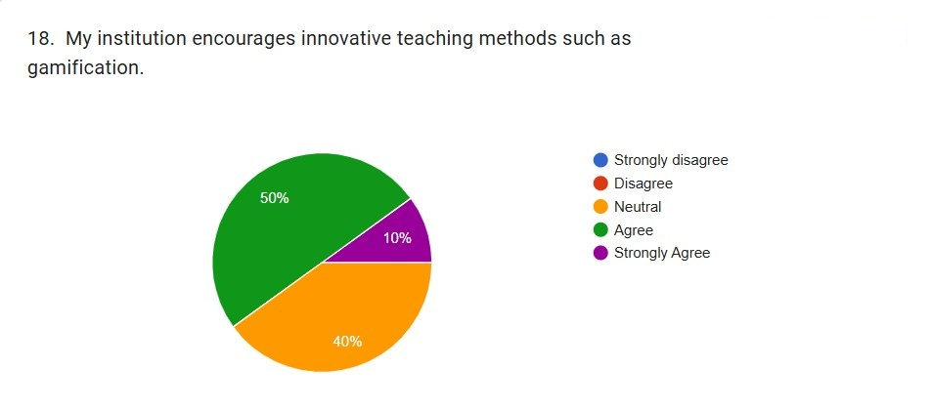

Interpretation: The survey item “My institution encourages innovative teaching methods such as gamification” provides insight into the extent of institutional support experienced by educators. The results show that 50% of respondents agreed, indicating that half of the participants perceive their institution as supportive of implementing gamified or innovative pedagogical approaches. Additionally, 10% strongly agreed, bringing the total proportion of positive responses to 60%.
Meanwhile, 40% of respondents marked ‘Neutral’, suggesting that a significant portion of educators are uncertain about whether their institution actively promotes innovation. Notably, no respondents disagreed or strongly disagreed, implying that while institutional encouragement may not be strongly visible or actively promoted for all staff, there is no widespread perception of resistance or discouragement.
Overall, the distribution highlights a generally supportive institutional climate, though opportunities remain to improve transparency, communication, and structured encouragement around innovative instructional strategies such as gamification.
The data suggests that institutional support is present but may not be universally experienced or strongly communicated. The 60% agreement rate indicates that many educators feel encouraged to explore innovative teaching methods, which is an essential factor in the adoption and sustainability of gamification. However, the relatively high neutral response (40%) may indicate inconsistent policy implementation, uneven access to support, or a lack of formalized incentives and professional communications.
This pattern aligns with literature showing that institutional backing is a key determinant of educators’ willingness to adopt new technologies or pedagogical models. When institutions signal support through training programs, resource allocation, and strategic priorities, educators are more likely to experiment with and sustain innovative practices. The absence of disagreement suggests that no institutional barriers are perceived, but the uncertainty among a large group of participants highlights a need for clearer policies, more explicit encouragement, or greater visibility of innovation-related initiatives.
Findings: 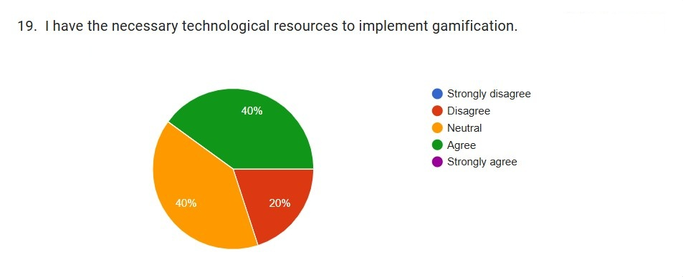

Interpretation: The responses to Item 19, “I have the necessary technological resources to implement gamification,” reveal a mixed but generally positive perception among participants. As shown in the pie chart, 40% of respondents agreed that they possess adequate technological resources, while none strongly agreed. Meanwhile, an additional 40% marked “Neutral,” indicating uncertainty or inconsistent access to required tools. A smaller proportion, 20%, disagreed, suggesting that one in five educators perceives a lack of adequate technological infrastructure to support gamified instructional practices.
Overall, the combined 40% agreement signifies that a substantial portion of respondents feel equipped to implement gamification; however, the equally large 40% neutral group highlights considerable ambiguity or variability in resource availability across educational contexts.
Findings: 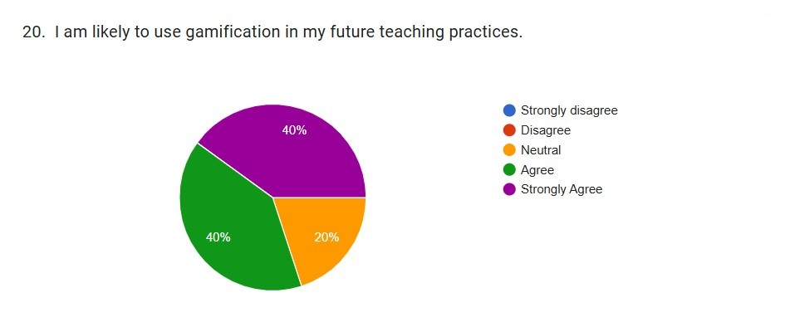

Interpretation: The responses to Item 20, “I am likely to use gamification in my future teaching practices,” reveal generally positive intentions toward adopting gamification. As shown in the pie chart, 40% of participants agreed, while an additional 40% strongly agreed with the statement. This means that 80% of respondents expressed a clear willingness to incorporate gamification into their future instructional approaches. Meanwhile, 20% of participants reported a neutral stance, and no respondents disagreed or strongly disagreed.
These results indicate a strong overall inclination toward future use of gamification among educators, reflecting openness to innovative pedagogical strategies. The absence of disagreement further reinforces the finding that participants do not perceive gamification negatively in terms of future professional practice.

Synthesis of the findings:
Across all items, participants reported strongly positive perceptions of gamification as an instructional strategy. The majority (60–90%) agreed or strongly agreed that gamified activities enhance student motivation, support differentiated learning, and promote active engagement. Respondents also expressed substantial confidence in gamification’s ability to develop 21st-century skills and facilitate meaningful student interaction, with many additionally affirming its value for fostering deeper conceptual understanding.
Perceptions of assessment were similarly favorable: 70% of participants endorsed the effectiveness of gamified assessments for evaluating student understanding. Strong alignment with constructivist principles was also evident, with nearly all respondents indicating that gamification is compatible with contemporary pedagogical approaches.
Despite these strengths, several challenges emerged. A large majority (90%) agreed that gamification requires significant preparation time, and 60% perceived a shortage of high-quality, subject-specific gamification resources. Participants also noted variability in student responsiveness and expressed mixed views on the suitability of gamification for higher-order cognitive tasks. Confidence in designing gamified experiences was generally positive (60%), yet half of respondents reported inadequate professional development, and access to technological resources appeared uneven.
Institutional support was viewed positively but ambiguously: while 60% agreed their institutions encourage innovative teaching, 40% remained uncertain. Overall, the findings indicate strong endorsement of gamification’s pedagogical benefits alongside clear structural and practical barriers that influence its implementation in educational settings.

Educational implications:
Drawing on the study’s findings and existing literature, several evidence-based recommendations are proposed to guide effective gamification in educational practice. First, game elements should be purposefully aligned with learning objectives to ensure that points, badges, levels, and challenges reinforce conceptual understanding rather than function as superficial rewards. Gamified tasks should provide immediate, meaningful feedback and incorporate adjustable challenge levels to support competence, persistence, and differentiated learning pathways.
Supporting learner autonomy is essential; offering choices in tasks, difficulty levels, or learning routes can enhance intrinsic motivation. Social and collaborative components—such as team challenges or group quests—should also be integrated to strengthen relatedness and promote cooperative problem-solving. To prevent distraction and cognitive overload, educators should avoid unnecessary complexity and ensure that game elements remain pedagogically focused.
Effective implementation requires iterative refinement. Educators should gather student feedback, monitor performance data, and routinely adjust gamified activities to optimize engagement and learning outcomes.
Professional development is critical: teachers benefit from targeted training in gamification design, digital tools, and motivational pedagogy, as well as support from institutional leadership. Collaboration within professional learning communities can ease design burdens by enabling the sharing of resources and co-development of materials.
Finally, given variability in student responses and resource availability, educators are encouraged to start with small-scale or low-tech gamification strategies and expand gradually as confidence, competence, and institutional support grow. Overall, purposeful design, ongoing evaluation, and sustained professional capacity-building are central to the effective integration of gamification in contemporary learning environments.
Conclusion:
The study reveals consistently positive perceptions of gamification across multiple dimensions of teaching and learning. Large majorities of respondents—often 70–100%—indicated agreement that gamified strategies enhance student engagement, motivation, active learning, differentiated instruction, conceptual understanding, and meaningful interaction. Participants also viewed gamification as aligned with contemporary pedagogical frameworks, including constructivist and learner-centered approaches, and many expressed confidence in their ability to design gamified learning experiences.
Despite these benefits, several challenges emerged. Educators widely reported that effective gamification requires substantial preparation time and that high-quality, subject-specific resources remain limited. Perceptions were mixed regarding the potential for distraction, variability in student receptiveness, and the suitability of gamification for higher-order cognitive tasks. Additionally, many participants indicated insufficient professional development and uneven access to technological resources, suggesting systemic constraints on implementation.
Overall, the findings underscore that while gamification is regarded as a pedagogically grounded and engaging instructional strategy with significant potential to improve learning outcomes, its successful adoption depends on thoughtful design, targeted training, and robust institutional and technological support.

Acknowledgement:

The author would like to express her sincere gratitude to Dr. Shalini Yadava, Associate Professor from Guru Gobind Singh Indraprastha University, New Delhi, for her motivation and encouragement for this research. Finally, the author extends her heartfelt thanks to her family members and friends for their unwavering support and patience during this journey.

References

Anderson, L. W., & Krathwohl, D. R. (Eds.). (2001). A taxonomy for learning, teaching, and assessing: A revision of Bloom’s taxonomy of educational objectives. Longman.
Bada, S. O. (2015). Constructivism learning theory: A paradigm for teaching and learning. Journal of Research & Method in Education, 5(6), 66–70.
Bai, S., Hew, K. F., & Huang, B. (2020). Does gamification improve student learning outcome? Evidence from a meta-analysis and synthesis of qualitative data in educational contexts. Educational Research Review, 30, 100322. https://doi.org/10.1016/j.edurev.2020.100322
Bandara, N., Chathurika, R., & Katukurunda, K. (2024). An Overview of Teaching Methods for Fostering Generation Alpha (Gen Alpha) Learning Process.International Journal of Research Publication and Reviews, 5(8), 1446-1461.https://doi.org/10.55248/gengpi.5.0824.2115
Bandura, A. (1997). Self-efficacy: The exercise of control. W. H. Freeman.
Barata, G., Gama, S., Jorge, J., & Gonçalves, D. (2013). Engaging engineering students with gamification. In 2013 5th International Conference on Games and Virtual Worlds for Serious Applications (pp. 1–8). IEEE. https://doi.org/10.1109/VGAMES.2013.6624228
Black, P., & Wiliam, D. (1998). Assessment and classroom learning. Assessment in Education: Principles, Policy & Practice, 5(1), 7–74.
Bose, B., Philip, Y., Joseph, A., & Abraham, M. (2024). Effect of Gamification on Teaching-Learning Process: A Descriptive Study. Indian Journal of Educational Technology, 6(I), 167–179. Retrieved from https://journals.ncert.gov.in/IJET/article/view/431
Buckley, P., & Doyle, E. (2016). Gamification and student motivation. Interactive Learning Environments, 24(6), 1162–1175. https://doi.org/10.1080/10494820.2014.964263
Caponetto, I., Earp, J., & Ott, M. (2014). Gamification and education: A literature review. Proceedings of the European Conference on Games-Based Learning, 50–57.
Christopoulos, Athanasios & Mystakidis, Stylianos. (2023). Gamification in Education. Encyclopedia. 3. 1223-1243. https://doi.org/10.3390/encyclopedia3040089
Davis, F. D. (1989). Perceived usefulness, perceived ease of use, and user acceptance of information technology. MIS Quarterly, 13(3), 319–340. https://doi.org/10.2307/249008
De Los Santos, J.N., & Escote, M.J.V.(2025).Exploring The world of generation alpha: Through the lens of the teachers. IJARIIE-ISSN(O)-2395-4396, 11(4), 74-80. Retreived from https://ijariie.com/AdminUploadPdf/EXPLORING_THE_WORLD_OF_GENERATION_ALPHA__THROUGH_THE_LENS_OF_THE_TEACHERS_ijariie27025.pdf?srsltid=AfmBOooSiZzsjs6BdY7-y1XOkHvkqI44Cr_GoDiROIzvq6isN3vdStC4
Deci, E. L., & Ryan, R. M. (2000). The “what” and “why” of goal pursuits: Human needs and the self-determination of behavior. Psychological Inquiry, 11(4), 227–268. https://doi.org/10.1207/S15327965PLI1104_01
Deterding, S. (2012). Gamification: Designing for motivation. Interactions, 19(4), 14–17. https://doi.org/10.1145/2212877.2212883
Dichev, C., & Dicheva, D. (2017). Gamifying education: What is known, what is believed and what remains uncertain: A critical review. International Journal of Educational Technology in Higher Education, 14(1), 1–36.
Domínguez, A., Saenz-de-Navarrete, J., de-Marcos, L., Fernández-Sanz, L., Pagés, C., & Martínez-Herráiz, J. J. (2013). Gamifying learning experiences: Practical implications and outcomes. Computers & Education, 63, 380–392.
Fernando, P. A., & Premadasa, H. K. S. (2024). Use of gamification and game-based learning in educating Generation Alpha: A systematic literature review. Educational Technology & Society, 27(2), 114-132.https://doi.org/10.30191/ETS.202404_27(2).RP03
González, C. S., Gómez, N., Navarro, V., Cairós, M., Quirce, C., Toledo, P., & Marrero-Gordillo, N. (2022). Learning and engagement in gamification: A systematic review. Computers & Education, 185, 104534.
Hamari, J., Koivisto, J., & Sarsa, H. (2014). Does gamification work? — A literature review of empirical studies on gamification. Proceedings of the 47th Hawaii International Conference on System Sciences, 3025–3034. https://doi.org/10.1109/HICSS.2014.377
Hanus, M. D., & Fox, J. (2015). Assessing the effects of gamification in the classroom: A longitudinal study on intrinsic motivation, social comparison, satisfaction, effort, and academic performance. Computers & Education, 80, 152–161. https://doi.org/10.1016/j.compedu.2014.08.019
Höfrová, A., Balidemaj, V. & Small, M.A.(2024) A systematic literature review of education for Generation Alpha. Discov Educ 3, 125. https://doi.org/10.1007/s44217-024-00218-3
Huang, R., & Soman, D. (2013). A practitioner’s guide to gamification of education. University of Toronto: Rotman School of Management.
Ibáñez, M. B., & Delgado-Kloos, C. (2018). Gamification for engaging computer science students in learning activities: A systematic review. IEEE Transactions on Learning Technologies, 11(2), 240–254.
Kalogiannakis, M., & Papadakis, S. (2019). Evaluating the effectiveness of gamification in education: A meta-analysis. Journal of Educational Technology & Society, 22(3), 1–14.
Kalogiannakis, M., & Papadakis, S. (2019). The use of serious games in preschool education: A review. International Journal of Emerging Technologies in Learning, 14(1), 4–18. https://doi.org/10.3991/ijet.v14i01.9285
Kapp, K. M. (2012). The gamification of learning and instruction: Game-based methods and strategies for training and education. Pfeiffer.
Kim, S., & Lee, J. (2020). The effects of gamification on student motivation and engagement: A meta-analysis. Journal of Educational Computing Research, 58(8), 1469–1497.
Kocadere, S. A., & Çağlar, Ş. (2018). The design and implementation of a gamified assessment. Journal of Computing in Higher Education, 30, 466–488.
Kolb, D. A. (1984). Experiential learning: Experience as the source of learning and development. Prentice Hall.
Kuo, M.-J., & Chuang, T.-Y. (2021). Teachers’ adoption of gamification in education: A systematic review. Education and Information Technologies, 26(5), 6061–6081. https://doi.org/10.1007/s10639-021-10647-9
Kuo, M.-S., & Chuang, T.-Y. (2016). How gamification motivates visits and engagement for online information services. Online Information Review, 40(5), 635–652.
Kuo-Wei, L.(2023).Effectiveness of gamification and selection of appropriate teaching methods of creativity: Students’ perspectives, Heliyon, 9(10), e20420, ISSN 2405-8440.https://doi.org/10.1016/j.heliyon.2023.e20420
Landers, R. N. (2014). Developing a theory of gamified learning: Linking serious games and gamification of learning. Simulation & Gaming, 45(6), 752–768.
Lee, J. J., & Hammer, J. (2011). Gamification in education: What, how, why bother? Academic Exchange Quarterly, 15(2), 1–5.
Leiss L, Großschedl J, Wilde M, Fränkel S, Becker-Genschow S and Großmann N (2025).Gamification in education—teachers’ perspectives through the lens of the theory of planned behavior.Front. Psychol. 16:1571463.https://doi:10.3389/fpsyg.2025.1571463
Mekler, E. D., Brühlmann, F., Tuch, A. N., & Opwis, K. (2017). Towards understanding the effects of individual gamification elements on intrinsic motivation and performance. Computers in Human Behavior, 71, 525–534. https://doi.org/10.1016/j.chb.2015.08.048
Mishra, P., & Koehler, M. J. (2006). Technological pedagogical content knowledge: A framework for teacher knowledge. Teachers College Record, 108(6), 1017–1054.
Nah, F. F.-H., Zeng, Q., Telaprolu, V. R., Ayyappa, A. P., & Eschenbrenner, B. (2014). Gamification of education: A review of literature. In International Conference on HCI in Business (pp. 401–409). Springer.
Negrín-Medina, M. Á., Bernárdez-Gómez, A., Portela-Pruaño, A., and Marrero-Galván, J. J. (2022). Teachers’ Perceptions of Changes in Their Professional Development as a Result of ICT. Journal of Intelligence 10: 90. https://doi.org/10.3390/jintelligence10040090

Núñez-Pacheco, R., Barreda-Parra, A., Castro-Gutierrez, E., Turpo-Gebera, O., & Aguaded, I. (2023).Professors’ perception of the use of digital skills and gamification in a peruvian university. Journal of Technology and Science Education, 13(2), 431-445 .https://doi.org/10.3926/jotse.1737
Papadakis, S., & Kalogiannakis, M. (2017). Using digital games for preschool education: A systematic review of the literature. European Early Childhood Education Research Journal, 25(4), 1–21.
Piaget, J. (1973). To understand is to invent: The future of education. Grossman Publishers.
Prashetha, S.R., & Devika, S.(2023).Perception Of Prospective Teachers On Gamification In Learning.International Journal of Creative Research Thoughts. 11(3), g596-g601, Retrieved from www.ijcrt.org

R. Jukić and T. Škojo, (2021).The Educational Needs of the Alpha Generation. 2021 44th International Convention on Information, Communication and Electronic Technology (MIPRO), Opatija, Croatia, pp. 564-569, https://doi.org/10.23919/MIPRO52101.2021.9597106
Rogers, E. M. (2003). Diffusion of innovations (5th ed.). Free Press.
Sáez-López, José-Manuel & Vázquez-Cano, Esteban & Fombona, Javier & Meneses, Eloy. (2022). Gamification and gaming proposals, teachers' perceptions and practices in Primary Education. Interaction Design and Architecture(s). 53. 213-229. https://doi.org/10.55612/s-5002-053-011
Sailer, M., Hense, J. U., Mayr, S., & Mandl, H. (2017). How gamification motivates: An experimental study of the effects of specific game design elements on psychological need satisfaction. Computers in Human Behavior, 69, 371–380.
Skaalvik, E. M., & Skaalvik, S. (2017). Still motivated to teach? A study of school context variables, stress, and job satisfaction among teachers in senior high school. Social Psychology of Education, 20, 15–37. https://doi.org/10.1007/s11218-016-9363-9
Sweller, J. (1994). Cognitive load theory, learning difficulty, and instructional design. Learning and Instruction, 4(4), 295–312.
Sweller, J. (2011). Cognitive load theory. Psychology of Learning and Motivation, 55, 37–76.
Tobias, S., & Fletcher, J. D. (2012). Reflections on simulation and game-based learning. In D. Ifenthaler, D. Eseryel, & X. Ge (Eds.), Assessment in game-based learning (pp. 23–44). Springer.
Tomlinson, C. A. (2014). The differentiated classroom: Responding to the needs of all learners (2nd ed.). ASCD.
Tschannen-Moran, M., & Hoy, A. W. (2001). Teacher efficacy: Capturing an elusive construct. Teaching and Teacher Education, 17(7), 783–805.
Vygotsky, L. S. (1978). Mind in society: The development of higher psychological processes. Harvard University Press.
Wang, A. I., & Tahir, R. (2020). The effect of using Kahoot! for learning – A literature review. Computers & Education, 149, 103818.
Werbach, K., & Hunter, D. (2012). For the win: How game thinking can revolutionize your business. Wharton Digital Press.
Wu, M.L., Zhou, Y., & Li, L.(2023).The effects of a gamified online course on pre‑service teachers’ confidence, intention, and motivation in integrating technology into teaching.Education and Information Technologies, 28:12903–12918.https://doi.org/10.1007/s10639-023-11727-3
Zainuddin, Z., Shujahat, M., Haruna, H., & Chu, S. K. W. (2020). The role of gamified learning in enhancing active learning: A systematic review. Education and Information Technologies, 25, 5361–5380.

