INTRODUCTION

Background of the Study

Curriculum reforms globally requires substantial adaptability and resiliency from educators at the forefront of implementation. In the Philippines to raise the caliber of the K–12 curriculum, the Department of Education (DepEd) implemented the MATATAG curriculum, which presented difficulties for teachers in this regard (Schleicher, 2024). The Department of Education (2024) claims that the updated curriculum places more emphasis on reading and numeracy skills, learning competencies, and fewer learning topics. However, this depends on how resilient the elementary teachers are.
Despite being essential to the success of curricular reform, the study of Javier (2024) revealed various obstacles in implementing the MATATAG curriculum, including the need for appropriate implementation approaches, inadequate government policies for inclusive education, including a lack of training, limited resources, and uneven support from administrators, and technical problems in implementation. Alsubaie (2024) asserts the MATATAG curriculum is designed to improve foundational skills of pupils’, yet, he further stated that, changing to a new curriculum led to increased workload for teachers, leading to additional stress and exhaustion.
Moreover, Hall & Hord (2025) revealed through comprehensive study that teachers must apply the curriculum to meet students' needs while adhering to the provided guidelines, the curriculum's failure and success still largely depends on the roles that teachers play. Macasero (2025) further highlights issues such as teacher readiness, lack of access to information resources, and infrastructural limitations pose significant challenges to the effective rollout of the curriculum. Effective support systems and teacher readiness are essential for the MATATAG curriculum's successful implementation (Kilag et al., 2024). The study of Keiler (2025) reveals that giving the teachers enough assistance, trainings, teaching resources, continuous administrative support will help improves the implementation of the new curriculum.
While many studies have looked into the implementation and outcomes of MATATAG curriculum, there's still a significant gap in research that specifically addresses how teachers feel about the new DepEd MATATAG Curriculum. Most existing literature has focused on systemic issues, student performance, and policy-level discussions, often missing out on the practical insights and concerns of classroom teachers who are the ones actually making these curricular changes happen. This study will seek to bridge that gap by examining elementary teachers’ sentiments on the implementation of the MATATAG Curriculum, offering a deeper understanding that can guide policy makers, school leaders and curriculum developers to look into the side of the curriculum implementers, the teachers. The findings of the study will serve as a basis to enhance the Instructional Supervision Plan that will help improve teachers in the curriculum implementation.

Purpose of the Study

The study aims to investigate and characterize the real-life experiences of teachers as they apply the MATATAG curriculum, with a focus on the 2024–2025 academic year. In order to record the teachers' individual stories, coping mechanisms, and insights in their own words, basis for the enhancement of instructional supervisory plan.

Research Questions

This study aims to understand the teacher’s live experiences on the implementation of the MATATAG curriculum focusing on opportunities for learning and enhancement of learners’ skills.
Specifically, the study seeks to answer the following questions:

1. What are the lived experiences of teachers in implementing the MATATAG curriculum in their classrooms?
2. How do teachers cope the challenges they faced in adapting the MATATAG curriculum?
3. What insights could you share on the support they receive in the implementation of the MATATAG Curriculum?

Theoretical Lens

MATATAG Curriculum is evident in its emphasis on hands-on, project-based learning and real-world applications. The MATATAG curriculum implementation is anchored in theories that support a holistic and student-centered approach. This alignment can enhance student engagement, deepen understanding, and foster critical thinking skills. This theoretical framework synthesizes key theories to provide a foundation for understanding on teachers implementing the MATATAG curriculum.
Experiential Learning Theory (ELT)
According to David Kolb's experiential learning theory, learning is a cyclical process involving tangible experience, active experimentation, abstract conceptualization, and thoughtful observation (Kolb, 2021). Kolb’s learning process cycle begins with a concrete experience, Roberts (2018) defines as completely new experience or a reimagined experience that already happened.
In the context of the MATATAG Curriculum, teachers experience curriculum changes directly inside the classroom. They encounter challenges such as limited training, time constraints, unpacking competencies, lack of resources, and learner difficulties. Through these actual experiences, teachers reflect on what works and what does not, develop new teaching approaches, and apply improved strategies in succeeding lessons. Teachers gain concrete experiences by implementing the new MATATAG lesson exemplars and competencies. Teachers engaged in reflective observation during LAC sessions, mentoring, or personal reflection about classroom difficulties. They develop abstract conceptualization by modifying strategies, contextualizing lessons, and understanding learner needs. They perform active experimentation when they try innovative teaching methods, differentiated instruction, or technology integration in future classes.
Experiential Learning Theory is highly applicable in this study because the MATATAG Curriculum emphasizes learner-centered, inquiry-based, and active learning approaches. Teachers themselves become experiential learners as they continuously adjust and improve their practices through lived experiences and professional collaboration. Furthermore, Experiential Learning Theory serves as a lens in understanding how teachers learn and adapt during the implementation of the MATATAG Curriculum. Through their daily teaching experiences, teachers reflect on challenges encountered, formulate new instructional strategies, and apply these improvements in their classroom practices. The theory emphasizes that meaningful professional growth occurs through continuous experience, reflection, and active adaptation, which are evident in teachers’ coping mechanisms and instructional adjustments during curriculum implementation.

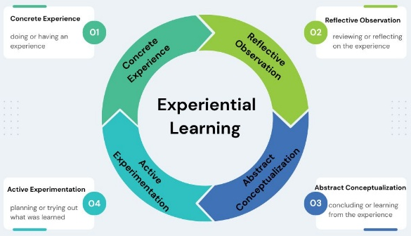

https://educationaltechnology.net/kolbs-experientiallearning theory-learning-styles/

Constructivist Learning Theory

Constructivist learning theory, which holds that students actively create knowledge from their experiences and interactions. This theory can be used to investigate how teachers' feelings are influenced by their individual experiences, convictions, and the social dynamics in their classroom when it comes to curriculum implementation.
According to Bruner (1966), learning is an active process in which students build new concepts or ideas using what they already know or have learned.
The centerforlites journal defines the teaching process begins with the engage stage, where the teacher motivates learners, activates their prior knowledge, and sparks curiosity about the new topic. During the exploration stage, students work in diverse groups to gather and classify data, develop hypotheses, and seek answers. In the explanation and elaboration stage, learners share ideas, propose and test solutions, and connect new knowledge with previous understanding. Finally, in the evaluation stage, students assess solutions, apply what they have learned, and integrate new and old concepts, leading to deeper and more comprehensive understanding.
Furthermore, in terms of teaching, the teacher ought to make an effort to motivate students to learn concepts on their own. The curriculum ought to be structured in a spiral fashion, allowing students to continuously expand on their prior knowledge.
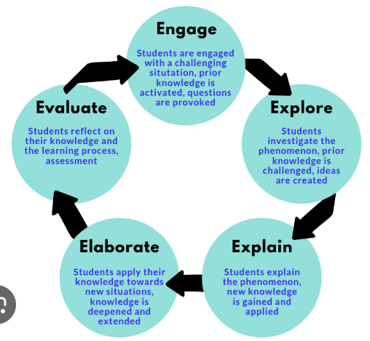

https://knowledgebase.centreforelites.com/4-stages-of-the-constructivist-learning-model/#google_vignette

Significance of the Study

This research holds substantial significance for various stakeholders in the community, offering both immediate and long-term benefits, the study's findings shed important light on the following.
For Principals, it will enables the principal to enhance supervisory strategies based on data, guaranteeing that the instructional supervisory plan is practical, adaptable, and conducive to teacher development. The principal as leaders and managers who bridge policy and classroom practice. They are instructional leaders who guide how the curriculum is understood, adopted, and enacted by teachers. Principals could be able to direct support where it is most needed if the study uncovers, for instance, gaps in training, instructional materials, or resource allocation. Additionally, it can draw attention to effective practices that the principal can expand and support. The principal can increase trust, boost morale, and promote a collaborative culture by coordinating supervision with the actual circumstances of the teachers.
For Teachers, it will offer clarity on teachers about what parts of the MATATAG curriculum work well, what parts need adaptation, and what supports they need in order to implement it effectively. The findings from the study can inform an instructional leader that is sensitive to the realities of everyday teaching, making supervisory feedback and professional development more relevant. This, in turn, can increase teachers’ sense of ownership and agency when supervision is based on what they actually experience, rather than what is assumed by policymakers, teachers are more likely to feel supported, respected, motivated, and confident in making improvements. It also improves teaching practices, a stronger sense of ownership over their work, and better professional development.
For Pupils, they will receive more consistent, effective teaching. Pupils as the core of curriculum implementation ultimately may see improved learning outcomes, more meaningful learning experiences, less burnout or stress from rushed or overloaded instruction, and greater development not only academically but also in socio-emotional, values, and life skills. Additionally, pupils may gain from more deliberate, context-sensitive instruction when teachers and administrators recognize and resolve MATATAG implementation challenges.
Future Researchers, The study will show how phenomenological design can reveal depth beyond surveys by eliciting participant meaning and emotion that is missed by standardized instruments. The findings can be expanded upon in future studies by evaluating monitoring techniques, feedback loops, professional development designs, or longitudinal outcomes related to teacher experience in the MATATAG curriculum.
Operational Definition of terms

To facilitate a better understanding of this study, the following terms are defined operationally.
MATATAG Curriculum refers to the new basic education curriculum implemented by the Philippine Department of Education (DepEd), which emphasizes strengthening foundational skills, assisting teachers and students, and making the curriculum more relevant.
Challenges refers to teachers’ burdens, workloads, stress factors in implementing the MATATAG curriculum in their day to day teaching.
Adaptation Strategies refers to planned modifications and steps done to mitigate the adverse effects of the curriculum changes or take advantage of the positive opportunities they present.
Support Needs refers to the support a teacher needs in order to fulfill his/her potential and engage in everyday teaching activities.

Scope and Delimitation of the Study

The study focuses specifically on the lived experiences of teachers in the MATATAG curriculum implementation during the S.Y. 2024-2025. The study is delimited to kindergarten, grade 1 and grade 4 public school teachers in Bunawan District, Bunawan, Agusan del Sur since these grade levels are already in the phase 2 of implementing the MATATAG curriculum. Exclusion criteria will carefully remove other grade levels, private schools, parents, school administrators, and students to keep the scope narrow and ensuring the integrity of the research sample. The inquiry will rely solely on focus-group discussions and individual interviews to understand the lived experiences of teachers. No classroom observations, document analyses, or student performance data will be collected.
The limitations of the study mostly come from its small, purposefully chosen sample of fifteen (15) teachers for the in-depth interview and 3 groups, compose of 7 teachers per group for the focus group discussion in Bunawan District . The MATATAG curriculum is broad, so this study focuses only on interview questions about teachers' lived experiences, coping strategies, and insights.

Organization of the Study

This research has been organized into five (5) independent but interrelated chapters. Chapter one provides an introduction to the subject matter of the study. The background of the study presents a brief overview of the problem area, while the statement of the problem clearly identifies the specific issues addressed in the research. Additionally, it includes the purpose of the study, research questions, significance of the study.
Chapter Two presents a review of related literature and studies on the subject matter. This chapter aims to determine what aspects of the topic have already been explored, identify the research gap, and compare and contrast findings from previous studies that serve as the foundation of the present study.

Chapter Three discusses the research methodology. It describes the research design, participants of the study, sampling technique, research instruments, data gathering procedures, and methods of data analysis. This chapter explains how data were collected, organized, and analyzed to ensure the validity and reliability of the study’s findings.

Chapter Four presents the results and discussion of the study. It provides a systematic presentation of the findings based on the collected data, organized according to the research questions. The emerging themes are identified and interpreted in relation to existing literature and studies. Furthermore, the discussion also establishes connections between the results, relevant theories supported by the teachers’ responses, thereby strengthening the credibility and significance of the study.

Finally, Chapter Five presents the summary of findings, conclusions, and recommendations. It summarizes the key results of the study, draws conclusions based on the research questions, and provides practical recommendations for teachers, school leaders, and policymakers. It also suggests areas for future research to further explore and enhance instructional supervision practices and teacher development.

REVIEW OF RELATED LITERATURE

The MATATAG Curriculum, introduced in the Philippines for the school year 2024-2025, represents a significant shift in basic education curriculum. The relevant research and literature about MATATAG curriculum implementation are presented in this section. These literature review have immensely strengthened the veracity of the study.
MATATAG Curriculum implementation

This evolving world require an evolving education that would ensure its continued relevance amid changes. In the Philippines DepEd launched the MATATAG Curriculum (DO_010,s. 2024),
However, the study of Abalde and Oco (2023) revealed that this curriculum change brings an ongoing difficulties of teachers in implementing the new curriculum. Addressing student performance deficiencies is crucial, especially in subjects like reading and math. Factors including teacher shortages, crowded classrooms, and a lack of resources make these difficulties on teachers worse (Guiaselon et al., 2022).
The implementation of the MATATAG Curriculum (MC) is shaped by teachers’ attitudes, instructional strategies, and systemic challenges. Teachers' perceptions of curriculum relevance and clarity significantly impact their engagement in its implementation (Barrot, 2023). While clear learning competencies enhance teacher confidence, inadequate administrative support can lead to resistance. Pedagogical practices play a crucial role, with MC emphasizing student-centered learning and technology integration.
Teachers face challenges such as curriculum overload, time constraints, and resource limitations, particularly in public schools, where large class sizes and limited teaching aids hinder implementation (Robosa et al., 2021). Additionally, inconsistent policy guidelines and inadequate training further complicate implementation (DepEd, 2023).
According to recent studies, teachers face substantial stress and workload difficulties when the curriculum changes. Fwu, Chang, and Wu's (2024) study looked at how teaching self-efficacy and increased job stress affected elementary school teachers introducing a new curriculum.
Furthermore, curricular overload has long plagued the Philippine educational system, with teachers under tremendous pressure to cover a wide range of abilities in a limited amount of time (Pillay & Panth, 2022).
Hence, the goal of improving educational outcomes and meeting the various needs of students is the foundation of the justification for curriculum reform initiatives like the MATATAG Curriculum. Gouedard et al. (2024) contend that the development of critical thinking, problem-solving, and socio-emotional skills should be given top priority in curriculum revisions. The MATATAG Curriculum seeks to equip students with the skills they need to succeed in a world that is becoming more complex and competitive by simplifying the curriculum and emphasizing fundamental abilities (Abragan et al., 2025).
On the other hand, there were numerous difficulties in putting the curriculum into practice. Domingo & Masabpi (2024) points out in there research that these are the challenges teachers face on a daily basis in promoting the curriculum. Given their crucial role in implementing the agenda, teachers faced challenges like confusion, discontent, and a sense of helplessness.
Additionally, Philippine research points out ongoing challenges, including a lack of training, limited resources, and uneven support from administrators, particularly in underserved areas (Santos & Navarro, 2024).
Furthermore, study also reveals that shortcomings in training, resource availability, and infrastructure have hindered the progress of these curriculum reforms. This is particularly noticeable in underserved regions, where teachers deal with extra challenges such as overcrowded classrooms and outdated teaching materials (Malinao, & Miano, 2025). Acknowledging these issues, it is crucial to explore and tackle the difficulties educators face in implementing the MATATAG Curriculum to fully enhance its potential impact on learning outcomes (Domingo & Masabpi, 2024).
On the other hand, Bongco (2025) asserts teachers are adapted to change, it is said that teachers can adapt to curriculum changes by embracing a flexible approach, staying informed about updates, modifying resources, engaging students, and collaborating with colleagues. To adhere to the curriculum reform and for the teachers not just to adapt to the changes but modify the teaching approaches, and create innovative methods, Pak et al., (2024) points out that the principal’s leadership had a big impact on implementing innovative practices. Biesta (2025) highlights that the best approach to handle the change is to offer intervention programs, such as training and the involvement of curriculum experts in developing a framework that will direct them in their day-to-day activities as curriculum implementers, in order to overcome resistance and eliminate it as a barrier. Teachers' reasonable disappointment, as well as their individual reactions and feelings, must be recognized, and a strategic plan must be.
According to Howard & Johnson (2024), resilient teachers can adapt to curriculum changes and improve student outcomes. Coping strategies that help manage stress and overcome obstacles. Therefore, curricular reforms are successful when teachers are motivated, given institutional support, and given clear implementation instructions. Support systems like training and resources are essential in facilitating curriculum transition (Fullan, 2025).
Consequently, According to Oreeg (2025) teachers felt forced when there was a curriculum change but immediately changed their mind-set when they realized how they were provided the support that they needed through supervision. Effective support systems and teacher readiness are essential for the successful implementation of the curriculum for MATATAG (Kilag et al., 2024). The overall implementation of the curriculum will be greatly aided by giving the teachers the support they need.
In addition, Uy et.al. (2024) suggests in their study that all Filipino teachers must undergo comprehensive training and seminars in order to properly deliver and implement the MATATAG curriculum. The successful implementation of the curriculum depends on the understanding that ongoing teacher training and community involvement are essential. To ensure that the curriculum is delivered effectively and that student outcomes are improved, communities must be actively engaged to support curriculum transition and teachers must continue their professional development to better modify teaching practices in line to the MATATAG Curriculum.
Lastly, the significance of administrative support in the successful implementation of the MATATAG Curriculum was highlighted in a recent case study. Teachers who received adequate guidance and resources from school administration reported more positive experiences and better student engagement. The study calls for improved communication between decision-makers and educators to assess challenges and provide timely interventions (Magsambol.2024).

METHODOLOGY

Research Design

This study utilized a qualitative research design. This design was a type of research methodology that focused on exploring and understanding complex phenomena and the meanings attributed to them by individuals or groups, capturing the richness and depth of human experiences, beliefs, attitudes, and behaviors (Taylor et al., 2023).
Moreover, the study solely focused on a phenomenological inquiry that elicited teachers’ lived experiences, coping strategies, and insights on the MATATAG curriculum implementation. Delve (2022) defined phenomenological inquiry as a qualitative research approach that sought to understand and describe the universal essence of a phenomenon. Phenomenological research studied lived experiences to gain deeper insights into how people understood those experiences.

Research Participants

According to Creswell and Poth (2021), the number of participants in phenomenological research included 5–15 individuals, which aligned with common recommendations for small sample sizes in qualitative studies. Through purposive sampling, approximately 15 public elementary school teachers from diverse educational backgrounds were selected to participate in in-depth interviews, along with three groups consisting of seven participants in each group for the focus group discussions.
The participants were public elementary school teachers who taught Kindergarten, Grade 1, and Grade 4 pupils in the Bunawan District. These teachers were actively teaching during the current academic year and had experienced the first and second phases of the MATATAG Curriculum implementation. Private school teachers, volunteer teachers, other elementary grade-level teachers, and teachers of Kindergarten, Grade 1, and Grade 4 who did not fully experience the two phases of the MATATAG curriculum were not included as participants in this research.
Research Instruments

The main data collection instrument for this study was a researcher-designed semi-structured interview guide, which was developed based on the review of related literature and the objectives of the study. The interview questions were worded in a neutral manner to gather the experiences, coping strategies, and insights of teachers in implementing the MATATAG curriculum. The interview guide questionnaire had three parts. Part 1 consisted of teachers’ lived experiences in implementing the MATATAG curriculum in their classrooms; Part 2 focused on the ways teachers adapted their instructional practices to align with the new curriculum; and Part 3 explored the meanings teachers attached to the support they received or needed in the implementation of the MATATAG curriculum.
The semi-structured interview guide ensured accuracy while capturing the complexity and depth of the topic, allowing participants to express their views and share their experiences in implementing the new curriculum. The questions were carefully crafted, evaluated, and tailored to fit the needs of the study and were analyzed using thematic analysis. Riger (2020) explained that thematic analysis was appropriate for examining qualitative data by identifying recurring patterns or themes within a dataset, which helped in interpreting participants’ responses meaningfully. This ensured that the questions asked were appropriate for the study. Open-ended questions enabled deep and descriptive insights, consistent with the phenomenological approach employed in the study.

Validity of the Instrument

Qualitative research had been criticized for its rigor and the strength of its validity and reliability in terms of data and conclusions. Concerns about transparency and methodological consistency had often been raised in qualitative studies. Middleton (2020) averred that it was important to consider reliability and validity in creating research designs and crafting research questions, as these increased transparency and reduced opportunities for researcher bias (Singh, 2021).
First, the researcher developed a comprehensive set of interview guide questions that aimed to address the research questions. Lastly, the researcher selected five research experts to validate the research instrument using a validation form, in order to establish the credibility of the instrument used in the study. The validation process contributed to the clarity, relevance, and accuracy of the questions in adequately capturing the lived experiences of the participants.
Data Collection
The data required for this study were gathered using several methods. The researcher first sent a letter of permission to the school principal where the teacher-respondents were teaching. The letter also informed the teachers that they were selected as participants, set a schedule based on their availability, and specified whether the interview would be conducted in person or online. It also emphasized that their participation in the study was entirely voluntary.
Furthermore, to ensure convenience, the researcher arranged the interviews according to the participants' free time. The in-depth interviews provided participants with the opportunity to discuss their experiences and viewpoints in detail. Virtual interviews were conducted when teachers were unavailable for in-person sessions, in order to respect their schedules and minimize disruption to their professional responsibilities, particularly during the conduct of focus group discussions. Data gathering took place over a predetermined period of time.
Data Analysis
The data were analyzed using thematic analysis to verbatim interview transcriptions to ensure the reliability and accuracy of the findings. Caulfield (2023) defined thematic analysis as a qualitative research method that researchers used to systematically organize and analyze complex data sets. King (2020) also defined it as a process of identifying themes that captured the narratives present within data sets. It involved the identification of themes through careful reading and repeated examination of the transcribed data. Hence, a rigorous thematic analysis approach produced insightful and trustworthy findings (Nowell, 2021).
Additionally, peer debriefing, member checking, and thick descriptions were included in the results report to ensure rigor and credibility. By using these techniques, the interpretations were validated, and the study’s representation of the participants’ experiences was ensured.
Trustworthiness of the Study
According to Pilot and Beck (2020), the degree of confidence in data, interpretation, and procedures used to ensure a study’s quality was referred to as rigor or trustworthiness. Stahl and King (2020) defined trustworthiness as encompassing credibility, transferability, dependability, and confirmability of the data and interpretations. In this study, the researcher observed fairness appropriately and ensured that the objectives were clear to the respondents. The data and information gathered from the respondents were treated with utmost confidentiality and anonymity. The respondents of the study were always treated with respect and consideration. Before participating in the study, participants received a thorough description of its objectives, procedures, and methodologies. Participants were given verbal or written consent, emphasizing that there was no coercion or incentive offered to influence their decisions, that participation was entirely voluntary, and that they could withdraw at any time without facing any repercussions. Participant identities and responses were kept confidential, and participants were informed of the study’s potential benefits, such as improved curriculum implementation and enhanced support from school leaders. Respondents were also reminded that they could withdraw from the activity at any time or choose not to answer any questions.

Ethical Considerations
Ethical factors taken into account guaranteed reflexivity (Garma, J. C., 2024). Ensuring research ethics and guidelines were also observed by the researcher helped avoid potential issues related to plagiarism, intellectual dishonesty, and other concerns that could have affected the validity and accuracy of the study.
Throughout the study, strict adherence to informed consent and confidentiality was maintained. The study accurately conveyed the essence of teachers’ lived experiences, coping strategies, and insights regarding the new curriculum; the findings were presented with detailed explanations and direct quotations from the respondents.
RESULTS AND DISCUSSION
This chapter presents the findings and discussion of the study on the lived experiences, coping mechanisms, and support systems of teachers implementing the MATATAG Curriculum. The data were gathered through In-Depth Interviews (IDI) and Focus Group Discussions (FGD), and analyzed using thematic analysis. The results are organized according to the research questions, highlighting the emerging themes derived from participants’ responses. Each theme is supported by representative statements and interpreted using relevant theoretical perspectives.

Table 1. Lived Experiences of Teachers in Implementing the MATATAG Curriculum
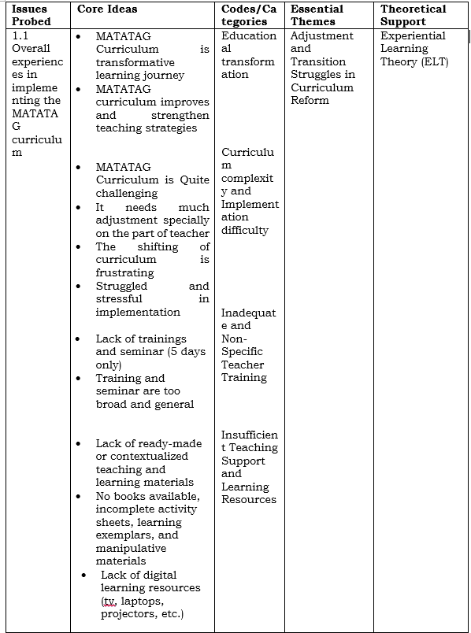
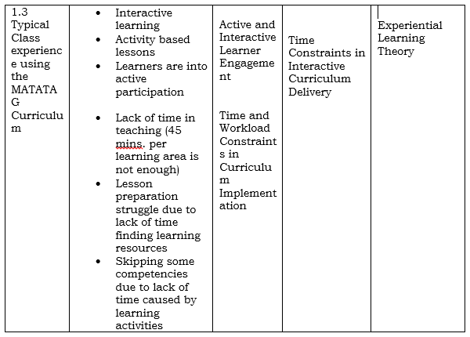
Adjustment and transition struggles in curriculum reform. Teachers consistently described the implementation of the MATATAG Curriculum as challenging, stressful, and demanding, particularly during the initial phase. Many participants emphasized the difficulty of adjusting to new competencies, teaching approaches, and expectations. Bautista et al. (2023) indicate that teachers may resist changes when inadequately prepared. Fwu, Chang, and Wu (2024) examined the impact of teaching self-efficacy and heightened job stress on elementary school teachers implementing a new curriculum. Adjustment and transition struggles in curriculum reform anchored in the theory experiential learning theory, MATATAG Curriculum is perceived as both beneficial and difficult, it captures the balanced reality of educational reform, and growth comes with challenges.
These are evident in the following quotes from the participants:
During the first implementation of this curriculum, I truly struggled because there is limited teaching and learning resources. I don’t know what to do. (IDI K-P3) (FGD G1-P1)
They stressed that Implementing the MATATAG curriculum has been challenging at first, especially in adjusting to the reduced learning competencies and new context standards. (IDI G1-P7)
Additionally, a teacher teaching for over 10 years said adjusting to the MATATAG Curriculum was challenging, since I have been teaching for over 10 years and was used to old curriculum, it took time to get used to the new pacing and structure. (FGD G4-P3)
It's so hard, I'm really struggling with the transition due to lack of teaching and ready-made learning materials! (FGD G1-P2) (IDI G4-P11)
The biggest challenge is the Lack of ready-made learning materials, Localized aligned- learning materials. As a teacher I often spend my own money and time after school to create and buy teaching materials online. (IDI G1-P7) (IDI K-P4) (FGD G4-P2)
Teacher’s adjustments to the new curriculum, Lack of trainings, limited teaching resources, Lack of teaching time. (IDI K-P2) (IDI G1-P8) (FGD G4-P7)
The training given for only 5 days is not enough, there are no books available, until now, it's only the second phase, there is only 1 book out of 5 subjects in grade 1. (FGD G1-P1)
On the other hand some teachers find MATATAG curriculum as transformative learning journey and improves and strengthen teaching strategies.
These are some evident quotes they utter:
Implementing the MATATAG curriculum has been a transformative journey of new learnings. (IDI G1-P6)
Implementing the MATATAG Curriculum improves and strengthen my teaching strategies, bisan lisod siya but it encouraged me to become more flexible and innovative. (FGD K-P2)
Shift toward foundational skills and mastery learning. Despite their experiences, teachers acknowledged positive aspects of the MATATAG Curriculum. Many participants emphasized its focus on literacy and numeracy, life skills and values formation and mastery through repetition. The study of Abaiz et al. 2025 revealed the effectiveness of the MATATAG Curriculum, which was more focused on children’s needs, refining mastery of skills and essential competencies to achieve. Effectiveness in Teaching and Learning refers to the impact of the MATATAG curriculum on improving the quality of education, focusing on how well it supports both teaching practices and student learning outcomes (Rodriguez & Garcia, 2024). MATATAG Curriculum prioritizes deep learning of essential skills through active, real-life, and learner-centered approaches, ensuring meaningful and applicable learning experiences.
These were supported by the responses of the following:
Responses such as “focus on essential skills” and “learners master foundational skills, because the lesson is repeated over and over again.” were common in IDI participants.
They also highlight that the most effective aspect of the MATATAG curriculum is the mastery and meaningful activity, real-life application. (FGD G1-P6)
Moreover, they said that the MATATAG curriculum is focus on the essential skills, literacy and numeracy. (FGD G4-P1) (IDI G1-P10)
Focus on the real-life skills, it's easier for the child to understand, because they can relate to the topic. (IDI G1-P9)
Time Constraints in Interactive Curriculum Delivery. A recurring issue in the typical class experience of the teachers is the insufficient time allocation (45 minutes per subject), which many teachers found inadequate for completing activities, delivering lessons fully and addressing diverse learner needs. Also they struggle in preparing their daily lesson due to lack of learning resources like books, digital materials and exemplars. In the descriptive study conducted by Abaiz et al. (2025) said that time management was a common problem for teachers because it was hard for them to know how quickly to move through topics. The theme is anchored on the theory experiential learning which highlights the respondents’ experiences of limited instructional time, difficulty in lesson preparation, and the need to skip competencies, all of which reflect how time pressure and workload demands affect effective implementation of interactive learning and curriculum requirements. However, some teachers describe their typical class day as Interactive learning, activity based lessons, and learners are into active participation. These are evident statements from the participants:
In Grade 1 class, MATATAG curriculum is easier to teach compared to K-12, it is interactive and more on activity but the time allotted per subject is too short for the amount of content that needs to be covered." “The time allotted for teaching the lessons is not enough. (FGD G1-P1).
Other teachers echoed similar sentiments, saying:
Lack of time in teaching, 45 mins. per subject instead of 1 hour. (FGD G1-P2) (FGD G4-P3)
Our typical class is more on activity, but I find it hard to manage my time per subject because the pedagogical process is explicit teaching. (IDI G4-P12).

Table 2. Coping Mechanism about the Challenges faced in the implementation of MATATAG Curriculum
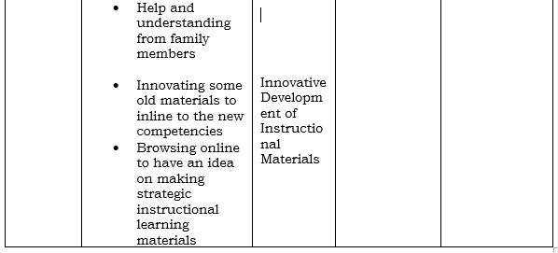
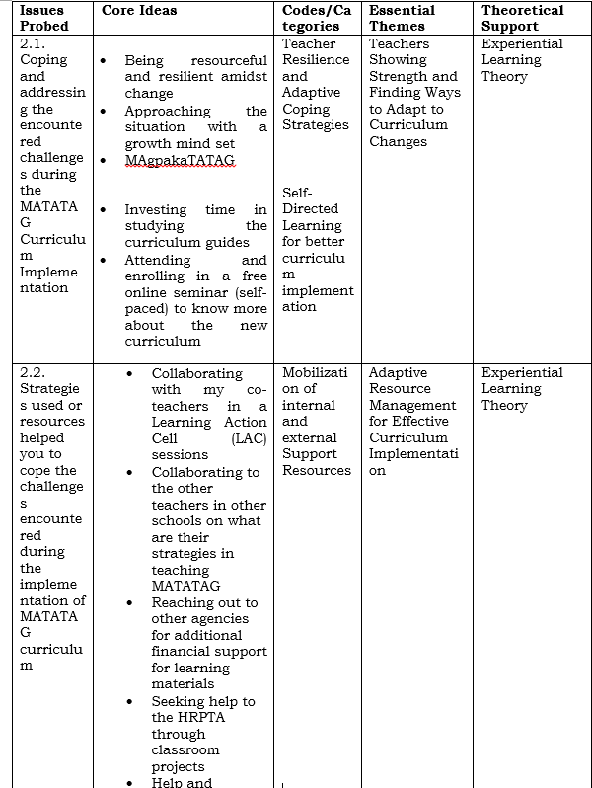

Teachers showing strength and finding ways to adapt to curriculum changes. Despite difficulties by curriculum change, teachers coped by being resourceful, maintaining a positive mind-set and demonstrating resilience as to the respondents they commonly say (“magpaka-TATAG”). Some teachers responded that they address that gap by investing extra time in studying the new curriculum and even enrolling on an online seminar just to cope with the gaps in the new curriculum. Despite challenging conditions, research has consistently demonstrated that teachers who retain a positive outlook can overcome failures, remain motivated, and continue to improve delivery instruction (Robinson et al., 2023). Additionally, by providing coping strategies for workload, stress, and burnout demands, educators can increase emotional resilience through professional development (Lee & McCaffrey, 2023). The theme is anchored on experiential learning theory which states that the ability of educators to adapt and enhance their methods is important for a resilient and effective teaching workforce, techniques through professional development when curricular revisions are still being developed. It takes professional development to help teachers become more resilient and had an ability to adapt to shifting conditions.
Here are some sentiments from the respondents:
I cope by being flexible and resourceful, being resilient delivering quality instructions despite challenges. (IDI G1-P8) (IDI K-P4)
They even emphasized that “MagpakaTATAG” because it is our duty to deliver quality education, even if support is lacking. (IDI K-P1) (IDI GI-P10)
I even enrolled myself in an online seminar, I pay online, just to learn more about this new enhanced basic K-12 curriculum or the MATATAG curriculum. (FGD G4-P7)
Invested extra time to study the new curriculum guide to familiarize the competencies, so that I can teach my pupils the right things that is in line with the new competencies. (FGD G1-P2)
Adaptive Resource Management for Effective Curriculum Implementation. Amidst difficulties teachers need to strategize to cope the challenges they faced in the new curriculum. Teachers responded that they seek help for additional support with the stakeholders and homeroom PTA for additional digital learning material like televisions and other classroom essentials, their family members also help them by emotional support, their family members listen to their frustrations and concerns, helping reduce stress and emotional burden, and even hand-in financial support for buying teaching materials when school resources are limited. Additionally, Peer cooperation has been shown to improve classroom practices, foster long-term professional growth, and boost teachers' confidence in handling the challenges of curriculum changes (Harrison & Westwood, 2020). The theme is anchored in the experiential learning theory which states that such collegiality boosts teachers' morale and resilience, making them more capable of adapting to the demands of new educational reforms. Peer and collaborative support is one of the best coping strategies elementary teachers may use to deal with the difficulties presented by the MATATAG Curriculum, this demonstrates resilience, showing positive adaptation despite adversity.
Here are some sentiments from the respondents:
I'm glad that the parents were supportive. They donated a television for the classroom, because it would be difficult without a TV because almost all lessons are ICT integrated, with power points. (IDI G4-P15) (FGD K-P1) (IDI G1-P9) (FGD G1-P1)
We seek for additional help from LGU and private sectors like Philsaga Mining Corporation and they donated printers, ink and even additional funds for classroom essentials. (FGD G4-P1) (FGD G1-P7) (IDI K-P2) (IDI G4-P14)
I am so blessed because I have supportive family members they help me in innovating IM’s, buying and printing learning materials and most especially their understanding in the nature of my work. I'm busy, that sometimes I can bring work home with me. (IDI G1-P8) (FGD K-P7)
I cope by collaborating with my co-teachers, through LAC sessions modifying activities to fit learner’s needs, and using online or creative resources to make my lesson more engaging. (FGD G4-P5) (IDI G1-7) (FGD K-P5) (IDI G4-P15)
Ask and collaborate with other teachers from other schools to get strategies on what they do, and also ask for learning resources that are available to them, just for the sake of strategy. (FGD G4-P2)
Because of limited localized learning resources, I strategized to browse on the internet for some interactive learning activities that suits on the competencies and my pupils learning level. (IDI K-P3)
As Master teacher, I made innovative strategic materials and share it with my co-teachers for us to cope with the gaps in this new curriculum (IDI G1-P8)

Table 3. Insights of teachers about the support they received in implementing the MATATAG Curriculum
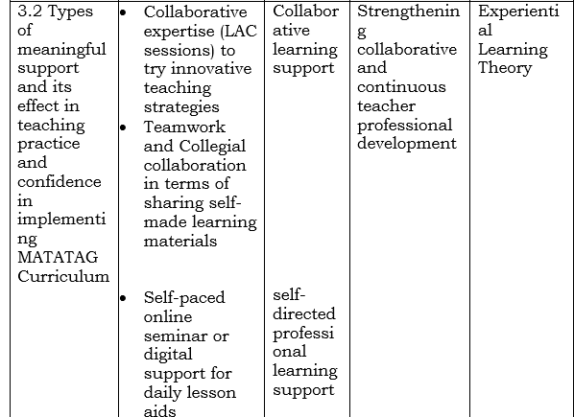
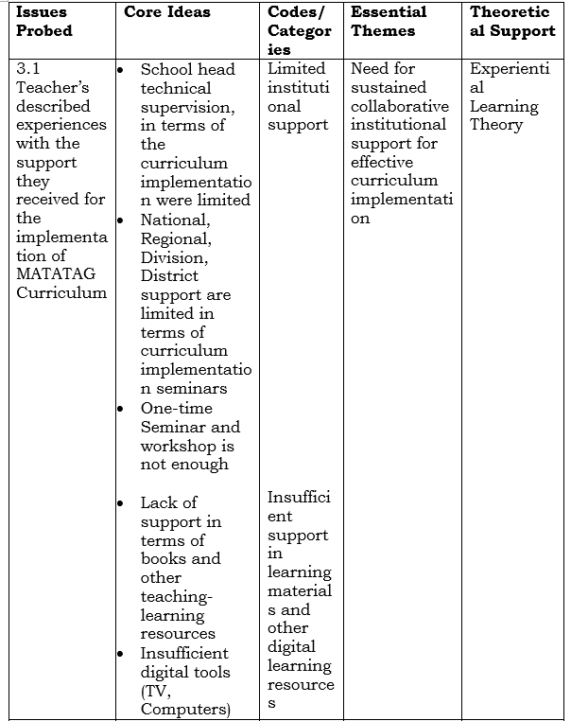

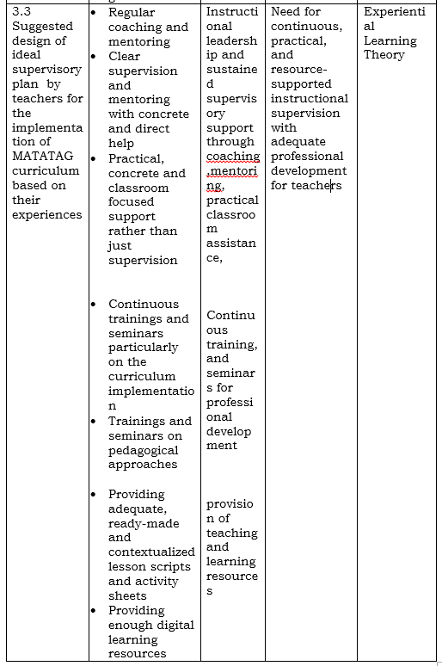

Need for sustained collaborative support for effective curriculum implementation. Teachers reported that they receive inadequate support. Limited trainings and seminar, lack of materials provision, and insufficient supervision from their school head. Kerry & Burke, 2020 emphasizes, achieving school and educational objectives, as well as the teaching and learning process, depend heavily on supervision. Supervising entails keeping an eye on the teacher’s instruction and classroom actions. In order to sustain successful education and give teachers adequate resources, supervision of instruction is intended to address this developmental need. According to Republic Act No. 9155, school administrators are in charge of setting the school's mission, vision, goals, and objectives; building a favorable learning environment; carrying out the curriculum; and guaranteeing excellent learning outcomes.
Here are statements from the participants, proving that they receive limited support from School heads:
The support I receive during the implementation of the MATATAG Curriculum was somewhat limited. While teachers had orientation and occasional LAC sessions, there were still gaps in detailed guidance and ready to use instructional Materials. (IDI G1-P6)
Lack of support, School Head often give technical assistance. (IDI K-P3) (FGD GI-P2) (IDI G1-P8)
Technical assistance is somewhat just talk, no real help is provided, like teaching materials. They just do a flash visit and you'll be fine. (FGD K-P7)
While some participants receive limited support from their school head, some participants also said that they received support from their co-teachers. Here are there statements:
The support from my co-teachers helped me while adjusting to the new curriculum. (IDI K-P2) (IDI G1-P10) (IDI- G4-P14) (FGD K-P1)
I received support through the guidance of my co-teachers, and master teachers. (IDI G4-P13) (FGD G1-P7).
Strengthening collaborative and continuous teacher professional development. The participants' responses show that making teacher professional development more collaborative and ongoing leads to shared learning, sharing of strategies, and working together to solve challenges, all of which improve teaching and learning gaps. Participants shared that this is the type of meaningful support they would like to receive that would affects their confidence in implementing the MATATAG Curriculum but they receive nothing but limited support. Recent research indicates that ongoing training enhances teachers' pedagogical skills and fosters resilience by boosting their self-efficacy and alleviating feelings of inadequacy (Singh & Sajitha, 2022). Teachers who regularly engage in professional development activities are more adept at managing classroom challenges and adapting to the demands of the MATATAG Curriculum. Professional development can also help teachers build emotional resilience by giving those ways to deal with stress, burnout, and heavy workloads (Lee & McCaffrey, 2023). The theme is anchored in experiential learning theory which highlights the need of teachers to better implement the curriculum.
Here are the sentiments from the participants:
They suggests that it should be ongoing/course seminar trainings but sadly it is lacking. (FGD G1-P3) (FGD G4-P7) (IDI K-P2) (IDI G4-P15)
Division workshops were helpful for understanding the curriculum in general, but they were sometimes too broad and lacked of practical strategies. (IDI-G1-P8)
There is no meaningful support received because the support given is not enough, the teacher is trying hard to deliver the lesson every day. (FGD G4-P1)
The meaningful support must be before we implement a new curriculum, but all they give us is lacking and insufficient. They need to provide first the materials needed for teachers and learners so that it may not affect the time effort of the teachers, before transitioning to a new curriculum. (IDI K-P1).
They want us to give quality education but they give us very poor support! (IDI G4-P12)
Need for continuous, practical, and resource-supported instructional supervision with adequate professional development for teachers. The results showed that teachers suggested ideal supervisory plan and a great need for ongoing, practical, and well-supported instructional supervision that goes beyond random observation. Participants stressed that supervision should include regular coaching, mentoring, and the provision of tangible teaching resources in addition to evaluation. This illustrates a change way from conventional supervisory methods and toward more collaborative and developmental models of professional assistance to accomplish the objectives of the MATATAG Curriculum. Teachers may feel tense and anxious as they try to anticipate the curriculum's growing demands. According to Cruz (2024), continuous monitoring and evaluation are critical for identifying gaps in both curriculum implementation and student learning, as they ensure that the goals of education reform are being met effectively. Futhermore, teachers shared that the monitoring process often involved self-assessment and peer evaluations, which created opportunities for reflection and growth.
In addition the limited number of seminars left teachers feeling that they lacked the knowledge and skills required to meet the curriculum's demands. Teachers also emphasized that attending more seminars would have provided them with additional opportunities to clarify their doubts and learn from experts and peers. Villanueva (2024) notes that seminars serve as valuable platforms for collaboration and knowledge sharing, allowing teachers to discuss challenges and exchange ideas. More frequent and comprehensive training sessions would have enabled teachers to deepen their understanding of the curriculum and build a stronger foundation for their teaching practices. Moreover, teachers suggested to reach the goal of MATATAG curriculum school heads should provide adequate teaching and learning materials to deliver quality education. This is anchored on the theory experiential learning theory which implies that teachers strongly prefer a supervisory system that is continuous, practical, and supportive rather than purely evaluative or one-time in nature.
This is what the teachers are trying to convey as their suggested ideal supervisory plan; this is what they said:
Based on my experience the School head should focus on the curriculum implementation of his/her teachers not only in the physical aspect of the school. Give every teachers the materials they need to deliver the lesson properly, and give technical assistance if needed. (IDI G1-P6)
They strongly suggest the instructional coaching and clear supervision from the school head. Give concrete help. (FGD K-P1) (FGD K-P5)
If I were to design, I would include the regular coaching and mentoring, continuous trainings and seminars for professional growth. Resources provision and sharing to attain the holistic growth of every individual. (FGD G4-P14)
Initiate in-house trainings for teachers on the proper delivery of curriculum. Provide teaching materials like TV, Laptops, Bond papers etc. (IDI G1-P7)
Provide us the complete lesson guides for daily use, or day by day, through downloaded materials, The agency just print out no need to write the lesson plans for us to have convenient of time, provide every teachers laptops, with Lesson Plans, Curriculum guide, etc. on it. Only few of the teachers got the laptop from Deped in every school. (FGD G4-P1)
SUMMARY, CONCLUSION, AND RECOMMENDATION

Summary
This study explored teachers’ experiences, challenges, coping mechanisms, and support systems in implementing the MATATAG Curriculum in Bunawan District, based on the thematic analysis, the following key findings emerged (1) Lived Experiences of Teachers, teachers experienced difficulty and stress during the transition to the MATATAG Curriculum due to lack of preparedness and sudden implementation, teachers struggled in adjusting to the curriculum transition due to its complexity, increased teacher workload, particularly in unpacking competencies, preparing instructional materials, and time constraints in teaching. Despite challenges, teachers recognized the curriculum’s strength in emphasizing foundational skills such as literacy, numeracy, and values formation. Classroom instruction became more learner-centered, activity-based, and interactive. (2) Challenges and Coping Mechanisms, teachers faced challenges due to insufficient learning materials and lack of continuous professional development particularly in curriculum implementation. Hence, teachers coped by becoming more resourceful, resilient, strengthening external collaboration with the stakeholders and family members and adaptive collaboration with co-teachers and participation in Learning Action Cell (LAC) sessions were key coping strategies. Teachers engaged in self-directed learning, including online trainings and independent study.
Lastly, (3) teachers’ need support for delivering the MATATAG Curriculum effectively because material support, institutional support was perceived as limited and insufficient, particularly in terms of materials and training. Support from school heads was often minimal or inconsistent, mostly limited to monitoring. Peer support and collaboration emerged as the most meaningful and effective form of support. Teachers emphasized the need for continuous, practical, and classroom-based support systems, to have a better quality of education.

Conclusion
Based on the comprehensive findings of this study, it can be conclusively stated that the implementation of the MATATAG Curriculum presents significant transition challenges, particularly due to inadequate preparation, limited resources, and insufficient training. Teachers play a critical role as adaptive agents, demonstrating resilience, creativity, and initiative despite systemic limitations. The MATATAG Curriculum is pedagogically sound, as it promotes foundational skills, learner-centered instruction, and real-life application of knowledge.
However, the effectiveness of the curriculum is compromised by structural and systemic gaps, including lack of instructional materials, insufficient professional development, and limited institutional support. Teachers rely heavily on peer collaboration and self-directed learning, indicating the absence of strong, structured support systems. There is a pressing need for improved educational support mechanisms, including adequate resources, continuous training, and effective instructional supervision, and continuous coaching and mentoring.

Recommendations
Based on the summary of the findings and conclusions of the study, the following recommendations are proposed:
Given the insights and alarming challenges faced by teachers in implementing the MATATAG Curriculum the Department of Education (DepEd) National, Regional and Division level should provide complete and timely instructional materials, including textbooks, worksheets, digital resources, ensure adequate funding and equitable distribution of resources across schools and develop standardized and ready-to-use lesson guides to reduce teachers’ workload.
Also, the school administrators should religiously implement regular instructional coaching and mentoring instead of purely supervisory approaches, know the teachers faced challenges, provide practical, classroom-based support, and feedback after observations. School administrators should enhance their supervisory plan in line with the teachers’ lived experiences in implementing the curriculum and strengthen Learning Action Cell (LAC) sessions by focusing on curriculum implementation strategies.
On the other hand, educators should continue engaging in collaborative learning and peer mentoring, utilize innovative and contextualized teaching strategies aligned with learners’ needs, and participate actively in professional development opportunities, including online trainings. For future researchers they should adopt this study to explore the long-term impact of the MATATAG Curriculum on student learning outcomes given the insights and challenges faced by teachers. Moreover, future researchers should investigate the effectiveness of specific support interventions given by the school administrators, such as coaching and mentoring programs.
Teachers lived experiences towards implementation of the MATATAG curriculum is the unsung voices of all resilient teachers, study highlights that while the MATATAG Curriculum holds promise in improving foundational learning and promoting learner-centered education, its successful implementation depends largely on the availability of resources, quality of support systems, and preparedness of teachers. Strengthening these areas is essential to ensure that the goals of the curriculum are fully realized and that teachers are empowered to deliver quality education.

LITERATURE CITED

Abalde, G., & Oco, R. (2023). Factors Associated with Mathematics PerformanceinMATATAGcurriculum.Retrievedfromhttps://www.researchgate.net/publication/369895282_Factors_Associated_with_Mathematics_Performance

Alsubaie, M.A. (2024). Curriculum Development: Teacher Involvement in Curriculum Development. Journal of Education and Practice, 7(9), 106-107. Retrieved from https://eric.ed.gov/?id=EJ1095725Alvarado

Barrot, J. S. (2023). K to 12 curriculum reform in the Philippines: Towards making students future ready. Asia Pacific Journal of Education, 43(4), 1193–1207. https://doi.org/10.1080/02188791.2021.1973959
Beard, C. & Wilson, J. P.(2023). Experiential learning: A handbook for education, training and coaching. Kogan Page Publishers. Retrieved August 19, 2025
Biesta, G. (2025). Good education in an age of measurement: on the need to reconnect with the question of purpose in education. Educational Assessment, Evaluation and Accountability, 21, (1) 33–46. Retrieved August 19, 2025
Bongco, R. T., (2025). Clash of spheres - the paradox of being a female teacher in the Philippines. Beijing International Review of Education, 1 (2-3).443-459. doi:10.1163/25902539-00102012.
Caulfield, J. (2023, June 22). How to Do Thematic Analysis | Step-by-Step Guide & Examples. Scribbr. Retrieved August 19, 2025, from https://www.scribbr.com/methodology/thematic-analysis/
Creswell, J. W., & Poth, C. N. (2021). Qualitative Inquiry and Research Design: Choosing Among Five Approaches.Sage Publishing Retrieved August 19, 2025
Cruz, P. L. (2024). Comprehensive teacher training and its role in curriculum reform. Journal of Education Development, 22(3), 45-56.
Delve. Ho, L., (2022). What is Phenomenological Research Design? Essential Guide to Coding Qualitative Data. From https://delvetool.com/blog/phenomenology. Retrieved August 19, 2025
Department of Education (2024) DepEd’s MATATAG Agenda, BEDP 2030 approved byNEDA Board as National Policy and Plan for Basic Education. Retrieved from https://www.deped.gov.ph/2024/04/27/depeds-matatag-agenda-bedp-2030-approved-by-neda-board-as-national-policy-and-plan-for-basic-education/
Department of Education Memorandum 54, s. 2023. Pilot Implementation of the MATATAG Curriculum. Retrieved fromhttps://www.deped.gov.ph/wpcontent/uploads/DM_s2023_054.pdf
Domingo, S. J. A., & Masabpi, A. G. (2024). Matatag Agenda: International Journal for Multidisciplinary Research, 2(6), 2071–2080. https://doi.org/10.5281/zenodo.12559940
Garma, J. C. (2024). Beyond the Four Walls: Teacher’s Experiences in Championing the MATATAG Curriculum. International Multidisciplinary Journal of Research for Innovation, Sustainability, and Excellence (IMJRISE), 1(9), 39-44. Retrieved on August 22, 2025
Gouëdard, P., Pont, B., Hyttinen, S., & Huang, P. (2024). Curriculum reform: A literature review to support effective implementation.
Guiaselon, B. U., Luyugen-Omar, S., Mohamad, H. A., Maidu, N. U., Maguid, N. P., Samson, C. D., & Datu Raffy Ralph Sinsuat Sinsuat, M. (2022). Mismatch of Teachers' Qualifications and Subjects Taught: Effects on Students' National Achievement Test. Psychology and Education: A Multidisciplinary Journal.
Hall, G., & Hord, S. (2025). Implementing change: Patterns, principles, and potholes (4th ed.). Upper Saddle River, NJ: Pearson.
Johnson, L., & Smith, B. (2024). Adapting instruction to curricular reform: A teacher’s guide. International Journal of Educational Leadership and Practice, 3(2), 22–35.
Keiler, L. S. (2024). Teachers’ roles and identities in student-centered classrooms. International journal of STEM education, 5, 1-20. Retrieved from https://link.springer.com/article/10.1186/s40594-018-0131-6. August 20, 2025
Kilag, O. K., Jesus, J., Uy, F., Sasan, J. M., Seblos, K., & Gier, R. A. (2024). Educational Transformation: Perspectives on the Implementation of the MATATAG Curriculum in the Philippines. International Multidisciplinary Journal of Research for Innovation, Sustainability, and Excellence (IMJRISE),1(5),306-311. Retrived from https://zenodo.org/records/11202378. August 20, 2025
Lee, M., & McCaffrey, C. (2023). Professional development for resilience in challenging educational environments. Teacher Development,27(2),167–185. https://doi.org/10.1080/13664530.2023.2029471
Malinao, A. J., & Miano, J. J. (2025). Implementing the MATATAG Curriculum: A Qualitative Study. Journal of Interdisciplinary Perspectives, 3(5), 362–374. Retrieved from https://www.jippublication.com/index.php/jip/article/view/345.
Magsambol.M.(2024).Teachersdismayedby‘chaotic’rolloutofMatatagcurriculum.NationalUniversity.(2023).HowtoKeepYourStudentsMotivatedtoLearn.https://www.nu.edu/blog/how-to-keep-your-students-motivated-to-learn/. August 20, 2025
Nikolopoulou, K. (2023, June 22). What Is Purposive Sampling? | Definition & Examples. Scribbr. Retrieved August 18, 2025, from https://www.scribbr.com/methodology/purposive-sampling.
Orleans, A. V. (2024). Educational challenges in the Philippines. Broken Chalk. https://brokenchalk.org/educational-challenges-in-the-philippines/. Retrieved August 07, 2025
Pillay, H., & Panth, B. (2022). Foundational (K-12) Education System: Navigating 21st Century Challenges. Retrieved August 10, 2025.
Rajurkar, S., Chavan, K. D., Kachewar, S. G., & Giri, P. A. (2024). A review of significant aspects contributing to curriculum development. International Journal of Research in Medical Sciences, 7(1), 317-322. DOI: http://dx.doi.org/10.18203/2320-6012.ijrms20185185.
Roberts, R., & Robinson, J. S. (2018). The motivational changes pre-service agricultural education teachers endure while facilitating quality supervised agricultural experiences: a six-week project-based learning experience. Journal of Agricultural Education, 59(1), 225-270. Retrieved August 15, 2025
Schleicher, A. (2024). International assessments of student learning outcomes. The SAGE handbook of curriculum, pedagogy and assessment. London: Sage. Retrived from https://www.torrossa.com/en/resources/an/5019472#page=944
Villanueva, J. P. (2024). Aligning teaching resources with curriculum goals: Challenges and solutions. Journal of Curriculum Studies, 16(3), 17-31.

