Utilization of Maternal and Child Health Services in Sant Kabir Nagar District, Uttar Pradesh: Patterns, Gaps and Local-Level Constraints

Abstract
The effective utilization of maternal and child health (MCH) services remains central to reducing preventable maternal and child morbidity and mortality in rural India. This study examines the uptake of antenatal care (ANC), postnatal care (PNC) and childhood immunization services in Sant Kabir Nagar district of Uttar Pradesh, using district-level evidence derived from NFHS-based District Nutrition Profiles, Health Management Information System (HMIS) bulletins and supporting literature. The analysis reveals substantial improvements between 2016 and 2020 in institutional deliveries, skilled birth attendance, postnatal care for children and full immunization coverage. However, continuity of antenatal care, particularly completion of four or more ANC visits, remains relatively low and uneven across blocks. The findings suggest that while programmatic interventions have successfully increased service contact at delivery and immunization stages, persistent socio-economic, infrastructural and administrative barriers continue to limit comprehensive maternal care. The paper argues for a shift towards block-specific micro-planning, strengthened follow-up mechanisms and improved data quality to ensure equitable and sustained MCH service utilization.

1. Introduction
Maternal and child health outcomes are widely recognized as sensitive indicators of both health system performance and broader socio-economic development. Access to timely antenatal care, safe institutional delivery, adequate postnatal care and complete childhood immunization significantly reduces risks associated with pregnancy, childbirth and early childhood. In India, sustained policy attention through national programmes has contributed to measurable improvements in several MCH indicators over the past two decades. Nevertheless, district-level and intra-district disparities remain pronounced, particularly in rural and socio-economically vulnerable regions.
Sant Kabir Nagar district, located in eastern Uttar Pradesh, represents a predominantly rural setting characterized by moderate levels of poverty, limited female educational attainment and variable access to health infrastructure. While state-level statistics often suggest improvement, district-specific analyses are essential to understand localized patterns of service utilization and the constraints faced by different population groups. This paper aims to analyze trends in the utilization of ANC, PNC and immunization services in Sant Kabir Nagar, identify block-level gaps, and examine the structural and behavioural barriers that continue to influence service uptake.
2: Study Area:
Sant Kabir Nagar district is situated in the eastern part of Uttar Pradesh. It’s named after the famous saint-poet Kabir Das. The district was created in 1997,earlier it was a part of Basti district.

The geographical area of Sant Kabir Nagar is 1646² kilometre. The geographical coordinates of Sant Kabir Nagar district are between 26⁰.10’ to 27⁰30’ north latitude and 82°45’ east longitude to 83⁰15’east longitude. The district is lies among Gorakhpur in the east, by Basti district in the west, by Ambedkar Nagar in the south and Sidhharth Nagar in the north.

The temperature and humidity of an area depend on its location. These factors influence rainfall patterns, which can cause floods or droughts. Floods destroy crops, shelters, and lead to food shortages. Droughts worsen malnutrition and spread diseases. The health problems of the area also depend on how healthcare facilities vary across the region.

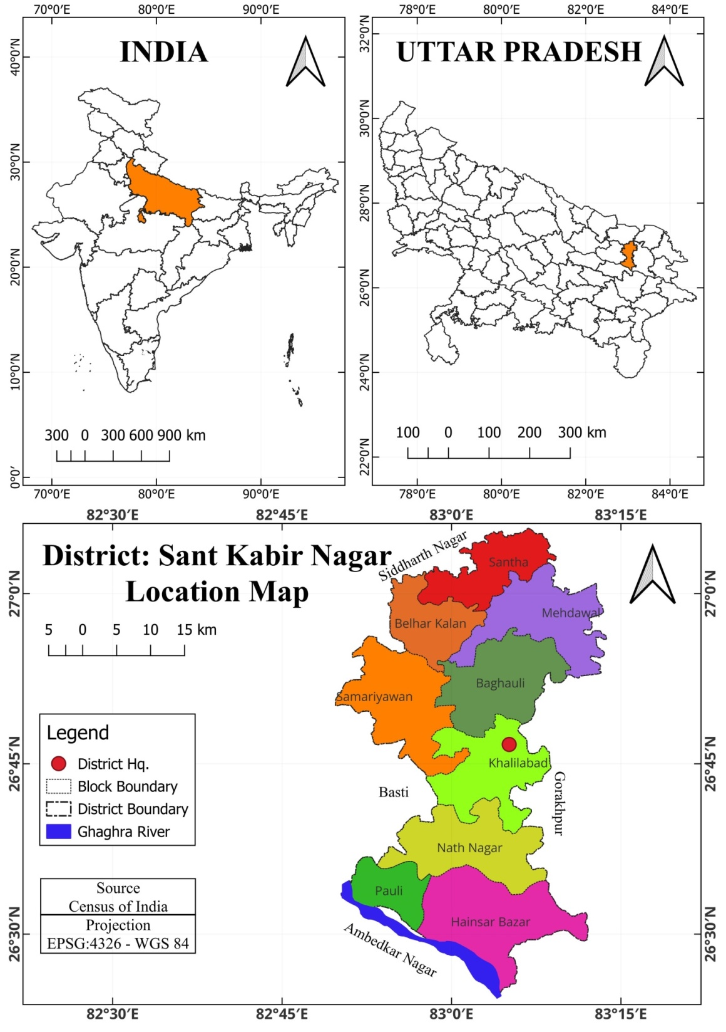

3. Data Sources and Methodology
This study is based on primary and secondary data analysis and systematic review of programmatic and scholarly sources. Besides primary data district-level indicators were primarily drawn from the District Nutrition Profile of Sant Kabir Nagar, which synthesizes data from successive rounds of the National Family Health Survey. These indicators provide comparable estimates for key MCH variables between 2016 and 2020.
To supplement survey-based findings, Health Management Information System (HMIS) district bulletins and district health planning documents were examined to identify operational patterns and block-level variations. Peer-reviewed studies and policy reports were reviewed to contextualize the findings and to interpret observed trends within broader national and regional experiences.
The analytical approach is descriptive and interpretative. Changes in key indicators over time are assessed, followed by a qualitative synthesis of literature to explain observed patterns and persistent gaps. Particular attention is given to the continuity of antenatal care and spatial inequalities across blocks.
Table 1: Geographic variation in the concentration of health care facilities: 2022
Block/Urban area | Area km² | Allopathic hospital/ Dispensary | CHC | PHC | Ayurvedic hospital | Homeopathic hospital | Unani | Bed | Doctor | Sub centre
Semariyawa | 200.74 | - | 2.5 | 0.45 | - | 0.14 | 0.14 | 20.92 | 4.98 | 3.88
Mehdawal | 196.17 | - | 2.5 | 0.30 | 0.30 | 0.30 | - | 19.37 | 4.58 | 3.21
Baghauli | 187.53 | - | - | 0.45 | 0.15 | 0.15 | - | 10.66 | 1.59 | 3.51
Khalilabad | 173.78 | - | 2.8 | 0.34 | 0.69 | 0.86 | - | 25.31 | 9.78 | 3.79
Nathnagar | 208.01 | - | 2.4 | 0.58 | 0.43 | 0.14 | - | 18.26 | 3.84 | 3.46
Haisar Bazar | 229.68 | - | 2.1 | 0.40 | 0.13 | 0.13 | - | 15.67 | 3.48 | 2.74
Santha | 193.66 | - | 2.6 | 0.46 | 0.46 | 0.46 | - | 21.68 | 4.64 | 2.78
Belhar kala | 122.58 | - | - | 0.24 | 0.48 | 0.73 | - | 1.63 | 3.26 | 4.16
Pauli | 114.84 | - | - | 0.52 | 0.26 | - | - | 13.93 | 4.35 | 3.13
Total Rural | 1626.99 | - | 1.9 | 0.42 | 0.31 | 0.31 | 0.01 | 17.08 | 4.48 | 3.37
Total Urban | 19.01 | 52.60 | - | 3.15 | 1.57 | 1.57 | 1.57 | 368.0 | 42.08 | -
District Total | 1646.00 | 0.61 | 1.8 | 0.45 | 0.32 | 0.32 | .03 | 21.14 | 4.92 | 3.33
Primary Data : 2022
Other areas do not have Ayurvedic hospitals. Homeopathic hospitals: Mehdawal, Nathnagar, and Haisar Bazar have Homeopathic hospitals, with Mehdawal having the highest number at 0.30. Other areas do not have Homeopathic hospitals. Unani hospitals: Only Mehndawal has a Unani hospital with a capacity of 0.14 beds. Bed availability: The areas with the highest bed availability are Khalilabad with 25.31, followed by Belhar Kala with 21.68, Santha with 21.14, Mehdawal with 19.37, Nathnagar with 18.26, Semariyawa with 20.92, Pauli with 13.93, Haisar Bazar with 15.67, Baghauli with 10.66, and Khalilabad with 9.78. Other areas have lower bed availability. Doctor availability: The areas with the highest doctor availability are Khalilabad with 9.78, followed by Nathnagar with 4.64, Semariyawa with 4.98, Santha with 4.92, Mehdawal with 4.58, Pauli with 4.35, Baghauli with 3.48, Haisar Bazar with 3.48, Belhar Kala with 3.26, and Khalilabad with 3.84. Other areas have lower doctor availability. Sub Centres: All areas have sub centres, with varying numbers. Khalilabad has the highest number with 3.79, followed by Nathnagar with 3.46, Santha with 3.33, Mehdawal with 3.21, Haisar bazar with 2.74, Pauli with 3.13, Semariyawa with 3.88, Belhar Kala with 4.16, Baghauli with 3.51, and Khalilabad with 3.37.Overall, there are variations in the distribution of different types of healthcare facilities across the areas within the blocks. Some areas have a more comprehensive healthcare infrastructure with multiple types of facilities, while others have a limited number or do not have certain facilities.
Table 1 shows the spatial concentration of healthcare facilities in the blocks with the highest bed capacity is Khalilabad (25.31) beds. This indicates a significant healthcare resource concentration in Khalilabad. Khalilabad also stands out with the highest number of doctors at 9.78. This suggests a relatively well-staffed medical environment in comparison to other blocks. Semariyawa has the highest total healthcare facilities, combining allopathic, CHC, PHC, Ayurvedic, Homeopathic, and Unani. This implies a diverse healthcare infrastructure. Belhar Kala has the lowest bed capacity at 1.63, indicating a relatively limited healthcare facility in terms of beds; Belhar Kala also has a lower number of doctors, suggesting potential challenges in accessing medical professionals. Pauli has the lowest total healthcare facilities, with a focus on PHCs and limited presence in other categories.
Table 2: Per capita distribution of healthcare services: 2022
Block/Urban area | Population/ km² | CHC | PHC | Ayurvedic hospital | Homeopathic hospital | Unani | Bed | Doctor | Sub centre
Semariyawa | 242053 | 0.49 | 0.37 | - | 0.12 | 0.12 | 17.35 | 4.1 | 0.53
Mehdawal | 160672 | 0.74 | 0.37 | 0.37 | 0.37 | - | 23.65 | 5.6 | 0.65
Baghauli | 184330 | - | 0.48 | 0.32 | 0.16 | - | 10.85 | 10.85 | 0.59
Khalilabad | 204131 | 0.58 | 0.29 | 2.35 | 2.93 | - | 21.55 | 21.55 | 0.53
Nathnagar | 201899 | 0.59 | 0.59 | 0.44 | 0.14 | -- | 18.82 | 18.82 | 0.59
Hainsar Bazar | 204293 | 0.58 | 0.44 | 0.14 | 0.14 | - | 17.62 | 17.62 | 0.51
Santha | 151716 | 0.79 | 0.59 | 0.59 | 0.59 | - | 27.68 | 27.68 | 0.59
Belhar kala | 137413 | - | 0.21 | 0.43 | 0.65 | - | 1.45 | 1.45 | 0.61
Pauli | 100145 | - | 0.59 | - | - | - | 15.97 | 15.97 | 0.59
Total Rural | 1586652 | 0.07 | 0.43 | 0.32 | 0.32 | - | 47.38 | 17.52 | 0.57
Total Urban | 120054 | - | 0.49 | 0.24 | 0.24 | - | 58.30 | 58.30 | -
District Total | 1706706 | 0.42 | 0.43 | 0.31 | 0.31 | 0.01 | 20.39 | 20.39 | 0.53
Source: Computed on the basis of district census hand book Sant kabir Nagar 2011, statistical information from chief medical officer Sant Kabir nagar, District statistical hand book Sant Kabir nagar 2021, District Homeopathic Medical officer office, Ayurvedic officer office Sant Kabir nagar, Regional Unani officer office Sant Kabir nagar .

3.1 District-level indicator trends (2016-2020)
Key changes (DNP figures):
- ANC in 1st trimester: 46% → 62%.
- ≥4 ANC visits: 32% → 43%.
- Institutional births: 69% → 91%.
- Skilled birth attendant: 66% → 90%.
- PNC for mothers: 57% → 72%.
- PNC for babies: 25% → 75%.
- Full immunization (12–23 months): 43% → 80%.
- Vitamin A coverage among children: 47% → 84%.

4. Trends in Maternal and Child Health Service Utilization

4.1 Antenatal Care
Between 2016 and 2020, Sant Kabir Nagar recorded a noticeable increase in early antenatal registration, with a larger proportion of women accessing ANC during the first trimester. Despite this improvement, completion of the recommended four or more ANC visits remained limited. Less than half of pregnant women achieved this benchmark in 2020, indicating challenges in sustaining engagement with maternal health services throughout pregnancy.
This pattern suggests that while initial contact with the health system has improved, barriers related to follow-up visits-such as distance to facilities, household responsibilities and perceived need-continue to constrain comprehensive antenatal care.

4.2 Institutional Delivery and Skilled Birth Attendance
The district has experienced substantial progress in institutional deliveries and skilled birth attendance. By 2020, a large majority of births occurred in health facilities and were attended by trained personnel. These gains reflect the impact of financial incentives, referral transport services and increased awareness regarding the risks associated with home deliveries.
However, improved delivery outcomes have not been accompanied by proportionate improvements in antenatal continuity, indicating a partial rather than holistic strengthening of maternal care.
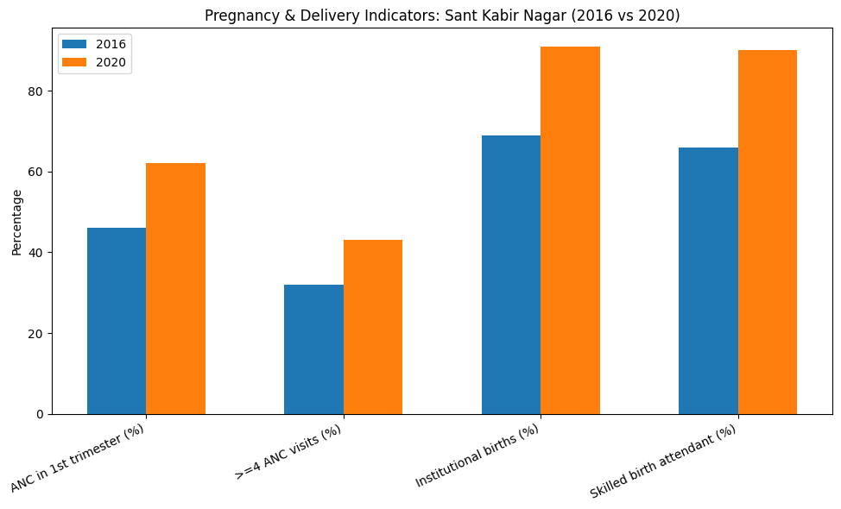

4.3 Postnatal Care
Postnatal care coverage for mothers and newborns improved significantly during the study period, with particularly sharp increases in postnatal check-ups for infants. This improvement reflects greater emphasis on immediate post-delivery follow-up and immunization-linked outreach. Nonetheless, qualitative evidence suggests that the quality and timing of postnatal visits vary across blocks.
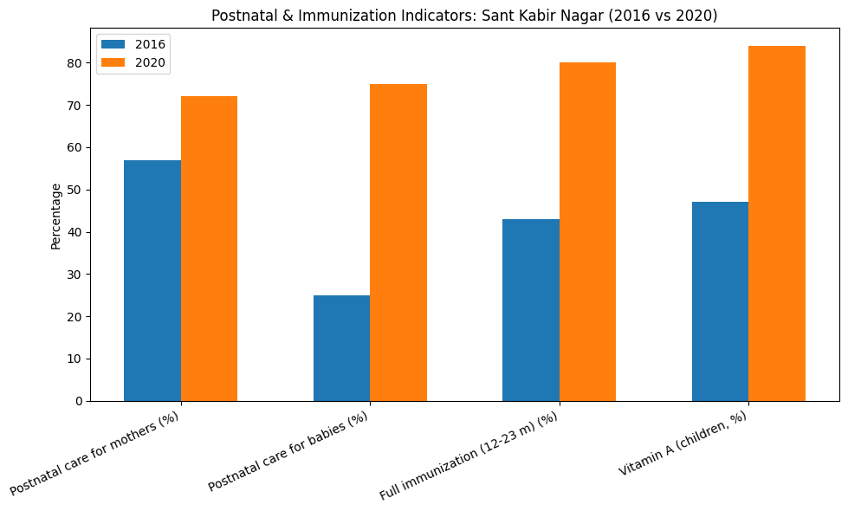

4.4 Childhood Immunization
Childhood immunization coverage showed marked improvement, with full immunization rates rising sharply between 2016 and 2020. Intensified outreach campaigns, periodic immunization drives and improved tracking of beneficiaries contributed to this progress. Despite these gains, HMIS records indicate the persistence of pockets of missed or partially immunized children in certain blocks, often corresponding to remote or socially disadvantaged areas.

5. Block-Level Variations and Determinants
HMIS bulletins and district health planning documents reveal notable variations in MCH service utilization across blocks. Blocks with better-staffed primary health centres and more active frontline worker networks demonstrate higher ANC follow-up and immunization coverage. Conversely, blocks characterized by staff shortages, logistical challenges and weaker supervision show lower performance on continuity-based indicators.
Socio-economic conditions also play a critical role. Lower levels of female education, early marriage and limited decision-making autonomy among women contribute to delayed or incomplete care-seeking. Cultural perceptions regarding pregnancy and immunization further influence utilization patterns, particularly in conservative rural settings.

6. Barriers to Effective Utilization
The analysis identifies several interrelated barriers affecting MCH service utilization in Sant Kabir Nagar:
- Continuity Gap in Antenatal Care: While initial ANC contact is relatively high, sustained engagement remains weak.
- Health System Constraints: Inconsistent availability of trained staff and diagnostic facilities at primary and community health centres.
- Geographical and Transport Barriers: Remote habitations face difficulties in accessing services regularly.
- Socio-Cultural Factors: Gender norms, low literacy and misconceptions regarding health interventions.
- Data Quality Issues: Discrepancies between survey estimates and HMIS reporting hinder precise targeting and monitoring.

7. Discussion
The experience of Sant Kabir Nagar reflects a broader national pattern where targeted interventions have successfully increased institutional deliveries and immunization coverage, but continuity of care remains a challenge. The findings highlight the limitations of indicator-specific incentives when not supported by sustained service availability and follow-up mechanisms.
Block-level heterogeneity underscores the importance of decentralized planning. District averages can obscure pockets of vulnerability that require focused attention. Integrating HMIS data with periodic survey findings and strengthening supervisory mechanisms at the block level could enhance responsiveness and equity.

8. Policy Implications and Recommendations
To address existing gaps, the following measures are recommended:
- Strengthening ANC follow-up through systematic tracking by frontline workers.
- Block-specific micro-planning based on HMIS data to identify and address low-performing areas.
- Improving staffing stability and facility readiness at PHCs and CHCs.
- Enhancing community-based behaviour change communication to address socio-cultural barriers.
- Investing in data quality improvement and regular validation exercises.

9. Conclusion
Sant Kabir Nagar has achieved significant progress in several dimensions of maternal and child health service utilization over recent years. Nevertheless, gaps in antenatal continuity and block-level inequities persist. Addressing these challenges requires a shift from uniform district-wide strategies towards context-sensitive, data-driven and community-engaged approaches. Strengthening the continuum of care will be essential for translating service contact into sustained health gains for mothers and children.

References:
- Government of India / NITI Aayog. (2022). District Nutrition Profile: Sant Kabir Nagar, Uttar Pradesh (NFHS-4 & NFHS-5 derived). NITI Aayog. https://www.niti.gov.in/sites/default/files/2022-07/Sant%20Kabir%20Nagar-Uttar%20Pradesh.pdf
- Ministry of Health and Family Welfare (MoHFW). (2024). Universal Immunization Programme: Guidelines and mission documents. Government of India. https://www.mohfw.gov.in/sites/default/files/Universal%20Immunization%20Programme.pdf
- The DHS Program (ICF). (2021). National Family Health Survey (NFHS-5) 2019–21: India; State fact sheets and district factsheets. ICF / MoHFW. https://dhsprogram.com/pubs/pdf/FR375/FR375_II.pdf
- NHM, Uttar Pradesh (State HMIS / District HMIS). (n.d.). Sant Kabir Nagar HMIS bulletin. NHM UP. https://upnrhm.gov.in/assets/site-files/mis/hmis/districts/S_K_Nagar_HMIS_bulletin.pdf
- Gupta, S. K., et al. (2012). Impact of Janani Suraksha Yojana on institutional deliveries in India. Indian Journal of Community Medicine. https://www.ncbi.nlm.nih.gov/pmc/articles/PMC3763618/
- Dhawan, V., et al. (2023). Intensified Mission Indradhanush and its impact on immunization coverage: A review. Journal of Family Medicine and Primary Care. https://pmc.ncbi.nlm.nih.gov/articles/PMC10795861/
- National Health Systems Resource Centre. (2021). Health Dossier: Uttar Pradesh. NHSRC India. https://nhsrcindia.org/sites/default/files/practice_image/HealthDossier2021/Uttar%20Pradesh.pdf
- Tripathi, S. K. (2024). Health and nutritional status of women in Sant Kabir Nagar, Uttar Pradesh. International Journal of Family Medicine & Research. https://www.ijfmr.com/papers/2024/4/26594.pdf
- MoHFW. (2014). Mission Indradhanush: Guidelines for implementation. Government of India. https://www.nhm.gov.in/New_Updates_2018/NHM_Components/Immunization/Guildelines_for_immunization/Mission_Indradhanush_Guidelines.pdf
- Census of India. (2011). District Census Handbook: Sant Kabir Nagar (Part A & B). Office of the Registrar General & Census Commissioner. https://censusindia.gov.in/nada/index.php/catalog/1282/download/4142/DH_2011_0955_PART_A_DCHB_SANT_KABIR_NAGAR.pdf
- World Health Organization (WHO). (2016). Standards for improving quality of maternal and newborn care in health facilities. WHO. https://www.who.int/publications/i/item/9789241511216
- Bhatia, J. C., & Cleland, J. (1995). Determinants of maternal health care use in India: an analysis of inter-district variations. Health Policy and Planning, 10(1), 9-22.
- Lim, S. S., et al. (2010). India’s Janani Suraksha Yojana and trends in institutional delivery: an individual-level analysis. Lancet Global Health.
- Porwal, A., et al. (2018). Role of ASHA workers in maternal health: evidence from field studies. Indian Journal of Public Health.
- Ministry of Health and Family Welfare. (2017). Intensified Mission Indradhanush- Implementation report. MoHFW.
- Pande, R. P., et al. (2014). Effects of conditional cash transfer on maternal services uptake: a systematic review. Health Policy and Planning.
- Lim, S. S., et al. (2010). A comparative assessment of interventions to reduce maternal mortality in India. BMJ.
- Bhattacharyya, S., et al. (2019). Community health worker programs: The case for ASHA in India. WHO Bulletin / Policy Brief.
- Indian Council of Medical Research (ICMR). (2020). Immunization coverage analysis: Lessons from Mission Indradhanush. ICMR monograph.
- United Nations Children’s Fund (UNICEF). (2018). Improving immunization coverage through community engagement. UNICEF.
- International Institute for Population Sciences (IIPS) & ICF. (2021). NFHS-5 India fact sheets. IIPS.
- Goli, S., & James, K. S. (2020). Maternal health and socio-economic determinants in India: a district level analysis. Social Science & Medicine.
- World Bank. (2017). Improving primary health care via community outreach in India. World Bank Report.
- Kumar, S., & Mohanty, S. (2015). Barriers to ANC uptake in rural India: A systematic review. Journal of Maternal Health.
- Joshi, R., & Jan, S. (2016). Data challenges in HMIS for district planning: Indian experiences. Health Informatics Journal.
- UNICEF India. (2019). Community engagement and demand generation for immunization. UNICEF India.
- Kearns, A., et al. (2017). Cold chain management and vaccine logistics in low resource settings. Vaccine Policy Journal.
- Nair, N., et al. (2015). Home visits and continuity of care: evidence from rural India. Global Public Health.
- WHO & UNICEF. (2019). Global routine immunization strategies and roadmap for implementation. WHO/UNICEF.
- Kumar, P., & Kumar, P., (2025) Healthcare facilities and their utilization in Sant Kabir Nagar district.

