Role of Radiographers in Computed Tomography: Image Quality Optimization, Radiation Dose Reduction, and Patient Safety

Abstract
Computed tomography (CT) is a widely utilized diagnostic imaging modality that provides high-resolution cross-sectional visualization of anatomical structures. Radiographers play a critical role in optimizing image quality while ensuring radiation safety. This review aims to evaluate the role of radiographers in CT imaging, with particular emphasis on image quality optimization, radiation dose reduction, and patient safety. The review is based on an analysis of published literature and clinical practices. Key techniques, including automatic exposure control (AEC), iterative reconstruction (IR), and adherence to the ALARA (As Low As Reasonably Achievable) principle, are discussed. Additionally, patient preparation, contrast administration, and emerging technologies such as artificial intelligence are explored. Radiographers are essential in balancing diagnostic accuracy with radiation protection, thereby contributing significantly to safe and effective imaging practices.

Keywords : Computed Tomography (CT); Radiographers; Image Quality Optimization; Radiation Dose Reduction

Introduction
Computed tomography (CT) has revolutionized diagnostic imaging since its development by Allan MacLeod Cormack and Godfrey Hounsfield, who were awarded the Nobel Prize in Physiology or Medicine in 1979 [1]. CT provides high-resolution cross-sectional images of the human body and overcomes the limitation of structural superimposition seen in conventional radiography, thereby enhancing diagnostic accuracy and clinical decision-making [2].
Despite its significant clinical benefits, CT is a major contributor to medical radiation exposure, accounting for approximately 50% of the total radiation dose from diagnostic imaging procedures [3]. This raises concerns regarding potential radiation-induced risks, particularly with repeated examinations.
Therefore, optimizing radiation dose while maintaining diagnostic image quality is essential. Radiographers play a crucial role in achieving this balance through appropriate protocol selection, parameter optimization, and adherence to radiation protection principles such as ALARA (As Low As Reasonably Achievable) [4].

Role of Radiographers in CT Imaging
Radiographers play a central role in computed tomography (CT) imaging, being responsible for patient preparation, protocol selection, and accurate image acquisition [5]. Proper patient positioning is essential, as it minimizes motion and positioning artifacts while enhancing diagnostic accuracy .
Radiographers optimize scanning parameters, including tube voltage (kVp), tube current (mAs), pitch, and slice thickness, to achieve high-quality diagnostic images while minimizing radiation exposure [6]. The use of advanced technologies such as automatic exposure control (AEC) further supports dose optimization by adjusting radiation output according to patient size and anatomical characteristics [7].
In contrast-enhanced studies, radiographers are responsible for the safe administration of contrast media, ensuring appropriate dosing and monitoring patients for any adverse reactions [8]. Following image acquisition, they perform post-processing procedures such as multiplanar reconstruction (MPR) and three-dimensional (3D) imaging, which significantly improve image interpretation and diagnostic value [9].
Additionally, radiographers monitor radiation dose indicators, including CT dose index (CTDI) and dose-length product (DLP), to ensure compliance with established radiation safety standards and guidelines [10]. Through these responsibilities, radiographers contribute significantly to maintaining a balance between image quality and patient safety in CT imaging.
Stage | Radiographer Role
Pre-scan | Patient preparation, history, screening
During scan | Parameter adjustment, positioning
Post-scan | MPR, 3D reconstruction, PACS transfer
Safety | Dose monitoring (CTDI, DLP)
Table 1: Responsibilities of Radiographers in CT

Image Quality Optimization
Image quality in computed tomography (CT) is primarily determined by spatial resolution, contrast resolution, and image noise . Radiographers play a crucial role in optimizing these parameters through appropriate selection of exposure factors and reconstruction techniques [11].
Proper patient positioning, accurate collimation, and limitation of the scan range to the region of interest are essential strategies that enhance image quality while minimizing unnecessary radiation exposure [12]. In addition, the use of advanced reconstruction methods, particularly iterative reconstruction techniques, significantly reduces image noise and improves overall image clarity without increasing radiation dose [13].
Achieving an optimal balance between radiation dose and image quality is fundamental in CT imaging, as excessive dose reduction may compromise diagnostic accuracy. Therefore, radiographers must ensure that image quality is sufficient to support reliable clinical interpretation while adhering to radiation protection principles [14].
Radiation protection in computed tomography (CT) is guided by the ALARA (As Low As Reasonably Achievable) principle, which emphasizes minimizing radiation exposure while maintaining adequate diagnostic image quality [15].
Technique | Function | Dose Impact
AEC | Adjusts mAs automatically | ↓ Dose
Low kVp | Reduces energy | ↓↓↓ Dose
High Pitch | Faster scan | ↓ Dose
IR | Reduces noise | ↓↓↓ Dose
Scan range limit | Avoids unnecessary exposure | ↓ Dose
Table 2: CT Dose Reduction Techniques
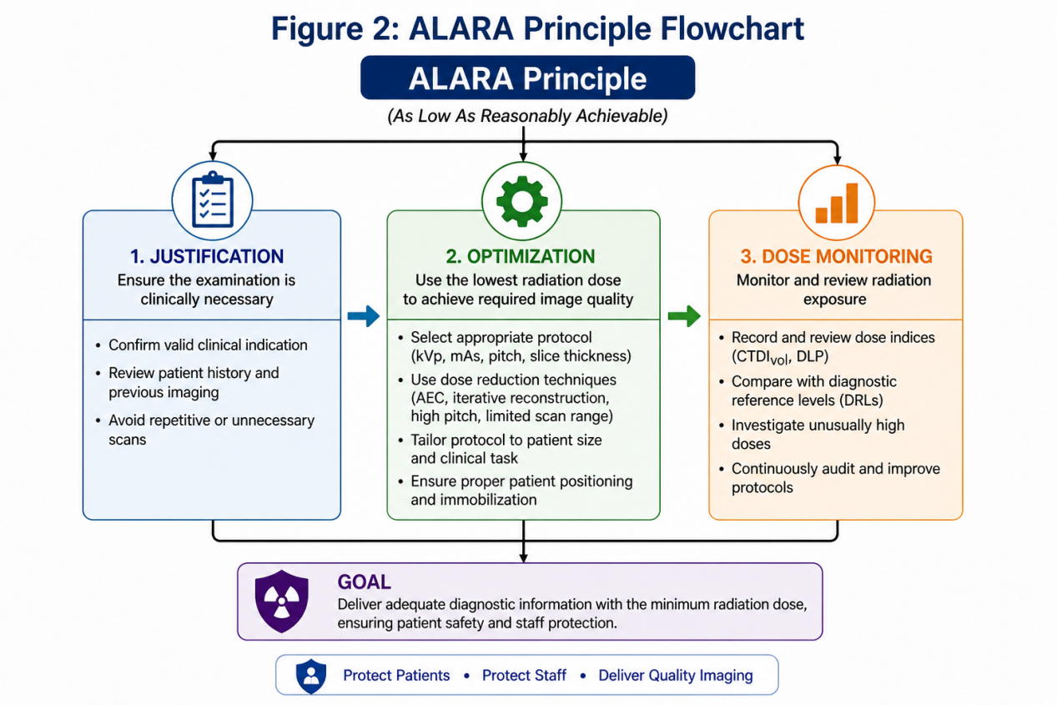
Figure 1: ALARA Principle Flowchart

Automatic Exposure Control (AEC)
Automatic exposure control adjusts the tube current (mAs) in real time based on patient attenuation and anatomical characteristics. This technique significantly reduces unnecessary radiation exposure while maintaining consistent image quality [16].

kVp and mAs Optimization
Optimization of tube voltage (kVp) and tube current (mAs) is essential for dose reduction. Lower kVp settings reduce radiation dose exponentially and are particularly beneficial in pediatric and smaller patients, while appropriate mAs selection ensures adequate image quality [17].

Pitch and Scan Range Optimization
Increasing the pitch (table feed per rotation) reduces scan time and overall radiation exposure. Additionally, limiting the scan range strictly to the region of interest prevents unnecessary irradiation of adjacent tissues [18].

Iterative Reconstruction (IR)
Iterative reconstruction techniques reduce image noise and allow substantial dose reduction—up to approximately 80% compared to conventional filtered back projection—while preserving diagnostic image quality [19].

Dose Monitoring
Radiation dose indicators such as CT dose index (CTDI) and dose-length product (DLP) are routinely monitored to ensure adherence to established safety standards and optimization protocols [20].

Patient Safety and Care
Patient safety is a fundamental component of computed tomography (CT) imaging and involves minimizing radiation exposure while preventing procedure-related complications [21].
Radiographers play a critical role in ensuring patient safety through comprehensive pre-examination assessment. This includes screening for contraindications such as renal impairment and pregnancy, which may influence imaging protocol selection or the use of contrast agents [22]. In addition, radiographers evaluate the risk of contrast media reactions, particularly in patients with a history of allergies or previous adverse events [23].
Appropriate patient preparation is essential and includes ensuring adequate hydration before and after contrast administration to reduce the risk of contrast-induced nephropathy [24]. Radiographers also provide clear instructions and reassurance to patients, which helps improve cooperation and minimizes motion-related artifacts, thereby enhancing image quality.
Although contrast-induced nephropathy and allergic reactions are relatively uncommon, they require careful monitoring and prompt management to ensure patient safety [25]. Through vigilant assessment, preparation, and continuous monitoring, radiographers play a vital role in maintaining safe and effective CT imaging practices.
Phase | Safety Action
Pre-scan | Check renal function, allergy
During scan | Monitor patient
Post-scan | Hydration advice
Emergency | Manage contrast reaction
Table: CT Contrast Safety Protocol
Computed tomography (CT) plays a pivotal role in modern clinical practice due to its rapid image acquisition, high spatial resolution, and wide diagnostic applicability.
CT is extensively utilized in emergency settings, particularly for the evaluation of acute conditions such as stroke and trauma, where rapid and accurate diagnosis is critical for timely management [26]. In oncology, CT is essential for tumor detection, staging, and monitoring response to treatment, thereby guiding clinical decision-making and therapeutic planning [27].
In vascular imaging, CT angiography provides detailed visualization of blood vessels, enabling the diagnosis of conditions such as aneurysms, stenosis, and pulmonary embolism. Additionally, CT is widely used in image-guided interventional procedures, including biopsies, drainage of abscesses, and minimally invasive therapeutic interventions, improving procedural accuracy and patient outcomes [28].
Overall, the versatility and diagnostic efficiency of CT imaging make it indispensable across a broad range of clinical applications.

Challenges and Limitations
Despite its significant diagnostic advantages, computed tomography (CT) imaging is associated with several limitations. One of the primary concerns is the relatively higher radiation dose compared to conventional radiography, which raises potential risks of radiation-induced biological effects [29]. Repeated exposure to ionizing radiation has been linked to an increased risk of malignancy, particularly in vulnerable populations such as pediatric patients, who are more radiosensitive and have a longer lifetime risk of exposure [30].
In addition to radiation concerns, CT has limited soft tissue contrast when compared to magnetic resonance imaging (MRI), making it less suitable for evaluating certain neurological and musculoskeletal conditions [31]. Furthermore, accessibility to CT imaging remains a challenge in resource-limited and rural settings due to the high cost of equipment, maintenance requirements, and the need for skilled personnel [32].
These challenges highlight the importance of appropriate justification, optimization of imaging protocols, and consideration of alternative modalities when necessary to ensure safe and effective patient care.
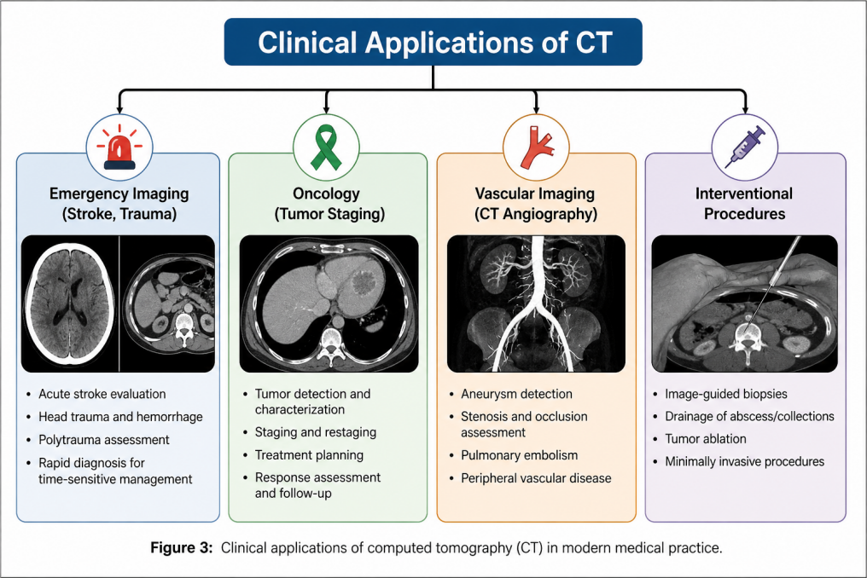

Figure 3: Clinical Applications of CT

Future Perspectives
Advancements in technology are continuously transforming computed tomography (CT) imaging, with emerging innovations aimed at improving image quality, reducing radiation dose, and enhancing diagnostic efficiency. Deep learning reconstruction techniques have shown significant potential in reducing image noise while preserving or even improving image quality, thereby enabling further dose reduction without compromising diagnostic accuracy [33].
Artificial intelligence (AI) is increasingly being integrated into CT workflows, assisting in automated image analysis, detection of abnormalities, and optimization of imaging protocols. These developments contribute to improved diagnostic accuracy, faster reporting, and enhanced workflow efficiency [34].
In addition, hybrid imaging modalities such as positron emission tomography–computed tomography (PET-CT) combine anatomical and functional imaging, offering advanced diagnostic capabilities, particularly in oncology and molecular imaging [35].
These technological advancements are expected to further expand the role of radiographers, requiring continuous professional development and adaptation to evolving imaging practices.
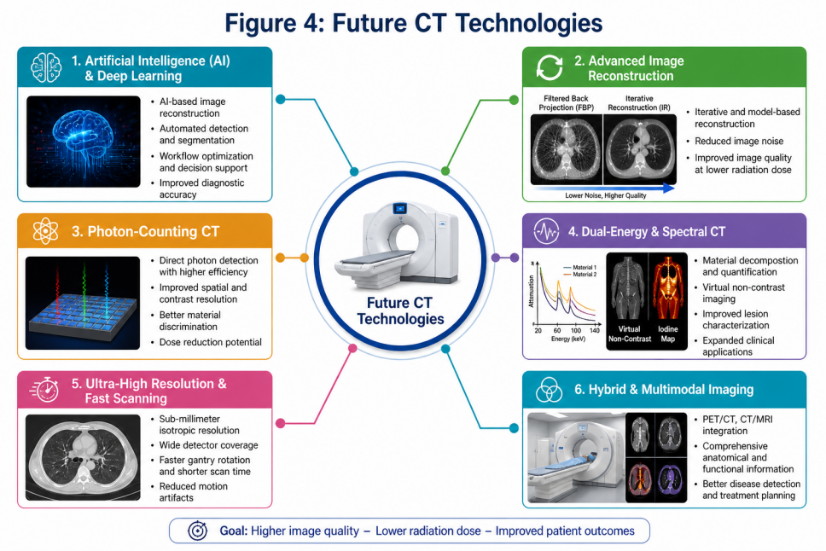
Figure 4: Future CT Technologies

Conclusion
Radiographers play a vital role in computed tomography (CT) imaging by ensuring optimal image quality, minimizing radiation exposure, and maintaining patient safety. Their expertise in protocol selection, parameter optimization, patient preparation, and post-processing is essential for achieving accurate diagnosis and effective clinical outcomes.
Through the application of radiation protection principles such as ALARA and the use of advanced technologies, radiographers contribute significantly to balancing diagnostic efficacy with patient safety. As CT technology continues to evolve with innovations such as artificial intelligence and advanced reconstruction techniques, the role of radiographers will become increasingly important. Continuous education and professional development are therefore essential to maintain high standards of imaging practice and patient care .

References
- Cormack AM. Representation of a function by its line integrals. J Appl Phys. 1963;34:2722–2727.
DOI: https://doi.org/10.1063/1.1729798

- Kalender WA. X-ray computed tomography. Phys Med Biol. 2006;51:R29–R43.
DOI: https://doi.org/10.1088/0031-9155/51/13/R03

- Brenner DJ, Hall EJ. Computed tomography—an increasing source of radiation exposure. N Engl J Med. 2007;357:2277–2284.
DOI: https://doi.org/10.1056/NEJMra072149
- Bushberg JT. Radiation dose and image quality in CT. Radiology. 2012;262:620–631.
DOI: https://doi.org/10.1148/radiol.11110779

- Goldman LW. Principles of CT: radiation dose and image quality. Radiographics. 2007;27:1037–1050.
DOI: https://doi.org/10.1148/rg.274065120

- McCollough CH, Primak AN, Saba O, et al. Dose performance of a dual-source CT scanner. Radiol Clin North Am. 2009;47:27–40.
DOI: https://doi.org/10.1016/j.rcl.2008.10.002

- Hsieh J. Computed tomography: recent advances. Curr Med Imaging Rev. 2015;11:1–14.
DOI: https://doi.org/10.2174/1573405611666150619095732

- Barrett JF, Keat N. Artifacts in CT. Radiographics. 2004;24:1679–1691.
DOI: https://doi.org/10.1148/rg.246045065

- Mayo JR, Aldrich J, Müller NL. Radiation exposure at chest CT. Radiology. 2003;228:15–21.
DOI: https://doi.org/10.1148/radiol.2281020870

- ICRP. Recommendations of the ICRP. Ann ICRP. 2007;37:1–332.
DOI: https://doi.org/10.1016/j.icrp.2007.10.003

- Kalra MK, Maher MM, Toth TL, et al. CT dose optimization strategies. Radiology. 2004;230:619–628.
DOI: https://doi.org/10.1148/radiol.2303021726

- Silva AC, Lawder HJ, Hara A, et al. CT dose reduction innovations. Radiographics. 2010;30:1745–1760.
DOI: https://doi.org/10.1148/rg.306105519

- Rehani MM, Berry M. Radiation doses in CT. BMJ. 2000;320:593–594.
DOI: https://doi.org/10.1136/bmj.320.7235.593

- ICRP. Managing patient dose in CT. Ann ICRP. 2000;30:7–45.
DOI: https://doi.org/10.1016/S0146-6453(00)00011-3

- Boone JM, Geraghty EM, Seibert JA, et al. Pediatric CT dose reduction. Med Phys. 2008;35:275–284.
DOI: https://doi.org/10.1118/1.2816108

- Strauss KJ, Goske MJ, Kaste SC, et al. Image gently campaign. AJR Am J Roentgenol. 2010;194:868–873.
DOI: https://doi.org/10.2214/AJR.09.4091

- Mayo JR, Hartman TE, Lee KS, et al. Minimal tube current CT. Radiology. 2003;228:721–726.
DOI: https://doi.org/10.1148/radiol.2283020872

- Leipsic J, Labounty TM, Heilbron B, et al. Iterative reconstruction dose reduction. Radiology. 2010;257:32–39.
DOI: https://doi.org/10.1148/radiol.10092409

- McCollough CH, Bushberg JT, Fletcher JG, Eckel LJ. Answers to CT dose questions. Radiographics. 2015;35:140–153.
DOI: https://doi.org/10.1148/rg.351140036

- Davenport MS, Cohan RH. Corticosteroid prophylaxis in contrast patients. Radiology. 2019;293:565–572.
DOI: https://doi.org/10.1148/radiol.2019190361

- Thomsen HS. Contrast media guidelines. Eur Radiol. 2006;16:2527–2533.
DOI: https://doi.org/10.1007/s00330-006-0320-2

- Van der Molen AJ, Reimer P, Dekkers IA, et al. ESUR contrast guidelines update. Eur Radiol. 2018;28:2840–2845.
DOI: https://doi.org/10.1007/s00330-017-5249-5

- Pronovost PJ, Holzmueller CG, Needham DM. Patient safety improvements. BMJ. 2006;333:756–758.
DOI: https://doi.org/10.1136/bmj.38931.425995.80

- Mehran R, Aymong ED, Nikolsky E, et al. CIN risk score. Circulation. 2004;110:2022–2029.
DOI: https://doi.org/10.1161/01.CIR.0000145170.83256.38

- Wintermark M, Sanelli PC, Albers GW, et al. Stroke imaging recommendations. Radiology. 2005;235:394–405.
DOI: https://doi.org/10.1148/radiol.2352041231

- Siegel RL, Miller KD, Jemal A. Cancer statistics. CA Cancer J Clin. 2020;70:7–30.
DOI: https://doi.org/10.3322/caac.21590

- Rubin GD. CT angiography. Radiology. 2001;218:1–10.
DOI: https://doi.org/10.1148/radiology.218.1.r01ja081

- Wallace MJ, Kuo MD, Glaiberman C, et al. Cone-beam CT. J Vasc Interv Radiol. 2005;16:1235–1242.
DOI: https://doi.org/10.1097/01.RVI.0000175330.14852.28

- Hall EJ, Brenner DJ. Cancer risks from CT radiation. Radiology. 2008;248:29–35.
DOI: https://doi.org/10.1148/radiol.2481071451

- National Research Council. BEIR VII. Radiat Res. 2006;166:109–112.
DOI: https://doi.org/10.1667/RR0706.1

- Edelman RR. Future of MRI. Radiology. 2006;239:1–13.
DOI: https://doi.org/10.1148/radiol.2391050840

- Smith-Bindman R, Lipson J, Marcus R, et al. Radiation dose variability in CT. Arch Intern Med. 2009;169:2078–2086.
DOI: https://doi.org/10.1001/archinternmed.2009.427

- Pearce MS, Salotti JA, Little MP, et al. CT radiation and cancer risk. Lancet. 2012;380:499–505.
DOI: https://doi.org/10.1016/S0140-6736(12)60815-0

- Wang G, Ye JC, Mueller K, Fessler JA. Machine learning reconstruction. IEEE Trans Med Imaging. 2018;37:1289–1296.
DOI: https://doi.org/10.1109/TMI.2018.2833635

- Topol EJ. High-performance medicine. Nat Med. 2019;25:44–56.
DOI: https://doi.org/10.1038/s41591-018-0300-7

