PROTECTIVE EFFECTS OF DIETARY CURCUMIN AGAINST HEAVY METAL-INDUCED GUT DYSBIOSIS, OXIDATIVE STRESS, AND INTESTINAL DAMAGE IN ZEBRAFISH (Danio rerio)
Nandana P , Dr. G Sasikala
Department of Zoology, PSGR Krishnammal College for Women, Coimbatore 641004, Tamil Nadu, India.

ABSTRACT
Aquatic species are negatively impacted by heavy metal contamination in aquatic ecosystems because it damages intestinal tissues, disrupts gut microbiota, and causes oxidative stress. The current work examines how dietary curcumin protects intestinal health and gut microbiota in zebrafish (Danio rerio) exposed to water contaminated by heavymetals.
To reduce toxicity and improve aquatic health, it is crucial to comprehend how environmental contaminants affect host–microbiota interactions and to find efficient and sustainable natural remedies. Physicochemical analyses of contaminated water samples showed high concentrations of heavy metals such as cadmium, copper, manganese, and chromium, as well as chemical oxygen demand (COD) and total suspended solids (TSS). Under these experimental conditions, zebrafish were fed feed enriched with curcumin. Colony forming unit (CFU) analysis was used to measure the gut microbial burden, and oxidative stress indicators such as total protein, reduced glutathione (GSH), superoxide dismutase (SOD), and malondialdehyde (MDA) were evaluated. A histopathological study was performed to assess intestinal structural changes.Significant microbial dysbiosis, decreased protein content, decreased SOD and GSH activity, and elevated MDA levels, all of which indicate increased oxidative stress and lipid peroxidation,were the results of heavy metal exposure. Severe intestinal damage, including villi ulceration, epithelial detachment, inflammatory infiltration, goblet cell hyperplasia, and muscle necrosis, was found. Curcumin administration reduced these effects by lowering oxidative damage, boosting antioxidant defenses, reducing microbial burden, and restoring gut architecture. Dietary curcumin shows strong protective potential against oxidative stress and intestinal toxicity caused by heavy metals.
KEY WORDS: Heavy metal toxicity; Curcumin; Zebrafish (Danio rerio); Gut microbiota; Oxidative stress; Antioxidant enzymes; Intestinal histopathology

INTRODUCTION
Heavy metal contamination has become a major environmental concern because of increasing industrialization, mining, agricultural runoff, and urban wastewater discharge into aquatic ecosystems. Heavy metals are non-biodegradable, environmentally persistent, and readily bioaccumulate in aquatic organisms, leading to adverse physiological, biochemical, and molecular alterations. Fish exposed to heavy metals frequently exhibit oxidative stress, histopathological lesions, immune dysfunction, and impaired growth and reproduction, making them valuable bioindicators of aquatic pollution [1,2].
Among aquatic vertebrates, zebrafish (Danio rerio) has become one of the most widely used experimental models in aquatic toxicology because of its genetic similarity to mammals, rapid development, high fecundity, and well-characterized physiology. Its transparent embryos and conserved molecular pathways make zebrafish particularly suitable for investigating the mechanisms of pollutant-induced toxicity and evaluating the efficacy of protective compounds [3,4].
The gastrointestinal tract is a major target of heavy metal toxicity because it is continuously exposed to contaminants through water and food. Heavy metals disrupt intestinal epithelial integrity, impair nutrient absorption, and alter immune function while simultaneously disturbing the composition and function of the gut microbiota. Intestinal dysbiosis has emerged as an important mechanism contributing to pollutant-induced toxicity by increasing oxidative stress, inflammation, and metabolic dysfunction [5,6].
Oxidative stress is considered one of the principal mechanisms responsible for heavy metal toxicity. Excessive production of reactive oxygen species (ROS) overwhelms endogenous antioxidant defence systems, leading to depletion of antioxidant enzymes and increased lipid peroxidation. Consequently, biomarkers including superoxide dismutase (SOD), reduced glutathione (GSH), and malondialdehyde (MDA) are widely employed to evaluate oxidative damage and antioxidant status in fish exposed to environmental contaminants [1].
Natural phytochemicals have attracted considerable interest as environmentally friendly alternatives for mitigating pollutant-induced toxicity. Curcumin, the principal polyphenolic constituent of turmeric (Curcuma longa), possesses potent antioxidant, anti-inflammatory, antimicrobial, and metal-chelating activities. Dietary curcumin has been shown to enhance antioxidant enzyme activities, reduce lipid peroxidation, improve immune responses, and alleviate tissue damage in aquatic animals subjected to chemical and environmental stressors [7].
Despite increasing evidence supporting the protective effects of curcumin, limited information is available regarding its ability to alleviate heavy metal-induced intestinal toxicity by simultaneously modulating gut microbiota, oxidative stress, and histopathological alterations under environmentally relevant exposure conditions. Therefore, the present study investigated the protective effects of dietary curcumin against heavy metal-induced intestinal toxicity in zebrafish (Danio rerio). Changes in intestinal bacterial load, antioxidant biomarkers (SOD, GSH, total protein, and MDA), and intestinal histopathology were evaluated to determine the efficacy of curcumin in mitigating pollutant-induced intestinal damage.

MATERIALS AND METHODS

2.1 Experimental animals, ethical approval and husbandry
Adult zebrafish (Danio rerio) of uniform size and good health were procured from a licensed commercial hatchery and transported to the laboratory in aerated containers. All experimental procedures were approved by the Institutional Animal Ethics Committee and conducted in accordance with institutional guidelines for the care and use of laboratory animals. Fish were acclimatized for 21 days in glass aquaria under controlled laboratory conditions, with a 14:10 h light–dark photoperiod, continuous aeration, and a maintained water temperature of 26 ± 1 °C. Fish were fed a commercial basal diet twice daily at 2–3% of their body weight. Water quality parameters were maintained within optimal ranges (temperature: 26–28 °C; pH: 7.0–7.5; dissolved oxygen > 6 mg L⁻¹), and approximately 50% of the water was renewed every alternate day.
Following acclimatization, fish were randomly assigned to six experimental groups (n = 10 per group), each maintained in triplicate tanks, and exposed for 28 days. The control group received dechlorinated water and basal diet. Treatment groups consisted of fish exposed to 10% or 20% contaminated water, with or without curcumin supplementation, while an additional group received curcumin-supplemented feed under non-contaminated conditions. Contaminated water was prepared by diluting polluted site water with dechlorinated water (v/v), and exposure media were renewed every 48 h. Fish were monitored daily for mortality and behavioral changes.

2.4. Water sample collection and analysis
Water samples were collected from two industrially polluted sites in Coimbatore, Tamil Nadu, India, using sterile 1 L polyethylene containers, transported under cooled conditions, and analyzed within 24 h. Physicochemical parameters, including temperature, pH, turbidity, total dissolved solids (TDS), total suspended solids (TSS), dissolved oxygen (DO), biochemical oxygen demand (BOD), and chemical oxygen demand (COD), were determined according to standard methods, with all analyses performed in triplicate. Heavy metal concentrations (Cd, Cr, Cu, Pb, Ni, Fe, and Mn) were quantified using atomic absorption spectrophotometry following nitric acid digestion. Calibration was performed using certified standards, and quality control was ensured through the use of blanks and duplicate samples. Results were expressed as mg L⁻¹.

2.6. Preparation of curcumin-supplemented feed
Curcumin-supplemented feed was prepared by dissolving 100 mg curcumin in approximately 3.2 mL fish oil and thoroughly mixing it with 100 g basal feed. The mixture was air-dried at room temperature, stored in airtight containers, and protected from light until use
2.7. Enumeration of gut microbiota
. Gut microbiota were enumerated using the serial dilution and spread plate technique. Intestinal tissues were aseptically excised, homogenized in sterile phosphate-buffered saline, serially diluted (10⁻¹–10⁻⁶), and plated (0.1 mL) on nutrient agar. Plates were incubated at 28–30 °C for 24–48 h, and colony-forming units (30–300 colonies) were counted and expressed as CFU g⁻¹.
2.8. Proximate composition of feed
Proximate composition of the feed was determined using standard methods, including total carbohydrate by the phenol–sulfuric acid method, protein by the Lowry method, lipid by solvent extraction, and dietary fiber by the enzymatic–gravimetric AOAC method. Energy content was calculated using Atwater general factors.

2.9. In vivo antioxidant assays
For antioxidant assays, fish were euthanized at the end of the exposure period, and intestinal tissues were excised, rinsed with ice-cold phosphate-buffered saline, homogenized in phosphate buffer (0.1 M, pH 7.4), and centrifuged at 10,000 rpm for 15 min at 4 °C. The supernatant was used for biochemical analyses. Protein concentration was determined by the Lowry method. Superoxide dismutase activity was measured according to McCord and Fridovich, lipid peroxidation was assessed by estimating malondialdehyde levels using the thiobarbituric acid reactive substances assay, and reduced glutathione levels were determined using standard protocols.

2.10. Histopathological analysis
For histopathological examination, intestinal tissues were fixed in 10% neutral buffered formalin, dehydrated through graded ethanol, cleared in xylene, and embedded in paraffin wax. Sections (4–5 µm) were prepared, stained with hematoxylin and eosin, and examined under a light microscope for histological alteration
2.11 Statistical Analysis
Data are presented as mean ± standard deviation (SD) based on three biological replicates (n = 3) for each experimental group. The results are presented as descriptive statistics to summarize the observed variation among replicates.

RESULT
S. No | Parameter | Method (IS Standard) | Unit | Sample 1 | Sample 2
1 | Temperature | IS 3025 (Part-04) | °C | 27.0 | 28.0
2 | pH | IS 3025 (Part-11) | — | 6.91 | 7.13
3 | Turbidity | IS 3025 (Part-04) | NTU | 2.3 | 0.6
4 | Total Alkalinity (as CaCO₃) | IS 3025 (Part-23) | mg/L | 168.0 | 120.0
5 | Total Dissolved Solids (TDS @180°C) | IS 3025 (Part-16) | mg/L | 827.0 | 792.0
6 | Dissolved Oxygen (DO) | IS 3025 (Part-14) | mg/L | 0.1 | 0.1
7 | Total Suspended Solids (TSS) | IS 3025 (Part-14) | mg/L | 214.0 | 333.0
8 | Ammonia | IS 3025 (Part-14) | mg/L | 5.14 | 3.92
9 | Chemical Oxygen Demand (COD) | IS 3025 (Part-32) | mg/L | 528.0 | 568.0
10 | Biological Oxygen Demand (BOD) | IS 3025 (Part-21) | mg/L | 139.0 | 144.0
11 | Total Iron (Fe) | IS 3025 (Part-53) | mg/L | 2.01 | 0.89
12 | Manganese (Mn) | IS 3025 (Part-46) | mg/L | 3.14 | 5.68
13 | Cadmium (Cd) | IS 3025 (Part-41) | mg/L | 0.31 | 1.02
14 | Chromium (Cr) | IS 3025 (Part-24) | mg/L | 0.57 | 0.72
15 | Copper (Cu) | IS 3025 (Part-42) | mg/L | 3.55 | 4.88
16 | Lead (Pb) | IS 3025 (Part-47) | mg/L | 0.35 | 0.49
17 | Nickel (Ni) | IS 3025 (Part-60) | mg/L | 0.44 | 0.56
18 | Coliform | IS 1622 | CFU/ml | 7 × 10^5 | 6 × 10^5

Table 1 : Physicochemical characteristics of the water samples

Table 1 :shows the physicochemical characteristics of the water samples that were gathered. The pH (6.91–7.13) and temperature (27–28 °C) stayed within acceptable freshwater levels. Total suspended particles (214–333 mg/L) and total dissolved solids (792–827 mg/L) were, however, higher in both samples. The chemical oxygen demand (528–568 mg/L) and biological oxygen demand (139–144 mg/L) were much higher than the dissolved oxygen (0.1 mg/L).
Cadmium (0.31–1.02 mg/L), chromium (0.57–0.72 mg/L), copper (3.55–4.88 mg/L), lead (0.35–0.49 mg/L), and nickel (0.44–0.56 mg/L) were detected by heavy metal analysis. Coliform levels varied between 6 × 10¹ and 7 × 10¹ CFU/mL. Compared to Sample 1, Sample 2 showed generally higher levels of contamination.

2.Enumeration of Colony Forming Units (CFU) of Gut Microbiota
GROUPS | INITIAL | FINAL
CONTROL | 96 | 96
T1 | 245 | 118
T2 | 220 | 117
T3 | 393 | 128
T4 | 311 | 124

Table 2: CFU Counts of Intestinal Microbiota Under Various Treatment Concentrations
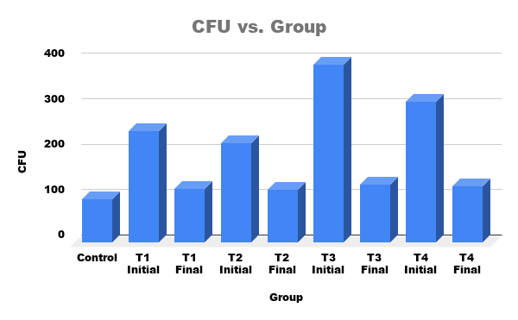
Figure 2: CFU Vs Group of Intestinal Microbiota Under Various Treatment Concentrations

Heavy metal–contaminated water can alter the gut microbial composition of fish and reduce microbial stability (Li et al., 2017). In the present study, differences in CFU values between 10% and 20% polluted water treatments indicate that increasing metal concentration influences gut microbial abundance (Xia et al., 2018). Heavy metals such as lead, cadmium, chromium, and copper can induce oxidative stress and inhibit the growth of intestinal microorganisms (Zhai et al., 2017).
Curcumin supplementation may reduce these effects due to its strong antioxidant activity, which scavenges reactive oxygen species produced during heavy metal exposure (Hewlings ; Kalman, 2017). Curcumin also exhibits metal-chelating properties that reduce the bioavailability and toxicity of heavy metals in biological systems (Priyadarsini, 2014). Furthermore, curcumin can modulate gut microbiota by suppressing harmful bacteria and promoting beneficial microbial populations, thereby helping maintain gut microbial balance in zebrafish (Zhang et al., 2019).

3.3. Nutritional Composition of the Experimental Diet

The formulated diet contained 7.6 ± 0.14 g/100 g protein, 2.04 ± 0.01 g/100 g carbohydrate, 3.5% lipid, and an estimated energy value of 70.15 kcal/100 g. These results indicate that the experimental diet provided adequate nutritional quality for zebrafish and was suitable for evaluating the biological effects of curcumin supplementation during heavy metal exposure
3.4. Total Protein Content
Heavy metal exposure significantly reduced intestinal protein content compared with the control group. Control fish exhibited the highest protein concentration (17.69 ± 1.13 mg g⁻¹), whereas Sample 1 and Sample 2 showed reduced values of 12.66 ± 1.03 mg g⁻¹ and 7.88 ± 0.48 mg g⁻¹, respectively. The greater reduction observed in Sample 2 indicates more severe metabolic impairment associated with increased pollutant exposure.
3.5. Superoxide Dismutase (SOD) Activity
SOD activity decreased following exposure to contaminated water. The control group showed the highest enzyme activity (0.092 ± 0.005 U mg⁻¹ protein), while Sample 1 (0.070 ± 0.007 U mg⁻¹ protein) and Sample 2 (0.050 ± 0.004 U mg⁻¹ protein) exhibited progressive reductions. These findings demonstrate impairment of the intestinal antioxidant defense system following heavy metal exposure.
3.6. Reduced Glutathione (GSH)
Intestinal GSH concentrations decreased in contaminated-water groups compared with controls. The highest GSH concentration was observed in the control group (25.37 ± 0.65 μM mg⁻¹ protein), while Sample 1 and Sample 2 exhibited lower values of 22.09 ± 0.67 and 21.73 ± 0.44 μM mg⁻¹ protein, respectively. The reduction in GSH indicates increased oxidative stress induced by heavy metal exposure.
3.7. Lipid Peroxidation (MDA)
Malondialdehyde (MDA), an indicator of lipid peroxidation, increased markedly in contaminated groups. The highest MDA concentration was recorded in Sample 2 (51.53 ± 1.58 μg mg⁻¹ protein), followed by Sample 1 (40.30 μg mg⁻¹ protein), whereas the control group exhibited the lowest value (34.91 ± 1.41 μg mg⁻¹ protein). These findings indicate enhanced oxidative damage in zebrafish exposed to heavy metal-contaminated water

Histopathological analysis of zebrafish intestine
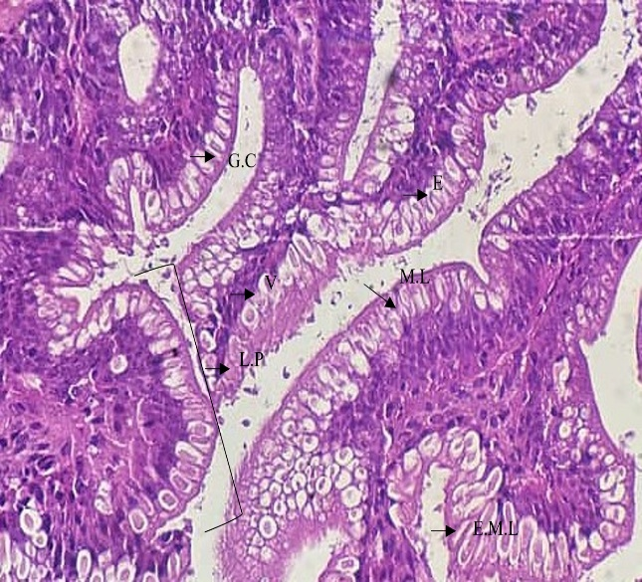  G.C: Goblet cell, E.M.L: Extternal muscukar layer, L.P: Lamina Propria, E: Enterocytes, M.L: Muscle layer, Villi  U.I.V: Ulceration of the intestinal Villi, I.E: Infiltration of eosinophils, H.G.C: Hyperplasia of Goblet Cells, N.I.M.L: Necrosis of Internal Muscular Layer, N.E.M.L: Necrosis of External Muscular Layer, D.E: Detachment of the Epithelium, V.E: vacuolization of the enterocytes | 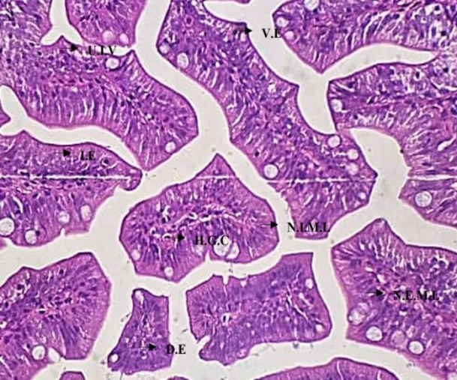
Control | (T1) 1 st day exposure
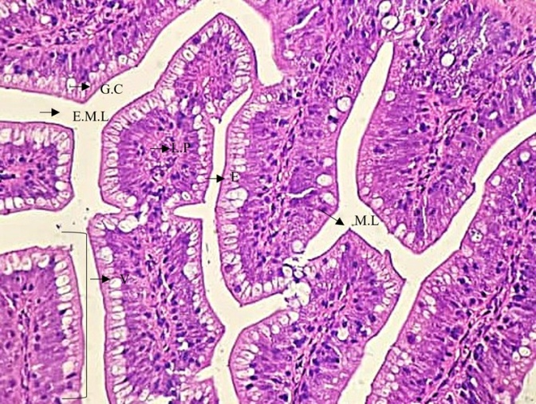  G.C: Goblet cell, E.M.L: Extternal muscukar layer, L.P: Lamina Propria, E: Enterocytes, M.L: Muscle layer, Villi | 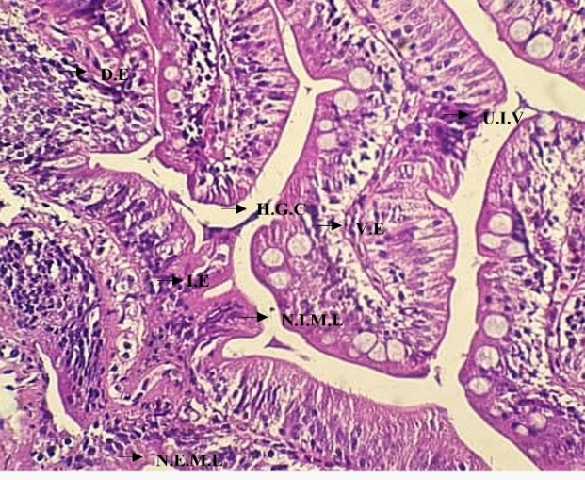  U.I.V: Ulceration of the intestinal Villi, I.E: Infiltration of eosinophils, H.G.C: Hyperplasia of Goblet Cells, N.I.M.L: Necrosis of Internal Muscular Layer, N.E.M.L: Necrosis of External Muscular Layer, D.E: Detachment of the Epithelium, V.E: vacuolization of the enterocytes
28 th day exposure | (T2)1 st day exposure
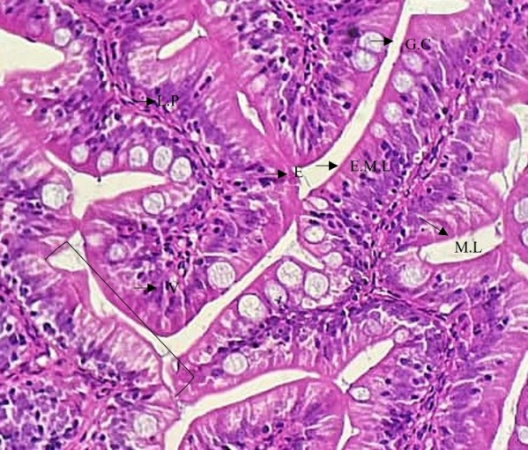
G.C: Goblet cell, E.M.L: Extternal muscukar layer, L.P: Lamina Propria, E: Enterocytes, M.L: Muscle layer, Villi

28 th day exposure

Figure 3: histopathology of zebrafish intestine exposed to different treated concentration
Histological examination of the intestine revealed normal villus architecture, intact epithelial cells, and abundant goblet cells in the control group. Fish exposed to heavy metal-contaminated water exhibited villus degeneration, epithelial disruption, inflammatory cell infiltration, and reduced goblet cell numbers. The severity of these lesions increased with pollutant concentration. Curcumin-treated fish showed improved intestinal morphology, including restoration of villus structure, preservation of epithelial integrity, and reduced inflammatory changes, indicating a protective effect against heavy metal-induced intestinal injury

DISCUSSION
Freshwater ecosystems are increasingly threatened by anthropogenic contamination arising from industrial discharge, agricultural runoff, mining activities, and urban effluents, resulting in elevated concentrations of heavy metals and other environmental contaminants. Persistent pollutants accumulate in aquatic organisms and disrupt multiple physiological processes through oxidative stress, inflammation, and metabolic dysfunction. In the present study, zebrafish exposed to contaminated freshwater exhibited concentration-dependent alterations in intestinal microbiota, antioxidant defense, biochemical status, and intestinal morphology, indicating that the gastrointestinal tract is a primary target of pollutant-induced toxicity [1].
The intestine represents a critical interface between aquatic organisms and the surrounding environment and is essential for nutrient absorption, immune regulation, and maintenance of microbial homeostasis. Exposure to heavy metals markedly altered intestinal bacterial populations, suggesting disruption of the gut microbial ecosystem. Environmental pollutants are known to induce gut dysbiosis by reducing beneficial microorganisms while promoting opportunistic bacteria, thereby compromising epithelial barrier integrity and immune function [6,8]. Such microbial alterations may increase host susceptibility to oxidative damage and inflammatory responses. The reduced bacterial homeostasis observed in polluted groups in the present study therefore supports the growing evidence that intestinal microbiota is a sensitive biomarker of aquatic pollution.
Oxidative stress is recognized as one of the principal mechanisms of heavy metal toxicity in fish. Excessive production of reactive oxygen species overwhelms endogenous antioxidant defense systems, resulting in depletion of antioxidant enzymes and enhanced lipid peroxidation. Consistent with this mechanism, zebrafish exposed to polluted water exhibited significantly reduced superoxide dismutase (SOD) activity and glutathione (GSH) levels together with elevated malondialdehyde (MDA), indicating severe oxidative damage. Similar biochemical alterations have been reported in fish exposed to heavy metals and other aquatic contaminants, where oxidative stress is closely associated with impaired metabolism, mitochondrial dysfunction, and tissue injury [1]. The observed reduction in total protein further suggests metabolic impairment resulting from increased protein degradation and inhibition of protein synthesis under toxic stress.
Dietary curcumin markedly alleviated pollutant-induced oxidative damage by restoring antioxidant capacity and reducing lipid peroxidation. Curcumin is a naturally occurring polyphenol possessing antioxidant, anti-inflammatory, and metal-chelating properties that enhance cellular defense against reactive oxygen species. The improved SOD and GSH activities together with reduced MDA concentrations observed in curcumin-treated fish indicate restoration of cellular redox homeostasis. These findings agree with recent studies demonstrating that dietary curcumin improves antioxidant status and protects fish tissues against environmental toxicants through activation of endogenous antioxidant pathways and suppression of oxidative injury [7,9].
Histopathological observations further supported the biochemical findings. Fish exposed to contaminated water exhibited degeneration of intestinal villi, epithelial disruption, inflammatory cell infiltration, and goblet cell alterations, indicating impaired intestinal integrity. Such lesions have been widely reported in fish subjected to heavy metal exposure and are considered characteristic indicators of intestinal toxicity [1]. In contrast, curcumin supplementation markedly preserved intestinal architecture, suggesting enhanced tissue regeneration and attenuation of inflammatory responses. The protective effect of curcumin is likely attributable to its combined antioxidant activity, regulation of inflammatory signaling, and maintenance of intestinal barrier function [7].
Collectively, the present findings demonstrate that freshwater pollution induces intestinal dysbiosis, oxidative stress, biochemical disturbances, and histopathological injury in zebrafish. Dietary curcumin effectively mitigated these toxic effects by enhancing antioxidant defenses, preserving intestinal structure, and improving intestinal microbial homeostasis. These findings support the potential application of curcumin as a sustainable dietary intervention to reduce pollutant-induced toxicity in aquaculture and provide further insight into the mechanisms underlying heavy metal-induced intestinal injury in fish.

CONCLUSION

The present study demonstrated that heavy metal-contaminated water induced oxidative stress and intestinal damage in zebrafish, as evidenced by reduced antioxidant status, altered gut microbial abundance, and pronounced histopathological changes. Dietary curcumin supplementation markedly improved intestinal morphology and restored antioxidant defenses, indicating its protective effect against heavy metal-induced toxicity. These findings suggest that curcumin has potential as a natural dietary supplement for mitigating intestinal toxicity and enhancing fish health under polluted aquatic conditions. Further molecular and microbiome-based studies are required to elucidate the mechanisms underlying its protective effects

ACKNOWLEDGEMENTS
The author sincerely thank Dr. G. Sasikala, Department of Zoology, PSGR Krishnammal College for Women, Coimbatore, for her valuable guidance, constructive suggestions, and continuous support throughout this study. The author also acknowledge the facilities and support provided by the Department of Zoology, PSGR Krishnammal College for Women, which enabled the successful completion of this research. Finally, the author express their gratitude to all those who directly or indirectly contributed to this work.
REFERENCES
- Kumar R, Singh AK, Sharma P, et al. Heavy metal toxicity in aquatic organisms: mechanisms of oxidative stress and antioxidant responses. Aquat Toxicol. 2024;268:106874.
- Zahran E, El-Hack MEA, Taha AE, et al. Heavy metal pollution in aquatic ecosystems: impacts on fish health, immunity, and oxidative status. Fish Shellfish Immunol. 2025;156:109980.
- Hou Y, Wang Y, Zhang X, et al. Zebrafish as a model organism for aquatic toxicology and environmental risk assessment. Sci Total Environ. 2023;857:159494.
- Bai C, Tang M. Toxicological study of zebrafish as a model for environmental health assessment. J Appl Toxicol. 2020;40(11):1467–1483.
- Duan Y, Zhang Y, Dong H, Wang Y, Zhang J. Gut microbiota: a target for heavy metal toxicity and host health. Sci Total Environ. 2020;716:137060.
- Kaur R, Rawal Y. Heavy metal-induced gut microbiota dysbiosis and intestinal toxicity: current perspectives. Environ Pollut. 2023;316:120650.
- Abd El-Hack ME, El-Saadony MT, Elbestawy AR, et al. Curcumin as a natural antioxidant and immunomodulator in aquaculture: mechanisms and applications. Aquaculture. 2023;563:738992.
- Burgos-Aceves MA, Cohen A, Smith Y, Faggio C. Microbiota–environment interactions in fish exposed to aquatic pollutants: implications for intestinal health and host physiology. Sci Total Environ. 2024;917:170210.
- Alagawany M, Abd El-Hack ME, Farag MR, et al. Curcumin and its different forms: a review on fish nutrition, health, and resistance to environmental stress. Aquaculture. 2021;532:736030.

