Statistical Assessment of Mechanical Properties of Recycled Reinforcing Bars within Kenya’s Construction Industry

Abstract
Variations in chemical, mechanical, and physical properties have been reported in steel bars sold in the Kenyan market, particularly those produced from scrap raw material, indicating a lack of unified quality control measures. To ascertain compliance with regional and international standards, this study investigated the mechanical properties of rebars of seven different manufacturers within Kenyan market. Standard tensile testing was conducted using Enkay Universal Testing Machine (capacity: 100 kN) in accordance with ISO 15630-1 and ISO 6892-1, yielding average values for yield strength (YS), ultimate tensile strength (UTS), and elongation. Results indicated that manufacturer A rebars exhibited adequate ductility, with YS and UTS values exceeding minimum thresholds (YS> 500 MPa, UTS > 550 MPa), and manufacturer B samples recorded low yield strength averaging at 475.0$±35.1$MPa which are lowest value among seven manufacturers. Percentage elongation results indicated that 6/7 (85.71%) of the manufacturers met the minimum threshold set by KS EAS 412, additionally all the manufacturers except F felt short of the requirement (UTS/YS ≥ 1.08).
Overall mechanical properties conformity of the tested samples revealed that 5 out 7 manufacturers, constituting to 71%, complied with the KS EAS 412 regional standard. The study concludes that while most locally manufactured rebars comply with regional and international standards, persistent variations in mechanical properties highlight the need for stricter quality control in Kenyan steel production. The findings aim to guide and advise the construction sector in Kenya, promoting long-term sustainability and aligning with Kenya’s Vision 2030 goals on infrastructural development.
Key words: manufacturer, mechanical properties, reinforcement bars, standards compliance

Introduction
Global population increase has brought about industrialization and urbanization. This has led to a rapid increase in the number and scale of infrastructural development projects, ultimately increasing demand on different types of engineering materials[1]. The building materials commonly in use include timber, sand, gravel and metal among others. Steel is the predominantly used engineering material due to its mechanical and economic advantage[2-4].
The demand for steel Africa is met by local production and imports [5, 6]. However, many stakeholders lack trust to use locally available reinforcement bars, largely due to concerns about quality and reliability [7].This lack of trust has been reinforced by the rise building collapses recorded in Kenya and other African countries such as Cameroon, Ethiopia, Nigeria, Uganda, Senegal, Tanzania, Rwanda South Africa and Ghana[8-16]. While these failures has been attributed to improper design, poor workmanship among other critical causes of failure, attention has been drawn on the quality of the reinforcing steel bars used in the construction industry[17].
In many countries around the globe, scrap metal is widely utilized in production of reinforcement bars (RBs) used in construction sector, roofing and other structural components. Studies have highlighted the importance of using scrap metal in manufacturing of products such RBs over the new (primary) alloy. This is as a result of environmental benefits of recycling such as reduction in landfills, CO2 emissions and energy requirements [18-23] . Despite the push for sustainability, Kenya’s construction sector has demonstrated laxity in the adoption of reinforcement bars manufactured from scrap. This is largely attributed limited recycling infrastructure, change of policy and governance, lack of effective regulatory frameworks and quality concerns [24, 25].

Several studies have been conducted, particularly in African countries, in a bid to assess the quality of rebars produced from recycled metals through performance and suitability evaluation of such materials utilized in the construction sector. This has been ignited by numerous reported incidents of building collapse in these countries [7, 8, 26-28]. This study is motivated by the need to explore the quality of recycled reinforcing bars (RRBs) used in Kenya’s construction sector by critically analysing suitability and conformity to the regional and international standards.
Findings from this study attempts to provide evidence on the quality and compliance of reinforcement bars with established regional and international standards, given their critical role in structural safety.
- Literature review.
2.1Overview of scrap metal Recycling in construction
Scrap metal recycling is an important process in enhancing circular economy. Scrap acts as raw material for steel manufacturing industries. Additionally, recycled metals are commonly used in manufacturing new building materials, such as prefabricated components and reinforcement products[29].The integration of recycling practices within the construction industry enhances resource efficiency by ensuring that metal waste is systematically reintegrated into the production cycle[30-32].
  - Global trends in metal recycling for construction
The global metal recycling market has risen significantly since 2020.This growth is driven by industrialization and increase in demand for affordable building materials[33]. The metal recycling process is environmentally friendly and economical, allowing manufacturers to obtain raw materials without degrading their properties and at lower costs compared to primary metal component production[34]. China is considered the leading steel production country with over 1019.1 million tons produced in 2023, accounting for 55% of worldwide crude steel output[35]. Metal scrap prices have risen significantly since 2022 as a result of robust construction activities and the impact of the Russia-Ukraine war on raw material availability and supply chain which have led to high demand and price increase of steel scrap[36].
  - Scrap metal recycling in Kenya
Metal recycling sector in Kenya has witnessed significant advancements especially as a result of enactment of Scrap Metal Act in 2015 which established regulatory framework on handling of scrap activities thereby promoting sustainable practices. Reports by the Ministry of Industrialization and Kenya Association of Manufacturers identify urban areas such as Kisumu, Nakuru, Eldoret, Thika, Nairobi and Mombasa serve as major collection points of the scrap metal thereby making steel recycling plants dominant in the regions. With the current emphasis on sustainability and the government’s support for recycling activities, the volume of scrap metal exports is projected to rise. Increased awareness on the benefits of scrap metal recycling is expected to champion the growth of metal recycling aligning with broader efforts to mitigate environmental impacts associated with waste[24, 25].
  - Scrap metal recycling process
Typical scrap metal process entails the following steps as outlined.
- Collection: Scrap metal is collected from yards or delivered by licensed scrap dealers.
- Sorting: Scrap is delivered in various type and has to be sorted before smelting. Sorting and grading of scrap depends on the technology adopted by the recycling plant. Visual identification by experts is employed as manual sorting technique. Large magnetic sensors are primary used to separate between ferrous and non-ferrous metal. Advanced techniques such as sink-float separations, LIBS and OES are used to analyse elemental composition for precise classification [37-39].The sorting methods ensure recovery of high-grade steel alloys for recycling.
- Shredding: This involves shredding bulk metals to make them easier to melt down, saving energy. Aluminium and steel, however, are processed into sheets and blocks to facilitate efficient melting and reuse in manufacturing.
- Melting: After shredding and processing, the scrap metal is ready to be smelted down. They are placed into large furnaces, each assigned to its own type of metal, and melted into liquid form. The time it takes for metal to reach liquidity ranges between a few minutes to a few hours.
- Decontamination: All residual contaminants and impurities are eliminated from the melted metal using a process known as electrolysis.
- Solidifying: Once the metal is all cleaned and purified, it is transferred via conveyor belt to cure, or turn into a solid. Then, they are transferred into moulds according to the type of metal and its intended application. Bars are the most commonly used shape in the recycling industry.
- Metal Bar Distribution: Once the process is completed, the final product is shipped out and distributed as needed. They are hauled off to factories to be used as raw materials to manufacture new products.

3.MATERIALS AND METHODS

3.1 Sampling and Coding of Test Specimens
The seven manufacturers were issued a unique identifier code (A, B, C, D, E, F and T) which were used in labelling all corresponding test specimens. The sample collection from each manufacturer employed a random sampling technique to ensure the results were representative of the manufacturer's overall product quality.
Table 3.1: Test samples and designation
Manufacturer ID | Tensile Strength
A | AT1, AT2, AT3, AT4, AT5, AT6, AT7
B | BT1, BT2, BT3, BT4, BT5, BT6, BT7
C | CT1, CT2, CT3, CT4, CT5, CT6, CT7
D | DT1, DT2, DT3, DT4, DT5, DT6, DT7
E | ET1, ET2, ET3, ET4, ET5, ET6, ET7
F | FT1, FT2, FT3, FT4, FT5, FT6, FT7
T | TC1, TC2, TC3, TC4, TC5, TC6, TC7

Source of samples and Replication Strategy

Source of samples
The test samples were sourced from seven (7) manufacturers designated hereafter as A, B, C, D, E, F and T. Samples from each source corresponded to the variations in manufacturers’ condition for milling steel depending on raw materials. Details regarding the steel milling processes employed by the manufacturers were not available for inclusion in this study, as the relevant information was not provided.

Number of Samples Tested
Test pieces of length 200mm were cut from the seven (7) specimens obtained from various independent manufacturers using a hacksaw, the test piece was prepared in accordance with ISO 6892-1 and ISO 6935-2 standards. Enkay Universal Testing Machine (capacity: 100 kN), equipped with MatBench V.3 software for data acquisition and machine control. The gauge length was computed from Eqn 3.2 in accordance with ISO 6892-1 and ISO 6935-2 standards.
$$Gauge length\left(test length\right)=5.65\sqrt{A } 3.2$$
The corresponding load and extension data was recorded in order to generate load-extension graphs needed for analysis. Properties such as ultimate tensile strength (UTS) and percentage elongation, and yield strength was computed from the obtained data. The force and extension graphs were automatically generated with the computer connected to the machine. The results compared with KS EAS 412 to check for conformity with regional standards. Figure 3.7 shows Enkay Universal Testing Machine (capacity: 100 kN), equipped with MatBench V.3 software for data acquisition and machine control.
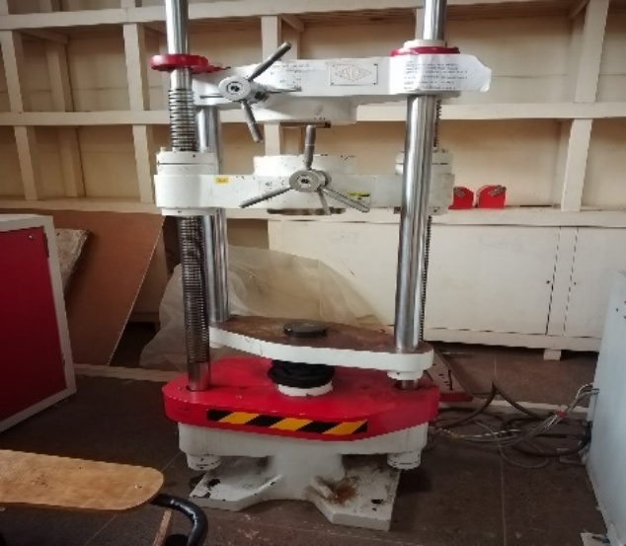
Figure 3.1:Enkay Universal Testing Machine (Image taken at Multimedia University of Kenya)
The samples were grouped in designated experimental batches ready for tensile testing as shown in Figure 3.2.
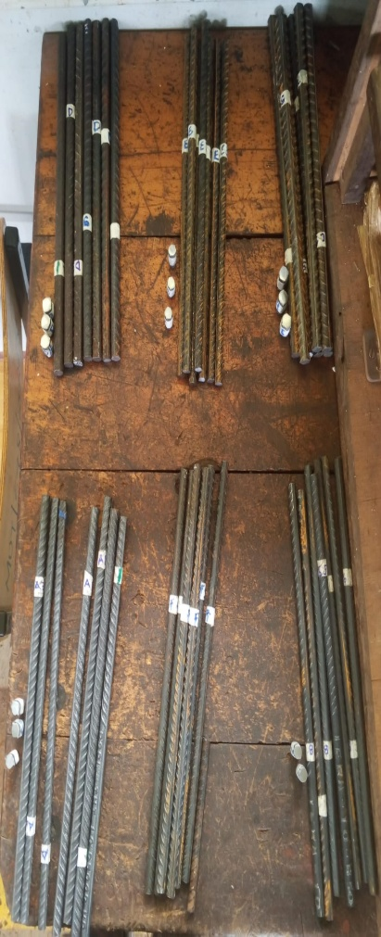
Figure 3. 2:Typical set of samples before testing

4. Results and Discussion
4.1: Tensile Strength, Yield Strength and Elongation
The mechanical properties of the tested reinforcement bars from the seven (7) sources are analysed to assesses their conformity with KS EAS 412, focusing on yield strength, ultimate tensile strength, stress ratios, and percentage elongation. The samples were tested in designated experimental batches and resulting data tabulated for analysis. Figure 4.1 show typical set of samples after testing.
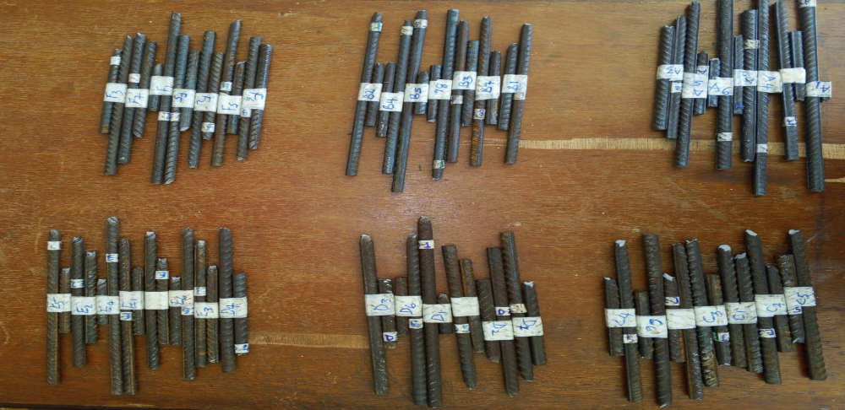
Figure 4. 1: Rebar samples after fracture
Manufacturer A
The stress – strain curves for all the seven samples obtained from manufacturer A are presented in Figure 4.2. The stress-strain curve showed in Figure 4.2, depicts a clear yield plateau followed by strain hardening, leading to fracture at strains between 0.11- 0.19. The summary of the results in Figure 4.2 are presented in Table 4.1.

Figure 4.2: Stress - Strain curves for steel samples from manufacturer A
Source B
The stress –strain curves of tested samples from manufacturer B are presented in Figure 4.3 and summarised in Table 4.1 While certain samples (such as BT1 and BT3) displayed poorly defined yield plateau, others (such as BT6 and BT7) demonstrated continuous yielding without distinct yield drop. This phase was followed by strain hardening, leading to fracture at strains between 0.17 and 0.20. The percentage elongation ranged between 16.56% and 20.2%. The high values hinted possible inconsistencies in production process.

Figure 4.3: Stress- Strain curves for steel samples from manufacturer B
Manufacturer C
The stress –strain curves of tested samples from manufacturer C are presented in Figure 4.4 and summarised in Table 4.1. The stress-strain curve shown in Figure 4.15 depicts continuous yielding and a non-distinct yield plateau, followed by strain hardening region, and finally fracture at strains between 0.19-0.25. From the stress–strain profiles of source C, specimens CT2 and CT6 were identified as distinct outliers and excluded from the summarized mean calculations due to initial machine grip slippage at the start of the test.
outliers
Figure 4.4: Stress- Strain curves for steel samples from manufacturer C
Manufacturer D
The stress–strain curves of the tested samples from Manufacturer D are presented in Figure 4.5 and summarised in Table 4.1 The stress-strain curve depicts continuous yielding characteristics with non-distinct yield plateau region. Followed by steady strain hardening phase, leading to fracture at strains between 0.17 and 0.20. Table 4.9 show yield strength ranged between 497.0 and 542.0 MPa, with an average of 522$± 15.4$ MPa. This meets the minimum threshold of 500.0 MPa specified in BS 4449 and KS EAS 412-2.

Figure 4.5: Stress-Strain curves for Steel samples from manufacturer D
Manufacturer E
The stress–strain curves of the tested samples from manufacturer E are presented in Figure 4.6 and summarised in Table 4.1. Figure 4.6 depicts continuous yielding behavior without a distinct yield plateau, followed by strain hardening, leading to fracture at strains between 0.17 and 0.20.

Figure 4.6: Stress-Strain curves for steel samples from manufacturer E
Manufacturer F
The stress–strain curves of the tested samples from manufacturer F are presented in Figure 4.7 and summarised in Table 4.1. The stress-strain curve in Figure 4.18, depicts continuous yielding without a distinct yield plateau followed by minimal strain hardening prior to fracture at strains between 0.19 to 0.28.

Figure 4.7: Stress-Strain curves for steel samples from manufacturer F
Manufacturer T
The stress–strain curves of the tested samples from manufacturer T are presented in Figure 4.8 and summarised in Table 4.1. Result from this figure depicts a clear initial yield plateau followed by strain hardening and finally fracture at strains ranging from 0.2-0.24. The maximum strain value is approximately 0.24 which corresponds to 24.0 % elongation.

Figure 4.8: Stress- Strain curves of steel samples from manufacturer T
The shape of the curves confirms that billet-made bars give higher ratio and high yield strength due to less impurities such as sulphur and phosphorus. Low impurity levels result when alloying elements such as sulphur and phosphorus are kept to minimum causing steels’ internal atomic structure to remain uniform and free of internal defects. As a result, the material undergoes yielding uniformly and smoothly across the entire bar, creating longer plateau region on the curve.
The results from manufacturer T establishes that billet-made bars have high mechanical properties. The results underscore the reliability of billet production in enhancing structural safety. The steel manufacturing industries should not rely purely on scrap as their main raw material (ingots) but consider using billets as an alternative material so as to act as benchmark.
  - Overall comparison of mechanical properties with the standards
This section presents consolidated results to assess the overall conformity against KS EAS 412-2 for Grade B500, highlighting Manufacturing T (billet-made bars) as the benchmark. The empirical findings from the tensile test are cross-examined against standard specification KS EAS 412.Table 4.13 provides comparative breakdown of mechanical properties including both averaged experimental (measured) value of each manufacturer and corresponding threshold specified in KS EAS 412. By crosschecking the averaged measured values of independent manufacturer against standardized baseline criteria, the table evaluates manufacturers level of compliance. The summary of compliance status is presented in Table 4.1.
Manufacturer | Property
Manufacturer | Yield Strength  YS (MPa) |  | Average UTS (MPa) |  | Avg Elongation (%) |  | Avg. Stress ratio
Manufacturer | Measured value | KS EAS 412 | Measured value | KS EAS 412 | Measured value | KS EAS 412 | Measured value | KS EAS 412
A | 535.0$±24.0$ | 500.0 | 616.1$±31.0$ | 550.0 | 16.1$±2.43$ | 14.0 | 1.15$±0.03$ | ≤ 1.08
B | 475.0$±35.1$ | 500.0 | 554.3$±23.4$ | 550.0 | 18.25$±1.37$ | 14.0 | 1.16$±0.06$ | ≤ 1.08
C | 612.0$±20.4$ | 500.0 | 715.7$± 25.3$ | 550.0 | 22.3$±1.83$ | 14.0 | 1.17$±0.03$ | ≤ 1.08
D | 522.0$±15.4$ | 500.0 | 600.0$±12.5$ | 550.0 | 19.25$±1.80$ | 14.0 | 1.15$±0.03$ | ≤ 1.08
E | 504.0$±9.0$ | 500.0 | 586.0$±16.1$ | 550.0 | 18.62$±1.28$ | 14.0 | 1.16$±0.02$ | ≤ 1.08
F | 481.8$±16.4$ | 500.0 | 517.0$±18.3$ | 550.0 | 23.1$±3.42$ | 14.0 | 1.07$±0.03$ | ≤ 1.08
T (virgin-material) | 577.0$±18.3$ | 500.0 | 663.3$±32.5$ | 550.0 | 21.9$±1.45$ | 14.0 | 1.14$±0.03$ | ≤ 1.08
Table 4. 1: Statistical comparison of the mechanical properties against standards.
The averaged values of yield and ultimate tensile strengths of the tested samples from manufacturers are presented in Figure 4.9. Target limits are also indicated as specified in KS EAS 412.The averaged values indicate that 71% of the manufacturers used in this study met the minimum threshold of YS ≥ 500.0 MPa set in KS EAS 412.Additionally, all the manufactures attained the minimum threshold UTS ≥ 550.0 MPa

Figure 4.9: Average values of YS and UTS of samples from manufacturers
Figure 4.9 compares the mean percentage elongation values across different manufacturers alongside their respective standard deviations, evaluated against KS EAS 412 threshold (indicated by the solid horizontal target line in the bar). It is observed that all the seven manufactures satisfy the minimum percentage elongation threshold. However, notable variations in consistency exists. Manufacturer F displays the highest mean ductility, followed closely by manufacturer C and T. On contrary, manufacturer A exhibit lowest mean percentage elongation hence slightly surpasses the minimum threshold.
A clear distinction is observed in experimental scatter represented by error bars. Manufacturer E depicts a highly pronounced STD, indicating inconsistent ductility performance among individual samples. The findings correspond to the variable fracture strains noted in its independent profiles in Fig 4.6. Conversely, manufacturer T exhibit negligible variance, demonstrating a uniform elongation response. This exceptional consistency reinforces the structural benefits of virgin material bars which yields predictable plastic deformation behaviour as noted in Figure 4.10

Figure 4.10: Average percentage elongation for different manufacturers.
Figure 4.11 evaluates the averaged stress ratios (UTS/YS) of the tested manufacturers against the minimum threshold (≥ 1.15) indicated by the solid horizontal orange baseline in the chart. The ratio demonstrates material’s capacity of plastic redistribution and strain-hardening reserve, which are critical for seismic resistance.
The comparative analysis revealed that six of out seven manufacturers denoted by (A, B, C, D, E, and T) surpassed the minimum threshold, demonstrating secure margin between yielding point and ultimate tensile failure. Manufacturer C samples exhibit highest ratio, implying the greatest capacity for energy absorption during post-yielding deformation. On contrary, critical failure in compliance is noted in manufacturer F samples, whose mean ratio fall below the target baseline on the chart. This deficiency implies a narrow margin between YS and UTS making the material experience rapid strain localization post-yielding with limited plastic warning before fracture.

Figure 4.11: Average stress ratio for different manufacturers
Overall compliance status in the dataset was computed using a logical AND condition: a source is marked ✓ only if yield strength, UTS, stress ratio, and elongation all meet KS EAS 412 thresholds. The results from this analysis are presented in Table 4.3
Table 4.3: Summary of Mechanical Property Compliance
Source | Property |  |  |  | Overall status
Source | YS  (≥ 500.0MPa) | UTS  (≥ 550.0 MPa) | % Elongation  (≥ 14.0%) | Stress ratios  (≥ 1.08) | Overall status
A | ✓ | ✓ | ✓ | ✓ | ✓ Compliant
B | ✗ | ✓ | ✓ | ✓ | ✗ Non-compliant
C | ✓ | ✓ | ✓ | ✓ | ✓ Compliant
D | ✓ | ✓ | ✓ | ✓ | ✓ Compliant
E | ✓ | ✓ | ✓ | ✓ | ✓ Compliant
F | ✗ | ✓ | ✓ | ✗ | ✗ Non-compliant
T (billet) | ✓ | ✓ | ✓ | ✓ | ✓ Compliant

Results in Table 4.3 show that five (5) out of six (6) rebar sources satisfied the KS EAS 412 mechanical property standards. This demonstrates major conformity. The findings further reveals that scrap-derived bars can achieve acceptable performance when properly processed. Billet-derived bars remain benchmark for consistent compliance. The results confirm that conformity is not only limited to billet production, but also steel production plants that rely on scrap as the major raw material can meet the Grade B500 requirements when quality control is maintained.
5: Conclusions and recommendations

5.1: Conclusions
The mechanical properties revealed that majority of the manufacturers (A, C, D, E, and T) satisfied the minimum threshold of ≥500.0 MPa as specified in KS EAS 412, while manufacturers B and F felt short of the standard. In contrast, all manufacturers achieved the ultimate tensile strength threshold of ≥ 550.0 MPa, confirming adequate tensile capacity across the dataset. Additionally, all the manufacturers exceeded the percentage elongation requirement of ≥ 14.0%, demonstrating ductile behaviour essential for structural resilience. Stress ratio analysis showed that compliant manufacturers-maintained values above 1.08, but manufacturer F failed this criterion, indicating poor strain-hardening capacity and potential brittleness. The findings further reveals that scrap-derived bars can achieve acceptable performance when properly processed. Billet-derived bars remain benchmark for consistent compliance.
  - Recommendations

5.2.1 Policy and Practice Recommendations
There is a need to improve existing quality control policies in Kenya’s steel manufacturing industry. Regulatory bodies, such as KEBS, must conduct routine inspections and random sampling of rebars at points of sale and construction sites to enhance compliance at all times.
The study revealed that scrap-derived steels often failed yield strength and stress ratio requirements. These deficiencies justify stronger quality control policies. Regulatory bodies such as KEBS should therefore conduct routine inspections and random sampling of rebars at points of sale and construction sites to ensure compliance.

5.2.2 Recommendation for further studies
Future studies should consider use of larger or more diverse sample sets from various manufacturers in Kenya to enhance representatives and generalization of results. There is need to simulate the production process of reinforcement steel bars using for optimization using computer aided manufacturing (CAM) software. Additionally, future researchers should consider studying fatigue performance, corrosion resistance, and service life under aggressive conditions to provide a more comprehensive understanding of rebar reliability.
REFERENCES

[1] J. Nilimaa, "Smart materials and technologies for sustainable concrete construction," Developments in the Built Environment, vol. 15, 2023, Art no. 100177, doi: 10.1016/j.dibe.2023.100177.
[2] A. Choudhury, S. Pal, R. Naskar, and A. Basumallick, "Computer vision approach for phase identification from steel microstructure," Engineering Computations, vol. 36, no. 6, pp. 1913-1933, 2019, doi: 10.1108/ec-11-2018-0498.
[3] J. G. Back, "Modelling and Characterisation of the Martensite Formation in Low Alloyed Carbon Steels," Doctoral dissertation (PhD in Engineering Sciences and Mathematics, Mechanics of Solid Materials) Doctoral dissertation, Luleå University of Technology, 2017.
[4] J. Dsilva, S. Zarmukhambetova, and J. Locke, "Assessment of building materials in the construction sector: A case study using life cycle assessment approach to achieve the circular economy," Heliyon, vol. 9, no. 10, 2023, Art no. e20404, doi: 10.1016/j.heliyon.2023.e20404.
[5] J. K. Machira, "A study into steel processing and recycling industry in Kenya," Master’s dissertation (Mechanical Engineering), Mechanical Engineering, Jomo Kenyatta University of Agriculture and Technology., 2014.
[6] S. M. Mukai, P. N. Muchiri, and J. B. Byiringiro, "Progression and Forecasting of Steel Demand in Kenya," IOSR Journal of Mechanical and Civil Engineering (IOSR-JMCE), vol. 15, no. 4 (Version III), pp. 79-88, 2018, doi: 10.9790/1684-1504037988.
[7] T. E. Fente, A. A. Tsegaw, A. T. Abebe, and B. T. Admasu, "Investigating the quality of ethiopian steel reinforcing bars through comprehensive analysis," Heliyon, vol. 10, no. 10, 2024, Art no. e31661, doi: 10.1016/j.heliyon.2024.e31661.
[8] S. O. Ametepey, K. S. Akorli, S. K. Ansah, C. Aigbavboa, and E. Y. Frempong-Jnr, "Investigating the standard sizes of steel reinforcement used in the Ghanaian industry," Materials Today: Proceedings, vol. 93, pp. 447-452, 2023, doi: 10.1016/j.matpr.2023.08.070.
[9] R. K. Nyabuga, "Resource Planning and Collapse of Buildings in Kiambu County, Kenya," Journal of Entrepreneurship and Project Management, vol. 9, no. 2, pp. 26-37, 2024, doi: 10.47941/jepm.2292.
[10] F. G. Boateng, "Knowing What Leads to Building Collapses Can Help Make African Cities Safer," SSRN Electronic Journal, doi: 10.2139/ssrn.4006924.
[11] M. Caleb, K. A. Olonade, and M. M. Lawan, "Evaluating The Causes of Building Collapse in Kampala District, Uganda," KIU Journal of Science, Engineering and Technology, vol. 2, no. 2, 2023, Art no. 01, doi: http://dx.doi.org/10.59568/KJSET-2023-2-2-01.
[12] CNN. "Five dead and 49 missing as multi-story building collapses in South Africa." CNN. https://edition.cnn.com/2024/05/07/africa/five-dead-and-49-missing-as-multi-story-building-collapses-in-south-africa/index.html (accessed 24 December 2024.
[13] Reuters. "At least five killed in Senegal building collapse." Reuters. (accessed 28 December, 2024).
[14] M. M. Hassan, A. Mamdouh, and S. Mourad, "Empirical Fragility Curves for Buildings in Historic Cairo," presented at the The Eleventh Alexandria International Conference Onstructural, Geotechnical Engineering and Management“Aicsge-11", Alexandria,Egypt, 2023.
[15] M. Bahaa, B. Timo, and Y. Ali, "Towards a PS-InSAR Based Prediction Model for Building Collapse: Spatiotemporal Patterns of Vertical Surface Motion in Collapsed Building Areas—Case Study of Alexandria, Egypt," Remote Sensing, vol. 12, no. 20, 2020, Art no. 3307, doi: 10.3390/rs12203307.
[16] C. E. Ogbemudia, E. Ndububa, and N. D. Mbaezue, "An Investigation into Causes of Building Collapse in Abuja, Nigeria," Global Scientific Journals, vol. 9, no. 2, pp. 435-446, 2021.
[17] T. Jean Claude and B. Théodore Gautier L. J., "Failure and Collapse of Building Structures in the Cities of Yaoundé and Douala, Cameroon from 2010 to 2014," Modern Applied Science, vol. 10, no. 1, pp. 23-34, 2016, doi: 10.5539/mas.v10n1p23.
[18] Cohen. "Everything You Need to Know About Scrap Metal Recyclin." Cohen. https://www.cohenusa.com/blog/everything-you-need-to-know-about-scrap-metal-recycling/ (accessed 28 December 2024.
[19] J. Pritchard. "Economic Impact of Recycled Steel: Benefits." https://buildingrenewable.com/economic-impact-of-recycled-steel-benefits/ (accessed 25-Dec-2024, 2024).
[20] W. Okumu. "Scrap metal smuggling could cripple East Africa's infrastructure." ISS Today. https://issafrica.org/iss-today/scrap-metal-smuggling-could-cripple-east-africas-infrastructure (accessed 25-Dec-2024, 2024).
[21] A. Kovačević. "Advantages to Metal Scrap Recycling: Environmental Impact." Metaloop Blog. https://blog.metaloop.com/advantages-to-metal-scrap-recycling-environmental-impact (accessed 24 December 2024, 2024).
[22] EuRIC. "Metal Recycling Factsheet." EuRIC. https://euric-aisbl.eu/resource-hub/reports-studies/metal-recycling-factsheet (accessed 27 December, 2024).
[23] F. Philip. "The Positive Impact the Scrap Metal Recycling Industry Has on the United States." Forbes. https://www.forbes.com/sites/philfava/2011/11/21/the-positive-impact-the-scrap-metal-recycling-industry-has-on-the-united-states/ (accessed 24 December 2024, 2024).
[24] F. Mugo. "We Invite Investors to Kenya." https://www.wasterecyclingmea.com/news/recycling/we-invite-investors-to-kenya (accessed 24 December 2024.
[25] J. Kahongeh, "Inside Kenya's multibillion scrap metal underworld," in Business Daily Africa, ed: Business Daily Africa (Nation Media Group), 2022.
[26] P. C. Bame, B. E. Yamb, and B. Ndigui, "Assessment of Deviation in Quality of Steel Reinforcing Bars Used in Some Building Sites in Cameroon," World Journal of Engineering and Technology, vol. 11, no. 04, pp. 917-931, 2023, doi: 10.4236/wjet.2023.114061.
[27] S. Abbas, R. Hameed, M. Nehdi, M. Afzal, and S. Shaukat, "Investigation of reinforcing steel rebar manufactured from local scrap at various finishing rolling temperature," Case Studies in Construction Materials (Elsevier, open access), vol. 19, 2023, Art no. e02499, doi: 10.1016/j.cscm.2023.e02499.
[28] S. Assiamah, C. K. Kankam, E. K. Banini, S. Agyeman, and K. Adinkrah-Appiah, "Standardization Issues in Africa: Bayesian analysis of physicogeometrical and mechanical characteristics of rebars in Ghana's construction industry," Journal of Building Engineering (Elsevier), vol. 73, 2023, Art no. 106835, doi: 10.1016/j.jobe.2023.106835.
[29] N. Soares and V. Tavares, "Bibliometric Analysis of the Intersection of Circular Economy, Prefabrication, and Modularity in the Building Industry," Buildings, vol. 15, no. 11, 2025, Art no. 1923, doi: 10.3390/buildings15111923.
[30] A. Kanyilmaz, M. Birhane, R. Fishwick, and C. del Castillo, "Reuse of Steel in the Construction Industry: Challenges and Opportunities," International Journal of Steel Structures, vol. 23, no. 5, pp. 1399-1416, 2023, doi: 10.1007/s13296-023-00778-4.
[31] K. Kabirifar, M. Mojtahedi, C. Wang, and V. W. Y. Tam, "Construction and demolition waste management contributing factors coupled with reduce, reuse, and recycle strategies for effective waste management: A review," Journal of Cleaner Production, vol. 263, 2020, Art no. 121265, doi: 10.1016/j.jclepro.2020.121265.
[32] T. A. Branca et al., "Reuse and Recycling of By-Products in the Steel Sector: Recent Achievements Paving the Way to Circular Economy and Industrial Symbiosis in Europe," Metals, vol. 10, no. 3, 2020, Art no. 345, doi: 10.3390/met10030345.
[33] F. Kedir, Q. Chen, D. M. Hall, B. T. Adey, and R. Boyd, "Formative scenario analysis of the factors influencing the adoption of industrialised construction in countries with high housing demand–the cases of Ethiopia, Kenya, and South Africa," Construction management and economics, vol. 40, no. 9, pp. 690-710, 2022, doi: 10.1080/15623599.2024.2397287.
[34] L. Jin Chai et al., "A Study on Recycling Waste Materials in Construction Industry," Journal of Advanced Research in Applied Sciences and Engineering Technology, pp. 227-241, 2024, doi: 10.37934/araset.59.1.227241.
[35] I. Group. "Metal Recycling Market: Global Industry Trends, Share, Size, Growth, Opportunity and Forecast 2023-2028." https://www.imarcgroup.com/metal-recycling-market. https://www.imarcgroup.com/metal-recycling-market (accessed December 26,2024, 2024).
[36] N. Bargujara, M. A. Kalwar, I. Dermitzakis, and A. Nawaz, "The impact of the Russia-Ukraine war on the Russian supply chain," Journal of Emerging Science and Engineering, vol. 3, no. 1, 2024, Art no. e33, doi: 10.61435/jese.2025.e33.
[37] S. K. Hussain Shah, J. Iqbal, P. Ahmad, M. U. Khandaker, S. Haq, and M. Naeem, "Laser induced breakdown spectroscopy methods and applications: A comprehensive review," Radiation Physics and Chemistry, vol. 170, 2020, Art no. 108666, doi: 10.1016/j.radphyschem.2019.108666.
[38] M. Cui et al., "Applications of laser-induced breakdown spectroscopy in industrial measurement and monitoring: Multi-technology combination," Applied Spectroscopy Reviews, pp. 1-49, 2024, Art no. 2398196, doi: 10.1080/05704928.2024.2398196.
[39] S. Pongstabodee, N. Kunachitpimol, and S. Damronglerd, "Combination of three-stage sink-float method and selective flotation technique for separation of mixed post-consumer plastic waste," Waste Manag, vol. 28, no. 3, pp. 475-83, 2008, doi: 10.1016/j.wasman.2007.03.005.

