Development and Validation of a Hydrotropic First-Derivative UV Spectrophotometric Method for Simultaneous Estimation of Sofosbuvir and Daclatasvir in Combined Tablet Dosage Forms

Abstract
A simple, precise, accurate, and economical first-derivative UV spectrophotometric method was developed and validated for the simultaneous estimation of Sofosbuvir and Daclatasvir in combined tablet dosage forms. The method employed 0.1 M sodium citrate as a hydrotropic solubilizing agent. Quantification was carried out using first-derivative spectroscopy at 246 nm for Sofosbuvir and 324 nm for Daclatasvir using the zero-crossing technique. Beer–Lambert’s law was obeyed over the concentration range of 5–30 µg/mL for Sofosbuvir and 2–12 µg/mL for Daclatasvir. The developed method was validated according to ICH guidelines with respect to linearity, accuracy, precision, and assay. The correlation coefficients were found to be 0.9992 and 0.9993 for Sofosbuvir and Daclatasvir, respectively. Recovery studies demonstrated accuracy within 98–100 % for Sofosbuvir and 97–102 % for Daclatasvir. The assay values obtained for the marketed formulation were 99.87% for Sofosbuvir and 99.23 % for Daclatasvir. The proposed method was found to be simple, reliable, precise, and suitable for routine quality control analysis of combined tablet formulations.
Keywords: Sofosbuvir, Daclatasvir, Hydrotropy, First-Derivative Spectroscopy, Method Validation, UV Spectrophotometry.

1. Introduction
Hepatitis C virus (HCV) infection remains a major global health concern. Sofosbuvir and Daclatasvir are direct-acting antiviral agents widely used in combination therapy for the treatment of chronic HCV infection. Sofosbuvir acts as an inhibitor of the NS5B RNA-dependent RNA polymerase, while Daclatasvir inhibits the NS5A protein essential for viral replication and assembly.
Simultaneous estimation of these drugs in combined dosage forms is important for quality control and regulatory compliance. Conventional analytical techniques such as HPLC are accurate but require sophisticated instrumentation and higher operational costs. UV spectrophotometry, particularly derivative spectroscopic techniques, offers a simple and economical alternative (1-15). Therefore, the present study aimed to develop and validate a first-derivative UV spectrophotometric method for simultaneous estimation of Sofosbuvir and Daclatasvir using sodium citrate as a hydrotropic solubilizing agent.

2. Materials and Methods

2.1 Materials
Sofosbuvir and Daclatasvir reference standards were obtained from Hetero Drugs Pvt. Ltd., Hyderabad. Sodium citrate and other analytical-grade reagents were used throughout the study.

2.2 Instrumentation
The analytical work was carried out using a Shimadzu UV–1800 UV-Visible spectrophotometer equipped with 1 cm quartz cells. Additional instruments included a Shimadzu AUX 220D digital balance, Elico pH meter, Ultrasonic cleaner, and FTIR spectrophotometer.

2.3 Preparation of Standard Solutions
A stock solution of Sofosbuvir was prepared by dissolving 10 mg of drug in 10 mL of 0.1 M sodium citrate to obtain a concentration of 1000 µg/mL. Similarly, a stock solution of Daclatasvir (1000 µg/mL) was prepared.
Appropriate dilutions were made with 0.1 M sodium citrate to obtain working concentrations within the required analytical range.

2.4 Determination of λmax
Standard solutions of Sofosbuvir and Daclatasvir were scanned between 200–400 nm against a reagent blank. The absorption maxima were found at 261 nm for Sofosbuvir and 302 nm for Daclatasvir. First-derivative spectra were generated and suitable zero-crossing wavelengths were selected for simultaneous estimation. (FIG-01)
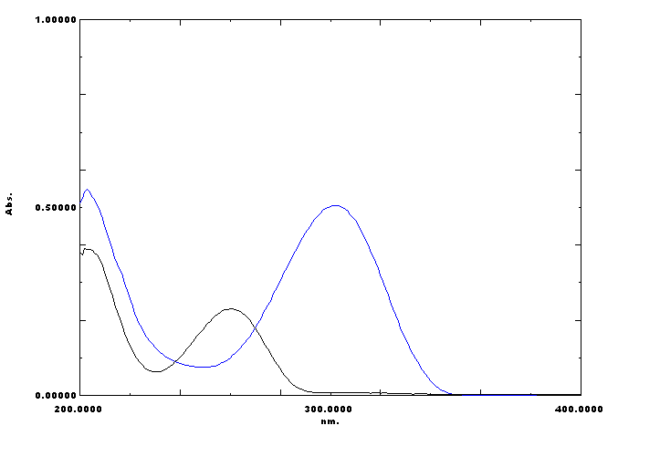

Fig-:01- overlain spectra and selection of wavelength of SOF-261 nm and DAC-302 nm.

2.5 First-Derivative Spectrophotometric Method
Aliquots of standard stock solutions were diluted to obtain concentrations of 5–30 µg/mL for Sofosbuvir and 2–12 µg/mL for Daclatasvir. The spectra were recorded and transformed into first-derivative mode. Quantification was performed at 246 nm for sofosbuvir and 324 nm for Daclatasvir. (FIG-02).

3. Method Validation
The method was validated according to ICH guidelines for the following parameters: (16-20).

3.1 Linearity
The method exhibited excellent linearity over the concentration ranges of:
- Sofosbuvir: 5–30 µg/mL
- Daclatasvir: 2–12 µg/mL
Regression equations:
Sofosbuvir: y = 0.000594x + 0.000185
(r² = 0.9992)
Daclatasvir: y = –0.0018x + 0.0020
(r² = 0.9993)

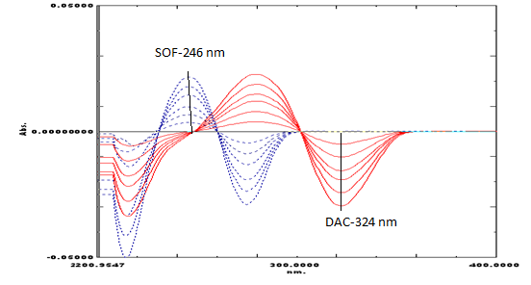
Fig-02- First derivative of sof (5-30 µg/mL) and dac (2-12 µg/mL)

3.2 Accuracy
Accuracy was evaluated by standard addition at 80%, 100%, and 120% levels.

Sofosbuvir
Recovery Level (%) | % Recovery
80 | 98.50
100 | 100.22
120 | 100.19

Daclatasvir
Recovery Level (%) | % Recovery
80 | 97.15
100 | 101.18
120 | 102.25
The recovery results confirmed the accuracy of the proposed method.

3.3 Precision

Intraday Precision
Drug | Concentration (µg/mL) | %RSD
Sofosbuvir | 5 | 0.542
Sofosbuvir | 15 | 0.654
Sofosbuvir | 25 | 1.204
Daclatasvir | 2 | 0.536
Daclatasvir | 6 | 0.175
Daclatasvir | 12 | 0.984

Interday Precision
Drug | Concentration (µg/mL) | %RSD
Sofosbuvir | 5 | 0.536
Sofosbuvir | 15 | 0.724
Sofosbuvir | 25 | 1.292
Daclatasvir | 2 | 0.602
Daclatasvir | 6 | 0.180
Daclatasvir | 12 | 1.020
All %RSD values were below 2%, indicating acceptable precision.

3.4 Assay of Marketed Formulation
The developed method was applied to the analysis of a commercial tablet formulation containing 400 mg Sofosbuvir and 60 mg Daclatasvir.
Drug | Label Claim | Amount Found | % Assay
Sofosbuvir | 400 mg | 399.5 mg | 99.87
Daclatasvir | 60 mg | 59.54 mg | 99.23
The assay results demonstrated the suitability of the method for routine pharmaceutical analysis.

4. Results and Discussion
The first-derivative spectrophotometric method successfully resolved the overlapping spectra of Sofosbuvir and Daclatasvir. Sodium citrate acted as an effective hydrotropic agent, improving drug solubility without interference in the UV region. The method exhibited excellent linearity, accuracy, precision, and assay performance. Validation results complied with ICH acceptance criteria, confirming the reliability of the analytical procedure.

5. Conclusion
A simple, rapid, accurate, and cost-effective first-derivative UV spectrophotometric method was developed and validated for the simultaneous estimation of Sofosbuvir and Daclatasvir in combined tablet dosage forms using 0.1 M sodium citrate as a hydrotropic solvent. The method demonstrated satisfactory validation characteristics and can be successfully employed for routine quality control analysis in pharmaceutical industries and research laboratories.

Acknowledgements
The authors are thankful to the management and Principal Dr. M. Ganga Raju of Gokaraju Rangaraju College of Pharmacy for providing facilities for this research work.

References
- Willard H. H., Merit L.L., Dean F.A., and Settle F.A., “Instrumental Methods of Analysis.”, C.B.S.Publishers, New Delhi, 7th edition , 2002, 580-613.
- ICH/CPMP guidelines Q2A,Text on Validation of Analyticcal Procedure,1994.
- Mohan Vikas, Dr T. Satyanarayana, D. Vinod Kumar, E. Mounika, M. Sri Latha, R. Anusha and Y. Sathish, 2016. Development and Validation of New RP-HPLC Method for the Determination of Sofosbuvir in Pure Form. World Journal of Pharmacy and Pharmaceutical Sciences. 5, 775-781.
- Swathi.P, Rajeswar Dutt.K, RP-HPLC Method Development And Validation For Estimation of Sofosbuvir In Pure And Tablet Dosage Form, Innovat International Journal of Medical & Pharmaceutical Sciences, 2017; 2(4).
- Jeevana Jyothi B *, Padmaja G, Uv Spectrophotometric Method For Estimation Of New Drug, Daclatasvir Dihydrochloride,International Research Journal Of Pharmacy ,2016,volume7,issue-9.
- Ashok Chakravarthy, Method Development And Validation Of Ultraviolet-visible Spectroscopic Method For The Estimation Of Hepatitis-c Drugs - Daclatasvir And Sofosbuvir In Active Pharmaceutical Ingredient Form,Asian journal of Pharmaceutical and Clinical Research,2016,volume 9,issue 3.

- Amira S. Eldin, The Development of A New Validated HPLC and Spectrophotometric Methods for the Simultaneous Determination of Daclatasvir and Sofosbuvir: Antiviral drugs, Journal of Pharmacy and Pharmacology Research 2017,volume 1,issue 1,page no:028-042.
- Khushbu S. Bhavsar, Development And Validation Of Stability Indicating RP- HPLC Method For The Simultaneous Estimation of sofosbuvir and Daclatasvir Dihydrochloride In Solid Dosage Form.World Journal of Pharmacy And Pharmaceutical Sciences, 2018, Vol 7, Issue 3.
- Ravikumar Vejendla, C.V.S. Subramanyam, G. Veerabhadram, 2016. Estimation and Validation of Sofosbuvir in Bulk and Tablet Dosage Form by RP-HPLC. Int J Pharm. 6, 121-127.
- H.M. Lotfy, M. Abdel-Monem Hagazy , Comparative study of novel spectrophotometric methods manipulating ratio spectra: An application on pharmaceutical ternary mixture of omeprazole, tinidazole and clarithromycin, Spectrochim. Act A,96 (2012) 259-270.
- Chakravarthy AV, Sailaja B.B.V, Method development and validation of assay and dissolution methods for the estimation of daclatasvir in tablet dosage forms by reverse phase HPLC, European Journal of Pharmaceutical And Medical Research, 2016; 3(7): 356-364
- Vikas K, Sachin G, Omprakash B, Development , Validation and stability study of UV Spectrophotometric Method for Determination of Daclatasvir in bulk and Pharmaceutical Dosage forms,Int J Chem Tech Res 10 (2017): 281-287.
- Mohammed A. Othman et al, Stability Indicating HPLC Method Development and Validation for Determination of Daclatasvir in Pure and Tablets Dosage Forms., Indo Am. J. P. Sci, 2016; 3(12): 1565-1572.
- Sreekanth Nadig and Jane T Jacob, Quantitative Estimation of DaclatasvirIn Drug Substances and Formulated Drug Product By UPLC, Der Pharmacia Lettre, 2016; 8 (13): 280-284. 7.
- Mounika, M. Sri Latha, R. Anusha and Y. Sathish, 2016. Development and Validation of New RP-HPLC Method for the Determination of Sofosbuvir in Pure Form. World Journal of Pharmacy and Pharmaceutical Sciences. 5, 775-781.
- Tamer Awad Ali, Gehad G. Mohamed, Ali A. Aglan, Fakiha El-Taib Heaka, 2015. Development and Validation of a Stability- Indicating RP-HPLC Method for the Determination of Sofosbuvir in Bulk and Pharmaceutical Dosage Forms. Euroanalysis, 18th Edition
- Srinivasu G, Kumar KN, Thirupathi C, Narayana CL, Murthy CP. Development and Validation of the Chiral HPLC Method for Daclatasvir in Gradient Elution Mode on Amylose-Based Immobilized Chiral Stationary Phase. Chromatographia79 (2016):1457-1467.
- Nannetti G, Messa L, Celegato M, Pagni S, Basso M, Parisi SG. et al. Development and validation of a simple and robust HPLC method with UV detection for quantification of the hepatitis C virus inhibitor daclatasvir in human plasma. J Pharm Biomed Anal 134 (2017):275-281.
- Sumathi K, Thamizhvanan K, Vijayraj S. Development and validation of stability indicating RP-HPLC method for the estimation of Daclatasvir in bulk and formulation. Der Pharm Lett8 (2016):107-113.
- Srinivasu G, Kumar KN, Thirupathi C, Narayana CL, Murthy CP. Development and Validation of the Chiral HPLC Method for Daclatasvir in Gradient Elution Mode on Amylose-Based Immobilized Chiral Stationary Phase. Chromatographia79 (2016):1457-1467.

