Analysis of Seagrass Biodiversity and Carrying Capacity of Coastal Waters at Bama, Baluran National Park, East Java

ABSTRACT
Seagrass ecosystems serve as protective areas and habitats for marine flora and fauna. Bama Beach in Baluran National Park, East Java, has become a popular tourist destination. Consequently, research on the condition of the seagrass and its ecosystem is necessary to recommend. This study aimed to inventory seagrass biodiversity and assess ecological conditions. Measured parameters included seagrass species, absolute and relative density, absolute and relative frequency, absolute and relative cover, and the Importance Value Index (IVI) of seagrass species, alongside aquatic environmental parameters such as substrate type, temperature, transparency, turbidity, pH, salinity, DO, CO₂, and BOD. An exploratory method was employed. The exploration and sampling of seagrass and the measurement of physical and chemical parameters using a transect method; this comprised 10 stations, with each station consisting of 10 plots, each containing 3 subplots. Station coordinates ranged from 7°50'27"S to 7°50'42"S and 114°27'43"E to 114°27'47"E. Seagrass species identification and data analysis, conducted at the Taxonomy and Ecology Laboratories of the Biology Study Program, Faculty of Mathematics and Natural Sciences, State University of Surabaya. The results showed that nine seagrass species were found at Bama Beach. The highest relative density was observed in Enhalus acoroides (33.8%). Regarding relative frequency, the highest value was recorded for Enhalus acoroides (44.17%). The highest relative cover was observed for Cymodocea serrulata (46.65%). The highest Importance Value Index was 96.47% (Enhalus acoroides). Mean water parameters were: temperature 29.26°C, transparency 0.40 m, depth 0.45 m, dissolved solids 37.9 mg/L, current velocity 0.24 m/s, turbidity 4.09 NTU, muddy sand substrate, pH 7.83, salinity 31‰, DO 6.80 ppm, CO₂ 10.55 ppm, and BOD 16.41 ppm; these values ​​generally fall within optimal ranges. It can be concluded that the ecological conditions of the intertidal waters at Bama Beach remain within the optimal range to support seagrass life.
Keywords: seagrass, biodiversity, importance value index, Bama Beach, Baluran National Park

INTRODUCTION
Bama Beach is one of the beaches located within the Baluran National Park area in Situbondo Regency, East Java. It serves as a tourist destination offering natural beauty while playing a vital role in the aquatic ecosystem. One of the biological components found in these waters is seagrass.
Seagrass meadows play a crucial role in shallow marine ecosystems by serving as habitats for fish and other aquatic biota; the total area of ​​seagrass meadows in Indonesia is approximately 30,000 km² (Nontji, 2009). Seagrasses are angiosperms that grow in shallow waters at depths ranging from 0.5 to 10 meters or more (Hemminga and Duarte, 2002). They possess the ability to adapt to marine ecosystems through a rhizome root structure, enabling them to withstand strong ocean currents (Paskalia et al., 2023). Seagrasses provide ecological functions for coastal organisms by contributing to increased biodiversity. Seagrass ecosystems serve as a primary support system for tropical coastal regions (Wicaksono et al., 2012). High primary productivity and complex structural characteristics make seagrass meadows essential habitats and life-support systems for aquatic biota (Kikuchi, 1966). Seagrass ecosystems are characterized by distinct floral community compositions and unique environmental conditions.
Ecologically, the seagrass ecosystem in Baluran National Park serves as a habitat and nutrient source for aquatic heterotrophs, as well as a refuge and breeding ground for fish, sea cucumbers, shrimp, and other organisms. Seagrass beds also stabilize the substrate and facilitate sediment deposition, thereby increasing water clarity (Baluran National Park, 2014). Threats to the survival of seagrass ecosystems stem from both natural causes—such as natural disasters—and human activities. Due to their lack of aesthetic appeal in terms of shape and color, seagrass ecosystems often receive less attention than mangrove forests or coral reefs; consequently, the general public remains largely unaware of the vital roles and functions seagrass plays in shallow-water ecosystems (Nusi et al., 2013). Seagrass ecosystems under stress are susceptible to overexploitation and land reclamation, which can lead to the disappearance of seagrass beds (Takaendengan, 2009). The survival of seagrass ecosystems is at risk unless tangible efforts are made to ensure their protection and maintain ecological balance.
Bama Beach currently serves as a tourist destination, featuring three motorboats—one of which has a capacity of 30 passengers. It is therefore necessary to analyze the impact of these activities on seagrass vegetation diversity at Bama Beach, Baluran National Park. Analyzing seagrass vegetation at Bama Beach involves assessing species, composition, frequency, density, percentage cover, and the importance value index of the seagrass community; this analysis is further supported by measuring environmental conditions—specifically pH, salinity, and temperature—as physicochemical parameters.
The presence of seagrass in coastal ecosystems is heavily influenced by various environmental factors, such as salinity, temperature, and light intensity (Utami et al., 2023). Seagrass plays a crucial role in providing habitats and food sources for diverse marine organisms and contributes to energy and nutrient cycling within aquatic ecosystems. Furthermore, seagrasses help maintain water quality by absorbing excess nutrients and stabilizing sediments, thereby preventing erosion and enhancing water clarity (Mardin et al., 2024).
Seagrasses play a vital role in supporting benthic life by providing shelter, food sources, and protection against currents and other environmental disturbances (Najjad, 2022). This balance reflects the quality of a healthy and sustainable aquatic ecosystem (Omar, 2021). Analyzing the relationship between environmental parameters and seagrass diversity is crucial for revealing the ecological condition of a coastal area (Agustina, 2023).
The presence and distribution of seagrass are heavily influenced by aquatic environmental parameters, including temperature, salinity, pH, dissolved oxygen, and substrate type (Inayyah, 2023). These parameters determine the habitat's carrying capacity for seagrass to fulfill its ecological role (Churiyyah, 2020). Environmental stability enables balanced ecological interactions between biotic and abiotic components (Maryati, 2023).
Research by Isnaini and Aryawati (2023) reveals that seagrass density in Lampung Bay is significantly influenced by environmental parameters such as salinity, nutrient content (nitrate and phosphate), and sediment characteristics. As coastal flora thriving under optimal environmental conditions, seagrass plays a key role in providing habitat, protection, and food sources for various benthic organisms. Previous studies indicate that the stability of abiotic factors is a primary determinant of seagrass distribution and species composition.
Understanding the relationship between environmental parameters and seagrass distribution patterns provides a comprehensive overview of ecosystem dynamics in coastal areas (Hendrawan, 2022). Although extensive research has been conducted on the influence of environmental parameters on seagrass distribution patterns along Indonesia's coasts, studies specifically examining how parameters such as temperature, pH, and salinity affect seagrass at Bama Beach, Situbondo, remain very limited. Therefore, this study is crucial for specifically understanding the influence of environmental parameters on seagrass species, thereby supporting science-based conservation and area management efforts (Junaidi, 2020). As part of the Baluran National Park conservation area, Bama Beach possesses high biodiversity and requires ecologically based management to ensure its sustainability (Hasanah, 2023).
Research examining the relationship between physicochemical water conditions and seagrass diversity in this region will make a significant contribution to the formulation of adaptive and sustainable coastal management policies (Husadah, 2021). It is crucial to conduct research on seagrass biodiversity and environmental conditions at Bama Beach, East Java, to obtain comprehensive data regarding the ecosystem's status and potential threats (Inayyah, 2023).
This study aims to assess environmental conditions and inventory seagrass biodiversity at Bama Beach, Baluran National Park, East Java. The specific objectives are to identify seagrass species at the site; determine diversity and community density indices; calculate the importance value of the constituent seagrass species; and evaluate the environmental conditions of the seagrass ecosystem. This research proposal aligns with the UNESA Research Strategic Plan (2020–2024), specifically supporting UNESA’s priority focus on Science and Technology research, with a particular emphasis on Natural Resource Conservation.

RESEARCH METHODS

The study was conducted in the waters of Bama Beach, Baluran National Park, East Java, in May 2024. An observational method was employed, involving direct field observation of the study subjects.
Figure 1. Research location: Bama Beach, Baluran National Park, Situbondo, East Java (Source: Google Earth, 2024)
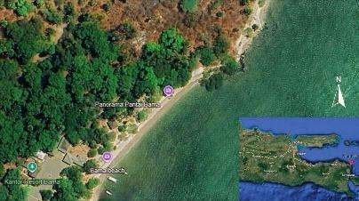

Table 1. Coordinate Points of Sampling Stations
Station | Coordinates
1 | 7°50'36.1"S 114°27'44.5''E
2 | 7°50'36.1"S 114°27'43"E
3 | 7°50'35.1"S 114°27'44.8"E
4 | 7°50'27"S 114°27'47"E
5 | 7°50'34"S 114°27'45"E
6 | 7°50'36"S 114°27'45.2"E
7 | 7°50'35.7"S 114°27'45.6"E
8 | 7°50'42"S 114°27'43"E
9  10 | 7°50'34"S 114°27'46"E  7°50'33''S 114°27'46"E
The research was carried out in two stages. Stage 1 involved an inventory of seagrass species and the measurement of physical and chemical environmental parameters in the waters of Bama Beach, Baluran National Park, using the transect method. Seagrass sampling was conducted at 10 stations spaced 20 meters apart; each station comprised 10 substations, with three 1x1 m² sampling plots established within each substation. The number of individual seagrass plants in each plot was recorded visually. Samples were collected manually and placed in containers for identification. Preliminary identification was performed on-site using graph paper, and visual documentation was captured via mobile phone camera. Further specimen identification and scientific name confirmation were conducted by referencing the World Register of Marine Species (WoRMS) and trusted scientific journals. Seagrass identification was based on morphological characteristics. To assess the environmental carrying capacity of Bama Beach for seagrass vegetation, physical and chemical parameters were measured, including substrate type, water transparency, turbidity, temperature, pH, salinity, dissolved oxygen (DO) levels, CO2, and BOD. Measurements were taken in situ during sampling. Seagrass specimens that could not be identified in situ were placed in plastic bags, labeled with the sampling location, and transported to the laboratory for further identification using seagrass identification manuals.
Stage 2 of the research involved seagrass species identification and data analysis. The following formulas were used to calculate absolute density, relative density, absolute frequency, relative frequency, absolute and relative cover, and the importance value of seagrass at Bama Beach, Baluran National Park, East Java.
a. Absolute Density and Relative Density
Absolute density refers to the number of individuals of a specific taxon within each station plot. Absolute density is calculated using the formula: Di$=\frac{Ni}{A}$
Relative density is the ratio of the number of individuals of a specific species to the total number of individuals of all species; it aims to determine the percentage contribution of each species to the total count of all species (Odum et al., 1998). Relative density is calculated using the formula:
DR$=\frac{ni}{∑ni}$× 100%.
b. Absolute Frequency and Relative Frequency
Absolute frequency represents the likelihood of a species being found within the observed sample points; this measure aims to determine the distribution of the seagrass species within a community. Species with high frequency values ​​generally possess greater adaptability to varying environmental factors. Absolute frequency is calculated using the formula: F= $\frac{Pi}{∑Pi}$ .
Relative frequency is the ratio of the frequency of the i-th category to the total frequency of all categories. Relative frequency is calculated using the formula:
FR= $\frac{Fi}{∑Fi}$ x 100%.
c. Absolute Cover and Relative Cover
Species cover refers to the area covered by a seagrass species. Seagrass species cover is calculated using the formula: C = $\frac{∑Mi x Fi}{\sum{}F}$ where Mi is the midpoint of the i-th class.
Relative cover is the ratio of the individual cover of the i-th species to the total cover of all species. Relative cover is calculated using the formula PR = $\frac{PJ}{∑PJ}x100\%$.
d. Importance Value Index (IVI)
The Importance Value Index is used to calculate the overall role of seagrass species within a community. It is calculated using the formula: IVI = DR + FR + PR.
e. Environmental Conditions of the Seagrass Ecosystem
The physicochemical parameters of the seagrass ecosystem's aquatic environment were compared against marine environmental quality standards (Decree of the Minister of Environment No. 51 of 2004 concerning the Implementation of Environmental Protection and Management).

RESULTS AND DISCUSSION

1. Types, Relative Density, Relative Frequency, Relative Coverage, and Importance Value Index of Seagrasses at Bama Beach, Baluran National Park, East Java
Vegetation analysis of the species constituting the seagrass meadow community at Bama Beach, Baluran National Park, East Java, identified nine seagrass species: Enhalus acoroides, Thalassia testudinum, Posidonia oceanica, Thalassia hemprichii, Zostera marina, Cymodocea rotundata, Syringodium isoetifolium, Halophila ovalis, and Cymodocea serrulata (Table 2).
Based on Table 3, the seagrass community structure at Bama Beach, Baluran National Park, consists of nine species with a total of 2,437 individuals. The species Enhalus acoroides had a total of 824 individuals found across 53 observation plots. The absolute density value for this species was 8.24, with a relative density of 33.81%. The absolute frequency was 0.44, while the relative frequency was 44.17%. Absolute coverage was recorded at 27.00, with a relative coverage of 18.49%. This species had an importance value index of 96.47%.
The species Thalassia testudinum had a total of 351 individuals found across 10 observation plots. The absolute density value for this species was 3.51, with a relative density of 14.40%. The absolute frequency was 0.08, while the relative frequency was 8.33%. Absolute coverage was recorded at 8, with a relative coverage of 5.14%. This species had an importance value index of 27.87%.

Table 2. Seagrass species at Bama Beach, Baluran National Park, East Java.
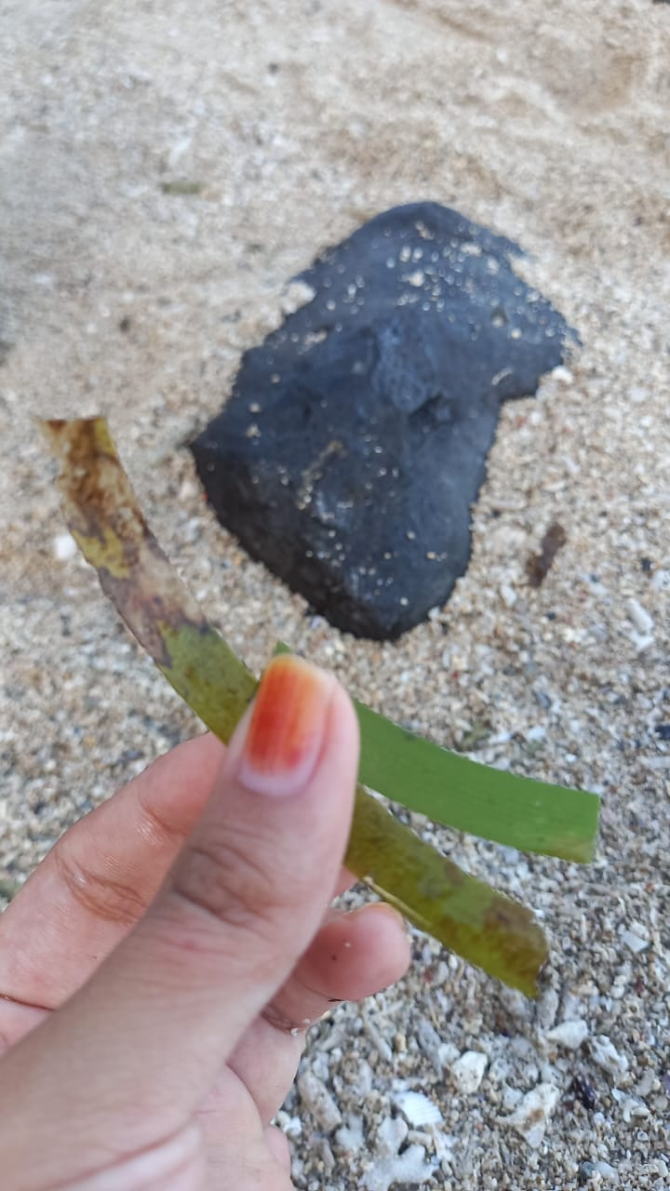  Figure 1. Enhalus acoroides | 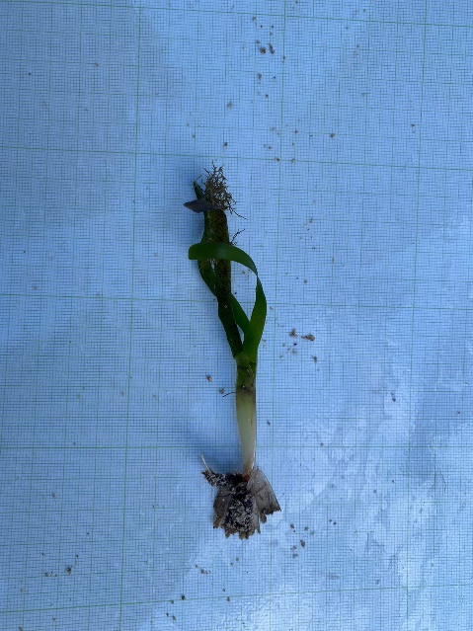  Figure 2. Thalassia testudinum Bankshsol | 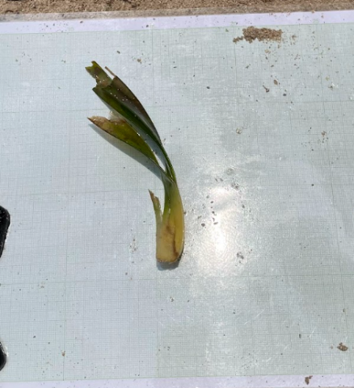  Figure 3. Posidonia oceanica
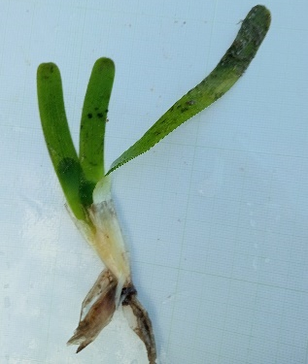  Figure 4. Thalasia hemprichii | 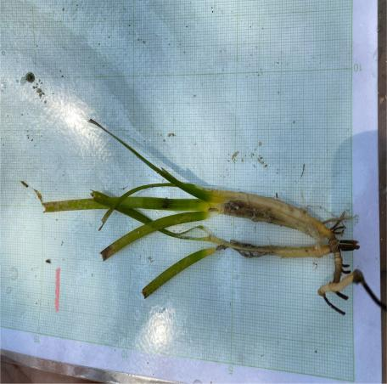  Figure 5. Zostera Marina | 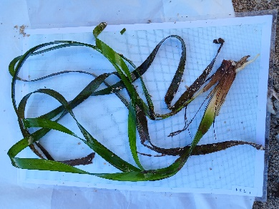  Figure 6. Cymodocea rotundata
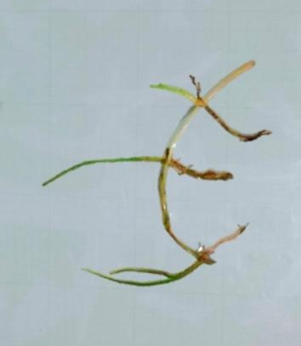  Figure 7. Syringodium isoetifolium | 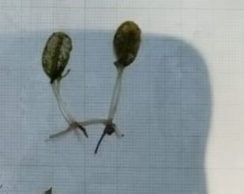  Figure 8. Halophilla ovaalis | 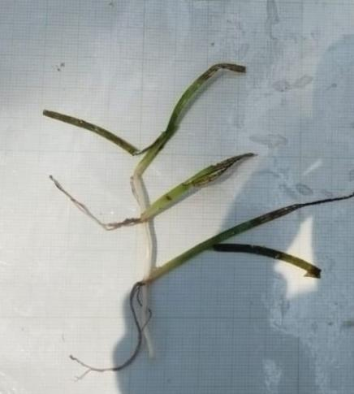  Figure 9. Cymodocea serulata

A total of 351 individuals of the species Thalassia testudinum were found across 10 observation plots. The absolute density of this species was 3.51, with a relative density of 14.40%. The absolute frequency was 0.08, while the relative frequency was 8.33%. Absolute cover was recorded at 8, and relative cover at 5.14%. This species had an importance value index of 27.87%.
A total of 434 individuals of the species Posidonia oceanica were found across 10 observation plots. The absolute density of this species was 4.34, with a relative density of 17.81%. The absolute frequency was 0.08, while the relative frequency was 8.33%. Absolute cover was recorded at 2.61, and relative cover at 1.79%. This species had an importance value index of 27.93%.
A total of 116 individuals of the species Thalassia hemprichii were found across 12 observation plots. The absolute density of this species was 1.16, with a relative density of 4.76%. The absolute frequency was 0.10, while the relative frequency was 10.00%. Absolute cover was recorded at 3, and relative cover at 2.29%. This species had an importance value index of 17.05%.
A total of 287 individuals of the species Zostera marina were found across 10 observation plots. The absolute density of this species was 2.87, with a relative density of 11.78%. The absolute frequency was 0.08, while the relative frequency was 8.33%. Absolute cover was recorded at 28.70, and relative cover at 19.65%. This species had an importance value index of 39.76%. A total of 13 individuals of the species Cymodocea rotundata were found across five observation plots. The absolute density of this species was 0.13, with a relative density of 0.53%. The absolute frequency was 0.04, while the relative frequency was 4.17%. Absolute cover was recorded at 1.87, and relative cover at 1.28%. The species had an importance value index of 5.98%.
The species Syringodium isoetifolium had a total of 160 individuals found across 6 observation plots. Its absolute density was 1.60, with a relative density of 6.57%. The absolute frequency was 0.05, while the relative frequency was 5.00%. Absolute cover was recorded at 1.87, and relative cover at 1.28%. This species had an importance value index of 12.85%.
The species Halophila ovalis had a total of 35 individuals found across 4 observation plots. Its absolute density was 0.35, with a relative density of 0.014%. The absolute frequency was 0.03, while the relative frequency was 3.33%. Absolute cover was recorded at 5.00, and relative cover at 3.43%. This species had an importance value index of 8.20%.
The species Cymodocea serrulata had a total of 217 individuals found across 10 observation plots. Its absolute density was 2.17, with a relative density of 8.90%. The absolute frequency was 0.08, while the relative frequency was 8.33%. Absolute cover was recorded at 68.13, and relative cover at 46.65%. This species had an importance value index of 63.89%.
Table 2 shows that nine seagrass species were found at Bama Beach, with varying numbers of individuals at each observation station. All seagrass species found exhibited a clumped distribution pattern. The species with the highest count was *Enhalus acoroides*, with a total of 824 individuals. This species was found at all observation stations (stations 1–10) across 53 plots. Meanwhile, the flora species with the lowest count was Cymodocea rotundata, with a total of 13 individuals. This species was found at only a few observation stations across five plots.

Table 3. Results of Seagrass Community Structure Analysis at Bama Beach, Baluran National Park, East Java
No. | Species | Number of Individual | X² | Total Plots Where Species-i Was Found | Dencity |  | Frekuency |  | Closing |  | IVI (%)
 |  |  |  |  | Absolute | Relative (%) | Absolute | Relative (%) | Absolute | Relative (%) | IVI (%)
1. | Enhalus acoroides | 824 | 678976 | 53 | 8,24 | 33,8 | 0,44 | 44,17 | 27,00 | 18,49 | 96,47
2. | Thalassia testudinum | 351 | 123201 | 10 | 3,51 | 14,40 | 0,08 | 8,33 | 8 | 5,14 | 27,87
3. | Posidonia oceanica | 434 | 188356 | 10 | 4,34 | 17,81 | 0,08 | 8,33 | 2,61 | 1,79 | 27,93
4. | Thalassia hemprichii | 116 | 13456 | 12 | 1,16 | 4,76 | 0,10 | 10,00 | 3 | 2.29 | 17,05
5. | Zostera marina | 287 | 82369 | 10 | 2,87 | 11,78 | 0,08 | 8,33 | 28,70 | 19,65 | 39,76
6. | Cymodocea rotundata | 13 | 169 | 5 | 0,13 | 0,53 | 0,04 | 4,17 | 1,87 | 1,28 | 5,98
7. | Syringodium isoetifolium | 160 | 25600 | 6 | 1,60 | 6,57 | 0,05 | 5,00 | 1,87 | 1,28 | 12,85
8. | Halophila ovaalis | 35 | 1225 | 4 | 0,35 | 0,014 | 0,03 | 3,33 | 5,00 | 3,43 | 8,20
9. | Cymodocea serulata | 217 | 47089 | 10 | 2,17 | 8,90 | 0,08 | 8,33 | 68,13 | 46,65 | 63,89
Total |  | 2437 | 1160441 | 120 | 24,37 | 100,00 | 1,00 | 100,00 | 146,03 | 100,00 | 300,00

Table 4. Measurement Results of Physicochemical Parameters of the Seagrass Ecosystem at Bama Beach, Baluran National Park, East Java
Parameter | Station |  |  |  |  |  |  |  |  |  | Average
Parameter | 1 | 2 | 3 | 4 | 5 | 6 | 7 | 8 | 9 | 10 | Average
Temperature (°C) | 30,00 | 29,33 | 30,00 | 29,67 | 28,00 | 29,30 | 29,26 | 28,00 | 29,70 | 29,30 | 29,26
Transparency | 0,31 | 0,50 | 0,49 | 0,49 | 0,17 | 0,36 | 0,46 | 0,46 | 0,41 | 0,35 | 0,40
Depth | 0,35 | 0,50 | 0,54 | 0,50 | 0,32 | 0,47 | 0,54 | 0,46 | 0,42 | 0,40 | 0,45
Dissolved solids | 8488 | 923 | 7420,6 | 555 | 9036 | 8175,6 | 814,1 | 827 | 847,6 | 849 | 3791
Current velocity | 0,01 | 0,02 | 0,02 | 0,03 | 0,05 | 0,06 | 0,40 | 0,05 | 0,46 | 1,28 | 0,24
Turbidity | 2,62 | 4,43 | 3,37 | 3,40 | 4,38 | 4,25 | 3,83 | 4,79 | 4,66 | 5,18 | 4,09
pH | 7,15 | 7,74 | 8,00 | 7,76 | 8,06 | 7,84 | 8,03 | 7,96 | 7,93 | 7,87 | 7,83
Salinity (%) | 31 | 31 | 31 | 31 | 31 | 31 | 31 | 31 | 31 | 31 | 31
DO (^{mg}/_{L}) | 7,52 | 7,64 | 7,24 | 7,53 | 7,38 | 6,22 | 6,17 | 5,86 | 6,47 | 5,93 | 6,80
CO₂ (^{mg}/_{L}) | 10 | 10 | 9,16 | 2,5 | 10 | 10 | 20 | 25 | 6,30 | 2,50 | 10,55
BOD | 18,43 | 18,32 | 17,64 | 16,37 | 16,97 | 15,65 | 14,64 | 15,65 | 15,26 | 15,18 | 16,41

Table 5. Substrate types in the coastal waters of Bama, Baluran National Park, East Java.
Station number | Substrate type
1 | Muddy sand
2 | Muddy sand
3 | Muddy sand
4 | Muddy sand
5 | Muddy sand
6 | Muddy sand
7 | Muddy sand
8 | Muddy sand
9 | Muddy sand
10 | Muddy sand
average | Muddy sand
Based on the analysis of the seagrass community structure at Bama Beach, Baluran National Park, East Java (Table 2), Enhalus acoroides was the dominant species across the 10 sampling stations, as it was found at every location. Consequently, Enhalus acoroides exhibited the highest Importance Value Index (IVI) at 96.47%, establishing it as the dominant seagrass species within the Bama Beach ecosystem.
Absolute densities varied among the seagrass species. Variations in seagrass density across stations were reflected in the total species stand counts. Enhalus acoroides showed the highest relative density at 33.81%, while Halophila ovalis showed the lowest at 0.014%. This variation is attributed to differences in sampling station locations; areas further from the shoreline tend to exhibit higher relative densities compared to those closer to the shore (Siregar, 2022).
Enhalus acoroides also recorded the highest frequency values, with an absolute frequency of 0.44 and a relative frequency of 44.17%. This is because the species was present at nearly every observation station, dominating the area from Station 1 through Station 10. Its high adaptability to various substrate types—particularly sand and muddy sand, which match the conditions at the different stations—is likely a key factor contributing to the dominance of Enhalus acoroides. Furthermore, the species' relatively rapid growth rate compared to other seagrasses supports its widespread distribution and high frequency (Sari et al., 2021).
The highest seagrass coverage was observed in the species Enhalus acoroides, with an absolute coverage value of 27.00 and a relative coverage of 18.49%; this was attributed to tidal conditions during the observation. During low tide, the measured coverage area is high, whereas during high tide, seagrass coverage appears to decrease because the leaf blades stand upright when submerged. Seagrass morphology also influences the extent of coverage: wider leaf blades result in greater coverage area, while narrower leaf blades result in less coverage (Siregar, 2022). The Importance Value Index (IVI) is used to measure a specific seagrass species' contribution to the overall seagrass community. IVI values ​​are influenced by frequency, dominance, and the percentage of seagrass coverage. A high IVI value indicates dominance and a significant ecological role for the species. The highest IVI value was recorded for Enhalus acoroides at 96.47%. This differs from the findings of Riswati and Effensi (2020), who reported the highest IVI for Thalassia hemprichii, a discrepancy attributed to differences in the study locations.
2. Physicochemical Parameters of the Seagrass Ecosystem Environment at Bama Beach, Baluran National Park, East Java
Water quality analysis based on physicochemical parameters at Bama Beach revealed an average pH of 7.83 across the 10 sampling stations. This pH level falls within the range established by seawater quality standards for marine biota—specifically between 7.0 and 8.5 (Saraswati et al., 2017). Imbalances in water pH can affect aquatic productivity. Field data showed a pH range of 7.15 to 8.06, indicating optimal levels that remain within the quality thresholds for marine waters. According to the State Minister for the Environment Decree No. 51 of 2004, the pH quality standard for seagrass growth is between 7.0 and 8.0. These findings are supported by research (Mabrouk et al., 2021) indicating that the optimal pH range for seagrass growth is 6.5 to 8.5. Based on this analysis, the pH levels in the waters of Bama Beach, Baluran National Park, meet optimal standards, thereby allowing seagrass to thrive in the area. Rising pH levels are associated with the impacts of global warming, leading to seawater acidification that is detrimental to marine life; however, seagrass possesses the ability to absorb and store carbon, which tends to mitigate acidification in surrounding waters (Retno et al., 2017). The average water temperature at Bama Beach was 29.26°C. This temperature range supports seagrass life in accordance with the State Minister for the Environment Decree No. 51 of 2004. Given that the temperature range for seagrass growth is between 25°C and 35°C, the average temperature recorded across the 10 stations is considered favorable for seagrass growth. Among the environmental factors observed, temperature—ranging from 10°C to 35°C—was the specific factor that significantly influenced seagrass productivity. This is because water temperature levels influence the process of photosynthesis in seagrass (Rayyis et al., 2021).
The average water salinity at Bama Beach is 31‰, which exceeds the ideal range for tropical seagrasses—typically 1.5% to 3% (15–30‰). This condition imposes significant osmotic stress on the seagrass. Nevertheless, high salinity tends to restrict seagrass distribution to specific areas, resulting in a clumped distribution pattern (Sahalessy et al., 2023). Salinity can influence seagrass growth and photosynthetic capacity. Hartati et al. (2018) noted that salinity affects seagrass density, a relationship linked to the fact that nutrient uptake is heavily influenced by salinity levels. While the optimal salinity range for seagrass is 20–30 ppt, the recorded salinity at Bama Beach (Baluran National Park) was 31 ppt—exceeding the optimum. However, the seagrass is able to survive and grow—albeit not at peak capacity—because the environment provides a suitable pH level.
Other physicochemical water parameters—including water clarity, depth, dissolved solids, turbidity, current velocity, dissolved oxygen, CO2, and BOD—meet the quality standards necessary to support seagrass survival. Water quality parameters play a crucial role in maintaining seagrass viability in the marine environment. This study observed specific physicochemical oceanographic parameters: temperature, pH, and salinity. Experts have documented significant impacts of temperature changes on seagrass, particularly regarding metabolism, nutrient uptake, and survival. Although seagrass meadows are geographically widespread, there is considerable variation in tolerance to temperature fluctuations. Tropical seagrasses exhibit low tolerance to temperature fluctuations; the optimal temperature range for these species is 28–30°C. Seagrass photosynthesis rates decline significantly when water temperatures fall outside this optimal range. Consequently, numerous seagrass species are able to thrive in the waters off Bama Beach, Baluran National Park (Retno et al., 2017). Furthermore, Tables 3 and 4 indicate that the pH, temperature, salinity, and muddy-sand substrate in the waters of Bama Beach, Baluran National Park, remain within the optimal range for seagrass growth.
Based on seawater quality standards for marine biota and marine tourism categories—as stipulated in the Decree of the Minister of Environment No. 51 of 2004 concerning the Implementation of Environmental Protection and Management—the pH standard for marine waters is set within the range of 7.0 to 8.5. According to Apriyunita et al. (2024), the recorded pH values ​​indicate that water conditions are relatively stable and free from significant acidic or alkaline pollution, thereby supporting the survival of seagrass at Bama Beach, Baluran National Park, East Java.

CONCLUSION
Based on the research conducted, it is concluded that nine seagrass species can be identified in the Bama Beach area of ​​Baluran National Park, East Java. Aquatic environmental parameters—specifically physical and chemical factors such as temperature, pH, and salinity—generally remain within the optimal range for seagrass life. The results demonstrate a relationship between physicochemical environmental parameters and the condition of the seagrass; the stability of these parameters contributes to seagrass abundance and distribution. This study underscores the importance of maintaining water quality to support the long-term sustainability of the seagrass ecosystem.

ACKNOWLEDGEMENTS
The author extends sincere gratitude to all parties who provided assistance and support during the conduct of this research, particularly Universitas Negeri Surabaya for funding the study and the students who assisted with data collection. Appreciation is also extended to the Baluran National Park Authority—specifically the staff managing Bama Beach—for granting permission and providing technical assistance during fieldwork. May all contributions and support provided be duly rewarded.

REFERENCES
- Agustina, R. (2023). Relationship between environmental parameters and the distribution of benthic organisms and coastal vegetation. Jurnal Ekologi Perairan, 18(2), 101–112.
- Apriyunita, S.-, Retnawaty, S. F., & Fitri, Y. (2024). Analysis of changes in pH, temperature, and COD characteristics of hospital wastewater in relation to changes in activity volume and capacity. Jurnal Rekayasa Hijau, 8(3), 285–296.
- Churiyyah, N. (2020). The influence of habitat quality on the carrying capacity of benthic ecosystems in coastal waters. Marine Biodiversity Journal, 14(1), 55–65.
- Hartati, R., Widianingsih, W., Santoso, A., Endrawati, H., Zainuri, M., Riniatsih, I., & Mahendrajaya, R. T. (2017). Variation in seagrass species composition and density in the waters of Ujung Piring, Jepara Regency. Jurnal Kelautan Tropis, 20(2): 96-105.
- Hartati, R., Zainuri, M., Ambariyanto, A., Trianto, A. & Mahendrajaya, R.T., (2018). Similarity microalgal epiphyte composition on seagrass of Enhalus acoroides and Thalasia hemprichii from different waters. IOP Conference Series: Earth and Environmental Science, 139(1)
- Hasanah. (2023). Biodiversity-based coastal area conservation in Baluran National Park. Malang: BioKonservasi Press
- Hemminga, M., & Duarte, C. (2002). Seagrass ecology. In Limnology and Oceanography, 611.
- Hendrawan. (2022). Coastal ecosystem dynamics: A perspective on benthic flora and fauna. Yogyakarta: Pantai Lestari Publishing.
- Husadah. (2021). Adaptive and sustainable coastal zone management policy. Bandung: Maritim Press.
- Inayyah. (2023). Ecological study of Bama Beach: Interactions between environmental parameters and biota distribution. Surabaya: Ekosains Nusantara.
- Isnaini, I., & Aryawati, R. (2023). Seagrass density and its relationship with environmental parameters in the coastal waters of Lampung Bay. Buletin Oseanografi Marina, 12(3): 331–339.
- Junaidi. (2020). Science-based conservation and management of coastal areas. Jakarta: Pesisir Research Institute.
- Kikuchi, T. (1966). An ecological study on animal communities of the Zostera marina belt in Tomioka Bay, Amakusa, Kyushu. Publish Amakusa Marine Biology Laboratory, 1-106.
- Mabrouk, L., Hamza, A., Mahfoudi, M. & Bradai, M.N., (2012). Spatial and temporal variations of epiphytic Ostreopsis siamensis on Posidonia oceanica (L.) Delile leaves in Mahdia (Tunisia). CBM-Cahiers de Biologie Marine, 53(4):419.
- Mardin, H., Husain, I. H., Latjompoh, M., Ahmad, J., & Lamangantjo, C. J. (2024). Utilization of Coastal Biodiversity for Disaster Mitigation: A Project-Based Learning Approach at SMK Negeri 1 Batudaa Pantai, Gorontalo Province. Jurnal Pengabdian Masyarakat: Darma Bakti Teuku Umar, 6(1), 119-128.
- Maryati. (2023). Ecological interactions in tropical coastal ecosystems. Bogor: Tropika Press.
- Najjad. (2022). The role of seagrass in supporting the life of benthic organisms. Makassar: Bina Laut Publisher.
- Nontji, A. (2009). Seagrass ecosystem rehabilitation in coastal resource management. Jakarta: 1st National Workshop on Seagrass Ecosystem Management.
- Nusi, S., Olii, A., & Syamsuddin. (2013). Seagrass vegetation structure in the waters of Saronde Island, Ponelo Kepulauan District, North Gorontalo Regency.
- Omar. (2021). Ecological balance and water quality indicators in coastal areas. Denpasar: Samudera Ilmu.
- Odum et al. (1998). Fundamentals of Ecology. Gadjah Mada University Press, UGM Press, Gadjah Mada University.
- Paskalia, E., Jailani, & Taru, P. (2023). Seagrass vegetation distribution patterns based on depth variations in the waters of Malahing, Bontang City. Tropical Aquatic Science, 78-84.
- Rayyis, A., Suryono, S., & Supriyantini, E. (2021). The influence of sediment nitrate and phosphate on seagrass density in Jepara. Journal of Marine Research, 10(2), 259–266. Retno, H., Widianingsih, & Adi, S. (2017). Variation in Seagrass Species Composition and Density in the Waters of Ujung Piring, Jepara Regency. Jurnal Kelautan Tropis, 20(2): 96–105.
- Riswati, M., & Efendy, M. (2020). Analysis of Seagrass Distribution Using Remote Sensing Techniques on Sapudi Island, Sumenep Regency. Juvenil: Jurnal Ilmiah Kelautan Dan Perikanan, 1(2), 250–259.
- Sari, R. M., Kurniawan, D., & Sabriyati, D. (2021). Seagrass Density and Distribution Patterns Based on Community Activities in the Waters of Pengujan, Bintan Regency. Journal of Marine Research, 10(4): 527-534.
- Siregar, A. O. (2022). Mapping Seagrass Distribution and Cover Using Sentinel-2 Satellite Imagery on Dua Island, Enggano District, Bengkulu Province. Jurnal Laut Khatulistiwa, 5(3): 125.
- Takaendengan, K. (2009). Seagrass Species Composition and Cover in the Waters of West Likupang, North Sulawesi. Bitung Marine Biota Conservation Center (UPT Loka Konservasi Biota Laut Bitung).
- Utami, T., Risnita, Wica E., Ayub, S., & Ari, A. (2023). Study on Seagrass Species Density and Cover in the Waters of Enggano, Bengkulu. Journal of Indonesian Tropical Fisheries, 6(2): 2655-5883.
- Wicaksono, S., Widianingsih, & Hartati, S. (2012). Vegetation Structure and Seagrass Species Density in the Waters of the Karimunjawa Islands, Jepara Regency. Journal of Marine Research, 1-7.

