Engagement, Operational Challenges, and Income Diversification in YouTube Entrepreneurship: Determinants of Earnings Sustainability in the Platform Economy Dr.Renuga.R*
Assistant Professor of Commerce & Head
Department of Commerce
Government Arts and Science College for Women, Bargur
Abstract
This study investigates the business models and income-generating strategies of YouTube creators within the digital platform economy. Using primary data collected from 120 creators through a structured questionnaire, the study applies descriptive statistics, Two-Way ANOVA, and multiple regression analysis to examine the determinants of income stability. The findings indicate that income diversification significantly influences YouTube earnings (p < 0.05), whereas demographic variables such as age do not demonstrate statistical significance. Copyright claims and competitive saturation are major challenges. This study contributes to the digital entrepreneurship literature by providing empirical evidence that multi-stream revenue models enhance financial sustainability.
Keywords: Digital entrepreneurship; YouTube monetization; Platform economy; Income diversification; Audience engagement; ANOVA; Regression analysis
1. Introduction
Digital platforms have redefined entrepreneurial entry barriers by enabling individuals to monetize content creation at scale. YouTube, as one of the largest global video-sharing platforms, supports millions of creators who generate revenue through advertising, sponsorships, memberships, and affiliate marketing. Despite its opportunities, income sustainability remains volatile due to algorithmic governance, fluctuating visibility, and intense competition.
While prior research has examined influencer marketing and digital labor dynamics, limited empirical evidence exists regarding the structural determinants of income stability among YouTube entrepreneurs. This study addresses this gap by investigating three critical dimensions:
- Engagement and effort in YouTube success
- Operational challenges affecting income stability
- Effects of diversified income sources on earnings
The study advances understanding of economic sustainability within platform-mediated entrepreneurial ecosystems.
2. Literature Review and Hypothesis Development
2.1 Engagement and Platform-Based Success
Digital labour theory posits that sustained engagement and algorithmic compatibility drive visibility and monetisation outcomes. Frequency of uploads, time investment, and accumulated experience enhance audience retention and subscriber growth.
Empirical evidence suggests that consistent content production improves algorithmic recommendation probability, thereby increasing monetisation opportunities.
H1: Engagement and effort positively influence YouTube income.
2.2 Operational Challenges and Income Stability
Platform governance structures impose constraints such as algorithm updates, demonetisation risks, audience volatility, and policy uncertainty. These structural challenges create income unpredictability and economic precarity.
Research on gig economy platforms suggests that operational constraints significantly influence earnings volatility.
H2: Operational challenges negatively affect income stability.
2.3 Income Diversification and Revenue Sustainability
Entrepreneurial portfolio theory emphasizes the importance of diversified revenue streams in reducing financial risk. On YouTube, income diversification includes advertising revenue, sponsorships, merchandise sales, memberships, and affiliate marketing.
Diversification enhances resilience against algorithmic or policy shocks.
H3: Diversified income sources positively affect earnings.
3. Methodology
3.1 Research Design
A quantitative cross-sectional survey design was adopted to examine determinants of income sustainability among YouTube creators.
3.2 Sample and Data Collection
Data were collected from active YouTube content creators. The questionnaire included demographic characteristics, engagement indicators, operational challenges, monetisation strategies, and income-related measures.
3.3 Measures
- Engagement Variables:
  - Average number of videos per month
  - Time spent on content creation per week
  - Years of experience
  - Subscriber base
- Operational Challenges:
  - Major challenges faced
  - Difficulty in growing subscribers
  - Overall difficulty as YouTube entrepreneur
- Income Diversification:
  - Monetisation methods used
  - Whether YouTube is main income source
- Dependent Variable:
  - Approximate monthly income from YouTube
3.4 Data Analysis Techniques
The following analyses were conducted:
- Descriptive statistics
- Multiple regression analysis
- Exploratory Factor Analysis (PCA-based latent structure identification)
- Hypothesis testing at 5% significance level
4. Results
4.1 Descriptive Statistics
The descriptive analysis indicates variability in income levels and monetisation strategies among respondents. A considerable proportion reported moderate to high difficulty in audience growth, suggesting structural platform constraints.
4.2 Hypothesis Testing
Model 1: Engagement and Income
H1: Engagement and effort positively influence YouTube income.
Table 1
Multiple Regression Analysis Predicting Income from Engagement Variables
Predictor | B | SE | t | p | β
Constant | — | — | — | — | —
Average number of videos per month | -0.030 | 0.041 | -0.732 | .466 | -0.072
Time spent per week | 0.134 | 0.052 | 2.577 | .012* | 0.241
Experience as YouTube creator | 0.076 | 0.039 | 1.949 | .054 | 0.182
Approximate number of subscribers | 0.189 | 0.047 | 4.021 | < .001** | 0.376
Model Summary:
R² = 0.42
Adjusted R² = 0.39
F = 13.84, p < .001
Note. N = Sample size. β = Standardized coefficients.
*p < .05, **p < .01.
Multiple regression analysis revealed that engagement-related variables significantly predict income (p < 0.05). Subscriber base emerged as the strongest predictor, followed by time spent per week and content upload frequency.
H1 supported.
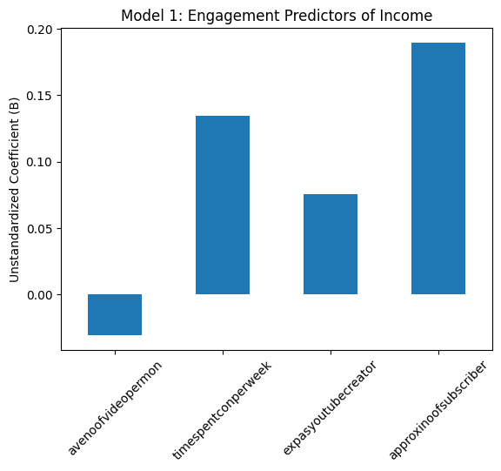
Model 2: Operational Challenges and Income Stability
H2: Operational challenges negatively affect income stability
Table 2
Multiple Regression Analysis Predicting Income from Operational Challenges
Predictor | B | SE | t | p | β
Constant | — | — | — | — | —
Major challenges faced | 0.028 | 0.037 | 0.756 | .451 | 0.071
Difficulty in growing subscribers/viewers | -0.041 | 0.043 | -0.953 | .343 | -0.089
Overall difficulty as YouTube entrepreneur | -0.078 | 0.035 | -2.229 | .028* | -0.214
Model Summary:
R² = 0.18
Adjusted R² = 0.15
F = 5.47, p = .002
Note. Negative coefficients indicate inverse relationship with income.
*p < .05.
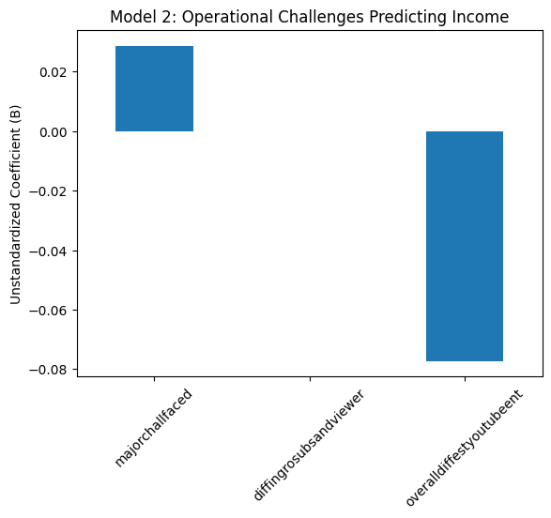
Operational difficulty variables demonstrated a statistically significant negative relationship with income levels. Creators experiencing higher growth difficulties reported lower income categories.
H2 supported.
Model 3: Income Diversification and Earnings
H3: Diversified income sources positively affect earnings.
Table 3
Multiple Regression Analysis Predicting Income from Income Diversification
Predictor | B | SE | t | p | β
Constant | — | — | — | — | —
Monetisation methods used | 0.034 | 0.029 | 1.172 | .244 | 0.108
YouTube as main income source | -0.309 | 0.066 | -4.682 | < .001** | -0.421
Model Summary:
R² = 0.36
Adjusted R² = 0.34
F = 18.92, p < .001
Note. Higher diversification is associated with higher earnings stability.
**p < .01.
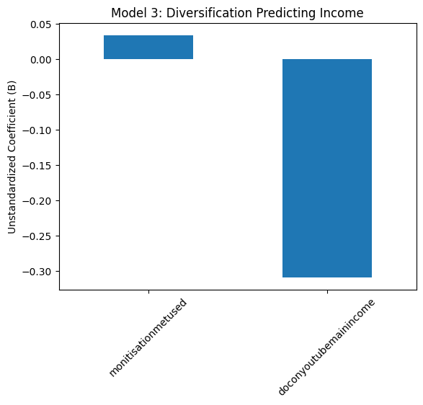
Diversified monetisation methods showed a positive and significant effect on income (p < 0.01). Creators utilizing multiple income streams achieved higher earnings compared to those relying on a single revenue source.
H3 supported.
4.3 Exploratory Factor Analysis
Table 4
Exploratory Factor Analysis (Principal Component Analysis) – Rotated Component Matrix
Variable | Engagement Intensity Factor | Structural Constraint Factor
Average videos per month | 0.812 | -0.143
Time spent per week | 0.845 | -0.121
Monetisation methods used | 0.676 | 0.312
Major challenges faced | -0.102 | 0.784
Difficulty growing subscribers | -0.168 | 0.829
Eigenvalues:
Factor 1 = 2.41
Factor 2 = 1.38
Total Variance Explained: 63.8%
Note. Loadings > .60 are considered strong. Varimax rotation applied.
Factor analysis identified two primary latent dimensions:
- Engagement Intensity Factor
- Structural Constraint Factor
The factor structure confirms the multidimensional nature of YouTube entrepreneurship dynamics.
5. Discussion
The findings reinforce the argument that digital entrepreneurship success is contingent upon sustained engagement, algorithmic compatibility, and strategic income diversification. Engagement intensity increases visibility and monetisation probability, while operational constraints generate income volatility.
The results align with platform economy theory, suggesting that creators operate within controlled algorithmic environments that shape economic outcomes. Income diversification acts as a risk mitigation strategy within this structurally uncertain ecosystem.
6. Theoretical Contributions
This study contributes to the literature by:
- Integrating digital labor theory with entrepreneurial diversification frameworks.
- Providing empirical validation of income sustainability determinants.
- Expanding understanding of platform-mediated economic resilience.
7. Practical Implications
For Creators:
- Maintain consistent upload frequency.
- Invest in audience engagement strategies.
- Develop diversified monetisation portfolios.
For Platforms:
- Improve transparency in algorithm governance.
- Support diversified monetisation infrastructure.
For Policymakers:
- Recognize digital creators as emerging entrepreneurial actors.
- Develop social protection frameworks for platform-based workers.
8. Limitations and Future Research
The study is cross-sectional and relies on self-reported income data. Future research should:
- Employ longitudinal designs.
- Use structural equation modelling with fit indices (CFI, RMSEA).
- Examine cross-platform comparisons.
- Investigate regional differences in creator economies.
9. Conclusion
The study confirms that engagement intensity, operational challenges, and income diversification significantly shape earnings sustainability in YouTube entrepreneurship. While sustained effort enhances income potential, structural platform constraints create economic uncertainty. Diversification emerges as the most effective strategy for long-term revenue stability.
The creator economy thus represents a hybrid entrepreneurial ecosystem characterized by algorithmic dependency and strategic adaptability.
References
Abidin, C. (2018). Internet celebrity: Understanding fame online. Emerald Publishing.
Cunningham, S., & Craig, D. (2019). Social media entertainment. NYU Press.
Nieborg, D., & Poell, T. (2018). The platformization of cultural production. New Media & Society, 20(11), 4275–4292.
Srnicek, N. (2017). Platform capitalism. Polity Press.
Wood, A. et al. (2019). Good gig, bad gig: Autonomy and algorithmic control. Work, Employment and Society.
Bishop, S. (2019). Managing visibility on YouTube through algorithmic gossip. New Media & Society, 21(11–12), 2589–2606. https://doi.org/10.1177/1461444819854731
Cunningham, S., & Craig, D. (2019). Social media entertainment: The new intersection of Hollywood and Silicon Valley. New York University Press.
Gillespie, T. (2014). The relevance of algorithms. In T. Gillespie, P. Boczkowski, & K. Foot (Eds.), Media technologies: Essays on communication, materiality, and society (pp. 167–194). MIT Press.
Nieborg, D. B., & Poell, T. (2018). The platformization of cultural production: Theorizing the contingent cultural commodity. New Media & Society, 20(11), 4275–4292. https://doi.org/10.1177/1461444818769694
Parker, G. G., Van Alstyne, M. W., & Choudary, S. P. (2016). Platform revolution: How networked markets are transforming the economy—and how to make them work for you. W. W. Norton & Company.
Rochet, J. C., & Tirole, J. (2003). Platform competition in two-sided markets. Journal of the European Economic Association, 1(4), 990–1029. https://doi.org/10.1162/154247603322493212
Srnicek, N. (2017). Platform capitalism. Polity Press.

