Influence of Drilling Parameters on Tool Wear, Delamination, and Surface Integrity of 3D Carbon–Carbon Composites

1. Introduction
Carbon/carbon (C/C) composites are among the most advanced high-temperature materials, capable of retaining high mechanical strength at temperatures approaching 3000 °C in non-oxidizing environments, outperforming many other fiber-reinforced ceramic matrix composites (FRCMCs). Due to their exceptional thermal stability and heat resistance, C/C composites are widely used in the manufacture of aerospace components exposed to extreme thermal conditions. Although near-net-shape manufacturing techniques are commonly employed to produce carbon components, post-machining operations are often required to improve surface quality and achieve the desired geometric accuracy. Furthermore, C/C composites frequently need to be joined with high-temperature structural components to meet engineering and assembly requirements. Among the various machining processes, drilling is one of the most commonly used operations for producing holes in carbon and carbon/carbon composites, enabling the attainment of dimensional tolerances and facilitating assembly applications.
Carbon–carbon composites have attracted considerable attention in aerospace, defense, and thermal protection applications due to their outstanding mechanical strength, low density, high thermal conductivity, and ability to retain structural integrity at elevated temperatures. Maojun Li et al. [1] investigated the drilling behavior of C/C composites and reported that machining parameters strongly influence hole quality, drilling temperature, and tool wear. Ruiying Luo et al. [2] demonstrated that Electrified Chemical Vapor Infiltration (ECVI) can effectively produce high-density C/C composites with superior flexural properties. Faheem Muhammed et al. [3] emphasized the need to optimize fabrication routes to reduce manufacturing costs and processing time while maintaining excellent thermomechanical performance. Chenghai Xu et al. [4] studied the compressive behavior of 3D C/C composites under multiaxial loading and revealed that failure mechanisms vary significantly with loading conditions. Similarly, A.P. Mouritz et al. [5] evaluated the fatigue performance of 3D woven, stitched, and z-pinned composites and found that through-thickness reinforcements substantially improve damage tolerance. These studies collectively demonstrate the growing importance of advanced C/C composites and the need for a comprehensive understanding of their processing and mechanical behavior.
The increasing industrial adoption of composite materials has stimulated extensive research on their machinability, particularly drilling operations, which are essential for assembly and fastening applications. P.M. George et al. [6] established empirical models for electric discharge machining of C/C composites and identified pulse current as the dominant parameter affecting machinability. K.V. Krishna Sastry et al. [7] employed Taguchi and Grey Relational Analysis techniques to optimize drilling parameters and improve hole quality in carbon-fiber-reinforced carbon composites. Chenwei Shan et al. [8] highlighted the challenges associated with drilling C/C composites due to their anisotropic and brittle nature, which often results in delamination and surface defects. Bachir Adda et al. [9] reported that feed rate and drill diameter are the most influential factors governing delamination during drilling. Furthermore, B.P. Mishra et al. [10] concluded that machining parameters, tool geometry, and tool material significantly affect thrust force generation and damage mechanisms.
To better understand machining-induced damage and optimize drilling performance, several researchers have focused on analytical and numerical approaches. Tiantian Yin et al. [10] developed a meso-mechanical model to investigate stress evolution and damage formation during the carbonization of C/C composites. Ozden Isbilir et al. [12] proposed a three-dimensional finite element model for drilling composite laminates and demonstrated that step drills significantly reduce thrust force and delamination compared with conventional twist drills. Janak Suthar et al. [13] reviewed conventional and non-conventional drilling techniques for composite materials and highlighted the increasing use of multi-objective optimization methods. Ali Faraz et al. [14] introduced cutting-edge rounding as an important tool-wear indicator and established its relationship with drilling loads and delamination. M.S. Won et al. [15] reported that pilot holes can effectively reduce thrust force and minimize drilling-induced damage. Additionally, Avdhoot Salunkhe et al. [16] emphasized the importance of selecting appropriate drill geometries, support plates, and vibration-assisted drilling techniques to improve hole quality and reduce machining defects in composite laminates.
Recent investigations have also focused on advanced machining technologies and process-enhancement strategies for C/C composites. Chenwei Shan et al. [17] proposed a dynamic cutting-force prediction model for orthogonal cutting of unidirectional C/C composites, providing insights into material-removal mechanisms. Shen Qingliang et al. [18] explored laser drilling of C/C composites and reported that thermal conduction and fiber orientation strongly influence hole geometry and surface quality. Y.Q. Wang et al. [19] demonstrated that cryogenic drilling using liquid nitrogen significantly reduces thrust force and drilling defects compared with dry drilling conditions. M. Singh et al. [20] investigated the joining behaviour of C/C composites using active brazing alloys and reported excellent interfacial bonding and low thermal resistance. Collectively, these studies indicate that significant progress has been made in understanding the fabrication, mechanical behaviour, and machining of composite materials. However, most of the reported investigations have focused on conventional composite systems or limited aspects of drilling performance.
Despite these advancements, the machining behaviour of 3D carbon–carbon composites remain insufficiently explored. The large-scale adoption of these materials is often constrained by their heterogeneous and anisotropic nature, limited machinability databases, complex process-parameter selection, and manufacturing challenges. Machining defects such as delamination, fiber pull-out, matrix cracking, void formation, debonding, surface burning, and dimensional inaccuracies continue to affect the quality and reliability of drilled components. Although various conventional and non-conventional machining techniques have been proposed to address these challenges, a comprehensive understanding of the influence of drill tool materials and cutting parameters on hole quality is still lacking. Therefore, the present study aims to systematically investigate the drilling performance of 3D carbon–carbon composites using different carbide-based drill tools under varying cutting conditions. Particular emphasis is placed on evaluating hole delamination, machining temperature, roundness error, surface roughness, and overall hole quality to identify optimal machining conditions for high-performance engineering applications.
2. Experimental Methodology
The experimental investigation was carried out to evaluate the drilling performance of 3D carbon–carbon (C/C) composites fabricated through the Chemical Vapor Infiltration (CVI) process (Fig.1). The workpiece material consisted of continuous carbon fibers embedded in a carbon matrix with a three-dimensional orthogonal braided architecture. Rectangular specimens of different dimensions were prepared from the composite blocks and subjected to drilling experiments under dry machining conditions. Preliminary trials were conducted using different drill tool materials such as HSS, plain carbide and tungsten carbide to identify the most suitable cutting tool for further experimentation (shown in Fig. 2) The drilling tests were performed on a vertical drilling machine using carbide-based drill tools. Three spindle speeds (300, 700, and 1000 rpm) and three feed rates (20, 40, and 60 mm/min) were selected to investigate the influence of machining parameters on drilling performance. Holes were drilled in an array pattern while maintaining a constant center-to-center distance between adjacent holes, and the machining temperature was monitored using a thermal imaging sensor positioned at a fixed distance from the workpiece.
Following the drilling experiments, comprehensive characterization of hole quality and tool condition was performed. Hole dimensional accuracy and roundness error were measured using a ZEISS PRISMO Coordinate Measuring Machine (CMM) shown in Fig. 4. Surface roughness measurements were carried out using a profilometer to assess the quality of the machined hole surfaces. Tool wear mechanisms and material adhesion on the cutting edges were analysed using optical microscopy was employed to examine progressive wear patterns at different magnifications (Fig.3). The experimental methodology focused on evaluating critical drilling performance indicators, including machining temperature, hole delamination, roundness error, surface roughness, and tool wear. The collected data were subsequently analysed to determine the influence of cutting parameters and drill tool materials, enabling the identification of optimal drilling conditions for achieving superior hole quality and machinability in 3D carbon–carbon composites.
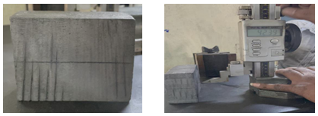
Figure 1. 3D Carbon-Carbon Composite Block and Measurement & Marking for cutting
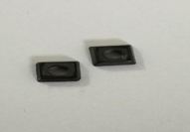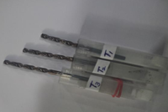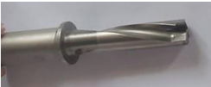
Figure 2. (a) Plain carbide inserts (b) Tungsten Carbide twist drill, & (c) U-drill
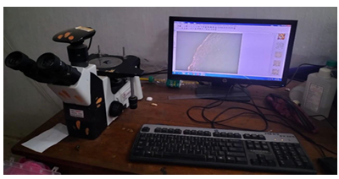
Figure 3. Optical microscope used during this study
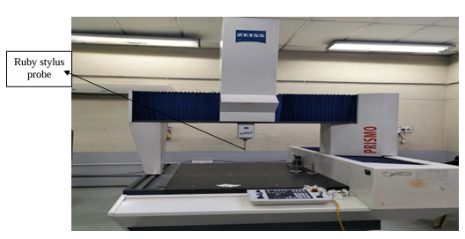
Figure 4. Zeiss Prisma Co-ordinate measuring machine (CMM)
3. Results and Discussion
3.1 Tool Wear
Optical microscopy analyses shown in Fig. 5 & 6 revealed that tool wear was strongly influenced by drilling conditions and the abrasive nature of the 3D carbon–carbon composite. The plain carbide inserts exhibited chipping and flank wear along the cutting edge, while carbon powder deposition was observed on the tool surface. Increased spindle speed and frictional interaction between the tool and workpiece accelerated wear progression. Similarly, the tungsten carbide drill exhibited edge damage, surface damage, and chip-off mechanisms, particularly under prolonged tool–workpiece contact conditions. The dominant wear mechanisms were identified as edge breakage, abrasion, and adhesion of carbonaceous material on the tool surface, indicating the severe machining environment associated with drilling C/C composites.
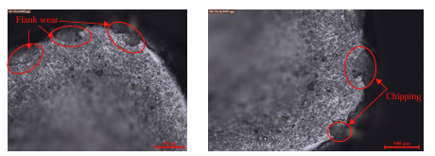
Figure .5 Microscopic images of Plain carbide drill insert after machining
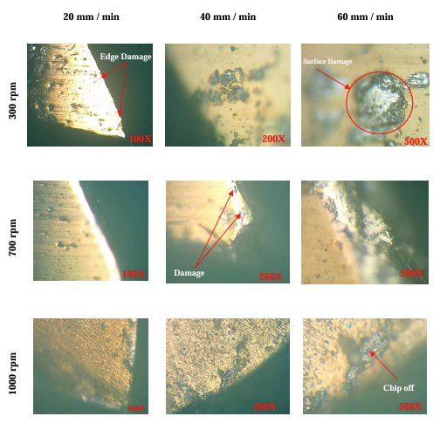
Figure .6 Microscopic images of tungsten carbide twist drill after machining at different speed and feed levels
3.2 Temperature
From the Fig.7, it was observed that the drilling temperature increased with increasing spindle speed and feed rate due to enhanced frictional heat generation at the tool–workpiece interface. The maximum recorded temperature was approximately 42 °C at a spindle speed of 1000 rpm and a feed rate of 60 mm/min. However, the average machining temperature remained relatively stable, ranging between 36.06 °C and 36.96 °C across all cutting conditions. The results indicate that spindle speed had only a limited influence on temperature variation during drilling of 3D C/C composites. The relatively low temperature rise can be attributed to the good thermal conductivity of carbon–carbon composites, which facilitates rapid heat dissipation during machining.

Figure 7. Speed vs Avg. temperature
3.3 Roundness Error
Hole roundness was evaluated using a coordinate measuring machine (CMM). The results (Fig. 8) showed that the roundness error remained relatively small under all machining conditions, indicating satisfactory dimensional accuracy. The minimum average hole diameter deviation of approximately 4.055 mm was obtained at a spindle speed of 1000 rpm and a feed rate of 60 mm/min. Higher cutting speeds reduced tool–workpiece contact time, thereby minimizing deformation and improving hole geometry. Although slight variations in hole size were observed due to the heterogeneous and brittle nature of the composite, higher speed and feed combinations generally produced improved roundness and geometric accuracy.

Figure 8. Speed vs Avg. hole diameter
3.4 Delamination Factor
Delamination was identified as one of the primary drilling-induced defects affecting the integrity of the composite laminate. The phenomenon occurred due to matrix cracking, fibre breakage, and interlaminar separation generated during drilling. Variations in cutting parameters influenced the extent of delamination, as excessive thrust force promoted crack propagation between adjacent layers. Fg.9 illustrates the effect of spindle speed on the delamination factor during drilling of 3D carbon–carbon composites. The delamination factor initially decreases slightly from 1.0076 at 300 rpm to 1.0063 at 700 rpm, indicating improved hole quality and reduced drilling-induced damage at the intermediate cutting speed. However, when the spindle speed is further increased to 1000 rpm, the delamination factor rises to 1.0141, suggesting increased fibre breakage and interlaminar damage around the hole edges. This increase may be attributed to higher cutting forces and intensified tool–workpiece interaction at elevated speeds. Overall, the results indicate that a spindle speed of 700 rpm produces the lowest delamination factor and is therefore the most favourable condition for minimizing drilling-induced damage in the investigated 3D C/C composite.

Figure 9. Speed vs Avg. delamination factor
3.5 Surface Roughness
Surface roughness measurements indicated a significant improvement in surface finish with increasing spindle speed and feed rate. Fig. 10 shows the influence of spindle speed on the average surface roughness during drilling of 3D carbon–carbon composites. The average roughness value decreases significantly from 1.656 μm at 300 rpm to 1.267 μm at 700 rpm and further decreases to 1.121 μm at 1000 rpm. This trend indicates that increasing the spindle speed improves the surface finish of the drilled holes. At higher cutting speeds, the tool removes material more efficiently, resulting in reduced fibre pull-out, matrix damage, and surface irregularities. Consequently, smoother hole surfaces are produced with lower roughness values. The minimum surface roughness obtained at 1000 rpm suggests that higher spindle speeds are favourable for achieving better hole quality and enhanced surface integrity in 3D C/C composites.

Figure 10. Speed vs Avg. surface roughness
4. Conclusions
Based on the experimental investigations conducted on the drilling of 3D carbon–carbon composites, the effects of machining parameters on tool wear, drilling temperature, roundness error, delamination factor, and surface roughness were systematically evaluated. The major findings of the study are summarized as follows:
- The dominant tool wear mechanisms during drilling of 3D carbon–carbon composites were edge chipping, abrasion, and carbon particle adhesion on the cutting edges.
- The drilling temperature remained relatively low (36.06–36.96 °C), indicating efficient heat dissipation by the carbon–carbon composite.
- The best dimensional accuracy was achieved at 1000 rpm, with a minimum average hole diameter deviation of approximately 4.055 mm.
- The minimum delamination factor (1.0063) was obtained at 700 rpm, indicating reduced drilling-induced damage and improved hole quality.
- The lowest surface roughness (1.121 μm) was achieved at 1000 rpm, resulting in superior surface finish and hole quality.
- Appropriate selection of drilling parameters significantly improves the machinability and hole quality of 3D carbon–carbon composites.
References
[1] M. Li, X. Jiang, Y. Chen, and X. Yang, “Hole surface morphology and tool wear mechanisms during cutting 3D carbon/carbon composites using diamond core drill,” Ceramics International, 2022.
[2] R. Luo, “Fabrication of carbon/carbon composites by an electrified preform heating CVI method,” Carbon, vol. 40, no. 11, pp. 1957–1963, 2002.
[3] F. Muhammed, T. Lavaggi, S. Advani, M. Mirotznik, and J. W. Gillespie, “Influence of material and process parameters on microstructure evolution during the fabrication of carbon–carbon composites: A review,” Journal of Materials Science, vol. 56, no. 32, pp. 17877–17914, 2021.
[4] C. Xu, L. Song, H. Zhu, S. Meng, W. Xie, and H. Jin, “Experimental investigation on the mechanical behaviour of 3D carbon/carbon composites under biaxial compression,” Composite Structures, vol. 188, pp. 7–14, 2018.
[5] A. P. Mouritz, “Tensile fatigue properties of 3D composites with through-thickness reinforcement,” Composites Science and Technology, vol. 68, no. 12, pp. 2503–2510, 2008.
[6] P. M. George, B. K. Raghunath, L. M. Manocha, and A. M. Warrier, “Modelling of machinability parameters of carbon–carbon composite—A response surface approach,” Journal of Materials Processing Technology, vol. 153–154, pp. 920–924, 2004.
[7] K. V. Krishna Sastry, V. Seshagiri Rao, K. Palanikumar, R. Dhanalakshmi, and A. Kuravi, “Assessment of process parameters influencing delamination factor on the drilling of CFRC composite material with TiN coated carbide tool,” International Journal of Advanced Manufacturing Technology, 2014.
[8] C. Shan, M. Zhang, Y. Yang, S. Zhang, and M. Luo, “Defect analysis in drilling needle-punched carbon–carbon composites perpendicular to nonwoven fabrics,” Advances in Mechanical Engineering, vol. 7, no. 8, 2015.
[9] B. Adda, A. Belaadi, M. Boumaaza, and M. Bourchak, “Experimental investigation and optimization of delamination factors in the drilling of jute fiber–reinforced polymer biocomposites with multiple estimators,” International Journal of Advanced Manufacturing Technology, vol. 116, no. 9, pp. 2885–2907, 2021.
[10] B. P. Mishra, D. Mishra, and P. Panda, “Drilling of glass fibre reinforced polymer/nanopolymer composite laminates: A review,” International Journal of Advanced Mechanical Engineering, vol. 8, no. 1, pp. 153–172, 2018.
[11] T. Yin, Y. Wang, L. He, and X. Gong, “Stress and damage development in the carbonization process of manufacturing carbon/carbon composites,” Computational Materials Science, vol. 138, pp. 27–33, 2017.
[12] O. Isbilir and E. Ghassemieh, “Numerical investigation of the effects of drill geometry on drilling induced delamination of carbon fiber reinforced composites,” Composite Structures, vol. 105, pp. 126–133, 2013.
[13] J. Sutar, S. N. Teli, and S. Lad, “Optimization techniques for drilling of CFRP and GFRP composite,” in Proc. 3rd Int. Conf. Engineering Confluence (EQUINOX), Navi Mumbai, India, 2017.
[14] A. Faraz, D. Biermann, and K. Weinert, “Cutting edge rounding: An innovative tool wear criterion in drilling CFRP composite laminates,” International Journal of Machine Tools and Manufacture, vol. 49, no. 15, pp. 1185–1196, 2009.
[15] M. S. Won and C. K. H. Dharan, “Chisel edge and pilot hole effects in drilling composite laminates,” Journal of Manufacturing Science and Engineering, vol. 124, no. 2, pp. 242–247, 2002.
[16] A. Salunkhe and V. Warule, “Drilling on fibre reinforced polymer/non-polymer composites laminates: A review,” International Journal of Innovations in Engineering Research and Technology, pp. 1–5, 2018.
[17] C. Shan, M. Zhang, Y. Yang, S. Zhang, and M. Luo, “A dynamic cutting force model for transverse orthogonal cutting of unidirectional carbon/carbon composites considering fiber distribution,” Composite Structures, vol. 251, Art. no. 112668, 2020.
[18] Q. Shen, T. Wang, Q. Song, F. Ye, H. Li, and M. W. Fu, “Unraveling of the laser drilling of carbon/carbon composites: Ablation mechanisms, shape evolution, and damage evaluation,” International Journal of Machine Tools and Manufacture, vol. 184, Art. no. 103978, 2023.
[19] Y. Q. Wang, L. S. Han, H. B. Liu, K. Li, and Y. Ma, “Effect of cryogenic conditions on the drilling performance of carbon-carbon composites,” in Proc. ASME Int. Manufacturing Science and Engineering Conference, 2017, Paper V002T03A003.
[20] M. Singh and R. Asthana, “Characterization of brazed joints of CC composite to Cu-clad-Molybdenum,” Composites Science and Technology, vol. 68, no. 14, pp. 3010–3019, 2008.

