MIXED METHODS IN WOMEN'S HEALTH RESEARCH: ENHANCING UNDERSTANDING THROUGH INTEGRATED METHODOLOGICAL APPROACHES

ABSTRACT

Introduction: Women's health is influenced by biological, psychological, social, and cultural factors that interact throughout the life course. Health issues such as maternal complications, reproductive disorders, menopause, mental health concerns, and nutritional deficiencies require comprehensive investigation. Traditional quantitative or qualitative methods alone may not fully explain these complex phenomena. Mixed methods research (MMR), which integrates quantitative and qualitative approaches, offers a holistic framework for understanding women's health issues. Aim and Objectives The aim of this study is to explore the significance of mixed methods research in women's health and understand how the integration of quantitative and qualitative approaches provides a comprehensive understanding of complex health issues affecting women. The objectives are to review its applications in various areas of women's health, examine its benefits and challenges, evaluate its role in evidence-based healthcare and policy development, and highlight its contribution to improving women's health outcomes and research quality. Methodology: This paper is based on review of published literature on mixed methods research in women's health. Relevant articles were identified from peer-reviewed journals, books, and electronic databases using keywords related to mixed methods research and women's health. Selected studies were reviewed and synthesized to examine applications, benefits, and challenges of mixed methods approaches. Results and Discussion: The review revealed that mixed methods research provides comprehensive insights by integrating numerical findings with contextual experiences. Quantitative data identify prevalence, risk factors, and health outcomes, while qualitative data explain beliefs, perceptions, and sociocultural influences. This approach enhances research validity, facilitates triangulation, and supports the development of patient-centered interventions and evidence-based healthcare policies. Conclusion: Mixed methods research is an effective methodological approach for addressing complex women's health issues. By combining quantitative and qualitative evidence, it contributes to a deeper understanding of health problems and supports improved healthcare delivery, policy formulation, and women's health outcomes. Its application is expected to expand further in future health research.

Keywords
Mixed Methods Research, Women's Health, Qualitative Research, Quantitative Research, Maternal Health, Reproductive Health, Healthcare Research.

1. INTRODUCTION
Women's health is a multidimensional concept that includes physical, mental, reproductive, nutritional, and social well-being throughout the lifespan. Health issues affecting women, such as maternal complications, menstrual disorders, infertility, menopause, mental health problems, and nutritional deficiencies, are influenced by a complex interaction of biological, psychological, cultural, and socioeconomic factors. Understanding these issues requires research approaches capable of capturing both measurable outcomes and individual experiences.
Traditionally, women's health research has relied on either quantitative methods, which provide numerical and statistical evidence, or qualitative methods, which explore personal experiences and social contexts. While each approach has its strengths, neither alone can fully explain the complexity of women's health concerns. Mixed methods research (MMR) combines both quantitative and qualitative methodologies within a single study, allowing researchers to gain a more comprehensive understanding of health phenomena.
The increasing emphasis on patient-centered care and evidence-based practice has highlighted the importance of mixed methods research in healthcare. By integrating statistical findings with women's lived experiences, mixed methods studies contribute to better intervention design, healthcare delivery, and policy formulation.

BACKGROUND OF THE STUDY
Women's health is an essential component of public health that encompasses physical, reproductive, mental, nutritional, and social well-being throughout the lifespan. Health conditions affecting women, including maternal complications, reproductive disorders, menstrual and menopausal problems, mental health concerns, and nutritional deficiencies, are influenced by a combination of biological, psychological, social, cultural, and environmental factors. These complexities make women's health a critical area of research and healthcare intervention.
Traditionally, women's health research has relied on either quantitative or qualitative methodologies. Quantitative approaches provide measurable evidence regarding disease prevalence, risk factors, treatment outcomes, and healthcare utilization, while qualitative approaches explore personal experiences, beliefs, attitudes, and social influences. Although both methodologies contribute valuable insights, neither alone can fully capture the complexity of women's health issues.
Mixed methods research has emerged as an effective approach that integrates quantitative and qualitative methods within a single study. This integration enables researchers to obtain both statistical evidence and contextual understanding, thereby providing a more comprehensive perspective on health-related phenomena. As a result, mixed methods research has become increasingly important in healthcare research and evidence-based practice.
The growing emphasis on patient-centered care and holistic healthcare has further increased the relevance of mixed methods research in women's health. By combining numerical findings with women's lived experiences, researchers can better understand healthcare needs, improve intervention strategies, and support the development of effective healthcare policies and programs.

3. AIM AND OBJECTIVES

Aim
- To explore the significance of mixed methods research in women's health and understand how the integration of quantitative and qualitative approaches contributes to a comprehensive understanding of women's health issues.

Objectives
- To describe the concept and principles of mixed methods research in women's health studies.
- To review the applications of mixed methods research in maternal, reproductive, mental, menopausal, and nutritional health.
- To examine the advantages of integrating quantitative and qualitative data in women's health research.
- To identify the challenges and limitations associated with mixed methods research.
- To evaluate the role of mixed methods research in improving evidence-based healthcare practice, policy development, and women's health outcomes.

4. REVIEW OF LITERATURE
Recent literature demonstrates the growing importance of mixed methods research in addressing complex women's health issues by integrating quantitative and qualitative evidence.


Digital Technologies in Maternal Healthcare

Lazarevic et al. (2023) conducted a mixed-methods study to explore women's perceptions of a pregnancy monitoring mobile application. The study combined survey data with in-depth interviews and found that women valued personalized health information, symptom monitoring, and easy communication with healthcare providers. The authors concluded that mixed methods approach provide a comprehensive understanding of user experiences and technology acceptance in maternal healthcare.

Healthcare-Seeking Behaviour Among Women
Jouanny, Abhyankar, and Maxwell (2024) performed a mixed-methods systematic review examining barriers and facilitators to help-seeking among women experiencing stigmatized pelvic health symptoms. The study identified embarrassment, social stigma, lack of awareness, and limited healthcare access as major barriers. The findings highlighted the importance of combining quantitative prevalence data with qualitative experiences to better understand women's healthcare-seeking behaviours.

Childbirth and Maternal Experiences
Paes et al. (2024) conducted a sequential explanatory mixed-methods study on childbirth experiences among women. Quantitative findings identified factors associated with positive and negative birth experiences, while qualitative interviews provided deeper insights into emotional, social, and healthcare-related influences. The researchers emphasized that mixed methods research offers a holistic understanding of maternal health experiences.


Mental Well-Being Among Women
Davis et al. (2024) investigated the long-term outcomes of digital emotional well-being training among perinatal women using a mixed-methods design. The study found significant improvements in emotional resilience, stress management, and mental well-being. Qualitative findings revealed that participants appreciated the accessibility and flexibility of digital interventions.

Nutritional and Reproductive Health Challenges
Acquah-Keelson et al. (2025) conducted a mixed-methods study among reproductive-aged women to assess knowledge regarding the causes and prevention of anemia. Quantitative results revealed knowledge gaps, while qualitative interviews identified cultural beliefs, misconceptions, and barriers to preventive practices. The study demonstrated the effectiveness of mixed methods in understanding women's nutritional and reproductive health challenges.

5. METHODOLOGY
This review article was conducted to examine the significance and applications of mixed methods research in women's health. A comprehensive review of published literature was undertaken to identify relevant studies that employed mixed methods approaches in addressing various women's health issues.
Relevant literature was retrieved from electronic databases including PubMed, Scopus, Web of Science, ScienceDirect, and Google Scholar. The search was performed using keywords such as "mixed methods research," "women's health," "maternal health," "reproductive health," "mental health," "menopause," "nutrition," "qualitative research," and "quantitative research." Boolean operators such as AND and OR were used to refine the search strategy and improve the retrieval of relevant articles.
The review included peer-reviewed research articles, review papers, and systematic reviews published between 2020 and 2025. Studies focusing on the application of mixed methods research in women's health were considered eligible for inclusion. Articles published in languages other than English, duplicate publications, conference abstracts, editorials, and studies not directly related to women's health were excluded from the review.
The selected studies were screened and critically evaluated based on their objectives, study design, methodological approach, and key findings. Relevant information was extracted and organized into thematic categories including maternal health, reproductive health, mental health, menstrual and menopausal health, and nutrition-related health issues among women.
The collected information was synthesized using a thematic review approach. The findings from the selected studies were analyzed to identify major applications, benefits, challenges, and future directions of mixed methods research in women's health. The synthesized evidence was used to evaluate the contribution of integrated methodological approaches to evidence-based healthcare practice, policy development, and improvement of women's health outcomes.
As this study was based entirely on published literature and secondary data sources, ethical approval and informed consent were not required.
Literature Search
↓
Database Selection
(PubMed, Scopus, Google Scholar,
ScienceDirect, Web of Science)
↓
Keyword Search
↓
Screening of Articles
(2020–2025)
↓
Application of Inclusion &
Exclusion Criteria
↓
Selection of Relevant Studies
↓
Data Extraction
↓
Thematic Analysis
↓
Synthesis of Findings
↓
Results and Discussion

6. Results and Discussion
The review revealed that mixed methods research has become increasingly important in addressing complex women's health issues.
Mixed Methods Research
↓
Data Integration
↓
Better Understanding
↓
Evidence-Based Practice
↓
Improved Women's
Health Outcomes

Maternal Health
Mixed methods studies have improved understanding of maternal healthcare utilization by combining survey findings with women's experiences regarding pregnancy, childbirth, and postpartum care. This approach helps identify both clinical and social determinants of maternal health.

Reproductive Health
Research has shown that integrating quantitative and qualitative data provides better understanding of contraceptive use, fertility preferences, and reproductive decision-making. Qualitative findings often explain the social and cultural factors influencing healthcare choices.

Menstrual and Menopausal Health
Mixed methods research has contributed significantly to understanding menstrual hygiene practices, menstrual disorders, and menopausal experiences. Quantitative assessments measure symptom prevalence, while qualitative investigations explore emotional and social impacts.

Mental Health
Studies addressing depression, anxiety, and stress among women have benefited from mixed methods approaches. Quantitative scales measure psychological status, whereas qualitative interviews provide insights into personal experiences and coping strategies.

Nutrition and Women's Health
Mixed methods studies have examined nutritional problems such as anemia, obesity, and micronutrient deficiencies. While quantitative assessments identify nutritional status, qualitative findings reveal dietary habits, food beliefs, and socioeconomic influences affecting nutrition.

Overall, the integration of quantitative and qualitative findings enhances the validity, reliability, and applicability of research outcomes. It enables researchers to develop patient-centered interventions and evidence

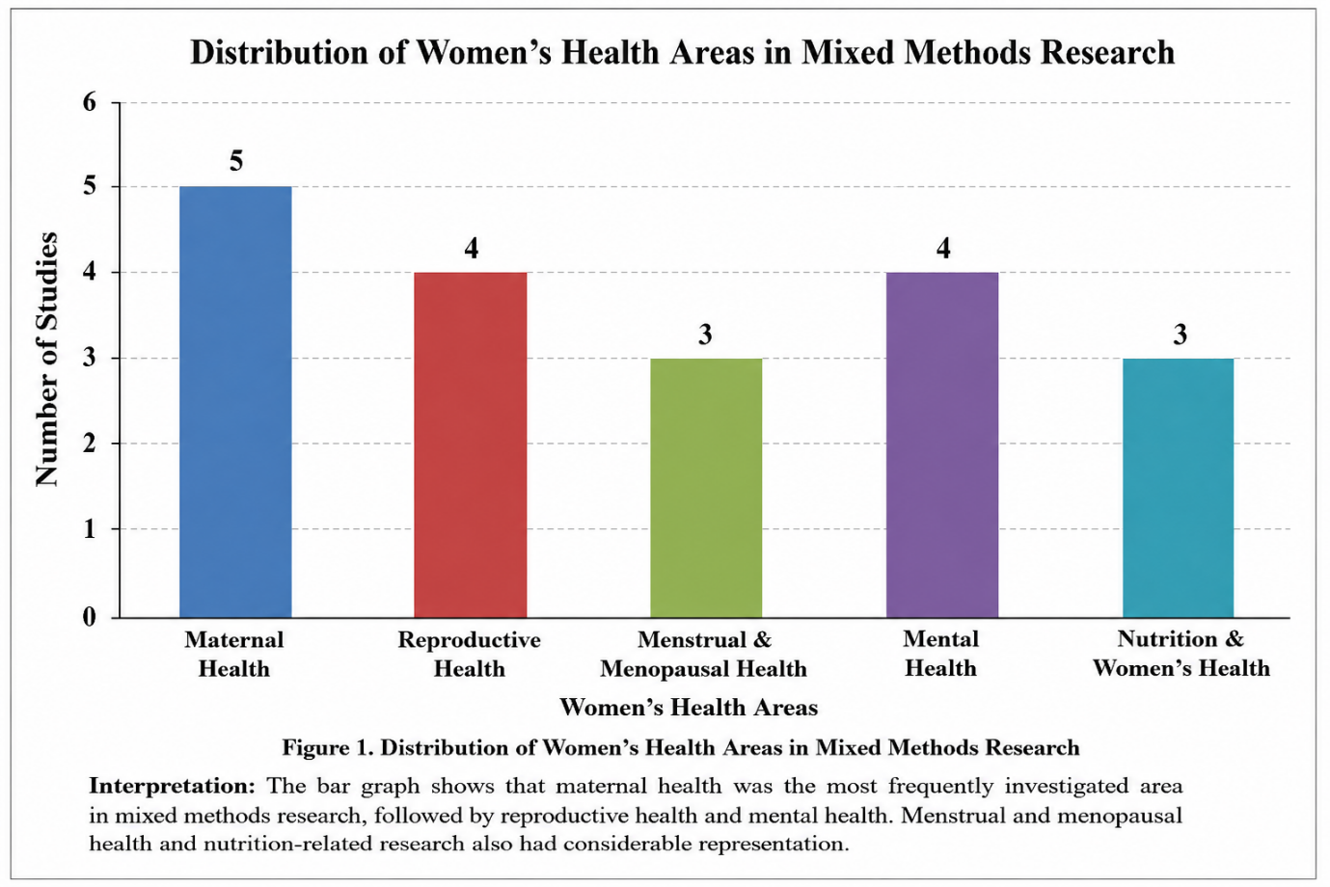

7. Conclusion
Mixed methods research has emerged as a valuable methodological approach in women's health research. By integrating quantitative measurements with qualitative insights, it provides a comprehensive understanding of complex health issues affecting women. The approach facilitates deeper exploration of health behaviors, social influences, and healthcare experiences while maintaining scientific rigor through statistical analysis. Mixed methods research contributes significantly to evidence-based practice, healthcare planning, and policy development. As women's health challenges continue to evolve, the application of mixed methods research will play an increasingly important role in improving health outcomes and promoting holistic healthcare.
10. References
- Sogari G, Velez-Argumedo C, Gómez MI, Mora C. College students and eating habits: A study of influencing factors. Nutrients. 2020;12(2):1–14.
- Akinade T, Kheyfets A, Piverger N, Layne TM, Howell EA, Janevic T. The influence of racial-ethnic discrimination on women's health care outcomes: A mixed methods systematic review. Social Science & Medicine. 2023; 316:114983.
- Jouanny C, Abhyankar P, Maxwell M. A mixed methods systematic literature review of barriers and facilitators to help-seeking among women with stigmatised pelvic health symptoms. BMC Women's Health. 2024; 24:217.
- Paes LBO, Fabbro MRC, Toso BRGO, Bussadori JCC, Ruiz MT, Salim NR, et al. Factors intervening in the childbirth experience: A mixed-methods study. BMC Pregnancy and Childbirth. 2024; 24:14.
- Singh S, Rajak R. Barriers in utilization and provisioning of obstetric care services in India: A mixed-methods systematic review. BMC Pregnancy and Childbirth. 2024; 24:16.
- Dey T, Shah MG, Baba A, Mugo N, Thommesen T, Vivilaki V, et al. Reproductive, maternal, newborn, child and adolescent health services in humanitarian and fragile settings: A mixed methods study of midwives' and women's experiences. PLOS Global Public Health. 2024;4(7).
- Henrich N, Brinson A, Arnold A, Jahnke HR. Digital health needs and preferences during pregnancy and the postpartum period: Mixed methods study. JMIR Formative Research. 2024;8.
- Moosa AS, Poon Z, Koh LAK, Kagradaimdoo DL, Park Y, Yang Y, et al. Mothers prefer a hybrid model of postpartum care: A pilot mixed method study. BMC Pregnancy and Childbirth. 2024; 24:757.
- Bhavana BM, Yogesh M, Padhiyar N, Damor N. Obstetric danger signs in context: A mixed methods study exploring knowledge and sociocultural factors among pregnant women. Journal of Education and Health Promotion. 2024; 13:491.
- Yogesh M, Bhavana BM, Padhiyar N, Gandhi R, Misra S. Identifying gaps in maternal knowledge and care-seeking for neonatal health: A mixed methods study in rural pregnant women. Journal of Education and Health Promotion. 2024; 13:201.

