GEOPHYSICAL INVESTIGATION OF FOUNDATION CONDITION OF A SITE IN AGBURA TOWN BAYELSA STATE USING ELECTRICAL RESISTIVITY METHOD
Arekumo ThankGod¹ and Osih Baridamue Raymond ²
¹Department of Physics Federal University Otuoke, Bayelsa State
²Department of Physics Ignatius Ajuru University of Education, Rivers State
Correspondence email: arekumott@fuotuoke.edu.ng
Abstract
This study presents a geophysical investigation of the foundation conditions at a proposed construction site in Agbura Town, Bayelsa State, Nigeria, using the electrical resistivity method. The research is motivated by the increasing incidence of building failures in Nigeria, often attributed to inadequate understanding of subsurface conditions and neglect of pre-construction site investigations. The study area lies within the Niger Delta, characterized by soft, water-saturated, and compressible alluvial deposits that pose significant challenges to foundation stability. Vertical Electrical Sounding (VES) employing the Schlumberger array configuration was used to acquire subsurface resistivity data at selected locations. For interpretation, the IPI2Win software was employed. The data were processed and interpreted to delineate subsurface lithology, identify stratification, and determine the depth to competent layers suitable for foundation placement. The results enabled the identification of geoelectric layers, including topsoil, clayey formations, and more competent sandy strata at depth. Findings reveal the presence of weak, low-resistivity clayey and water-saturated zones in the near surface, which are unsuitable for supporting heavy structures due to their high compressibility and low bearing capacity. Conversely, relatively higher resistivity zones corresponding to sandy materials were identified at greater depths, indicating more competent layers for foundation support. The study demonstrates that electrical resistivity methods provide a reliable, cost-effective, and non-invasive approach for evaluating subsurface conditions. It emphasizes the importance of integrating geophysical investigations into engineering site assessments to mitigate risks of structural failure. The results offer valuable insights for safe and sustainable foundation design in flood-prone and geologically complex environments like Agbura. It is recommended that geophysical investigations be integrated into pre-construction planning to minimize structural failure risks in the Niger Delta region.

Keywords: Electrical, Resistivity, Geophysical, Foundation, Subsurface

Introduction

The safety and durability of engineering structures depend largely on the competence of the underlying subsurface materials. In Nigeria, frequent cases of building collapse have been attributed to inadequate site investigation and poor understanding of subsurface conditions (Kehinde et al., 2021). The subsurface is inherently heterogeneous, with variations in lithology, moisture content, and structural features influencing load-bearing capacity (Abam, 2015).
In the Niger Delta region, including Bayelsa State, the geological setting is dominated by unconsolidated alluvial deposits characterized by soft, compressible, and water-saturated soils (Oghenero & Akankpo, 2019). These conditions pose significant challenges to foundation design, often resulting in differential settlement and structural instability (Nwankwoala & Walter, 2020).
Electrical resistivity methods have been widely applied in engineering geophysics for subsurface characterization due to their sensitivity to lithological variations and fluid content (Oyedele et al., 2015). Techniques such as Vertical Electrical Sounding (VES) provide reliable information on depth to competent strata and identification of weak zones (Ibrahim & Olatunji, 2021). Previous studies in southern Nigeria have successfully used resistivity methods to investigate foundation failures and subsurface conditions (Adeyemo, 2004; Akintorinwa & Adesoji, 2009).
The stability and durability of engineering structures depend largely on the competence of subsurface materials. In Nigeria, frequent building failures have been attributed to inadequate geotechnical and geophysical investigations prior to construction. The problem is particularly severe in the Niger Delta region, where soils are predominantly soft, waterlogged, and highly compressible. Agbura Town, located within the Bayelsa State floodplain, is characterized by alluvial and mangrove swamp deposits. These geological conditions often result in weak foundation materials that can lead to differential settlement, cracking, and eventual structural collapse.
Geophysical methods, especially the electrical resistivity technique, provide a fast, cost-effective, and non-invasive means of investigating subsurface conditions. This study aims to evaluate the foundation conditions of a site in Agbura using resistivity methods to identify competent layers and delineate weak zones that may affect structural stability. This study aims to evaluate the foundation condition of a site in Agbura Town using the electrical resistivity method to identify competent layers and zones that may pose risks to structural development.
Materials and Methods
The study area is located in Agbura Town, Bayelsa State, within the Niger Delta region of Nigeria. The area is characterized by low elevation, poor drainage, and predominantly soft, water-saturated alluvial soils. Agbura in Bayelsa State, Nigeria, is located at approximately 4.8466° N latitude and 6.2676° E longitude. It is situated within the Yenagoa vicinity, featuring an altitude of roughly 93 meters (308 feet). The location falls within the tropical Niger Delta region.
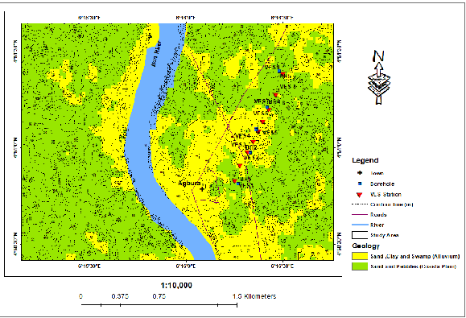
Fig 1: Map of the study Area
Material
The following instruments were used for data acquisition: ABEM Terrameter SAS 3000, four Electrodes, connecting cables, Measuring tapes, GPS device, Field notebook, Power source (battery), sledge hammer, record sheet etc
Methodology
The electrical resistivity method using Vertical Electrical Sounding (VES) with the Schlumberger array configuration was employed. Four electrodes were arranged linearly with current electrodes (A and B) placed outward and potential electrodes (M and N) placed closer together. Current was injected into the ground, and the resulting potential difference was measured. Electrode spacing was progressively increased to probe deeper subsurface layers. Apparent resistivity values were calculated and plotted against electrode spacing. 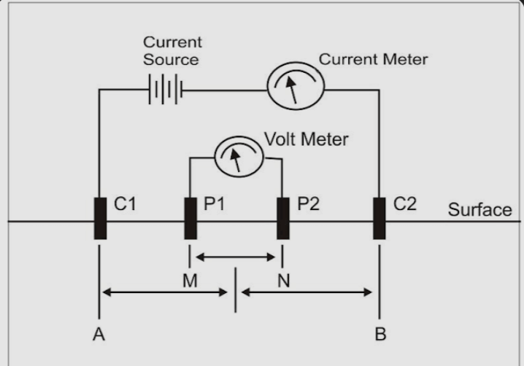
Fig 2: Schlumberger electrode configuration

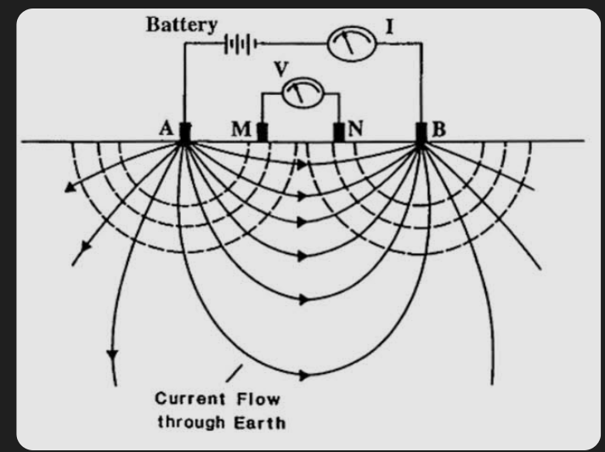
Fig 3: Typical electrode configuration for Schlumberger array

ρa = π $\frac{{\left(\frac{AB}{2}\right)}^{2}-{\left(\frac{MN}{2}\right)}^{2}}{MN}.\frac{V}{I}$
where ρa is apparent resistivity, AB is current electrode spacing, MN is potential electrode spacing, ΔV is potential difference, and I is current.

OHMS LAW AND RESISTANCE IN MICROSCOPIC FORM
V, I, and R, the parameters of Ohm's law
Ohm's law states that the current through a conductor between two points is directly proportional to the voltage across the two points. Introducing the constant of proportionality, the resistance, one arrives at the usual mathematical equation that describes this relationship:
$I=\frac{V}{R}$ (2.1)
where I is the current through the conductor in units of amperes, V is the voltage measured across the conductor in units of volts, and R is the resistance of the conductor in units of ohms. More specifically, Ohm's law states that the R in this relation is constant, independent of the current. Ohm's law is an empirical relation which accurately describes the conductivity of the vast majority of electrically conductive materials over many orders of magnitude of current. However, some materials do not obey Ohm's law, these are called non-ohmic.
The law was named after the German physicist Georg Ohm, who, in a treatise published in 1827, described measurements of applied voltage and current through simple electrical circuits containing various lengths of wire. Ohm explained his experimental results by a slightly more complex equation than the modern form above.
In physics, the term Ohm's law is also used to refer to various generalizations of the law; for example, the vector form of the law used in electromagnetics and material science:
$J= σ E$ (2.2)
where J is the current density at a given location in a resistive material, E is the electric field at that location, and σ (sigma) is a material-dependent parameter called the conductivity. This reformulation of Ohm's law is due to Gustav Kirchhoff.
Microscopic form of ohm’s law
Let us consider a conductor of length L having cross-sectional area A. Let I be the current passing through the conductor and R is the resistance of the conductor and V is the potential difference applied across the two ends of the conductor then by ohm's law:
$V=IR$ (2.3)
since the resistance of a conductor with resistivity r, length L and area A is given by:
$R=\frac{rL}{A}$ (2.4)
Putting above value of R in equation (2.3):
$V=\frac{rIL}{A}$ (2.5)
If E is the electric field intensity across the ends of conductor and V is the potential difference, then the relation between field and potential difference is;
$V=EL$ (2.6)
Comparing equation (1.5) and equation (1.6):
$EL=\frac{rIL}{A}$ (2.7)
$E=\frac{rI}{A}$
$E=\left(\frac{I}{A}\right)r$ (2.8)
Since by definition of current density J:
$J=\frac{I}{A}$
Putting this value in equation (2.8):
$E=Jr$
Since r is resistivity and conductivity σ is the reciprocal of resistivity i.e.
$σ=\frac{1}{r}$
$r=\frac{1}{σ}$
Hence; $E=\frac{J}{σ}$
Finally, we arrive at equation (2.2);
$J= σE$
Equation (2.2) is the Microscopic Form of Ohm's Law in terms of conductivity, electric field intensity and current density.
Conductivity, electric field intensity and current density are microscopic quantities and the reason for the name of equation (2.2) is that it relates microscopic quantities. Microscopic quantities of materials depend on certain properties of the material at a certain point inside the material and is independent pf overall properties of the material. Resistivity is also a microscopic quantity.

Results

Below is the result for the field work. Three VES points were taken in the study area.
Table 1: FIELD DATA SHEET FOR SCHLUMBERGER FIELD CONFIGURATION
LOCATION 1: AGBURA PIPELINE
VES 1
$$\frac{AB}{2}(m)$$ | AB (m) | $$\frac{MN}{2}(m)$$ | MN (m) | K | R($Ω)$ | ρ (Ωm)
1.0 | 2.0 | 0.3 | 0.6 | 4.77 | 5.56 | 26.52
1.5 | 3.0 | 0.3 | 0.6 | 11.31 | 2.88 | 32.57
2.0 | 4.0 | 0.3 | 0.6 | 20.48 | 1.11 | 22.73
3.0 | 6.0 | 0.3 | 0.6 | 46.66 | 0.391 | 18.24
5.0 | 10.0 | 0.3 | 0.6 | 130.45 | 0.117 | 15.26
7.0 | 14.0 | 0.3 | 0.6 | 256.13 | 0.060 | 15.37
7.0 | 14.0 | 1.0 | 2.0 | 75.41 | 0.260 | 19.61
10.0 | 20.0 | 1.0 | 2.0 | 155.53 | 0.127 | 19.75
15.0 | 30.0 | 1.0 | 2.0 | 351.90 | 0.157 | 55.25
15.0 | 30.0 | 3.0 | 6.0 | 113.11 | 0.16 | 18.09
20.0 | 40.0 | 3.0 | 6.0 | 204.75 | 0.14 | 28.67
25.0 | 50.0 | 3.0 | 6.0 | 322.58 | 0.09 | 29.03
30.0 | 60.0 | 3.0 | 6.0 | 466.59 | 0.08 | 37.33
40.0 | 80.0 | 3.0 | 6.0 | 833.15 | 0.05 | 41.66
45.0 | 90.0 | 3.0 | 6.0 | 1055.71 | 0.03 | 31.67
50.0 | 100.0 | 3.0 | 6.0 | 1304.45 | 0.04 | 52.18
55.0 | 110.0 | 3.0 | 6.0 | 1579.38 | 0.05 | 78.97
60.0 | 120.0 | 3.0 | 6.0 | 1880.49 | 0.31 | 582.95
70.0 | 140.0 | 3.0 | 6.0 | 2561.25 | 0.35 | 896.43
80.0 | 160.0 | 3.0 | 6.0 | 3346.75 | 0.32 | 1070.96
90.0 | 180.0 | 3.0 | 6.0 | 4236.99 | 0.14 | 593.18
90.0 | 180.0 | 5.0 | 10.0 | 2537.17 | 0.271 | 687.57
100.0 | 200.0 | 5.0 | 10.0 | 3134.15 | 0.032 | 100.29

Table 2: FIELD DATA SHEET FOR SCHLUMBERGER FIELD CONFIGURATION
LOCATION 2: AGBURA PIPELINE
VES 2
$$\frac{AB}{2}(m)$$ | AB (m) | $$\frac{MN}{2}(m)$$ | MN (m) | K | R($Ω)$ | ρ (Ωm)
1.0 | 2.0 | 0.3 | 0.6 | 4.77 | 0.259 | 1.235
1.5 | 3.0 | 0.3 | 0.6 | 11.31 | 0.256 | 2.895
2.0 | 4.0 | 0.3 | 0.6 | 20.48 | 0.501 | 10.260
3.0 | 6.0 | 0.3 | 0.6 | 46.66 | 0.207 | 9.659
5.0 | 10.0 | 0.3 | 0.6 | 130.45 | 0.211 | 27.525
7.0 | 14.0 | 0.3 | 0.6 | 256.13 | 0.234 | 59.934
7.0 | 14.0 | 1.0 | 2.0 | 75.41 | 0.214 | 16.138
10.0 | 20.0 | 1.0 | 2.0 | 155.53 | 0.214 | 33.283
15.0 | 30.0 | 1.0 | 2.0 | 351.90 | 0.189 | 66.509
15.0 | 30.0 | 3.0 | 6.0 | 113.11 | 0.185 | 20.925
20.0 | 40.0 | 3.0 | 6.0 | 204.75 | 0.183 | 37.469
25.0 | 50.0 | 3.0 | 6.0 | 322.58 | 0.181 | 58.387
30.0 | 60.0 | 3.0 | 6.0 | 466.59 | 0.185 | 86.319
40.0 | 80.0 | 3.0 | 6.0 | 833.15 | 0.196 | 163.297
45.0 | 90.0 | 3.0 | 6.0 | 1055.71 | 0.168 | 177.359
50.0 | 100.0 | 3.0 | 6.0 | 1304.45 | 0.205 | 267.412
55.0 | 110.0 | 3.0 | 6.0 | 1579.38 | 0.227 | 358.519
60.0 | 120.0 | 3.0 | 6.0 | 1880.49 | 0.165 | 310.280
70.0 | 140.0 | 3.0 | 6.0 | 2561.25 | 0.175 | 448.219
80.0 | 160.0 | 3.0 | 6.0 | 3346.75 | 0.119 | 398.263
90.0 | 180.0 | 3.0 | 6.0 | 4236.99 | 0.193 | 817.739
90.0 | 180.0 | 5.0 | 10.0 | 2537.17 | 0.219 | 555.640
100.0 | 200.0 | 5.0 | 10.0 | 3134.15 | 0.172 | 539.074

Table 3: FIELD DATA SHEET FOR SCHLUMBERGER FIELD CONFIGURATION
LOCATION 3: AGBURA PIPELINE
VES 3
$$\frac{AB}{2}(m)$$ | AB (m) | $$\frac{MN}{2}(m)$$ | MN (m) | K | R($Ω)$ | ρ (Ωm)
1.0 | 2.0 | 0.3 | 0.6 | 4.77 | 10.85 | 51.755
1.5 | 3.0 | 0.3 | 0.6 | 11.31 | 2.570 | 29.067
2.0 | 4.0 | 0.3 | 0.6 | 20.48 | 1.059 | 21.688
3.0 | 6.0 | 0.3 | 0.6 | 46.66 | 0.337 | 15.724
5.0 | 10.0 | 0.3 | 0.6 | 130.45 | 0.124 | 16.176
7.0 | 14.0 | 0.3 | 0.6 | 256.13 | 0.059 | 15.111
7.0 | 14.0 | 1.0 | 2.0 | 75.41 | 0.268 | 20.209
10.0 | 20.0 | 1.0 | 2.0 | 155.53 | 0.122 | 18.975
15.0 | 30.0 | 1.0 | 2.0 | 351.90 | 0.043 | 15.132
15.0 | 30.0 | 3.0 | 6.0 | 113.11 | 0.202 | 22.848
20.0 | 40.0 | 3.0 | 6.0 | 204.75 | 0.124 | 25.389
25.0 | 50.0 | 3.0 | 6.0 | 322.58 | 0.072 | 23.226
30.0 | 60.0 | 3.0 | 6.0 | 466.59 | 0.083 | 38.727
40.0 | 80.0 | 3.0 | 6.0 | 833.15 | 0.049 | 40.824
45.0 | 90.0 | 3.0 | 6.0 | 1055.71 | 0.045 | 47.507
50.0 | 100.0 | 3.0 | 6.0 | 1304.45 | 0.364 | 474.819
55.0 | 110.0 | 3.0 | 6.0 | 1579.38 | 0.022 | 34.746
60.0 | 1200 | 3.0 | 6.0 | 1880.49 | 0.091 | 171.125
70.0 | 140.0 | 3.0 | 6.0 | 2561.25 | 0.027 | 69.154
80.0 | 160.0 | 3.0 | 6.0 | 3346.75 | 0.036 | 120.483
90.0 | 180.0 | 3.0 | 6.0 | 4236.99 | 0.018 | 76.266
90.0 | 180.0 | 5.0 | 10.0 | 2537.17 | 0.078 | 197.899
100.0 | 200.0 | 5.0 | 10.0 | 3134.15 | 0.036 | 112.829

GEOLOGICAL DISCUSSION
VES 1 (H-Curve)
The H-type curve is characterized by a decrease in resistivity followed by a significant increase (ρ₁ > ρ₂ < ρ₃). This suggests a conductive weathered or clay-rich intermediate layer overlying a highly resistive basement. The low resistivity second layer (13.3 Ωm) is indicative of clay or water-saturated weathered material, while the high resistivity third layer (22,430 Ωm) represents fresh crystalline basement. The weathered layer may possess groundwater potential if sufficiently thick.
VES 2 (A-Curve)
(The A-type curve shows resistivity increasing with depth (ρ₁ < ρ₂ < ρ₃). The surface layer (1.61 Ωm) is highly conductive, indicating clay or waterlogged material. Resistivity increases to 575 Ωm in the second layer, suggesting weathered basement or coarse-grained sand, before reaching 6,133 Ωm in the basement, which is interpreted as competent fresh rock. This succession indicates increasing consolidation with depth.
VES 3 (H-Curve)
The H-type response at VES 3 also indicates a conductive intermediate layer between two more resistive layers. The first layer (99.4 Ωm) likely represents sandy or lateritic topsoil, while the second layer (15.3 Ωm) corresponds to clayey weathered material. The basement resistivity (17,837 Ωm) indicates fresh crystalline rock. As with VES 1, groundwater occurrence is most likely within the weathered layer if it has adequate thickness.

Interpretation
This is a typical geoelectric succession for basement complex terrains. The H-type soundings (VES 1 and VES 3) suggest favorable weathered zones that may serve as aquifers where the weathered layer is sufficiently thick. The A-type sounding (VES 2) indicates a gradual increase in competence with depth and comparatively lower groundwater potential.
Location 1: VES 1
This is the H curve type which indicates $ρ_{1 }>ρ_{2}<ρ_{3}$
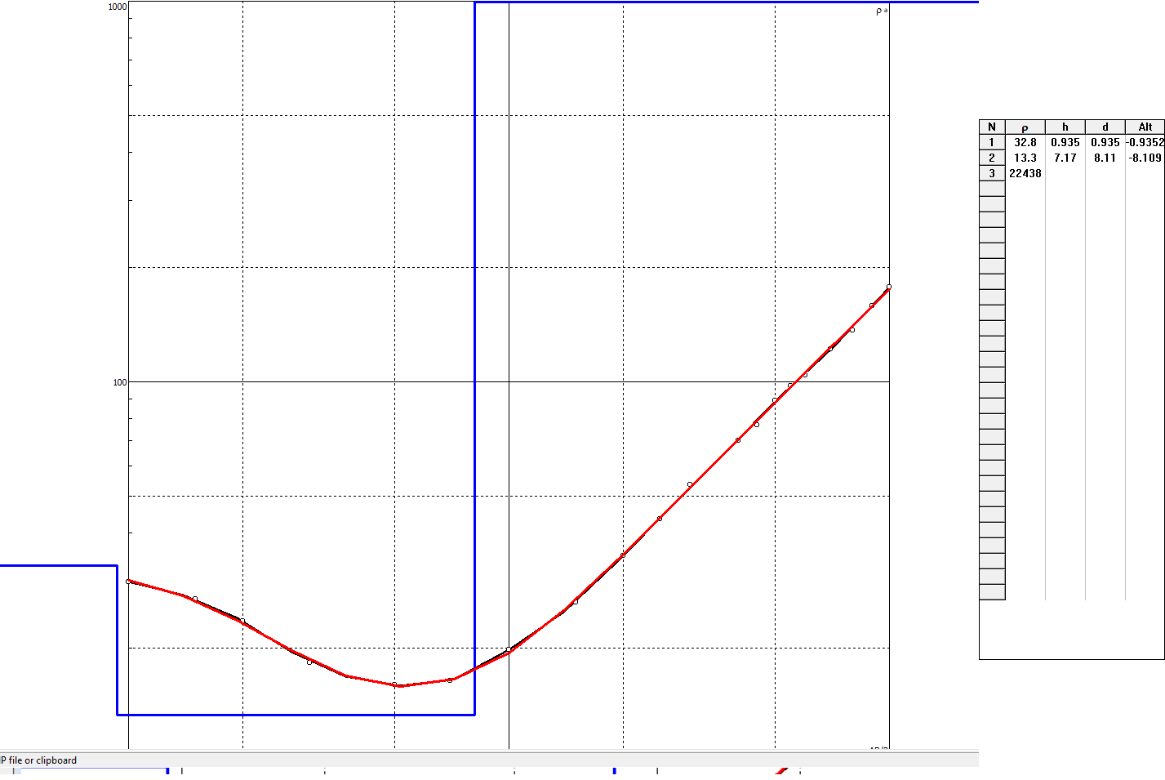

VES 1 DISCUSSION TABLE
Layers | Resistivity $ρ(Ωm)$ | Height H(m) | Lithology interpretation
1 | 32.8 | 0.935 | Topsoil (sandy clay/clayey sand)
2 | 13.3 | 7.17 | Clay or saturated clayey material (conductive layer)
3 | 22430 | 7.137 | Fresh basement or very competent consolidated rock
Location 2: VES 2
This is the A curve type which indicates that $ρ_{1 }<ρ_{2}<ρ_{3}$
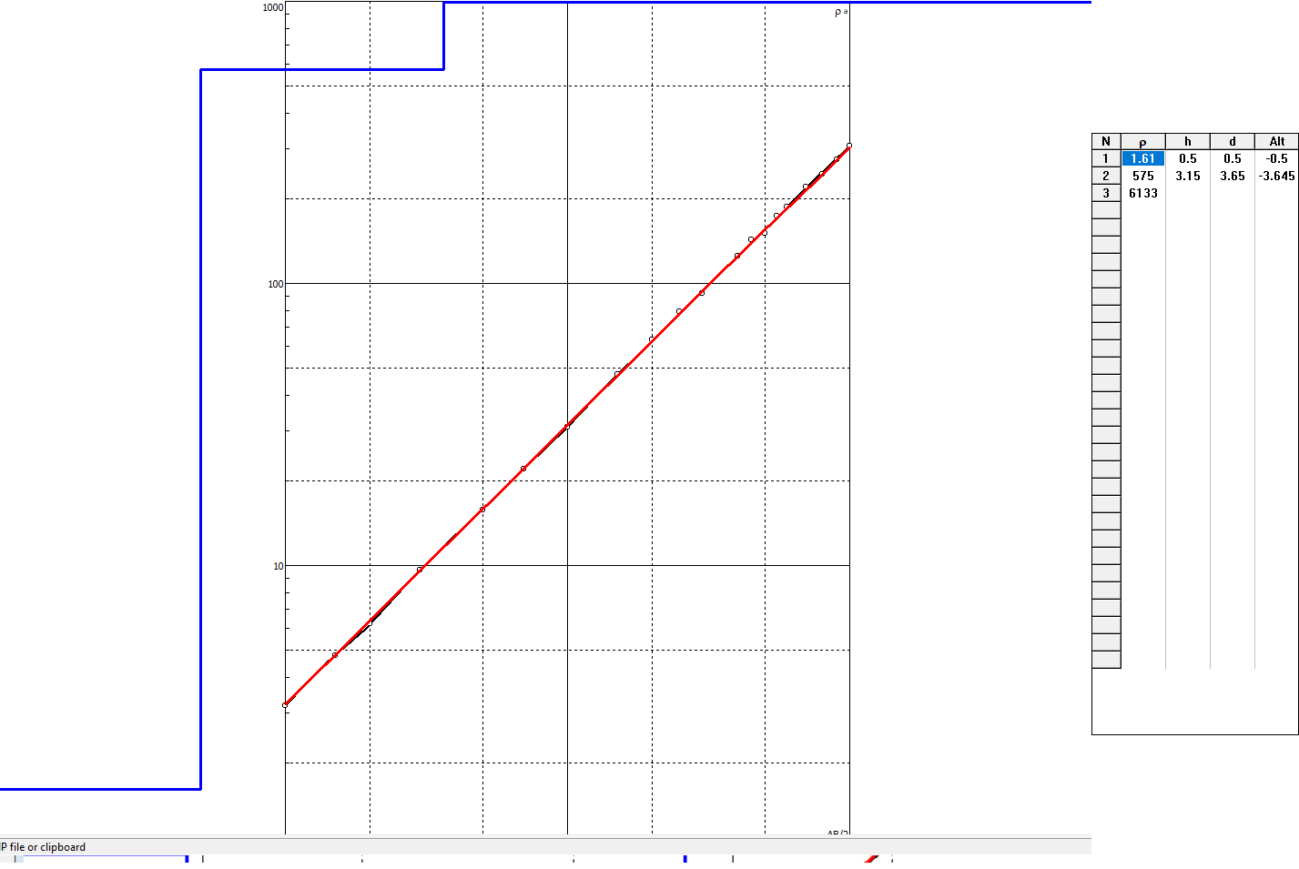
VES 2 DISCUSSION TABLE
Layers | Resistivity $ρ(Ωm)$ | Height H(m) | Lithology interpretation
1 | 1.61 | 0.5 | Very conductive clay/topsoil
2 | 575 | 3.15 | Weathered/fractured basement or coarse sand
3 | 6133 | 3.15 | Fresh basement rock
Location 3: VES 3
This is the H curve type which indicate that $ρ_{1 }>ρ_{2}<ρ_{3}$
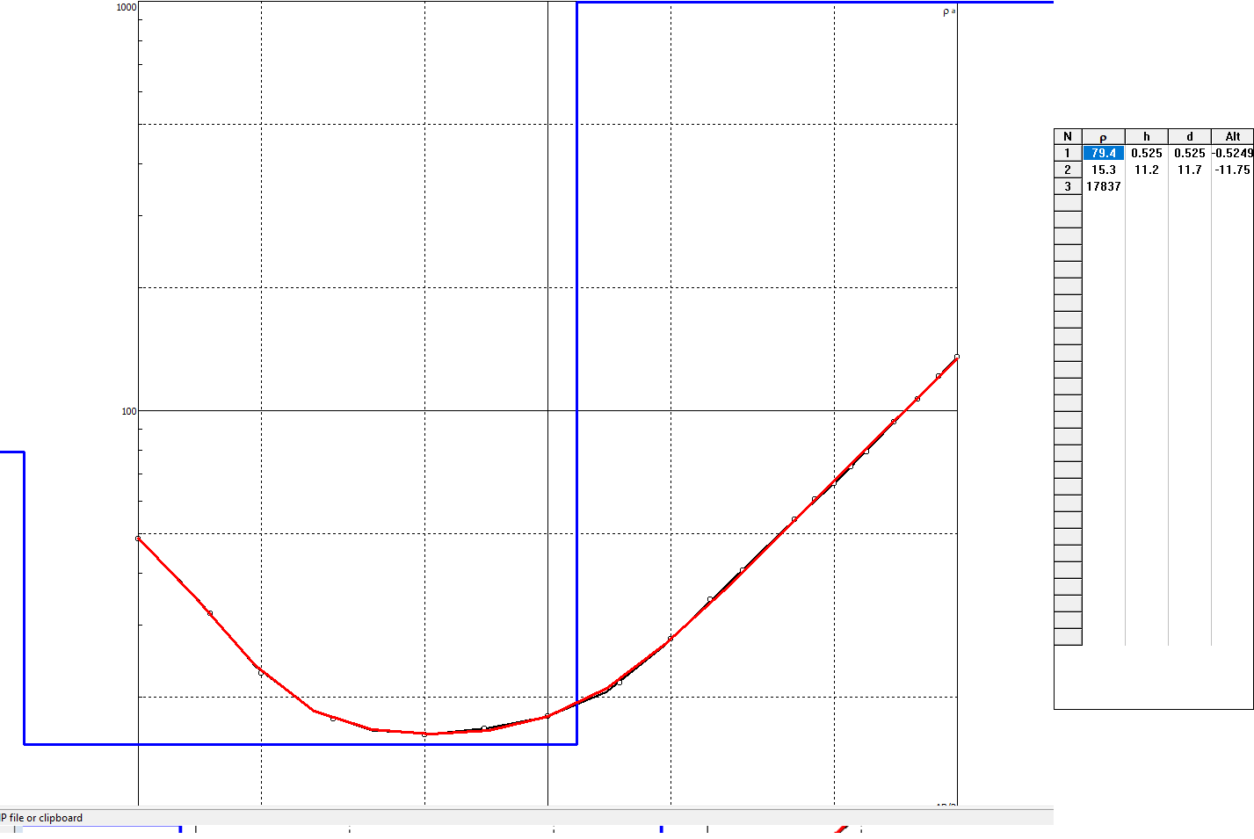

VES 3 DISCUSSION TABLE
Layers | Resistivity $ρ(Ωm)$ | Height H(m) | Lithology interpretation
1 | 99.4 | 0.525 | Sandy topsoil or lateritic soil
2 | 15.3 | 11.2 | Clay/weathered layer
3 | 17837 | 11.2 | Fresh basement rock

Conclusion
This study has demonstrated the effectiveness of the electrical resistivity method in evaluating subsurface conditions for foundation design in Agbura Town. The results indicate that the near-surface soils are weak and unsuitable for supporting heavy structures, while deeper sandy layers provide more competent foundation materials. In conclusion, Electrical resistivity methods are reliable for site characterization. Weak clayey layers dominate the shallow subsurface in the study area. Foundations should be designed to extend to deeper competent layers. The study strongly recommends the incorporation of geophysical investigations in all construction projects to mitigate risks of structural failure.
References
Abam, T. K. S. (2015). Geotechnical aspects of foundation engineering in Nigeria. Journal of Earth Sciences, 10(2), 45–60.
Adeyemo, I. A. (2004). Application of dipole-dipole array in road failure investigation. Nigerian Journal of Geophysics, 18(1), 23–30.
Akintorinwa, O. J., & Adesoji, J. I. (2009). Integrated geophysical and geotechnical investigation for engineering site characterization. Journal of Applied Sciences, 9(4), 561–567.
Ede, A. N., et al. (2025). Electrical resistivity studies of oil-impacted soils in Bayelsa State. Environmental Geophysics Journal, 12(1), 88–102.
Ibrahim, M., & Olatunji, S. (2021). Application of resistivity methods in engineering site investigations in southern Nigeria. African Journal of Earth Sciences, 45(3), 112–125.
Kehinde, O. O., et al. (2021). Causes of building collapse in Nigeria: A geotechnical perspective. Nigerian Journal of Engineering, 28(2), 67–75.
Mesida, E. A. (1987). Geotechnical properties of residual soils in southwestern Nigeria. Engineering Geology Journal, 25(3), 215–225.
Nwankwoala, H. O., & Walter, R. (2020). Subsurface characterization of Niger Delta soils. International Journal of Geosciences, 11(5), 301–315.
Oghenero, A. E., & Akankpo, A. O. (2019). Foundation challenges in the Niger Delta region. Journal of Environmental Geology, 7(2), 55–63.
Oyedele, A. A., et al. (2015). Electrical resistivity imaging for foundation studies. Geophysical Research Letters, 42(6), 210–218.

