From Training Provider to Knowledge Producer:

Abstract
Purpose. This paper examines how a long-established public management institute in a developing economy is shifting from a near-exclusive identity as a training provider toward a fuller identity that also encompasses knowledge production. Using the Bangladesh Institute of Management (BIM) as a single longitudinal case, it documents and interprets an “applied research turn”: the visible activation, in recent years, of a research-and-consultancy mandate that had long been subordinated to short-course training and post-graduate diploma delivery.
Design/methodology. The study draws on a complete set of BIM annual reports spanning 2012–13 to 2024–25, supplemented by the institute’s consolidated operational dataset. Reported activity is reconstructed across four streams—short-course training, diploma enrolment, research output, and consultancy—and triangulated with institutional and financial signals (a dedicated research division, a quarterly journal, inter-institutional memoranda of understanding, and ring-fenced budget lines).
Findings. Training and diploma delivery remain BIM’s operational core, with roughly 3,680 short courses and over 63,000 participants recorded cumulatively. Yet a structural change is evident from 2020–21 onward: research works begin to appear as a distinct, reported category (13 works in 2020–21, 13 in 2021–22, and 9 in 2024–25), commissioned and grant-funded applied studies multiply, and the 2024–25 accounts carry dedicated research (BDT 12.8 million) and consultancy (BDT 10.4 million) expenditure lines—together about 30% of the training line. The turn is distinctively applied: problem-driven, client-commissioned, and practice-proximate rather than basic.
Originality/value. The paper offers a rare, document-grounded account of how a developing-country management institute reactivates a dormant statutory research mandate, and frames the shift through organizational ambidexterity and engaged-scholarship lenses. It also offers a candid methodological caution: part of the observed “emergence” reflects changes in reporting practice, a finding that is itself diagnostic of the institute’s evolving self-understanding as a knowledge producer.
Keywords: applied research; knowledge production; management training institute; organizational ambidexterity; engaged scholarship; public sector capacity building; Bangladesh.

1. Introduction
Across the developing world, public management institutes occupy an unusual institutional space. They were typically founded to build administrative and managerial capacity through training, yet their enabling mandates almost always pair training with research and consultancy. In practice, the training function tends to crowd out the others: it generates fee income, fills classrooms, and produces countable outputs, while research is slower, riskier, and harder to monetize. The result is a familiar asymmetry in which an institute that is statutorily a triad of training, research, and consultancy operates, for decades, as a training provider with research and consultancy at the margins.
The Bangladesh Institute of Management (BIM) is an instructive case of this asymmetry—and, more interestingly, of its partial reversal. Tracing its origins to a 1961 UNDP-supported Management Development Center, reconstituted as the Bangladesh Management Development Centre and finally established as an institute in 1997, BIM was charged from the outset with human-resource development through, in the words of its own mission statement, “Management Education, Training, Research and Consultancy Services.” Its 2024–25 annual report is candid about the imbalance that followed: while training, research, and consultancy are the three mandated activities, “the major thrust during the last decade has been on training and Post Graduate Diploma Programs.”
This paper asks a simple question with broad relevance: when, how, and in what form does such an institute begin to act on the knowledge-production half of its mandate? Drawing on a complete run of BIM annual reports from 2012–13 to 2024–25, it documents what we term an applied research turn—the recent and visible activation of research, commissioned study, publication, and inter-institutional knowledge partnerships on top of an unchanged training core. The turn is empirically datable, financially material, and qualitatively distinctive in being oriented toward applied, problem-driven work rather than basic science.
The contribution is threefold. First, the paper provides a longitudinal, document-grounded reconstruction of a developing-country management institute’s activity mix, a setting that is under-represented in the management-education and public-administration literatures. Second, it interprets the observed shift through the complementary lenses of organizational ambidexterity and engaged scholarship, clarifying what “applied” means in this context. Third, it is transparent about a methodological subtlety: because the evidence is the institute’s own reporting, part of what looks like emergence is a change in what the institute chooses to count and disclose—which is itself a signal of identity change worth taking seriously.

2. Conceptual background

2.1 Training provision and knowledge production as distinct logics
Training delivery and knowledge production rest on different organizational logics. Training is an exploitation activity in March’s (1991) sense: it refines and reuses an existing curriculum, rewards throughput and reliability, and converts known content into participant-hours and fee income. Research is an exploration activity: it is uncertain, slow to yield returns, and oriented toward producing something the organization did not previously possess. The two logics compete for the same scarce faculty time and managerial attention, which is why institutes built for one struggle to sustain the other.
Organizations that manage both simultaneously are described as ambidextrous (O’Reilly & Tushman, 2013). For a management institute, ambidexterity means protecting the training engine that pays the bills while carving out structurally distinct space—divisions, budgets, time, and reward—for exploratory research. The presence or absence of such protected space is, on this view, the practical test of whether a “research turn” is real or rhetorical.

2.2 Applied, engaged, and Mode 2 knowledge
The knowledge a management institute is positioned to produce is rarely basic. It is closer to what Gibbons et al. (1994) called Mode 2 knowledge—generated in the context of application, transdisciplinary, and accountable to users beyond the academy—and to Van de Ven’s (2007) engaged scholarship, in which research questions are co-produced with practitioners and addressed to real problems. Commissioned feasibility studies, training-needs analyses, sector diagnostics, and policy-facing evaluations are paradigmatic outputs of this mode. They are research by any reasonable definition, yet they are also continuous with the consultancy tradition the institute already possesses, which is why the knowledge turn in such settings tends to be an applied turn rather than a basic-science one.

2.3 Absorptive capacity and the triple helix
Two further ideas frame the case. Absorptive capacity (Cohen & Levinthal, 1990) holds that an organization’s ability to generate new knowledge depends on its prior related knowledge and on the people who carry it; a training institute’s faculty, steeped in practitioner content, constitute a latent research capability waiting to be activated. The triple-helix perspective (Etzkowitz & Leydesdorff, 2000) situates such institutes within evolving university–industry–government relations, in which boundary organizations increasingly take on knowledge-production roles previously reserved for universities. Both ideas predict that a turn toward applied research, once seeded, can be self-reinforcing—partnerships beget projects, projects build capability, and capability attracts further partnerships.

3. Research context: the Bangladesh Institute of Management
BIM is a statutory institute under Bangladesh’s Ministry of Industries, headquartered in Dhaka with campuses in Chattogram and Khulna. Its work is organized into ten academic divisions—among them Human Resource Management, Accounting and Financial Management, Marketing Management, Production Management, Computer Services, and, notably for this study, a Research, Evaluation and Publication Division and a Productivity and Consultancy Division. The institute delivers two principal products: short courses of one to four weeks, and one-year post-graduate diploma (PGD) programmes across HRM, Financial Management, Marketing Management, Computer Science, Industrial Management, and—newly—Supply Chain Management. It also publishes a quarterly journal, Management Development, which solicits empirically based articles.
Two recent contextual developments matter. A new BIM Act was enacted in 2023, described by the institute as enhancing its capacity and performance; and a twelve-storey building under a “BIM Strengthening Project,” completed around the end of 2024, sharply expands physical capacity (24 classrooms accommodating over 1,500 participants, plus seminar and conference facilities). These developments coincide with, and plausibly enable, the activity changes documented below.

4. Data and method
The study is a single-case, longitudinal documentary analysis. The primary corpus is the complete set of BIM annual reports for the fiscal years 2012–13 through 2021–22, together with the final annual report for 2024–25. These were supplemented by the institute’s consolidated operational workbook, which compiles course-, diploma-, and finance-level records across years. Annual reports are an appropriate evidentiary base because they are the institute’s own audited account of what it did and spent, and because their changing structure—which categories appear, and when—is itself informative about institutional priorities.
Analysis proceeded in three steps. First, four activity streams were reconstructed and tabulated year by year: (i) short-course counts and participants; (ii) PGD enrolment; (iii) reported research works; and (iv) consultancy and commissioned studies. Second, institutional and financial signals of a knowledge orientation were extracted: the existence and staffing of a research division, the quarterly journal, inter-institutional memoranda of understanding (MoUs), research-oriented seminars, and ring-fenced expenditure lines for research, consultancy, innovation, seminars, and publications. Third, the streams were read against one another to identify the timing and character of change.
Two cautions are stated up front, in keeping with conservative inference. First, annual-report reporting practice is not constant: a research-works table appears only from 2020–21, so the apparent “emergence” of research partly reflects a decision to begin reporting it. This is treated below as both a finding and a limitation. Second, counts of “research works” mix internal grant-funded studies, externally commissioned studies, and faculty papers; they are indicative of effort and orientation, not bibliometric quality measures. No claim is made about peer-reviewed publication counts, citations, or research quality, which the available documents do not support.

5. Findings

5.1 The training-provider core remains dominant
Short-course delivery is, and remains, BIM’s operational backbone. Over the period captured in the institute’s short-course annexure (since 1961–62), BIM records on the order of 3,680 courses and roughly 63,700 participants cumulatively; by mid-2024 it reports 66,884 participants trained. Annual volumes fluctuate with demand and capacity—peaking at 137 courses and 3,084 participants in 2014–15, dipping during the pandemic, and recovering to 84 courses and 1,899 participants in 2021–22 (Figure 1). In 2024–25 the institute organized 53 short courses and delivered a further 323 participants through 13 online courses, the latter a durable legacy of pandemic-era digitization via the national research-and-education network.
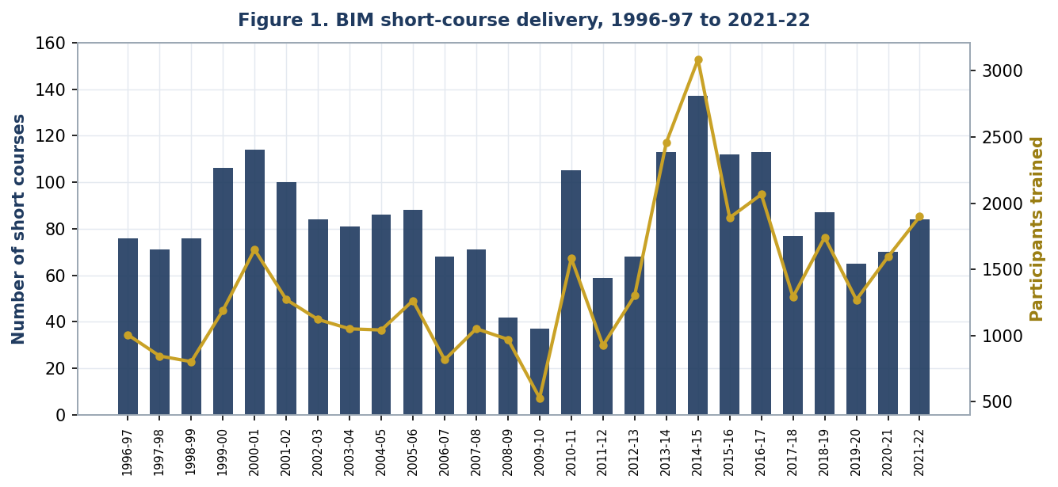
Figure 1. BIM short-course delivery, 1996–97 to 2021–22. Bars: number of short courses (left axis); line: participants trained (right axis). Source: BIM annual-report short-course annexures.

5.2 The diploma backbone: stable but concentrated
The one-year PGD programmes constitute a second, more academic pillar. Total PGD enrolment moved from 803 in 2013 to a plateau around 920 in 2017–2018, declined to 511 in 2021 amid the pandemic, and stood at 704 in 2024–25 (Figure 2). Enrolment is heavily concentrated in HRM, which alone accounts for the majority of diploma students every year. A new PGD in Supply Chain Management, introduced in 2023, attracted 172 enrolments by 2024–25—evidence that the diploma portfolio is being refreshed toward contemporary, demand-led fields. Cumulatively, the diploma stream has enrolled 20,809 participants and graduated 14,559 since 1966.
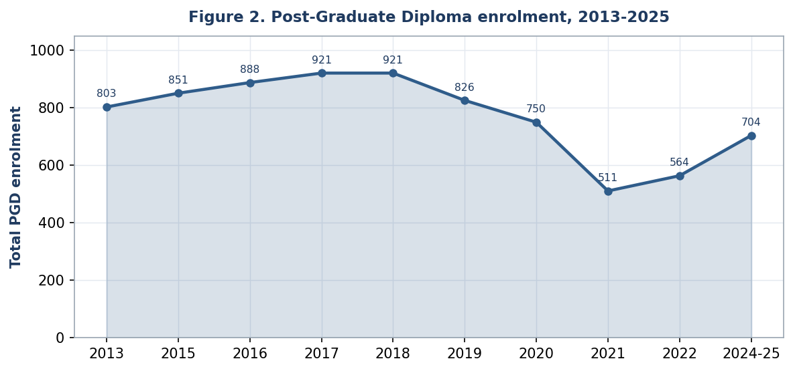
Figure 2. Total Post-Graduate Diploma enrolment, 2013–2025. Source: BIM annual reports and consolidated diploma records.

5.3 The emergence of reported research output
Against this stable training-and-diploma core, the most striking change is the appearance of research as a distinct, reported activity. Across the annual reports for 2012–13 through 2019–20, there is no research-works table: the documents are organized almost entirely around short courses, diploma enrolment, faculty, and income and expenditure. From 2020–21, a “Research Works” table appears and persists—13 works listed in 2020–21, 13 in 2021–22, and 9 in 2024–25 (Figure 3, Table 1). The 2024–25 figure is explicitly decomposed by the institute into seven internally grant-funded works and two externally funded works, signalling a deliberate research-financing model rather than incidental scholarship.
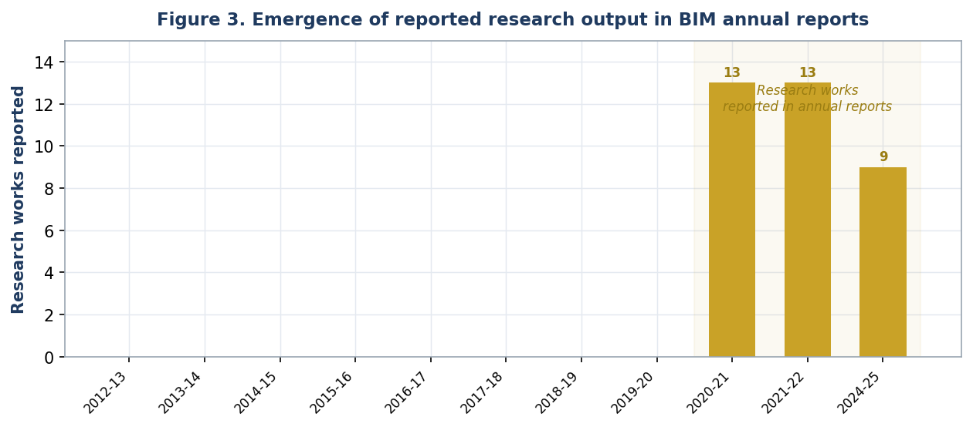
Figure 3. Emergence of reported research output in BIM annual reports. No research-works table appears before 2020–21 (grey); gold bars mark years in which research works are reported. Source: BIM annual reports.
The themes of these works locate the turn firmly in the applied register. They cluster around the Fourth Industrial Revolution and manufacturing, digital transformation and digital leadership, “SMART Bangladesh” and organizational innovativeness, supply-chain and talent-acquisition practice, technostress and employee wellbeing, corporate sustainability, consumer trust in f-commerce, and skill-gap and training-needs diagnostics. These are practitioner-facing questions addressed to Bangladeshi firms and institutions—engaged, problem-driven scholarship rather than basic inquiry.
Table 1. Reported research works by year and representative themes
Fiscal year | Research works reported | Funding basis (where stated) | Representative themes
2012–13 to 2019–20 | None reported | — | Research not tabulated in annual reports
2020–21 | 13 | Internal; some commissioned | Grievance redress; student factors; social compliance; technological innovation; COVID-19 vulnerability; light-engineering needs assessment; cyclone preparedness
2021–22 | 13 | Internal grant of BIM | Organizational culture; 4IR & skills; digital leadership; technostress; employability skill gaps; women empowerment; HR cost
2024–25 | 9 | 7 internal grant + 2 external | Leadership & OCB in RMG; organizational innovativeness; supply chain & talent; 4IR electronics; technology adoption; corporate sustainability; f-commerce trust; budget management; sick industries
Source: BIM annual reports, 2012–13 to 2024–25. Counts mix internal grant-funded studies, externally commissioned work, and faculty papers; they indicate research effort and orientation, not bibliometric quality.

5.4 Consultancy and commissioned applied studies
Consultancy is the channel through which BIM’s research orientation has historically been most active, and it is increasingly framed as research. The institute has a long client list spanning ministries and state enterprises—Planning, Finance, Petrobangla, the Power Development Board, Dhaka WASA, Bangladesh Railway—and international agencies including ADB, UNIDO, and UNFPA. In 2024–25 it reports four major consultancy works: a feasibility study for a regional nursing and midwifery training institute, and recruitment consultancies for the Directorate General of Drug Administration, the Bangladesh Computer Council, and the Electricity Generation Company of Bangladesh.
Several 2020–21 “research works” were in fact commissioned applied studies—a development-needs assessment for the light-engineering sector, a project feasibility study, and a cyclone-preparedness study for a ministry. The boundary between consultancy and research is therefore porous at BIM, and deliberately so: commissioned, client-funded studies are simultaneously revenue, capability-building, and knowledge output. This porousness is the defining feature of an applied research turn, distinguishing it from the basic-research trajectory of a conventional university.

5.5 Institutional and financial signals of a knowledge orientation
Beyond counts, four structural signals indicate that the turn is being institutionalized rather than improvised. First, structure: a Research, Evaluation and Publication Division exists with a divisional head and a dedicated research officer, and a Productivity and Consultancy Division anchors commissioned work. Second, dissemination: the quarterly journal Management Development provides an in-house outlet, and 2024–25 seminars include a “Research Proposal Writing” workshop and a “SMART Bangladesh for Smart Training Institutes” seminar—capability-building for research itself. Third, partnerships: memoranda of understanding signed in 2024–25 with North South University (education, research, and capacity development) and the National Productivity Organization (productivity, research, and training) embed BIM in a wider knowledge network, consistent with a triple-helix dynamic.
Fourth, and most concretely, money. The 2024–25 accounts carry ring-fenced expenditure lines that simply did not feature prominently in earlier reporting: research at BDT 12.83 million, consultancy at BDT 10.44 million, innovation at BDT 0.33 million, seminars and conferences at BDT 0.63 million, and books and journals at BDT 0.05 million (Figure 4, Table 2). Set against the training line of BDT 76.68 million, research alone equals about 17% of training spend, and research, consultancy, and innovation together reach roughly BDT 23.6 million—close to a third of the training line. Budget lines are the most credible evidence that a mandate is being acted upon, because they survive only if the activity recurs.
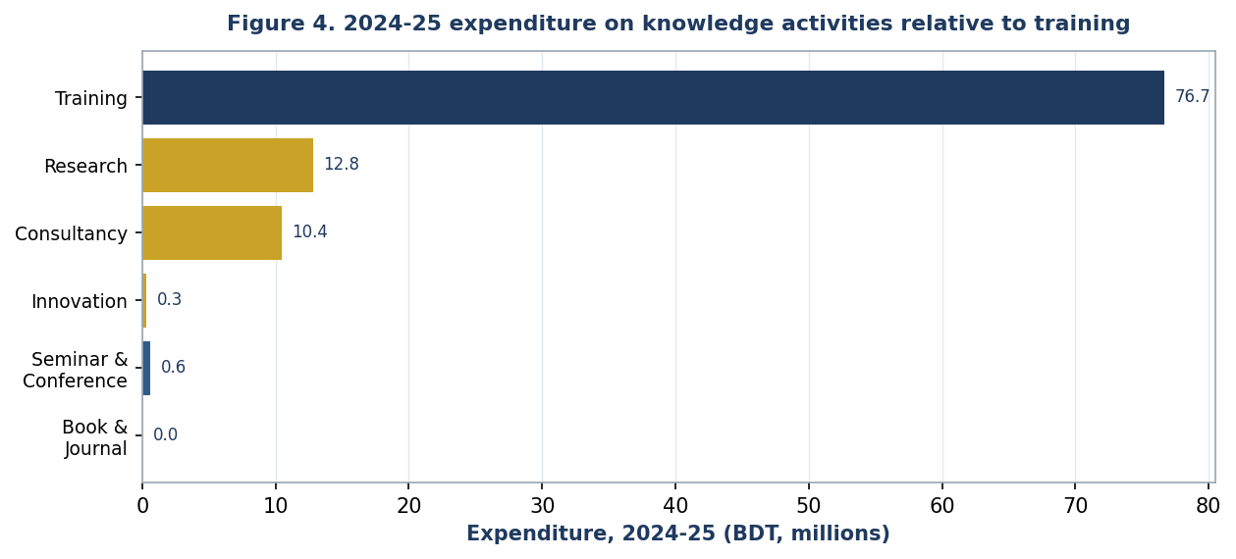
Figure 4. 2024–25 expenditure on knowledge activities relative to training (BDT millions). Source: BIM 2024–25 income and expenditure statement, by economic code.
Table 2. Selected 2024–25 expenditure lines (BDT)
Activity (economic code) | Expenditure, 2024–25 (BDT) | Share of training line
Training (3231301) | 76,678,824 | 100.0%
Research (3257103) | 12,827,735 | 16.7%
Consultancy (3257101) | 10,437,896 | 13.6%
Innovation (3257105) | 325,550 | 0.4%
Seminar & Conference (3211111) | 629,910 | 0.8%
Book & Journal (3211127) | 45,810 | 0.1%
Source: BIM 2024–25 income and expenditure statement. Shares are computed relative to the training expenditure line.

6. Discussion
Read together, the four streams tell a coherent story. BIM has not abandoned, or even diminished, its training-provider identity; the short-course and diploma engines run at familiar scale. What has changed is that, from about 2020–21, the institute began to report, fund, staff, and partner around research and commissioned study as recurring activities rather than occasional by-products. The change is best understood as the activation of a long-dormant half of a statutory mandate—ambidexterity achieved not by reinventing the organization but by building protected structures (a division, budget lines, a journal, MoUs) around an exploratory logic that now coexists with the exploitative training core.
The turn is unmistakably applied. Its outputs are feasibility studies, sector diagnostics, training-needs analyses, and practitioner-facing papers on 4IR, digital leadership, supply chains, and sustainability—Mode 2, engaged knowledge produced in the context of application and accountable to government and industry clients. This is exactly what absorptive-capacity reasoning would predict: BIM’s faculty, already expert in practitioner content, represented a latent research capability that needed only structure and incentive to activate. It is also what the triple-helix lens anticipates: a boundary organization between university, industry, and government taking on knowledge-production roles, with partnerships and commissions reinforcing one another.
Several plausible drivers coincide with the turn. The 2023 BIM Act and the capacity-expanding Strengthening Project altered the institute’s self-image and physical possibility frontier. The pandemic forced digitization and, with it, online seminars and a more research-literate faculty culture. National policy framing around “SMART Bangladesh” and Industry 4.0 created demand for exactly the applied studies BIM is positioned to supply. And the reporting change itself—the decision to tabulate research works from 2020–21—signals that leadership came to regard knowledge output as something worth counting and displaying, which is a meaningful identity shift in its own right.
That last point deserves emphasis rather than concealment. Because the evidence is the institute’s own reporting, some of the measured “emergence” is a change in disclosure, not only in underlying behaviour: BIM almost certainly conducted commissioned studies before 2020–21 without tabulating them as research. But disclosure is not nothing. An organization that begins to count, fund, and publicize its research is constructing a knowledge-producer identity, and that construction has real consequences for recruitment, partnerships, and future activity. The reporting change is thus both a measurement caveat and a substantive finding.

7. Implications for policy and practice
For institute leadership, the case suggests that a research turn in a training-dominated organization is engineered through structure, not exhortation. The levers that appear to matter are protected budget lines, a division with dedicated research staff, an internal grant mechanism, an in-house dissemination outlet, capability-building seminars, and external MoUs that generate a pipeline of commissioned work. None requires abandoning the training engine; each carves out durable space alongside it.
For ministries and funders, the lesson is that latent research capacity in public training institutes can be activated relatively cheaply by commissioning applied studies and by ring-fencing modest research budgets. The marginal cost is small relative to training expenditure, and the output—feasibility studies, sector diagnostics, evaluations—feeds directly back into public decision-making, closing a loop that pure training cannot.
For the institute specifically, the analysis points to natural next steps: moving from counting research works toward tracking peer-reviewed and indexed output; deepening university partnerships into co-supervised and co-authored work; and using the quarterly journal as a bridge from commissioned studies to citable scholarship. These would convert an applied research turn into a sustained research capability.

8. Limitations and future research
This is a single case built on self-reported documents, and its limits should temper its claims. As noted, changing reporting practice confounds the timing of “emergence,” and the research-works counts are heterogeneous and unaudited for quality; they cannot stand in for bibliometric measures. The 2022–23 and 2023–24 reports were not part of the core corpus analysed here, leaving a gap between 2021–22 and 2024–25 that future work should fill. Financial comparability across years is also imperfect, as economic-code reporting and category labels evolved.
Three extensions would strengthen the account. First, interviews with BIM faculty and leadership could disentangle behavioural change from reporting change and surface the institute’s own theory of its turn. Second, a comparative design—placing BIM alongside peer institutes in South Asia—would test whether the applied research turn is idiosyncratic or a regional pattern. Third, tracing individual commissioned studies through to policy use would test the engaged-scholarship claim that this knowledge is genuinely consumed by its clients.

9. Conclusion
BIM has spent six decades as, in effect, a training provider with a research mandate on paper. The evidence assembled here suggests that, since about 2020–21, the paper mandate has begun to acquire substance: research appears as a reported, funded, staffed, and partnered activity, oriented toward applied, problem-driven questions and continuous with the institute’s consultancy tradition. The training-provider identity persists, but it is no longer the institute’s whole self-description. Whether this applied research turn matures into a durable knowledge-producer identity will depend on whether the protected structures now in place—divisions, budgets, partnerships, and outlets—outlast the conditions that created them. For developing-country management institutes navigating the same asymmetry between a training engine and a dormant research mandate, BIM offers both an encouraging proof of concept and a practical, structure-first template for acting on the half of the mandate that has long been deferred.

References
Cohen, W. M., & Levinthal, D. A. (1990). Absorptive capacity: A new perspective on learning and innovation. Administrative Science Quarterly, 35(1), 128–152.
Etzkowitz, H., & Leydesdorff, L. (2000). The dynamics of innovation: From national systems and “Mode 2” to a triple helix of university–industry–government relations. Research Policy, 29(2), 109–123.
Gibbons, M., Limoges, C., Nowotny, H., Schwartzman, S., Scott, P., & Trow, M. (1994). The new production of knowledge: The dynamics of science and research in contemporary societies. Sage.
Grant, R. M. (1996). Toward a knowledge-based theory of the firm. Strategic Management Journal, 17(S2), 109–122.
March, J. G. (1991). Exploration and exploitation in organizational learning. Organization Science, 2(1), 71–87.
Nonaka, I., & Takeuchi, H. (1995). The knowledge-creating company: How Japanese companies create the dynamics of innovation. Oxford University Press.
O’Reilly, C. A., & Tushman, M. L. (2013). Organizational ambidexterity: Past, present, and future. Academy of Management Perspectives, 27(4), 324–338.
Pfeffer, J., & Fong, C. T. (2002). The end of business schools? Less success than meets the eye. Academy of Management Learning & Education, 1(1), 78–95.
Van de Ven, A. H. (2007). Engaged scholarship: A guide for organizational and social research. Oxford University Press.
Bangladesh Institute of Management. (2013–2025). Annual reports, fiscal years 2012–13 to 2024–25 [Primary data]. BIM, Ministry of Industries, Dhaka.
Author note: The conceptual references above are established, verifiable works selected to frame the case; the literature scaffolding should be expanded with the author’s own reading and any target-journal requirements before submission. All empirical claims derive from the BIM annual reports listed as primary data.

Declarations
Funding. No external funding was received for this study.
Conflicts of interest. The corresponding author is a faculty member of the institution studied. The analysis relies solely on the institution’s publicly reported annual data; the author declares no other competing interests.
Data availability. The primary data are the BIM annual reports for 2012–13 to 2024–25 and the institute’s consolidated operational workbook; derived figures supporting this article are available from the corresponding author on reasonable request.
AI-use disclosure. An AI assistant was used to support data extraction from legacy spreadsheets, descriptive computation, figure generation, and manuscript drafting. All analytical claims, interpretations, and conclusions were reviewed and are the responsibility of the author(s).
CRediT author statement. Tanvir Hossain: Conceptualization, Methodology, Investigation, Data curation, Formal analysis, Writing – original draft, Writing – review & editing. [Co-author(s)]: to be confirmed.

