Review on Design of Development Approach of Pedal Operated Potato Grading Machine
Kashish verma , Vinayak singh , Kartik lal , Harsh taygi , Dr Madhuri dubey
Department of Agricultural Engineering
Dayalbagh Educational Institute
ABSTRACT
Potato is one of the most widely cultivated crops and plays a significant role in agriculture. After harvesting, it is essential to classify potatoes based on their size, a process known as grading. Proper grading not only helps farmers obtain better prices in the market but also ensures that potatoes are used appropriately for purposes such as consumption or seed production. In many rural areas, however, grading is still carried out manually. This traditional method is slow, labor-intensive, and often produces inconsistent results. Studies have indicated that manual grading lacks efficiency and consumes more time compared to mechanized methods (Huda et al., 2019).
To address these issues, several grading machines have been developed. Most modern grading systems are powered by electricity and are capable of processing large quantities of potatoes with higher accuracy and speed. Depending on their design and operational capacity, these machines can grade hundreds of kilograms per hour (Awasthi, 2021). Typically, such machines consist of a feeding unit, grading mechanism, motor, and collection system for sorted produce.
Despite their advantages, electrically operated grading machines are often expensive and beyond the reach of small and marginal farmers. Moreover, the availability of electricity in rural and remote areas is still limited, which further restricts their usability. Therefore, there is a growing demand for cost-effective and simple technologies that can be easily adopted in such regions. Research highlights that affordable and user-friendly machines are more suitable for agricultural practices in developing countries (AMA Journal, 2005).
A promising alternative is the pedal-operated potato grading machine, which functions using human power. The working principle is similar to that of a bicycle, where pedaling motion is transmitted through a chain and sprocket system to operate the machine. These machines are economical, easy to maintain, and do not require any external power source. Additionally, they are environmentally sustainable. Previous studies suggest that pedal-driven systems can effectively reduce dependency on energy while remaining practical for rural applications (Gaikwad et al., 2017).
In this study, a pedal-operated potato grading machine is proposed at the design stage. Since the machine has not yet been fabricated, the focus is on its conceptual framework and expected working mechanism. The proposed system includes a structural frame, pedal assembly, power transmission unit, rotating drum or sieve, and collection trays. When the operator pedals, rotational motion is generated, causing the drum to rotate and separate potatoes according to size through perforations of different diameters.
During the design process, key parameters such as drum dimensions, hole size, rotational speed, and material selection are carefully considered. These factors directly influence the efficiency, capacity, and grading accuracy of the machine. Earlier research also emphasizes the importance of optimizing these parameters to achieve better performance (Huda et al., 2019).
The proposed machine offers several advantages. It eliminates the need for electricity, reduces operational costs, and simplifies the grading process. It also decreases manual labor while improving grading consistency. Furthermore, as it operates on human energy, it is environmentally friendly and sustainable.
However, certain limitations must also be acknowledged. The machine relies entirely on human effort, which may lead to fatigue during prolonged use. Its operational speed and capacity are comparatively lower than those of electrically powered machines. Additionally, the efficiency of the system depends on the pedaling speed and consistency of the operator.
In conclusion, the pedal-operated potato grading machine presents a practical and economical solution for small-scale farmers. It has the potential to improve productivity, reduce labor dependency, and enhance grading quality. Future research should focus on the fabrication and experimental evaluation of the machine to validate its performance under real working conditions
INTRODUCTION
Potato is a very common crop and it is used in daily life in many food items. After harvesting, it is important to sort potatoes properly so that their quality remains good. This sorting process is called grading. In grading, potatoes are separated on the basis of their size.
Grading is important because it helps farmers to get a better price in the market. It also makes it easy to use potatoes for seed and for eating. But in many villages, grading is still done manually by hand. This method takes more time, needs more workers, and is not very accurate. Because of this, farmers do not get proper results and sometimes face loss.
To solve this problem, different types of grading machines have been developed. Many of these machines work with electricity and can grade potatoes faster and in large quantity. These machines give better performance depending on their design and working conditions (Awasthi, 2021) . Also, drum type graders are used which help in proper grading and reduce damage to potatoes (Huda et al., 2019) .
But these machines are costly and not suitable for small farmers. In rural areas, electricity is also not available properly, so it becomes difficult to use such machines. That is why there is a need for a simple and low-cost machine which can be used easily. It is also said that simple machines are more useful for farmers in developing countries (AMA Journal, 2005) .
A good solution for this is a pedal operated machine. This machine works on human power just like a bicycle. When a person pedals, the machine runs with the help of chain and sprocket system. These machines are cheap, easy to use, and do not require electricity. They are also environment friendly. Studies show that pedal operated machines are useful in rural areas and help in saving energy (Gaikwad et al., 2017) .
In this paper, a pedal operated potato grading machine is proposed. The machine is not fabricated yet, so this study is based on its design and expected working. The main aim is to develop a simple and affordable machine which can help small farmers in grading potatoes easily.
LITERATURE REVIEW
Different researchers have studied various methods to improve the grading of potatoes and other agricultural products. In earlier times, grading was mostly done manually. This process required a lot of time and labor, and the results were not always accurate. Because of these problems, different types of grading machines were introduced to make the work faster and more efficient.
A study by Huda et al. (2019) developed a drum type potato grading machine. The machine included a feeding hopper, rotating drum, motor, and collection trays. It was observed that the performance of the grader depends on factors like the speed of rotation and the angle of inclination. The machine showed good grading efficiency and also helped in reducing damage to the potatoes during operation (Huda et al., 2019) .
Another research by Awasthi (2021) focused on a power operated grading machine used for fruits and vegetables. This machine worked with the help of an electric motor and was capable of handling large quantities in a short period of time. The study indicated that parameters such as belt speed and grading angle affect the overall performance of the machine. Although the machine was efficient, it required electricity and involved higher cost (Awasthi, 2021) .
Research related to agricultural mechanization also highlights that machines play an important role in increasing productivity and saving time. However, in developing regions, many farmers are not able to use advanced machines due to their high cost and limited availability of electricity. Therefore, there is a growing need for simple, low-cost, and easy-to-use machines that can be adopted by small farmers (AMA Journal, 2005) .
In recent years, pedal operated machines have become popular as an alternative solution. A review by Gaikwad et al. (2017) explained that pedal operated machines work using human power and use mechanisms similar to a bicycle. These machines are economical, easy to operate, and suitable for rural areas. They also help in saving energy and reducing dependence on electricity (Gaikwad et al., 2017) .
From the above studies, it is clear that power operated machines provide high efficiency but are not affordable for small farmers. On the other hand, pedal operated machines are simple and cost-effective. However, there is limited research available specifically on pedal operated potato grading machines. Hence, there is a need to develop a simple and efficient pedal operated potato grader that can be used by small farmers.

PROBLEM STATEMENT
In many rural areas, potato grading is still done manually, which takes a lot of time and requires more labor. This method is not accurate and leads to uneven grading of potatoes. Because of this, farmers do not get good price in the market. Although different grading machines are available, most of them are costly and require electricity, which is not easily available in villages. Therefore, small farmers are not able to use these machines. Hence, there is a need to develop a simple, low-cost, and easy-to-use potato grading machine that can work without electricity.
OBJECTIVE
- To design a pedal operated potato grading machine
- To reduce manual labor in grading process
- To develop a low-cost machine suitable for small farmers
- To create a machine that does not require electricity
- To improve grading efficiency and uniformity
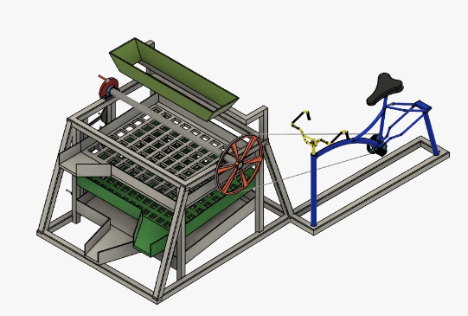
DESIGEN
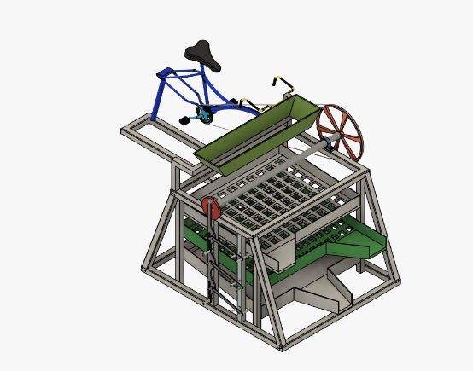
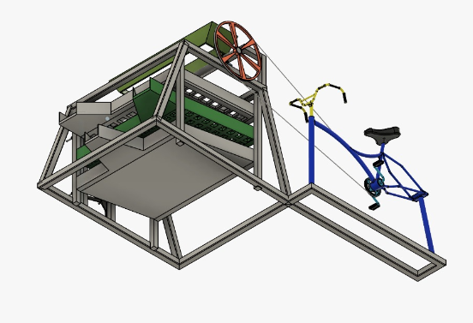
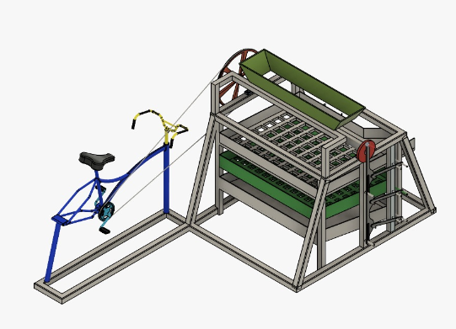

1. Frame:
The frame is the main body of the machine. It is made of strong mild steel so that it can support all parts and carry the weight of potatoes. Every component like pedal system, drum, hopper, and trays is fixed on this frame. A strong frame keeps the machine stable and prevents vibration during operation.
2. Pedal Mechanism:
This part transfers motion from the pedal to the drum. When the pedal rotates, the chain moves along the sprocket (gear), and this rotation is passed forward to the shaft and drum. It ensures smooth and continuous power transmission. Without this system, motion cannot reach the grading unit.
3. Chain and Sprocket
This part transfers motion from the pedal to the drum. When the pedal rotates, the chain moves along the sprocket (gear), and this rotation is passed forward to the shaft and drum. It ensures smooth and continuous power transmission. Without this system, motion cannot reach the grading unit.
4. Hopper
The hopper is the entry point of the machine. Potatoes are poured into it. It is designed in a slanted shape so that potatoes can easily slide down into the rotating drum. This helps in smooth and continuous feeding without blockage.

5. Grading Drum / Sieve
This is the most important part of the machine. It is a rotating cylindrical drum with holes of different sizes. When the drum rotates:
- Small potatoes fall through small holes
- Medium potatoes fall through medium holes
- Large potatoes move to the end
In this way, potatoes are automatically separated based on size.
6. Shaft
The shaft is a metal rod that connects different moving parts. It carries the rotational motion from the chain and sprocket to the drum. It must be strong because it handles the load and rotation together.
7. Bearings
Bearings are used to support the shaft and allow it to rotate smoothly. They reduce friction between moving parts, so the machine runs easily with less effort. Bearings also increase the life of the machine.
9. Seat
The seat is provided for the operator to sit comfortably while pedaling. Since the machine works on human power, a comfortable seat helps the operator work for a longer time without fatigue.
10. Wheels
Some machines have wheels for easy movement. These help in shifting the machine from one place to another in the field or storage area.
WORKING PRINCIPLE:
This machine works just like a cycle. A person sits on it and starts pedaling. When the pedals move, they rotate the chain and sprocket, which then makes the drum of the machine rotate.
Potatoes are poured into the hopper from the top. Because the hopper is tilted, the potatoes easily slide into the rotating drum.
As the drum keeps rotating, the potatoes move forward inside it. The drum has different size holes, so the potatoes get separated automatically:
- Small potatoes fall first
- Medium potatoes fall next
- Big potatoes come out at the end
All the potatoes are collected in different trays according to their size.
METHODLOGY
In this project, our goal was to make a simple machine that can help farmers without using electricity. First, we understood that sorting potatoes by hand takes a lot of time and hard work. So, we decided to design a pedal operated potato grader to make this work easier.
After that, we planned a simple design using basic and easily available parts. We selected materials like a mild steel frame, pedal system, chain and sprocket, and a drum with holes.
We followed a step-by-step process to build the design:
- First, we made a strong frame
- Then we added the pedal system to produce power
- After that, we connected the chain and sprocket to transfer motion
- Then we designed the rotating drum for grading
- A hopper was added on the top to put potatoes
- Trays were placed below to collect different sizes
We also made sure that the materials are strong and long-lasting. The design is kept simple so that farmers can easily use and maintain it.
Overall, the machine is designed to be low-cost, easy to use, and useful in villages where electricity is not available.
FUTURE SCOPE
n the future, this machine can be made even better in many ways. A small motor can be added so that the machine can run automatically without pedaling all the time. This will reduce human effort and make the work easier.
The size and design of the drum can also be improved to handle more potatoes and give better sorting results. Different hole sizes can be adjusted according to need.
The machine can be made more comfortable by improving the seat and pedal system, so a person can work for a longer time without getting tired. Wheels can also be added to make it easy to move from one place to another.
With some changes, this machine can also be used for sorting other vegetables like onions and tomatoes.
Overall, in the future, this machine can become more efficient, easy to use, and more useful for farmers.

RESULTS
The designed pedal-operated potato grading machine shows that it can successfully reduce manual effort and improve the grading process. Based on the conceptual design:
• The machine can separate potatoes into different sizes (small, medium, large) efficiently using the rotating drum.
• It does not require electricity, making it suitable for rural and remote areas.
• The use of a pedal mechanism allows continuous operation using human power.
• The design is simple, low-cost, and easy to operate for small farmers.
• Compared to manual grading, the machine is expected to save time and improve uniformity.
However, performance depends on the operator’s pedaling speed, and continuous use may cause fatigue.

CONCLUSION
The pedal-operated potato grading machine is a practical and affordable solution for small-scale farmers. It reduces manual labor, saves time, and improves grading accuracy without using electricity. The simple design makes it easy to use and maintain in rural areas.
Although its capacity is lower than electric machines and depends on human effort, it is still very useful where electricity is not available. Overall, this machine can help farmers increase productivity and get better market value for their produce. Future work should focus on building and testing the machine to check its actual performance.

REFERENCES
- Huda, M. et al. (2019). Development of drum type potato grading machine.
- Awasthi, A. (2021). Performance evaluation of power-operated grading machine for fruits and vegetables.
- AMA Journal (2005). Agricultural mechanization and its importance in developing countries.
- Gaikwad, B. et al. (2017). Design and development of pedal operated agricultural machines.

