Adopting Flexibility and Efficient Circulation as a Design Strategy in Civic Centers in Nigeria

Abstract
The performance of civic centers as multifunctional public buildings in Nigeria is increasingly constrained by rigid spatial configurations and inefficient circulation systems, which result in congestion, poor accessibility, and underutilization of spaces. These challenges are particularly evident in rapidly developing urban areas such as Bori, where the absence of adaptable and well-organized civic infrastructure limits the effectiveness of public engagement and socio-cultural activities. This study examines the adoption of flexibility and efficient circulation as integrated design strategies for enhancing the functionality and sustainability of civic centers in Nigeria. Guided by two core objectives—to analyze principles of effective circulation systems and to explore strategies for integrating flexibility into civic architecture—the research adopts a qualitative methodology involving literature review, climatic analysis of Port Harcourt and Bori, and comparative case study evaluation. Findings indicate that the integration of these strategies significantly improves spatial efficiency, enhances user comfort, and supports long-term adaptability. The study identifies major problems, including linear circulation patterns, poor spatial hierarchy, and lack of adaptability, which hinder building performance and user experience. In response, the study recommends the following sustainable solutions such as multi-directional circulation networks, modular spatial planning, central orientation nodes, and climate-responsive design strategies tailored to tropical conditions. The study concludes that flexibility and efficient circulation are essential design imperatives for contemporary civic centers in Nigeria and provides a framework for their practical implementation in emerging urban contexts.
Keywords: Civic centers, flexibility, circulation systems, spatial efficiency, adaptive architecture, thermal comfort, public buildings
1.0 Introduction
Civic centers are very important public buildings that provide spaces for governance, community interaction, cultural activities, conferences, exhibitions, and civic engagement. As urban populations continue to grow and community needs become increasingly diverse, civic centers are expected to accommodate so many functions while ensuring accessibility, comfort, and operational efficiency. Consequently, contemporary civic center design has shifted from rigid and single-purpose spatial arrangements toward more flexible and user-centered environments that can respond to changing social and functional demands (Lee, 2024, pp. 417–430). In recent years, flexibility and circulation have emerged as critical considerations in the design of public buildings. Flexibility enables spaces to support different activities over time without requiring significant physical alterations, while efficient circulation ensures smooth movement of users, reduces traffics, and enhances spatial legibility. Studies have shown that public buildings with adaptable spatial configurations and well-organized circulation networks achieve higher levels of functionality, user satisfaction, and long-term sustainability than buildings with fixed layouts and inefficient movement systems (Keleş et al., 2024, pp. 199–213). The growing emphasis on multifunctional public facilities has also increased the need for flexible planning and efficient circulation systems. Contemporary civic architecture increasingly incorporates open-plan layouts, modular spaces, interconnected activity zones, and integrated indoor–outdoor environments to improve adaptability and space utilization. These approaches enable civic centers to accommodate changing user demands while maintaining operational efficiency and environmental performance (Safo et al., 2024). In Nigeria, many civic and public buildings continue to experience challenges associated with poor circulation patterns, limited spatial adaptability, overcrowding during major events, and underutilization of facilities during off-peak periods. These challenges often reduce the effectiveness of public buildings and hinders their ability to serve evolving community needs. Recent studies on public-building performance in Nigeria have highlighted the need for design approaches that promote accessibility, adaptability, and user-centered spatial organization (Ekolama et al., 2024). Bori, the traditional headquarters of Ogoniland in Rivers State, is an increasing developing urban center with rapid social, cultural, and administrative activities. However, the town lacks a modern civic center capable of supporting diverse community functions through flexible spaces and efficient circulation systems. Given the climatic conditions, population growth, and expanding civic needs of the area, there is a need to explore design strategies that enhance adaptability, movement efficiency, and environmental responsiveness. This study therefore investigates the adoption of flexibility and efficient circulation as design strategies for civic centers in Nigeria, with particular emphasis on generating design principles that can inform the development of a proposed civic center in Bori, Rivers State.
1.1 Statement of the Problem
The design of civic centers in Nigeria is often characterized by rigid spatial configurations and inefficient circulation systems, which limit their functionality and adaptability. These limitations manifest in overcrowded corridors, poorly defined movement paths, and underutilized spaces, particularly during varying occupancy levels. Such conditions not only reduce user satisfaction but also compromise safety and operational efficiency.
In many cases, civic centers are designed for singular functions, making it difficult to accommodate diverse activities without significant modifications. This lack of flexibility results in inefficient use of space, where certain areas remain idle while others experience excessive congestion. In Bori, the absence of a purpose-built civic center further exacerbates these issues, highlighting the need for a design approach that integrates flexibility and efficient circulation to enhance performance and sustainability.
1.3 Aim and Objectives
The aim of this study is to examine how flexibility and efficient circulation can be adopted as design strategies for improving civic centers in Nigeria.
  - Objectives
- To analyze principles of effective circulation systems in civic center design, focusing on accessibility, movement efficiency, and user experience.
- To explore strategies for integrating flexibility into civic architecture to support multi-functionality and long-term adaptability.
2.0 Literature Review
The literature on civic architecture emphasizes that flexibility and circulation are fundamental determinants of building performance, particularly in public facilities where user diversity and functional variability are high (Till, 2009). Scholars argue that the success of civic centers depends on their ability to accommodate change while maintaining efficiency and usability (Brand, 1994). In developing countries, this requirement is even more critical due to resource constraints and rapid urban growth (Adebayo, 2014).
2.1 Principles of Circulation in Civic Centers
Circulation refers to the movement systems within a building that connect spaces and facilitate user interaction. According to Francis D. K. Ching (2014), circulation encompasses approach, entry, path configuration, and spatial relationships, all of which influence how users navigate building. Efficient circulation systems enhance accessibility, reduce congestion, and improve overall user experience. The concept of spatial legibility introduced by Kevin Lynch (1960) highlights the importance of creating environments that are easy to understand and navigate. Buildings with clear circulation paths and visual cues enable users to move intuitively, reducing confusion and enhancing usability. Similarly, Hillier and Hanson (1984) emphasize that spatial configuration directly influences movement patterns and social interaction.
2.2 Classification of Flexibility
Spatial flexibility is the ability of interior spaces to accommodate multiple activities through adaptable layouts such as open plans, movable partitions, and reconfigurable furniture systems without permanent structural changes (Schneider & Till, 2007; Leupen, 2006).
Structural flexibility refers to the design of building frameworks, including column spacing and load-bearing systems, that allow future modifications or expansions without compromising structural integrity (Leupen, 2006).
Functional flexibility is the ability of a space to support different activities either simultaneously or over time, thereby improving efficiency and maximizing space utilization (Kronenburg, 2007; Till, 2009).
Temporal flexibility describes the ability of a building to adapt over time in response to changing user needs, technological advancements, or socio-economic conditions (Brand, 1994).
2.3 Flexibility and Circulation in Public Buildings
Flexibility and circulation are two fundamental design principles that influence the functionality and performance of public buildings. Flexibility refers to the capacity of a building and its spaces to accommodate different activities, changing user requirements, and future modifications without extensive structural alterations. Circulation, on the other hand, refers to the movement system that enables users to access and navigate spaces efficiently within a building (Ching, 2014). In civic centers, these concepts are closely interconnected because flexible spaces require efficient circulation systems to support multiple uses and varying occupancy levels. A well-designed civic center should provide adaptable spaces that can host meetings, exhibitions, conferences, cultural events, and community activities, while also ensuring smooth movement through clearly defined entrances, corridors, lobbies, and circulation routes. The integration of flexibility and efficient circulation enhances accessibility, reduces congestion, improves user experience, and promotes the long-term sustainability of public buildings by allowing them to respond effectively to evolving community needs (Brand, 1994; Kronenburg, 2007; Schneider & Till, 2007).
2.4 Passive Design Strategy in Civic Center Design
Passive design strategies refer to architectural approaches that utilize natural environmental conditions to improve thermal comfort, energy efficiency, and indoor environmental quality without excessive dependence on mechanical systems. In civic center design, passive strategies include building orientation, natural ventilation, daylight utilization, solar shading, thermal mass, and landscape integration. These approaches have become increasingly important in public architecture due to growing concerns about energy consumption, climate change, and sustainable development. Recent studies indicate that passive design significantly improves environmental performance and reduces operational energy costs in large public buildings (Adewale et al., 2024; Wang et al., 2023, p. 112679). In tropical climates such as Bori and Port Harcourt, passive design strategies contribute to thermal comfort by minimizing solar heat gain and enhancing natural airflow. Features such as courtyards, deep roof overhangs, sun-shading devices, and cross-ventilation corridors improve indoor conditions while reducing reliance on air-conditioning systems. Research on Nigerian public buildings shows that climate-responsive passive design enhances sustainability and user comfort while supporting long-term building performance (Adewale et al., 2024, pp. 4–8). Furthermore, passive design strategies are particularly suitable for civic centers because these facilities accommodate large numbers of users and often operate for extended periods. The integration of natural ventilation systems, atria, and shaded transitional spaces can create comfortable public environments while promoting energy conservation. Studies on large-scale public buildings demonstrate that passive environmental strategies contribute significantly to carbon reduction and sustainable building operation (Wang et al., 2023, p. 112679).
2.5 Wayfinding in Civic Center Design
Wayfinding refers to the process through which users orient themselves and navigate efficiently within a built environment. In civic centers, effective wayfinding is achieved through clear spatial organization, visual landmarks, logical circulation networks, signage systems, and identifiable nodes. Wayfinding is a critical component of user experience because it influences how easily visitors can locate destinations, access services, and move through public spaces. Recent studies indicate that building visibility, spatial configuration, and route clarity significantly influence wayfinding performance in complex public facilities (Gath-Morad et al., 2024; Feng & Duives, 2023).
The relationship between wayfinding and circulation is particularly important in civic center design. Buildings with well-defined entrances, central orientation spaces, and hierarchical movement systems enable users to understand spatial relationships more easily. Research on public facilities has shown that effective wayfinding reduces confusion, minimizes travel time, and improves user satisfaction, especially in buildings that serve diverse user groups and accommodate multiple functions simultaneously (Daniel & Okoro, 2024, pp. 6–11).
Recent developments in wayfinding research emphasize the importance of spatial legibility and visibility in enhancing navigation performance. Legible environments enable users to form cognitive maps of spaces, thereby improving orientation and reducing dependence on external assistance. Consequently, wayfinding should be considered an integral design component rather than merely a signage system in civic center architecture (Gath-Morad et al., 2024; Feng & Duives, 2023).
2.6 Public Space Efficiency in Civic Center Design
Public space efficiency refers to the ability of civic center spaces to support diverse activities while maximizing accessibility, functionality, and user satisfaction. Efficient public spaces ensure that available areas are utilized effectively without unnecessary congestion, underutilization, or spatial conflicts. In civic centers, public space efficiency is achieved through appropriate zoning, flexible planning, integrated circulation systems, and adaptable spatial arrangements that accommodate varying user demands (Wogu et al., 2024).
Efficient public spaces contribute significantly to the social and functional performance of civic centers. They promote interaction, community engagement, and inclusiveness while supporting a wide range of activities such as conferences, exhibitions, cultural events, and administrative functions. Recent research on public building performance indicates that the integration of functional spaces with efficient circulation systems improves overall usability and enhances visitor experience (Zhang et al., 2024, pp. 623–649).
The concept of public space efficiency is closely linked to flexibility and circulation. Flexible spaces can accommodate changing activities, while efficient circulation systems facilitate movement between these spaces. Studies on large public facilities suggest that prioritizing public space performance and transportation systems significantly enhances building functionality and long-term sustainability. Therefore, public space efficiency remains a fundamental consideration in the design of contemporary civic centers (Zhang et al., 2024; Wang et al., 2023).
2.7 Integration of Circulation and Flexibility
The relationship between circulation and flexibility is central to the performance of civic centers. Efficient circulation systems enable the smooth movement of users between flexible spaces, while adaptable spatial configurations support diverse movement patterns. Hertzberger (1991) argues that circulation spaces should be integrated with functional spaces, rather than treated as separate elements. This integration enhances both usability and spatial quality.
2.8 Modularity and Adaptive Design
Modular design is a key strategy for achieving flexibility. By using standardized units, architects can create spaces that are easily reconfigured or expanded. This approach not only enhances adaptability but also improves construction efficiency and reduces costs. In civic centers, modular design allows for the subdivision of large halls into smaller spaces or the expansion of facilities to accommodate larger events.
2.9 Sustainable Development Goal (SDG) 11: Sustainable Cities and Communities
SDG 11 aims to make cities and human settlements inclusive, safe, resilient, and sustainable (United Nations, 2015). This goal is relevant to the article because civic centers are important public facilities that promote community interaction, cultural activities, and public participation. The adoption of flexibility and efficient circulation in civic center design enhances accessibility, improves user comfort, supports multiple functions, and ensures long-term sustainability. These qualities contribute to the development of inclusive and resilient communities, which are key objectives of SDG 11.
3.0 Methodology
This study adopts a qualitative research methodology supported by comparative case study analysis and literature review. The research design is exploratory in nature, aiming to identify design strategies that enhance flexibility and circulation in civic centers (Creswell, 2014).
Data collection involves an extensive review of scholarly literature, including books, journal articles, and reports on civic architecture, flexibility, and circulation systems.
Case studies of selected civic centers are analyzed to identify best practices and design patterns. These include both Nigerian and international examples, allowing for comparative evaluation. The data is analyzed using thematic analysis, focusing on key variables such as spatial organization, circulation patterns, and flexibility strategies. The findings are synthesized to develop a design framework that integrates flexibility and efficient circulation, providing practical recommendations for civic center design in Nigeria.

3.1 Case Study Analysis and Selection Criteria
Case study analysis reveals that civic centers with efficient circulation systems and flexible spatial configurations perform better in terms of usability and adaptability (Gehl, 2011). Nigerian examples highlight challenges related to linear circulation and rigid layouts, while international examples demonstrate the benefits of modular design and central circulation nodes.
After a careful evaluation and observation as regard the study, the Case Studies were selected based on the following Criteria
- The ability of Spaces to adapt to multiple functions over time.
- The organization of movement systems that enable efficient navigation and spatial connectivity.
- Recognition as successful civic facilities.
- Demonstration of flexible design principles.
3.2 Case study 1; Baro de Viver Civic Center .
Located in Barcelona Spain was design and constructed in 2014, the building has 1652 m² area.
The Baró de Viver Civic Center, located in Barcelona, the concept of this building was a community-based public facility developed to support social interaction, cultural activities, and neighborhood revitalization. It was built bassically to serve as a multi-functional hub for local residents, accommodating events such as meetings, exhibitions, training programs, and recreational activities.
The building is designed with open-plan spaces and movable partitions, allowing rooms to be easily reconfigured for different uses. This ensures efficient space utilization and adaptability to changing community needs.
the center adopts a multi-directional movement system rather than rigid corridors, enabling easy navigation and reducing congestion. The integration of circulation with activity spaces also enhances user interaction and spatial connectivity.
This case study is relevant to this research because it demonstrates how flexible design and efficient circulation systems can improve the functionality and usability of civic centers, making it a suitable model for application in Bori, Nigeria.
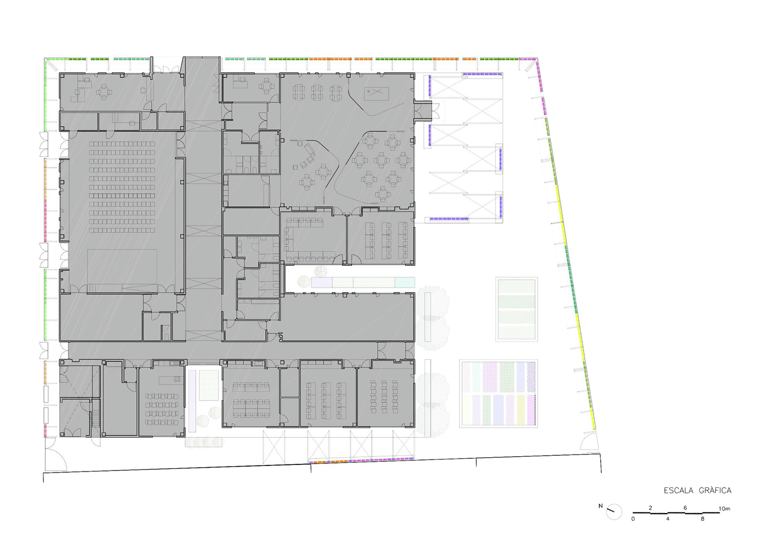
Figure 3.1 Open floor plan showing circulation pattern and flexible spaces
Source; Archi daily
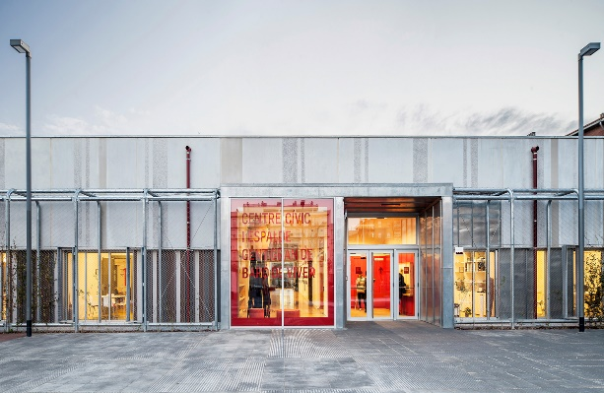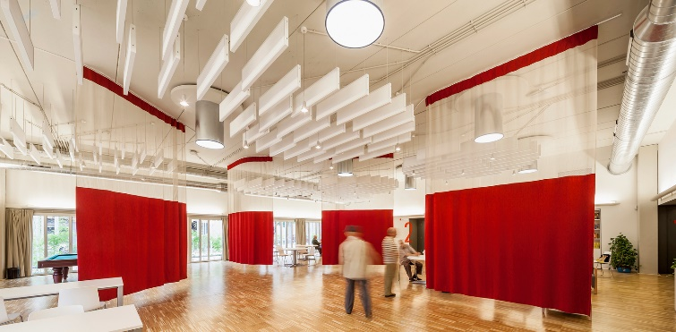
Figure 3.2 Views showing external circulation pattern and a flexible multi-purpose hall
Source; Archi daily
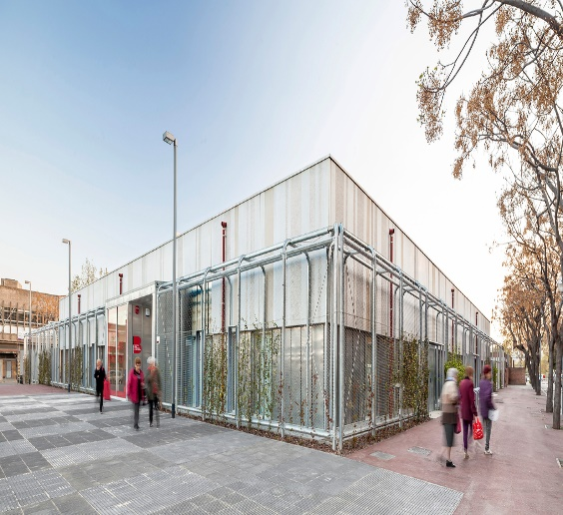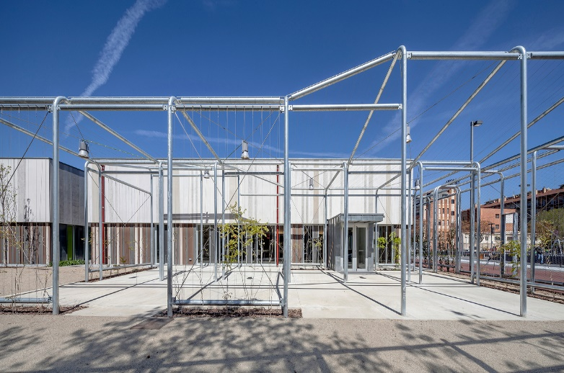
3.2.1 Findings, Advantages And disadvantages from Case study 1
1. Finding
The building features open-plan layouts and moveable partitions, enabling high levels of adaptability. Circulation is multi-directional, with strong visual connections between spaces.
2. Advantages
- High spatial flexibility
- Excellent circulation efficiency
- Stong community engagement
- Supports multiple functions
3. Disadvantage
- Open circulation networks create navigational challenges for first time users
- Extensive use of adaptable spaces reduced the sense of spatial identity for specific functions.
3.3 Case study 2; Waitakere Civic Center.
Located in Germany was design and constructed in 2006, the building has 13400m² area.
The Waitakere Civic Center, located in Germany was developed as a public administrative and community facility designed to bring together civic services, public interaction, and cultural activities within a unified environment. Its primary purpose is to function as a central hub for governance and community engagement, integrating offices, public halls, and shared spaces.
This building incorporates adaptable interior spaces and multi-use public areas that can accommodate different functions such as meetings, exhibitions, and civic events. The design allows spaces to evolve over time, supporting changing user needs and improving long-term usability (Brand, 1994).
The civic center is organized around a central atrium, which serves as a major circulation node. This creates a radial movement system, allowing users to navigate easily between spaces while enhancing spatial clarity and wayfinding. The open circulation layout also encourages interaction and improves accessibility.
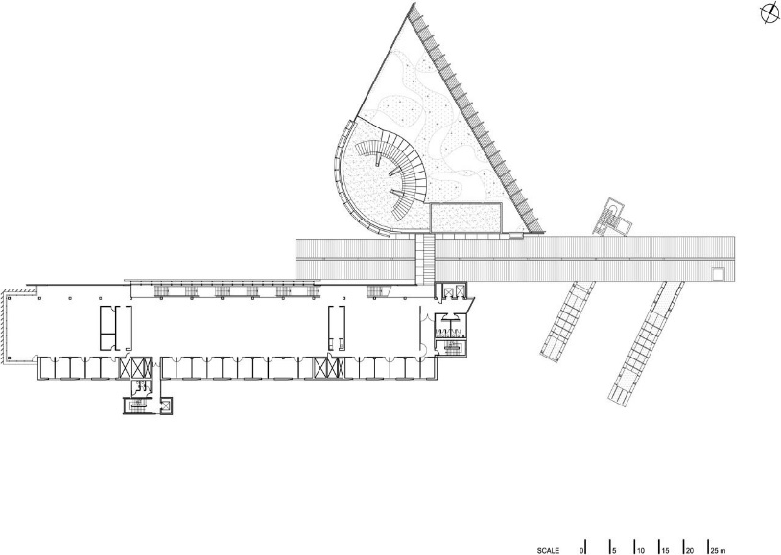
This case study is relevant to this research because it demonstrates how centralized circulation systems and flexible spatial planning can enhance efficiency, user experience, and functional adaptability in civic center design
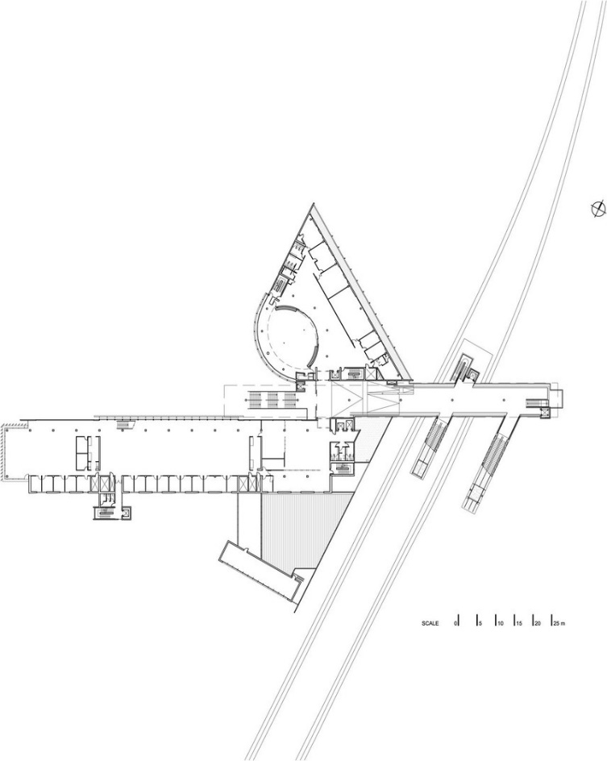

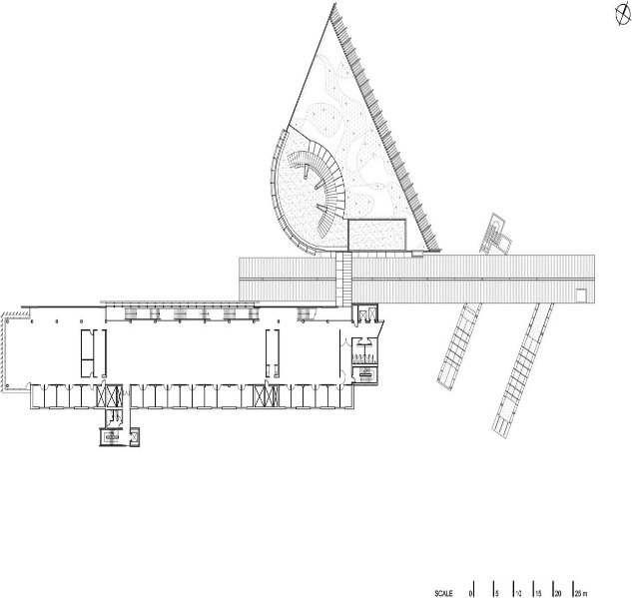

Figure 3.3.1 Open floor plan showing circulation pattern and flexible spaces
Source; Archi daily

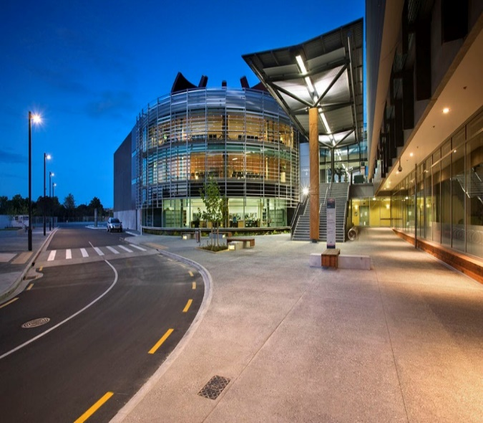
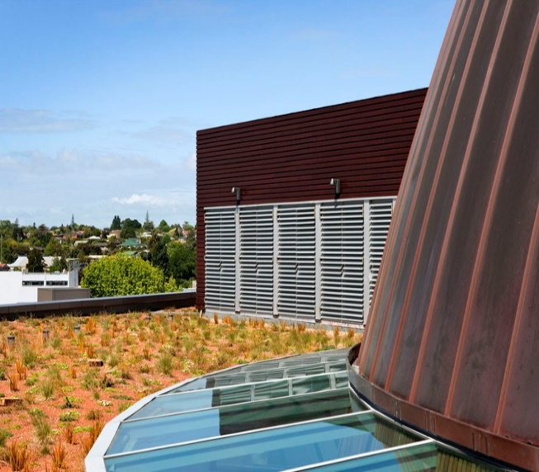

Figure 3.3.2 Views showing external circulation pattern
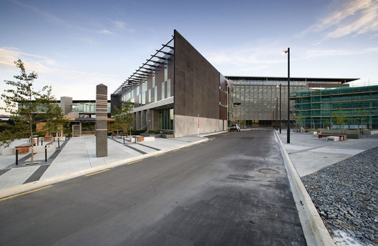
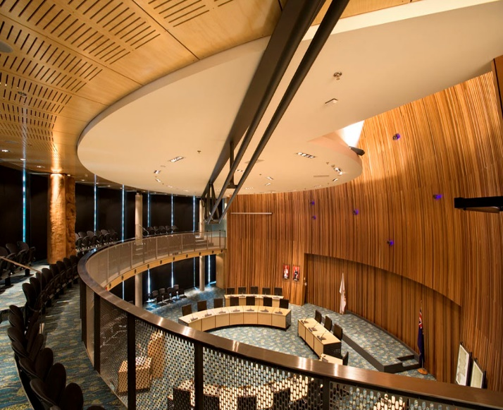
Source; Archi daily

Figure 3.3.3 Views showing external circulation pattern and a flexible multi-purpose hall
3.3.1 Findings, Advantages and Disadvantages from Case study 2
1. Findings
The building is organized around a central atrium, which acts as a circulation hub. This circulation system allows users to access different spaces efficiently. The atrium also serves as a visual and spatial anchor, improving wayfinding.
2. Advantages
- It provides a model for integrating circulation with public space
- It enhances spatial legibility and user orientation
- It demonstrates effective use of central circulation
3. Disadvantages
- Long internal circulation routes increases walking distances for users.
- Large public atriums also consume considerable floor area that might used for other functions
Table 3.1: Comparative Analysis of Case Studies Based on Flexibility, Circulation, Adaptability and User Experience
Case Study | Flexibility | Circulation | Adaptability | User Experience
Case Study 1  Baró de Viver Civic Center, Barcelona, Spain | • Highly flexible open-plan design.  • Movable partitions enhance space transformation.  • Supports educational, social, and cultural activities.  • Spaces can be reconfigured easily.  • Encourages multifunctional use. | • Multiple circulation pathways.  • Open and interconnected movement system.  • Good visual connectivity.  • Reduces congestion.  • Promotes smooth user movement. | • High adaptability to changing community needs.  • Flexible spatial organization.  • Supports evolving public programs.  • Easy space reconfiguration.  • Long-term functional relevance. | • Strong community interaction.  • Welcoming public environment.  • Easy movement between functions.  • Encourages social engagement.  • High level of user satisfaction.
Case Study 2  Waitakere Civic Centre, Germany. | .  • Flexible public and administrative spaces.  • Adaptable interior layouts.  • Shared-use facilities.  • Supports diverse civic activities.  • Future-oriented planning approach. | • Central atrium acts as circulation hub.  • Excellent wayfinding system.  • Multiple route options.  • Strong visual orientation.  • Efficient distribution of users. | • High capacity for future modifications.  • Spaces accommodate changing civic demands.  • Integrated planning strategy.  • Adaptable public facilities.  • Sustainable long-term performance | • Comfortable and intuitive navigation.  • Attractive public spaces.  • Strong visual connectivity.  • Encourages public participation.  • Enhanced spatial experience.

3.3.2 Key Comparative Findings
Flexibility
Baró de Viver Civic Center demonstrate the highest levels of flexibility through open-plan and modular design approaches.
Waitakere Civic Centre incorporates adaptable civic spaces that respond to changing community needs.
Circulation
Waitakere Civic Centre demonstrates the most efficient circulation system through its central atrium concept.
Baró de Viver Civic Center benefits from interconnected movement routes that reduce congestion.
Adaptability
Walkerville Civic Center exhibits the highest adaptability due to its modular design approach.
Baró de Viver and Waitakere Civic Centres effectively respond to changing functional requirements.
User Experience
Waitakere Civic Centre provides excellent wayfinding and visual orientation.
Baró de Viver Civic Center encourages community interaction and social engagement
  - Findings and Discussion
4.1 Adoption from the Selected Case Studies
Based on the evaluation of the selected case studies, it is evident that successful civic centers prioritize flexible spaces that can accommodate different activities without major structural changes. The study also shows that efficient circulation systems, characterized by clear movement routes, logical spatial organization, and effective connectivity between spaces, significantly improve accessibility and user experience. Furthermore, the selected case studies demonstrate that integrating adaptable planning, multifunctional spaces, and well-defined zoning enhances the long-term performance and sustainability of civic centers. These observations provide practical design strategies that can be adopted in the design of civic center in Nigeria to create a functional, adaptable, and user-friendly public facility.
4.2 Proposed Framework for Integrating Flexibility and Circulation in Nigerian Civic Centers
- Based on the findings from the literature review, and case study investigations, this study proposes a framework for integrating flexibility and circulation in the design of civic centers in Nigeria. The framework recognizes that flexibility and circulation should not be treated as independent design considerations but as interrelated components that collectively influence building performance.
- The framework is built upon five major components: spatial flexibility, circulation efficiency, climatic responsiveness, user-centered planning, and future adaptability. Spatial flexibility ensures that civic spaces can accommodate multiple functions without extensive physical alterations. Circulation efficiency facilitates smooth movement and accessibility, thereby reducing congestion and improving user experience. Climatic responsiveness ensures that circulation routes and activity spaces are environmentally comfortable and energy efficient. User-centered planning focuses on the needs of diverse user groups, including children, elderly persons, and persons with disabilities. Future adaptability enables civic centers to respond to changing social, technological, and economic conditions.
- The interaction between these components creates a civic center that is functional, adaptable, sustainable, and capable of supporting diverse community activities. The framework therefore provides a strategic model for future civic center development in Nigeria and other rapidly urbanizing regions.
4.2 Design Principles that Enhances Flexibility and Efficient Circulation in Civic Center
1. One key principle is the establishment of spatial hierarchy, which organizes spaces according to their importance and function, thereby guiding movement and improving accessibility.
2. Another principle is the provision of multi-directional circulation systems, which distribute movement across multiple pathways and reduce congestion. Central orientation spaces, such as atriums, serve as reference points that enhance wayfinding and spatial legibility.
Modular design systems also play a critical role in enhancing flexibility, as they allow spaces to be reconfigured to accommodate different functions. Also, to integrate indoor and outdoor spaces enhances adaptability and user experience in civic centers.
4.3 Proposed Contribution to Knowledge
This study proposes an Integrated Flexibility–Circulation Framework (IFCF) for civic centers in Nigeria, which combines spatial flexibility, adaptive zoning, climate-responsive circulation, and multifunctional planning into a single design model. Unlike conventional civic center designs that treat flexibility and circulation as separate concepts, the framework demonstrates how both elements can work together to improve adaptability, user experience, operational efficiency, and long-term sustainability in emerging urban environments.
5.0 Recommendation and Conclusion
The study, therefore, recommends the following;
- To improve the design of civic centers in Nigeria, I recommend modular planning systems that allow for flexibility and future expansion.
- The integration of multi-directional circulation systems should be prioritized to enhance movement efficiency and reduce congestion.
- Climate-responsive design strategies must also be incorporated to takes care of the environmental challenges associated with the tropical climate.
- Professionals in the built environment especially the architects, should design buildings with future adaptability in mind, using movable partitions and flexible layouts to accommodate changing needs.
The establishment of clear spatial hierarchies and the provision of central orientation spaces will further enhance navigation and user experience. Finally, the separation of circulation routes for different user groups is necessary to improve functionality and security.
Conclusion
This study demonstrates that flexibility and efficient circulation are essential design strategies for improving the performance of civic centers in Nigeria. By addressing the limitations of existing designs, these strategies enhance functionality, user experience, and sustainability. The proposed framework provides a basis for the development of adaptive civic architecture that responds to both current and future needs
References
Adeyemi, E. A. (2018). Public building design in Nigeria. Lagos, Nigeria: University of Lagos Press.
Adewale, B. A., Ogunbayo, B. F., Aigbavboa, C. O., & Ene, V. O. (2024). Evaluation of green design strategies adopted by architects for public buildings in Nigeria. Engineering Proceedings, 76(1), 24. Basel, Switzerland: MDPI. https://doi.org/10.3390/engproc2024076024⁠
Adebayo, A. (2014). Urban development in Nigeria. Ibadan, Nigeria: University of Ibadan Press.
Brand, S. (1994). How buildings learn: What happens after they're built. New York, NY, USA: Viking Press.
Ching, F. D. K. (2014). Architecture: Form, space, and order. Hoboken, USA: Wiley.
Creswell, J. W. (2014). Research design. Thousand Oaks, USA: Sage Publications.
Daniel, J. C., & Okoro, B. A. (2024). Design approaches to managing human flow in crowded public event venues: A Nigerian case study. Material Science and Engineering International Research Journal, 12(2), 1–15. Port Harcourt, Nigeria.
Ekolama, R. E., Ibitoye, O. A., Agbaje, I. A., & Thomas, A. J. (2024). Assessment of functional circulation in selected mixed-use buildings in Ikoyi, Lagos State. International Journal of Multidisciplinary Research and Growth Evaluation, 5(4), 43–48.
Feng, Y., & Duives, D. C. (2023). Pedestrian wayfinding behavior in a multi-story building: A comprehensive modeling study featuring route choice, wayfinding performance, and observation behavior. Transportation Research Studies, 1–25.
Gath-Morad, M., Grübel, J., Steemers, K., Sailer, K., Ben-Alon, L., Hölscher, C., & Aguilar, L. (2024). The role of strategic visibility in shaping wayfinding behavior in multilevel buildings. Scientific Reports, 14, 3735. London, United Kingdom: Nature Portfolio.
Kronenburg, R. (2007). Flexible architecture. London, UK: Laurence King.
Keleş, B. N., Takva, Ç., & Çakıcı, F. Z. (2024). Accessibility analysis of public buildings with graph theory and the space syntax method: Government houses. Journal of Asian Architecture and Building Engineering, 23(1), 199–213.
Lee, S. (2024). An application effect analysis of open-type space design for public government offices. Journal of Korea Institute of Spatial Design, 19(7), 417–430.
Leupen, B. (2006). Frame and generic space. Rotterdam, Netherlands: 010 Publishers.
NIMET. (2020). Climate report. Abuja, Nigeria: Government Press.
Olotuah, A. O., & Adesiji, A. R. (2005). Housing development in Nigeria. Lagos, Nigeria: University Press.
Safo, L. K. A., Duah, D. Y. A., & Liwur, S. B. (2024). Sustainable architectural design and land-use application to civic centres in Ghana: The case of Damongo. Urban, Planning and Transport Research, 12(1), 1–18
Schneider, T., & Till, J. (2007). Flexible housing. Cambridge, UK: Cambridge University Press.
Till, J. (2009). Architecture depends. Cambridge, USA: MIT Press.
United Nations. (2015). Transforming our world: The 2030 agenda for sustainable development
Wang, Y., Zhang, X., & Li, J. (2023). An interactive design framework for large-scale public buildings based on comfort and carbon abatement. Energy and Buildings, 279, 112679. Amsterdam, Netherlands: Elsevier.
Wogu, D. C., Anthony, O., Otuonyo, G., & Adenubi, F. (2024). Benefits of a smart building design in public library facilities, Lagos State, Nigeria. ABUAD Journal of Engineering and Applied Sciences, 2(1), 145–159. Ado-Ekiti, Nigeria: Afe Babalola University.
Zhang, X., Liu, Y., & Chen, H. (2024). Spatial performance evaluation and optimization of integrated aboveground and underground spaces in urban commercial complexes. Journal of Asian Architecture and Building Engineering, 23(3), 623–649. Tokyo, Japan:
Zhao, X., & Cho, E. (2023). Analysis on spatial hierarchy characteristics according to the functional arrangement of complex community centers. Journal of Korea Institute of Spatial Design, 18(1), 233–244.

