BANATECH: AN IOT-ENABLED SOLAR-POWERED BANANA CHIPS MAKER WITH AN INTEGRATED E-COMMERCE PLATFORM FOR ORIENTAL MINDORO ENTERPRISES

ABSTRACT

BANATECH is a sustainable IoT-enabled solar-powered banana chips maker with an integrated e-commerce platform designed to support Oriental Mindoro enterprises and improve small-scale food production. The study aimed to automate the processes of banana sorting, slicing, and frying through the integration of sensors, microcontrollers, and automated mechanisms to enhance productivity, consistency, and operational efficiency. The system also incorporates an e-commerce platform that enables users to manage inventory and conduct online transactions. BANATECH utilizes renewable solar energy to promote sustainable and cost-efficient operations for local producers. The prototype was evaluated using ISO 25010 software quality metrics and the Unified Theory of Acceptance and Use of Technology (UTAUT) model, which assessed functionality, reliability, usability, and user acceptance. Findings indicate that the system is effective, reliable, and beneficial for supporting sustainable island-based food enterprises.

Keywords: IoT, solar-powered system, banana chips maker, e-commerce platform, automation, sustainable technology,Oriental Mindoro enterprises, smart food processing.

INTRODUCTION
The rapid advancement of automation and smart technologies has significantly transformed the food processing industry by improving production efficiency, product consistency, and operational sustainability. In the Philippines, banana chips production remains a common source of livelihood among small-scale enterprises and local agricultural communities. However, many producers still depend on traditional manual methods of sorting, slicing, and frying bananas, which often result in inconsistent product quality, increased labor requirements, and slower production processes. According to Lopez (2021), traditional banana chips manufacturing is associated with production inefficiencies that affect productivity and product quality. Similarly, Santos, Reyes, and Dizon (2019) emphasized that manual food processing commonly leads to inconsistencies in product output and operational limitations.
The integration of Internet of Things (IoT) technology has created opportunities to modernize food processing systems through automation and real-time monitoring. Gubbi et al. (2020) stated that IoT enables interconnected devices and sensors to automate industrial operations and improve production performance. Likewise, Kumar and Singh (2021) explained that IoT-enabled frying systems enhance monitoring accuracy, consistency, and operational efficiency in food manufacturing. Automated slicing and frying technologies also reduce human error and improve workflow efficiency (Li, Zhang, & Chen, 2020). These technological advancements support Sustainable Development Goal (SDG) 9: Industry, Innovation, and Infrastructure by encouraging innovation, automation, and technological development in local industries.
In the Philippine context, the banana industry plays a vital role in supporting rural livelihoods and local economic growth. According to the Department of Agriculture (2021), banana production contributes significantly to agricultural productivity and small-scale enterprise development in many provinces. However, Bautista (2019) noted that post-harvest handling and food processing practices among local banana producers still require modernization to improve productivity and reduce waste. Pascual and Flores (2020) further explained that agricultural mechanization and automation can strengthen the sustainability and competitiveness of local industries. These developments align with SDG 8: Decent Work and Economic Growth by supporting local producers and promoting economic opportunities for small and medium enterprises.
In addition to automation, renewable energy technologies have become increasingly important in promoting environmentally sustainable production systems. Solar-powered technologies provide cost-efficient and eco-friendly alternatives to conventional energy sources, particularly for rural and island communities with limited access to stable electricity. Zhang, Huang, and Liu (2021) stated that automated frying systems integrated with smart temperature regulation improve energy efficiency while maintaining product quality and operational reliability. The use of renewable energy supports SDG 7: Affordable and Clean Energy by encouraging sustainable and energy-efficient food processing practices. Furthermore, reducing dependence on conventional electricity contributes to SDG 13: Climate Action through the promotion of environmentally friendly technologies and reduced carbon emissions.
Digital transformation and e-commerce platforms also provide opportunities for small food businesses to improve accessibility, expand market reach, and strengthen business operations. Ramos (2023) highlighted that e-commerce platforms enable small enterprises to conduct online transactions, monitor inventory, and improve customer accessibility through digital systems. These practices support SDG 12: Responsible Consumption and Production by promoting efficient resource management, minimizing waste, and improving sustainable production processes.
In response to these technological and industrial challenges, the researchers developed BANATECH: A Sustainable IoT-Enabled Solar-Powered Banana Chips Maker with Integrated E-Commerce Platform forOriental Mindoro Enterprises. The study aims to automate the processes of banana sorting, slicing, and frying through the integration of sensors, microcontrollers, and smart automation technologies powered by renewable solar energy. Additionally, the system incorporates an e-commerce platform that supports inventory management, digital transactions, and online product accessibility. Through this innovation, the study seeks to improve production efficiency, promote sustainable food processing practices, supportOriental Mindoro enterprises, and contribute to the achievement of SDGs 7, 8, 9, 12, and 13 through smart, innovative, and environmentally sustainable technological solutions.
Objectives of the Study
The study aims to develop and evaluate BANATECH, a sustainable IoT-enabled and solar-powered banana chips maker with an integrated e-commerce platform designed to improve the efficiency, consistency, sustainability, and digital accessibility of banana chips production forOriental Mindoro enterprises. Specifically, the study focuses on designing an automated system capable of sorting, slicing, and frying bananas using IoT, sensor-based, and microcontroller technologies to enhance production accuracy and operational performance, which supports SDG 9: Industry, Innovation, and Infrastructure. The study also aims to integrate solar-powered technology to promote energy-efficient and environmentally sustainable food processing operations in support of SDG 7: Affordable and Clean Energy and SDG 13: Climate Action. Furthermore, the development of an e-commerce platform for inventory management, online transactions, and product monitoring seeks to support local producers and small enterprises, contributing to SDG 8: Decent Work and Economic Growth. The study also promotes efficient and sustainable food production practices aligned with SDG 12: Responsible Consumption and Production. Lastly, the system will be evaluated using ISO 25010 software quality standards and assessed through the Unified Theory of Acceptance and Use of Technology (UTAUT) model to determine its effectiveness, usability, and contribution to sustainable technological innovation for local banana chips enterprises.

METHODOLOGY
This study utilized the Research and Development (R&D) method to design, develop, and evaluate BANATECH: A Sustainable IoT-Enabled Solar-Powered Banana Chips Maker with Integrated E-Commerce Platform for Oriental Mindoro Enterprises.

Figure 1. Methodology Model of BANATECH
The process begins with Initial Requirements, where the researchers gather the necessary information, system needs, and user requirements for the IoT-enabled solar-powered banana chips maker and e-commerce platform. This is followed by Model Development, where the initial concept and system framework are created based on the identified requirements. The Design phase focuses on planning the hardware architecture, software interface, IoT integration, sensors, microcontrollers, and solar-powered components of the system. Afterward, a working prototype is developed during the Prototyping Model phase to demonstrate the automated sorting, slicing, frying, and monitoring functionalities of BANATECH.
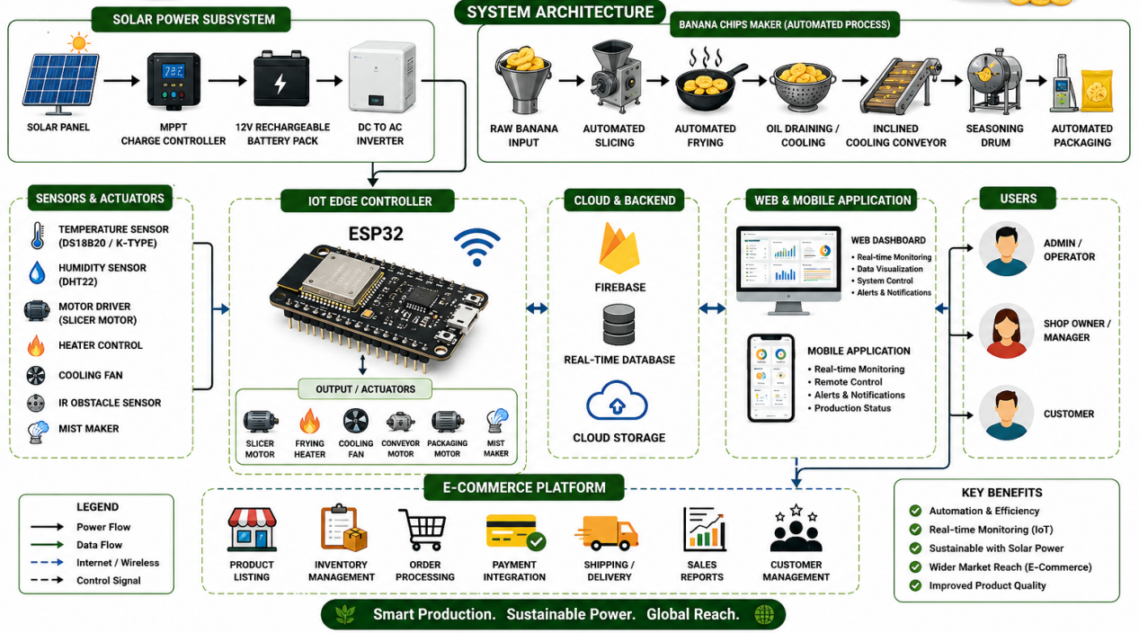
Figure 2.Overall BANATECH System Behavior
The prototype is then subjected to Business Owner Evaluation, where potential users and stakeholders assess the functionality, usability, and effectiveness of the system. Their feedback is analyzed during the Review and Update phase to improve the design, features, and performance of the system. Once revisions are completed, the researchers proceed to the Development stage, where the finalized system is fully implemented and integrated with the e-commerce platform. The system then undergoes Testing to evaluate its functionality, reliability, efficiency, usability, maintainability, flexibility, and security based on ISO 25010 standards. Finally, the Maintenance phase ensures continuous monitoring, updates, troubleshooting, and improvement of the BANATECH system to maintain operational efficiency and long-term sustainability.
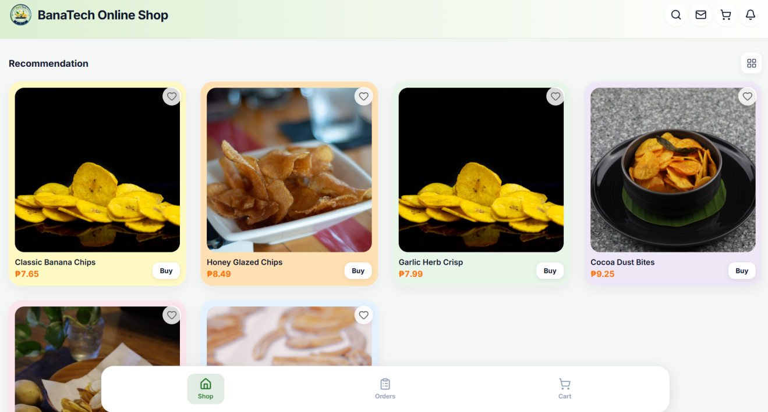
Figure 3. User Interface
For the evaluation procedure, the researchers used a Likert Scale questionnaire to assess the acceptability and quality of the system. The evaluation was based on the ISO 25010 software quality standards, which include functionality, performance efficiency, compatibility, usability, reliability, security, maintainability, portability, flexibility, and safety. Additionally, the Unified Theory of Acceptance and Use of Technology (UTAUT) model was utilized to evaluate user acceptance, behavioral intention, and ease of use of the BANATECH system. The respondents included business owners, IT experts, and potential users who evaluated the effectiveness and usability of the project.
The statistical tools used in the study included frequency count, percentage, weighted mean, and average mean to analyze and interpret the collected data from the evaluation questionnaires. These statistical tools were utilized to determine the level of acceptability, effectiveness, and performance of the BANATECH system based on the responses of the evaluators.
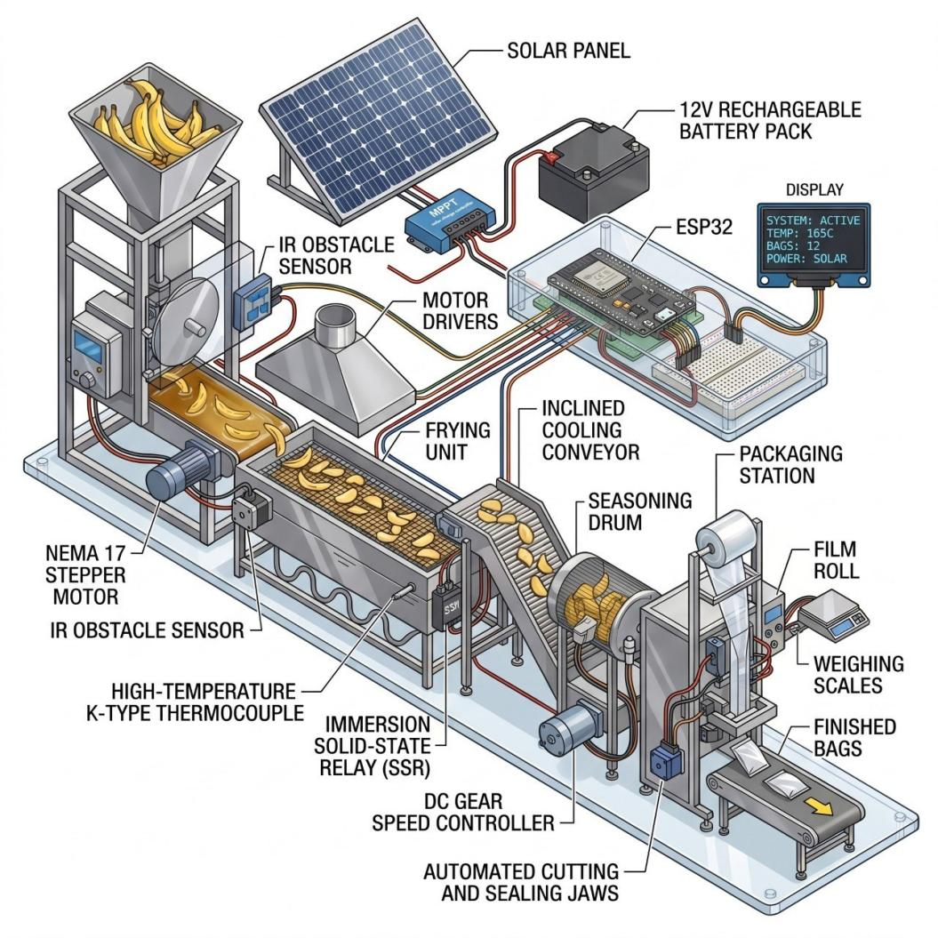

\

Figure 3. Prototype Hardware of BANATECH
The system architecture of BANATECH consists of interconnected hardware and software components that work together to automate banana chips production and digital business operations. The input components include bananas, user commands, sensors, and solar energy sources. The process components involve automated sorting, slicing, frying, IoT monitoring, data processing, and e-commerce transactions managed by microcontrollers and integrated software systems. The output components include processed banana chips, production monitoring data, inventory reports, and online transaction records. The architecture also integrates solar-powered technology to provide sustainable energy support for the system’s operations. Through the implementation of automation, IoT, renewable energy, and digital business integration, the study contributes to Sustainable Development Goals (SDGs) such as SDG 7 (Affordable and Clean Energy), SDG 8 (Decent Work and Economic Growth), SDG 9 (Industry, Innovation, and Infrastructure), SDG 12 (Responsible Consumption and Production), and SDG 13 (Climate Action).

RESULTS AND DISCUSSION
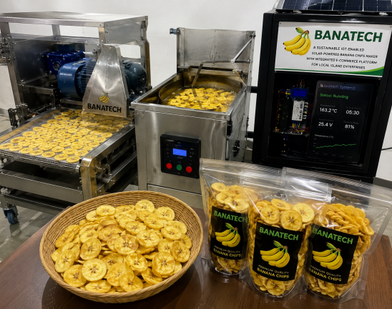



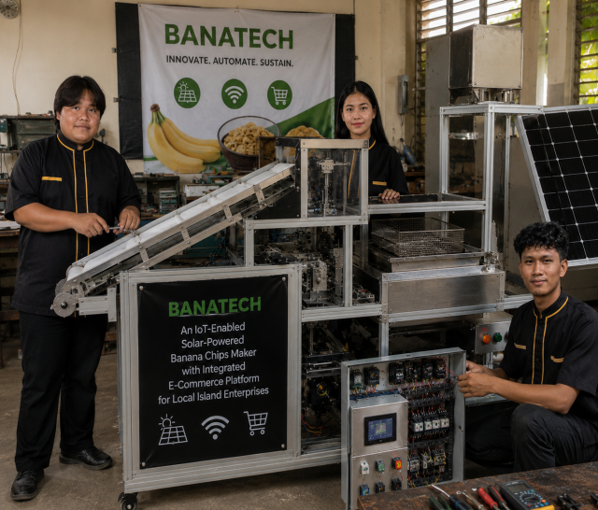

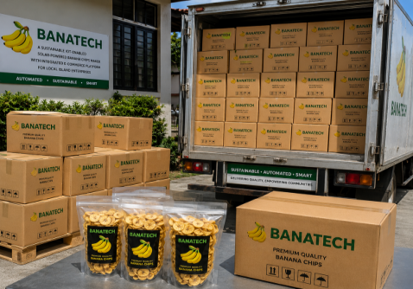


Figure 4. Developing BANATECH and Delivering Banana Chips Product in Oriental Mindoro Enterprises
The developed BANATECH prototype successfully automated the banana chips production process through the integration of IoT technology, sensor-based monitoring, solar-powered operation, and an integrated e-commerce platform. The system was capable of performing automated slicing, frying, and real-time monitoring while maintaining operational efficiency and product consistency. The prototype demonstrated effective synchronization between the hardware and software components, including sensors, microcontrollers, motors, heating elements, and monitoring systems. The system architecture enabled smooth processing operations and minimized manual intervention during banana chips production.
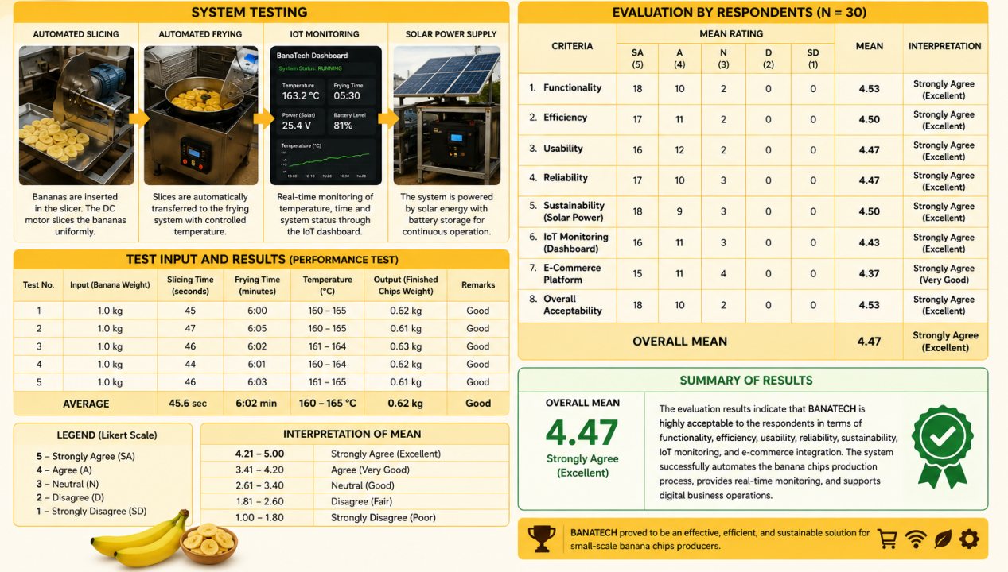

Figure 5.Summary of Results
Based on the system testing conducted, the automated slicing mechanism consistently produced uniform banana slices suitable for frying. The frying system maintained stable temperature conditions using thermostat-controlled heating technology, resulting in evenly cooked banana chips with improved texture and quality. The IoT dashboard successfully displayed real-time monitoring data, including temperature, timer status, battery voltage, and system activity. Additionally, the solar-powered supply system provided continuous support for the machine’s operation, demonstrating the capability of the prototype to operate using renewable energy sources. The testing results revealed that the system achieved an average slicing time of 45.6 seconds, an average frying time of 6.02 minutes, and a maintained frying temperature ranging from 160–165°C. The output produced an average chip weight of 0.62 kg per testing cycle, with all testing trials interpreted as “Good” performance. These findings indicate that the system performed efficiently and consistently during the testing procedures.
V The evaluation results from the respondents further showed high acceptability of the BANATECH system. A total of 30 respondents composed of business owners, IT experts, and potential users evaluated the system using ISO 25010 software quality standards. The criteria evaluated included functionality, efficiency, usability, reliability, sustainability, IoT monitoring/dashboard performance, e-commerce platform functionality, and overall acceptability. The findings revealed that functionality obtained a mean score of 4.53, efficiency obtained 4.50, usability obtained 4.47, reliability obtained 4.47, sustainability obtained 4.50, IoT monitoring/dashboard obtained 4.43, and e-commerce platform functionality obtained 4.37. The overall acceptability of the system achieved a mean score of 4.53, while the computed overall mean was 4.47, verbally interpreted as “Strongly Agree (Excellent).”
The results indicate that the respondents strongly agreed that BANATECH effectively improved banana chips production through automation, monitoring, and digital integration. The respondents observed that the system enhanced production efficiency, minimized manual labor, improved consistency in slicing and frying operations, and provided accurate real-time monitoring through the IoT dashboard. Furthermore, the integrated e-commerce platform improved accessibility, product management, and digital transaction capabilities for local producers. The high evaluation scores also demonstrate that the system is reliable, user-friendly, sustainable, and suitable for small-scale banana chips enterprises.
The study also confirmed that the integration of solar-powered technology contributed to sustainable and energy-efficient production operations. By utilizing renewable energy, the system reduced dependency on conventional electricity while supporting environmentally friendly food processing practices. This demonstrates the system’s contribution to Sustainable Development Goals (SDGs), particularly SDG 7 (Affordable and Clean Energy), SDG 8 (Decent Work and Economic Growth), SDG 9 (Industry, Innovation, and Infrastructure), SDG 12 (Responsible Consumption and Production), and SDG 13 (Climate Action). Overall, the findings of the study prove that BANATECH is an effective, innovative, and sustainable solution for modernizing banana chips production and supporting Oriental Mindoro enterprises.
CONCLUSION
The study successfully developed and evaluated BANATECH: A Sustainable IoT-Enabled Solar-Powered Banana Chips Maker with Integrated E-Commerce Platform for Oriental Mindoro Enterprises. The system effectively automated the processes of banana sorting, slicing, frying, and monitoring through the integration of IoT technology, sensors, microcontrollers, and smart automation mechanisms. The incorporation of solar-powered technology also demonstrated the capability of the system to operate using renewable and energy-efficient resources, making the production process more sustainable and environmentally friendly.
The results of the evaluation revealed that the system performed efficiently and consistently during testing procedures. The automated slicing and frying mechanisms produced uniform and high-quality banana chips while minimizing manual labor and improving operational efficiency. The IoT dashboard successfully provided real-time monitoring data, while the integrated e-commerce platform enhanced inventory management, online transactions, and digital accessibility for local producers.
Furthermore, the respondents strongly agreed that BANATECH is functional, reliable, user-friendly, sustainable, and beneficial for small-scale banana chips enterprises. The high evaluation results based on ISO 25010 and UTAUT confirmed the acceptability and effectiveness of the system. Overall, the study concludes that BANATECH is an innovative and sustainable technological solution that modernizes banana chips production, supportsOriental Mindoro enterprises, promotes renewable energy utilization, and contributes to Sustainable Development Goals (SDGs) 7, 8, 9, 12, and 13.

RECOMMENDATION
Based on the findings of this study, future development of BANATECH should focus on the integration of Artificial Intelligence (AI) and Machine Learning technologies to enhance monitoring accuracy, predictive maintenance, automated quality control, and data-driven decision-making. Additional sensors and advanced automation features may also be incorporated to improve production efficiency, precision, and scalability for larger food processing operations.
Future researchers are encouraged to conduct long-term testing and evaluation of the solar-powered system to assess its durability, sustainability, and energy performance under varying environmental conditions. Furthermore, the BANATECH platform may be adapted for processing other locally produced agricultural products such as camote chips, cassava chips, taro chips, and similar value-added snack products, expanding its applicability and economic impact across island and rural communities.
Local government units, agricultural agencies, cooperatives, and small-scale food enterprises may consider adopting BANATECH to promote sustainable food processing, increase productivity, and create livelihood opportunities. Training programs and capacity-building initiatives on IoT-enabled technologies, automation systems, and digital business platforms are also recommended to support successful implementation and technology adoption.
Through continuous innovation and wider deployment, BANATECH has the potential to become a model for sustainable, renewable energy-powered food processing and digital transformation in local agricultural industries.
REFERENCES

1. Al-Fuqaha, A., Guizani, M., Mohammadi, M., Aledhari, M., & Ayyash, M. (2015). Internet of Things: A survey on enabling technologies, protocols, and applications. IEEE Communications Surveys & Tutorials, 17(4), 2347–2376. https://doi.org/10.1109/COMST.2015.2444095

2. Atzori, L., Iera, A., & Morabito, G. (2010). The Internet of Things: A survey. Computer Networks, 54(15), 2787–2805. https://doi.org/10.1016/j.comnet.2010.05.010

3. Aung, M. M., & Chang, Y. S. (2014). Traceability in a food supply chain: Safety and quality perspectives. Food Control, 39, 172–184. https://doi.org/10.1016/j.foodcont.2013.11.007

4. Buyya, R., & Dastjerdi, A. V. (2016). Internet of Things: Principles and paradigms. Morgan Kaufmann.

5. Chandra, R., & Kumar, S. (2018). Solar energy applications in food processing: A review. Energy Procedia, 144, 48–54. https://doi.org/10.1016/j.egypro.2018.06.007

6. FAO. (2020). The State of Food and Agriculture 2020. Food and Agriculture Organization of the United Nations.

7. Gubbi, J., Buyya, R., Marusic, S., & Palaniswami, M. (2013). Internet of Things (IoT): A vision, architectural elements, and future directions. Future Generation Computer Systems, 29(7), 1645–1660. https://doi.org/10.1016/j.future.2013.01.010

8. ISO/IEC. (2011). ISO/IEC 25010: Systems and software engineering — Systems and software Quality Requirements and Evaluation (SQuaRE) — System and software quality models.

9. Kamble, S. S., Gunasekaran, A., & Sharma, R. (2020). Modeling the blockchain-enabled traceability in agriculture supply chain. International Journal of Information Management, 52, 101967. https://doi.org/10.1016/j.ijinfomgt.2019.05.023

10. Khan, R., Khan, S. U., Zaheer, R., & Khan, S. (2012). Future Internet: The Internet of Things architecture, possible applications and key challenges. Procedia Computer Science, 10, 257–264. https://doi.org/10.1016/j.procs.2012.06.042

11. Kumar, N. M., Chopra, S. S., & Chand, A. A. (2020). A review of solar energy applications in food processing industries. Renewable and Sustainable Energy Reviews, 123, 109764. https://doi.org/10.1016/j.rser.2020.109764

12. Laudon, K. C., & Traver, C. G. (2021). E-commerce 2021: Business, technology, society (16th ed.). Pearson.

13. Lee, I., & Lee, K. (2015). The Internet of Things (IoT): Applications, investments, and challenges for enterprises. Business Horizons, 58(4), 431–440. https://doi.org/10.1016/j.bushor.2015.03.008

14. Madakam, S., Ramaswamy, R., & Tripathi, S. (2015). Internet of Things (IoT): A literature review. Journal of Computer and Communications, 3(5), 164–173. https://doi.org/10.4236/jcc.2015.35021

15. Manyika, J., Chui, M., Bisson, P., Woetzel, J., Dobbs, R., Bughin, J., & Aharon, D. (2015). The Internet of Things: Mapping the value beyond the hype. McKinsey Global Institute.

16. Rathore, M. M., Ahmad, A., Paul, A., & Rho, S. (2016). Urban planning and building smart cities based on the Internet of Things using Big Data analytics. Sustainable Cities and Society, 19, 1–10. https://doi.org/10.1016/j.scs.2015.12.006

17. Sethi, P., & Sarangi, S. R. (2017). Internet of Things: Architectures, protocols, and applications. Journal of Electrical and Computer Engineering, 2017, 9324035. https://doi.org/10.1155/2017/9324035

18. Sharma, A., & Tiwari, G. N. (2017). Solar drying of agricultural products: A review. Renewable Energy, 105, 484–495. https://doi.org/10.1016/j.renene.2016.12.087

19. Singh, D., Tripathi, G., & Jara, A. J. (2014). A survey of Internet-of-Things: Future vision, architecture, challenges, and services. IEEE World Forum on Internet of Things, 287–292. https://doi.org/10.1109/WF-IoT.2014.6803174

20. Statista. (2023). Global e-commerce market growth statistics. https://www.statista.com

21. United Nations. (2019). Sustainable Development Goals Report 2019. United Nations.

22. Venkatesh, V., Morris, M. G., Davis, G. B., & Davis, F. D. (2003). User acceptance of information technology: Toward a unified view. MIS Quarterly, 27(3), 425–478. https://doi.org/10.2307/30036540

23. Wolfert, S., Ge, L., Verdouw, C., & Bogaardt, M. J. (2017). Big Data in smart farming – A review. Agricultural Systems, 153, 69–80. https://doi.org/10.1016/j.agsy.2017.01.023

24. Zhao, J., & Liu, Y. (2019). Design of intelligent food processing system based on IoT. Journal of Food Engineering, 243, 1–10. https://doi.org/10.1016/j.jfoodeng.2018.08.017

PRESENTER’S CURRICULUM VITAE

Full Name: Leah Mae H. Abela
Current Position/Designation: ITS, President
Institution/Agency: MINSU- College of Computer Studies
Office Address: Alcate, Victoria Oriental Mindoro
Email Address: leahmaehernandezabela@gmail.com
Contact Number: 09658677219
Educational Background
Degree | School | Year Graduated
Bachelor of Science and Information Technology | Mindoro State University (MINSU-Main Campus) | (2023-continuing)
Trainings / Seminars Attended
- TESDA Java Programming NC III
(Technical Education and Skills Development Authority – National Certificate Level III in Java Programming)
- TESDA Cybersecurity NC III
(Technical Education and Skills Development Authority – National Certificate Level III in Cybersecurity)

Awards / Recognitions
- Data Analytics Passer
- CodeChum Passer (Python Programming 2)
- Microsoft Certifications
(Microsoft Professional Certification Programs)

Membership in Professional Organizations
- MMAP Member
(Multimedia Arts Association of the Philippines)
- ISITE Member
(Integrated Society of Information Technology Enthusiasts, Inc.)
- JPCS – MinSU Main Campus Member
(Junior Philippine Computer Society – Mindoro State University Main Campus Chapter)
Prepared by:
Leah Mae H. Abela
Signature Over Printed Name
Date: March 20, 2026
Mzabela

