Design Science Research (DSR) Framework for Heritage Hybridisation and Digital Manufacturing of Contemporary Malay Jewellery

ABSTRACT
This study discusses the preservation and transformation of traditional Malay craft heritage through a hybrid approach that integrates traditional craftsmanship practices with digital manufacturing technologies. Grounded in the national Corak Malaysia project, this research develops a Computer-Aided Design (CAD) Innovation Framework to translate the aesthetic values and visual symbolism of the Mutiara Pipit Motif (inspired by the turkey berry flower) and the Motif Lapan (Figure-of-Eight Motif) into contemporary Malay bracelet designs. The research is structured around the Design Science Research (DSR) methodology to address issues of digital authenticity and the loss of narrative value in mass production. Visual analysis was conducted using Charles Sanders Peirce’s Semiotic Theory, examining the relationship between the representamen, object, and interpretant of the physical artifacts fabricated from 925 sterling silver, cubic zirconia stones, and rhodium plating. An expert review was undertaken with the participation of three industry experts representing jewellery design, creative heritage, and the creative industries. The evaluation focused on aesthetic quality, cultural telesis, ergonomic performance, and commercial marketability. The evaluation results indicate high mean scores across all criteria, proving that the integration of the DSR-Semiotic framework not only successfully produces premium, ergonomic, and highly competitive ethnic jewellery but also contributes a replicable methodological blueprint for the preservation of other intangible cultural heritage crafts. The study implications suggest that digital hybridization can positively influence younger generations’ perceptions of heritage crafts, positioning them as relevant and inclusive contemporary jewellery products.
Keywords: Design Science Research (DSR); Heritage Hybridization; Digital Manufacturing; Peirce's Semiotics; Contemporary Jewellery.
INTRODUCTION
Traditional Malay crafts, particularly fine metalwork and jewellery design, represent a manifestation of the philosophy, worldview, cosmology, and aesthetic values of Malay society (Annuar & Aziz, 2022; Hamat & Yusoff, 2020). Every carved form, motif, and decorative arrangement applied to the surfaces of precious metals is not created by chance; rather, these elements function as a system of signs that convey cultural meanings, symbolic values, and utilitarian functions that have been transmitted across generations.
The advancement of the Fourth Industrial Revolution and the transition towards Industry 5.0 have transformed the jewellery manufacturing landscape through the adoption of digital technologies such as Computer-Aided Design (CAD) modelling, laser cutting, laser engraving, and computer-assisted manufacturing systems. These developments provide new opportunities for designers to create more complex and precise forms. Nevertheless, such changes have also raised concerns regarding the sustainability of traditional craftsmanship values, particularly when inexpensive and rapidly produced mass-manufactured products reduce reliance on the skills of master artisans and diminish the uniqueness of local visual identities (Victor, 2019).
A major issue within contemporary digital craft discourse is closely associated with the concept of digital authenticity. The application of CAD technology and digital manufacturing processes is frequently criticised for its potential to eliminate the human touch that is commonly associated with the refinement and sensitivity of handcrafted work (Islami & Sutanto, 2024; Nimkulrat & Groth, 2024). When heritage motifs are transferred into digital media without a comprehensive understanding of their original philosophy and cultural context, such motifs risk becoming merely decorative geometric forms devoid of cultural narrative value.
Therefore, this study examines the balance between the geometric precision afforded by CAD technology and the subtle semiotic values embedded within traditional heritage. The research is grounded in the Corak Malaysia project by Ruzzgahara (2024), an initiative aimed at structuring and modernising Malaysian ethnic motifs to enhance their relevance within contemporary design contexts. The study focuses on the development of a contemporary women’s bracelet through the reinterpretation of the Mutiara Pipit Motif and the Motif Lapan.
Specifically, the objectives of this study are: (1) to analyse the visual symbolism system and semiotic sign categories of the selected motifs using Charles Sanders Peirce’s Semiotic Theory; (2) to develop an innovation framework for contemporary bracelet design based on the Design Science Research approach through CAD modelling; and (3) to evaluate the quality of the final artefact produced from 925 sterling silver with cubic zirconia stone settings and rhodium plating based on expert assessment encompassing aesthetic quality, ergonomics, and marketability.
LITERATURE REVIEW
Visual Semiotics and Cultural Telesis in Heritage Craft Design
Research on traditional crafts within contemporary academic discourse is no longer confined solely to external aesthetic considerations. Instead, traditional crafts should be understood as complex systems of visual communication imbued with cultural significance. Marlina (2019) explains that traditional motifs function as sign systems that communicate social codes, status, cultural values, and the belief systems of a particular community. Within the design context, the concept of cultural telesis refers to the capacity of a product to integrate physical functionality, aesthetic value, and socio-cultural impact in a balanced manner (Menéses, 2019; Paete, 2022).
In fine metalwork, the translation of motifs derived from nature into rigid materials such as silver and gold requires a process of formal stylisation. This process does not aim to eliminate the original identity of the source object; rather, it refines organic forms into visual structures that are more organised, balanced, and suitable for product functionality. Li et al. (2024) emphasise that failure to preserve heritage narratives in the development of digital craft products may result in the loss of premium value and reduce the competitiveness of such products within contemporary markets.
CAD Technology and Digital Transformation in Jewellery Manufacturing
The adoption of computer technologies within the jewellery industry has significantly expanded design possibilities, particularly through CAD modelling. Saleh et al. (2018) and Manavis et al. (2021) argue that CAD provides designers with a high degree of flexibility to explore complex forms that would be difficult to achieve using traditional forging or manual wax-carving techniques. Specialised software such as RhinoGold, MatrixGold, and JewelCAD enables the calculation of precious metal weight, gemstone placement simulation, and preliminary structural durability assessments prior to physical prototyping (Ignaszak & Wojciechowski, 2019; Manavis et al., 2021).
However, the transition towards Industry 5.0 demands a more human-centred approach to technological implementation (Oostveen et al., 2025). Within this context, CAD should not be viewed merely as a technical instrument but rather as a creative medium that facilitates the translation of cultural values, emotions, and heritage narratives into contemporary products. Such integration enables consistency in production while preserving the ethnic context and visual meaning embedded within the product (Mei & Ahmad, 2023).

Market Sustainability and Commercialisation of Contemporary Heritage Jewellery
The contemporary jewellery market has experienced significant shifts in consumer demand patterns, particularly among younger consumers such as Generation Z and Millennials. These consumer segments tend to seek products that possess unique identities, exclusivity, and clearly articulated cultural narratives while simultaneously demanding affordability and suitability for everyday wear (Krismajayanti et al., 2025; Putri & Utama, 2021).
Consequently, the use of premium alternative materials such as rhodium-plated 925 sterling silver combined with high-quality cubic zirconia stones is regarded as an effective strategy for broadening market accessibility to heritage-inspired craft products. This approach reduces material costs without compromising the perception of luxury, while digital manufacturing ensures that visual details remain refined, consistent, and aligned with contemporary market requirements (McGrath, 2014).
INTEGRATED RESEARCH METHODOLOGY: DESIGN SCIENCE RESEARCH
This study employs the Design Science Research (DSR) methodology to organise the artefact development process in a systematic, structured, and empirically evaluable manner. This approach was selected due to its capacity to address practical industrial challenges through the creation of design artefacts while simultaneously contributing to theoretical knowledge development (Hevner et al., 2004). Within the context of this research, DSR enables a creative process that is typically exploratory in nature to be documented through clearly defined phases supported by traceable methods of analysis and evaluation.
The research framework adapts the six principal phases of the Design Science Research Methodology (DSRM) proposed by Peffers et al. (2007), namely problem identification, definition of solution objectives, design and development, demonstration, evaluation, and communication. This adapted framework guides the development of a contemporary bracelet artefact inspired by traditional Malay motifs.
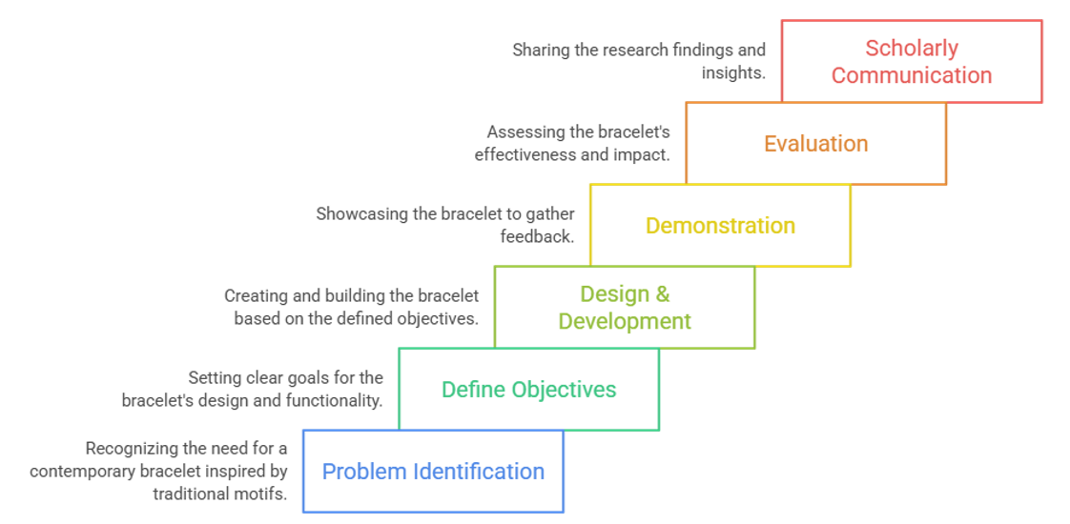
Figure 1. Adapted Design Science Research (DSR) framework for the development of a contemporary bracelet artefact inspired by Malay heritage.
Phase 1: Problem Identification and Definition
This phase focuses on the issue of declining cultural identity within craft traditions resulting from the dominance of mass-produced products and the application of digital technologies without sufficient cultural understanding (Peffers et al., 2007). The principal challenge identified is the threat of digital authenticity, whereby the transfer of traditional motifs into digital formats fails to preserve the meanings, narrative values, and heritage identities embedded within the original craft traditions.
Accordingly, this study emphasises the necessity of establishing a balance between the precision offered by digital technologies and the preservation of cultural values, aesthetic qualities, and the refinement associated with traditional craftsmanship.
Phase 2: Definition of Solution Objectives
This phase establishes the objective of translating traditional motifs from the Corak Malaysia project into contemporary jewellery products without compromising their original cultural identity. The proposed solution involves the development of a bracelet artefact that fulfils requirements relating to aesthetics, functionality, ergonomics, and commercial viability.
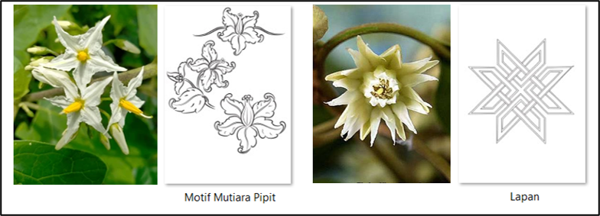
Figure 2. Transformation of Floral Sources of Inspiration into Traditional Motifs in Contemporary Bracelet Design.
Phase 3: Design and Development
The design and development phase integrates two principal methods. Firstly, a qualitative semiotic analysis based on Charles Sanders Peirce’s Semiotic Theory is employed to map the relationships between the representamen, object, and interpretant. Secondly, digital stylisation through three-dimensional CAD modelling is utilised to transform preliminary sketches into digital three-dimensional models. At this stage, technical parameters including structural thickness, gemstone-setting tolerances, volume control, and material mass are carefully regulated to ensure that the artefact satisfies both design and manufacturing requirements.
Phase 4: Artefact Demonstration
The optimised CAD model is fabricated into a contemporary bracelet prototype using 925 sterling silver, cubic zirconia gemstones, and rhodium plating. The manufacturing process incorporates modern production technologies such as laser cutting, laser engraving, and laser soldering to achieve high structural precision and refined finishing quality.
Phase 5: Empirical Evaluation
The evaluation phase is conducted through expert review involving a panel representing the fields of traditional crafts, jewellery design, and creative industries. A Likert-scale evaluation instrument is employed to assess four principal dimensions: Contemporary aesthetics; Cultural telesis; Ergonomics for everyday wear; and Product marketability for younger consumer segments.
Phase 6: Scholarly Communication
The final phase involves disseminating the research findings, innovation framework, and artefact contributions to both the academic community and industry practitioners. Through this phase, the study generates contributions on two levels: a physical artefact with industrial potential and a DSR-Semiotic methodological framework that may serve as a reference for future academic research.
TRIADIC SEMIOTIC ANALYSIS BASED ON CHARLES SANDERS PEIRCE
Prior to the CAD modelling process, the Mutiara Pipit Motif and Motif Lapan were conceptually analysed using Charles Sanders Peirce’s Semiotic Theory. This step was essential to ensure that the visual heritage narrative could be preserved throughout the digitisation process.
The analysis employed Peirce’s triadic structure, examining the relationships among the representamen as the visual sign, the object as the cultural reference, and the interpretant as the meaning generated within the viewer’s mind (Haizra Hashim et al., 2022).
The findings demonstrate that the reinterpretation of traditional motifs within the contemporary bracelet design was successfully achieved through the integration of organic floral elements with contemporary geometric structures. This combination created a balance between heritage values and design innovation.
From the perspective of the representamen, the bracelet surface features the Mutiara Pipit Motif through raised engravings, layered structures, curved organic lines, and symmetrical floral arrangements. These elements are reinforced by linear geometric structures and the strategic use of negative space to establish visual stability and balance.
From the perspective of the object, the floral motif refers to Malay cultural identity grounded in nature-based philosophy, personal refinement, modesty, and feminine elegance. The geometric structures signify strength, stability, and the continuity of heritage within a modern technological context.
From the perspective of the interpretant, contemporary users may perceive the bracelet as a premium jewellery product that embodies modernity while retaining a strong sense of local identity. Consequently, the artefact functions not merely as an ornamental accessory but also as a medium of cultural communication that conveys symbolic meaning to contemporary audiences.
According to Peirce’s sign categories, the floral motif functions as an icon because it visually resembles natural plant forms. The motif also functions as an index because of its direct connection to the historical traditions of Malay craftsmanship and decorative metalwork. Simultaneously, the overall bracelet design functions as a symbol, representing feminine elegance, cultural resilience, and innovation in digital craft practice.
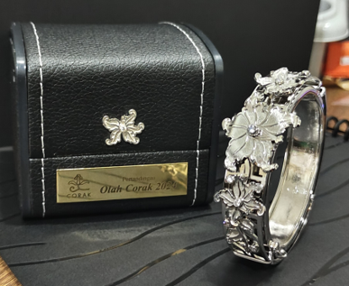
Figure 3. Contemporary Bracelet Prototype Inspired by Traditional Malay Motifs.

Table 1. Contemporary bracelet prototype inspired by traditional Malay motifs.
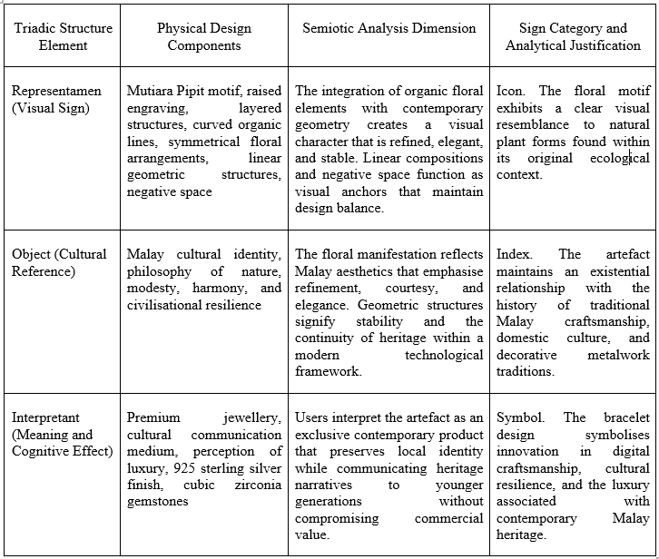
CAD Development and Geometric Formulation Process
The bracelet form development phase was carried out using parametric CAD modelling based on standard anthropometric measurements of the Asian female wrist. Design parameters were digitally controlled to prevent distortion of the traditional aesthetic characteristics that served as the primary source of inspiration. The bracelet body was developed using a hinged bangle structure to facilitate ease of wear, while a secure clasp mechanism was integrated into the digital model to enhance the product’s mechanical functionality.
The metal mass was estimated using the equation M = V × ρ, where M represents the material mass, V denotes the total volume of the three-dimensional model, and ρ represents the density of 925 sterling silver (0.01036 g/mm³). Based on the final model volume of 6,563.7 mm³ and a controlled wall thickness of approximately 1.5 mm, the developed bracelet was estimated to have a metal mass of 68.0 g. This weight provides a substantial visual presence while remaining within an appropriate range for comfortable everyday wear.
Gemstone setting was achieved using a digitally modelled tube-setting technique positioned within the petals of the Mutiara Pipit Motif. A total of nine AAA-grade cubic zirconia stones measuring 2.0 mm and 4.0 mm in diameter were arranged across the upper section of the prototype to enhance aesthetic value and emphasise the design’s focal elements. Upon completion of the prototype, a rhodium-plating process was applied to optimise surface finishing, increase lustre, and provide protection against tarnishing and oxidation.
Expert Evaluation Analysis and Product Validation
To enhance the reliability of the findings and minimise designer self-assessment bias, the evaluation phase of this study employed an expert review method. Face-to-face evaluation sessions were conducted in 2024 involving three experts selected through purposive sampling based on their professional experience in the jewellery industry, creative heritage, and the creative industries.
The evaluation panel comprised Ms Shiela Osman, Head of Jewellery Design at Habib Jewels Sdn. Bhd.; Nik Faiz Nik Amin, Director of the Corak Malaysia Project and Founder of Ruzzgahara; and Ms Zainariah Johari, Group Chief Executive Officer of MyCreative Ventures. The evaluation was conducted using a five-point Likert scale, where 1 represented Very Poor and 5 represented Excellent. Four principal evaluation criteria were assessed: CAD aesthetic quality and visual refinement, strength of cultural identity and cultural telesis, ergonomics and mechanical functionality, and marketability.
Table 2. Analysis of Expert Evaluation Scores for the Contemporary Bracelet Prototype.
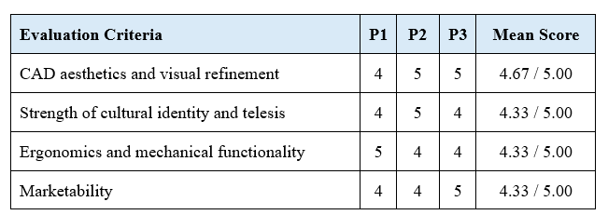
Critical Discussion and Implications of the Findings
The evaluation results indicate high mean scores across all assessment criteria, each exceeding 4.30. The highest score was recorded for CAD aesthetics and visual refinement (4.67), suggesting that the application of CAD technology does not necessarily diminish the artistic character of traditional craftsmanship. On the contrary, digital technology can facilitate the creation of more precise geometric arrangements, consistent finishing quality, and controlled preservation of the visual characteristics of traditional motifs.
The criterion of ergonomics and mechanical functionality achieved a mean score of 4.33. The combination of a 60 mm diameter and a 68 g weight was considered appropriate for the anatomy of Asian female users while providing a substantial tactile presence. In the context of jewellery, physical weight is associated not only with wearing comfort but also with perceptions of value, durability, and luxury.
From the perspective of marketability, the score of 4.33 indicates that the selection of 925 sterling silver and cubic zirconia gemstones represents an effective material strategy for attracting younger consumers. This approach has the potential to reshape perceptions that traditional jewellery is excessively expensive or incompatible with contemporary lifestyles. At the same time, the heritage narrative embedded within the motifs provides added value that differentiates the product from conventional commercial jewellery.
Overall, the expert evaluation confirms that the DSR framework integrating semiotic analysis and CAD technology can serve as a systematic approach for the development of contemporary craft products. The findings demonstrate that heritage hybridisation and digital manufacturing involve not merely the transfer of form, but also the preservation of meaning, the enhancement of functionality, and the adaptation of products to contemporary market demands.
CONCLUSION
This study has developed and refined a heritage hybridisation framework for Malay craft traditions through the integration of CAD modelling within a Design Science Research (DSR) methodology. The findings demonstrate that digital technology has the potential to serve as a medium that supports the preservation and advancement of local metalcraft traditions without compromising their original visual identity and cultural values. Through the combination of Charles Sanders Peirce’s semiotic analysis and expert evaluation, the reinterpretation of the Mutiara Pipit Motif and Motif Lapan from the Corak Malaysia project was successfully translated into a contemporary bracelet design that achieves a balance between aesthetics, functionality, ergonomics, and marketability.
From a theoretical perspective, this study contributes to the development of a DSR–Semiotic framework that may be applied in future heritage-based design research. From a practical perspective, the study has produced a physical artefact in the form of a 925 sterling silver bracelet, demonstrating the potential of digital manufacturing to expand the application of traditional Malay motifs within contemporary jewellery design. The findings further indicate that the use of premium alternative materials in conjunction with CAD technology can broaden market accessibility for culturally inspired ethnic jewellery products while maintaining a strong heritage identity.
Nevertheless, several limitations should be acknowledged. The evaluation process involved only three expert reviewers and did not incorporate feedback from actual consumers within the target market segment. Therefore, future research is recommended to include user acceptance testing, experience analysis, long-term ergonomic assessment, and the integration of augmented reality technologies to further examine consumer perceptions of heritage-inspired jewellery designs within digital environments.
ACKNOWLEDGEMENTS
The authors would like to express their sincere appreciation to The Bench Studio and Ruzzgahara for their technical support, archival documentation, design references, and visual resources provided throughout the implementation of this research project.
AUTHOR CONTRIBUTIONS
The first author was responsible for conducting the literature review, developing the research methodology, analysing the data, refining the conclusion and recommendation sections, and reviewing the references. The second author contributed a comprehensive review of the manuscript structure, analysis, and discussion to ensure academic accuracy, language quality, and overall coherence of the manuscript. The third author was involved in formulating the study conclusions and developing recommendations for future research.
CONFLICT OF INTEREST
The authors declare that there are no conflicts of interest that could potentially be associated with the research, authorship, and publication of this article.
DECLARATION OF GENERATIVE AI USE IN SCIENTIFIC WRITING
The authors used generative artificial intelligence (AI) tools solely for language editing purposes, including the improvement of grammar, readability, and clarity of the manuscript. All AI-generated or AI-assisted content was critically reviewed, evaluated, and verified by the authors prior to its inclusion in the manuscript. The authors retained full intellectual control over the entire writing process and assume complete responsibility for the accuracy, validity, originality, and academic integrity of the published content. Generative AI tools were not used to generate research findings, conduct data analysis, interpret results, or formulate research conclusions, and have not been listed as authors or co-authors of this manuscript.
ACKNOWLEDGMENT
We would like to express our sincere appreciation to the Faculty of Art & Design, Universiti Teknologi MARA (UiTM), Kelantan Branch, for their generous support and provision of research data, which played a crucial role in the development of this study. We are especially grateful to the dedicated students who contributed to this project, whether directly through their active involvement or indirectly through their insights and creative input. Their participation and enthusiasm have significantly enriched the quality and depth of this study.
REFERENCE
- Annuar, N. A. K., & Aziz, A. Ab. (2022). Form & Symbolism of Rings from Perbadanan Adat Melayu dan Warisan Negeri Selangor. International Journal Of Art And Design, 6(2), 35-53. https://doi.org/10.24191/ijad.v6i2.1147
- Collected Papers of Charles Sanders Peirce. (1935). Nature, 135(3404), 131–131. https://doi.org/10.1038/135131a0
- Haizra Hashim, M., Hernani Mohd Janis, F., Raihan Wan Shaaidi, W., & Afzainizam, N. (2022). Visual Communication on UC TATI Logo. International Journal of Synergy in Engineering and Technology, 3(August), 25–33.
- Hamat, M. R., & Yusoff, M. Y. M. (2020). Motif Alam Flora Dalam Seni Ukiran Logam Halus Kelantan. Jurnal Melayu, 19(1). http://journalarticle.ukm.my/14801/
- Hevner, A. R., March, M., Park, J., & Ram, S. (2004). Design Science in Information Systems Research1. MIS Quarterly, 28(1), 75–106. https://doi.org/10.2307/25148625
- Ignaszak, Z., & Wojciechowski, J. (2019). Analysis and Validation of Database in Computer Aided Design of Jewellery Casting. Archives of Foundry Engineering, 9–16. https://doi.org/10.24425/afe.2020.131275
- Islami, F., & Sutanto, A. (2024). Digitalization of Design and Machining Processes of Wood Carving Products Using CAD/CAM/CNC Technologies for Preservation of Minangkabau Culture. Journal of Ocean Mechanical and Aerospace -Science and Engineering- (JOMAse), 68(3), 127–132. https://doi.org/10.36842/jomase.v68i3.375
- Jones, D., & Gregor, S. (2007). The Anatomy of a Design Theory. Journal of the Association for Information Systems, 8(5), 312–335. https://doi.org/10.17705/1jais.00129
- Krismajayanti, N. P. A., Nurmalasari, M. R., Prawitasari, P. P., & Megawati, I. A. P. (2025). Antara Tren, Gaya dan Kebutuhan Pada Produk Fashion. Journal of Islamic Business Management Studies (JIBMS), 6(1), 28–38. https://doi.org/10.51875/jibms.v6i1.587
- Li, M., Wang, L., & Li, L. (2024). Research on narrative design of handicraft intangible cultural heritage creative products based on AHP-TOPSIS method. Heliyon, 10(12). https://doi.org/10.1016/j.heliyon.2024.e33027
- Manavis, A., Minaoglou, P., Aidinli, K., Efkolidis, N., & Kyratsis, P. (2021). CAD based design for the jewellery industry: A case study. IOP Conference Series Materials Science and Engineering, 1009(1), 12036–12036. https://doi.org/10.1088/1757-899x/1009/1/012036
- March, S. T., & Smith, G. F. (1995). Design and natural science research on information technology. Decision Support Systems, 15(4), 251–266. https://doi.org/10.1016/0167-9236(94)00041-2
- Marlina, H. (2019). Kajian Semiotik Motif Pakaian Adat Dayak Kenyah Di Desa Pampang Samarinda Kalimantan Timur. Ars Jurnal Seni Rupa dan Desain, 22(1), 45–56. https://doi.org/10.24821/ars.v22i1.2524
- McGrath, M. (2014). Jewelry Design Handbook. McGrath Jewelry Publications.
- Mei, L., & Ahmad, N. (2023). A Review of Current Cultural Jewellery Trend. Journal of Law and Sustainable Development, 11(5). https://doi.org/10.55908/sdgs.v11i5.839
- Menéses, E. E. S. (2019). Télesis y diseño: análisis del papel de las condicionantes culturales en los cambios paradigmáticos. Legado de Arquitectura y Diseño, 14(26), 175–175. https://doi.org/10.36677/legado.v14i26.14470
- Nimkulrat, N., & Groth, C. (2024). Introduction (pp. 83–136). https://doi.org/10.4324/9781003328018-10
- Oostveen, A., Eimontaite, I., & Fletcher, S. (2025). Human factors in digital manufacturing technology adoption: a workforce perspective. The International Journal of Advanced Manufacturing Technology, 140, 6575–6593. https://doi.org/10.1007/s00170-025-16524-5
- Paete, M. (2022). Cultural Code Analysis of the Integration of Pintados Design in Furniture Product Development using Semiotics and Quality Function Deployment. Journal of Visual Art and Design, 14(1), 86–105. https://doi.org/10.5614/j.vad.2022.14.1.7
- Peffers, K., Tuunanen, T., Rothenberger, M. A., & Chatterjee, S. (2007). A Design Science Research Methodology for Information Systems Research. Journal of Management Information Systems, 24(3), 45–77. https://doi.org/10.2753/mis0742-1222240302
- Putri, D. W., & Utama, L. (2021). Pengaruh Persepsi Kualitas, Pengaruh Sosial, Dan Kebutuhan Akan Keunikan Terhadap Minat Pembelian Konsumen Luxury Brand Pada Generasi Y. Jurnal Manajerial Dan Kewirausahaan, 3(1), 176–176. https://doi.org/10.24912/jmk.v3i1.11302
- Ruzzgahara, R. (2024). Special project: Corak Malaysia. https://corakmalaysia.com/
- Saleh, B., Rasul, M. S., & Affandi, H. M. (2018). The Conceptual Framework of Quality Product Design Based on Computer Aided Design (CAD). Creative Education, 9(14), 2311–2324. https://doi.org/10.4236/ce.2018.914171
- Solano-Meneses, E. (2019). Telesis and design: analysis of the role of cultural conditioning in paradigmatic changes. Legado De Arquitectura Y DiseñO, 14 (26), 175-188. doi:10.36677/legado.v14i26.14470
- Victor, V. (2019). Melestarikan Seni Kerajinan Tradisional Dari Ancaman Produksi Massal Di Era Global. 32(1), 1–4.

