PREVALENCE, ANTIBIOTIC RESISTANCE PATTERN FOR ENTEROBACTERALES

ABSTRACT
Urinary tract infections (UTIs) are highly prevalent in the elderly population (>50–65 years), often presenting with high morbidity due to age-related co morbidities and increased exposure to healthcare settings. Enterobacterales are the leading cause of these infections, with rising rates of multi-drug resistance (MDR).
Urinary tract infections (UTIs) are common in elderly patients and present a very significant public health concern, particularly due to the increasing prevalence of antibiotic-resistant pathogens. This study aims to assess the prevalence of UTI-causing pathogens and their antibiotic resistance patterns in an above 50 years population.
Antibiotic resistance presents a significant global public health challenge, particularly for urinary tract infections (UTIs), and is notably severe in developing countries. Surveillance of the antimicrobial susceptibility patterns of UTI‐causing bacteria is crucial for effective treatment selection. This study aimed to analyze these patterns in enterobacteriaceae isolated from the urine samples of patients at Serum Analysis Center Pvt.Ltd., Howrah, West Bengal, India from January 2026 to March 2026; examined clinical and laboratory data from patients with positive urine cultures (≥10⁵ CFU/mL). The study patients age old adults (>50 years). The Vitek® 2 systems is an automated, rapid, and accurate method for determining the Minimum Inhibitory Concentration (MIC) method was used to assess antibiotic sensitivity to common antibiotics.
Results:
In our study positive culture growth shows in enterobacteriaceae group 66 (19.88%) from 332 total samples of age group > 50 to 59 years and 215 (31.25%) from 688 total samples of age group >60 years.
In this study all enterobacteriaceae bacteria shows increasing resistance rate of antibiotics in both age groups are Amxycillin/ clavulanic acid, Cephalosporis group, Quinolones [Fluoroquinolones] group and Colistin.
The findings underscore the need for ongoing surveillance and tailored antibiotic therapy to effectively manage UTIs in this vulnerable population.
Keywords:
Enterobacterales; UTI; Old Adult Patients (>50 years); Antibiotic Resistance.

INTRODUCTION
Urinary tract infection is a common problem worldwide. Urinary tract infections (UTI) is one of the most important causes of morbidity and mortality in the developing countries like India. Urinary tract infections (UTIs) are counted among the most common infections in children. Urinary tract infections (UTI) are among the most frequently acquired infections in the community, but also in hospitals and other health care institutions, causing a huge amount of antibiotic consumption. During the last decade we have seen significant changes in the field of urinary tract infections regarding causative pathogens and antibiotic treatment calling for an update of current trends.
Enterobacterales, primarily Escherichia coli and Klebsiella pneumoniae, are the leading causes of UTIs in patients over 50, with a high prevalence of 34% or more in this age group, often exacerbated by comorbidities. Resistance to commonly used antibiotics like ampicillin, ciprofloxacin, and TMP/SMX is very high, frequently exceeding 50-80%. There is a significant, increasing trend of ESBL-producing and multi-drug resistant (MDR) isolates in the elderly population.
Urinary tract infections (UTIs) are among the most common infections affecting the elderly population, particularly those residing in long-term care facilities or with chronic comorbid conditions.[1] The incidence of UTIs increases with age, primarily due to age-related physiological changes, weakened immune systems, and the presence of underlying conditions such as diabetes and benign prostatic hyperplasia in men.[2] In elderly patients, UTIs can lead to serious complications, including urosepsis and acute kidney injury, making prompt and effective treatment essential.[3]

In patients over 50 years with UTIs, Enterobacterales (especially Escherichia coli and Klebsiella pneumoniae) show high prevalence and significant resistance, with up to 75% resisting common antibiotics like trimethoprim and piperacillin/Tazobactam. Resistance is particularly high in institutionalized elderly patients, with >35% non-susceptible to 3rd-generation cephalosporins and rising carbapenem resistance.
The use of antibiotics in patients over 50 is heavily impacted by rising resistance, making the management of UTIs a complex, and high-risk endeavor that requires careful, individualized treatment decisions based on recent exposure history and laboratory testing to mitigate the risk of severe complications.
In old adult patients with urinary tract infections (UTIs), antibiotic resistance is a significant challenge, with a high prevalence of multidrug-resistant (MDR) and extended-spectrum beta-lactamase (ESBL)-producing pathogens, especially Escherichia coli. Resistance rates are notably higher in this age group due to increased comorbidity, previous antibiotic use, and potential for hospital-acquired infections.
Appropriate use of antibiotics is the most important interventable factor in fight against AMR.[4] Thus, antimicrobial stewardship programs and societies published guidelines for defining appropriate treatments in each stage of UTIs.[5–8] On the other hand, antibiotic consumption trends and policies vary among countries which cause different susceptibility patterns that may lead to variable therapies.[9] Recently AMR showing increasing ratios of Enterobacterales producing extended-spectrum β-lactamases (ESBL), AmpC β-lactamases, and carbapenemases along with other resistance mechanisms threaten public health.[10] The European Committee on Antimicrobial Susceptibility Testing (EUCAST) is the reference method to apply and interpret AMST results, which is strongly recommended to monitor years by even local facilities.[ 11,12] The aim of this study is to share AMR status of our tertiary centre in urine isolates and to observe whether there is a significant alteration, or not.
MATERIALS AND METHODS

STUDY AREA:
The present retrospective study was carried out in the Referral Laboratory, Serum Analysis Centre Pvt. Ltd.; 177, Netaji Subhas Road, Halder Para, Howrah-711101, West Bengal, India.
STUDY PERIOD:

This study was carried out a period of Three months from January 2026 to March 2026.
STUDY SAMPLES:
The inclusion criteria for this study in all old adult patients above 50 years age of both sexes of outpatients of urine sample.

COLLECTION OF URINE SAMPLES:
Early morning mid-stream urine samples were collected using sterile, wide mouthed container with screw cap tops. [13] On the urine sample bottles were indicated name, age, sex, and time of collection along with requisition forms.
SAMPLE PROCESSING:
A calibrated sterile micron wire loop for the semi-quantitative method was used for the plating and it has a 4.0 mm diameter designed to deliver 0.01 ml. A loopful of the well mixed urine sample was inoculated on HiCrome UTI Agar media and EMB [Eosin Methylene Blue] Agar media. The plate was incubated aerobically at 37⁰C for overnight. The plates were then examined macroscopically and microscopically (colony Gram stain) for bacterial growth. The bacterial colonies were counted and multiplied by 100 to give an estimate of the number of bacteria present per milliliter of urine. Culture results were interpreted according to the standard criteria and a growth of > 10⁵ colony forming unit [CFU] /ml was considered as significant bacteriuria [14]. The urine samples were analyzed bacteriological using the methods [13, 15, 16].

IDENTIFICATION OF ISOLATES:
The isolates were identified using colony morphology, Gram staining, Motility test, Indole test, Citrate test [Simmons Citrate Agar media], Urease test [Urease Agar media + 40% Urea], Triple Sugar Iron Agar media, and ONPG [Ortho-nitrophenyl beta-D-galactopyranoside] [13, 16].

SENSITIVITY TESTING USING MIC TECHNIQUE

The Vitek® 2 system is an automated, rapid, and accurate method for determining the Minimum Inhibitory Concentration (MIC) (lowest antibiotic concentration inhibiting bacterial growth). It uses 64-well, miniaturized, disposable cards containing premeasured antibiotics, which are inoculated, incubated, and read automatically via turbidimetric/colorimetric technology. The system, often used for identifying Gram-positive/negative bacteria and yeasts, provides results usually within hours, aiding in the selection of effective, targeted antibiotic therapy based on CLSI or EUCAST breakpoints.

Key Aspects of the Vitek MIC Method:
- Technology: The system uses a turbidity-based (sometimes fluorescence-based) detection method to measure bacterial growth in the presence of different antibiotics within the card.
- Workflow: A standardized bacterial suspension (0.5 McFarland) is prepared, and the Vitek card is filled, sealed, and incubated. The Vitek 2 Compact allows for manual loading, while the Vitek 2 automates the entire process.
- Advanced Expert System (AES): Vitek 2 includes an AES that validates results by analyzing the MIC pattern against a database to interpret resistance mechanisms (e.g., MRSA, ESBL).
- Card Types: Specific cards exist for Gram-positive, Gram-negative, and yeast, with a limited, though expanding, selection of antibiotics.
- Advantages: Offers rapid results (often in 4-18 hours), high reproducibility, and reduced manual labor.
- Limitations: It may not detect some novel resistance mechanisms, and certain bacteria (e.g., highly mucoid strains) may not be accurately interpreted.
In this study following Antibiotics use in Vitek® 2 system:
[I] PENICILLIN GROUP:
  - (A) Amoxicillin + Clavulanic acid
  - (B) Piperacillin/Tazobactam

[II] CEPHALOSPORINS GROUP:
  - Cefoxitin
(B) Cefixime
  - Ceftriaxone
  - Cefipime
  - Cefoperazone/Sulbactam

[III] QUINOLONES GROUP [FLUOROQUINOLONES]:
(A) Norfloxacin
(B) Ciprofloxacin

[IV] AMINOGLYCOSIDES GROUP:
- Amikacin

[V] CARBAPENEM GROUP:
- Ertapenem
- Meropem
[VI] SULFONAMIDES GROUP:
- Co-trimoxazole [Trimethoprim+ Sulphamethoxale]
[VII] MISCELLANEOUS ANTI-INFECTIVE AGENTS:
- Nitrofurantoin
- Colistin

RESULTS
Age Group:
- Old Adult Age: >50–59 years.
- Senior Adult Age: 60+ years.

Table: 1. Age Distribution of Sampled Population.
Age Group | Total Population  of Patient | Male | Female
>50 to 59 years | 332 | 166 | 166
>60 years | 688 | 378 | 310

Table: 2. Prevalence of UTI in different age groups.
Age Group | Total Population | Positive culture | Negative culture
>50 to 59 years | 332 | 66 (19.88%) | 266 (80.12%)
>60years | 688 | 215 (31.25%) | 473 (68.75%)

Table: 3. Prevalence of UTI in different age groups with Male & Female.
Age Group | Total Population in Male | Positive culture in  Male | Total Population in Female | Positive culture in Female
>50 to 59 years | 166 | 30 (18.07%) | 166 | 24 (14.46%)
>60 years | 378 | 64(16.93%) | 310 | 80 (25.81%)

Table: 4. Prevalence of pathogens isolated on urine culture with age group of >50 to 59 years.

Pathogens | Total Isolates | Male Patient | Female Patient
Escherichia coli | 48 | 26 | 22
Klebsiella pneumonia | 14 | 08 | 06
Proteus mirabilis & others Proteus Spp. | 04 | 03 | 01

Table: 5. Prevalence of pathogens isolated on urine culture with age group of >60 years.

Pathogens | Total Isolates | Male Patient | Female Patient
Escherichia coli | 166 | 72 | 94
Klebsiella pneumonia | 40 | 14 | 26
Proteus mirabilis & Others Proteus Spp. | 09 | 04 | 05

Table: 6. Percentage of Resistant & Susceptibility of isolated Escherichia coli to tested use of antibiotics: [>50 TO 59 YEARS]

Total Isolates: 48
Antibiotics | R (No.) |  | R (%) |  | S (No.) |  | S (%)
Amoxicillin + Clavulanic acid | 36 |  | 75.0% |  | 12 |  | 25.0%
Piperacillin/Tazobactam | 20 |  | 41.0% |  | 28 |  | 59.0%
Cefoxitin | 36 |  | 75.0% |  | 12 |  | 25.0%
Cefixime | 40 |  | 83.0% |  | 08 |  | 17.0%
Ceftriaxone | 32 |  | 66.0% |  | 16 |  | 34.0%
Cefipime | 20 |  | 41.0% |  | 28 |  | 59.0%
Cefoperazone/Sulbactam |  | 08 | 17.0% |  | 40 |  | 83.0%
Norfloxacin |  | 12 | 25.0% |  | 36 |  | 75.0%
Ciprofloxacin |  | 40 | 83.0% |  | 08 |  | 17.0%
Amikacin |  | 04 | 8.0% |  | 44 |  | 92.0%
Ertapenem |  | 08 | 17.0% |  | 40 |  | 83.0%
Meropem |  | 04 |  | 8.0% | 44 | 92.0%
Co-trimoxazole [Trimethoprim+ Sulphamethoxale] |  | 20 |  | 41.0% | 28 |  | 59.0%
Nitrofurantoin |  | 10 |  | 21.0% | 38 |  | 79.0%
Colistin |  | 46 |  | 96.0% | 02 |  | 4.0%

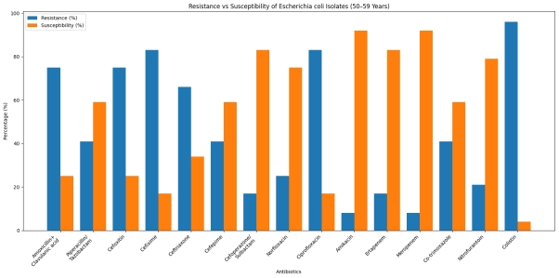
Fig: 1. Pattern of Escherichia coli Resistant & Sensitive [>50to 59 Years]

Table: 7. Percentage of Resistant & Susceptibility of isolated Klebsiella pneumoniae to tested use of antibiotics: [>50 TO 59 YEARS]

Total Isolates: 14
Antibiotics | R (No.) |  | R (%) |  | S (No.) |  |  | S (%)
Amoxicillin + Clavulanic acid | 10 |  | 71.0% |  | 04 |  |  | 29.0%
Piperacillin/Tazobactam | 10 |  | 71.0% |  | 04 |  |  | 29.0%
Cefoxitin | 10 |  | 71.0% |  | 04 |  |  | 29.0%
Cefixime | 10 |  | 71.0% |  | 04 |  |  | 29.0%
Ceftriaxone | 12 |  | 86.0% |  | 02 |  |  | 14.0%
Cefipime | 12 |  | 86.0% |  | 02 |  |  | 14.0%
Cefoperazone/Sulbactam |  | 10 | 71.0% |  | 04 |  | 29.0%
Norfloxacin |  | 09 | 64.0% |  | 05 |  | 36.0%
Ciprofloxacin |  | 09 | 64.0% |  | 05 |  | 36.0%
Amikacin |  | 12 | 86.0% |  | 02 |  | 14.0%
Ertapenem |  | 10 | 71.0% |  | 04 |  | 29.0%
Meropem |  | 08 |  | 57.0% | 06 | 43.0%
Co-trimoxazole [Trimethoprim+ Sulphamethoxale] |  | 10 |  | 71.0% | 04 | 29.0%
Nitrofurantoin |  | 10 |  | 71.0% | 04 | 29.0%
Colistin |  | 12 |  | 86.0% | 02 | 14.0%

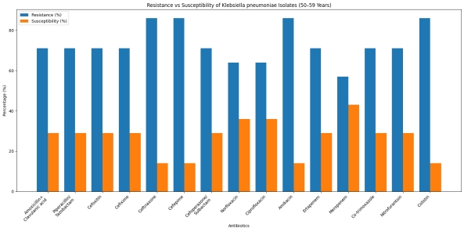
Fig: 2. Pattern of Klebsiella pneumoniae Resistant & Sensitive [>50 to 59 Years]

Table: 8. Percentage of Resistant & Susceptibility of isolated others Proteus mirabilis & Others Proteus Spp. to use of antibiotics: [>50 TO 59 YEARS]

Total Isolates: 04
Antibiotics | R (No.) |  | R (%) |  | S (No.) |  |  | S (%)
Amoxicillin + Clavulanic acid | 03 |  | 75.0% |  | 01 |  |  | 25.0%
Piperacillin/Tazobactam | 02 |  | 50.0% |  | 02 |  |  | 50.0%
Cefoxitin | 03 |  | 75.0% |  | 01 |  |  | 25.0%
Cefixime | 03 |  | 75.0% |  | 01 |  |  | 25.0%
Ceftriaxone | 03 |  | 75.0% |  | 01 |  |  | 25.0&
Cefipime | 02 |  | 50.0% |  | 02 |  |  | 50.0%
Cefoperazone/Sulbactam |  | 02 | 50.0% |  | 02 |  | 50.0%
Norfloxacin |  | 02 | 50.0% |  | 02 |  | 50.0%
Ciprofloxacin |  | 03 | 75.0% |  | 01 |  | 25.0%
Amikacin |  | 02 | 50.0% |  | 02 |  | 50.0%
Ertapenem |  | 02 | 50.0% |  | 02 |  | 50.0%
Meropem |  | 01 |  | 25.0% | 03 | 75.0%
Co-trimoxazole [Trimethoprim+ Sulphamethoxale] |  | 02 |  | 50.0% | 02 | 50.0%
Nitrofurantoin |  | 01 |  | 25.0% | 03 | 75.0%
Colistin |  | 03 |  | 75.0% | 01 | 25.0%

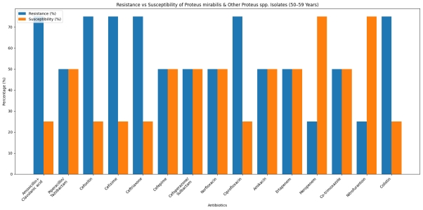
Fig: 3. Pattern Proteus mirabilis & Others Proteus Spp. Resistant & Sensitive [>50 to 59 Years]

Table: 9. Percentage of Resistant & Susceptibility of isolated Escherichia coli to tested use of antibiotics: [>60 YEARS]

Total Isolates: 166
Antibiotics | R (No.) |  | R (%) |  | S (No.) |  |  | S (%)
Amoxicillin + Clavulanic acid | 77 |  | 46.39% |  | 89 |  |  | 53.61%
Piperacillin/Tazobactam | 79 |  | 47.59% |  | 87 |  |  | 52.41%
Cefoxitin | 90 |  | 54.22% |  | 76 |  |  | 45.78%
Cefixime | 104 |  | 62.65% |  | 62 |  |  | 37.35
Ceftriaxone | 99 |  | 59.64% |  | 67 |  |  | 40.36%
Cefipime | 87 |  | 52.41% |  | 79 |  |  | 47.59%
Cefoperazone/Sulbactam |  | 79 | 47.59% |  | 87 |  | 52.41%
Norfloxacin |  | 66 | 40.00% |  | 100 |  | 60.00%
Ciprofloxacin |  | 118 | 71.08% |  | 48 |  | 28.92%
Amikacin |  | 58 | 34.94% |  | 108 |  | 65.06%
Ertapenem |  | 67 | 40.36% |  | 99 |  | 59.64%
Meropem |  | 51 |  | 30.72% | 115 | 69.28%
Co-trimoxazole [Trimethoprim+ Sulphamethoxale] |  | 99 |  | 59.64% | 67 | 40.36%
Nitrofurantoin |  | 33 |  | 19.88% | 133 | 80.12%
Colistin |  | 107 |  | 64.46% | 59 | 35.54%

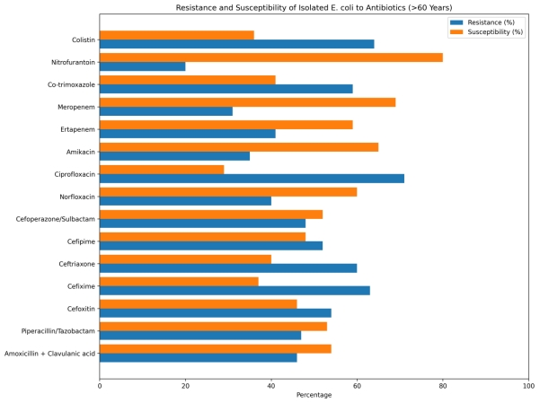

Fig: 4. Pattern of Escherichia coli Resistant & Sensitive [>60 Years]

Table: 10. Percentage of Resistant & Susceptibility of isolated Klebsiella pneumoniae to tested use of antibiotics: [>60 YEARS]

Total Isolates: 40
Antibiotics | R (No.) |  | R (%) |  | S (No.) |  |  | S (%)
Amoxicillin + Clavulanic acid | 28 |  | 70.00% |  | 12 |  |  | 30.00%
Piperacillin/Tazobactam | 22 |  | 55.00% |  | 18 |  |  | 45.0%
Cefoxitin | 25 |  | 62.50% |  | 15 |  |  | 37.50
Cefixime | 23 |  | 57.50% |  | 17 |  |  | 42.50%
Ceftriaxone | 21 |  | 52.50% |  | 19 |  |  | 48.50%
Cefipime | 28 |  | 70.00% |  | 12 |  |  | 30.00%
Cefoperazone/Sulbactam |  | 26 | 65.00% |  | 14 |  | 35.00%
Norfloxacin |  | 23 | 57.50% |  | 17 |  | 42.50%
Ciprofloxacin |  | 29 | 72.50% |  | 11 |  | 28.50%
Amikacin |  | 26 | 65.00% |  | 14 |  | 35.00%
Ertapenem |  | 19 | 47.50% |  | 21 |  | 52.50%
Meropem |  | 20 |  | 50.00% | 20 | 50.00%
Co-trimoxazole [Trimethoprim+ Sulphamethoxale] |  | 23 |  | 57.50% | 17 | 42.50%
Nitrofurantoin |  | 21 |  | 52.50% | 19 | 47.50%
Colistin |  | 09 |  | 22.50% | 31 | 77.50%

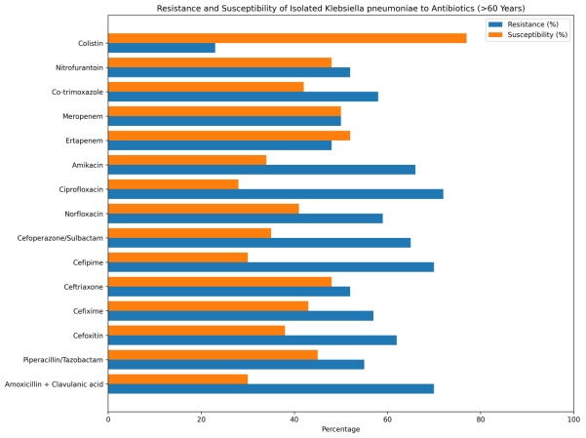
Fig: 5. Pattern of Klebsiella pneumoniae Resistant & Sensitive [>60 Years]

Table: 11. Percentage of Resistant & Susceptibility of isolated Proteus mirabilis & Others Proteus Spp. to tested use of antibiotics: [>60YEARS]
Total Isolates: 09
Antibiotics | R (No.) |  | R (%) |  | S (No.) |  |  | S (%)
Amoxicillin + Clavulanic acid | 07 |  | 77.78% |  | 02 |  |  | 22.22%
Piperacillin/Tazobactam | 02 |  | 22.22% |  | 07 |  |  | 77.78%
Cefoxitin | 05 |  | 55.56% |  | 04 |  |  | 44.44%
Cefixime | 05 |  | 55.56% |  | 04 |  |  | 44.44%
Ceftriaxone | 05 |  | 55.56% |  | 04 |  |  | 44.44%
Cefipime | 05 |  | 55.56% |  | 04 |  |  | 44.44%
Cefoperazone/Sulbactam |  | 04 | 44.44% |  | 05 |  | 55.56%
Norfloxacin |  | 05 | 55.56% |  | 04 |  | 44.44%
Ciprofloxacin |  | 06 | 66.67% |  | 03 |  | 33.33%
Amikacin |  | 03 | 33.33% |  | 06 |  | 66.67%
Ertapenem |  | 04 | 44.44% |  | 05 |  | 55.56%
Meropem |  | 02 |  | 22.22% | 07 | 77.78%
Co-trimoxazole [Trimethoprim+ Sulphamethoxale] |  | 03 |  | 33.33% | 06 | 66.67%
Nitrofurantoin |  | 05 |  | 55.56% | 04 | 44.44%
Colistin |  | 06 |  | 66.67% | 03 | 33.33%

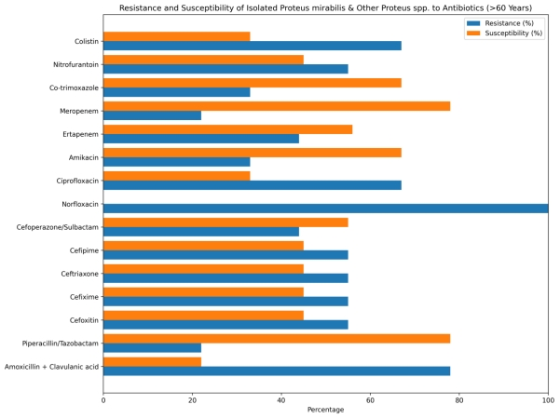

Fig: 6. Pattern of Proteus mirabilis & Others Proteus Spp. Resistant & Sensitive [>60 Years]

DISCUSSION:
Urinary tract infections are some of the most common bacterial infections and is prevalent worldwide. The treatment of UTIs relies heavily on antimicrobial therapy. However, the overuse of antimicrobial therapy has led to the development of drug-resistant microorganisms. Since microorganisms frequently change their susceptibility patterns, it is essential to continuously monitor antimicrobial susceptibility patterns.
Enterobacterales, primarily Eschericchia coli and Klebsiella pneumoniae, are leading causes of UTIs in patients >50 years, with high resistance rates driven by excessive empirical antibiotic use (e.g., fluoroquinolones, cephalosporins). High prevalence of Extended-Spectrum Beta-Lactamase (ESBL) production and, in some cases, carbapenem resistance, often necessitates tailored therapy based on regional resistance patterns, as resistance increases with age.
In our study positive culture growth shows in enterobacteriaceae group 66 (19.88%) from 332 total samples of age group > 50 to 59 years and 215 (31.25%) from 688 total samples of age group >60 years.
In this study all enterobacteriaceae bacteria shows increasing resistance rate of antibiotics in both age groups are Amxycillin/ clavulanic acid, Cephalosporis group, Quinolones [Fluoroquinolones] group and Colistin.
This study aimed to assess the prevalence and antibiotic resistance patterns of urinary tract infections (UTIs) in above 50 years patients a 3- month period. The findings underscore the significant burden of UTIs in the elderly, with Escherichia coli identified as the predominant pathogen, consistent with existing literature (Mareș et al,[17] 2023; Nguyen et al,[18] 2019). However, the high levels of antibiotic resistance observed in Escherichia coli and other pathogens raise serious concerns about the effectiveness of commonly used empirical treatments (Alhomayani et al,[19] 2022). Prevalence of Pathogens The dominance of Escherichia coli (56%) as the leading causative agent aligns with global trends, where it is recognized as the primary pathogen in UTIs across all age groups (Paul,[20] 2018). The presence of other pathogens such as Klebsiella pneumonia and Proteus mirabilis reflects the diverse microbial landscape associated with UTIs in elderly patients. These pathogens, while less prevalent, exhibited substantial resistance to multiple antibiotics, complicating treatment options (Ho et al,[21] 2019). In our study findings are consistent with reports from other regions, indicating that resistance to these antibiotics is widespread (Khan et al,[22] 2023).
This study highlights the high prevalence of Escherichia coli as the primary uropathogen in elderly patients, with significant resistance to commonly used antibiotics. The presence of multidrug-resistant strains, particularly in Klebsiella pneumoniae further complicates treatment. These findings necessitate a reassessment of current empirical treatment protocols, favouring the use of antibiotics with lower resistance rates. Continuous surveillance of antibiotic resistance patterns is crucial to improving clinical outcomes and managing the increasing threat of multidrug-resistant UTIs in this vulnerable population.
Antibiotic resistance has emerged as a significant public health issue, resulting in restricted treatment alternatives, elevated healthcare expenses, and extended hospitalization. It is crucial to continually monitor and investigate the shifting trends in bacterial drug susceptibility pattern, especially in relation to urinary tract infections. This enables treating physicians to remain up to date on the most effective initial treatments for UTIs. Instead of depending on standardized guidelines, the selection of antibiotics for UTI therapy should be determined by periodically understanding the prevalence of particular microorganisms responsible for the infection and assessing their susceptibility to antibiotics in the local region.

CONCLUSION:
In summary, rising antibiotic resistance among urinary pathogens, and especially the emergence of multi-drug resistant clonal groups, has provided urgency to the development of novel preventative and therapeutic strategies. Some older antibiotics may prove to be very useful in treating antimicrobial-refractory UTIs, especially those due to ESBL-producers. Newer Antibiotic, such as the recently approved doripenem, have proven highly effective in the clinic to treat complicated UTIs. Research into novel anti-virulence therapies, such as inhibiting the production of, or adherence by, urinary pathogenic Escherichia coli (UPEC) fimbriae is still an early stage but holds promise for future development. The use of probiotics to prevent vaginal urinary pathogenic Escherichia coli (UPEC) colonization and the use of an immuno-stimulatory urinary pathogen extract (SolcoUrovac) are currently in clinical trials to determine efficacy in preventing recurrent UTIs. Another preventative strategy is vaccination, and experimental vaccines have been developed that are effective in preventing UTIs in primates.
It is important that each country should have its own epidemiological data, and physicians should know antimicrobial resistance rates in their regions so as to arrange treatment, and prophylaxis accordingly. Antimicrobial resistance rates are increasing steadily against antibiotics expected to exert clinical efficacy in the treatment of UTI as a result of their widespread, and erroneous use. We think that at certain intervals canters should identify urinary pathogens prevalent in their regions, and aware of antimicrobial susceptibilities of these pathogens which are very important for the economy of the country, and appropriate treatment.

Antimicrobial resistance is a globally ever increasing problem. The emergence and spread of antimicrobial resistance are complex and driven by numerous interconnected factors. The principle causes of microbial resistance are inappropriate, irrational, high consumption, and profligate use of antibiotics. The use of antimicrobials must be restricted and monitored in order to decline the resistance. The present results in increasing antibiotic resistance trends in UTI patients indicate that it is imperative to rationalize the use of antimicrobials and to use these conservatively. Considering the relatively increase rates of UTI and drug resistance observed in this study, continued local, regional, and national surveillance is warranted. Antibiotics should only be issued when prescribed by physicians.
Regular monitoring is required to establish reliable information about resistance pattern of urinary pathogens for optimal empirical therapy of patients with UTIs. A combination of traditional and innovative prevention and treatment strategies is being deployed to combat the threat of emerging antibiotic resistance among urinary pathogens. Finally, we suggest that empirical antibiotic selection should be based on the knowledge of local prevalence of bacterial organisms and antibiotic sensitivities rather than on universal guidelines.
The prevalence of Enterobacterales causing UTIs is high in patients over 50, with alarming rates of antibiotic resistance and ESBL production, necessitating tailored, evidence-based, and often broader-spectrum empirical therapy to avoid treatment failure.

ACKNOWLEDGEMENTS:
I would like to thank Faculty of the Department of Microbiology, Sister Nivedita University; Kolkata; West Bengal; India for critical review of the manuscript and suggestions. I express my sincere thanks to Managing Director of Serum Analysis Centre Pvt. Ltd.; Howrah-711101; West Bengal; India for granting me permission to work in the department and extending all facilities available.

REFERENCES
1. Rodriguez-Mañas L. Urinary tract infections in the elderly: a review of disease characteristics and current treatment options. Drugs Context. 2020 Jul 8; 9:2020-4-13. doi: 10.7573/dic.2020-4-13. PMID: 32699546; PMCID: PMC7357682.
2. Gajdács M, Ábrók M, Lázár A, Burián K. Urinary Tract Infections in Elderly Patients: A 10-Year Study on Their Epidemiology and Antibiotic Resistance Based on the WHO Access, Watch, Reserve (AWaRe) Classification. Antibiotics (Basel). 2021 Sep 11;10(9):1098. doi: 10.3390/antibiotics10091098. PMID: 34572680; PMCID: PMC8467796.
3. Tarek A, Abdalla S, Dokmak NA, Ahmed AA, El-Mahdy TS, Safwat NA. Bacterial Diversity and Antibiotic Resistance Patterns of Community-Acquired Urinary Tract Infections in Mega Size Clinical Samples of Egyptian Patients: A Cross-Sectional Study. Cureus. 2024 Jan 8;16(1): e51838. doi: 10.7759/cureus.51838. PMID: 38327928; PMCID: PMC10849261.
4. Sanchez GV, Babiker A, Master RN, Luu T, Mathur A, Bordon J. Antibiotic resistance among urinary isolates from female outpatients in the United States in 2003 and 2012. Antimicrob Agents Chemother 2016;60:2680–3.
5. Okarska-Napierała M, Wasilewska A, Kuchar E. Urinary tract infection in children: Diagnosis, treatment, imaging–Comparison of current guidelines. J Pediatr Urol 2017;13:567–73.
6. Kang CI, Kim J, Park DW, Kim BN, Ha US, Lee SJ, et al. Clinical practice guidelines for the antibiotic treatment of community-acquired urinary tract infections. Infect Chemother 2018;50:67–100.
7. Nicolle LE, Gupta K, Bradley SF, Colgan R, DeMuri GP, Drekonja D, et al. Clinical practice guideline for the management of asymptomatic bacteriuria: 2019 update by the Infectious Diseases Society of America. Clin Infect Dis 2019;68:e83–110.
8. Bonkat G, Bartoletti R, Bruyère F, Cai T, Geerlings SE, Köves B, et al; European Association of Urology. EAU Guidelines on Urological Infections. Available at: https://d56bochluxqnz.cloudfront.net/documents/ full-guideline/EAU-Guidelines-on-Urological-Infections-2022.pdf. Accessed Feb 23, 2023.
9. Aykan SB, Ciftci IH. Antibiotic resistance patterns of Escherichia coli strains isolated from urine cultures in Turkey: A meta-analysis. Mikrobiyol Bul [Article in Turkish] 2013;47:603–18.
10. Bassetti M, Garau J. Current and future perspectives in the treatment of multidrug-resistant gram-negative infections. J Antimicrob Chemother 2021;76(Suppl 4):iv23–37.
11. European Committee on Antimicrobial Susceptibility Testing. Breakpoint tables for interpretation of MICs and zone diameters. Version 9.0. Available at: https://www.eucast.org. Accessed June 15, 2021.
12. Frieri M, Kumar K, Boutin A. Antibiotic resistance. J Infect Public Health 2017;10:369–78.
13. Collee JG, Duguid JP, Fraser AG, Marmion BP, Simmons A. (1996). Laboratory strategy in diagnosis of infective syndromes. In: Collee JG, Duguid JP, Fraser AG, Marmion BP, Simmons A (Editor). Mackie and McCartney Practical Medical Microbiology, 14th ed. London: Churchill Livingstone; pp. 53-94.
14. Cruickshank R, Duguid JP, Marmion BP. (1975). Tests for identification of bacteria. In: Medical Microbiology. 12th ed. London: Churchill Livingstone; pp. 170-189.
15. Kass, E. H. (1957). Bacteriuria and diagnosis of infections of urinary tract. Arch. Intern. Med., 100: 709-714.
16. District laboratory Practice in Tropical Countries Monika Cheesbrough. (2002). 2nd Edition, Part-2, Cambridge University Press; 132-234.
17. Mareș C, Petca RC, Popescu RI, Petca A, Geavlete BF, Jinga V. Uropathogens' Antibiotic Resistance Evolution in a Female Population: A Sequential Multi-Year Comparative Analysis. Antibiotics (Basel). 2023 May 23;12(6):948. doi: 10.3390/antibiotics12060948. PMID: 37370266; PMCID: PMC10294854.

18. Nguyen HQ, Nguyen NTQ, Hughes CM, O'Neill C. Trends and impact of antimicrobial resistance on older inpatients with urinary tract infections (UTIs): A national retrospective observational study. PLoS One. 2019 Oct 3;14(10): e0223409. doi: 10.1371/journal.pone.0223409. PMID: 31581222; PMCID: PMC6776395.

19. Alhomayani FK, Alazwari NM, Alshhrani MS, Alkhudaydi AS, Basaba AS, Alharthi TM, et al. The prevalence of multiple drug resistant urinary tract infections: A singlecentered, observational retrospective study in King Abdulaziz Specialized Hospital, Taif, Saudi Arabia. Saudi Med J. 2022 Aug;43(8):927-932. doi: 10.15537/smj.2022.43.8.20220238. PMID: 35964957; PMCID: PMC9749674.

20. Paul R. State of the Globe: Rising Antimicrobial Resistance of Pathogens in Urinary Tract Infection. J Glob Infect Dis. 2018 Jul-Sep;10(3):117-118. doi: 10.4103/jgid.jgid_104_17. PMID: 30166807; PMCID: PMC6100332.

21. Ho HJ, Tan MX, Chen MI, Tan TY, Koo SH, Koong AYL, et al. Interaction between Antibiotic Resistance, Resistance Genes, and Treatment Response for Urinary Tract Infections in Primary Care. J Clin Microbiol. 2019 Aug 26;57(9): e00143-19. doi: 10.1128/JCM.00143-19. PMID: 31243084; PMCID: PMC6711900.

22. Khan MA, Rahman AU, Khan B, Al-Mijalli SH, Alswat AS, Amin A, et al. Antibiotic Resistance Profiling and Phylogenicity of Uropathogenic Bacteria Isolated from Patients with Urinary Tract Infections. Antibiotics (Basel). 2023 Oct 3;12(10):1508. doi: 10.3390/antibiotics12101508. PMID: 37887209; PMCID: PMC10603882.

