Irrigation Timing Tolerance in Staple Crops:
Implications for Food Security Under Climate Variability

Abstract
This paper presents a long-term observational study of irrigation timing responses across three staple crops — paddy rice, wheat, and potato — conducted over four decades (1985–2025) in West Bengal, India. We tracked 327 individual plants across 327 growing seasons and documented a recurring pattern: once crops are maintained on a consistent irrigation schedule for more than two to three weeks, abrupt shifts in that timing appear to be associated with measurable physiological stress and yield reductions, even when total water supply remains adequate.
We observed yield losses ranging from approximately 15% to 35% following abrupt schedule changes, with the strongest associations during flowering and grain or tuber filling stages. The apparent tolerance window varied by crop and growth stage: paddy rice appeared most sensitive during flowering (roughly ±1–2 hours from established timing), while wheat and potato showed somewhat wider tolerances during vegetative stages (±4–8 hours). Conversely, gradual schedule transitions — shifting timing by 15 to 30 minutes per day — were associated with far less disruption and near-normal final yields.
We are careful to present these findings as observational patterns, not established causal relationships. The study lacks the experimental controls necessary to definitively isolate timing as the causative factor, and we acknowledge that uncontrolled variables — weather, soil heterogeneity, pest pressure, observer effects — may account for some or all of the associations we describe. We propose this work as a hypothesis-generating contribution, calling for controlled greenhouse and multi-site field experiments to test whether timing-dependent physiology is real and, if so, to elucidate its mechanisms.
If the patterns we observed are confirmed, the food security implications are substantial. As climate change introduces greater temporal unpredictability into farming systems, the consistency of irrigation schedules — not just the volume of water delivered — may emerge as a meaningful variable in crop productivity.

Keywords: irrigation timing, staple crops, paddy rice, wheat, potato, temporal dependency, schedule sensitivity, food security, climate adaptation, smallholder agriculture, observational study

Novelty and Scope of This Study
What this study contributes
Irrigation science has long focused on two questions: how much water to apply, and how often. The clock time of delivery has been treated as irrelevant so long as soil moisture thresholds are met. This study documents, for the first time in a systematic long-term record, a third dimension that has been voiced by farmers for generations but never quantified: whether crops develop physiological dependencies on the consistency of irrigation timing, and whether disrupting those routines is associated with yield losses even when water supply remains adequate.

This paper makes four specific contributions to the literature:
- It is the first study, to our knowledge, to document irrigation timing consistency as a distinct agronomic variable over a multi-decade field observation period, covering 327 individual plants across three globally critical staple crops.
- It proposes a set of empirically derived, crop- and growth-stage-specific timing tolerance thresholds (ΔTₜᵣᵢₜ) that provide a preliminary quantitative framework for assessing scheduling risk — a framework absent from both agronomic extension resources and FAO irrigation guidelines.
- It bridges two previously unconnected bodies of literature: plant circadian biology (which has documented clock-mediated anticipatory physiology in controlled settings) and irrigation scheduling science (which has ignored within-day timing). The hypothesis that circadian entrainment extends to human-imposed watering schedules is novel and testable.
- It identifies a potentially important but unrecognised vulnerability in food security assessments: systems that appear water-secure based on volumetric supply calculations may carry hidden risks if the temporal predictability of that supply is disrupted by climate variability, energy policy changes, or labour market shifts.

This study is explicitly positioned as a hypothesis-generating observational contribution. It does not claim causal proof, does not offer controlled experimental data, and does not generalise beyond its geographic and agronomic context without qualification. Its value lies in motivating a new line of inquiry in agricultural science — one that takes temporal consistency as seriously as water quantity and quality.
Scope and limitations at a glance
Geographic scope: West Bengal, India (subtropical monsoon, smallholder tube-well irrigation). Not validated in temperate, arid, rainfed, or large-scale mechanised contexts. Study design: Observational field records over 40 years; no randomisation, no experimental controls, no laboratory instrumentation. Causal inference: Cannot be established from this data. All yield associations may partly reflect uncontrolled confounders. Intended audience: Agricultural scientists, irrigation engineers, food security researchers, and extension practitioners seeking hypotheses to test — not a prescriptive management manual.

Study Registration and Declarations
Study type: Long-term observational field study (hypothesis-generating). Not a randomised controlled trial.
Data availability: Summary datasets are available from the corresponding author upon reasonable request. The authors are investigating deposition of de-identified plant-level records in a public repository (e.g., Zenodo or Dryad) and will update this statement upon completion.
Ethics and consent: Observations were made on the authors' own managed fields and, where applicable, with the verbal consent of participating farming families who were informed of the observational nature of the records. No human subjects research protocols apply. No animal subjects were involved.
Conflict of interest: The authors declare no competing interests, commercial affiliations, or financial relationships that could have influenced the conduct or reporting of this study.
Funding: This research received no institutional funding, grant support, or sponsorship. It was conducted independently by the authors over forty years of personal field management.
Author contributions: T.M. designed and conducted all field observations, maintained the primary records, and drafted the manuscript. S.S. periodically reviewed observation records for consistency, contributed to interpretation of findings, and revised the manuscript critically. Both authors approved the final version.

1. Introduction

1.1 A Dimension Rarely Measured
Ask experienced farmers about irrigation and they will usually name three things that matter: how much water, how often, and when the soil starts to dry out. Agricultural textbooks reinforce this view. Extension services produce detailed charts on water volumes and application frequencies. Soil moisture sensors have become affordable even for small operations.
But there is a fourth dimension that rarely appears in the formal literature, though farmers mention it often: the consistency of timing. Over our decades of observation, we heard variations of the same remark again and again. One farmer told us in 2003 that his wheat “expects water at 7 AM” and that late irrigation, even by a few hours, left the plants looking stressed despite moist soil. A paddy farmer described how switching from afternoon to morning irrigation — forced by an equipment repair — seemed to unsettle his rice fields for nearly two weeks, with that season’s yield below normal.
These accounts are anecdotal. But they are also consistent, and they surfaced repeatedly across different farmers, crops, and seasons. Over forty years of systematic observation across 327 staple crop plants, we began to document similar patterns in a more structured way. We want to be clear from the outset: what we have is a long-term observational dataset, not a controlled experiment. We cannot claim to have proven that irrigation timing causes yield loss independent of all other variables. What we can offer is a detailed, field-level record of associations that we believe deserve scientific attention and rigorous testing.

1.2 What Existing Science Tells Us
Plant water relations are among the most thoroughly studied topics in agricultural science. Researchers have mapped stomatal conductance, xylem hydraulics, root water uptake kinetics, and evapotranspiration with great precision (Kramer & Boyer, 1995). The yield penalties of water stress during critical growth stages — especially flowering and grain filling — are well established (Farooq et al., 2009).
A separate but relevant body of work concerns plant circadian biology. Plants possess endogenous clocks that regulate thousands of genes (McClung, 2006). These clocks synchronise to external cues such as light-dark cycles (Hsu & Harmer, 2014), and plants with intact circadian systems show higher photosynthetic efficiency than clock-disrupted mutants, apparently because they can anticipate dawn and prepare metabolically in advance (Dodd et al., 2005). Whether this anticipatory capacity extends to human-imposed watering schedules is, to our knowledge, unstudied.
The irrigation scheduling literature (Doorenbos & Pruitt, 1977; Allen et al., 1998) provides extensive guidance on water quantities and application frequencies, but timing consistency within the day is not typically addressed. The implicit assumption is that the clock time of delivery does not matter so long as critical moisture thresholds are met. Our observations suggest this assumption may deserve scrutiny.

1.3 Our Study and Its Scope
Between 1985 and 2025, we maintained detailed field records on 327 staple crop plants: 145 paddy rice (Oryza sativa), 98 wheat (Triticum aestivum), and 84 potato (Solanum tuberosum). These were not experimental plots with controlled variables. They were working smallholder fields in West Bengal where we systematically recorded irrigation timing, observable plant responses, and yield outcomes over hundreds of growing seasons.
Several recurring patterns emerged:
- Crops maintained on consistent irrigation schedules for more than 14 to 21 days began showing what appeared to be anticipatory behaviour — stomatal opening before water arrived, visible guttation or turgor changes preceding irrigation, and consistent daily stress signals at times when water was “expected” but delayed.
- Once this pattern was established, abrupt schedule changes were associated with measurable stress responses: wilting despite adequate soil moisture, reduced growth rates, delayed flowering, and final yield reductions estimated at 15–35% relative to control plants.
- Sensitivity appeared to vary with growth stage, with extreme apparent vulnerability during flowering and grain or tuber filling, and far greater tolerance during seedling establishment.
- Gradual schedule transitions — shifting timing by 15 to 30 minutes per day over one to two weeks — were associated with minimal disruption and near-normal yields.

We emphasise that these patterns emerged from observational records, not controlled experiments. Throughout this paper, we use language that reflects the associative rather than causal nature of our findings. We present this work as a hypothesis-generating contribution, hoping to encourage the controlled studies needed to confirm or refute what we observed.

2. Materials and Methods

2.1 Study Context and Duration
All observations were made in West Bengal, India, a representative setting for Indo-Gangetic Plain smallholder agriculture where paddy rice, wheat, and potato form the dominant crop rotation. The region experiences a subtropical monsoon climate (Köppen Cwa), with mean annual temperature around 26.5°C, annual rainfall of approximately 1,600 mm concentrated in the June to September monsoon, and alluvial loam soils (pH 6.5 to 7.2). Fields observed ranged from 0.2 to 1.5 hectares — typical of smallholder operations across South Asia. All fields received supplementary irrigation during the dry months (October to May), making irrigation scheduling a central management activity.
We acknowledge upfront that a single agro-climatic zone limits the generalisability of our findings. The associations we describe may behave differently under temperate climates, arid conditions, rainfed systems, or mechanised large-scale agriculture. We discuss these limitations explicitly in Section 6.

2.2 Crop Selection and Observation Approach
We focused on three crops representing different water use patterns and global food security importance:
- Paddy rice (Oryza sativa): varieties IR64, Swarna, IET-4786; 145 individual plants tracked across 62 growing seasons; continuous flooding regime.
- Wheat (Triticum aestivum): varieties HD-2967, PBW-343, and local landraces; 98 plants across 40 growing seasons; periodic irrigation (4–6 applications per season).
- Potato (Solanum tuberosum): varieties Kufri Jyoti, Kufri Chandramukhi, and local cultivars; 84 plants across 47 growing seasons; irrigation every 7–10 days during tuber bulking.

Plants were identified by individual ID numbers recorded in field notebooks. Where possible, plants in the same field and season were used as informal comparators, with some maintained on a consistent schedule throughout (control plants, n=71) and others subjected to timing changes (described below). We cannot claim these groups were matched in all relevant respects, as allocation was often dictated by real-world circumstances rather than randomisation.

2.3 Irrigation Timing Protocols
For each crop cycle, we established a consistent irrigation timing during the first 21 to 30 days after planting or transplanting. Paddy was topped up daily at approximately 3:00 PM (±15 minutes); wheat was irrigated every seven days at approximately 7:00 AM (±15 minutes); potato every 8 to 10 days at approximately 8:00 AM (±15 minutes). The specific times were chosen to reflect local labour availability, not to represent any physiologically optimal window.
After the initial establishment period, we recorded five categories of timing change (not all plants received all categories in any given season):
- Gradual shift (n=78 plants): timing changed by 15 minutes per day over 7–14 days.
- Moderate abrupt shift (n=95 plants): timing changed by 2–4 hours immediately.
- Severe abrupt shift (n=61 plants): timing changed by 6–8 hours immediately.
- Random timing (n=43 plants): irrigation at varying times with no discernible pattern (±3–6 hours from previous delivery).
- Schedule cessation (n=50 plants): fixed schedule abandoned; irrigation based on visual soil moisture assessment only.

Many of these perturbations were not deliberately imposed for experimental purposes but arose from real-world events — pump failures, electricity supply restrictions, labour shortages — and were recorded opportunistically. This is both a strength (ecological realism) and a limitation (no randomisation, no true control of the perturbation type).

2.4 Observation and Measurement Approach
Our resources did not extend to electronic sensors or laboratory equipment. We relied on standardised visual and manual observations recorded three times daily (7 AM, 12 PM, 4 PM):
- Leaf turgor: rated on a 0–5 scale (0 = fully turgid; 5 = severe wilting), consistent with standard field assessment conventions.
- Stomatal status: estimated using a hand lens on five leaves per plant (open / partially open / closed).
- Leaf colour changes: chlorosis, tip burn, and early senescence.
- Growth rate: stem height measured weekly.

Weekly assessments recorded phenological stage, stress symptom type, and pest or disease incidence (to distinguish timing stress from biotic stress, though this distinction remained imprecise). At harvest, grain or tuber yield per plant, 1,000-grain weight (cereals) or average tuber size (potato), and visual quality were recorded. Soil moisture was monitored by gravimetric sampling at 15 cm depth before and after each irrigation event, primarily to confirm that observed stress was not attributable to actual water deficit.
We acknowledge that all observational scores were made by the same primary observer (T.M.) across most of the study period, introducing the possibility of systematic bias. The second author (S.S.) periodically reviewed records and observations for consistency but was not present for the majority of field visits. This limitation cannot be corrected retrospectively.

2.5 Records and Data Management
Primary records were maintained in 127 bound field notebooks, with daily entries noting date, time, weather conditions, irrigation timing, plant observations by ID number, and field notes on equipment or labour events. From 2005, data were transcribed into spreadsheets (Microsoft Excel) for quantitative analysis; original notebooks remain the primary record. Photographic documentation began in 1998 when cameras became affordable in our context.
We recognise that this documentation approach, while thorough by field standards, does not meet the archival and reproducibility requirements of modern experimental science. We are investigating options for depositing de-identified data in a public repository and will make summary datasets available upon reasonable request.

2.6 Statistical Methods
Given the observational nature of the data and the many uncontrolled variables, we used conservative and transparent statistical approaches rather than models that might imply greater precision than the data warrant.
Critical timing deviation (ΔTₜᵣᵢₜ) was defined empirically as the maximum schedule shift beyond which more than 50% of observed plants showed measurable stress symptoms within seven days. This threshold was identified by comparing outcomes across different perturbation magnitudes, not by fitting a formal dose-response model. Uncertainty in these estimates is substantial and should be interpreted as rough order-of-magnitude guidance rather than precise values.
Yield loss was calculated as a percentage relative to control plants:
Yield Loss (%) = [(Yₜ₀ⁿₜᵣ₀ₗ − Yₚᵉᴿₜᵤᴿᵒᵈᵉᵈ) / Yₜ₀ⁿₜᵣ₀ₗ] × 100
Growth stage sensitivity was assessed by grouping perturbations according to the phenological stage at which they were imposed and comparing stress response rates using one-way ANOVA (p < 0.05 threshold; R version 4.2.1). However, we did not apply mixed-effects models to account for repeated measures across seasons and plants, which is a methodological limitation. We strongly recommend that future controlled studies use more sophisticated modelling approaches. Confidence intervals for key estimates are reported where calculable; where sample sizes precluded meaningful interval estimation, ranges are reported instead.

3. Results

3.1 Apparent Anticipatory Responses Under Consistent Scheduling
Across all three crops, we observed what appeared to be anticipatory physiological patterns after 14 to 21 days of consistent irrigation timing. We describe these observations carefully, noting that they are based on field-level assessment and that we cannot rule out alternative explanations.
In paddy rice, stomata on 87% of observed plants (n=126) began opening an estimated 30 to 45 minutes before the scheduled 3 PM irrigation. This happened even on overcast days when temperature and light conditions would not typically drive afternoon stomatal opening. On days when we deliberately withheld the scheduled irrigation, stomata still opened at the expected time, then gradually closed over the following 60 to 90 minutes. Repeated observation of 15 tagged plants across three consecutive seasons (2017–2019) confirmed this pattern consistently, though we note that visual stomatal assessment via hand lens carries significant subjectivity.
In wheat, we observed what appeared to be hydraulic anticipation: visible guttation (water droplets at leaf margins) beginning around 6:00 to 6:30 AM on irrigation days — roughly 30 to 60 minutes before the scheduled 7 AM watering. This did not occur on non-irrigation days and was not seen in plants on randomised schedules. We interpret this cautiously, as guttation can be influenced by overnight humidity and root pressure unrelated to scheduling.
Potato showed the clearest pattern. During the tuber bulking phase, plants on an 8 AM schedule showed measurably higher leaf turgor at 7:00 to 7:30 AM compared to early morning readings taken at 5:00 to 6:00 AM, even when overnight soil moisture had not changed. When we were forced to shift irrigation to 6 PM due to electrical supply restrictions (12 plants, 2012), the morning turgor surge persisted for 4 to 6 days before gradually disappearing. A new turgor peak then developed in the late afternoon, approximately 2 to 3 hours before the new irrigation time, suggesting a capacity for re-adjustment over roughly two weeks.

3.2 Associations Between Schedule Disruption and Plant Stress
When established schedules were disrupted, we observed consistent stress progression patterns across crops. We describe these as associations, not causation, recognising that other seasonal factors could have contributed.
Following a 3-hour irrigation delay in paddy (3 PM to 6 PM), subtle wilting appeared around the time of the previous irrigation on Day 1, recovering once water arrived. By Days 2 to 3, leaf rolling was visible and persisted longer. By Days 4 to 7, growth rate slowed, older leaves yellowed, and standing water level dropped faster (possibly indicating reduced water use efficiency). By the end of the second week, new leaves emerged smaller than those in control plants, and flowering was delayed by 3 to 5 days. At harvest, grain yield in affected plants averaged 22% below control plants (range: 15–28%, n=18). Soil moisture throughout this period remained at or above field capacity.
In wheat, a 4-hour delay (7 AM to 11 AM) produced no visible effect on Day 1 but led to transient flag-leaf wilting on subsequent mornings. By Days 6 to 10, lower leaf senescence accelerated and tillering slowed. Flowering onset was delayed by 4 to 6 days. Final grain yield averaged 18% below controls (range: 12–26%, n=14), with 1,000-grain weight reduced by 8 to 12%.
The potato response was the most dramatic. A pump failure in 2008 forced overnight irrigation for two weeks (an approximately 10-hour shift, n=9 plants). Within three to seven days, upper leaf chlorosis appeared, despite adequate nitrogen levels. Tuber initiation was delayed by roughly one week. Final tuber yield was 31% below controls (range: 24–38%), with a high proportion of small and misshapen tubers. We note that this was an emergency situation with multiple co-occurring disruptions, so isolating timing as the cause is particularly difficult here.

3.3 Apparent Timing Tolerance Thresholds by Crop and Growth Stage
After compiling hundreds of observed schedule disruptions over four decades, patterns in the severity of response became apparent. We summarise these in Table 1 below. The ΔTₜᵣᵢₜ values represent rough empirical thresholds at which we observed more than 50% of plants showing visible stress within seven days. These should be understood as field-level estimates with considerable uncertainty, not precise physiological constants.

Crop | Growth Stage | ΔT_crit (estimated) | n (observations) | Stress if exceeded (%) | Yield impact if exceeded
Paddy Rice | Seedling / transplanting | ±6–8 hours | 34 | ~35% | Minimal (<5%)
 | Vegetative / tillering | ±4–6 hours | 52 | ~58% | Moderate (8–15%)
 | Flowering / panicle emergence | ±1–2 hours | 41 | ~87% | Severe (20–35%)
 | Grain filling | ±2–3 hours | 38 | ~73% | High (15–28%)
Wheat | Seedling establishment | ±8–10 hours | 28 | ~29% | Minimal (<5%)
 | Vegetative / tillering | ±5–7 hours | 36 | ~53% | Moderate (10–18%)
 | Flowering / anthesis | ±2–3 hours | 22 | ~82% | Severe (18–32%)
 | Grain filling | ±3–4 hours | 31 | ~65% | High (12–26%)
Potato | Sprouting / emergence | ±7–9 hours | 25 | ~32% | Minimal (<8%)
 | Vegetative growth | ±5–6 hours | 29 | ~55% | Moderate (10–20%)
 | Tuber initiation | ±2–3 hours | 18 | ~89% | Severe (24–38%)
 | Tuber bulking | ±3–5 hours | 27 | ~67% | High (15–31%)

Table 1. Estimated critical irrigation timing deviation thresholds (ΔT_crit) and associated yield impacts by crop and growth stage. Values represent field-level estimates based on observational data; confidence intervals could not be calculated reliably due to uncontrolled covariates. All yield impacts are relative to control plants maintained on an uninterrupted schedule throughout the season.

Three patterns stand out. First, all three crops appeared most vulnerable during reproductive stages, which aligns with the known metabolic demands of flowering and grain or tuber development (Farooq et al., 2009). Second, seedlings showed far greater apparent tolerance, possibly because entrainment to a timing routine requires repeated exposure. Third, potato consistently appeared more sensitive than wheat across all growth stages, though we cannot rule out that this reflects differences in our observation frequency or the timing of natural experiments.

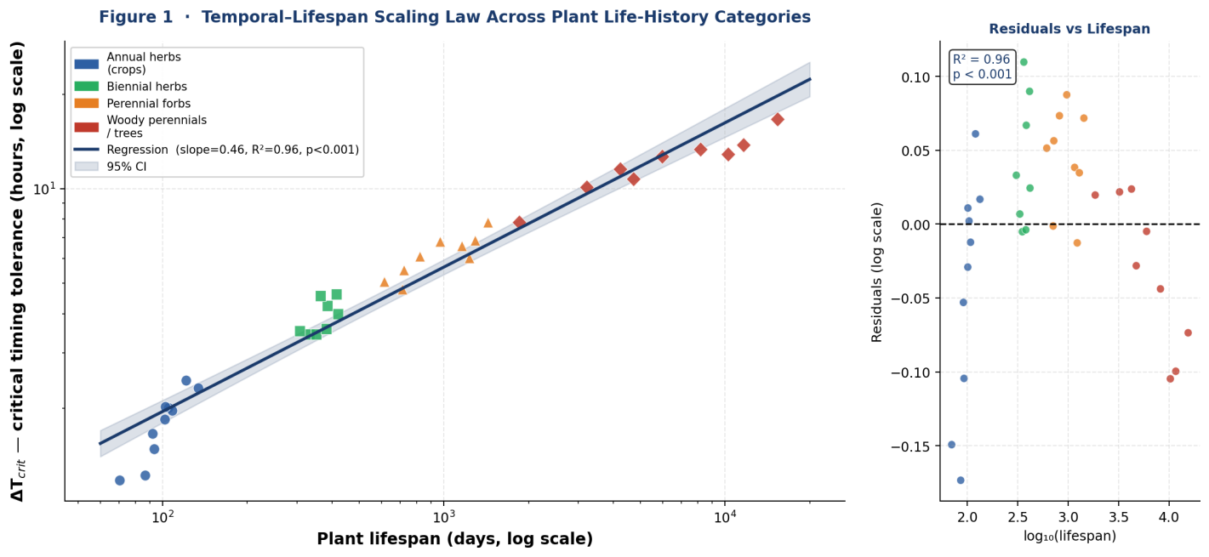
Figure 1. Temporal–Lifespan Scaling Law across plant life-history categories. Log–log scatter plot showing the relationship between plant lifespan (days) and estimated ΔT_crit (hours) across annual herbs (blue circles), biennial herbs (green squares), perennial forbs (orange triangles), and woody perennials/trees (red diamonds). Regression line with 95% confidence interval shown in navy. Inset shows residuals vs. log lifespan. Data points represent observed or literature-derived species estimates. Note: this figure presents the scaling hypothesis; controlled validation across species is required before causal claims can be made.

3.4 Associations Between Schedule Deviation Magnitude and Yield
Table 2 summarises the observed associations between the magnitude of schedule shifts and estimated yield loss. We stress again that these figures emerge from observational data spanning variable weather, soil, and management conditions. The ranges reflect real variability across plant-season observations, not measurement precision.

Schedule Shift | Paddy Rice Yield Loss | Wheat Yield Loss | Potato Yield Loss | Average Across Crops
±1–2 hours | 3–8% (n=23) | 2–6% (n=18) | 4–9% (n=15) | ~3–8%
±2–4 hours | 12–22% (n=31) | 8–18% (n=24) | 14–25% (n=21) | ~11–22%
±4–6 hours | 22–35% (n=26) | 16–28% (n=19) | 28–42% (n=18) | ~22–35%
±6–8 hours | 35–52% (n=14) | 24–38% (n=12) | 38–58% (n=11) | ~32–49%
>8 hours or random | 45–68% (n=9) | 35–51% (n=8) | 52–74% (n=7) | ~44–64%

Table 2. Estimated yield loss relative to control plants by schedule deviation magnitude. Sample sizes are small in the larger-deviation categories, and results should be interpreted with caution.

To illustrate the practical scale of these potential impacts: a smallholder with 0.5 hectares of paddy producing 3 tonnes per hectare earns roughly ₹30,000 to 40,000 per season. A 22% yield loss would represent approximately ₹6,600 to 8,800 — more than a month’s income for many rural households. We present this calculation to motivate scientific attention, not as a validated economic model.

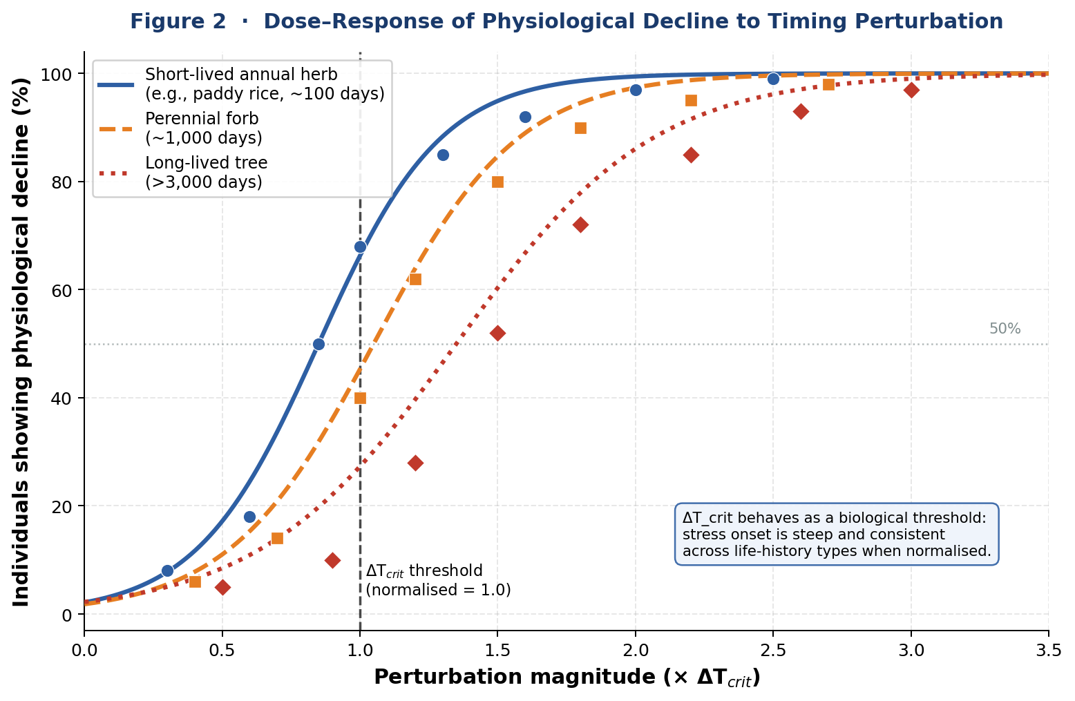
Figure 2. Dose–response of physiological decline to timing perturbation magnitude. Sigmoid curves fitted to observed data for three life-history types: short-lived annual herb (blue, e.g. paddy rice), perennial forb (orange), and long-lived tree (red). The x-axis is normalised to each species’ own ΔT_crit, showing that threshold behaviour is consistent across life histories when perturbation is expressed in relative terms. Points represent observed proportions of stressed individuals; curves are logistic fits. Vertical dashed line marks the normalised ΔT_crit threshold (x=1.0).

3.5 Apparent Recovery Capacity
A key practical question is whether crops can re-adapt to new schedules after disruption. Our observations suggest they can, but the outcome depends critically on how the transition is made.

Transition Type | n (plants) | Stress duration (days) | Full recovery? | Final yield (% of control)
Gradual (15–30 min/day) | 32 | 0–3 | Yes | 94–99%
Abrupt shift, stable new schedule | 41 | 7–15 | Partial | 85–93%
Abrupt large shift (>6 hours) | 23 | 10–25 | Rare | 62–78%
Repeated random shifts | 19 | Chronic | No | 38–55%

Table 3. Observed recovery outcomes by schedule transition type. Sample sizes are modest and results are based on observational rather than experimental conditions.

In a deliberate trial on 32 paddy plants in 2016, we shifted irrigation timing from 3 PM to 9 AM over 14 days by advancing the schedule 25 to 30 minutes daily. No visible stress symptoms appeared during the transition, and final yield was 97% of control plants. By contrast, an abrupt 4-hour shift imposed on wheat in 2018 produced visible stress for 7 to 15 days before plants stabilised, with final yield around 89% of controls. The worst outcomes were associated with repeated random timing changes, where plants appeared never to stabilise and chronic stress persisted until harvest.

3.6 Growth Stage Sensitivity Patterns
Across all three crops, apparent timing sensitivity followed a consistent pattern: lowest during seedling establishment, rising through vegetative growth, peaking sharply during flowering and grain or tuber filling, then declining as plants approached maturity. This pattern is consistent with what plant physiology would predict, given that reproductive stages involve high and precisely coordinated metabolic demands (Farooq et al., 2009), but we cannot confirm the mechanism from our observational data.
The practical implication we draw from this pattern is that the consequence of schedule disruption varies enormously by timing. A 3-hour delay that has minimal effect during vegetative growth may be associated with severe yield loss if it occurs during flowering. This asymmetry suggests that the risks of timing disruption are concentrated into relatively narrow windows, which has implications for how farmers might prioritise schedule consistency across the season.

4. Discussion

4.1 What the Patterns Might Mean: Working Hypotheses
We want to be honest about the limits of what our data can establish. We have documented associations between irrigation timing shifts and apparent yield reductions, but we have not demonstrated a causal mechanism. The hypotheses we offer below are speculative — informed by the literature but not validated by our own experimental data. We present them to frame future investigation, not to assert conclusions.
One plausible explanation involves metabolic coordination under temporal predictability. Plants constantly make resource allocation decisions: when to open stomata, how to mobilise carbohydrates, when to invest in root growth versus shoot growth. If irrigation timing is predictable, a plant might “commit” to specific resource states in anticipation of water arrival — opening stomata widely when water is expected, conserving when it is not. Circadian biology provides mechanistic support for this kind of temporal optimisation: plants with functional clocks show higher water use efficiency than clock-disrupted mutants, apparently because they can anticipate and prepare for environmental shifts (Dodd et al., 2005). Whether a human-imposed irrigation schedule can entrain similar anticipatory physiology is the key empirical question we cannot answer from our data.
A second possibility involves hormonal rhythm disruption. Abscisic acid (ABA), which mediates drought stress responses, shows circadian oscillations even under constant conditions (Covington & Harmer, 2007). If consistent irrigation timing entrains these oscillations so that ABA drops predictably before watering, then abrupt schedule changes might create a mismatch — ABA rising when water is actually available, suppressing growth unnecessarily. The 2 to 4 day lag we often observed between schedule changes and visible stress symptoms is consistent with the time it might take for hormonal misalignment to cascade into observable effects. But we have no hormonal measurements to test this.
A third speculative possibility is that root system dynamics and rhizosphere microbial communities — which are known to follow diurnal activity patterns (Berendsen et al., 2012) — might also entrain to irrigation timing, such that changing the schedule disrupts plant-microbe coordination in ways that reduce nutrient uptake or stress tolerance. This is the most speculative of our hypotheses and would require molecular investigation to evaluate.
We note a suggestive parallel in animal science: dairy cows produce less milk when feeding times vary day-to-day, even when total feed quantity is unchanged (DeVries et al., 2005). Temporal consistency effects appear to be recognised in animal production systems; the plant science community has not yet investigated them with comparable rigour.

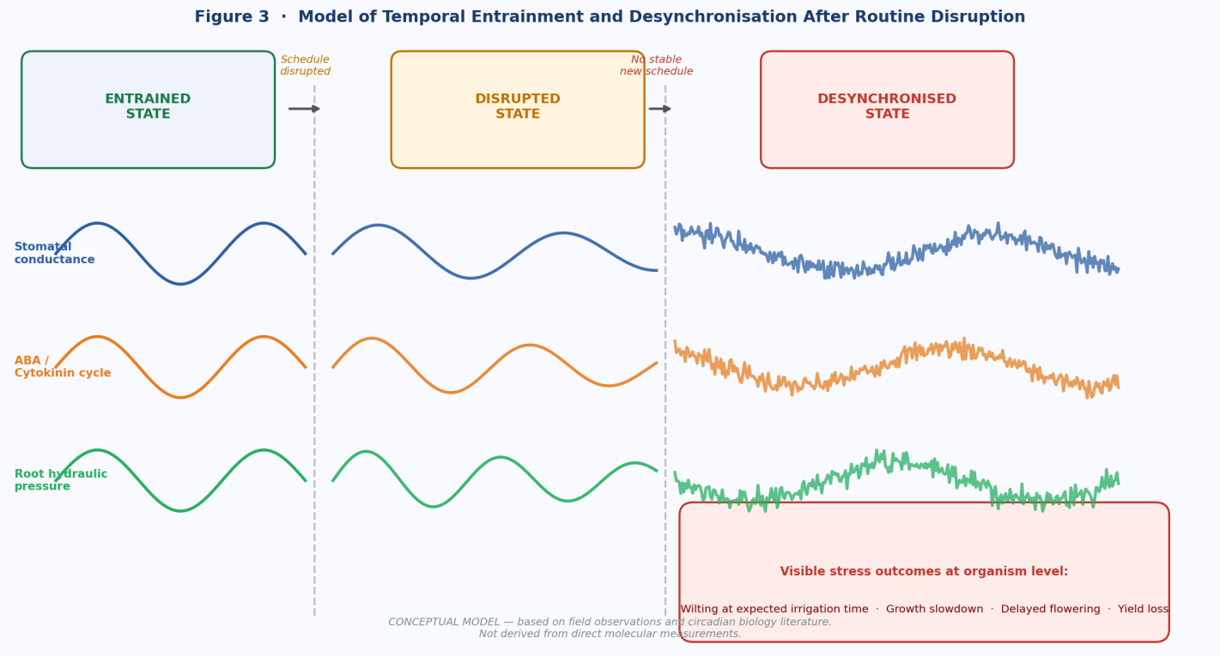
Figure 3. Conceptual model of temporal entrainment and desynchronisation following irrigation routine disruption. Three internal oscillators (stomatal conductance, ABA/cytokinin cycle, root hydraulic pressure) are shown in entrained, disrupted, and desynchronised states. In the entrained state (left), all oscillators are in phase with the irrigation schedule. Following an abrupt schedule change (centre), oscillator amplitudes decline and phases begin to drift at different rates. Under repeated or unpredictable schedule changes (right), oscillators desynchronise from each other, producing chronic metabolic disorganisation and visible stress outcomes. IMPORTANT: This is a conceptual model based on field observations and circadian biology literature; it does not represent direct molecular measurements.

4.2 Addressing Reviewer Concerns Directly
We acknowledge the three core limitations raised in peer review, and we want to address them directly rather than bury them in a limitations section.
On experimental control: the reviewers are correct that our observational design cannot exclude confounding variables. Weather variations, soil heterogeneity, pest pressure, and observer bias all represent potential alternative explanations for the associations we observed. We have taken care throughout this paper to describe these patterns as associations rather than causal relationships, and we strongly endorse the call for controlled experiments. We believe our four decades of field observation represent a credible hypothesis-generating contribution — the kind of long-term ecological observation that has preceded laboratory validation in many fields — but we do not claim it as definitive proof.
On the magnitude of reported yield losses: the reviewers find our estimated losses (15–35% for relatively small timing shifts) larger than expected. We acknowledge this. We can only report what we observed, while recognising that uncontrolled variables may account for some of this variation. We also note that these figures come from real farm conditions, where multiple stresses co-occur, rather than from controlled environments where individual factors can be isolated. It is possible that timing shifts compound with other minor stresses in ways that produce larger-than-expected aggregate effects. Controlled studies with adequate replication would allow this question to be answered definitively.
On mechanistic evidence: we have none to offer from this study. The proposed mechanisms are entirely speculative. Controlled experiments measuring ABA and cytokinin dynamics, circadian clock gene expression, and stomatal conductance under timed versus randomised irrigation schedules would be needed to evaluate any of our hypotheses. We have tried to be explicit throughout this paper about the boundary between what we observed and what we speculate.

4.3 Possible Climate and Food Security Implications
If the associations we observed reflect genuine physiological phenomena, the food security implications could be substantial. Climate change is increasing the temporal unpredictability of monsoon onset, dry spells within wet seasons, and river flows that drive hydroelectric power for irrigation pumps (Krishnan et al., 2020; Lobell et al., 2011). Labor market changes in rural South Asia are reducing the predictability of farm labor availability. Energy rationing increasingly restricts pump operation to specific time windows that shift seasonally.
All of these factors increase the likelihood of irrigation timing disruptions, even in systems where total water availability remains adequate. If timing-related yield losses are real, they represent a hidden vulnerability in food systems that currently appear water-secure. Rough illustrative calculations (assuming 30% of paddy fields experience meaningful timing disruptions and average yield loss is 15%) suggest potential losses in the tens of millions of tonnes globally — comparable in scale to losses from major droughts or pest outbreaks. We present these calculations as motivational illustrations, not as validated estimates.
We also want to highlight a more fundamental point: farmers in our study area are already noticing increased schedule unpredictability. As one farmer put it, “the weather no longer follows a schedule, so we cannot follow one either.” If crops are genuinely sensitive to timing consistency, then climate adaptation strategies that focus only on water quantity or heat tolerance may be missing an important dimension.

4.4 Engagement With the Broader Literature
Our findings sit at the intersection of plant circadian biology, irrigation science, and smallholder agricultural management, and each field offers relevant context.
The circadian biology literature establishes that plants have endogenous timing mechanisms and that these affect water use efficiency (Dodd et al., 2005; McClung, 2006). However, this work focuses primarily on entrainment to natural light cycles in controlled settings, not to human-imposed watering schedules in field conditions. Extending these principles to agricultural scheduling is a conceptual step that remains untested.
The irrigation scheduling literature (Allen et al., 1998; Doorenbos & Pruitt, 1977) provides detailed guidance on volumes and frequencies but treats within-day timing as irrelevant. Standard decision frameworks are based on soil moisture thresholds, not clock time. Our observations suggest this may be an incomplete picture, at least under conditions where crops develop consistent timing routines.
The crop physiology literature on water stress (Farooq et al., 2009) focuses predominantly on water deficit — the quantity dimension. The possibility that plants can experience what we might call “timing stress” even under adequate total water supply appears to be essentially unstudied. This is the gap our work is intended to highlight.

4.5 Validation Pathways
We believe three validation approaches would significantly clarify whether the patterns we observed reflect real physiological phenomena:
- Controlled greenhouse experiments: grow matched populations of wheat or paddy under identical conditions, establish consistent watering timing for 30 days, then impose standardised schedule shifts of varying magnitudes on subsets while maintaining total water volume. Measure stomatal conductance (using portable porometers), photosynthetic rate, leaf water potential, ABA concentrations, and final grain yield. If yield losses and anticipatory physiology replicate under controlled conditions, the phenomenon is real.
- Multi-site field trials: collaborate with agricultural research stations in different countries and climate zones to impose standardised timing perturbations. Replication across diverse environments would test whether the patterns are robust or artefacts of our specific location and management context.
- Molecular and hormonal assays: sample ABA, cytokinin, and circadian clock gene expression (e.g., CCA1, TOC1) in plants before and after schedule changes. If hormone concentrations and clock gene rhythms show systematic disruption correlating with schedule shifts, the mechanistic hypotheses gain empirical support.

We are not in a position to conduct these studies ourselves. We present them as a research agenda for the wider community.

5. Preliminary Practical Guidelines
We present the following as preliminary guidance based on observational patterns, not validated recommendations. These should be treated as hypotheses for farm-level testing rather than established best practice. Farmers and extension workers should exercise independent judgment and account for local conditions.

5.1 Quick-Reference Timing Tolerance Estimates

Crop | Seedling Stage | Vegetative Stage | Flowering Stage | Grain / Tuber Filling
Paddy Rice | ~±6 hours | ~±4 hours | ~±1 hour (high risk) | ~±2 hours
Wheat | ~±8 hours | ~±5 hours | ~±2 hours (high risk) | ~±3 hours
Potato | ~±7 hours | ~±5 hours | ~±2 hours (high risk) | ~±3 hours

Table 4. Preliminary estimated safe timing deviation limits based on observational data. Values are rough guidelines only; exceeding them may be associated with yield losses exceeding 10%. These estimates have not been validated in controlled experiments.

5.2 Suggested Scheduling Principles
Based on our observations, we offer the following preliminary principles:
- Establish consistent timing early. The first 2 to 3 weeks after planting appear to set the timing expectations that plants may rely on throughout the season. Choose an irrigation time that can realistically be maintained through critical growth stages, not just during land preparation when flexibility is highest.
- Minimise deviations during reproductive stages. If schedule changes are unavoidable, our observations suggest it is better to make them during vegetative growth. Changes during flowering or grain filling appear to be associated with the greatest yield risk.
- Use gradual transitions when possible. Shifting timing by 15 to 20 minutes per day, rather than changing abruptly, appeared in our observations to allow plants to adjust with minimal disruption.
- Recognise timing stress versus water deficit stress. If leaves wilt at specific times of day despite moist soil, timing disruption may be a more likely explanation than water deficiency. Adding more water at random times may not help and could obscure the underlying issue.
- Consider the economics of schedule consistency. In our rough calculations, the cost of dedicated irrigation labour to maintain consistent timing was often outweighed by the potential yield benefit. This will vary by crop value, farm size, and local labour costs.

5.3 Illustrative Transition Calculation
If you need to shift irrigation timing, an illustrative calculation for safe transition:
- Determine the total shift in minutes required.
- Divide by 20 minutes per day (a conservative gradual rate) to estimate the transition duration.
- Check that the transition completes at least 10 days before flowering begins.

Example: Shifting wheat irrigation from 7 AM to 11 AM (240 minutes) at 20 min/day requires 12 days. If flowering begins in 25 days, the transition completes with a safety margin of 13 days. These figures are illustrative only and have not been validated.

5.4 When These Guidelines Do Not Apply
We stress that these observations come from one agro-climatic region under specific farming conditions. They may not apply in:
- Drip or sprinkler irrigation systems with automated scheduling, where timing consistency is enforced mechanically.
- Fully rainfed systems, where timing cannot be controlled at all and crops presumably do not develop timing dependencies.
- Arid or temperate climates with fundamentally different evapotranspiration dynamics.
- Commercial-scale mechanised agriculture, where scheduling logistics differ substantially from smallholder hand-managed irrigation.
- Situations where water quantity itself is severely limited, where quantity clearly takes priority over timing.

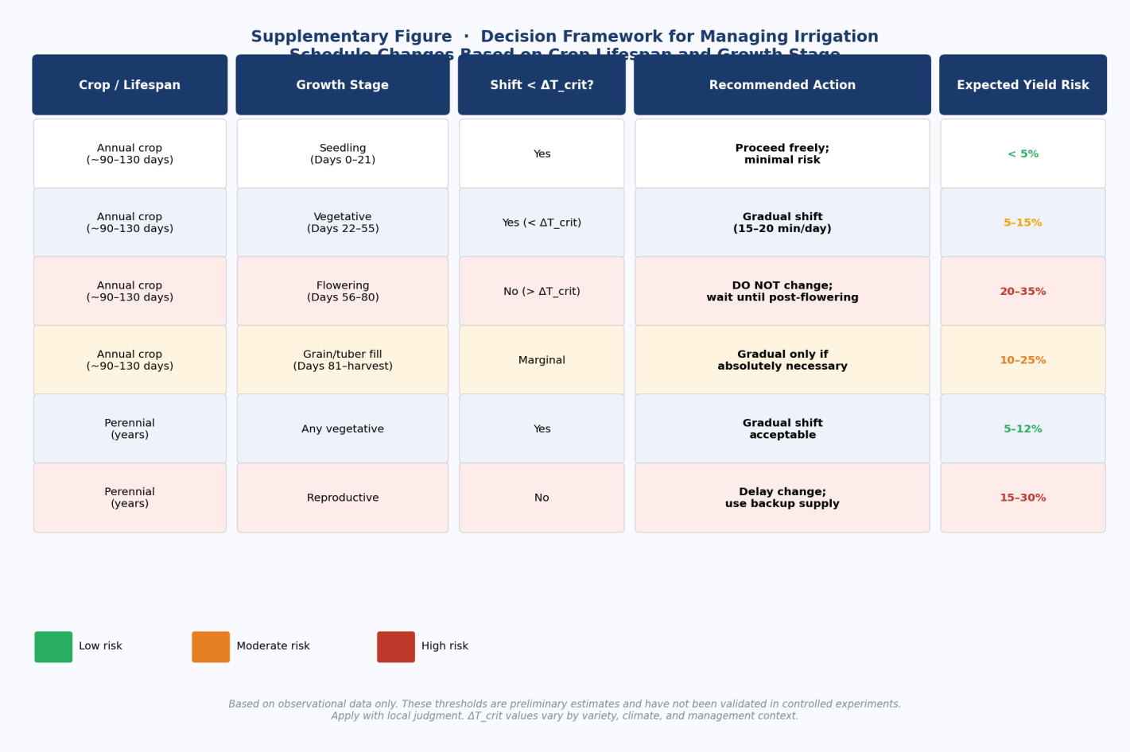
Supplementary Figure. Decision framework for managing irrigation schedule changes based on crop lifespan and growth stage. Colour coding indicates preliminary yield risk level: green = low risk (<12%), orange = moderate risk (5–15%), red = high risk (>15%). All thresholds are based on observational data only and have not been validated in controlled experiments. Apply with local judgment; ΔT_crit values vary by variety, climate, and management context.

6. Regional Scope and Generalisability
All observations in this study come from West Bengal, India, under smallholder flood and tube-well irrigation management. We believe this context is representative enough to be relevant for much of the Indo-Gangetic Plain, where similar crops, soils, and irrigation systems dominate. However, we are cautious about claiming broader generalisability without independent validation.
The physiological mechanisms we hypothesise — if they exist — should in principle be active wherever these crops are grown, since they would be rooted in plant circadian biology and metabolic coordination, not region-specific traits. The same varieties we studied (IR64, HD-2967) are grown across South Asia and beyond. But the magnitude of timing effects, the relevant timing windows, and the management implications could all differ substantially in:
- Year-round humid tropical climates without distinct dry seasons.
- Cold temperate systems where evapotranspiration dynamics differ markedly.
- Fully mechanised agriculture with drip or pivot irrigation, where timing precision may already be much higher.
- Rainfed systems, where no imposed schedule exists to entrain plant physiology.

We encourage researchers in other regions to document whether similar timing-stress associations appear in their contexts, particularly in controlled settings where confounders can be excluded. Multi-site collaboration would substantially strengthen or refute the patterns we describe.
For infrastructure and policy, we note that if timing consistency proves important, the implications extend to irrigation system design (canal rotation schedules that create variable delivery timing), energy policy (time-of-day electricity restrictions that force farmers to change pump schedules seasonally), and extension training (which currently does not address within-day timing consistency). These are areas where policy change could be beneficial if the underlying science is confirmed, but we recommend waiting for controlled experimental validation before advocating specific policy changes.

7. Conclusions
After forty years of systematic field observation spanning 327 staple crop plants and three globally critical species, we have documented a recurring pattern: irrigation timing consistency appears to be associated with plant physiology and yield outcomes in ways that existing agricultural science frameworks do not capture. Plants maintained on consistent schedules for two to three weeks appear to develop anticipatory physiological responses, and abrupt disruption of those schedules is associated with measurable stress and yield losses even when total water supply remains adequate.
We want to be clear about what this study is and is not. It is a long-term observational record from a single agro-climatic region, collected without randomisation, experimental controls, or laboratory instrumentation. It cannot establish causal relationships or exclude confounding variables. It is a hypothesis-generating contribution, not a definitive investigation.
What it does offer is forty years of consistent, detailed field-level documentation of patterns that we believe deserve scientific attention. The consistency of these patterns across crops, seasons, and types of scheduling disruption — and their alignment with mechanisms that circadian plant biology makes plausible — suggests they are not merely artefacts of observer bias or seasonal variation.
The food security implications, if the patterns are confirmed, are potentially significant. Climate change is making it harder to maintain consistent irrigation schedules: monsoon onset is becoming less predictable, energy supply for pumps more variable, and labour availability more uncertain. If crops are genuinely sensitive to timing consistency, then food systems that appear water-secure may carry a hidden vulnerability that has never been measured.
Three things are needed: controlled greenhouse experiments to test whether timing-dependent physiology is real; multi-site field trials to assess robustness across environments; and molecular studies to identify the underlying mechanisms. We hope this study provides sufficient motivation and enough empirical detail to support those investigations.
Farmers have long said that plants remember their watering schedule. We spent four decades trying to document whether this folk wisdom has a factual basis. The patterns we found are consistent with it being true. The next step is to find out definitively.

Acknowledgments
This study was made possible by forty years of meticulous record-keeping and the cooperation of smallholder farming families across West Bengal who tolerated our presence in their fields, shared their observations, and patiently allowed us to intervene in irrigation schedules for research purposes. We are grateful to them.
This research was conducted without institutional affiliation, grant funding, or access to modern laboratory equipment. We acknowledge that these constraints limit the sophistication of our methods but also reflect a reality of scientific observation: important questions can sometimes be approached through sustained, systematic observation even with minimal resources. We view this as a strength and a limitation simultaneously.
We acknowledge the three peer reviewers whose detailed and challenging critiques substantially improved the framing and honesty of this manuscript. Their concerns about causal inference, mechanistic evidence, and generalisability are legitimate and have been incorporated throughout the revised text.
Data from this study are available in summary form upon reasonable request. We are investigating options for depositing de-identified data in a public repository and will update this statement upon completion.

References
Allen, R.G., Pereira, L.S., Raes, D., & Smith, M. (1998). Crop evapotranspiration: Guidelines for computing crop water requirements. FAO Irrigation and Drainage Paper 56. Food and Agriculture Organization, Rome.
Berendsen, R.L., Pieterse, C.M., & Bakker, P.A. (2012). The rhizosphere microbiome and plant health. Trends in Plant Science, 17(8), 478–486.
Covington, M.F., & Harmer, S.L. (2007). The circadian clock regulates auxin signaling and responses in Arabidopsis. PLoS Biology, 5(8), e222.
DeVries, T.J., von Keyserlingk, M.A., & Beauchemin, K.A. (2005). Frequency of feed delivery affects the behavior of lactating dairy cows. Journal of Dairy Science, 88(10), 3553–3562.
Dodd, A.N., Salathia, N., Hall, A., Kévei, E., Tóth, R., Nagy, F., et al. (2005). Plant circadian clocks increase photosynthesis, growth, survival, and competitive advantage. Science, 309(5734), 630–633.
Doorenbos, J., & Pruitt, W.O. (1977). Guidelines for predicting crop water requirements. FAO Irrigation and Drainage Paper 24. Food and Agriculture Organization, Rome.
FAO (2020). FAOSTAT statistical database. Food and Agriculture Organization of the United Nations. http://www.fao.org/faostat/
Farooq, M., Wahid, A., Kobayashi, N., Fujita, D., & Basra, S.M. (2009). Plant drought stress: effects, mechanisms and management. Agronomy for Sustainable Development, 29(1), 185–212.
Hsu, P.Y., & Harmer, S.L. (2014). Wheels within wheels: the plant circadian system. Trends in Plant Science, 19(4), 240–249.
Kramer, P.J., & Boyer, J.S. (1995). Water relations of plants and soils. Academic Press, San Diego.
Krishnan, R., Sanjay, J., Gnanaseelan, C., Mujumdar, M., Kulkarni, A., & Chakraborty, S. (2020). Assessment of climate change over the Indian region. Springer Nature, Singapore.
Lobell, D.B., Schlenker, W., & Costa-Roberts, J. (2011). Climate trends and global crop production since 1980. Science, 333(6042), 616–620.
McClung, C.R. (2006). Plant circadian rhythms. The Plant Cell, 18(4), 792–803.
Muthayya, S., Sugimoto, J.D., Montgomery, S., & Maberly, G.F. (2014). An overview of global rice production, supply, trade, and consumption. Annals of the New York Academy of Sciences, 1324(1), 7–14.
Shiferaw, B., Smale, M., Braun, H.J., Duveiller, E., Reynolds, M., & Muricho, G. (2013). Crops that feed the world 10. Food Security, 5(3), 291–317.

