INTERPLAY OF PROFESSIONAL DEVELOPMENT AND TEACHERS’

APPROVAL SHEET

DEDICATION

ABSTRACT

TABLE OF CONTENTS

ABSTRACT |  | v
TABLE OF CONTENTS |  | vi
LIST OF TABLES |  | ix
LIST OF FIGURE |  | x
CHAPTER
I | THE PROBLEM AND ITS BACKGROUND
Background of the Study |  | 1
Theoretical Framework |  | 3
Conceptual Framework |  | 7
Statement of the Problem |  | 9
Statement of Null Hypothesis |  | 10
Significance of the Study |  | 10
Scope and Delimitations of the Study |  | 12
Definition of Terms |  | 13
II | REVIEW OF RELATED LITERATURE AND STUDIES | 16
Professional Development of Teachers |  | 16
Classroom Management  Instructional Delivery  Learning Action Cell |  | 20  vii
23
vii
 |  | 25
Synthesis |  | 26
III | RESEARCH METHODOLOGY | 29
Research Design |  | 29
Locale of the Study |  | 29
Respondents |  | 30
Sampling Technique  Data Gathering Instrument |  | 31
 |  | 31
Data Gathering Procedure |  | 32
Statistical Treatment/Method of Analysis |  | 33
Ethical Considerations |  | 35
Declaration on the Use of Artificial Intelligence
IV | PRESENTATION, ANALYSIS AND INTERPRETATION OF DATA | 36
Section 1. Extent of Teacher's Engagement in Professional Development Program |  | 36
Section 2. Level of Teachers' Classroom Management |  | 42
Section 3. Level of Teachers' Instructional Delivery |  | 49
Section 4. Relationship Between Professional Development and Teachers'  Classroom Management |  | 56
Section 5. Relationship Between Professional Development and Teachers'  Instructional Delivery |  | 59
Section 6. Challenges and Enabling Factors in Applying Professional Development |  | 62
V | SUMMARY, CONCLUSIONS AND RECOMMENDATIONS | 68
Summary of Findings |  | 68
Conclusions |  | 73
Recommendations |  | 76
REFERENCES |  | 81
APPENDICES
A | Request Letter to the Schools Division Superintendent | 89
B. | 1st Indorsement from the Division Office | 90
C | Request Letter to the Public Schools District Supervisor | 91
D | Request Letter to the School Head | 92
E | Request Letter to the Respondents | 104
F | Survey Questionnaire | 105
G | Validation Sheet | 110
H | Reliability Analysis Report | 136
I | Proposed Development Program | 148
CURRICULUM VITAE |  | 154
viii
LIST OF TABLES
ix
Table |  | Page
1 | Extent of Teachers' Engagement in Professional Development in Terms of Frequency of Participation | 36
2 | Extent of Teachers' Engagement in Professional Development in Terms of Relevance and Applicability | 38
3 | Extent of Teachers' Engagement in Professional Development in Terms of Support and Commitment | 41
4 | Level of Teachers' Classroom Management in Terms of Rules and Procedures | 43
5 | Level of Teachers' Classroom Management in Terms of Time Management | 45
6 | Level of Teachers' Classroom Management in Terms of Behavior Management | 47
7 | Level of Teachers' Instructional Delivery in Terms of Curriculum | 50
8 | Level of Teachers' Instructional Delivery in Terms of Instructional Practices | 52
9 | Level of Teachers' Instructional Delivery in Terms of Assessment | 54
10 | Challenges Encountered by Teachers in Applying Professional Development | 62
11 | Enabling Factors that Support Teachers in Applying Professional Development | 65
12 | Pearson's r Correlation Between Professional Development and Classroom Management (N = 64) | 57
13 | Pearson's r Correlation Between Professional Development and Instructional Delivery (N = 64) | 60

LIST OF FIGURE
x
Figure |  | Page
1 | Conceptual Framework of the Study | 7

CHAPTER I

THE PROBLEM AND ITS BACKGROUND

Introduction
Teachers play a central role in shaping the learning experiences of students, and their effectiveness is often linked to the quality of professional development they receive. Professional development (PD) provides educators with opportunities to refine their instructional practices, strengthen classroom management skills, and respond to the evolving needs of learners. Studies emphasize that sustained and well-structured PD fosters teacher growth, enhances instructional quality, and improves student learning outcomes (Kaulēns, 2022; Kind, 2019). In the Philippines, the Department of Education (DepEd) underscores the importance of continuous professional learning through its Learning and Development (L&D) framework, which is aligned with the broader goal of cultivating competent and adaptive educators (Department of Education [DepEd], as cited in DFAT, 2017).
Consistent with national education reforms, the Department of Education (DepEd) has institutionalized quality education through policy instruments that place teachers’ professional growth at the core of system improvement. DepEd Order No. 48, s. 2020, which provides the guidelines on the implementation of the Learning and Development (L&D) System, underscores professional development as a strategic mechanism for enhancing teachers’ competencies, instructional effectiveness, and classroom practices in alignment with organizational goals. Complementing this, DepEd Order No. 35, s. 2016 institutionalized the Learning Action Cell (LAC) as a school-based professional learning strategy that promotes collaborative inquiry, reflective practice, and continuous improvement among teachers, particularly in addressing classroom management and instructional challenges. Furthermore, DepEd Order No. 29, s. 2022, which establishes the Basic Education Monitoring and Evaluation Framework (BEMEF), emphasizes the use of evidence-based data to assess the effectiveness of educational programs, including professional development initiatives, in improving teaching quality and learner outcomes. These policy directions are reinforced by the Quality Basic Education Development Plan (QBEDP) 2025–2035, which prioritizes the development of high-performing teachers as a key outcome in achieving inclusive, equitable, and quality basic education. In this context, examining how professional development influences teachers’ classroom management and instructional delivery directly supports DepEd’s mandate to ensure that professional learning initiatives translate into improved classroom practices and meaningful learning outcomes at the school and district levels.
Despite these initiatives, challenges remain in translating professional development into effective classroom practices. Research indicates that while many teachers attend training sessions and workshops, the extent to which these experiences impact classroom management and instructional delivery varies significantly (Gafurov et al., 2019; King et al., 2022). Classroom management, in particular, remains a persistent concern as it directly influences the learning environment and student engagement. Effective classroom management not only minimizes disruptions but also creates conditions conducive to meaningful teaching and learning (Bhadouria, 2024).
Equally important is the quality of instructional delivery, which encompasses lesson planning, the use of appropriate teaching strategies, and clarity in communication. Teachers who integrate PD into their instructional practices demonstrate greater adaptability and effectiveness in addressing diverse student needs (Canaran & Mirici, 2019). However, gaps exist in ensuring that PD programs are context-specific and responsive to the realities of teachers working in various districts, including rural and semi-urban settings like Bagabag 2.
Given these circumstances, examining the influence of professional development on teachers’ classroom management and instructional delivery is both timely and relevant. Understanding this relationship can help determine the extent to which professional learning translates into practice and identify areas where additional support is necessary. Ultimately, the study aims to provide evidence-based insights that can guide the design of an intervention program tailored to the needs of teachers in Bagabag 2 District. By doing so, it contributes to the ongoing efforts of enhancing teaching quality and promoting better learning outcomes for students.
Theoretical Framework
The present study is anchored on several well-established educational and psychological theories that explain the interrelated dynamics between teachers’ professional development, classroom management, instructional delivery, and learners’ academic achievement. These frameworks provide a solid conceptual lens for understanding how continuous learning experiences influence teachers’ practices and student outcomes.
One of the central theories guiding this study is Guskey’s Model of Teacher Change (Guskey, 2002). Guskey asserts that significant and lasting change in teachers’ beliefs and attitudes occurs only after they experience positive results in student learning. Unlike traditional views that emphasize belief change as a prerequisite for behavioral change, Guskey maintains that teachers are more likely to adopt and sustain new instructional strategies when they observe tangible improvements in classroom engagement and student performance. In the context of this study, this model highlights the importance of designing professional development activities that allow teachers to immediately apply new skills, reflect on their effectiveness, and consequently improve their classroom management and instructional delivery practices.
Another relevant framework is Bandura’s Social Learning Theory (Bandura, 1986; Saka, 2025), which posits that learning occurs through observation, imitation, and modeling within a social context. According to Bandura, individuals acquire new behaviors by engaging in four interrelated processes: attention, retention, reproduction, and motivation. In teacher professional development, this implies that teachers learn effectively not only through lectures and trainings but also by observing mentors, collaborating with colleagues, and participating in professional learning communities. When professional development programs are structured to support these processes, teachers are more likely to internalize effective classroom management techniques and innovative instructional strategies, which in turn positively influence student learning outcomes.
The study is also grounded in Vygotsky’s Sociocultural Theory of Learning (Vygotsky, 1978; Tzuriel, 2021), which emphasizes that cognitive development occurs through social interaction and mediated learning. Vygotsky introduced the concept of the Zone of Proximal Development (ZPD), wherein learners, with the assistance of a more knowledgeable individual, are able to achieve tasks beyond their independent capabilities. When applied to teachers as learners in a professional development context, this theory suggests that mentoring, coaching, and collaborative dialogue play a crucial role in enhancing their instructional competence. Through guided support and meaningful interaction with peers and experts, teachers develop more effective classroom management techniques and more responsive instructional delivery approaches.
In addition, Kounin’s Theory of Classroom Management (Kounin, 1977) serves as a foundational framework in understanding how effective teachers prevent and reduce disruptive behaviors in the classroom. Kounin introduced important concepts such as withitness, overlapping, momentum, smoothness, and group focus, which describe a teacher’s ability to anticipate disruptions, maintain instructional flow, and engage all learners simultaneously. Teachers who demonstrate withitness and properly manage transitions are more successful in creating orderly learning environments that support sustained academic engagement. Integrating Kounin’s principles into professional development programs equips teachers with concrete strategies to maintain discipline and maximize instructional time.
This study is likewise supported by Skinner’s Behaviorist Theory and the principles of Operant Conditioning (Skinner, 1965). According to this theory, behaviors are shaped and maintained by reinforcement and consequences. In the classroom setting, positive reinforcement, feedback, and structured behavior management systems can significantly influence learners’ conduct and motivation. Teachers who are trained to use appropriate reinforcement strategies through professional development can effectively manage classroom behaviors and promote desirable learning habits, which consequently enhances students’ academic achievement.
Moreover, Bloom’s Taxonomy of Educational Objectives (Bloom et al., 1964; Anderson, 2014) provides a theoretical basis for understanding effective instructional delivery. Bloom’s framework categorizes cognitive processes into hierarchical levels—remembering, understanding, applying, analyzing, evaluating, and creating. This taxonomy guides teachers in designing lessons and assessments that move beyond rote memorization toward higher-order thinking skills. Professional development programs that help teachers apply Bloom’s Taxonomy in lesson planning contribute to more structured, goal-oriented, and cognitively engaging instruction, which positively affects learner achievement.
Anchoring the relationship between instruction and achievement is also Constructivist Learning Theory, as advanced by Piaget (1970) and Bruner (1997). Constructivism posits that learners actively construct knowledge through experience, reflection, and interaction with their environment. Rather than passively receiving information, students make meaning by linking new concepts to existing knowledge structures. Teachers who are trained to implement student-centered, inquiry-based, and discovery-oriented strategies are more capable of fostering deeper understanding among learners. Thus, professional development rooted in constructivist principles reinforces effective instructional delivery and promotes meaningful learning. Furthermore, the study aligns with Self-Determination Theory (SDT) proposed by Deci and Ryan (2000), which emphasizes the importance of autonomy, competence, and relatedness in enhancing intrinsic motivation. A classroom environment that supports these three psychological needs encourages students to actively engage in learning and persist in academic tasks. Teachers who undergo professional development focused on learner-centered approaches and motivational strategies are better equipped to create supportive classroom climates that nurture student engagement and academic success.
Together, these theories—Guskey’s Model of Teacher Change, Bandura’s Social Learning Theory, Vygotsky’s Sociocultural Theory, Kounin’s Classroom Management Theory, Skinner’s Behaviorism, Bloom’s Taxonomy, Constructivist Theory, and Self-Determination Theory—provide a comprehensive and integrated foundation for this study. They collectively explain how professional development strengthens teachers’ knowledge, skills, attitudes, and practices in classroom management and instructional delivery, which ultimately leads to improved learner achievement.
Conceptual Framework
Figure 1
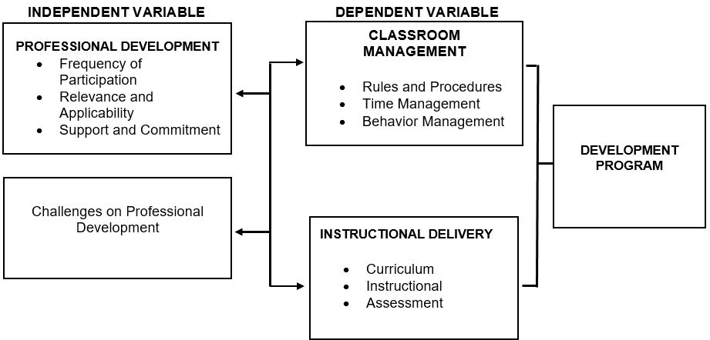

This study is anchored on the idea that professional development serves as a vital influence on how teachers carry out their responsibilities inside the classroom. In the research paradigm, professional development is treated as the independent variable, since it represents the set of experiences, training, and growth opportunities that teachers participate in. The assumption is that the more frequent, relevant, and well-supported these professional development activities are, the more likely they will shape teachers' practices and performance.
On the other hand, classroom management and instructional delivery are considered the dependent variables. These areas represent the observable outcomes of how teachers apply what they have learned in their professional development activities. For instance, effective classroom management reflected in clear rules and procedures, proper time management, and consistent behavior management can often be traced back to strategies acquired through training. Similarly, strong instructional delivery demonstrated through thorough lesson planning, effective teaching strategies, and clear communication may be enhanced when teachers are exposed to professional learning opportunities that are both relevant and supportive.
The conceptual framework illustrates a directional relationship where professional development is expected to positively influence classroom management and instructional delivery. The logic is that as teachers engage in continuous professional growth, they acquire not only new knowledge but also practical skills and confidence, which then manifest in better management of classroom dynamics and more effective teaching practices.
By presenting the study this way, the framework offers a clear roadmap for exploring the central question: to what extent does professional development contribute to improving teachers' classroom management and instructional delivery? This structure not only guides the investigation but also lays the foundation for designing an intervention program that directly addresses identified gaps and maximizes the benefits of professional development for the teaching and learning process.

Statement of the Problem

This study seeks to determine how professional development influences teachers' classroom management and instructional delivery in Bagabag 2 District, with the aim of formulating an intervention program that will address identified needs and enhance teaching practices.
Specifically, it aims to answer the following research questions:
1. What is the extent of teachers' engagement in professional development programs in Bagabag 2 District in terms of:
1.1 frequency of participation;
1.2 relevance and applicability; and
1.3 support and commitment?

2. What is the level of teachers' classroom management after undergoing professional development in terms of:
2.1. rules and procedures;
2.2. time management; and
2.3. behavior management?
3. What is the level of teachers' instructional delivery in terms of:
3.1. curriculum;
3.2. instructional; and
3.3. assessment?
4. Is there a significant relationship between professional development and teachers' classroom management?
5. Is there a significant relationship between professional development and teachers' instructional delivery?
6. What challenges and enabling factors do teachers encounter in applying the knowledge and skills gained from professional development in their actual classroom practice?
7. What development program may be proposed based on the findings of the study?
Statement of Null Hypothesis
1. There is no significant relationship between professional development and teachers' classroom management.
2. There is no significant relationship between professional development and teachers' instructional delivery.
Significance of the Study
This study is significant because it addresses the crucial role of professional development in enhancing teachers' classroom management and instructional delivery, ultimately leading to better learning outcomes for students in Bagabag 2 District. The findings will have the following implications:
Teachers. Teachers will benefit directly from this research as it highlights the connection between their participation in professional development and their classroom practices. The study will provide them with feedback on how training influences their classroom management, lesson preparation, and delivery strategies, thereby motivating them to engage more actively in professional development opportunities. It can also help them reflect on their strengths and areas for improvement, fostering professional self-efficacy.
Learners. Learners are the ultimate beneficiaries. Well-trained teachers who effectively manage classrooms and deliver lessons clearly create a more supportive, engaging, and efficient learning environment.
Department of Education (DepEd) and Policy Makers. At the broadest level, the results will provide valuable insights for DepEd and educational policy makers in formulating policies that strengthen professional development programs. By identifying which aspects of training are most relevant and effective, the study can contribute to crafting an evidence-based professional development framework that aligns with the goals of quality education under the MATATAG Curriculum.
School Administrators and District Officials. For school heads and district supervisors, the study will serve as a basis in planning, prioritizing, and monitoring professional development activities that directly enhance teachers' classroom performance. The results can inform decisions about resource allocation, capacity-building initiatives, and support mechanisms that create a culture of continuous professional growth among teachers.
Future Researchers. The study will enrich the existing body of literature on professional development, classroom management, and instructional delivery. Future researchers may use this as a reference for replicating or expanding the study in other contexts, or for developing new intervention programs.
The Researcher. Finally, this study will allow the researcher to strengthen expertise in educational research, particularly in linking professional development to instructional effectiveness. It will also contribute to the researcher's professional growth by providing practical experience in the design of intervention programs that respond to identified educational needs.

Scope and Delimitation
This study focuses on examining the influence of professional development on teachers' classroom management and instructional delivery within Bagabag 2 District. Specifically, it covers the extent of teachers' participation in professional development programs in terms of frequency of participation, relevance and applicability, and support and commitment. It also explores the level of classroom management among teachers, looking into rules and procedures, time management, and behavior management, as well as their instructional delivery in relation to curriculum, instructional practices, and assessment. Furthermore, the study seeks to determine whether significant relationships exist between professional development and both classroom management and instructional delivery, with the ultimate goal of formulating a proposed development program anchored on the findings.
The research is delimited to teachers assigned in Bagabag 2 District who are the primary respondents of the study. The number of participants is limited to those currently employed in the district during the conduct of the research to ensure accuracy and relevance of the data. The study was conducted within the schools under Bagabag 2 District, and the results are based solely on the responses of the identified participants. The research is also bounded by the academic year in which the study was undertaken, thereby excluding professional development programs and teaching practices outside the set timeframe.

Definition of Terms
For clarity and precision, the following key terms are defined operationally as they are used in this study.

Assessment of Participation (Frequency of Participation)
In this study, it is measured by the frequency with which teachers attend seminars, trainings, workshops, Learning Action Cells (LACs), and other professional development activities as indicated in the questionnaire.

Behavior Management
In this study, behavior management is measured through teachers’ self-reported responses to survey items assessing their ability to manage student behavior, enforce discipline, and apply corrective and positive reinforcement strategies in the classroom.

Classroom Management
Classroom management is operationalized through a survey instrument measuring teachers’ practices in terms of rules and procedures, time management, and behavior management.

Instructional Clarity and Communication
This variable is measured through teachers’ responses to questionnaire items assessing clarity of explanations, coherence of instructions, and effectiveness of classroom communication.

Instructional Delivery
In this study, instructional delivery is measured using survey indicators related to curriculum implementation, instructional strategies, and assessment practices.

Intervention Program
The intervention program refers to the proposed development program formulated based on the results of the study on professional development, classroom management, and instructional delivery.

Lesson Planning and Preparation
This variable is measured through teachers’ responses to questionnaire items related to preparation of lesson plans, alignment of objectives, and readiness of instructional materials.

Professional Development
In this study, professional development is measured in terms of frequency of participation, relevance and applicability, and support and commitment as indicated in the survey responses.

Relevance and Applicability

This is measured through teachers’ ratings of how applicable and useful professional development activities are to their classroom management and instructional delivery.

Rules and Procedures
In this study, rules and procedures are measured through questionnaire items assessing teachers’ consistency in implementing classroom rules and routines.

Support and Commitment
This variable is measured through teachers’ perceptions of administrative support, availability of resources, and their own commitment to professional development activities.

Teaching Strategies
Teaching strategies are measured through survey items assessing the use of varied instructional approaches, learner-centered methods, and engagement techniques.
Time Management
In this study, time management is measured through teachers’ self-reported ability to manage lesson pacing, transitions, and classroom activities efficiently.
CHAPTER II

REVIEW OF RELATED LITERATURE AND STUDIES

This chapter presents a comprehensive review of related literature and studies that provide theoretical, empirical, and contextual foundations for examining the influence of professional development on teachers' classroom management and instructional delivery. It synthesizes local and foreign studies on professional development, classroom management, and instructional delivery, and concludes with a research gap that justifies the conduct of the present study.
Professional Development of Teachers
Teachers' professional development (PD) has long been recognized as a cornerstone for improving instructional practice and student outcomes. However, defining and sustaining effective PD remains a challenge due to its multidimensional nature and the evolving needs of teachers across their careers. Sancar et al. (2021) argue that PD should be understood as a comprehensive framework that addresses assessment, duration, context, collaboration, and support structures, highlighting that PD must be embedded within the realities of teaching rather than treated as isolated events. Bragg et al. (2021) reinforce this by showing that online professional development (OPD), which surged during the COVID-19 pandemic, requires thoughtful design elements such as learner supports, flexibility, reflection, and practical applications to effectively enhance teachers' pedagogical content knowledge and instructional practices. These insights suggest that the design and structure of PD initiatives are as critical as their content, calling for a systemic approach that integrates context, delivery, and sustainability.
The role of inclusivity and equity in professional development has also gained attention, particularly in relation to teacher retention. Kohli (2019) emphasizes that professional development must not only build teaching competence but also address systemic inequities, particularly for teachers of color who often encounter hostile racial climates in schools. By framing racial literacy development and teacher-led spaces as forms of critical professional development, Kohli highlights the need for PD to serve as a support mechanism that sustains educators in challenging contexts. Complementing this perspective, Fairman et al. (2022) note that PD relevance often hinges on balancing competing demands between external accountability pressures and teachers' localized professional learning needs. They argue that leadership plays a pivotal role in aligning state or institutional goals with the lived realities of teachers, making PD meaningful, timely, and impactful for practice.
Research on teacher change provides further evidence of how professional development shapes practice. Smith and Gillespie (2023) synthesize findings across K-12 and adult literacy education, showing that while traditional models such as workshops and conferences dominate, they often yield limited impact unless contextualized within ongoing, job-embedded models. Their review stresses that sustained, collaborative, and school-based PD fosters greater teacher change than short-term or fragmented interventions. Admiraal et al. (2021) provide empirical support for this by examining schools that functioned as professional learning communities, finding that interventions rooted in collaborative learning opportunities, shared school visions, and organizational changes were more sustainable and effective in supporting teacher growth.
In the Philippines, the shift toward remote and distance education during the COVID-19 pandemic highlighted the urgent need for sustained and relevant professional development. Chin et al. (2022) found that teachers' professional growth was constrained by limited financial resources, time, and logistical support, while their developmental needs were largely centered on enhancing online teaching competencies, technological literacy, and research skills. Similarly, Ancho and Arrieta (2021) emphasized that Filipino teachers view professional development as a lifelong learning process, with the pandemic intensifying the demand for webinars, mental health training, and online pedagogy.
Beyond pandemic-related changes, continuing professional development (CPD) remains an institutional requirement but faces persistent challenges in terms of engagement and responsiveness. Tulo and Lee (2022) reported that faculty in state universities and colleges often participated in CPD for career progression, financial stability, and academic status, yet overall engagement remained low despite legal mandates. On the other hand, Kilag et al. (2023) illustrated the promise of Individual Plans for Professional Development (IPPD), noting that personalized PD helped teachers improve performance, apply training in practice, and positively influence student learning and behavior.
Studies consistently emphasize that teacher professional development is a critical driver of effective instructional delivery and improved student outcomes. Ajani (2023) demonstrated that when professional development is designed through the lens of Kolb's Experiential Learning Theory, teachers become more reflective, adaptive, and responsive to classroom demands. Wright (2019) found that teachers perceive professional development as most effective when it is targeted, relevant, and strategically delivered, particularly in areas such as technology integration and learner-centered approaches. Dulo (2022) and Igoni and Nwabueze (2021) further reinforced the link between teacher competence and instructional quality, underscoring that continuous, well-designed, and skills-focused professional development is instrumental in enhancing teachers' instructional capacity.
Teacher professional development (PD) has evolved into a multifaceted process that extends beyond traditional skill acquisition toward a more holistic enhancement of teachers’ competencies, attitudes, and adaptability in dynamic learning environments. As emphasized by Aravantinos et al. (2026), the integration of artificial intelligence in K–12 education demonstrates that teachers require not only technical skills but also pedagogical knowledge, ethical awareness, and continuous training to effectively respond to emerging educational demands. This indicates that PD must be sustained and comprehensive rather than limited to one-time training initiatives. Similarly, Kim (2026) highlights that systematic support, including alignment between teachers’ professional training and their instructional roles, significantly improves instructional quality, particularly in promoting higher-order thinking skills. These findings suggest that effective PD programs should be coherent, context-responsive, and designed to address both current and evolving needs of teachers in diverse educational settings.
Research underscores the importance of evidence-based and reflective approaches in strengthening teacher professional development. Levi-Nielsen et al. (2026) identify performance feedback as an effective PD strategy, demonstrating that structured observation and feedback mechanisms can lead to substantial improvements in teacher practices. This supports the notion that PD should involve continuous monitoring and targeted interventions to ensure meaningful outcomes. Furthermore, Qi and Derakhshan (2026) explain that continuing professional development significantly influences teachers’ agency and reflective teaching, emphasizing that PD contributes not only to instructional competence but also to cognitive and affective growth. This perspective broadens the understanding of PD as a transformative process that cultivates autonomy, reflective practice, and professional decision-making. Taken together, these insights affirm that high-quality professional development is continuous, evidence-driven, and holistic, enabling teachers to enhance both their instructional delivery and overall professional effectiveness.
Classroom Management
Classroom management remains a cornerstone of effective teaching, shaping not only the immediate learning climate but also long-term student engagement and achievement. Teachers' ability to establish rules, manage behavior, and sustain orderly learning environments has been consistently linked with instructional quality and professional efficacy. Lazarides et al. (2020) underscore how teachers' self-efficacy in classroom management is deeply influenced by contextual job demands and resources, with early-career experiences particularly critical in shaping long-term professional identity. Their longitudinal study highlights how high self-efficacy equips teachers to better regulate classroom environments, whereas excessive demands during formative years can weaken this confidence and limit effective classroom practices.
The interplay between experience and professional expertise in classroom management has also been widely theorized. Wolff et al. (2021) introduce the concept of classroom management scripts, highlighting how novice and expert teachers differ in perceiving, interpreting, and responding to classroom events. Novices, often overwhelmed by competing demands, struggle with attentional focus, while expert teachers demonstrate sharper awareness and nuanced decision-making informed by internalized scripts. Burden (2025) frames classroom management through the lens of building a positive classroom culture, emphasizing the creation of learning communities where discipline, routines, and relationships are harmoniously integrated.
Technological innovations are increasingly offering novel approaches to classroom management training. Seufert et al. (2022) demonstrate how virtual reality (VR) classrooms enable pre-service teachers to practice management strategies in realistic yet controlled conditions. Similarly, McGarr (2021) emphasizes the use of virtual simulations in teacher education as a means to safely encounter disruptive behaviors, experiment with responses, and reflect critically on classroom scenarios.
In the Philippine context, classroom management continues to be a critical area of research, highlighting how cultural and institutional dynamics influence teacher practices. Garcia (2025), through a case study of Grade 8 teachers, demonstrated that classroom management approaches do not uniformly align with years of teaching experience, underscoring the importance of continuous professional development to maintain effective classroom management across career stages. Callorina et al. (2024) examined the interplay between teacher competence, classroom management, and student engagement, revealing a strong positive correlation between teacher competence and classroom management. Afalla and Fabelico (2020) found that students' academic performance improved when teachers prioritized the classroom's physical condition and reinforced positive behaviors.
Professional development plays a vital role in strengthening teachers' classroom management skills, particularly as many educators receive limited formal training in this area during their pre-service preparation. A comprehensive review by Wilkinson et al. (2020), which analyzed 74 empirical studies, emphasized that effective professional development in classroom management typically incorporates direct instruction, coaching, and performance feedback. Simonsen et al. (2020) demonstrated that even brief, targeted professional development interventions can increase teachers' use of empirically supported strategies such as prompting and specific praise, which are crucial in establishing positive classroom environments.
Classroom management is a multifaceted construct that integrates teachers’ beliefs, skills, and observable practices, yet recent research highlights notable inconsistencies among these dimensions. For instance, Shi et al. (2026) found that teachers’ classroom management self-efficacy does not necessarily translate into effective classroom behaviors, revealing a misalignment between perceived competence and actual practice, although specific strategies such as praise showed positive correspondence with observed behaviors. Similarly, Müller and Gold (2026) identified diverse profiles of pre-service teachers’ situation-specific skills, emphasizing that variations in these competencies do not always result in differences in classroom management quality, thereby underscoring the complexity of skill application in real classroom contexts. Moreover, Zhang (2026) demonstrated that classroom management styles significantly influence students’ self-control, with differing impacts observed across authoritarian, authoritative, and permissive approaches, highlighting the critical role of management style in shaping learner behavior. Collectively, these studies suggest that effective classroom management extends beyond knowledge and beliefs, requiring alignment between competencies, practices, and contextual responsiveness to optimize both teaching and student outcomes.
Instructional Delivery
Instructional delivery is one of the most critical aspects of effective teaching, as it directly influences how learners engage with and absorb knowledge. Recent research underscores that instructional competence extends beyond content expertise it requires teachers to integrate professional, personal, and pedagogical skills to meet the needs of learners in dynamic classroom settings. Culajara and Luces (2023) emphasized that ideal instructional delivery is characterized by compassion, adaptability, and alignment with professional standards such as the Philippine Professional Standards for Teachers (PPST).
Equally significant is the role of information and communication technology (ICT) in enhancing instructional practices. Otemuyiwa et al. (2020) found that teachers' perceptions of ICT integration can profoundly affect its actual use. Bisong et al. (2023) argued that systemic challenges such as inadequate infrastructure, weak policy frameworks, and limited training hinder the effective use of ICT in instructional delivery, though they noted the strong prospects of ICT as a vehicle for learner-centered, discovery-based education.
In the Philippine setting, instructional delivery remains a central concern in ensuring quality education. Radjuni (2021) observed that teachers consistently demonstrated mastery of subject matter and teaching strategies, though interpersonal skills were less consistently applied. Bibon (2022) noted that the implementation of the K-12 curriculum brought expectations of improved academic outcomes in science, with a strong correlation found between instructional delivery and academic achievement. Mallillin et al. (2023) stressed the importance of instructional design, showing that interactive methods such as peer learning, role-playing, simulation, and cooperative learning significantly contributed to students' engagement and critical thinking.
Recent studies affirm that professional development programs produce measurable differences in teachers' attitudes, competence, and classroom performance. Akhter (2023) found that trained science teachers exhibited significantly more positive attitudes toward teaching and demonstrated stronger professional confidence than their untrained counterparts. Nzarirwehi and Atuhumuze (2019) confirmed that in-service training had a significant impact on improving teachers' academic qualifications, professional behavior, and overall teaching performance, though they emphasized that the positive effects of training are maximized only when professional development is well-planned, adequately resourced, and continuously evaluated.
Instructional delivery is a critical dimension of teaching effectiveness, and existing literature consistently highlights the role of professional development in enhancing how teachers implement instruction in the classroom. In the context of higher education, Onyiorah (2023) found that professional development programs significantly influence the effectiveness of instructional delivery, as educators who are exposed to relevant training demonstrate improved teaching strategies, content organization, and learner engagement. This underscores that continuous capacity-building initiatives are indispensable in equipping teachers with updated pedagogical skills necessary for effective instruction. Similarly, Liang et al. (2020) emphasized that professional development focused on formative instructional practices leads to observable instructional changes, particularly in providing meaningful feedback and promoting student ownership of learning. Their findings suggest that structured and sustained professional development initiatives can transform instructional delivery by fostering more responsive, student-centered teaching practices despite contextual challenges in implementation.
Contemporary studies further reinforce the importance of integrating technology and sustained professional growth in improving instructional delivery. Capili and Paglinawan (2024) revealed that teachers’ technological competence, when combined with ongoing professional development, significantly enhances the quality of instructional delivery, enabling educators to adopt innovative teaching approaches and effectively facilitate learning. This indicates that modern instructional delivery extends beyond traditional methods and requires the integration of digital tools and collaborative practices. Supporting this, Amemasor et al. (2025) highlighted through a systematic review that effective professional development programs promote positive changes in teachers’ attitudes, confidence, and competencies toward digital instructional integration. Their study further stressed that impactful instructional delivery is achieved when professional development is continuous, collaborative, and context-specific, ensuring that teachers can meaningfully apply acquired knowledge and skills in real classroom settings.
Learning Action Cell
The Learning Action Cell (LAC) is widely recognized as a school-based professional development mechanism that strengthens collaborative learning and continuous improvement among teachers. As a structured and cost-efficient platform, LAC enables educators to collectively examine instructional gaps, exchange effective teaching practices, and respond to emerging classroom challenges. Culajara (2023) highlights its role in fostering teacher professional growth, while Verbo (2020) emphasizes that sustained participation in LAC enhances teachers' content knowledge and instructional performance through reflective practice and peer collaboration.
Empirical studies demonstrate that LAC implementation contributes significantly to teachers' professional competence across instructional, managerial, and behavioral domains. Moises and Maguate (2023) reveal that high levels of LAC implementation are associated with improvements in assessment practices, pedagogical skills, learning environment management, and personal professional growth. Reyes et al. (2022) highlight that structured LAC sessions effectively enhance teachers' research self-efficacy, indicating that collaborative professional learning positively influences both instructional confidence and scholarly engagement.
Recent literature positions LAC as an effective in-house professional development strategy that fosters instructional leadership, innovation, and community building within schools. Vega and Orleans (2025) argue that LAC facilitates the formation of professional learning communities that encourage collaboration, pedagogical innovation, and shared accountability for student learning outcomes. Sales (2024) underscores that despite its effectiveness, challenges such as inconsistent teacher participation and limited preparation time necessitate structured intervention plans and stronger administrative support.

Synthesis
The review of related literature and studies shows that professional development (PD), classroom management, and instructional delivery are deeply interconnected elements that shape the quality of teaching and learning. Across global and local contexts, professional development emerges as a multidimensional endeavor one that goes beyond technical skill-building and extends to equity, contextual responsiveness, and sustained support. Scholars such as Sancar et al. (2021) and Smith and Gillespie (2023) emphasize that PD must be continuous, collaborative, and embedded in teachers' day-to-day realities rather than treated as one-time interventions. In the Philippine context, this resonates with findings by Chin et al. (2022) and Ancho and Arrieta (2021), who highlight that teachers increasingly view PD as a lifelong necessity.
Classroom management, on the other hand, remains a cornerstone of effective teaching practice. Research consistently affirms that teachers' ability to establish clear rules, manage behavior, and utilize time wisely significantly influences student engagement and achievement (Lazarides et al., 2020; Afalla & Fabelico, 2020). However, studies also reveal that classroom management competence does not automatically improve with years of experience, as evidenced by Garcia (2025), which underscores the importance of ongoing training tailored to evolving classroom realities.
Instructional delivery likewise stands as a critical domain that requires both pedagogical mastery and adaptability. Research underscores that effective instructional delivery is not limited to content knowledge but involves compassion, clarity, and flexibility in addressing diverse learners' needs (Culajara & Luces, 2023). In the Philippine setting, studies by Bibon (2022) and de Guzman and Orge (2021) point to a persistent gap between instructional strategies and student achievement, particularly due to limited digital literacy and infrastructure.
Taken together, the literature points to a consensus that while professional development positively influences teachers' classroom management and instructional delivery, its impact often falls short when programs are fragmented, irrelevant, or disconnected from teachers' actual needs. Despite the wealth of studies on these themes, limited research directly explores how these dimensions intersect within the specific context of Philippine public schools at the district level such as Bagabag 2. This study addresses that gap by investigating the influence of professional development on teachers' classroom management and instructional delivery and by proposing a development program responsive to their specific challenges and contexts.

CHAPTER III

RESEARCH METHODOLOGY

This chapter presents the research methodology employed to examine the influence of professional development on teachers' classroom management and instructional delivery in Bagabag 2 District. It outlines the research design, locale and participants, sampling technique, data gathering instruments and procedures, statistical treatment of data, and ethical considerations that guided the conduct of the study.
Research Design
This study employed a descriptive-correlational research design, which is deemed appropriate for examining the influence of professional development on teachers' classroom management and instructional delivery in Bagabag 2 District. The descriptive aspect provides a clear picture of the extent of teachers' participation in professional development programs, as well as their levels of classroom management and instructional delivery, while the correlational component allows for the analysis of possible significant relationships between these variables. By utilizing this design, the study not only captures the current status of teachers' practices but also establishes the strength and direction of associations among professional development, classroom management, and instructional delivery, thereby generating evidence-based insights that guided the formulation of an intervention program tailored to the needs of the district's educators.
Locale of the Study
The study was conducted in Bagabag 2 District, Division of Nueva Vizcaya, a public-school district situated in the municipality of Bagabag, Philippines. The district is composed of elementary schools that cater to a diverse population of learners from both urban and rural communities, reflecting varied socioeconomic and cultural backgrounds. As a learning community, Bagabag 2 District places strong emphasis on teacher capacity-building initiatives and actively implements professional development programs to enhance instructional practices and classroom management. This setting provides an ideal locale for the study since it offers a rich context to examine how teachers' participation in professional development translates into improved classroom management and instructional delivery.
Respondents
The respondents of this study were the public school teachers assigned in Bagabag 2 District, Division of Nueva Vizcaya. These teachers represent a diverse group in terms of grade levels taught, years of teaching experience, and subject specializations. Their inclusion is highly relevant because they are the primary implementers of classroom management strategies and instructional delivery practices, while also being the direct recipients of professional development programs provided by the Department of Education and other educational stakeholders.
In selecting the respondents, the study employed a purposive sampling technique to ensure that only licensed teachers who had actively participated in professional development activities within the last three years were included. This criterion ensures that the participants can provide accurate and meaningful reflections on the relevance, frequency, and applicability of such programs to their classroom practices. The respondents encompass teachers from elementary schools within the district, allowing the study to generate a comprehensive understanding of the phenomenon.

Sampling Technique
This study utilized a purposive sampling technique, which is appropriate when the goal is to select participants who can provide the most relevant and meaningful information aligned with the objectives of the research. Since the study seeks to examine the influence of professional development on teachers' classroom management and instructional delivery, it was necessary to include only those teachers who had undergone professional development activities within the last three years. This ensures that the responses reflect current practices and experiences, making the findings more credible and useful in developing an intervention program for the district.
While purposive sampling does not aim to generalize findings beyond the target population, it is particularly suitable for this study because it ensures that the sample reflects the actual teaching realities in the district. Furthermore, the technique acknowledges the diversity of the teachers' contexts ranging from grade levels and subject areas to years of service which may yield nuanced perspectives on how professional development impacts both classroom management and instructional delivery.
Data Gathering Instrument(s)
For this study, the primary data gathering instrument was a researcher-designed survey questionnaire carefully crafted to align with the specific objectives and research questions. The questionnaire was divided into three main sections: teachers' participation in professional development, classroom management, and instructional delivery. Each section includes structured items measured on a four-point Likert scale, as follows:

Scale | Description | Verbal Interpretation
4 | Very High | Very Frequent
3 | High | Frequent
2 | Low | Less Frequent
1 | Very Low | Not Frequent

To strengthen the reliability and validity of the instrument, the questionnaire underwent expert validation by seasoned educators and researchers in the field. A pilot test was also conducted with a small group of teachers outside the study locale to check for item clarity, consistency, and overall usability. The results of the pilot test were used to compute reliability indices, such as Cronbach's Alpha, to confirm the internal consistency of the scales with an overall result of 0.913.
Data Gathering Procedure
The data gathering procedure followed a systematic and ethical process to ensure the accuracy and credibility of the findings. Prior to data collection, formal approval was sought from the Division Office of Nueva Vizcaya and the District Supervisor of Bagabag 2. Letters of permission were also sent to the school heads of the participating institutions to secure their support and to formally request access to the teachers as respondents.
Once approval was granted, the researcher personally administered the validated questionnaire to the respondents. A clear orientation was provided to explain the purpose of the study, the nature of the questions, and the confidentiality of their responses. Teachers were assured that their participation was entirely voluntary and that the information they provided would be used solely for academic purposes. The distribution of the questionnaires was scheduled in coordination with the school heads to avoid disrupting the teachers' instructional duties. After completion, the questionnaires were collected personally by the researcher to ensure that all instruments were retrieved and that data integrity was maintained.
Statistical Treatment/Method of Analysis
To address the objectives of this study, the data gathered from the validated questionnaires were subjected to appropriate statistical treatments. Descriptive statistics such as means and standard deviations were employed to determine the extent of teachers' participation in professional development programs, as well as their levels of classroom management and instructional delivery. These measures provide a clear and organized summary of the respondents' perceptions and practices, highlighting the prevailing trends within the district.
For the analysis of relationships between variables, Pearson Product-Moment Correlation Coefficient (Pearson r) was used. This inferential statistical tool is suitable for determining the strength and direction of the relationship between professional development and classroom management, as well as between professional development and instructional delivery. The level of significance was set at 0.05, ensuring that the findings are statistically reliable, with only a minimal probability that the observed relationships occurred by chance.
Ethical Considerations
This study strictly adhered to established ethical standards to protect the rights, dignity, and welfare of all participants. Before the conduct of data collection, formal approval was sought from the proper authorities, including the Division Office of Nueva Vizcaya and the District Supervisor of Bagabag 2, as well as the school heads of the participating institutions. Each teacher who participated was provided with a clear explanation of the study's objectives, procedures, and expected outcomes, ensuring that their informed consent was obtained and that participation was voluntary.
The primary audience includes the District Supervisor, school administrators, and the teacher-respondents themselves. By sharing the results with these stakeholders, the study aims to foster a collaborative environment for professional growth and instructional improvement. The principle of confidentiality and anonymity was strictly observed throughout the study. Respondents were not identified by name; instead, codes were assigned to their responses to protect their identity. All information provided was treated with the highest degree of confidentiality and used solely for academic purposes. Furthermore, the study upheld the principle of non-maleficence, ensuring that no physical, psychological, or professional harm came to the participants. The researcher maintained academic honesty and integrity by accurately reporting the data and observing proper acknowledgment of sources throughout the study.
After the data were encoded and analyzed, all completed questionnaires were securely stored and will be retained for a limited period for verification purposes. Thereafter, the documents will be properly disposed of through shredding (for printed copies) and permanent deletion (for electronic files) to ensure the confidentiality and protection of participants’ information.
The findings will be shared through a formal research report submitted to the District Office of Bagabag 2 and the School Heads of participating institutions. Furthermore, the researcher intends to present the data during School Learning Action Cell (SLAC) sessions or district-level conferences. A copy of the proposed development program will also be made available to the district to serve as a reference for future teacher training initiatives.
Declaration on the Use of Artificial Intelligence
This study declare that Artificial Intelligence (AI), specifically Google Gemini, was utilized in the preparation of this thesis for the sole purpose of grammar correction, syntax refinement, and linguistic polishing. The use of the tool was limited to improving the readability and professional tone of the manuscript. The researcher affirm that all research data, analysis, and conclusions are original work, and the AI did not generate any substantive academic content or findings.

CHAPTER IV

PRESENTATION, ANALYSIS, AND INTERPRETATION OF DATA

This chapter presents the data gathered from the survey questionnaire administered to the teacher-respondents of Bagabag 2 District. The results are presented, analyzed, and interpreted in accordance with the research questions set forth in Chapter I. The tables present the mean scores, standard deviations, and corresponding verbal interpretations for each variable and sub-variable of the study.
Section 1. Extent of Teachers' Engagement in Professional Development Programs
The first research question sought to determine the extent of teachers' engagement in professional development programs in Bagabag 2 District in terms of frequency of participation, relevance and applicability, and support and commitment. Tables 1, 2, and 3 present the results for each sub-variable.
Table 1
Extent of Teachers' Engagement in Professional Development in Terms of Frequency of Participation
Item No. | Statement | Mean | SD
1 | I regularly participate in professional development programs such as seminars, trainings, and workshops. | 3.91 | 0.29
2 | I attend professional development activities aimed at improving specific teaching skills provided by the school or district at least several times each year. | 3.94 | 0.24
3 | I actively seek additional professional development opportunities beyond those required by the school. | 3.67 | 0.64
4 | I consistently engage in professional learning activities that enhance my teaching competence. | 3.86 | 0.35
 | Overall Mean | 3.84
Note. Scale: 4 = Very High/Very Frequent; 3 = High/Frequent; 2 = Low/Less Frequent; 1 = Very Low/Not Frequent.
Table 1 reveals that teachers in Bagabag 2 District demonstrate a very high level of engagement in professional development in terms of frequency of participation, with an overall mean of 3.84. All four items obtained means above 3.60, consistently falling within the Very High/Very Frequent verbal interpretation range. Attendance at school or district-organized professional development activities received the highest rating (M = 3.94), while proactively seeking additional opportunities beyond school requirements registered the relatively lowest score (M = 3.67). All items nonetheless reflect a strong and consistent pattern of teacher participation in professional learning activities throughout the year.
The very high frequency of participation can be attributed to the strong institutional culture of professional development embedded within the Department of Education’s policies and frameworks. Teachers in the Philippines are required to complete a specified number of training hours annually, and the results suggest that teachers in Bagabag 2 District are highly compliant with these expectations. The slightly lower rating on self-initiated learning (Item 3, M = 3.67), while still very high, implies that intrinsic motivation to seek learning beyond mandatory requirements may still be developing among some teachers. This pattern indicates that while extrinsic drivers such as institutional mandates are effective in sustaining participation, the cultivation of autonomous professional curiosity remains an area for continued growth. The higher rating for institutionally organized activities further suggests that when administrative structures actively facilitate professional learning, teachers are more inclined to engage, pointing to the critical mediating role of leadership in sustaining professional development momentum.
These findings are consistent with Guskey’s Model of Teacher Change (2002), which posits that teachers are more likely to engage in professional development when they perceive its direct impact on their teaching outcomes. Ancho and Arrieta (2021) similarly noted that Filipino teachers view professional development as a lifelong learning process, with institutional mandates significantly driving participation rates. The present study corroborates these perspectives, affirming that structured, institutionally supported professional learning is a powerful driver of frequent teacher participation. Moreover, the findings extend the literature by contextualizing this dynamic within a district-level public school setting in Nueva Vizcaya, where compliance with national policy frameworks appears to be a dominant mechanism shaping participation behavior rather than purely intrinsic professional interest.
Table 2
Extent of Teachers' Engagement in Professional Development in Terms of Relevance and Applicability
Item No. | Statement | Mean | SD
5 | The professional development programs I attend are relevant to my grade level that improve both classroom management and instruction. | 3.84 | 0.37
6 | The content of professional development activities is applicable to my actual classroom situation. | 3.84 | 0.37
7 | I consistently integrate the specific instructional strategies and pedagogical approaches acquired through professional development into my daily classroom practice. | 3.81 | 0.43
8 | Professional development programs address real challenges I encounter in the classroom. | 3.83 | 0.38
9 | Professional development programs help me address the diverse needs of my learners. | 3.84 | 0.41
 | Overall Mean | 3.83
Note. Scale: 4 = Very High/Very Frequent; 3 = High/Frequent; 2 = Low/Less Frequent; 1 = Very Low/Not Frequent.
Table 2 reveals that teachers in Bagabag 2 District perceive their professional development programs as highly relevant and directly applicable to their classroom needs, as reflected in an overall mean of 3.83. All five items yielded means ranging from 3.81 to 3.84, indicating a uniformly high appraisal of the professional development programs in terms of their practical value. Professional development programs are perceived as contextually appropriate and immediately usable in the classroom setting. The slightly lower score in consistently integrating acquired strategies into daily practice (Item 7, M = 3.81) suggests a minor gap in the transfer of learning to actual classroom implementation, though it remains within the very high range.
The near-uniform distribution of means across all five items points to a professional development system in Bagabag 2 District that is broadly aligned with the day-to-day demands of classroom teaching. When teachers perceive professional learning as directly relevant to their grade level and subject area, they are more inclined to adopt and implement the strategies introduced during training. The slightly lower rating for consistent integration into daily practice reflects a well-documented challenge in education: the gap between professional development as an event and professional development as a sustained behavioral change. This suggests that while the relevance of programs is strong, mechanisms for embedding new strategies into regular classroom routines may benefit from further reinforcement, such as follow-up coaching or peer mentoring after training events.
These findings are consistent with Kilag et al. (2023) illustrated the promise of Individual Plans for Professional Development (IPPD), noting that personalized PD helped teachers improve performance, apply training in practice, and positively influence student learning and behavior. Wright (2019), who found that teachers perceive professional development as most effective when it is targeted, relevant, and strategically delivered, particularly in areas such as technology integration and learner-centered approaches. The results also align with Sancar et al. (2021), who argued that professional development must be embedded within the realities of teaching rather than treated as isolated events, emphasizing context and practical applicability as essential design features. Bragg et al. (2021) reinforce this by showing that online professional development (OPD), which surged during the COVID-19 pandemic, requires thoughtful design elements such as learner supports, flexibility, reflection, and practical applications to effectively enhance teachers' pedagogical content knowledge and instructional practices. Dulo (2022) and Igoni and Nwabueze (2021) further reinforced the link between teacher competence and instructional quality, underscoring that continuous, well-designed, and skills-focused professional development is instrumental in enhancing teachers' instructional capacity.
The present study reinforces these conclusions within a Philippine public school district setting, where relevance and applicability emerged as consistently strong dimensions, affirming that well-designed, context-sensitive professional development programs are being effectively implemented in Bagabag 2 District. At the same time, the marginally lower integration score extends the literature by pointing to the need for greater structural support during the post-training transfer phase.
Table 3 demonstrates that both institutional support and personal commitment to professional development are at a very high level in Bagabag 2 District, with an overall mean of 3.85. Administrative support for teachers’ participation (Item 10, M = 3.94) emerged as the strongest indicator, followed closely by teachers’ personal motivation to invest time and effort in professional learning (Item 14, M = 3.89). The provision of adequate time and resources by the school (Item 11, M = 3.78) recorded the lowest mean among the five items, though this figure remains well within the very high range.

Table 3
Extent of Teachers' Engagement in Professional Development in Terms of Support and Commitment
Item No. | Statement | Mean | SD
10 | The school administration supports teachers' participation in professional development activities. | 3.94 | 0.24
11 | The school provides adequate time and necessary resources to enable teachers to participate and complete professional development programs. | 3.78 | 0.42
12 | The school provides encouragement and follow-up support after professional development activities. | 3.80 | 0.41
13 | I am personally committed to continuous professional growth as a teacher. | 3.86 | 0.35
14 | I am motivated and willingly invest my time and effort to improve my teaching through continuous professional development. | 3.89 | 0.31
 | Overall Mean | 3.85
Note. Scale: 4 = Very High/Very Frequent; 3 = High/Frequent; 2 = Low/Less Frequent; 1 = Very Low/Not Frequent.

The strong administrative support reflected in Table 3 indicates that school leaders in Bagabag 2 District actively promote and prioritize professional development as a key element of school improvement. The high rating for personal motivation (Item 14) alongside institutional encouragement (Item 10) suggests that professional learning in this context is driven by a productive convergence of top-down administrative priority and bottom-up teacher agency. The relatively lower rating for the provision of adequate time and resources (Item 11) may reflect systemic budgetary and logistical constraints common in public school settings, wherein administrative willingness to support professional development does not always translate into sufficient material and temporal resources. This gap between supportive intent and material provision represents a practical challenge worth addressing to sustain the high levels of engagement observed.
The findings resonate strongly with Bandura’s Social Learning Theory (1986), which highlights the role of social reinforcement and supportive environments in sustaining learning behaviors. When significant others such as school administrators model and affirm the value of continuous learning, teachers are more likely to internalize professional development as a meaningful professional norm rather than an imposed obligation. Kohli (2019) highlights the need for PD to serve as a support mechanism that sustains educators in challenging contexts. Complementing this perspective, Fairman et al. (2022) note that PD relevance often hinges on balancing competing demands between external accountability pressures and teachers' localized professional learning needs.
These results also echo Fairman et al. (2022), who found that leadership plays a pivotal role in aligning institutional goals with teachers’ professional learning needs, making professional development meaningful and timely. The present study corroborates this perspective by demonstrating that administrative support is the single strongest predictor of engagement in the support and commitment dimension, while simultaneously pointing to a resource provision gap that echoes findings by Chin et al. (2022) on systemic constraints limiting Philippine teachers’ professional development experiences.

Section 2. Level of Teachers' Classroom Management
The second research question aimed to assess the level of teachers' classroom management after undergoing professional development in terms of rules and procedures, time management, and behavior management. Tables 4, 5, and 6 present the findings for each sub-variable.

Table 4
Level of Teachers' Classroom Management in Terms of Rules and Procedures
Item No. | Statement | Mean | SD
15 | I consistently implement classroom routines and procedures in my class. | 3.95 | 0.21
16 | My learners understand and follow the established rules and procedures. | 3.88 | 0.33
17 | Professional development has helped me improve the way I establish classroom rules. | 3.95 | 0.21
 | Overall Mean | 3.93
Note. Scale: 4 = Very High/Very Frequent; 3 = High/Frequent; 2 = Low/Less Frequent; 1 = Very Low/Not Frequent.
Table 4 indicates that teachers in Bagabag 2 District maintain a very high level of classroom management in terms of rules and procedures, with an overall mean of 3.93, the highest among the classroom management sub-variables. Teachers consistently implement classroom routines and procedures (Item 15, M = 3.95), learners understand and follow established rules (Item 16, M = 3.88), and professional development has helped improve rule-setting practices (Item 17, M = 3.95). Two items tied for the highest rating, while the understanding and compliance of learners with established rules registered a slightly lower but still very high mean.
The exceptionally high overall mean for this sub-variable suggests that rules and procedures represent the most well-developed dimension of classroom management in Bagabag 2 District. The equal top ratings for both implementing routines (Item 15) and perceiving professional development as having improved rule-setting (Item 17) point to a strong and direct connection between professional learning and the practical establishment of classroom order. The slightly lower mean for learner compliance (Item 16, M = 3.88), while still very high, implies that while teachers are proficient in establishing and communicating rules, sustaining universal learner adherence remains a more variable outcome, likely influenced by factors such as learner diversity, age group, and individual student behavior. This also underscores that rule enforcement is not solely a function of teacher competence but is shaped by the interactive dynamics of the classroom community.
These findings strongly align with Kounin’s Theory of Classroom Management (1977), which emphasizes the importance of establishing clear rules, routines, and procedures as foundational elements of an orderly learning environment. Kounin’s concept of withitness, or the teacher’s awareness of and responsiveness to classroom events, is reflected in the high scores on consistent implementation and rule communication. Furthermore, Wilkinson et al. (2020), whose comprehensive review of 74 empirical studies found that professional development incorporating direct instruction and performance feedback significantly improved teachers’ classroom management, provides direct empirical support for the pattern observed in this table. Wolff et al. (2021) introduce the concept of classroom management scripts, highlighting how novice and expert teachers differ in perceiving, interpreting, and responding to classroom events. Novices, often overwhelmed by competing demands, struggle with attentional focus, while expert teachers demonstrate sharper awareness and nuanced decision-making informed by internalized scripts. Burden (2025) frames classroom management through the lens of building a positive classroom culture, emphasizing the creation of learning communities where discipline, routines, and relationships are harmoniously integrated.
The present findings extend this body of literature to the Philippine public school context, affirming that structured professional development programs in Bagabag 2 District are successfully translating into measurable improvements in teachers’ capacity to establish and maintain orderly, rule-based learning environments.
Table 5
Level of Teachers' Classroom Management in Terms of Time Management
Item No. | Statement | Mean | SD | Verbal Interpretation
18 | I manage instructional time effectively during lessons. | 3.75 | 0.44 | Very Frequent
19 | Classroom transitions are handled smoothly without wasting learning time. | 3.83 | 0.38 | Very Frequent
20 | I am able to complete lesson activities within the allotted time. | 3.72 | 0.45 | Very Frequent
21 | Strategies learned from professional development help me maximize instructional time. | 3.78 | 0.42 | Very Frequent
22 | I manage classroom activities to keep learners engaged throughout the lesson. | 3.89 | 0.31 | Very Frequent
 | Overall Mean | 3.79 |  | Very Frequent
Note. Scale: 4 = Very High/Very Frequent; 3 = High/Frequent; 2 = Low/Less Frequent; 1 = Very Low/Not Frequent.

Table 5 presents the level of teachers’ classroom management in terms of time management. The overall mean of 3.79 reflects a Very High/Very Frequent level of performance. Keeping learners engaged throughout the lesson (Item 22, M = 3.89) obtained the highest rating, while completing all lesson activities within the allotted time (Item 20, M = 3.72) recorded the lowest mean. Of the five time management items, two items involving instructional pacing, namely managing instructional time effectively (Item 18, M = 3.75) and completing lesson activities within the allotted time (Item 20, M = 3.72), yielded the relatively lower scores, pointing to lesson completion and pacing as the most nuanced dimensions of time management among teachers in the district.
The pattern of findings in Table 5 suggests that while teachers demonstrate strong ability to sustain learner engagement and manage transitions, the pressure to complete all planned lesson activities within a fixed period remains a more persistent challenge. This is a meaningful distinction because keeping learners engaged and covering the full scope of a lesson are not always compatible goals, particularly in heterogeneous classrooms where learners progress at varying rates. The slightly lower scores for instructional pacing items may indicate that some teachers adjust their delivery to respond to learner needs, which, while pedagogically sound, can disrupt planned timelines. The use of strategies acquired through professional development to maximize instructional time (Item 21, M = 3.78) indicates that training programs are providing some support for this challenge, though further reinforcement of time management strategies may be beneficial.
The findings are consistent with Kounin’s (1977) foundational concepts of momentum and smoothness in classroom management, wherein effective teachers maintain the flow of lessons and minimize disruptions that consume instructional time. Afalla and Fabelico (2020) reinforced this in the Philippine context by finding that effective teacher time management is significantly linked to improved student academic performance, underscoring the high-stakes nature of this dimension. The results of the present study echo these conclusions while adding nuance: teachers in Bagabag 2 District appear to be effectively managing engagement and transitions, suggesting that their professional development has strengthened interactive and relational aspects of time management, yet the challenge of fully completing lesson plans within allotted periods signals a need for targeted training in instructional pacing and differentiated time allocation strategies.

Table 6
Level of Teachers' Classroom Management in Terms of Behavior Management
Item No. | Statement | Mean | SD | Verbal Interpretation
23 | I handle disruptive behavior in a calm and consistent manner. | 3.73 | 0.45 | Very Frequent
24 | I apply appropriate reinforcement and corrective measures when managing behavior. | 3.81 | 0.39 | Very Frequent
25 | Professional development has improved my ability to manage learner behavior effectively. | 3.91 | 0.29 | Very Frequent
26 | I use consistent behavior management strategies with all my learners that helps me to focus more on instruction. | 3.84 | 0.37 | Very Frequent
 | Overall Mean | 3.82 |  | Very Frequent
Note. Scale: 4 = Very High/Very Frequent; 3 = High/Frequent; 2 = Low/Less Frequent; 1 = Very Low/Not Frequent.

Table 6 shows that teachers in Bagabag 2 District exhibit a very high level of performance in behavior management, with an overall mean of 3.82. Professional development’s contribution to improved behavior management (Item 25, M = 3.91) received the highest rating, while handling disruptive behavior calmly and consistently (Item 23, M = 3.73) registered the lowest mean. The remaining items, including applying appropriate reinforcement and corrective measures (Item 24, M = 3.81) and using consistent behavior management strategies that help maintain instructional focus (Item 26, M = 3.84), fell within the upper range of very high performance, demonstrating a broadly strong behavior management profile.
The notable gap between the highest-rated item (Item 25, professional development’s role in improving behavior management) and the lowest-rated item (Item 23, calm and consistent handling of disruptions) reveals an important distinction between teachers’ acquired knowledge and their real-time application of that knowledge under pressure. While professional development clearly builds awareness and intent around behavior management strategies, the actual execution of those strategies in emotionally charged, unpredictable classroom situations is more challenging. This reflects the well-documented transfer gap between training and practice, where skills rehearsed in relatively controlled learning environments may not be readily accessible when teachers are confronted with sudden disruptions. The high scores on Items 24 and 26 suggest that deliberate and planned behavior management practices are consistently applied, while reactive responses to spontaneous disruptions remain more variable.
These findings are grounded in Skinner’s Behaviorist Theory and Operant Conditioning (1965), which posits that consistent application of reinforcement and corrective consequences shapes desirable classroom behaviors over time. Teachers in Bagabag 2 District appear to be successfully applying these principles in planned and structured ways, as evidenced by the high means for reinforcement strategies and consistent behavior management. Wilkinson et al. (2020) further confirmed through a large-scale review that professional development programs incorporating direct instruction and performance feedback significantly improved teachers’ use of empirically supported behavior management strategies. The present study supports these findings while highlighting a context-specific nuance: in the Philippine public school setting, where large class sizes and resource constraints add complexity to behavior management, the emotional regulation demands of responding to disruptive behavior merit dedicated attention in future professional development program design. This supports the findings of Shi et al. (2026) found that teachers’ classroom management self-efficacy does not necessarily translate into effective classroom behaviors, revealing a misalignment between perceived competence and actual practice, although specific strategies such as praise showed positive correspondence with observed behaviors. Similarly, Müller and Gold (2026) identified diverse profiles of pre-service teachers’ situation-specific skills, emphasizing that variations in these competencies do not always result in differences in classroom management quality, thereby underscoring the complexity of skill application in real classroom contexts. Moreover, Zhang (2026) demonstrated that classroom management styles significantly influence students’ self-control, with differing impacts observed across authoritarian, authoritative, and permissive approaches, highlighting the critical role of management style in shaping learner behavior. Collectively, these studies suggest that effective classroom management extends beyond knowledge and beliefs, requiring alignment between competencies, practices, and contextual responsiveness to optimize both teaching and student outcomes.
Section 3. Level of Teachers' Instructional Delivery
The third research question sought to determine the level of teachers' instructional delivery in terms of curriculum, instructional delivery practices, and assessment. Tables 7, 8, and 9 present the findings for each sub-variable.
Table 7 reveals that teachers in Bagabag 2 District demonstrate a very high level of instructional delivery in terms of curriculum utilization, with an overall mean of 3.91, the highest among all instructional delivery sub-variables. Using the Curriculum Guide to sequence lessons logically (Item 28, M = 3.95) obtained the highest rating, followed by regularly referring to the Curriculum Guide when planning lessons (Item 27, M = 3.91) and professional development enhancing the ability to use the Curriculum Guide (Item 29, M = 3.91). Identifying appropriate learning competencies to ensure lesson continuity (Item 30, M = 3.89) received the relatively lowest mean, though it remains firmly within the very high range. The four items are closely clustered, indicating a highly consistent pattern of curriculum-aligned instructional planning across the district.
Table 7
Level of Teachers' Instructional Delivery in Terms of Curriculum
Item No. | Statement | Mean | SD | Verbal Interpretation
27 | I regularly refer to the Curriculum Guide when planning my lessons. | 3.91 | 0.29 | Very Frequent
28 | The Curriculum Guide helps me sequence lessons logically and effectively. | 3.95 | 0.21 | Very Frequent
29 | Professional development has enhanced my ability to use the Curriculum Guide in teaching. | 3.91 | 0.29 | Very Frequent
30 | The curriculum guide helps me identify appropriate learning competencies to ensure lesson continuity. | 3.89 | 0.31 | Very Frequent
 | Overall Mean | 3.91 |  | Very Frequent
Note. Scale: 4 = Very High/Very Frequent; 3 = High/Frequent; 2 = Low/Less Frequent; 1 = Very Low/Not Frequent.

The consistently high scores across all four curriculum items reflect a well-established culture of curriculum adherence among teachers in Bagabag 2 District. The highest rating for logical lesson sequencing (Item 28) suggests that teachers not only consult the Curriculum Guide as a checklist but actively use it as a structural framework for planning coherent learning progressions. The fact that professional development is perceived to have enhanced this capacity (Item 29) reinforces the direct functional link between professional learning and curriculum proficiency. The slightly lower mean for identifying appropriate learning competencies to ensure lesson continuity (Item 30) may indicate that while teachers plan within the Curriculum Guide, the more advanced task of strategically sequencing competencies across lessons to build cumulative understanding requires ongoing attention, particularly for teachers handling multiple grade levels or subject areas simultaneously.
These findings are consistent with Bloom’s Taxonomy (Bloom et al., 1964), which underscores the importance of aligning instructional planning with clearly defined cognitive objectives that progress from lower to higher order thinking. The high curriculum utilization scores suggest that teachers are translating this principle into practice by anchoring their lessons to the structured cognitive targets embedded in the Curriculum Guide. Bibon (2022) further noted that teachers in the Philippine context regularly employ curriculum-aligned strategies and that this competency is strongly linked to consistent participation in professional development programs. Otemuyiwa et al. (2020) found that teachers' perceptions of ICT integration can profoundly affect its actual use. Bisong et al. (2023) argued that systemic challenges such as inadequate infrastructure, weak policy frameworks, and limited training hinder the effective use of ICT in instructional delivery, though they noted the strong prospects of ICT as a vehicle for learner-centered, discovery-based education.
The present study corroborates and extends this finding by demonstrating that professional development not only maintains curriculum fidelity but actively enhances it, positioning professional learning as a critical mechanism for sustaining standards-based instructional quality in public elementary schools.
Table 8 indicates that teachers in Bagabag 2 District maintain a very high level of instructional practice, with an overall mean of 3.85. The use of inquiry-based teaching strategies (Item 31, M = 3.89) was rated highest, reflecting teachers’ emphasis on encouraging learners to ask questions and discover answers through guided activities. Using approaches where learners actively connect new ideas to prior knowledge (Item 32, M = 3.81) received the relatively lowest mean, followed by reflective practice to identify areas for improvement (Item 33, M = 3.84). All three items clustered closely, indicating consistent and high-quality instructional practice across the three assessed dimensions.
Table 8
Level of Teachers' Instructional Delivery in Terms of Instructional Practices
Item No. | Statement | Mean | SD | Verbal Interpretation
31 | I use teaching strategies that encourage learners to ask questions, investigate topics, and discover answers through guided activities. | 3.89 | 0.31 | Very Frequent
32 | I use teaching approaches where learners actively participate in lessons by connecting new ideas to what they already know. | 3.81 | 0.39 | Very Frequent
33 | I reflect on my teaching practices to identify areas for improvement and enhance the way I deliver my lessons. | 3.84 | 0.41 | Very Frequent
 | Overall Mean | 3.85 |  | Very Frequent
Note. Scale: 4 = Very High/Very Frequent; 3 = High/Frequent; 2 = Low/Less Frequent; 1 = Very Low/Not Frequent.

The strong ratings for inquiry-based teaching (Item 31) indicate that teachers in Bagabag 2 District have moved beyond rote, lecture-based instruction toward more dynamic and participatory approaches that invite learners to think critically and construct understanding through guided exploration. The slightly lower score for actively connecting new knowledge to prior learning (Item 32) may reflect the cognitive demands this approach places on teachers, who must possess both deep content knowledge and strong facilitation skills to effectively scaffold knowledge-building conversations. The high rating for reflective practice (Item 33) is a particularly noteworthy finding, as self-reflection is a hallmark of professionally mature and growth-oriented teaching. Together, these patterns suggest that professional development programs in the district are fostering not only specific instructional techniques but a broader disposition toward adaptive, learner-centered teaching.
These findings are directly grounded in Constructivist Learning Theory (Piaget, 1970; Bruner, 1997), which holds that learners actively construct knowledge through experience and interaction rather than passively receiving information. The high use of inquiry-based and constructivist strategies reflects the successful internalization of these principles by teachers who have engaged in relevant professional development. Ajani (2023) further demonstrated that professional development grounded in experiential learning theory produces teachers who are more reflective and adaptive in their instructional approaches, a pattern clearly evidenced in the present study’s data. Onyiorah (2023) opined that professional development programs significantly influence the effectiveness of instructional delivery, as educators who are exposed to relevant training demonstrate improved teaching strategies, content organization, and learner engagement. This underscores that continuous capacity-building initiatives are indispensable in equipping teachers with updated pedagogical skills necessary for effective instruction. Similarly, Liang et al. (2020) emphasized that professional development focused on formative instructional practices leads to observable instructional changes, particularly in providing meaningful feedback and promoting student ownership of learning. Their findings suggest that structured and sustained professional development initiatives can transform instructional delivery by fostering more responsive, student-centered teaching practices despite contextual challenges in implementation. The findings also resonate with Mallillin et al. (2023), who found that interactive instructional methods such as peer learning, cooperative activities, and guided discovery significantly enhance student engagement and critical thinking in the Philippine context, affirming the broader educational value of the learner-centered practices reported in this table.
Table 9
Level of Teachers' Instructional Delivery in Terms of Assessment
Item No. | Statement | Mean | SD
34 | I regularly use formative assessments to monitor learners' progress. | 3.88 | 0.33
35 | I provide timely feedback based on formative assessment results. | 3.92 | 0.27
36 | I use summative assessments to evaluate learners' mastery of lessons. | 3.89 | 0.36
37 | Assessment results guide my instructional decisions, lesson adjustments and remediation activities. | 3.91 | 0.29
38 | I use diagnostic assessments to identify my learners' existing knowledge, skills, strengths and weaknesses. | 3.88 | 0.33
 | Overall Mean | 3.89
Note. Scale: 4 = Very High/Very Frequent; 3 = High/Frequent; 2 = Low/Less Frequent; 1 = Very Low/Not Frequent.

Table 9 shows that teachers in Bagabag 2 District demonstrate a very high level of assessment practice, yielding an overall mean of 3.89. Providing timely feedback based on formative assessments (Item 35, M = 3.92) was rated highest, followed by using assessment results to guide instructional decisions and remediation (Item 37, M = 3.91). Regular use of formative assessments to monitor learner progress (Item 34, M = 3.88) and use of diagnostic assessments to identify existing knowledge and skills (Item 38, M = 3.88) tied for the lowest mean, though these remain solidly within the very high range. The tight clustering of means from 3.88 to 3.92 across all five items reflects a remarkably consistent and comprehensive assessment practice among the district’s teachers.
The uniformly high ratings across all assessment types, including formative, summative, and diagnostic assessment, indicate that teachers in Bagabag 2 District do not rely on a single assessment mode but instead employ a varied repertoire that serves multiple instructional purposes. The highest score for providing timely feedback (Item 35) is particularly significant because feedback quality is one of the strongest known determinants of student learning outcomes. It signals that teachers not only administer assessments but actively use results to communicate with learners about their progress in a responsive and constructive manner. The equally high score for using assessment results to guide instructional decisions (Item 37) further confirms that assessment is being treated as a dynamic tool for improving instruction rather than merely a summative record of achievement. The relatively lower but still very high scores for formative and diagnostic assessment may reflect the greater cognitive and logistical demands these modes place on teachers compared to the more structured delivery of feedback and summative evaluation.
The assessment practices reflected in Table 9 resonate closely with Bloom’s Taxonomy (Bloom et al., 1964), which emphasizes aligning assessment tasks with specific cognitive learning objectives across the full spectrum of thinking levels. The range of assessment modes employed by teachers in this study suggests an alignment with this tiered approach, where diagnostic assessment maps learners’ prior knowledge, formative assessment tracks progress toward objectives, and summative assessment evaluates mastery. Akhter (2023) further validated the transformative role of professional development in shaping robust assessment practices, demonstrating that trained teachers exhibit significantly stronger classroom assessment competence compared to untrained counterparts. The present findings corroborate this conclusion within a Philippine public school context and extend it by showing that the benefits of professional development are distributed across all five distinct assessment dimensions, underscoring the broad and comprehensive influence of well-designed professional learning programs on teachers’ assessment literacy.
Section 4. Relationship Between Professional Development and Teachers’ Classroom Management
The fourth research question investigated whether a significant relationship exists between teachers’ professional development and their classroom management. Pearson’s product-moment correlation coefficient was used to determine the strength and direction of this relationship. The null hypothesis states that there is no significant relationship between professional development and teachers’ classroom management. Table 12 presents the results.
Table 12 reveals a significant positive relationship between professional development and teachers’ classroom management at the overall level (r = 0.677, t = 7.245, p < .001). This strong correlation indicates that as teachers’ engagement in professional development increases, their classroom management competence correspondingly improves, and the null hypothesis is therefore rejected. Among the sub-variable pairings, Relevance and Applicability demonstrated the strongest correlations with all three classroom management dimensions: Rules and Procedures (r = 0.568, p < .001), Time Management (r = 0.600, p < .001), and Behavior Management (r = 0.592, p < .001). Frequency of Participation was significantly related to Time Management (r = 0.494, p < .001) and Behavior Management (r = 0.317, p = .011), but its correlation with Rules and Procedures (r = 0.116, p = .359) was not statistically significant. Support and Commitment showed significant relationships with all three classroom management sub-variables, with associations ranging from weak to moderate (r = 0.275 to 0.542).
Table 12
Pearson’s r Correlation Between Professional Development and Classroom Management (N = 64)
Variables | r | t-value | p-value | Decision
Professional Development – Classroom Management (Overall) | 0.677 | 7.245 | .000 | Reject H₀
Frequency of Participation – Rules and Procedures | 0.116 | 0.921 | .359 | Fail to Reject H₀
Frequency of Participation – Time Management | 0.494 | 4.468 | .000 | Reject H₀
Frequency of Participation – Behavior Management | 0.317 | 2.641 | .011 | Reject H₀
Relevance and Applicability – Rules and Procedures | 0.568 | 5.462 | .000 | Reject H₀
Relevance and Applicability – Time Management | 0.600 | 5.895 | .000 | Reject H₀
Relevance and Applicability – Behavior Management | 0.592 | 5.793 | .000 | Reject H₀
Support and Commitment – Rules and Procedures | 0.275 | 2.254 | .028 | Reject H₀
Support and Commitment – Time Management | 0.542 | 5.118 | .000 | Reject H₀
Support and Commitment – Behavior Management | 0.320 | 2.666 | .010 | Reject H₀
Note. Critical value: t(62) = 1.999, α = .05 (two-tailed). Correlation strength: 0.00–0.19 = negligible; 0.20–0.39 = weak; 0.40–0.59 = moderate; 0.60–0.79 = strong; 0.80–1.00 = very strong (Evans, 1996).

The pattern of correlations in Table 12 carries important interpretive weight beyond the overall significant relationship. The fact that Relevance and Applicability emerged as the strongest predictor of classroom management across all three sub-variables underscores a critical principle: professional development is most effective in improving classroom practice when teachers perceive it as directly connected to the real challenges they face in their classrooms. By contrast, the non-significant correlation between Frequency of Participation and Rules and Procedures suggests that simply attending more professional development sessions does not automatically improve a teacher’s ability to establish and maintain classroom rules. This finding implies that the quality and perceived usefulness of professional development content matters far more than the sheer quantity of hours accumulated, particularly for rule-setting competencies that may be more deeply shaped by classroom experience, school culture, and deliberate reflection than by training frequency alone. The weak but significant correlations involving Support and Commitment with Rules and Procedures and Behavior Management further indicate that institutional and personal backing for professional development, while meaningful, has a more diffuse and indirect effect on classroom management skill development.
These findings are consistent with Guskey’s Model of Teacher Change (2002), which posits that durable changes in teacher practice are most likely when professional learning is perceived as directly impactful on classroom outcomes. The strong link between relevance and classroom management competence in the present study directly operationalizes this theoretical proposition. The findings also align with Kounin’s (1977) framework of effective classroom management, which emphasizes that teachers who are attuned to classroom dynamics, a quality that professional development can sharpen, are more successful in maintaining order and momentum. Compared with Wilkinson et al. (2020), who found that professional development emphasizing coaching and direct instruction most effectively improves classroom management, the present study extends this conclusion by demonstrating that the perceived applicability of professional development content is the critical mediating mechanism: when teachers find professional learning relevant to their specific classroom realities, the transfer from training to practice becomes more direct and sustained.
Section 5. Relationship Between Professional Development and Teachers’ Instructional Delivery
The fifth research question examined whether a significant relationship exists between teachers’ professional development and their instructional delivery. Pearson’s product-moment correlation coefficient was applied, with the null hypothesis stating that there is no significant relationship between professional development and teachers’ instructional delivery. Table 13 presents the results.
Table 13 demonstrates a significant positive relationship between professional development and teachers’ instructional delivery at the overall level (r = 0.650, t = 6.743, p < .001), and the null hypothesis is therefore rejected. All nine sub-variable pairings yielded statistically significant positive correlations, reflecting the broad influence of professional development across all dimensions of instructional delivery. Frequency of Participation showed the strongest association with Assessment (r = 0.633, p < .001), a moderate relationship with Instructional Practices (r = 0.372, p = .003), and a weak but significant link with Curriculum (r = 0.290, p = .020). Relevance and Applicability produced consistently moderate-to-strong correlations with Curriculum (r = 0.423, p = .001), Instructional Practices (r = 0.529, p < .001), and Assessment (r = 0.534, p < .001). Support and Commitment was significantly related to all three instructional delivery dimensions, with the strongest link to Assessment (r = 0.474, p < .001) and the weakest to Instructional Practices (r = 0.276, p = .028).
Table 13
Pearson’s r Correlation Between Professional Development and Instructional Delivery (N = 64)
Variables | r | t-value | p-value | Decision
Professional Development – Instructional Delivery (Overall) | 0.650 | 6.743 | .000 | Reject H₀
Frequency of Participation – Curriculum | 0.290 | 2.379 | .020 | Reject H₀
Frequency of Participation – Instructional Practices | 0.372 | 3.155 | .003 | Reject H₀
Frequency of Participation – Assessment | 0.633 | 6.469 | .000 | Reject H₀
Relevance and Applicability – Curriculum | 0.423 | 3.659 | .001 | Reject H₀
Relevance and Applicability – Instructional Practices | 0.529 | 4.921 | .000 | Reject H₀
Relevance and Applicability – Assessment | 0.534 | 4.992 | .000 | Reject H₀
Support and Commitment – Curriculum | 0.423 | 3.659 | .001 | Reject H₀
Support and Commitment – Instructional Practices | 0.276 | 2.263 | .028 | Reject H₀
Support and Commitment – Assessment | 0.474 | 4.228 | .000 | Reject H₀
Note. Critical value: t(62) = 1.999, α = .05 (two-tailed). Correlation strength: 0.00–0.19 = negligible; 0.20–0.39 = weak; 0.40–0.59 = moderate; 0.60–0.79 = strong; 0.80–1.00 = very strong (Evans, 1996).

The differential patterns of correlation across the three professional development dimensions and three instructional delivery sub-variables offer nuanced insights into the mechanisms through which professional learning shapes instructional quality. The particularly strong link between Frequency of Participation and Assessment (r = 0.633) suggests that repeated engagement in professional development, through accumulated exposure to assessment strategies, tools, and feedback practices, progressively deepens teachers’ assessment competence in a way that may not be captured through single or infrequent training events. Conversely, the weaker correlation between Frequency of Participation and Curriculum (r = 0.290) suggests that curriculum fidelity may be more strongly shaped by individual teacher initiative, school-level guidance, or departmental expectations than by the number of professional development sessions attended. The consistent moderate-to-strong correlations of Relevance and Applicability across all three instructional delivery sub-variables further reinforce the conclusion drawn from Table 12: that the perceived contextual fit of professional development content is the most broadly impactful driver of instructional improvement, regardless of the specific dimension being assessed.
These findings are consistent with Constructivist Learning Theory (Piaget, 1970; Bruner, 1997) and Bloom’s Taxonomy (Bloom et al., 1964), both of which emphasize the critical role of purposeful, structured, and progressively scaffolded learning experiences in developing instructional competence. Constructivist principles are particularly visible in the strong relationship between Relevance and Applicability and Instructional Practices, as teachers who perceive their professional learning as connected to real classroom demands are better positioned to construct and apply new pedagogical knowledge in an active and meaningful way. Ajani (2023) and Akhter (2023) further affirmed that well-designed professional development produces measurable improvements in teachers’ instructional behaviors and attitudes, a conclusion that is clearly supported by the uniformly significant correlations in this table. The present study adds to the existing literature by providing sub-variable level correlation data from a Philippine district-level public school context, contributing evidence that the influence of professional development on instructional delivery is not monolithic but operates through differentiated pathways depending on the dimension of professional learning and the aspect of instructional practice under consideration.
Section 6. Challenges and Enabling Factors in Applying Professional Development
The sixth research question sought to identify the challenges and enabling factors that teachers encounter in applying the knowledge and skills gained from professional development in their actual classroom practice. Tables 10 and 11 present the results.
Table 10
Challenges Encountered by Teachers in Applying Professional Development
Item No. | Statement | Mean | SD
39 | Adequate instructional resources that support the effective application of professional development learning. | 3.78 | 0.45
40 | Well-managed class size create opportunities for implementing new teaching strategies effectively. | 3.77 | 0.46
41 | Insufficient school funds to support teacher's participation in professional development. | 3.73 | 0.45
42 | Limited administrative support affects implementation of professional development learning. | 3.66 | 0.62
43 | Access to additional resources can help fully to implement the strategies learned. | 3.73 | 0.54
 | Overall Mean | 3.73
Note. Scale: 4 = Very High/Very Frequent; 3 = High/Frequent; 2 = Low/Less Frequent; 1 = Very Low/Not Frequent.

Table 10 shows that teachers in Bagabag 2 District frequently encounter challenges in applying professional development learning, with an overall mean of 3.73, the lowest among all research question findings but still interpreted as Very High/Very Frequent. Inadequate instructional resources (Item 39, M = 3.78) and issues related to class size management (Item 40, M = 3.77) were identified as the most pressing challenges. Insufficient school funds to support participation in professional development (Item 41, M = 3.73) and limited access to additional implementation resources (Item 43, M = 3.73) tied for the next highest challenge ratings, while limited administrative support (Item 42, M = 3.66) registered the lowest mean. All five items nonetheless remain within the very high range, indicating that challenges related to resources and implementation conditions are consistently and frequently experienced across the district.
The clustering of the four highest-rated challenges around inadequate instructional resources, class size, funding, and access to materials points to a structural tension embedded in the professional development experience of teachers in Bagabag 2 District. While they gain valuable knowledge and strategies through professional learning, the conditions necessary to put those strategies into consistent practice remain constrained by resource limitations that fall outside individual teachers’ control. This gap between knowledge acquisition and practical implementation is a well-recognized challenge in education systems with limited material resources. The slightly lower rating for limited administrative support (Item 42) is a notable finding, as it suggests that school leadership is largely viewed as supportive, a conclusion consistent with the very high mean found in Table 3 for administrative support. This means that the challenges teachers face are more structural and material in nature rather than motivational or relational, pointing to systemic rather than interpersonal barriers as the primary obstacles to full professional development application.
Vygotsky’s Sociocultural Theory (1978) provides a strong theoretical lens for interpreting these findings. Vygotsky argued that learning and development are contingent on the availability of mediating tools and supportive social structures, and the challenges identified in this table represent deficiencies in precisely those mediating conditions. When teachers lack adequate materials, sufficient instructional space for large classes, and financial support for training, their capacity to operationalize professional learning within the zone of proximal development is fundamentally undermined. These findings parallel those of Chin et al. (2022), who reported that Philippine teachers’ professional growth is constrained by limited financial resources, time, and logistical support, and of Sales (2024), who noted that despite the effectiveness of school-based professional development mechanisms, challenges such as inadequate preparation time and resource limitations necessitate structured intervention plans. The present study deepens this understanding by quantifying the frequency and relative severity of specific resource-related challenges in an elementary district context, providing an empirical basis for targeted policy and programmatic responses.
Table 11 reveals that teachers in Bagabag 2 District perceive a strong set of enabling factors supporting their application of professional development learning, with an overall mean of 3.85. The availability of practical and usable classroom strategies from professional development programs (Item 47, M = 3.91) and the role of monitoring and feedback in sustaining professional development practices (Item 50, M = 3.91) jointly registered the highest ratings. Availability of instructional materials (Item 48, M = 3.89) and school-based trainings (Item 49, M = 3.83) followed closely, while collaboration with colleagues (Item 45, M = 3.81) and support from school administrators (Item 44, M = 3.75) rounded out the enabling factor profile. All seven items were rated within the very high range, reflecting a robust perception of support across multiple dimensions.

Table 11
Enabling Factors that Support Teachers in Applying Professional Development
Item No. | Statement | Mean | SD | Verbal Interpretation
44 | Support from school administrators helps me apply professional development learning. | 3.75 | 0.53 | Very Frequent
45 | Collaboration with colleagues and sharing of best practices enables me to apply new teaching strategies. | 3.81 | 0.43 | Very Frequent
46 | Follow-up coaching or mentoring supports the application of professional development. | 3.88 | 0.33 | Very Frequent
47 | Professional development programs equip me with practical and usable classroom strategies. | 3.91 | 0.29 | Very Frequent
48 | Availability of instructional materials supports professional development application. | 3.89 | 0.31 | Very Frequent
49 | School-based trainings enhance the application of professional development learning. | 3.83 | 0.38 | Very Frequent
50 | Monitoring and feedback help sustain professional development practices. | 3.91 | 0.29 | Very Frequent
 | Overall Mean | 3.85 |  | Very Frequent
Note. Scale: 4 = Very High/Very Frequent; 3 = High/Frequent; 2 = Low/Less Frequent; 1 = Very Low/Not Frequent.

The joint top rating for the practical utility of professional development strategies (Item 47) and the role of monitoring and feedback (Item 50) points to two reinforcing pillars of effective professional development application: the strategies must be immediately usable, and their sustained use must be supported through ongoing accountability and feedback loops. The strong rating for instructional materials availability (Item 48) aligns with the challenges identified in Table 10, suggesting that while resource inadequacy is a recognized barrier, the district has made meaningful progress in making teaching materials accessible, mitigating some of the implementation challenges faced by teachers. The slightly lower rating for administrative support (Item 44) compared to monitoring and feedback mechanisms (Item 50) may indicate that teachers value follow-through and structured accountability more than general encouragement, a nuance that points to the importance of designing professional development programs with built-in mechanisms for practice monitoring and reflective feedback rather than relying solely on administrative goodwill and verbal support.
The enabling factors identified in this table are well-supported by Vygotsky’s Sociocultural Theory (1978), which emphasizes that learning and professional development are facilitated through social interaction, collaborative engagement, and guided support from more experienced peers or supervisors. The high ratings for peer collaboration (Item 45), follow-up coaching and mentoring (Item 46, M = 3.88), and school-based trainings collectively reflect the sociocultural scaffolding that sustains professional learning within the district. This supports the findings of Admiraal et al. (2021) that providing empirical support for schools that functioned as professional learning communities, finding that interventions rooted in collaborative learning opportunities, shared school visions, and organizational changes were more sustainable and effective in supporting teacher growth. Smith and Gillespie (2023) emphasized that sustained, job-embedded, and school-based professional development fosters greater teacher change than fragmented, one-time interventions, a finding directly corroborated by the strong enabling role of monitoring, feedback, and school-based trainings identified in this table. When considered alongside Table 10’s documentation of resource challenges, the data collectively suggest that while material barriers remain significant, the human, relational, and structural support systems within Bagabag 2 District are functioning as effective counterbalancing enablers, creating conditions in which professional development learning can be translated into sustained classroom practice.

Section 7. Proposed Development Program
Based on the findings of this study, a School-Based Professional Development Enhancement Program (SBPDEP) is proposed for the teachers of Bagabag 2 District, Division of Nueva Vizcaya. The program is anchored on the identified gaps in professional development application, specifically the challenges related to resource adequacy, time management in instruction, behavior management under pressure, and the transfer of professional development learning into sustained classroom practice. The proposed program aligns with the Department of Education’s Learning Action Cell (LAC) framework and the Philippine Professional Standards for Teachers (PPST), ensuring compatibility with existing institutional structures.

CHAPTER V

SUMMARY, CONCLUSIONS, AND RECOMMENDATIONS

This chapter presents the summary of findings, conclusions, and recommendations drawn from the study on the professional development engagement of teachers and its relationship to classroom management and instructional delivery in Bagabag 2 District. The findings discussed in Chapter IV serve as the basis for the conclusions and recommendations formulated in this chapter. Taken together, these sections provide a comprehensive synthesis of the research and offer meaningful insights for educational practice, policy, and future inquiry.
Summary of Findings
The study investigated the extent of teachers' engagement in professional development programs and its influence on classroom management and instructional delivery among teacher-respondents of Bagabag 2 District. The following summarizes the key findings organized according to the research problems:
1. The extent of teachers' engagement in professional development programs in Bagabag 2 District, assessed across three sub-variables, yielded the following results:
• In terms of frequency of participation, teachers registered an overall mean of 3.84, interpreted as Very High/Very Frequent. Attendance at school- or district-organized activities obtained the highest individual rating (M = 3.94), while self-initiated learning beyond institutional requirements received the relatively lowest score (M = 3.67), though both remained within the very high range.
• In terms of relevance and applicability, the overall mean was 3.83, also interpreted as Very High/Very Frequent. All items clustered closely between M = 3.81 and M = 3.84, indicating that teachers uniformly perceived professional development programs as contextually appropriate, practically applicable to their classrooms, and responsive to the diverse needs of their learners.
• In terms of support and commitment, an overall mean of 3.85 was obtained, interpreted as Very High/Very Frequent. Administrative support for participation garnered the highest rating (M = 3.94), while the provision of adequate time and resources by the school registered the lowest among the sub-items (M = 3.78), though all items fell within the very high category.
2. The level of teachers' classroom management after undergoing professional development, assessed across three sub-variables, yielded the following results:
• In terms of rules and procedures, teachers demonstrated the highest classroom management performance among the three sub-variables, with an overall mean of 3.93, interpreted as Very High/Very Frequent. Teachers consistently implemented classroom routines (M = 3.95), learners understood and followed established rules (M = 3.88), and professional development was reported to have improved rule-setting practices (M = 3.95).
• In terms of time management, an overall mean of 3.79 was obtained, interpreted as Very High/Very Frequent. Keeping learners engaged throughout the lesson received the highest rating (M = 3.89), while completing all lesson activities within the allotted time was the most challenging aspect (M = 3.72), though it still fell within the very high range.
• In terms of behavior management, an overall mean of 3.82 was recorded, interpreted as Very High/Very Frequent. Professional development's contribution to improved behavior management received the highest rating (M = 3.91), while calmly handling disruptive behavior in real time received the lowest mean (M = 3.73), suggesting that this dimension requires continued development through sustained experience.
3. The level of teachers' instructional delivery, assessed across three sub-variables, yielded the following results:
• In terms of curriculum utilization, teachers achieved the highest overall mean among all instructional delivery sub-variables at 3.91, interpreted as Very High/Very Frequent. Using the Curriculum Guide to sequence lessons logically received the highest individual rating (M = 3.95), and professional development was reported to have enhanced curriculum use (M = 3.91), reflecting strong curriculum fidelity across the district.
• In terms of instructional practices, an overall mean of 3.85 was obtained, interpreted as Very High/Very Frequent. Inquiry-based teaching strategies received the highest rating (M = 3.89), followed by reflective practice (M = 3.84) and student-centered constructivist approaches (M = 3.81), indicating a widespread adoption of learner-centered pedagogical methods.
• In terms of assessment, an overall mean of 3.89 was recorded, interpreted as Very High/Very Frequent. Providing timely feedback based on formative assessments received the highest rating (M = 3.92), while the use of diagnostic and formative assessment strategies for monitoring learner progress also obtained consistently high means, reflecting a comprehensive and data-informed assessment practice.
4. A significant positive relationship was found between professional development and teachers’ classroom management (r = 0.677, t = 7.245, p < .001), leading to the rejection of the first null hypothesis. The overall correlation was strong, indicating that as teachers’ engagement in professional development increases, their classroom management competence correspondingly improves. At the sub-variable level, the Relevance and Applicability dimension of professional development showed the strongest correlations with all three classroom management sub-variables: Rules and Procedures (r = 0.568, p < .001), Time Management (r = 0.600, p < .001), and Behavior Management (r = 0.592, p < .001). Frequency of Participation was significantly related to Time Management (r = 0.494, p < .001) and Behavior Management (r = 0.317, p = .011), but not with Rules and Procedures (r = 0.116, p = .359). Support and Commitment demonstrated significant but weaker associations with all three classroom management sub-variables (r = 0.275 to 0.542).
5. A significant positive relationship was likewise found between professional development and teachers’ instructional delivery (r = 0.650, t = 6.743, p < .001), leading to the rejection of the second null hypothesis. The strong overall correlation affirms that professional development substantially influences the quality of teachers’ instructional delivery. All sub-variable pairings yielded statistically significant positive correlations. Frequency of Participation showed the strongest relationship with Assessment (r = 0.633, p < .001), a moderate association with Instructional Practices (r = 0.372, p = .003), and a weak but significant relationship with Curriculum (r = 0.290, p = .020). Relevance and Applicability demonstrated moderate-to-strong correlations with all three instructional delivery sub-variables: Curriculum (r = 0.423, p = .001), Instructional Practices (r = 0.529, p < .001), and Assessment (r = 0.534, p < .001). Support and Commitment showed significant associations with Curriculum (r = 0.423, p = .001), Assessment (r = 0.474, p < .001), and Instructional Practices (r = 0.276, p = .028).

6. The challenges encountered by teachers in applying professional development learning in the classroom yielded an overall mean of 3.73, the lowest among all research problem findings but still interpreted as Very High/Very Frequent. Inadequate instructional resources (M = 3.78) and large class sizes (M = 3.77) were identified as the most pressing barriers. Insufficient school funding (M = 3.73) and limited access to implementation resources (M = 3.73) were also frequently cited. Limited administrative support received the lowest mean (M = 3.66), suggesting that while administrators generally provide encouragement, concrete resource provisioning remains inconsistent.
7. The enabling factors that support teachers in applying professional development learning yielded an overall mean of 3.85, interpreted as Very High/Very Frequent. The availability of practical and usable classroom strategies (M = 3.91) and consistent monitoring and feedback mechanisms (M = 3.91) were rated highest. Follow-up coaching and mentoring (M = 3.88), availability of instructional materials (M = 3.89), school-based trainings (M = 3.83), and peer collaboration (M = 3.81) also emerged as strong enablers, while administrative support (M = 3.75), though very high, received the relatively lowest rating among the enabling factors.
Conclusions
Based on the findings of the study, the following conclusions were drawn:
1. Teachers in Bagabag 2 District are highly engaged in professional development programs across all three dimensions of frequency, relevance, and support. The consistently very high ratings reflect a well-established professional development culture driven by both institutional mandates and teachers' personal commitment to growth. The relatively modest score in self-initiated learning beyond required activities suggests that while extrinsic motivation and systemic requirements are effective in sustaining participation, the cultivation of intrinsic professional curiosity and autonomous learning remains an area for further development. The strong alignment between perceived relevance of programs and actual classroom applicability further indicates that professional development initiatives in the district are thoughtfully designed and meaningfully connected to teachers' instructional contexts.
2. Professional development has had a measurable and positive influence on teachers' classroom management competencies in Bagabag 2 District. The very high performance across rules and procedures, time management, and behavior management reflects a teaching force that is structured, responsive, and intentional in managing learning environments. The fact that teachers themselves attributed improvements in rule-setting and behavior management directly to professional development underscores the practical utility of the training programs. The slightly lower ratings in completing lesson activities within time and calmly managing disruptive behavior reveal that certain dimensions require more than knowledge transfer they demand experiential judgment, emotional regulation, and adaptive decision-making developed through sustained and reflective practice.
3. Teachers in Bagabag 2 District demonstrate a very high level of instructional delivery across all three dimensions of curriculum, instructional practices, and assessment. Their strong adherence to the official Curriculum Guide, combined with the adoption of inquiry-based and student-centered pedagogical strategies, reflects a teaching workforce well-aligned with the standards of the K-12 curriculum reform. The high use of varied assessment strategies and the priority given to timely feedback indicate that teachers treat assessment as a continuous and integral part of the instructional process rather than a terminal evaluation activity.
4. A significant positive relationship exists between professional development and teachers’ classroom management in Bagabag 2 District (r = 0.677, p < .001). The strong correlation coefficient indicates that increased professional development engagement is substantially associated with higher classroom management competence. The finding that the Relevance and Applicability dimension consistently yielded the strongest correlations with all classroom management sub-variables underscores a critical insight: it is not merely the frequency of training attendance that drives classroom management improvement, but the degree to which training content is perceived as contextually meaningful and practically usable. The non-significant relationship between Frequency of Participation and Rules and Procedures further reinforces this point volume of professional development participation alone does not guarantee improvement in the most foundational aspect of classroom management. These results support the rejection of the first null hypothesis and are consistent with Guskey’s Model of Teacher Change (2002) and Kounin’s (1977) theory of classroom management.
5. A significant positive relationship likewise exists between professional development and teachers’ instructional delivery in Bagabag 2 District (r = 0.650, p < .001). All sub-variable pairings between professional development dimensions and instructional delivery components yielded statistically significant correlations. Notably, the Frequency of Participation showed the strongest correlation with Assessment (r = 0.633), suggesting that regular participation in professional development is most powerfully reflected in the breadth and quality of teachers’ assessment practices. Relevance and Applicability demonstrated consistently strong associations across all instructional delivery components, affirming that contextually aligned professional development translates most readily into improved instructional practice. These results lead to the rejection of the second null hypothesis and affirm that professional development is a significant driver of instructional quality, consistent with Constructivist Learning Theory (Piaget, 1970; Bruner, 1997) and Bloom’s Taxonomy (Bloom et al., 1964).
6. Despite the high levels of professional development engagement, significant implementation challenges persist in Bagabag 2 District. The recurring theme of resource inadequacy spanning instructional materials, school funding, and access to supplementary tools points to a structural gap between professional learning and actual classroom application. Teachers may leave professional development programs equipped with new knowledge and strategies, but the absence of adequate material support constrains their ability to fully operationalize what they have learned. Professional development, however effective in content and design, can only produce lasting change in practice when it is accompanied by sufficient institutional and material scaffolding.
7. A robust set of enabling conditions supports teachers in applying their professional development learning in Bagabag 2 District. The prominence of monitoring and feedback mechanisms, follow-up coaching, school-based trainings, and peer collaboration as top enabling factors underscores that sustained professional learning is most effective when embedded in the school’s everyday culture. The strong role of collegial collaboration further highlights that professional learning communities are powerful vehicles for translating professional development into meaningful classroom change. The relatively modest rating for administrative support suggests that administrators play a critical role not only in providing moral encouragement but in actively removing structural barriers that hinder implementation.
Recommendations
In light of the findings and conclusions of the study, the following recommendations are offered:
1. To further strengthen and sustain teacher engagement in professional development, the following are recommended:
• It is recommended School administrators and district education supervisors actively recognize and reward teachers who pursue professional development beyond institutional requirements. Establishing incentive structures such as priority consideration for promotion, special commendations, or access to advanced training opportunities can help nurture intrinsic motivation and cultivate a culture of voluntary professional learning.
• It is proposed that Professional development coordinators at the school and district levels continue to design and select programs explicitly tied to the realities of the classroom and the specific needs of teachers. Regular needs assessments should be conducted before planning professional development activities to ensure continued alignment between program content and actual classroom challenges.
• School heads are recommended to work toward improving the allocation of time and tangible resources for professional development, including scheduling protected time for participation and ensuring that workload demands do not serve as barriers to meaningful engagement.
2. To deepen and sustain the gains in classroom management achieved through professional development, the following are recommended:
• It is proposed that Professional development programs addressing classroom management will go beyond the presentation of strategies and frameworks. Training should incorporate simulation exercises, classroom observations, and reflective debriefing sessions that allow teachers to practice and internalize management skills in contexts that approximate real classroom conditions.
• Given the slightly lower ratings in time management and handling disruptive behavior in real time, school administrators should consider establishing mentoring or coaching arrangements particularly for early-career teachers wherein experienced teachers serve as models and guides for their colleagues.
- It is recommended that school-based action research on classroom management challenges be encouraged, allowing teachers to systematically examine their practices and develop context-sensitive solutions.
3. To further enhance the already high levels of instructional delivery among teachers, the following are recommended:
• It is recommended that Curriculum supervisors and instructional leaders sustain and intensify professional development activities that deepen teachers' understanding and use of the Curriculum Guide, particularly in relation to the identification and contextualization of learning competencies for diverse learner populations.
• Teachers should be encouraged to expand their repertoire of constructivist and inquiry-based instructional strategies through participation in learning action cells, pedagogical study groups, and collaborative lesson planning sessions.
• Assessment literacy should be a consistent focus area in professional development offerings. Teachers are encouraged to use diagnostic and formative assessment data to inform broader instructional decisions, identify learning gaps, and design differentiated interventions that respond to the varying needs of their learners.
4. To address the resource-related challenges that hinder the full application of professional development learning, the following are recommended:
• It is proposed that School division offices and local government units prioritize the allocation of adequate budget for instructional materials and school-based professional development activities. Budget proposals submitted by school heads for professional development support should be given serious consideration at the division and local government levels.
• School administrators are recommended to explore alternative and low-cost resource options such as open educational resources, digital teaching tools, and locally developed instructional materials to bridge the gap between professional development learning and actual classroom implementation.
• It is recommended that the Department of Education review existing policies on class size management in public schools, particularly in districts where large class sizes impede the effective implementation of learner-centered instructional strategies.
5. To maximize the enabling factors that support the application of professional development learning, the following are recommended:
• It is proposed that School administrators institutionalize structured follow-up mechanisms after every professional development activity, including classroom observation and feedback cycles, learning action cell discussions, and structured peer coaching arrangements.
• Schools are encouraged to formally establish and sustain professional learning communities where teachers meet regularly to share experiences, analyze student work, co-plan lessons, and reflect on the effectiveness of strategies learned through professional development.
• It is recommended that administrative leaders should take an active and visible role in supporting the application of professional development by not only providing moral encouragement but also by removing logistical barriers, facilitating peer collaboration, and ensuring that monitoring and feedback mechanisms are consistently implemented.
• Future researchers are encouraged to conduct parallel studies in other districts and divisions to determine whether the findings of this study hold across different geographic, demographic, and institutional contexts. Longitudinal studies that track the long-term effects of professional development engagement on teacher performance and learner outcomes would also provide valuable evidence for shaping education policy and program design. Studies employing mixed-methods or qualitative approaches may further illuminate the nuanced experiences and perspectives of teachers regarding professional hdevelopment and its application in the classroom.

REFERENCES
Admiraal, W., Schenke, W., De Jong, L., Emmelot, Y., & Sligte, H. (2021). Schools as professional learning communities: What can schools do to support professional development of their teachers? Professional Development in Education, 47(4), 684–698. https://doi.org/10.1080/19415257.2019.1665573
Afalla, B., & Fabelico, F. (2020). Pre-service teachers' pedagogical competence and teaching efficacy. Journal of Critical Reviews, 7(11), 224–231. https://doi.org/10.31838/jcr.07.11.34
Ajani, O. A. (2023). Professional development through experiential learning: Theory and practice in teacher education. International Journal of Research in Business and Social Science, 12(4), 437–449.
Akhter, N. (2023). Comparison of trained and untrained science teachers' classroom management and assessment practices. Pakistan Journal of Educational Research, 6(1), 1–17.
Amemasor, S. K., Oppong, S. O., Ghansah, B., Benuwa, B. B., & Essel, D. D. (2025). A systematic review on the impact of teacher professional development on digital instructional integration and teaching practices.
Ancho, I. V., & Arrieta, G. S. (2021). Filipino teacher professional development in the new normal. Education Quarterly Reviews, 4(2), 255–268. https://doi.org/10.31014/aior.1993.04.02.208
Aravantinos, S., Lavidas, K., Komis, V., Karalis, T., & Papadakis, S. (2026). Artificial intelligence in K–12 education: A systematic review of teachers’ professional development needs for AI integration. Computers, 15(1), 49.
Bandura, A. (1986). Social foundations of thought and action: A social cognitive theory. Prentice-Hall.
Bibon, M. B. (2022). Instructional delivery and academic performance of learners in science under K-12 curriculum. International Journal of Multidisciplinary: Applied Business and Education Research, 3(4), 618–627.
Bisong, A. E., Nkanu, C. U., Imoke, J. E., & Akpo, F. A. (2023). Challenges and
prospects of using information and communication technologies (ICT) in instructional delivery in Cross River State secondary schools. Library Philosophy & Practice, 1–17.
Bloom, B. S., Engelhart, M. D., Furst, E. J., Hill, W. H., & Krathwohl, D. R. (1964). Taxonomy of educational objectives: The classification of educational goals. Handbook 1: Cognitive domain. David McKay.
Bragg, L. A., Walsh, C., & Heyeres, M. (2021). Successful design and delivery of online professional development for teachers: A systematic review of the literature. Computers & Education, 166, 104158.
Bruner, J. (1997). The culture of education. Harvard University Press.
Burden, P. R. (2025). Classroom management: Creating a successful K–12 learning community (7th ed.). Wiley.
Callorina, E. O., Dayagbil, F. T., & Abao, E. L. (2024). Teacher competence, classroom management, and student engagement in private higher education institutions. International Journal of Educational Management, 38(1), 142–160.
Capili, S. R., & Paglinawan, J. L. (2024). Technological competence and professional development on instructional quality delivery of teachers. International Journal of All Research Writings, 6(5), 224–230.
Chin, J. M., Castillo, D. J., & Quines, K. (2022). Professional development needs and challenges of Filipino teachers during the COVID-19 pandemic. International Journal of Research in Education and Science, 8(4), 722–737.
Culajara, C. J. (2023). Learning action cell and teacher professional development: A systematic review. Philippine Journal of Education Research, 1(1), 30–45.
Culajara, C. J., & Luces, J. (2023). Dimensions of effective instructional delivery in Philippine basic education. Journal of Pedagogical Research, 7(1), 105–119.
Dulo, P. (2022). In-service professional development and instructional quality among primary school teachers. African Journal of Education, 5(2), 45–60.
Fairman, J. C., Smith, D., Pullen, P. C., & Lebel, S. J. (2022). Increasing teachers' professional development through learning design. Professional Development in Education, 48(3), 448–461.
Garcia, L. C. (2025). Four teachers’ classroom management approaches (CMA): A case
study in the Philippines. The Asian Journal of Biology Education, 17, 15–32.
Guskey, T. R. (2002). Professional development and teacher change. Teachers and Teaching, 8(3), 381–391.
Igoni, O. H., & Nwabueze, A. I. (2021). Teacher competencies and instructional delivery in secondary schools in Rivers State. Journal of Education and Practice, 12(3), 22–30.
Kilag, O. K. T., Andales, A. A., Calledo, R. B., Orda, G. C., Villanueva, E. M., & Villagonzalo, V. V. (2023). Individual professional development plans and teacher performance: Insights and implications. International Journal of Innovative Science and Research Technology, 8(8), 1202–1210.
Kilag, O. K. T., Bariquit, I. A., Glipa, C. G., Ignacio, R. A., Alvez, G. U., Guilot, R. T.,
& Sasan, J. M. (2023). Implication of individual plan for professional development (IPPD) on teachers' professional development and career advancement. Basic & Applied Education Research Journal, 4(1), 1–12. https://doi.org/10.11594/baerj.04.01.01
Kim, A. (2026). Impact of systematic support in teacher education and professional development on training-teaching alignment and instructional quality. Journal for STEM Education Research, 9(1), 33–58.
Kohli, R. (2019). Lessons for teacher education: The role of critical professional development in teacher of color retention. Journal of Teacher Education, 70(1), 39–50.
Kounin, J. S. (1977). Discipline and group management in classrooms. Krieger Publishing.
Lazarides, R., Watt, H. M. G., & Richardson, P. W. (2020). Teachers' classroom management self-efficacy, perceived classroom management and teaching contexts from beginning until mid-career. Learning and Instruction, 69, 101346.
Levi-Nielsen, S., Dowdy, A., Tobin, R. M., & Schneider, W. J. (2026). A systematic review and single-case meta-analysis of performance feedback as teacher professional development. Journal of School Psychology, 115, 101527.
Liang, X., Collins, L. J., Lenhart, L., & Ressa, V. (2020). Instructional change following formative instructional practices professional development. Teacher Development, 24(1), 108–125.
Mallillin, L. L. D., Mallillin, J. B., Carag, E. A., & Acabado, G. C. (2023). Integration of interactive instructional strategies in teaching and learning. International Journal of Humanities and Education Development, 5(5), 1–14.
McGarr, O. (2021). The use of virtual simulations in teacher education to develop pre-service teachers' classroom management skills: Implications for reflective practice. Journal of Education for Teaching, 47(2), 274–286.
Moises, E. B., & Maguate, R. M. (2023). Learning action cell implementation and teachers' professional competence. Asian Journal of Education and Social Studies, 44(1), 18–27.
Müller, M. M., & Gold, B. (2026). Exploring profiles of pre-service teachers’ situation-specific skills regarding classroom management. European Journal of Teacher Education, 1–19.
Nzarirwehi, J., & Atuhumuze, F. (2019). In-service teacher professional development and teaching performance in Ugandan primary schools. International Journal of Educational Policy Research and Review, 6(2), 22–31.
Onyiorah, B. O. (2023). Influence of business educators’ professional development on instructional delivery of business education courses in universities in Anambra State.
Otemuyiwa, B. I., Idowu, B., & Attah, J. O. (2020). Teachers’ perception on the use of
information and communication technology for instructional delivery. International Journal of Innovative Technology Integration in Education, 4(2), 25–33.
Piaget, J. (1970). Genetic epistemology. Columbia University Press.
Qi, J., & Derakhshan, A. (2026). Teacher professionalism and cognitive-affective factors: The predictive power of EFL teachers' continuing professional development in their agency and reflective teaching. European Journal of Education, 61(1), e70365.
Radjuni, A. (2021). Teachers' instructional delivery and its relationship with academic performance in a Philippine state university. Asia Pacific Journal of Multidisciplinary Research, 9(1), 75–83.
Sales, C. A. (2024). Challenges and strategies in learning action cell implementation in public elementary schools. Journal of Education Research and Evaluation, 8(2), 214–224.
Sancar, R., Atal, D., & Deryakulu, D. (2021). A new framework for teachers' professional development. Teaching and Teacher Education, 101, 103305.
Seufert, C., Gurevych, I., & Strippgen, S. (2022). Classroom management training in virtual reality simulations. Computers & Education, 178, 104403.
Shi, Y., Wang, Z., Chen, Z., Ren, D., Liu, H., & Zhang, J. (2026). Do teachers practice what they believe? Exploring discrepancies between teachers’ classroom management self-efficacy, self-reported strategies, and AI-observed behaviors in K-12 education. Teaching and Teacher Education, 169, 105280.
Simonsen, B., Fairbanks, S., Briesch, A., Myers, D., & Sugai, G. (2020). Evidence-based practices in classroom management: Considerations for research to practice. Education and Treatment of Children, 43(1), 1–29.
Simonsen, B., Freeman, J., Myers, D., Dooley, K., Maddock, E., Kern, L., & Byun, S.
(2020). The effects of targeted professional development on teachers’ use of empirically supported classroom management practices. Journal of Positive
Behavior Interventions, 22(1), 3–14.
Skinner, B. F. (1965). Science and human behavior. Free Press.
Smith, C., & Gillespie, M. (2023). Research on professional development and teacher change: Implications for adult basic education. Review of Adult Learning and Literacy, 7(7), 205–244.
Tulo, M. J., & Lee, E. (2022). Continuing professional development engagement of faculty in state universities and colleges in the Philippines. Journal of Education and Practice, 13(8), 21–28.
Vega, F. R., & Orleans, A. V. (2025). Learning action cell as a professional learning community: Practices and outcomes. Philippine Journal of Education, 104(1), 1–15.
Vygotsky, L. S. (1978). Mind in society: The development of higher psychological processes. Harvard University Press.
Wilkinson, S., Harvey, W. J., Bloom, G. A., Jovanovic, D., & Pearce, P. (2020). Exploring effective professional development for physical education teachers. Professional Development in Education, 47(1), 91–107.
Wolff, C. E., Jarodzka, H., & Boshuizen, H. P. A. (2021). Classroom management scripts: A theoretical model contrasting expert and novice teachers' knowledge and awareness of classroom events. Educational Psychology Review, 33(1), 131–148.
Wright, S. P. (2019). Exploring the 'impact' of professional development on teacher practice and student learning outcomes. Teacher Education and Practice, 32(2), 156–175.
Wilkinson, S., Freeman, J., Simonsen, B., Sears, S., Byun, S. G., Xu, X., & Luh, H. J. (2020).
Professional development for classroom management: A review of the literature. Educational Research and Evaluation, 26(3–4), 182–212.
Zhang, Y. (2026). The impact of English teachers’ classroom management style on self-control among primary school students. In SHS Web of Conferences (Vol. 228, p. 01005). EDP Sciences.

APPENDICES

Appendix A

REQUEST LETTER TO THE SCHOOLS DIVISION SUPERINTENDENT


Appendix B

1st INDORSEMENT FROM THE DIVISION OFFICE

Appendix C
REQUEST LETTER TO THE PUBLIC SCHOOLS DISTRICT SUPERVISOR

Appendix D
REQUEST LETTER TO THE SCHOOL HEADS




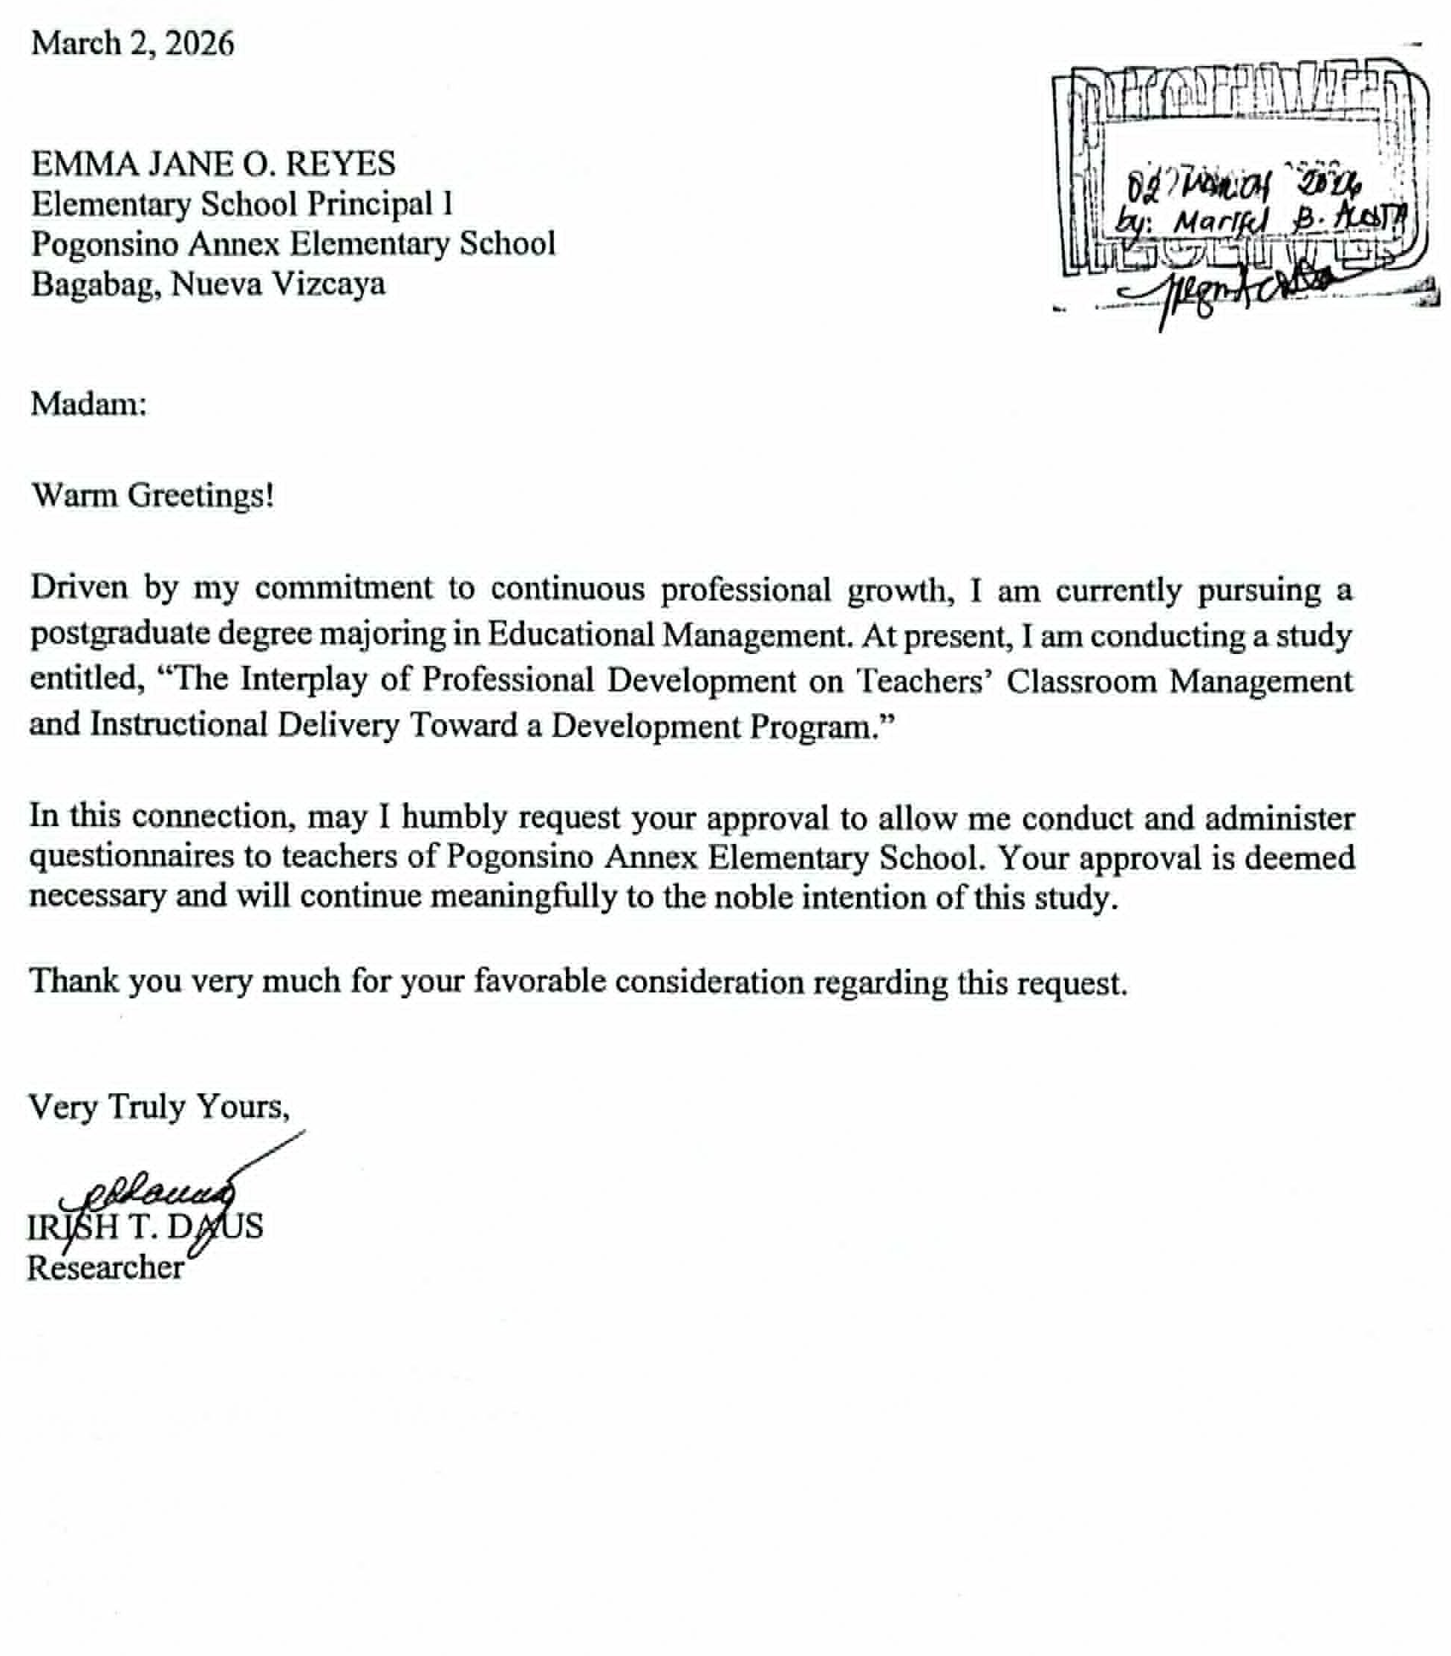

















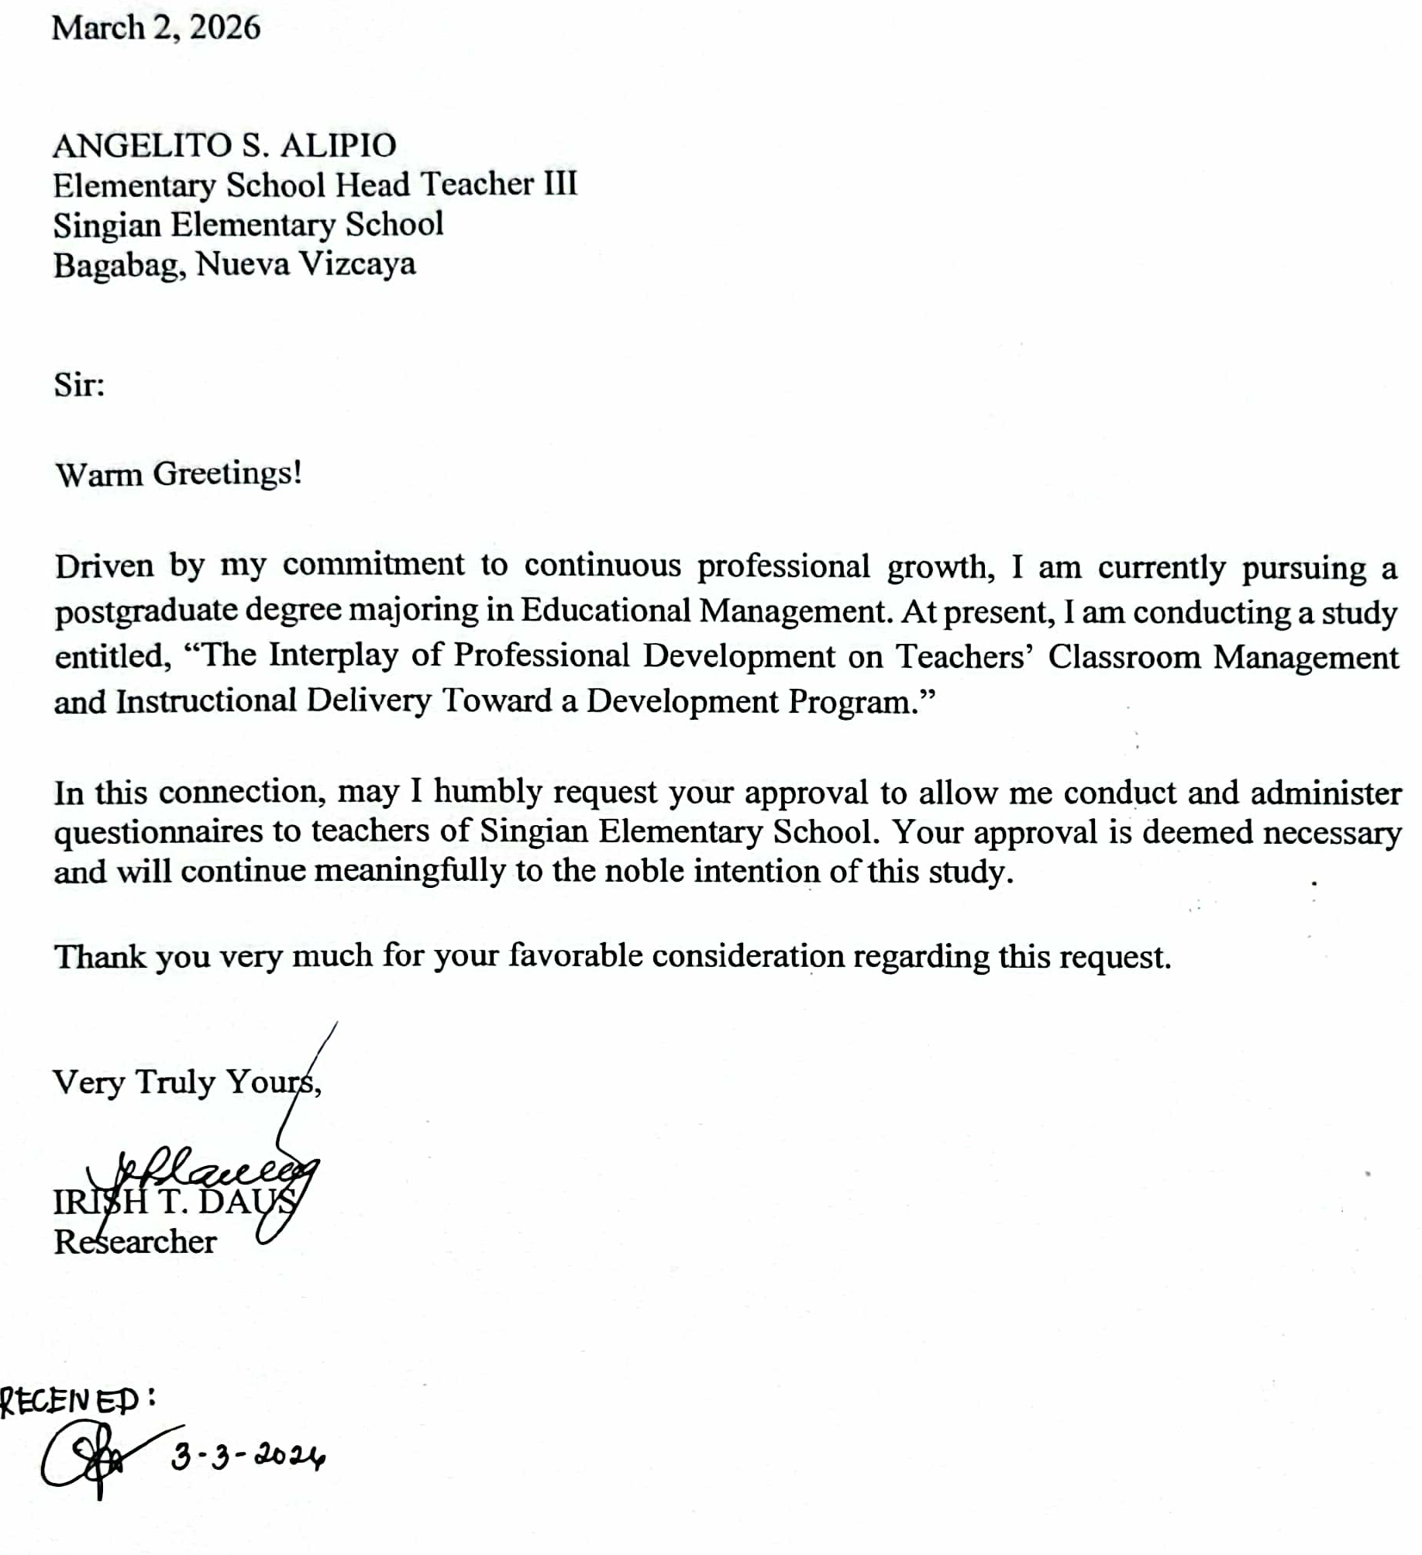

Appendix E
REQUEST LETTER TO THE RESPONDENTS


Dear Respondents,
Sir/Madam:

In view of my research study entitled “Interplay of Professional development on Teacher’s Classroom Management and Instructional Delivery Toward a Development Program” the undersigned wishes to appeal to your kind consideration to answer the questionnaires for the proposed study. Rest assured that all facts and data will be gathered and treated with utmost confidentiality.

I sincerely bring to your attention my deepest gratitude for your support.

Very Truly Yours,

IRISH T. DAUS
Researcher

Appendix F
SURVEY QUESTIONNAIRE
Interplay of Professional Development on Teachers’ Classroom Management and Instructional Delivery
Name (Optional): _________________________________
School:
Position: _____________ Years in Service: _____________
Direction: Please read each statement carefully and indicate the extent to which you agree by checking the appropriate response using the scale provided.
Scale |  | Verbal Interpretation
4 | Very High | Very Frequent
3 | High | Frequent
2 | Low | Less Frequent
1 | Very Low | Not Frequent
PART I. PROFESSIONAL DEVELOPMENT

A. Frequency of Participation
Item No. | Statement | 4 | 3 | 2 | 1
1 | I regularly participate in professional development programs such as seminars, trainings, and workshops.
2 | I attend professional development activities aimed at improving specific teaching skills provided by the school or district at least several times each year.
3 | I actively seek additional professional development opportunities beyond those required by the school.
4 | I consistently engage in professional learning activities that enhance my teaching competence.

B. Relevance and Applicability
Item No. | Statement | 4 | 3 | 2 | 1
5 | The professional development programs I attend are relevant to my grade level that improve both classroom management and instruction.
6 | The content of professional development activities is applicable to my actual classroom situation.
7 | I consistently integrate the specific instructional strategies and pedagogical approaches acquired through professional development into my daily classroom practice in ways that are directly relevant to my students’ learning needs and my curriculum objectives.
8 | Professional development programs address real challenges I encounter in the classroom.
9 | Professional development programs help me address the diverse needs of my learners.

C. Support and Commitment
10 | The school administration supports teachers’ participation in professional development activities.
11 | The school provides adequate time and necessary resources to enable teachers to participate and complete professional development programs.
12 | The school provides encouragement and follow-up support after professional development activities.
13 | I am personally committed to continuous professional growth as a teacher.
14 | I am motivated and willingly invest my time and effort to improve my teaching through continuous professional development.

PART II. CLASSROOM MANAGEMENT

A. Rules and Procedures
Item No. | Statement | 4 | 3 | 2 | 1
15 | I consistently implement classroom routines and procedures in my class.
16 | My learners understand and follow the established rules and procedures.
17 | Professional development has helped me improve the way I establish classroom rules.

B. Time Management
Item No. | Statement | 4 | 3 | 2 | 1
18 | I manage instructional time effectively during lessons.
19 | Classroom transitions are handled smoothly without wasting learning time.
20 | I am able to complete lesson activities within the allotted time.
21 | Strategies learned from professional development help me maximize instructional time.
22 | I manage classroom activities to keep learners engaged throughout the lesson.

C. Behavior Management
Item No. | Statement | 4 | 3 | 2 | 1
23 | I handle disruptive behavior in a calm and consistent manner.
24 | I apply appropriate reinforcement and corrective measures when managing behavior.
25 | Professional development has improved my ability to manage learner behavior effectively.
26 | I use consistent behavior management strategies with all my learners that helps me to focus more on instruction.

PART III. TEACHERS’ INSTRUCTIONAL DELIVERY

A. Curriculum
Item No. | Statement | 4 | 3 | 2 | 1
27 | I regularly refer to the Curriculum Guide when planning my lessons.
28 | The Curriculum Guide helps me sequence lessons logically and effectively.
29 | Professional development has enhanced my ability to use the Curriculum Guide in teaching.
30 | The curriculum guide helps me identify appropriate learning competencies to ensure lesson continuity.

B. Instructional Delivery
Item No. | Statement | 4 | 3 | 2 | 1
31 | I use teaching strategies that encourage learners to ask questions, investigate topics, and discover answers through guided activities.
32 | I use teaching approaches where learners actively participate in lessons by connecting new ideas to what they already know and learning through activities and interaction.
33 | I reflect on my teaching practices to identify areas for improvement and enhance the way I deliver my lessons.

C. Assessment
Item No. | Statement | 4 | 3 | 2 | 1
34 | I regularly use formative assessments to monitor learners’ progress.
34 | I provide timely feedback based on formative assessment results.
36 | I use summative assessments to evaluate learners’ mastery of lessons.
37 | Assessment results guide my instructional decisions, lesson adjustments and remediation activities.
38 | I use diagnostic assessments to identify my learners’ existing knowledge, skills, strengths and weaknesses.

PART IV. CHALLENGES AND ENABLING FACTORS IN APPLYING PROFESSIONAL DEVELOPMENT

A. Challenges Encountered
Item No. | Statement | 4 | 3 | 2 | 1
39 | Adequate instructional resources that supports the effective application of professional development learning.
40 | Well-managed class size create opportunities for implementing new teaching strategies effectively.
41 | Insufficient school funds to support teacher’s participation in professional development.
42 | Limited administrative support affects implementation of professional development learning.
43 | Access to additional resources can help fully to implement the strategies learned.

B. Enabling Factors
108
Item No. | Statement | 4 | 3 | 2 | 1
44 | Support from school administrators helps me apply professional development learning.
45 | Collaboration with colleagues and sharing of best practices enables me to apply new teaching strategies.
46 | Follow-up coaching or mentoring supports the application of professional development.
47 | Professional development programs equip me with practical and usable classroom strategies.
48 | Availability of instructional materials supports professional development application.
49 | School-based trainings enhance the application of professional development learning.
50 | Monitoring and feedback help sustain professional development practices.
Thank you for your response!

Appendix G
VALIDATION SHEET

Name of Evaluator: ______________________ Date Evaluated: ___________
Highest Educational Attainment: _____________________
Field of Specialization: ______________________________
Position: __________________________
Signature: ________________________

I. Overall Evaluation of the Instrument
Directions: Please indicate the degree of your agreement or disagreement with the statement provided below by checking the appropriate response which corresponds to your answer.
4- Excellent 3- Very Good 2- Fair 1-Poor

Statements | 4 | 3 | 2 | 1
- Clarity and Direction of items
The items are clearly stated, with appropriate vocabulary, language, and structure that the respondents can easily understand.
- Presentation and Organization of Items
The items are presented and organized in a logical and systematic manner that facilitates clear understanding and smooth response from the respondents.
 | 4 | 3 | 2 | 1
- Suitability of items
The items are relevant to the study and effectively measure the constructs or variables under investigation.
- Adequateness of the Content
The items provide sufficient coverage of all areas needed to measure the variables of the study.
- Attainment of Purpose
The instrument effectively addresses the research problems stated in the study.
- Research Questions
The items are aligned with the research questions and can generate data to answer them accurately.
- Scale and Evaluation Rating
The response scale is appropriate, clear, and capable of capturing accurate and meaningful responses from respondents.
Remarks:_______________________________________________________________________________________________________________________________________________________________________________________________________________
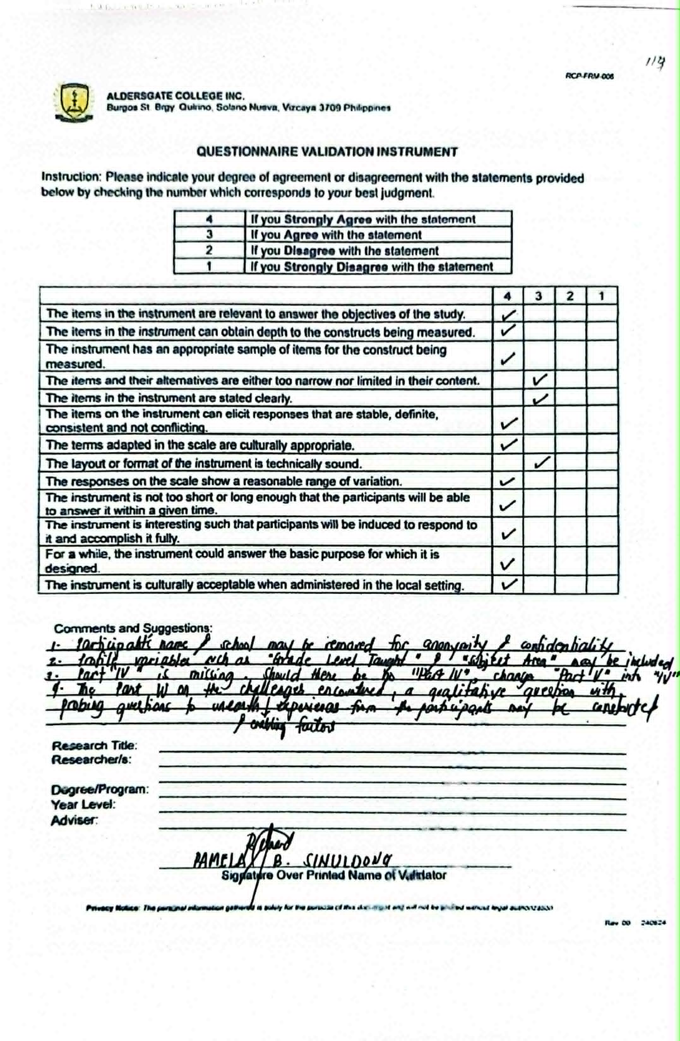


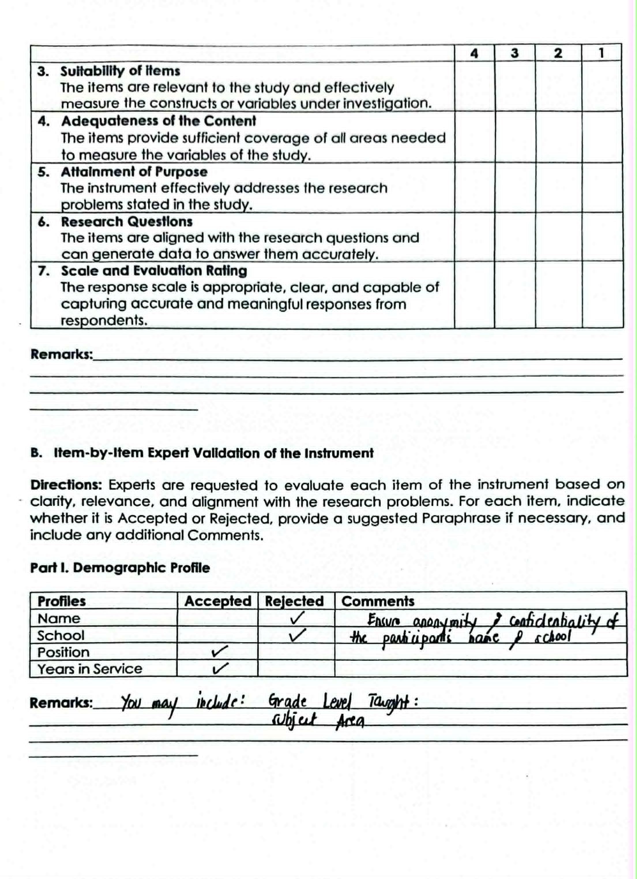
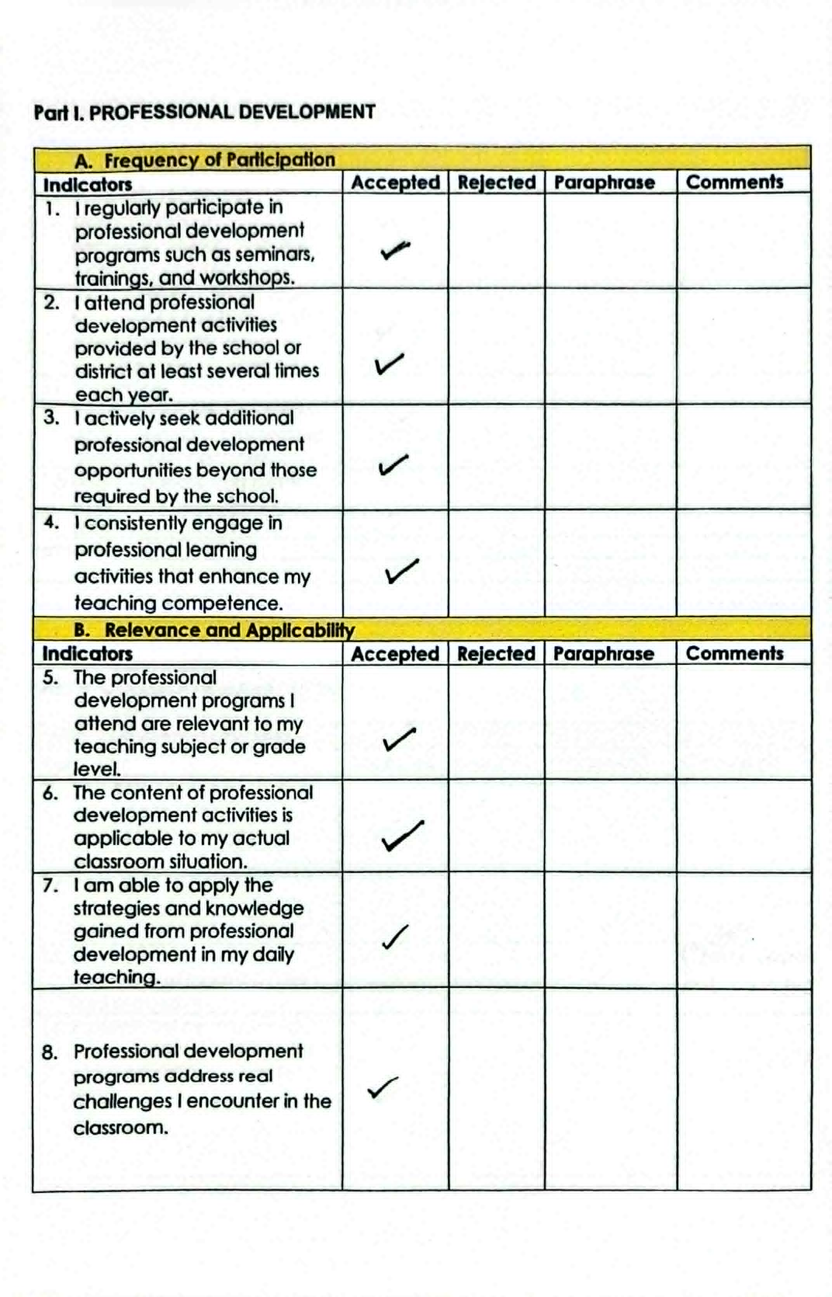
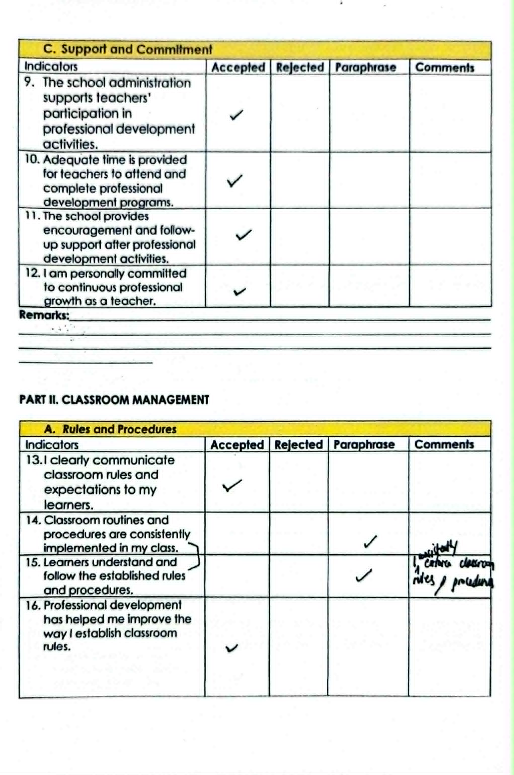

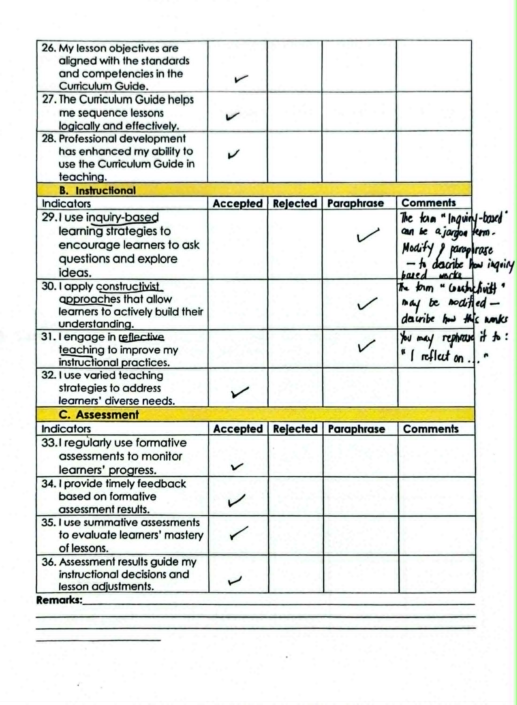





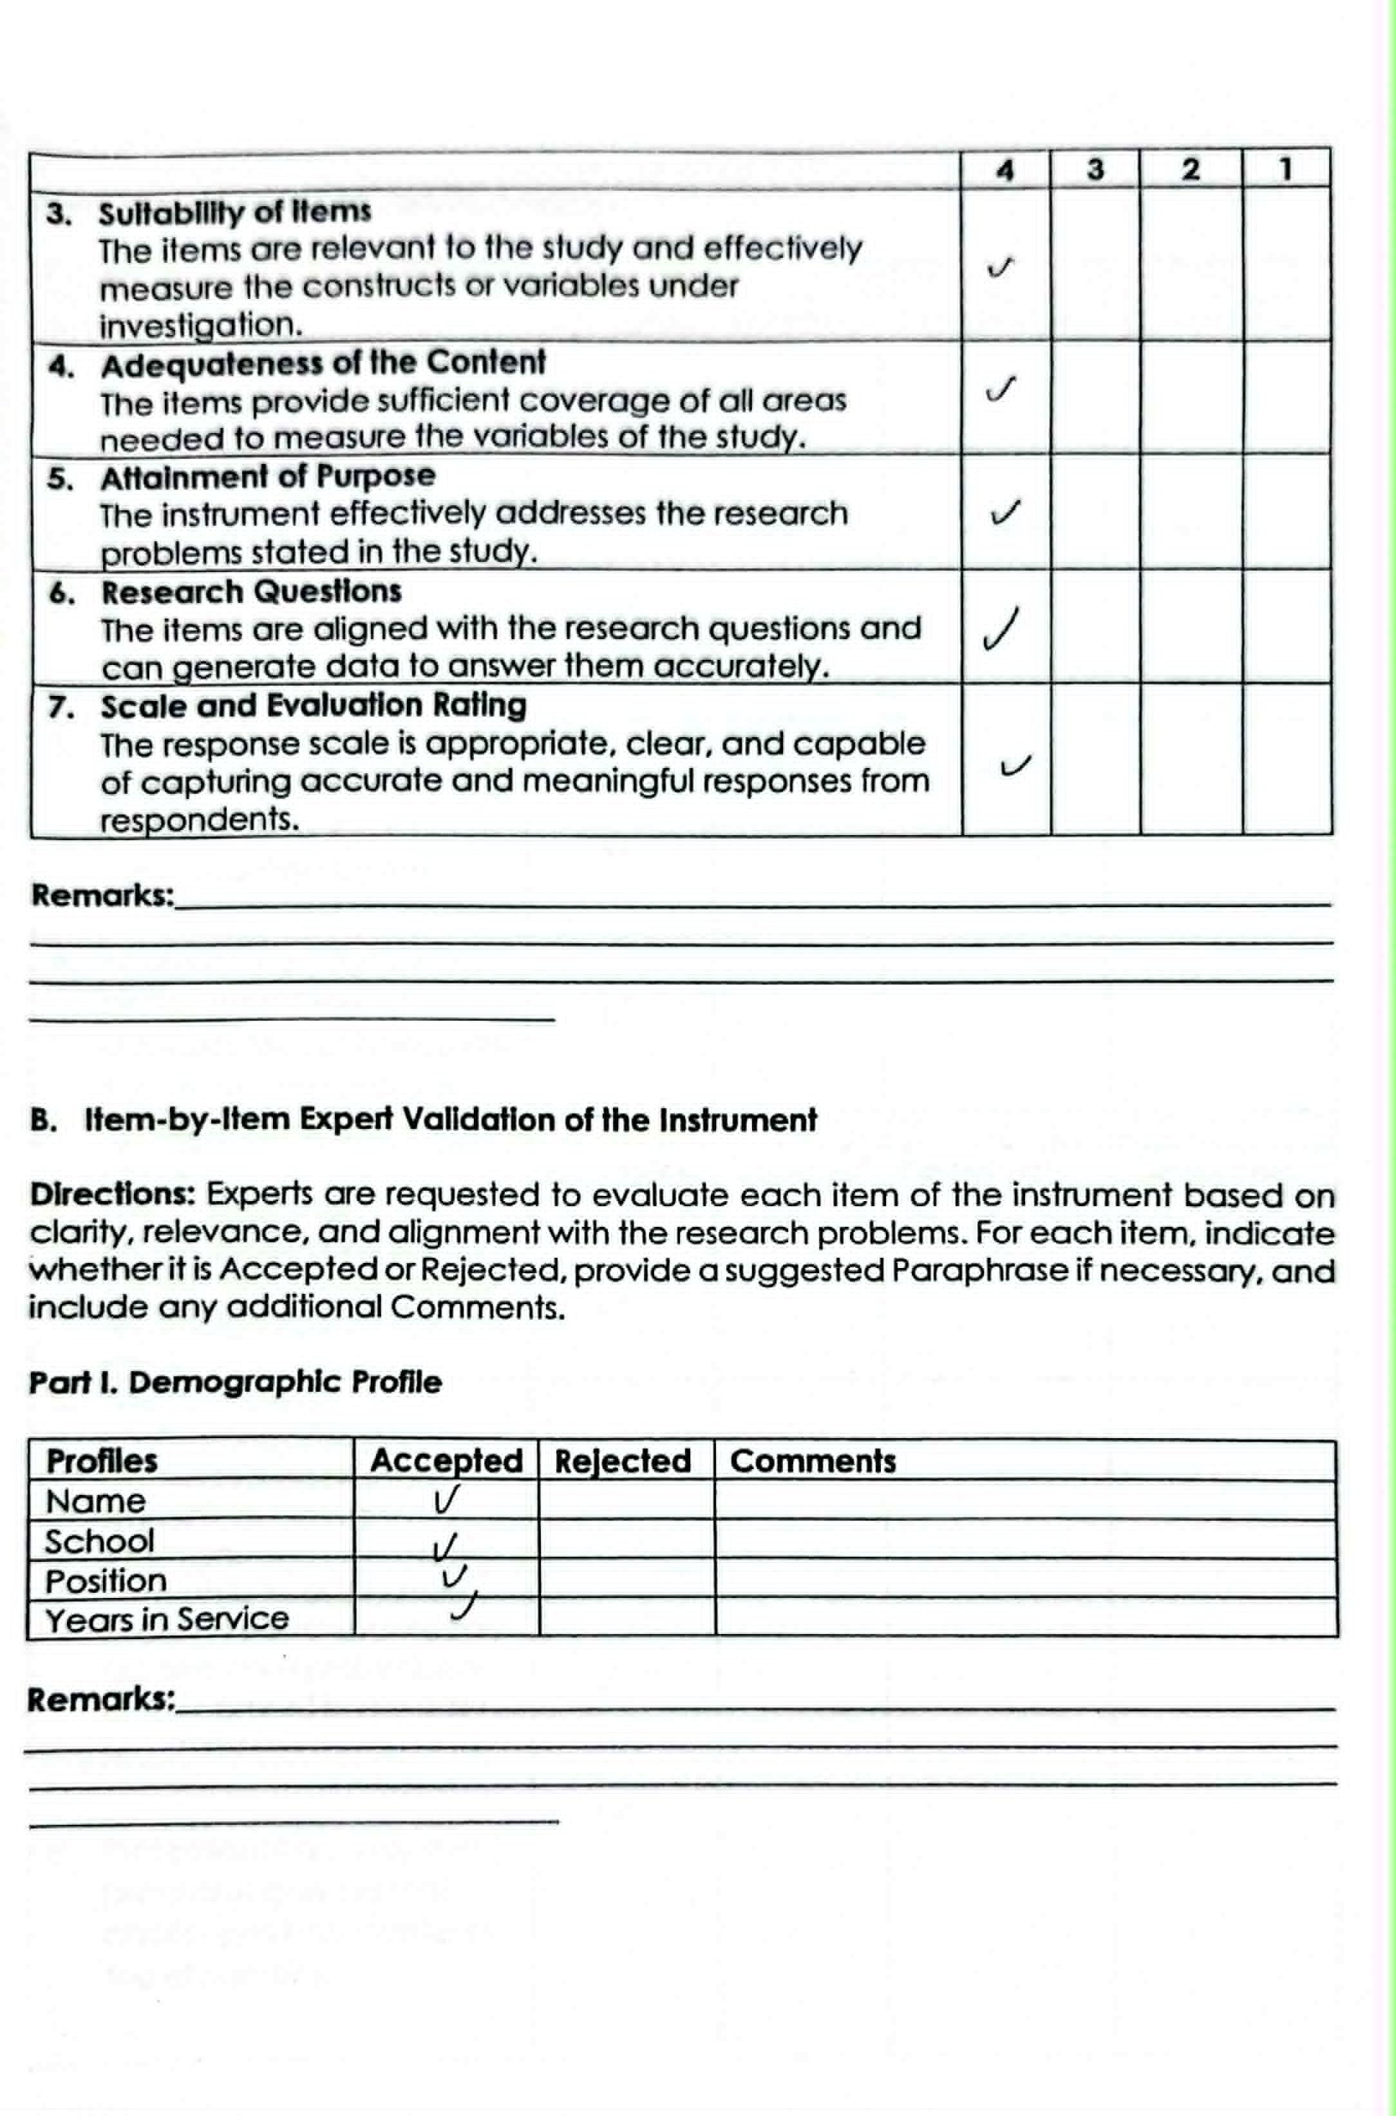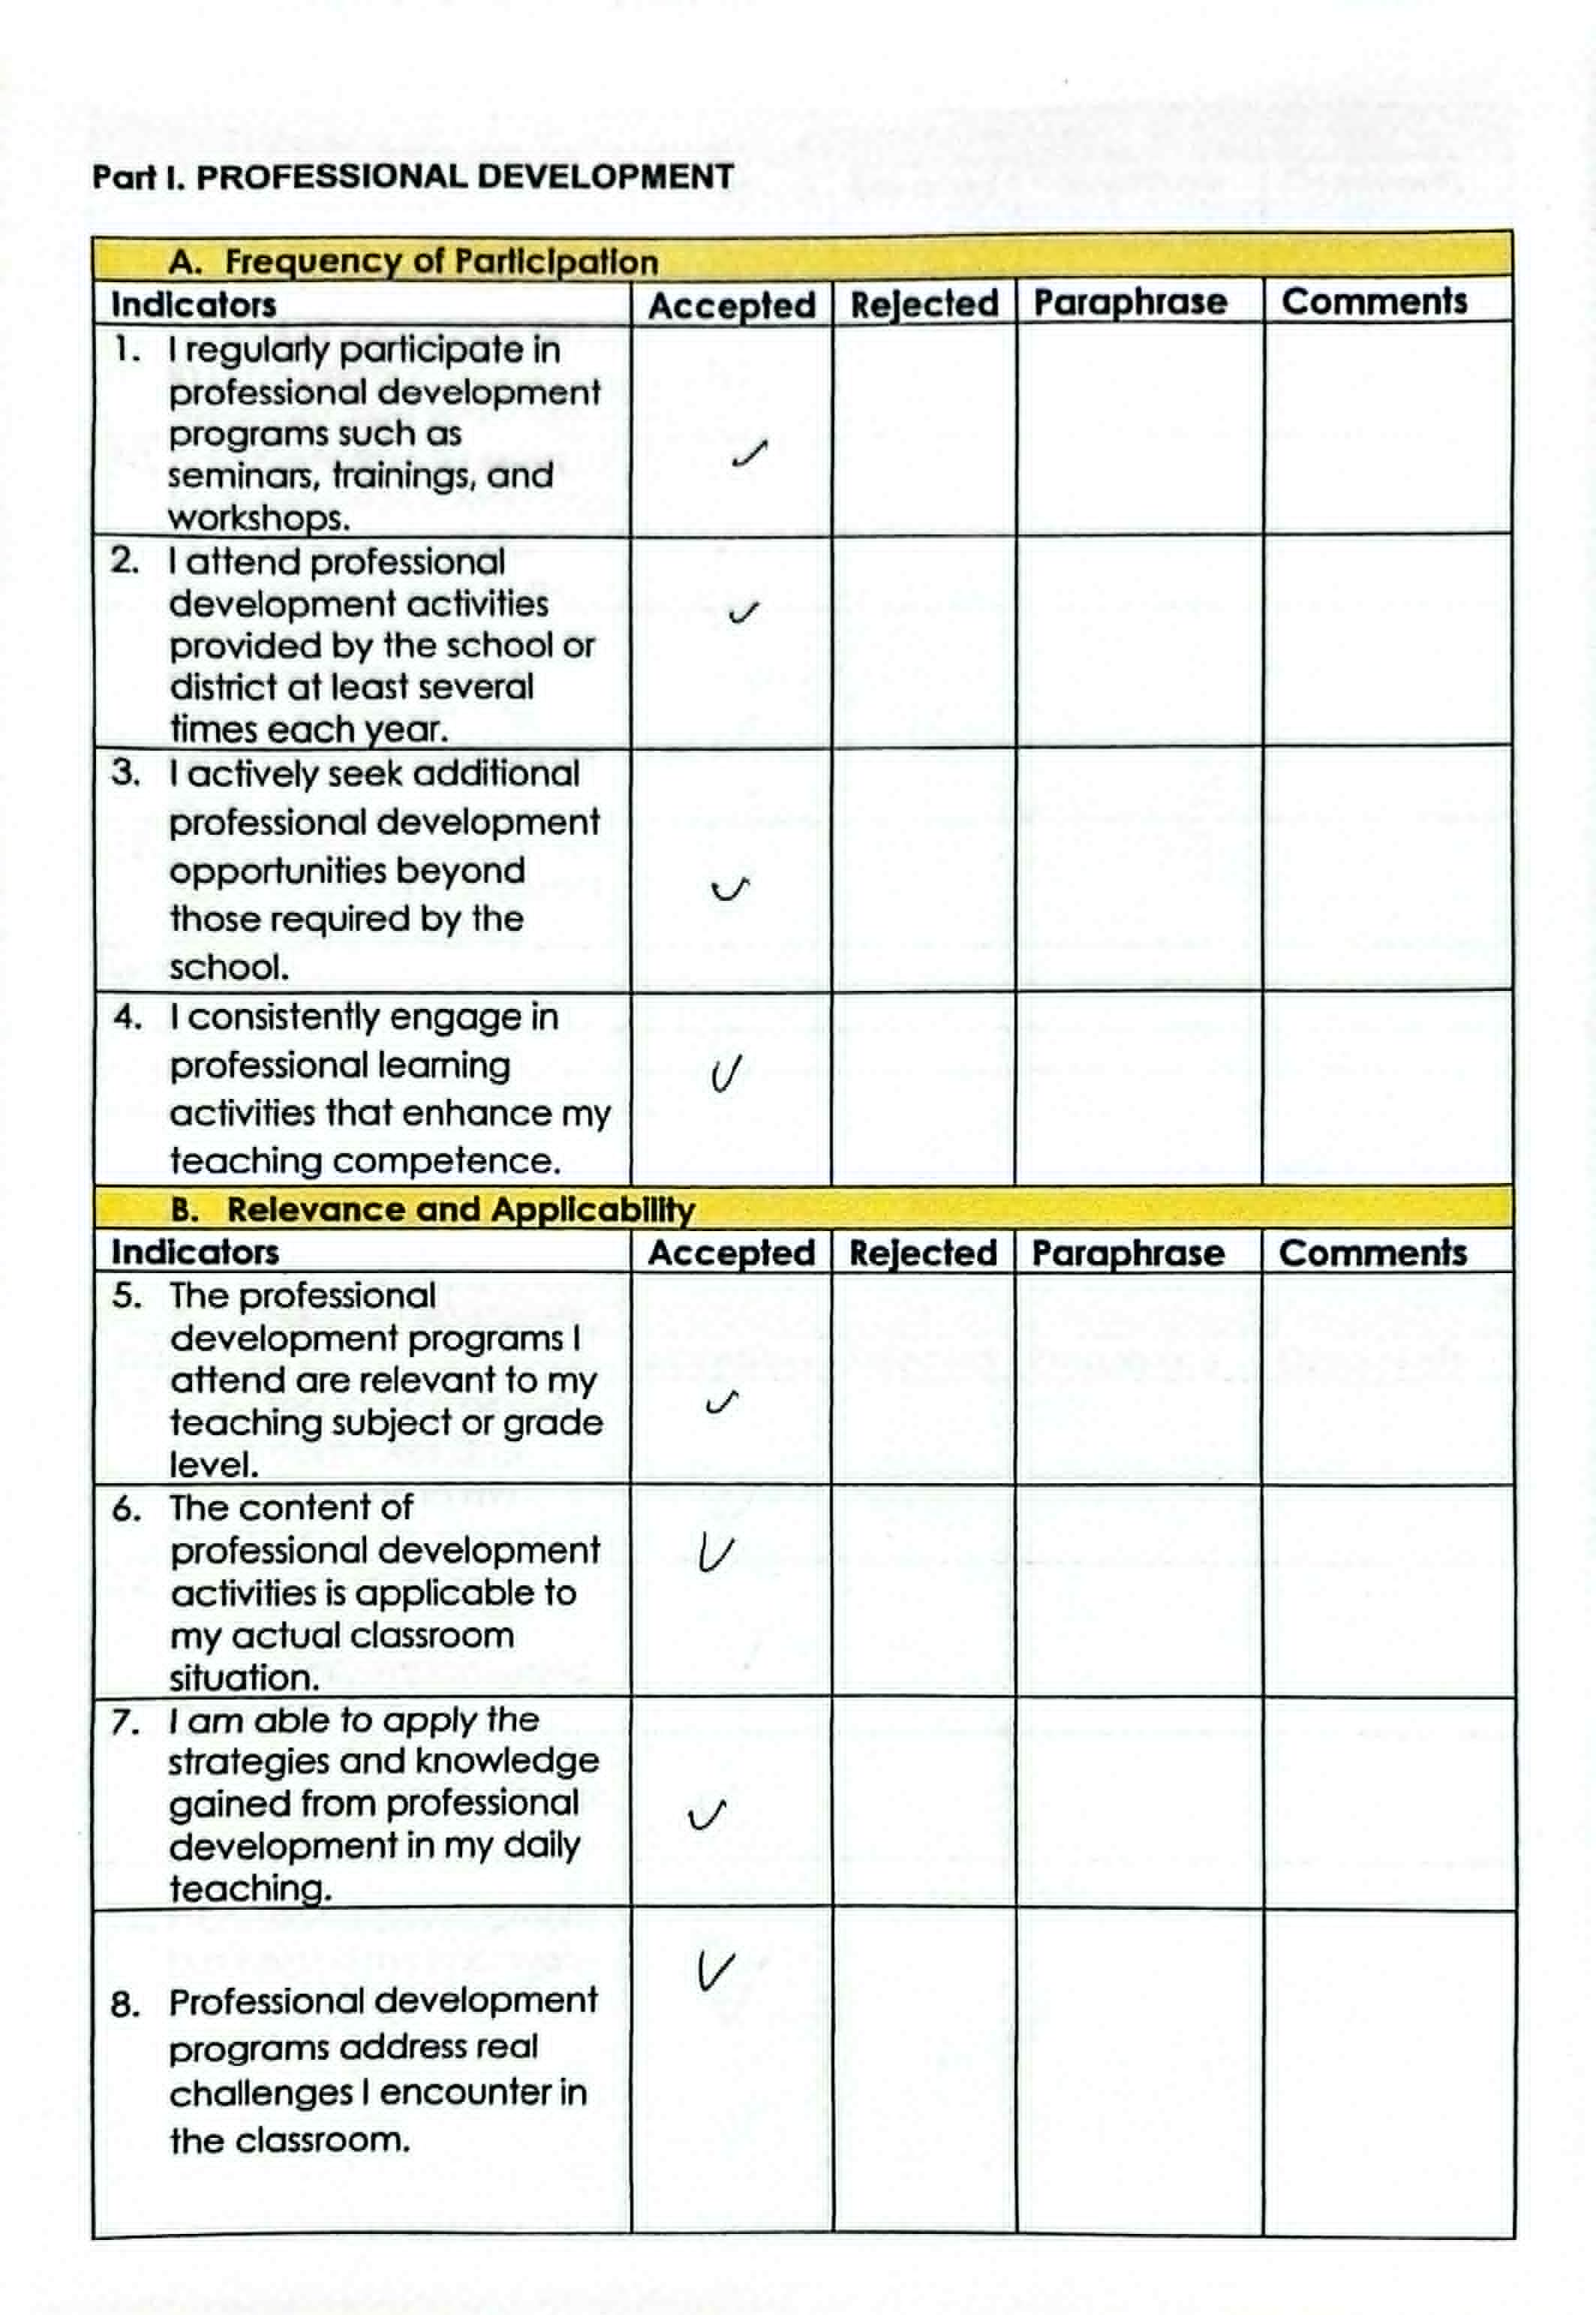


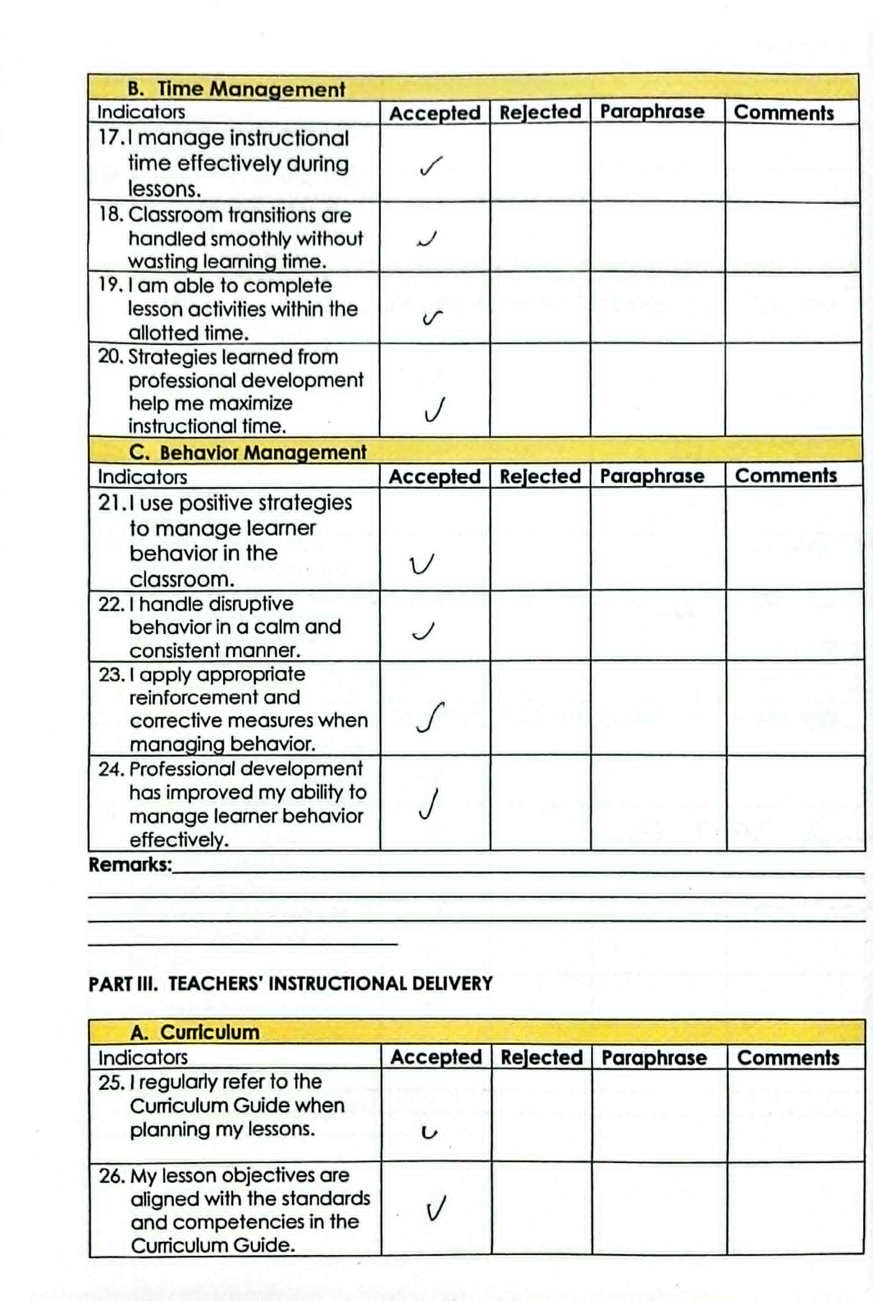
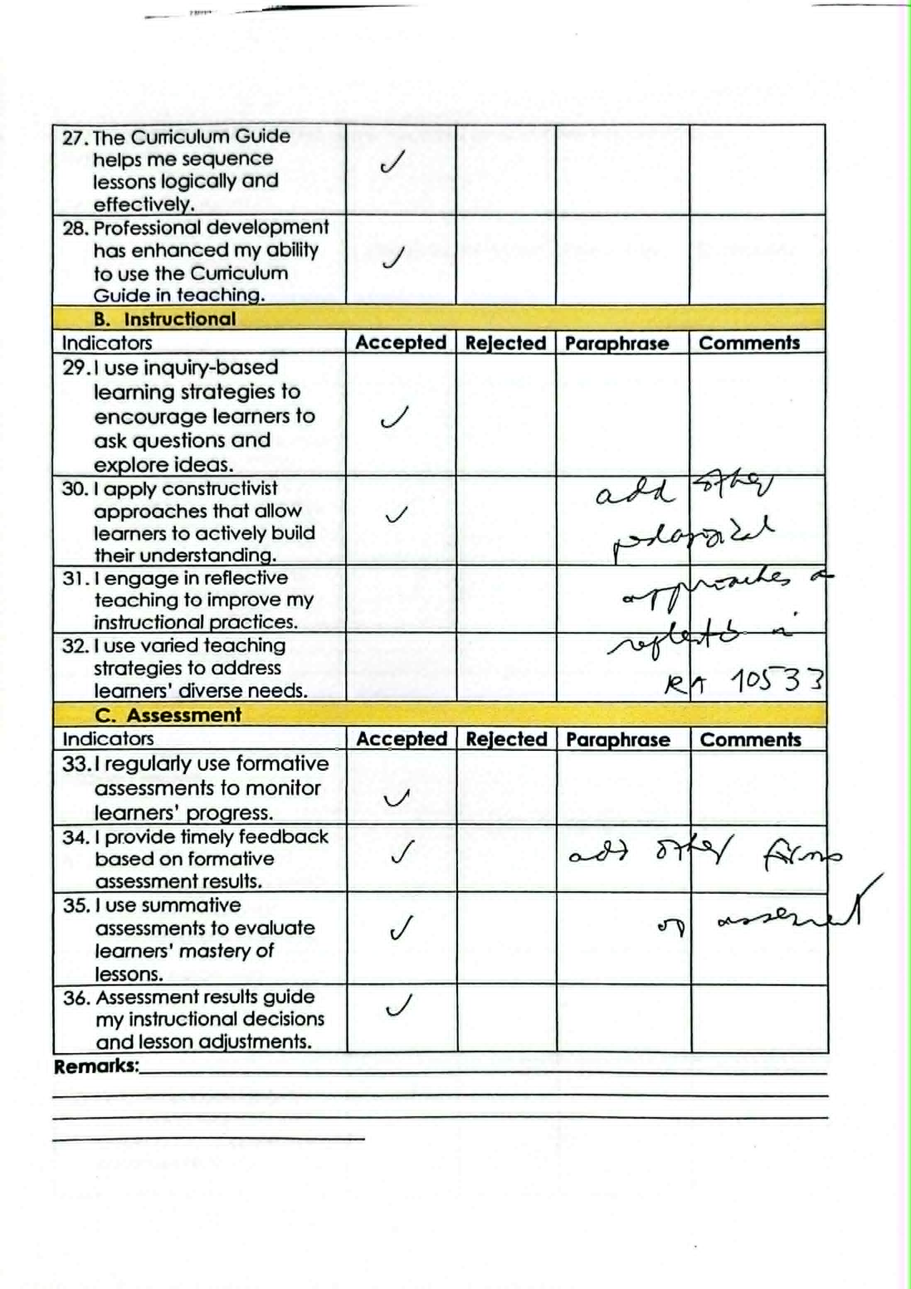
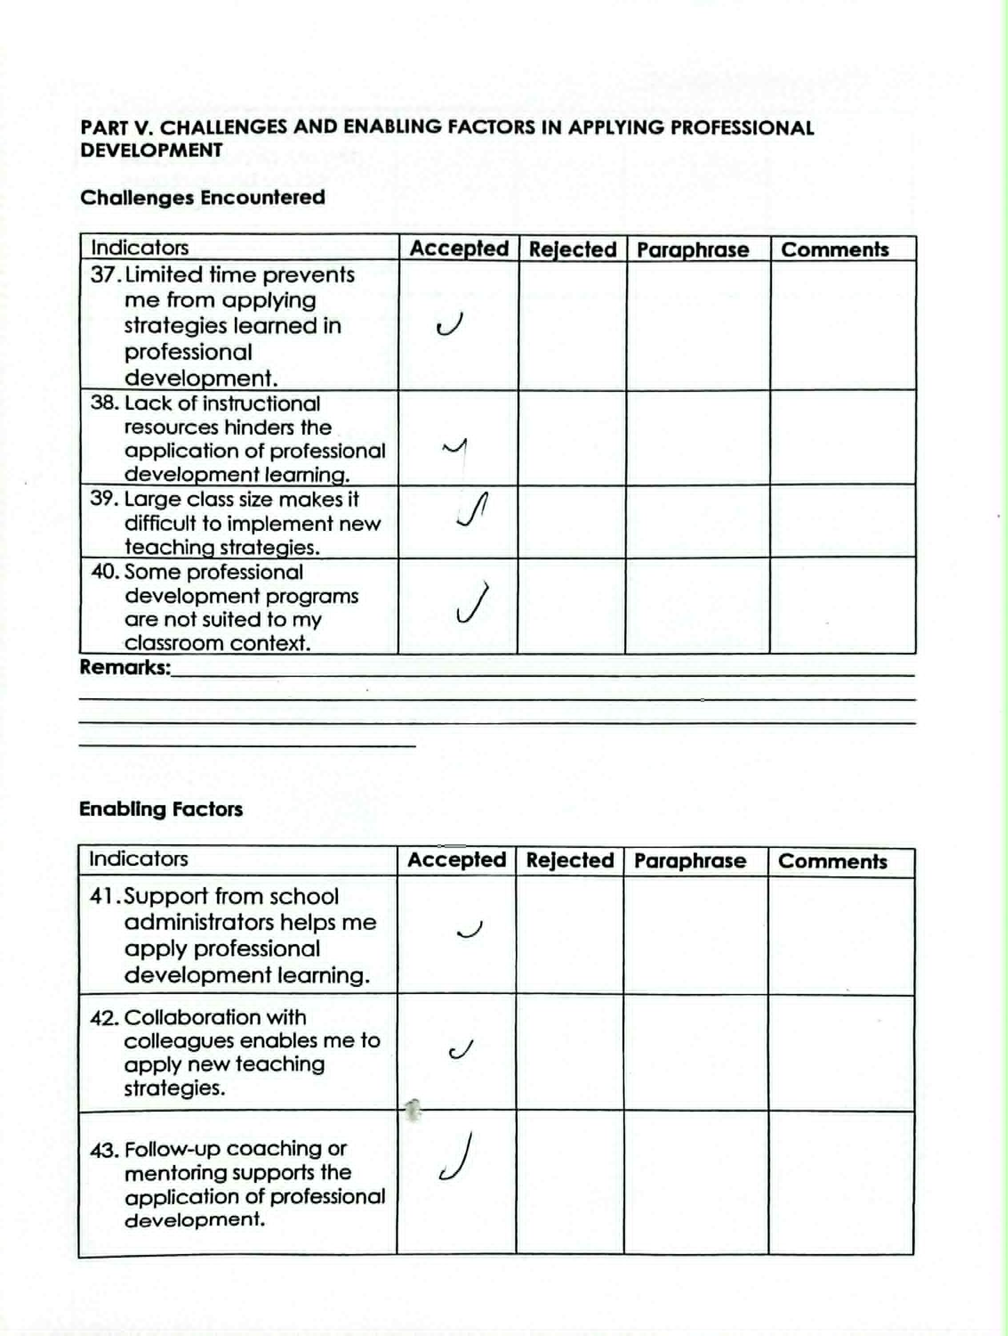



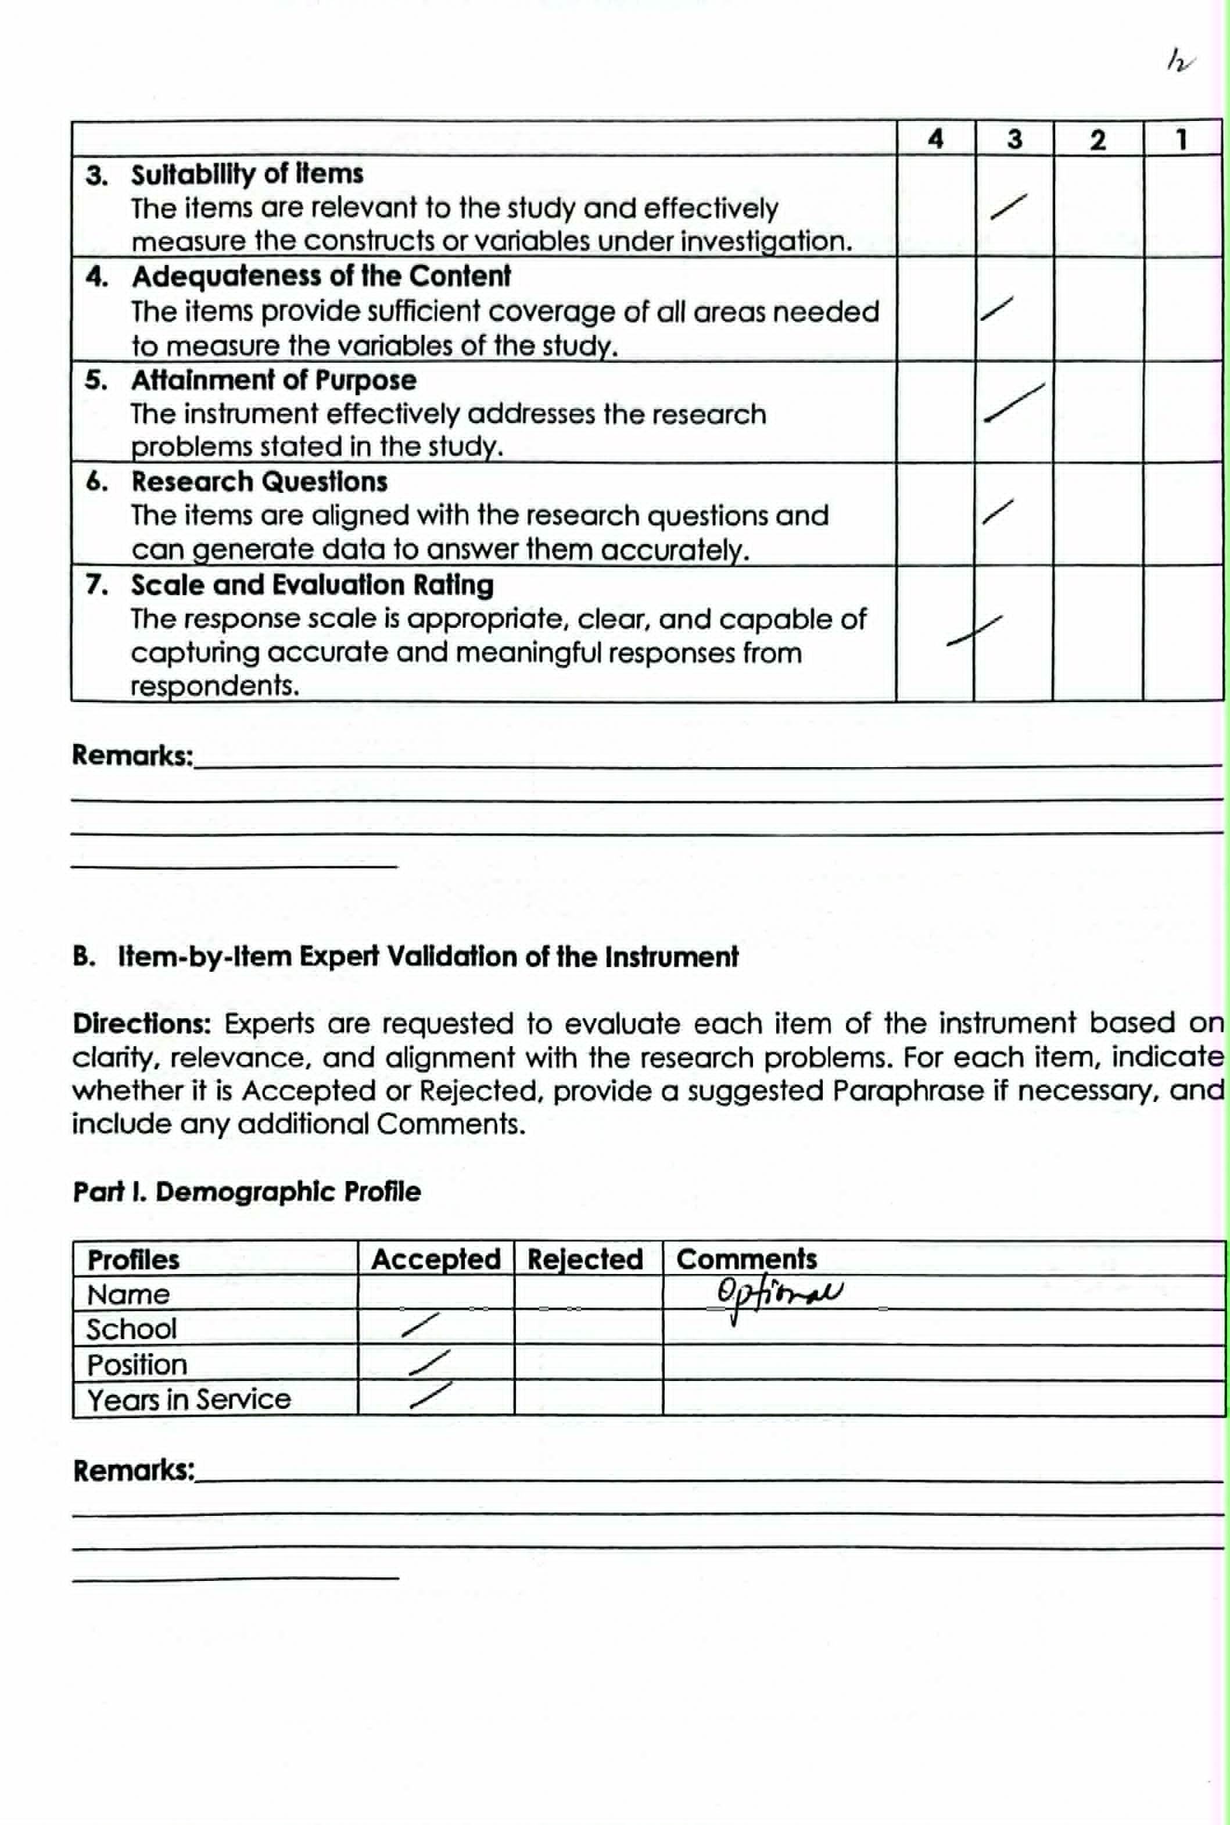




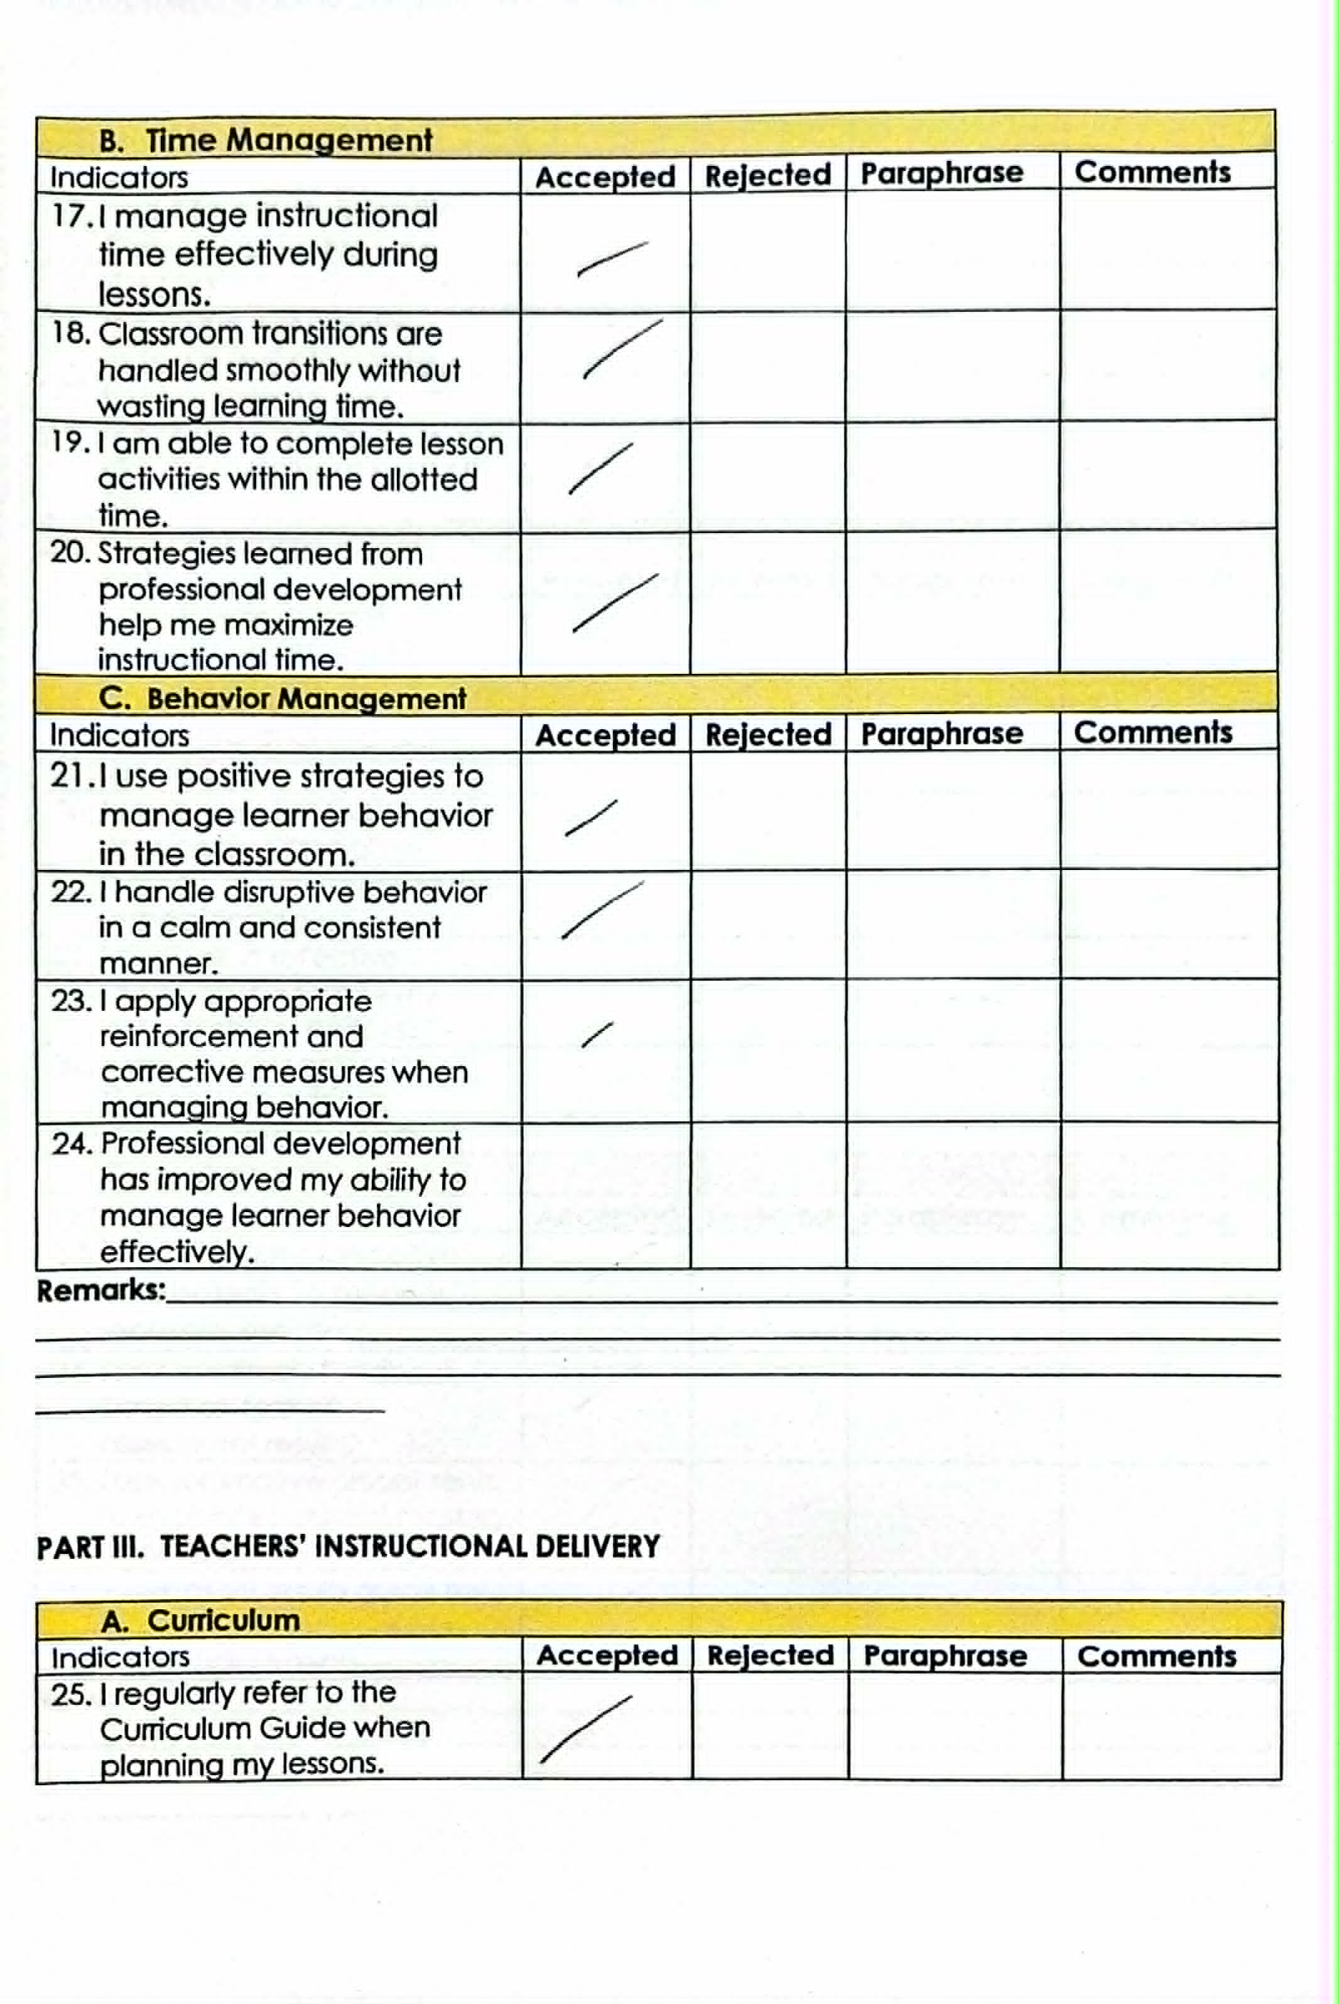
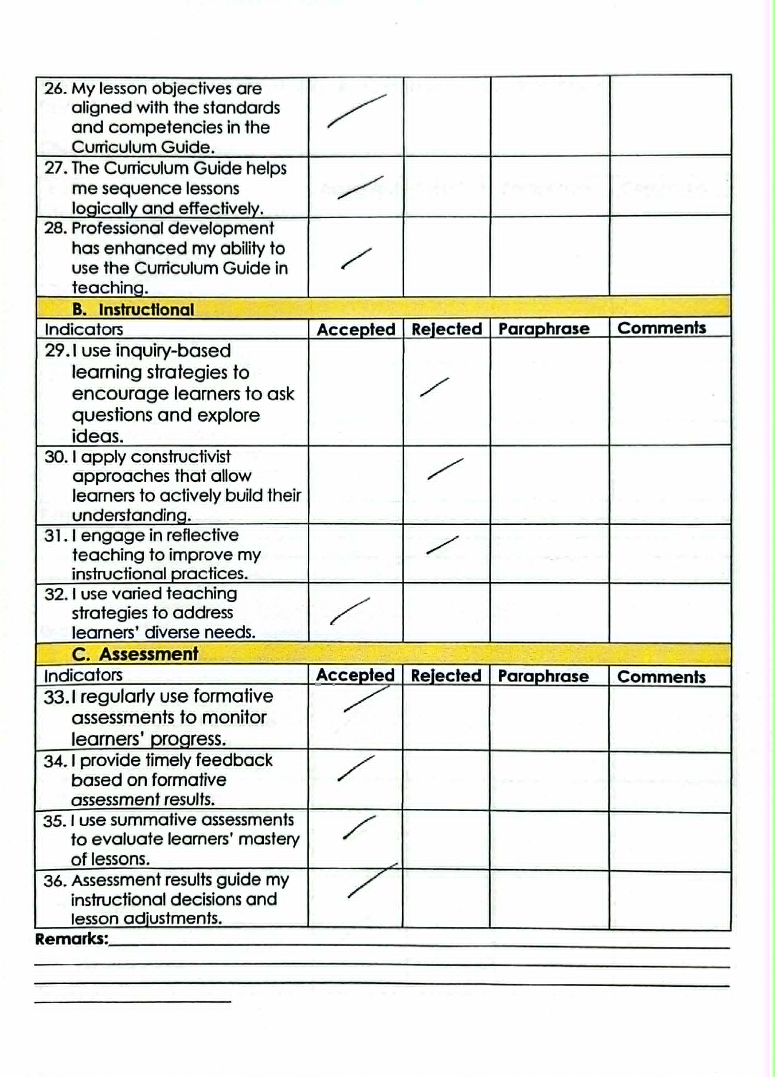
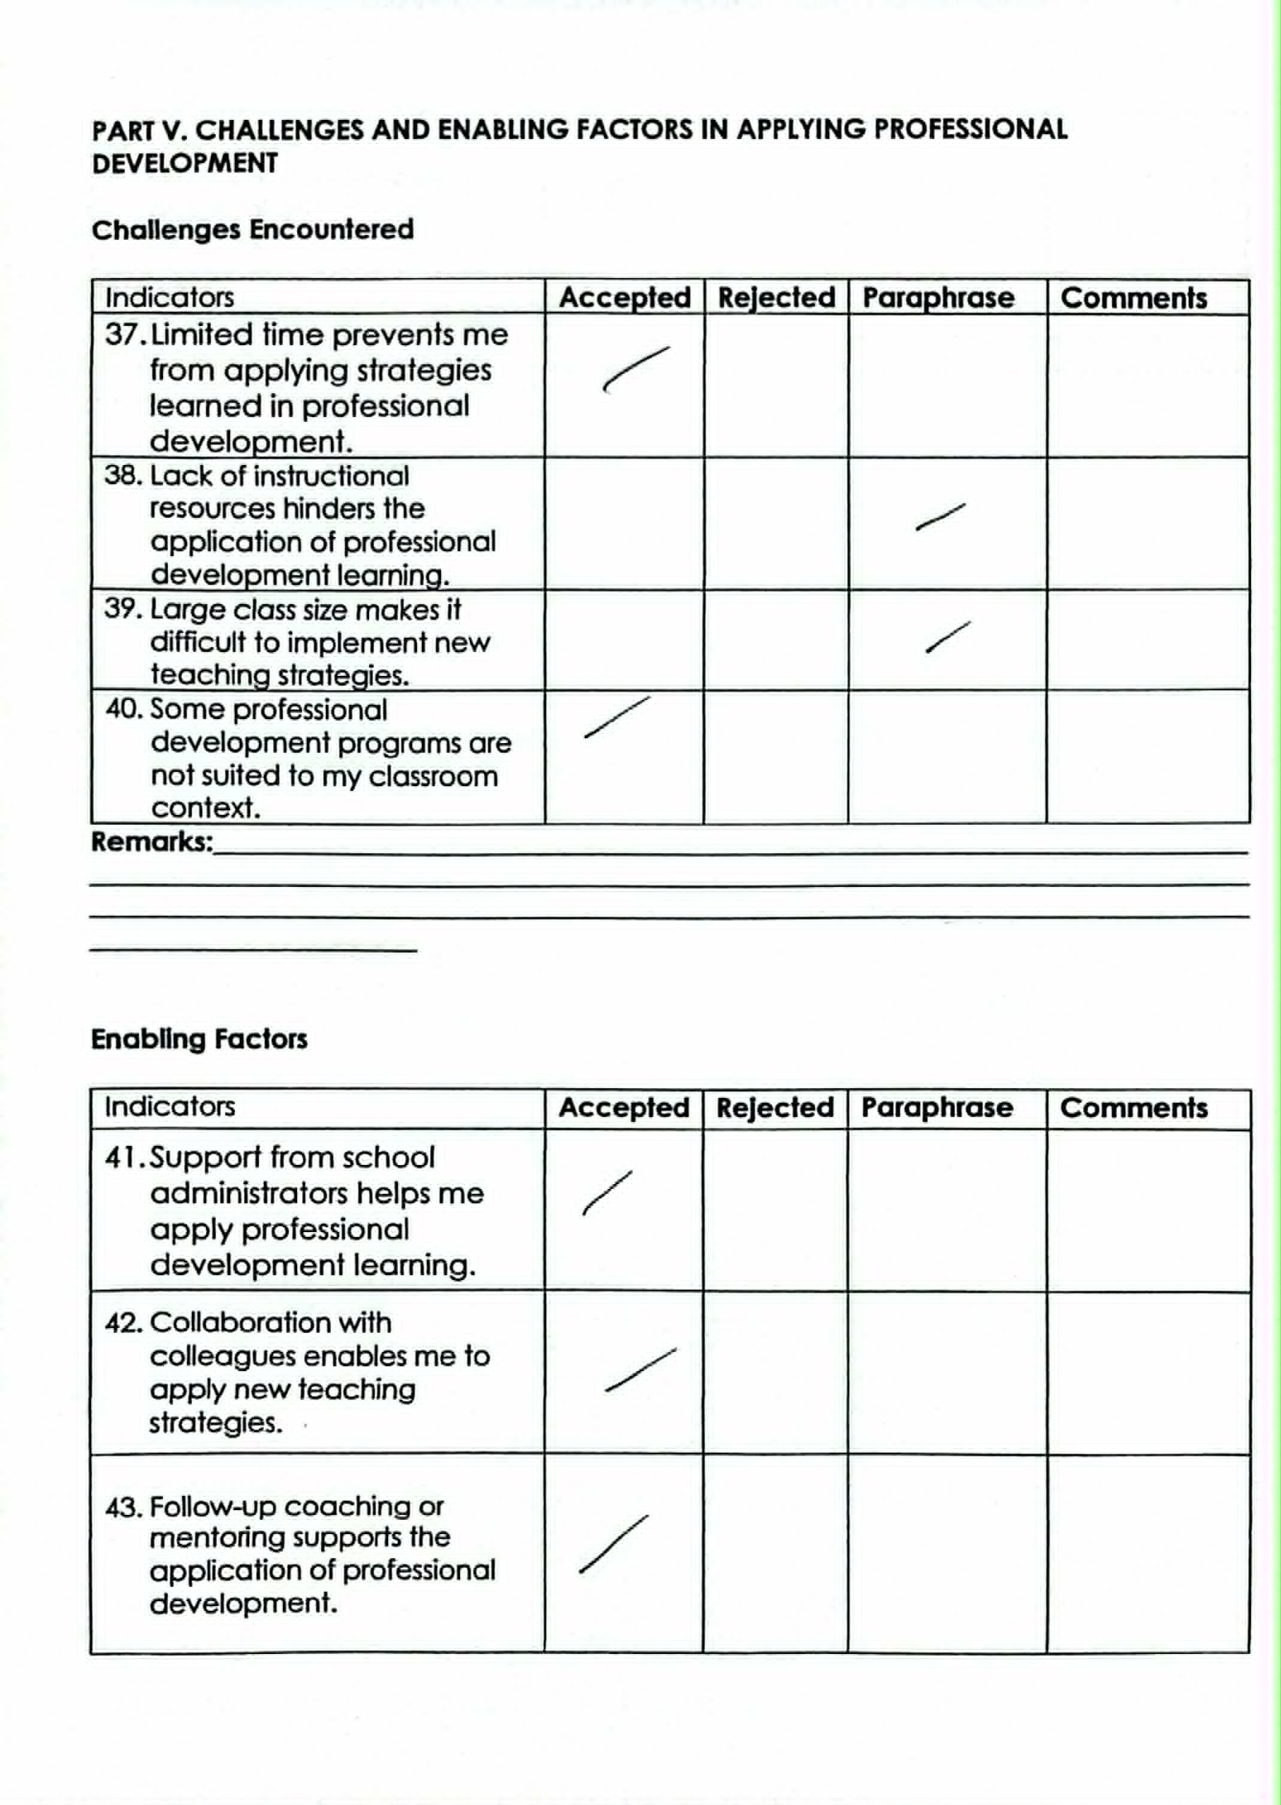

Appendix H
RELIABILITY ANALYSIS REPORT
Research Questionnaire: Interplay of Professional Development and Teachers' Classroom Management and Instructional Delivery
Researcher: Irish T. Daus

1. Overall Reliability Statistics
The instrument demonstrated excellent internal consistency as indicated by the Cronbach's Alpha coefficient. The table below summarizes the overall reliability findings and item classification.
Statistic | Value
Overall Cronbach's Alpha | 0.913
Number of Items | 60
Interpretation | Excellent / Very High Reliability
Items with CITC < 0.20 (Consider Revision) | Items 5, 16, 20, 32, 39, 40, 46, 49, 50
Items with CITC 0.20–0.29 (Marginal) | Items 26, 36
Items with CITC ≥ 0.30 (Acceptable) | 48 items

Cronbach's Alpha Interpretation Guide
Alpha Range | Interpretation
α ≥ 0.90 | Excellent
0.80 ≤ α < 0.90 | Good
0.70 ≤ α < 0.80 | Acceptable
0.60 ≤ α < 0.70 | Questionable
α < 0.60 | Poor – Requires Revision

2. Item-Total Statistics (All 60 Items)
Items highlighted in red indicate a Corrected Item-Total Correlation (CITC) below 0.20, suggesting low discriminability and potential revision. Yellow-highlighted items have marginal CITC values (0.20–0.29).
Item No. | Part | Statement | Scale Mean if Item Deleted | Scale Variance if Item Deleted | Corrected Item-Total Correlation | Cronbach's Alpha if Item Deleted | Remark
1 | I-A | I regularly participate in professional development programs such as seminars, trainings, and workshops. | 222.0303 | 117.593 | 0.477 | 0.910 | Acceptable
2 | I-A | I attend professional development activities aimed at improving specific teaching skills provided by the school or district at least several times each year. | 221.9697 | 119.968 | 0.333 | 0.912 | Acceptable
3 | I-A | I actively seek additional professional development opportunities beyond those required by the school. | 222.0303 | 117.718 | 0.466 | 0.910 | Acceptable
4 | I-A | I consistently engage in professional learning activities that enhance my teaching competence. | 222.0000 | 115.375 | 0.687 | 0.908 | Acceptable
5 | I-A | I participate in school-based professional development activities such as Learning Action Cells (LAC). | 221.8485 | 121.883 | 0.181 | 0.913 | ⚠ Low – Consider revision or deletion
6 | I-B | The professional development programs I attend are relevant to my grade level that improve both classroom management and instruction. | 221.9091 | 118.898 | 0.486 | 0.910 | Acceptable
7 | I-B | The content of professional development activities is applicable to my actual classroom situation. | 221.8788 | 119.110 | 0.492 | 0.910 | Acceptable
8 | I-B | I consistently integrate the specific instructional strategies and pedagogical approaches acquired through professional development into my daily classroom practice. | 221.9394 | 117.684 | 0.593 | 0.909 | Acceptable
9 | I-B | Professional development programs address real challenges I encounter in the classroom. | 221.9091 | 114.960 | 0.796 | 0.907 | Acceptable
10 | I-B | Professional development programs help me address the diverse needs of my learners. | 221.8788 | 117.360 | 0.702 | 0.909 | Acceptable
11 | I-C | The school administration supports teachers' participation in professional development activities. | 222.0000 | 117.875 | 0.462 | 0.910 | Acceptable
12 | I-C | The school provides adequate time and necessary resources to enable teachers to participate and complete professional development programs. | 222.0606 | 117.434 | 0.482 | 0.910 | Acceptable
13 | I-C | The school provides encouragement and follow-up support after professional development activities. | 221.9091 | 117.023 | 0.592 | 0.909 | Acceptable
14 | I-C | I am personally committed to continuous professional growth as a teacher. | 221.8485 | 117.133 | 0.642 | 0.909 | Acceptable
15 | I-C | I am motivated and willingly invest my time and effort to improve my teaching through continuous professional development. | 221.7879 | 120.297 | 0.482 | 0.911 | Acceptable
16 | II-A | I clearly communicate classroom rules and expectations to my learners. | 221.7576 | 124.002 | -0.110 | 0.914 | ⚠ Low – Consider revision or deletion
17 | II-A | I consistently implement classroom routines and procedures in my class. | 221.7576 | 121.064 | 0.440 | 0.911 | Acceptable
18 | II-A | My learners understand and follow the established rules and procedures. | 221.9394 | 119.996 | 0.344 | 0.911 | Acceptable
19 | II-A | Professional development has helped me improve the way I establish classroom rules. | 221.9394 | 120.059 | 0.338 | 0.912 | Acceptable
20 | II-A | I involve students in establishing classroom rules based on strategies learned in professional development. | 221.8788 | 124.360 | -0.120 | 0.915 | ⚠ Low – Consider revision or deletion
21 | II-B | I manage instructional time effectively during lessons. | 221.8485 | 120.008 | 0.417 | 0.911 | Acceptable
22 | II-B | Classroom transitions are handled smoothly without wasting learning time. | 221.8788 | 119.047 | 0.499 | 0.910 | Acceptable
23 | II-B | I am able to complete lesson activities within the allotted time. | 221.9394 | 117.309 | 0.633 | 0.909 | Acceptable
24 | II-B | Strategies learned from professional development help me maximize instructional time. | 221.8788 | 118.547 | 0.559 | 0.910 | Acceptable
25 | II-B | I manage classroom activities to keep learners engaged throughout the lesson. | 221.8485 | 117.945 | 0.682 | 0.909 | Acceptable
26 | II-C | I use positive strategies to manage learner behavior in the classroom. | 221.7576 | 122.064 | 0.251 | 0.912 | Marginal
27 | II-C | I handle disruptive behavior in a calm and consistent manner. | 222.0606 | 117.059 | 0.514 | 0.910 | Acceptable
28 | II-C | I apply appropriate reinforcement and corrective measures when managing behavior. | 221.9394 | 118.371 | 0.518 | 0.910 | Acceptable
29 | II-C | Professional development has improved my ability to manage learner behavior effectively. | 221.9697 | 117.530 | 0.585 | 0.909 | Acceptable
30 | II-C | I use consistent behavior management strategies with all my learners that helps me to focus more on instruction. | 221.8788 | 118.985 | 0.507 | 0.910 | Acceptable
31 | III-A | I regularly refer to the Curriculum Guide when planning my lessons. | 221.7879 | 119.735 | 0.571 | 0.910 | Acceptable
32 | III-A | My lesson objectives are aligned with the standards and competencies in the Curriculum Guide. | 221.7273 | 123.767 | -0.085 | 0.913 | ⚠ Low – Consider revision or deletion
33 | III-A | The Curriculum Guide helps me sequence lessons logically and effectively. | 221.7273 | 121.142 | 0.599 | 0.911 | Acceptable
34 | III-A | Professional development has enhanced my ability to use the Curriculum Guide in teaching. | 221.7576 | 119.814 | 0.678 | 0.910 | Acceptable
35 | III-A | The curriculum guide helps me identify appropriate learning competencies to ensure lesson continuity. | 221.7576 | 121.064 | 0.440 | 0.911 | Acceptable
36 | III-B | I use teaching strategies that encourage learners to ask questions, investigate topics, and discover answers through guided activities. | 221.8182 | 121.591 | 0.242 | 0.912 | Marginal
37 | III-B | I use teaching approaches where learners actively participate in lessons by connecting new ideas to what they already know and learning through activities and interaction. | 221.7879 | 119.860 | 0.551 | 0.910 | Acceptable
38 | III-B | I reflect on my teaching practices to identify areas for improvement and enhance the way I deliver my lessons. | 221.8788 | 120.297 | 0.351 | 0.911 | Acceptable
39 | III-B | I use varied teaching strategies and differentiated instruction to address learners' diverse needs. | 221.8182 | 124.028 | -0.091 | 0.914 | ⚠ Low – Consider revision or deletion
40 | III-B | I encourage learners to participate actively and express their ideas during discussions. | 221.7879 | 123.735 | -0.054 | 0.914 | ⚠ Low – Consider revision or deletion
41 | III-C | I regularly use formative assessments to monitor learners' progress. | 221.7576 | 121.564 | 0.345 | 0.912 | Acceptable
42 | III-C | I provide timely feedback based on formative assessment results. | 221.7879 | 120.797 | 0.403 | 0.911 | Acceptable
43 | III-C | I use summative assessments to evaluate learners' mastery of lessons. | 221.8788 | 121.172 | 0.248 | 0.912 | Marginal
44 | III-C | Assessment results guide my instructional decisions, lesson adjustments and remediation activities. | 221.7879 | 120.485 | 0.452 | 0.911 | Acceptable
45 | III-C | I use diagnostic assessments to identify my learners' existing knowledge, skills, strengths and weaknesses. | 221.9091 | 119.773 | 0.388 | 0.911 | Acceptable
46 | IV-A | Limited time prevents me from applying strategies learned in professional development. | 222.3939 | 121.684 | 0.063 | 0.917 | ⚠ Low – Consider revision or deletion
47 | IV-A | Adequate instructional resources that supports the effective application of professional development learning. | 222.2424 | 118.502 | 0.312 | 0.912 | Acceptable
48 | IV-A | Well-managed class size create opportunities for implementing new teaching strategies effectively. | 222.2121 | 118.985 | 0.382 | 0.911 | Acceptable
49 | IV-A | Some professional development programs are not suited to my classroom context. | 222.6667 | 118.854 | 0.179 | 0.917 | ⚠ Low – Consider revision or deletion
50 | IV-A | Heavy teaching workload limits the application of professional development learning. | 222.4545 | 118.943 | 0.188 | 0.916 | ⚠ Low – Consider revision or deletion
51 | IV-A | Insufficient school funds to support teacher's participation in professional development. | 222.4242 | 115.252 | 0.396 | 0.912 | Acceptable
52 | IV-A | Limited administrative support affects implementation of professional development learning. | 222.4545 | 116.693 | 0.321 | 0.913 | Acceptable
53 | IV-A | Access to additional resources can help fully to implement the strategies learned. | 222.3030 | 116.593 | 0.453 | 0.911 | Acceptable
54 | IV-B | Support from school administrators helps me apply professional development learning. | 221.7879 | 120.360 | 0.472 | 0.911 | Acceptable
55 | IV-B | Collaboration with colleagues and sharing of best practices enables me to apply new teaching strategies. | 221.7879 | 120.860 | 0.393 | 0.911 | Acceptable
56 | IV-B | Follow-up coaching or mentoring supports the application of professional development. | 221.8788 | 120.547 | 0.322 | 0.912 | Acceptable
57 | IV-B | Professional development programs equip me with practical and usable classroom strategies. | 221.8182 | 120.591 | 0.380 | 0.911 | Acceptable
58 | IV-B | Availability of instructional materials supports professional development application. | 221.8788 | 119.985 | 0.388 | 0.911 | Acceptable
59 | IV-B | School-based trainings enhance the application of professional development learning. | 221.7879 | 120.235 | 0.492 | 0.911 | Acceptable
60 | IV-B | Monitoring and feedback help sustain professional development practices. | 221.7879 | 120.235 | 0.492 | 0.911 | Acceptable

3. Findings and Recommendations
3.1 Overall Reliability
The 60-item questionnaire obtained a Cronbach's Alpha of 0.913, which falls in the 'Excellent' range (α ≥ 0.90). This indicates that the instrument has very high internal consistency and is reliable for use in the study.
3.2 Items with Low CITC (< 0.20) – Flagged for Revision
Nine items have a Corrected Item-Total Correlation below 0.20, suggesting these items may not be measuring the same construct as the overall scale. These are Items 5, 16, 20, 32, 39, 40, 46, 49, and 50. Notably, the Cronbach's Alpha if Item Deleted values for some of these items (e.g., Item 20: α = 0.915, Item 46: α = 0.917) exceed the overall alpha, suggesting that removing these items could marginally improve reliability. The researcher should review the wording and content relevance of these items and consider revising or removing them.
3.3 Items with Marginal CITC (0.20–0.29)
Items 26, 36, and 43 yielded marginal CITC values (between 0.20 and 0.29). While these items do not severely compromise reliability, they warrant review for potential rewording to improve their discriminability and alignment with the overall construct.
3.4 Strongest Items
The highest CITC values belong to Item 9 (CITC = 0.796, 'Professional development programs address real challenges I encounter in the classroom') and Item 10 (CITC = 0.702). These items are excellent anchors for the professional development relevance subscale. Items 4 (CITC = 0.687) and 25 (CITC = 0.682) also demonstrated strong discrimination.
3.5 Overall Conclusion
The questionnaire demonstrates excellent reliability overall and is suitable for use in the study. To further strengthen the instrument, the researcher may consider revising the nine flagged items with CITC < 0.20 and reviewing the three marginal items. The remaining 48 items are performing well and adequately measure the intended constructs across all four parts of the survey.

Appendix I
PROPOSED DEVELOPMENT PROGRAM
Program Title: School-Based Professional Development Enhancement Program (SBPDEP)
Target Dates: June 2026-April 2027

Proposed Venue: Tuao North Elementary School Conference Room

Background/ Rationale

This Proposed Development Plan is anchored on the findings of the study on Interplay of Professional Development and Teachers’ Classroom Management and Instructional Delivery. Teachers in Bagabag 2 District demonstrated consistently very high levels of professional development engagement, classroom management, and instructional delivery. The study identified a significant structural gap between professional development learning and actual classroom application. Resource inadequacy, large class sizes, limited follow-through support, and the absence of systematic feedback mechanisms were identified as recurring constraints. Furthermore, the correlational analysis confirmed that the quality and relevance of professional development rather than mere frequency of participation is the most powerful predictor of improved classroom management and instructional delivery. The SBPDEP is designed specifically to address these gaps by embedding professional development within the school’s daily operations, ensuring contextual relevance, resource support, and structured follow-up mechanisms.

Objectives:
s
The SBPDEP aims to:
(1) strengthen the transfer of professional development learning into consistent classroom practice;
(2) address identified gaps in time management, behavior management, and assessment competence;
(3) institutionalize structured follow-up mechanisms for professional development activities;
(4) promote collegial learning through professional learning communities; and
(5) ensure adequate resource support for the application of professional development strategies in actual classroom settings.

Target Beneficiaries: Tuao North Elementary School teachers of Bagabag 2 District, Division of Nueva Vizcaya

Program Management

No. | Name | Position | Role
1 | Reyma M. Casareno | ESHT-III | Consultant
2 | Irish T. Daus | Teacher III | Proponent/Resource Speaker
3 | Jill T. Balunsat | Master Teacher I | Resource Speaker/Trainer
4 | Winnielyn T. Cainglet | Teacher III | Resource Speaker/Trainer
8 | Hazel Y. Dela Cruz | ADAS III | Secretariat
9 | Jane Alleli Torres | Teacher III | Documenter
10 | Rhodora D. Galzote | Teacher III | M & E In-charge/QA

Budget Estimate
Particulars/Item | Unit | Quantity | Unit Cost | Total
Bond Paper (A4) | ream | 5 | 210.00 | 1, 050.00
Folder (A4) | pcs | 10 | 9.00 | 90.00
Epson ink 003 | set | 1 | 940 | 940.00
Total Amount |  |  |  | 2080.00

Source of Fund
- MOOE/ Training Fund

Program Components and Implementation Plan
The program is organized into four quarterly components, each addressing a specific domain of concern identified in the study findings.
Quarter | Focus Area | Key Activities | Expected Output | Person Responsible
Quarter 1 | Classroom Management Enhancement: Rules, Procedures, and Behavior | LAC sessions on classroom rules and routines; peer observation on behavior management strategies; simulation exercises on handling disruptions; mentoring for early-career teachers; post-activity reflection journal | Updated classroom rules and procedures; reflective practice journal; coaching observation report | School head; master teachers; department heads
Quarter 2 | Instructional Delivery Strengthening: Time Management and Curriculum Alignment | Collaborative lesson planning; LAC sessions on Curriculum Guide utilization; demonstration teaching focused on time allocation and lesson pacing; peer feedback sessions; development of contextualized instructional materials | Collaboratively designed lesson plans; locally developed instructional materials; demonstration teaching documentation | Curriculum supervisors; master teachers; department heads
Quarter 3 | Assessment Literacy and Learner-Centered Practices | Workshop on formative and diagnostic assessment design; training on data-driven instructional decision making; peer learning circles on inquiry-based and constructivist strategies; development of assessment tools aligned with PPST competencies | Portfolio of assessment tools; documented LAC outputs; learner performance data analysis report | School head; district education supervisor; master teachers
Quarter 4 | Monitoring, Feedback, and Sustainability of PD Gains | Structured classroom observation with feedback cycle; professional learning community forum; year-end individual professional growth plan review; action research sharing; planning session for next year’s SBPDEP | Classroom observation reports; individual professional growth plans; action research outputs; program evaluation report | School head; district supervisor; department heads; all teachers

Complete Staff Work meeting/s schedule

Date | Activity | Responsible Person
June 10, 2026 | Planning/Meeting with PMT and TWG | Proponent  School Head
June 8, 2026-March 23, 2027 | Implementation of the Program | Proponent  School Head  PMT/TWG
March 29, 2027 | Accomplishment of Terminal Report | Proponent
April 5, 2027 | Submission of Terminal Report | Proponent

Prepared by:

IRISH T. DAUS
Teacher III/Proponent

Approved by:

REYMA M. CASARENO
Elementary School Head Teacher III

Noted:

CESARIO C. MARIANO, EdD
Public Schools District Supervisor

CURRICULUM VITAE

IRISH T. DAUS
Teacher III
Tuao North Elementary School
irish.daus@deped.gov.ph

EDUCATION

2023 – present Aldersgate College, Inc.
Master of Arts in Education

2010-2014 Nueva Vizcaya State University-Bayombong Campus
Bachelor in Elementary Education

EMPLOYMENT HISTORY

2026-at present Tuao North Elementary School
Tuao North, Bagabag, Nueva Vizcaya
Teacher III
2022 –2026 Villaros Elementary School
Villaros, Bagabag, Nueva Vizcaya
Teacher III
2018-2022 Tabban Elementary School
Sitio Tabban, Bagabag, Nueva Vizcaya
Teacher I



