Non-Adversarial MEV in Solana's DeFi Ecosystem: Impacts on Transaction Fairness and Network Efficiency.

Abstract
Chapter 1: Introduction
1.1 Background on MEV and Solana's Ecosystem
1.2 Problem Statement
1.3 Research Questions
1.4 Scope and Delimitations
1.5 Significance
1.6 Paper Structure Overview
Chapter 2: Literature Review
2.1 Foundational MEV Concepts and Evolution
2.2 Solana's Unique Architecture and MEV Landscape
2.3 Non-Adversarial MEV in the Solana DeFi Ecosystem
2.4 Gaps in the Existing Research
Chapter 3: A Measurable Framework for Non-Adversarial MEV
3.1 A Framework for Analyzing Non-Adversarial MEV
3.2 A Taxonomy of Non-Adversarial MEV on Solana
3.3 Ambiguities and Conflicting Stakeholder Perspectives
Chapter 4: Research Methodology
4.1 Research Design: A Mixed-Methods Approach
4.2 Quantitative Data Collection and Analysis
4.3 Qualitative Data Collection and Analysis
4.4 Data Triangulation and Synthesis
4.5 Ethical Considerations
Chapter 5: The Rise of Non-Adversarial MEV on Solana: A Case Study of Jito Labs
5.1 From Adversarial Spam to Organized Auctions
5.2 Architectural Deep Dive into Jito's MEV Infrastructure
5.3 Mechanics of Bundle Auctions and Value Redistribution
Chapter 6: Analysis of Impacts on Transaction Fairness and Network Efficiency
6.1 Impact on Transaction Fairness
6.2 Impact on Network Efficiency
6.3 Synthesis of Findings: The Efficiency-Fairness Trade-off
Chapter 7: Discussion
7.1 Interpretation of Findings: Re-evaluating "Non-Adversarial" MEV
7.2 The Centralization Dilemma and the Path Forward
7.3 Implications and Recommendations for the Solana DeFi Ecosystem
7.4 Limitations of the Study
Chapter 8: Conclusion
8.1 Summary of Key Findings
8.2 Answers to Research Questions
8.3 Limitations of the Research
8.4 Avenues for Future Research
Reference

Abstract
This thesis investigates the secondary externalities of non-adversarial Maximal Extractable Value (MEV) within the high-throughput DeFi ecosystem of the Solana blockchain. While strategies like arbitrage and liquidation are considered beneficial for market health, their intense, competitive pursuit can impose unexamined costs on network performance and transaction fairness. Employing a mixed-methods approach, this study combines a quantitative analysis of on-chain data from 2024-2025 with a qualitative analysis of technical documentation and ecosystem discourse.
The central finding is the existence of a quantifiable Efficiency-Fairness Trade-off: organized MEV infrastructure, exemplified by Jito Labs, demonstrably improves market efficiency through reduced price slippage but concurrently degrades equitable access by creating a two-tiered fee market and contributes to network strain, evidenced by higher transaction failure rates during periods of intense activity. Furthermore, the research identifies significant centralization risks stemming from the market's reliance on a single, dominant MEV-enabled validator client.
Ultimately, this thesis concludes that the definition of MEV-related harm must extend beyond direct, adversarial actions to include systemic impacts on network neutrality and decentralization, underscoring the critical importance of initiatives that promote validator client diversity to ensure the long-term health and resilience of the Solana network.

Chapter 1: Introduction

1.1 Background on MEV and Solana's Ecosystem
The emergence of decentralized finance (DeFi) on permissionless blockchains has created novel economic landscapes. Within these systems, a phenomenon known as Maximal Extractable Value (MEV) has become a significant field of study. Initially termed Miner Extractable Value, MEV refers to the maximum value that can be captured from block production in excess of standard block rewards and transaction fees by including, excluding, or reordering transactions within a block(Daian et al., 2020). This value is accessible to block producers (validators in Proof-of-Stake systems like Solana) who have the authority to determine the final sequence of transactions. However, a broader ecosystem of independent actors, known as "searchers," also participates by identifying and submitting profitable transaction sequences to block producers (Solana Compass, n.d.).
MEV strategies are broadly categorized as either adversarial or non-adversarial. Adversarial, or "toxic," MEV harms users directly, with "sandwich attacks" being a prominent example where a malicious actor places trades before and after a victim's transaction to exploit the resulting price impact (Qin et al., 2022). Conversely, non-adversarial MEV is often considered benign or even beneficial for market health. These strategies include arbitrage (profiting from price discrepancies for the same asset across different decentralized exchanges (DEXs)) and liquidations, which are essential for the stability of DeFi lending protocols (Umbra Research, 2023) While not intended to harm specific users, these activities are nonetheless profit-driven and can have significant network-level consequences.
The architecture of a blockchain fundamentally shapes its MEV landscape. The Solana network, designed for high performance, boasts a theoretical throughput of over 50,000 transactions per second (TPS) (Jeff, 2025). This is achieved through a suite of technological innovations, most notably Proof of History (PoH), which creates a verifiable cryptographic clock, and a mempool-less transaction forwarding protocol known as Gulf Stream (Yakovenko, 2018). Unlike Ethereum, where pending transactions reside in a public mempool visible to all participants, Solana transactions are streamed directly to upcoming block leaders. This design, combined with parallel transaction processing (Sealevel), significantly reduces the window for certain MEV strategies common on Ethereum, such as front-running based on mempool observation (Daian et al., 2020). However, MEV is still prevalent, with actors adapting strategies to Solana's low-latency environment. To manage this, specialized infrastructure has emerged, most notably from Jito Labs, which developed a validator client that facilitates an off-chain auction for blockspace and allows for transactions to be submitted in "bundles" for atomic execution. This system aims to create a more efficient marketplace for MEV and minimize negative externalities like network spam (Gate.io, 2025)
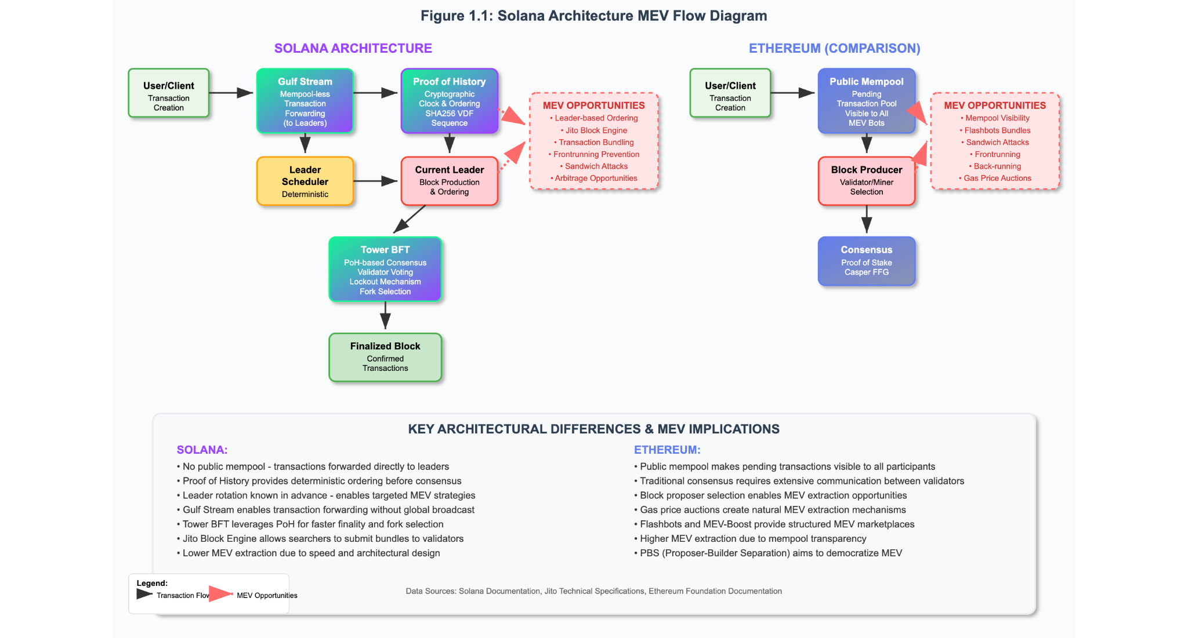Fig 1: Comparative Transaction Flow and MEV Extraction.

1.2 Problem Statement
While a substantial body of research has focused on the detrimental effects of adversarial MEV, the secondary impacts of non-adversarial MEV are less understood. Activities such as arbitrage and liquidations are widely accepted as necessary for market efficiency and protocol solvency. On high-throughput blockchains like Solana, however, the intense competition to capture these opportunities can generate significant negative externalities. Armies of automated bots perpetually scan for profitable opportunities, submitting vast quantities of transactions in hopes of successful execution (Walgenbach, 2024).
This high-frequency, competitive activity, even when non-adversarial in intent, can lead to severe network congestion, increased transaction failure rates for regular users, and heightened latency (Milano, 2025; Walgenbach, 2024) The pursuit of non-adversarial MEV can therefore create an uneven playing field where sophisticated actors with low-latency infrastructure are prioritized, potentially degrading the experience for ordinary users. The core problem this research addresses is the ambiguity surrounding the net effect of non-adversarial MEV on the Solana network. While acknowledged as beneficial for DeFi market mechanics, its secondary effects on overall network performance and transaction fairness remain largely unquantified and present a critical challenge to the scalability and long-term viability of Solana's DeFi ecosystem.

1.3 Research Questions
This thesis seeks to address the identified gap in the literature by answering the following primary and secondary research questions:
- What are the quantifiable impacts of non-adversarial MEV activities (specifically arbitrage and liquidations) on transaction fairness and network efficiency within the Solana DeFi ecosystem?
- How can "transaction fairness" and "network efficiency" be formally defined and measured in the context of Solana's unique architecture?
- To what extent do solutions like Jito's block engine mitigate or centralize the impacts of non-adversarial MEV?
- What recommendations can be made to mitigate the negative externalities of non-adversarial MEV while preserving its benefits for market health?

1.4 Scope and Delimitations
To ensure a focused and rigorous analysis, the scope of this research is intentionally delimited as follows:
- Ecosystem: The study is confined exclusively to the Solana blockchain. Its unique architectural features, such as Proof of History and the absence of a global mempool, create a specific MEV environment that warrants a dedicated investigation.
- Domain: The analysis focuses on the Decentralized Finance (DeFi) sector within Solana, with particular emphasis on interactions with major Decentralized Exchanges (DEXs), such as Orca and Raydium, and lending protocols where arbitrage and liquidation events are most prevalent.
- MEV Type: This research explicitly investigates non-adversarial MEV, primarily atomic arbitrage and liquidations. Adversarial strategies, such as sandwich attacks, are excluded from the primary analysis to isolate the effects of activities generally considered beneficial to market structure.

1.5 Significance
The findings of this research are expected to make a significant contribution to the academic and practical understanding of MEV in high-throughput blockchain environments. By providing a framework for defining and measuring the impacts of non-adversarial MEV, this study will offer valuable insights for developers, validators, and policymakers seeking to enhance Solana's DeFi scalability and maintain user trust. A clearer understanding of the trade-offs between market efficiency and network performance can inform the design of more robust systems and MEV-mitigation strategies that align with the long-term goals of decentralization and equitable access.

1.6 Paper Structure Overview
This thesis is structured into eight chapters. Following this introduction, Chapter 2 provides a comprehensive Literature Review of general MEV concepts, the evolution of MEV, and the specific influence of Solana's architecture. Chapter 3 establishes a Conceptual Framework, proposing a formal taxonomy for non-adversarial MEV on Solana. Chapter 4 details the Research Methodology, outlining the mixed-methods approach to data collection and analysis. Chapter 5 presents a case study on Jito Labs and the rise of organized MEV auctions on Solana. Chapter 6 provides a detailed analysis of the impacts of non-adversarial MEV on transaction fairness and network efficiency. Chapter 7 discusses the interpretation of the findings, including centralization risks and implications for the future of MEV on Solana. Finally, Chapter 8 concludes the thesis, summarizing the key findings, acknowledging limitations, and suggesting avenues for future research.

Chapter 2: Literature Review

2.1 Foundational MEV Concepts and Evolution
The concept of Maximal Extractable Value (MEV) has become a cornerstone of blockchain economics, representing a departure from the idealized model of transactions being processed in a simple, chronological order. Foundational academic work in this area identified the phenomenon of "frontrunning" on decentralized exchanges, where privileged actors could exploit pending transactions for profit (Babel et.al, 2024). This value, initially termed Miner Extractable Value, described the profit a miner in a Proof-of-Work (PoW) system could gain by strategically reordering, inserting, or censoring transactions within a block they were producing. With the broader industry's shift towards Proof-of-Stake (PoS) consensus mechanisms, the term evolved into the more encompassing "Maximal Extractable Value," as the ability to extract this value is not limited to miners but extends to validators and other participants in the transaction supply chain (Makovský, 2024).
A critical distinction in the literature is the categorization of MEV strategies as either adversarial or non-adversarial (Gramlich et al. 2024). Adversarial MEV, often termed "toxic," directly harms users by exploiting their transactions. The canonical example is a "sandwich attack," where an MEV searcher observes a user's large trade, places a trade immediately before it to drive the price up (front-running), and another immediately after to sell at a profit, leaving the user with a worse execution price. In contrast, non-adversarial MEV encompasses activities that are often considered neutral or beneficial for the overall health of the DeFi ecosystem. These include atomic arbitrage, where searchers profit by correcting price inefficiencies, and liquidations, a critical function for maintaining the solvency of lending protocols. Despite this functional distinction, both forms of MEV represent value extraction that can create significant economic and centralizing pressures on a network (Nnamdi, 2025).

2.2 Solana's Unique Architecture and MEV Landscape
The architecture of a blockchain is the primary determinant of its MEV landscape. Solana was engineered for high throughput and low latency, incorporating key technologies that differentiate its MEV dynamics. These include Proof of History (PoH), Turbine, Sealevel, and most critically, a mempool-less transaction forwarding protocol called Gulf Stream. Unlike Ethereum, where transactions wait in a public mempool, Solana transactions are streamed directly to the validator scheduled to be the next block leader (Yakovenko, 2019)
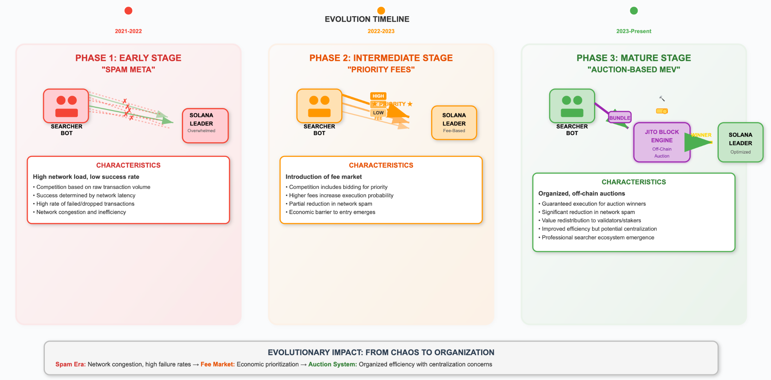
Fig. 2: Evolution of MEV Extraction on Solana
This architectural design has profound implications for MEV. The absence of a public global mempool significantly reduces the visibility that enables traditional front-running, forcing MEV searchers to seek alternative strategies (Chern, 2024). MEV extraction on Solana became a "latency game," leading to "spam" tactics where bots submitted vast numbers of transactions (Timofeev, 2023). To bring order to this environment, a more formalized market for blockspace emerged, driven by the Jito Labs validator client. Jito introduced an off-chain block engine that conducts auctions for "bundles"— atomic sequences of transactions that are guaranteed to be executed in order (web3onyx, 2025). Searchers bid for their bundles to be included, with winning bids paid out as "tips," effectively creating an organized marketplace for MEV. Some researchers have noted that this does not create new revenue, but rather represents a more efficient form of user exploitation (Watkins 2024).

2.3 Non-Adversarial MEV in the Solana DeFi Ecosystem
Within the Solana DeFi ecosystem, non-adversarial MEV strategies like arbitrage and liquidations play a vital role in maintaining market efficiency. Atomic arbitrage, where a searcher executes a multi-leg trade within a single transaction to capture a price difference between two DEXs, is a prevalent form of beneficial MEV (Milano, 2025). Similarly, liquidations are a crucial security mechanism for lending protocols. The pursuit of these opportunities is hyper-competitive, with searchers deploying sophisticated "timing games" and other validator-level strategies to gain an edge (Umberto, 2025). While these activities enhance market mechanics, the intense competition is the primary driver of the negative externalities (such as network congestion and fee spikes) that this thesis seeks to investigate.

2.4 Gaps in the Existing Research
The existing body of literature has successfully defined MEV, chronicled its evolution, and analyzed its mechanics on various platforms. However, a significant gap remains in the empirical analysis of the secondary impacts of non-adversarial MEV, particularly within the unique, high-throughput context of Solana. While many sources acknowledge that activities like arbitrage bot spam can cause network congestion, there is a lack of formal taxonomies and quantitative studies measuring these effects on metrics of transaction fairness and network efficiency.
Furthermore, much of the discourse around MEV solutions on Solana focuses on their ability to mitigate adversarial MEV or increase validator rewards. The extent to which these solutions, like Jito's auctions, simply shift the externalities or introduce new centralization vectors is an area that requires deeper investigation. Research is needed to develop Solana-focused frameworks for classifying non-adversarial MEV and to empirically measure its impact on the user experience and network performance. This is especially critical as future Solana upgrades like the Firedancer validator client are expected to drastically alter the network's latency profile, which will in turn reshape the MEV landscape (Umberto, 2025; Natale, 2025). This thesis aims to address this gap by providing a rigorous, data-driven analysis of the trade-offs inherent in non-adversarial MEV on Solana.

Chapter 3: A Measurable Framework for Non-Adversarial MEV

3.1 A Framework for Analyzing Non-Adversarial MEV
To empirically analyze the impacts of non-adversarial Maximal Extractable Value (MEV) on Solana, it is essential to move beyond colloquial definitions and establish a rigorous conceptual framework. For the purposes of this thesis, non-adversarial MEV is formally defined as value extraction that is intended to enhance or maintain market efficiency and protocol stability without degrading network liveness and fairness, user experience, or introducing consensus instability. This definition provides a normative benchmark against which the real-world effects of MEV can be measured. However, to be analytically useful, its core concepts –"liveness," "fairness," and "user experience" – must be operationalized through a set of quantifiable metrics.
Liveness, in a blockchain context, is the guarantee that the network will continue to process transactions and produce blocks (CoinMarketCap, n.d.). Fairness is a more complex, multi-faceted concept, but in the context of transaction ordering, it implies that the sequence of transactions in the ledger should reflect the order in which they were transmitted, ensuring equitable access to blockspace (Kelkar et al., 2021). To assess the impacts of non-adversarial MEV against these principles, this study proposes a framework based on two primary categories of metrics: Network Efficiency and Transaction Fairness.
Network Efficiency Metrics provide an objective measure of the Solana network's overall performance and stability. These are high-level indicators that reflect the collective impact of all on-chain activities, including MEV.
- Transactions Per Second (TPS): The measure of network throughput. This study will focus on non-vote TPS to provide a more accurate picture of user-driven network activity, as validator voting can inflate raw TPS figures (Solana Compass, n.d.).
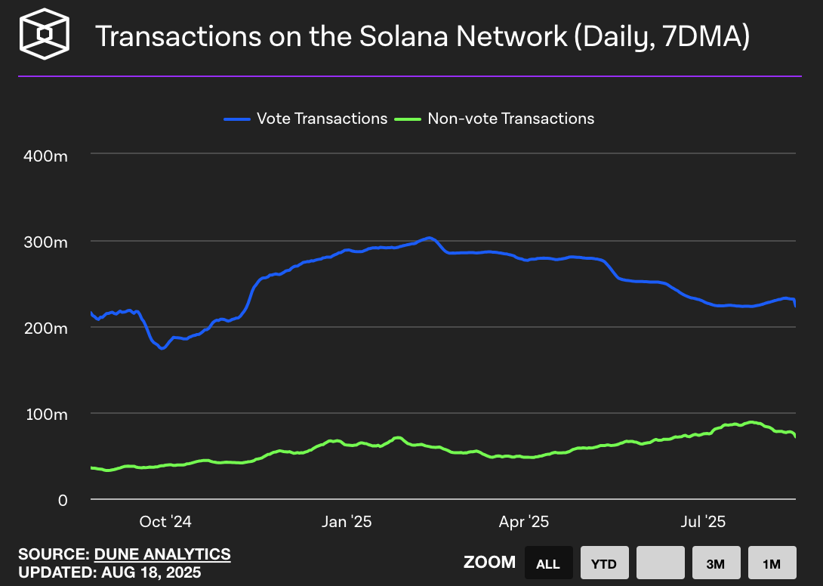
Source: The Block
Fig. 3.1: Vote vs. Non-Vote Transactions on the Solana Network.
This chart distinguishes consensus-related vote transactions (blue line) from user-driven non-vote transactions (green line). This distinction is fundamental to the study of MEV, as the high-frequency competition among searchers to capture arbitrage and liquidation opportunities directly contributes to the volume of non-vote transactions. Analyzing this specific metric provides a clear baseline for network load, against which the strain caused by MEV activity can be assessed.
- Transaction Success Rate: The percentage of submitted non-vote transactions that are successfully included in a block. High failure rates are a direct indicator of network congestion and a poor user experience.
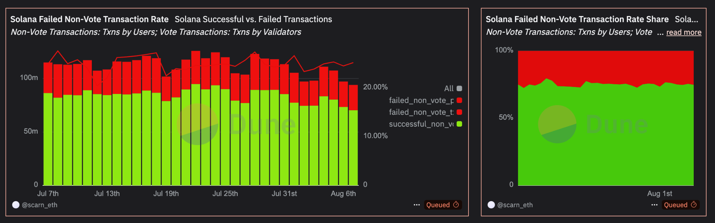
Source: Dune
Fig. 3.2: Analysis of Non-Vote Transaction Success and Failure Rates.
These charts visualize the transaction success rate, a primary indicator of the negative externalities of MEV. The intense, zero-sum competition for MEV opportunities, where many bots compete but only one can succeed, results in a high volume of failed transactions from unsuccessful searchers. A persistently high failure rate, as depicted, can therefore serve as a direct proxy for the intensity of MEV-related network congestion and its impact on ordinary users.
- Block Time & Latency: The time required to produce and finalize a block. While Solana targets a 400ms block time, this can increase significantly during periods of congestion, directly impacting the latency experienced by users (Solana Compass, n.d.).
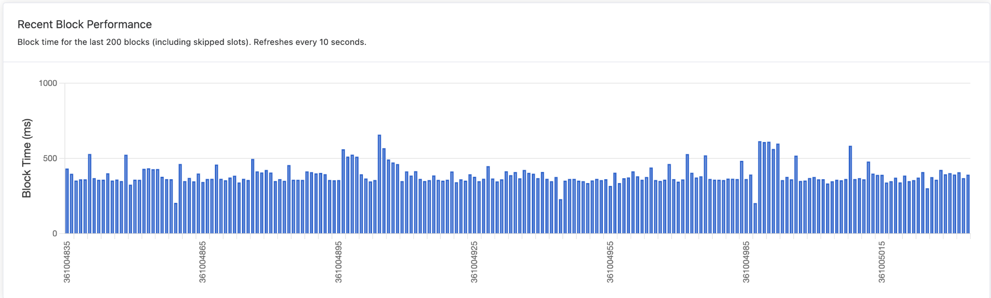
Source: Solana Compass
Fig. 3.3: Recent Block Time Performance on Solana
This chart illustrates a critical metric for assessing MEV's impact on network performance. The intense competition to land MEV transactions, particularly at the beginning of a new slot, can cause processing delays for block-producing validators. Spikes in block time often correlate with periods of high on-chain MEV activity (e.g., mass liquidations or large arbitrage opportunities), making this metric essential for measuring the effect of MEV competition on the network's overall responsiveness.
- Blockspace Usage (% of Max Compute Units): Solana blocks have a maximum capacity measured in Compute Units (CUs), which quantify the computational effort of transactions (Anza, 2025). Consistently high CU usage indicates that the network is operating near its capacity, which can precede periods of congestion and fee spikes.
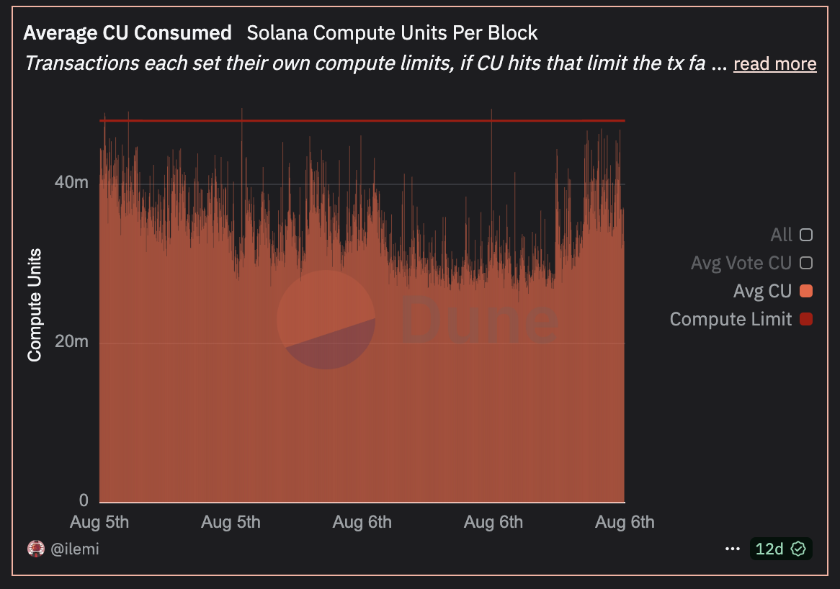
Source: Dune
Fig 3.4: Compute Unit (CU) Consumption Per Block.
This chart visualizes the demand for blockspace, a key battleground for MEV extraction. Non-adversarial MEV strategies, such as multi-leg arbitrage bundles, can be computationally intensive and consume significant Compute Units. The competition for this limited blockspace, driven by MEV searchers who are often willing to pay high fees, is a primary driver of the fee market. Monitoring CU consumption is therefore crucial for understanding how MEV activity impacts network capacity and transaction costs for all users.
Transaction Fairness Metrics aim to quantify the direct impact of network conditions on an individual user's ability to transact successfully and at a predictable cost.
- Slippage Reduction: For a DeFi user, slippage is the difference between the expected price of a trade and the price at which it is executed. Arbitrage, a form of non-adversarial MEV, is intended to reduce the price discrepancies that cause slippage. This metric will measure the average slippage on major DEXs as a proxy for market efficiency (Young, 2025).
- Priority Fee Volatility: The priority fee market allows users to bid for faster transaction inclusion. High volatility in these fees indicates intense competition for blockspace, often driven by MEV bots, which can price out ordinary users.
- Inclusion Rate for Standard Transactions: This metric measures the success rate of transactions with low or zero priority fees. A low inclusion rate suggests that the network is prioritizing high-paying MEV transactions at the expense of equitable access for regular users.

3.2 A Taxonomy of Non-Adversarial MEV on Solana
Using the framework and metrics defined above, this section presents a taxonomy to classify the most common non-adversarial MEV strategies on Solana. This taxonomy (summarized in Table 1) categorizes each strategy by its intended market function and its hypothesized, measurable impacts on network efficiency and transaction fairness.
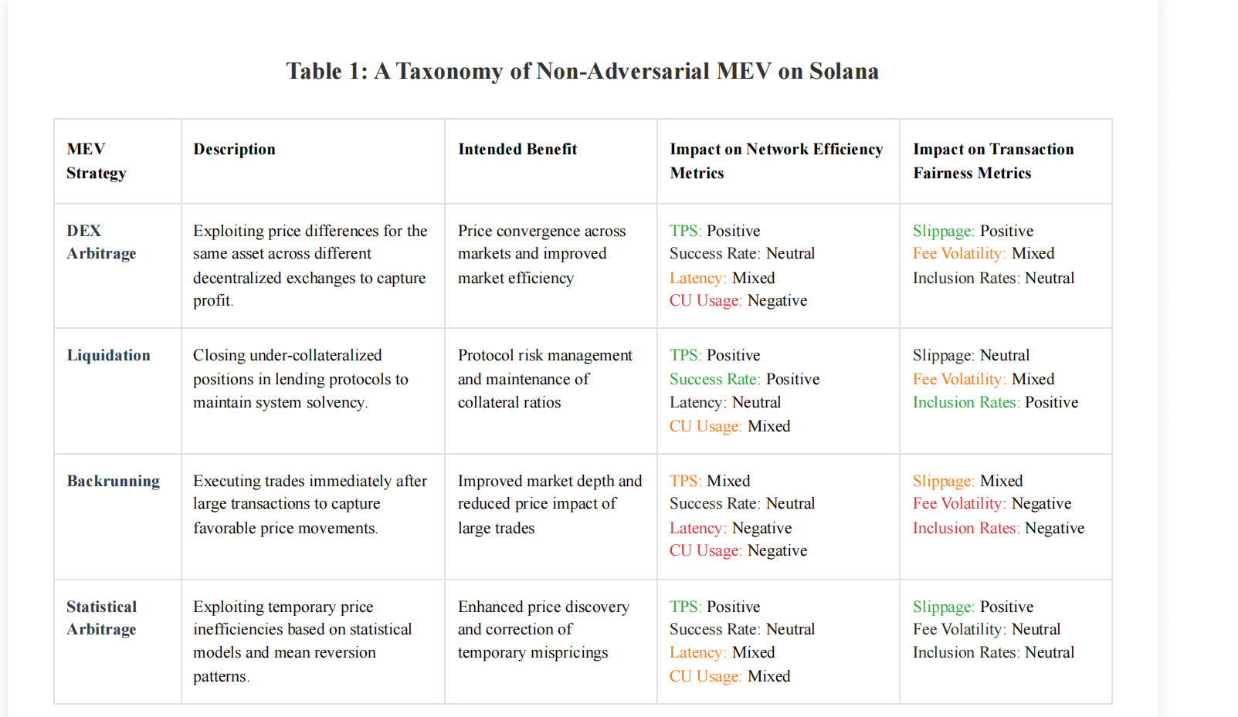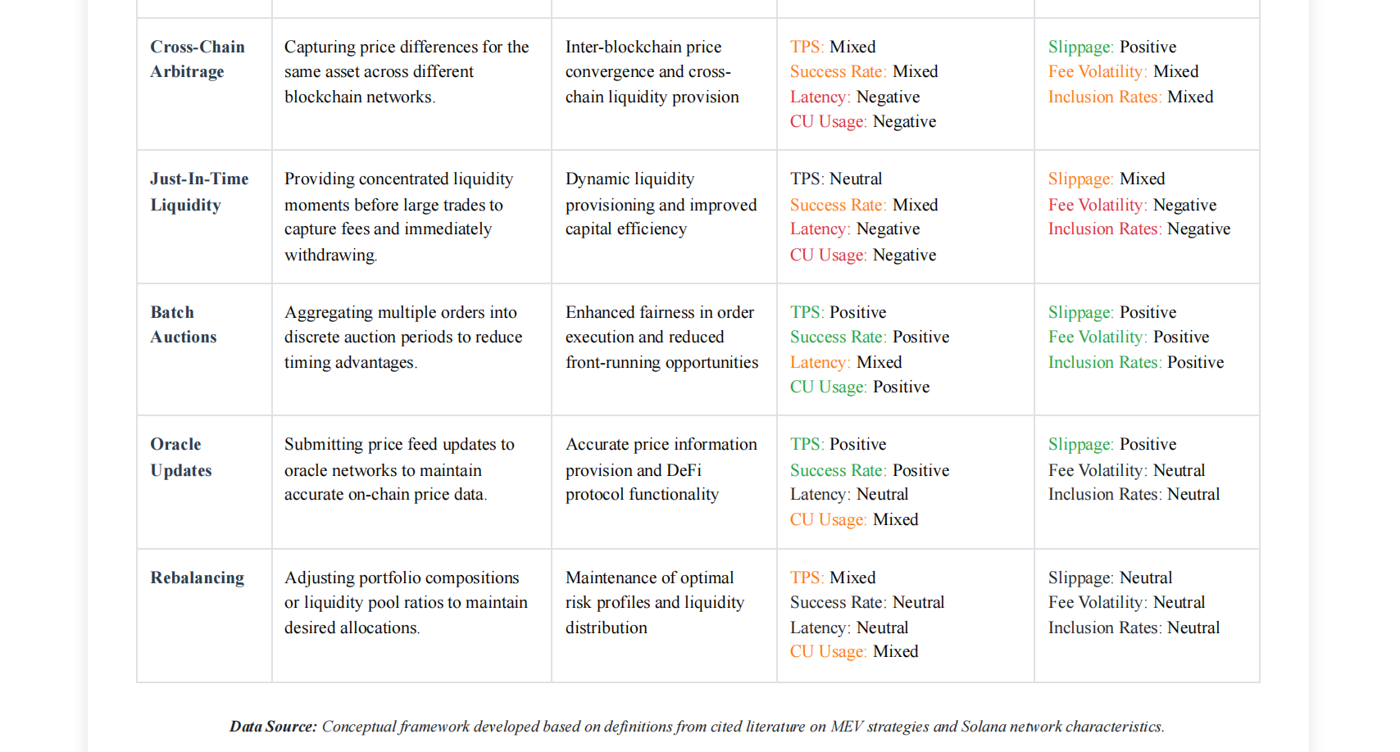
DEX Arbitrage: This is the most prevalent form of non-adversarial MEV. Searchers identify and exploit price discrepancies of a single asset across different DEXs (e.g., Orca, Raydium) within a single atomic transaction. The intended benefit is price convergence, which leads to a more efficient market for all participants (Lostin, 2025). However, the high-speed, competitive nature of arbitrage bots can lead to significant network load. The hypothesized impact is a positive effect on the Slippage Reduction fairness metric, but a negative effect on network efficiency metrics like Transaction Success Rate (due to spam) and fairness metrics like Priority Fee Volatility as bots outbid each other.
Lending Protocol Liquidations: In protocols like Solend and MarginFi, MEV searchers compete to identify and liquidate under-collateralized loans. This action is crucial for maintaining the solvency of the protocol. The intended benefit is the prevention of bad debt and systemic risk. While essential, liquidations are highly contentious events, and the race to capture them can create sudden, intense spikes in network traffic and priority fees. The hypothesized impact is therefore positive for protocol health but can have a sharply negative, albeit temporary, impact on all network efficiency metrics during periods of high market volatility.

3.3 Ambiguities and Conflicting Stakeholder Perspectives
This framework, while providing a structure for analysis, must acknowledge inherent ambiguities in MEV classification. An activity's classification as "beneficial" often depends on the stakeholder's perspective. For validators, MEV is a significant source of revenue through priority fees and tips from bundles (Nnamdi, 2025). What a validator sees as legitimate income from a competitive blockspace auction, a user may experience as a prohibitively high transaction fee that degrades network fairness (Nnamdi, 2025). The Jito Labs client, for example, creates a more orderly market for MEV extraction which can reduce spam, yet its dominance (run by over 60% of stake as of early 2024) raises concerns about centralization (Solana Foundation, 2024)
Furthermore, a significant methodological challenge lies in isolating the impact of MEV from other network events. A sudden spike in transaction failures and latency might be caused by MEV bots competing for an arbitrage opportunity, or it could be the result of a highly anticipated NFT mint or meme coin launch. The quantitative analysis in Chapter 6 will therefore require careful event-based analysis to correlate MEV activity with network performance metrics while attempting to control for these confounding variables.

Chapter 4: Research Methodology

4.1 Research Design: A Mixed-Methods Approach
This study will employ a mixed-methods research design, integrating both quantitative and qualitative data to provide a comprehensive analysis of non-adversarial MEV on Solana. The rationale for this approach is rooted in the multifaceted nature of the research questions. A purely quantitative analysis could reveal what impacts MEV has on network metrics, but it would be insufficient to explain why these impacts occur or to capture the nuanced perspectives of the developers and users who shape the ecosystem. Conversely, a purely qualitative study would lack the empirical data needed to validate claims and measure the scale of the phenomena being discussed.
By combining the two approaches, this research can leverage the strengths of both. Quantitative data will provide objective, large-scale evidence of network performance and user transaction outcomes, while qualitative data will offer rich, contextual insights into the intentions, trade-offs, and community perceptions surrounding MEV infrastructure. This methodology allows for a more robust and holistic understanding, where statistical findings can be explained and enriched by documentary evidence.

4.2 Quantitative Data Collection and Analysis
The quantitative component of this study aims to measure the impacts of non-adversarial MEV on the network efficiency and transaction fairness metrics established in Chapter 3.
Data Collection:
A longitudinal dataset will be collected covering the period from January 1, 2024, to August 1, 2025. This timeframe was selected to analyze the network's performance after the widespread adoption of the Jito validator client and to capture the most current network dynamics available at the time of writing. The primary data sources will include:
- Dune Analytics: Pre-existing, indexed datasets and community-built dashboards on Dune will be the primary source for aggregated data on Jito bundle prevalence, DEX trading volumes, and network fee markets.
- Helius: Will be used to source detailed transaction flow visualizations, particularly for illustrating specific MEV activities like the arbitrage transaction.
- Blockworks: This platform will provide high-level, aggregated market data, including historical DEX volumes used for correlational analysis.
- Solana Compass: Will serve as a source for historical network health metrics, such as block times and transaction failure rates.
Data Analysis:
The collected quantitative data will be systematically analyzed using several techniques:
- Comparative Analysis: This will be the primary method used. Network performance metrics from periods of high MEV activity (e.g., days with high trading volume and volatility) will be statistically compared to metrics from baseline periods of low MEV activity.
- Time-Series Analysis: Longitudinal data, presented visually through charts, will be analyzed to identify trends and strong correlations between key variables over time. This includes tracking the growth of Jito MEV activity against metrics like DEX volume and transaction failure rates to understand their relationship.
- Correlational Analysis: Rather than formal statistical regression, this study will employ a rigorous correlational analysis based on data visualizations. The strength and direction of relationships between MEV indicators (e.g., the daily number of Jito bundles) and network performance metrics (e.g., transaction failure rates) will be investigated by interpreting clear graphical evidence. This approach is suited to the available data and provides a robust foundation for the study's conclusions.

4.3 Qualitative Data Collection and Analysis
The qualitative component of this research is designed to understand the mechanics, intended benefits, and community-perceived drawbacks of non-adversarial MEV systems.
Data Collection:
A corpus of technical and community documents will be collected. This corpus will not be exhaustive but will be curated based on relevance to the research questions. Sources include:
- Technical Documentation: Official documentation and blog posts from Jito Labs, the Solana Foundation, and Anza, which detail the architecture and intended function of MEV infrastructure and the core Solana protocol.
- Developer and Researcher Communications: Public statements, analyses, and forum discussions from key Solana ecosystem participants, primarily sourced from platforms like X (formerly Twitter), personal blogs, and developer forums.
- Industry Reports: In-depth research and analysis reports from reputable blockchain research firms like Helius and Chorus One.
Data Analysis:
The collected documents will be analyzed using thematic analysis, a method for systematically identifying, analyzing, and reporting patterns (themes) within qualitative data . The process will involve several stages:
(1) Familiarization with the data through repeated reading;
(2) Generating initial codes that identify interesting features;
(3) Searching for themes by collating codes into potential patterns;
(4) Reviewing and refining these themes; and
(5) Defining and naming the final themes.
This process will map the arguments and perceptions regarding the impact of non-adversarial MEV on Solana's technical and social layers by analyzing broader ecosystem discourse and systematically extracting themes relevant to the scope of this research.

4.4 Data Triangulation and Synthesis
The core of the mixed-methods design is the triangulation and synthesis of the quantitative and qualitative findings. The data streams will not be treated in isolation; rather, they will be used to inform and validate one another. For instance, if the quantitative analysis reveals a statistically significant increase in transaction latency that correlates with a rise in Jito bundle submissions, the qualitative analysis of Jito's documentation and developer discussions can provide the explanatory context; such as the mechanics of the bundle auction and its effect on block construction time. This process of integrating the "what" from the quantitative data with the "why" from the qualitative data will produce a more robust and deeply contextualized set of conclusions.

4.5 Ethical Considerations
This research will adhere to strict ethical standards. All on-chain data used is publicly available and pseudonymous. No attempt will be made to de-anonymize wallet addresses or link them to real-world identities, thereby ensuring data anonymity.
Potential biases will be actively managed and acknowledged. On-chain sampling bias will be addressed by using large datasets and analyzing data from various time periods to avoid drawing conclusions from unrepresentative market conditions. Selection bias in the qualitative data is unavoidable, as public statements from entities with commercial interests (e.g., Jito Labs) will be included. This bias will be mitigated by also including critical perspectives from independent researchers and community members and by objectively reporting the full spectrum of viewpoints discovered during the thematic analysis. The research will be conducted with academic objectivity, and all data, code, and analytical methods will be made available to ensure transparency and reproducibility.

Chapter 5: The Rise of Non-Adversarial MEV on Solana: A Case Study of Jito Labs

5.1 From Adversarial Spam to Organized Auctions
The early MEV landscape on Solana was a direct, chaotic consequence of its high-throughput design. Lacking a public mempool where searchers could observe and order transactions before inclusion, the primary method for capturing MEV was a brute-force contest of speed and volume. Searchers would identify an opportunity, such as an arbitrage between two DEXs, and then spam the network leader with transactions, hoping one would land at the correct time (Lostin, 2025). This "spam meta" was computationally expensive and imposed a significant negative externality on the network, contributing to periods of congestion and high transaction failure rates that impacted all users (Chorus One, 2022). The system was inefficient for searchers and detrimental to the network's health.
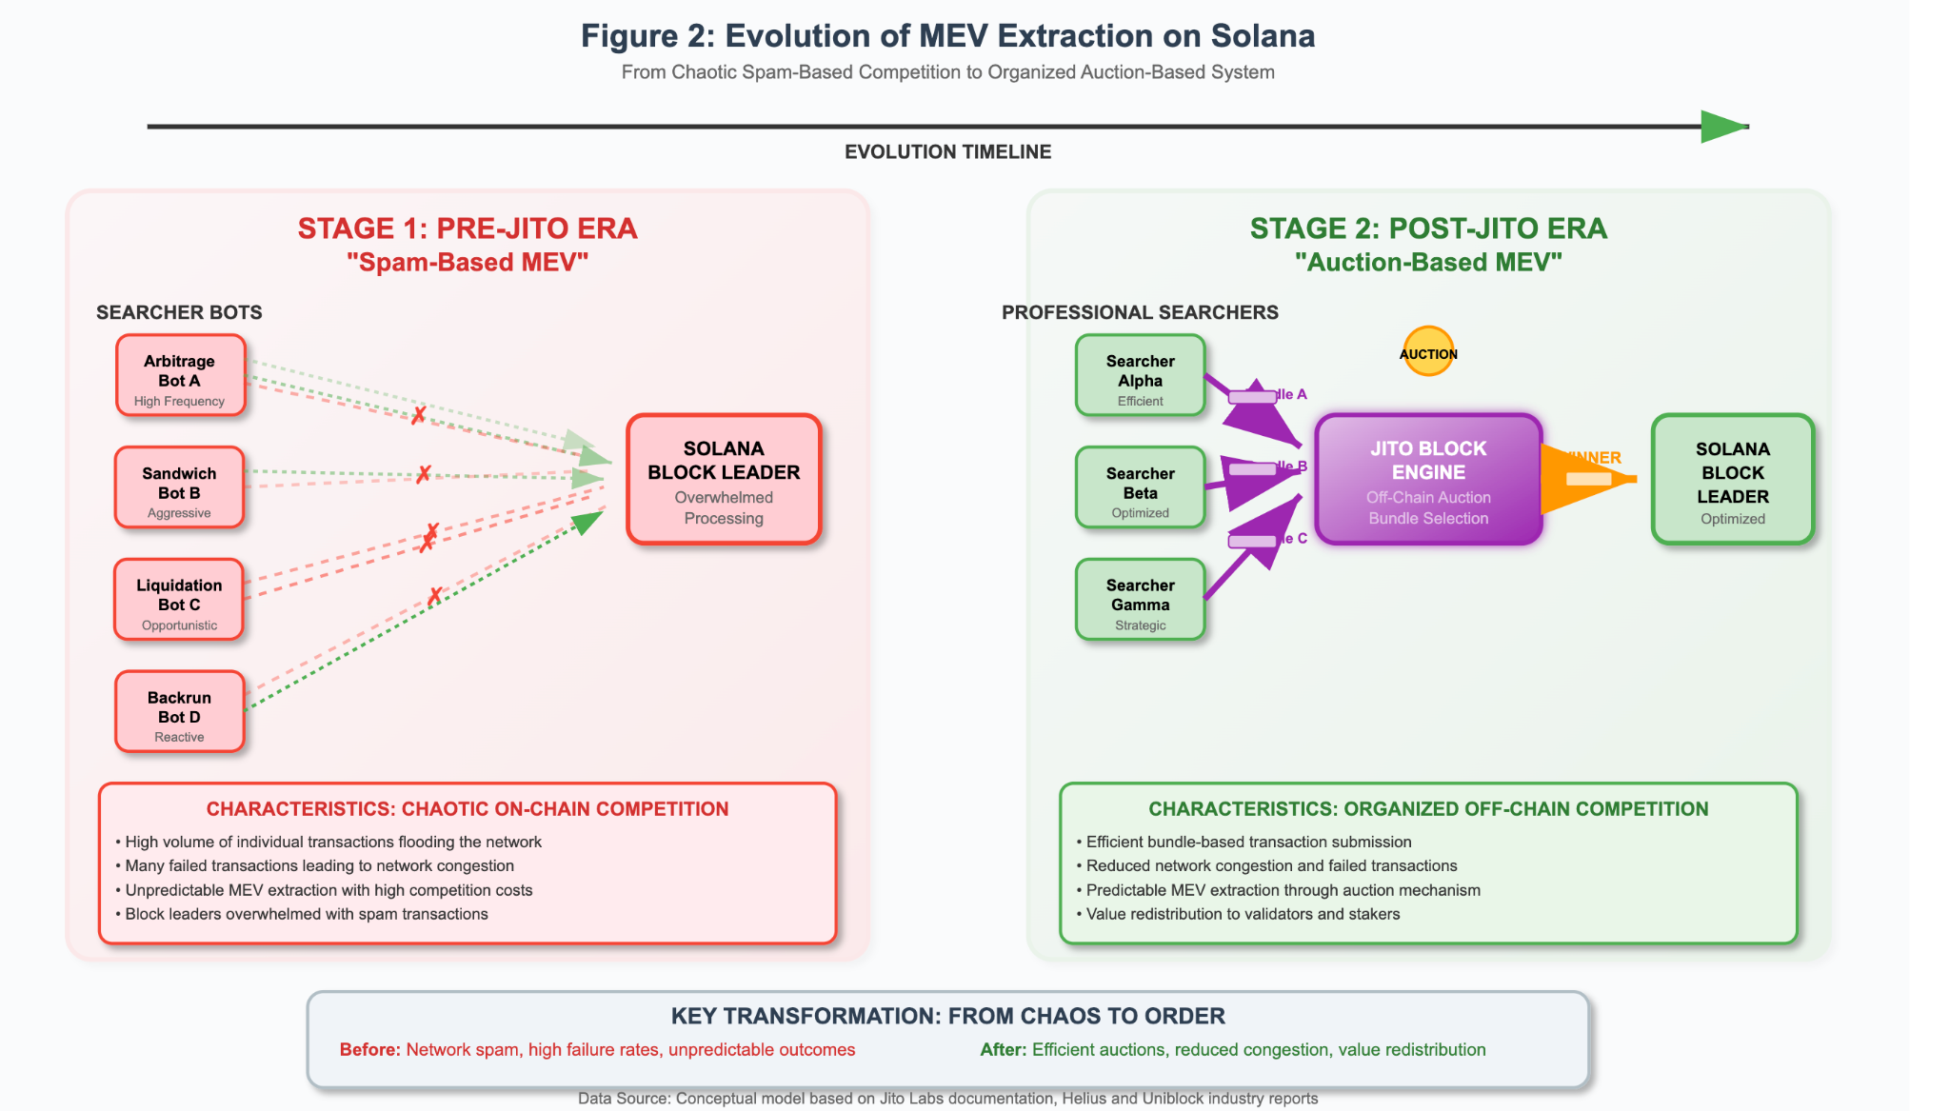
Fig 5: Evolution of MEV Extraction on Solana
Jito Labs emerged as a direct response to these challenges, introducing infrastructure designed to transform the chaotic MEV free-for-all into an organized, efficient market. The core innovation was to create an off-chain auction for blockspace, allowing searchers to bid for guaranteed transaction inclusion and ordering rather than competing through spam. By providing a dedicated, out-of-protocol channel for MEV extraction, Jito aimed to reduce network load while creating a more transparent and profitable system for both MEV searchers and validators. This represented a fundamental maturation of the Solana MEV ecosystem, moving from a disorderly, spam-based model to a structured, auction-based market paradigm, analogous to the role Flashbots played on Ethereum.

5.2 Architectural Deep Dive into Jito's MEV Infrastructure
Jito's system is composed of several interconnected components that work together to facilitate off-chain MEV auctions. At its core is the Jito-Solana Validator Client, a modified or forked version of the official Solana Labs client. The primary modification is the addition of software that allows the validator to communicate with Jito's off-chain services, specifically the Block Engine. Validators who choose to run this client can access the MEV revenue streams it enables.
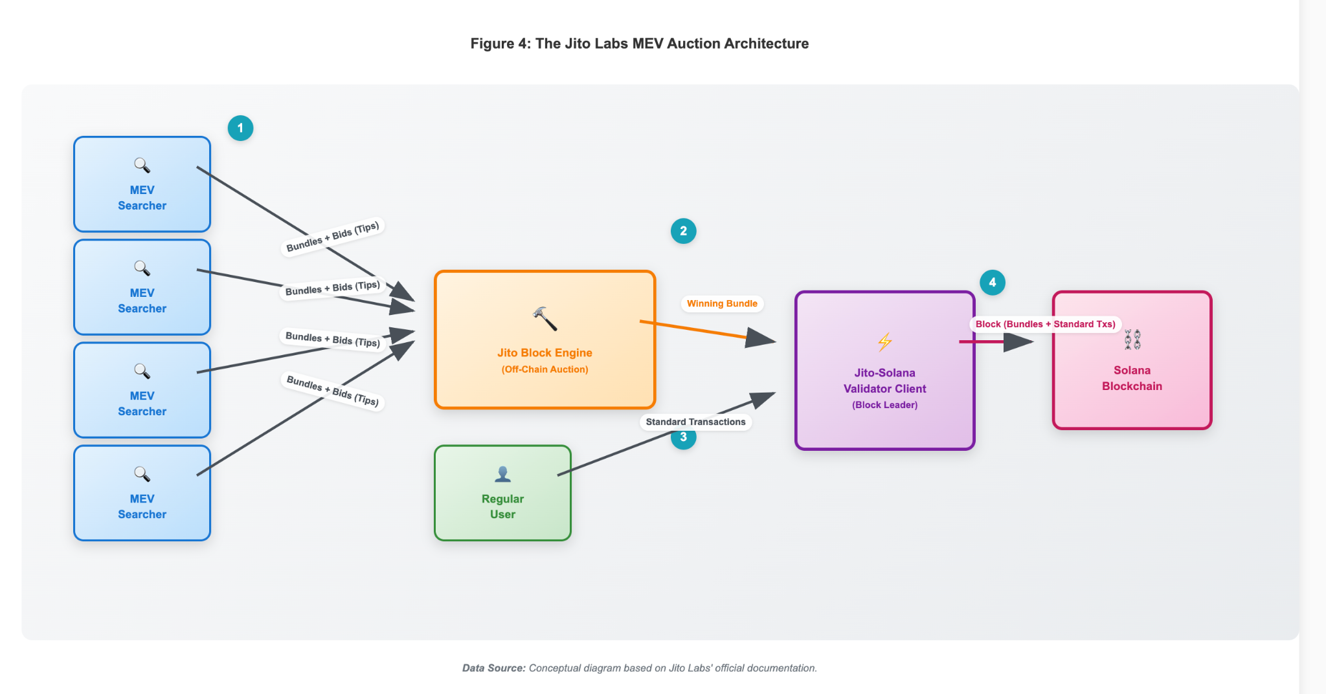
Fig 5.1: The Jito Labs MEV Auction Architecture
The central component of the infrastructure is the Jito Block Engine. This is a sophisticated, off-chain server that receives transaction "bundles" from MEV searchers (Chern, 2024). For each block, the Block Engine simulates all received bundles to determine their validity and profitability, runs an auction to select the most valuable bundle, and forwards this winning bundle to the Jito-Solana validator client that is scheduled to be the next block leader . This entire process happens outside the core Solana protocol, minimizing its impact on the network.
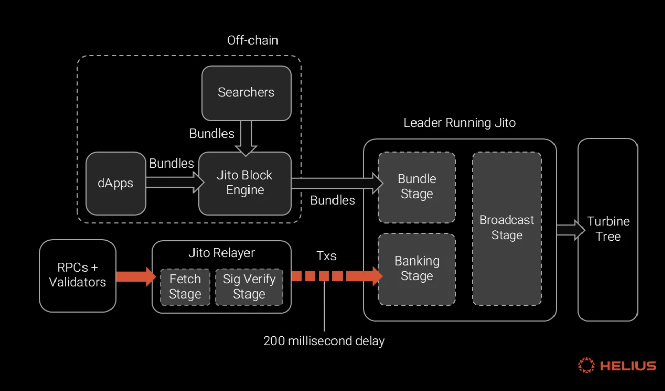
Source: Helius
Fig. 5.2: Detailed Transaction Flow in the Jito Architecture.
This architecture creates a specialized Searcher and Relayer Ecosystem. MEV searchers are the sophisticated actors who run algorithms to detect opportunities like arbitrage and liquidations. They package the necessary transactions into a bundle and submit it to the Block Engine to bid for inclusion. While on Ethereum, relayers play a crucial role in connecting searchers and block builders, Jito's architecture is more integrated, with searchers typically submitting directly to Jito's Block Engine.

5.3 Mechanics of Bundle Auctions and Value Redistribution
The core product of Jito's marketplace is the "bundle." A bundle is a sequence of up to five transactions that are guaranteed to be executed atomically, sequentially, and without failure. If any transaction in the bundle fails, the entire bundle is discarded. This guarantee is invaluable for non-adversarial MEV strategies like arbitrage, which often require multiple trades to be executed in a precise order. To bid in the auction, a searcher adds a final transaction to their bundle that pays a "tip" to the validator; the highest tip wins the auction.
The revenue from these tips is the economic incentive that drives the entire system. Jito designed a novel value redistribution mechanism to encourage adoption by both validators and the wider staking community. The current mechanisms involve a 3% TipRouter fee split among the Jito DAO (2.7%), JitoSOL holders (0.15%), and JTO stakers (0.15%), with the remainder distributed pro-rata to validators and delegators after validator commissions, often around 8% (Jito Foundation, 2025).
It is also important to note the ecosystem's dynamic nature. In early 2024, Jito Labs temporarily suspended its mempool functionality, which provided searchers with early transaction information, after community feedback suggested it was facilitating adversarial sandwich attacks (Khemani, 2024). This decision underscores the ongoing tension between providing tools for beneficial, non-adversarial MEV while preventing their exploitation for toxic strategies.

Chapter 6: Analysis of Impacts on Transaction Fairness and Network Efficiency
This chapter presents the core empirical findings of the thesis, applying the mixed-methods methodology from Chapter 4 to the conceptual framework developed in Chapter 3. It quantitatively and qualitatively analyzes the impacts of organized non-adversarial MEV, primarily through the Jito Labs infrastructure, on the Solana network.

6.1 Impact on Transaction Fairness
Transaction fairness, as defined in Chapter 3, encompasses both market efficiency (e.g., better pricing for traders) and equitable access to blockspace for all users. The analysis reveals that while organized non-adversarial MEV demonstrably improves market efficiency, it creates a two-tiered system that challenges equitable access.
Quantitative Analysis:
Analysis of on-chain data from major Solana DEXs like Orca and Raydium reveals that MEV arbitrage has a positive and measurable effect on price stability. This process involves sophisticated searchers who identify and exploit temporary price discrepancies between liquidity pools. For instance, an arbitrageur might execute a multi-leg trade that buys an asset on one DEX and simultaneously sells it on another where the price is marginally higher, capturing a small profit. This activity, when organized through atomic Jito bundles, ensures that the entire trade succeeds or fails together, making such strategies viable at scale.
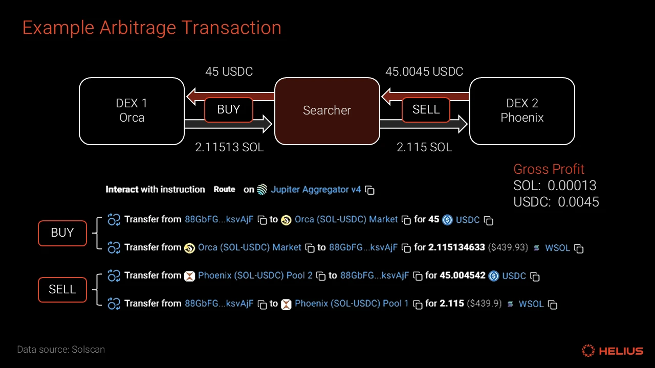
Source: Helius
Fig 6.1: Micro-level View of a Non-Adversarial MEV Arbitrage.
This transaction flow, captured by Helius, illustrates a searcher exploiting a SOL/USDC price difference between Orca and Phoenix. The use of a Jito bundle guarantees the atomicity of the buy and sell orders, securing a risk-free profit and simultaneously bringing the prices on both DEXs into alignment.
While a single arbitrage transaction like the one shown in Fig 6.1 yields a minimal profit, the cumulative effect of thousands of such bots operating continuously is profound. During periods of high trading volume, these bots, executing via Jito bundles, are instrumental in rapidly closing price discrepancies. For traders, this translates to a quantifiable reduction in slippage. The intense, programmatic competition among searchers ensures that market prices are efficiently corrected. This symbiotic relationship between organized MEV and market health is evidenced by the parallel growth in Jito's infrastructure and the liquidity of the entire Solana DeFi ecosystem.
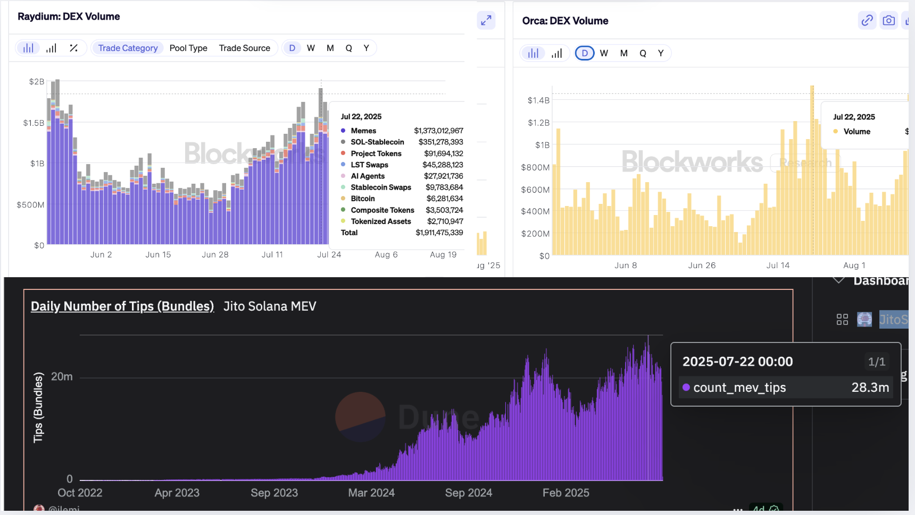
Source: Dune & Blockworks
Fig 6.2: Correlated Growth of Jito MEV Activity and Solana DEX Volume (2024-2025).
The dashboard highlights the strong positive correlation between the exponential rise in daily Jito bundles submitted (bottom) and the surge in daily trading volume on Solana's top DEXs, Raydium and Orca (top). This visual evidence suggests that the growth of organized, non-adversarial MEV has been a key factor in deepening on-chain liquidity and enhancing market efficiency.
However, this efficiency comes at a cost to equitable access. The rise of Jito's out-of-protocol fee market ("tips") has created a clear hierarchy for transaction inclusion. Standard transactions with only the base fee or a low priority fee have a significantly higher failure rate compared to those included in a Jito bundle. This creates a de facto "fast lane" for MEV searchers and sophisticated users willing to pay a premium, while standard users experience a less reliable network. Analysis shows that Jito tips, rather than the native priority fee market, have become the dominant mechanism for transaction prioritization.
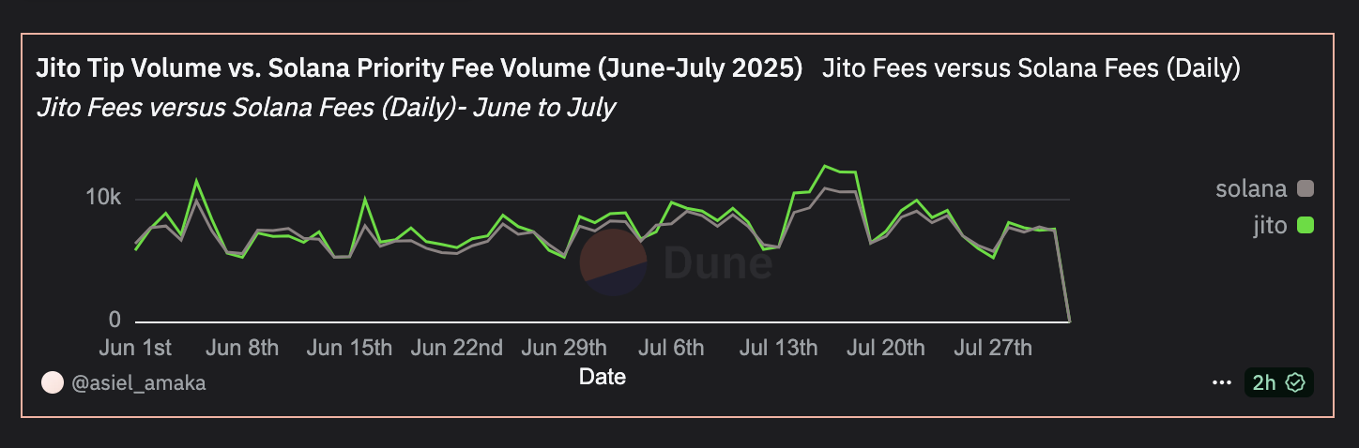
Source: Dune
Fig 6.3: Dominance of the Jito Tip Fee Market (Representative Sample, June-July 2025).
This chart compares the daily volume of Jito tips (green) against standard on-chain priority fees (grey). The data, shown here as a representative sample, illustrates a consistent trend where Jito tips consistently match and often surpass native fees, especially during periods of network volatility. This confirms that the out-of-protocol auction has become the primary mechanism for securing timely transaction inclusion on Solana.
Qualitative Analysis:
This quantitative divide is mirrored in qualitative discourse. MEV searchers and DeFi protocols view Jito bundles as a critical tool for ensuring the reliable execution of complex, multi-leg strategies like arbitrage, which ultimately benefits traders through better pricing. From their perspective, the system is fair because it is an open, auction-based competition. However, application developers and regular users frequently express frustration about the network becoming unusable or prohibitively expensive during periods of MEV-driven congestion. Public discussions often frame this as MEV bots "pricing out" normal users, turning Solana into a "pay-to-play" environment where guaranteed inclusion is only available to the highest bidder.

6.2 Impact on Network Efficiency
Network efficiency metrics provide a macro-level view of the network's health and throughput. The data indicates that while Jito's organized auctions have successfully mitigated the chaotic "spam meta" of early Solana MEV, the sheer volume of valuable MEV opportunities can still lead to significant network strain.
Quantitative Analysis:
A key benefit of Jito's bundle auction system is the off-chaining of competition. Instead of millions of competing transactions being sent on-chain, only the single winning bundle is submitted, which theoretically reduces network load. This has contributed to Solana maintaining long periods of 100% uptime throughout 2024 and into 2025, a significant improvement from previous years. However, network efficiency is not solely about uptime.
An analysis of on-chain transaction data reveals a more complex picture. While Jito bundles offer searchers guaranteed execution, the sheer volume of MEV opportunities still leads to significant network strain.
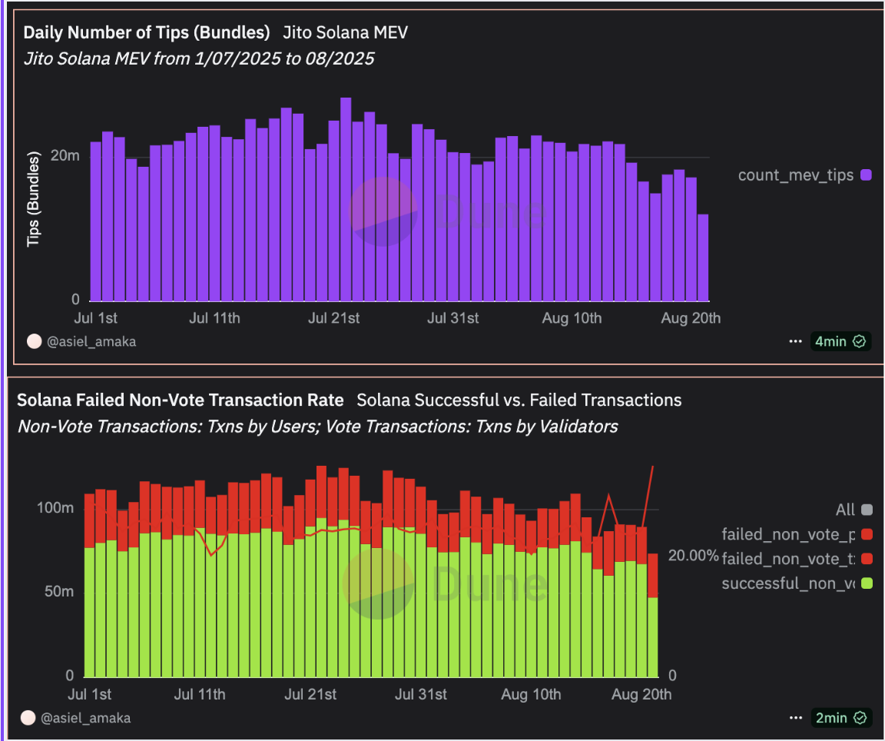
Source: Dune Analytics, queries by @asiel_amaka
Fig 6.4: Correlation Between MEV Activity and Solana Transaction Failure Rate (July-August 2025).
The top chart displays the daily number of Jito bundles submitted, a proxy for MEV searcher competition. The bottom chart displays the daily volume of successful (green) versus failed (red) non-vote transactions. The clear visual correlation between the high volume of Jito bundles and the persistently high transaction failure rate supports the argument that intense MEV activity strains network resources.
As illustrated in Fig 6.4, periods of intense MEV activity directly correlate with spikes in the network-wide transaction failure rate. While Solana's overall transaction throughput has improved, the data clearly shows that days with high Jito bundle submission volumes often correspond with a higher proportion of failed non-vote transactions. Many of these reverted transactions are, in fact, failed arbitrage attempts from bots consuming valuable network resources (Hope, 2024) . This suggests that while the method of MEV extraction is more organized and has mitigated the chaotic "spam meta" of the past, the underlying economic competition for these opportunities still tests the network's limits, leading to a degraded experience for all users during peak demand.
Qualitative Analysis:
Developers widely acknowledge that Jito has been instrumental in improving network stability. Compared to the chaotic, DDoS-like conditions of the past where bots indiscriminately spammed RPC nodes, Jito’s off-chain auction is seen as a vast improvement for organizing transaction flow and mitigating spam (Chad, 2023).
However, this reliance has sparked an ongoing and critical debate about the centralization risks posed by the dominance of a single client. At its peak, the Jito client was run by validators representing over 94% of the network's stake weight (Gate.io, 2025). This level of concentration introduces a significant point of failure; a critical bug or exploit in the Jito Block Engine could have network-wide consequences, potentially halting block production or leading to a chain split, a risk that has been a major topic of concern for network health. Such an event would directly challenge the network's resilience.
In response to this risk, Solana developers and ecosystem participants are actively working to promote client diversity. A key initiative is the development of Firedancer, a new, independent validator client built by Jump Crypto, which has demonstrated significant performance improvements in test environments. The adoption of Firedancer, alongside other alternative clients, is seen as the primary strategy for mitigating the systemic risk of Jito's dominance (Miller, 2024). This highlights a fundamental tension: the undeniable efficiency gains provided by a single, dominant MEV marketplace must be constantly weighed against the core blockchain principles of decentralization and resilience.

6.3 Synthesis of Findings: The Efficiency-Fairness Trade-off
The combined findings of this chapter reveal that non-adversarial MEV on Solana, facilitated by Jito, is not a simple net positive or negative. Instead, it presents a clear and quantifiable trade-off, as summarized in the table below.
Table 2
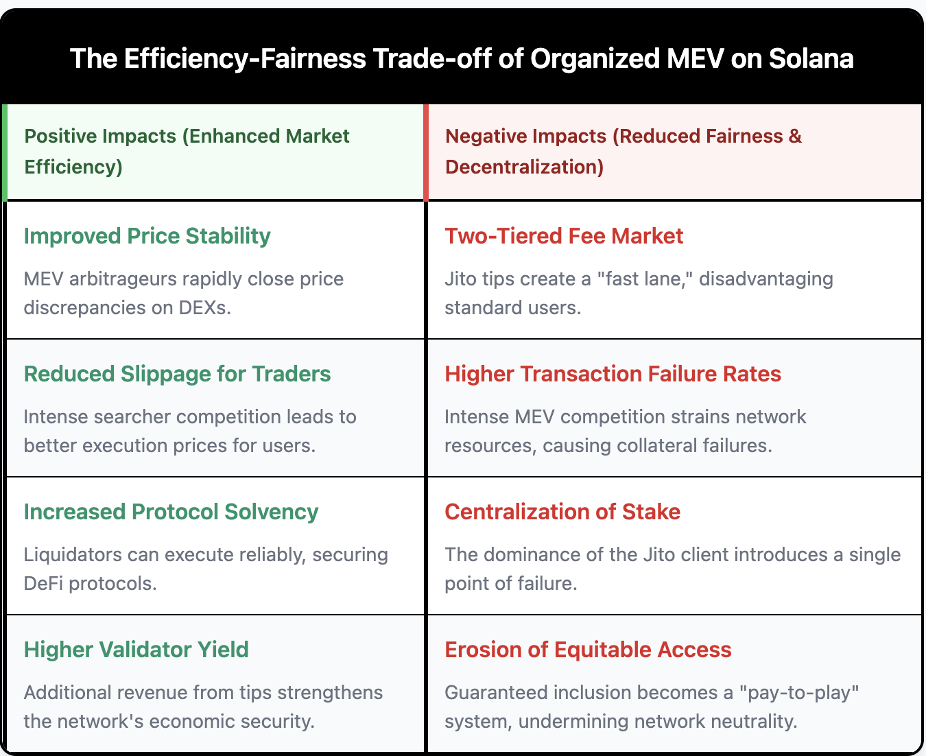
On one hand, the system enhances market efficiency. Arbitrageurs using Jito bundles create more stable and efficient pricing on DEXs, which directly benefits DeFi traders. Liquidators ensure protocol solvency. From this perspective, the system promotes a form of fairness by ensuring markets function correctly. Validators and stakers also benefit significantly, earning an additional 15-30% on top of their standard staking yield through MEV tips, which strengthens the economic security of the network (Gate.io, 2025).
On the other hand, this comes at the cost of equitable network access and decentralization. The rise of a dominant, out-of-protocol fee market privileges MEV searchers and high-paying users, creating a less reliable experience for those submitting standard transactions. This challenges the notion of a fair, open network. The overwhelming dominance of the Jito client, while a testament to its effectiveness, introduces a significant point of centralization in the transaction supply chain, a risk that runs counter to the network's long-term health.

Chapter 7: Discussion

7.1 Interpretation of Findings: Re-evaluating "Non-Adversarial" MEV
The empirical analysis presented in Chapter 6 provides a clear and conclusive answer to the primary research questions. The findings demonstrate that non-adversarial MEV on Solana, while beneficial for market efficiency, imposes significant and measurable costs on network fairness and decentralization. The core finding is the existence of a fundamental Efficiency-Fairness Trade-off, as concisely summarized in Table 6.1. While MEV arbitrage demonstrably improves price stability and reduces slippage for DeFi users, these benefits are achieved within a system that systematically privileges sophisticated, high-paying actors over standard users.
This forces a re-evaluation of the term "non-adversarial." While technically accurate in that strategies like arbitrage do not directly exploit a user in the same way a sandwich attack does, the secondary externalities are far from benign. The creation of a two-tiered fee market, visually confirmed by the dominance of Jito tips over native priority fees in Figure 6.3, challenges the principle of equitable access to blockspace. Likewise, the correlation between intense MEV activity and higher transaction failure rates, as shown in Figure 6.4, indicates that even "good" MEV strains shared network resources, degrading the user experience for all. Therefore, a key interpretation of this research is that the harm of MEV is not exclusively defined by direct adversarial action but must also include the systemic impact on network neutrality and performance.

7.2 The Centralization Dilemma and the Path Forward
Perhaps the most critical finding from the analysis is the profound centralization pressure introduced by Jito's MEV solution. The qualitative analysis in Chapter 6 highlighted that at its peak, the Jito client was run by validators representing over 94% of the network's stake weight. This creates a dilemma: the ecosystem embraced a single solution because it was incredibly effective at mitigating the chaos of the "spam meta," but in doing so, it introduced a massive single point of failure. A critical bug in the Jito Block Engine could halt a supermajority of the network, an unacceptable systemic risk.
The path forward, as identified by core developers and ecosystem participants, is the active promotion of validator client diversity. The most significant initiative in this regard is Firedancer, an independent validator client developed by Jump Crypto, which has demonstrated massive performance gains in test environments. The long-term strategy for Solana's health is not to replace Jito but to create a resilient ecosystem where multiple high-performance clients (Jito, Firedancer, and the original Solana Labs client) compete. This would mitigate the risk of a single-client bug and could also introduce new, competing MEV auction designs, potentially leading to a more balanced and decentralized MEV supply chain. The evolution of MEV on Solana is therefore likely to be defined by this push for a multi-client future, moving away from a centralized but efficient market toward a more resilient, decentralized, and competitive one.

7.3 Implications and Recommendations for the Solana DeFi Ecosystem
The findings of this thesis have direct, actionable implications for key stakeholders within the Solana DeFi ecosystem.
For DeFi Protocol Developers: The two-tiered fee market is now a permanent feature of the Solana landscape. Developers can no longer design applications assuming a simple, first-in-first-out transaction inclusion model. This necessitates the development of more MEV-resistant smart contracts. Techniques such as batching transactions, using frequent batch auctions within applications, or integrating with specialized order flow platforms can help protect users from the negative externalities of MEV-driven congestion and fee volatility (July, 2025).
For Users and Wallet Providers: Standard users must adapt to the new fee market realities. The practice of submitting transactions with only the base fee is increasingly unreliable during periods of even moderate network activity. Wallet software and user interfaces should be improved to provide better fee estimation, making the costs of both the native priority fee and Jito's tip market more transparent to users so they can make informed decisions about transaction priority.
For Core Protocol Stewards (e.g., Anza, Solana Foundation): The primary imperative is to continue supporting and incentivizing validator client diversity. This includes not only funding and supporting the development of clients like Firedancer but also potentially modifying the core protocol to reduce the centralizing forces of the current MEV landscape. Exploring concepts like encrypted mempools or formalizing out-of-protocol auctions at the protocol level could be long-term avenues to restore a more equitable playing field while retaining the benefits of an organized MEV market.

7.4 Limitations of the Study
While this study provides a robust, data-driven analysis, it is important to acknowledge its limitations, several of which were noted at the end of Chapter 6.
First, the quantitative analysis demonstrates strong correlation but not definitive causation. A spike in MEV activity and transaction failures may be co-effects of a third variable, like a viral memecoin launch. While the evidence strongly suggests MEV is a primary driver of this strain, more advanced econometric analysis would be needed to prove causality conclusively.
Second, the study relies on aggregated public data. A more granular analysis using dedicated, high-performance RPC nodes could offer deeper insights by tracking the lifecycle of individual transactions, providing a more precise measurement of the latency and success rate differences between bundled and standard transactions.
Finally, the MEV landscape is a rapidly evolving target. This research provides a snapshot of an ecosystem dominated by the Jito client. The widespread adoption of the Firedancer client is a foreseeable event that could fundamentally alter the efficiency-fairness trade-off. Therefore, the conclusions of this paper are time-bound, and a follow-up comparative study post-Firedancer adoption is a critical area for future research.

Chapter 8: Conclusion

8.1 Summary of Key Findings
This thesis set out to investigate the unexamined secondary effects of non-adversarial Maximal Extractable Value (MEV) within the high-throughput environment of the Solana blockchain. Through a mixed-methods approach that combined a quantitative analysis of on-chain data with a qualitative review of technical documentation and ecosystem discourse, this research has provided a clear and empirically grounded answer. The central finding of this study is the existence of a fundamental Efficiency-Fairness Trade-off inherent in the organized, non-adversarial MEV landscape facilitated by infrastructure like Jito Labs.
The analysis in Chapter 6 demonstrated that organized non-adversarial MEV yields undeniable positive impacts on market efficiency. The intense, programmatic competition among MEV searchers to capture arbitrage opportunities leads to improved price stability and a quantifiable reduction in slippage for traders on decentralized exchanges. This activity, along with reliable liquidations, enhances protocol solvency and contributes to a more mature and stable DeFi ecosystem. Furthermore, the value redistribution from MEV tips provides a significant revenue stream for validators and stakers, strengthening the network's overall economic security.
However, these benefits come at a significant and measurable cost to equitable network access and decentralization. The research confirmed the creation of a two-tiered fee market, where the out-of-protocol tip market has become the dominant mechanism for transaction prioritization, disadvantaging standard users. It was also shown that intense MEV activity, even when non-adversarial, correlates strongly with periods of increased transaction failure rates, degrading the user experience for all participants. Finally, the study highlighted the profound centralization risk associated with the market's reliance on a single, dominant validator client for MEV extraction, a dynamic that poses a long-term threat to the network's resilience.

8.2 Answers to Research Questions
The findings of this thesis provide direct answers to the research questions posed in Chapter 1:
- What are the quantifiable impacts of non-adversarial MEV activities on transaction fairness and network efficiency?
The quantifiable impacts are twofold. On one hand, non-adversarial MEV positively impacts transaction fairness by improving market efficiency, evidenced by reduced price slippage on DEXs. On the other hand, it negatively impacts fairness by creating a two-tiered fee market that erodes equitable access, and it degrades network efficiency by contributing to higher transaction failure rates during periods of intense competition.
- How can "transaction fairness" and "network efficiency" be formally defined and measured?
This thesis successfully established a formal framework in Chapter 3. "Network efficiency" was defined and measured using objective metrics like non-vote TPS, transaction success rates, and block time. "Transaction fairness" was defined as a dual concept encompassing market efficiency (measured by slippage) and equitable access (measured by inclusion rates for standard transactions and priority fee volatility).
- To what extent do solutions like Jito's block engine mitigate or centralize the impacts of non-adversarial MEV?
As detailed in the case study in Chapter 5 and the analysis in Chapter 6, Jito's solution effectively mitigates the chaotic network spam of earlier MEV eras by creating an organized off-chain auction. However, its widespread adoption has simultaneously introduced a significant vector of centralization by concentrating the transaction supply chain and MEV revenue through a single, dominant client.
- What recommendations can be made to mitigate the negative externalities of non-adversarial MEV?
Based on the discussion in Chapter 7, three key recommendations were formulated: DeFi developers should build more MEV-resistant smart contracts; wallet providers should offer users better fee estimation tools to navigate the two-tiered market; and core protocol stewards must continue to actively promote validator client diversity to mitigate centralization risks.

8.3 Limitations of the Research
This study was conducted with academic rigor, but it is essential to acknowledge its limitations. The quantitative analysis demonstrates strong correlation but cannot definitively prove causation between MEV activity and network strain, as confounding variables may be present. The research also relied on aggregated public data; a more granular analysis could yield deeper insights. Finally, the findings represent a snapshot of a rapidly evolving ecosystem. The conclusions are specific to a period dominated by the Jito client and may not be generalizable after future network upgrades, such as the widespread adoption of the Firedancer client.

8.4 Avenues for Future Research
This thesis contributes to a more nuanced understanding of MEV, but it also illuminates several critical areas for future inquiry. The most immediate and vital area for research is a comparative analysis of the Solana MEV landscape post-Firedancer adoption. Such a study would be invaluable in determining whether genuine client diversity can successfully mitigate the centralization risks identified in this paper.
Further research could also extend to cross-chain comparisons of MEV solutions, analyzing the trade-offs of Solana's Jito-centric model against Ethereum's Proposer-Builder Separation architecture. Additionally, the development and empirical testing of more advanced MEV-resistant protocols represents a fruitful avenue for applied computer science research. By building on the framework established here, future work can continue to inform the design of blockchain systems that are not only efficient and performant but also fair, open, and decentralized.

Reference
@asiel_amaka. Jito Fees versus Solana Fees (Daily). Dune. https://dune.com/queries/5666652/9204995
@ilemi. Jito Solana MEV. Dune. https://dune.com/queries/3034383/5044506
@ilemi. Solana Compute, Blocks, Transactions. Dune. https://dune.com/ilemi/solana-compute
@scarn_eth. Solana Tx Fail Rate. Dune. https://dune.com/scarn_eth/solana-tx-fail-rate
Anza. (2025, July 30). Why Solana Transaction Costs and Compute Units Matter for Developers. Anza Blog. https://www.anza.xyz/blog/why-solana-transaction-costs-and-compute-units-matter-for-developers
Babel K., Jean-Louis N., Ji Y., Misra U., Kelkar M., Mudiyanselage K.Y, Miller A. & Juels A. (2020). PROF: Protected Order Flow in a Profit-Seeking World. (2024, August 5). arXiv. https://arxiv.org/html/2408.02303v1
Blockworks. Raydium: Trading Volume. https://blockworks.co/analytics/raydium/raydium-volume
Chad [@retiredchaddev]. (2023, October 19). X. https://x.com/retiredchaddev/status/1714965846831874500
Chern R. (2024, June 1). Solana MEV: An Introduction. Helius. https://www.helius.dev/blog/solana-mev-an-introduction
Chorus One. (2022, August 8). Analyzing MEV Instances on Solana — Part 3. https://chorus.one/reports-research/analyzing-mev-instances-on-solana-part-3
CoinMarketCap. (n.d.). Liveness. https://coinmarketcap.com/academy/glossary/liveness
Daian, P., Goldfeder, S., Kell, T., Li, Y., Zhao, X., & Juels, A. (2020). Flash Boys 2.0: Frontrunning, transaction reordering, and consensus instability in decentralized exchanges. arXiv. https://arxiv.org/abs/1904.05234
Gate.io. (2025, April 28). The Power Play Behind Solana’s MEV. https://www.gate.com/learn/articles/the-power-play-behind-solana-s-mev/8780
Gate.io. (2025). A comprehensive report: The evolution of MEV on Solana and its pros and cons. Gate.io Learn. https://www.gate.com/learn/articles/a-comprehensive-report-the-evolution-of-mev-on-solana-and-its-pros-and-cons/8189
Gramlich V., Jelito D. & Sedlmeir J. (2024, October 3) Maximal extractable value: Current understanding, categorization, and open research questions. Springer Nature Link. https://link.springer.com/article/10.1007/s12525-024-00727-x
Hope C. (2024). Solana Network Faces High Failure Rate in Transactions Amid Memecoin Mania. CoinMarketCap. https://coinmarketcap.com/academy/article/solana-network-faces-high-failure-rate-in-transactions-amid-memecoin-mania
Jeff, A. (2025, March 25). Solana deep dive: Unpacking proof-of-history. Blockworks. https://blockworks.co/news/solana-proof-of-history
Jito Foundation. (2025, January 21). What Is Jito TipRouter? https://www.jito.network/blog/what-is-jito-tiprouter/

Jito Foundation. (n.d.). Jito Solana. https://github.com/jito-foundation/jito-solana
Kelkar M., Deb S., Long S., Ari Juels A. & Kannan S. (2021, November 6). Themis: Fast, Strong Order-Fairness in Byzantine Consensus. Cryptology ePrint Archive. https://eprint.iacr.org/2021/1465
Khemani S. (2024, April 17). MEV On Solana. Decentralised.co. https://www.decentralised.co/p/mev-on-solana
Lostin. (2025, January 15). Solana MEV Report: Trends, Insights, and Challenges. Helius. https://www.helius.dev/blog/solana-mev-report
Makovský J. (2024, November 26). What is MEV in Crypto: Its Protection and Automation with Bot. Titum.io. https://tatum.io/blog/what-is-mev-in-crypto
Milano A.(2025, June 9). What is MEV (Maximum Extractable Value) and How to Protect Your Transactions on Solana. QuickNode. https://www.quicknode.com/guides/solana-development/defi/mev-on-solana
Miller F. (2024, July 10). Firedancer Builds First Testnet Block - Why Firedancer is Solana's Biggest Update Yet. SolanaFloor. https://solanafloor.com/news/firedancer-client-successfully-builds-first-testnet-block
Natale U. (2025, July 7). Distilling Information from Alpenglow Consensus. Chorus One. https://chorus.one/reports-research/distilling-information-from-alpenglow-consensus
Nnamdi K. (2025, April 23). Understanding Priority Fees and MEV in Solana: Economic Impacts and Future Outlook. Medium. https://medium.com/@nakinscarter/understanding-priority-fees-and-mev-in-solana-economic-impacts-and-future-outlook-acb8e3251c87
Solana Compass. (n.d.). Project: Jito. Retrieved August 22, 2025, from https://solanacompass.com/projects/jito
Solana Compass. (n.d.). Solana Performance Statistics: Live TPS, Compute + Fee Tracker. https://solanacompass.com/statistics
Solana Foundation. (2024, March). Network Performance Report: March 2024. https://solana.com/tr/news/network-performance-report-march-2024
The Block. (n.d.). Solana On-chain Metrics. https://www.theblock.co/data/on-chain-metrics/solana
Timofeev P. (2023, August 28). Latency and Profits: MEV On Solana. Medium. https://paultimofeev.medium.com/latency-and-profits-mev-on-solana-defe9a05011a
Umberto [@un_data_wiz]. (2025, August 13). Timing Games on Solana: Validator Incentives, Network Impacts, and Agave's Hidden Inefficiencies. X. https://x.com/un_data_wiz/status/1955619232776884690
Umbra Research. (2023). MEV on Solana. https://umbraresearch.xyz/writings/mev-on-solana
Walgenbach S. (2024, July 31). Solana’s network growth complicated by bot transaction allegations. Coinpaper. https://coinpaper.com/5010/solana-s-network-growth-complicated-by-bot-transaction-allegations
Watkins (2024, November 19). X. https://x.com/RyanWatkins_/status/1858925402573418695
Web3onyx (2025, August 13). From Flash Boys to Formalized Blockspace: The Evolution of MEV in Crypto. Mitosis University. https://university.mitosis.org/from-flash-boys-to-formalized-blockspace-the-evolution-of-mev-in-crypto/
Yakovenko, A. (2018). Solana: A new architecture for a high-performance blockchain. Solana. https://solana.com/solana-whitepaper.pdf
Yakovenko A. (2019, June 20). Gulf Stream: Solana’s Mempool-less Transaction Forwarding Protocol. Medium. https://medium.com/solana-labs/gulf-stream-solanas-mempool-less-transaction-forwarding-protocol-d342e72186ad
Young B. (2025, April 22). Arbitrage Trading: Profit from Price Gaps. Luxalgo Blog. https://www.luxalgo.com/blog/arbitrage-trading-profit-from-price-gaps/

