Rural Healthcare Delivery Using Telemedicine and Smart Medicine Vending
Pandiyarajan P¹, Arjun S², Aswath S³, Gobi Krishna S⁴, Mohammed Afridi M S⁵
1 Professors, Department of Information Technology, Hindusthan Institute of Technology, Coimbatore, Tamil Nadu, India
2,3,4,5 Students, Department of Information Technology, Hindusthan Institute of Technology, Coimbatore, Tamil Nadu, India.
1pandi.knp@gmail.com, ²720822106007@hit.edu.in, ³720822106008@hit.edu.in, ⁴720822106012@hit.edu.in, 5720822106028@hit.edu.in

Abstract-. Access to quality healthcare in rural areas remains a major challenge due to the shortage of doctors, limited infrastructure, and long distances to hospitals. This project proposes a telemedicine-based healthcare system integrated with a smart medicine vending machine to address these issues. The system enables patients to consult doctors remotely through video or audio communication using internet connectivity. Health parameters such as temperature, heart rate, and blood pressure are collected using sensors and transmitted to the doctor for analysis. Based on the diagnosis, the doctor provides a digital prescription, which is used to automatically dispense medicines through the vending machine. This system reduces travel time, minimizes healthcare costs, and ensures timely treatment. Overall, the project improves accessibility, efficiency, and quality of healthcare services in rural areas.

Keywords:Telemedicine, Rural Healthcare, Smart Medicine Vending Machine, Internet of Things (IoT), Remote Patient Monitoring, Digital Healthcare, Automated Medicine Dispensing, Health Sensors, Cloud- Based Healthcare, Embedded Systems

i. Introduction
The Healthcare accessibility in rural areas is a critical issue faced by many developing regions. Rural populations often lack access to qualified doctors, modern medical equipment, and well-equipped hospitals Due to long travel distances and poor transportation facilities, patients delay seeking medical attention, which leads to severe health complications
Telemedicine has emerged as a powerful solution that allows patients to consult doctors remotely using digital communication technologies. This project enhances telemedicine by integrating it with a smart medicine vending machine that provides immediate access to prescribed medicines. The system ensures that patients not only receive medical consultation but also obtain medicines without traveling to distant pharmacies. This integrated approach helps in improving healthcare delivery, reducing delays, and promoting digital healthcare adoption in rural communities.

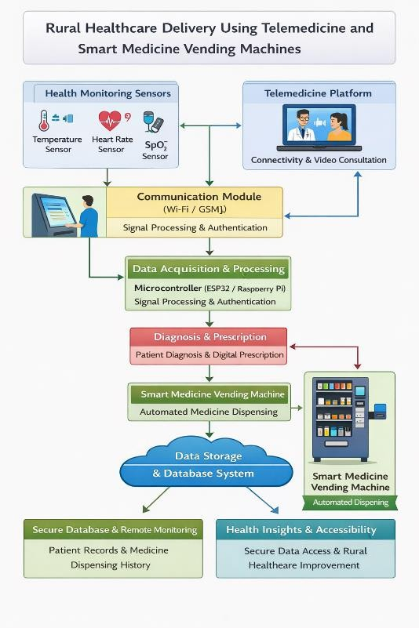
I. BLOCK DIAGRAM

PROPOSED SYSTEM

The proposed system aims to provide an efficient and accessible healthcare solution for rural areas by integrating telemedicine technology with a smart medicine vending machine. This system is designed to reduce the gap between patients and healthcare providers by enabling remote consultation and instant medicine delivery.

The system consists of multiple interconnected modules, including health monitoring sensors, a microcontroller unit, a communication module, a telemedicine platform, and an automated medicine dispensing unit.

  - System Overview:

The patient interacts with the system through a user interface installed at a rural healthcare kiosk. Basic health parameters such as temperature, heart rate, blood pressure, and oxygen saturation (SpO₂) are measured using sensors. These readings, along with patient details and symptoms, are transmitted to a doctor through an internet-based telemedicine platform.

The doctor reviews the data and conducts a remote consultation via video or audio call. After diagnosis, a digital prescription is generated and sent to the system.

  - Smart Medicine Vending Mechanism:
The proposed system includes an automated medicine vending machine that stores commonly prescribed medicines in separate compartments. Once the prescription is verified, the system activates the vending mechanism, which dispenses the correct medicine and dosage using motor-driven compartments.
This ensures:
    - Immediate access to medicines
    - Reduced dependency on pharmacies
    - Accurate and controlled dispensing

  - Remote Monitoring and Data Handling:

All patient data, including sensor readings, consultation records, and prescriptions, are securely stored in a cloud-based database. This enables:

    - Easy access to medical history
    - Continuous health monitoring
    - Better future diagnosis

The system ensures data privacy and security using authentication and encryption techniques.

  - Communication Framework:
The system uses internet connectivity (Wi- Fi/4G/5G) to establish communication between the patient and doctor. A real-time telemedicine interface supports:
    - Video consultation
    - Audio calls
    - Messaging
This ensures timely medical attention even in remote locations.
  - System Workflow:

The working process of the proposed system is as follows:

    - Patient enters details and symptoms
    - Sensors collect health parameters
    - Data is processed and sent to the doctor
    - Doctor performs remote consultation
    - Digital prescription is generated
    - System verifies prescription
    - Medicine vending machine dispenses medicines
    - Data is stored in cloud for future reference

  - Key Features of the Proposed System:

    - Real-time remote healthcare access
    - Automated medicine dispensing
    - IoT-based health monitoring
    - Cloud-based data storage
    - User-friendly interface for rural users
    - Scalable and deployable in multiple locations.

IMPLEMENTATION

The implementation of the proposed system involves the integration of hardware and software components to enable remote healthcare consultation and automated medicine dispensing. The system is developed using embedded systems, IoT technologies, and cloud-based communication platforms.

  - Hardware Implementation:
The hardware setup consists of the following components:
    - Microcontroller Unit (MCU): Acts as the core processing unit (e.g., Arduino
/ Raspberry Pi)
    - Display Unit: LCD/Touchscreen to show patient details and instructions
    - Communication Module: Wi-Fi (ESP8266/ESP32) or GSM module for internet connectivity

  - Remote Monitoring and Data Handling:
The software system is responsible for data processing, communication, and user interaction. It includes:
    - Embedded Programming: The microcontroller is programmed using Arduino IDE or Python (for Raspberry Pi) to read sensor data and control hardware components.
    - Telemedicine Interface: A web or mobile-based application is used for communication between doctor and patient. It supports:
      - Video consultation
      - Audio calls
      - Chat functionality
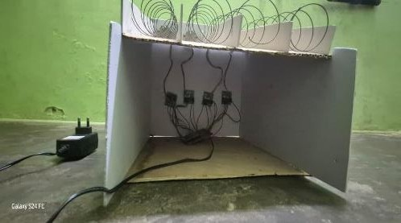
  - System Integration:

All modules are integrated to ensure seamless operation:

    - Sensor data → Microcontroller → Cloud platform
    - Cloud platform → Doctor interface
    - Doctor prescription → System verification → Vending machine
The integration ensures real-time data flow and minimal delay in communication and processing.

  - System Integration:
The system uses Wi-Fi or GSM networks to establish communication between modules. Real-time data transmission is ensured using IoT protocols such as HTTP or MQTT.

Methodology
The proposed system follows a structured approach to provide efficient healthcare services using telemedicine and a smart medicine vending machine. Patient health data is collected through sensors and transmitted to doctors via a communication module for remote consultation. Based on the diagnosis, a digital prescription is generated and verified by the system. The vending machine then dispenses the prescribed medicines, while all data is securely stored for future reference.
  - Requirement Analysis & System Design:
The system is designed to meet the healthcare needs of rural populations by providing an easy-to-use and efficient platform. It includes both hardware and software components that work together to deliver healthcare services. The design focuses on simplicity so that users with minimal technical knowledge can operate the system. It includes modules for data collection, communication, processing, and medicine dispensing. The system ensures secure data handling and reliable communication between patients and doctors. Proper system design also ensures scalability so that the system can be deployed in multiple rural areas.
  - Data Acquisition:
Data acquisition is the process of collecting health-related information from the patient using sensors. The system uses various sensors such as temperature sensors, heart rate sensors, blood pressure sensors, and SpO₂ sensors to measure vital health parameters. These sensors provide real-time data that helps doctors understand the patient’s condition. In addition to sensor data, patient details such as name, age, and symptoms are entered through the user interface. All collected data is transmitted to the microcontroller for further processing. Accurate data acquisition is essential for proper diagnosis and effective treatment.

  - Data Processing:
After data collection, the microcontroller processes the sensor readings and patient information. The data is filtered and formatted to ensure accuracy and reliability. Any noise or errors in the sensor readings are removed during this stage. The processed data is then transmitted to the telemedicine platform through the communication module. Efficient data processing ensures that doctors receive clear and accurate information for diagnosis. This step is important to maintain the overall performance and reliability of the system.
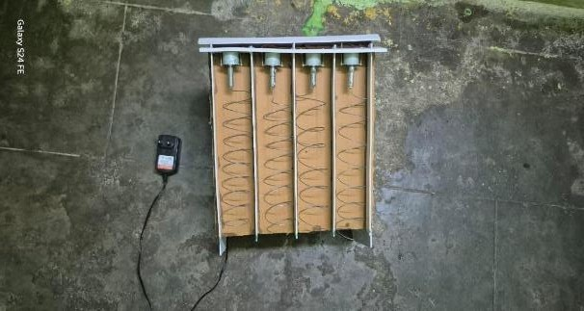

  - System Integration:
System integration involves combining all hardware and software components into a single functional system. The sensors, microcontroller, communication module, telemedicine platform, and vending machine are interconnected to ensure smooth operation. The integration ensures that data flows seamlessly between different modules without any delay. Proper integration improves system efficiency and reliability. It also ensures that the system can handle multiple users and operations simultaneously.

  - Medicine Dispensing:
After the doctor provides a digital prescription, the system verifies its authenticity and activates the medicine vending machine. The vending machine contains compartments for different medicines and uses motors to dispense them automatically. The correct medicine and dosage are dispensed based on the prescription. This eliminates the need for patients to visit pharmacies and ensures immediate access to medicines. Automated dispensing reduces human error and improves accuracy. It also saves time and enhances patient convenience.
  - Data Storage and Monitoring:
The system stores all patient information, consultation details, prescriptions, and sensor data in a secure database. This digital record management system helps doctors track patient history and provide better treatment in future consultations. Cloud-based storage allows remote access to patient records. The system also enables monitoring of patient health data over time. Proper data storage ensures data security, reliability, and easy retrieval when required.
  - Testing and Evaluation:
The system is tested to ensure proper functioning and performance. Testing includes checking sensor accuracy, communication reliability, and medicine dispensing efficiency. The system is evaluated under different conditions to ensure it works effectively in real-world scenarios. Performance metrics such as response time, accuracy, and reliability are analyzed. Testing helps identify errors and improve system performance. It ensures that the system meets all functional requirements.

  - Deployment:
The system is deployed in rural healthcare centers, kiosks, or community service areas. It can be installed in locations where healthcare access is limited. The deployment process includes installation, configuration, and user training. Healthcare workers may assist patients in using the system. The system can be expanded to multiple locations to serve a larger population. Proper deployment ensures maximum utilization and effectiveness of the system.

vi.​ Advantages
  - Provides remote healthcare access
  - Reduces travel time and cost
  - Ensures quick medicine availability
  - Improves early diagnosis
  - Reduces hospital overcrowding
  - Supports digital record management

vii. ​Disadvantages
- Requires internet connectivity
- Initial setup cost
- Needs regular maintenance
- Limited to basic treatments
- Requires technical assistance

CONCLUSION
The proposed system provides an innovative solution to the challenges faced in rural healthcare. By integrating telemedicine with a smart medicine vending machine, the system ensures timely consultation and immediate access to medicines.

It reduces travel costs, improves healthcare accessibility, and enhances efficiency. The system promotes digital healthcare adoption and supports preventive care. With further improvements and large-scale implementation, this system can significantly improve healthcare services in rural areas. It has the potential to create a sustainable and scalable healthcare model for the future.

ix.​ References

- WHO, “Telemedicine: Opportunities and Developments in Member States,” World Health Organization Report, 2010.
- D. S. Bhatia and R. Sood, “Telemedicine Technology and Applications,” Journal of Medical Systems, vol. 45, no. 3, pp. 1–10,
2021.
- A. Kumar et al., “IoT-Based Smart Healthcare Monitoring System,” International Journal of Engineering Research & Technology (IJERT), vol. 9, no. 6, 2020.
- S. R. Islam, D. Kwak, M. H. Kabir,
M. Hossain, and K. S. Kwak, “The Internet of Things for Health Care: A Comprehensive Survey,” IEEE Access, vol. 3, pp. 678–708, 2015.
- P. Gope and T. Hwang, “BSN-Care: A Secure IoT-Based Modern Healthcare System Using Body Sensor Network,” IEEE Sensors Journal, vol. 16, no. 5, pp. 1368–
1376, 2016.
- J. Smith and L. Brown, “Smart Medicine Vending Machines for Rural Healthcare,” International Journal of Advanced Healthcare Technology, vol. 8, no. 2, 2022.
- M. Chen, Y. Ma, J. Song, C. Lai, and
B. Hu, “Smart Clothing: Connecting Human with Clouds and Big Data for
Sustainable Health Monitoring,” Mobile Networks and Applications, vol. 21, pp. 825–845, 2016.
- R. K. Jha and S. Kumar, “Cloud-Based Healthcare Monitoring System Using IoT,” International Journal of Computer Applications, vol. 182, no. 23,
2018.
- I. Chiuchisan, H. Costin, and O. Geman, “Adopting the Internet of Things Technologies in Health Care Systems,” International Conference on e-Health and Bioengineering, 2014.
- K. Ashton, “That ‘Internet of Things’ Thing,” RFID Journal, 2009.
- M. Hassanalieragh et al., “Health Monitoring and Management Using Internet-of-Things (IoT) Sensing with Cloud-Based Processing,” IEEE International Conference on Services Computing, 2015.
- A. Darwish and A. Hassanien, “Wearable and Implantable Wireless Sensor Network Solutions for Healthcare Monitoring,” Sensors Journal, vol. 11, 2011.
- R. S. H. Istepanian, “Telemedicine in the 21st Century: Challenges and Opportunities,” IEEE Engineering in Medicine and Biology Magazine, 2012.
- S. Majumder, T. Mondal, and M. J. Deen, “Wearable Sensors for Remote Health Monitoring,” Sensors, vol. 17, no. 1, 2017.
- J. G. Webster, “Medical Instrumentation: Application and Design,” Wiley Publication, 2010.

