Food Sharing Application for Reducing Wastage

Vivek Shukla Vivek Rai Mohit Kumar Singh
Department of Computer Department of Computer Department of Computer
Science and Engineering Science and Engineering Science and Engineering
Galgotias University, Greater Galgotias University, Greater Galgotias University, Greater
Noida, India Noida, India Noida, India
vs4436843@gmail.com vivekkumar123.vk72@gmail.com mohit.singh.7463@gmail.com

Abstract– Food waste remains a major global challenge when many people go hungry. This work outlines an Android Food Sharing App that links food donors with those who can receive the food for a more effective distribution of leftover food. The platform enables donors to share the information of their surplus food, and the hungry people can view the data. It relies on Firebase for live data management and Google Maps API for determining the location. The offered concept aids in rescuing food from being wasted, assists the destitute, and encourages the use of resources in a sustainable manner.

Index Terms– Food waste, Food sharing, Android application, Firebase, NGOs, Sustainable development, Resource utilization, Hunger reduction.

- INTRODUCTION
According to a 2021 UNEP meta-analysis, over one-third of all food produced annually—roughly 931 million tons—is wasted worldwide [1].
This substantial loss is four times greater than what is required to end hunger. The effects are severe: despite the fact that there is enough food to feed everyone, over 2 billion people suffer from malnutrition, and hunger related issues remain critical globally [2].
35–40% of food in the US is thrown away, even though a large portion of it is still edible. According to experts, 870 million hungry people could be fed by recovering just 25% of the food that is wasted globally [1].
With 67 million tonnes of food wasted annually, valued at Rs 92,000 crores, India's enormous population presents a particularly critical concern [5].

Bihar may be fed for a year with this sum. On the Global Hunger Index, however, India comes in at number 103. 15% of people are undernourished, and households waste 50 kg of food per person annually [2]. Poor infrastructure, insufficient storage, ineffective delivery, and cultural customs—such as the 10 million weddings that result in over 25% of food being thrown away, costing $14 billion—are the main factors.
The issue is exacerbated by restaurants. Despite the fact that there are 30,000 restaurants in Mumbai, a survey revealed that many of them cook 15–20% more food than is necessary, and just 3 out of 100 work with NGOs for redistribution. This indicates a substantial chance to reroute excess food.
In today's digital world, it helps reduce waste, supports vulnerable populations with necessities, and fosters social solidarity by making it simpler to list and match products digitally.
India’s food processing sector faces challenges such as poor infrastructure and supply chain inefficiencies [6].

- LITERATURE REVIEW

In order to prevent food waste, this article suggests an integrated system that links surplus food providers with non-governmental organizations so that it can be distributed to those in need. It consists of four primary modules that act as an essential bridge. NGOs are instantly notified when donors enter information about extra food. It enhances supply chains, resource utilization, and distribution logistics by building on earlier research. Even though awareness increased, the 2016 research "Beyond Food Sharing: Supporting Food Waste Reduction with ICTs" focused on food quality for various users but did not thoroughly examine the function of ICT [3]. The 2015 research "Food Donation Portal" examined the interactions between donors, non-governmental organizations, and social groups; however, it lacked GPS tracking, necessitating manual searches. These gaps demonstrate the need for technological advancements to increase the efficiency of excess delivery [4].

2.1 Existing system

There are major issues with the present methods of distributing extra meals. This makes it obvious that a more straightforward and user-friendly platform is required. Currently, Better storage and transportation facilities, as well as coordinated efforts to balance supply and demand, are necessary to reduce waste. The necessity for efficient donation networks is highlighted by similar problems with clothing, books, and home goods.
"Helping Hands" can help with it. Donors of extra food, clothing, books, and items can connect with recipients and organizations through this easy-to-use app.
Better coordination tools and instant access to distribution information are essential for volunteers. Additionally, they must increase public knowledge of NGOs and volunteer work.

The following are the main drawbacks of the current configuration:

- Limited Coverage: The overall impact of sharing programs is limited since donations frequently do not reach people in rural or varied places.
- Manual Effort: Without automated assistance, donors must look for local NGOs or organizations, which is an additional headache.
- Overly Complex Process: There are delays and waste because the system requires an excessive amount of time and stages.
- Duplicate Information: Confusion and errors are caused by repeated data inputs.

To successfully remove these obstacles and improve connections between volunteers, donors, and individuals in need, a technology-driven solution is required.

2.2 Proposed system

The suggested Android software makes it simple for donors to share extra food with people in need, which helps cut down on waste, particularly in India. An admin panel, an NGO interface, a volunteer section, and a user area make up its four modules. Every user must initially register with basic information, including administrators, NGOs, volunteers, funders, and receivers.
The entire procedure is overseen by administrators. They plan pickups, manage logins, and authorize registrations. Java is used for logic in Android Studio 4.0.3, whereas XML is used for the user interface. It uses Firebase for database operations and authentication [7], and the Google Maps API for maps and position tracking [8].
After signing up, users choose whether to donate or request food. The data is saved to the database. This improves access and reduces waste in the community.

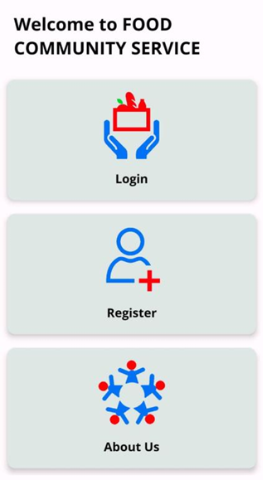
Fig. 1. Home Page Module

3. MODULES

3.1 Login & Registration
The login and registration procedure for our app prioritizes data security and user privacy. Using basic details like name, email address, and a secure password, it enables visitors and agents to create personal profiles. To make sure that only those with permission may access the accounts, we have implemented security measures including phone and email verification.

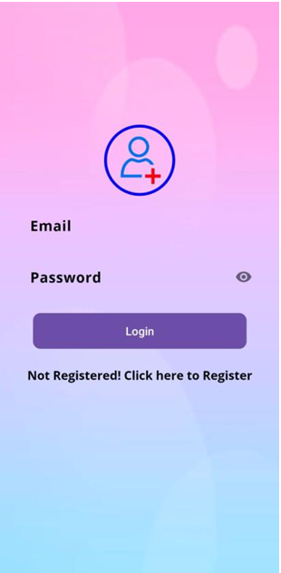

Fig. 2. Login Page Module

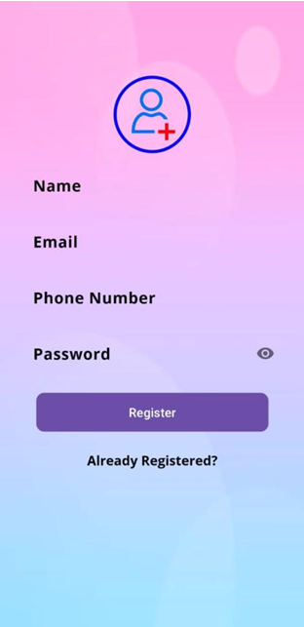
Fig. 3. Register Page Module

3.2 Admin Module
The administrator oversees platform operations and maintains donor and agent information in the admin module. They ensure that data entry is accurate, safely preserved, up to date, and confidential. They oversee every action to guarantee the system functions properly and successfully safeguard confidential data.

3.3 Donator Module
By distributing extra food to those in need, particularly orphans, our donor module enables individuals and organizations to have a significant influence. In order to empower underprivileged populations and reduce food waste, donors are crucial. The donation method is quick and easy since they just post the food that is available on the platform.

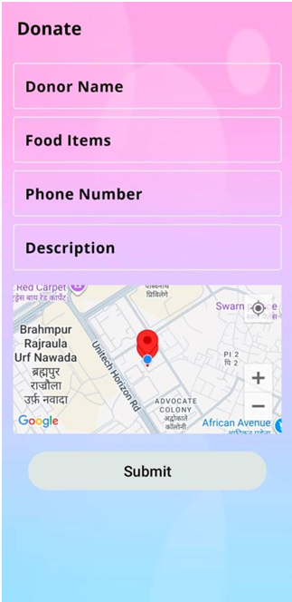

Fig. 4. Donator Page Module

3.4 Dashboard Module
A mobile app dashboard is a primary visual hub that offers rapid access to key information, functions, and features. Its layout encourages simple and effective user engagement. Typical characteristics consist of: For quick insights, a summary of key metrics and app status. Rearranging widgets, selecting data presentations, and emphasizing priorities are examples of customization options. Shortcuts or widgets provide quick access to frequently used features.

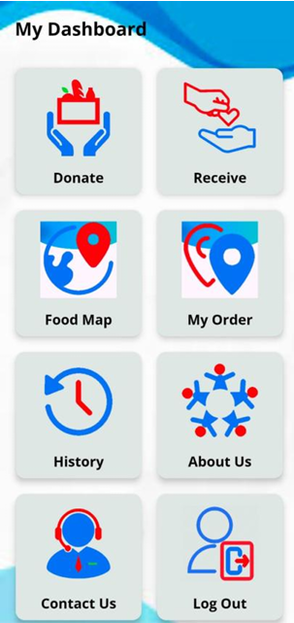

Fig. 5. Dashboard Module

4. CONCLUSION

By making it possible to donate food, clothing, books, utensils, household goods, and other necessities to those in need, this app provides a sound strategy to combat food waste and benefit several NGOs. It mostly concentrates on dealing with the enormous surpluses that cafés and restaurants produce on a daily basis. This food frequently ends up in landfills. Rather, the site uses this excess to feed orphans, the homeless, and other underprivileged people.
Because the app efficiently handles all pickups through its network of volunteers and non governmental organizations, businesses benefit from simple logistics. This strategy reduces the carbon footprint, landfill trash, and total operating waste of restaurants while simultaneously addressing hunger for people in need.
A standardized food information system that provides users with comprehensive information on item names, amounts, and expiration dates is planned for the future. Although users may still enter information manually for flexibility, new capabilities like barcode scanning for automated identification and OCR technologies for reading expiration labels will streamline the process. To improve openness, several businesses are already experimenting with QR codes on packaging. This program serves as a workable and quick solution to guarantee that excess resources successfully reach those who need them most, even though there are technological and legal issues to be resolved for wider use.

5. REFERENCES

[1] United Nations Environment Programme, "Food Waste Index Report 2021," Nairobi, 2021.

[2] Global Hunger Index, "India Country Profile," 2023.

[3] A. R. Davies, F. Fahy, and H. Rau, "Beyond Food Sharing: Supporting Food Waste Reduction with ICTs," Journal of Cleaner Production, vol. 123, pp. 196–206, 2016.

[4] R. Patel and M. Shah, "Food Donation Portal: An Online System for Reducing Food Waste," International Journal of Computer Applications, vol. 119, no. 12, pp. 1–5, 2015.

[5] FICCI, "Food Waste in India: Causes and Solutions," New Delhi, 2019.

[6] Ministry of Food Processing Industries, "Annual Report on Food Processing Sector," Government of India, 2020.

[7] Google, "Firebase Documentation," 2023.

[8] Google, "Google Maps Platform Documentation," 2023.

