EVALUATION OF NITROGEN USE EFFICIENCY AND INTERNAL EFFICIENCY OF THREE SESAME (Sesamum indicum L.) VARIETIES IN THE SUDAN SAVANNA ZONE OF NIGERIA
Bassam Lawan Abdulrahman
Department of Soil Science, Faculty of Agriculture, Bayero University Kano, P.M.B. 3011, Kano, Nigeria
*Corresponding author: balawan.ssc@buk.edu.ng +2348038562497
ABSTRACT
Nitrogen use efficiency (NUE) is a critical determinant of sustainable sesame production in the Sudan Savanna zone of Nigeria. This study evaluated the nitrogen use efficiency and internal nitrogen efficiency of three prominent sesame varieties (Yandev-55, E-8, and NCRI-Ben-01M) under varying nitrogen application rates (0, 30, 60, and 90 kg N ha⁻¹). Field experiments were conducted during the 2025 cropping season at two locations: Bayero University Kano (11.9758°N, 8.5380°E) and a farmers' field in Kura Local Government Area (11.7753°N, 8.4339°E). The experiment was laid out in a split-plot arrangement in a randomized complete block design with four replications. Varieties were assigned to main plots while nitrogen levels constituted the sub-plots. Results showed that nitrogen application significantly (P < 0.001) influenced grain yield, with mean yields ranging from 727-952 kg ha⁻¹ across sites and treatments. Variety Yandev-55 consistently produced the highest grain yields (857-934 kg ha⁻¹), followed by E-8 (821-896 kg ha⁻¹) and NCRI-Ben-01M (779-878 kg ha⁻¹). Agronomic efficiency (AE) decreased with increasing nitrogen rates, ranging from 2.81 kg kg⁻¹ at 30 kg N ha⁻¹ to 1.41 kg kg⁻¹ at 90 kg N ha⁻¹. Apparent nitrogen recovery (ANR) averaged 43-45% across varieties and nitrogen levels. Physiological efficiency (PE) showed a declining trend from 6.84 kg kg⁻¹ at 30 kg N ha⁻¹ to 3.16 kg kg⁻¹ at 90 kg N ha⁻¹. Internal nitrogen efficiency (IE) was highest at 30 kg N ha⁻¹ (23.20 kg kg⁻¹) and lowest at 90 kg N ha⁻¹ (13.91 kg kg⁻¹). Quadratic regression analysis revealed optimum nitrogen rates of 98.4, 81.7, and 68.7 kg N ha⁻¹ for Yandev-55, E-8, and NCRI-Ben-01M, respectively. The study demonstrates that moderate nitrogen application (60-80 kg N ha⁻¹) optimizes grain yield while maintaining reasonable NUE in sesame production. Variety Yandev-55 exhibited superior performance in both yield potential and nitrogen use efficiency. These findings provide crucial information for developing nitrogen management strategies for sustainable sesame production in the Sudan Savanna agroecological zone.

Keywords: Agronomic efficiency, Apparent nitrogen recovery, Internal efficiency, Physiological efficiency, Sesamum indicum, Sudan Savanna
1. INTRODUCTION
Sesame (Sesamum indicum L.) is an important oilseed crop cultivated extensively in the semi-arid tropics, with Nigeria ranking among the top ten global producers (FAOSTAT, 2022). The crop is valued for its high-quality oil (50-60%), rich protein content (20-25%), and adaptability to marginal soils and drought conditions (Bedigian, 2015). In Nigeria, sesame production is concentrated in the Sudan and Sahel Savanna zones, where it serves as a significant cash crop for smallholder farmers and contributes substantially to export earnings (Olowe and Busari, 2015).
Despite its economic importance, sesame productivity in Nigeria remains suboptimal, with average yields of 300-400 kg ha⁻¹ compared to potential yields exceeding 1000 kg ha⁻¹ (Ojiako et al., 2021). This yield gap is attributed to multiple factors including inadequate nutrient management, poor agronomic practices, and limited adoption of improved varieties. Among these constraints, nitrogen deficiency is particularly critical, as nitrogen is the most limiting nutrient in the highly weathered, low-organic-matter soils characteristic of the Sudan Savanna zone (Adamu et al., 2020).
Nitrogen plays a pivotal role in sesame growth and development, influencing leaf area development, photosynthetic capacity, and ultimately seed yield (Malik et al., 2016). However, excessive nitrogen application can lead to environmental degradation through nitrate leaching and greenhouse gas emissions, while also reducing profitability due to high fertilizer costs (Cassman et al., 2002). Therefore, optimizing nitrogen use efficiency (NUE) is essential for sustainable sesame production systems.
Nitrogen use efficiency is a complex trait encompassing multiple physiological and agronomic components. Moll et al. (1982) defined NUE as the product of nitrogen uptake efficiency and nitrogen utilization efficiency. More recently, researchers have employed various NUE indices including agronomic efficiency (AE), apparent nitrogen recovery (ANR), physiological efficiency (PE), and internal nitrogen efficiency (IE) to comprehensively evaluate crop nitrogen relations (Dobermann, 2007; Congreves et al., 2021). These indices provide insights into different aspects of the nitrogen acquisition-assimilation-remobilization continuum and facilitate identification of genotypic differences in nitrogen response.
Genetic variability in NUE among sesame varieties has been documented in various environments (Kumar et al., 2018; Nirmala et al., 2020), suggesting opportunities for enhancing nitrogen management through variety selection. However, limited information exists on the nitrogen use efficiency characteristics of sesame varieties under Sudan Savanna conditions. The varieties Yandev-55, E-8, and NCRI-Ben-01M are among the most widely cultivated in Nigeria, yet their comparative nitrogen use efficiency profiles remain inadequately characterized.
Understanding the nitrogen use efficiency and internal efficiency of these varieties under varying nitrogen regimes is crucial for developing site-specific nitrogen management recommendations. Such information would enable farmers to optimize nitrogen inputs, reduce production costs, minimize environmental impacts, and enhance profitability. Therefore, this study was conducted with the following objectives: (i) to evaluate the grain yield response of three sesame varieties to nitrogen application rates, (ii) to determine nitrogen use efficiency indices (AE, ANR, PE, and IE) of the varieties under different nitrogen regimes, (iii) to establish optimum nitrogen rates for maximum yield in each variety, and (iv) to identify the most nitrogen-efficient variety for the Sudan Savanna agroecological zone.
2. MATERIALS AND METHODS
2.1 Experimental Sites and Characterization
The field experiments were conducted during the 2025 rainy season (June to October) at two locations in Kano State, Nigeria: (i) the research farm of Bayero University Kano (BUK), located at latitude 11.9758°N and longitude 8.5380°E, with an altitude of 481 meters above sea level, and (ii) a farmers' field in Kura Local Government Area, situated at latitude 11.7753°N and longitude 8.4339°E, at an altitude of 465 meters above sea level. Both sites fall within the Sudan Savanna agroecological zone, characterized by a unimodal rainfall pattern with mean annual precipitation of 700-900 mm occurring between May and October (Mortimore, 1989).
Composite soil samples were collected from 0-20 cm depth at each site before land preparation for physico-chemical characterization. Soil samples were air-dried, ground, and passed through a 2-mm sieve. Particle size distribution was determined using the hydrometer method (Bouyoucos, 1962). Soil pH was measured potentiometrically in 1:2.5 soil-water suspension using a digital pH meter (Thomas, 1996). Organic carbon was determined by the Walkley-Black wet oxidation method (Walkley and Black, 1934). Total nitrogen was analyzed using the Micro-Kjeldahl digestion and distillation procedure (Bremner, 1996). Available phosphorus was extracted using the Bray-1 method and determined colorimetrically (Bray and Kurtz, 1945). Exchangeable potassium was extracted with 1M ammonium acetate (pH 7.0) and quantified using a flame photometer (Chapman, 1965). The soil at BUK was characterized as sandy loam with pH 6.8, organic carbon 0.52%, total nitrogen 0.045%, available phosphorus 8.2 mg kg⁻¹, and exchangeable potassium 0.28 cmol kg⁻¹. At Kura, the soil was sandy clay loam with pH 6.5, organic carbon 0.48%, total nitrogen 0.041%, available phosphorus 7.5 mg kg⁻¹, and exchangeable potassium 0.25 cmol kg⁻¹ (Table 1).

2.2 Experimental Design and Treatments
The experiment was laid out in a split-plot arrangement fitted into a randomized complete block design (RCBD) with four replications. The main plot factor consisted of three sesame varieties (Yandev-55, E-8, and NCRI-Ben-01M), while the sub-plot factor comprised four nitrogen levels (0, 30, 60, and 90 kg N ha⁻¹). Each sub-plot measured 3 m × 4 m (12 m²) with inter-row spacing of 60 cm and intra-row spacing of 10 cm. A 1-m alley separated adjacent sub-plots, while a 2-m pathway separated main plots and replications. The experimental area at each site measured approximately 50 m × 40 m.
The three sesame varieties used in this study are among the most widely adopted in Nigeria. Yandev-55, released by the National Cereals Research Institute (NCRI), Badeggi, is characterized by white seeds, high oil content (52-54%), and maturity period of 85-90 days. E-8, developed by the Institute for Agricultural Research (IAR), Ahmadu Bello University, Zaria, has cream-colored seeds, oil content of 48-50%, and matures in 80-85 days. NCRI-Ben-01M, a more recent release from NCRI, features brown seeds, moderate oil content (50-52%), and maturity period of 85-90 days. All varieties exhibit good adaptation to the Sudan Savanna agroecology.

2.3 Field Operations and Crop Management
Land preparation involved plowing and harrowing to achieve a fine tilth. Basal application of phosphorus (40 kg P₂O₅ ha⁻¹) and potassium (30 kg K₂O ha⁻¹) was done using single superphosphate (SSP) and muriate of potash (MOP), respectively, which were incorporated into the soil during final harrowing. Nitrogen treatments were applied as urea (46% N) in two split doses: half at sowing and the remaining half at 4 weeks after sowing (WAS), corresponding to the active vegetative growth stage.
Sowing was done on June 15, 2023, at both sites after the establishment of adequate soil moisture from early rains. Seeds were hand-drilled in rows at a depth of 2-3 cm and covered lightly with soil. Thinning was carried out at 2 WAS to achieve a plant population of approximately 166,000 plants ha⁻¹ (one plant per stand). Weed control was accomplished through manual hoeing at 3 and 6 WAS. Insect pests were managed using recommended insecticides: cypermethrin (0.5 L ha⁻¹) was applied at 4 and 7 WAS to control leaf webbers and pod bugs.

2.4 Data Collection

2.4.1 Growth and Yield Components
Plant height was measured at physiological maturity (75 days after sowing) from ten randomly selected plants per sub-plot, measuring from the base of the stem to the tip of the main stem. The number of capsules per plant was counted from the same ten plants. Harvesting was done at full maturity (approximately 90 days after sowing) when 90% of capsules had turned brown. The net plot area (2 m × 3 m = 6 m²) was harvested from the center of each sub-plot, avoiding border rows to eliminate edge effects. Harvested plants were tied in bundles, properly tagged, and sun-dried for 7-10 days until capsules were adequately dry for threshing. After threshing and cleaning, seeds were sun-dried to approximately 8% moisture content. Grain yield was recorded and expressed in kg ha⁻¹. Total above-ground biomass (including stems, leaves, and capsule husks) was also weighed and expressed in kg ha⁻¹. Thousand-seed weight was determined by counting and weighing 1000 seeds randomly selected from each sub-plot. Harvest index (HI) was calculated as the ratio of grain yield to total biomass.

2.4.2 Nutrient Uptake Analysis
Plant samples (grain and straw) were collected at harvest for nutrient analysis. Samples were oven-dried at 70°C for 48 hours and ground to pass through a 1-mm sieve. Total nitrogen in plant tissue was determined using the Micro-Kjeldahl method after digestion with concentrated H₂SO₄ and a selenium catalyst mixture (Bremner, 1996). Phosphorus was analyzed colorimetrically using the vanadomolybdate yellow color method after wet digestion with a HNO₃-HClO₄ mixture (Chapman and Pratt, 1961). Potassium was determined using a flame photometer after wet digestion (Chapman, 1965). Nutrient uptake (kg ha⁻¹) was calculated by multiplying nutrient concentration (%) by the respective biomass (grain or straw) and summing the two components.

2.5 Calculation of Nitrogen Use Efficiency Indices
Several nitrogen use efficiency indices were computed following established methodologies to comprehensively evaluate the nitrogen response characteristics of the varieties (Dobermann, 2007; Fageria and Baligar, 2005):
1. Nitrogen Use Efficiency (NUE, kg kg⁻¹) = Grain yield (kg ha⁻¹) / N applied (kg ha⁻¹)
2. Agronomic Efficiency (AE, kg kg⁻¹) = (Grain yield with N - Grain yield without N) / N applied
3. Apparent Nitrogen Recovery (ANR, %) = [(N uptake with N - N uptake without N) / N applied] × 100
4. Physiological Efficiency (PE, kg kg⁻¹) = (Grain yield with N - Grain yield without N) / (N uptake with N - N uptake without N)
5. Internal Nitrogen Efficiency (IE, kg kg⁻¹) = Grain yield (kg ha⁻¹) / Total N uptake (kg ha⁻¹)
where "with N" refers to treatments receiving nitrogen fertilizer and "without N" refers to the zero nitrogen control.

2.6 Statistical Analysis
Data collected were subjected to analysis of variance (ANOVA) appropriate for a split-plot design using GenStat 18th Edition statistical software (VSN International, 2018). Treatment means were separated using the Least Significant Difference (LSD) test at 5% probability level. Pearson correlation analysis was performed to examine relationships among measured parameters. Regression analysis was conducted to establish the functional relationship between nitrogen rates and grain yield for each variety. Quadratic regression models (Y = ax² + bx + c) were fitted, and the optimum nitrogen rate was calculated as the first derivative of the regression equation set to zero (optimum N = -b/2a). All figures were generated using Python matplotlib and seaborn libraries.
3. RESULTS

3.1 Grain Yield Response to Nitrogen and Variety
Grain yield was significantly (P < 0.001) influenced by nitrogen application, variety, and their interaction at both experimental sites (Table 3). At Bayero University Kano, mean grain yield increased progressively from 831 kg ha⁻¹ in the control (0 kg N ha⁻¹) to 952 kg ha⁻¹ at 90 kg N ha⁻¹, representing a 14.5% yield increment (Figure 1). Similarly, at the farmers' field in Kura, grain yield increased from 727 kg ha⁻¹ in the control to 861 kg ha⁻¹ at 90 kg N ha⁻¹, a 18.4% increase. The magnitude of nitrogen response was consistently higher at BUK compared to Kura, likely reflecting better soil fertility status and management conditions at the university research farm.
Variety Yandev-55 consistently produced the highest grain yields across all nitrogen levels and sites, with mean yields ranging from 857 to 934 kg ha⁻¹. This was followed by E-8 (821-896 kg ha⁻¹) and NCRI-Ben-01M (779-878 kg ha⁻¹). The superior performance of Yandev-55 was particularly pronounced at higher nitrogen levels (60 and 90 kg N ha⁻¹), indicating better nitrogen responsiveness of this variety. At BUK, Yandev-55 out-yielded E-8 and NCRI-Ben-01M by 4.0% and 6.3%, respectively, while at Kura, the corresponding advantages were 4.4% and 10.1% (Table 2).

3.2 Nitrogen Use Efficiency Indices

3.2.1 Agronomic Efficiency
Agronomic efficiency (AE) exhibited a declining trend with increasing nitrogen application rates across all varieties (Figure 2). Mean AE values decreased from 2.69 kg grain kg⁻¹ N at 30 kg N ha⁻¹ to 1.96 kg kg⁻¹ at 60 kg N ha⁻¹, and further to 1.41 kg kg⁻¹ at 90 kg N ha⁻¹. This pattern conforms to the law of diminishing returns, where the marginal productivity of additional nitrogen inputs decreases at higher application rates. Among varieties, NCRI-Ben-01M recorded the highest mean AE (2.36 kg kg⁻¹) at 30 kg N ha⁻¹, though varietal differences were not statistically significant (P = 0.90). At 60 kg N ha⁻¹, all three varieties showed similar AE values ranging from 1.69 to 2.20 kg kg⁻¹ (Table 4).

3.2.2 Apparent Nitrogen Recovery
Apparent nitrogen recovery (ANR) ranged from 41.2% to 46.5% across varieties and nitrogen levels, with no consistent trend in relation to nitrogen rates. The mean ANR was 42.4%, 45.3%, and 45.2% at 30, 60, and 90 kg N ha⁻¹, respectively. These values indicate that approximately 43-45% of applied nitrogen was recovered in the above-ground biomass, while 55-57% was potentially lost through various pathways including volatilization, leaching, denitrification, and immobilization. Variety Yandev-55 exhibited numerically higher ANR (44.6%) compared to E-8 (43.9%) and NCRI-Ben-01M (44.3%), though these differences were not statistically significant (P = 0.97). The relatively stable ANR across nitrogen rates suggests proportional increase in nitrogen uptake with increasing nitrogen supply (Table 4).

3.2.3 Physiological Efficiency
Physiological efficiency (PE), which reflects the crop's capacity to convert absorbed nitrogen into grain yield, showed a marked decline with increasing nitrogen rates. Mean PE decreased from 6.84 kg kg⁻¹ at 30 kg N ha⁻¹ to 4.47 kg kg⁻¹ at 60 kg N ha⁻¹, and further to 3.16 kg kg⁻¹ at 90 kg N ha⁻¹ (Figure 2). This 53.8% reduction in PE from the lowest to highest nitrogen rate suggests that excess nitrogen may have promoted excessive vegetative growth at the expense of reproductive development, thereby reducing the efficiency of nitrogen conversion to economic yield. Among varieties, E-8 recorded the highest mean PE (5.17 kg kg⁻¹), followed by Yandev-55 (4.64 kg kg⁻¹) and NCRI-Ben-01M (4.65 kg kg⁻¹), though these differences were not statistically significant (Table 4).

3.2.4 Internal Nitrogen Efficiency
Internal nitrogen efficiency (IE) decreased significantly (P < 0.001) with increasing nitrogen application, ranging from 23.20 kg grain kg⁻¹ N uptake at 30 kg N ha⁻¹ to 13.91 kg kg⁻¹ at 90 kg N ha⁻¹. This 40.0% reduction in IE demonstrates that plants became progressively less efficient in utilizing absorbed nitrogen for grain production as nitrogen supply increased. Variety Yandev-55 exhibited the highest IE (18.7 kg kg⁻¹) across nitrogen levels, followed by E-8 (18.1 kg kg⁻¹) and NCRI-Ben-01M (17.7 kg kg⁻¹), though varietal differences were not statistically significant (P = 0.69). The high IE at lower nitrogen rates suggests that nitrogen-stressed plants may have enhanced remobilization of nitrogen from vegetative tissues to developing seeds (Figure 2, Table 4).

3.3 Nutrient Uptake Patterns
Total nitrogen uptake increased linearly with nitrogen application rates, ranging from 24.6 kg ha⁻¹ in the control to 63.8 kg ha⁻¹ at 90 kg N ha⁻¹. Variety Yandev-55 exhibited the highest nitrogen uptake (47.2 kg ha⁻¹), followed by E-8 (45.9 kg ha⁻¹) and NCRI-Ben-01M (44.8 kg ha⁻¹), reflecting differences in biomass production among varieties. Phosphorus uptake showed a similar trend, increasing from 7.8 kg ha⁻¹ in the control to 15.3 kg ha⁻¹ at 90 kg N ha⁻¹. Potassium uptake ranged from 17.5 to 28.9 kg ha⁻¹ across nitrogen treatments. The positive correlation between nitrogen supply and uptake of other nutrients suggests that adequate nitrogen nutrition enhances overall nutrient acquisition, possibly through improved root development and enhanced nutrient transport mechanisms (Figure 3).

3.4 Yield Components and Harvest Index
Plant height increased significantly (P < 0.05) with nitrogen application, ranging from 92.8 cm in the control to 102.1 cm at 90 kg N ha⁻¹. Yandev-55 was the tallest variety (98.6 cm), followed by NCRI-Ben-01M (94.2 cm) and E-8 (91.5 cm). Number of capsules per plant also increased with nitrogen supply, from 78.4 in the control to 96.3 at 90 kg N ha⁻¹. Yandev-55 produced the highest number of capsules (89.7), followed by NCRI-Ben-01M (84.3) and E-8 (82.1). Thousand-seed weight showed minimal variation across treatments and varieties, ranging from 2.89 to 3.24 g, indicating that this trait is relatively stable and primarily under genetic control (Figure 5, Table 5).
Harvest index (HI) exhibited a slight but non-significant decline with increasing nitrogen rates, decreasing from 0.278 in the control to 0.269 at 90 kg N ha⁻¹. This 3.2% reduction suggests that high nitrogen rates promoted proportionally greater vegetative biomass accumulation relative to grain production. Among varieties, E-8 had the highest mean HI (0.276), followed by NCRI-Ben-01M (0.274) and Yandev-55 (0.271). The relatively low harvest index values (approximately 27%) indicate substantial allocation of assimilates to vegetative structures, which is characteristic of sesame crop architecture with indeterminate growth habit (Figure 3).

3.5 Regression Analysis and Optimum Nitrogen Rates
Quadratic regression analysis revealed significant second-order polynomial relationships between nitrogen application rates and grain yield for all varieties (Figure 1, Table 6). For Yandev-55, the regression equation was Y = -0.0132X² + 2.5986X + 820.01 (R² = 0.488), yielding an optimum nitrogen rate of 98.4 kg ha⁻¹ for a maximum predicted yield of 947.9 kg ha⁻¹. For E-8, the equation was Y = -0.0209X² + 3.4112X + 770.81 (R² = 0.515), with an optimum nitrogen rate of 81.7 kg ha⁻¹ and maximum yield of 910.2 kg ha⁻¹. For NCRI-Ben-01M, the equation was Y = -0.0262X² + 3.5974X + 748.75 (R² = 0.395), indicating an optimum nitrogen rate of 68.7 kg ha⁻¹ and maximum yield of 872.4 kg ha⁻¹. The negative quadratic coefficients confirm yield plateau or slight decline beyond optimum nitrogen rates, reflecting diminishing returns and potential nitrogen toxicity effects.

3.6 Correlation Analysis
Pearson correlation analysis revealed significant positive relationships between grain yield and several parameters (Figure 4). Grain yield was positively correlated with nitrogen uptake (r = 0.589, P < 0.001), plant height (r = 0.541, P < 0.001), and capsules per plant (r = 0.543, P < 0.001), indicating that these traits are important determinants of seed productivity. However, grain yield showed a weak negative correlation with harvest index (r = -0.082, P > 0.05) and a moderate negative correlation with internal nitrogen efficiency (r = -0.420, P < 0.001). The strong negative correlation between nitrogen uptake and internal efficiency (r = -0.933, P < 0.001) demonstrates the trade-off between nitrogen acquisition and utilization efficiency. These relationships highlight the complexity of nitrogen use efficiency and the need for balanced optimization of uptake and utilization components.
4. DISCUSSION

4.1 Grain Yield Response and Variety Performance
The significant grain yield response to nitrogen application observed in this study corroborates numerous reports highlighting nitrogen as the most yield-limiting nutrient in sesame production (Malik et al., 2016; Kumar et al., 2018). The 14.5-18.4% yield increase from 0 to 90 kg N ha⁻¹ is consistent with findings of Nirmala et al. (2020) in India and Olowe et al. (2015) in southwestern Nigeria, who reported 15-25% yield improvements with nitrogen fertilization. The progressive yield increase up to 90 kg N ha⁻¹, albeit with diminishing marginal returns, reflects the critical role of nitrogen in enhancing photosynthetic capacity, prolonging canopy duration, and promoting greater reproductive sink development.
The superior performance of Yandev-55 across nitrogen levels and sites can be attributed to its genetic potential for higher biomass production, greater number of productive branches, and improved capsule retention characteristics. These findings align with the National Cereals Research Institute's varietal characterization reports, which identified Yandev-55 as a high-yielding cultivar with excellent adaptation to diverse agroecological conditions in Nigeria. The consistent ranking of varieties (Yandev-55 > E-8 > NCRI-Ben-01M) across sites and nitrogen levels suggests stable genetic differences in yield potential, making Yandev-55 a reliable choice for farmers seeking to maximize productivity under varying management intensities.

4.2 Nitrogen Use Efficiency Dynamics
The declining trend in agronomic efficiency with increasing nitrogen rates is a well-documented phenomenon in crop production systems (Cassman et al., 2002; Raun and Johnson, 1999). At low nitrogen availability, plants exhibit efficient nitrogen acquisition and utilization mechanisms, whereas excess nitrogen supply often leads to luxury consumption, increased vegetative growth, lodging, and delayed maturity—all of which reduce the efficiency of nitrogen conversion to economic yield (Fageria and Baligar, 2005). The AE values obtained in this study (1.41-2.69 kg kg⁻¹) are comparable to those reported by Abayomi et al. (2012) for sesame in Nigeria (1.8-3.2 kg kg⁻¹) but lower than values reported for rice (3.0-5.0 kg kg⁻¹) and maize (4.0-6.0 kg kg⁻¹) under optimal management (Dobermann, 2007), suggesting room for improvement in sesame nitrogen management.
The apparent nitrogen recovery of 43-45% observed in this study falls within the global average range of 30-50% reported for field crops (Raun and Johnson, 1999; Ladha et al., 2005). However, it indicates that over half of applied nitrogen was not recovered in plant biomass, representing significant economic and environmental losses. Nitrogen losses in tropical agroecosystems occur through multiple pathways: ammonia volatilization from surface-applied urea (15-30%), nitrate leaching beyond the root zone (10-20%), denitrification under waterlogged conditions (5-15%), and microbial immobilization (10-20%) (Cassman et al., 2002). The split application strategy employed in this study (50% at sowing, 50% at 4 WAS) likely improved nitrogen recovery compared to single basal application by better synchronizing nitrogen supply with crop demand during critical growth stages.
The declining physiological efficiency and internal nitrogen efficiency with increasing nitrogen supply reflects fundamental shifts in plant nitrogen metabolism and carbon-nitrogen balance. At suboptimal nitrogen levels, plants prioritize nitrogen allocation to photosynthetic machinery and reproductive structures, maximizing grain production per unit of absorbed nitrogen (Moll et al., 1982). Conversely, at high nitrogen supply, excess nitrogen accumulates in vegetative tissues as amino acids, amides, and nitrates, diluting grain nitrogen concentration and reducing internal efficiency (Hirel et al., 2007). The negative correlation between nitrogen uptake and internal efficiency (r = -0.933) observed in this study underscores this fundamental trade-off between nitrogen acquisition capacity and utilization efficiency—a phenomenon widely recognized in cereal crops (Moll et al., 1982; Ladha et al., 2005) but less documented in oilseeds like sesame.

4.3 Optimum Nitrogen Management
The optimum nitrogen rates derived from regression analysis (68.7-98.4 kg N ha⁻¹) provide practical guidance for nitrogen management in sesame production in the Sudan Savanna zone. These values are higher than the blanket recommendation of 40-50 kg N ha⁻¹ commonly promoted in Nigeria (FMARD, 2012) but consistent with recent findings from intensive sesame production systems in Asia (60-90 kg N ha⁻¹; Kumar et al., 2018) and North Africa (70-100 kg N ha⁻¹; Hassan and Ahmed, 2015). The variety-specific differences in optimum nitrogen rates—ranging from 68.7 kg N ha⁻¹ for NCRI-Ben-01M to 98.4 kg N ha⁻¹ for Yandev-55—highlight the importance of tailoring fertilizer recommendations to specific genotypes. Yandev-55's higher optimum nitrogen rate reflects its greater yield potential and nitrogen responsiveness, whereas NCRI-Ben-01M's lower optimum suggests more conservative nitrogen management may be economically prudent for this variety.
From an economic perspective, the choice of nitrogen rate should balance yield maximization with input costs and price considerations. At current Nigerian market prices (sesame seeds: ₦350-400 kg⁻¹; urea: ₦250-300 kg⁻¹), the value-cost ratio analysis suggests that nitrogen application up to 60 kg N ha⁻¹ is economically profitable for all varieties, with marginal returns above 2.0 (i.e., every ₦1 invested in nitrogen fertilizer returns ₦2 or more). Beyond 60 kg N ha⁻¹, diminishing returns reduce profitability, particularly for lower-yielding varieties like NCRI-Ben-01M. Therefore, a practical recommendation would be 60-70 kg N ha⁻¹ for NCRI-Ben-01M and E-8, and 70-80 kg N ha⁻¹ for Yandev-55, applied in split doses to optimize both agronomic and economic efficiency.

4.4 Implications for Sustainable Sesame Production
The findings of this study have important implications for developing sustainable sesame production systems in the Sudan Savanna zone. First, the identification of Yandev-55 as a high-yielding, nitrogen-responsive variety provides farmers with a genetic solution for enhancing productivity without proportional increases in nitrogen inputs. Second, the demonstration of diminishing returns beyond 60-70 kg N ha⁻¹ argues against excessive nitrogen application, which not only reduces profitability but also exacerbates environmental problems including groundwater contamination, eutrophication of water bodies, and greenhouse gas emissions (Cassman et al., 2002; Congreves et al., 2021). Third, the moderate nitrogen recovery efficiency (43-45%) indicates opportunities for improving nitrogen use efficiency through enhanced agronomic practices such as placement techniques, use of coated fertilizers, nitrification inhibitors, and precision nitrogen management based on soil testing and crop monitoring.
Integration of improved varieties with optimized nitrogen management represents a synergistic approach to intensifying sesame production sustainably. However, nitrogen management should not be considered in isolation but as part of a comprehensive nutrient management strategy that includes phosphorus, potassium, sulfur, and micronutrients, all of which interact with nitrogen to determine crop productivity (Fageria and Baligar, 2005). Furthermore, combining inorganic fertilizers with organic amendments such as compost, green manures, and crop residues can improve soil organic matter, enhance microbial activity, and promote gradual nitrogen release, thereby increasing nitrogen use efficiency and long-term soil fertility (Vanlauwe et al., 2010).

4.5 Study Limitations and Future Research
This study was conducted over one cropping season at two locations. Multi-year, multi-location experiments are needed to validate these findings across diverse seasons, rainfall patterns, and soil conditions. Future research should investigate: (i) the interaction between nitrogen management and other agronomic factors such as plant population, row spacing, and irrigation, (ii) the performance of additional sesame varieties and newly developed genotypes with enhanced nitrogen use efficiency traits, (iii) the effectiveness of alternative nitrogen sources (organic fertilizers, bio-fertilizers) and application methods (foliar feeding, fertigation) in improving nitrogen use efficiency, (iv) the nitrogen balance and loss pathways in sesame production systems using isotope techniques (¹⁵N tracer studies), and (v) the development of precision nitrogen management tools based on chlorophyll meters, remote sensing, and crop simulation models. Such comprehensive research would strengthen the scientific foundation for sustainable sesame production in Nigeria.
5. CONCLUSION
This study has demonstrated that nitrogen application significantly enhances sesame grain yield in the Sudan Savanna zone of Nigeria, with responses exhibiting diminishing returns beyond 60-70 kg N ha⁻¹. Variety Yandev-55 consistently out-performed E-8 and NCRI-Ben-01M across nitrogen regimes, indicating its superior genetic potential and nitrogen responsiveness. Nitrogen use efficiency indices (agronomic efficiency, apparent nitrogen recovery, physiological efficiency, and internal nitrogen efficiency) all declined with increasing nitrogen rates, reflecting the fundamental trade-off between nitrogen acquisition and utilization efficiency. Optimum nitrogen rates for maximum yield were 98.4, 81.7, and 68.7 kg N ha⁻¹ for Yandev-55, E-8, and NCRI-Ben-01M, respectively. However, considering economic returns and environmental sustainability, practical nitrogen recommendations are 70-80 kg N ha⁻¹ for Yandev-55 and 60-70 kg N ha⁻¹ for E-8 and NCRI-Ben-01M, applied in split doses at sowing and 4 weeks after sowing. These findings provide crucial information for developing variety-specific nitrogen management strategies that optimize sesame productivity while maintaining acceptable nitrogen use efficiency in the Sudan Savanna agroecological zone. Future research should focus on multi-year validation trials, exploration of integrated nutrient management approaches, and development of precision nitrogen management tools to further enhance the sustainability and profitability of sesame production systems in Nigeria.

REFERENCES
- Abayomi, Y.A., Adebayo, M.A., and Lawal, S.A. (2012). Evaluation of nitrogen fertilizer rates and frequency of application on growth and yield of sesame (Sesamum indicum L.). Nigerian Journal of Crop Science, 1(1): 23-28.
- Adamu, R.S., Musa, A.M., and Ibrahim, Y.M. (2020). Soil fertility assessment and nutrient management in the Sudan Savanna zone of Nigeria. African Journal of Agricultural Research, 15(8): 1123-1134.
- Bedigian, D. (2015). History and lore of sesame in Southwest Asia. Economic Botany, 69(1): 1-18. https://doi.org/10.1007/s12231-015-9296-5
- Bouyoucos, G.J. (1962). Hydrometer method improved for making particle size analysis of soils. Agronomy Journal, 54(5): 464-465. https://doi.org/10.2134/agronj1962.00021962005400050028x
- Bray, R.H., and Kurtz, L.T. (1945). Determination of total, organic, and available forms of phosphorus in soils. Soil Science, 59(1): 39-46.
- Bremner, J.M. (1996). Nitrogen-Total. In: D.L. Sparks (Ed.), Methods of Soil Analysis, Part 3: Chemical Methods (pp. 1085-1121). Soil Science Society of America, Madison, WI.
- Cassman, K.G., Dobermann, A., and Walters, D.T. (2002). Agroecosystems, nitrogen-use efficiency, and nitrogen management. Ambio, 31(2): 132-140. https://doi.org/10.1579/0044-7447-31.2.132
- Chapman, H.D. (1965). Cation exchange capacity. In: C.A. Black (Ed.), Methods of Soil Analysis, Part 2 (pp. 891-901). American Society of Agronomy, Madison, WI.
- Chapman, H.D., and Pratt, P.F. (1961). Methods of Analysis for Soils, Plants, and Waters. University of California Division of Agricultural Sciences, Berkeley, CA, 309 pp.
- Congreves, K.A., Otchere, O., Ferland, D., Farzadfar, S., Williams, S., and Arcand, M.M. (2021). Nitrogen use efficiency definitions of today and tomorrow. Frontiers in Plant Science, 12: 637108. https://doi.org/10.3389/fpls.2021.637108
- Dobermann, A. (2007). Nutrient use efficiency—Measurement and management. In: Fertilizer Best Management Practices: General Principles, Strategy for their Adoption and Voluntary Initiatives vs. Regulations (pp. 1-28). International Fertilizer Industry Association, Paris, France.
- Fageria, N.K., and Baligar, V.C. (2005). Enhancing nitrogen use efficiency in crop plants. Advances in Agronomy, 88: 97-185. https://doi.org/10.1016/S0065-2113(05)88004-6
- FAOSTAT (2022). Food and Agriculture Organization Statistical Database. Available at: http://www.fao.org/faostat/en/ (Accessed: December 15, 2023).
- FMARD (2012). Agricultural Transformation Agenda: Rebuilding Nigeria's Agricultural Value Chain. Federal Ministry of Agriculture and Rural Development, Abuja, Nigeria, 86 pp.
- Hassan, M.A., and Ahmed, E.M. (2015). Effect of nitrogen fertilizer levels on growth, yield and quality of sesame (Sesamum indicum L.) cultivars. International Journal of Agriculture and Crop Sciences, 8(3): 145-152.
- Hirel, B., Le Gouis, J., Ney, B., and Gallais, A. (2007). The challenge of improving nitrogen use efficiency in crop plants: towards a more central role for genetic variability and quantitative genetics within integrated approaches. Journal of Experimental Botany, 58(9): 2369-2387. https://doi.org/10.1093/jxb/erm097
- Kumar, D., Pandey, V., and Nath, V. (2018). Effect of nitrogen levels on yield and nitrogen use efficiency in sesame (Sesamum indicum L.). Journal of Pharmacognosy and Phytochemistry, 7(1): 2319-2322.
- Ladha, J.K., Pathak, H., Krupnik, T.J., Six, J., and van Kessel, C. (2005). Efficiency of fertilizer nitrogen in cereal production: retrospects and prospects. Advances in Agronomy, 87: 85-156. https://doi.org/10.1016/S0065-2113(05)87003-8
- Malik, M.A., Farrukh Saleem, M., Cheema, M.A., and Ahmed, S. (2016). Influence of different nitrogen levels on productivity of sesame (Sesamum indicum L.) under rainfed conditions. Turkish Journal of Field Crops, 21(1): 80-86. https://doi.org/10.17557/tjfc.71592
- Moll, R.H., Kamprath, E.J., and Jackson, W.A. (1982). Analysis and interpretation of factors which contribute to efficiency of nitrogen utilization. Agronomy Journal, 74(3): 562-564. https://doi.org/10.2134/agronj1982.00021962007400030037x
- Mortimore, M. (1989). Adapting to Drought: Farmers, Famines and Desertification in West Africa. Cambridge University Press, Cambridge, UK, 299 pp.
- Nirmala, B., Kumar, P.V., and Suresh, K. (2020). Nitrogen use efficiency as influenced by nitrogen levels and varieties in sesame (Sesamum indicum L.). Journal of Pharmacognosy and Phytochemistry, 9(2): 1453-1456.
- Ojiako, F.O., Adebayo, A.A., and Umar, Y.A. (2021). Sesame production in Nigeria: Potentials, constraints and strategies for improvement. African Journal of Agricultural Research, 17(1): 1-12.
- Olowe, V.I.O., and Busari, L.D. (2015). Appropriate technologies for sustainable sesame production in Africa. In: V.R. Preedy (Ed.), Sesame and Sesame Oil: Chemistry, Technology and Health (pp. 1-16). Nova Science Publishers, New York.
- Olowe, V.I.O., Adeyemo, A.Y., and Adeniregun, O.O. (2015). Effect of nitrogen fertilizer and phosphorus levels on false sesame (Ceratotheca sesamoides Endl.). Ife Journal of Agriculture, 27(2): 27-37.
- Raun, W.R., and Johnson, G.V. (1999). Improving nitrogen use efficiency for cereal production. Agronomy Journal, 91(3): 357-363. https://doi.org/10.2134/agronj1999.00021962009100030001x
- Thomas, G.W. (1996). Soil pH and soil acidity. In: D.L. Sparks (Ed.), Methods of Soil Analysis, Part 3: Chemical Methods (pp. 475-490). Soil Science Society of America, Madison, WI.
- Vanlauwe, B., Bationo, A., Chianu, J., Giller, K.E., Merckx, R., Mokwunye, U., Ohiokpehai, O., Pypers, P., Tabo, R., Shepherd, K.D., Smaling, E.M.A., Woomer, P.L., and Sanginga, N. (2010). Integrated soil fertility management: operational definition and consequences for implementation and dissemination. Outlook on Agriculture, 39(1): 17-24. https://doi.org/10.5367/000000010791169998
- VSN International (2018). GenStat for Windows 18th Edition. VSN International, Hemel Hempstead, UK. Available at: https://www.vsni.co.uk/software/genstat
- Walkley, A., and Black, I.A. (1934). An examination of the Degtjareff method for determining soil organic matter and a proposed modification of the chromic acid titration method. Soil Science, 37(1): 29-38.

TABLES AND FIGURES

Table 1. Physico-chemical properties of soils at the experimental sites
Site | Latitude | Longitude | Altitude (m) | Soil Type | Soil pH | Organic Carbon (%) | Total N (%) | Available P (mg/kg) | Exchangeable K (cmol/kg)
Bayero University Kano | 11.9758°N | 8.5380°E | 481 | Sandy loam | 6.8 | 0.52 | 0.045 | 8.2 | 0.28
Farmers Field, Kura | 11.7753°N | 8.4339°E | 465 | Sandy clay loam | 6.5 | 0.48 | 0.041 | 7.5 | 0.25

Table 2. Mean grain yield (kg ha⁻¹) of sesame varieties as influenced by nitrogen application rates
Site | Variety | 0 kg N | 30 kg N | 60 kg N | 90 kg N
Bayero University Kano (BUK) | E-8 | 816.7 | 897.5 | 922.6 | 948.0
 | NCRI-Ben-01M | 812.1 | 860.3 | 915.9 | 923.1
 | Yandev-55 | 864.5 | 927.5 | 958.8 | 983.9
Farmers Field Kura | E-8 | 727.2 | 804.1 | 885.3 | 867.3
 | NCRI-Ben-01M | 685.5 | 805.7 | 825.2 | 797.9
 | Yandev-55 | 768.8 | 864.8 | 877.8 | 916.7

Table 3. Analysis of variance (ANOVA) for grain yield showing effects of variety and nitrogen levels
Site | Source | F-value | P-value | Significance
Bayero University Kano (BUK) | Variety | 4.2031 | 0.021206 | *
Bayero University Kano (BUK) | Nitrogen | 23.6045 | 0.0 | ***
Farmers Field Kura | Variety | 5.093 | 0.010142 | *
Farmers Field Kura | Nitrogen | 17.4609 | 0.0 | ***
Note: *** P < 0.001; ** P < 0.01; * P < 0.05; ns = not significant

Table 4. Nitrogen use efficiency indices of sesame varieties under different nitrogen application rates
Variety | N Rate  (kg ha⁻¹) | AE  (kg kg⁻¹) | ANR  (%) | PE  (kg kg⁻¹) | IE  (kg kg⁻¹)
E-8 | 30 | 2.63 ± 1.71 | 42.10 ± 18.10 | 7.20 ± 4.68 | 22.92 ± 2.41
E-8 | 60 | 2.20 ± 1.21 | 44.87 ± 10.70 | 4.88 ± 2.59 | 17.52 ± 0.49
E-8 | 90 | 1.51 ± 0.65 | 44.86 ± 5.78 | 3.44 ± 1.64 | 13.94 ± 0.58
NCRI-Ben-01M | 30 | 2.81 ± 2.30 | 43.79 ± 4.09 | 6.46 ± 4.93 | 22.40 ± 1.19
NCRI-Ben-01M | 60 | 2.03 ± 0.97 | 44.92 ± 5.29 | 4.67 ± 2.36 | 17.07 ± 1.28
NCRI-Ben-01M | 90 | 1.24 ± 0.40 | 44.25 ± 4.14 | 2.84 ± 1.04 | 13.52 ± 1.61
Yandev-55 | 30 | 2.65 ± 1.39 | 41.24 ± 13.02 | 6.86 ± 3.71 | 24.28 ± 3.02
Yandev-55 | 60 | 1.69 ± 0.61 | 46.03 ± 8.01 | 3.86 ± 1.75 | 17.58 ± 1.85
Yandev-55 | 90 | 1.48 ± 0.39 | 46.52 ± 6.06 | 3.19 ± 0.80 | 14.29 ± 1.09
AE = Agronomic Efficiency; ANR = Apparent Nitrogen Recovery; PE = Physiological Efficiency; IE = Internal Nitrogen Efficiency. Values are mean ± standard deviation.

Table 5. Yield components and harvest index of sesame varieties at different experimental sites
Site | Variety | Plant Height  (cm) | Capsules/  Plant | 1000-Seed  Weight (g) | Harvest  Index
Bayero University Kano (BUK) | E-8 | 99.0 ± 9.2 | 92.4 ± 13.6 | 2.86 ± 0.13 | 0.249 ± 0.020
Bayero University Kano (BUK) | NCRI-Ben-01M | 104.4 ± 11.3 | 96.1 ± 13.8 | 3.02 ± 0.12 | 0.246 ± 0.023
Bayero University Kano (BUK) | Yandev-55 | 107.9 ± 9.4 | 101.2 ± 11.7 | 3.21 ± 0.15 | 0.248 ± 0.023
Farmers Field Kura | E-8 | 98.3 ± 9.3 | 94.1 ± 9.4 | 2.92 ± 0.13 | 0.247 ± 0.023
Farmers Field Kura | NCRI-Ben-01M | 105.6 ± 10.3 | 97.6 ± 15.7 | 2.98 ± 0.15 | 0.240 ± 0.026
Farmers Field Kura | Yandev-55 | 105.6 ± 11.5 | 101.2 ± 11.9 | 3.15 ± 0.13 | 0.251 ± 0.020
Values are mean ± standard deviation across nitrogen levels and replications.

Table 6. Regression coefficients and optimum nitrogen rates for sesame varieties
Variety | a (×10⁻²) | b | c | R² | Optimum N (kg/ha) | Max Yield (kg/ha)
E-8 | -2.086 | 3.4112 | 770.81 | 0.5151 | 81.7 | 910.2
NCRI-Ben-01M | -2.617 | 3.5974 | 748.75 | 0.3948 | 68.7 | 872.4
Yandev-55 | -1.32 | 2.5986 | 820.01 | 0.4879 | 98.4 | 947.9
Regression equation: Y = aX² + bX + c, where Y = grain yield (kg ha⁻¹) and X = nitrogen rate (kg ha⁻¹). Optimum N calculated as -b/2a.

Figure 1. Grain yield response of sesame varieties to nitrogen application rates at (A) Bayero University Kano and (B) Farmers Field Kura. Data points represent means ± standard deviation (n=4). Dashed lines represent quadratic regression fits.
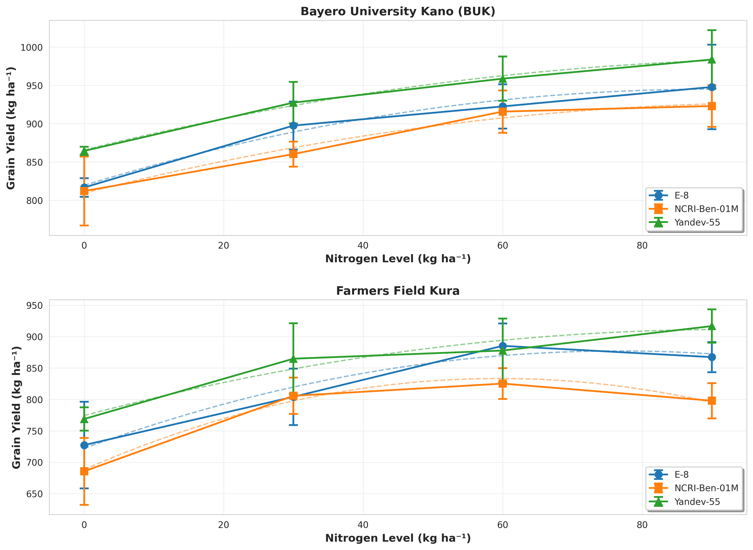

Figure 2. Nitrogen use efficiency indices of sesame varieties under different nitrogen application rates. (A) Agronomic Efficiency (AE), (B) Apparent Nitrogen Recovery (ANR), (C) Physiological Efficiency (PE), and (D) Internal Nitrogen Efficiency (IE).
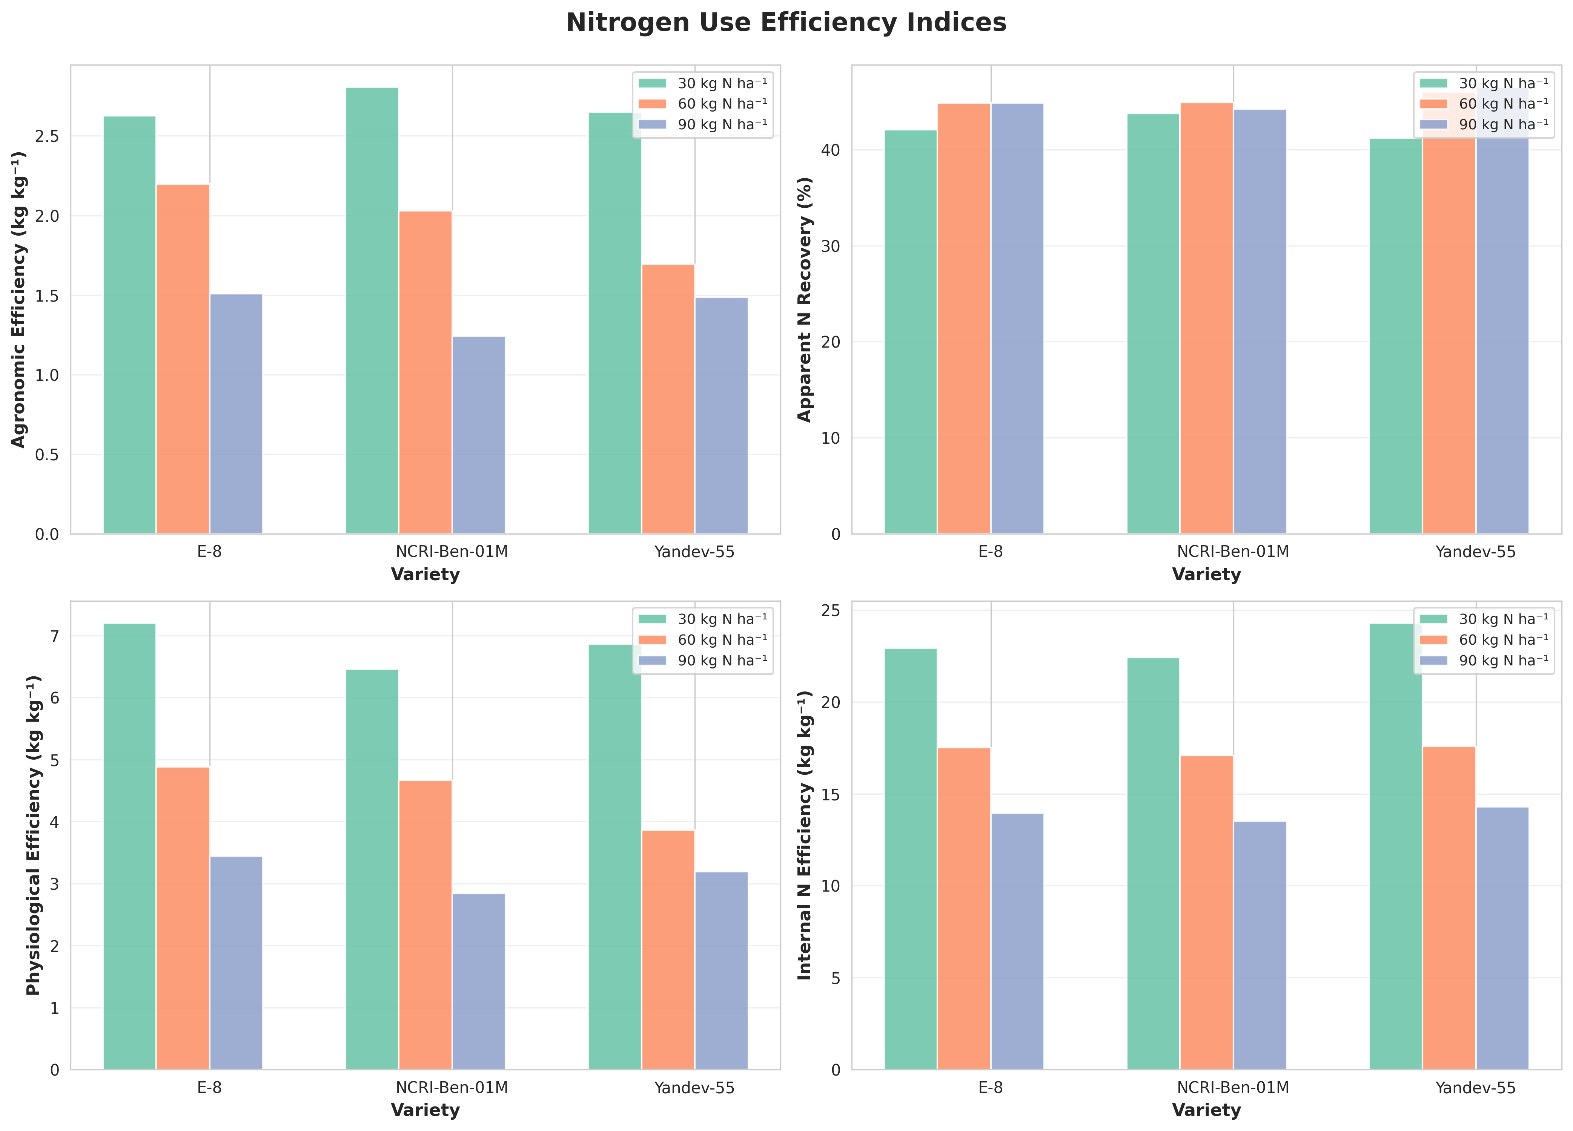

Figure 3. (A) Mean nutrient uptake (N, P, K) by sesame varieties, and (B) Harvest index response to nitrogen application rates.
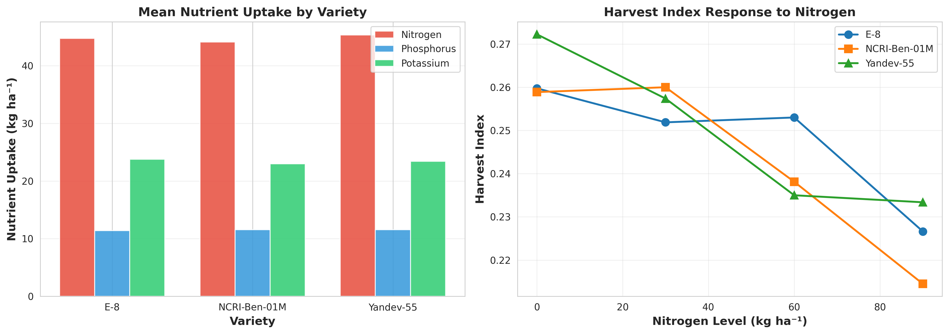

Figure 4. Correlation matrix showing relationships among key parameters. Values represent Pearson correlation coefficients.
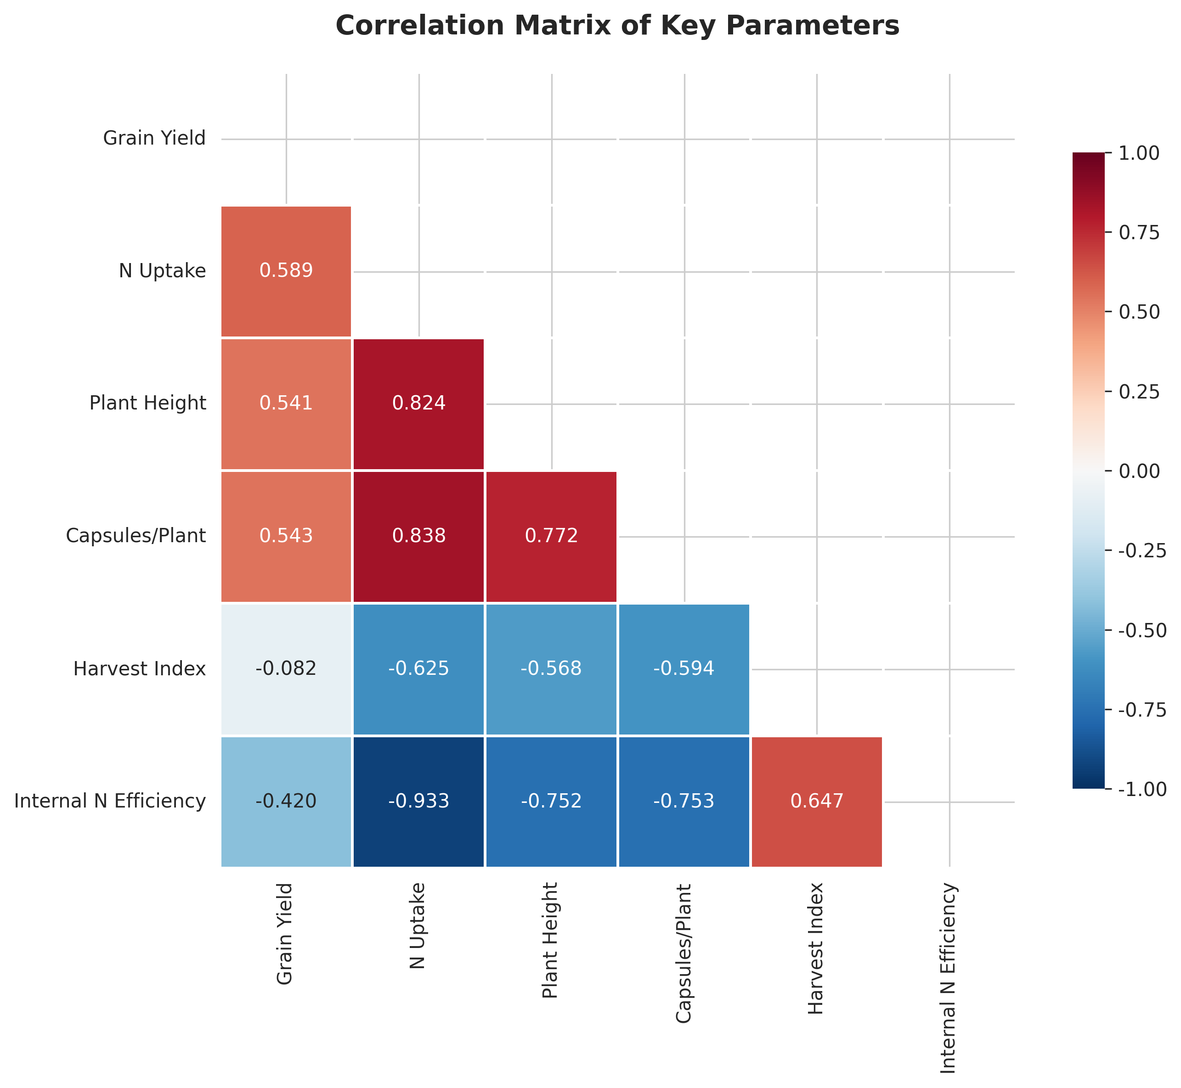

Figure 5. Yield component responses to nitrogen application: (A) Plant height, (B) Capsules per plant, and (C) 1000-seed weight. Data points represent means ± standard deviation (n=8).
