Comparison of Motor Execution and Imagery: Analyzing EEG Signals to Investigate Brain Activity Patterns

Goodnews Akindele1, Ayoade Adeyemi2,∗, Cyrille Mesue Njume3 1Electronics Engineering Department, Kadir Has University, Istanbul, Turkey

2Computational Science and Engineering, Kadir Has University, Istanbul, Turkey
3Computational Science and Engineering, Istanbul Technical University, Istanbul, Turkey
¹goodnews.akindele@stu.khas.edu.tr; ORCID: 0009-0006-6253-664X ^{2,∗}ayoade.adeyemi@stu.khas.edu.tr; ORCID: 0009-0009-8162-394X ³njume24@itu.edu.tr
∗Corresponding author: Ayoade Adeyemi, ayoade.adeyemi@stu.khas.edu.tr

ABSTRACT

Motor execution and imagery are important aspects involved in human movement. The motor cortex is involved in the execution of voluntary movements. This research paper analyzes brain activity patterns using electroen-cephalography (EEG), focusing on motor execution and motor imagery activities using a previously collected dataset. We compare EEG signals during actual movement and imagined movement tasks to identify neural activity patterns associated with each task condition. To compare and classify EEG activity related to motor execution and motor imagery, we utilized ten machine learning models. Our findings show that Random Forest, AdaBoost, and CatBoosting classifiers performed well for the shorter experimental time period. For the longer experimental period, the CatBoosting Classifier, XGBClassifier, and Random Forest performed well. Under-standing how EEG patterns differ during different motor activities can improve brain-computer interface (BCI) technology and rehabilitation strategies.
Keywords: EEG; BCI; Motor Execution; Motor Imagery; Machine Learning

INTRODUCTION

Human brains are highly complex structures that play an essential role in all stages of movement. Motor execu-tion is the act of carrying out movement, such as moving a limb, while motor imagery is the ability to mentally rehearse or imagine carrying out a particular movement. These two processes rely on the motor cortex, which is responsible for movement. The mental rehearsal of movement without any physical action engages neural mechanisms that largely overlap with those of real motor execution [1]. Both actual movement and imagined movement modulate characteristic EEG rhythms over the sensorimotor cortex, notably the mu rhythm, approxi-mately 8–12 Hz, and beta rhythm, around 13–30 Hz. Despite similarities in brain activation patterns, differences exist in the neural signals associated with these two activities. In this paper, we aim to compare and analyze brain activity patterns for motor execution and motor imagery conditions, focusing on tasks involving hand and feet movements.
EEG is a non-invasive BCI method that measures electrical activity generated by the brain through electrodes placed on the scalp. By analyzing EEG signals obtained during these tasks, we can identify specific neural

signatures that differentiate motor execution from motor imagery [2]. This analysis is useful in biomedical research and Brain-Computer Interface applications. Understanding patterns in EEG data helps provide insight into motor learning and brain function and can support rehabilitation strategies, especially for individuals with movement disorders.
The development of large electroencephalographic motor imagery datasets is crucial for advancing BCI technolo-gies. These datasets provide the necessary data for designing and evaluating EEG data processing approaches, which are essential for controlling robotic systems through mental processes. The availability of large and uni-form datasets addresses the challenge of variability in EEG signals, which remains a significant hurdle in BCI research [3].
The following sections of this paper explore current discussions on motor execution and imagery, methodology, results, and future research. By understanding the different EEG signals associated with these activities, we can improve the efficacy of BCIs that rely on motor imagery for control. Additionally, this work can inform rehabilitation strategies for individuals with movement disorders. This paper seeks to answer the following research questions:

- RQ1: How do EEG patterns, specifically within sensorimotor rhythms, differ during motor execution and motor imagery tasks?
- RQ2: Can we identify specific EEG signatures that distinguish between motor execution and motor im-agery using electroencephalography?

LITERATURE REVIEW

The performance of models in comparing Motor Execution (ME) and Motor Imagery (MI) by analyzing Elec-troencephalogram signals to investigate brain activity patterns has been extensively studied in Brain-Computer Interface systems [4–6]. EEG signals exhibit variations between motor execution and motor imagery tasks. Studies have shown that motor execution, observation, and imagery tasks engage distinct neurons, as detected by EEG and fNIRS modalities [4, 5]. The differentiation in activation patterns between EEG signals during motor execution and imagery tasks suggests distinct neural processes underlying these two modalities [6].
According to Tang et al. [6], developing advanced signal processing techniques, such as Multi-Scale Hybrid Net-works, is important for capturing and differentiating between these neural activities effectively. The complexity of EEG signals during motor imagery creates challenges due to noise [7]. A recently introduced Multi-Scale Hybrid CNN improves motor-imagery EEG classification by jointly capturing fine-grained temporal and spatial patterns, yielding higher accuracy [5].
Tacstan et al. [8] classified EEG data using an Adaptive Boosting classifier. The proposed model assigned EEG-derived features to correct categories, enabling identification of motor imagery actions. This was achieved with a hybrid deep-learning architecture that integrates a Convolutional Neural Network and a Long Short-Term Memory network to extract discriminative features from EEG signals for motor-imagery detection. The model outperformed existing state-of-the-art models, achieving a classification accuracy of 98%. The research contributes to the field by addressing challenges associated with detecting motor imagery movement from EEG signals and providing a promising approach for paralyzed individuals to control external devices.
Tacstan et al. [8] also utilized common spatial pattern analysis for feature extraction from motor imagery EEG signals. This method is widely used in motor imagery applications and was effective in extracting relevant fea-tures for classification. The paper also compares the performance of different classification algorithms, including Artificial Neural Network, Convolutional Neural Network, Support Vector Machine, and K-Nearest Neighbor Algorithm. This comparison provides valuable insights into the effectiveness of these algorithms in classifying

motor imagery EEG signals for neurorehabilitation applications. It identified Artificial Neural Network as the most successful classifier, with an accuracy of 93.9%.
Bao et al. [9] explored various feature extraction methods in motor imagery brain-computer interfaces across four domains: time, frequency, time-frequency, and spatial. The study discussed methods such as ERD/ERS computation, FFT, Wavelet Transform, Discrete Wavelet Transform, Common Spatial Patterns, and Sub-band Common Spatial Patterns. By comparing the advantages and disadvantages of each method, the study provides a useful reference for future MI-BCI research.
Balim and Akdagli [10] focused on classifying Motor Imagery Signals using a Convolutional Neural Network with the BCI-IV 2b dataset. Their approach allowed the identification of brain signals related to imagined limb movements, which is crucial for BCI applications. The study achieved a performance of 75.7% in classifying MIS signals with fewer parameters compared to similar studies, indicating the efficiency of the proposed CNN model.
Paez et al. [11] compared four machine learning techniques for motor imagery EEG signal classification: Rie-mannian minimum distance to mean, deep neural network, convolutional neural network, and common spatial patterns using linear discriminant analysis. The study assessed model performance using mean accuracy, with values ranging from 60% to 80%. The Riemannian minimum distance to mean algorithm achieved the highest accuracy of 80%.
Bashashati et al. [12] concluded that focusing on electrical brain signals can contribute to standardizing signal processing techniques within the BCI field, thereby promoting consistency and interoperability among different BCI systems. Lakshmi et al. [13] provided a comprehensive overview of EEG signal processing methods used in Brain-Computer Interfaces, including SVM, ANN, ICA, PCA, Wavelet Transform, autoregressive modeling, Wavelet Packet Decomposition, and Fast Fourier Transform.
The surveyed literature underscores the increasing prominence of EEG-driven brain-computer interfaces. Con-temporary machine-learning and deep-learning models can discriminate between executed and imagined move-ments by mining patterns in EEG recordings. This supports advancement in BCI applications, particularly in neurorehabilitation, by offering new solutions for individuals with impaired mobility.

DATA DESCRIPTION

This dataset includes 1,526 EEG recordings from 109 volunteers, with each recording lasting one or two minutes [14, 15]. A 64-channel EEG setup using the BCI2000 system was used for the recordings. Participants performed various motor and imagery tasks during the recordings. Each participant completed 14 experimental runs, which included baseline runs and task runs.
The baseline runs were:

- Eyes open, lasting one minute.
- Eyes closed, lasting one minute.

The task runs were:

- Open and close the left or right fist based on target position, lasting two minutes.
- Imagine opening and closing the left or right fist based on target position, lasting two minutes.
- Open and close both fists, when the target was at the top, or both feet, when the target was at the bottom, lasting two minutes.

- Imagine opening and closing both fists, when the target was at the top, or both feet, when the target was at the bottom, lasting two minutes.

Each task run was repeated three times, resulting in the following run sequence: baseline eyes open, baseline eyes closed, Task 1, Task 2, Task 3, Task 4, Task 1, Task 2, Task 3, Task 4, Task 1, Task 2, Task 3, and Task 4.
The annotations were defined as follows:

  - T0: Rest.
  - T1: Onset of motion, real or imagined, of the left fist for Tasks 1 and 2, or both fists for Task 3.
  - T2: Onset of motion, real or imagined, of the right fist for Tasks 1 and 2, or both feet for Task 3.

In the BCI2000 setup, event information is encoded in the TargetCode state with numeric values of 0, 1, or 2. Recordings relied on a 64-channel cap that follows the 10–10 placement scheme, although certain electrodes, including Nz, F9/F10, FT9/FT10, A1/A2, TP9/TP10, and P9/P10, were excluded. The stored data list these channels in order, labeled 0 through 63, as shown in Figure 1.
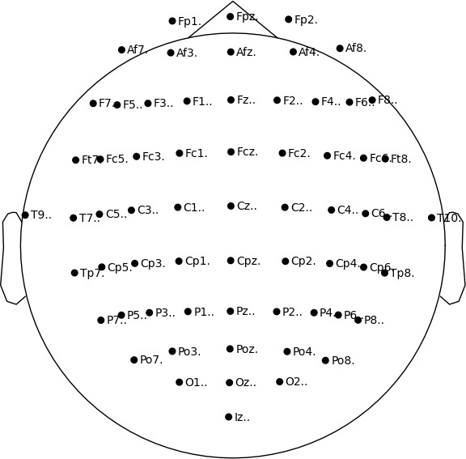

Figure 1: Montage from 64 electrodes arranged according to the international 10–10 system.

METHODOLOGY

Data Processing and Window Definition

All recordings were stored in EDF format and digitized at a sampling rate of 160 Hz; therefore, each EEG channel produced 160 sample points per second. Consequently, a 60-second window contains 60 × 160 = 9, 600 sample points per channel, and a 120-second window contains 120 × 160 = 19, 200 sample points per channel.
Two window lengths were used because each trial begins with a resting baseline followed by an executed-movement cue and, in runs 3–14, an additional motor-imagery block. We therefore segmented the data as follows:

    - 0–60 s common window: This window is present in all 14 runs and captures the baseline plus the first executed-movement cue. Using this universal segment guarantees equal-length trials for the three-class task, namely rest, executed, and imagined.
    - 0–120 s extended window: This window is present only in runs 3–14, where the imagery block is avail-able. Using the full window maximizes data volume for the two-class task, namely executed versus imag-ined, without diluting the dataset with shorter trials.

After windowing, we applied the feature-extraction pipeline, which consisted of Mel-spectrogram transformation followed by f classif feature selection. This yielded two clean datasets:

      - Dataset 1, 60 s: All 14 runs with 9,600 sample points per channel. This dataset was used for statistical testing and three-class classification, namely rest versus executed versus imagined, as shown in Figure 2.
      - Dataset 2, 120 s: Runs 3–14 only with 19,200 sample points per channel. This dataset was used for extracting significant samples and two-class classification, namely executed versus imagined, as shown in Figure 3.

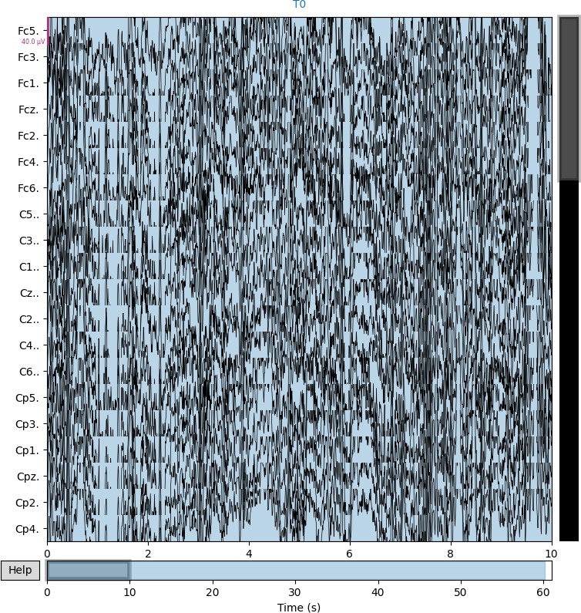

Figure 2: Sample of 60 seconds of signals used to compare baseline signals with action signals.

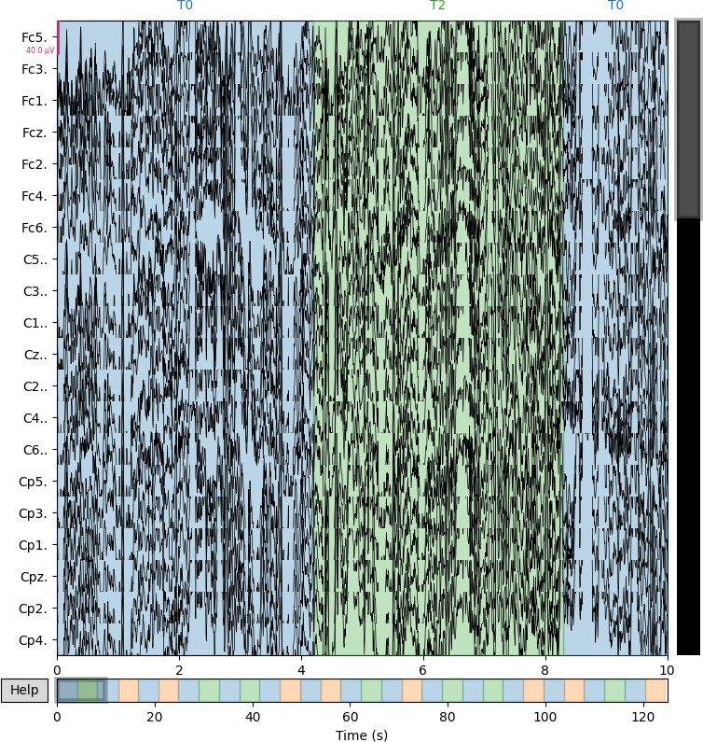

Figure 3: Sample of 120 seconds of signals used to compare baseline signals with action signals.

Feature Extraction

Extracting features from EEG signals with a Mel spectrogram is more involved than with single-channel audio because EEG contains many spatially distributed channels of brain activity. The workflow below converts the multichannel time series into a compact time-frequency representation suitable for machine-learning classifiers.

Pre-processing and windowing.

Each trial was trimmed to the analysis window, either 0–60 s or 0–120 s, corresponding to 9,600 or 19,200 samples at 160 Hz. To reduce dimensionality while preserving spatial information, raw electrodes were aver-aged into 13 neuro-anatomical groups: Fp, Af, F, Ft, Fc, T, C, Tp, Cp, P, Po, O, I. The grouping constants, channel categories in the code, were based on standard 10–10 electrode nomenclature.

Log-Mel spectrogram per group.

For each group g, the one-dimensional signal x_{g}[n] was transformed with LIBROSA1 using 128 Mel bands, where
n mels = 128:

1https://librosa.org

S_{g}[k, p] = log Mel₁₂₈ STFT{x_{g}[n]} , p = 1, . . . , 128.

Here, STFT uses Librosa’s default window and hop sizes, and the Mel filterbank spans the 0.5–40 Hz EEG band of interest. Only one segment, num segments = 1, was computed, giving the lowest possible latency.

Concatenation and vectorization.

The 13 log-Mel matrices were concatenated along the frequency axis, flattened into a single feature vector, and forwarded to the f classif selector. On a 3.1 GHz laptop CPU, the full transform including Mel mapping and feature selection executed in under 20 ms per one-second window, comfortably inside the 100–150 ms control loop typical for motor-imagery BCIs.

Reproducibility.

The complete Python implementation, including the function feature transform, channel definitions, and all parameter settings, is available in the project repository.

Feature Selection

Feature selection is an essential stage in EEG data analysis because it improves the effectiveness of machine learning models by selecting the most relevant characteristics. One common method for feature selection is the ANOVA F-test, which can be applied using f classif from the scikit-learn library. The f classif function performs an ANOVA F-test for the features. The ANOVA F-test checks the null hypothesis that the means of the features are the same across different classes. It provides two main outputs: F-values and p-values.
Using f classif for EEG feature selection helps identify which features, such as Mel spectrogram coeffi-cients, are most relevant for distinguishing between different classes or mental states. It also reduces the number of features, mitigates the curse of dimensionality, improves model performance, and reduces overfitting. Dataset 1 and Dataset 2 were first filtered using p < 0.05, followed by p < 0.01, to reduce the number of features to fewer than 100. A cluster map was developed for the 120-second data, as shown in Figure 4, and the 60-second data, as shown in Figure 5.

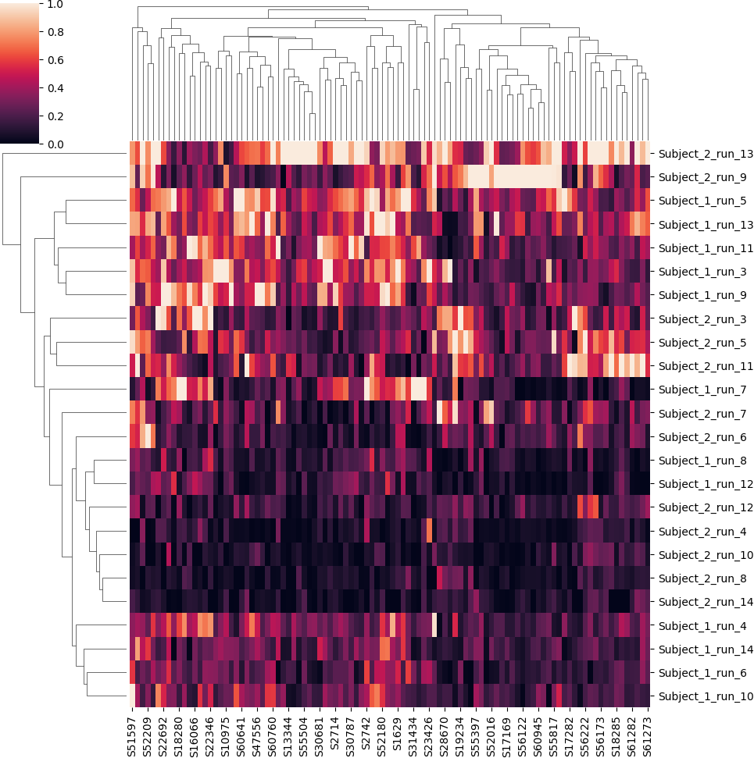

Figure 4: Combined heat and cluster grid of the 120-second data.

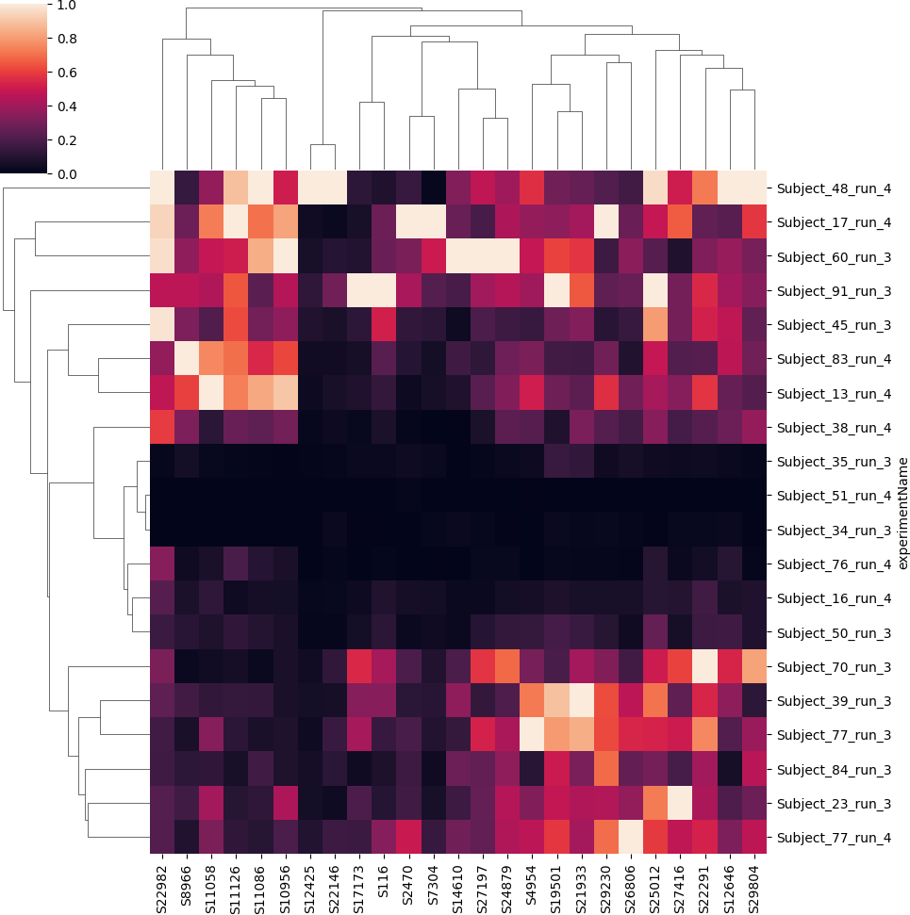

Figure 5: Cluster grid of the 60-second data.

Machine Learning Methods

The goal of this study was to analyze the EEG Motor Movement/Imagery Dataset acquired from PhysioNet. The main objective was to identify distinct patterns of brain activity linked to motor imagery and motor execution. Specifically, we compared EEG signals for imagined and real movement activities to identify different patterns of brain activity. After data preprocessing, feature extraction, and feature selection, several machine learning algorithms were used to achieve the aim of the study. The models used were Random Forest, Decision Tree, Gradient Boosting, Logistic Regression, XGBClassifier, CatBoosting Classifier, AdaBoost Classifier, Support Vector Classifier, KNeighborsClassifier, and MLPClassifier. These machine learning models were selected to evaluate which models performed better in identifying brain activity patterns.

RESULTS

In this section, we report the findings obtained from the analysis carried out on the dataset. To evaluate model performance, we used several metrics, including F1 score, accuracy, ROC AUC, precision, and recall.

Performance Metrics for Baseline Samples

The performance metrics with respect to the baseline samples, which were approximately 60 s, are summarized in Table 1. From the results, the Random Forest, AdaBoost, and CatBoosting models achieved the highest scores based on the evaluation metrics.

Table 1: Model performance metrics for 60 seconds.

Model | F1 | Acc. | ROC AUC | Prec. | Recall
Random Forest | 0.554 | 0.588 | 0.586 | 0.571 | 0.538
AdaBoost Classifier | 0.537 | 0.544 | 0.544 | 0.520 | 0.555
CatBoosting Classifier | 0.533 | 0.552 | 0.551 | 0.529 | 0.538
MLPClassifier | 0.533 | 0.544 | 0.544 | 0.520 | 0.546
Decision Tree | 0.529 | 0.544 | 0.544 | 0.520 | 0.538
XGBClassifier | 0.492 | 0.520 | 0.519 | 0.496 | 0.487
Logistic Regression | 0.491 | 0.536 | 0.533 | 0.514 | 0.471
KNeighborsClassifier | 0.484 | 0.496 | 0.496 | 0.472 | 0.496
Gradient Boosting | 0.483 | 0.512 | 0.510 | 0.487 | 0.479
SVC | 0.381 | 0.520 | 0.510 | 0.493 | 0.311

Performance Metrics for Action Samples

The performance metrics for the action samples, which were approximately 120 s, are summarized in Table 2. From the results, the CatBoosting Classifier, XGBClassifier, and Random Forest model achieved the highest scores based on the evaluation metrics.
Table 2: Model performance metrics for 120 seconds.

Model | F1 | Acc. | ROC AUC | Prec. | Recall
CatBoosting Classifier | 0.544 | 0.564 | 0.563 | 0.542 | 0.546
XGBClassifier | 0.522 | 0.524 | 0.525 | 0.500 | 0.546
Random Forest | 0.509 | 0.560 | 0.556 | 0.543 | 0.479
KNeighborsClassifier | 0.498 | 0.548 | 0.544 | 0.528 | 0.471
Gradient Boosting | 0.485 | 0.508 | 0.507 | 0.483 | 0.487
MLPClassifier | 0.485 | 0.524 | 0.522 | 0.500 | 0.471
AdaBoost Classifier | 0.463 | 0.508 | 0.505 | 0.482 | 0.445
Decision Tree | 0.436 | 0.472 | 0.470 | 0.443 | 0.429
Logistic Regression | 0.400 | 0.520 | 0.512 | 0.494 | 0.336
SVC | 0.361 | 0.532 | 0.520 | 0.516 | 0.277

Model Comparison

Comparing the results obtained from both datasets indicates that some models are better suited for handling EEG data for motor movement and imagery tasks. From both results, CatBoosting and Random Forest classifiers performed well, with an accuracy of approximately 55% for both the 60-second and 120-second datasets. This consistent performance indicates that these models are suitable for EEG signal classification tasks. From the action sample results, Logistic Regression and SVC were less efficient than the top-performing models. The findings from this study provide an overview of the efficiency of using several machine learning models to classify EEG signals.

DISCUSSION

This study addressed two research questions. RQ1 asked whether EEG signatures of motor execution and motor imagery can be discriminated reliably. RQ2 asked whether lightweight signal processing combined with classical machine learning can operate quickly enough for online BCI use.
Empirical results in Table 1 and Table 2 show that the CatBoosting Classifier and Random Forest are the most

robust models across both the 60 s and 120 s windows, answering RQ1 in the affirmative. After Mel-spectrogram transformation and f classif feature selection, the CatBoosting model achieved F1 = 0.54 and ROC AUC =
0.56 on the extended 120 s dataset. This gain was obtained without subject-specific deep learning and with only
a single-subject calibration set.
For practical BCI use, the entire feature-extraction pipeline, including Mel-spectrogram transformation and f classif, executed in less than 20 ms per second window on a standard laptop. This leaves enough time for classification and feedback inside the 100–150 ms loop typically required for motor-imagery BCIs. The two window lengths serve complementary clinical scenarios:

- 60-second quick-calibration mode: Every trial contains this segment, so clinicians can obtain a working model after only one minute of data. This is useful for patients with limited attention or fatigue.
- 120-second maximum-accuracy mode: When more data can be collected, particularly from runs 3–14, the longer window increases F1 by approximately 2–3 points, providing additional accuracy for research or high-stakes control tasks.

The main limitation is data scarcity because five subjects had missing blocks, reducing the effective training set. Future work will enlarge the cohort through data augmentation and cross-database transfer learning, test richer time-frequency decompositions such as wavelet packets, and perform systematic hyperparameter searches and ensemble stacking to improve accuracy beyond the current plateau.
In summary, the combination of quantitative improvement, millisecond-level latency, and dual-window flexibility represents a meaningful step toward deployable motor-imagery BCIs.

CONCLUSION

By leveraging approaches that can extract temporal and spatial features from EEG data, researchers can enhance the classification accuracy and performance of Brain-Computer Interface systems for motor imagery tasks. This study aimed to improve understanding of brain activity related to motor tasks, potentially aiding the development of better interventions for individuals with sensory or motor impairments.

ETHICAL APPROVAL

This study used a publicly available EEG Motor Movement/Imagery Dataset from PhysioNet. No new human-subject data were collected by the authors. If required by the journal, the original dataset’s ethical approval and data-use conditions should be cited here.

CONFLICT OF INTEREST

The authors declare that there is no conflict of interest regarding the publication of this paper.

DATA AVAILABILITY

The data used in this study are publicly available from PhysioNet through the EEG Motor Movement/Imagery Dataset. Relevant dataset references are included in the reference list.

ACKNOWLEDGMENTS

This dataset was created and contributed to PhysioBank by Gerwin Schalk and colleagues at the BCI R&D Program, Wadsworth Center, New York State Department of Health, Albany, NY. W. A. Sarnacki collected the data. Aditya Joshi compiled the dataset and prepared the documentation. D. J. McFarland and J. R. Wolpaw were responsible for experimental design and project oversight. This work was supported by grants from NIH/NIBIB.

References

- Daeun Gwon, Kyungho Won, Minseok Song, Chang S Nam, Sung Chan Jun, and Minkyu Ahn. Review of public motor imagery and execution datasets in brain-computer interfaces. Frontiers in human neuro-science, 17:1134869, 2023.
- Kavitha P Thomas, Neethu Robinson, Kavallur Gopi Smitha, and A Prasad Vinod. Eeg-based discrimina-tive features during hand movement execution and imagination. In 2018 15th International Conference on Control, Automation, Robotics and Vision (ICARCV), pages 883–888. IEEE, 2018.
- Murat Kaya, Mustafa Kemal Binli, Erkan Ozbay, Hilmi Yanar, and Yuriy Mishchenko. A large electroen-cephalographic motor imagery dataset for electroencephalographic brain computer interfaces. Scientific data, 5(1):1–16, 2018.
- Abm Adnan Azmee, Manohar Murikipudi, and Md Abdullah Al Hafiz Khan. Detecting motor imagery movement from eeg signal. In Proceedings of the 2023 ACM Southeast Conference, pages 89–95, 2023.
- Wan-Chun Su, Hadis Dashtestani, Helga O Miguel, Emma Condy, Aaron Buckley, Soongho Park, John B Perreault, Thien Nguyen, Selin Zeytinoglu, John Millerhagen, et al. Simultaneous multimodal fnirs-eeg recordings reveal new insights in neural activity during motor execution, observation, and imagery. Scien-tific Reports, 13(1):5151, 2023.
- Xianlun Tang, Caiquan Yang, Xia Sun, Mi Zou, and Huiming Wang. Motor imagery eeg decoding based on multi-scale hybrid networks and feature enhancement. IEEE Transactions on Neural Systems and Re-habilitation Engineering, 31:1208–1218, 2023.
- Zaid Shuqfa, Abdelkader Nasreddine Belkacem, and Abderrahmane Lakas. Decoding multi-class motor imagery and motor execution tasks using riemannian geometry algorithms on large eeg datasets. Sensors, 23(11):5051, 2023.
- Yahya Tas¸tan, Ulvi Bas¸pınar, and Burcu Bulut Okay. Classification of motor imagery eeg signals for using in neuro-rehabilitation applications. In 2022 Innovations in Intelligent Systems and Applications Conference (ASYU), pages 1–4. IEEE, 2022.
- Fengge Bao and Weiheng Liu. Eeg feature extraction methods in motor imagery brain computer interface. In Third International Seminar on Artificial Intelligence, Networking, and Information Technology (AINIT 2022), volume 12587, pages 375–380. SPIE, 2023.
- Mustafa Alper Balim and Nurettin Acir. Classification of motor imagery signals by convolutional neural network for bci applications. In 2019 27Th Signal Processing And Communications Applications Confer-ence (Siu), pages 1–4. Ieee, 2019.
- RT Pa´ez-Amaro, E Moreno-Barbosa, JM Herna´ndez-Lo´pez, CH Zepeda-Ferna´ndez, LF Rebolledo-Herrera, and B de Celis-Alonso. Eeg motor imagery classification using machine learning techniques. Revista mexicana de f´ısica, 68(4), 2022.

- Ali Bashashati, Mehrdad Fatourechi, Rabab K Ward, and Gary E Birch. A survey of signal processing algorithms in brain–computer interfaces based on electrical brain signals. Journal of Neural engineering, 4(2):R32, 2007.
- M Rajya Lakshmi, TV Prasad, and Dr V Chandra Prakash. Survey on eeg signal processing methods.
International journal of advanced research in computer science and software engineering, 4(1), 2014.
- G Schalk, DJ McFarland, T Hinterberger, N Birbaumer, and JR Wolpaw. Eeg motor movement/imagery dataset. Retrieved November, 18:2011, 2009.
- Ary L Goldberger, Luis AN Amaral, Leon Glass, Jeffrey M Hausdorff, Plamen Ch Ivanov, Roger G Mark, Joseph E Mietus, George B Moody, Chung-Kang Peng, and H Eugene Stanley. Physiobank, physiotoolkit, and physionet: components of a new research resource for complex physiologic signals. circulation, 101 (23):e215–e220, 2000.

