A Review on Green Synthesis of Metallic Nanoparticles and their Applications for Sustainable Environment
A. Niresha Gnana Mary¹, Dr. A. S. Stella Shalini²
^{1&2} PG & Research Department of Chemistry, St. Joseph’s College (Autonomous), (Affiliated to Bharathidasan University) Tiruchirappalli-620 002, Tamil Nadu, India

Abstract

Nanotechnology is a significant field of contemporary research dealing with design, synthesis and manipulation of particle structures ranging from in the region of 1-100 nm. The application of the twelve principles of green chemistry in nanoparticle synthesis is a relatively new emerging issue concerning the sustainability. This field has received great attention in recent years due to its capability to design alternative, safer, energy efficient, and less toxic routes towards synthesis. This article gives an overview of green synthesis of nanoparticles and applications of such synthesized products to environmental remediation in terms of antimicrobial activity, catalytic activity, removal of pollutants dyes, and heavy metal ion sensing. In the area of environmental remediation, nanomaterials offer the potential for the efficient removal of pollutants and biological contaminants. Key focus of the literature review will relate to the nanomaterial’s including metallic nanoparticles like Iron, Zinc, Silver, Gold, their oxides, nanocomposites from plant extracts and their applications towards sustainable environment.

Key words: green synthesis, silver nanoparticles, gold nanoparticles, sustainable environment

INTRODUCTION
Metallic nanoparticles have fascinated scientist for over a century and are now heavily utilized in biomedical sciences and engineering. Nanotechnologyis the creation, manipulation and use of materials at the nanometre size scale (1 to 100 nm). At this size scale there are significant differences in many material propertiesthat are normally not seen in the same materials at larger scales. It is predominantlythe nanoparticles’ extremely small size and large surface area to volume ratio that leads to thesignificant differences in properties. Noble metal, especially gold (Au) and silver (Ag) nanoparticles exhibit unique and tunable optical properties on account of their surface plasmon resonance (SPR).They are a focus of interest because of their huge potential applications in nanotechnology.[1]Nanoparticles are being used fordiverse purposes, from medical treatments, using in various branches of industry production such as solar and oxide fuel batteries for energy storage to wide incorporation into diverse materials of everyday use such as cosmetics or clothes, optical devices, catalytic, bactericidal, electronic, sensor technology, biological labeling and treatment of some cancers.[2] Due to their exceptional properties including antibacterial activity, high resistance to oxidation and high thermal conductivity, nanoparticles have attracted considerable attention in recent years.[3,4] Consequently, with wide range of applications available, these particles have potential to make a significant impact to the society. The development of reliable experimental protocols for the synthesis of nanomaterials over a range of chemical compositions, sizes, and high monodispersity is one of the challenging issues in current nanotechnology. In the context of the current drive to develop green technologies in material synthesis, this aspect of nanotechnology is of considerable importance.. Recent studies on the use of microorganisms in the synthesis of nanoparticles are a relatively new and exciting area of research with considerable potential for development. The synthesis of metallic nanoparticles is an active area of academic and, more importantly, “application research” in nanotechnology. A variety of chemical and physical procedures could be used for synthesis of metallic nanoparticles. However, these methods are fraught with many problems including use of toxic solvents, generation of hazardous by-products, and high energy consumption. Accordingly, there is an essential need to develop environmentally benign procedures for synthesis of metallic nanoparticles. A promising approach to achieve this objective is to exploit the array of biological resources in nature. Indeed, over the past several years, plants, algae, fungi, bacteria, and viruses have been used for production of low-cost, energy-efficient, and nontoxic metallic nanoparticles.This review describes a brief overview of the current research worldwide on synthesis of metal nanoparticles and their applications.
REVIEW ON GREEN SYNTHESIS AND APPLICATIONS OF METALLIC NANOPARTICLES
Nanoparticles can be synthesized chemically or biologically.Many adverse effects have been associated with chemicalsynthesis methods due to the presence of some toxic chemicalabsorbed on the surface. Eco-friendly alternatives to chemicaland physical methods are biological ways of nanoparticlessynthesis using microorganisms [5,6] enzymes, [7] fungus,[8] andplants or plant extracts. [9,10] The development of these eco-friendlymethods for the synthesis of nanoparticles is evolving into animportant branch of nanotechnology especially silver and gold nanoparticles, which have many applications. [11,12] Biosynthesis of nanoparticles by microorganisms is a green and
eco-friendly technology. Diverse microorganisms, bothprokaryotes and eukaryotes are used for synthesis of metallicnanoparticles viz. silver, gold, platinum, zirconium, palladium,iron, cadmium and metal oxides such as titanium oxide, zincoxide, etcThese microorganisms include bacteria,actinomycetes, fungi and algae. The synthesis of nanoparticlesmay be intracellular or extracellular according to the location of
nanoparticles. [13, 14]
INTRACELLULAR SYNTHESIS OF NANOPARTICLES BY FUNGI

This method involves transport of ions into microbial cells to formnanoparticles in the presence of enzymes. As compared to thesize of extracellularly reduced nanoparticles, the nanoparticlesformed inside the organism are smaller. The size limit is
probably related to the particles nucleating inside theorganisms.[15]
EXTRACELLULAR SYNTHESIS OF NANOPARTICLES BY FUNGI
Extracellular synthesis of nanoparticles has more applications ascompared to intracellular synthesis since it is void ofunnecessary adjoining cellular components from the cell.Mostly, fungi are known to produce nanoparticlesextracellularly because of their enormous secretory components,which are involved in the reduction and capping of
nanoparticles. [16]

MICROBES FOR PRODUCTION OF NANOPARTICLES
Both unicellular and multicellular organisms produce inorganic materials either
intra- or extracellularly[17]. The ability of microorganisms likebacteria and fungi to control the synthesis of metallicnanoparticles is employed in the search for new materials.Because of their tolerance and metal bioaccumulation ability,fungi have occupied the center stage of studies on biologicalgeneration of metallic nanoparticles
IRON NANOPARTICLES SYNTHESIS AND THEIR CHARACTERIZATIONS
Productions of nanoparticles by using microbes are a new area of interest. Pleurotus sp was allowed for biosynthesis of iron nanoparticles in a culture media. The fungus was allowed togrow in 2x10-4 M FeSO4 solutions for 72 hours. U.V-Vis spectra analysis helps us to know aboutformations of nanoparticles at 226 nm and 276 nm wavelength. Involvement of proteins inculture was determined by spectral analysis of broth culture at different interval of times at 265nm. FTIR analysis detects the presence of functional groups in binding of particles with biomass.There was a shift in case of treated cells indicating participations of proteins in more quantity.TEM images reflect depositions of particles in both inside as well as outside indicating thebiosynthesis process. However such depositions are absent in case of control sample. XRF ofcontrol samples donot show any iron elements but was present in treated mycelium. Someothers elements were also detected; it may be due to present in culture media. The transport ofiron particles may be due to presence of Siderophores. Iron transport molecules likehydroxamates are mainly present in fungi. They bind the complex molecules and transport theminside of cells.
BLANK
Iron nanoparticles
WAVELENGTH (nm)
500
450
400
350
300
250
200
0.03

0.025

0.02

0.015

0.01

0.005

0

Figure: 1 UV-Vis spectra of Iron nanoparticles in solutions (226 & 276 nm)
The above Figure clearly indicate that secretion of proteins into the FeSO₄ solution by the test fungus that brings about change in the oxidation-reductions potential of the FeSO₄ solution. This finally brings about oxidations of FeSO₄. In the initial period of 24 hour of treatment; no visible change in the colour of the solution was visible. Change in absorbance value (at 265 nm wavelength) of the solution during this period is thought to be due to secretion of protein/enzymes by the fungus. Thus iron nanoparticle synthesis was an extracellular protein mediated process. Formations of Iron nanoparticles were detected by spectral analysis under U.V-Vis spectrophotometer. Absorptions spectra were observed at two wavelengths (226 nm and 276 nm).
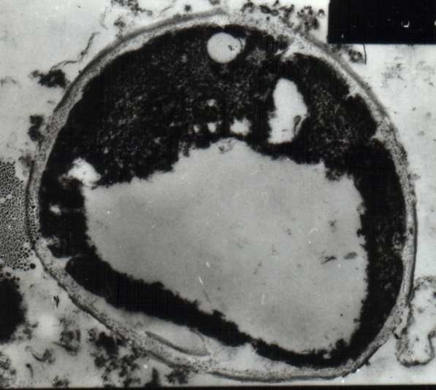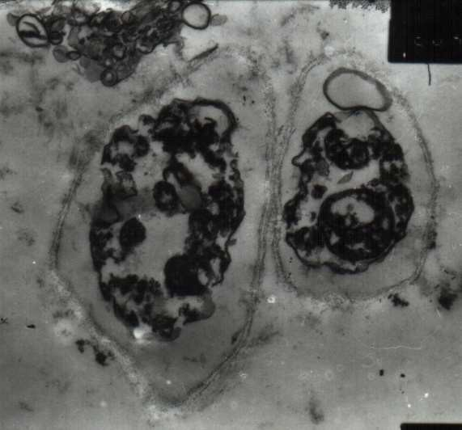LOCALIZATIONS OF PARTICLES IN TEM
The thin cross sections of fungal hyphae before and after the treatment with FeSO₄ solution were observed under TEM at variousmagnifications.
Figure:2 TEM images of untreated fungal cells (after 72 Hours)
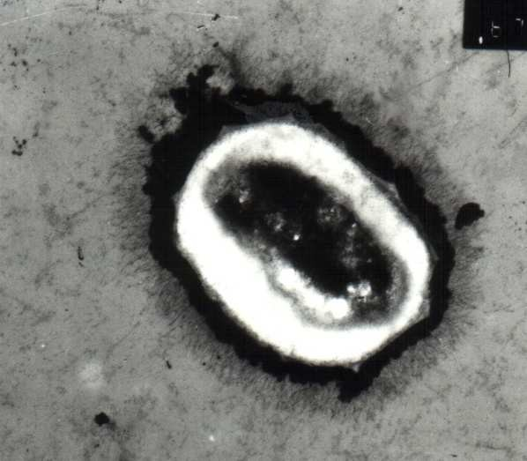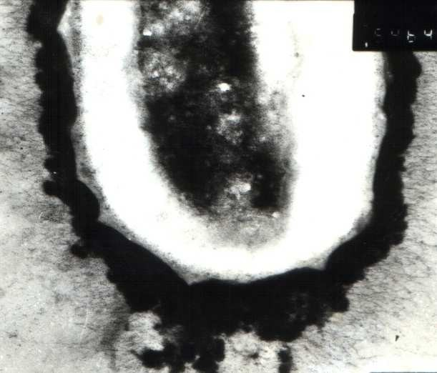
Figure: 3 Depositions of Iron nanoparticles in both extracellular and intracellular of fungal cells, after 72 Hours (Arrows indicates nanoparticles)
SILVER NANOPARTICLE SYNTHESIS AND THEIR APPLICATIONS
Silver nanoparticles (AgNPs) are attractive option for treating drug-resistant microorganisms because they are non-toxic to the human body at low concentrations and have broadspectrumantibacterial actions. The biosynthesis of nanoparticles has received increasing attention due to thegrowing need to develop safe, cost-effective and environmentally friendly technologies for nano-materials synthesis. In this report, silver nanoparticles (AgNPs) were synthesized using a reduction of aqueous Ag⁺ ion with the culture supernatants of Aspergillus niger. The reaction occurred at ambient temperature and in a few hours. The bio reduction of AgNPs was monitored by ultraviolet-visible spectroscopy, and the AgNPs obtained were characterized by transmission electron microscopy and X-ray diffraction. The synthesized AgNPs were poly dispersed spherical particles ranging in size from 1 to 20 nm and stabilized in the solution. Furthermore, the antimicrobial potential of AgNPs was systematically evaluated. The synthesized AgNPs could efficiently inhibit various pathogenic organisms, including bacteria and fungi. The current research opens a new avenue for the green synthesis of nano-materials and AgNPs have the potential to serve as an alternative to antibiotics and to controlmicrobial infections such as those caused by multidrug- resistant pathogens.
AgNPs were synthesized using a reduction of aqueous Ag⁺ with the culture supernatants of Aspergillus nigerat room temperature. It was generally recognized that AgNPs produced brown solution in water, due to the surface plasmon resonances (SPR) effect and reduction of AgNO3 [20]. After the addition of AgNO3 solution, the cell filtrate of A.niger changed from light yellow to brown in a few hours, while no color change was observed in the culture supernatant without AgNO3 (Figure 1).
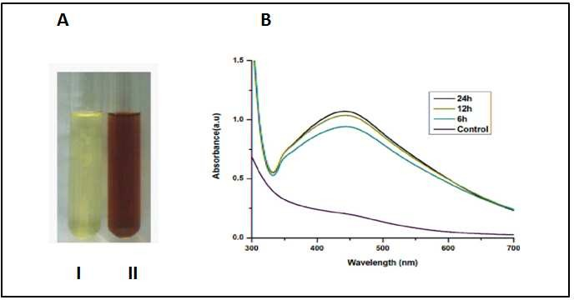
Figure: 4 (A) The crude cell filtrate of Aspergillus niger mixed without AgNO3 (I) and with AgNO3(II) after 24h. (B) The UV-Vis spectra recorded for the reaction of fungal cell filtrate with AgNO₃ solution.
Thus, color change of the solution clearly indicated the formation of AgNPs. The color intensity of the cell filtratewith AgNO3 was sustained even after 24 h incubation, which indicated that the particles were well dispersed in the solution and there was no obvious aggregation. All these reactions were monitored by ultraviolet-visible spectroscopy of the colloidal AgNPs solutions. The ultraviolet-visible spectra of the cell filtrate with AgNO₃showed a strong broad peak at 440 nm which is surface Plasmon resonances (SPR band), which indicated the presence of AgNPs (Figure 1B). These results were consistent with the reports of Naik et al. and Verma et al.[21,22]. The intensity of the SPR band steadily increased from 6 h to 24 h as a function of time of reaction. It was also observed that the AgNPs formed were quite stable in the supernatant of A. niger.

Figure:5 (A) Representative images of AgNPs synthesized by the reduction of AgNO₃ solution with the crude cell filtrate from Aspergillus niger; (B) Size distribution of the AgNPs from TEM analysis, C) X-ray diffraction patterns of AgNPs (a.u.= arbitrary units).

The application of AgNPs was highly dependent on the chemical composition, shape, size, and mono dispersity of particles [18]. To broaden the application scope, the AgNPs obtained were systematically characterized using TEM and XRD analysis. Through the TEM analysis, the particles were spherical and polydisperse with an average size of 4.3nm (1–20nm) and the majority of the particles were less than 10nm.

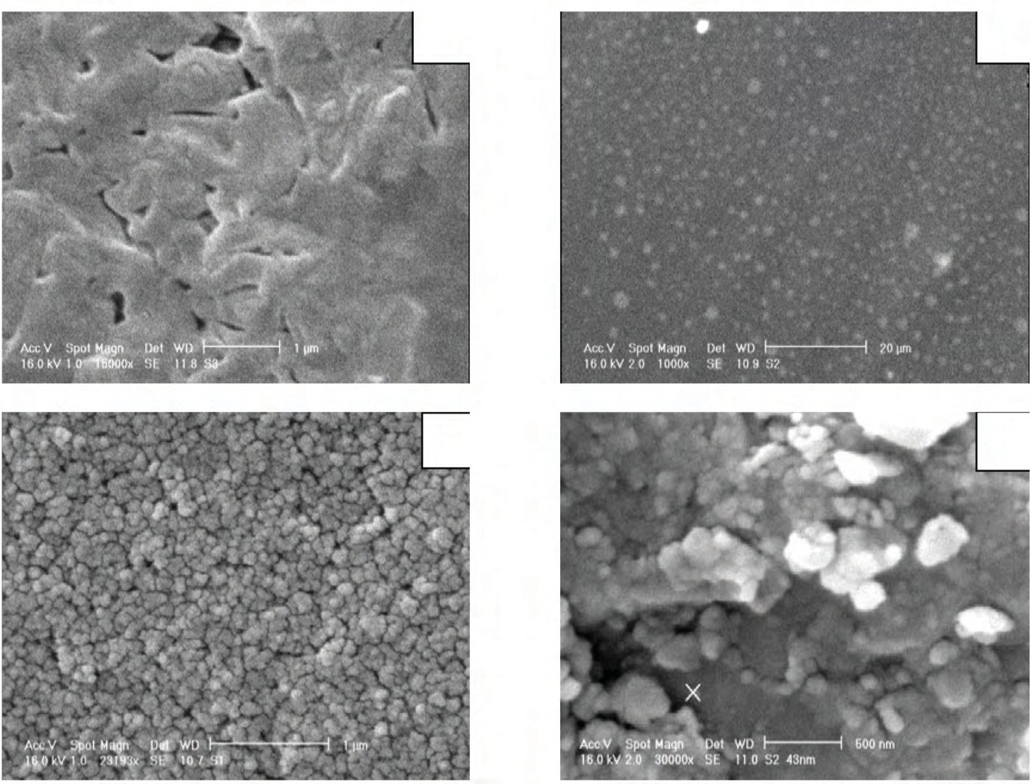Figure:6. Scanning electron micrograph of the plant material incubated with deionized water (5A) and of the silver nanoparticles obtained with plant extract incubated with 0.003 M silver nitrate solution at 86◦C for 13min (5B-5D).
A
B
C
D
GOLD NANOPARTICLE SYNTHESIS AND THEIR APPLICATIONS
Supported metal nanoparticles, M-NPs, are of great scientific and economic interest as they encompass application in chemical manufacturing, oil refining and environmental catalysis. Oxidation and hydrogenation reactions are among the major reactions catalyzed by supported M-NPs. Although supported M-NPs are preferable due to their easy recovery and reuse, there are still some practical issues regarding their catalytic activity and deactivation. This review highlights the general features of supported M-NPs as catalysts with particular attention to copper, gold, platinum, palladium, ruthenium, silver, cobalt and nickel and their catalytic evaluation in various reactions. The catalytic performance of noble M-NPs has been explored extensively in various selective oxidation and hydrogenation reactions. In general, noble metals are expensive and sensitive to poisons. Despite their significant merits and potential (easily available, comparatively inexpensive and less sensitive to poisons), catalysis by base M-NPs is relatively less explored. Therefore, activity of base M-NPs can be improved and still, there is potential for such catalysts.

  - Platinum nanoparticles as catalysts
The use of platinum in catalysis presumably representsthe most important application of platinum.Platinum nanoparticles (Pt-NPs) are widely used inthe catalysis of many reactions, including thehydrogen evolution reaction used in fuel cells [19]. Itis well known that the activity of M-NPs increaseswith the decrease in the particle sizes. However, astudy by Tan and co-workers [20] revealed that forthe hydrogen evolution reaction the catalytic activityof the Pt-NPs is unfavorably affected by size in the1–3 nm range. That was explained by the fact thatedge sites on small Pt-NPs bind too strongly to
hydrogen atoms and become catalytically inactive [21]. Supported Pt-NPs are known to have good catalyticactivity in many reactions, including oxidationof organic compounds [22,23], alcohol oxidation [24], hydrogenation of biomass-derived compounds [25], NO reduction reaction ethylene glycol reformingand a variety of processes such as the ones usedin oil refinery. Recently, we have evaluated theactivity of the Pt-NPs in gas-phase oxidation ofethanol. It was reported that the activity of thecatalysts was boosted by the immobilization of Pt- NPs on the surface of the mesoporous materials, and the immobilization of Pt-NPs favors complete oxidation to carbon oxide.
3.4 Palladium nanoparticles as catalysts
Palladium was used earlier in catalysis for organictransformations. The use of palladium as catalyst inorganic chemistry was mostly stimulated by the discoveryof palladium-catalyzed oxidation of ethylene to acetaldehyde by air [26]. The Nobel Prize inChemistry 2010 was awarded to R.F. Heck, E. Negishiand A. Suzuki for the palladium-catalyzed crosscouplingreactions, families of organic synthesis thatuse palladium complexes as catalysts . Recently, Monfared et al. have highlighted the advance in the application of palladium nanoparticles (Pd-NPs) for Hiyama cross-coupling reactions. The investigation showed that Pd-NPs were catalytically highly effective in fluoride-free Hiyama coupling reactions. The importance of the choice of the carrier was also mentioned, with carbon carrier being the most suitable. Pd-NPs have been effective catalysts for the synthesis of various compounds. The activity of the Pd-NPs is size and shape dependent. It was revealed that very sharp shaped Pd-NPs show strong catalytic activity for the organic reactions such as Heck, Suzuki and Stille couplings. In a study conducted in our group, Pd-NPs supported onSBA-15 typical silica materials were revealed to be an efficient catalyst for Suzuki coupling. High performance in terms of turnover frequencies was obtained even under an aqueous system and fairly low temperatures.

CONCLUSION
The 21st century has brought a great interest and expansion of the nanomaterials field. The timeliness of being “green and nano” for nanomaterials synthesis has become evident from the latest developments and publications in the field. Among them, supported metal nanoparticles are important owing to their unique properties and various methods of preparation. Recent advances in the design and preparation of supported metal nanoparticles confirmed that a numerous variety of metal nanoparticles can now a days be synthesized through different preparation routes and supports to give tailored sizes, shapes and distributions, overcoming the main drawbacks of traditional synthetic methodologies. Such designer materials will have a significant impact in many areas including increasing applications in industrial catalytic processes. However, we must not forget that the preparation of supported metal nanoparticles should be promoted in a more sustainable way, reducing waste generation and the use of toxic compounds with room-temperature aqueous solution protocols, improving manufacturing safety as well as decreasing the production costs. In addition to that, the implementation of such catalysts may not come without a price and the environmental impact associated with the preparation of supported metal nanoparticles must be assessed from many different of view (transport, waste, bio magnification in the food chain) as well as their potential toxicity when released in ecosystems and humans.

REFERENCES
- Dubchak S., Ogar A., Mietelski J.W. and Turnau K.,Influence of silver and titanium nanoparticles on arbuscular mycorhiza colonization and acumulation of radiocaesiumin Helianthus anus, Span. J. Agric. Res., 8(1), 103-108,(2010).
- Klaus T., Joerger R., Olsson E. and Granqvist C.G., Silver-Based Crystalline Nanoparticles, Microbially Fabricated,J. Proc. Natl. Acad. Sci. USA, 96, 13611-13614,(1999)
- Konishi Y. and Uruga T., Bioreductive Deposition of Platinum Nanoparticles on the Bacterium Shewanella algae, J. Biotechnol., 128, 648-653, (2007)4. Willner I., Baron R. and Willner B., Growing metalnanoparticles by enzymes, J. Adv. Mater, 18, 1109-1120,(2006).
- Vigneshwaran N., Ashtaputre N.M., Varadarajan P.V,Nachane R.P., Paralikar K.M., Balasubramanya R.H.,Materials Letters, 61(6), 1413-1418, (2007)
- Shankar S.S., Ahmed A., Akkamwar B., Sastry M., Rai A.,Singh A. Biological synthesis of triangular goldnanoprism, Nature, 3 482, (2004)
- Sakthi, S.A., Mani, C., Priyadarshini, K. et al. 3D MnNi₂S₄-MOF-67/rGO composite: a high-performance material for advanced supercapacitor applications. Appl. Phys. A 131, 911 (2025). https://doi.org/10.1007/s00339-025-08977-y
- Armendariz V., Gardea-Torresdey J.L. , Jose Yacaman M.,Gonzalez J., Herrera I. and Parsons J.G., Proceedings ofConference on Application of Waste Remediation Technologies to Agricultural Contamination of WaterResources, Kansas City, Mo, USA, (2002)
- Kim B.Y., Rutka J.T., Chan W.C., Nanomedicine, N. Engl.J. Med.,363(25), 2434-2443, (2010)
- S. Antony Sakthi, K. Priyadarshini , C. Mani and S. Rusho Robin Prasad, Synthesis and Spectral Characterization Of High-Performance Supercapacitor ZIF-67@RGO Nanocomposite Electrode Materials, Rasayan J. Chem., 16(3), 1462-1472(2023) http://doi.org/10.31788/RJC.2023.1638206
- Hulakoti N.I. and Taranath T.C., Biosynthesis ofnanoparticles using microbes: A Review. Colloids surf BioInterfaces, (121), 474-83, (2014)
- Mann S., Biomineralization, Principles and Concepts inBioinorganic Materials Chemistry, Oxford UniversityPress, Oxford, UK, (2001)
- Narayanan K.B. and Sakthivel N., Biological Synthesis ofmetal nanoparticles by microbes, Advances in Colloid andInterface Science, 156, 1- 13, (2010)
- Shiv Shankara S., AkhileshRai, Absar Ahmad, MuraliSastrya, J. of Colloid and Interface Science, 275(2), (2004)
- S.Antony Sakthi, K. Priyadarshini, C. Mani, S. Rusho Robin Prasad and A. Dominic, Synthesis and Characterization of NiCo₂S₄-MOF-ZIF-67@rGO for Efficient Electrochemical Energy Storage, Journal of Physics: Conference Series, 2024, 2801 012001. http://DOI 10.1088/1742-6596/2801/1/012001
- Narayanan K.B. and Sakthivel N., Biological Synthesis of metal nanoparticles by microbes, Advances in Colloid andInterface Science, 156, 1- 13, (2010)
- Mahendra Rai, AlkaYadav, Aniket Gade, Biotech. Adv.,27(1), 76-83, (2009)
- Rai M., Yadav A. and Gade A., Biotech. Adv., 27, 76-83,(2009)19. Sharma V.K., Ria A.Y. and Lin Y., Advances in Colloidand Interface Science, 145, 83-96, (2009)
- S.Antony Sakthi, J.H. Rakini Chanderasekaran, A. Niresha Gnana Mary, M. Surendra Varma and P. Lakhsmi Prabha, Synthesis and Characterization of 3D MnNi2O4@ MnNi2S4/NF-MOF-67-rGO nanoflower@ nanosheet for ultra-high capacity electrode material, Journal of Physics: Conference Series, 2024, 2801 012009,
DOI: 10.1088/1742-6596/2801/1/012009
- Bar H., Bhui D.K., Sahoo G.P., Sarkar P., De S.P. andMisra A., Colloids and Surfaces A, Physicochem. Eng.Aspects, 339, 134-139, (2009)
- Jha A.K., Prasad K., International Journal of GreenNanotechnology: Physics and Chemistry, 1, 110-117,(2010)
- Antony Sakthi, S, Selvakumar, M. S, & Prabha, P. L, Electroorganic Synthesis and Characterization of 4-Ethoxy Acetanilide using Platinum and Graphite as Anodes, Journal of Scientific Research, 14(2), (2022), 583–591. https://doi.org/10.3329/jsr.v14i2.54735
- Avnika Tomar and Garima Garg, Short Review on Application of Gold Nanoparticles. Global Journal of Pharmacology, 7 (1), 34-38, (2013)
- Antony Sakthi S, Selvakumar, M.S, Ramanathan P, Electrosynthesis and characterization of 2-ethoxy benzoic acid at platinum electrode by Potentiostatic method, Materials Today: Proceedings, 2022, 69, 1375-1380. https://doi.org/10.1016/j.matpr.2022.09.005
- Junggwon Y., Kyoungah C., Byoungjun P., Ho-Chul K.,Byeong-Kwon J. and Sangsig K.J., J. of Appl. Phys. 47 :5070 (2008)
- Mohl M., Dobo D., Kukovecz A., Konya Z., Kordas K.,Wei J., Vajtai R. and Ajayan P.M., J. Phys. Chem. C 115,9403, (2011)
- Fan T.X., Chow S.K. and Zhang D., Biomorphicmineralization: from biology to materials, Progress inMaterials Science, 54(5), 542–659, (2009)

