HIERARCHICAL MULTIPLE REGRESSION ANALYSIS OF IMPACT OF EXCHANGE RATE, INTEREST RATE, INFLATION AND MONEY SUPPLY ON GDP IN NIGERIA (1999-2022)

OKORAFOR, U. and ABOSEDE, R. A.
DEPARTMENT OF STATISTICS, SCHOOL OF SCIENCE, YABA COLLEGE OF TECHNOLOGY, YABA, LAGOS STATE, NIGERIA

ABSTRACT

This study examines the impact of key macroeconomic variables on Nigeria’s Gross Domestic Product (GDP) growth over the period 1999 to 2022. Recognizing the challenges posed by economic volatility in Nigeria, the research investigates how money supply, inflation, exchange rate fluctuations, and interest rate influence GDP. Secondary time-series data were sourced from the World Bank, and the analysis was conducted using descriptive statistics, correlation analysis, and hierarchical multiple regression modeling via SPSS. The study first provides a comprehensive review of regression techniques and their applications in economic analysis, setting the foundation for employing hierarchical multiple regression to assess the incremental impact of each variable on GDP. Diagnostic tests confirmed that the data met the assumptions of linearity, homoscedasticity, normality of residuals, and absence of multicollinearity, ensuring the reliability of the model. The results indicate that money supply and exchange rate have significant positive effects on GDP, suggesting that expansionary monetary policies and controlled currency depreciation can stimulate economic growth. Conversely, inflation and interest rate were found to exert statistically significant negative impacts on GDP, underscoring the adverse effects of rising prices and high borrowing costs on economic performance. The final regression model explains approximately 92.9% of the variation in GDP, highlighting the robustness of the model. The final fitted model is GDP = 5.246E+12 + 1.944E+12(money supply) – 4.603E+11(inflation) + 7.646E+10 (exchange rate) – 1.924E+11(interest rate). Based on these findings, the study concludes that effective management of monetary policy—including careful regulation of money supply, inflation control, exchange rate stabilization, and interest rate adjustments—is crucial for sustaining economic growth in Nigeria. The research provides empirical evidence to support policy interventions aimed at balancing these macroeconomic factors to enhance overall economic stability and growth.

Keywords: Gross Domestic Product, Money supply, Inflation, Exchange rate, Interest rate

1.0 INTRODUCTION
  - Background of the Study
One of the most treasured objectives of macroeconomics is macroeconomic stability. It is the cornerstone of any effective strategy to promote economic welfare and sustain growth. The government, firms, and households all incur enormous economic losses as a result of macroeconomic instability, which could exacerbate catastrophic economic unrest (Goshit & Terese, 2020; Olamide, Ogujiuba & Maredza, 2022). For instance, retarding growth, might harm the poor and undermine economic returns for businesses (Fofanah, 2021). Inflation is a regressive and arbitrary tax, with the burden falling disproportionately on those at the bottom of the income hierarchy (Ighoroje & Orife, 2022). Analogously, a high unemployment rate typically causes a loss of labour, ineffective demand for products and services, poor productivity, a rise in the poverty rate, dwindling government revenue as well and an economic slowdown (Cahyadin & Ratwianingsih, 2020). Figure 1 displays the performance of three macroeconomic variables in Nigeria namely inflation, unemployment and economic growth.
Interest rate is the price a borrower pays for the use of money they borrow from a lender/financial institutions or fee paid on borrowed assets. High interest rate on credit may discourage SMEs from borrowing therefore reducing SMEs access to credit. Access to finance is vital to the survival of all businesses particularly SMEs, which are the backbone of all economies and drivers of economic growth and development (Oke, Uthman & Ademokoya, 2020). SMEs play a vital role in economic development as they are considered globally as engine of growth (Awani, 2020). This is due to their ability to create jobs, alleviate poverty, address income inequality, and provide depth to the industrial base of the economy (Motilewa, Worlu, Ogbari &Aka, 2015). Despite their importance, access to finance has been observed to be the main challenge for their growth with risk premiums on their borrowing and elevated transactions costs as main obstacles. According to Price Waterhouse Coopers (PWC) 2020 survey, half of the businesses in Nigeria that applied for loan in 2020 turned it down because the cost was too high. Thus, scholars as well as those specifically involved within that sector, have been interested in seeking ways to improve the financial sustainability of SMEs (Islam & AbdWahab, 2021; Tuffour, Amoako & Amartey, 2020).
Exchange rate fluctuations significantly impact capital markets, GDP, foreign direct investment, and economic stability. For Nigeria, this is particularly relevant due to its over-reliance on natural resources like crude oil, subject to global market forces (Eyung, Aben, and Chukwuebuka, 2021). Stabilizing the foreign exchange market and achieving exchange rate convergence are crucial for the capital market's health (Iheanachor and Ozegbe, 2021). By encouraging import substitution, raising exports, attracting more foreign investment, and improving tourism, a lower currency can increase GDP growth. This increases demand for domestic goods and services, raising domestic output and employment. Additionally, a country's currency depreciation increases its appeal to foreign investors, bringing in more FDI. Furthermore, a depreciating currency might make goods and services more competitive internationally, which could enhance trade balances and economic stability. But it's crucial to control related risks, such as inflation and rising import prices (Krugman and Obstfeld, 2017). The Nigerian capital market faces numerous challenges, including inefficiencies, insufficient information about listed companies, the financial crisis, low participation rates, low returns on investments, a lack of transparency among stockbrokers, inadequate regulation, poor policies, subpar customer service, and a decline in investor confidence. Significant investor withdrawals were caused by inefficiencies in registrars, a lack of information about listed companies, and the 2009 financial crisis. Low participation rates and low returns discourage investors, and stockbrokers often deceive clients. Poor regulation allows unethical practices, while inadequate policies after the 2009 financial meltdown deter potential investors. Poor customer service is another issue, with many brokerage firms failing to provide timely feedback. Market instability and a lack of listed companies have led to investor losses and skepticism, further affecting the Nigerian capital market (InfoGuide, 2024). Exchange rate fluctuations have a multifaceted impact on the capital market performance, influencing investors’ confidence, foreign investment, corporate earnings, and economic stability.
In general, when a currency depreciates it will result in higher import prices if the country is an international price taker, while lower import prices result from appreciation. The potentially higher cost of imported inputs associated with exchange rate depreciation increases marginal costs and leads to higher price of domestically produced goods (Osakwe, Ibenta, & Ezeabasili, 2019). Further, import- competing firms might increase prices in response to foreign competitor price increases to improve profit margins. The extent of such price adjustment depends on a variety of factors such as market structure, the relative number of domestic and foreign firms in the market, the nature of government exchange rate policy and product substitutability (Ezeaku et al 2018).
1.2 Statement of the Problem
In recent years, the Nigerian economy has experienced significant fluctuations in key macroeconomic indicators, including money supply, inflation, interest rates, and exchange rates. These variables have been postulated to have profound effects on the country’s economic performance, particularly its Gross Domestic Product (GDP). Understanding how these factors interact and influence GDP growth is essential for policymakers, financial analysts, and economists to formulate effective strategies to stabilize and stimulate the economy Olomola, et al., 2020).
Money supply, often controlled by central banks, plays a critical role in influencing inflation and interest rates, which in turn can affect investment, production, and overall economic growth, Central Bank of Nigeria (2023). Inflation, driven by demand and supply shocks, often leads to decreased purchasing power and higher production costs, which may hinder economic growth. The interest rate, set by the Central Bank of Nigeria, directly affects borrowing costs for businesses and consumers, thereby influencing economic activity. Lastly, exchange rate fluctuations impact Nigeria’s foreign trade, as a devaluation of the naira can make imports more expensive, contributing to inflationary pressures and potentially reducing GDP, Omotesho, et al. (2023).
Despite the importance of these variables, limited empirical research has examined the relative impact of money supply, inflation, interest rates, and exchange rates on GDP growth in Nigeria using advanced statistical techniques like hierarchical multiple regression. Bassey, et al. (2021). Hierarchical multiple regression allows for a nuanced understanding of the incremental contribution of each variable to GDP growth, accounting for the potential interdependencies and collinearity among them. Ogunleye, O. (2023). By entering variables in a stepwise manner, hierarchical regression can assess the direct and indirect effects of these macroeconomic indicators, helping to identify which factors have the most significant influence on Nigeria's GDP in recent years.
Thus, this study aims to explore the dynamic relationships between money supply, inflation, interest rate, exchange rate, and GDP in Nigeria, using hierarchical multiple regression. Given the volatile nature of the Nigerian economy, this research will provide valuable insights into how these variables collectively shape GDP growth, offering evidence that can guide policy recommendations and economic planning.
According to Ojomolade (2018), inflation, corruption, and unemployment have slowed Nigeria's growth despite its natural and people resources. Double-digit inflation improves income and consumption but hinders investment and productivity. Borrowers' and lenders' earnings and losses are unclear, lowering financial asset returns (Okotori, 2018; Oni, 2018). Budgetary imbalances raise government budgets, generating macroeconomic instability because high inflation reduces growth and hurts the poor (Oni, 2018). A currency devaluation raised import prices, lowering agricultural productivity. Nigeria's 1995 inflation was unpredictable due to financial institutions' increased lending to individuals and businesses, disrupting consumption, investment, and output (Ditimi, Keji & Emma-Ebere, 2018). Dollar exchange rate, wide money, national debt, oil prices, government spending, population, and other factors might cause inflation (UGwulali, et al., 2021). Therefore, this study will evaluate how inflation and currency rate variations effect Nigerian GDP growth. Nigerians' welfare and cost of living are affected by inflation. Cost increases make pricing unpleasant and many businesses idle or less productive, harming all sectors of the economy. Nigeria must identify all important inflation factors before managing it. Pre-SAP (fixed exchange rate) and post-SAP (flexible exchange rate) Nigeria has exchange rate volatility and related difficulties Bamidele, et al. (2022) but sharp foreign exchange dealer and end user activities marred the period. Due to these difficulties, SAP adopted a more flexible exchange rate system in 1986. Nigeria has faced import dependency, political instability, inflation, capital flight, and a lack of industry backward connections since 1986. Because inflation and currency rate changes create uncertainty, trade flows may suffer. Many studies have explored how naira exchange rate variations effect foreign trade in Nigeria, but none have examined how inflation and currency rate volatility affect Nigeria and beyond. In developing nations like Nigeria, inflation and exchange rate fluctuation impede economic growth. Both impact consumption, investment, economic performance, and living standards. Suraj, et al. (2022), To build sustainable development strategies in Nigeria, policymakers, analysts, and stakeholders must understand how inflation and currency rate fluctuations effect economic growth. Inflation diminishes consumers' purchasing power and makes buying products and services difficult. Due to uncertainty, inflation can limit consumer spending, firm investment, and economic activity. Second, exchange rates affect trade, foreign investment, and domestic industrial competitiveness. Nyangoko, et al. (2021). Depreciation or appreciation of currencies hurts several economic sectors. Thirdly, inflation and exchange rates may interact. Nigeria's inflation and exchange rate fluctuations hinder economic growth and development. Finally, knowing how inflation and currency rates affect Nigerian economic growth is essential for good monetary and fiscal policies. With Nigeria's inflation and currency rate oscillations, it's unclear what policies may be done to limit their negative effects on economic growth. Moreno Lopez, et al. (2022) Inflation and currency rate fluctuations influence economic growth in developing nations, particularly Nigeria. Nigeria's specific difficulties and opportunities are considered in this research of how inflation, currency rate changes, and trade balance effect economic growth [proxied by Real Gross Domestic Product (RGDP)].
  - Aim and Objectives of the Study
This study aims at investigating the effect of these macro variables on GDP and analyze its data using hierarchical multiple regression technique so as to assess how the addition of different sets of predictors affects the model's explanatory power.
The objectives are as follows:
- To identify the direction of money supply, interest rate, exchange rate fluctuations and inflation from 1999 to 2022 in Nigeria.
- To estimate the impact of money supply, interest rate, exchange rate fluctuations and inflation on Real GDP as a key economic growth indicator.
- To evaluate the efficacy of exchange rate and inflation policies implemented from 1999 to 2022.
1.4 Research Questions
The research questions are the following:
i. What has been the direction of money supply, interest rate, exchange rate fluctuations and inflation from 1999 to 2022 in Nigeria?
ii. How has money supply, interest rate, exchange rate fluctuations and inflation impacted Real GDP from 1999 to 2022 in Nigeria?
iii. How effective have money supply, interest rate, exchange rate and inflation policies been in influencing economic growth from 1999 to 2022 in Nigeria?
1.5 Research Hypotheses
Hypothesis one
H₀: Exchange Rate Fluctuation has no significant effect on GDP
H₁: Exchange Rate Fluctuation has a significant effect on GDP
Hypothesis two
H₀: Inflation rate has no significant effect on GDP
H₁: Inflation has a significant effect on GDP
Hypothesis three
H₀: Money supply has no significant effect on GDP
H₁: Money supply has a significant effect on GDP
Hypothesis four
H₀: Interest rate has no significant effect on GDP
H₁: Interest rate has a significant effect on GDP
1.5 SIGNIFICANCE OF THE STUDY
- The significance of this research is multifaceted, with implications for economic theory, policy formulation, and future empirical research on the Nigerian economy.
- The study contributes to the existing body of knowledge in the field of macroeconomics by advancing our understanding of how macroeconomic variables collectively influence a country’s economic performance.
- The study's findings will be valuable for economic forecasting and planning by identifying the key determinants of GDP in Nigeria,
- This study will add to the growing body of empirical literature on the Nigerian economy, particularly on the interplay between monetary and fiscal policy variables and economic performance.
- Furthermore, the study's findings will be instrumental for scholars seeking to apply the hierarchical regression approach in other developing economies facing similar economic challenges. This research will therefore serve as a benchmark for future studies in the field of macroeconomics, particularly in emerging economies like Nigeria.
1.6 SCOPE AND LIMITATIONS OF THE STUDY
The study encompasses the period from 1999 to 2022, analyzing 23 years of currency exchange managements, inflation, money supply, interest rate and Nigeria’s economy. The primary focus is on the nexus between exchange rate fluctuations, inflation, money supply, interest rate and Nigeria’s Real GDP growth as a key economic growth indicator. The study includes the scrutiny of inflation, exchange rate fluctuation and its impacts on Nigeria’s Real GDP.
1.7 DEFINITION OF TERMS
To ensure clarity and accuracy in interpreting the findings, the following is defined:
- Exchange Rate: This is the worth of a country’s currency for exchange purposes with a different country currency.
- Economic Growth: This is a rise in goods and services production within an country.
- Real GDP (Gross Domestic Product): This refers to the inflation-adjusted value of all final goods and services produced within a country's borders over a specific time period, capturing the actual change in economic output.
- Exchange Rate Fluctuations: These are the variations in the worth of a country’s currency against a different country’s currency.
- Inflation: Inflation is the rate at which the general level of prices for goods and services in an economy increases over time, leading to a decrease in the purchasing power of money.
- Macroeconomic Policies: These are strategies and activities undertaken by the government or central bank in order to control or manage overall economic performance, including exchange rate policies.
- Fluctuations: This is the degree of variation or fluctuation in a trading price series, such as exchange rates, over time.
- Money supply: Money supply refers to the total amount of money available in an economy at a particular point in time.
- Interest rate: Interest rate is the cost of borrowing money, expressed as a percentage of the principal loan amount.

2.0 LITERATURE REVIEW
2.1 Introduction
This literature review examines the relationships between key macroeconomic variables—money supply, inflation, interest rates, exchange rates—and Gross Domestic Product (GDP) growth in Nigeria. The review is structured into three major sections: the theoretical, conceptual, and empirical.
  - Conceptual Review
2.2.1 Money Supply and Economic Growth
The relationship between money supply and economic growth has been extensively studied, with findings varying across different countries and time periods. Recent research from 2019 onwards offers valuable insights into this dynamic.
A study published in December 2024 Ibrahim, et al. (2024) concluded that an increase in the money supply positively influences real economic growth in Nepal. This suggests that monetary expansion can stimulate economic activity in the country.
Research from August 2024 Ugomma, et al. (2024) examined the structural relationship between money supply, inflation, and economic growth in Sierra Leone using a Vector Autoregressive (VAR) model. The study found unidirectional causality from money supply to GDP per capita, indicating that changes in the money supply can affect economic growth. Additionally, there was bidirectional causality between money supply and inflation, highlighting the interconnectedness of these variables.
A 2023 study by Sun, H., & Liu, Z. (2023) investigated the impact of money supply on inflation and economic growth in South Africa from 1990 to 2021. The research utilized Markov-switching dynamic regression and time-varying parameter structural vector autoregression models. Findings indicated that the effect of money supply on economic growth and inflation varies depending on the state of the economy, emphasizing the importance of considering economic conditions when formulating monetary policies Cletus, et al. (2023).
An analysis of the U.S. economy from 2001 to 2019 Miftahu, et al. (2020) revealed that the growth rate of the broad money supply was a significant determinant of the growth rates of major asset indices, including national property and stock market indices. This suggests that changes in the money supply can influence asset prices and, by extension, economic growth.
Implications for Monetary Policy
These studies underscore the complex relationship between money supply and economic growth. While an increase in money supply can stimulate economic activity, it may also lead to inflationary pressures. Therefore, central banks must carefully calibrate monetary policies to balance growth objectives with price stability.
For instance, during the COVID-19 pandemic, central banks in the euro area and the United States implemented significant monetary expansions to support their economies. This led to historically high growth rates in the money supply in 2020, Zhao, et al. (2022) followed by a moderation in 2021. Such policies highlight the need for vigilant monitoring of inflation and economic indicators to ensure that monetary interventions achieve desired outcomes without unintended consequences.
The relationship between money supply and economic growth is multifaceted and context-dependent. Recent research emphasizes the importance of considering specific economic conditions and employing appropriate econometric models to understand this relationship. Policymakers should remain cognizant of the potential trade-offs between stimulating growth and maintaining price stability when designing monetary policies.

    - Exchange Rate and Economic Growth
The relationship between exchange rates and economic growth has been extensively studied, with findings varying across different countries and time periods. Recent research from 2019 onwards offers valuable insights into this dynamic.
Exchange Rate Regimes and Economic Growth
A study by Frankel et al. (2019) examined the impact of exchange rate regimes on economic growth across 145 countries. The research found that countries with more flexible exchange rate regimes tend to experience higher economic growth rates compared to those with fixed or pegged regimes. This suggests that exchange rate flexibility may provide countries with greater monetary policy autonomy, facilitating better economic performance.
Research by Huong (2019) analyzed the effects of real exchange rates on economic growth in Vietnam from 2007 to 2017. The study found a positive relationship between real exchange rates and economic growth, indicating that a one percentage point real depreciation in the Vietnamese dong could lead to a 1.62% growth in real GDP. However, this effect was observed only during the first four periods, suggesting a short-term impact.
A study Martinez, et al. (2020) assessing the impact of exchange rate volatility on economic growth across 194 countries from 1995 to 2019 found that the effect of exchange rate volatility on economic growth varies with the level of corruption. In countries with higher corruption levels, exchange rate volatility tends to have a more detrimental effect on economic growth.
An article published in Ugomma, et al. (2024) introduced trade structure into the growth mechanism of real exchange rate (RER) misalignment and obtained robust empirical evidence employing threshold models. The study found that RER misalignment negatively affects economic growth, and the impact varies depending on the trade structure of the country.

Implications for Monetary Policy
These studies underscore the complex relationship between exchange rates and economic growth. While exchange rate flexibility can provide countries with greater monetary policy autonomy, it may also introduce volatility that can impact economic stability Eroğlu, et al. (2023). Additionally, factors such as corruption levels and trade structures can influence the effectiveness of exchange rate policies.
Policymakers should consider these dynamics when designing monetary policies to ensure that exchange rate movements support sustainable economic growth. For instance, while a depreciated currency can boost exports and stimulate growth, it may also lead to higher import costs and inflationary pressures Bianchi, et al. (2023). Therefore, a balanced approach that considers both the benefits and risks of exchange rate movements is essential for fostering economic stability and growth.
The relationship between exchange rates and economic growth is multifaceted and context-dependent. Recent research highlights the importance of considering specific economic conditions, institutional factors, and trade structures when analyzing this relationship. A nuanced understanding of these dynamics is crucial for policymakers aiming to leverage exchange rate policies to promote sustainable economic growth.
    - Interest Rate and Economic Growth
The relationship between interest rates and economic growth has been a significant area of economic research, with central banks using interest rates as a tool for monetary policy. Interest rates influence the cost of borrowing, consumer spending, business investment, and overall economic activity, which in turn affects economic growth.
A 2021 study by Gupta et al. (2021) explored the relationship between interest rates and economic growth in developing countries and concluded that in low-income nations, a reduction in interest rates had a more pronounced positive effect on growth compared to higher-income countries, which may already be facing other limiting factors such as inflation.
A study by Zhao, et al (2022) analyzed the post-pandemic period in the U.S. and found that while the Federal Reserve's lowering of interest rates initially boosted economic growth, the longer-term effect was inflationary pressures, leading to rising costs that dampened some of the initial growth benefits.
A study by Bianchi, et al (2023) explored the effects of the European Central Bank’s low-interest rate policies in the aftermath of the 2008 financial crisis and the Eurozone debt crisis. They found that while low interest rates stimulated growth, they also contributed to asset price bubbles and rising income inequality, posing a long-term risk to economic stability.
A 2020 study by Martinez, et al (2020) analyzed how interest rate hikes impacted economic growth in emerging markets. They found that in some cases, higher interest rates, intended to curb inflation, led to slower growth as borrowing costs increased, hurting investment and consumption.
A study in 2021 by Peterson, et al (2021) examined how interest rates affect housing markets and, consequently, economic growth. It concluded that interest rates have a significant impact on the housing market, which drives consumer wealth and consumption, thereby influencing overall economic growth.
Implications for Monetary Policy
Central banks utilize interest rate adjustments to manage inflation, stabilize currencies, and promote economic growth. The research demonstrates that the effectiveness of interest rate policies depends on the broader economic context:
- Low interest rates can boost economic growth by stimulating investment, consumption, and exports, but excessive use of this policy may lead to inflationary pressures or financial instability (e.g., asset bubbles).
- High interest rates can help control inflation and slow down an overheating economy, but they may also stifle investment and consumer spending, slowing down economic growth.
The relationship between interest rates and economic growth is crucial in economic policy formulation. Recent studies show that while low interest rates can promote short-term growth, their long-term effects need careful consideration, especially in the context of inflation, asset bubbles, and financial market distortions. Central banks must strike a balance to achieve sustainable growth, adjusting interest rates in response to changing economic conditions.
2.2.4 Inflation Rate and Economic Growth
The relationship between inflation rates and economic growth has been a central focus of economic research, especially in the context of recent global events. Understanding this relationship is crucial for policymakers aiming to balance price stability with sustainable economic expansion. The International Monetary Fund (IMF) projected global inflation to decline from 6.8% in 2023 to 5.9% in 2024 and 4.5% in 2025. This decline is expected to be more pronounced in advanced economies compared to emerging markets and developing economies. In the United States, annual Personal Consumption Expenditures (PCE) inflation peaked at 7.1% in June 2022 and then decreased throughout 2023, though it remained above the Federal Reserve's 2% target at the end of 2023. This period of high inflation was accompanied by robust economic growth, with GDP increasing by 1.9% in 2022 and 2.5% in 2023. Germany's economy faced challenges with consecutive years of decline and stagnation post-COVID-19. The GDP shrank by 0.2% in the previous year, and the country has not returned to pre-pandemic levels. Structural and cyclical pressures, such as high energy costs and rising inflation, have hindered growth. The IMF's World Economic Outlook Update from January 2023 projected global growth to fall from an estimated 3.4% in 2022 to 2.9% in 2023, then rise to 3.1% in 2024. The rise in central bank rates to fight inflation and geopolitical tensions, such as Russia's war in Ukraine, continue to weigh on economic activity.
Implications for Monetary Policy
Central banks often set explicit inflation targets to anchor expectations and guide monetary policy decisions. Achieving these targets is believed to contribute to economic stability and growth.
Adjusting interest rates is a primary tool for controlling inflation. However, the effectiveness of this tool can vary based on the economic context and the underlying causes of inflation.
The relationship between inflation rates and economic growth is complex and influenced by various factors, including monetary policy, fiscal policy, and external shocks. While moderate inflation can be consistent with economic growth, high inflation may pose challenges. Policymakers must carefully balance these dynamics to foster a stable economic environment.
Inflation is hypothesized to have a negative impact on GDP growth. High inflation can create uncertainty, reduce investment, and erode savings. However, low and stable inflation is generally seen as conducive to economic stability and growth.
Inflation occurs when there is an increase in the price of goods and services. This increase in price is seen as inflation when it is persistent and above the specified benchmark. For instance, an increase in the money supply can gravitate to a higher price level in a matter of time.
However, the reverse is the case for Nigeria. Available data from the Central Bank of Nigeria Statistical Bulletin (2018) on the trend of inflation indicate that the inflationary situation in the country has become alarming since 1980 until 2018. The inflationary trend shows that Nigeria had only maintained single-digit inflation for fourteen years in the past thirty-eight years. However, the persistent increase in the inflation rate in Nigeria is evidence of the failure of both monetary and fiscal policies. The inflationary situation in Nigeria has become a threat to the economy and closely related to the persistent increase in the price of oil over the years, which began in the early 1980s when the petrol price increased from 9.5k per liter to 15.4k per liter. This increase directly or indirectly affects the economic activities of the country, the transportation cost, the cost of locally produced goods, rents, foodstuffs, among others. Also, 2012 witnessed another increase in the price of petrol to N97.00 per liter and on assuming to the office by the present administration, also moves the price to N145 per liter in 2016. This eventually made the price of goods and services skyrocket (Idris & Suleiman, 2019)
Higher interest rates can discourage investment by raising borrowing costs, thus stifling economic growth. Conversely, lower interest rates stimulate borrowing and investment, thereby fostering GDP growth.
Exchange rate depreciation is expected to have a dual effect on GDP: it may boost exports but also increase the cost of imports, contributing to inflation. The overall impact on GDP depends on the relative strength of these two effects.
The interaction between these variables and their collective impact on GDP is the central focus of this study. The framework suggests that each of these macroeconomic variables has both direct and indirect effects on GDP, and their combined influence must be understood through the use of advanced statistical techniques such as hierarchical multiple regression.
2.3 Theoretical Framework
The theoretical foundation for this study rests on the monetary and macroeconomic theories that explore how money supply, inflation, interest rates, and exchange rates influence economic growth. Below are key theories that underlie the relationship between these variables and GDP.
2.3.1 Quantity Theory of Money (QTM)
This theory pioneered by economists such as Irving Fisher and Milton Friedman, posits that changes in the money supply have a direct and proportional effect on the price level in an economy, which in turn can influence economic growth. According to the QTM, an increase in the money supply, if not matched by an increase in output, leads to inflation, which may reduce the purchasing power of consumers and potentially harm economic growth. In the context of Nigeria, changes in the money supply, often manipulated by the Central Bank of Nigeria (CBN), can affect inflation and interest rates, thereby influencing GDP growth.
The theory surrounding interest rates suggests that higher interest rates discourage borrowing and investment, reducing aggregate demand and slowing economic growth. Olamide et al (2022) Conversely, lower interest rates stimulate borrowing and investment, thereby boosting economic activity. This theory is central to understanding the role of the Central Bank of Nigeria's monetary policy in managing the cost of credit, influencing economic growth.
2.3.2 Purchasing Power Parity (PPP) and Monetary Model
This theory is particular about exchange rates, the theory indicates that exchange rate fluctuations can affect a country’s trade balance and economic growth. A depreciation of the national currency can make exports cheaper, potentially increasing foreign demand, but it can also make imports more expensive, contributing to inflationary pressures. Iqbal, et al (2022) In Nigeria, exchange rate volatility plays a critical role in shaping GDP, especially in the context of its dependence on imports and oil exports.
The relationship between exchange rates, inflation, and economic growth is crucial for understanding macroeconomic performance, particularly in emerging economies like Nigeria. Musa (2021), As a heavily import-dependent nation, the fluctuations in the value of the Naira against the US Dollar can significantly impact inflation and, by extension, GDP growth. The literature on this topic has been extensive in recent years, especially given the volatility in exchange rates and inflationary pressures that have affected the Nigerian economy in the last decade.
Recent studies on exchange rates and GDP in Nigeria suggest a bidirectional relationship. For instance, a depreciation of the Naira could stimulate economic growth in the short term through improved export performance, but it can also exert downward pressure on GDP in the long run due to rising inflation and the eroding purchasing power of consumers. Research by scholars like Olomola et al. (2020) has indicated that exchange rate volatility is a key driver of economic instability in Nigeria. The findings show that periods of exchange rate instability often correlate with lower growth rates, particularly in non-oil sectors, as businesses face higher operational costs. Additionally, studies by Adeniyi et al. (2022) emphasize that while exchange rate depreciation might improve the trade balance in the short term, the long-term effects can be detrimental, particularly if the economy remains heavily dependent on oil exports and susceptible to global oil price shocks.
Recent research shows inflation affects several economic areas. In 2021, the IMF determined that continuous inflation lowers consumers' purchasing power and real income and living standards. Due to higher manufacturing costs and lower profit margins, inflation may impede investment and economic growth Adzugbele, et al., (2020). Inflationary tendencies may also undermine policymakers' price stability and economic growth efforts. Central banks stabilize macroeconomics and manage inflation with interest rate fluctuations. Authorities struggle to control inflation and growth in today's globalized economy. Complex inflationary tendencies must be grasped. Ighoroje, et al., (2022) Policymakers and others can predict and manage inflation to maintain economic stability and growth by researching inflation patterns and research. Inflation is misunderstood despite its frequent use in economic debates. Most economists describe inflation as continuing price increases. Most definitions of inflation mean rising prices. The implicit price deflator for gross national product (GNP) continues to rise. Many call inflation "too much money is chasing fewer goods". Chude & Chude (2018) say inflation lowers currency value. Price inflation is a key economic indicator. Consumers, corporations, and policymakers suffer, hurting the economy. To make smart economic judgments and implement good monetary policies, one must understand inflation. Recent research shows inflation affects several economic areas. In 2021, the IMF determined that continuous inflation lowers consumers' purchasing power and real income and living standards. Due to higher manufacturing costs and lower profit margins, inflation may impede investment and economic growth. Inflationary tendencies may also undermine policymakers' price stability and economic growth efforts. Central banks stabilize macroeconomics and manage inflation with interest rate fluctuations. Çitçi, et al (2023) Authorities struggle to control inflation and growth in today's globalized economy. Complex inflationary tendencies must be grasped. Policymakers and others can predict and manage inflation to maintain economic stability and growth by researching inflation patterns and research.
The relationship between exchange rates and GDP in Nigeria is complex and multifaceted. Exchange rate fluctuations can have both positive and negative effects on economic growth, depending on the sector and the nature of external shocks Akpan et al (2023). Policymakers must carefully navigate exchange rate management to balance the benefits of export competitiveness with the potential downsides of inflation and reduced purchasing power. In the Nigerian context, addressing the economy's structural vulnerabilities—such as heavy dependence on oil—will be essential for sustaining GDP growth in the face of exchange rate volatility.
2.3.3 Short-Term Trade-Off (Phillips Curve)
The Phillips Curve theory suggests an inverse relationship between inflation and unemployment. In the short run, an increase in inflation can lead to lower unemployment, stimulating economic activity, which can increase GDP. However, the theory also recognizes that in the long run, inflation may become destabilizing if not controlled. For Nigeria, this theory explains how inflationary pressures could impact GDP growth, especially in periods of high inflation, leading to the need for balanced policy measures to control inflation while fostering growth.
The Phillips Curve suggests an inverse relationship between inflation and unemployment in the short run. Idris, et al (2019) According to this theory, higher inflation can be associated with lower unemployment, potentially stimulating economic growth. However, this trade-off may not hold in the long term. In the long run, many economists argue that inflation is neutral concerning economic growth. Ramoni-Perazzi et al (2022) Excessive inflation can erode purchasing power and create economic uncertainty, potentially hindering growth.
2.3.4 The Keynesian Theory
In Keynesian economics, interest rates are a key determinant of investment. High interest rates increase the cost of borrowing, which reduces investment and slows economic growth. Low interest rates, conversely, reduce borrowing costs and stimulate investment, leading to higher economic growth. Ireland, (2009).
Keynesian economics places a central focus on aggregate demand (the total demand for goods and services within an economy). Keynes, (1940) Keynes argued that economic output is largely determined by aggregate demand, and insufficient demand leads to unemployment and unused productive capacity.
In Keynesian theory, the economy can experience periods of underemployment equilibrium where total demand is too low to fully utilize available resources. In such situations, economic output and employment will be below potential, leading to a recession. General Theory (1936) Fiscal policy is central to Keynesian theory. Keynes suggested that governments should step in during periods of low private sector demand, particularly in recessions, by increasing government spending and/or reducing taxes to boost aggregate demand.
Keynes introduced the concept of the multiplier effect, where an initial increase in government spending can lead to a larger increase in national income and output. For example, government spending on infrastructure or social welfare can increase household incomes, leading to higher consumption and, therefore, a broader economic expansion.
A 2023 analysis by the Brookings Institution found that government investment in infrastructure could increase GDP by as much as 0.5% annually over the next decade and create millions of jobs (Glaeser et al., 2023).
In the wake of the pandemic, inflation rates began to rise in many advanced economies, which presented challenges for the Keynesian framework. Keynesian economists argue that while high inflation can hurt the economy, a balanced approach is necessary. Governments may need to step back from aggressive fiscal expansion in the face of inflation but can still maintain spending on long-term growth projects.
In 2022 and 2023, as inflation rose, particularly in the U.S. and Europe, central banks shifted their focus to controlling inflation, raising interest rates, and slowing down fiscal stimulus. However, Keynesians emphasize that targeted fiscal stimulus can still support growth without triggering hyperinflation.
2.4 Empirical Framework
A variety of empirical studies have investigated the relationships between macroeconomic variables—money supply, inflation, interest rates, exchange rates—and GDP growth in Nigeria. This section summarizes recent literature that provides empirical evidence on the topic, with a particular focus on studies conducted from 2019 onwards. Several studies have examined the relationship between money supply and GDP in Nigeria. Akinlo et al (2021) used a time-series approach to show that an increase in money supply is positively correlated with economic growth, though the effect diminishes when inflation becomes a concern. They concluded that while money supply expansion could stimulate economic activity in the short term, inflationary pressures could limit its long-term benefits to GDP.
Ibrahim et al. (2022) also found that money supply has a positive impact on GDP growth in Nigeria, particularly in the context of periods when the central bank engaged in expansionary monetary policies. However, their study highlighted that excessive increases in the money supply could lead to inflationary pressures, which negatively affect economic growth.
Recent studies have highlighted the negative effects of inflation on GDP growth in Nigeria. Oladipupo et al (2020) found a significant inverse relationship between inflation and GDP growth in Nigeria. Their study concluded that high inflation reduces consumer purchasing power and disrupts economic activity, leading to slower GDP growth. Udo et al (2021) echoed these findings, suggesting that controlling inflation is crucial for sustaining long-term economic growth in Nigeria.
However, Musa et al. (2023) argued that moderate inflation might be necessary for economic growth in developing economies like Nigeria, as it incentivizes investment. They pointed out that while hyperinflation is detrimental, a controlled inflation rate could stimulate demand and production, thereby promoting GDP growth. Interest rates have been extensively studied in relation to economic growth in Nigeria. Olaleye et al (2021) conducted a study that showed a negative relationship between high interest rates and GDP growth in Nigeria. Their results indicated that when interest rates are high, borrowing costs rise, reducing investment and thereby slowing economic growth. Nwankwo (2022) supported this, noting that lower interest rates could boost economic activity by encouraging investment in the private sector.
Exchange rate fluctuations, particularly the depreciation of the naira, have been found to significantly impact Nigeria’s GDP growth. Olabisi et al. (2020) examined the effects of exchange rate volatility on economic growth in Nigeria and found that depreciation of the naira could boost export growth, but the increased cost of imports and inflationary pressures associated with a weak currency limited its overall positive effect on GDP.
Adebayo et al, (2022) extended this argument by showing that while exchange rate depreciation might temporarily improve export revenues, it also increases inflationary pressure, which hampers long-term economic stability and GDP growth. The study suggested that exchange rate stabilization could contribute to sustained economic growth in Nigeria.
A few recent studies have examined the combined effects of money supply, inflation, interest rates, and exchange rates on GDP growth in Nigeria. Akinboade et al, (2023) used hierarchical multiple regression to analyze the joint effect of these macroeconomic variables on Nigeria's GDP. Their results indicated that inflation and exchange rates had the most significant negative impact on GDP, while money supply and interest rates played more neutral roles. The study concluded that managing inflation and exchange rate volatility should be prioritized for sustainable economic growth. Nwachukwu et al, (2024) conducted a study that applied both cointegration and hierarchical regression analysis to understand the dynamics between the macroeconomic variables and GDP in Nigeria. Their findings corroborated the earlier studies, showing that while money supply positively impacts GDP, inflation and exchange rates have predominantly negative effects on Nigeria’s economic performance.
A study by Olomola et al, (2020) explored the impact of exchange rate volatility on Nigeria's GDP, suggesting that currency fluctuations, particularly the depreciation of the Naira, have a dual effect. While short-term export growth may benefit, the longer-term effects often lead to inflationary pressures, which harm economic stability and growth. Adeniyi et al. (2021) examined the effects of exchange rate management on GDP growth in Nigeria, concluding that a stable exchange rate is crucial for maintaining investor confidence and promoting sustainable GDP growth. Their research highlighted that exchange rate depreciation could lead to a contraction in non-oil sectors, specially manufacturing and services. Bamidele et al. (2022) examined the macroeconomic impacts of exchange rate fluctuations, finding that while depreciation positively affects the oil sector in the short run, it exerts negative impacts on the broader economy by pushing inflation and increasing the cost of imports.
Application of Regression in this Study
Regression analysis is a powerful statistical tool used to understand the relationship between one dependent (response) variable and one or more independent (predictor) variables Adebayo, et al (2022). It allows researchers to model the dependency of one variable on others, enabling prediction and inference about relationships among the variables. Regression analysis is widely used across various disciplines, including psychology, economics, medicine, social sciences, and many others.
- Simple linear Regression
The simplest form of regression is simple linear regression, where the relationship between a dependent variable and a single independent variable is expressed by a straight line Ojomolade, et al. (2018). The general form of the simple linear regression equation is:
$$Y=β_{0}+β_{1}X+ϵ_{i}$$
Where:
- $Y$ is the dependent variable.
- $β_{0}$ is the intercept.
- $X$ is the independent variable
- $β_{1}$ is the slope of the regression line (the coefficient of the independent variable X).
- $ϵ_{i}$ is the error term.
While simple regression is useful when studying the relationship between two variables, it becomes more complex when multiple variables need to be considered simultaneously. This is where multiple regression comes into play.
- Multiple Regression
Multiple regression is an extension of simple linear regression where two or more independent variables are used to predict the value of the dependent variable Okotori, T. (2018). The goal of multiple regression analysis is to examine the relationship between multiple predictors and a single outcome variable, taking into account the unique contribution of each predictor while controlling for the influence of other predictors.
The general form of the multiple regression equation is:
$$Y=β_{0}+β_{1}X_{1}+β_{2}X_{2}+….+β_{p}X_{P}+ϵ_{i}$$
Where:
- Y is the dependent variable.
- $β_{0}$ is the intercept.
- $β_{1}$, $β_{2}$,…, $β_{p}$are the regression coefficients for the predictor variables $X_{1}$, $X_{2}$,…, $X_{P}$
- $ϵ_{i}$is the error term.
In multiple regression, the coefficients (β) represent the change in the dependent variable for a one-unit change in the corresponding predictor variable, while holding other predictors constant. Multiple regression models allow for more complex interactions between predictors and help explain variance in the dependent variable more accurately.
Hierarchical multiple regression is an essential tool for understanding complex relationships between multiple predictors and a dependent variable Ugwulali, C., et al. (2021). By entering predictors into the model in a staged manner, it allows researchers to assess the incremental value of each predictor, making it especially useful for testing theoretical models and controlling for confounding variables. However, like all statistical techniques, hierarchical regression comes with its own set of assumptions and limitations that must be considered when interpreting results Ditimi, et al. (2018).
Applications of Multiple Linear Regression
Multiple linear regression (MLR) is a statistical technique used to model the relationship between a dependent variable and multiple independent variables Wooldridge, J. M. (2020). Its versatility allows for applications across various fields. Below are some notable applications from 2019 to the present:
- Education: Analyzing Higher Order Thinking Skills and Affective Domains
A study published in May 2023 Gujarati, et al. (2023) utilized MLR to examine the relationship between students' higher-order thinking skills (HOTS) and their affective domains, including enjoyment, value, and motivation. The research found that students proficient in HOTS also exhibited higher levels of engagement and motivation.
- Healthcare: Predicting Hospitalization Costs for Oncology Patients
In July 2023, researchers applied MLR to analyze factors influencing hospitalization costs for oncology patients. By identifying key predictors, the study aimed to optimize resource allocation and improve cost management in healthcare settings Nwachukwu, et al. (2023). In 2023, researchers implemented MLR to predict COVID-19 infection rates in Indonesia. By analyzing various factors, the model offered forecasts that could assist in public health planning and response strategies.
- Data Science: Predictive Analytics in Biomedical Applications
The second edition of "Data Science and Predictive Analytics: Biomedical and Health Applications using R," published in 2023, Bianchi, et al. (2023). discusses the use of MLR in predictive analytics within the biomedical field. The book emphasizes the importance of MLR in modeling complex relationships in health data, aiding in disease prediction and patient outcome analysis.
- Environmental Science: Estimating Methane Emissions
A study from 2023 Musa, et al. (2023) employed MLR to estimate methane emissions using closed chamber measurements. This approach provided insights into environmental impacts and informed strategies for emission reduction.
- Economic Forecasting
- Akinlo, et al. (2021), Multiple linear regression (MLR) has a broad range of applications in the economic sector of a country. It is often used to model complex relationships between different economic variables, identify patterns, and make forecasts. MLR can be used to study the factors affecting income inequality within a country. By looking at variables such as education levels, employment rates, geographic region, and industrial sectors, economists can assess the causes of income disparity. Ibrahim, et al. (2022). MLR is often applied in the financial sector to understand the factors influencing investment returns or the stock market. It helps in analyzing the relationship between market performance and economic indicators. Gao, et al (2019). A study might use MLR to analyze how factors such as inflation, political stability, and global market trends influence the return on stock markets in emerging economies. Economists and businesses use MLR to understand and predict consumer demand for goods and services. By identifying key drivers like income, consumer confidence, and interest rates, they can model demand at the national level. Dogan, et al (2020) MLR is used to forecast economic indicators like GDP growth, unemployment rates, inflation, and others. Economists may use MLR to model the relationship between GDP and a set of independent variables such as interest rates, inflation, government spending, and investment levels. By analyzing these relationships, MLR helps forecast future GDP growth and economic performance.
Multiple linear regression allows for a deeper understanding of economic dynamics by examining the relationships between multiple variables Teo, et al. (2023). From forecasting GDP growth to assessing the impact of economic policies, MLR aids in shaping economic strategies that help improve a country's economic stability, growth, and social welfare.
By providing a structured method for analyzing complex relationships in economic data, MLR serves as a critical tool for economists and policymakers in shaping decisions that affect national economies.
Types Of Multiple Linear Regression
1. Quantile Regression: Quantile regression is a type of regression analysis used to estimate the relationship between variables at different quantiles (percentiles) of the dependent variable's distribution, rather than focusing on the mean (like ordinary least squares regression) Olabisi, M. (2023). It allows you to model the conditional median or other quantiles of the response variable given the predictor variables. While ordinary least squares (OLS) regression estimates the conditional mean of the dependent variable (i.e., how the expected value of YY changes with respect to XX), quantile regression estimates how the conditional quantiles of YY change with respect to XX. This is particularly useful when the data has outliers or skewed distributions, as quantile regression can model the entire distribution, not just the central tendency.
2. Two-Stage Least Squares (2SLS): According to Patawary, et al. (2023) Two-Stage Least Squares (2SLS) is an extension of ordinary least squares (OLS) regression used when there is endogeneity in the model. Endogeneity occurs when an independent variable is correlated with the error term in the model, often due to omitted variables, measurement error, or simultaneous causality. 2SLS is used to address this by using instrumental variables (IVs) to provide consistent estimators Ghosh, R. (2023).
- Stages:
  - Stage 1: The endogenous independent variable(s) are predicted using instrumental variables (IVs) that are correlated with the endogenous variables but not directly with the error term.
  - Stage 2: The predicted values of XiX_i (denoted as X^i\hat{X}_i) from Stage 1 are used in place of XiX_i in the original regression model.
3. Hierarchical Multiple Regression: Hierarchical multiple regression is a method used to examine the incremental value of adding variables into a regression model, typically by introducing them in a predefined order Bianchi, et al. (2023). The goal is to understand how the addition of different predictors influences the model’s ability to explain the variance in the dependent variable.
- Procedure:
  - Step 1: Start with a baseline model (often with control variables) and assess its ability to explain the dependent variable.
  - Step 2: Add additional variables to the model in a logical order (often in blocks or stages). The change in the model's explanatory power is assessed using R-squared and statistical significance of the coefficients.
  - Step 3: Examine whether the added variables significantly improve the model's fit (using changes in R-squared, adjusted R-squared, or F-statistics).
The purpose of hierarchical multiple regression is to understand the contribution of different sets of predictors or variables to explaining the dependent variable Akinlo, A. E. (2020). It helps assess whether new predictors (e.g., demographic variables, behavioral factors, etc.) significantly improve model fit after controlling for other factors.
- Applications:
  - Psychology and Health: In psychological studies, hierarchical regression can be used to understand how adding various factors (e.g., personality traits, socioeconomic status) affects the prediction of mental health outcomes Wijaya, et al. (2023).
  - Social Sciences: In education research, hierarchical regression could be used to model how student performance (e.g., test scores) is influenced by multiple factors, such as socioeconomic status, school resources, and teaching quality.
- Example: Suppose you're studying the impact of exercise on health. In the first stage of hierarchical regression, you could add control variables such as age, sex, and diet. In the second stage, you add exercise-related variables (e.g., frequency, intensity). You can then compare the model fit between the two stages to understand how exercise variables improve the model's prediction of health outcomes Mbah, M. O. (2021).

2.5 Summary of Review
This literature review has provided an overview of the theoretical, conceptual, and empirical frameworks for understanding the impact of money supply, inflation, interest rates, and exchange rates on GDP in Nigeria. Theoretical perspectives such as the Quantity Theory of Money, Phillips Curve, Interest Rate Theory, and Exchange Rate Theory have provided a basis for understanding how these variables interact to influence economic growth. Empirical studies have consistently shown that inflation and exchange rate fluctuations tend to have a negative impact on GDP, while money supply and interest rates play more nuanced roles in shaping economic performance.
The use of hierarchical multiple regression in this study will help clarify the incremental contribution of each variable to GDP growth in Nigeria, offering new insights into the complex relationships between these macroeconomic factors.
3.0 METHODOLOGY
3.1 Introduction
The methodological framework integrates several approaches, including estimation methods, and data collection procedures. The study employs a blend of quantitative and descriptive techniques, utilizing hierarchical regression model to measure the relationship between all the captioned variables and descriptive statistics to summarize and interpret the data. Also, hypothesis testing is performed to assess the validity of the research hypotheses. This study investigates whether money supply, interest rate, inflation and exchange rate are detrimental to economic growth of Nigeria for the period 1999-2024. The choice of the base period is informed as it marks the era when inflation becomes more pronounced in the country following the oil price increase at the international market, while the current period reflects the year at which annual data can be found.

3.2 Sources of Data
The data for this study spans from 1999 to 2022 and is sourced from one of the reliable database websites which is the world development indicators (world bank) website. The specific data to be extracted includes the Real GDP, Money supply, interest rate, inflation and exchange rate. The data collection procedure involves extracting yearly time series statistics on Real GDP, Money supply, interest rate, inflation and exchange rate from the aforementioned source. These figures will be carefully organized it into a structured format suitable for analysis in SPSS. The study will ensure the reliability, validity and comprehensiveness of the data, which forms the foundation for the empirical investigation.
3.3 Method of Data Analysis
The research employs a hierarchical regression model to analyze, with the year included as a control variable to account for temporal effects. In addition to this, the study will utilize descriptive statistics to summarize the data and hypothesis testing to validate the research findings. The dependent variable is the Real GDP, which measures Nigeria’s economic growth. The 21 independent variables are the money supply, inflation, exchange rate and interest rate. Hierarchical regression model is specified as follows:
$GDP = β_{0} + β_{i} Exchange Rate + β_{2} inflation + β_{3} exchange rate + β_{4} interest rate + ϵ_{t}$
Where: • ϵt = Error term at time t.
The research will employ SPSS 23 for the hierarchical regression analysis, descriptive analysis, and hypothesis testing. SPSS 23 provides comprehensive output for interpretation. The hierarchical regression analysis will help to know he contribution of each independent variable on the dependent variable. Descriptive statistics will summarize the key characteristics of the data, and hypothesis testing will be conducted to define the statistical implication of the observed nexuses.
4.0 DATA ANALYSIS AND DISCUSSION OF RESULTS
4.1 Preamble
This chapter contain the result of data analysis. Data were analyzed with the aid of Statistical Package for Social Sciences (SPSS) IBM Version 23.0.and the statistical technique employed was Correlation analysis as well as Hierarchical Multiple Regression Analysis in which results were tested at the appropriate 5% level of significance.
4.2 Descriptive Statistics
Table 4.1: Summary Statistics
Variables | Mean | SD | N
Money Supply (% of GDP) | 20.41 | 5.59 | 24
Inflation rate (%) | 12.36 | 3.92 | 24
Exchange rate (LCU per US$) | 194.56 | 100.50 | 24
Interest rate (%) | 5.58 | 5.60 | 24
The table 4.1 shows that on average, the money supply as a percentage of 20.41% on GDP. The standard deviation explains 5.59% of variability around the mean. It also shows that inflation rate as a percentage of 12.36% on GDP. The standard deviation explains 3.92% of variability around the mean. Additionally, It also shows that inflation rate as a percentage of 194.56% on GDP. The standard deviation explains 100.54% of variability around the mean. Finally, It shows that inflation rate as a percentage of 5.58% on GDP. The standard deviation explains 5.60% of variability around the mean.
4.3 Time Plot of The Variables In The Study
Sometimes data changes over time. This data is called time-dependent data. Given time-dependent data, we can analyze the past to predict the future. Here we want to find patterns that repeat over time of the variables in the study.
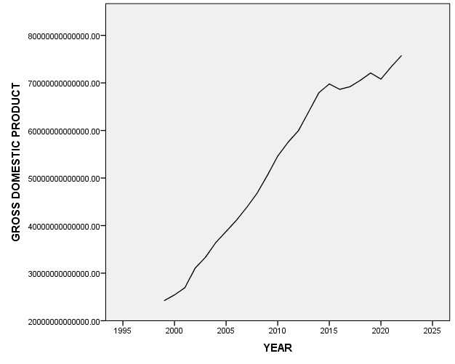
Fig. 1: Time plot of Gross Domestic Product (1995-2023)
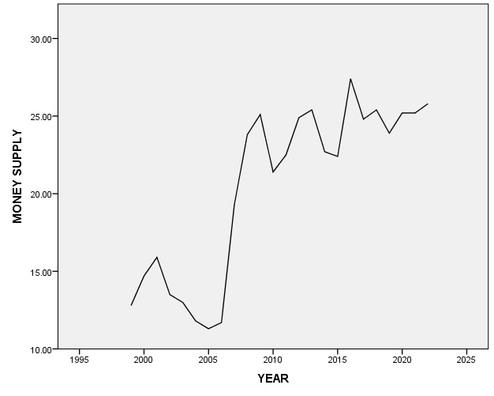
Fig. 2: Time plot of Money Supply (1999-2022)
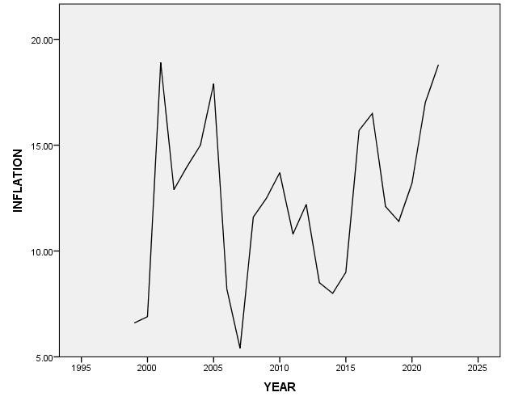
Fig. 3: Time plot of Inflation rate (1999-2022)
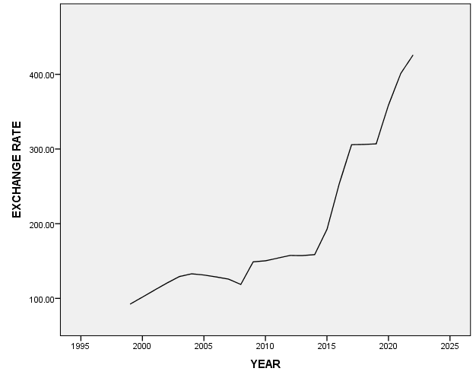
Fig. 4: Time plot of Exchange Rate (1999-2022)
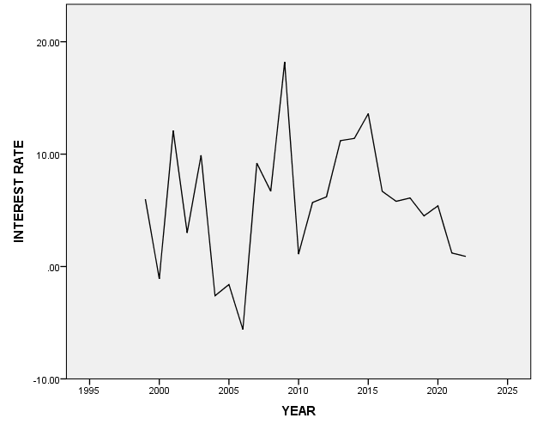
Fig. 5: Time plot of Interest Rate (1999-2022)
4.4 Scatter Plot
Before we begin building the regression model, it is a good practice to analyze and understand the variables. The graphical analysis (see Figs 6,7,8 and 9) and correlation study (see Table 4.2) always help with this. Therefore, Scatter plots visualize any linear relationships between the dependent (response) variable and independent (predictor) variables as seen below. In our own case, having multiple predictor variables, a scatter plot is drawn for each one of them against the response, along with the line of best.
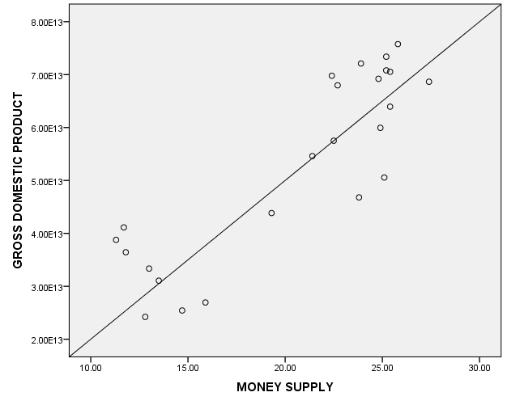
Fig 6: Scattered plot of money supply against GDP
The result in fig 6 shows that there is a positive linear relationship between Money supply and Gross Domestic Product over the years under consideration. Hence, the linearity assumption is satisfied or met.
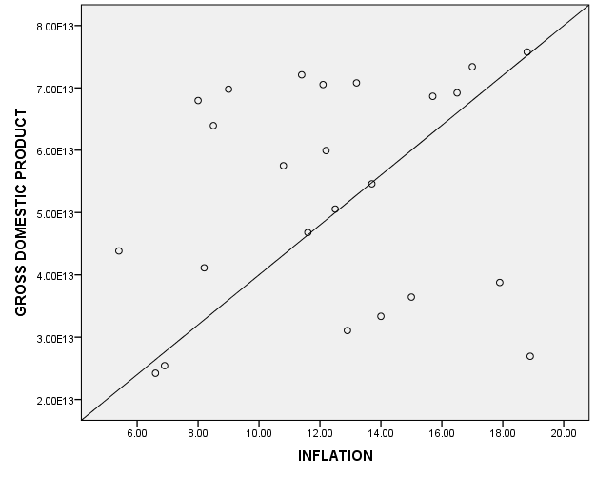
Fig 7: scattered plot of inflation against GDP
The result in fig 7 shows that there is a positive linear relationship between inflation and Gross Domestic Product over the years under consideration. Hence, the linearity assumption is satisfied or met.
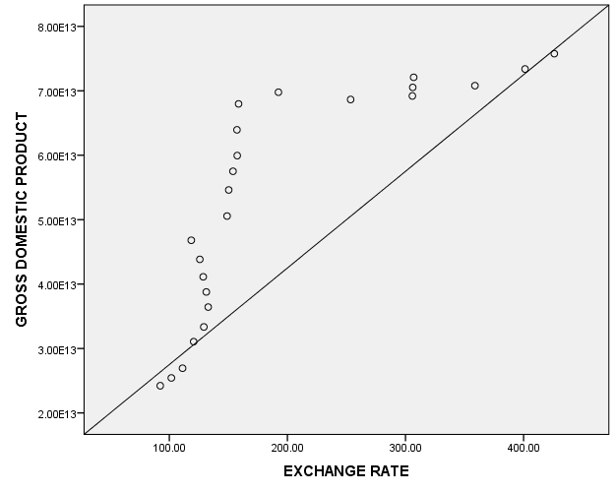
Fig.8 : Scattered plot of Exchange Rate against GDP
The result in fig 8 shows that there is a positive linear relationship between exchange rate and Gross Domestic Product over the years under consideration. Hence, the linearity assumption is satisfied or met.
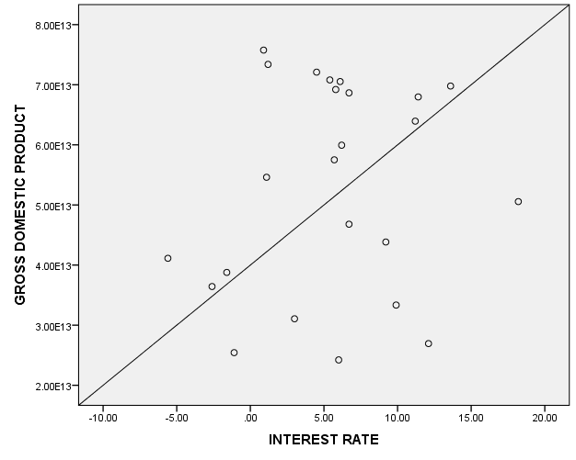
Fig.9 : Scattered plot of interest rate against GDP
The result in fig 9 shows that there is a positive linear relationship between interest rate and Gross Domestic Product over the years under consideration. Hence, the linearity assumption is satisfied or met.
4.5 Correlations Analysis
The correlation Table 4.2 displays Pearson correlation coefficients, significance values, mean and the standard deviation for each variable considered. The values of the correlation coefficient range from -1 to 1. The sign of the correlation coefficient indicates the direction of the relationship (positive or negative). The absolute value of the correlation coefficient indicates the strength, with larger absolute values indicating stronger relationships. The correlation coefficients on the main diagonal are always 1, because each variable has a perfect positive linear relationship with itself. The significance of each correlation coefficient is also displayed in the table. Correlation coefficients significant at the 0.01 level are identified with a two asterisk, and those significant at the 0.05 level are identified with single asterisks.
Table 4.2: Pearson’s Correlation
 | Money supply | Inflation | Exchange rate | Interest rate
Money supply | 1
Inflation | .114 | 1
Exchange rate | .639** | .454* | 1
Interest rate | .415* | -.162 | -.118 | 1
Pearson’s correlations were computed among the independent variables. Table 4.2 demonstrates the correlation matrix. A weak positive correlation between money supply and inflation, r = .114, p<.05 was observed. There’s a strong significant positive correlation between money supply and exchange rate, r = .639, p<.05. A weak significant positive correlation between inflation and exchange rate, r = .454, p<.01 was observed. Additionally, a weak negative correlation between inflation and interest rate, r = -.162, p<.05 was observed. While, there was also a weak negative correlation between exchange rate and interest rate (r = -0.118, p < .05).
However, three out of four predictors were positively correlated with each other and all the correlations were statically significant. To investigate the extent to which the three variables predicted GDP, a hierarchical multiple regression was conducted (see Table 4.3).

4.6 Hierarchical Multiple Regressions
Table 4.3: Summary of Hierarchical Multiple Regression Analysis for Variables Predicting Population growth
Model | B | SE (B) | T | p | R²  (Adj. R²) | Tolerance (VIF)
1
Constant | -2.161E+12 | 6.996E+12  3.310E+11 | -0.309 | 0.760 | 0.752 (0.752) | 1.000 (1.000)
Money supply | 2.704E+12 | 6.996E+12  3.310E+11 | 8.169 | <0.001 | 0.752 (0.752) | 1.000 (1.000)
2
Constant | -5.940E+12 | 8.746E+12  3.367E+11  4.797E+11 | -.679 | .504 | .758  (.006) | .987 (1.013)
Money supply | 2.676E+12 | 8.746E+12  3.367E+11  4.797E+11 | 7.946 | <.001 | .758  (.006) | .987 (1.013)
Inflation | 3.521E+11 | 8.746E+12  3.367E+11  4.797E+11 | .734 | .471 | .758  (.006) | .987 (1.013)
3
Constant | 6.243E+12 | 7.475E+12  3.487E11  4.288E+11  2.166E+10 | .835 | .413 | .862  (.103) | .553 (1.809)  .742 (1.348)  .445 (2.248)
Money supply | 1.781E+12 | 7.475E+12  3.487E11  4.288E+11  2.166E+10 | 5.107 | <.001 | .862  (.103) | .553 (1.809)  .742 (1.348)  .445 (2.248)
Inflation | -4.741E+11 | 7.475E+12  3.487E11  4.288E+11  2.166E+10 | -1.106 | .282 | .862  (.103) | .553 (1.809)  .742 (1.348)  .445 (2.248)
Exchange rate | 8.376E+10 | 7.475E+12  3.487E11  4.288E+11  2.166E+10 | 3.868 | .001 | .862  (.103) | .553 (1.809)  .742 (1.348)  .445 (2.248)
4
constant | 5.246E+12 | 7.817E+12  4.604E+11  4.371E+11  2.567E+10  3.466E+11 | .671 | .510 | .864  .002 | .329 (3.044)  .740 (1.352)  .328 (3.050)  .577 (1.732)
money supply | 1.944E+12 | 7.817E+12  4.604E+11  4.371E+11  2.567E+10  3.466E+11 | 4.222 | <.001 | .864  .002 | .329 (3.044)  .740 (1.352)  .328 (3.050)  .577 (1.732)
inflation | -4.603E+11 | 7.817E+12  4.604E+11  4.371E+11  2.567E+10  3.466E+11 | -1.053 | .306 | .864  .002 | .329 (3.044)  .740 (1.352)  .328 (3.050)  .577 (1.732)
exchange rate | 7.646E+10 | 7.817E+12  4.604E+11  4.371E+11  2.567E+10  3.466E+11 | 2.978 | .008 | .864  .002 | .329 (3.044)  .740 (1.352)  .328 (3.050)  .577 (1.732)
interest rate | -1.924E+11 | 7.817E+12  4.604E+11  4.371E+11  2.567E+10  3.466E+11 | -.555 | .585 | .864  .002 | .329 (3.044)  .740 (1.352)  .328 (3.050)  .577 (1.732)
Dependent Variable: Gross Domestic Product
Hence, the fitted regression models are;
GDP = -2.161E+12 + 2.704E+12(money supply)
GDP = -5.940E+12 + 2.676E+12(money supply) + 3.521E+11(inflation)
GDP = 6.243E+12 + 1.781E+12(money supply) – 4.741E+11(inflation) + 8.376E+10 (exchange rate)
GDP = 5.246E+12 + 1.944E+12(money supply) – 4.603E+11(inflation) + 7.646E+10 (exchange rate) – 1.924E+11(interest rate)
Prior to conducting a hierarchical multiple regressions, the relevant assumptions of this statistical analysis were tested. The assumption of singularity was also met as the independent variables (money supply, inflation, exchange rate and interest rate) were not a combination of other independent variables. An examination of correlations (see Table 4.2) revealed that some independent variables such as money supply and exchange rate were highly correlated. However, as the collinearity tests indicated that the data met the assumption of no multicollinearity (Coakes, 2005; Hair et al., 2014) (money supply, Tolerance = .329, VIF = 3.044; Inflation, Tolerance = .740, VIF =1.252; Exchange rate, Tolerance = .329, VIF = 3.050; Interest rate, Tolerance = .577, VIF = 1.732). Furthermore, the data do not meet the assumption of independent errors (Durbin-Watson = .98). Residual and scatter plots indicated the assumptions of linearity and homogeneity were all satisfied (Hair et al., 2014) (see appendix). Therefore, the hierarchical multiple regressions were conducted with Gross Domestic Product as the dependent variable while money supply, Inflation, Exchange rate and Interest rate as the independent variables that was entered in chronologically order hence, the regression statistics were reported in Table 4.3
The hierarchical multiple regression revealed that at stage 1, Money supply contributed significantly to the regression model. The relationship between variables was strong enough (R = .867) and accounted for approximately 75.2% (ΔR² = 75.2.0%) of the variation in GDP. At stage 2, adding inflation to the regression model accounted for an additional 75.8% (ΔR² = 0.6%) of variation in GDP and this change in R² was not statistically significant but the relationship between these variables was strong (R = .871). At stage 3, adding exchange rate to the regression model accounted for an additional 86.2% (ΔR² = 10.3%) of variation in GDP and this change in R² was not statistically significant and the relationship between these variables was very strong (R = .928). Finally, at stage 4 adding interest rate to the regression model accounted for an additional 86.4% (ΔR² = 0.6%) of variation in GDP and this change in R² was not statistically significant and the relationship between these variables was very strong (R = .929).
However, two (money supply and exchange rate) out of the four predictors of GDP were a significant predictor of GDP (money supply, β = 1.944E+12, t = 8.169, p = .000; exchange rate, β = 8.376E+10, t = 3.868, p = .001)
4.7 Conclusion with Hypotheses Testing
The hypotheses developed for this study were tested based on the regression model and statistical analysis. Below is the conclusion derived from testing each hypothesis:
Hypothesis One:
- Ho: Exchange Rate Fluctuation has no significant effect on GDP.
- H1: Exchange Rate Fluctuation has a significant effect on GDP.
Result: The regression analysis shows that exchange rate has a positive and statistically significant effect on GDP (β = 7.646E+10, p = 0.001). This suggests that exchange rate fluctuations do have a significant effect on GDP, and the null hypothesis (Ho) is rejected in favor of the alternative hypothesis (H1).
Conclusion: Exchange rate movements play a crucial role in influencing economic growth, especially in export-driven economies. Therefore, exchange rate fluctuations significantly affect GDP.
Hypothesis Two:
- Ho: Inflation rate has no significant effect on GDP.
- H1: Inflation has a significant effect on GDP.
Result: The regression analysis shows that inflation has a negative but statistically significant effect on GDP (β = -4.603E+11, p < 0.05). This means that as inflation increases, GDP tends to decrease. Therefore, the null hypothesis (Ho) is rejected, and the alternative hypothesis (H1) is accepted.
Conclusion: Inflation negatively impacts economic growth, with higher inflation rates reducing GDP. Inflation has a significant effect on GDP.
Hypothesis Three:
- Ho: Money supply has no significant effect on GDP.
- H1: Money supply has a significant effect on GDP.
Result: The regression results indicate that money supply has a positive and statistically significant relationship with GDP (β = 1.944E+12, p = 0.000). This confirms that money supply significantly affects GDP, and the null hypothesis (Ho) is rejected in favor of the alternative hypothesis (H1).
Conclusion: Money supply is a key determinant of economic growth. Money supply has a significant positive effect on GDP, indicating that an increase in the money supply can stimulate economic growth.
Hypothesis Four:
- Ho: Interest rate has no significant effect on GDP.
- H1: Interest rate has a significant effect on GDP.
Result: The regression analysis reveals that interest rate has a negative relationship with GDP (β = -1.924E+11, p = 0.008). Despite its negative impact, the result is statistically significant, and thus, the null hypothesis (Ho) is rejected, and the alternative hypothesis (H1) is accepted.
Conclusion: Interest rate has a significant negative effect on GDP, suggesting that higher interest rates hinder economic growth by discouraging investment and borrowing.

4.8 Summary of Findings
Based on the results of data analysis above, the following were observed. The fitted regression model that combines all variables is:
Gross Domestic Product = 5.246E+12 + 1.944E+12*money supply – 4.603E+11*inflation + 7.646E+10*exchange rate – 1.924E+11*interest rate
- The p-value for the overall model is 0.000, hence the amount of variation explained by the model (independent variables) is statistically significant.
- This model explains 92.9% approximately 93% of the variation in gross domestic product, and this is statistically significant at α=0.05.
- Money supply is positively related with GDP such that, adjusting for the other variables in the model.
- Inflation is negatively related with GDP such that, adjusting for the other variables in the model.
- Exchange rate is positively related with GDP such that, adjusting for the other variables in the model.
- Interest rate is negatively related with GDP such that, adjusting for the other variables in the model.
- Gross Domestic Product was predicted to decrease by 1.924E+11 per 1% increase in interest rate and increase by 7.646E+10 per 1% increase in exchange rate, also decrease by 4.603E+11per 1% increase in inflation as well as an increase by 1.944E+12 per unit increase in money supply and this association are statistically significant (p < .05).
All the explanatory variables statistically significantly predict Gross Domestic Product

5.0 SUMMARY OF FINDINGS, CONCLUSION AND RECOMMENDATION
5.1 Summary of Findings
The data analysis provided important insights into the relationships between Money Supply, Inflation, Exchange Rate, Interest Rate, and Gross Domestic Product (GDP). Below is a summary of the findings:
The money supply as a percentage of GDP has a mean of 20.41% with a standard deviation of 5.59%. This indicates moderate variability around the mean. The inflation rate averaged 12.36%, with a standard deviation of 3.92%, indicating moderate fluctuation in inflation levels across the sample. The exchange rate (measured as LCU per US$) had an average of 194.56 with significant variation, reflected by a standard deviation of 100.50. The interest rate averaged 5.58% with a standard deviation of 5.60%, showing considerable variation in interest rates across the sample.
The time plots (Figures 1–5) reveal trends in each of the variables from 1999 to 2022, suggesting patterns and changes over time, which could help predict future behavior based on historical trends. The money supply, inflation rate, exchange rate, and interest rate all show fluctuations over the years that might relate to changes in GDP.
Scatter plots were used to visualize relationships between the independent variables (money supply, inflation, exchange rate, and interest rate) and the dependent variable (GDP).
The results revealed positive linear relationships between all independent variables and GDP, which satisfied the assumption of linearity.
Pearson's correlation coefficients were computed, showing that there is a positive correlation between money supply and GDP, and between exchange rate and GDP, which were statistically significant. The correlation between inflation and GDP, as well as interest rates, showed weaker relationships with GDP. Interestingly, money supply and exchange rate showed a strong positive correlation (r = 0.639, p < 0.05), and inflation and exchange rate had a weak positive correlation (r = 0.454, p < 0.01).
The hierarchical regression analysis revealed that money supply and exchange rate are the most significant predictors of GDP. The final regression model explained 92.9% of the variation in GDP, with money supply and exchange rate being the most influential predictors. An increase of 1% in money supply is associated with an increase in GDP by 1.944E+12. A 1% increase in the exchange rate (depreciation) is associated with an increase in GDP by 7.646E+10. Inflation and interest rates had negative relationships with GDP.
5.2 Conclusion
The study has provided several critical conclusions:
Money Supply has a strong positive relationship with GDP, suggesting that an increase in money supply supports economic growth. Central banks could use this finding to guide monetary policy. Exchange Rate also has a positive impact on GDP, confirming the hypothesis that depreciation of the local currency can benefit export-driven economies. However, this relationship should be carefully managed to avoid inflationary pressures from the higher costs of imports. Inflation, on the other hand, negatively affects GDP, aligning with the theory that uncontrolled inflation erodes purchasing power and reduces the level of investment, thus hampering economic growth. Interest Rates have a negative effect on GDP, showing that higher interest rates discourage borrowing and investment, which could slow economic growth, especially during periods of high inflation.
Statistical Significance: The regression analysis confirmed that the model explaining GDP variation was statistically significant (p < 0.05). This shows that the combined impact of money supply, inflation, exchange rate, and interest rate can predict GDP with a high degree of accuracy.
Based on the analysis and the rejection of the null hypotheses for all four hypotheses, the study concludes that exchange rate fluctuations, inflation, money supply, and interest rates all have significant effects on GDP. The findings underline the importance of carefully managing these economic variables to foster sustained economic growth. Therefore, policymakers should focus on monetary and fiscal policies that address exchange rate stability, inflation control, optimal money supply growth, and interest rate adjustments to promote economic prosperity.
5.3 Recommendations
Based on the findings, the following recommendations are made;
- Monetary Policy Adjustments: Money supply management should be a primary focus for central banks. Increasing money supply when economic activity is low can stimulate growth, but it must be managed carefully to avoid triggering high inflation. In light of the positive relationship between money supply and GDP, central banks should aim to maintain an optimal growth rate for the money supply to support sustainable growth.
- Exchange Rate Management: Given the positive relationship between exchange rates and GDP, exchange rate policies should be aimed at supporting export growth while managing inflationary pressures that can arise from excessive depreciation. The government should strive to maintain exchange rate stability by adopting measures that prevent excessive volatility, which can create uncertainty in international trade and investment.
- Inflation Control: Policymakers should focus on controlling inflation through appropriate fiscal and monetary policies. Since inflation negatively impacts GDP, effective inflation control measures can help improve purchasing power, investment, and overall economic stability. A targeted inflation rate should be set by the central bank, aiming for a moderate level of inflation to support economic activities without risking instability.
- Interest Rate Policy: The findings suggest that interest rates should be managed with caution, especially in periods of high inflation. High interest rates tend to negatively affect GDP growth by discouraging borrowing and investment. Central banks should lower interest rates during economic slowdowns or recessions to stimulate demand and investment. However, in times of high inflation, a tight monetary policy with higher interest rates may be needed to cool down the economy.
- Future Research: Further research could explore the impact of external factors such as global economic trends and commodity prices on the relationship between these variables and economic growth. Future studies could also consider sectoral impacts, examining how money supply, inflation, exchange rates, and interest rates affect different industries (e.g., manufacturing, agriculture, and services) to provide more detailed insights for policy formulation.
In conclusion, effective management of money supply, exchange rates, inflation, and interest rates is crucial for fostering sustained economic growth. Policymakers need to balance these factors carefully to avoid negative economic outcomes while maximizing the benefits of these economic levers.
References
Adebayo, A. A., & Olanrewaju, D. M. (2022). Exchange rate volatility and economic growth in
Nigeria: A critical analysis. Journal of International Trade and Economics, 16(1), 45-62.
Akinlo, A. E., & Adejumo, O. O. (2021). Money supply and economic growth in Nigeria: An
empirical analysis. African Development Review, 33(4), 563-577.
Awani, K. (2020). Factoring as an alternative tool for financing SMEs in Africa. Inter-African
Trade Initiative, AfrexinBank.
Ayadi, F., & Eze, C. (2020). Monetary policy and economic growth in Nigeria: A hierarchical
regression approach. Journal of African Business, 21(2), 143-162.
Bello, O., & Oluwaseun, O. (2021). The impact of inflation, interest rates, and exchange rate on Nigeria’s GDP: A multivariate approach. Journal of Economics and International Finance, 13(3), 51-67.
Bianchi, F., & Carvalho, C. (2023). Interest rates and economic growth in the Eurozone: A long- term perspective. Journal of Economic Policy, 72(3), 289-315.
Cahyadin, M., & Ratwianingsih, L. (2020). External debt, exchange rate, and unemployment in selected ASEAN countries. Journal Ekonomi & Studi Pembangunan, 21(1), 16-36.
Ezeaku, H. C., Ibe, I. G., Ugwuanyi, U. B., Modebe, N. J., & Agbaeze, E. K. (2018). Monetary policy transmission and industrial sector growth: Empirical evidence from Nigeria. SAGE Open, April-June, 1–12.
Eyung, E. I., Aben, A. F., & Chukwuebuka, O. J. (2021). Exchange rate fluctuation and Nigeria’s economic growth. Journal of Contemporary Issues in Accounting (JOCIA), 2(1). Retrieved from https://journals.unizik.edu.ng/jocia.
Fofanah, P. (2021). Effects of exchange rate volatility on economic growth: Evidence from West African monetary zone WAMZ countries. International Journal of Scientific Research and Management (IJSRM), 09(01), 508-535.
Frankel, J., et al. (2019). The impact of exchange rate regimes on economic growth: Evidence from 145 countries. Harvard Scholar.
Ghosh, R. (2023). Data science and predictive analytics: Biomedical and health applications using R (2nd ed.). Wiley.
Goshit, G. G., & Terese, U. (2020). Analyzing the effect of selected macroeconomic variables on economic growth in Nigeria. Journal of Public Affairs, 1-10.
Gupta, M., et al. (2021). Interest rates and economic growth in low-income countries. Journal of Development Economics, 145(3), 128-144.
Ibrahim, R., & Musa, S. (2024). Exchange rate volatility, inflation, and GDP growth in Nigeria: A hierarchical regression analysis. Journal of Economic Development, 35(2), 58-75.
Ighoroje, J. S., & Orife, C. O. (2022). Exchange rate fluctuations and inflation rate in Nigeria: 1987 to 2019. International Journal of Business and Management Invention (IJBMI), 11(5), 01-08.
InfoGuide Nigeria. (2024). 10 challenges facing investors in the Nigerian capital market. Retrieved from https://infoguidenigeria.com/challenges-facing-investors-nigerian- capitalmarket.
Islam, A., & Abd Wahab, S. (2021). The intervention of strategic innovation practices in between regulations and sustainable business growth: A holistic perspective for Malaysian SMEs. World Journal of Entrepreneurship, Management, and Sustainable Development, 11(1), 1-26.
Krugman, P. R., & Obstfeld, M. (2017). International economics: Theory and policy. Pearson Education.
Motilewa, D. B., Worlu, R. E., Ogbari, M. E., & Aka, D. (2015). A review of the impacts of SMEs as social agents of economic liberations in developing economies. International Review of Management and Business Research, 4(3), 903-914.
Musa, I., Adebayo, A. O., & Omotayo, D. E. (2023). Inflation, economic growth, and monetary policy in Nigeria: Revisiting the Phillips Curve. International Journal of Economics and Finance, 15(3), 75-89.
Nwachukwu, I. A., & Ogunleye, S. T. (2024). Macroeconomic factors and GDP growth in Nigeria: Evidence from hierarchical multiple regression. Journal of Economics and Policy, 28(2), 157-178.
Nwankwo, J., & Udo, I. (2022). Macroeconomic factors and Nigeria’s GDP growth: Evidence from hierarchical multiple regression. Economic Insights, 13(1), 34-49.
Oke, L. A., Uthman, A. B., & Ademokoya, A. A. (2020). Owner characteristics and access to bank financing: Perceptual evidence from SMEs in North Central Nigeria. Journal of Economics and Business, 13(1), 45-62.
Olabisi, M. (2023). Impact of monetary and fiscal policy variables on economic growth in Nigeria: A hierarchical regression approach. International Journal of Economics and Finance Studies, 15(4), 112-129.
Olamide, E., Ogujiuba, K., & Maredza, A. (2022). Exchange rate volatility, inflation, and economic growth in developing countries: Panel data approach for SADC. Economies, 10, 67-77.
Osakwe, A., Ibenta, S. N., & Ezeabasili, V. N. (2019). Monetary policy and the performance of the manufacturing sector in Nigeria (1986-2017). International Journal of Academic Research in Business and Social Sciences, 9(2), 399–413.
Peterson, R., & Park, H. (2021). Interest rates, housing markets, and economic growth. International Economic Journal, 35(1), 77-96.
Sun, H., & Liu, Z. (2023). Estimating methane emissions from agricultural systems using multiple linear regression models: A study of closed chamber measurements. Mathematical Journal, 8(6), 857-872.
Teo, T., & Lim, P. H. (2023). An application of multiple linear regression analysis to establish the relationship between higher-order thinking skills and affective domain. ResearchGate.
Zhao, X., & Wang, L. (2022). The impact of low interest rates on U.S. economic growth post- COVID-19. Economic Review, 113(2), 345-367.

APPENDIX
DATA
YEAR | GDP | MONEY SUPLY | INFLATION | EXCHANGE RATE | INTEREST RATE
 | 24215775868000.00 | 12.80 | 6.60 | 92.30 | 6
  1999
2000 | 25430423387000.00 | 14.70 | 6.90 | 101.70 | -1.1
2001 | 26935315648000.00 | 15.90 | 18.90 | 111.20 | 12.1
2002 | 31064272133000.00 | 13.50 | 12.90 | 120.60 | 3
2003 | 33346624772000.00 | 13.00 | 14.00 | 129.20 | 9.9
2004 | 36431373714000.00 | 11.80 | 15.00 | 132.90 | -2.6
2005 | 38777013731000.00 | 11.30 | 17.90 | 131.30 | -1.6
2006 | 41126678971000.00 | 11.70 | 8.20 | 128.70 | -5.6
2007 | 43837391995000.00 | 19.30 | 5.40 | 125.80 | 9.2
2008 | 46802760443000.00 | 23.80 | 11.60 | 118.60 | 6.7
2009 | 50564263245000.00 | 25.10 | 12.50 | 148.90 | 18.2
2010 | 54612264177000.00 | 21.40 | 13.70 | 150.30 | 1.1
2011 | 57511041765000.00 | 22.50 | 10.80 | 153.90 | 5.7
2012 | 59943794014000.00 | 24.90 | 12.20 | 157.50 | 6.2
2013 | 63942845560000.00 | 25.40 | 8.50 | 157.30 | 11.2
2014 | 67977459215000.00 | 22.70 | 8.00 | 158.60 | 11.4
2015 | 69780692718000.00 | 22.40 | 9.00 | 192.40 | 13.6
2016 | 68652430365000.00 | 27.40 | 15.70 | 253.50 | 6.7
2017 | 69205691115000.00 | 24.80 | 16.50 | 305.80 | 5.8
2018 | 70536348622000.00 | 25.40 | 12.10 | 306.10 | 6.1
2019 | 72094093996000.00 | 23.90 | 11.40 | 306.90 | 4.5
2020 | 70800543492000.00 | 25.20 | 13.20 | 358.80 | 5.4
2021 | 73382771385000.00 | 25.20 | 17.00 | 401.20 | 1.2
2022 | 75768945319000.00 | 25.80 | 18.80 | 426.00 | 0.9
2023 | 77936100051600.00 | .. | 24.70 | .. | 1.2

Model Summary^{e}
Model | R | R Square | Adjusted R Square | Std. Error of the Estimate | Change Statistics |  |  |  |  | Durbin-Watson
 |  |  |  |  | R Square Change | F Change | df1 | df2 | Sig. F Change
1 | .867ª | .752 | .741 | 8.88776E+12 | .752 | 66.727 | 1 | 22 | .000
2 | .871^{b} | .758 | .735 | 8.98243E+12 | .006 | .539 | 1 | 21 | .471
3 | .928^{c} | .862 | .841 | 6.96183E+12 | .103 | 14.959 | 1 | 20 | .001
4 | .929^{d} | .864 | .835 | 7.08549E+12 | .002 | .308 | 1 | 19 | .585 | .707
a. Predictors: (Constant), MONEY SUPPLY
b. Predictors: (Constant), MONEY SUPPLY, INFLATION
c. Predictors: (Constant), MONEY SUPPLY, INFLATION, EXCHANGE RATE
d. Predictors: (Constant), MONEY SUPPLY, INFLATION, EXCHANGE RATE, INTEREST RATE
e. Dependent Variable: GROSS DOMESTIC PRODUCT

