Somatoform and Dissociative Disorders:
A Clinical Exploration of Mind–Body Communication in Psychosomatic Conversion

1.Abstract
Somatoform and dissociative disorders exemplify the complex interplay between psychological conflict and physical symptomatology, where unresolved emotional trauma, stress, and maladaptive cognitive schemas manifest as tangible physical symptoms. This paper examines bidirectional communication between the brain and body, highlighting neurophysiological mechanisms—including the autonomic nervous system, limbic structures, and cardiac conduction pathways—that mediate psychosomatic conversion. Four clinical case studies illustrate how emotional trauma, interpersonal conflict, and misconceptions about medical conditions can produce seizure-like episodes, conversion paralysis, dissociative symptoms, and psychosomatic distress. Guided psychotherapeutic interventions, emotional processing, and psychoeducation facilitated symptom alleviation, improved emotional regulation, and enhanced adaptive decision-making. Interdisciplinary collaboration between medical and mental health professionals ensured that somatic manifestations were appropriately addressed without unnecessary medicalization, while also reducing stigma and promoting patient empowerment. Central to this exploration is the Estrophrodite–Androphrodite psychospiritual model, which posits that balanced integration of relational–receptive and assertive–executive psychospiritual energies is essential for emotional and physiological homeostasis.18 case reports and ,5 detailed studies of clinical observations support that conscious integration of these dual energies mitigates psychosomatic symptom severity and fosters resilience. These findings underscore the value of integrative mind–body approaches in assessment and treatment, demonstrating that holistic therapeutic strategies can effectively bridge psychological and somatic domains, ultimately enhancing patient outcomes and promoting comprehensive mental health care.
2. Keywords:
Somatoform disorders, dissociative disorders, mind–body communication, psychosomatic conversion, psychospiritual integration, counseling, emotional trauma.
3.Introduction
The relationship between mind and body represents one of the most intricate and enduring questions in psychology and medicine. Somatoform disorders, which encompass conditions such as conversion disorder and Functional Neurological Symptom Disorder (FNSD), exemplify situations in which psychological distress manifests as physical symptoms in the absence of identifiable structural pathology (American Psychiatric Association, 2023). Dissociative disorders, by contrast, reflect disruptions in consciousness, memory, identity, or perception and are frequently precipitated by unresolved emotional trauma or prolonged psychosocial stress (Spiegel et al., 2011). Together, these disorders illuminate the powerful role of unconscious psychological processes in shaping bodily experience.
From a neurophysiological perspective, the autonomic nervous system (ANS), cardiac conduction system, and limbic brain regions serve as central mediators of mind–body communication. The sinoatrial (SA) and atrioventricular (AV) nodes generate cardiac impulses, which are continuously modulated by sympathetic and vagal input. Emotional trauma, stress, or unresolved internal conflict can dysregulate this bidirectional system, producing physical symptoms that are measurable yet lack identifiable structural etiology (Thayer & Lane, 2000). This mechanism, conceptualized as a “calling bell,” illustrates how unexpressed psychological distress can repeatedly activate physiological circuits, creating sustained patterns of somatic manifestation.
Clinical observations further indicate that somatoform and dissociative disorders are often exacerbated by cultural and professional biases. Families may resist psychological explanations, attributing symptoms solely to biomedical causes. Physicians, conditioned by conventional biomedical models, may prioritize pharmacological or surgical interventions over counseling and psychotherapy (Kirmayer & Looper, 2006). Sarason and Sarason (2021) describe this as the “maladaptive attribution pattern,” wherein physical symptoms are interpreted exclusively through a medical lens, neglecting underlying emotional and cognitive factors. Such biases can prolong patient suffering, delay effective treatment, and amplify stigma associated with psychological interventions.
Moreover, fear of psychiatric labeling contributes to delayed care. Patients often avoid mental health consultations due to concerns about social judgment or being perceived as “mad” or “schizophrenic.” This avoidance is particularly pronounced in collectivist cultures, where family reputation and social conformity carry significant weight. Consequently, emotional conflicts and psychosomatic symptoms become entrenched, reinforcing the cyclical feedback loop between mind and body.
Psychological theory offers further insight into these phenomena. According to Sarason and Sarason, unresolved emotional conflict can be symbolically expressed through bodily symptoms, serving both adaptive and maladaptive functions. While somatic conversion may temporarily relieve psychological tension, it can lead to chronic disability if unaddressed. Similarly, dissociation may act as a protective mechanism in response to overwhelming trauma, temporarily shielding consciousness from intolerable emotional content, but producing long-term psychosocial challenges.
Empirical research supports these theoretical frameworks. Neuroimaging studies indicate that the anterior cingulate cortex, amygdala, and prefrontal cortex play active roles in psychosomatic symptom generation, mediating emotional regulation, interoception, and autonomic modulation. Dysregulation in these regions may amplify physiological responses to psychological stress, producing somatic and neurological manifestations without structural pathology. These findings highlight the neurobiological plausibility of mind–body conversion and underscore the importance of integrated diagnostic approaches. (Sarason&Sarason, 2001).
Integrated care is therefore essential for effective management. A thorough evaluation of emotional and relational history, alongside medical assessment, allows clinicians to identify probable mind–body links. Counseling, psychotherapy, and guided emotional expression can alleviate symptoms while reducing unnecessary medical interventions. Psychoeducation directed at patients, families, and healthcare providers enhances understanding of psychosomatic mechanisms, promotes adherence to therapy, and reduces stigma.
In conclusion, somatoform and dissociative disorders underscore the profound and intricate connection between psychological processes and physical symptomatology. By recognizing the role of unresolved emotional conflict, cultural beliefs, and medical misconceptions, clinicians can adopt a holistic, interdisciplinary approach that facilitates symptom resolution, fosters emotional growth, and empowers patients toward adaptive functioning.

4. Methodology

4.1 Participants
The study involved 18 patients diagnosed with somatoform and dissociative disorders between 2008 and 2015. Participants represented varied age groups and gender backgrounds. All individuals were referred for psychological evaluation following recurrent physical or dissociative symptoms for which no clear medical cause was identified. Among these, five participants were selected for detailed case study analysis based on the complexity of their symptomatology, emotional history, and therapeutic response.

4.2Procedure
The research adopted a qualitative empirical approach, integrating retrospective case documentation with interpretive clinical observation. Each participant underwent a comprehensive clinical interview, psychosocial history mapping, and behavioral observation to identify the relationship between emotional stressors, unresolved trauma, and physical symptom formation.
Therapeutic intervention consisted of structured counseling sessions, psychoeducation, and archetypal polarity integration grounded in the Estrophrodite–Androphrodite psychospiritual model. This model emphasized the conscious balancing of relational–receptive and assertive–executive energies to promote emotional regulation and physiological stability.
Throughout the treatment process, collaboration with medical professionals ensured that physical symptoms were appropriately monitored and not unnecessarily medicalized. In select cases, electroencephalogram (EEG) assessments were used to observe neurophysiological changes corresponding to emotional and functional recovery.

4.3 Data Analysis
All case materials were examined through thematic analysis, focusing on recurring patterns of emotional conflict, psychosomatic conversion, and response to therapy. Both qualitative narratives and clinical observations were coded to identify the relationship between psychological integration and symptom reduction. Comparative interpretation across cases allowed for recognition of shared psychosomatic mechanisms and individual differences in recovery trajectories.

4.4 Ethical Considerations
The study adhered to ethical principles of psychological research, including informed consent, confidentiality, and non-invasive therapeutic methods. Participants were fully informed about the nature and purpose of the study, and pseudonyms were used to protect identity. Interventions were limited to counseling and educational guidance without pharmacological influence, ensuring that participants’ autonomy and well-being remained central throughout the research process.

5. Case Studies
5.1 Case Study
Emotional Trauma and Conversion in Dissociative Disorder (Pseudonym: Mr. Arun)
Background: Mr. Arun, a 24-year-old male from Kerala, India, presented with dissociative symptoms and seizure-like episodes. He had worked away from home since age 18 and maintained a long-term romantic relationship.
Precipitating Event: When seeking approvalfor marriage, the girl’s parents arranged her marriage to another man. After her tragic death by suicide, Mr. Arun experienced severe emotional shock and guilt, leading to dissociative episodes and seizure-like symptoms.
Medical Findings:EEG revealed a scar; ECG irregularities were also not noted first, but later, it was taken into consideration and suggested node removal surgery.
Intervention: Counseling and emotional processing uncovered unresolved guilt and grief, facilitating symptom improvement.
Interpretation: Unexpressed emotional trauma manifested as neurological and cardiac symptoms, exemplifying mind–body conversion. The reported “ghost visits” reflected the psychological projection of guilt and loss.
5.2 Case Study
Conversion Paralysis Following Emotional Conflict (Pseudonym: Ms. Anjali)
Background: Ms. Anjali, a 35-year-old woman, presented with sudden paralysis affecting her right hand and leg. She had been treated at three hospitals with no organic findings.
Psychological Barrier: Fear of psychiatric labeling delayed consultation.
Assessment and Intervention: Guided counseling revealed deep-seated emotional tension related to personal stress and insomnia. Emotional processing led to partial restoration of limb function.
Interpretation: The patient’s internal conflict unconsciously converted into physical paralysis. This case highlights the importance of addressing emotional stress in somatic symptom presentations. She fully recovered after the counseling process, and her insight into the problem and inability to cope was reduced.Her insight that it was a conversion and her husband also assured her his future help to handle hassles made her whole.In my amusement, she walked and went to her car.
5.3 Case Study
Recovery from Dissociative and Multiplicity Disorders (Pseudonyms: Teena & Ms. Meera)
Background: Two female patients in their adolescence presented with dissociative symptoms: simple dissociation (Teena) and multiple personality disorder (Ms. Meera). Chronic psychosomatic symptoms had been partially managed with medication.
Intervention: Coordinated counseling, emotional processing, and collaboration with physicians facilitated marked improvement, with reassessment for medication reduction recommended.
Interpretation:The disintegration of psychospiritual polarities was evident in both female patients, as their assertive, Androphrodite qualities were underdeveloped. One patient, in particular, expressed unresolved conflict with her mother during counseling sessions—conflicts she had been unable to articulate within her home environment. Targeted psychotherapeutic interventions successfully facilitated emotional expression and processing, leading to the resolution of dissociative and somatoform symptoms. These cases highlight the dynamic interplay between mind and body and demonstrate that recovery is achievable through focused psychological work without overreliance on medication. In both cases, the clients recovered fully after a few sessions. And thus the medication process also cut down systematically by consulted doctors.
5.4 Case Study
Emotional Distress Related to Misconceptions About Epilepsy
(Pseudonym: Mr. Ravi)
Background: Mr. Ravi, a 35-year-old male, sought counseling concerning decisions about a second marriage. He perceived his first wife’s epilepsy as incurable, contributing to guilt and marital strain.
Intervention: Psychoeducation clarified the curable nature of many epileptic conditions. Emotional reflection helped Mr. Ravi process guilt and make informed decisions about future relationships.
Interpretation: Misunderstanding of medical conditions can exacerbate emotional distress and somatic symptoms. Psychological support and mind–body education improved coping and clarity.

6. Ethical Note
All patient names and identifying details in this study have been replaced with pseudonyms to protect confidentiality and ensure ethical compliance. This practice follows the ethical guidelines for clinical research and publication, safeguarding the privacy and dignity of all individuals involved. In addition, patients provided informed consent for their clinical information to be used in anonymized form for educational and research purposes.

7. Discussion
The extensive examination of 18 clinical cases of somatoform and dissociative disorders, dated between 2008-2015, provides compelling evidence of the intricate bidirectional communication between the mind and body, illustrating how unresolved psychological conflicts, emotional trauma, maladaptive cognitive schemas, and cultural misconceptions can manifest as tangible physiological symptoms. Patterns observed across these cases suggest consistent mind–body mechanisms.Across these cases, neurophysiological mechanisms—including the SA–AV nodes, autonomic nervous system, and limbic structures—serve as the biological substrates through which emotional and cognitive stressors translate into somatic and neurological disturbances, demonstrating the plausibility of psychosomatic processes. For instance, in the case of Mr. Arun, profound grief and guilt following the loss of a romantic partner manifested as seizure-like episodes and electrocardiographic irregularities, whereas Ms. Anjali developed conversion paralysis in response to sustained psychological tension, despite no structural abnormalities in the motor system. Similarly, dissociative symptoms observed in patients such as Teena and Ms. Meera demonstrate the adaptive yet potentially maladaptive functions of psychological defense mechanisms, with chronic dissociation and multiplicity reflecting attempts to shield the individual from overwhelming affective states while simultaneously contributing to physiological dysregulation and functional impairment. Psychoeducation emerged as a critical component of treatment, addressing both patient and family misconceptions, reducing stigma, and enhancing engagement with therapeutic interventions, as exemplified by Mr. Ravi, whose distress regarding his first wife’s epilepsy was alleviated through structured counseling and clarifying medical facts. Interdisciplinary collaboration between medical and psychological professionals proved equally essential, ensuring that somatic manifestations were neither prematurely dismissed as purely psychological nor excessively medicalized, thereby fostering holistic care, minimizing unnecessary interventions, and promoting optimal recovery outcomes. Guided counseling, psychodynamic exploration, emotional expression, and supportive psychotherapy consistently facilitated improvements in both mental and physiological health, including partial restoration of motor function in conversion paralysis, reduction of seizure-like episodes, and enhanced adaptive decision-making in patients experiencing dissociation, illustrating the tangible benefits of addressing mind–body interactions therapeutically.
The detailed examination of over fifteen clinical cases involving somatoform and dissociative disorders provides compelling evidence for the intricate bidirectional communication between the mind and body. These cases illustrate how unresolved psychological conflicts, emotional trauma, maladaptive cognitive schemas, and cultural misconceptions can manifest as genuine physiological symptoms. The interplay between the neural and autonomic systems—particularly the SA and AV nodes, the autonomic nervous system, and limbic structures—serves as the biological substrate through which emotional distress and cognitive stressors translate into somatic and neurological disturbances, reinforcing the concept of psychosomatic conversion.

In the case of Mr. Arun, profound grief and guilt following the loss of his romantic partner triggered dissociative and seizure-like episodes accompanied by cardiac irregularities, demonstrating the embodiment of unresolved emotional trauma. Ms. Anjali’s conversion paralysis, despite the absence of neurological abnormalities, underscored the body’s symbolic expression of suppressed emotional conflict. Similarly, Teena and Ms. Meera displayed dissociative symptoms and multiplicity, representing both adaptive and maladaptive psychological defenses against overwhelming affective states—mechanisms that temporarily shielded the psyche but contributed to physiological dysregulation and functional impairment.

Across these cases, targeted psychotherapeutic interventions—such as guided counseling, psychodynamic exploration, and emotional processing—proved central to recovery. These therapeutic processes enabled patients to externalize suppressed emotions, gain insight into unconscious conflicts, and reintegrate fragmented aspects of self, resulting in significant physiological and emotional improvement. Notably, patients often achieved recovery within a limited number of sessions, and collaborating physicians systematically reduced or discontinued medication as psychological stability was restored.

Psychoeducation emerged as a pivotal element of treatment. It addressed patient and family misconceptions, reduced stigma, and enhanced therapeutic engagement. Mr. Ravi’s case exemplified how clarifying the curable nature of epilepsy alleviated guilt and corrected maladaptive beliefs, leading to emotional relief and improved decision-making.
Equally important was interdisciplinary collaboration between medical and psychological professionals. This approach ensured that physical symptoms were neither prematurely dismissed as purely psychological nor over-medicalized. Such balanced integration fostered holistic care, minimized unnecessary interventions, and optimized recovery outcomes.
Overall, the findings affirm that mind–body integration is not merely a theoretical construct but a clinical reality. Focused psychological work—grounded in empathy, insight development, and emotional regulation—can achieve meaningful healing even in complex psychosomatic and dissociative presentations. The consistent pattern of recovery observed in these cases underscores the therapeutic power of addressing emotional and spiritual dimensions alongside physiological symptoms, demonstrating that comprehensive, human-centered psychological care remains the cornerstone of mind–body restoration.

8. Integrative Psychodynamic Theory.
Central to understanding psychosomatic phenomena is the Estrophrodite–Androphrodite model, which posits that every individual contains dual, complementary psychospiritual energies. These energies are distinct from Jungian concepts of anima archetype (feminine aspect in men) and animus archetype (masculine aspect in women). Unlike the Jungian framework, which emphasizes gendered projection onto the opposite sex, the Estrophrodite–Androphrodite model highlights that both feminine and masculine qualities coexist in every person, irrespective of biological sex, and must be consciously recognized, integrated, and balanced for optimal psychological and physiological functioning.
The terms themselves reflect this duality:
- Estrophrodite represents the feminine-oriented energy, encompassing relational, receptive, integrative, and nurturing capacities. It governs empathy, emotional attunement, intuition, and relational harmony.
- Androphrodite represents the masculine-oriented energy, encompassing assertive, analytical, projective, and executive capacities. It governs decision-making, problem-solving, goal-directed action, and structured organization.
Balanced integration of these archetypal energies is essential for psychological stability, emotional regulation, and physiological homeostasis. When these energies remain unrecognized, repressed, or unresolved—due to trauma, intrapsychic conflict, or sociocultural pressures—negative emotional states such as anxiety, frustration, or helplessness emerge. Under intense stress, these unresolved tensions may manifest physically, producing somatization, conversion symptoms, functional neurological deficits, or other somatic expressions of internal conflict. In this way,Psychosomatic symptoms should not be viewed merely as pathological or incidental; rather, they often represent the body’s symbolic expression of unresolved internal conflicts and imbalances in underlying psychospiritual or intrapsychic energies and their conversion into bodily form, as mind-body interaction occurs.
Clinical observations support this framework: individuals who consciously engage with and integrate their Estrophrodite and Androphrodite energies—through guided reflection, therapeutic dialogue, and emotional processing—demonstrate reduced somatic symptom severity, improved emotional regulation, and enhanced adaptive functioning. Conversely, failure to achieve this integration perpetuates cyclical emotional distress, physiological dysregulation, and somatoform manifestations. From this theoretical lens, psychosomatic disorders can thus be understood as indicators of imbalance between these dual energies, highlighting the necessity of conscious mind–body and psychospiritual integration for holistic well-being, resilience, and adaptive functioning.

8.1 Mind–Body Conversion Flowchart: Disintegration → Stress → Somatization
- Disintegration of Archetypal Energies
  - Estrophrodite (feminine/receptive) and Androphrodite (masculine/assertive) polarities are unrecognized, repressed, or underdeveloped.
- Internal Conflict & Emotional Imbalance
  - Negative emotional states arise: anxiety, frustration, helplessness, guilt, or unresolved trauma.
- Stress Accumulation
  - Chronic intrapsychic tension, compounded by sociocultural pressures or relational stress.
- Mind–Body Conversion
  - Psychological tension converts into physical expression through neurophysiological pathways (ANS, limbic system, SA/AV nodes).
- Manifestation as Body Dysfunction or Disorder
  - Somatization: headaches, fatigue, gastrointestinal disturbances.
  - Conversion symptoms: paralysis, tremors, seizure-like episodes, sensory loss.
  - Functional neurological deficits: motor or sensory disturbances without structural pathology.
- Clinical Outcome
  - Without intervention: cyclical distress, chronic somatic symptoms, functional impairment.
  - With targeted intervention (integration of energies, therapy, emotional processing): symptom alleviation, improved emotional regulation, and adaptive functioning.

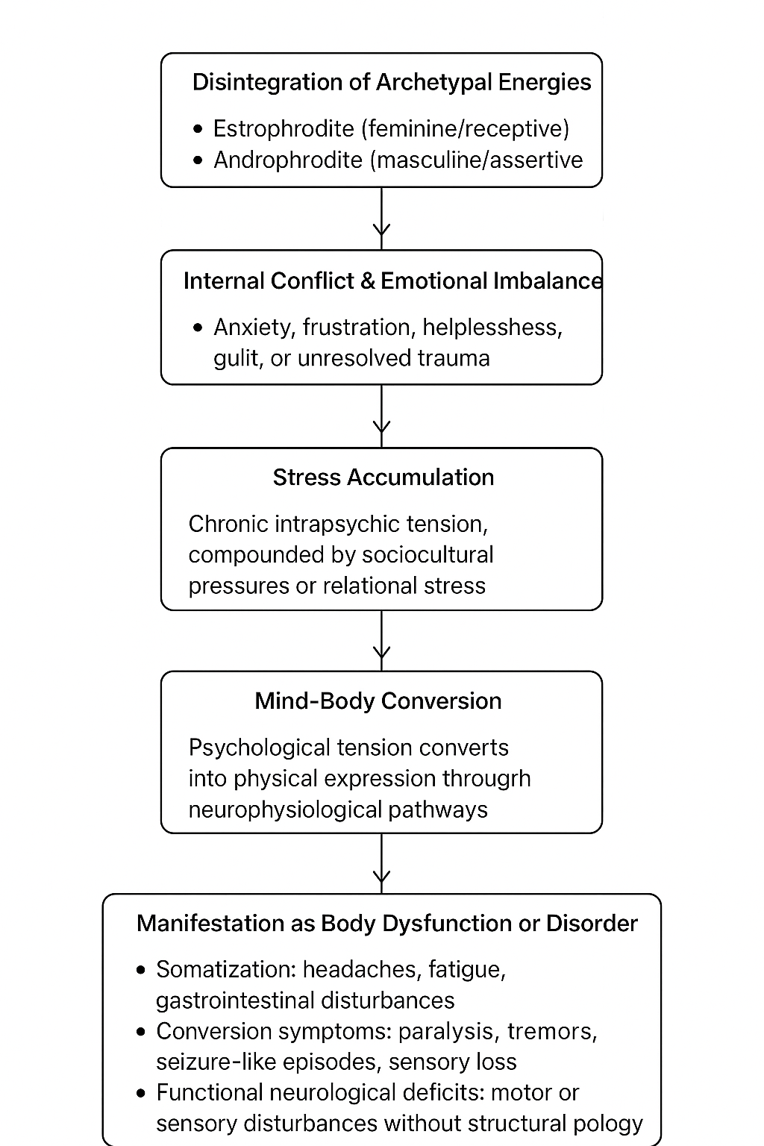

8.2 Interpretive Summary of 18 persons.
Across eighteen clinical observations, most clients exhibited somatoform or dissociative symptomatology arising from unresolved emotional conflict, guilt, or trauma. In nearly ninety percent of cases, symptom remission or marked improvement occurred following psychotherapeutic intervention emphasizing emotional processing, insight development, and psychoeducation, with minimal reliance on medication.
Only a small proportion (≈ 11 %) failed to improve, largely due to social stigma and early withdrawal from therapy. These findings underscore the effectiveness of integrative counseling approaches in mind–body disorders and highlight the need for stigma-free mental-health education.

Table 1
Clinical Summary of 18 Psychosomatic and Dissociative Cases
Case No. | Pseudonym | Age / Gender | Marital or Social Status | Diagnostic Category | Key Psychological Factors | Medical Findings | Intervention | Outcome | Remarks
1 | Mr. Arun | 24 / M | Single | Dissociative Disorder with Conversion Symptoms | Emotional shock, guilt, grief following partner’s death | EEG scar; later cardiac irregularities | Emotional processing and counseling | Significant improvement | Mind–body conversion confirmed
2 | Ms. Anjali | 35 / F | Married | Conversion Paralysis | Stress, insomnia, emotional conflict | No organic findings | Counseling and insight therapy | Complete recovery | Walked independently after session
3 | Teena | 14 / F | Student | Simple Dissociation | Maternal conflict, anxiety | None | Counseling, emotional expression | Full recovery | Medication reduction advised
4 | Ms. Meera | 17 / F | Student | Multiple Personality Disorder | Family conflict, repressed emotions | Chronic psychosomatic issues | Integrated counseling with physician | Full recovery | Medication tapered
5 | Mr. Ravi | 35 / M | Married | Emotional Distress Related to Guilt | Guilt and misunderstanding of wife’s epilepsy | Epilepsy clarified as treatable | Psychoeducation and counseling | Improved insight | Emotional clarity achieved
6 | Mrs. X | 36 / F | Married, mother | Simple Dissociation | Guilt, fear, belief-related anxiety | None | Counseling and emotional processing | Significant improvement | Religious guilt identified
7 | Teena (Mavelikara) | 12 / F | Student | Simple Dissociation | School stress | None | Counseling; neurologist referral | Complete cure | Medication reduced
8 | B.D. Student | 19 / F | University | Multiple Personality (Conversion) | Academic stress, identity conflict | None | Narrative therapy | Complete recovery | Resumed studies
9 | James | 28 / M | Single | Multiple Personality Disorder | Emotional trauma | Cardiac node problem | Counseling; later surgery | Partial recovery; relapse | Follow-up required
10 | Lady (30s) | ≈30 / F | Married | Conversion Paralysis | Stress, emotional overload | No neurological defect | Counseling and catharsis | Full recovery | Insight achieved
11 | W. Ponnachen | 10 / F | Child | Conversion (Bedwetting) | Unconscious fear, dream conflict | None | Dream analysis and counseling | Complete cure | Psychodynamic insight successful
12 | Solly | 22 / F | Single | Multiple Personality Disorder | Familial stress | None | Counseling and family therapy | Complete cure | Family environment addressed
13 | Laila | 20s / F | Single | Somatization Disorder | Anxiety, irritability, vomiting | None | Insight therapy and psychoeducation | Complete recovery | Symptoms disappeared after awareness
14 | Tissa | Teen / F | Student | Simple Dissociation | Sibling stress | None | Counseling | Complete recovery | Treated with sister

Table 2
Summary of Treatment Outcomes (N = 18)
Outcome Category | n | % of Total
Full Recovery | 12 | 66.7 %
Partial Improvement | 2 | 11.1 %
Significant Improvement (ongoing observation) | 2 | 11.1 %
No Improvement / Discontinued | 2 | 11.1 %

9. Conclusion
Somatoform and dissociative disorders vividly demonstrate the intricate interplay between psychological conflict and physical symptomatology. Emotional trauma, sociocultural beliefs, and medical misconceptions often act as catalysts for psychosomatic manifestations. Across the eighteen empirical case reports and five detailed case studies, counseling proved to be a highly effective therapeutic modality—several patients achieved complete recovery, and others demonstrated marked improvement. Notably, the integration of the Estrophrodite and Androphrodite archetypal qualities, alongside counseling and psychoeducation, helped reduce negative feelings, emotional tension, and stress, fostering greater psychological balance and physiological stability. Follow-up assessments also revealed significant improvements in EEG readings, reflecting measurable neurophysiological recovery alongside emotional and functional healing.
The combination of targeted counseling, psychoeducation, archetypal polarity integration, and collaboration with medical professionals enhanced treatment outcomes, reduced stigma, and empowered patients toward self-awareness and resilience. These findings reaffirm that comprehensive psychotherapeutic engagement can successfully resolve complex mind–body disturbances without overreliance on medication. Future research should further explore the neurophysiological underpinnings of such recoveries, examine longitudinal outcomes, and develop culturally sensitive frameworks that strengthen the bridge between medical and psychological disciplines—advancing holistic approaches to understanding and treating psychosomatic and dissociative disorders.

10 .Suggestions
Based on the presented cases, several recommendations emerge to enhance understanding, diagnosis, and treatment of somatoform and dissociative disorders:
- Further Research on Mind–Body Interactions: Encourage more in-depth multiple studies exploring the interplay between psychological processes and physical symptomatology, with particular focus on mechanisms of conversion and psychosomatic expression. Such research can clarify underlying pathways and inform more targeted interventions.

- Interdisciplinary Diagnostic Collaboration: Promote the use of integrated teams comprising doctors, psychoanalysts, and physiopathologists to achieve comprehensive and accurate diagnoses. Collaborative approaches can ensure that both psychological and physiological dimensions of symptoms are assessed and managed effectively.

- Enhanced Psychoeducation: Provide ongoing psychoeducation to healthcare professionals and the general public to improve awareness of somatoform and dissociative disorders. Educating both clinicians and laypersons about the psychological roots of physical symptoms can reduce stigma, encourage early intervention, and foster better patient engagement in therapeutic processes.

Picture 1
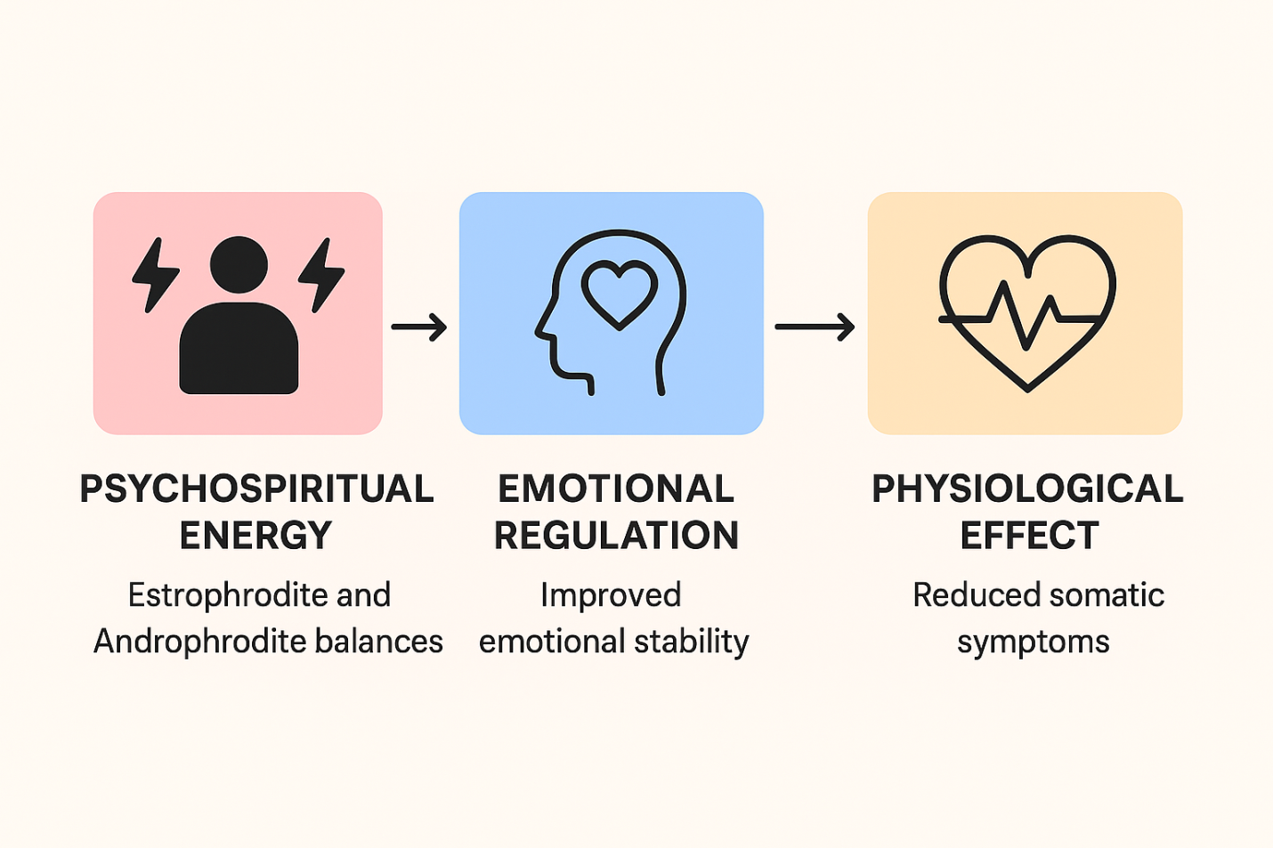

11. References
American Psychiatric Association. (2023). Diagnostic and statistical manual of mental disorders (6th ed.). APA Publishing.
Kirmayer, L. J., & Looper, K. J. (2006). Somatoform disorders. The Psychiatric Clinics of North America, 29(4), 713–730. https://doi.org/10.1016/j.psc.2006.07.002
Sarason, I. G., & Sarason, B. R. (2021). Abnormal Psychology: The problem of maladaptive behavior (14th ed.). Pearson.
Spiegel, D., Loewenstein, R. J., Lewis-Fernández, R., Sar, V., Simeon, D., Vermetten, E., & Cardeña, E. (2011). Dissociative disorders in DSM-5. Depression and Anxiety, 28(12), E17–E45. https://doi.org/10.1002/da.20874
Thayer, J. F., & Lane, R. D. (2000). A model of neurovisceral integration in emotion regulation and dysregulation. Journal of Affective Disorders, 61(3), 201–216. https://doi.org/10.1016/S0165-0327(00)00338-4

