AI-Integrated Breast Point-of-Care Ultrasound (POCUS): Image Acquisition Standard Operating Procedure (SOP)
Oteibi, M., Tamimi, A., Abbas, K., Tamimi, G., Khazaei, H, Khajehee, B., Etesami, F
Validus Institute Inc.,USA
DOI: https://dx.doi.org/10.51584/IJRIAS.2025.101100063
Received: 30 November 2025; Accepted: 07 December 2025; Published: 13 December 2025
PURPOSE
This Standard Operating Procedure (SOP) outlines a standardized workflow for performing bilateral breast point-of-care ultrasound (POCUS) examinations in an outpatient clinical setting. The purpose of the SOP is to reduce procedural variability, promote consistent high-quality imaging, and support patient safety during breast ultrasound screening. The protocol is intended for clinicians and trainees with foundational knowledge of ultrasound physics and breast anatomy who are working under appropriate supervision. Examinations are performed using the Butterfly iQ3 probe paired with the Butterfly App on a 10th-generation Apple iPad, selected for its portability, ease of use, and imaging performance comparable to conventional ultrasound systems. Real-time images are displayed through the app interface via USB-C connection, enabling efficient acquisition and review during scanning. This SOP provides a structured framework to guide breast POCUS acquisition and support evaluation of AI-assisted feasibility for breast ultrasound screening.

Disclaimer
This Standard Operating Procedure is for internal use only. It does not replace physician referrals, established care plans, or formal diagnostic breast ultrasound performed by radiology. It is not intended for cancer staging, diagnostic decision-making, or general-population breast cancer screening. This SOP serves solely as a workflow guide for breast POCUS acquisition and for evaluating the feasibility of AI-assisted ultrasound interpretation. It is not a substitute for formal ultrasound education, credentialing, or professional training.
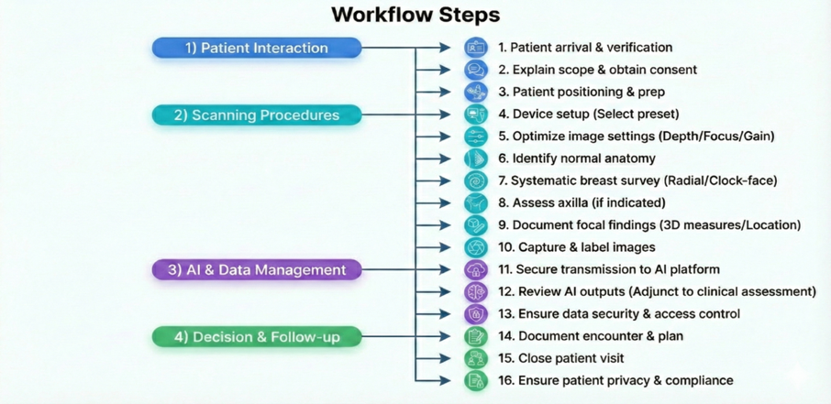
Figure 1. Workflow operational illustration of the Breast Point-of-Care Ultrasound (POCUS) process
INDICATIONS
Common indications include:
- Evaluation of a focal palpable area (e.g., lump, focal tenderness)
- Using AI-assisted POCUS to support the characterization of focal findings seen on other bedside exams to test AI validity and accuracy of interpretation.
- Assessment of focal breast or chest wall trauma.
- support with guidance for bedside procedures within the breast or chest wall (where locally permitted)
- To examine adjacent lymph nodes/ skin anomalies, and deformities
- Comparison of structural integrity/ in implant placement and surgical procedure
- Scope:
This Standard Operating Procedure (SOP) is a guide to help support the proper conduct of breast point-of-care ultrasound (POCUS) screening in our Breast Mass Early Detection research. Trained healthcare professionals will perform the ultrasound and will be interpreted by a licensed physician(s). The images will be collected for further analysis and dissemination for future research to help improve current screening modalities of breast mass.
- Personnel & Equipment:
- Sonographer / trained healthcare professional: Perform exam, document images, maintain equipment
- Radiologist: Interpret images, finalize report
- Medical Assistant/Front Desk: Verify patient identity, obtain consent, assist with patient preparation
- Equipment and System Setup
  - Devices
- Butterfly iQ3+ probe.
- 10th-generation Apple iPad (or equivalent) with Butterfly App installed
- USB-C cable/adapter to connect the probe to the iPad
- Ultrasound gel (hypoallergenic)
- Towels & drapes
- Patient gown
- Cleaning supplies (approved disinfectant wipes)
- Documentation system: Radiology Information System (RIS) and a Picture Archiving and Communication System (PACS)
  - Initial setup
- Open the Butterfly App and log in if required
- Connect the Butterfly iQ3 to the iPad via USB-C
- Select an appropriate preset (e.g., Breast, Small Organs, MSK)
- Presets automatically optimize depth, gain, and frequency for superficial structures
- Confirm that real-time imaging appears on the screen when the probe is touched to any surface
  - Gel Application
- Apply a liberal amount of ultrasound gel to the transducer surface of the probe.
- Ensure no visible air bubbles, as ultrasound transmits best through fluid and is attenuated by air.
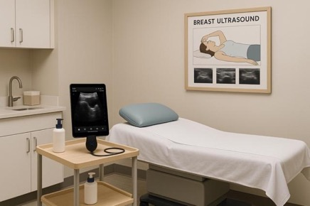
Figure 2. Examination room with a butterfly probe available to conduct Breast POCUS
- Patient Preparation and Positioning
  - Patient care:
- Explain the procedure's purpose and process
- Clarify that ultrasound is safe and painless
- Allow time for patient questions
- Provide a gown (open in front)
- Remove clothing and jewelry from the waist up
5.2. Patient Attire
- Provide a gown (open in front)
- Remove clothing and jewelry from the waist up
5.3. Patient Encounter
- The patient will enter the room and will be instructed to put on a gown
- Verify identity and gather necessary information
- A trained healthcare professional will assist the patient with proper positioning at the examination table
- Confirm the correct patient profile in the system
- Patient Screening Procedure
  - Identification & Verification
- Verify patient identity using name and DOB
- Confirm indication for breast ultrasound, laterality, and patient history
  - Explain and consent
- Explain the purpose of breast POCUS; it is adjunctive and does not replace formal diagnostic imaging.
- Obtain verbal consent per local policy
  - Clothing and draping
- Provide a front-opening gown
- Expose one breast at a time:
- For the breast being scanned, open the gown and expose the breast and lateral chest
- Keep the opposite breast and abdomen covered with a sheet or towel
7. Proper Positioning Technique
7.1. Patient Positioning
Patient Position
- Patient supine on the exam table with a pillow under the head
- Place a small wedge or folded towel under the shoulder on the side being scanned to flatten the breast
- Rotate the patient 20–30° away from the side being scanned (supine-oblique)
- Raise the ipsilateral arm above the head or rest it behind the neck to open the axilla
- Select a high-frequency linear probe
- Set preset: Breast / Superficial
- Clean and disinfect equipment per protocol
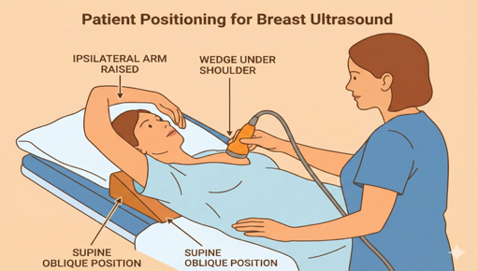
Figure 3. Patient positioning for Butterfly IQ3 ultrasound probe
- Patient in supine or slightly oblique position
- Arm of the target side raised above the head
- A small wedge under the shoulder may be used to flatten the breast
8. Room & Equipment Preparation
- Ensure adequate lighting and privacy
8.1. Probe Orientation and Handling
8.2. Orientation marker and image layout
- Identify the orientation marker on the Butterfly probe:
- A small light/ridge on one side of the probe
- This marker corresponds to the marker indicator on the screen (usually the left side)
- The Butterfly provides a top-down view:
- Top of screen = structures closest to the probe (superficial)
- Bottom of screen = deeper structures
8.3. Standard orientation for this protocol
- Transverse (short-axis) view
  - Marker → patient’s RIGHT
  - Screen left = patient’s right
- Longitudinal (long-axis) / radial view
  - Marker → patient’s HEAD (cephalad) or toward the nipple if using radial pattern, and kept consistent
  - Screen left = toward head (or nipple), depending on chosen convention
8.4. Hand position and “PART” technique
Hold the probe in a relaxed “pencil grip”:
- Thumb and first two fingers around the probe
- The small finger or ulnar edge of the hand can rest lightly on the skin for stability
Use PART to optimize images:
- P – Pressure
- Apply gentle, even pressure to maintain contact and exclude air, but avoid compressing/distorting the tissue

- A – Alignment / Angle (Tilting/Fanning)
- Angle the beam by tilting/fanning the probe to bring structures into full view and improve needle/lesion visibility
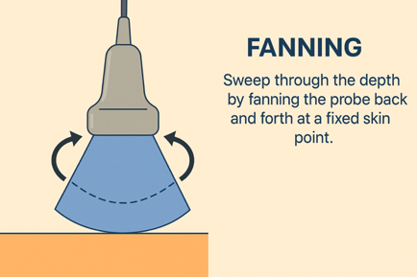
Figure 4. Fanning out technique POCUS breast
- R – Rotation
- Rotate the probe 90° to change between transverse/longitudinal or radial/antiradial
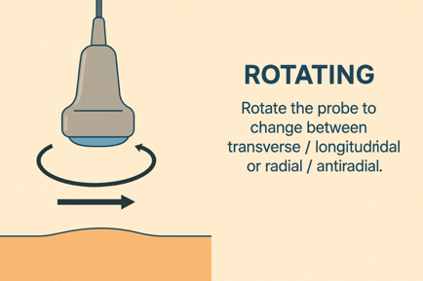
Figure 5. Rotating technique POCUS breast
- Rock to center structures and optimize perpendicular insonation. "Rocking" involves tilting.
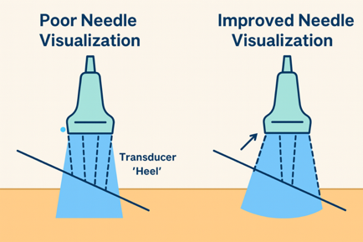
Figure 6. Rocking technique: Tilting the probe along the curved surface to maintain perpendicular contact
- T – Translation (Sliding)
  - Slide the probe over the skin to move to a new region. Move the probe along its long axis over the skin, keeping it perpendicular to the target so the structure stays centered on the screen.
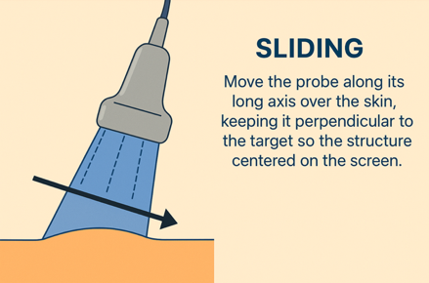
Figure 7. Sliding POCUS technique

9. Scanning Setup & Orientation

9.1. System Setup
- Connect the Butterfly probe and open the Butterfly app
- Select preset: Breast or Small Organ/Superficial
- Set depth to 3–5 cm (pectoralis and ribs visible)
- Adjust the gain so subcutaneous fat appears mid-gray
- Apply a thin layer of gel to the probe or skin
- Position the focal zone at or just below the region of interest
- Performing an ultrasound using POCUS and image capture
9.2. Probe Handling and Patient Contact
- Maintain light, consistent pressure
- Apply only enough pressure to maintain full skin contact and eliminate air gaps.
- Avoid excessive pressure that may distort lesions, ducts, or vascular structures.
- Maintain proper probe orientation
- Transverse scans: Marker toward the patient’s right
- Longitudinal scans: Marker toward the patient’s head
- Keep orientation stable throughout each sweep
9.3. Scanning Technique
- Use a combination of:
- Radial / Anti-radial sweeps (aligned with ducts)
- Transverse and longitudinal sweeps across each quadrant
- Superior–inferior and medial–lateral fanning to evaluate full tissue thickness (More details on this below)
- Cover the following anatomical regions systematically:
  - Retroareolar region
  - All four quadrants
  - Axillary tail of Spence
  - Axilla (if indicated)
  - Chest wall interface and pectoral muscle
9.4. Optimize the image during scanning, and adjust during scanning by following these steps:
- Depth
  - Include the entire breast, retromammary fat, and pectoralis muscle
  - Avoid setting depth excessively deep, which reduces resolution
  - Ensure the posterior breast and pectoral muscle are visible but not excessively deep
- Gain
  - Adjust so fat is mid-gray, not bright white or completely dark
  - Maintain consistent tissue brightness across the breast
- Focus
  - Set the focal zone at or just below the structure of interest
- Time Gain Compensation (TGC)
- Adjust to ensure uniform brightness from near to far field.

9.5. Probe Orientation

1. How to Hold the Probe?
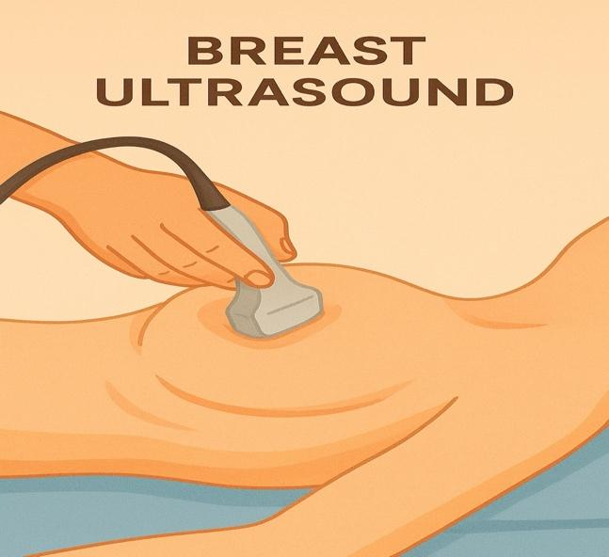
Figure 8. How to hold the probe in a breast ultrasound
- Patient supine, feet toward the sonographer
- Marker (M) → patient’s RIGHT for transverse views
- This applies to both breasts.
9.6. Scanning Pattern for Breast POCUS
You may use either a clock-face radial pattern or a quadrant pattern. Choose one method for your site and apply it consistently.
9.6.1. Overview of required coverage
For each breast:
- Scan in a clock-face or quadrant pattern:
- Start at the 12 o’clock position and sweep radially from nipple to periphery
- Repeat around the breast to cover the entire breast
- Specifically evaluate:
- Retroareolar region (behind the nipple–areolar complex)
- All quadrants/clock positions
- Axillary tail of Spence
- Axilla, if clinically indicated
9.6.2. Detailed step-by-step scanning (per breast)
Step 1 – Retroareolar survey
- Place the probe with gel directly over the nipple–areolar complex in transverse orientation (marker → patient’s right)
- Adjust:
- Depth so that the chest wall / pectoral muscle is visible.
- Gain: Adjust overall gain so that subcutaneous fat appears as a medium gray, and fibroglandular tissue is slightly brighter, with lesions and tissue planes clearly visualized
- Use the Fanning technique with the probe in both the superior–inferior and medial–lateral directions to familiarize yourself with the tissue layers.
Step 2 – Clock-face radial sweeps (example method)
- Rotate the probe to a radial “long-axis” orientation (e.g., marker toward the nipple or head according to your standard).
- From the nipple, sweep along the 12 o’clock line:
- Slide from nipple → periphery and back
- Fan slightly on either side of the line to include adjacent tissue.
- Repeat at additional clock positions with overlapping coverage:
  - 1–2 o’clock
  - 3–4 o’clock
  - 5–6 o’clock
  - 7–8 o’clock
  - 9–10 o’clock
  - 11 o’clock
- At any focal abnormality, rotate 90° to obtain an antiradial (perpendicular) view, then slide and fan to fully characterize it.
(If your site prefers a quadrant/lawnmower pattern, substitute those steps but maintain the same principles: complete coverage with overlapping sweeps.)
Step 3 – Axillary tail and axilla
- From the upper outer quadrant, slide laterally into the axillary tail.
- Scan in both transverse and longitudinal planes to include:
  - Axillary tail of Spence
  - Adjacent chest wall
- If indicated, continue superiorly into the axilla to evaluate superficial lymph nodes and soft tissues.
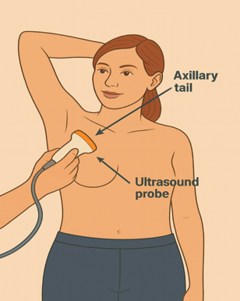
Figure 9. Right Axillary breast ultrasound probe positioning
Step 4 – Repeat for the opposite breast
- Re-drape, reposition the wedge, and raise the opposite arm.
- Perform the same sequence:
  - Retroareolar survey
  - Complete clock-face or quadrant coverage
  - Axillary tail ± axilla
- Maintain identical orientation rules and documentation schemes on both sides.
9.7. Scanning in Transverse and Longitudinal Planes
For each region of interest:
9.7.1. Transverse (short axis) scan
- Hold the probe perpendicular to the long axis of the structure (marker → patient’s right).
- Maintain steady contact and sweep side-to-side slowly to obtain cross-sectional views.
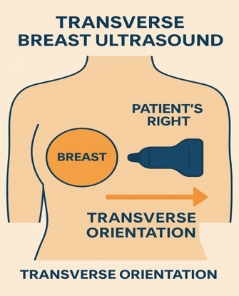

Figure 10. Transverse Breast Ultrasound Orientation
9.7.2. Longitudinal (long-axis) scan
- Rotate the probe 90°, so it aligns with the long axis of the structure (marker → head or nipple per your standard).
- Scan along the length of the structure, sliding proximal–distal or superior–inferior as needed.
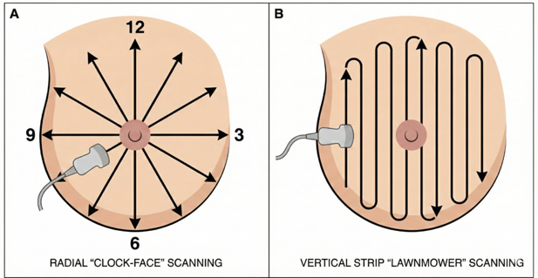
Figure 11. Standardized Scanning Patterns. (A) Radial (Clock-Face) Pattern: The probe is oriented radially (pointing toward the nipple) and swept along the "spokes" of the clock from 12:00 to 12:00. This is the primary method for ductal evaluation. (B) Vertical Strip (Lawnmower) Pattern: Overlapping vertical sweeps are performed across the entire breast volume to ensure no tissue is missed.
- Switching between transverse and longitudinal (or radial/antiradial) planes gives a more complete anatomical understanding and helps confirm any finding.

10. Image Optimization
- Adjust gain, depth, and focus as needed. (Check steps in 9.3 for details)
- Use compound imaging if available
- Apply Doppler when evaluating vascularity
10.1. Image Capture & Documentation
- Freeze the image when a representative or abnormal finding is properly visualized.
- Save the following required images:
- Retroareolar region (transverse and longitudinal)
- Each quadrant, in both planes
- Any lesion or abnormality (measured in two orthogonal planes)
- Axillary tail and axilla when indicated
- Pectoral interface
- Cine loops for sweeping views when needed
- Measurements/ Annotations (if applicable):
- Lesion size in 3 dimensions
- Distance from the nipple (radial clock-face format)
- Label all images according to office convention:
- Example: “R 2 o’clock, 3 cm from nipple, TRV”
- Mark lesion characteristics as needed (solid, cystic, shadowing, etc.)
- Quality Check Before Saving:
- Confirm the orientation marker is correct
- Confirm that depth, gain, and focus are optimized
- Ensure the lesion is centered and clearly visualized

Table 1. POCUS Decision-Support: Lesion Characterization Criteria
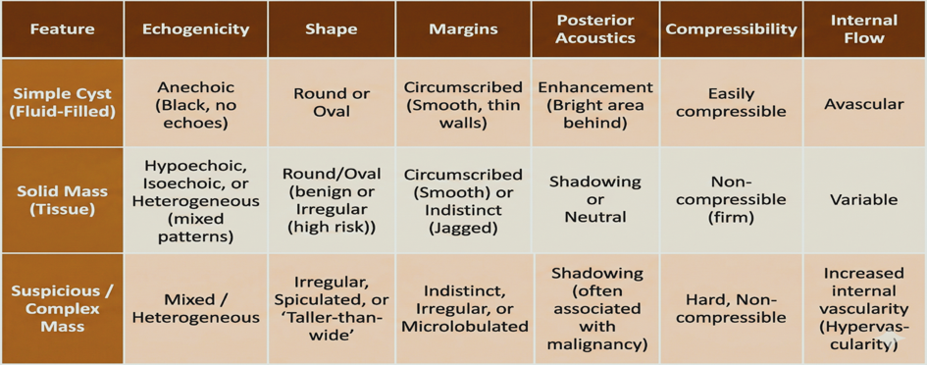
Note. This table is a descriptive guide for image acquisition and labeling only. It is not intended for final diagnostic categorization (BI-RADS) or cancer staging, which a radiologist must perform.
10.2. Image Transmission and AI Integration
- Submit stored images and cine loops into the clinic’s secure imaging system.
- Transmit the completed study to Vertex AI for AI-assisted interpretation and training, following all imaging security protocols.
- Verify successful upload and document study completion.
10.3. Proper Documentation
Mandatory images:
- Entire breast, systematic sweeps
- Retroareolar region
- Any focal lesion (orthogonal views)
- Comparison images of the follow-up
- Axilla if scanned
10.4. Annotations:
- Side: RT / LT
- Orientation: Radial/Anti-radial or Longitudinal/Transverse
- Clock-face position
- Depth marker
- Measurements
11. Completion & Documentation
Document the study in the medical record, including indication, sides scanned, technique, key POCUS annotations, and follow-up plan with primary care or specialist
11.1. For each record, document the following:
- Indications for breast POCUS
- Device used (Butterfly iQ + iPad)
- Preset and general technique (clock-face vs quadrant, transverse + longitudinal)
- Areas scanned (both breasts, retroareolar, axillary tail, axilla if done)
11.2. Save Annotated POCUS images
- Send images to the patient's doctor for follow-up
- Transmit images to Vertex AI for AI model training and interpretation
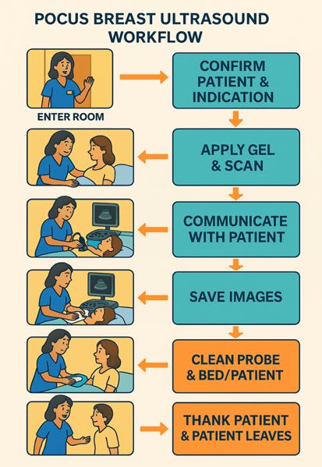
Figure 12. Stepwise patient workflow of Breast POCUS visit to the office from start to end of encounter
12. Post-Exam Procedures
12.1 Patient Care
- Provide towels for cleaning gel.
- Wipe excess gel from the breast and surrounding skin using towels or tissues.
- Help the patient back to a comfortable, covered position.
- Assist the patient to a comfortable posture
- Assure the patient about the report timeline
12.2 Equipment Care
- Clean the transducer and machine
- Dispose of used linens
- Clean the table with disinfecting solution
12.3. Ensure Proper Documentation and capture of images
Documentation and Record:
- Indication for breast POCUS screening
- Number of Side(s) scanned
- Annotate on the iPad the preset that was used
- Document the technique of the Butterfly used when scanning
- Document the patient's position
12.4. Image Security and Access Control
- All imaging data must be stored, transmitted, and viewed only on secure, authorized devices that comply with institutional privacy and security standards.
- Devices displaying patient images must never be left unattended or unlocked.
- Users must ensure screens are closed, locked, or logged out when not actively in use.
- Only personnel with authorized access privileges may handle, prepare, or submit imaging files.
- Unauthorized access, sharing, or disclosure is strictly prohibited.
12.5. Reporting Workflow
- All images must be stored and transmitted using only authorized devices
- Only authorized users are allowed to prepare and submit images
- Submit images to PACS
- Sonographer prepares preliminary worksheet
- Transmit images to Vertex AI for AI model training and interpretation
- The radiologist interprets and finalizes the report
13. Safety & Sanitary Control
- Follow universal precautions
- Clean and disinfect the transducer before and after each patient
- Use probe covers for open wounds or infectious cases

Standard Operating Procedure ( SOP) Summary Steps:

This Standard Operating Procedure (SOP) defines a standardized workflow for AI-integrated breast POCUS in outpatient settings. It is designed for trained clinicians and serves as an adjunct to existing diagnostic pathways, not a substitute for formal radiologic breast screening.

Workflow Steps:

1. Patient arrival and verification

a. Confirm patient identity using institutional standards.

b. Review clinical indications, relevant history, and any prior breast imaging.

2. Explain the scope and obtain consent

a. Clearly explain the role and limitations of breast POCUS relative to diagnostic radiology.

b. Answer patient questions and obtain informed consent in accordance with institutional policy.

3. Patient positioning and preparation

a. Position the patient supine or in a slight oblique position with the ipsilateral arm raised.

b. Drape appropriately and expose the breast region from the clavicle to the inframammary fold.

4. Device setup

Select the breast preset (or equivalent) on the POCUS device and confirm appropriate baseline settings prior to scanning.

5. Optimize image settings Adjust depth, focus, and gain so that subcutaneous fat and fibroglandular tissue are clearly differentiated.

6. Identify normal anatomy Confirm the expected anatomic layers and overall breast architecture.

7. Perform a systematic breast survey Scan the entire breast in a radial or clock-face pattern, including the retro-areolar region and axillary tail.

8. Assess axilla as indicated Perform targeted axillary scanning when clinically appropriate.

9. Document focal findings For any focal abnormality, obtain orthogonal views, measure in three dimensions, and record clock-face position and depth, using structured documentation.

10. Capture and label images

a. Acquire representative images and cine loops of normal survey views and any abnormalities.

b. Label them according to the standardized protocol.

11. Secure transmission and storage of data to the AI platform

a. Store images in the designated system using the approved file structure to support downstream AI training and analysis.

b. De-identify image sets before transmission, then transmit de-identified image sets to the approved AI integration platform using secure, encrypted channels.

12. Review AI outputs The clinician reviews AI-generated outputs as an adjunct to clinical assessment, not as a substitute for clinical judgment or formal radiologic interpretation.

13. Ensure data security and access control Handle all images on encrypted devices, never leave them unattended, and restrict access to authorized users only, in accordance with institutional policies.

14. Document encounter and plan Document the AI-assisted POCUS findings, interpretation, and recommended next steps in the medical record.

15. Communicate next steps with the patient and close the visit Ask the patient to follow up with her treating physician for ongoing care. Confirm that all images have been securely saved and transmitted before the patient leaves.

16. Ensure patient privacy Ensure secure data handling, and compliance with institutional policies is emphasized at every step.

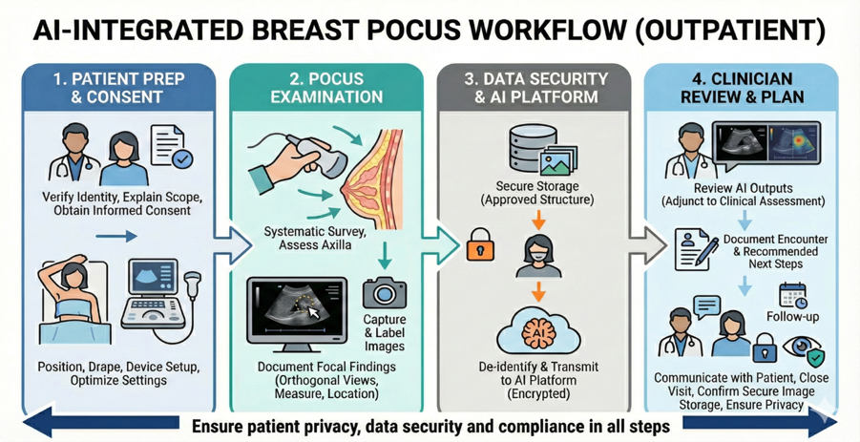

Figure 13. Sequential Clinical Workflow for POCUS: From Patient Intake to Image Transmission and Storage

ACKNOWLEDGEMENT

Thank you to all team members of the Validus Institute Inc. who contributed to this Standard Operating Procedure (SOP). This SOP document and all the materials included in this SOP are the intellectual property of Validus Institute Inc.

REFERENCES
- American College of Radiology. (2023). ACR practice parameter for the performance of a breast ultrasound examination. ACR.
- American Institute of Ultrasound in Medicine. (2022). AIUM practice parameter for the performance of a breast ultrasound examination. AIUM.
- Berg, W. A., et al. (2021). Diagnostic imaging: Breast (3rd ed.). Elsevier.
- Butterfly Network. (2023). Butterfly iQ user manual & clinical scanning guide. Butterfly Network Inc.
- Evans, A., Trimboli, R. M., Athanasiou, A., Balleyguier, C., Baltzer, P. A., Bick, U., ... & European Society of Breast Imaging (EUSOBI), with language review by Europa Donna–The European Breast Cancer Coalition. (2018). Breast ultrasound: recommendations for information to women and referring physicians by the European Society of Breast Imaging. Insights into imaging, 9(4), 449-461.
- Oteibi, M., Tamimi, A., Abbas, K., Tamimi, G., Khazaei, D., Khajehee, B., & Khazaei, H. (2025). AI-Assisted Point of Care Ultrasound (POCUS) Vs. Mammography for Early Breast Cancer Detection: A Comparative Review. https://dx.doi.org/10.51584/IJRIAS.2025.10100000125
- Oteibi, M., Tamimi, A., Abbas, K., Tamimi, G., Khazaei, D., & Khazaei, H. (2025). Breast tumor ultrasound: Clinical applications, diagnostic features, and integration with AI. International Journal of Research and Innovation in Applied Science, 11(11), 518–527.
https://doi.org/10.51584/IJRIAS.2025.100800034
- Oteibi, M., Tamimi, A., Abbas, K., Tamimi, G., Khazaei, D., & Khazaei, H. (2024). Advancing digital health using AI and machine learning solutions for early ultrasonic detection of breast disorders in women. International Journal of Research and Innovation in Applied Science, 11(9), 590–601. https://doi.org/10.51244/IJRSI.2024.11110039
- Oteibi, M., Khazaei, H., Abbas, K., Balaguru, B., Williams, A. R., & Etesami, F. (2025). Breast imaging and omics for non-invasive integrated classification (BIONIC). International Journal of Research and Innovation in Applied Science, 10(8), 826–835.
https://doi.org/10.51584/IJRIAS.2025.100800094
- Yang, L., Wang, S., & Zhang, L. (2020). Performance of ultrasonography screening for breast cancer: A systematic review and meta-analysis. BMC Cancer, 20, 499. https://doi.org/10.1186/s12885-020-06992-1

