OhmMA: An Interactive Mobile Simulation for Teaching Ohm’s Law

ABSTRACT
This study introduces OhmMA (Ohm’s Mobile Application), an offline mobile application designed to calculate voltage, current, or resistance when one variable is absent. The application includes an interactive simulation that visually demonstrates current flow as users connect and operate the provided apparatus. The primary aim is to develop an application with an engaging simulation to enhance students' understanding of Ohm's Law. A descriptive-quantitative research design was employed, involving randomly selected respondents to assess their learning experiences related to Ohm’s Law. Science faculty validated the application's content and design, while Physics teachers and students evaluated the application's accessibility, conceptual accuracy, visual appeal, functionality, and engagement through survey questionnaires. Analytic rubrics were utilized, with separate criteria for teachers and students. The findings indicated that most respondents found the application’s design aesthetically pleasing, easy to navigate, and user-friendly. The application was also deemed effective in meeting learners' needs for understanding Ohm's Law. Both Physics teachers and students rated the application's color scheme, brightness, contrast, and the accuracy of output values favorably. In conclusion, OhmMA is an effective educational tool that significantly aids students in comprehending the concept of Ohm's Law.
Key words: OhmMA, Ohm’s Law, simulation, multi-media, aesthetic, and user-interface

INTRODUCTION
Physics, as a discipline, presents significant challenges for students due to its inherently abstract and complex nature. It requires not only a deep understanding of scientific concepts but also the ability to perform intricate mathematical computations. These complexities often lead to misconceptions if the concepts are not effectively explained and contextualized [8]. Addressing these misconceptions remains a major challenge in science education today [7]. One specific area where students struggle is in the practical application of Ohm’s Law. Without functioning electrical devices, Ohm’s Law can become purely theoretical—reduced to a set of verbal or mathematical statements without the hands-on experience necessary for students to fully grasp its implications. This highlights the need for educational interventions that integrate practical applications, ensuring that students’ learning is holistic, covering both the theoretical and practical aspects of the concepts.
Given the rapid advancement of technology and the fact that today’s students are digital natives, there is a growing recognition of the potential for integrating technology into education to enhance learning outcomes. Mobile technology, in particular, offers a powerful tool for creating interactive and engaging learning experiences [6]. Recent studies have shown that digital gamification can significantly improve students’ understanding of physics concepts [10]. Simulations, which replicate real-world equipment in a simplified manner, provide valuable opportunities for students to visualize and interact with abstract concepts like electricity, which are not directly observable [4]. These tools are essential for preventing misconceptions and enhancing the comprehension of complex science topics.
Moreover, the use of simulation games in education has been demonstrated to improve student learning outcomes across various subjects. This improvement is attributed to features such as increased learner engagement, motivation, and the provision of a safe, interactive environment [1]. In the context of developing countries like the Philippines, where access to technology can be limited, the adoption of offline simulation applications presents a promising opportunity to bridge the gap between theoretical knowledge and practical application. Such tools allow students to engage with the material in meaningful ways, even outside the classroom [9].
In recent years, inquiry-based learning has been identified as one of the most effective approaches to teaching complex scientific concepts like Ohm’s Law. This method encourages students to explore and apply scientific reasoning, fostering a deeper understanding of the material [2,3]. Inquiry-based learning is a versatile activity that involves making observations, posing questions, reviewing existing knowledge, planning investigations, gathering and analyzing data, and communicating results [5]. By combining inquiry-based learning with modern technological tools, educators can create a learning environment that not only enhances students' understanding of physics but also prepares them to apply this knowledge in real-world situations.
In conclusion, addressing the challenges in teaching and learning physics requires a multifaceted approach that combines practical applications, technology integration, and inquiry-based learning. By redesigning instructional methods to incorporate these elements, educators can enhance students' learning experiences, making abstract concepts more accessible and engaging.

METHODS
The study utilizes a descriptive-quantitative research design. The researchers conducted a survey among randomly selected students to assess their understanding of Ohm’s Law, collecting data to identify areas for improvement. Based on these findings, the researchers collaborated with an application developer to create an interactive simulation as a learning tool targeted at science students and teachers. The quality of the Ohm’s Mobile Application (OhmMA) was evaluated by both students and Physics teachers, with the results presented through descriptive statistics such as mean and standard deviation.
The development process of the mobile application's interactive simulation as an instructional tool for teaching Ohm’s Law followed a systematic flow. As illustrated in Figure 1, the initial stage involved validating the concept of the application in relation to Ohm’s Law, with input from Physics teachers in the Science Education Department. The subsequent stage focused on planning and design, where the researchers, in collaboration with the app developer, created the mobile application. A rubric was then developed for the evaluation of the application by the teachers. Following this, the researchers selected respondents and locations for conducting the survey and testing the application through the use of survey questionnaires. The final stage involved analyzing the survey results to evaluate the effectiveness of the application.

Figure 1. Methodology Flow Chart

PARTICIPANTS
Thirty respondents participated in the evaluation of the application. This group comprised ten Physics teachers from various colleges within the University of Science and Technology of Southern Philippines, representing diverse genders and statuses, with no age restrictions. Additionally, twenty students from the University of Science and Technology of Southern Philippines - Cagayan de Oro Campus also evaluated the application.

SAMPLING TECHNIQUE
This study employed convenience sampling to target Physics teachers from various colleges within the University of Science and Technology of Southern Philippines (USTP) who are currently teaching or have previously taught concepts related to Ohm’s Law. A total of ten Physics teachers participated in the study to evaluate the effectiveness of the application. Additionally, twenty students from USTP were selected based on their current or recent exposure to Ohm’s Law in their physics classes. The results from both groups were used to assess the application’s effectiveness as a tool for teaching Ohm’s Law.
INSTRUMENT
The data collection instrument utilized in this study was a rubric developed by the researchers. The items within the rubric were derived from concepts identified through relevant literature and findings related to the study.
The rubric comprised five criteria focused on evaluating the application's performance and structure: accuracy, ease of use, performance, aesthetics, and user interface. Each criterion was rated on a scale of 1.0 to 5.0, where 1.0 indicated that the application "Needs Improvement" and 5.0 indicated an "Excellent" rating.
The study was conducted with the participation of ten Physics teachers from various colleges within the University of Science and Technology of Southern Philippines (USTP), ten Senior High School students from the STEM strand, and ten college students. Each participant was provided with the researcher-developed rubric to evaluate the application.
Developmental Stage
- Planning and Designing
The design is inspired by the PhET simulation but incorporates additional electrical components and the variables of Ohm's Law, specifically voltage, resistance, and current, which are displayed on the right side of the software interface.
- Developing the Application with the help of an Application Developer

The software was developed with the assistance of a developer who utilized the Iconic 3 programming language.
- Develop a Rubric

This stage involves the development of a rubric to evaluate the application based on the following criteria:
- accuracy d. user-interface
- performance e. aesthetic
- ease of use

Testing the Application
The demonstration of the application to the teachers and students allowed us to collect performance data on the calculated variables.

Following the presentation and interaction with the application, the evaluators completed the survey form, which involved the following steps:
- Presentation of the mobile application to the evaluators
- Explanation of the use and procedure of the application
- Manipulation of the evaluators of the application
- Evaluation of the application by the evaluators using the survey form that was prepared by the researchers.

Product Assessment
- ASSESSMENT OF THE ACCURACY, ATTRACTIVENESS, FUNCTION, ACCESSIBILITY AND INTERACTIVENESS OF THE APPLICATION
The evaluators will complete the survey form after the presentation and interaction with the application, following the steps outlined below.
- Presentation of the application
- Explanation of the use and procedure of the application
- Manipulation of the evaluators of the application
- Evaluation of the application by the evaluators using the survey form that will be prepared by the researchers.

DATA ANALYSIS
The research questions in this study were analyzed using descriptive statistics, specifically mean and standard deviation, to assess whether the application was rated as excellent, competent, developing, or in need of improvement. The mean was used to determine the average ratings for each criterion of the application, as gathered through the rubrics.
The overall rating of the application was then calculated, and the following parameters were adopted:
- Excellent. The application met the expected results in its criterion.
- Competent. The application met some expected results but exhibit some failures which are mostly negligible.
- Developing. The application failed to meet the expected results however; the application can still be used in teaching the topic.
- Needs to be improved. The application failed to meet the expected results and is inappropriate in teaching the topic.
The mean described the results on the evaluation of the application by the teachers and students.

RESULTS AND DISCUSSION
Design and Features of OhmMA

OhmMA is an interactive simulation mobile application designed to explain the concept of Ohm’s Law, specifically focusing on the relationship between current, voltage, and resistance.
Figure 3 presents the prototype of the OhmMA interactive simulation mobile application, developed by the researchers in collaboration with an application developer.
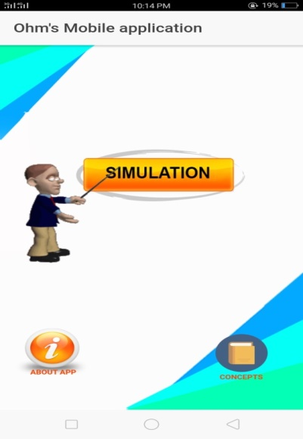
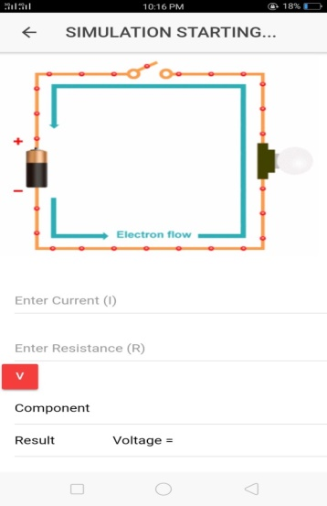
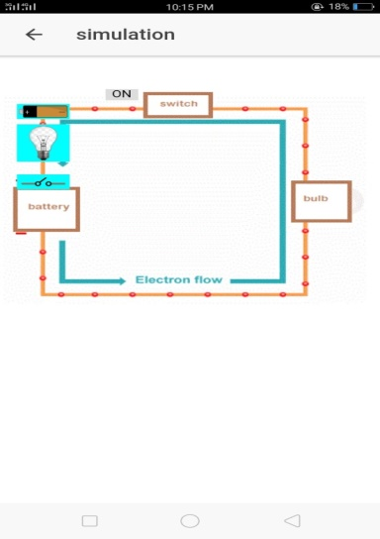

Figure 3. Prototype of OhmMA Mobile Application

The application features a light and eye-friendly color scheme to ensure a comfortable user experience for students. Additionally, the application is designed for ease of use; students can simply click the simulation button, which will automatically display the electrical circuit with the apparatus initially disconnected. Students can then position the apparatus according to the labels and input the necessary values to identify the variables they wish to calculate.
The survey was initially planned to include 40 potential participants from various colleges within the University of Science and Technology of Southern Philippines. However, only 30 participants responded within the designated time frame. The final survey group comprised 10 Senior High School students, 10 college students, and 10 Physics teachers, with no restrictions on age, gender, or academic program.

Table 1: Teacher’s Assessment Ratings of the Interactive Simulation Mobile Application for Ohm’s Law
Criteria | Mean | Standard Deviation | Description
Aesthetic | 4.7 | 1.48 | Excellent
User-Interface | 4.5 | 1.42 | Excellent
Accuracy | 4.3 | 1.36 | Competent
Performance | 4.1 | 1.30 | Competent
Ease of use | 4.7 | 1.48 | Excellent

The table indicates that the categories of aesthetics, user interface, and ease of use received the highest mean and standard deviation values, each earning an "excellent" rating. This is followed by accuracy, which has a mean of 4.3 and a standard deviation of 1.36. Performance, however, recorded the lowest mean of 4.1 and a standard deviation of 1.30. These results suggest that Physics teachers found the application’s design to be appropriate in terms of color scheme, brightness, and text contrast. They also believed that students would be able to launch and navigate the app independently, as its features are user-friendly and familiar. Additionally, the majority of the teachers trusted the accuracy of the output values, noting that there were no technical issues, particularly regarding load handling. Overall, they considered the application a valuable tool for enhancing students' understanding of Ohm’s Law.

Table 2: College Student’s Assessment Ratings of the Interactive Simulation Mobile Application for Ohm’s Law
Criteria | Mean | Standard Deviation | Description
Aesthetic | 4.3 | 1.36 | Excellent
User-Interface | 3.5 | 1.11 | Competent
Accuracy | 5 | 1.58 | Excellent
Performance | 3.5 | 1.11 | Competent
Ease of use | 3.8 | 1.20 | Competent

Table 2 shows that aesthetic and accuracy have high mean and standard deviation values in which both has an excellent description respectively. This is followed by the ease of use with a mean of 3.8 and a standard deviation of 1.20. On the other hand, both user-interface and performance have the lowest mean of 3.5 and a 26 standard deviation of 1.11 respectively. The results imply that college students found the application design as appropriate in color scheme, brightness, and contrast text. Most of them trusted the output of entered values which are correct and can navigate independently since the features are easy to manipulate. They believed that they could use it as an effective tool in learning Ohm’s Law.

Table 3: Senior High School Students’ Assessment Ratings of the Interactive Simulation Mobile Application for Ohm’s Law
Criteria | Mean | Standard Deviation | Description
Aesthetic | 4.5 | 1.42 | Excellent
User-Interface | 4.4 | 1.39 | Competent
Accuracy | 4.4 | 1.39 | Competent
Performance | 4.5 | 1.42 | Excellent
Ease of use | 4.4 | 1.39 | Competent

The table indicates that the categories of aesthetics and performance received the highest mean and standard deviation values, both earning an "excellent" rating. This is followed by accuracy, user interface, and ease of use, each with a mean of 4.4 and a standard deviation of 1.39. These results suggest that Senior High School students found the application's design to be appropriate in terms of color scheme, brightness, and text contrast. Additionally, they were able to launch and navigate the app independently, as its features were familiar and user-friendly. The accuracy of the output values was also trusted, with no technical issues, particularly concerning load handling. The students regarded the application as an effective tool for enhancing their understanding of Ohm’s Law. Thus, OhmMA interactive simulation is viewed positively by both learners and teachers, serving as a valuable tool in today's technology-driven educational landscape

CONCLUSION AND RECOMMENDATIONS
Conclusion
The OhmMA application successfully addresses all fundamental needs of learners in understanding Ohm’s Law. Its design, which aligns well with the topic, has been deemed suitable by both Physics teachers and students in terms of color scheme, brightness, and text contrast. Additionally, they have confidence in the accuracy of the output values. Consequently, the mobile application is an effective tool for enhancing students' comprehension of Ohm’s Law.
Recommendations
For future research, additional features related to Ohm’s Law will be incorporated, and the simulation will be enhanced to provide a more interactive learning experience.
Based on the findings and conclusions of this study, the following recommendations are proposed:
1. Integrate additional features into the mobile application that are relevant to Ohm’s Law.
2. Enhance the simulation to increase its interactivity and effectiveness in the learning process.
3. Raise awareness among teachers and administrators about the importance of utilizing the application to improve learning outcomes and ensure quality education.

ACKNOWLEDGEMENTS

The researchers extend their sincere gratitude and deep appreciation to the research adviser and panel members for their invaluable support and guidance.

Most importantly, they give thanks to the Almighty God for bestowing upon them knowledge, wisdom, and the blessing of life, which made the realization of this work possible.

REFERENCES
1 Almaki, S. H., Gunda, M. A., Idris, K., Hashim, A. T. M., & Ali, S. R. (2023). A systematic review of the use of simulation games in K-12 education. Interactive Learning Environments, 1–25. https://doi.org/10.1080/10494820.2023.2205894
2 Alfieri, L., Brooks, P. J., Aldrich, N. J., & Tenenbaum, H. R. (2011). Does discovery-based instruction enhance learning?. Journal of educational psychology, 103(1), 1.
3 Deslauriers, L., & Wieman, C. (2011). Learning and retention of quantum concepts with different teaching methods. Physical Review Special Topics—Physics Education Research, 7(1), 010101.
4 Finkelstein, S. (2015). Educational technologies to support linguistically diverse students, and the challenges of classroom integration. In Artificial Intelligence in Education: 17th International Conference, AIED 2015, Madrid, Spain, June 22-26, 2015. Proceedings 17 (pp. 836-839). Springer International Publishing.
5 Hussain, M. A. M., Zainuri, N. A., Zulkifli, R. M., & Rahman, A. A. (2023). Effect of an Inquiry-Based Blended Learning Module on Electronics Technology Students' Academic Achievement. Journal of Technical Education and Training, 15(2), 21-32.
6 Hwang, G. J., & Wu, P. H. (2014). Applications, impacts and trends of mobile technology-enhanced learning: A review of 2008–2012 publications in selected SSCI journals. International Journal of Mobile Learning and Organisation, 8(2), 83-95.
7 Sarwanto, S., Sunarno, W., & Yusliana, E. How Student Learn Ohm Law in the Classroom. In International Conference on Teacher Training and Education. Sebelas Maret University.
8 Setyani, N. D., & Handhika, J. (2017). Students conception and perception of simple electrical circuit. In Journal of Physics Conference Series (Vol. 909, No. 1).
9 Tirakoat, S. (2013). The Accomplishment of the Designing of Course of Digital Content Development Training for Non-IT and Various Experiences Teachers. International Proceedings of Economics Development and Research, 60, 78.
10 Uluskan, S. (2024). EDUPERES and GAMERES: A smart interactive education platform and digital gamification for basic circuit analysis. Computer Applications in Engineering Education, e22754.

