A STUDY TO ASSESS THE EFFECTIVENESS OF PLANNED TEACHING PROGRAM ON KNOWLEDGE REGARDING CATARACT AMONG PEOPLE (45-60 YEARS) IN A SELECTED AREA NTPC JHARLI, JHAJJAR, Haryana.

ABSTRACT
Introduction: A natural lens is present inside our eyes that reflects the rays of light coming into the eyes and helps us see the clear images. Cataract is a disease in which this lens becomes opaque, that makes the image look blurred, hazy, and less colorful. It causes increased light sensitivity, blurred vision; decreased vision at night, seeing double images and leads to total blindness .Surgery is the only treatment of the cataract. Some dietary modification may help to prevent the cataract. So planned teaching programmed was developed and administered to improve the knowledge of general population regarding cataract.
Material and methods : A pre experimental study was conducted in NTPC Hospital Jharli Jhajjar (HR).60 sample were selected by using convenient sampling technique. Pre- test was conducted. Planned teaching programme regarding cataract was provided to the samples. Then after seven days post- test was conducted. Data was collected by using self-planned questionnaire related to cataract. The gathered data was analsed by calculating mean, median, mean percentage, mean difference, standard deviation, paired t-test to evaluate the effectiveness of planned teaching programme and chi square test to find association of knowledge with selected socio-demographic variables.
Results: The study finding showed that the post –test mean knowledge score regarding cataract has statistically improved from in pre-test to in post-test.
Conclusion: The planned teaching programme has improved has the post interventional knowledge score of people (45-60 years) in a selected Ntpc Jharli Jhajjar (HR).
INTRODUCTION
Cataract is lens opacity or cloudiness. It is a slowly progressing disease and can render the person completely blind if it is left untreated. According to WHO, cataract is the leading cause of blindness in the world. The most common type is age related or senile. Senile cataract usually begins around the age of 50 years. Several risk factors have been identified to influence cataract formation which include sunlight (UV) exposure, trauma, smoking, steroid use, genetic, uveitis and diabetes. Symptoms of cataract include blurred/reduced vision, cloudy vision, glare, seeing haloes around light and inability to see in dim light. Several studies showed that the reasons for delaying from timely treatment are low economic status, lack of transportation, wrong perception, residual vision and poor knowledge about the risk factors, nature of disease and treatment. Knowledge about cataract is the most vital aspect for delaying the occurrence of cataract, to initiate regular eye checkup, and to institute timely intervention. This, in turn, reduces the burden of the disease. Furthermore assessing knowledge regarding cataract is a precondition for designing health education and promotion programs. In developing countries, it is conceived that health education and promotion plays a significant role in reducing burden of avoidable causes of blindness and visual impairment. Several previous studies revealed that there was a gap in knowledge regarding cataract in developing and some developed countries. The studies also considered age, literacy, residency, marital status, previous exposure for eye care services, and other socio-economic variable as determinant for knowledge concerning to cataract . Although there are different types of cataract which can affect all people most of previous studies conducted on age-related cataract and consider subject age greater than 40 years. In addition, majority of previous studies were institution based. Hence, the findings were less generalizes able to all people. Therefore, this study aimed to assess the general knowledge of people regarding cataract and its associated factors, which will provide basic information for researchers, policymakers and resource allocators to plan health education and promotion programs to allow disease prevention and take early treatment options.
REVIEW OF LITERATURE
(Komolafe et. al 2023) To assess the visual impairment from age related cataract among an Indigenous African population study was conducted, among the rural population in southwestern Nigeria. The magnitude of visual impairment (VI) resulting from lens opacity/cataract was determined using a multistage sampling method to select subjects of 50 years a population‐ based cross‐sectional survey. The ophthalmologist further examined the participants with pinhole visual acuity of 6/18 in their better eye, exclusively from lens opacity/cataract. Their level of VI was categorized using the International Classification of Disease tenth revision and lens opacity. The level of VI was graded using The World Health Organization's cataract grading system. Subjects 1031 were examined from the enumerated population of 1200. The prevalence of VI from cataract/lens opacity in the population studied was 11.9% (95% CI: 10.1– 14.0) with a cataract blindness prevalence of 2.0% (95% CI: 1.3–3.0). Cataract remains ever present public health problem.
Sharma M. et al., 2023 In Utranjal, Chandigarh among elderly population aged over 65 years an epidemiological study of correlates of cataract was studied. To determine the prevalence and correlates of cataract among elderly aged 65 years and above. To cover 245 subjects 953 houses from 6 randomly selected sectors and 2 villages were visited. (141 females and 104 were males). A total of 178 (72.6%) elderly, [108(76.6%) females and 0(67.3%) males] were found to have cataract. Young elderly (78.0% in the age group 75+ years versus 69.9% in the age group of 65‐74 years) was less prevalence than the old elderly. In urban areas than in rural areas (77.9% versus 52%), for educated ones than for illiterates (75% versus 70.1%), in diabetics than in non‐diabetics (81.5% versus 70.1%), in smokers than in non-smokers (73.9% versus 73.5%), alcohol drinkers than in non- drinkers (73.7% versus 72.6%) and amongst hypertensive than in non‐ hypertensive (74% versus 69.8%)
METHODOLOGY
Research Approach: Quantitative Research Approach
Research Design: One Group Pre test post test only Design
Target population: Cataract Patients
Sample size: 60
Sampling technique: Convenient sampling technique
Research setting: NTPC JHARLI, HARYANA
Dependent variables: Knowledge of patients who under gone cataract, Influencing, variable, Age, Education, Occupation
Tool: Planned Teaching Program
Independent variable: Planned teaching program,

ANALYSIS AND INTERPRETATION
Table 4.1 : Distribution of Demographic Variables of Cataract Patients
N=60

S.No | Demo graphic variables | Number of  samples | Percentage
1 | Age in years
 | a. 45‐48 | 10 | 16.67
 | - 49‐52  - 53‐56  - 57-60 | 6  30  14 | 10  50  23.33
2 | Sex
 | - Male | 26 | 43.33
 | b. Female | 34 | 56.67
3 | Education
 | a. Primary | 40 | 66.67
 | b. Secondary | 12 | 20
 | c. Other | 8 | 13.33
4 | Occupation
 | a. Private job | 40 | 66.67
 | b. House wife | 12 | 20
 | c. Govt. job | 8 | 13.33
The above table illustrates the distribution of demographic variables. Regarding the age of patients 5(16.67%) of them were 45-48 years,3(10%)ofthemwere 49‐52 years, 15 (50
%) ofthemwere 53-56 years,7(23.33 %) were 57‐60 years. Concerned with sex 13(43.33%) of them were male and 17 (56.67%) of them were female. When considering the education 20 (66.67 %) of them illiterate and10 (33.33 %) literate. Regarding occupation 17 (56.67 %) of them were labors 13 (43.33%) of them were house wife. Regarding family income 22(73.33%) of them were between Rs. 2001‐ Rs. 4000, 8 (26.67 %) of them were 4001‐6000. Regarding family type 22(73.33%) of them were single family,8(26.67%)of them were joint family. Regarding the source of information 5 (16.67%) were received information from relatives, 25(83.33 %) of them were from hospital. Regarding history of chronic disease 6(20 %) of them had diabetes, 24 (80 %) did not have any chronic disease.

Figure 4.1 : Diagram Showing Distribution Of Age Of Cataract Patients

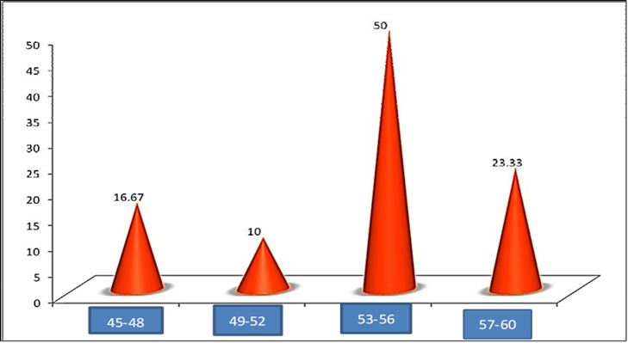

Figure 4.2 : Diagram Showing Distribution Of Education Al Status Of Cataract Patients

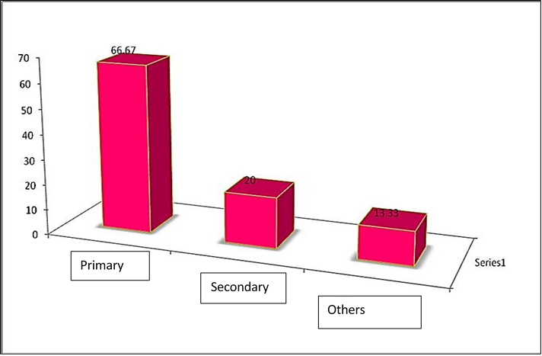
Figure 4.3 ; Diagram Showing Distribution of Family type of Cataract Patients
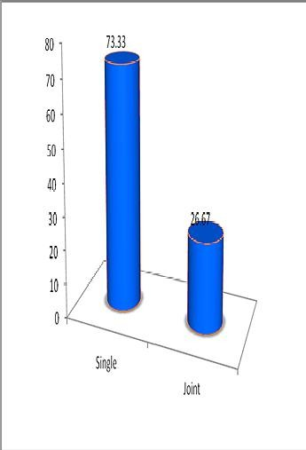

TYPE OF FAMILY

Figure 4.4 ; Diagram Showing Distribution of History of Chronic Disease
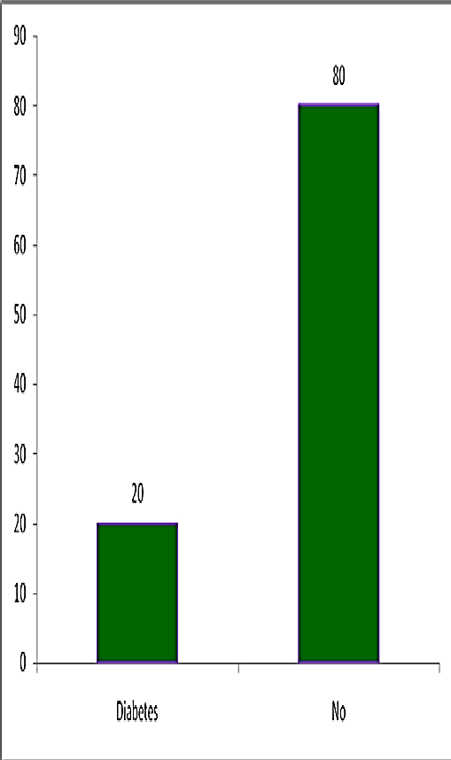

Table 4.2 : Distribution Of Level Of Knowledge On Various Aspects Of Cataract Among Cataract Patients

n=60

S. No. | Aspects of knowledge | Pre-test |  |  |  |  |  | Post-test
S. No. | Aspects of knowledge | <50% |  | 51‐75% |  | 76‐100% |  | <50 % |  | 51‐75% |  | 76‐100%
S. No. | Aspects of knowledge | No | % | No | % | No | % | No | % | No | % | No | %
1 | General information on cataract | 20 | 33.33 | 34 | 56.67 | 6 | 20 | ‐ | ‐ | 8 | 13.33 | 52 | 86.67
2 | Preoperative preparation | 10 | 16.67 | 38 | 63.33 | 12 | 40 | 4 | 6.67 | 28 | 46.67 | 28 | 46.67
3 | Postoperative Care | 6 | 10 | 42 | 70 | 12 | 40 | 2 | 3.33 | 20 | 33.33 | 38 | 63.33
4 | Instillation of eye drops | 10 | 16.67 | 44 | 73.33 | 6 | 20 | 2 | 3.33 | 14 | 23.33 | 44 | 73.33

The above table showed that in the pre-test level of knowledge concerning general information of cataract, 10(33.33%) of them had below 50% and 17 (56.67%) of them had between 51‐75 %.
With regard to preoperative preparation of cataract 5(16.67%)of them had below 50% and 19 (63.33 %)of them had between 51‐75%.
Regarding post-operative care after cataract 3 (10 %) of them had below 50% and 21 (70%) of them had between 51‐75%.
Regarding instillation of eye drops 5(16.67%) of them had below 50 % and 22(73.33%) of them had between 51‐75 %.
This table shows that the cataract patients had inadequate knowledge regarding cataract.

In the post-test, the level of knowledge regarding general information on care after cataract only 4 (13.33%)of them had between 51‐75 % and 26 (86.67%) of them had between 76‐100%.
Regarding pre-operative preparation 2 (6.67 %) of them had below 50 % 14 (46.67%) of them had between 51‐75 % and 14 (46.67 %) of them had between 76‐100 %
Regarding post-operative care 1 (3.33 %) of them had below 50%, 10 (33.3%) of them had between 51‐75 % and 19 (63.33 %) of them had between 76‐100 %.
Regarding instillation of eye drops 1 (3.33%) of them had below 50%, 7(23.33%) of them had between 51‐75 % and 22 (73.33%) of them had between 76‐100 %.
It reveals that in the Post-test, the cataract patients gained adequate knowledge in all aspects regarding cataract.

Table 4.3 : Comparison of Pre-Test and Post-Test Knowledge Scores on Various Aspects of Cataract Patients
n=60

S. no. | Various aspects of care after cataract | Pre-test  Knowledge |  | Post-test  Knowledge |  | Calculated value of paired ‘t’ | Tabulated value of paired ‘t’ at 5%
S. no. | Various aspects of care after cataract | Mean | SD | Mean | SD | Calculated value of paired ‘t’ | Tabulated value of paired ‘t’ at 5%
1 | General  information | 4.87 | 1.13 | 7.23 | o.8 7 | 8.92 | 2.056
2 | Pre-operative  Preparation | 5.47 | 1.42 | 6.3 | 1.27 | 6.52 | 2.056
3 | Post-operative  preparation | 7.97 | 1.09 | 8.83 | 1.01 | 5.71 | 2.056
4 | Instillation of  eye drops | 7.83 | 1.63 | 10.13 | 1.31 | 7.41 | 2.056

The calculated value of ‘t’ is greater than the tabulated value of ‘t’ at 5% level of significance. So the null hypothesis is rejected. Therefore is a significant difference between pre-test and post-test knowledge regarding general information on cataract, pre- operative post-operative and instillation of eye drops. The results show that Planned teaching program on knowledge of cataract is effective.

Table 4.4 : Coefficient of Variation in Pre-Test and Post-Test Scores of Knowledge Regarding Cataract
n=60

S.no | Various aspects of care after cataract | Pre-test Knowledge |  |  | Post-test Knowledge
S.no | Various aspects of care after cataract | Mean | SD | CV | Mean | SD | CV
1 | Genera l Information | 4.87 | 1.13 | 23.20 | 7.23 | 0.87 | 12.03
2 | Pre op Preparation | 5.47 | 1.42 | 25.96 | 6.3 | 1.27 | 20.15
3 | Post op preparation | 7.97 | 1.09 | 13.67 | 8.83 | 1.01 | 11.45
4 | Instillation of eye drops | 7.83 | 1.63 | 20.81 | 10.13 | 1.31 | 12.93

Regarding the general information of cataract, pre-operative preparation, post-operative care and instillation of eye drops, the post-testCV score are lesser than the pre-test CV scores. This showsthat post-test scores are more consistent. The researcher concluded that planned teaching program is effective.

Table 4.5 : Association Between the Levels of Knowledge Regarding Cataract with Selected Demographic Variables
n=60

S.NO | Demographic variables | Below median (or) equal | Above median | Calculated value of χ2 | Tabulated  value of χ² at 5% level
1 | Agein years  < 45  > 60 | 20  16 | 14  10 | <1  NS | 3.84
2 | Sex  - Male  - Female | 12  22 | 14  12 | <1  NS | 3.84
3 | Education  - Primary  - Secondary | 24  12 | 14  10 | <1  NS | 3.84
4 | Family type  - Single  - Joint | 26  8 | 22  4 | <1  NS | 3.84
5 | Source of  information  - Relatives  - Hospital | 2  32 | 14  12 | * 6.38 | 3.84
Table 4.6 : Diagram Showing Distribution of History of Chronic Disease

DIABETES | 20
NO | 80
*‐Significant, NS‐Not Significant

From the above table the calculated value of χ2 was less than the tabulated value of χ2 at 5 % level of significance. Results revealed that:
- There is no association between level of knowledge on cataract and age, sex, educational status and family type.
- There is a association between level of knowledge on cataract and source of information.

REFERENCES

1. Facts About Cataract". September 2009. Archived from the original on 24 May 2015. Retrieved 24 May 2015.
2. Jump up to:a b Gimbel HV, Dardzhikova AA (January 2011). "Consequences of waiting for cataract surgery". Current Opinion in Ophthalmology. 22 (1): 28–30. doi:10.1097/icu.0b013e328341425d. PMID 21076306. S2CID 205670956.
3. Jump up to:a b "Visual impairment and blindness Fact Sheet N°282". August 2014. Archived from the original on 12 May 2015. Retrieved 23 May 2015.
4. Jump up to:a b c d e "Priority eye diseases". Archived from the original on 24 May 2015. Retrieved 24 May 2015.
5. Chan WH, Biswas S, Ashworth JL, Lloyd IC (April 2012). "Congenital and infantile cataract: aetiology and management". European Journal of Pediatrics. 171 (4): 625–630. doi:10.1007/s00431-012-1700-1. PMID 22383071. S2CID 195680440.
6. Vos T, Allen C, Arora M, Barber RM, Bhutta ZA, Brown A, et al. (October 2016). "Global, regional, and national incidence, prevalence, and years lived with disability for 310 diseases and injuries, 1990-2015: a systematic analysis for the Global Burden of Disease Study 2015". Lancet. 388 (10053): 1545–1602. doi:10.1016/S0140-6736(16)31678-6. PMC 5055577. PMID 27733282.
7. Jump up to:a b Wilson Jr ME, Trivedi RH, Pandey SK (2005). Pediatric cataract surgery techniques, complications, and management. Philadelphia, Pennsylvania: Lippincott Williams & Wilkins. p. 20. ISBN 978-0-7817-4307-5. Archived from the original on 2015-05-24.
8. Allen D, Vasavada A (July 2006). "Cataract and surgery for cataract". BMJ. 333 (7559): 128–132. doi:10.1136/bmj.333.7559.128. PMC 1502210. PMID 16840470.
9. Global Data on Visual Impairments 2010 (PDF). WHO. 2012.
p. 6. Archived (PDF) from the original on 2015-03-31.
10. Recognizing Cataracts". NIH News in Health. 2017-05-30. Retrieved 2020-02-
02. Try wearing sunglasses or a hat with a brim. Researchers also believe that good nutrition can help reduce the risk of age-related cataract. They recommend eating plenty of green leafy vegetables, fruits, nuts and other healthy foods.
11. Lamoureux EL, Fenwick E, Pesudovs K, Tan D (January 2011). "The impact of cataract surgery on quality of life". Current Opinion in Ophthalmology. 22 (1): 19–27. doi:10.1097/icu.0b013e3283414284. PMID 21088580. S2CID 22760161.
12. Jump up to:a b Rao GN, Khanna R, Payal A (January 2011). "The global burden of cataract". Current Opinion in Ophthalmology. 22 (1): 49.doi:10.1097/icu.0b013e3283414fc8. PMID 21107260. S2CID 205670997.

