A BLOCKCHAIN-BASED TOKENIZATION APPROACH TO EMPOWER FARMERS AND YOUTH IN SMART AGRICULTURE
ABSTRACT:
Smart agriculture has witnessed significant advancements through the integration of digital technologies; however, traditional agricultural trade systems still suffer from issues such as lack of transparency, unfair pricing, and dependence on intermediaries. These challenges often limit farmer profitability and reduce youth participation in agriculture. To address these issues, this article presents a blockchain-based tokenization approach designed to enable secure, transparent, and decentralized agricultural trade. In the proposed system, agricultural produce is represented as digital tokens on a blockchain network, allowing farmers to tokenize crop batches and directly engage with buyers through smart contracts. The use of blockchain ensures immutability, traceability, and trustless transactions, while smart contracts automate ownership transfer and payment settlement without the need for third-party intermediaries. The framework promotes fair trade practices, enhances trust among stakeholders, and encourages youth involvement by introducing digital ownership and decentralized transaction mechanisms. The proposed approach demonstrates how blockchain-enabled tokenization can support sustainable smart agriculture and create an inclusive digital agricultural ecosystem.
KEYWORDS: Blockchain; Tokenization; Smart Agriculture; Smart Contracts; Decentralized Trade; Farmer Empowerment; Youth Participation
- INTRODUCTION:
Agriculture plays a vital role in economic stability and food security, particularly in developing countries. Despite the adoption of smart farming technologies, agricultural trade remains highly dependent on intermediaries, leading to poor price transparency, delayed payments, and reduced farmer profits. These challenges also discourage youth participation in agriculture. Smart agriculture has advanced through the use of IoT, data analytics, and automation to improve productivity. However, post-harvest trade processes still face issues such as lack of trust, data manipulation, and centralized control, highlighting the need for secure and transparent trade mechanisms.
Blockchain technology provides a decentralized and tamper-resistant solution by enabling immutable transaction records and trustless interactions. Smart contracts further automate agreements and payments, reducing reliance on intermediaries and minimizing fraud. Tokenization allows agricultural produce to be digitally represented as blockchain-based tokens, enabling secure ownership transfer, transparent trading, and improved traceability. This article proposes a blockchain-based tokenization approach that empowers farmers, encourages youth participation, and enables fair, secure, and decentralized agricultural trade.
- BACKGROUND AND MOTIVATION:
Traditional agricultural trade systems are centralized and intermediary-driven, limiting price transparency and reducing farmer income. Farmers often lack real-time market information, which weakens their bargaining power and delays fair payments. While smart agriculture technologies such as sensors, automation, and data analytics have improved crop production, trade and commercialization processes remain inefficient. Challenges including delayed transactions, lack of traceability, and data manipulation continue to affect trust between farmers and buyers.
Blockchain technology offers a decentralized and immutable platform for secure and transparent transactions. By recording verified data on a distributed ledger, blockchain enables traceability, data integrity, and automated trade execution through smart contracts. Tokenization extends blockchain capabilities by digitally representing agricultural produce as unique tokens, enabling transparent ownership tracking and secure trading. The motivation of this work is to integrate blockchain-based tokenization into agricultural trade to reduce intermediary dependency, ensure fair pricing, and promote trust, while also attracting youth participation through a technology-driven agricultural model.
- BLOCKCHAIN AND TOKENIZATION IN AGRICULTURE
Blockchain is a decentralized and immutable digital ledger that enables secure and transparent transaction recording without relying on a central authority. Transactions are maintained across distributed nodes, ensuring data integrity, trust, and resistance to tampering. In agriculture, blockchain supports secure storage and verification of crop-related data such as production details, quality, ownership, and transactions. Time-stamped and permanent records enable transparent tracking of agricultural produce, reducing fraud and disputes across the supply chain.
Smart contracts automate predefined actions such as trade execution, payment settlement, and ownership transfer. Their use minimizes intermediary involvement, reduces manual intervention, and ensures fair and efficient transactions. Tokenization converts agricultural produce into digital tokens with unique identifiers that store essential crop information. These tokens enable secure, transparent trading and ownership transfer through smart contracts. The integration of blockchain and tokenization enables decentralized agricultural trade, empowering farmers, providing verified information to buyers, and attracting youth through digitally driven agricultural platforms while promoting trust and fair trade.
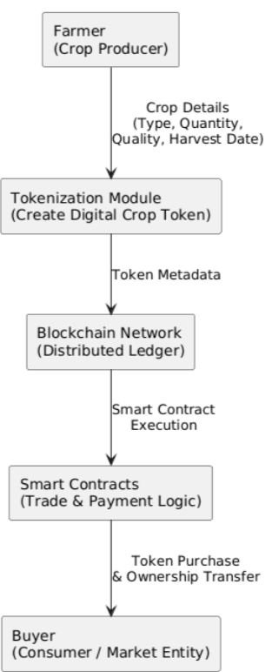
FIG 1: BLOCKCHAIN-BASED TOKENIZATION FRAMEWORK FOR AGRICULTURE
Figure 1 illustrates the blockchain-based tokenization framework for agricultural trade. Farmers generate digital tokens representing crop batches by submitting crop details to the tokenization module. These tokens are recorded on a blockchain network as immutable assets. Smart contracts manage trade execution, payment processing, and ownership transfer between farmers and buyers. All transactions are securely stored on the distributed ledger, ensuring transparency, traceability, and trust across the agricultural ecosystem.
- PROPOSED SYSTEM OVERVIEW:
The proposed system presents a blockchain-based tokenization framework for decentralized agricultural trade. The system enables farmers to convert agricultural produce into digital tokens and trade them directly with buyers through smart contracts. By eliminating intermediaries, the framework ensures transparency, secure transactions, and fair pricing.
The system consists of three main layers: the user layer, the tokenization and smart contract layer, and the blockchain layer. Farmers generate tokens by submitting crop-related information, while buyers interact with the system to purchase tokens. Smart contracts manage trade execution, payment settlement, and ownership transfer. All transactions are recorded on the blockchain, ensuring immutability and traceability. This approach empowers farmers by providing direct market access and encourages youth participation by introducing a technology-driven agricultural trading platform.
- TOKENIZATION PROCESS:
The tokenization process enables agricultural produce to be digitally represented as blockchain-based tokens. Farmers initiate the process by submitting essential crop details such as crop type, quantity, quality parameters, and harvest date. Each crop batch is converted into a unique digital token that represents ownership of the produce. Once created, the token is stored on the blockchain network, ensuring immutability and traceability. Smart contracts manage token validation, trading, and ownership transfer between farmers and buyers. This process enables secure, transparent, and decentralized agricultural trade without the involvement of intermediaries.
TABLE 1: PARAMETERS USED IN TOKENIZATION IMPLEMENTATION
PARAMETER | VALUE | DESCRIPTION
Crop Batch Size | 50–500 kg | Quantity represented by one token
Token Creation Time | ~2–4 seconds | Time to generate and record a token
Blockchain Transactions | 2 per trade | Token creation and ownership update
Smart Contract Functions | 3 | Create token, transfer token, verify ownership
Gas Cost (Average) | 0.002–0.005 ETH | Cost per token transaction
Users Supported | Farmer, Buyer | Roles involved in token trading
Table 4 presents the numerical parameters observed during the implementation of the tokenization process. These values reflect token creation overhead, transaction frequency, and operational cost associated with blockchain-based agricultural token trading.
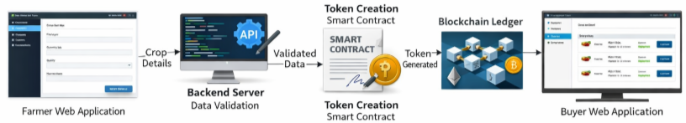
FIG 2: IMPLEMENTED TOKENIZATION PROCESS IN THE PROPOSED BLOCKCHAIN-BASED AGRICULTURAL SYSTEM
Figure 5 presents the implemented tokenization process of the proposed system. Farmers submit crop details through a web-based application, which are validated by the backend server. Upon successful validation, a smart contract is invoked to generate a digital token representing the agricultural produce. The generated token and its metadata are securely stored on the blockchain ledger. Buyers access the system through a web application to view available tokens and perform secure purchases. This implemented workflow ensures transparency, traceability, and decentralized ownership management in agricultural trade.
- SMART CONTRACT WORKFLOW:
The smart contract governs the creation, management, and transfer of agricultural tokens on the blockchain network. When a farmer submits validated crop details, the smart contract is triggered to generate a unique digital token representing the crop batch. Each token is assigned ownership and stored on the blockchain ledger. During trading, buyers interact with the smart contract to purchase available tokens. Upon successful payment verification, the smart contract automatically transfers token ownership from the farmer to the buyer and records the transaction on the blockchain. This automated execution eliminates the need for intermediaries and prevents manual manipulation. By enforcing predefined rules and conditions, the smart contract ensures secure, transparent, and tamper-proof agricultural transactions while enabling decentralized and trustless trade.
- SECURITY AND TRANSPARENCY ANALYSIS:
The proposed system ensures security and transparency through the inherent properties of blockchain technology and smart contracts. All token creation and trade transactions are recorded on a decentralized blockchain ledger, making the data immutable and resistant to unauthorized modification. Smart contracts enforce predefined rules for token creation, ownership transfer, and payment execution, eliminating manual intervention and reducing the risk of fraud. Since transactions are time-stamped and publicly verifiable on the blockchain, complete transparency is maintained throughout the trading process. Additionally, backend data validation ensures that only verified crop information is processed for token generation. This combination of validation, smart contracts, and blockchain storage provides a secure, transparent, and trustworthy agricultural trading environment.
- USE CASE ILLUSTRATION:
To illustrate the working of the proposed system, consider a farmer who tokenizes a harvested crop batch using the platform. The farmer submits crop details such as type, quantity, and quality through the web application, and a digital token representing the crop batch is generated on the blockchain. A buyer accesses the platform to view available crop tokens and selects a token for purchase. The smart contract verifies the transaction and automatically transfers token ownership to the buyer upon successful payment. The transaction is permanently recorded on the blockchain ledger. This use case demonstrates how the proposed system enables secure, transparent, and decentralized agricultural trade while eliminating intermediaries and ensuring fair transactions.
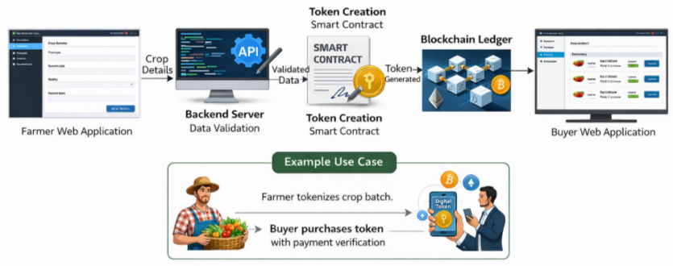
FIG 3: IMPLEMENTED TOKENIZATION FRAMEWORK FOR BLOCKCHAIN-BASED SMART AGRICULTURE
Figure 3 illustrates the implemented tokenization framework of the proposed blockchain-based smart agriculture system. The farmer submits crop details through a web application, which are validated by the backend server. Upon successful validation, a smart contract is executed to generate a digital token representing the crop batch. The generated token and related transaction details are securely recorded on the blockchain ledger. Buyers access the system through a web interface to view available tokens and complete purchases. This implemented framework ensures secure token generation, transparent ownership transfer, and decentralized agricultural trade.
- BENEFITS OF THE PROPOSED APPROACH:
The proposed blockchain-based tokenization approach enables transparent and secure agricultural trade by recording all transactions on an immutable blockchain ledger. This ensures trust among farmers and buyers while preventing data manipulation and fraud. By eliminating intermediaries, the system supports fair pricing and faster transactions, thereby increasing farmer profitability. The use of smart contracts automates trade execution and ownership transfer, reducing manual effort and operational overhead. Additionally, the digital and decentralized nature of the platform encourages youth participation in agriculture by introducing technology-driven trading mechanisms and promoting modern agricultural practices.
- CHALLENGES AND FUTURE SCOPE:
Despite its advantages, the proposed system faces challenges such as blockchain scalability, transaction cost variations, and the need for reliable internet connectivity in rural areas. Initial user adoption and technical awareness among farmers also remain key concerns. Future enhancements include integrating IoT sensor data and AI-based quality prediction with token generation, adopting more scalable blockchain platforms, and extending the system to support NFT-based crop representation and carbon credit trading. These improvements can further strengthen the applicability of blockchain-enabled smart agriculture systems.
- CONCLUSION:
This article presented a blockchain-based tokenization approach for enabling secure, transparent, and decentralized agricultural trade. By representing agricultural produce as digital tokens and managing transactions through smart contracts, the proposed system reduces dependency on intermediaries and ensures fair pricing and trustworthy transactions. The implemented framework demonstrates the practical feasibility of integrating blockchain technology into smart agriculture platforms. By promoting transparency, data integrity, and automated trade execution, the approach empowers farmers and encourages youth participation through technology-driven agricultural practices. The proposed system highlights the potential of blockchain-enabled tokenization to support sustainable and inclusive agricultural ecosystems.
REFERENCES:
[1] M. Casino, T. K. Dasaklis, and C. Patsakis, “A systematic literature review of blockchain-based applications: Current status, classification and open issues,” Telecommunications Systems, vol. 67, no. 2, pp. 353–371, 2018.
[2] A. Kamilaris, A. Fonts, and F. X. Prenafeta-Boldú, “The rise of blockchain technology in agriculture and food supply chains,” Trends in Food Science & Technology, vol. 91, pp. 640–652, 2019.
[3] Y. Lin, J. Xiong, D. Wu, F. Li, and J. Xu, “An IoT-based blockchain framework for agricultural supply chain management,” IEEE Internet of Things Journal, vol. 8, no. 6, pp. 1–12, 2021.
[4] S. Nakamoto, “Bitcoin: A peer-to-peer electronic cash system,” 2008. [Online]. Available: https://bitcoin.org/bitcoin.pdf
[5] X. Feng, J. Yu, and H. Zhang, “Blockchain-based smart contracts for agricultural product transactions,” IEEE Access, vol. 8, pp. 1–10, 2020.
[6] P. K. Sharma, S. Singh, and J. H. Park, “Blockchain-based distributed framework for secure agricultural supply chain,” Future Generation Computer Systems, vol. 108, pp. 135–146, 2020.
[7] K. Christidis and M. Devetsikiotis, “Blockchains and smart contracts for the Internet of Things,” IEEE Access, vol. 4, pp. 2292–2303, 2016.
[8] A. Rejeb, K. Rejeb, S. Simske, and H. Treiblmaier, “Blockchain technologies in logistics and supply chain management: A bibliometric review,” Logistics, vol. 4, no. 2, pp. 1–28, 2020.
[9] N. Kshetri, “Blockchain’s roles in strengthening cybersecurity and protecting privacy,” Telecommunications Policy, vol. 41, no. 10, pp. 1027–1038, 2017.
[10] J. Lin, Z. Shen, A. Zhang, and Y. Chai, “Blockchain and IoT based food traceability for smart agriculture,” Journal of Cleaner Production, vol. 259, pp. 1–12, 2020.
[11] H. Xu, Z. Xiong, Y. Zhang, and D. Niyato, “Smart contract-based agricultural product trading system,” IEEE Transactions on Engineering Management, vol. 69, no. 3, pp. 1–12, 2022.
[12] R. K. Kodali, S. Yerroju, and S. Kota, “Smart agriculture using IoT and blockchain,” in Proc. Int. Conf. on Computing, Communication and Automation (ICCCA), IEEE, 2021, pp. 1–6.

