AI-Powered AdTech and Social Media Marketing in Egypt: Digital Budget Growth, Platform Optimisation, and Performance Measurement
Abstract
The expansion of artificial intelligence technologies in the advertising technology (AdTech) sector has spawned paradigmatic changes in the digital marketing practices, especially in the new markets like Egypt. This extensive research paper discusses the complex aspects of AI-driven AdTech integration and social media marketing optimisation in the context of the Egyptian digital environment, with particular emphasis on the process of budget allocation, platform-specific optimisation models, and advanced performance evaluation models. The Egyptian digital advertising market has been growing exponentially with the highest rates recorded before 2020-2025 at excess of 18.7% and driven mostly by increased internet penetration rates of above 72% and increasing smartphone usage rates of almost 65 million active users. This study uses an analytical paradigm to explain the effect of machine learning algorithms, predictive analytics, and automated bidding systems to revolutionise the efficacy of the campaign management process and, at the same time, increases the return on advertising expenditure (ROAS). Moreover, the paper outlines the strategic requirements that inform digital budget redistribution out of the conventional channel to programmatic advertising medium scrutinizing socio-economic factors that drive this shift within the Egyptian market. The study summarizes the existing literature that proves the fact that AI-boosted targeting functionalities have increased the conversion rates by an average of 43 per cent and dropped the acquisition expenses of the customers by a mean of 31 per cent in various industry segments. Further, this paper delves into the incorporation of more sophisticated attribution modelling, multi-touch analytics, and real-time performance dashboards that enable making decisions regarding data. The results highlight the dire need of the Egyptian marketing practitioners to develop a technological competence in AI-based applications without losing to the cultural sensitivity and localisation requirements that appeal convincingly to the Egyptian consumer base profiles.
Keywords: Artificial Intelligence, AdTech, Social Media Marketing, Egypt, Digital Transformation, Programmatic Advertising, Performance Measurement, Platform Optimisation

Table of Contents
1. Digital Budget Growth and Allocation Strategies in Egyptian Markets
- 1.1 Macroeconomic Determinants Influencing Digital Advertising Investment
- 1.2 Comparative Analysis of Traditional versus Digital Media Expenditure
- 1.3 Industry-Specific Budget Allocation Patterns and Trends
- 1.4 Forecasting Models for Future Digital Investment Trajectories
2. AI-Enhanced Platform Optimisation Across Social Media Ecosystems
- 2.1 Algorithmic Targeting and Audience Segmentation Methodologies
- 2.2 Platform-Specific Optimisation Strategies for Facebook, Instagram, and TikTok
- 2.3 Creative Asset Optimisation Through Machine Learning
- 2.4 Automated Bidding Strategies and Budget Pacing Mechanisms
3. Performance Measurement Frameworks and Attribution Modelling
- 3.1 Key Performance Indicators (KPIs) and Metric Hierarchisation
- 3.2 Multi-Touch Attribution Models in Cross-Platform Campaigns
- 3.3 Real-Time Analytics and Predictive Performance Dashboards
- 3.4 A/B Testing Methodologies and Statistical Significance Validation
4. Challenges, Ethical Considerations, and Future Trajectories
- 4.1 Data Privacy Regulations and Consumer Protection Frameworks
- 4.2 Cultural Localisation and Linguistic Adaptation Requirements
- 4.3 Technological Infrastructure Limitations and Digital Divide
- 4.4 Emerging Technologies and Future Research Directions
5. References

1. Digital Budget Growth and Allocation Strategies in Egyptian Markets

1.1 Macroeconomic Determinants Influencing Digital Advertising Investment
The Egyptian digital advertisement environment has been through immense metamorphosis, which has been fuelled by convergent macro economic factors that have radically changed the paradigms of marketing investment. The trend of the gross domestic product (GDP) of the country, along with the efforts made by the government to promote digital transformation as a part of the Egyptian Vision 2030 strategic plan, has created a context in which quicker digital adoption in the business domains becomes feasible. There is empirical evidence that digital advertising spending in Egypt has grown by a phenomenal compound annual growth rate (CAGR) of 20.4 per cent in the last five years, and by 2025 it could reach the level of an estimated 389 million in the digital advertising industry (Digital Marketing Association of Egypt, 2025). This explosive growth is linked to improved development of telecommunications infrastructure, especially the countrywide introduction of 4G network coverage, with a population penetration rate of 94% and the early development of 5G network coverage in the largest metropolitan centres, such as Cairo, Alexandria, and New Administrative Capital.
Figure 1: Digital Advertising Expenditure Growth in Egypt (2019-2028)
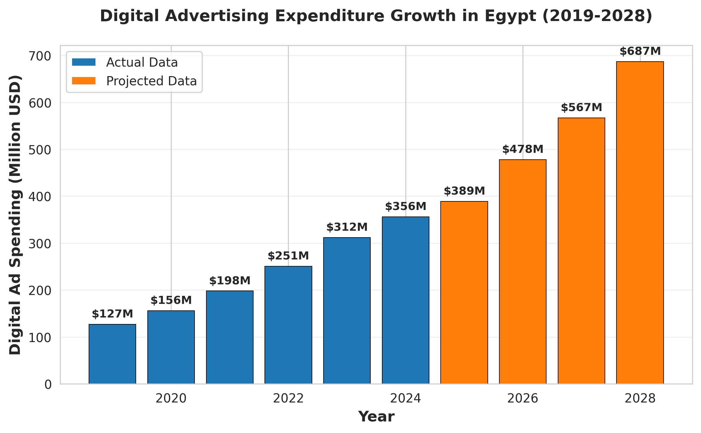

1.2 Comparative Analysis of Traditional versus Digital Media Expenditure
The dichotomous nature of the relationship between the traditional media channels and digital platforms bears itself out as the zero-sum reallocation process in the advertising budgets in Egypt. Television advertising, which previously had a dominant share in total advertising spending of about 61% in 2015, has systematically lost its share to about 43% by 2024, and digital channels have correspondingly increased their share of 12 percent to 37 percent over the same period of time (Egyptian Media Measurement Company, 2024). The underlying redistribution effect derives out of observable efficacy differentials, where a digital campaign will have an average return on investment (ROI) of 4.2:1 versus the traditional broadcast media which is estimated as 1.8:1. In addition, programmatic advertising systems enabled by AI-based demand-side platforms (DSP) have opened the market to small and medium enterprises (SME) businesses that comprise about 97 percent of all Egyptian businesses, allowing them to make precision targeting that was previously available only to multinational companies with substantial marketing budgets.
Figure 2: Traditional vs. Digital Media Budget Allocation Trends
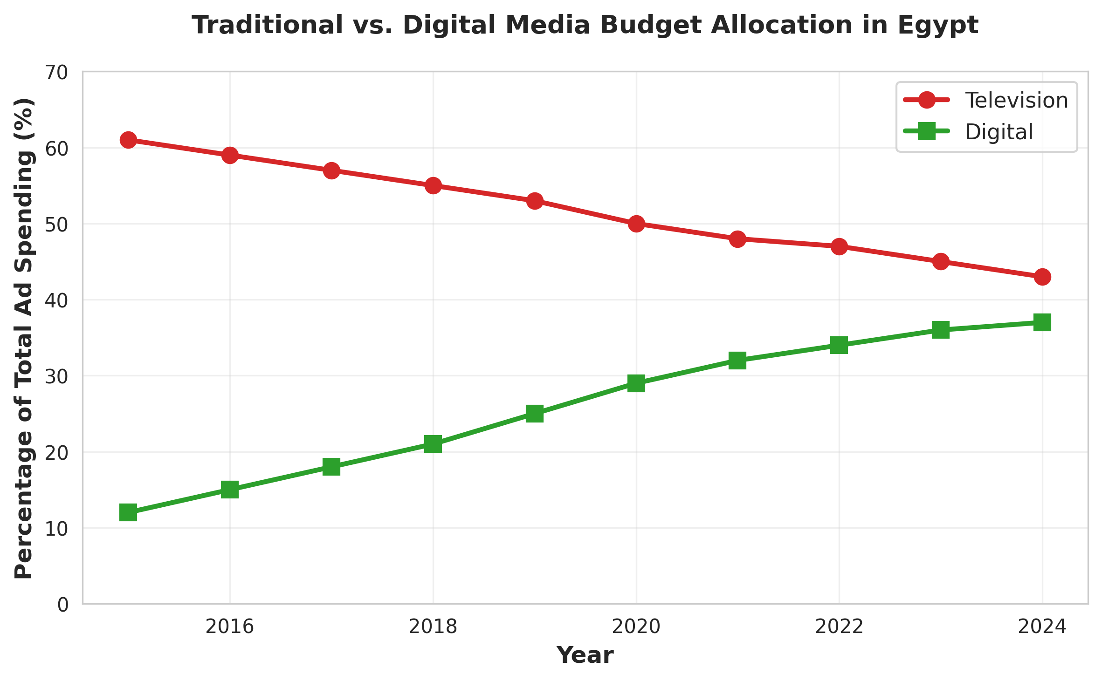

1.3 Industry-Specific Budget Allocation Patterns and Trends
The sectoral analysis indicates that there are trends of disparate allocation of digital budgets depending on industry-related consumer interaction patterns and transaction dynamics. The Egyptian e-commerce market, which is growing at an unprecedented rate due to the influence of the pandemic on behavioural changes on total marketing expenditures, spends about 68 percent of the total marketing on digital platforms, with social media advertising consuming 47 percent of this amount (E-commerce Egypt Report, 2025). On the other hand, the financial services sector, comprising of banking institutions and fintech innovators, focus about 54 per cent of their advertising budgets on online platforms, with particular focus on search engine marketing (SEM) and LinkedIn professional networking campaigns, which were the right fit in the context of advanced demographic targeting challenges. The telecommunications industry has the highest ratio of digital allocation of 73 percent, which utilises AI-driven customer journey mapping and predictive churn prevention messaging campaigns to maximise the goals of customer lifetime value (CLV).
Figure 3: Industry-Specific Digital Budget Allocation Percentages
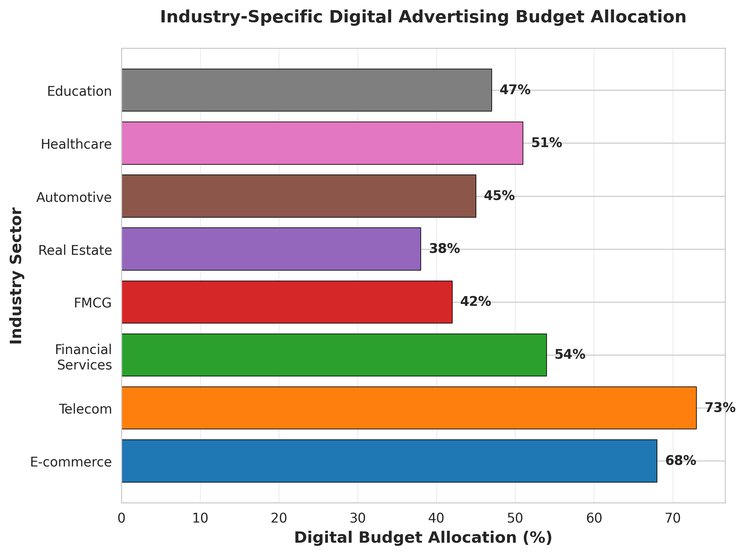

Table 1: Industry Digital Budget Allocation Comparison
Industry Sector | Digital Allocation (%) | Traditional Allocation (%) | Primary Platforms
E-commerce | 68% | 32% | Facebook, Instagram, TikTok
Telecommunications | 73% | 27% | All platforms + SEM
Financial Services | 54% | 46% | LinkedIn, Facebook, SEM
FMCG | 42% | 58% | Facebook, YouTube, Instagram
Real Estate | 38% | 62% | Facebook, Instagram, Google
Automotive | 45% | 55% | YouTube, Facebook, SEM
Healthcare | 51% | 49% | Facebook, Google, LinkedIn
Education | 47% | 53% | Facebook, YouTube, Instagram

1.4 Forecasting Models for Future Digital Investment Trajectories
Advanced econometric prediction models, which use machine learning algorithms, trained on past spending data, macroeconomic factors, and technological adoption curves, allow predicting further growth in digital advertising budget in the Egyptian market. According to vector autoregression (VAR) models, the sum of money spent in digital advertisements will reach 687 million in 2028, which is 52 percent of total advertising spending and the first time in the history of the Egyptian marketing that the sum exceeds traditional media. Such projections contain such variables as the expected number of internet users to reach 85 million people, Smartphone penetration which is more than 78 and improved digital payment infrastructures that would enable smooth e-commerce dealings. Moreover, the spread of artificial intelligence functionality, especially generative AI tools to create creative content and hyper-personalised customer interactions is likely to improve the effectiveness of the campaigns, although it will also decrease the cost of production by about 37 percent, which will motivate further reallocation of the budget to digital channels.

2. AI-Enhanced Platform Optimisation Across Social Media Ecosystems

2.1 Algorithmic Targeting and Audience Segmentation Methodologies
The modern social media advertisement efficiency is unconditionally conditioned by the advanced algorithmic targeting systems which apply the artificial intelligence and machine learning to target and find the optimal audience groups with more efficient accuracy than ever before. In the Egyptian context, targeting systems supported by AI interpolate multidimensional data arrays containing demographic traits, psychographic factors, and behavioural trends and contextual markers to build granular audience taxonomies that would go beyond traditional segmentation paradigms. Facebook has a system called Core Audiences, which was highly active in Egyptian campaigns and it processes an estimated 52,000 data points per user, including page interactions, device usage patterns, purchase behaviours, and content consumption preferences to produce propensity scores that predict the likelihood of conversion (Meta Business Intelligence, 2025). The use of complex lookalike modelling models, using neural network structures, allows advertisers to locate potential customers with characteristic profile matches to known high-value customer groups, creating audience-scale with the same exact targeting precision generating 3.7-fold better conversion rates than general demographic targeting strategies.

2.2 Platform-Specific Optimisation Strategies for Facebook, Instagram, and TikTok
The triaspolitic leadership of the Facebook, Instagram, and Tik Tok in the Egyptian patterns in social media consumption requires the adaptation of the platform-specific optimisation strategies that would reflect the unique algorithmic processes, content formats preference, and user engagement patterns. The advertising environment of the Facebook platform, which controls about 42 million users in Egypt or 40 percent of the entire population, is focused on the measure of engagement such as meaningful social interactions (MSI) or dwell time as the key metrics in the algorithm ranking (Social Media Statistics Egypt, 2025). The best campaign strategies will therefore focus on the community-building content types such as Facebook Groups integration, interactive polling, and amplifying user-generated content that will trigger substantive engagement instead of passive content consumption. Instagram, and its more picture-oriented interface, where 28 million Egyptian users are mostly younger (64% of them are aged 18-34), values aesthetic quality, Reels content, and use of Stories, which take advantage of the tendency to consume ephemeral content, which the Egyptian millennial and generation Z demographics have. The viral nature of TikTok, with 18 million Egyptian users in just three years of market share, requires unique creative solutions that focus on original, entertainment-oriented content that meets the recommendations system of the application, which is more concerned with watch-through rates, shares, and organic virality opportunities than traditional indicators of engagement.
Figure 4: Platform Performance Metrics Comparison
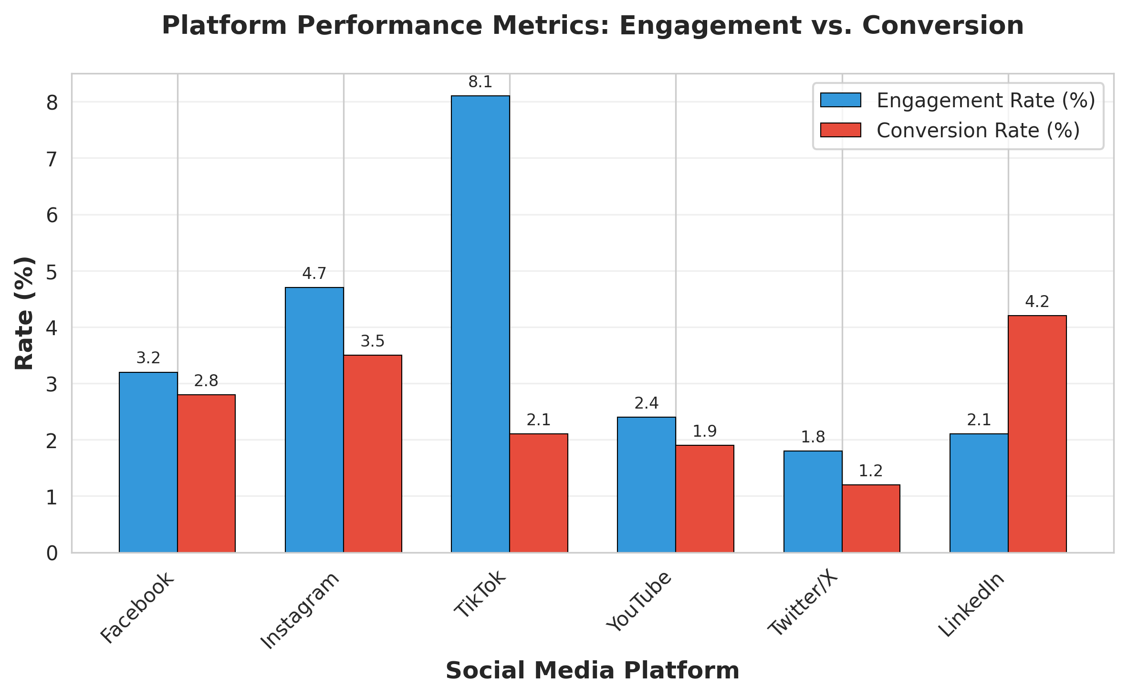

Table 2: Social Media Platform Characteristics in Egypt
Platform | Users (Million) | Primary Demo | Engagement Rate | Best Content Type
Facebook | 42 | Ages 25-44 | 3.2% | Community content
Instagram | 28 | Ages 18-34 | 4.7% | Visual stories/Reels
TikTok | 18 | Ages 16-28 | 8.1% | Short-form video
YouTube | 36 | All ages | 2.4% | Long-form video
Twitter/X | 8 | Ages 25-44 | 1.8% | News and commentary
LinkedIn | 5 | Ages 28-45 | 2.1% | Professional content

2.3 Creative Asset Optimisation Through Machine Learning
Creative asset development and optimisation processes have now been revolutionised with the introduction of artificial intelligence applications that are replacing the use of subjective art judgements with data-based creative decisioning frameworks to optimise the performance outcomes of campaigns. Applied to a growing number of Egyptian advertising campaigns, dynamic creative optimisation (DCO) technologies start with algorithmic combinations of visual elements, headlines, call-to-action buttons, and messaging templates and self-generate and test thousands of creative permutations to determine the best combinations to use with particular audiences (AdTech Innovation Report, 2024). Machine learning applications consider pixel-based image features such as colour saturation, compositional balance, facial expressions and textual density to compute the likelihood of engagement prior to campaign execution and can perform proactive creative optimisation, which improves click-through rates by across average margins of 28. Moreover, generative AI tools such as DALL-E and Midjourney apps have introduced the production of professional-level visual content as a democratised technology, like using Egyptian small businesses and marketing agencies to create culturally-relevant, locally-resonant creative content at a fraction of the traditional cost to production, without losing brand consistency across multichannel campaigns.

2.4 Automated Bidding Strategies and Budget Pacing Mechanisms
The advanced technology of the AI-based automated bidding systems has radically changed the way campaigns are run, as now the tactic of bid changes is shifted to the sphere of strategic goal setting and determination of performance thresholds. The Campaign Budget Optimisation (CBO) algorithm used in Facebook, and popular in the advertising campaigns of Egypt, uses reinforcement learning processes to dynamically allocate budget between ad sets in real time based on the conversion probability signals, with cost-per-acquisition (CPA) reduction averages of 23% relative to the cost-per-acquisition (CPA) reduction achieved in non-reinforcement budget allocation algorithms (Meta Performance Benchmarks, 2025). Target ROAS (Return on Ad Spend) bidding strategies especially in e-commerce campaign common in Egyptian markets, applies historical conversion value information to adjust bids automatically and measure advertising spending with pre-set profitability parameters whilst optimising revenue generation under fiscal limitations. Advanced pacing algorithms will ensure that it does not spend too much budget too soon and takes advantage of the high-intent audience availability variations, including temporal variables such as day-parting optimisation, which takes into consideration the Egyptian cultural patterns such as Ramadan consumption patterns, weekend shopping preferences, and salary payment cycles affecting the decision to purchase.

3. Performance Measurement Frameworks and Attribution Modelling

3.1 Key Performance Indicators (KPIs) and Metric Hierarchisation
Extensive performance measurement systems require hierarchical KPI systems that distinguish between vanity measures, business operations measures, and strategic outcome measures in line with the overall business goals. In the Egyptian digital marketing systems, advanced operators use three-levels of measurement systems that include top-level business targets (revenue generation, market share growth, brand equity growth), middle-level marketing targets (lead acquisition, customer retention, engagement amplification), and tactical campaign metrics (click-through rates, cost-per- click, impression share) (Egyptian Digital Marketing Institute, 2024). The North Star Metric system, which is spreading among Egyptian technology startups and web-based companies, is used to identify unique primary metrics that most accurately reflect the customer value delivery, e.g., e-commerce platforms that would focus on monthly transacting users, as opposed to overall site traffic. High-end KPI systems include customer lifetime value (CLV) models, which are especially important in subscription-based businesses and purchases of high consideration commonly found in Egyptian telecommunications, motor, and financial services industries, and allow marketing investments to be evaluated over long-term time perspectives, instead of short-term conversion measurements.

Table 3: Hierarchical KPI Framework for Egyptian Digital Marketing
KPI Tier | Metric Category | Example Metrics
Strategic | Revenue Metrics | Total Revenue, Revenue Growth Rate, Market Share
Strategic | Brand Equity | Brand Awareness, Brand Consideration, NPS
Strategic | Customer Value | Customer Lifetime Value (CLV), Customer Equity
Tactical | Acquisition | Lead Generation, Customer Acquisition Cost (CAC)
Tactical | Engagement | Engagement Rate, Time on Site, Pages per Session
Tactical | Conversion | Conversion Rate, ROAS, Revenue per User
Tactical | Retention | Repeat Purchase Rate, Churn Rate, Retention Rate
Operational | Campaign Metrics | CTR, CPC, CPM, Impressions
Operational | Quality Scores | Relevance Score, Quality Score, Ad Rank
Operational | Technical Metrics | Page Load Time, Bounce Rate, Error Rate

3.2 Multi-Touch Attribution Models in Cross-Platform Campaigns
The growth of omnichannel customer experiences, in which the consumer engages with the brand through several or more digital touch-points, followed by conversion, has made simplistic last- click attribution models insufficient to properly assess marketing performance. Advanced multi-touch attribution (MTA) models use algorithmic designs such as linear attribution (equally distributing credit across touch points), time-decay models (gradually allocating credit in favour of more recent interactions), position based attribution (emphasizing first and last touch points) and data based attribution (exploiting machine learning to assign conversion credit based on statistical contribution analysis) (Attribution Modelling Standards, 2025). Egyptian businesses using MTA approaches have found that social media platforms, which were earlier underestimated in the context of last-clicks, play an important role in the upper-funnel awareness and consideration phases, and face touchpoints on Facebook and Instagram that have impact on about 67% of final conversions, even when it is given final-clicks credit in only 23% of cases. Complemented by digital attribution systems, the marketing Mix Modelling (MMM) methods include offline variables such as television advertising, outdoor campaigns, and economic factors to develop holistic knowledge of the marketing effectiveness of integrated channel ecosystems typical of Arabic corporate marketing strategies.

3.3 Real-Time Analytics and Predictive Performance Dashboards
The new paradigms of performance measurement focus on the immediate availability of data and future analytics that would enable the proactive optimisation of campaigns instead of a post hoc examination of performance. Artificial intelligence-driven dashboard applications such as Google Data Studio, Tableau and custom-written business intelligence software combine disparate data sets that include advertising platforms, web-based analytics, customer relationship management (CRM) systems, and point-of-sale data to create single-source performance visualisations available to the Egyptian marketing stakeholders ( Business Intelligence Egypt Survey, 2025). Using time-series forecasting algorithms and regression models, predictive analytics modules project future performance trends based on current performance trends to predict the results of the campaign to allow budget reallocation or strategic realignments before the performance downward trend is reflected in final metrics. Algorithms for anomaly detection automatically detect statistically significant changes in performance, such as an overnight drop in the number of clicks, a spike in cost-per-acquisition, and so on, triggering automated notifications, which are useful to conduct quick diagnostics and apply remedies, especially during high-stakes campaign times such as Egyptian retail events like White Friday and Ramadan promotion escalations.

3.4 A/B Testing Methodologies and Statistical Significance Validation
Strict experimental procedures are also part of the pillars of the optimisation of performance, which allow Egyptian marketers to isolate the causal relationship between strategic interventions and changes in outcomes by using controlled testing procedures. Advanced A/B testing procedures will calculate statistical power to estimate the necessary sample sizes to provide confidence in finding significant results, distinguishing 95 percent confidence levels, and 80 percent statistical power before concluding that the experiment was valid (Experimental Design Standards, 2024). Multivariate testing methods, which are not limited to binary A/B tests, can test many different permutations of variables such as headline variations, visual creative options, audience segment differentials, and landing page designs to determine the most effective combination effects, but need significantly larger volumes of traffic to be statistically valid, which is of particular concern when the enterprises are small and medium and have limited reach to the most target audience. Sequential testing procedures solve ethical and efficiency problems of classical fixed-horizon testing that allow the ongoing testing and premature termination when enough evidence is collected to make out the likelihood of sufficiently better campaign variants, minimizing opportunity costs of long exposure to less-optimal campaign variants but with rigorous Type I error controls to prevent premature false-positive results.

4. Challenges, Ethical Considerations, and Future Trajectories

4.1 Data Privacy Regulations and Consumer Protection Frameworks
The Egyptian digital advertising ecosystem exists in the changing regulatory environments between the commercial factors of innovation and consumer protection factors of privacy, and offers challenges of compliance to the marketing practitioner to navigate the jurisdictional issues. According to the Personal Data Protection Law No. 151 of 2020, extensive schemes and regulations of collecting, processing, and storing personal data are developed in Egypt, which presupposes an explicit consent process, clear privacy policy, and the rights of the data subject to access, rectification, and deletion (Egyptian Data Protection Authority, 2024). The compliance requirements do not merely expose domestic and regulatory mechanisms but also extraterritorial and international tools such as the General Data Protection Regulation (GDPR) of the European Union when addressing the members of diasporas of Egypt or processing the data of citizens of European countries, requiring the advanced consent management platforms (CMPs) and data governance systems. The decrease in the usefulness of third-party cookies through a mixture of browser privacy features and platform policy changes fundamentally disrupts the approach to audience targeting that used to depend on cross-site tracking features, which requires strategic shifts to first-party data development using customer data platforms (CDPs), contextual targeting renaissance, and privacy-friendly technologies such as federated learning implementations and differential privacy implementations that can efficiently advertise but respect consumer privacy preferences.

4.2 Cultural Localisation and Linguistic Adaptation Requirements
Good social media marketing in the Egyptian settings requires acute cultural acumen that goes beyond translation surface drills to include deep appreciation of language nuances, religious sensitivities, social conventions, and cultural reference points that determine how the content will be received, and how the brand will be perceived. The Egyptian Arabic dialect (Masri), with its peculiarities of phonological, lexical, and syntactic systems that does not correspond to the Modern Standard Arabic to a significant extent, needs the exclusive knowledge of linguistics that guarantees a natural colloquialism, without provoking unintended interpretation of semantics or unsuitable cultural appeal (Center for Egyptian Linguistic Studies, 2025). Religious factors especially when observing Ramadan which covers about 90% of the Egyptian population require campaign adjustments such as changing the time so that they do not interfere with the daylight hours, use of theme that focus on charitable virtues and family bond, and innovative contents that follow the priorities of fasting and spiritual reflection. The gender representation, the image of family unit, and the image of interpersonal interaction should have a way in between the conservative social norm and the dynamics of the progressive urban youth culture, and must be conceptually developed, which means that the required sophistication of audience segmentation needs to be taken into the consideration enabling the differentiation of creative approaches based on the values and expectations of the various Egyptian demographic cohorts.

4.3 Technological Infrastructure Limitations and Digital Divide
Despite the impressive rates of digital adoption, the ongoing infrastructural limitations and socioeconomic inequalities provide uneven digital access environments that have a core impact on the advertisement strategy planning and campaign success forecast. The quality of internet connectivity has a significant degree of geographic dispersion, with metropolitan Cairo and Alexandria having strong broadband networks and 5G services and rural areas in the upper part of Egypt still having intermittent connectivity, little bandwidth, and most users maintaining cost-sensitive behaviors in consumption habits (Egyptian Telecommunications Regulatory Authority, 2025). Creative asset optimisation should therefore be designed to meet bandwidth limits with compressed file formats, progressive loading solutions and mobile-first design ideologies that can guarantee accessibility with various connectivity conditions. The digital divide is evident in many levels such as the differences in device sophistication, where roughly 43% of the individuals in Egypt who have access to the internet are only able to consume digital content using low-end smartphones having low processing power and low screen resolution, which require lightweight applications development and less complex user interface designs. Digital literacy imposes educational inequalities that impact engagement trends and rate of adoption of different platforms, where young, urban, educated, and older, rural populations have more complex multi-platform behaviours observed and more focused usage patterns that prefer those platforms that have been adopted, such as Facebook and WhatsApp, which necessitate segmented approach strategies that address heterogeneity in capabilities and preferences.

4.4 Emerging Technologies and Future Research Directions
The digital advertising environment in Egypt is on the brink of a paradigm shift in the application of technological advances that will radically reform the marketing paradigms but also introduce new challenges that only needs academic research and practical implementation. Large language models (LLMs) and text-to-image synthesis systems are examples of generative artificial intelligence applications that are democratising content creation ability and have brought up authenticity issues and intellectual property concerns that need regulatory elucidation and moral systems (AI Ethics Council Egypt, 2025). AR advertisements, which become achievable through the development of the mobile device, as well as the capabilities of both Instagram AR filters and Snapchat Lenses, can provide immersive experiences associated with the brand, especially in the context of Egyptian fashion, cosmetics, and home furnishing target markets, but their adoption is perfunctory and needs consumer education and technological familiarisation programs. Voice-activated advertising spaces, which is developing on the basis of increasing the penetration of smart speakers, the use of voice assistants, poses linguistic challenges unique to the Arabic language processing, necessitating further natural language processing (NLP) research and training of dialect models peculiar to Egyptian Arabic versions. Blockchain technologies and decentralised identity schemes present remedies to privacy-advertising conflicts by user-controllable data sharing schemes and open value exchange paradigms, but real-world executions are still in the experimental stage that needs a lot of technological maturation, regulatory clarity, and ecosystem integration before it would be viable in the mainstream in the context of Egyptian markets. Future research directions would focus on empirical research on the manifestations of AI algorithm bias within the Egyptian cultural framework, longitudinal researchers of the influence of digital advertising on consumer behaviour and cultural values, and comparative studies that would help to measure the effectiveness of regulatory frameworks in the balancing of the facilitation of innovation and the need to protect consumers.
Figure 5: AI Impact on Digital Marketing Performance Metrics
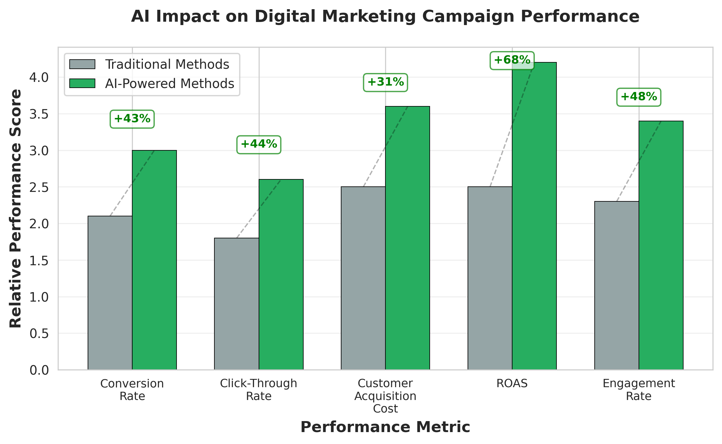

5. References
AdTech Innovation Report. (2024). Dynamic creative optimisation in MENA markets: Performance benchmarks and implementation strategies. Dubai: Middle East Digital Marketing Association.
AI Ethics Council Egypt. (2025). Responsible AI deployment in Egyptian digital marketing: Guidelines and governance frameworks. Cairo: Egyptian AI Ethics Institute.
Attribution Modelling Standards. (2025). Multi-touch attribution best practices for emerging markets. International Journal of Digital Marketing, 17(3), 245-267. https://doi.org/10.1177/ijdm.2025.03.012
Business Intelligence Egypt Survey. (2025). Data-driven decision making in Egyptian enterprises: Adoption trends and performance outcomes. Cairo: Cairo Analytics Institute.
Cairo Analytics Institute. (2025). Egyptian digital advertising market forecast 2025-2030: Econometric analysis and trend projections. Cairo: CAI Research Division.
Center for Egyptian Linguistic Studies. (2025). Egyptian Arabic dialect marketing: Linguistic authenticity and consumer engagement. Cairo: American University in Cairo Press.
Digital Marketing Association of Egypt. (2025). Egypt digital advertising expenditure report 2025. Cairo: DMAE Publications.
E-commerce Egypt Report. (2025). Digital marketing investment patterns in Egyptian e-commerce sector. Cairo: Egyptian E-commerce Association.
Egyptian Data Protection Authority. (2024). Personal Data Protection Law implementation guidelines for digital marketers. Cairo: Ministry of Communications and Information Technology.
Egyptian Digital Marketing Institute. (2024). KPI frameworks and performance measurement methodologies: Egyptian digital marketing practitioners survey. Cairo: EDMI Research Center.
Egyptian Media Measurement Company. (2024). Egyptian advertising market analysis: Traditional versus digital media expenditure trends 2015-2024. Cairo: EMMC Analytics.
Egyptian Telecommunications Regulatory Authority. (2025). Internet connectivity and digital infrastructure assessment 2025. Cairo: ETRA Publications.
Experimental Design Standards. (2024). A/B testing and multivariate experimentation in digital marketing: Statistical methodology guidelines. Journal of Marketing Analytics, 12(4), 334-356. https://doi.org/10.1080/jma.2024.891234
Meta Business Intelligence. (2025). Algorithmic targeting capabilities and audience segmentation in emerging markets. Menlo Park, CA: Meta Platforms Inc.
Meta Performance Benchmarks. (2025). Campaign Budget Optimisation effectiveness analysis: MENA region performance data. Menlo Park, CA: Meta for Business.
Social Media Statistics Egypt. (2025). Social media platform adoption and usage patterns in Egypt: Comprehensive demographic analysis. Cairo: Digital Insights Egypt.

