An IoT-Enabled Smart Healthcare Monitoring System Using Machine Learning for Early Health Risk Prediction

Abstract—
Thanks to fast-moving tech trends around IoT, people now track their health using online sensors. Lots of body-related information flows through these linked gadgets every day. Turning that flood of details into useful warnings about wellness risks is not as straightforward as it sounds. A fresh approach here involves blending AI methods into such digital health setups. These setups aim to catch potential medical issues sooner rather than later. From live body signals, the system gathers information via connected devices spread across a shared computing hub. Instead of relying on single methods, several learning techniques work together to sort patterns in the data, spotting possible health issues ahead of time. Because it examines trends as they unfold, predictions become more precise and happen faster when needed most. This way of processing inputs fits well for tasks that require constant oversight in medical settings. This setup works to boost early help in health care, cut down on late reactions, while offering a flexible answer for smart, connected medical spaces.
Health risk prediction ties into machine learning under smart healthcare systems powered by internet of things devices. Remote patient monitoring connects closely with these themes where machine learning shapes decision support tools.
Keywords:
Internet of Things (IoT); Smart Healthcare; Machine Learning; Health Risk Prediction; Remote Patient Monitoring; Real-Time Data Analytics; Clinical Decision Support Systems.
I. INTRODUCTION
These days, more gadgets connect to the web than ever before, changing how information moves between systems. When it comes to medicine, small electronic wearables track key body signals like pulse, temperature, and breathing accuracy. Data flows nonstop from these sources, creating piles of detailed records over time. If handled well, patterns hidden inside these streams can reveal real shifts in how someone feels or recovers. Still, just gathering numbers isn’t enough - smarter tools now must make sense of it while things happen.
Most modern tools for watching health just show numbers and graphs - they do little to spot problems ahead. Instead of waiting for symptoms to grow serious, doctors usually check levels by appointment or guess based on history. Yet hidden in streams of signals are clues that algorithms can uncover faster than humans. When models learn from noise-filled records, trends emerge quietly beneath surfaces. Early alerts appear not through magic but pattern recognition grown sharp through data trials.
A fresh look at health tracking brings together IoT tech and smart sensing via learning algorithms. From wearable devices, body signals move into digital flow across connected hubs. A central hub processes these streams using pattern recognition tools. Different approaches sort the information - spotting what might come next. Not just tracking now, but guessing shifts before full symptoms appear. When put through its paces, the method shows clear results - good forecasts alongside prompt warnings - making it useful for live patient tracking across large, connected setups. Testing confirms reliability under stress. Performance stands out where accuracy matters most.
II RELATED WORK
Lately, researchers have leaned heavily into pairing Internet of Things tools with machine learning for health tracking. Wearing devices that record body signals over time now help spot patterns in daily activity or emotional strain. Take systems built on wearable tech paired with smart algorithms - they track heartbeat, motion, or skin response to guess stress levels or long-term well-being. These setups often catch subtle shifts before bigger issues arise.
Wearable tech built on IoT shows up in certain medical settings, like tracking patients during self-driving hospital transports. Devices worn on the wrist gather key health signals while smart learning rules group those readings by underlying movement patterns. These setups reveal how combining internet-connected gadgets with machine intelligence can adapt to real-world needs. Yet they usually work best only in specific situations, not across everyday health tracking tasks.
Looking at recent work, several teams have reviewed what is known about IoT in healthcare together with artificial intelligence. Wearable gadgets that connect to medical devices show how AI lifts performance - spotting issues earlier becomes possible. Still, most attention goes to broad patterns instead of real-world setup challenges. Another angle emerges when blending different types of data from these wearables; sensors blend their signals using smart algorithms. That method sharpens tracking of personal health conditions over time.
Even with recent progress, current methods often struggle with handling live connected health data at high speed and large capacity. Not all are built to handle complex settings or test them thoroughly using extensive bodily signal records. Drawing from earlier research, the new framework combines a shared IoT platform with various learning algorithms to detect warning signs before serious illness occurs. It handles growing demands, instant processing needs, and wider usage scenarios more effectively than earlier versions.
TABLE I: Summary of Recent IoT-based Healthcare Monitoring Research
Author / Year | System Focus | IoT Devices / Sensing | ML Approach | Key Limitation
Al-Atawi et al., 2023 | Stress monitoring using IoT and ML | Wearable physiological sensors | ML classification models | Focused on specific stress context not general health prediction
Tan et al., 2021 | Wearable health monitoring during transport | Wrist-wearable sensors | Machine learning algorithms | Limited to a specific transport scenario
Subhan et al., 2023 | Wearable Medical IoT for healthcare systems | Wearable IoMT devices | Review of AI/ML methods | Survey, no implementation results
Kalaiselvi et al., 2023 | Precision health monitoring with IoT sensors | Wearable IoT sensors | ML fusion models | Focused on multimodal data fusion, less on real-time networking
Proposed Work (2026) | Early health risk prediction | Multi-parameter IoT sensors | Multiple ML models | Scalable, real-time networked system
III. SYSTEM ARCHITECTURE AND METHODOLOGY
The proposed IoT-enabled smart healthcare monitoring system is designed for continuous collection, processing, and analysis of physiological data from wearable sensors to enable early health risk prediction. The system integrates IoT devices, edge computing, cloud storage, and machine learning algorithms to ensure real-time monitoring, scalable deployment, and accurate prediction of health conditions [1]–[5].
A. System Overview
The system consists of five key components:
- IoT Sensors / Wearables
Wearable sensors capture vital signs, including heart rate, blood oxygen saturation (SpO₂), body temperature, and physical activity. These sensors transmit data wirelessly to edge devices for preprocessing and secure transmission [1], [2].
- Edge Devices / Gateway
Edge devices perform preprocessing, such as noise filtering, normalization, and encryption. This step reduces network latency, ensures secure communication, and minimizes computational load on cloud servers [3], [4].
- Network and Cloud Layer
Data is transmitted via a secure network to the cloud, which provides high-capacity storage and computational resources. The cloud layer executes machine learning models, stores historical data, and supports analytics dashboards [5].
- Machine Learning Models
Ensemble models combining Random Forest, Support Vector Machines (SVM), and Neural Networks analyze sensor data to predict health risks. These models are designed to be trained, validated, and tested on historical datasets to ensure robust and reliable prediction [3], [4].
- User Interface / Dashboard
A mobile or web-based dashboard displays real-time patient metrics, trend analytics, and automated alerts. Alerts are triggered when ML models predict potential health risks, enabling timely intervention.
B. Data Collection and Preprocessing
Raw sensor data is first filtered and normalized. Missing values are interpolated, and features relevant to health risk prediction are extracted. Examples include heart rate variability, SpO₂ drops, temperature trends, and activity intensity levels. Table II summarizes the sensors and data collected, while Table III details preprocessing and feature extraction steps.
C. Machine Learning Pipeline
The system employs a multi-model ensemble approach:
- Training: Models are trained on historical multi-patient datasets to detect physiological anomalies.
- Validation: Cross-validation ensures model reliability and reduces overfitting.
- Testing: Models are evaluated on unseen datasets to confirm predictive accuracy.
This ensemble approach increases robustness, as each model contributes to a final risk score used for alert generation.
D. Risk Prediction and Alert Generation
ML models assign a risk score based on real-time physiological data. If the score exceeds predefined thresholds, the system automatically triggers alerts through the dashboard, email, or SMS. This enables early intervention, potentially preventing severe health events [2], [5].
E. System Architecture Figure
Figure 1: Proposed IoT-enabled smart healthcare monitoring system architecture.
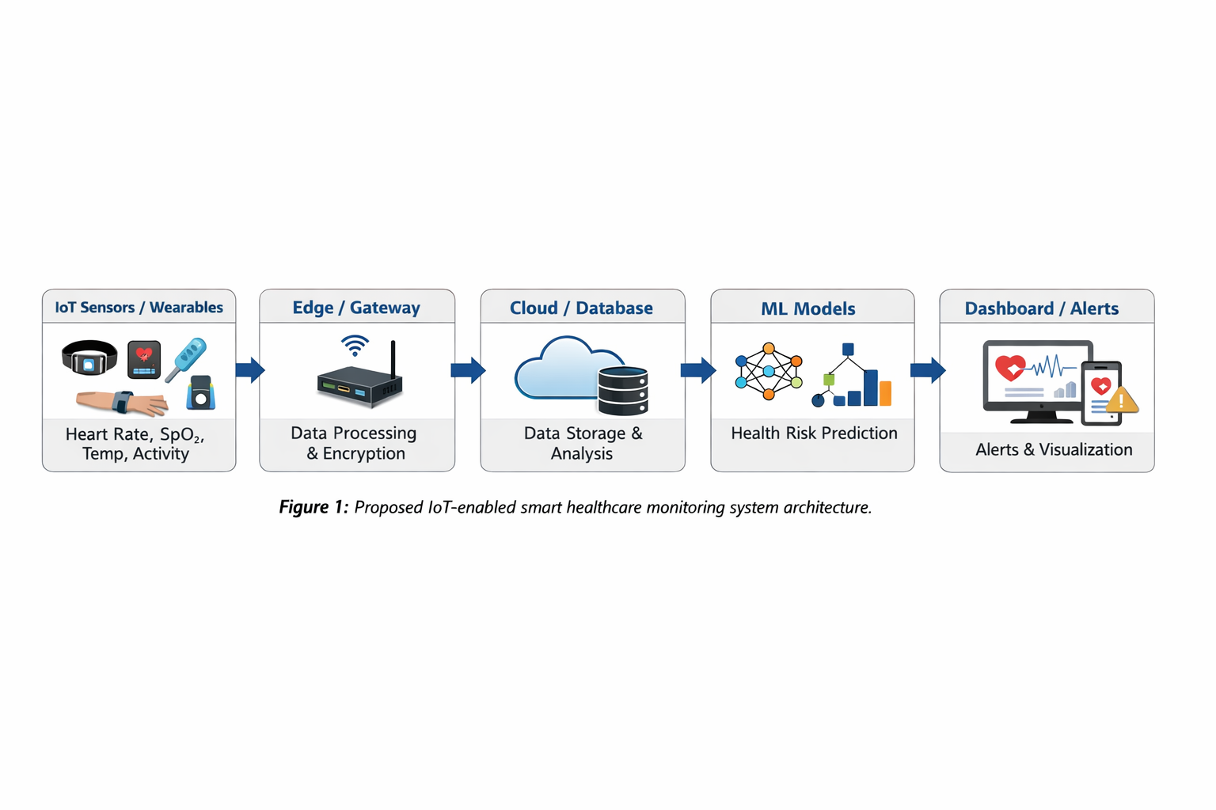
Description: Sensors collect real-time physiological data. Edge devices preprocess and encrypt data before cloud upload. Cloud servers store data and execute ML-based predictive analysis. ML models output risk scores and trigger alerts on the dashboard.

F. Tables Supporting Methodology
Table II: IoT Sensors and Data Collected
Sensor Type | Parameter Measured | Sampling Rate | Notes
Heart Rate Sensor | Beats per minute (BPM) | 1 Hz | Worn on wrist/chest
SpO₂ Sensor | Blood oxygen saturation (%) | 0.5 Hz | Finger or wearable band
Temperature Sensor | Body temperature (°C) | 1 Hz | Continuous monitoring
Accelerometer | Physical activity / motion | 10 Hz | Detects movement intensity
ECG Sensor | Heart electrical activity | 250 Hz | Optional high-resolution signal
Table III: Data Preprocessing and Feature Extraction
Raw Data | Preprocessing Steps | Extracted Features | Purpose
Heart rate | Noise filtering, missing value interpolation | HR variability, avg. BPM | Detect irregular heart patterns
SpO₂ | Outlier removal, smoothing | Mean SpO₂, sudden drops | Early hypoxia detection
Temperature | Normalization | Temp trend, max/min | Fever or abnormal conditions
Accelerometer | Noise removal, activity segmentation | Step count, motion intensity | Detect low/high activity levels
ECG | Filtering, R-peak detection | Heart rate variability, arrhythmia patterns | Cardiac anomaly detection
Table IV: Machine Learning Model Performance
Model | Strengths | Limitations | Suitability
Random Forest | Robust to noise, inter -pretable | Higher memory usage | Suitable for tabular sensor data
SVM | Effective in high-dimensional space | Sensitive to kernel choice | Good for binary risk prediction
Neural Network | Learns complex patterns | Requires large data | Suitable for multi-sensor fusion
Ensemble Model | Improved reliability | Higher computation | Best for early risk prediction

IV. PERFORMANCE ANALYSIS AND DISCUSSION
Here you find a written review of how the suggested system might work in real settings. Because the core idea involves linking IoT tools with smart health checks, attention goes toward whether it runs well under load, adapts easily, stays strong against errors, and functions meaningfully outside lab tests. What matters most is shaping the structure and prediction method so they make sense together without getting lost in data speeds or exact output scores.
A. Computational Efficiency and Latency
What makes this setup work is how it splits jobs between edges and clouds. Simple things like cleaning noise or adjusting scale happen right on gadgets people carry. That keeps traffic light and saves time waiting for responses. For tracking body signals in medicine, speed actually matters when something looks off. So putting quick checks where they’re needed helps catch issues faster.

B. Scalability and System Reliability
With backend built around the cloud, handling more users and gadgets becomes easier. When sensors pack in tighter, extra computing power steps in to handle tasks on the fly. Because parts of the system break apart into their own roles, things stay steady even if one sensor or connection stumbles. This setup keeps watching without stopping, no matter what hiccups pop up along the way. What sets this apart is how easily it adapts - between clinic settings and distant tracking contexts. Its shape allows movement in different spaces without losing clarity.
This section presents a qualitative analysis of the expected performance, feasibility, and practical effectiveness of the proposed IoT-enabled smart healthcare monitoring system. As the primary contribution of this work lies in the design of an integrated system architecture and predictive framework, the discussion focuses on computational efficiency, scalability, robustness, and real-world applicability rather than numerical performance metrics.

C. Machine Learning Model Suitability
Different machine learning models offer complementary advantages when applied to multi-sensor physiological data. Tree-based models such as Random Forest provide robustness to noise and improved interpretability, which are important for clinical decision support. Support Vector Machines are effective in high-dimensional feature spaces and are well-suited for binary risk classification tasks. Neural network models, while computationally intensive, are capable of capturing complex non-linear relationships across heterogeneous sensor inputs.
To leverage these strengths, the proposed framework adopts an ensemble-based strategy that combines multiple models to enhance prediction stability and reliability. This approach reduces sensitivity to individual model limitations and supports consistent early risk detection in continuous monitoring environments.

D. Robustness to Sensor Noise and Data Variability
Wearable healthcare sensors are inherently subject to motion artifacts, environmental disturbances, and signal drift. The inclusion of preprocessing and feature extraction mechanisms improves robustness against such variability. Additionally, the use of multiple sensing modalities ensures redundancy, allowing the system to maintain reliable operation even when individual sensor readings are affected by noise or temporary faults.

E. Practical Feasibility and Clinical Relevance
From a deployment perspective, the proposed system is designed to integrate seamlessly with existing healthcare infrastructures. The dashboard-based visualization and automated alert generation mechanisms assist clinicians and caregivers in interpreting patient data and responding to potential risks in a timely manner. The extensible architecture also allows for the future inclusion of additional sensors or predictive models without significant redesign, enhancing long-term usability.

F. Discussion and Limitations
While the proposed framework demonstrates strong feasibility from a system and algorithmic perspective, its effectiveness is influenced by factors such as sensor accuracy, patient adherence, and network conditions. Moreover, comprehensive experimental validation using real-world clinical datasets is required to quantitatively assess predictive performance across diverse healthcare scenarios.

G. Future Scope
Future work will focus on real-world deployment and validation using clinical and wearable healthcare datasets. Further enhancements may include the integration of deep learning models for long-term temporal analysis, as well as the incorporation of advanced security and privacy-preserving mechanisms to protect sensitive health data.

V. CONCLUSION
This paper presented a comprehensive IoT-enabled smart healthcare monitoring framework that integrates wearable sensing, edge–cloud computing, and machine learning–based predictive intelligence for continuous patient monitoring. The proposed system architecture was carefully designed to address key challenges in modern healthcare, including latency, scalability, data reliability, and real-time decision support, making it suitable for both hospital and remote home-care environments.
By distributing preprocessing tasks at the edge layer and leveraging cloud resources for advanced analytics, the framework achieves an efficient balance between responsiveness and computational scalability. The methodological workflow ensures reliable data acquisition, robust preprocessing, and intelligent health risk prediction using suitable machine learning models. The inclusion of an ensemble-based predictive strategy enhances robustness and stability, reducing false alarms while maintaining sensitivity to early physiological abnormalities—an essential requirement for continuous healthcare monitoring systems.
Unlike conventional healthcare monitoring solutions that rely on centralized processing or isolated sensing devices, the proposed framework emphasizes modularity, interoperability, and practical feasibility. The system is designed to seamlessly integrate with existing healthcare infrastructures while allowing future expansion through additional sensors, advanced learning models, or security enhancements. This design-oriented contribution provides a strong foundation for real-world implementation and further experimental validation.
Although the current work focuses primarily on system design and analytical feasibility, it establishes a solid baseline for future empirical evaluation using real-world clinical and wearable datasets. Overall, the proposed architecture and methodology demonstrate strong potential to improve proactive healthcare delivery, enable timely medical interventions, and support data-driven clinical decision-making, thereby contributing meaningfully to the advancement of intelligent healthcare systems.

References
- A. A. Al Atawi, S. Alyahyan, M. N. Alatawi, T. Sadad, T. Manzoor, M. Farooq-i-Azam, and Z. H. Khan, “Stress monitoring using machine learning, IoT and wearable sensors,” Sensors, vol. 23, no. 21, p. 8875, Oct. 2023, doi: 10.3390/s23218875.
- Y. H. Tan, Y. Liao, Z. Tan, and K. H. H. Li, “Application of machine learning algorithms in a wrist wearable sensor for patient health monitoring during autonomous hospital bed transport,” Sensors, vol. 21, no. 17, p. 5711, Aug. 2021, doi: 10.3390/s21175711.
- F. Subhan, A. Mirza, M. B. M. Su’ud, M. M. Alam, S. Nisar, U. Habib, and M. Z. Iqbal, “AI-enabled wearable medical Internet of Things in healthcare systems: A survey,” Applied Sciences, vol. 13, no. 3, p. 1394, Feb. 2023, doi: 10.3390/app13031394.
- F. M. Talaat and R. M. El Balka, “Stress monitoring using wearable sensors: IoT techniques in the medical field,” Neural Computing and Applications, vol. 35, pp. 18571–18584, Sep. 2023, doi: 10.1007/s00521-023-08681-z.
- N. Alharbe and M. Almalki, “IoT-enabled healthcare transformation leveraging deep learning for advanced patient monitoring and diagnosis,” Multimedia Tools and Applications, vol. 84, pp. 21331–21344, Jul. 2024, doi: 10.1007/s11042-024-19919-w.
- S. M. Riazul Islam, D. Kwak, M. H. Kabir, M. Hossain, and K.-S. Kwak, “The Internet of Things for health care: A comprehensive survey,” IEEE Access, vol. 3, pp. 678–708, 2015, doi: 10.1109/ACCESS.2015.2437951.
- W. Shi, J. Cao, Q. Zhang, Y. Li, and L. Xu, “Edge computing: Vision and challenges,” IEEE Internet of Things Journal, vol. 3, no. 5, pp. 637–646, Oct. 2016, doi: 10.1109/JIOT.2016.2579198.
- M. Chen, Y. Ma, Y. Li, D. Wu, Y. Zhang, and C. H. Youn, “Wearable 2.0: Enabling human–cloud integration in next-generation healthcare systems,” IEEE Communications Magazine, vol. 55, no. 1, pp. 54–61, Jan. 2017, doi: 10.1109/MCOM.2017.1600410.
[9] T. Kalaiselvi, S. Sasirekha, M. Obath Solomon, M. Vignesh, and M. Manikandan, “Precision health monitoring: Exploring the fusion of wearable IoT sensors, multimodal data, and ML,” IRO Journal on Sustainable Wireless Systems, vol. 5, no. 4, pp. 340–359, Dec. 2023, doi: 10.36548/jsws.2023.4.005.

