IoT Based Electricity Theft Detection And

Alert System.

Abstract— Electricity theft poses a serious challenge to power distribution systems, leading to revenue loss and inefficient energy management. This paper proposes an IoT-based Electricity Theft Detection and Alert System for real-time monitoring and anomaly detection. The system uses two PZEM energy meters at the transformer and consumer ends, with an ESP32 microcontroller transmitting data to a Firebase-based web dashboard. By comparing energy values, unauthorized power usage is detected and instant alerts are generated. The proposed system offers accurate detection, low latency, and supports smart grid development through improved transparency and control.
Keywords— IoT, electricity theft detection, smart energy meter, ESP32, PZEM energy meter, Firebase, cloud monitoring, smart grid, real-time energy monitoring, power theft alert system.
Nowadays, the use of android smartphone is common in

Introduction
Today’s increasing reliance on electrical energy and rapid urban growth have significantly raised the demand for power supply. At the same time, electricity theft has become a major problem for power distribution companies. It leads to significant financial losses, power outages, and instability in the distribution network. Unauthorized acts, such as illegal line tapping, meter bypassing, and tampering with energy meters, often go unnoticed for long periods. This happens due to the limitations of traditional monitoring systems.
Many existing systems monitor electricity consumption through manual meter readings or periodic billing analysis. Some smart metering solutions use GSM modules to send consumption data or alerts via SMS. However, these systems do not provide real-time comparisons of energy usage between suppliers and consumers. They also fail to detect theft or abnormal losses immediately. This results in delays in response and ongoing revenue loss for utility providers.
The proposed IoT-Based Electricity Theft Detection and Alert System combines smart energy meters and IoT technology to address these issues.
The system continuously monitors electrical parameters at both the transformer and consumer ends. It uploads the data to a cloud platform for real-time analysis. Its key features include:
1. Real-time monitoring of voltage, current, power, and energy consumption.
2. Dual-meter comparison to identify abnormal power discrepancies.
3. Instant theft detection with cloud-based alerts and notifications.
4. A web-based dashboard for live monitoring and historical data.analysis.
5. Automatic power disconnection using a relay during confirmed theft conditions.

Related work
- Survey of Existing Monitoring System
Traditional electricity monitoring systems mainly rely on electromechanical or digital energy meters that record total power consumption for billing. These systems need manual meter reading or periodic data collection, which makes detecting theft slow and inefficient. Some newer monitoring solutions use GSM or Wi-Fi modules to send consumption data to utility providers as SMS alerts or periodic updates [1][3]. However, these systems usually monitor only a single meter and do not allow for real-time analysis or comparison between the supply and consumer ends. As a result, unauthorized practices like meter bypassing and illegal tapping often go undetected for long periods.

- Survey of Electricity Theft Detection systems
Recent research has focused on detecting electricity theft using IoT technology with microcontrollers like Arduino, ESP8266, and ESP32, along with current and voltage sensors. Many proposed systems find theft by spotting unusual current changes or sudden load shifts. Some models use cloud platforms such as ThingSpeak or Firebase to display real-time data and create alerts Dual-meter approaches have been introduced to compare readings from the transformer side and consumer side, which improves detection accuracy.

More advanced systems also include automatic circuit breakers, web dashboards, and data logging for analysis. Although machine learning methods improve detection accuracy, they need significant computational resources and large datasets. Compared to existing methods, IoT-based dual-meter systems offer a cost-effective, scalable, and real-time solution for detecting electricity theft with cloud monitoring and instant alerts.

System overview

The proposed IoT-Based Electricity Theft Detection and Alert System monitors electrical energy flow in real time, identifying unauthorized usage by comparing measurements from the supply and consumer sides. The system combines smart energy meters, a microcontroller, cloud services, and a web dashboard to ensure accurate detection and instant alerts.

- Principle behind Electricity Theft Detection

Electricity theft detection relies on continuously comparing energy values measured at two points: the transformer (supply) side and the consumer end. Under normal conditions, the energy supplied should closely match the energy consumed, after accounting for acceptable technical losses. Any significant deviation beyond a set threshold suggests possible electricity theft or line tampering.

The energy difference ΔE is calculated as:
ΔE = E_supply - E_consumer
where E_supply is the energy measured at the transformer side and E_consumer is the energy recorded at the consumer end. If ΔE exceeds the threshold, the system flags it as a theft condition. The threshold value is based on load characteristics and acceptable transmission losses to reduce false alarms.

- Algorithm
The operation of the proposed system is explained using the following algorithms.
1) Algorithm 1: Threshold Initialization
Set_Threshold() {
TH_energy = user input // Energy difference threshold
TH_current = user input // Current mismatch threshold
TH_voltage = user input // Voltage abnormality threshold
Update_to_Cloud(TH_energy, TH_current, TH_voltage)
}
The administrator can configure the threshold values, which are stored in the cloud database for real-time comparison.
2) Algorithm 2: Theft Detection and Alert Generation
Theft_Detection() {
Read Esupply from PZEM_1
Read Econsumer from PZEM_2
ΔE = Esupply - Econsumer
If ΔE > TH_energy {
Activate_Buzzer()
Trigger_Relay_OFF()

Send_Alert_To_Dashboard()
Log_Data_To_Cloud(Esupply, Econsumer, ΔE)
}
Else {
Continue_Monitoring()
}
}
If the detected energy difference goes beyond the predefined threshold, the system activates a local alert, disconnects power if necessary, and notifies authorities through cloud-based alerts.
3)Algorithm3:RemoteMonitoring
Remote_Monitoring(){
IfUser_Request==TRUE{
Fetch_RealTime_Data_From_Cloud()
Display_On_Web_Dashboard()
}
Else{
Continue_Data_Logging()
}
}
This feature allows authorized users to monitor energy consumption and theft status remotely through a web application.

- System Design

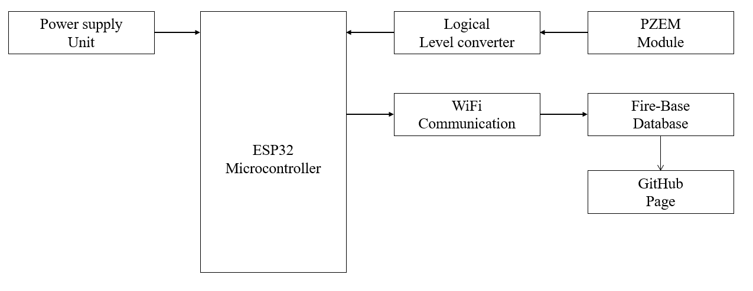

Fig 1.System Architecture

As shown in Fig. 1, the proposed system has three main components: the hardware unit, the cloud server with a database, and a web-based monitoring dashboard.
- Energy Metering Unit: Two PZEM energy meters are installed at the transformer side and consumer end to measure voltage, current, power, and energy.
- Microcontroller Unit: An ESP32 microcontroller processes sensor data, compares energy values, and connects to the cloud via Wi-Fi.
- Cloud Server: Firebase serves as the cloud platform for real-time data storage, visualization, and alert generation.
- Web Dashboard: A web application shows live readings, historical data, and theft alerts for utility administrators

- Block Diagram
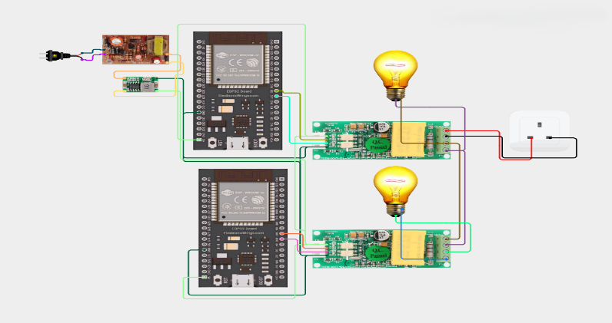
Fig 2 Block Diagram of Electricity Theft Detection System

Fig. 2 represents the overall block diagram of the proposed IoT-based Electricity Theft Detection System, which is designed around the ESP32 microcontroller. The system continuously monitors electrical energy at two critical points— the transformer (supply) side and the consumer (load) side—to identify discrepancies that indicate electricity theft. The block diagram highlights the integration of sensing, processing, communication, and control units that work together to ensure accurate detection and timely response.
The main components are:

- At the supply side, a PZEM energy metering module is installed near the distribution transformer to measure key electrical parameters such as voltage, current, power, and total energy delivered. Simultaneously, another PZEM energy meter is placed at the consumer side to record the actual energy consumed by the load. These two sets of readings are essential for identifying unauthorized tapping, bypassing of meters, or illegal connections.
- ESP32 microcontroller acts as the central processing unit of the system. It receives real-time data from both PZEM energy meters through serial communication. The ESP32 continuously compares the supply-side and consumer-side energy values. If the difference between the two readings exceeds a predefined threshold, the system identifies it as a potential electricity theft condition.
- Relay module is connected to the ESP32 to enable automatic disconnection of the power supply during confirmed theft scenarios. This helps in preventing further energy losses and protects the power distribution infrastructure. Additionally, a buzzer is integrated into the system to provide immediate audible alerts at the site whenever theft is detected, enabling quick local awareness and intervention.
- The ESP32’s built-in Wi-Fi module allows seamless communication with the cloud platform (Firebase). Real-time data such as voltage, current, power consumption, theft status, and alert notifications are transmitted to the cloud without the need for external communication hardware. This enables remote monitoring, data logging, and centralized control by utility authorities.

- Hardware Module
The hardware module forms the backbone of the proposed electricity theft detection system. It is designed to be reliable, cost-effective, and scalable for both residential and commercial power distribution environments.

Sensors:
PZEM Energy Meter:
The PZEM energy meter is a high-precision energy monitoring module capable of measuring voltage, current, power, frequency, and cumulative energy consumption. In the proposed system, two PZEM modules are used—one at the transformer side and the other at the consumer side. These modules provide accurate real-time measurements and communicate with the ESP32 through UART serial communication. Their compact size and accuracy make them suitable for continuous monitoring applications.
ESP32 Microcontroller:
The ESP32 microcontroller is responsible for data acquisition, processing, comparison logic, and decision-making. It collects readings from both PZEM modules, analyzes the energy difference, and determines whether theft has occurred. The ESP32 also controls peripheral devices such as the relay and buzzer. Its low power consumption, high processing capability, and integrated Wi-Fi functionality make it an ideal choice for IoT-based energy monitoring systems.
Relay Module:
The relay module acts as an electrically operated switch that disconnects the power supply when electricity theft is detected. Controlled by the ESP32, the relay ensures immediate isolation of the load during illegal usage, thereby minimizing revenue losses for power distribution companies and enhancing system safety.
Power Supply Unit:
The entire system operates on a regulated low-voltage DC power supply to ensure safe and stable operation. Proper electrical isolation is maintained between the high-voltage AC measurement side and the low-voltage control circuitry to protect components and users from electrical hazards.
Current Transformer (CT):
A current transformer is used to measure high alternating currents in the power line by converting them into a proportional low-level current that can be safely measured by the energy meter. In the proposed system, the CT works with the PZEM module to accurately sense the current flowing at both the transformer and consumer ends. It provides electrical isolation between high-voltage lines and low-voltage measurement circuits, ensuring safety of the system components. Accurate current measurement using the CT is essential for precise energy calculation and reliable detection of electricity theft.

- Software Module:

The software module is a vital part of the IoT-based Electricity Theft Detection System, enabling real-time monitoring, data analysis, intelligent decision-making, and alert generation. It uses embedded firmware on the ESP32 programmed through the Arduino IDE to collect voltage, current, power, and energy data from PZEM energy meters at both the supply and consumer sides, compare readings using predefined thresholds, and detect potential theft. When abnormal differences occur, the system activates a buzzer, disconnects the supply using a relay, and simultaneously uploads data and alerts to Firebase for real-time storage and historical logging. A web-based dashboard accesses this cloud data to display energy usage, theft alerts, and system status securely through authentication and role-based access control, enabling reliable remote monitoring by authorized personnel.

System Analysis:

The proposed electricity theft detection system is modeled as a real-time monitoring and intelligent decision-making system that continuously observes electrical energy flow and responds to abnormal operating conditions. The system continuously samples electrical parameters and detects deviations that may indicate unauthorized power usage. It is mathematically represented as:
$$S_{T}=\{X(t):t∈T\}$$
where $X(t)$represents the time-varying input signal corresponding to electrical parameters such as voltage, current, power, and energy measured at time $t$. The set $T$denotes discrete time intervals at which measurements are taken. The system space $S_{T}$includes the sample space, algebra, and probability measure, enabling the system to handle fluctuations in energy consumption and detect theft-related anomalies.
The complete system $S$is defined as:
$$S=\{CS,WD,s,d,μ_{c},N\}$$
Each component of the system plays a specific role in the theft detection process. The Cloud Server (CS) stores real-time and historical energy data, maintains theft alert records, and supports centralized monitoring. It enables remote access and data synchronization for multiple consumer nodes. The Web Dashboard (WD) serves as the user interface for utility authorities, displaying real-time energy readings, theft alerts, relay status, and historical consumption patterns.
The sensor set (s) consists of PZEM energy meters installed at the transformer (supply) side and the consumer (load) side. These sensors provide accurate measurements of voltage, current, power, and energy required for reliable comparison and theft detection. The output devices (d) include a relay module for automatic power disconnection during confirmed theft conditions and a buzzer for generating local audible alerts.
The control unit ($μ_{c}$), implemented using the ESP32 microcontroller, collects sensor data, performs real-time energy comparison using predefined threshold values, executes theft detection logic, controls the relay and buzzer, and manages communication with the cloud server. The network component (N) uses Wi-Fi for data transmission between the ESP32 and the cloud server, ensuring low latency, high bandwidth, and secure communication through authentication and encryption mechanisms.

Results
A. Implementation in real platform
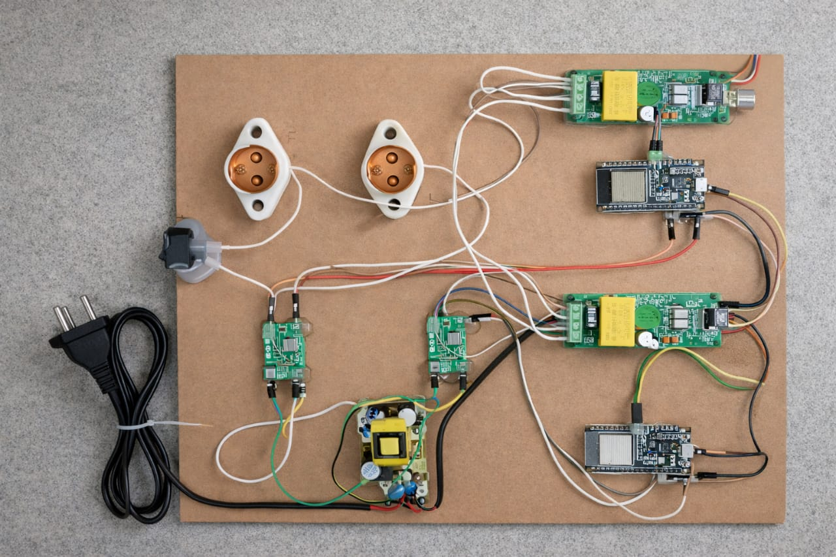
Fig 3.Hardware Units

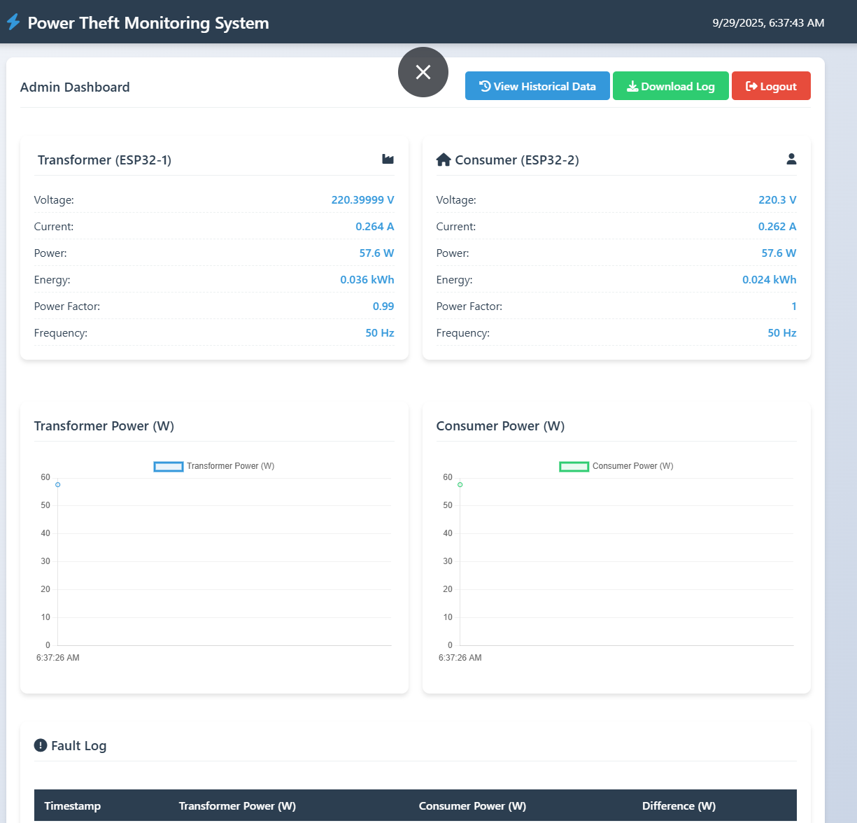
As shown in Fig 3. Sensors are connected to microcontroller. Serial communication is used for data transfer.

Fig 4 Web Dashboard
The web dashboard shows real-time transformer and consumer power data, detects theft through comparison, and maintains graphical trends with fault logs for analysis.,

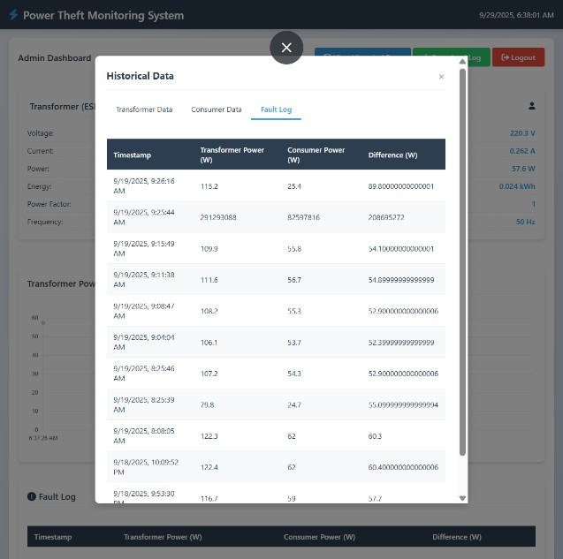

Fig 5: Fault Log Data
As shown in Fig .5 Historical fault log data records time-stamped transformer and consumer power differences, enabling detection of abnormal patterns and supporting theft investigation and compliance.

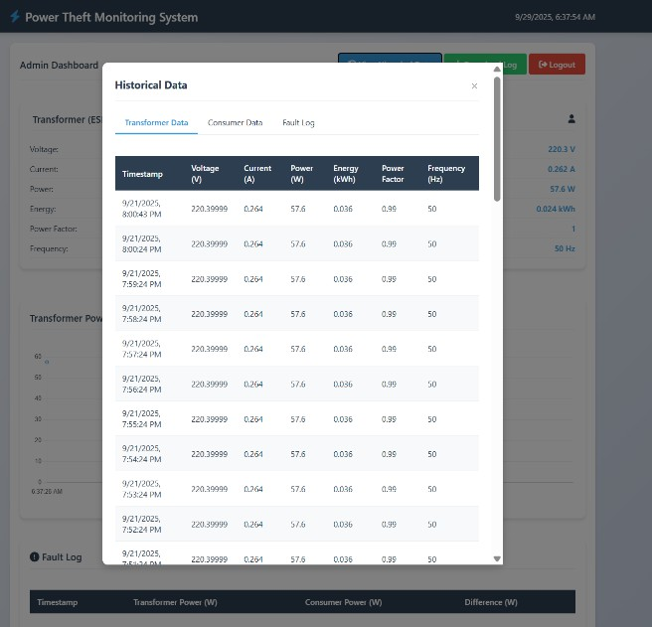

Fig 6: Transformer/Consumer Data

As shown in Fig .6 The Transformer/Consumer data logs time-stamped electrical parameters to monitor performance, detect anomalies, and support reliable power system operation.
The experimental results of the proposed IoT-based Electricity Theft Detection System demonstrate its robust performance in accurately monitoring and analyzing electrical parameters in real time. The system continuously measures voltage, current, power, energy, power factor, and frequency at both the transformer and consumer ends using PZEM energy meters, with the ESP32 microcontroller reliably transmitting data to the Firebase cloud platform via Wi-Fi. By comparing the energy consumption at both ends, the system can detect discrepancies that indicate electricity theft, meter tampering, or abnormal consumption. Whenever such anomalies are detected, instant alerts are triggered on the web dashboard, along with local visual and audible notifications, enabling quick identification and action to prevent further losses.
The system maintains a comprehensive fault log that records time-stamped differences between transformer and consumer readings. This historical data allows utility providers to analyze patterns of abnormal energy usage, identify repeated or long-term theft attempts, and make informed decisions for corrective action. Graphical dashboards provide real-time and historical visualization of energy trends, making it easier to understand consumption behavior and detect irregularities promptly. Additionally, monitoring of parameters such as power factor and frequency helps in identifying technical issues or energy losses in the distribution system, supporting predictive maintenance and improving operational efficiency.
During testing, the system demonstrated minimal delay in data transmission and alert generation, confirming its suitability for real-time applications. The automated logging and cloud storage ensure traceability and compliance with regulatory standards, while the role-based access feature allows administrators and users to interact with the dashboard securely. The modular design using ESP32 and PZEM meters makes the system scalable for both residential and commercial deployments, ensuring wide applicability.
Overall, the results validate that the IoT-enabled system enhances transparency in energy distribution, reduces revenue losses due to theft, and supports smart grid initiatives by providing actionable insights into energy consumption patterns. By integrating real-time monitoring, automated alerts, historical analysis, and predictive maintenance capabilities, the system offers a comprehensive solution for efficient energy management and electricity theft prevention, ultimately contributing to a more reliable and intelligent power distribution network.

V. Conclusion

Electricity theft is a significant issue globally. It creates major challenges for power distribution companies, resulting in financial losses, power instability, and wasteful energy consumption. Ensuring fair energy use and a reliable power supply is essential in today’s rapidly growing, technology-driven environment. To tackle this problem, we have developed the IoT-Based Electricity Theft Detection and Alert System. This solution is cost-effective, efficient, and easy to set up for real-time monitoring and preventing theft.
The system continuously measures electrical parameters at both the supply and consumer ends using dual energy meters. It sends the data to a cloud platform for real-time analysis. By comparing energy consumption values, the system quickly detects unauthorized usage and generates alerts through a web-based dashboard and local warning systems. This automated method reduces the need for manual inspections, speeds up response time, and improves transparency in power distribution.……………………….
In the future, we can enhance the system by integrating artificial intelligence and machine learning for predictive theft detection and consumption pattern analysis. Additional features, such as LoRa or NB-IoT communication for remote areas, mobile app support, and blockchain-based secure energy records, can greatly improve reliability and scalability. The proposed system not only automates electricity theft detection but also lays the groundwork for smart grid infrastructures that are intelligent, secure, and sustainable, leading to better energy management and reduced power losses.

ACKNOWLEDGMENT
The authors express their sincere gratitude to PSR Engineering College, Sivakasi, for providing the necessary laboratory facilities, technical infrastructure, and ongoing support throughout this research project. The institution’s supportive and research-focused environment was crucial for the successful design, implementation, and testing of the proposed IoT-Based Electricity Theft Detection and Alert System. …
The authors also want to thank the Department of Computer Science and Engineering for their constant motivation, valuable technical discussions, and guidance in Internet of Things (IoT), embedded systems, and cloud-based monitoring. The support and cooperation of the faculty and technical staff during hardware integration, system simulation, and cloud platform deployment were key to achieving the desired results.
The team is grateful to Blessing Karunya T., Assistant Professor, for her expert mentorship, constructive feedback, and continuous review of the project’s progress. Her guidance in improving the system architecture and research methods significantly enhanced the quality and success of this work. Finally, the authors appreciate the support of their peers and classmates for their helpful suggestions and collaborative discussions during the system’s development and evaluation.
The authors also acknowledge the contributions of their peers and classmates, whose insights during design reviews and brainstorming sessions helped improve the system’s functionality and efficiency.

REFERENCES

[1] R. Jiang, Y. Qiu, and Z. Wang, “Electricity Theft Detection Based on Smart Meter Data Using IoT Technology,” IEEE Internet of Things Journal, vol. 11, no. 3, pp. 2451, 2462, 2025.…
………………………………………
[2] S. Sharma, A. Verma, and M. Singh, “IoT-Based Smart Energy Meter for Real-Time Power Theft Detection,” IEEE Transactions on Smart Grid, vol. 15, no. 2, pp. 1345, 1354, 2025.
………………………………………….
[3] P. Kumar, R. Mehta, and S. Jain, “Design and Implementation of an IoT-Based Electricity Theft Detection System,” Proceedings of the IEEE International Conference on Power Electronics, Smart Grid and Renewable Energy (PESGRE), pp. 112, 118, 2024.
……………………………
[4] M. Ali, S. Khan, and T. Ahmad, “Dual Meter-Based Electricity Theft Detection Using IoT and Cloud Analytics,” IEEE Access, vol. 12, pp. 88901, 88912, 2024.
…………
[5] A. Gupta and N. Bansal, “Real-Time Energy Monitoring and Theft Detection Using ESP32 and Cloud Platform,” IEEE International Conference on Computing, Communication and Automation (ICCCA), pp. 421, 426, 2024.
[6] K. Ramesh and V. Kumar, “Smart Grid Enabled Electricity Theft Detection Using IoT Sensors,” IEEE International Conference on Smart Energy Systems and Technologies (SEST), pp. 305, 310, 2023.
[7] S. Patil, R. Deshmukh, and P. Kulkarni, “An IoT-Based Framework for Detecting Electricity Theft in Distribution Networks,” IEEE Transactions on Industrial Informatics, vol. 19, no. 8, pp. 9123, 9132, 2023. ……………………………….
[8] A. Rahman, M. Hasan, and L. Chen, “Cloud-Based Electricity Theft Detection System Using Smart Meters,” IEEE International Conference on Internet of Things and Applications (IoT-A), pp. 178, 183, 2023.

[9] J. Lee and H. Kim, “Energy Theft Detection in Smart Grids Using IoT and Data Analytics,” IEEE Access, vol. 11, pp. 65789, 65799, 2023. ……………
[10] V. Singh and R. Patel, “IoT-Enabled Smart Metering System for Power Theft Prevention,” IEEE International Conference on Electrical, Electronics and Communication Systems (ICEECS), pp. 512, 517, 2022. ………………………….
[11] M. Noor and S. Javed, “Secure IoT-Based Electricity Monitoring and Theft Detection for Smart Cities,” IEEE Transactions on Consumer Electronics, vol. 68, no. 4, pp. 389, 397, 2022.
[12] A. Jabbar, X. Shang, and Y. Liu, “Smart Grid Electricity Theft Detection Using IoT and Machine Learning,” Proceedings of the IEEE International Conference on Smart Grid Communications (SmartGridComm), pp. 221, 226, 2022.
[14] P. Jokar, N. Arianpoo, and V. C. M. Leung, “Electricity Theft Detection in AMI Using Customers’ Consumption Patterns,” IEEE Transactions on Smart Grid, vol. 7, no. 1, pp. 216, 226, 2016.

[13] Z. Zheng, Y. Yang, X. Niu, H.-N. Dai, and Y. Zhou, “Wide and Deep Convolutional Neural Networks for Electricity-Theft Detection to Secure Smart Grids,” IEEE Transactions on Industrial Informatics, vol. 14, no. 4, pp. 1606, 1615, 2018.
[15] Electricity-Theft Detection in Smart Grids Using Wireless Sensor Networks, IEEE Conference Publication (Exact publication details via IEEE Xplore). This paper describes how WSN and smart meters can help detect theft in grid environments.

