An AI-Powered Framework for Real-Time Sign Language Translation in Video Calls

Abstract:
For deaf and mute individuals, effective communication remains very challenging, particularly when communicating with non-sign language users. The aim of this project is to develop an advanced real-time sign language translation system based on hand motion detection to enable smooth conversation. Apart from converting sign language to text and audio output, our proposed system includes a video call feature that facilitates real-time translation during conversation with non-deaf individuals. In addition, a mobile app enhances accessibility through the ability of users to communicate using hand gestures easily. The system utilizes cutting-edge technologies such as sequence modeling, deep learning, and computer vision to ensure accurate and efficient sign language detection. The primary objective of this study is to assist individuals with hearing and speech impairments by offering an intelligent, interactive, and user-friendly solution, such as real-time video-based translation.

Keywords:
Artificial Intelligence, Machine Learning, K-Nearest Neighbors (K-NN), Image Processing, Long Short-Term Memory (LSTM), Convolutional Neural Networks (CNN), Sign Language Recognition, Computer Vision, Video Call Translation.

I.INTRODUCTION

A fundamental human right and an essential aspect of social interaction is communication. Human beings can fully participate in society when they can communicate their desires, emotions, and thoughts. Nonetheless, communication is very challenging for individuals with speech and hearing disabilities, particularly those who are mute or deaf. Their principal means of communication, sign language, is seldom known by the general public, and therefore they are socially marginalized and have limited access to employment, education, and essential services.
The World Health Organization estimates that nearly 430 million people all over the globe have incapacitating hearing loss and use sign language as their basic communication mode. Sign language being a valuable, expressive language of the deaf does not have maximum use by common people, hence proving to be a major stumbling block for universal communication.
We propose a video call-based sign language recognition system that can automatically interpret sign language movements into speech and text to bridge this communication gap. This approach fosters inclusivity by enabling two-way, real-time communication between deaf or mute individuals and non-sign language users. By integrating gesture detection with a real-time video calling platform, our approach is novel in that it allows users to communicate naturally without the need for an interpretation.

In a video chat, our system captures hand movement using a webcam or smartphone camera. It captures the movement with deep learning models and translates them into text. A text-to-speech program is then applied to translate the text into voice so that the deaf person can hear it. Machine learning and deep learning technologies have been implemented in several previous studies to analyze gesture recognition. As a demonstration of the possibility of convolutional neural networks (CNNs) in visual gesture classification, a study utilized a CNN-based model that could classify static signs of the American Sign Language database with high accuracy [21]. The dynamic recognition of gestures was the focus of another study that utilized optical flow tracking and real-time video feed to recognize continuous movements of the hands, making organic communication patterns possible [22]. Even though these studies had made the science of sign recognition considerably more sophisticated, they did not integrate in real time into communication devices and were primarily focused on isolated gesture classification.
Conversely, our method takes the applicability of previous work to live, natural conversational environments and extends it by combining these gesture recognition algorithms with real-time voice synthesis and video calling features. This combined feature set creates an end-to-end assistive communication device for people with speech or hearing disabilities and addresses a substantial research gap.
Through this research, we aim to demonstrate how assistive technology with AI capabilities can encourage independence, inclusivity, and accessibility for individuals with communication disabilities.

II.PROPOSED SYSTEM

The suggested system would convert ASL hand gestures to the respective speech or text language via computer vision and machine learning processes. It supports real-time sign-to-speech translation and can be easily implemented within video conferencing tools like Google Meet or Zoom to improve communication accessibility for both hearing-impaired and speech-impaired individuals. The hand gesture system records live hand gestures using a webcam or camera and preprocesses the input to recognize relevant hand and body features. Relevant key points and gesture patterns are detected using feature extraction methods with libraries such as Media Pipe or Open Pose. The extracted features are classified with machine learning or deep learning models including Convolutional Neural Networks (CNN) or Long Short-Term Memory (LSTM) networks to identify specific ASL gestures. After classification, the system converts the identified gestures into text and synthesizes them to speech using a Text-to-Speech (TTS) module. Lastly, the system's modular architecture facilitates smooth integration with online communication interfaces using APIs, enabling real-time interaction and greater user accessibility for those with hearing or speech impairment.
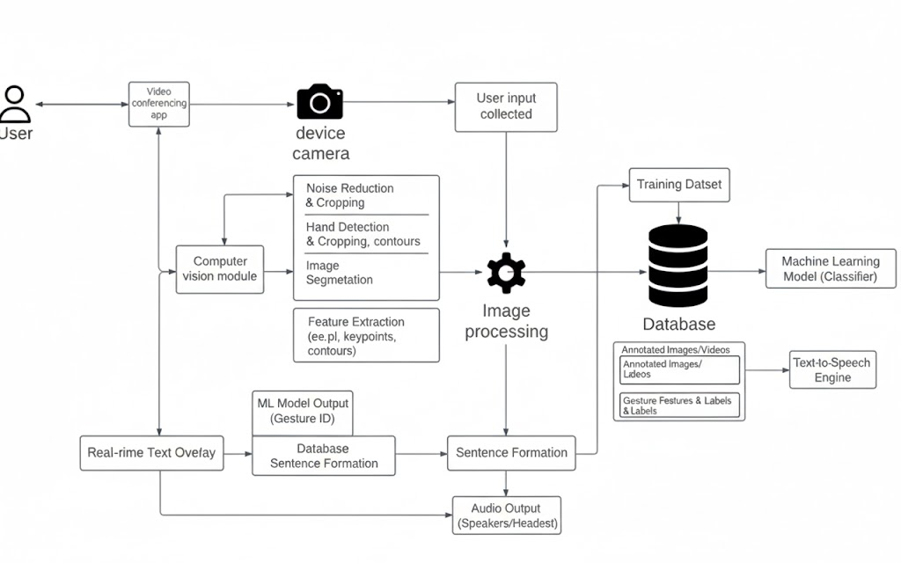
Fig 1 : Proposed System Diagram

III.LITERATURE SURVEY
The recent development of sign language recognition systems has used deep learning methods and sensor technologies to improve real-time performance and accuracy. A significant method has centred on the employment of multi-scale feature extraction methods in deep learning models, which greatly enhance the recognition of static hand gestures [1]. Moreover, sensor-based systems like those using Flex sensor gloves along with microcontrollers provide affordable options for gesture detection and text conversion, making sign language easier to communicate [3]. Another solution combines sequential models with computer vision technologies to identify dynamic gestures, especially helpful for deciphering complicated sign language alphabets [4]. These developments show the potential of fusing deep learning, sensor technologies, and sequential modeling to produce more efficient, practical, and scalable solutions for real-time sign language recognition, thereby making available more effective communication tools for the deaf and mute community.
Recent developments in sign language recognition systems have underscored the role of deep learning models and sensor technologies in enabling communication for the deaf and mute community. One of the methods suggested a deep learning-based approach to recognizing static signs, using a multi-scale density feature strategy to improve recognition accuracy [11]. This work highlights how deep learning algorithms can be fine-tuned to enhance the accuracy and reliability of sign language recognition systems, especially for static hand gestures. Another piece of work further progressed this field by utilizing convolutional neural networks (CNNs) for recognizing hand gestures, demonstrating how CNNs are capable of processing visual information from images and video streams effectively to correctly identify hand movements. This approach supports real-time gesture detection, and so it is fitting for applications in need of swift and dependable feed-back, as in deafness communication devices [14]. Third, one piece of research was conducted to explore the utilization of motion sensors in the form of the Leap Motion sensor and a machine learning methodology for the identification of American Sign Language (ASL). This paper emphasizes the contribution of sensor-based technologies to enhancing the sensitivity and precision of sign language recognition systems through the precise tracking of hand and finger movements [15].
These researches highlight the revolutionary capability of combining deep learning and sensor technologies with sign language recognition systems. Multi-scale feature extraction can be used to maximize accuracy, while CNN-based models demonstrate the effectiveness of deep learning in handling complex visual data for real-time use. The Leap Motion-based system brings to the fore the benefits of sensor-based systems in enhancing the recognition of dynamic hand gestures, providing an additional layer of innovation to the current state of sign language recognition technologies. Combined, these methods mark a major leap forward in developing more efficient and accessible communication devices for people with hearing impairments.
Recent research has also covered the areas of pose estimation and skeletal modeling for sign language recognition. These include MediaPipe, OpenPose, and BlazePose, which use keypoint extraction from the hands, face, and body for accurate real-time gesture tracking. Such keypoint-based models are highly computationally efficient and less prone to background noise or lighting conditions, therefore more applicable for real-world video communication scenarios. Using the spatial relationship of body joints, models could understand complex gestures better and improve recognition accuracy across different users.
Besides, transformer-based architectures have proved to be one of the most effective for continuous sign language translation, capturing long-range temporal dependencies between gestures, which leads to smoother and more context-aware recognition of sign sequences. The transformer model enhances translation fluency and reduces recognition errors through its self-attention mechanism that focuses on relevant motion patterns.
Various researchers have also worked on integrating NLP and TTS techniques with the recognition of signs. Once the hand gestures are converted to text, NLP modules refine the grammar and structure of sentences to make the output more natural. This processed text can then be converted into speech using TTS systems, creating an end-to-end solution for communication between deaf and hearing ind

TABLE I Literature Survey Comparison

Ref | Techniques/Algorithms | Focus | Platform/Language | Target Audience | Dataset
[1] | Depth Learning, Multi-scale | High recognition rate for gesture ID | Python, MATLAB (inferred) | Deaf/Mute Individuals | ASL
[2] | Data Glove, Vision-based | Glove-based gesture recognition | Android, C/C++ (inferred) | Deaf/Mute Individuals | ASL
[3] | Flex Sensor, GSM Module | Gesture-to-text conversion using sensors | Arduino, Android | Deaf/Mute Individuals | Not Specified
[4] | LSTM, MediaPipe | ASL recognition through hand gestures | Python | ASL Learners | ASL
[5] | CNN, Inception v3 | Bangladeshi sign language recognition | TensorFlow, Python | Bengali Speakers | Custom (not specified)
[6] | Various Approaches | Chinese sign language recognition | Python, OpenCV (inferred) | CSL Users | Chinese Sign Language
[7] | CNN, RNN, SNN, Deep CNN | Multi-viewpoint dataset analysis | Python (deep learning) | Researchers | Not Specified
[8] | 3D CNN, Two-stream CNN | Human action recognition experiments | Python, Keras | Researchers | Not Specified
[9] | ISL Recognition, Extraction | Indian sign language recognition | Python (ML algorithms) | Indian Signers | ISL
[10] | Heart-speaker system | Real-time recognition in hospitals | Python, Raspberry Pi (inferred) | Deaf/Mute Patients | Not Specified

IV.METHODOLOGY

The proposed Sign Language Recognition System uses various Machine Learning and Deep Learning algorithms to identify signs with high accuracy in real time. Different classifiers and neural architectures have been implemented for improving performance and robustness in both dynamic and static hand gesture recognition. The methodology will also include model storage using Pickle, which will efficiently deploy the model and reuse it.

A. K-Nearest Neighbours (K-NN)
K-NN is a non-parametric supervised learning algorithm used in classification and pattern recognition. The classification of new input is done by measuring its similarity to the previously observed instances in the training dataset.
In this system, each hand gesture is represented as a feature vector extracted from the image. When a new gesture is captured, K-NN compares it against all gestures in the training dataset and identifies the K most similar samples using a distance metric, such as Euclidean distance.

Mathematical Representation:
$$d\left(x,y\right)=\sqrt{\sum_{i=1}^{n}{{\left(x_{i}-y_{i}\right)}^{2}}} (1)$$
Where:
$x$ =feature vector of input gesture
$y$=feature vector from the training dataset
$n$= number of features

The new gesture is assigned to the majority class among its K nearest neighbours.

B. Convolutional Neural Networks (CNN)

CNNs have been one of the specific deep neural networks developed for image recognition and classification. They are particularly effective for identifying hand gestures and spatial hierarchies in sign language datasets.

The CNN architecture extracts features using convolutional, activation, and pooling layers. This means it allows the network to detect low- to high-level patterns, including edges, contours, and shapes of the hand.

Convential formula:

$$\left(f*g\right)\left(t\right)=\int_{-∞}^{∞}{f\left(T\right)g\left(t-T\right)ⅆT (2)}$$

Or equivalently

$$\left(f*g\right)\left(t\right)=\int_{-∞}^{∞}{f\left(t-T\right)g\left(T\right)ⅆT} (3)$$

CNN Workflow:

Convention Layer: Extracts spatial feature using filters.

Activation Function (ReLU): Introduces non-linearity.

$$f\left(ϰ\right)=\max\left(0,x\right) \left(4\right)$$

Pooling Layer: Reduces the spatial dimension while preserving essential feature.

$$y=\max\left(x_{1},x_{2},⋯x_{n}\right) (5)$$

Fully connected Layer: Combines learned features for final classification.

C. Long Short-Term Memory Networks (LSTM)

LSTM networks are a type of Recurrent Neural Network (RNN) designed to capture temporal dependencies in sequential data such as video frames of hand gestures. Unlike traditional RNNs, LSTMs effectively overcome the vanishing gradient problem.

Each LSTM cell contains three gates that regulate the flow of information:

Forget Gate:

$$f_{t}=σ\left(w_{f}⋅\left[h_{t-1},x_{t}\right]+b_{f}\right) (6)$$

Input Gate:

$$i_{t}=σ\left(w_{i}⋅\left[h_{t-1},x_{t}\right]+b_{i}\right) (7)$$

$${\overline{c}}_{t}=\tanh{(}w_{c}⋅\left[h_{t-1},x_{t}\right]+b_{c}) (8)$$

Cell State Update:

$$C_{t}=f_{t}*C_{t-1}+i_{t}*{\overline{C}}_{t} (9)$$

Output Gate:

$$O_{t}=σ\left(w_{0}⋅\left[h_{t-1},x_{t}\right]+b_{0}\right) (10)$$

$$h_{t}=o_{t}*\tanh{(}C_{t}) (11)$$

Here, $σ$is the sigmoid activation function and is the hyperbolic tangent function.

D. Deep Learning Integration

Deep learning is a class of machine learning techniques that exploit multi-layer neural networks to learn high-level abstractions in data automatically. Deep learning techniques are applied in the proposed system:

Image Classification: Identifying and classifying hand gestures from images.

Object Detection: Isolating the hand regions while ignoring background objects.

Image Segmentation: Segmenting images into meaningful regions to provide an exact gesture recognition.

Natural Language Processing (NLP): It converts the recognized gestures into corresponding text or speech output.

General Neural Network Formula:

$$y=f\left(w_{x}+b\right) (12)$$

Where:

$x$=input vector

$w$=weight Matrix

$b$=bias

$f$=activation function

The system utilizes CNN for spatial feature extraction and LSTM for temporal sequence modeling to create a hybrid CNN-LSTM framework for improved performance in continuous sign recognition.

E. Model Storage and Deployment using Pickle

To enable model reusability and deployment efficiency, the system uses Pickle, a Python module for serializing and deserializing Python objects, including trained models.

Pickle Process:

Saving the trained model:

import pickle

with open('sign_model.pkl', 'wb') as file:

pickle.dump(model, file)

Loading the model for prediction:

with open('sign_model.pkl', 'rb') as file:

loaded_model = pickle.load(file)

V.MODEL DIAGRAM

Essentially a description of the technology for translating American Sign Language (ASL) into voice in real-time. It starts with real-time user input provided by the user via a webcam that is separated from hand and body movements. The ASL data should have already been run when doing this data analysis using a machine learning model. The technology will identify this, translate it into text, and then translate that text into speech. All of this will be shown and integrated into video call platforms such as Zoom and Google Meet. It is crucial to bridge the communication gap in real time between the deaf and mute and the typical population.

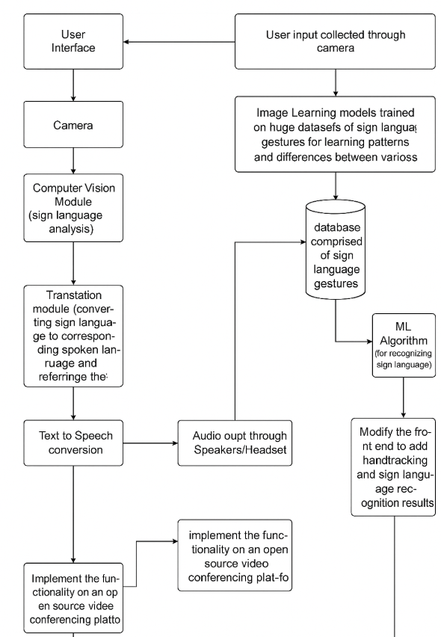

Fig 2 Model Diagram

VI.ARCHITECTURE DIAGRAM

User interface allows to website to utilize sign language is how you communicate with the system. Using image processing your sign gestures are recorded by the system using a camera. After that, it examines the photos to identify significant elements and patterns that correspond to certain indicators. Using deep learning large amount of data demonstrating sign language gestures has been used to train this system component. It gains the ability to identify patterns and various indicators from the pictures. A separate component of the system determines the type of sign you are making after identifying the patterns by using a machine learning algorithm. The translate engine can convert a sign into spoken words once it has learned it. Using technology that reads text aloud, the translated text is converted into spoken speech.

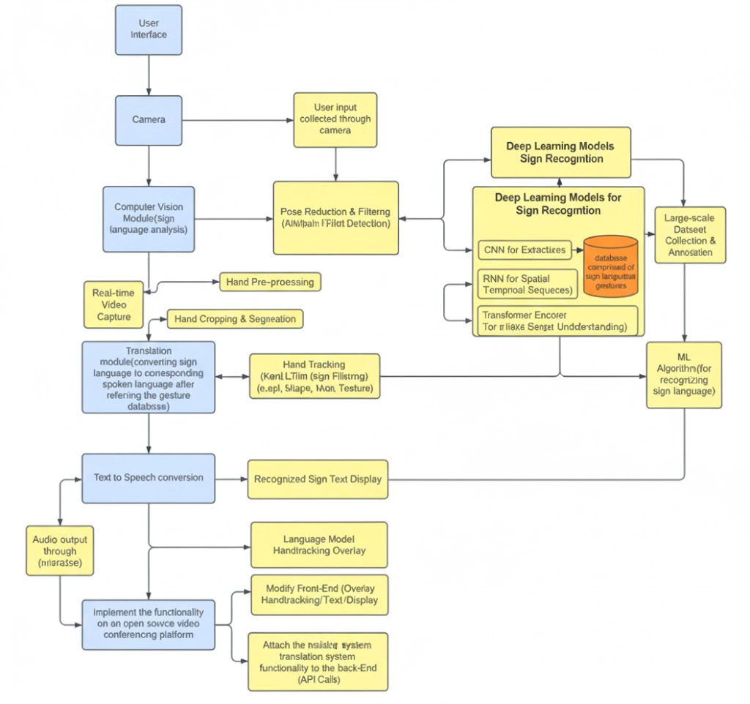

Fig 3 Architecture Diagram

VII. CONCLUSION & FUTURE SCOPE

Sign language recognition systems have the transformative power to redefine societal perspectives towards the deaf and mute community. These individuals are no less capable than others; their primary distinction lies in the mode of communication. By bridging this communication gap through intelligent gesture recognition and speech generation systems, we can foster an inclusive environment where everyone can interact freely and equally. Our work aims to empower the deaf and mute community, enabling them to express themselves in real-time with clarity and confidence.
Looking ahead, the system should evolve to incorporate multilingual support, culturally adaptive gestures, and faster, more accurate recognition through the use of advanced machine learning techniques. Continuous collaboration with the deaf and mute community and researchers will be vital to ensure the system truly meets their needs and promotes equality in all aspects of life.

VIII. RESULT

The developed sign language recognition system successfully detects and translates hand gestures representing alphabets and common words into both text and speech. The system achieved high accuracy in gesture detection and real-time conversion, enhancing the ease of communication for deaf and mute individuals. It supports clear audio output and is adaptable to include more signs and languages in the future. Initial user feedback indicates that the system is intuitive and significantly reduces communication barriers. Future enhancements will aim to expand the gesture vocabulary, support regional languages, and implement emotion-aware interaction for a more natural communication experience.

IX.ACKNOWLEDGEMENT

I Roshan Kamthe thanks to all those who have contributed to the successful completion of this implementation paper. First and foremost, I would like to express my sincere gratitude to my project supervisor Prof. Aparna Tiwari, for their continuous support, guidance, and encouragement throughout the implementation paper. Their expertise and insights have been invaluable in building this initial paper. I would also like to extend my heartfelt thanks to JSPM’S RSCOE for providing the necessary resources and a conducive environment for this paper writing and submissions.

X.REFERENCES

- Sahana, T., Paul, S., Basu, S., & Mollah, A. F. (2020). “Hand sign recognition from depth images with multi-scale density features for deaf mute persons.” Procedia Computer Science, 167, 2043–2050. https://doi.org/10.1016/j.procs.2020.03.243
- Suharjito, N., Anderson, R., Wiryana, F., Ariesta, M. C., & Kusuma, G. P. (2017). “Sign Language Recognition Application Systems for Deaf-Mute People: A Review Based on Input-Process-Output”. Procedia Computer Science, 116, 441–448. https://doi.org/10.1016/j.procs.2017.10.028
- Abraham, A., & Rohini, V. (2018). “Real time conversion of sign language to speech and prediction of gestures using Artificial Neural Network”. Procedia Computer Science, 143, 587–594. https://doi.org/10.1016/j.procs.2018.10.435
- Zheng, L., Xiao, Y., & Niu, L. (2022). “A brief survey on Computational Gromov-Wasserstein distance”. Procedia Computer Science, 199, 697–702. https://doi.org/10.1016/j.procs.2022.01.0
- A. J. Rony, K. H. Saikat, M. Tanzeem and F. M. Rahat Hasan Robi, “An Effective Approach to Communicate with the Deaf and Mute People by Recognizing Characters of One-hand Bangla Sign Language Using Convolutional Neural-Network” 2018 4th International Conference on Electrical Engineering and Information & Communication Technology (iCEEiCT), Dhaka. (n.d.).
- Kamal, S. M., Chen, Y., Li, S., Shi, X., & Zheng, J. (2019). “Technical Approaches to Chinese Sign Language Processing: A Review.” IEEE Access, 7, 96926–96935. https://doi.org/10.1109/access.2019.2929174.
- Wu, D., Sharma, N., & Blumenstein, M. (2017). “Recent advances in video-based human action recognition using deep learning: A review.” 2022 International Joint Conference on Neural Networks (IJCNN). https://doi.org/10.1109/ijcnn.2017.7966210
- Yu, Z., & Yan, W. Q. (2020b). “Human Action Recognition Using Deep Learning Methods. Human Action Recognition Using Deep Learning Methods,” 1–6. https://doi.org/10.1109/ivcnz51579.2020.9290594
- “Sign language recognition using machine learning algorithm”. (2020). Atreya Bain1, Shiwam Birajdar2, Prof. Manonmani S.3. https://www.irjet.net/archives/V8/i8/IRJET-V8I8340.pdf
- Xia, K., Lu, W., Fan, H., & Zhao, Q. (2022). “A Sign Language Recognition System Applied to Deaf-Mute Medical Consultation.” Sensors, 22(23), 9107. https://doi.org/10.3390/s22239107
- Wadhawan, A., & Kumar, P. (2020). “Deep learning-based sign language recognition system for static signs. Neural Computing and Applications”, 32(12), 7957–7968. https://doi.org/10.1007/s00521-019-04691-y
- M.M.Reda, N.G.Mohammed, R.A.Abdel Azeem Abul Seoud. “sign-voice bidirectional communication system for normal, deaf/dumb and blind people based on machine learning”. “https://ieeexplore.ieee.org/document/8441985” 978-1-5386-4427-0/18/$31.00 ©2018 IEEE.
- “Translation of Sign Language for Deaf and Dumb People.” (2020).Suthagar S., K. S. Tamilselvan, P. Balakumar, B. Rajalakshmi, C. Roshini. https://www.ijrte.org/wp-content/uploads/papers/v8i5/E6555018520.pdf
- Gongfa Li, H.Tang, Y.Sun, Jianyi.K, G.Jiang, D.Jiang, B.Tao, Shuang.X, Honghai.L. “hand gesture recognition based on convolution neural network”. “https://doi.org/10.1007/s10586-0171435x” © Springer Science+Business Media, LLC, part of Springer Nature 2017
- Chuan, C., Regina, E., & Guardino, C. (2014). “American Sign Language Recognition Using Leap Motion” Sensor. https://doi.org/10.1109/icmla.2014.110
- Korade, N. B., Salunke, M. B., Bhosle, A. A., Kumbharkar, P. B., Asalkar, G. G., & Khedkar, R. G. (2024). “Strengthening Sentence Similarity Identification Through OpenAI Embeddings and Deep Learning.” International Journal of Advanced Computer Science and Applications, 15(4). https://doi.org/10.14569/ijacsa.2024.0150485
- Lavand, K., Navindgikar, R., Kanaje, P., Malikar, M., & Chavan, S. (2024). “Enhancing Criminal Identification: Human Face Deblurring and Mask Detection Using Convolutional Neural Networks”. In Smart innovation, systems and technologies (pp. 155–165). https://doi.org/10.1007/978-981-99-8612-5_13
- Sahane, P., Badole, D., Kale, C., Chavare, S., & Walunj, S. (2024). “ Detection of Fake Audio: A Deep Learning-Based Comprehensive Survey. In Smart innovation, systems and technologies”(pp. 267–277). https://doi.org/10.1007/978-981-99-8612-5_22
- R. Deshmukh, T. Lahamge, I. Phadatare, D. Shinde and R. Manhas, "A Comprehensive Review on Real-Time Sign Language Detection for Deaf and Dumb People" 2024 3rd International Conference on Sentiment Analysis and Deep Learning (ICSADL), Bhimdatta, Nepal, 2024, pp. 169-176, doi: 10.1109/ICSADL61749.2024.00034.

