A study of mathematical model, Types of algorithms

Abstract

Algorithm literally means problem solving. It is a set of sequential and detailed instructions that we use to solve a problem. The goals of sustainable agriculture are to increase the efficiency of agricultural production by applying correct management practices, and this requires a more complete understanding of the relationships between crop production rates and soil and cultivation environment characteristics. The first step is to find appropriate methods that can determine the correct relationships between land characteristics and crop yield.

In mathematics and computer science, an algorithm is a finite sequence of well-defined instructions, usually used to solve a specific class of problems or perform calculations. Algorithms are used as specifications for performing calculations, data processing, automated reasoning, automated decision-making, and other tasks. In this paper we concluded that writing algorithms in the native language of each country or region has two drawbacks: It is difficult to write complex algorithms this way.

It is not clear how a computer program can be created from a description of the algorithm in the language of each region or country. Too we show in (fig 4) that management algorithms can be designed to perform a wide variety of tasks, such as sorting a list of numbers, performing calculations, or searching for information. A model management , on the other hand, is a simplified representation of a system or phenomenon.

Keywords: mathematical model, algorithm branch, Artificial intelligence

Introduction

A mathematical model is a description of a system using mathematical language and its theorems and symbols; modeling or mathematical modeling is an attempt to develop a mathematical model for a specific system. Mathematical modeling is not only used in natural sciences such as physics, chemistry, astronomy, cosmology, biology, geology, meteorology and engineering sciences such as computer science, artificial intelligence, etc., but also has wide applications in social sciences such as economics, psychology, sociology.

Modeling helps researchers analyze a system in a systems way and predict its behavior. System dynamics, statistical models, differential equations and game theory are examples of mathematical modeling for solving real-world problems; although modeling is not limited to these(Woodcock and Graham (2019)

A mathematical model sometimes also includes a logical model, since logic is also a part of mathematics. In most cases, the quality of research conducted is completely dependent on the accuracy of the model built. The greater the agreement between the given theories and the experimental results, the better the model will be built(kheyrodin hamid 2016 and 2025).

Non-mathematical symbolic models

In addition to using mathematical language for modeling, there are other methods for modeling the real world: Linguistic models, Graphic models, Schematic models, Category of mathematical models

Mathematical models, with all their diversity, fall into these categorie

Linear vs. nonlinear model

If all the operators in a mathematical model are linear, then the mathematical model is linear. Otherwise, the model is nonlinear. The definition of linear and nonlinear models is in their content, and a linear model may have nonlinear terms. For example, in a linear statistical model, it is assumed that the relationship between the parameters is linear, while nonlinearity in the predictor variables may be present.

Deterministic vs. Non-deterministic (random) model

In a deterministic model, the values ​​of the parameters are deterministic, but in a non-deterministic model, they are random. A deterministic model is appropriate when all factors are known. This model is used for feasibility testing. A system implemented in a stochastic manner is better because it produces a random output that is close to reality.[citation needed]

Static vs. Dynamic Model

A dynamic model is time-dependent and depends on the state of the system at time, while a static model does not change with time. In a discrete model, the behavior of objects is discrete, while in a continuous model, it is continuous, such as temperature. A deductive model is derived from experimental findings and generalizations from them. The floating model is simply called.

Prediction from Information

In mathematical modeling, problems are divided into two categories based on the amount of information available about a system: black box and white box. The black box problem is used for systems where little information is available about their details. The term white box, also known as a glass box, is used to describe systems where a lot of information is available about their components and performance. In the real world, most systems will be neither completely black nor completely white. Real-world systems will fall somewhere in between.

Artificial Intelligence

Artificial intelligence algorithms, especially neural network algorithms, can be used to train a model based on parameters. In this method, the output of the model is continuously evaluated and improved with the parameters of the system.

An algorithm.

In mathematics and computer science, an algorithm is a finite sequence of well-defined instructions, usually used to solve a specific class of problems or perform calculations. Algorithms are used as specifications for performing calculations, data processing, automated reasoning, automated decision-making, and other tasks. The way grades are calculated in school is an example of an algorithm.
The root of the word algorithm
Table 1 show
Comparing Machine Learning Algorithms 2025
The word algorithm is derived from the name of the Iranian polymath, al-Khwarizmi. He was born in Khwarazm, which was under the Abbasid Caliphate.
Table . 1 Comparing between machine learning in algorithms(www.escuelaenmovimiento.com)
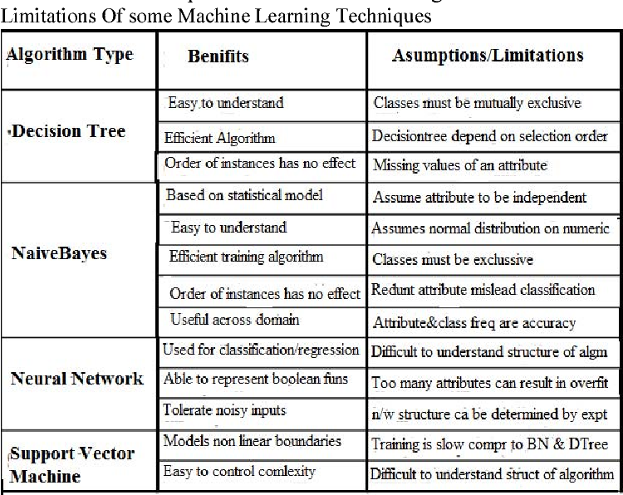

A treatise written in Arabic by al-Khwarizmi in the 9th century AD was translated into Latin in the 12th century under the title; that is, "[a book by] 'Algorithm' on Indian numbers", where 'Algorithm' was the name of al-Khwarizmi, whose name the translator had put before the original title of the book (on Indian numbers) in the Latin translation. In the 13th century AD, the word algorismus meant "the Arabic (decimal) numbering system" (i.e. the numbers 1 to 9 plus zero, as well as the concept of decimals); which is still one of the meanings of the word algorithm. Another meaning of algorithm is "calculation with the help of Arabic numbers"; That is, the art of performing basic arithmetic operations, such as addition and multiplication, by placing numbers under each other and applying certain rules, which replaced the use of Roman numerals and the use of an abacus. Even the method of performing division and taking roots (radicals) by hand is called an algorithm. In the 19th century, the word changed its form in French, although its meaning remained the same. It did not take long for the word to enter the English language; but it was not until the late 19th century that it acquired its more general meaning today, and it was called "any set of rules used to carry out a computational procedure or computer routine." The conversion of Al-Khwarizmi's name to Algorithm and then Algorithm was probably influenced by the Greek words (meaning number) and (meaning calculation). Some sources have not considered the word logarithm to be irrelevant in the conversion of Algorithm and Algorithm.

Applications of Algorithms

Sorting Algorithm

Suppose you want to sort a number of test papers based on people's information. You can do this based on the alphabet of the first name, last name, or other characteristics of people; however, the procedure that you must follow by performing a series of specific steps until you obtain a result is actually the same algorithm for doing the work. The application of the algorithm we are talking about is also abundant in the computer world. This algorithm, which of course takes various forms, is called the sorting algorithm, and this algorithm is also widely used in programming(fig 1).

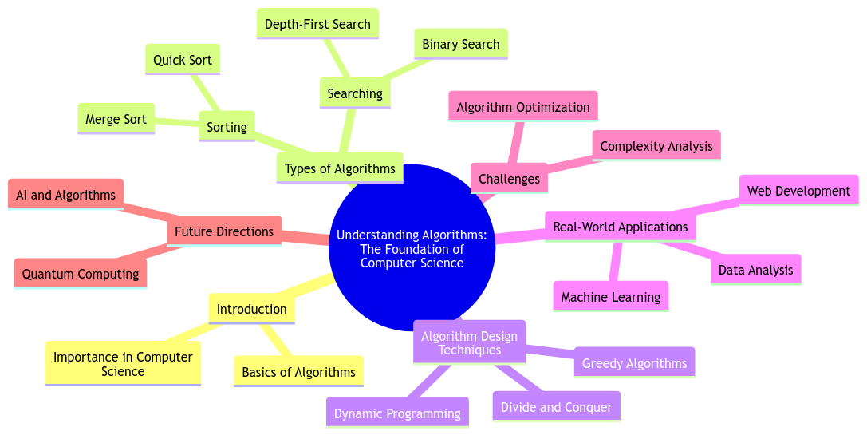

Fig 1: Algorithm and the Foundation Of Computer Science

Facial Recognition Algorithm

You may have paid less attention to how you recognize people from their faces. If we look at this very simply, we will see that our eyes see an image, the neural network conveys the relevant message to the brain, and the brain tries to analyze and match or compare the image with its previous information, including appearance characteristics or other individual emotions and experiences. The human body system does this process automatically, but what about the computer systems that do this? Of course, we, humans, have to give the problem-solving algorithm to the machine to achieve the desired result; so the application of the algorithm in this field is also clear(fig 2).

Of course, it goes without saying that the facial recognition algorithm in various computer systems is still not completely error-free, and this is where programmers and of course the application of the algorithm in programming must play their role well in order to achieve a better facial recognition algorithm.( Veen et al. 2020).

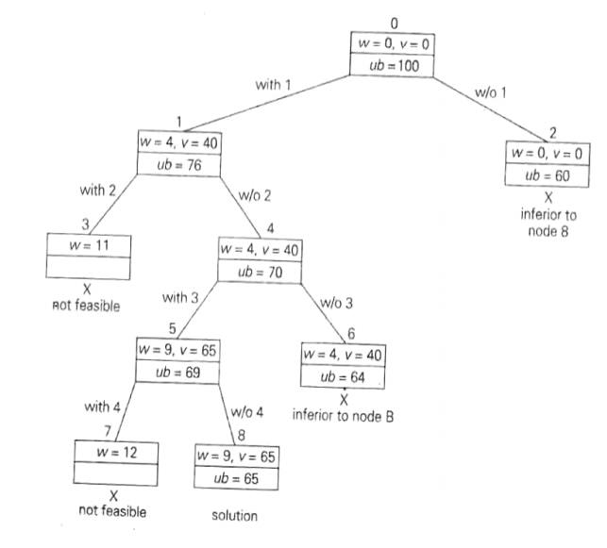

Fig 2: Algorithm: Branch and Bound

Achieving results in repetitive problems

There are many problems in our lives that other humans have faced before us. Therefore, as David Chekovsky, a computer science and technology teacher at Hyde Park Central Schools, says, “If you want to do something well, looking at previous successful examples of other people can be very useful.” For example, consider cooking recipes, they are a good example of the application of algorithms in cooking.

The use of algorithms in programming is similar; when you encounter repetitive problems, you can create a new algorithm to solve it using different methods that may not necessarily be optimal or use algorithms that other people have achieved before you and have passed their test, so to speak (Lee et 2015).

Traffic lights

Traffic lights are equipped with devices that determine the timing of each of the green, yellow, and red lights using sensory inputs and based on the traffic flow. So if a series of devices and sensors are going to do this for us, where is the use of the algorithm in this example? Obviously, the above process includes a specific sequence of steps to properly direct traffic, which of course, if we do not consider a suitable algorithm for this purpose, we will witness numerous problems and we will have to spend much more time and energy to resolve them. Undoubtedly, this is not a desirable situation for anyone.

Bus Schedule

Intercity buses come to the aid of many citizens every day and take them to their desired destination, but is it possible to do this without planning and scheduling the buses properly, determining their route, and predicting the time of arrival at each stop? Is it possible to have such a program without using algorithms? This is known in computer science as the "Traveling Salesman Problem". So far, it is clear how much the use of algorithms is in daily life and that algorithms play a prominent role in every field we look at; but in the following, we want to enter more specialized areas of the use of algorithms in programming and computer science.

Application of algorithms on the Internet

The Internet is a very important and vital tool in today's world and has undergone major changes in the lives of all humans in just a few years. By now, it should be clear that behind almost every procedure and process, there is an algorithm involved. The Internet also follows the same rule and depends on various algorithms to function properly. From searching in search engines to online shopping, sending and receiving information, etc., all of them are indebted to the use of algorithms in the computer world. The backbone of the Internet is deeply dependent on algorithms, and we will continue to examine some of the applications of algorithms in this vast world.

Google Search Engine

Search algorithms meet many needs in our lives every day. Needless to say, one of the most important search engines is Google. You have certainly experienced that it is enough to type a few words of the concept you want in Google and it will provide you with a sea of ​​information on that subject in a fraction of a second. Google uses the use of algorithms in programming to provide us with this information. Therefore, the importance of algorithms in search engines, including Google, is quite clear.

Network Routing

In today's world, computer networks play a very important role in the transmission of information, and without them, many facilities, including the Internet, are not possible. Of course, in order to deliver packets from their source to their destination, they must find the best possible path and then transmit the data along that path. In this regard, computer networks use routing algorithms to effectively direct Internet traffic; by effective, we mean a path that is "low cost". There are various routing algorithms(Zuboff 2019).

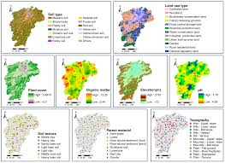

Fig 3: Algorithm management and Application of Machine Learning Approaches to Predict Soil Element

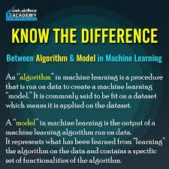

Fig 4: Difference between algorithm and model

Conclusion

As the world population is increasing, traditional farming methods will not be able to meet the needs. Manual methods lead to a waste of resources for the limited agricultural environment. In addition, the Internet of Things plays an important role in modern agriculture. In this paper, an innovative hybrid model using the Internet of Things in agriculture is proposed, which introduces machine learning (ML) and artificial intelligence (AL) algorithms for a robust anomaly detection mechanism during LSTM on agricultural product datasets.

Algorithmic management is a form of workforce supervision, control, and management in which traditional management tasks performed by humans are delegated to technological systems and algorithms(fig 3). These systems monitor workers' performance in real time through continuous data collection and, based on predetermined rules, automatically make decisions such as assigning tasks, assessing work quality, and even imposing disciplinary measures. This management style is particularly popular in the gig economy (such as Uber and Snap) and in environments such as Amazon warehouses, where speed and efficiency are a priority(Rosenblat 2018).

References

Rosenblat, Alex (2018). Uberland: How Algorithms Are Rewriting the Rules of Work. University of California Press. ISBN 9780520298576.

Woodcock, Jamie; Graham, Mark (2019). The Gig Economy: A Critical Introduction. Polity Press. ISBN 9781509536375.

Lee, Min Kyung; Kusbit, Daniel; Metsky, Evan; Dabbish, Laura (2015). "Working with Machines: The Impact of Algorithmic and Data-Driven Management on Human Workers". Proceedings of the 33rd Annual ACM Conference on Human Factors in Computing Systems: 1603–1612.

Veen, Alex; Barratt, Tom; Goods, Caleb (2020). "Platform-Capital's 'App-etite' for Control: A Labour Process Analysis of Food-Delivery Gig Work in Australia". Work, Employment and Society. 34 (3): 388–406.

Kheyrodin, Hamid. 2025. Silk Road Effect and Architecture . First conference in Silk road . Semnan university. Iran

Kheyrodin Hamid.2016. Book. Science and Agricultural technology.

Kheyrodin hamid. 2025. Important Equipment and Tools for Extracting Castor Oil in Iran. International Journal of Latest Research in Engineering and Management (IJLREM). Volume 09 - Issue 04

Zuboff, Shoshana (2019). The Age of Surveillance Capitalism: The Fight for a Human Future at the New Frontier of Power. PublicAffairs. ISBN 978-1610395694.

