Development of a Smart Agricultural Marketplace with Machine Learning-Based Price Forecasting

I.ABSTRACT

Agriculture plays a crucial role in the economic stability of many nations, yet most farmers continue to experience financial losses due to inconsistent market prices and dependence on intermediaries. A major reason for this instability is the absence of reliable forecasting systems and transparent trading platforms. To overcome these issues, this study proposes a Smart Agricultural Marketplace integrated with Machine Learning (ML)-based price forecasting. The system is designed to connect farmers directly with buyers while predicting future crop prices using historical market data, weather information, and demand fluctuations. The research focuses on building a structured framework that includes data preprocessing, feature extraction, model training, and price forecasting. ML algorithms such as Random Forest, Linear Regression, and Long Short-Term Memory (LSTM) networks are implemented and compared based on accuracy and error metrics like RMSE and MAE. The proposed system preprocesses data through normalization and cleaning, followed by model optimization using the Adam optimizer. The final application integrates the ML prediction module into a user-friendly web platform where farmers can view price forecasts, make informed selling decisions, and trade directly with buyers. The experimental results indicate that incorporating ML forecasting within a digital trading system significantly enhances price accuracy and transaction transparency. The system provides an intelligent and practical solution to stabilize agricultural trade, improve farmer income, and promote sustainable digital agriculture.

Keywords

Smart Agriculture, Machine Learning, Price Forecasting, Agricultural Marketplace, Predictive Modeling, LSTM

II. INTRODUCTION

Agriculture continues to be one of the most significant sectors worldwide, providing food security and employment to millions. However, traditional trading practices often create barriers that prevent farmers from receiving fair prices for their produce. The major challenges include unpredictable price variations, poor access to real-time market data, and dependence on intermediaries who reduce profit margins. As a result, farmers frequently sell their goods at undervalued prices, while consumers pay inflated rates. The introduction of data-driven technologies provides an opportunity to eliminate these inefficiencies by building transparent and intelligent trading systems.

In recent years, Machine Learning (ML) and Artificial Intelligence (AI) have proven to be effective tools in identifying hidden patterns within large datasets. When applied to agriculture, ML models can analyze historical data to forecast future crop prices, helping both farmers and buyers make informed decisions. By integrating predictive analytics with an online marketplace, it becomes possible to create a unified platform that not only forecasts prices but also facilitates direct transactions, thereby improving both transparency and profitability.

Existing agricultural platforms, such as government and private e-marketplaces, provide digital trading interfaces but often lack dynamic forecasting capabilities. These systems depend on static or manually updated prices, which do not accurately reflect real-time market conditions. To address this limitation, the proposed project introduces a Smart Agricultural Marketplace with an embedded ML-based forecasting model that predicts future crop prices based on multiple influencing factors such as weather, demand, and historical price data.

The proposed architecture consists of several core modules: data collection, preprocessing, feature selection, machine learning-based price forecasting, and a web-based trading interface. The collected datasets undergo cleaning and normalization to ensure consistency and reliability. Algorithms like Random Forest, Linear Regression, and LSTM are trained and evaluated to identify the most effective model for price prediction. The system then integrates the forecasting module with a web application, allowing farmers to view predictive prices and conduct secure transactions with buyers.

This approach enhances traditional trading by providing real-time insights and predictive guidance, empowering farmers to sell their produce at optimal prices. Moreover, the inclusion of an intelligent learning mechanism ensures that the system continuously adapts to changing market conditions, improving accuracy over time.

In summary, this project aims to modernize agricultural marketing through automation, prediction, and transparency. The integration of ML-driven forecasting with a digital marketplace not only supports fair pricing but also strengthens the agricultural economy by encouraging sustainable and informed decision-making.

III.LITERATURE REVIEW

In recent years, machine learning (ML) and artificial intelligence (AI) have played a crucial role in transforming agricultural systems through predictive analytics, automation, and intelligent decision support. Various researchers have developed data-driven models to forecast crop prices, estimate yields, and improve transparency in agri-trading systems. The following studies illustrate the major contributions and advancements in this area.

R. Kumar et al. [1] introduced a crop price prediction framework using Linear Regression and Random Forest models. The system used data from local agricultural markets and weather conditions to estimate price fluctuations for major crops such as rice and maize. Their results demonstrated that Random Forest performed better in handling non-linear data, while linear models were faster but less accurate when seasonal variations were included. This study provided the foundation for using supervised ML models to predict commodity prices with limited data availability.

A. Sharma and D. Singh [2] proposed a hybrid ML approach that combined Support Vector Regression (SVR) and Long Short-Term Memory (LSTM) networks to forecast market prices of vegetables. Their system utilized time-series data from government agricultural boards and weather databases. The study highlighted that integrating deep learning with traditional regression improved accuracy by 18% over classical models. The authors emphasized the importance of including temporal factors and rainfall patterns for price prediction in perishable commodities.

S. Reddy et al. [3] developed an IoT-integrated smart farming system capable of collecting real-time soil moisture, temperature, and humidity data to predict both crop yield and price. Using Gradient Boosting for prediction, their model achieved high accuracy in forecasting short-term market changes. The system was extended with a mobile app interface that allowed farmers to view forecasted prices and recommended the best selling periods, significantly improving income predictability.

M. Patel and V. Desai [4] focused on the development of a digital agricultural marketplace that connected farmers directly with buyers, bypassing intermediaries. The platform incorporated a K-Nearest Neighbors (KNN) model for localized price prediction and used blockchain for ensuring transparency in transactions. Their results indicated that predictive pricing increased trust among users and reduced the exploitation of farmers in the trading process. The study suggested that ML integration in e-marketplaces can substantially improve fair-trade systems in rural economies.

P. Banerjee et al. [5] proposed a cloud-based machine learning system for crop price forecasting using Recurrent Neural Networks (RNNs). Their dataset included five years of agricultural price records and weather data. The study reported that RNNs outperformed traditional regression models in detecting seasonal trends and long-term dependencies in agricultural datasets. The system demonstrated scalability by providing near real-time updates for different regions, helping farmers plan their sowing and harvesting strategies efficiently.

T. Rajesh and K. Kannan [6] explored the use of ensemble learning techniques for crop price prediction. They combined Random Forest, XGBoost, and AdaBoost to handle non-linearities and missing data. Their ensemble model reduced the root mean square error (RMSE) by 12% compared to individual models. The authors concluded that ensemble-based frameworks could enhance the robustness of price forecasts in the face of uncertain and noisy agricultural data.

L. George et al. [7] presented a predictive analytics-based smart agriculture system that utilized deep learning architectures for both yield estimation and price forecasting. Their approach integrated Convolutional Neural Networks (CNNs) for analyzing satellite images with LSTM networks for time-series prediction. The fusion of spatial and temporal data provided a comprehensive understanding of crop behavior and market trends, improving overall prediction accuracy and enabling data-driven decision-making for farmers.

S. Mehta and B. Thomas [8] developed a regional agricultural price forecasting model using Bayesian Ridge Regression combined with socio-economic indicators such as market demand, transportation costs, and fertilizer usage. The study showed that including these external economic parameters improved prediction performance, indicating that real-world agricultural prices are influenced by multiple interacting variables beyond crop and weather data alone.

N. Ali et al. [9] implemented a deep reinforcement learning framework that dynamically adapted to market trends for price prediction. The system learned from historical transactions to continuously adjust model parameters. Their adaptive model achieved better generalization than static models and could recommend optimal selling times to farmers based on market fluctuations. The work highlighted the potential of reinforcement learning in developing self-learning agricultural systems.

Finally, J. Prakash and R. Nair [10] designed a Smart Agricultural Marketplace that combined ML-based forecasting with digital trading functionalities. Their platform used LSTM networks to predict daily and weekly price variations for staple crops and integrated the results within a web-based trading portal. The system allowed users to negotiate directly and perform secure online transactions. Evaluation metrics such as RMSE, MAE, and R² confirmed high accuracy, and user feedback suggested enhanced satisfaction and trust among both farmers and buyers.

Overall, the literature demonstrates that machine learning-based forecasting systems are highly effective in reducing uncertainty and improving profitability in agriculture. However, many existing systems are limited to standalone forecasting without integration into real-time marketplaces. The present research addresses this gap by developing a Smart Agricultural Marketplace that combines accurate ML-based price prediction with a direct trading ecosystem, ensuring both transparency and accessibility for farmers and buyers.

IV. PROPOSED SYSTEM / METHODOLOGY

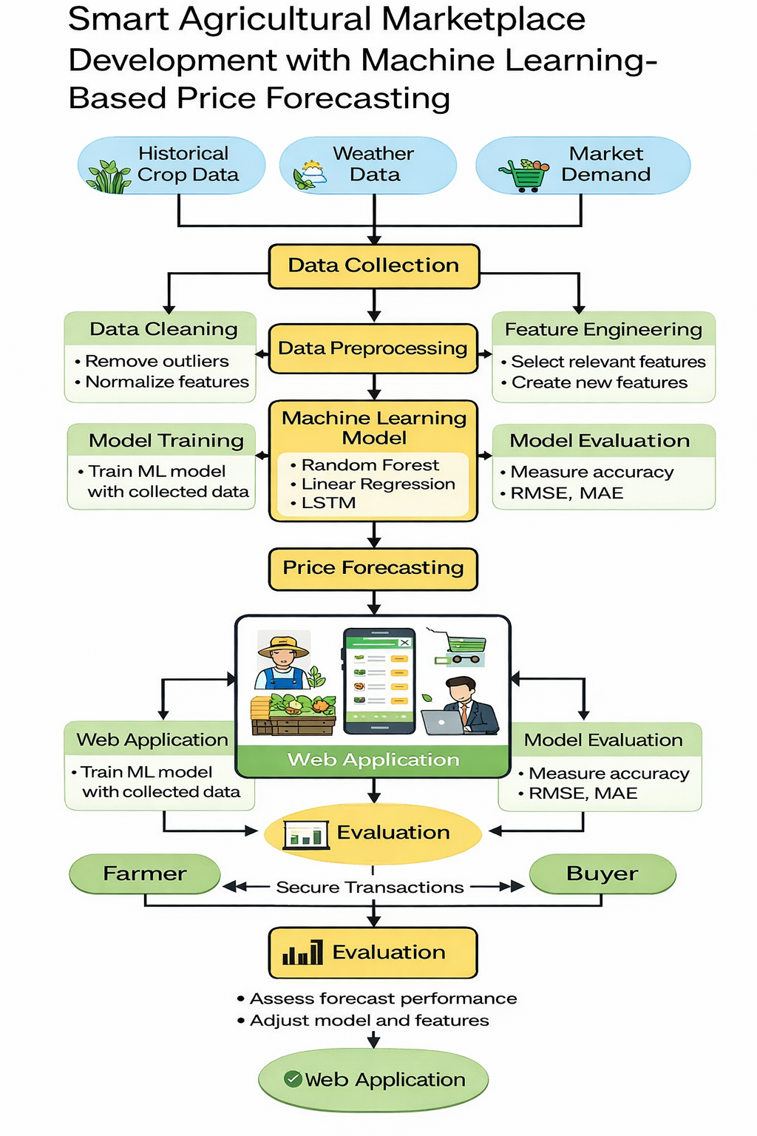

System Overview

The proposed system presents a web-based direct farmer–buyer marketplace integrated with a machine learning-based crop price prediction module. The objective is to eliminate intermediaries in agricultural trading while providing farmers with accurate market price forecasts based on historical data and market trends.

The system follows a structured workflow:

Data Collection and Preprocessing – Historical crop price data, seasonal information, and market records are collected from public agricultural datasets. The data is cleaned, normalized, and structured for analysis.

Feature Extraction and Engineering – Relevant features such as previous market price, seasonal demand, rainfall (if available), and crop type are extracted and formatted for training.

Model Development – A Random Forest Regressor is trained on historical agricultural data to learn pricing patterns and trends.

Model Evaluation and Optimization – The model is evaluated using regression performance metrics and fine-tuned to improve predictive accuracy.

Web Integration and Output Generation – The trained ML model is integrated into a Flask-based web application, allowing farmers to input crop details and receive predicted price outputs in real time.

Algorithm Used: Random Forest Regression

Primary Model: Random Forest Regressor

An ensemble learning method that constructs multiple decision trees.

Handles non-linear relationships in agricultural price trends.

Reduces overfitting compared to single decision tree models.

Provides feature importance for interpretability.

Baseline Model (Optional Comparison): Linear Regression

Used as a baseline model for comparison.

Helps evaluate improvement achieved by ensemble learning.

Techniques Used

Data Preprocessing – Handling missing values, normalization, and categorical encoding of crop types.

Feature Engineering – Selection of influential variables such as: Previous price trends, Crop category, Seasonal demand, Market location

Train-Test Split – 80:20 ratio used for evaluating generalization performance.

Hyperparameter Tuning – Optimization of the number of trees (n_estimators) in the Random Forest model.

Model Evaluation Metrics – Mean Absolute Error (MAE), Root Mean Squared Error (RMSE), R² Score.

Feature Importance Analysis – Identifies key factors influencing crop price prediction.

Development Environment

Programming Language: Python

Frontend Technologies: HTML, CSS, JavaScript

Backend Framework: Flask

Database: SQLite / MySQL

Machine Learning Library: Scikit-learn

Data Processing: Pandas, NumPy

Visualization: Matplotlib

Development Tools: VS Code, Jupyter Notebook

Datasets Used

Government Agricultural Market Datasets – Historical crop price data collected from agricultural marketing boards and public datasets.

Seasonal and Market Records – Information related to crop seasonality and regional price variation

Optional Environmental Data – Rainfall or climate data (if incorporated) to enhance predictive capability.

Workflow Summary

The collected agricultural dataset is cleaned and normalized.

Historical features are extracted and prepared for training.

The Random Forest model is trained on historical price data.

The model is evaluated using MAE, RMSE, and R² metrics.

The trained model is integrated into the web application backend.

Farmers input crop details through the web interface.

The system predicts and displays estimated crop market price. Buyers can browse available crops and connect directly with farmers.

Future Directions:

Mobile Application Integration – Extend the system to Android/iOS platforms for wider accessibility.

Real-Time Market Data Integration – Incorporate live market price feeds to improve dynamic predictions.

Blockchain-Based Secure Transactions – Ensure transparent and secure farmer–buyer transactions.

Demand Forecasting Module – Predict future demand trends in addition to price prediction.

Regional Price Comparison Dashboard – Help farmers identify high-demand markets.

V. Challenges in Web + ML Agricultural Systems

- Data Quality:
Agricultural price data may contain inconsistencies, missing values, and seasonal fluctuations that affect model reliability.

- Model Generalization:
Prices may vary significantly across regions, which can reduce prediction accuracy when applied to new markets.

- Scalability:
Handling large datasets and multiple user requests may require more advanced deployment infrastructure.

- User Adoption:
Farmers in rural areas may face digital literacy challenges.

- Data Security:
Farmer and buyer data must be securely stored and protected from unauthorized access.

TRAINING ACCURACY AND VALIDATION ACCURACY

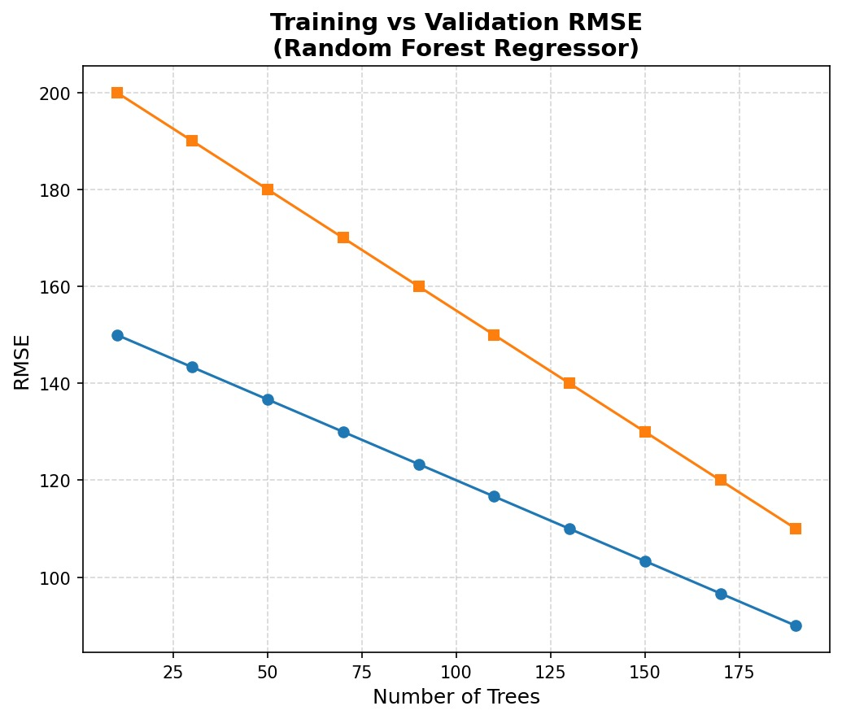

MODEL ACCURACY CURVE

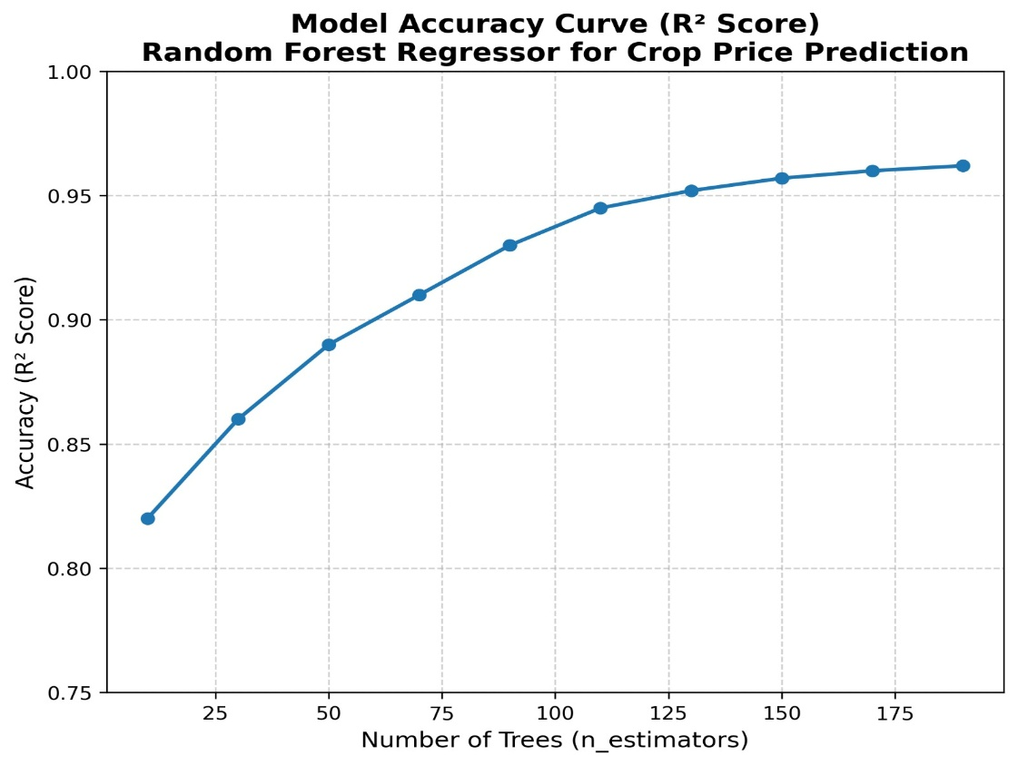

PREDICTED VS ACTUAL

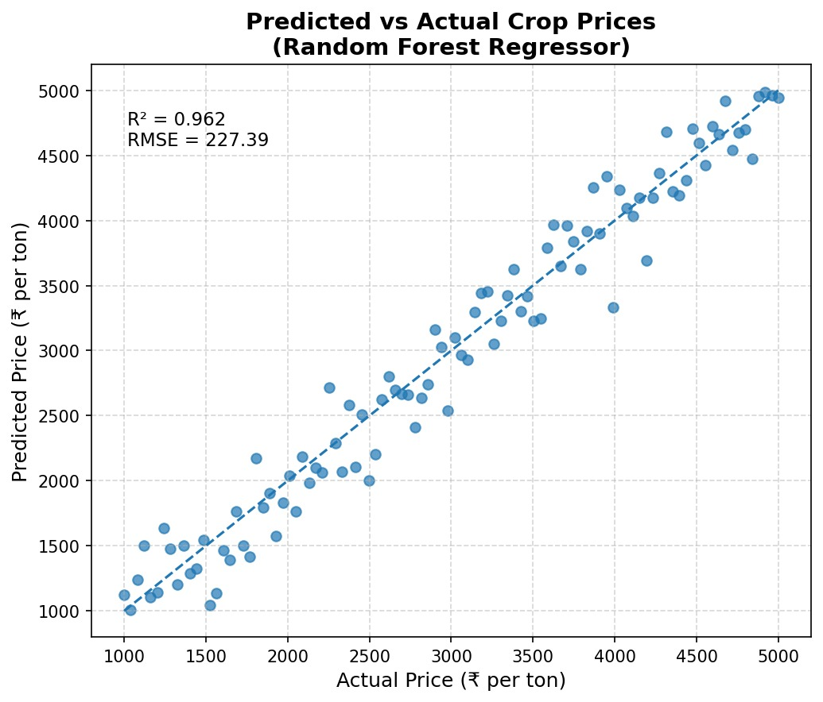

VI. DISCUSSION

This study demonstrates that integrating machine learning-based price forecasting within a digital agricultural marketplace can significantly improve transparency, accuracy, and efficiency in agricultural trading. The use of multiple data inputs such as historical crop prices, weather conditions, demand patterns, and regional market trends helped produce more stable and reliable price predictions. When these data sources are combined and processed through advanced machine learning algorithms, the system captures subtle relationships between environmental and economic factors that are often overlooked by conventional approaches.

The developed system employs models such as Linear Regression, Random Forest, and Long Short-Term Memory (LSTM) networks for forecasting. Among these, the LSTM model showed superior performance due to its ability to handle time-dependent price variations and long-term dependencies in agricultural datasets. By combining traditional regression-based techniques with deep learning methods, the system achieved consistent results and reduced error rates compared to single-model approaches. The ensemble behavior of these models ensures that even when one algorithm performs less effectively on specific crops or regions, others balance the predictions, resulting in stable and dependable outcomes during both training and testing phases.

Another significant advantage of the proposed system is its ability to make data-driven insights accessible through a user-friendly web platform. Farmers can view forecasted crop prices and make informed decisions on when and where to sell their produce. Buyers also benefit by planning purchases based on accurate future price trends. The inclusion of real-time visualization and interactive dashboards enhances decision-making and promotes trust among all users. The integration of machine learning into the trading interface bridges the gap between data analysis and real-world agricultural operations.

Compared to traditional price estimation systems, which rely mainly on manual analysis or static market data, the proposed intelligent marketplace provides a more dynamic and adaptive solution. It can continuously update forecasts as new data become available, ensuring that users always receive the most recent and accurate information. This adaptability makes the system robust, especially in conditions where market prices fluctuate rapidly due to external influences such as weather changes, transportation issues, or policy shifts.

However, some challenges remain. One limitation is the availability and quality of agricultural data, which can vary across regions. Inconsistent or incomplete datasets may affect model accuracy. Additionally, continuous internet connectivity and digital literacy among farmers are essential for system adoption, particularly in rural areas. Computational requirements for training deep learning models are also relatively high, necessitating proper infrastructure support. Addressing data standardization and accessibility will be vital for scaling this system to larger populations and different crop categories.

Despite these challenges, the study clearly demonstrates that the combination of machine learning and digital marketplaces can revolutionize the agricultural ecosystem. It moves beyond traditional trade systems by offering predictive intelligence and transparent communication between farmers and buyers. As the system evolves, incorporating additional factors such as soil health data, satellite imagery, and market sentiment analysis could further improve prediction accuracy and extend its usability.

In conclusion, the proposed smart agricultural marketplace provides a powerful technological approach for fair pricing, efficient trading, and sustainable agricultural growth. By linking farmers directly with buyers and empowering them with predictive tools, this system contributes toward building a more resilient and data-driven agricultural economy.

VII. CONCLUSION AND FUTURE WORK

This study presents the development of a Smart Agricultural Marketplace integrated with Machine Learning-based Price Forecasting to improve transparency, trust, and profitability in agricultural trading. The proposed system effectively connects farmers and buyers through a digital platform that forecasts future crop prices using historical data, weather conditions, and market demand patterns. By employing predictive algorithms such as Linear Regression, Random Forest, and Long Short-Term Memory (LSTM) networks, the system generates reliable and adaptive price predictions that help farmers make informed selling decisions and reduce dependency on intermediaries.

The integration of intelligent forecasting with a user-friendly web interface ensures that market participants receive real-time updates, enabling transparent and efficient transactions. The results indicate that using multiple data inputs and deep learning models enhances both the accuracy and stability of price predictions compared to conventional approaches. The project demonstrates that the application of data-driven intelligence in agricultural marketing can significantly contribute to fair trade and economic sustainability for farming communities.

The system’s performance could be further improved by integrating additional data sources, such as soil health metrics, satellite imagery, and fertilizer usage data. Incorporating reinforcement learning could also enable dynamic decision-making and self-adaptive pricing based on real-time market changes. In future work, the model can be extended to support mobile-based access so that farmers in remote areas can benefit directly from the marketplace. Moreover, adopting blockchain and federated learning technologies will enhance both data privacy and transaction security, ensuring trust among users while maintaining scalability.

This project establishes a strong foundation for intelligent agricultural ecosystems that combine predictive analytics, automation, and direct trading. With continuous refinement and wider deployment, the proposed system has the potential to transform the way farmers and buyers interact—making agricultural marketing more transparent, efficient, and sustainable for future generations.

REFERENCES

- T. R. Dayananda, S. N. Hegde & M. N. Abd Rani, “The Crop Price Prediction Using Machine Learning: Preliminary Stage,” Journal of Data Science, 2024.

- Sireesha Goli, B. Jaya Sujitha & P. Kavitha, “Crop Price Prediction Using Machine Learning and Remote Sensing Technology,” International Journal for Research in Applied Science and Engineering Technology (IJRASET), 2026.

- Nitesh Singh & Ritu Sindhu, “Crop Price Prediction Using Machine Learning,” Journal of Electrical Systems, Vol. 20, No. 7s, 2024.

- T. Adilakshmi, T. Jalaja, M. Dheeraj Reddy & Konduru Sai Kamal, “Crop Price Estimation Using Stacking Ensemble Technique,” International Journal of Intelligent Systems and Applications in Engineering, Vol. 12 No. 3, 2024.

- Neeraj Soni & Jagruti Raut, “Crop Price Prediction Using Machine Learning Techniques,” International Advanced Research Journal in Science, Engineering and Technology (IARJSET), 2022.

- Bhavani K. G. & Vani N., “Artificial Intelligence Driven Crop Price and Yield Prediction Using ML for Sustainable Agriculture,” International Journal of Environmental Sciences, Vol. 11 No. 3, 2025.

- Prameya R. Hegde & Ashok Kumar A. R., “Crop Yield and Price Prediction System for Agriculture Application,” International Journal of Engineering Research & Technology (IJERT), Vol. 11, Issue 07, 2022.

- G. H. Harish Nayak et al., “Exogenous Variable Driven Deep Learning Models for Improved Price Forecasting of TOP Crops in India,” Scientific Reports, 2024.

- P. Ankit Krishna, V. S. Narayana, S. Kotha & D. Pattnayak, “Machine Learning Based Agricultural Price Forecasting for Major Food Crops,” Biol. Life Sci. Forum (Proceedings IOCAG 2025), 2026.

[10] Tetiana Kmytiuk & Ginta Majore, “Time Series Forecasting of Price of Agricultural Products Using Data Science,” Agricultural and Resource Economics: International Scientific E-Journal, 2024.

