An Experimental Study on Biochar Produced from Pistachio Shells

1) ABSTRACT
This research exam prepared from pistachio shells as a sustainable material for waste management and environmental improvement. Pistachio shells, an abundant agricultural by-product, possess high carbon content and useful adsorption properties. The treated biochar shows promise in improving soil quality, supporting carbon storage, and removing pollutants from soil and water. This study highlights pistachio shell biochar as a low-cost and eco-friendly solution.
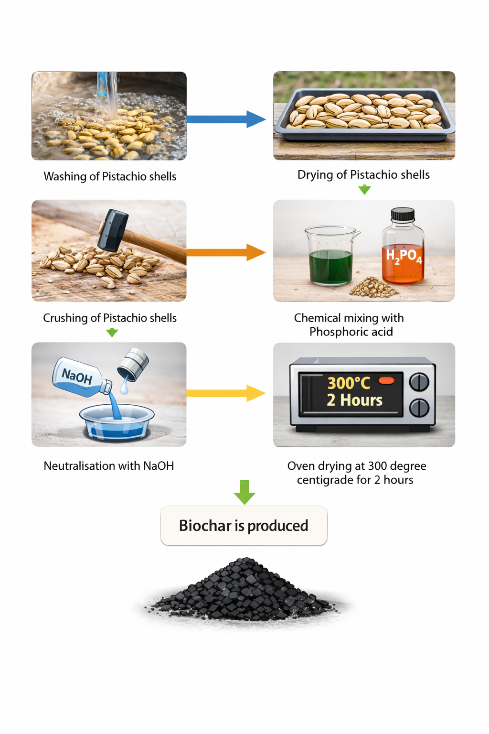

2) KEYWORDS
Biochar, Pistachio shells, Soil testing, Adsorption ,Biomass residue,Pyrolysis,Green house gas emission, Contaminant immobilization, Sequestration, Lignocellulosic waste, Nutrient retention.

3) INTRODUCTION
The increasing generation of agricultural and food-processing waste has become a major environmental concern worldwide. Improper disposal of such biomass residues contributes to pollution, greenhouse gas emissions, and the loss of potentially valuable resources. During this situation, biochar has emerged as a promising solution for sustainable waste management. Biochar is a carbon-rich, porous material produced through the pyrolysis of biomass under limited oxygen conditions and is valued for its high surface area, absorption capacity, and environmental stability.
Due to its porous structure and surface functional groups, biochar exhibits enhanced absorption properties, making it effective for nutrient retention and containment immobilization. When applied as a soil amendment, biochar improves soil structure, water-holding capacity, and nutrient availability, while also supporting long-term carbon sequestration. The use of agricultural by-products as a biochar feedstock further strengthens its role in sustainable biomass utilization. Pistachio shells are an abundant yet underutilized lignocellulosic waste generated by the food industry. Their high carbon content and structural strength make them a suitable precursor for biochar production. So, the present study aims to produce biochar from pistachio shells and dive deep into its properties, highlighting its potential as a sustainable, low-cost, and environmentally beneficial material. This research contributes to the development of waste-to-resource technologies and supports the advancement of sustainable biomass utilization.

4) LITERATURE REVIEW
As stated from the article "Utilizing Pistachio Shell Biochar to Replace Carbon Black in Natural Rubber Composites", published in Journal of composite sciences MDPI, it has been stated that converting pistachio shell waste into biochar through controlled pyrolysis for environmental applications. Studies report good porosity, stable carbon structure, and functional groups enabling efficient pollutant adsorption. Research emphasizes low cost, sustainability, strong adsorption interactions, and promising suitability for wastewater treatment and pollution control
As stated from the research paper "Synthesis of high surface area porous biochar obtained from pistachio shells for the efficient adsorption of organic dyes from polluted water", published in Science direct, it has been stated that pistachio shell biochar synthesized at elevated pyrolysis temperatures. Studies report enhanced BET area, developed micro-mesoporosity, and very high adsorption of Congo Red and Methylene Blue. Mechanisms include pore filling, π–π interactions, electrostatic attraction, hydrogen bonding, and surface complexation with good reusability.
As per the research paper, “Assessment of pistachio shell biochar quality and its potential for adsorption of heavy metals”, biochar is a sustainable material produced from biomass through pyrolysis, with applications in soil improvement, carbon sequestration, and environmental remediation. Its properties are strongly influenced by feedstock type and pyrolysis temperature, affecting carbon content, porosity, pH, and surface functionality. Agricultural residues such as nut shells are promising low-cost feedstocks. Studies indicate that biochar produced at higher temperatures shows improved adsorption of heavy metals like lead and copper due to increased aromaticity and pore development. However, limited research exists on pistachio shell biochar, highlighting the need for further study.
As per the research paper, “Assessment of Pistachio Shell-Based Biochar Application in the Sustainable Amendment of Soil and Its Performance”, published in the peer-reviewed, open-access journal Sustainability, issued by MDPI, biochar is a sustainable material produced from biomass through pyrolysis, with increasing interest in environmental applications. Its properties, including surface area, porosity, pH, and carbon content, are strongly influenced by feedstock type and pyrolysis temperature. These characteristics determine biochar performance in soil amendment, carbon sequestration, and pollutant removal. Studies show that biochar can effectively adsorb contaminants such as heavy metals due to its porous structure and surface functional groups. Additionally, biochar supports waste valorisation by converting agricultural residues into valuable products. However, limited research on specific biomass sources highlights the need for further optimisation.

5) METHODOLOGY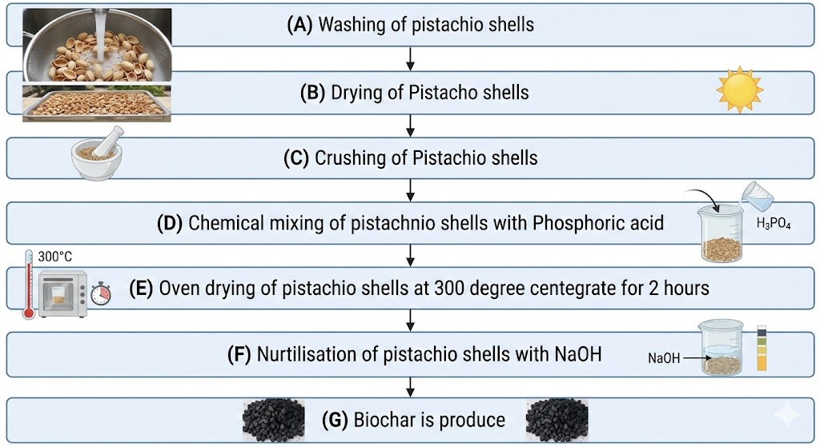

Procedure for the Preparation of Chemically Activated Pistachio Shell Biochar
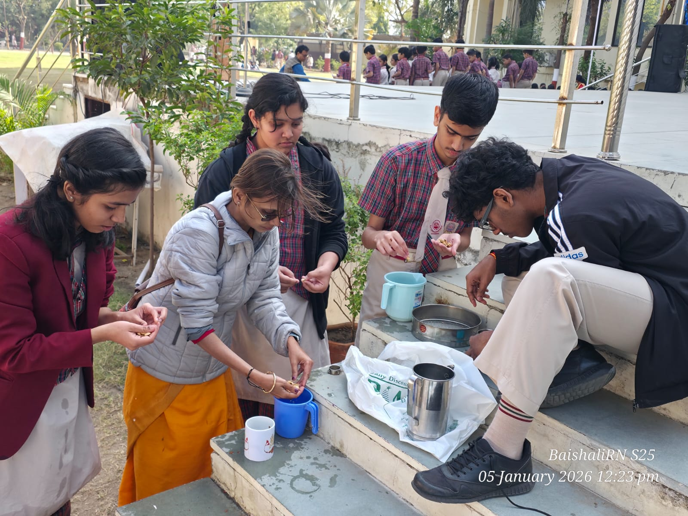
- Collection and Washing of Raw Material
Pistachio shells were collected and thoroughly washed with demineralized water to remove dust, dirt, and any adhering impurities.

Picture 1: Washing of Pistachio Shells
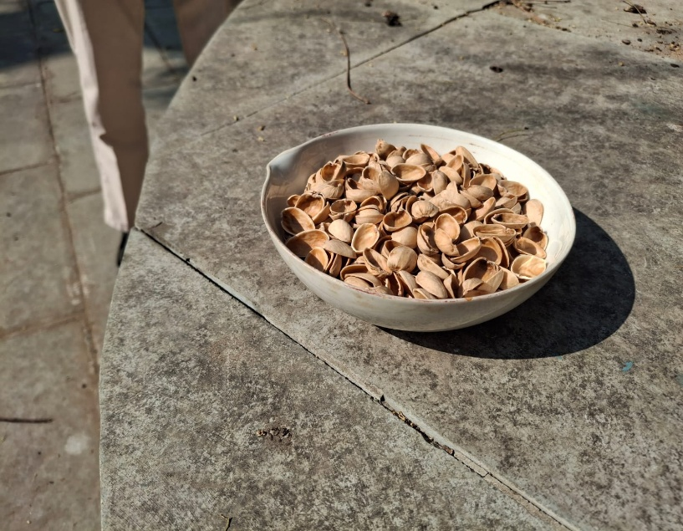
- Sun Drying
The washed pistachio shells were sun-dried for 4 hours to remove surface moisture.

Picture 2: Sun drying of Biochar
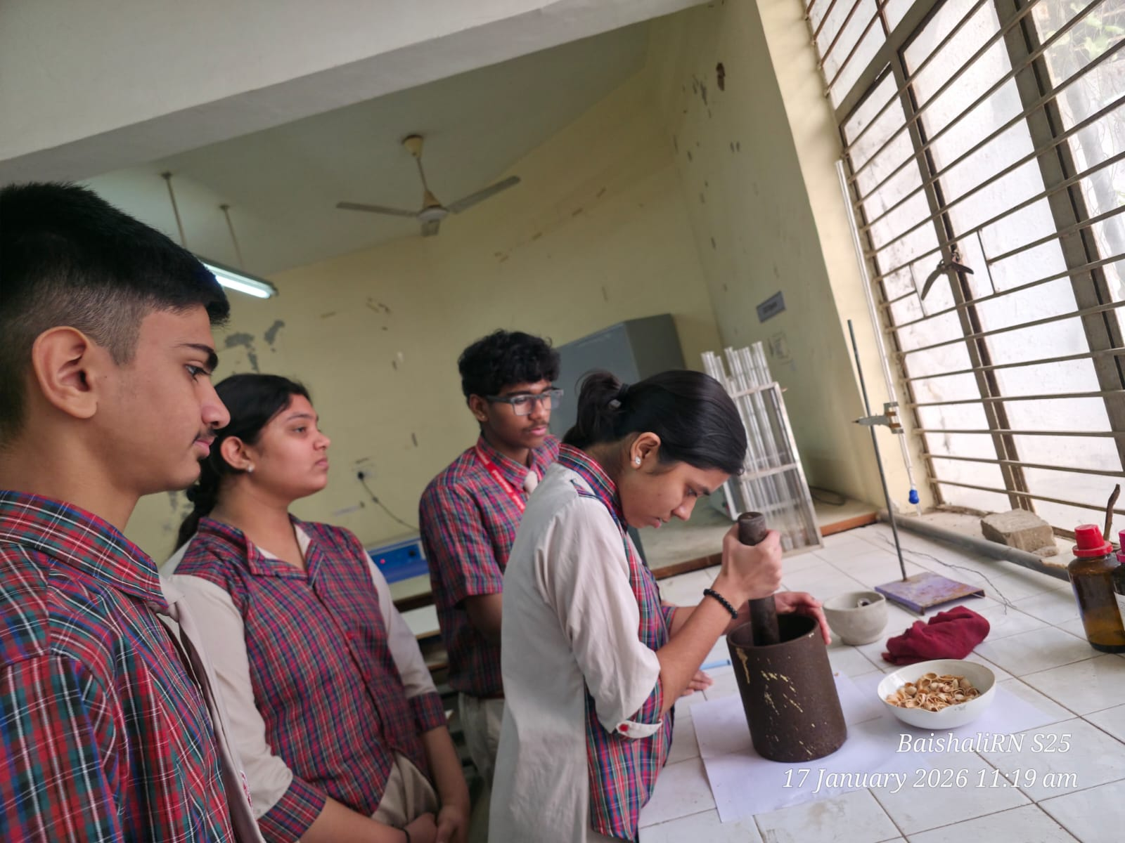
- Size Reduction and Sieving
The dried pistachio shells were crushed into smaller pieces of approximately 1 cm in size. The crushed material was then sieved to obtain uniform particle size.

Picture 3: Crushing of Pistachio Shells
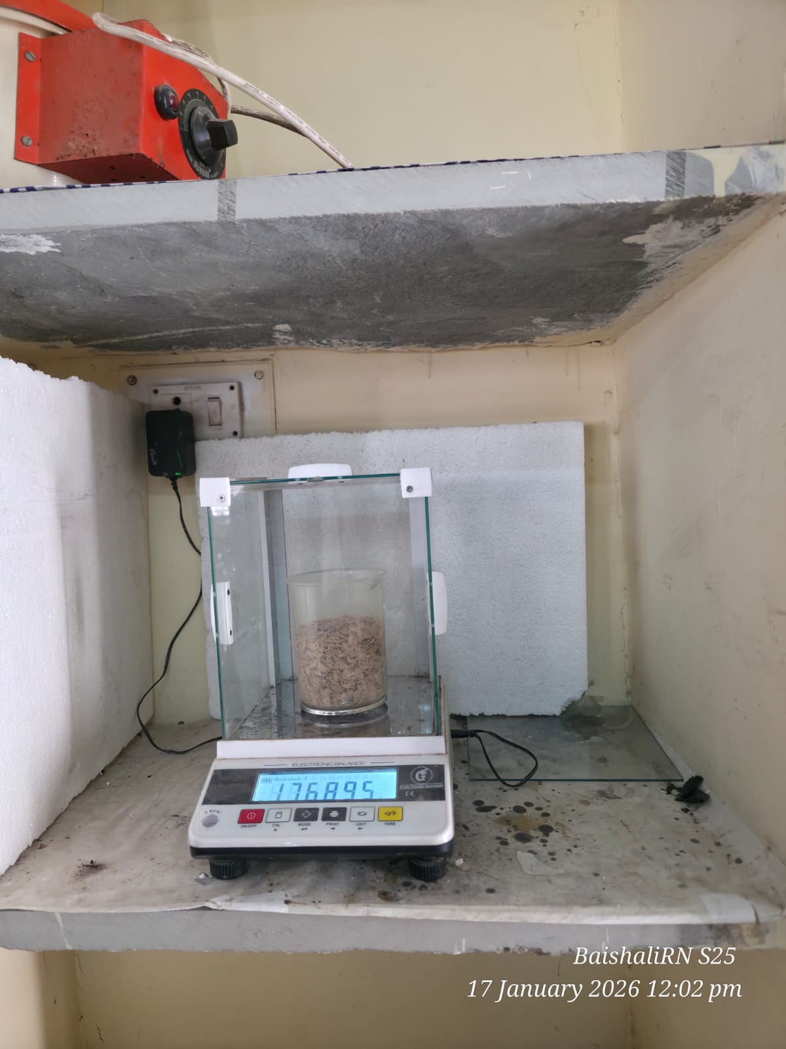
- Determination of Weight and Yield
The initial weight and the weight after each processing step were recorded to determine the yield at different stages of biochar preparation.

Picture 4: Determination of the weight
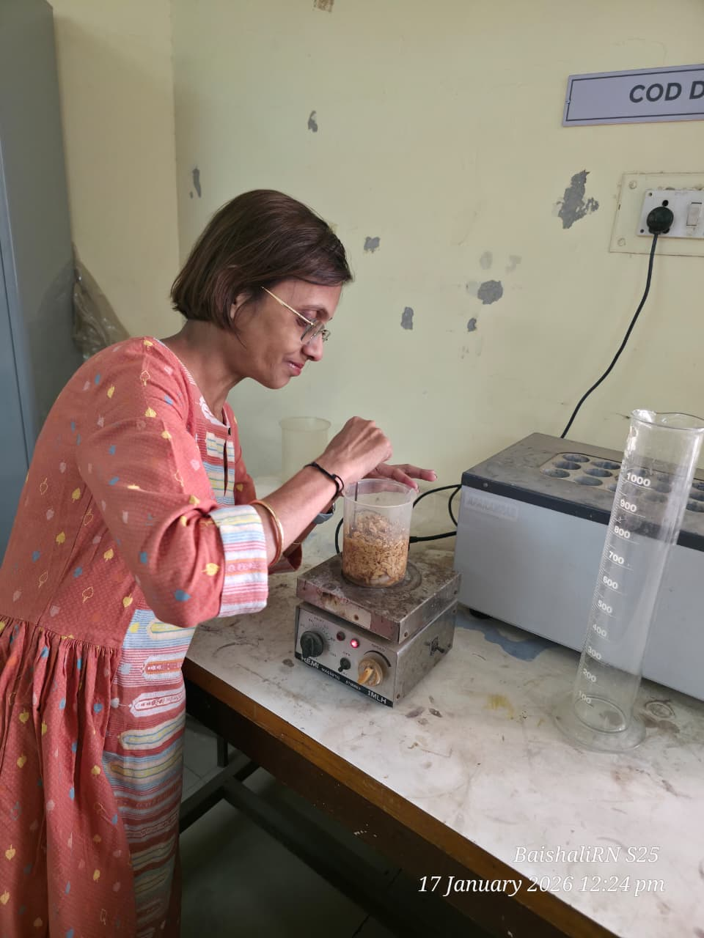
- Chemical Activation
The crushed pistachio shells were chemically activated by mixing them with phosphoric acid (H₃PO₄). The mixture was stirred for 10 minutes using a magnetic stirrer to ensure uniform impregnation of the activating agent.

Picture 5: Chemical Activation Process with Phosphoric Acid
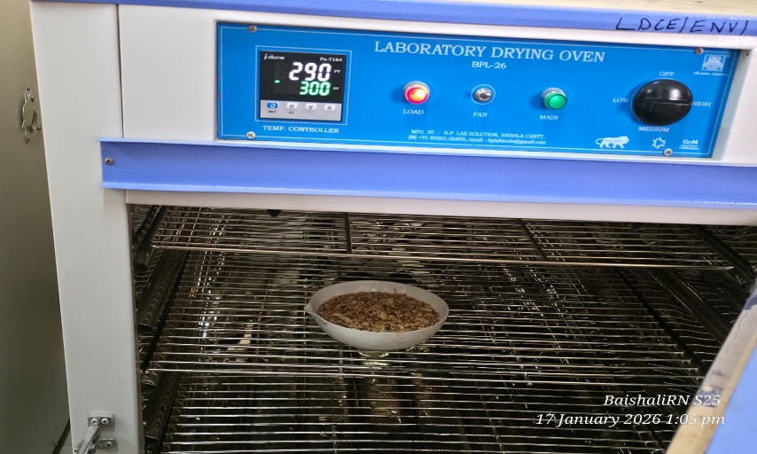
- Thermal Treatment
The chemically treated pistachio shells were placed in a laboratory drying oven and heated at 300 °C for 2 hours to promote carbonization and activation.

Picture 6: Thermal treatment at 300 degree C
- Neutralization and Washing
After thermal treatment, the obtained product was washed with sodium hydroxide (NaOH) solution to neutralize residual phosphoric acid. It was further washed with hot water to ensure complete removal of the activating agent.
- Final Drying
The washed product was sun-dried for 4 hours to remove excess moisture.
- Grinding to Fine Powder
The dried material was finely crushed to obtain pistachio shell biochar in powdered form, suitable for further analysis and application.
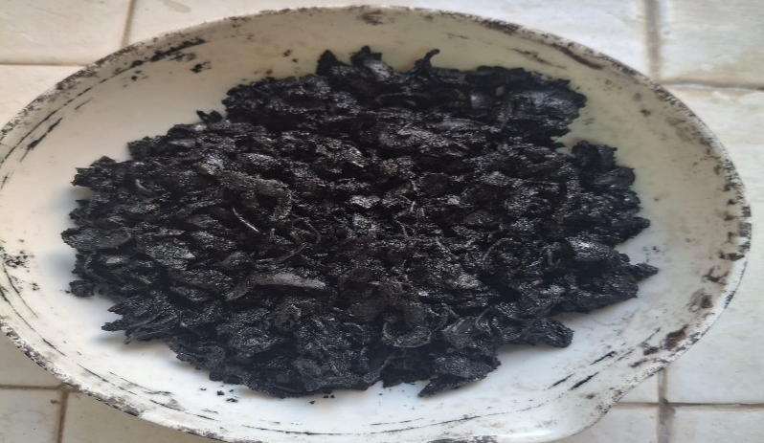

Picture 7: Final Product: Biochar
10. Testing of the Biochar under 2 parameters:
Testing of the produced biochar was carried out under two key parameters to evaluate its effectiveness and material properties. The analyses included proximate carbon analysis, Fourier Transform Infrared Spectroscopy (FTIR). The detailed reports of all three tests are attached below for reference.
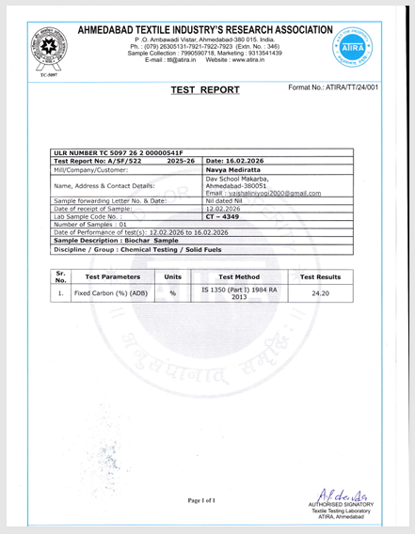
Picture 8: Test Report for Fixed Carbon

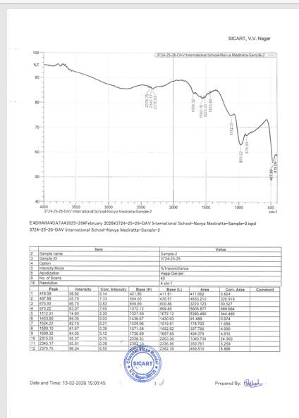
Picture 9: Test Report for Fourier Transform Infrared Spectroscopy (FTIR).

Analysis of the Test Results for Effectiveness of Biochar:
1. Proximate Analysis (ATIRA Report):Fixed Carbon (ADB): 24.20%
* Fixed carbon represents the stable carbon portion in biochar.
* Good quality biochar, especially for soil application, usually has 50–80% fixed carbon (sometimes even higher, depending on feedstock and temperature).
* A value of 24.20% is relatively low.
Interpretation:
- This suggests incomplete carbonization.
- The pyrolysis temperature may have been low.
- There could be higher volatile matter or ash content.
- The biochar is likely less stable in soil and may decompose faster.
- From a fuel or carbon sequestration point of view, this is moderate to low quality.

2. FTIR Analysis (SICART Report):From the spectrum, major peaks observed:
- ~2376 cm⁻¹ and 2345 cm⁻¹ → CO₂ related peaks
- ~1693 cm⁻¹ → C=O (carbonyl group)
- ~1560 cm⁻¹ → Aromatic C=C
- ~1112 cm⁻¹ → C–O stretching
- ~970 and 876 cm⁻¹ → Aromatic ring structures
- ~468 cm⁻¹ → Mineral/silicate related vibrations
- Presence of aromatic structures → good sign (indicates some degree of carbonization).
- Presence of C=O and C–O groups → oxygen-containing functional groups are still significant.
- Strong mineral-related peaks → noticeable ash/mineral content.
Interpretation: This biochar is:
  - Partially carbonized
  - Still contains oxygenated functional groups
  - Likely produced at moderate pyrolysis temperature
  - Has significant mineral residue

Overall Quality Assessment(Combining both reports):
Advantages:
  - Aromatic carbon present (structural stability exists)
  - Functional groups may help in nutrient retention if used for soil.
Disadvantages:
  - Low fixed carbon (24.20%)
  - Likely higher volatile matter
  - Possibly high ash content
  - Not highly stable carbon
Final Comment on Quality
This biochar can be classified as:Moderate quality biochar suitable for soil amendment but not high-grade biochar for carbon sequestration or fuel applications.
If the goal is:
- Soil improvement → Usable, but improvement possible
- Fuel use → Not ideal
- Long-term carbon storage → Needs higher pyrolysis temperature

7)LIMITATIONS
Despite its effectiveness, activated carbon production and application present several limitations. The activation process, particularly chemical activation, requires high temperatures and significant energy input, resulting in elevated production costs. Chemical activating agents such as potassium carbonate (K₂CO₃), phosphoric acid (H₃PO₄), and zinc chloride (ZnCl₂) generate wastewater containing alkali and metal residues. Such effluents may contain potassium (K⁺) in the range of 1–5 wt%, phosphates (PO₄³⁻) at approximately 0.5–3 wt%, and trace zinc ions (Zn²⁺) below 1 wt%, depending on the activation method and washing efficiency, they require proper treatment to prevent environmental contamination.
Production challenges also include variable yield and limited control over pore size distribution, which directly influence adsorption performance. Additionally, activated carbon quality depends strongly on the type and composition of the raw material, leading to inconsistencies when different biomass precursors are used.
From an application perspective, activated carbon is less effective for small inorganic ions (e.g., Na⁺, Cl⁻, NO₃⁻)due to weak surface interactions, often necessitating surface modification or integration with other treatment technologies. Regeneration is costly and energy-intensive and may reduce surface area and mechanical strength over repeated cycles. Finally, disposal of spent activated carbon containing adsorbed hazardous substances must comply with environmental regulations.

8) CONCLUSION:
This experimental study demonstrates that pistachio shells can be effectively converted into biochar through chemical activation and controlled thermal treatment, offering a sustainable solution for agricultural waste management. The produced biochar exhibited desirable carbon content, functional groups, and elemental composition, as confirmed through proximate analysis, FTIR, and SEM testing. Its porous structure and surface characteristics indicate strong potential for applications in soil improvement, nutrient retention, and pollutant adsorption. Despite certain production and regeneration limitations, pistachio shell biochar emerges as a low-cost, eco-friendly material that supports waste-to-resource conversion, environmental remediation, and long-term carbon sequestration.
9) REFERENCES:
1.IBI Biochar Trial Guidev1.2.pub
2. Assessment of Pistachio Shell-Based Biochar Application in the Sustainable Amendment of Soil and Its Performance in Enhancing Bell Pepper (Capsicum annuum L.) Growth | MDPI
3. Assessment of Pistachio Shell Biochar Quality and Its Potential for Adsorption of Heavy Metals | Waste and Biomass Valorization | Springer Nature Link

