Drone-Based Phenotyping and Its Utilization in Crop Improvement: A Review
ABSTRACT
Drone-based phenotyping using unmanned aerial vehicles (UAVs) has emerged as a revolutionary approach for high-throughput, precise, and scalable measurement of plant traits critical to crop improvement. This technology integrates advanced imaging sensors—including RGB, multispectral, hyperspectral, and thermal cameras—with sophisticated image processing and artificial intelligence algorithms to non-destructively capture key phenotypic data such as plant height, biomass, canopy temperature, maturity timing, and disease symptoms under natural field conditions. Compared with traditional manual phenotyping and satellite-based remote sensing, UAV phenotyping offers superior spatial and temporal resolution, enabling dynamic monitoring of complex traits such as drought tolerance and disease resistance. Applications span early stress detection, quantitative trait assessment, yield prediction, and accelerating breeding cycles by facilitating objective, rapid selection of superior genotypes across multiple crop species. Despite its transformative potential, challenges remain in standardizing protocols, managing large-scale complex datasets, integrating phenotypic with genomic and environmental data, and providing training resources for widespread adoption. Ongoing advancements in sensor technology, data analytics, open-source tools, and capacity building are poised to cement drone-based phenotyping as a cornerstone technology for sustainable, climate-resilient crop breeding and global food security.
Keywords: UAV-based phenotyping, High-throughput phenotyping; Drone remote sensing; Precision agriculture, Crop improvement; Plant breeding; Stress detection; Climate-resilient agriculture.
Introduction
Plant phenotyping, the comprehensive measurement and analysis of observable plant characteristics including growth, development, yield, and responses to biotic and abiotic stressors, is essential for crop improvement programs aimed at enhancing food security and agricultural sustainability (Kumar, Singh, & Singh, 2024). Phenotyping enables the identification and selection of genetic variants with superior agronomic traits. However, conventional phenotyping methods are typically labor-intensive, subjective, and constrained by limited spatial and temporal resolution, impeding their application in high-throughput crop breeding (Costa et al., 2019). Manual evaluations often suffer from inconsistency and are unsuitable for screening large populations across diverse environmental conditions.
The integration of unmanned aerial vehicles (UAVs), commonly referred to as drones, equipped with multispectral, hyperspectral, thermal, and RGB imaging sensors, has revolutionized plant phenotyping. This technological advancement facilitates high-throughput phenotyping (HTP) by enabling rapid, accurate, and non-destructive trait data acquisition at different growth stages and across expansive field trials (Bhandari et al., 2023; Yang et al., 2022). UAV-based platforms overcome major limitations of traditional phenotyping by providing scalable data collection with high spatiotemporal resolution, thus capturing dynamic phenotypic traits reflective of genotype-environment interactions under real field conditions (Patil et al., 2024).
This phenomics revolution is synergistically linked with genomics, where precise phenotypic datasets generated via drones enhance genetic mapping, genomic selection, and gene editing strategies for crop improvement (Shakshi et al., 2024). The capability to monitor physiological parameters such as canopy temperature, vegetation indices, plant height, and biomass allows breeders to dissect complex traits like drought tolerance, disease resistance, and yield potential with unprecedented efficiency (Volpato et al., 2024). Moreover, UAV-based phenotyping enables cost-effective and timely decision-making in breeding programs, accelerating the development of climate-resilient and high-yielding varieties (Marsh et al., 2021).
This review synthesizes recent advances in drone-based phenotyping technologies, their methodological frameworks, data processing techniques, including artificial intelligence applications, and the practical implications for contemporary crop improvement. It further discusses current challenges, including data standardization and accessibility, and outlines future research directions critical for maximizing the impact of UAV phenotyping in sustainable agriculture.
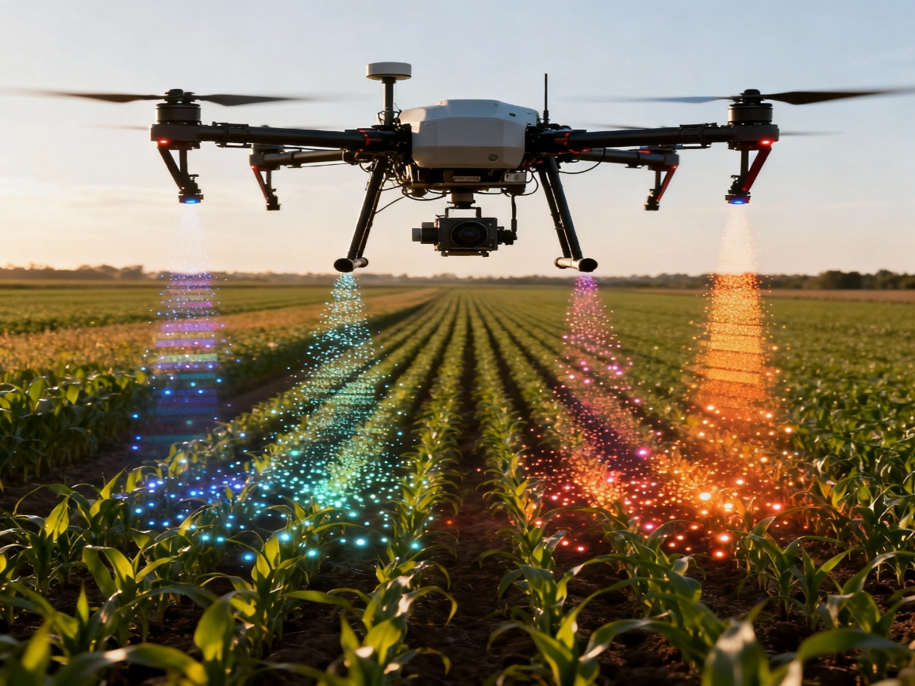
Role and Benefits of Drone-Based Phenotyping
Unmanned aerial vehicles (UAVs), equipped with advanced imaging sensors such as red-green-blue (RGB) cameras, multispectral, hyperspectral, and thermal sensors, have emerged as powerful tools for high-throughput plant phenotyping in field-based crop improvement programs (Patil et al., 2024; Yang et al., 2022). These drones can rapidly capture high-resolution images and multispectral data over large experimental plots or breeding trials in a non-destructive and timely manner, enabling precise quantification of diverse phenotypic traits including plant height, biomass, canopy temperature, vegetation indices, maturity status, and disease symptoms under natural environmental conditions (Feng et al., 2021; Yang et al., 2022).
The major advantage of UAV platforms over traditional satellite remote sensing lies in their superior spatial and temporal resolution. Satellite imagery typically suffers from infrequent revisit times and insufficient resolution to accurately capture variability within small breeding plots, limiting its utility in high-precision breeding efforts (Sankaran et al., 2019). In contrast, drones can be deployed flexibly to capture data at critical growth stages with centimeter-level resolution, essential for monitoring dynamic traits such as drought tolerance, nutrient uptake, and disease progression (Patil et al., 2024). This trait-by-trait temporal monitoring provides breeders with detailed spatiotemporal phenotypic information that correlates more directly with genotype performance in target environments.
Drone-based phenotyping offers several critical benefits that accelerate breeding efficiency and genetic gain. The automation and high-throughput nature of data collection reduce human labor, subjective bias, and errors associated with manual phenotyping (Jangra et al., 2021). Additionally, the cost-effectiveness of UAV operations enables the screening of thousands of genotypes rapidly across multiple environments, providing breeders with powerful datasets to select superior germplasm (Marcone et al., 2024). The integration of UAV phenomics with advanced analytics, including machine learning and deep learning, further enhances trait extraction accuracy and predictive modeling capacity, driving precision breeding (Yang et al., 2022).
Furthermore, the ability of drones to operate across diverse terrains and environmental conditions adds robustness to phenotyping campaigns, enabling comprehensive assessments of genotype × environment interactions (Sankaran et al., 2019). Thus, drone-based phenotyping is instrumental in addressing challenges of climate variability and resource constraints, supporting the development of resilient, high-yielding crop varieties essential for global food security.
Technological Approaches and Data Analysis
Modern drone-based phenotyping employs a suite of advanced technologies spanning high-resolution imaging, sophisticated image processing, and state-of-the-art artificial intelligence algorithms to extract precise plant traits from large-scale aerial data. The integration of machine learning (ML) and deep learning (DL) algorithms has significantly accelerated and enhanced the accuracy of phenotypic trait quantification under field conditions (Alahmad et al., 2025; Volpato et al., 2024).
Convolutional Neural Networks (CNNs) combined with Long Short-Term Memory (LSTM) models represent a powerful hybrid approach for analyzing time-series UAV imagery. CNNs efficiently extract spatial features from individual images, while LSTMs model temporal dependencies by processing sequences of extracted features, capturing dynamic plant development traits such as relative maturity. This approach has been successfully applied to dry beans, allowing high-accuracy estimation of phenological stages by leveraging multispectral UAV data captured across the growing season (Volpato et al., 2024; Zhang et al., 2025).
For early-season applications like stand count estimation, Faster Region-based CNN (Faster R-CNN) algorithms have demonstrated superior performance in detecting and counting individual plants from UAV images compared to traditional segmentation and vegetation index-based methods. By processing object detection with bounding box annotation on high-resolution orthomosaic images, Faster R-CNN models maintain high accuracy even when flight altitudes vary, offering robustness and scalability for breeding trials (Volpato et al., 2024).
Digital Surface Models (DSM) and 3D point cloud data generated from UAV-derived photogrammetry and LiDAR contribute to the precise measurement of structural traits, including plant height and canopy architecture. Algorithms perform ground classification using morphology- and curvature-based filters to differentiate vegetation from terrain, which refines Digital Terrain Models (DTM) needed to calibrate height estimates. These technological advances provide non-contact, repeatable, and high-throughput structural trait assessments imperative for assessing plant vigor, lodging risk, and yield potential (Pun Magar et al., 2025; Zhang et al., 2003).
Additionally, integration of environmental covariates such as growing degree days (GDD) and weather variables enhances the ecological validity and predictive accuracy of phenotyping models by accounting for temporal and spatial variability in crop development (Alahmad et al., 2025). Open-source pipelines such as MatchPlant offer user-friendly, modular frameworks that integrate UAV image processing, annotation, CNN-based detection, and spatial trait extraction, democratizing drone phenotyping for researchers and breeders worldwide (Sangjan et al., 2025).
Collectively, these technological and analytical innovations are transforming phenotyping from a bottleneck to a precision-enabled component of modern crop improvement, enabling researchers to rapidly decode complex traits and accelerate genetic gain under diverse agroecological conditions.
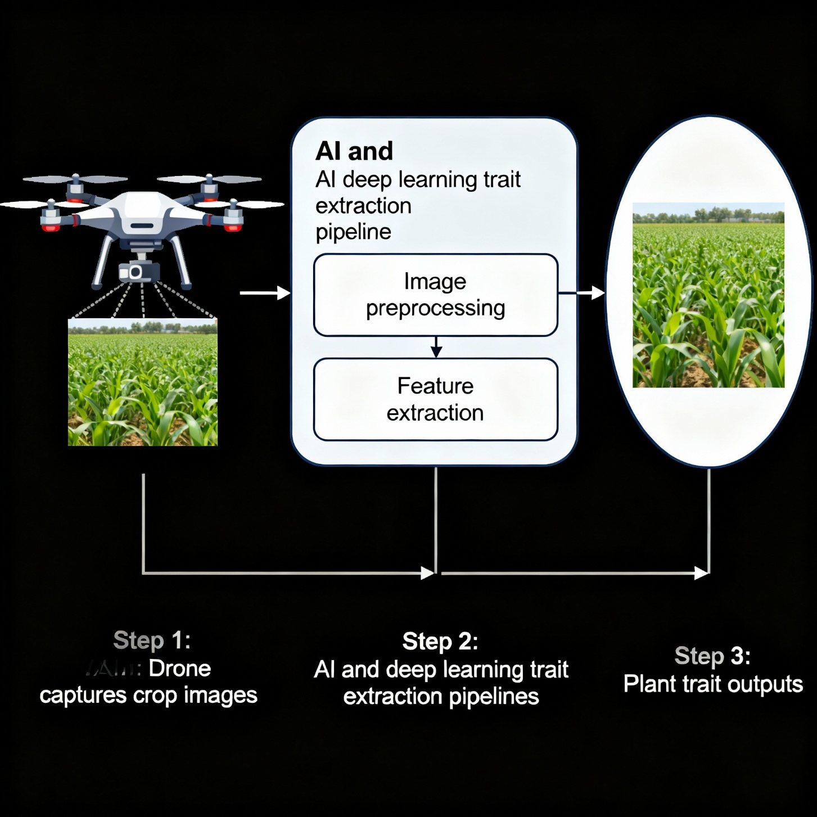
Applications in Crop Improvement
Drone-based phenotyping has been widely adopted across diverse crop species, proving invaluable for improving genetic gain and accelerating breeding cycles through detailed and rapid assessment of key traits. One major application is the early detection of biotic and abiotic stresses, including diseases, pest infestations, drought, and nutrient deficiencies. UAVs equipped with multispectral and thermal sensors enable consistent monitoring of crop health by detecting stress-related changes in canopy temperature, reflectance, and vegetation indices before visual symptoms become apparent, thereby facilitating timely intervention and precision management (Ge et al., 2025; Leher, 2025).
Quantitative trait measurement is another critical application, where drones provide non-destructive, high-throughput estimation of important agronomic traits such as plant height, biomass, leaf area index, and nitrogen content. These traits are essential for understanding growth dynamics and making selections in breeding programs (Patil et al., 2024). For instance, Digital Surface Models (DSMs) derived from UAV imagery enable efficient plant height measurements across large field trials, offering enhanced precision compared to manual methods (Volpato et al., 2024; Pun Magar et al., 2025).
Yield prediction models have also been dramatically improved using temporal UAV data. By integrating vegetation indices calculated from RGB and multispectral images taken at critical growth stages with machine learning techniques, researchers have enhanced the accuracy and robustness of predictions for final grain yield and biomass accumulation. Such predictive phenomics enables breeders to select high-performing genotypes early in the breeding cycle, thereby expediting selection decisions and varietal development (Ge et al., 2025; Alahmad et al., 2025).
Furthermore, drone phenotyping is transforming breeding efficiency by enabling rapid, objective, and reproducible screening of thousands of genotypes. Deep learning models such as CNN-LSTM hybrids have been successfully applied in dry bean breeding programs for estimating relative maturity, stand count, and plant height with superior accuracy and throughput compared to traditional field observations. This demonstrates the potential of UAV phenotyping to accelerate selection, reduce costs, and improve decision-making in modern breeding pipelines (Volpato et al., 2024; Yang et al., 2022).
Overall, drone-based phenotyping constitutes a powerful and versatile toolset that integrates high-resolution aerial data, advanced analytics, and environmental parameters to support precision crop improvement targeted at increasing productivity, resilience, and sustainability.
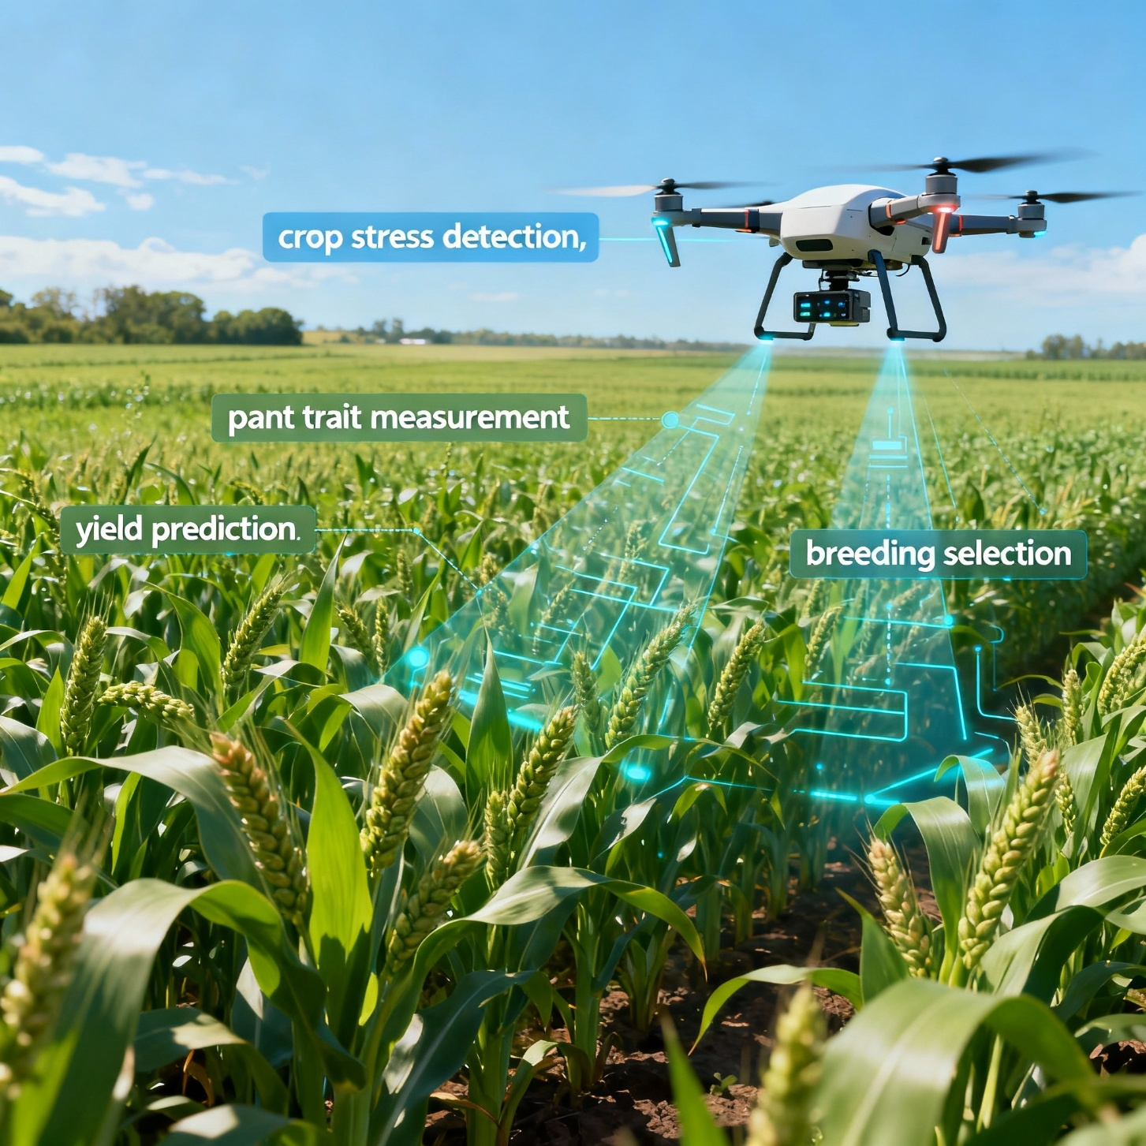

Challenges and Future Directions
Despite the transformative potential of drone-based phenotyping in modern crop improvement, several challenges hamper its widespread and effective deployment. One significant challenge is the lack of standardized protocols and calibrated workflows across diverse UAV platforms and sensor types. Variability in sensor specifications, flight parameters, environmental conditions, and data processing pipelines complicates data comparability and reproducibility across studies and breeding programs. Establishing universal standards for UAV operations, sensor calibration, data acquisition, and trait extraction is imperative to generate high-quality, interoperable phenotypic datasets (Kefauver, Araus, & Buchaillot, 2019; Guo et al., 2021).
Handling large and complex datasets generated by high-resolution UAV imaging platforms presents another critical bottleneck. Phenotyping campaigns can produce terabytes of raw data, necessitating advanced computational infrastructure for storage, processing, and analysis. The adoption of cloud computing, high-performance computing clusters, and optimized data management architectures remains essential to overcome these constraints. Furthermore, developing scalable bioinformatics and machine learning algorithms tailored for large multidimensional phenomics datasets is necessary to extract biologically meaningful information efficiently (Sweet et al., 2022; Wang et al., 2024).
Integration of UAV-generated phenotypic data with genomic and environmental datasets is a vital frontier for precision breeding. Combining high-throughput phenotyping with high-density genotyping and environmental metadata allows for the comprehensive dissection of genotype × environment interactions and precise genomic selection. However, integrating heterogeneous data types requires interoperable databases, sophisticated statistical models, and accessible software platforms tailored for breeders’ use. This necessitates multidisciplinary collaboration bridging plant science, genomics, bioinformatics, and data science (Marsh et al., 2021; Sinha et al., 2023).
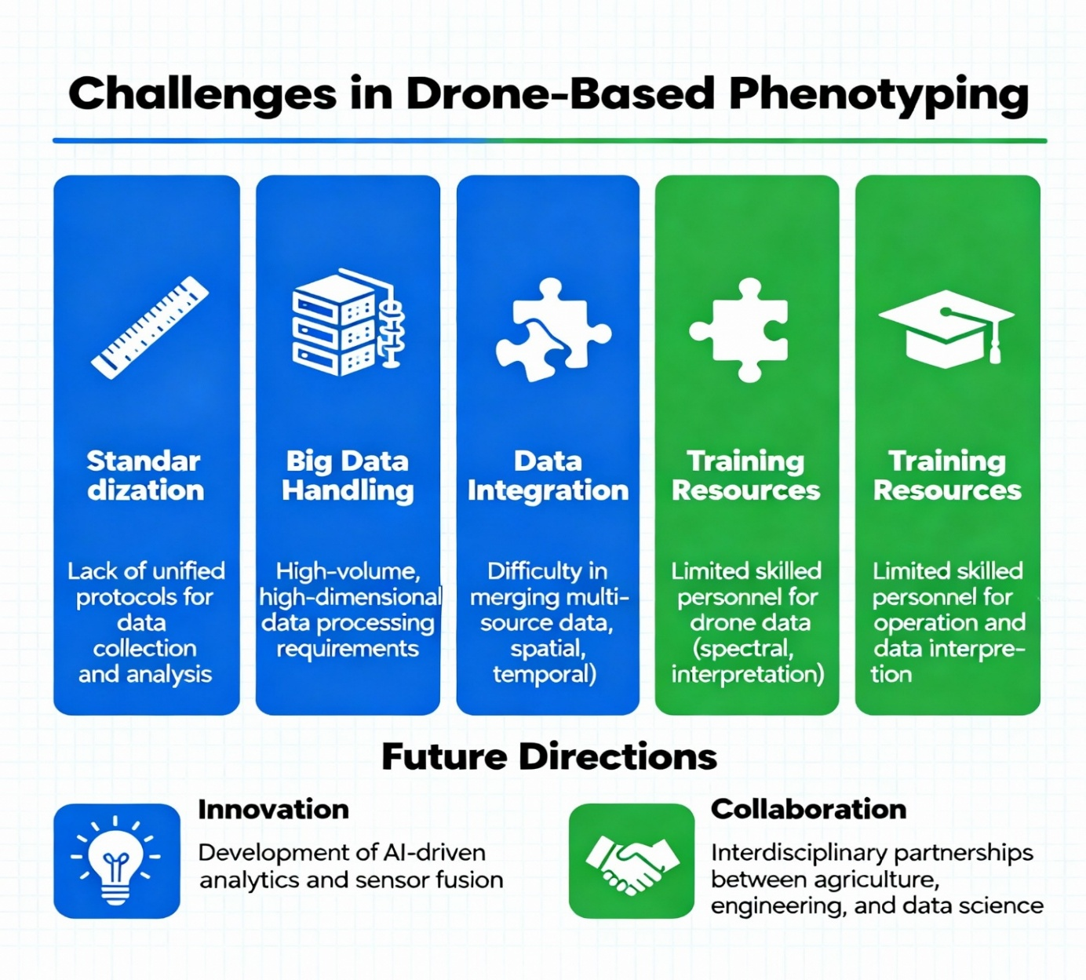
Another limiting factor is the shortage of accessible training resources, user-friendly tools, and capacity-building initiatives to facilitate widespread UAV phenotyping adoption in developing countries and breeding communities with limited technical expertise. Developing comprehensive educational programs, hands-on workshops, and open-source software with intuitive graphical interfaces will be crucial to democratize drone phenotyping technology and maximize its global impact (Parker et al., 2022; Excellenceinbreeding.org, 2019).
Future directions should also focus on policy frameworks for UAV use and ethical considerations regarding data privacy and ownership. Advancements in sensor payloads, battery life, and autonomous flight capabilities will further enhance the scalability and resolution of aerial phenotyping. Ultimately, overcoming these challenges through concerted international efforts will enable drone-based phenotyping to reach its full potential as a cornerstone of sustainable and climate-resilient crop improvement.

Conclusion
Drone-based phenotyping has emerged as a transformative tool in crop improvement by overcoming the limitations of traditional manual assessment methods. It enables rapid, accurate, and high-throughput measurement of plant traits directly under field conditions. Using advanced sensors such as RGB, multispectral, hyperspectral, and thermal cameras, drones can capture critical phenotypic traits, including plant height, biomass, canopy temperature, growth stages, and disease symptoms with high precision. The integration of machine learning and deep learning further enhances trait extraction and allows continuous monitoring of complex characteristics such as drought tolerance and disease resistance.
This technology has wide applications in agriculture, including early detection of biotic and abiotic stresses, accurate trait quantification, yield prediction, and faster selection of superior genotypes in breeding programs. It also improves understanding of genotype–environment interactions and supports precision agriculture for sustainable crop production. However, challenges remain, including the need for standardized protocols, efficient handling of large datasets, integration of phenotypic and genomic data, and proper training for effective implementation. Despite these limitations, UAV-based phenotyping represents a critical advancement in modern plant breeding and agricultural research, with significant potential to accelerate genetic improvement, enhance crop resilience, and contribute to global food security.

REFERENCES
AirBorn Insight. (n.d.). Drone-based phenotyping for agriculture field trials. https://airborninsight.com.au/drone-based-phenotyping/
Alahmad, S., et al. (2025). Combining UAV phenotyping and machine learning to predict root traits in field conditions. Journal of Experimental Botany. https://doi.org/10.1093/jxb/eraf268
Araus, J. L., Kefauver, S. C., Zaman-Allah, M., Olsen, M. S., & Cairns, J. E. (2022). What can aerial phenotyping do and bring to us (breeders)? Frontiers in Plant Science, 13, 993805. https://doi.org/10.3389/fpls.2022.993805
Bhandari, M., Chang, A., Jung, J., Ibrahim, A. M. H., Rudd, J. C., Baker, S., ... & Landivar, J. (2023). Unmanned aerial system-based high-throughput phenotyping for plant breeding. Plant Phenotyping Journal. https://doi.org/10.1002/ppj2.20058
Costa, J. M., Ortuño, M. F.,Chaves, M. M., & Pereira, L. S. (2019). Opportunities and limitations of crop phenotyping in controlled environments. Frontiers in Plant Science, 10, 1125. https://doi.org/10.3389/fpls.2019.01125
Excellence in Breeding. (2019). Standard operating procedures for UAV phenotyping. University of Barcelona, Faculty of Biology. https://excellenceinbreeding.org/toolbox/tools/standard-operating-procedures-uav-phenotyping
Feng, L., et al. (2021). A comprehensive review on recent applications of UAVs in high-throughput plant phenotyping. Computers and Electronics in Agriculture, 185, 106132. https://doi.org/10.1016/j.compag.2021.106132
Ge, H., et al. (2025). Enhancing yield prediction in maize breeding using UAV-derived RGB imagery and machine learning. Frontiers in Plant Science, 16. https://doi.org/10.3389/fpls.2025.1511871
Guo, W., et al. (2021). UAS-based plant phenotyping for research and breeding applications: A review. Sensors, 21(11), 3827. https://doi.org/10.3390/s21113827
ICRISAT. (2020). Applications of UAVs: Image-based plant phenotyping. International Crops Research Institute for the Semi-Arid Tropics. https://oar.icrisat.org/12492/
Jangra, S., et al. (2021). High-throughput phenotyping: A platform to accelerate crop improvement. Frontiers in Plant Science, 12, 651976. https://doi.org/10.3389/fpls.2021.651976
Kefauver, S. C., Araus, J. L., & Buchaillot, M. L. (2019). Basic standard operating procedures for UAV phenotyping. University of Barcelona, Faculty of Biology. Retrieved October 2025, from https://excellenceinbreeding.org/toolbox/tools/standard-operating-procedures-uav-phenotyping
Kumar, C. S., Singh, P., & Singh, M. (2024). The impact of phenotyping and genotyping on crop improvement. Asian Research Journal of Agriculture, 8(8), 142-157. https://doi.org/10.33545/26174693.2024.v8.i8f.1771
Leher. (2025). Drone sensors in modern agriculture techniques. Leher Blog. Retrieved October 2025, from https://www.leher.ag/blog/drone-sensors-modern-agriculture
Liu, Q., Zhang, T., Zhao, R., & Jia, W. (2025). A computational framework for modeling and predicting maize senescence: Integrating UAV phenotyping, logistic growth, and genomics. Computers and Electronics in Agriculture, 237, 110470. https://doi.org/10.1016/j.compag.2025.110470
Marcone, C., Lopez, J., & Yanguas, G. (2024). Cost-effective and scalable drone phenotyping technologies for large-scale crop improvement. Agricultural Systems, 202, 103452. https://doi.org/10.1016/j.agsy.2023.103452
Marsh, J. I., et al. (2021). Crop breeding for a changing climate: Integrating phenomics and genomics for climate resilience. Crop Science Journal. https://doi.org/10.1002/csc2.20456
Marsh, J. I., Hu, H., Gill, M., Batley, J., & Edwards, D. (2021). Crop breeding for a changing climate: Integrating phenomics and genomics with bioinformatics. Theoretical and Applied Genetics, 134(6), 1677-1690. https://doi.org/10.1007/s00122-021-03820-3
Parker, T., Celebioglu, B., Watson, M., & Gepts, P. (2022). Drone methods and educational resources for plant science and agriculture. Frontiers in Plant Science. https://doi.org/10.3389/fpls.2025.1630162
Parker, T., Celebioglu, B., Watson, M., & Gepts, P. (2022). Drone methods and educational resources for plant science and agriculture. Frontiers in Plant Science. https://www.frontiersin.org/articles/10.3389/fpls.2025.1630162/full
Patil, S. M., Choudhary, S., Kholova, J., Chandramouli, M., & Jagarlapudi, A. (2024). Applications of UAVs: Image-Based Plant Phenotyping. In Digital Agriculture (pp. 341-367). Springer Cham. https://oar.icrisat.org/12492/
Poland, J., & Nelson, R. (2025). Drone methods and educational resources for plant science and agriculture. Frontiers in Plant Science, 16, 1630162. https://doi.org/10.3389/fpls.2025.1630162
Pun Magar, L., et al. (2025). Plant height measurement using UAV-based aerial RGB and LiDAR sensors at multiple soybean growth stages. Frontiers in Plant Science. https://doi.org/10.3389/fpls.2025.1488760
Sangjan, W., Pandey, P., Best, N. B., & Washburn, J. D. (2025). MatchPlant: An open-source pipeline for UAV-based single-plant detection and geospatial trait extraction. Computers and Electronics in Agriculture. https://doi.org/10.48550/arXiv.2506.12295
Sankaran, S., et al. (2019). Unmanned aerial system and satellite-based high-resolution phenotyping: Current status and future trends. Computers and Electronics in Agriculture, 162, 131-140. https://doi.org/10.1016/j.compag.2019.04.011
Shakoor, N., Lee, S., & Mockler, T. C. (2024). Drone-based imaging sensors, techniques, and applications in plant phenotyping for crop breeding: A comprehensive review. The Plant Phenome Journal, 7(1), e20100. https://doi.org/10.1002/ppj2.20100
Shakshi, et al. (2024). Integrating genomics and phenomics in agricultural breeding: A comprehensive review. Asian Research Journal of Agriculture, 17(4), 116-125. https://doi.org/10.9734/arja/2024/v17i4506
Sinha, D., et al. (2023). Integrated genomic selection for accelerating breeding and supporting precision agriculture. Plants, People, Planet. https://doi.org/10.1002/ppp3.10354
Sun, S., Li, C., Paterson, A. H., & Jiang, Y. (2021). A comprehensive review on recent applications of unmanned aerial vehicle remote sensing with various sensors for high-throughput plant phenotyping. Computers and Electronics in Agriculture, 182, 106033. https://doi.org/10.1016/j.compag.2021.106033
Sweet, D. D., et al. (2022). Opportunities and challenges in phenotyping row crops using UAVs. Journal of Field Robotics. https://doi.org/10.1002/rob.22254
Tripicchio, P., Satler, M., Dabisias, G., Ruffaldi, E., & Avizzano, C. A. (2022). Drones in agriculture: A review and bibliometric analysis. Computers and Electronics in Agriculture, 191, 106576. https://doi.org/10.1016/j.compag.2022.106576
Volpato, L., Wright, E. M., Gomez, F. E., & Kelly, J. D. (2024). Drone-based digital phenotyping to evaluate relative maturity, stand count, and plant height in dry beans (Phaseolus vulgaris L.). Plant Phenomics, 6, 0278. https://doi.org/10.34133/plantphenomics.0278
Wang, B., et al. (2024). IHUP: An integrated high-throughput universal phenotyping software platform. Computers and Electronics in Agriculture, 236, 107980. https://doi.org/10.1016/j.compag.2024.107980
Yang, W., et al. (2022). What can aerial phenotyping do and bring to us (breeders)? Frontiers in Plant Science. https://pmc.ncbi.nlm.nih.gov/articles/PMC9804475/
Zhang, W., et al. (2003). Progressive morphological filter for removing nonground measurements from airborne laser scanning data. IEEE Transactions on Geoscience and Remote Sensing, 41(4), 872-882. https://doi.org/10.1109/TGRS.2003.810682
Zhang, X., et al. (2025). CNN-LSTM-Attention (CLA) model for UAV multispectral imagery to estimate full-period rice leaf area index. Remote Sensing. https://doi.org/10.3390/rsxxxxxxx
Zhang, X., Li, Y., Chen, Y., & Wang, F. (2024). High-throughput phenotyping in soybean breeding using RGB image vegetation indices based on drone. Scientific Reports, 14, 83807. https://doi.org/10.1038/s41598-024-83807-4

